4.Architecture
4.1) Architectural style(s)/model used:
The architectural framework serves as more than just the operational structure of our software. It acts as a representation that empowers software engineers to achieve several key objectives:
Analysis of Design Effectiveness: It enables an evaluation of how the design corresponds to its specified requirements. This assessment is vital to ensure that the intended objectives are achieved efficiently.
Consideration of Alternatives: By providing a clear architectural representation, it enables engineers to explore alternative design options at a stage where implementing changes is still feasible. This flexibility contributes to making informed decisions in the design process.
Risk Reduction: The architecture plays a pivotal role in mitigating risks associated with software construction. Identifying potential challenges and issues early in the design phase allows for proactive measures to minimize risks during implementation.

Why Architecture Matters a lot in our project:

Facilitates Communication: Architectural representations serve as a means of communication among all stakeholders involved in the development of a computer-based system. This ensures a shared understanding among team members, fostering effective collaboration.
Highlights Early Design Decisions: The architectural framework brings attention to critical design decisions made early in the process. These decisions significantly influence subsequent software engineering work and ultimately impact the success of the system as an operational entity.
Intellectually Graspable Structure: Architecture provides a concise and comprehensible mode of understanding how the system is structured and how its components collaborate. This clarity aids in maintaining a unified vision among the development team.
Architecture plays a role, in our software beyond being a blueprint. It serves as a way to communicate guide decision making and manage risks. Architecture provides a model that shapes the structure and collaboration of system components..
In software engineering, various architectural styles/models exist, each suited for specific applications and requirements. Common architectural styles include:

- Client-Server Architecture
- Microservices Architecture
- Monolithic Architecture
- Service-Oriented Architecture (SOA)
- Event-Driven Architecture
- Layered Architecture
- Component-Based Architecture
- Peer-to-Peer Architecture
For the Airline Management System, we have chose the Client-Server Architecture. This choice is rooted in the unique characteristics and requirements of the airline industry, as well as the specific needs of our software system.

Why We Chose Client-Server Architecture:
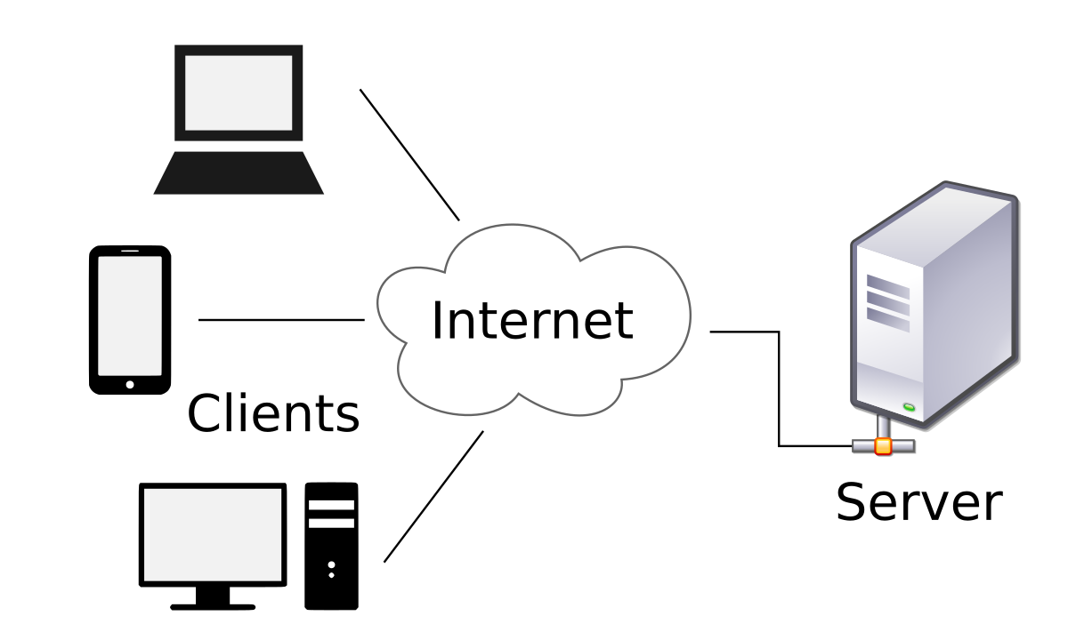

1. Scalability: Client-Server Architecture is inherently scalable, making it well-suited for systems with potentially large numbers of users, such as an airline management system. The division of functionality between clients and servers allows for easier scaling of components based on demand.
2. Centralized Control and Management: In the airline industry, centralized control and management are critical for overseeing reservations, flight schedules, and overall system functionality. The server component acts as the central point of authority, ensuring consistency and coherence in data management.
3. Efficient Resource Utilization: With a dedicated server managing core functionalities, clients (passenger interfaces) can be relatively lightweight. This ensures efficient resource utilization, especially for end-users accessing the system from various devices and locations.
4. Enhanced Security: Client-Server Architecture facilitates centralized security measures, allowing for robust protection of sensitive data. Security protocols and access controls can be implemented at the server level, providing a secure environment for both passenger information and administrative controls.
5. Separation of Concerns: The architectural style enables a clear separation of concerns between the client-side (user interface and user interactions) and the server-side (business logic, data management). This modularity enhances maintainability and allows for easier updates or modifications to specific components without affecting the entire system.
6. Flexibility and Interoperability: Client-Server Architecture promotes flexibility and interoperability. Clients with different interfaces (web, mobile applications) can interact with the server using standardized protocols, providing adaptability to various user needs and preferences.
7. Improved Performance: The division of tasks between clients and servers contributes to improved performance. Client devices can focus on rendering user interfaces and handling user input, while the server manages the processing of complex business logic and database interactions.
8. Adaptability to Distributed Environments: Client-Server Architecture is well-suited for distributed environments, accommodating scenarios where clients and servers may be located in different geographical locations. This is particularly relevant for an airline management system accessed by passengers and administrators worldwide.
In conclusion, the decision to employ Client-Server Architecture for the Airline Management System is rooted in its scalability, centralized control, security benefits, separation of concerns, flexibility, and adaptability to the distributed nature of the airline industry. This architectural style aligns with the specific requirements of managing flight reservations, passenger interactions, and administrative controls within the context of a modern and efficient airline management system.
4.2) Technology, software, and hardware used
Backend:
Database: SQLite
Why: SQLite is a lightweight, serverless, and easy-to-use relational database that aligns with the project's requirements. Its simplicity and efficiency make it suitable for managing airline-related data.
API Framework: Python + Flask
Why: Python, coupled with Flask, provides a concise and powerful framework for building APIs. Flask's simplicity and flexibility suit the project's needs, facilitating efficient backend development.
Frontend:
Web Development: HTML
Why: HTML serves as the fundamental markup language for creating the structure of web pages. It is a standard choice for frontend development and ensures compatibility across browsers.
Styling: Bootstrap
Why: Bootstrap simplifies frontend design with its responsive and customizable components. Its pre-built CSS and JavaScript components expedite the development of a user-friendly and visually appealing interface.
4.3) Rationale for Choosing Client-Server Architecture:

The decision to use Client Server Architecture for our Airline Management System is based on the requirements and characteristics of our project. This architectural option is strategically aligned with the nature of the airline industry. Fulfills the needs of our software solution.
1. Scalability for Dynamic Demand:
Rationale: The airline industry experiences dynamic fluctuations in demand, especially during peak travel times. The Client-Server Architecture is inherently scalable, allowing our system to efficiently handle varying levels of user interactions. This adaptability is crucial for ensuring optimal performance during periods of high booking activity.
2. Centralized Control and Management:
Rationale: Airline operations demand centralized control and management of critical information, such as flight schedules, reservations, and passenger details. The server component in Client-Server Architecture serves as the central authority, facilitating streamlined data management and consistent decision-making. This centralized control is essential for the smooth functioning of our Airline Management System.
3. Security for Sensitive Data:
Rationale: Security is paramount in the airline industry, given the sensitive nature of passenger information and financial transactions. The Client-Server model allows for the implementation of robust security measures at the server level, safeguarding passenger details and ensuring secure financial transactions. This approach aligns with the high-security standards required in the aviation sector.
4. Separation of Concerns for Modularity:
Rationale: The separation of concerns in Client-Server Architecture enhances modularity and maintainability. By delineating user interfaces (client-side) from business logic and data management (server-side), we create a modular system that facilitates easier updates, modifications, and maintenance. This modularity is crucial for long-term sustainability and adaptability to evolving requirements.
5. Adaptability to Distributed Environments:
Rationale: The airline industry involves a geographically dispersed user base, including passengers and administrators located worldwide. Client-Server Architecture accommodates this distributed nature, allowing clients to interact with the server seamlessly irrespective of their geographical location. Standardized communication protocols ensure interoperability and adaptability to diverse environments, aligning with the global reach of our airline services.
6. Efficient Resource Utilization:
Rationale: Client-Server Architecture optimizes resource utilization by assigning specific roles to clients and servers. Clients focus on rendering user interfaces and handling user input, while the server manages resource-intensive tasks such as database interactions and business logic. This allocation ensures efficient use of resources, contributing to the overall performance and responsiveness of our Airline Management System.
To summarize we have chosen the Client Server Architecture for our Airline Management System based on factors. These include its ability to scale effectively provide control offer security features promote modularity adapt well to distributed environments and optimize resource usage. This architectural decision has been specifically designed to meet the needs and demands of the airline industry. By selecting this approach we can ensure that our system is reliable, secure and able to deliver an experience, for both passengers and administrators.

