GIS
Course Learning Objectives
- Use ArcGIS Pro software efficiently
- Explore, create and analyze spatial GIS data in ArcGIS Pro software
- Create and share new GIS data
- Use ArcGIS geoprocessing tools for data preparation and spatial analysis
- Create informative maps, graphs and charts
- Perform spatial analyses on points, lines, and polygons to gain deeper insight into data, pattern and relationship
https://arcg.is/09O0v4
Module 1 Learning Objectives
- Define Geographic Information System (GIS)
- Explain different GIS data types: vector and raster data
- Distinguish between vector data and raster data
- Recognize different GIS data file types
- Explain the difference between geographic and projected coordinate systems
- Explore GIS applications in different fields, download and Install ArcGIS Pro software

'Spatial Analysis' refers to intelligent use of event locations, their distribution, and relationships in solving a problem. In simpler terms: just as a database has data types like integer (for numbers), varchar (for text), and date (for dates), a spatial database has special data types like POINT, LINESTRING, and POLYGON to store shapes and locations.
ESRI-In 1969, Jack and Laura Dangermond founded Environmental Systems Research Institute, Inc. (ESRI)
LANDSAT- In 1972, the first remote sensing satellite was launched named Landsat.
ARC/INFO- In 1981, Esri developed ARC/INFO--the first commercial GIS software product.
ArcGIS-At the 2000 Esri International User Conference, Esri unveiled a new software suite called ArcGIS.The release of ArcGIS constituted a major change in Esri's software offerings.
In 2004, OpenStreetMap (also known as OSM) was founded. This is an open collaborative project
In 2005, Google LLC launched Google Earth and Google Maps.Google Earth provides the real-world visual representations while google maps.

Five major components
- People who understand the functioning of the whole GIS environment, usually refer to GIS experts.
- Data- Data with intrinsic location information is collected and extracted to have a collection of useful and relevant information.
- Method that defines the different approaches for the data analysis and processing.

Hardware -or the physical device, mainly the computer system on which GIS operates.
Software or the computer program that provides tools and features to store, analyze and process the geographic information. All these components together constitute a complete GIS environment.
GIS platforms are incredibly useful because they allow the user to overlay multiple layers of data
.
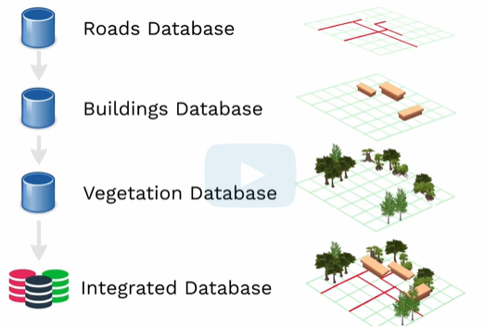
Fig: GIS platform
and understand both how the layers relate to each other and how each of them exists in a separate space .

'GIS is about uncovering meaning and insights from within data.'It is a powerful technology built using the principles of spatial analysis for understanding our changing world, and for solving complex real-world problems.

GIS data types
There are two types of GIS data: Vector and Raster data.
a Geographic Information System (GIS) is a way to digitally represent the real world. To do this effectively, spatial data is organized into different data types and models, each suited for different kinds of information.
The two fundamental types of GIS data are Vector and Raster. Think of it as the difference between using a pen (vector) and a paintbrush (raster) to draw a map.
Vector data represents geographic features as discrete geometric shapes: points, lines, and polygons. Each feature is defined by its coordinates and has attributes (descriptive information) stored in a table. Vector representation could be of three different types: points, line and polygon.
Point data can be used to represent city, building location. A single X, Y coordinate pair. Has no length or area at a given scale.
Line data can be used to represent roads and rivers, a sequence of connected points. Has length but no area.
Polygon data can be used to represent land cover. A closed shape of connected lines. Has both length and area

In this figure there is an example of the real world.
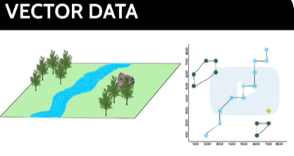.
If we have river, house and cluster of trees in a scene, we can represent this in vector form
by representing house as point feature, river as line feature, trees as polygon features.

Raster dataset (image data)
Raster data represents the world as a continuous surface divided into a grid of cells (or pixels). Each cell has a value that represents information, such as color, elevation, or temperature.
Image is a grid of cells that are commonly called pixels.
Source Examples:
1.Sattelite: - Landsat, Sentinel-2, SPOT, WorldView.
2.Aerial Photography (Airplanes, Drones)
This is actually the historical origin of most raster base maps. Cameras mounted on airplanes or drones take photographs. These photographs are then orthorectified (corrected for topographic relief and camera tilt) and stitched together to form a seamless raster image. Examples: Traditional aerial surveys, drone mapping projects.
Good for: Very high resolution (you can see small details), project-specific data collection (e.g., a construction site
3. Radar and Sonar
These systems actively emit energy (radio waves or sound waves) and measure the return signal to create a raster grid.
Radar (Radio Detection and Ranging): Often satellite or aircraft-based. Can penetrate clouds. Used to create elevation models (e.g., SRTM mission) and measure surface texture.
Sonar (Sound Navigation and Ranging): Used underwater. A ship-mounted sonar system pings the seafloor and measures the return time to create a raster bathymetric map (underwater elevation).
4. Scanned Maps
A very common source. Existing paper maps are scanned by large format scanners. The resulting image is a raster (often a simple JPEG or TIFF). To make it spatially useful, it must be georeferenced—a process of assigning real-world coordinates to the pixels.Good for: Historical data, preserving old maps, digitizing unique collections.
5. Digital Elevation Models (DEMs) from Various Sources
A DEM is a classic raster where each pixel's value is elevation, not a color. These can be created from:
- Satellite Radar: (e.g., SRTM)
- Aerial LiDAR: A laser scanner on an airplane measures distances to the ground, creating a massive "point cloud" that is then converted into a raster DEM.
- Ground Surveying: Surveyors can take elevation points and interpolate them into a raster grid.
6. Thematic Output from Analysis
Often, the raster you use is the result of a GIS analysis. For example:

A landscape here with different elements on ground.

Satellite capture | DN number | Corresponding Color
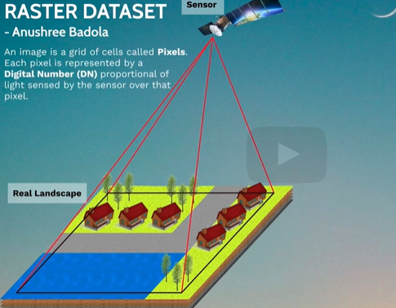 | 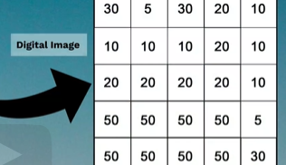 | 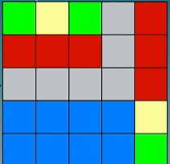

When a satellite captures this area, it divides the landscape into a grid and records the observation of each cell known as a pixel. Each pixel is represented by a digital number (DN) as shown here. These Digital numbers are representative of the energy sensed by the sensor.
In an image we see these DN numbers portrayed as colors as shown here.
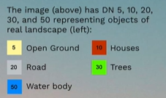

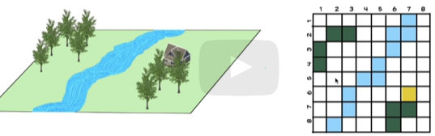
The figure on the right-hand side is the raster representation of the real world. Here Grids represents the pixel. We can see for a single class all the grids are of same color that means all the pixel will have the similar values for same class. Therefore, for river all the grids are blue.

Raster Data
Raster data has a matrix of cells where each cell contains a value representing information. Each cell center, or cell lower left corner, has geographic coordinates associated with it. We can perform
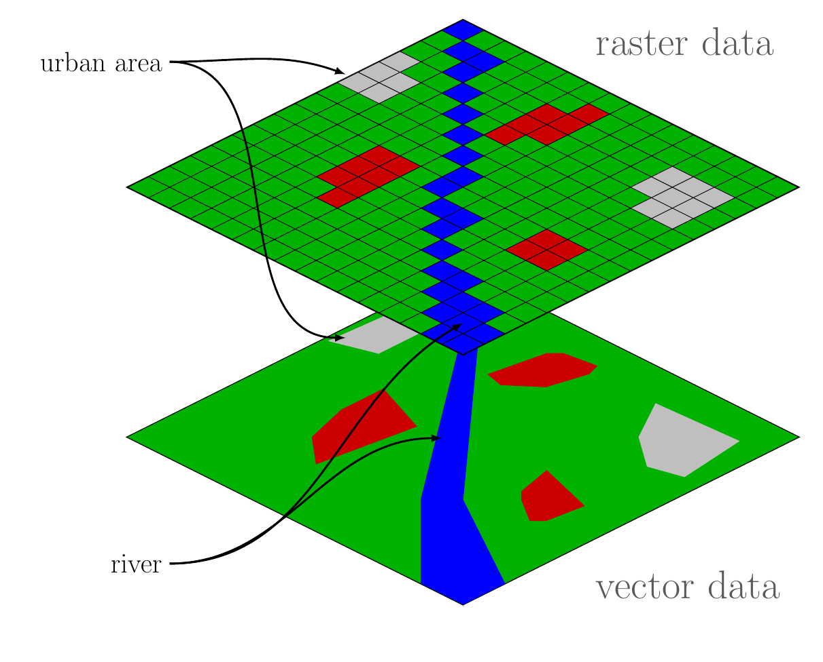
advanced spatial and statistical analysis using raster data. Raster format is used to represent continuous data. It is also used to represent temperature, elevation of regions, precipitation maps, soil condition, etc.
Vector Data
Vector data represents data using sequential points or vertices in the form of points, lines, or polygons. Each point or vertex has a geographic coordinate associated with it. The data performs spatial query, adjacency area and shape analysis. Vector format is used to represent discrete data objects like trees, roads, fire hydrants, buildings, etc.
File Data Types
Multiple data types are used while working with GIS. Below is a list of common data types and some information on how they are used.
Geodatabase (.gdb)
a geodatabase structure in ArcGIS
- 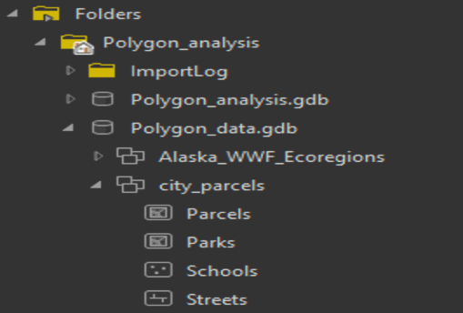
A collection of geographic datasets of various types held in a common file system folder. this can store both spatial data (feature classes) and non-spatial data (tables)
- primary data format used for editing and data management
- The figure adjacent or following is an example of a geodatabase structure in ArcGIS. The next few bullets refer to this figure.
- Polygon_analysis.gdb and Polygon_data.gdb are two file geodatabases
- Alaska_WWF_Ecoregions and city_parcels are two feature datasets inside the Polygon_data.gdb
- Parcels and Parks are polygon feature classes stored inside the city_parcels feature dataset
- Schools is a point feature class stored inside the city_parcels feature dataset
- Streets is a line feature class

Shapefile (.shp)
- stores the feature geometry and attribute information
- geographic features are represented by points, lines or polygons
- maximum size limit of 2 GB
- composed of the following mandatory files:
- Index file (.shx)
- dBASE File (.dbf)
- Projection file (.prj)
- composed of the following optional files:
- Extensible Markup Language File (.xml)
- Code Page File (.cpg)
- Spatial Index File (.sbn)

GeoTIFF (.tif)
- the most common raster data file type
- suitable for storage, transfer, display and printing of raster images
- supports black-and-white, grayscale, pseudocolor, and true color images

Geographic Coordinate System (GCS)
how to locate a point using latitudes-longitudes and the shape of the Earth.

Shape
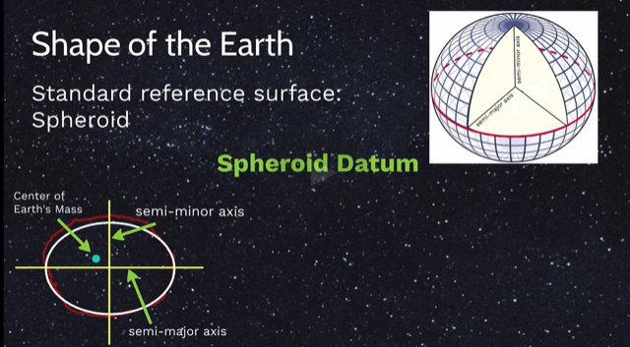
Spheroid datum
WGS84
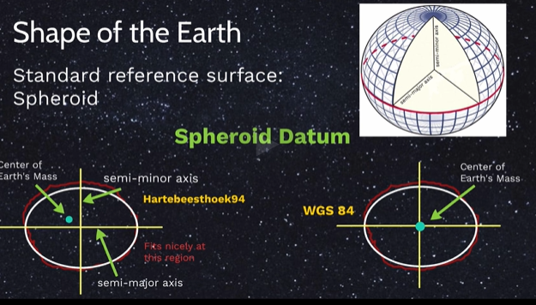

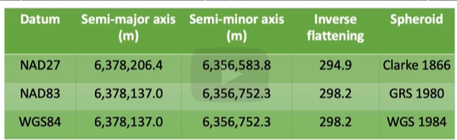
a three-dimensional spherical surface to define locations on the earth. In GCS, a point is located using longitude and latitude values. A datum provides a frame of reference for mapping locations
on the surface of the earth and the choice of datum depends on the location of interest.
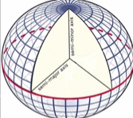

UTM
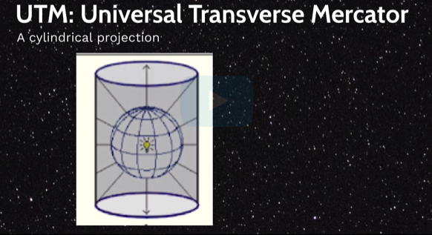
Universal Transverse Mercator, also known as UTM,is an example of a cylindrical projection.
Cylindrical projection is created by wrapping a cylinder around the globe and projecting the globe surface on the inside surface of the cylinder.

The Core Idea: Flattening the Earth Accurately
A UTM Zone is one of 60 numbered sections of the Earth's surface, each with its own dedicated map projection designed to minimize distortion for that specific region.
The Earth is a 3D sphere, but maps and digital screens are 2D. Flattening the globe inevitably causes distortion of shape, area, distance, or direction. The Universal Transverse Mercator (UTM) system solves this by slicing the Earth into 60 narrow, vertical zones (like segments of an orange). Each zone is narrow enough (only 6° of longitude wide) that the distortion introduced by its specific projection is minimal and can be corrected for, making it excellent for accurate measurements.

