Data Visualization Homework

author: Prommin Vutivivatchai

date: 2023-07-20

### This homework contains

* ggplot2
  + histogram
  + bar
  + scatter
  + facet
* ggpubr (additional)

#### 0. Load Library

library(tidyverse) # ggplot2 included  
library(ggpubr) # use for combine multiple of ggplot graphs

#### 1. Price Histrogram

ggplot(diamonds, aes(price)) +  
 geom_histogram(bins=30, fill="darkgreen") +  
 labs(title="Price Distribution", y="frequency")+  
 theme_minimal() + # remove background color  
 theme(plot.title=element_text(hjust=0.5)) # align title to center

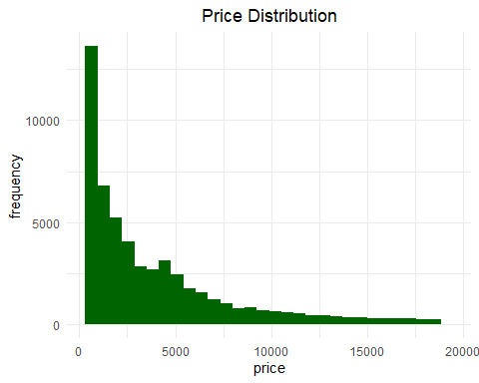

* As shown, we found a positively skewed distribution in the price data.

#### 2. Carat Histogram

ggplot(diamonds, aes(carat)) +  
 geom_histogram(bins=30, fill="salmon") +  
 labs(title="Carat Distribution", y="frequency")+  
 theme_minimal() +  
 theme(plot.title=element_text(hjust=0.5)) # align title to center

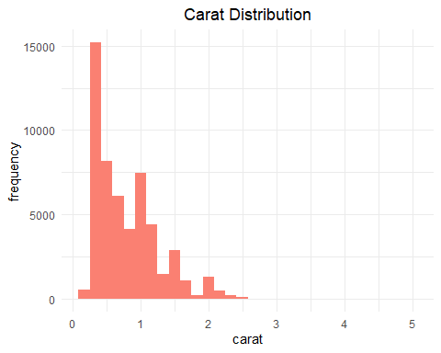

* As shown, we found a positively skewed distribution in the carat data.

#### 3. (Stacked) Bar Chart : Color/Cutting of Diamonds

ggplot(diamonds, aes(color, fill=cut)) +  
 geom_bar() +  
 labs(title="Type of cuts and colors of diamond", y="frequency") +  
 theme_minimal() +  
 theme(plot.title=element_text(hjust=0.5))

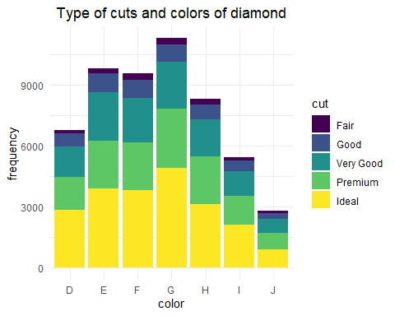

* We found that the top rank of cutting is ideal cutting regardless of colors.
* Very-Good and Good cutting are quite the same proportion regardless of colors.
* G-color diamonds have the highest frequency, and J-color diamonds have the lowest frequency.

#### 4. Scatter Plot: Relationship between Length (x) and Price

ggplot(diamonds %>% sample_frac(0.5), aes(x, price)) +  
 geom_point(alpha=0.4) +  
 geom_smooth(color="green") +  
 labs(title = "Length (x) vs. Price", x = "length x [mm]", y = "price [$]") +  
 theme_minimal() +  
 theme(plot.title=element_text(hjust=0.5))

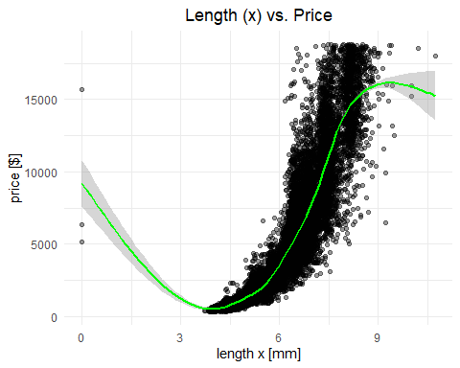

* Informally, we found outliers however we can deal with it.

##### 4.1 Box Plot (Explore Outliers located out of +- 1.5*IQR)

ggplot(diamonds %>% sample_frac(0.5), aes(x)) +  
 geom_boxplot(outlier.color="red") +  
 xlab("x length [mm]") +  
 theme_minimal()

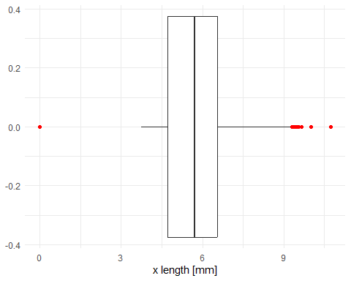

* Outliers located at x = 0 and x > 9 (approximately)
* There are methods to identify outlier values correctly but we don’t mention here.
* We will filter out. See below

ggplot(diamonds %>% sample_frac(0.5) %>% filter(x > 0 & x < 9) ## this line  
 , aes(x, price)) +  
 geom_point(alpha=0.4) +  
 geom_smooth(color="green") +  
 labs(title = "Length (x) vs. Price", x = "length x [mm]", y = "price [$]") +  
 theme_minimal() +  
 theme(plot.title=element_text(hjust=0.5))

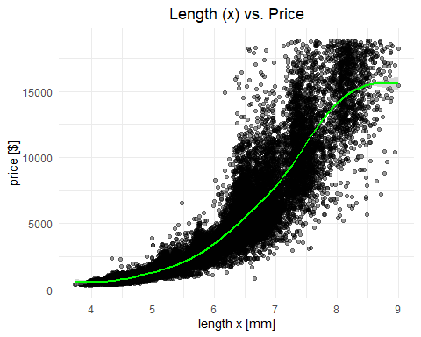

* It works! But a theoretical investigation is needed.

### 5. Length vs. Price + by Colors (using facet_wrap)

ggplot(diamonds %>% sample_n(5000), aes(x, price)) +   
 geom_point() +  
 facet_wrap(~color, ncol=4) +  
 labs(title="Length vs. Price by Color", x="length x [mm]", y="price [$]") +  
 geom_smooth(color="lightgreen") +  
 theme_minimal() +  
 theme(plot.title=element_text(hjust=0.5))

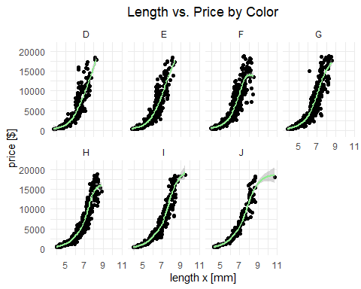

### 6. Relationship between Price and Dimensions (x,y,z) / showing color data into each point.

* Create each graph (length x to price, width y to price, depth z to price) as below.

## create each graphs   
  
# x-price   
g1 <- ggplot(diamonds %>% filter(x>2.5) %>% sample_frac(0.5), aes(x, price)) +  
 geom_point(aes(color = color), alpha=0.6) +  
 theme_minimal() +  
 geom_smooth(color="red") +  
 xlab("length x [mm]") +  
 ylab("price [$]")  
  
# y-price  
g2 <- ggplot(diamonds %>% filter(y>2 & y<11) %>% sample_frac(0.5), aes(y, price)) +  
 geom_point(aes(color = color), alpha=0.6) +  
 theme_minimal() +  
 geom_smooth(color="green") +  
 xlab("width y [mm]") +  
 ylab("price [$]")  
  
# z-price  
g3<- ggplot(diamonds %>% filter(z>2 & z<9) %>% sample_frac(0.5), aes(z, price)) +  
 geom_point(aes(color = color), alpha=0.6) +  
 theme_minimal() +  
 geom_smooth(color="blue") +  
 xlab("depth z [mm]") +  
 ylab("price [$]")

* Let’s combine them by ‘ggpubr’ library.

library(ggpubr)  
  
combine <- ggarrange(g1,  
 g2,  
 g3,  
 nrow = 3,  
 common.legend=TRUE, # share color legend between 3 graphs  
 legend="right")  
  
combine <- annotate_figure(combine, top=text_grob("Price vs. Dimensions (mm)",  
 face = "bold", size = 14))  
  
combine

