
AI Face Lock (IoT-based)

Course Name: Microprocessor

Course code: EEC214

Name | ID
Ahmed Bushra Ahmed | 20243166
Islam Elsayed Ghonmey | 20210536
Abdelrahman Ehab Issa | 20200580
Mohamed Tharwat Mohamed | 20160772

Abstract

This report presents the design and implementation of a smart door lock system based on an ESP32 microcontroller that utilizes a mobile application for AI-driven face authentication. The system aims to automate access control by leveraging the smartphone's camera and processing power to recognize faces, significantly enhancing security while minimizing manual key intervention. The mobile app captures and processes visual data; when an authorized face is identified, a secure signal is sent to the ESP32. The microcontroller then activates a relay module to trigger a solenoid door lock. This architecture provides a cost-effective and scalable solution for modern smart home security by combining high-performance mobile AI with reliable IoT hardware.

Acknowledgement

First and foremost, I would like to express my deepest gratitude to my parents for their endless love, continuous support, and encouragement throughout my academic journey. Their motivation has always been my greatest strength.

I would also like to sincerely thank Dr. Mohamed Torad for his valuable guidance, support, and supervision during the completion of this project. His advice and feedback were essential in improving the quality of this work.

Introduction
The demand for efficient security and access management has increased due to the vulnerabilities of traditional manual locking systems. This project presents an AI Face Authentication Door Lock system that integrates smartphone technology with an ESP32 microcontroller. By using the phone's camera and a dedicated application, the system performs sophisticated facial recognition to verify identity. Unlike local camera modules, this approach utilizes the superior processing speed of a smartphone to ensure fast and accurate authentication. The primary goal is to develop a reliable, low-cost solution that improves security and reduces reliance on physical keys through automation and IoT connectivity.

Components and Tools

Components | Description
ESP32 | Main microcontroller used to control the system and read sensor data
Relay Module | Acts as a switch to control the water pump
BC107 Transistor | Used as a switching component to drive or control circuits
Breadboard | Used for assembling and testing the circuit
Jumper Wires | Used for connecting the electronic components
WiFi Module (Built-in ESP32) | Enables internet connectivity for remote control

Software Used

Arduino IDE
Arduino IDE is the main programming environment used to write, compile, and upload the code to the ESP32. It allows easy development using C/C++ language and provides a Serial Monitor to display sensor readings and debug the system during testing.

Mobile App (AI Recognition Engine):

The heart of the system, which uses the phone's hardware to run facial recognition models and send "Unlock" commands via WiFi

Methodology
The system is built around the communication between a mobile application and the ESP32 microcontroller. The process begins when the user opens the app and points the phone camera at their face. The application runs an AI model to detect and match the face against a secure database. Upon successful authentication, the app sends an encrypted command to the ESP32 via a built-in web server or Bluetooth Low Energy (BLE). The ESP32 receives the command, verifies it, and activates the relay for five seconds to pull the solenoid lock and open the door. The system also logs access events in its non-volatile memory to ensure data is preserved during power losses.

Hardware Implementation
The figure below shows the hardware implementation of The hardware consists of the ESP32 connected to a relay module, which in turn controls the power supply to the solenoid door lock. This setup is assembled on a breadboard for testing, ensuring that the ESP32 can reliably trigger the lock upon receiving a wireless signal.
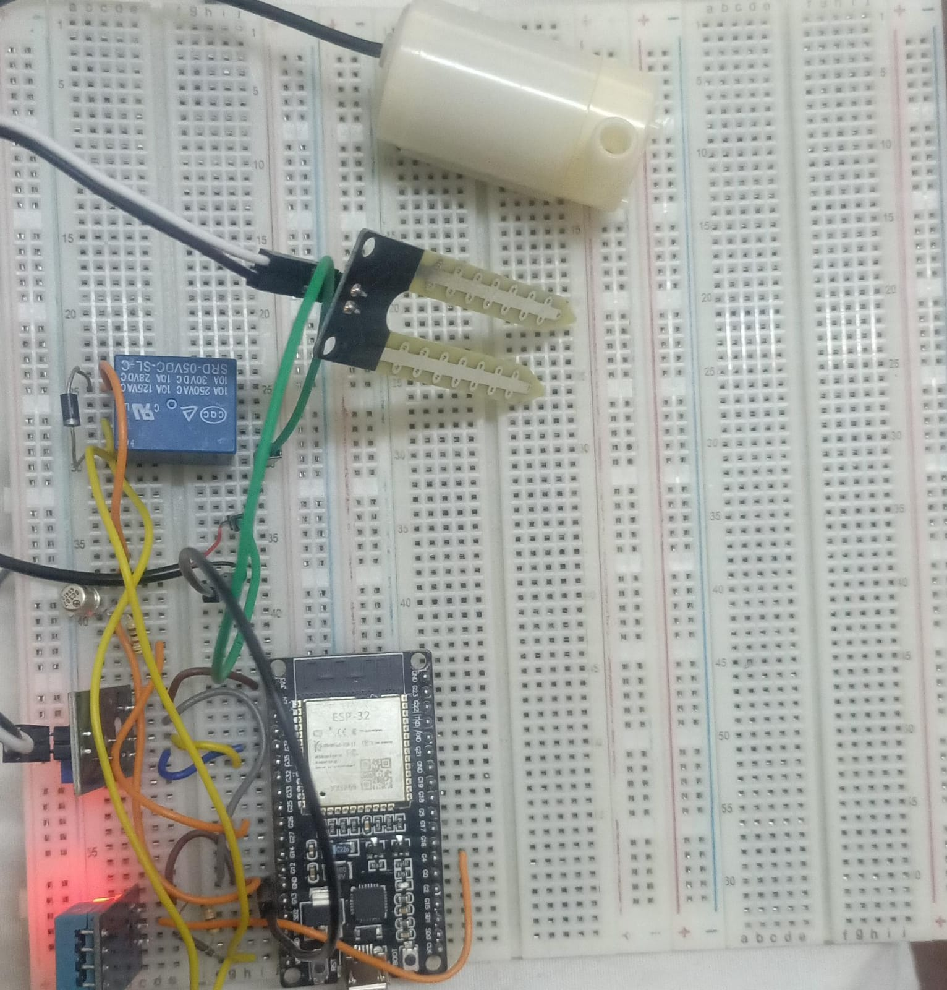
figure : 1 Hardware picture

Mobile Application Interface
The figures below show the mobile application interface used to monitor data and control the Face lock system remotely via WiFi
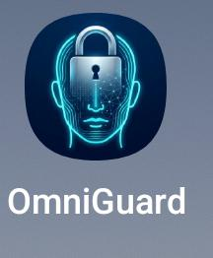
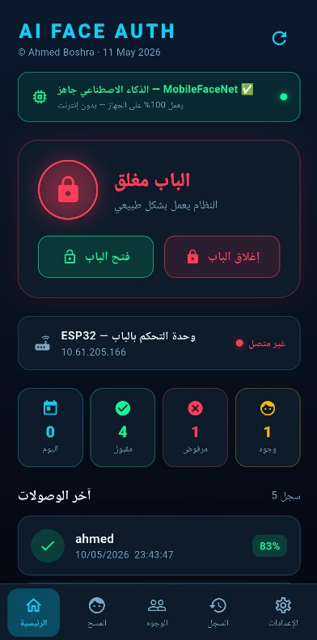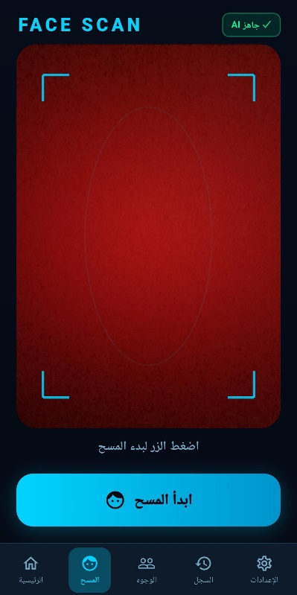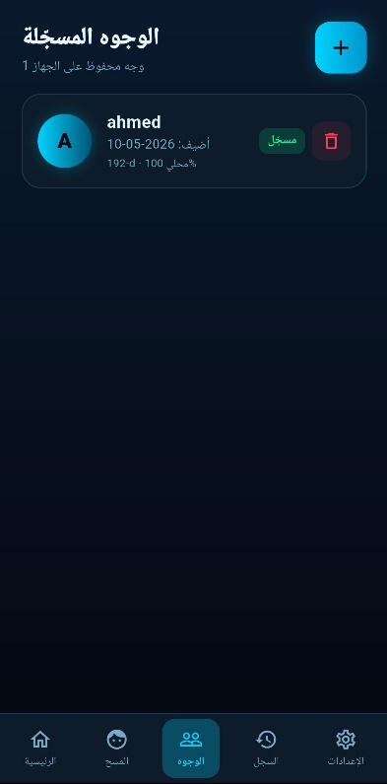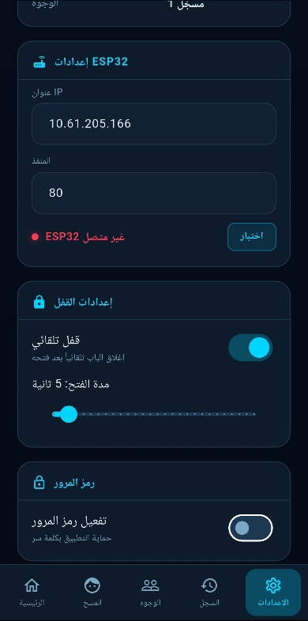
figure 2 : mobile App

Results

Testing demonstrated that the system operates with high reliability. The mobile app provided rapid face recognition, and the ESP32 responded instantly to unlock commands. The use of the smartphone camera significantly improved recognition accuracy compared to standard low-cost camera modules. The BLE and WiFi interfaces remained stable, allowing for seamless remote operation. Overall, the project successfully created a secure, keyless entry system that leverages existing consumer hardware for high-end security features.

System Implementation Code

#include <WiFi.h>

#include <WebServer.h>

const char* ssid = "OPPO Reno3";

const char* password = "12345678";

const int LOCK_PIN = 23;

const int BUZZER_PIN = 19;

WebServer server(80);

void handleUnlock() {

digitalWrite(LOCK_PIN, HIGH);

tone(BUZZER_PIN, 1000, 500);

server.send(200, "application/json", "{\"status\":\"success\"}");

delay(3000);

digitalWrite(LOCK_PIN, LOW);

}

void setup() {

Serial.begin(115200);

pinMode(LOCK_PIN, OUTPUT);

pinMode(BUZZER_PIN, OUTPUT);

digitalWrite(LOCK_PIN, LOW);

WiFi.begin(ssid, password);

Serial.print("Connecting to WiFi");

while (WiFi.status() != WL_CONNECTED) {

delay(500);

Serial.print(".");

}

Serial.println("");

Serial.println("WiFi Connected!");

Serial.print("IP Address: ");

Serial.println(WiFi.localIP());

server.on("/unlock", HTTP_POST, handleUnlock);

server.on("/status", HTTP_GET, []() {

server.send(200, "application/json", "{\"status\":\"online\"}");

});

server.begin();

}

void loop() {

server.handleClient();

}

Conclusion
The AI Face Auth Door Lock system effectively combines mobile AI processing with IoT hardware to create a secure access solution. By delegating facial recognition to a smartphone app, the system achieves higher performance and better accuracy than standalone microcontroller solutions. The ESP32 serves as a reliable bridge, executing physical actions based on authenticated mobile commands. This project demonstrates that smart security can be both highly advanced and cost-effective through the strategic integration of existing mobile technology.

References
• Espressif Systems. ESP32 Technical Reference Manual.
• Arduino IDE Documentation.
• Espressif Systems. ESP32 WiFi & BLE Programming Guide.
• Google ML Kit / TensorFlow Lite for Mobile Facial Recognition documentation.

