A PYTHON PROJECT

ON

***PANDAS AND SQLITE***

COMPLETED BY TEAM TORNADO

GUIDE: MR. SHOBHIT NIGAM

**Submitted By:**

Dolly Bagaria

Devvrat Vaidya

Ishant Tiwari

Pramodh Narayan L

# TECHNOLOGIES USED

The project uses **Python 3** as the coding platform and uses two libraries i.e.,

1. **Pandas -**  an open source, BSD-licensed library providing high-performance, easy-to-use data structures and data analysis tools for the Python programming
2. **SQLite 3 -**  SQLite is a C-language library that implements a [small](https://www.sqlite.org/footprint.html), [fast](https://www.sqlite.org/fasterthanfs.html), [self-contained](https://www.sqlite.org/selfcontained.html), [high-reliability](https://www.sqlite.org/hirely.html), [full-featured](https://www.sqlite.org/fullsql.html), SQL database engine

## **SOURCE CODE**

**IMPLEMENTATION USING PANDAS AND SQLITE3**

1. **Import**

Importing essential libraries pandas and sqlite3

1. **Opening a file to store the final result set**



1. **Creating a connection between python and the database**



1. **Fetching all the required data from the tables in database**

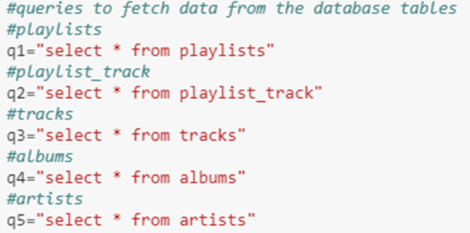

1. **Storing the fetched data in data frames**

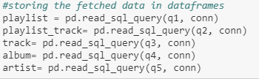

1. ** Declaring the required data structures**

1. **Creating a function named insert_dict() to populate a dictionary with keys as column names and values as a list of table names to which the columns belong to**

## 

1. **Creating a list of column names for each table**

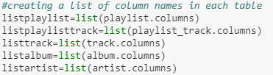

1. 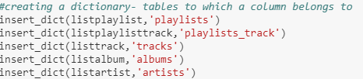**Calling the helper function for each table**
2. **Finding the required table to fetch PlaylistId**
3. 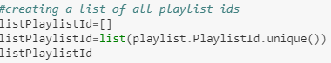**Creating a list of all playlists ids**
4. **Creating a function named list_track_id() to fetch track ids for corresponding playlist ids**

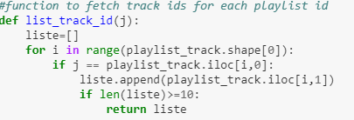

1. 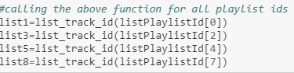**Calling the helper function for four playlist ids**

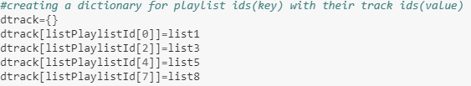

**m) Creating a dictionary with keys as playlist ids and values as track ids**

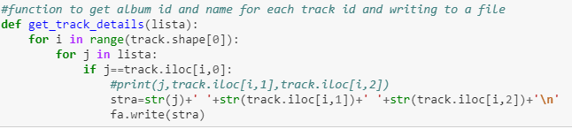 **n) Creating a function named get_track_details() to write to a file the required data**

**o) Calling the helper function for track ids**

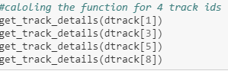

**p) Closing the file**



**SAMPLE OUTPUT**

# 

.