BAGH_SIR — The Mathematics, With Worked Examples and Pictures
Every equation in the tool, shown step by step with real numbers and diagrams.
Promod Bagh · Independent researcher · Raghunathpur, India

1. Method A — Volume from signed tetrahedra
A shape model is a mesh: a list of corner points (vertices) joined into triangles (faces). Take any one triangular face with corners v0, v1, v2. Together with the origin O, it forms a tetrahedron (a 4-cornered pyramid). Its volume is:
V(tetra) = (1/6) · | v0 · (v1 × v2) |
where × is the cross product and · is the dot product. Sum this signed value over every face of a closed mesh, and the parts outside the shape cancel out exactly, leaving the true enclosed volume:
V(total) = (1/6) · | Σ v0 · (v1 × v2) | (sum over all faces)
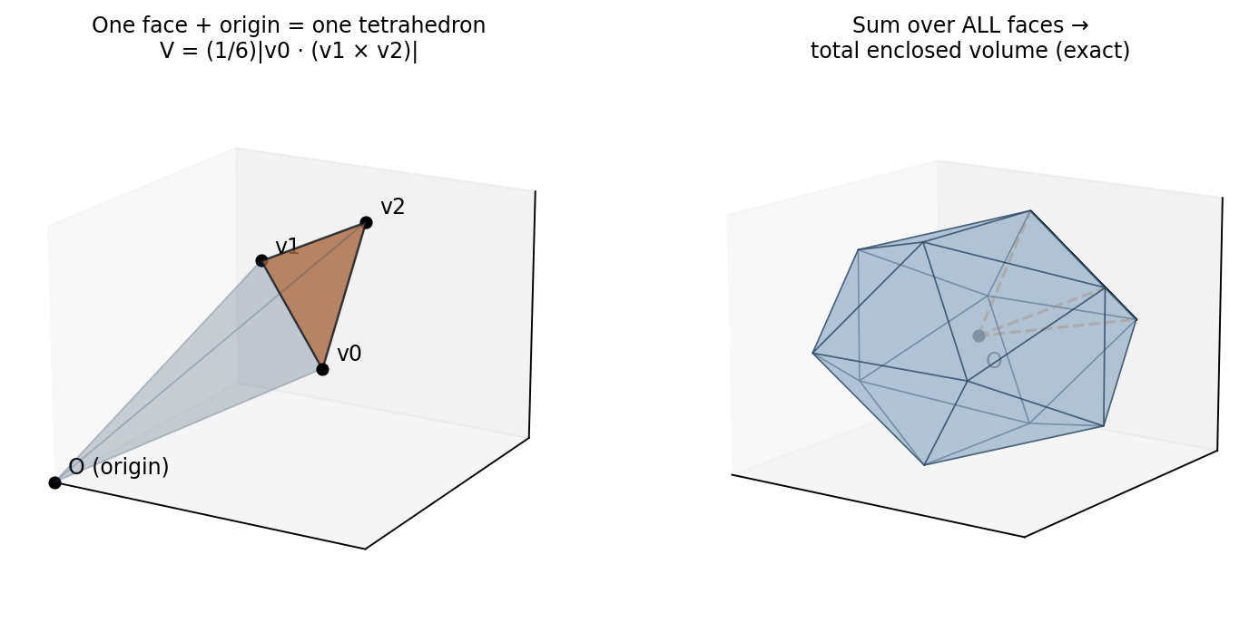
Figure 1 — Left: one face plus the origin makes one tetrahedron. Right: summing over every face of the mesh gives the exact total volume.

Cross and dot product — the two ingredients
For vectors a = (a₁, a₂, a₃) and b = (b₁, b₂, b₃):
a × b = ( a₂b₃ − a₃b₂, a₃b₁ − a₁b₃, a₁b₂ − a₂b₁ )
a · b = a₁b₁ + a₂b₂ + a₃b₃

Worked example — one face of a unit cube
Take the highlighted face of the unit cube (side 1, true volume exactly 1):
v0 = (1, 0, 0) v1 = (1, 0, 1) v2 = (1, 1, 1)

Step 1 v1 × v2 = (0·1 − 1·1, 1·1 − 1·1, 1·1 − 0·1)
= (−1, 0, 1)
Step 2 v0 · (−1, 0, 1) = 1·(−1) + 0·0 + 0·1 = −1
Step 3 tetra volume = |−1| / 6 = 1/6
Doing the same for all 12 triangles of the cube and summing the signed values gives 6/6 = 1 — the exact cube volume. This is the self-test built into the tool.
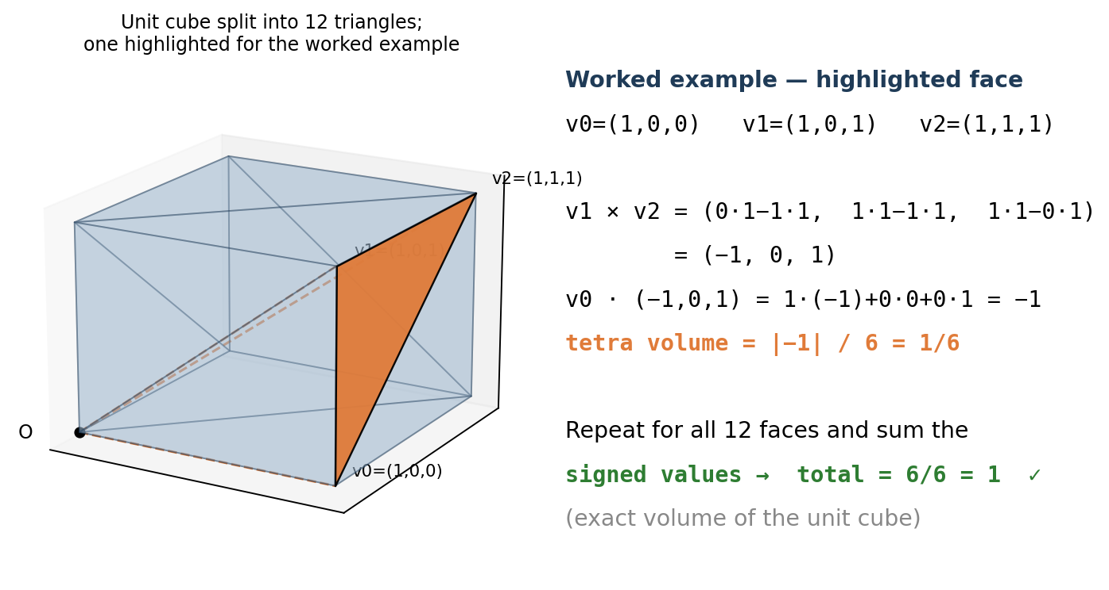
Figure 2 — The worked cube example: one highlighted triangle contributes 1/6; all twelve together give exactly 1.

2. Method B — Volume from prisms (the cross-check)
The same volume can be computed a completely different-looking way. Project each face down onto the x-y plane to get its signed footprint area A, and note the face's mean depth z̄ (average of the three corners' z values):
A = ½ [ (x₁−x₀)(y₂−y₀) − (x₂−x₀)(y₁−y₀) ]
z̄ = (z₀ + z₁ + z₂) / 3
V(total) = | Σ A(face) · z̄(face) |
Each face contributes a prism of base A and height z̄; the signed sum over a closed mesh again cancels perfectly to the enclosed volume.
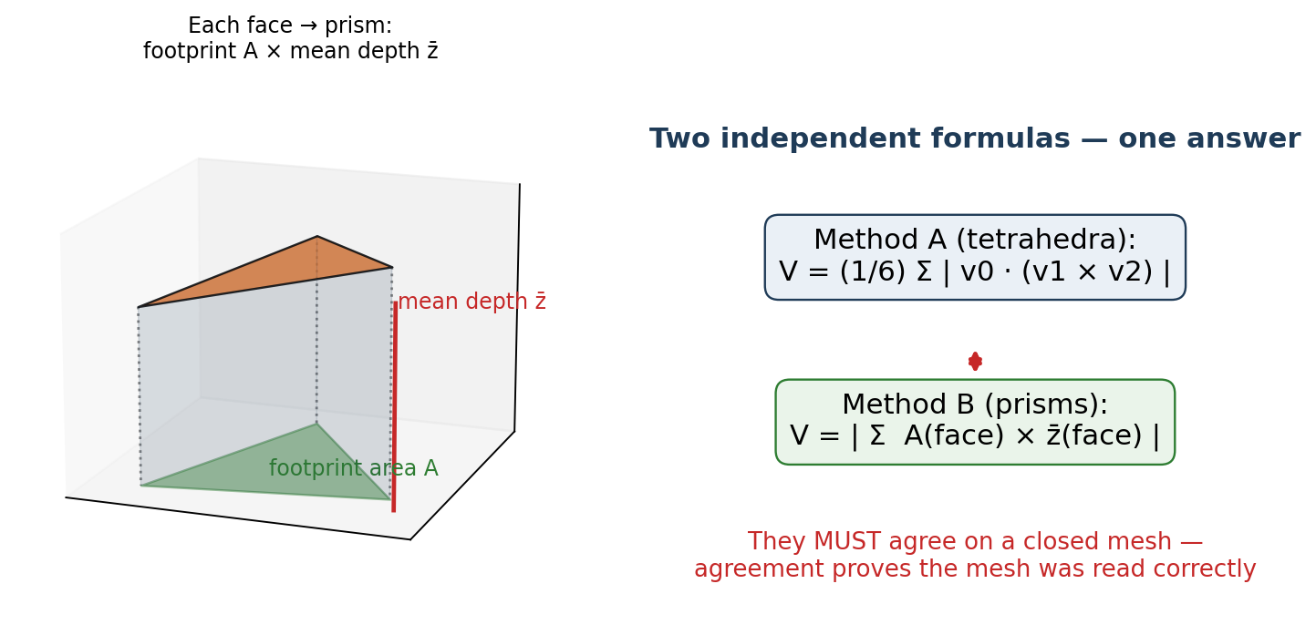
Figure 3 — Left: one face projected to its footprint, forming a prism. Right: the two formulas are independent routes to the same number.

Worked example — same cube face
v0=(1,0,0) v1=(1,0,1) v2=(1,1,1)
A = ½[(1−1)(1−0) − (1−1)(0−0)] = ½[0 − 0] = 0
z̄ = (0+1+1)/3 = 2/3 contribution = 0 × 2/3 = 0
This vertical side face contributes zero (its footprint has no area) — correct, because all the cube's volume is delivered by the top and bottom faces in this method. Summed over all 12 faces, Method B also gives exactly 1. On every asteroid tested, Methods A and B agree to machine precision, which proves the mesh was read and oriented correctly.

3. Equivalent diameter and scaling to true size
The volume-equivalent diameter is the diameter of the sphere that has the same volume as the shape:
D(eq) = ( 6V / π )^(1/3)

Worked example
V = 853,745 model-units³ (Klymene mesh)
D(eq) = (6 × 853745 / 3.14159)^(1/3) = (1,630,690)^(1/3) ≈ 117.7
DAMIT models have correct form but arbitrary size, so the mesh is scaled until D(eq) equals the measured diameter. Because volume grows with the cube of size:
scale factor s = D(known) / D(model) V(scaled) = s³ · V(model)

Worked example — Lydia
model D(eq) = 95.5 known D = 78.5 km
s = 78.5 / 95.5 = 0.822 s³ = 0.555
V(scaled) = 0.555 × V(model) → D(eq) = 78.5 km ✓

4. Bulk density
With mass M in kilograms and volume V in cubic kilometres:
ρ = M / ( V × 10¹² ) → grams per cubic centimetre
(The 10¹² converts km³ to the right unit combination: 1 km³ = 10¹⁵ cm³ and 1 kg = 10³ g, so kg/km³ ÷ 10¹² = g/cm³.)

Worked example — Bennu (real mission numbers)
M = 7.329 × 10¹⁰ kg V = 0.0616 km³ (from the OSIRIS-REx mesh)
ρ = 7.329×10¹⁰ / (0.0616 × 10¹²)
= 7.329×10¹⁰ / 6.16×10¹⁰ = 1.190 g/cm³ ✓ (published: 1.190)
This match is meaningful because the Bennu mesh is in true kilometres — no size fitting was involved. The density came purely from the geometry and the measured mass.

5. Macroporosity — how hollow is the inside?
Grain density ρ(grain) is the density of the solid rock itself, known from meteorites of the same type. If the bulk density is lower, the difference must be empty space:
P = 1 − ρ(bulk) / ρ(grain)

Worked example — Bennu
ρ(bulk) = 1.190 ρ(grain) ≈ 2.4 (carbonaceous / CM meteorite)
P = 1 − 1.190/2.4 = 1 − 0.496 = 0.504 → ≈ 50% empty space
Half of Bennu's interior is void — it is a rubble pile of loosely packed boulders, exactly what OSIRIS-REx found when it touched the surface.
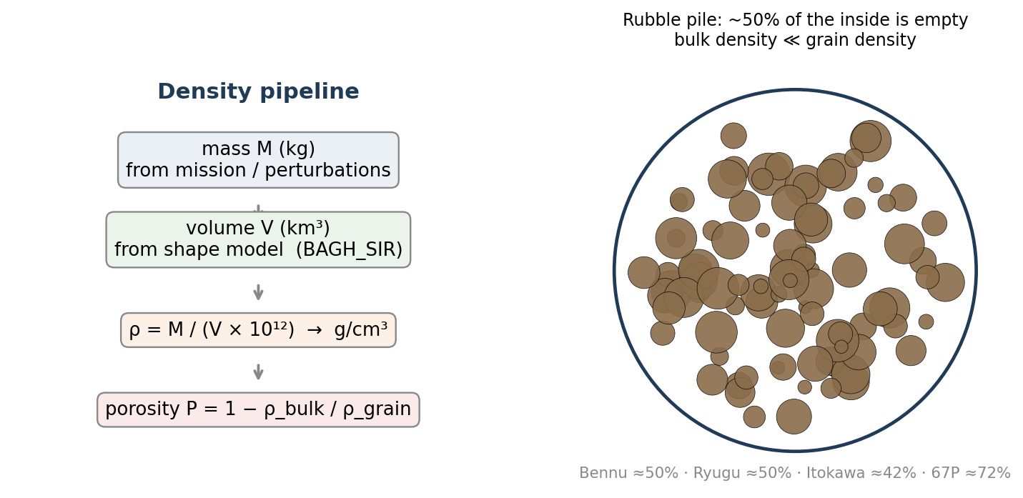
Figure 4 — Left: the full pipeline from mass and shape to density and porosity. Right: what ~50% porosity physically means.

6. Shape uncertainty — why the real mesh matters
For the same body, compute four volumes: a sphere fitted to the bounding box, a best-fit ellipsoid, the convex hull, and the real mesh. The spread measures how badly a round-shape assumption would do:
U = ( V(max) − V(min) ) / V(mesh) × 100%

Worked example — Thetis
V(sphere)=456,300 V(ellipsoid)=477,900 V(hull)=367,878 V(mesh)=367,878
U = (477,900 − 367,878) / 367,878 × 100 = 29.9%
A round-shape assumption would overestimate Thetis's volume by up to 30% — and therefore underestimate its density by the same factor. For the most irregular bodies the error reaches 56% (comet 67P).
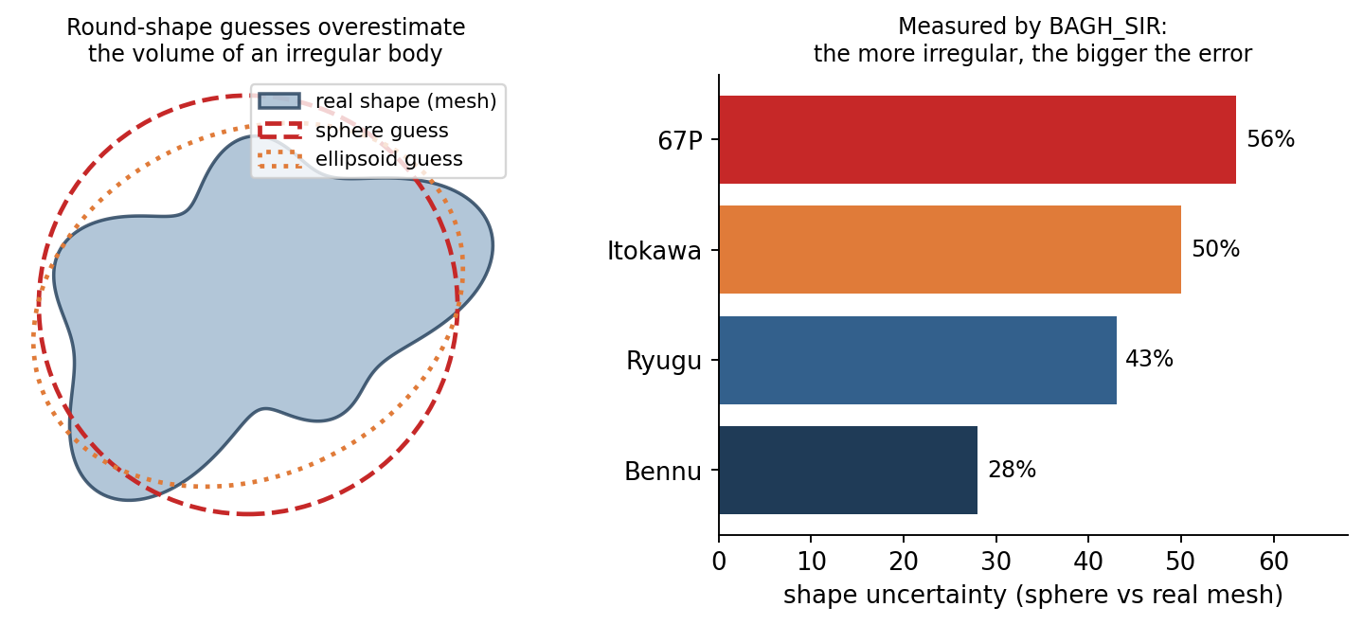
Figure 5 — Left: sphere and ellipsoid guesses drawn over a real irregular outline. Right: measured shape uncertainty for the four mission targets.

7. The plausibility test — the audit inequality
Porosity can only remove material, never add it. Therefore, for every real object:
ρ(bulk) ≤ ρ(grain) — always, with no exceptions
Any catalogue entry that violates this inequality is physically impossible and must contain a measurement error. For carbonaceous (C, P class) asteroids, ρ(grain) ≈ 2.2–2.9 g/cm³.

Worked example — (206) Hersilia
published ρ = 6.08 g/cm³ class = C → ρ(grain) ≈ 2.9 max
6.08 > 2.9 → IMPOSSIBLE as published
diameter is well measured → the MASS must be too high
required correction: mass ÷ ~3.9 → ρ ≈ 1.3–1.7 (normal C-type)
The same test flags Chloris, Circe and Miriam. Each flag becomes a falsifiable prediction: a future mass redetermination (e.g. from Gaia astrometry) should land in the predicted green range below.
Note on prior work: this inequality test is the standard framework of the field (Britt et al. 2002; Carry 2012), and the Circe mass overestimate (~2×) was already identified by Hanuš et al. (2013) — in agreement with this audit's independent result. The audit's contribution is the systematic, reproducible application to the current SiMDA catalogue with explicit predicted ranges.
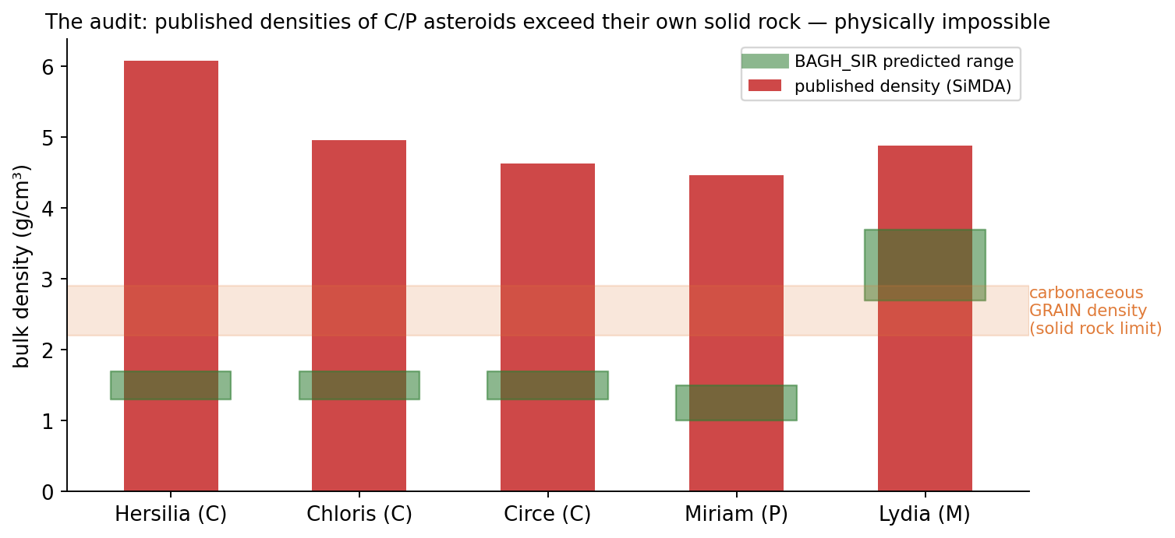
Figure 6 — Published densities (red bars) versus the solid-rock ceiling (orange band) and the BAGH_SIR predicted ranges (green). The red bars physically cannot be correct.

8. All equations on one page
Quantity | Formula | Units
Tetra volume (Method A) | V = (1/6)|Σ v0 · (v1 × v2)| | model units³
Prism volume (Method B) | V = |Σ A(face) · z̄(face)| | model units³
Equivalent diameter | D = (6V/π)^(1/3) | km
Scale to known size | s = D(known)/D(model); V → s³V | —
Bulk density | ρ = M / (V × 10¹²) | g/cm³
Macroporosity | P = 1 − ρ(bulk)/ρ(grain) | fraction
Shape uncertainty | U = (Vmax − Vmin)/V(mesh) × 100 | %
Plausibility test | ρ(bulk) ≤ ρ(grain) must hold | —

Every formula above is standard mathematics (vector algebra and the divergence theorem). The tool's contribution is applying them carefully to real shape models, verifying every result two independent ways, and using the plausibility inequality to audit the catalogue.

