Assignment1
22124187_Zhang Linyihan

Question1
A large-scale Chinese application, such as Wechat and Alipay, can be understood as a microservices-based distribution system. The platform splits the system into many small services. Each service focuses on one business capability, such as login, payment, search and so on. This design improves scalability, fault isolation of the application.
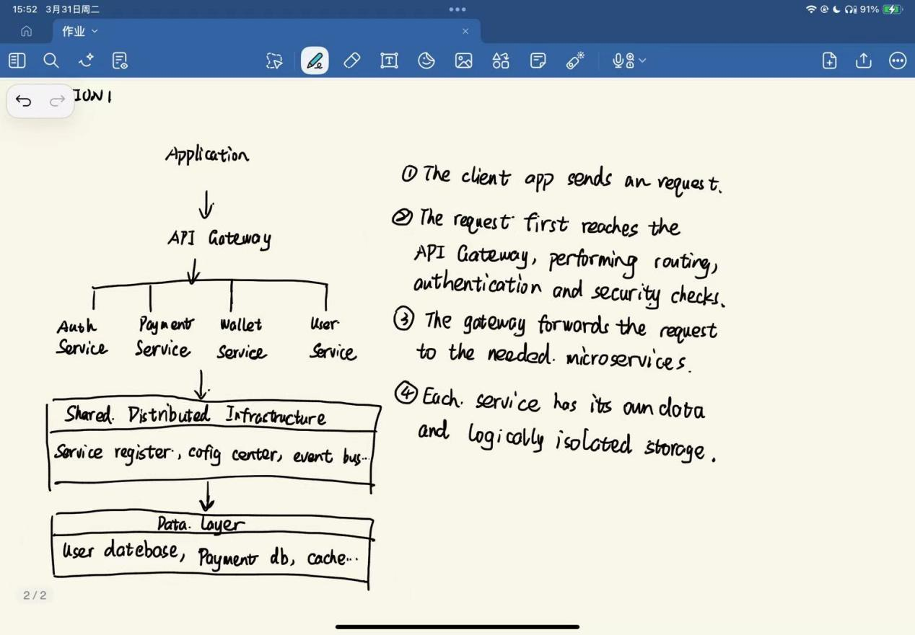

Question2
- Application layer
At the application layer, my browser sends a request, such as an HTTPS/HTTP GET, for the video file. The Google server responds with the requested video data.

- Transport layer
TCP establishes a connection, splits the video data into segments, numbers them, and ensures reliable delivery. If a segment is lost, TCP retransmits it. Port numbers are used so that the data reaches the correct application on my PC.

- Internet layer
At the internet layer, each TCP segment is placed inside an IP packet. The packet contains the source IP address of the Google server and the destination IP address of my PC. Routers on the Internet examine the IP header and forward the packet toward the destination.

- Network access layer
Each IP packet is placed into a frame suitable for the local link technology, such as Ethenet in the data centerm fiber links in the ISP backbone, and Wi-Fi in my home network. The data is transmitted as bits over the cables, fiber or radio waves.

Question3
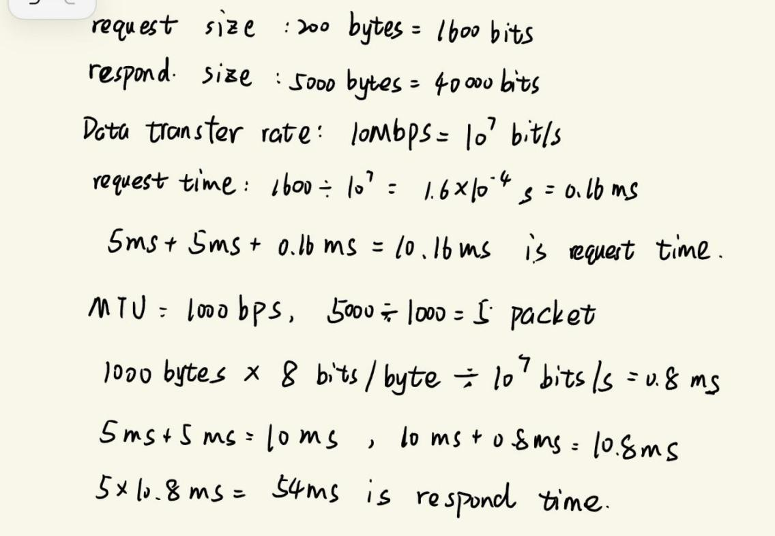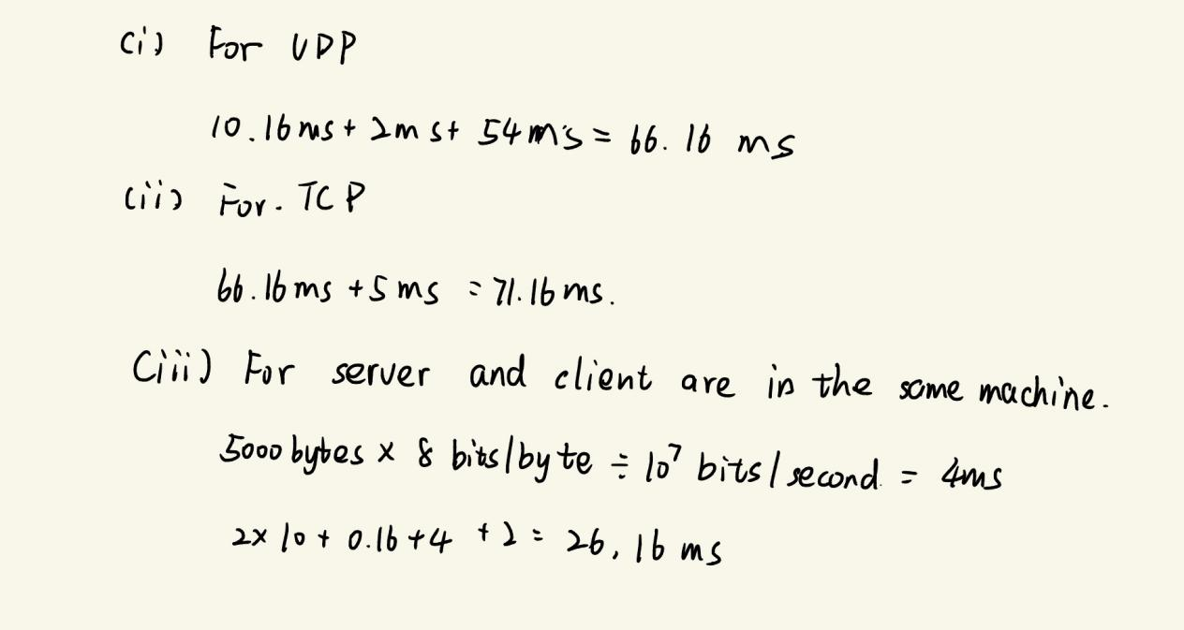

Question4
