DSANet-ISLES: An Interpretable Multi-Architecture Ensemble of DenseNet, SegResNet, and Attention U-Net for Low-Resource Stroke Lesion Segmentation
Abstract
keywords:
1. Introduction
2. Related Work

3. Methodology
The proposed method starts from multi-modal data acquisition and preprocessing to ensemble-based segmentation and evaluation. The overall working procedure consists of modality pairing, preprocessing, independent model training, ensemble fusion, post-processing, and quantitative assessment. Figure 1 shows the step-by-step procedure of segmenting the stroke lesion.
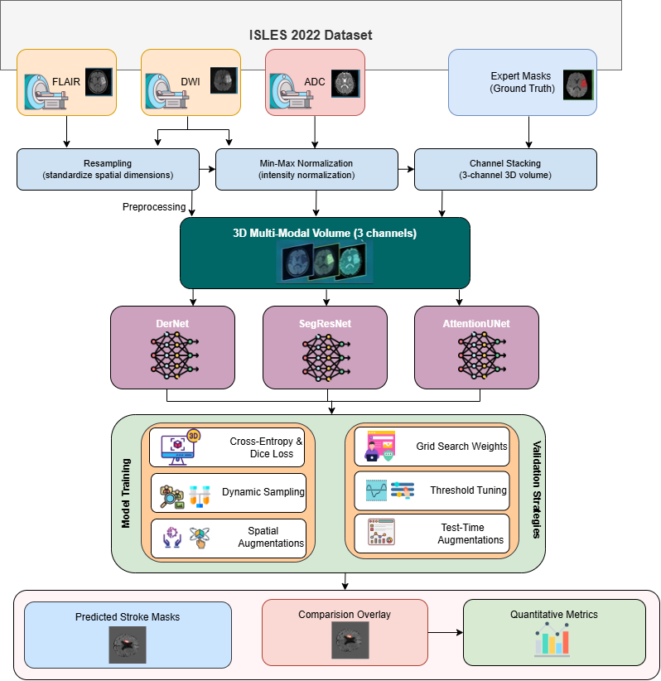
Figure 1: Step-by-step procedure of of stroke lesion segmentation
3.1 Data Preprocessing
This study use the ISLES-2022 dataset for experiment. Then normalize the intensity values of all images and apply Z-score normalization. The formula is X_{norm} = $\frac{X-μ}{σ}$ Here, $μ$ is the mean intensity and $σ$ is the standard deviation. To remove excess background noise and fit the GPU memory limits, this study apply spatial padding and random cropping. The study resize all volumes to a fixed dimension of 64*64*64 and this uniform size ensures consistent model input. Furthermore, since medical datasets typically contain a limited amount of data, spatial augmentations are applied to prevent overfitting. Specifically, flips along the X, Y, and Z axes are performed using 'RandFlipd' with a 50% probability, and random 90-degree rotations are executed using 'RandRotate90d' with the same probability. Finally, to enhance memory efficiency and ensure rapid computations on the GPU, all data is converted to the torch.float32 format using the 'CastToTyped' function.
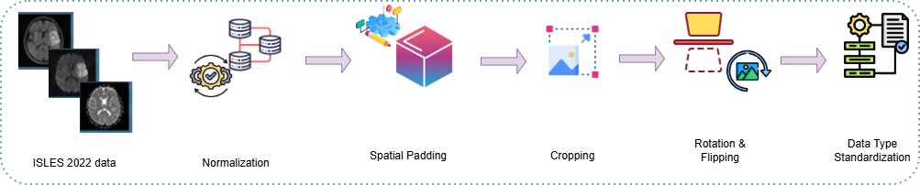
Figure 2: Overview of the 3D MRI data preprocessing pipeline
3.2 Problem Formulation
We aim to segment lesions from medical images. Let an input image be $X∈R^{H*W*D*C}$. Here, H, W, D represent the spatial dimensions. C represents the number of input modalities. The true label mask is $Y∈{\{0,1\}}^{H*W*D}$. The goal is to learn a mapping function f_{θ}. This function predicts a binary mask $\hat{Y.}$ The equation is $\hat{Y}$= f_{θ}(X).θ. θ represents the trainable model parameters. We optimize θ to minimize the difference between Y and $\hat{Y.}$
3.3 Proposed DSANet Framework
We propose the DSANet framework for the stroke lesion segmentation. The name stands for DerNet, SegResNet, and Attention U-Net Network. DSANet uses a multi-branch architecture and extracts diverse features from the input images. The framework consists of three parallel branches. Each branch generates an independent prediction mask. An ensemble module combines these predictions. This combination improves the final segmentation accuracy. The DSANet consists of three distinct deep learning architectures.
3.3.1 DerNet
This study use a DerNet model which connects each layer to every other layer. This structure ensures maximum information flow. The feature map of the l-th layer is x_{l}. The operation is x_{l} = H_{l}([{x₀, x₁, ..., x_{l-1}}]). H_{l} denotes a composite non-linear function. The brackets denote feature concatenation. DenseNet effectively extracts high-level semantic features.
This study set the random seed to 42 for complete reproducibility and normalize the intensity values of all input images. Then this study crop the image volumes to a fixed dimension of 64x64x64 and apply random flips and spatial rotations to the training data. These augmentations prevent the model from overfitting. The study initialize the network using pre-trained weights and fine-tune the model for 80 epochs. Then this study use the AdamW optimizer with a learning rate of 1e-4 and optimize the model using the DiceFocalLoss function. This specific loss function handles target class imbalance effectively. This study also use Automatic Mixed Precision (AMP) during the training phase. AMP speeds up computation and reduces memory usage. The specific hyperparameter configurations used for training the DERNet model are summarized in Table 1.
Table 1: Hyperparameter values of the DERNet model.
Parameter | Value
Input ROI Size | 64 x 64 x 64
Batch Size | 1
Total Epochs | 80
Initial Learning Rate | 1e-4
Optimizer | AdamW
Loss Function | DiceFocalLoss
Evaluation Metric | Dice Metric (F1 Score)
Train/Val/Test Split | 70% / 15% / 15%
Random Seed | 42
Augmentation Probability | 0.5 (Flip & Rotate)

3.3.2 SegResNet
This study uses the SegResNet model as the second model of the segmentation framework. SegResNet utilizes residual connections and a residual block computes $y = F(x, Wi) + x$ . Here, x is the input and y is the output. F(x, W_{i}) represents the residual mapping. These connections solve the vanishing gradient problem. SegResNet captures multi-scale contextual information. The network is initialized with specific architectural parameters, including an initial filter size of 32 and a dropout probability of 0.2. The global random seed is set to 42 to ensure the reproducibility of the experiments. During the data preprocessing phase, the intensity of all input images is normalized, and the volumes are padded or cropped to a uniform spatial dimension of 64x64x64. The training data is augmented using random spatial crops, random flips, and 90-degree rotations with a 50% probability to enhance model generalization.
The study trains the SegResNet model for 100 epochs using the AdamW optimizer with an initial learning rate of 1e-4 and a cosine annealing learning rate scheduler. To optimize memory usage while maintaining training stability, a gradient accumulation strategy is utilized. The physical batch size is set to 1, but gradients are accumulated over 4 steps, effectively simulating a larger batch size of 4. The model weights are optimized using the DiceFocalLoss function. The training process is accelerated by applying Automatic Mixed Precision (AMP) with a gradient scaler. The model's performance is evaluated on the validation set at the end of each epoch using a sliding window inference technique. Finally, to maximize the evaluation accuracy on the test set, Test-Time Augmentation (TTA) is applied. This technique processes the original image alongside its X-axis and Y-axis flipped versions, averaging the three predictions to produce a highly precise final segmentation mask. The specific hyperparameter configurations used for training the SegResNet model are summarized in Table 2.
Table 2: Hyperparameter values of the SegResNet model.
Parameter | Value
Input ROI Size | 64 x 64 x 64
Physical Batch Size | 1
Gradient Accumulation Steps | 4 (Simulated Batch Size = 4)
Total Epochs | 100
Initial Learning Rate | 1e-4
Optimizer | AdamW (Weight Decay = 1e-4)
LR Scheduler | Cosine Annealing
Loss Function | DiceFocalLoss (γ = 2.0)
Evaluation Metric | Dice Metric (F1 Score)
Train/Val/Test Split | 70% / 15% / 15%
Random Seed | 42
Augmentation Probability | 0.5 (Flip & Rotate)
Dropout Probability | 0.2

3.3.3 Attention U-Net
The study uses the Attention U-Net model as the third model of the segmentation framework. The model incorporates attention gates to highlight salient features. These gates effectively suppress irrelevant background regions. Attention gates highlight salient features. They suppress irrelevant background regions. The attention coefficient is α_{i}. We calculate it as α_{i} = $σ$(W^{T} tanh(W_{x}x_{i} + W_{g}g_{i} + b₁) + b₂). Here, x_{i} is the input feature, g_{i} is the gating signal and $σ$ is the sigmoid function. The random seed is set to 42 to guarantee reproducible outcomes. During preprocessing, the intensity of all input images is normalized. The image volumes are padded or cropped to a uniform spatial dimension of 64x64x64. The training dataset undergoes several data augmentation techniques to prevent overfitting. These techniques include random spatial crops, random flips, and 90-degree rotations with a 50% probability.
The Attention U-Net is trained for exactly 100 epochs. The training process uses a batch size of 1. The model parameters are optimized using the AdamW optimizer with a weight decay of 1e-5. The initial learning rate is set to 1e-4 and is regulated by a cosine annealing scheduler. The network learns to segment lesions using the DiceFocalLoss function. The training loop utilizes Automatic Mixed Precision (AMP) with a gradient scaler to maximize convergence and minimize memory consumption. The model is evaluated on the validation set at the end of each epoch using a sliding window inference approach. The best-performing model weights, measured by the highest Dice Similarity Coefficient (F1 Score), are saved for final testing. The specific hyperparameter configurations used for training the Attention U-Net model are summarized in Table 3.
Table 3: Hyperparameter values of the Attention U-Net model.
Parameter | Value
Input ROI Size | 64 x 64 x 64
Batch Size | 1
Total Epochs | 100
Initial Learning Rate | 1e-4
Optimizer | AdamW (Weight Decay = 1e-5)
LR Scheduler | Cosine Annealing
Loss Function | DiceFocalLoss (γ = 2.0)
Evaluation Metric | Dice Metric (F1 Score)
Train/Val/Test Split | 70% / 15% / 15%
Random Seed | 42
Augmentation Probability | 0.5 (Flip & Rotate)

3.4 Ensemble Strategy
This study proposes an advanced ensemble pipeline to maximize final prediction accuracy. First, Test-Time Augmentation (TTA) is applied to the test set. Each model processes the original image, an X-axis flipped version, and a Y-axis flipped version. The pipeline averages these three predictions. Next, an automated grid-search runs on the validation set to find the best combination weights for the three models. This search gives the highest weight priority to the DERNet model. Another grid-search finds the optimal threshold value. This step converts the weighted probability map into a final binary mask. Finally, a morphological post-processing step removes small, disconnected noise blobs under 30 pixels. This clean-up eliminates false positives and heavily refines the prediction. Here, this study combine the outputs of the three branches. Let the three individual predictions be P₁, P₂, P₃. We use a weighted averaging strategy. The final prediction is P_{final}. We calculate it as P_{final} = w₁ P₁ + w₂ P₂ + w₃ P₃. Here, w₁, w₂, w₃ are learned weights and w₁+ w₂+ w₃ = 1. We apply a threshold T to P_{final}. This step creates the final binary mask. Algorithm 1 shows how the full procedure works.
The selection of these three specific models relies on their distinct and complementary architectures. The DERNet uses dense connections and Local Spatial Convolution blocks. This structure effectively captures complex lesion boundaries and high-level semantic features. The SegResNet uses residual connections to solve the vanishing gradient problem. It easily captures multi-scale contextual information. The Attention U-Net incorporates attention gates. These gates actively suppress irrelevant background noise and focus solely on the targeted lesion. The ensemble method combines these diverse architectures to offset individual model biases. If one model makes an error, the other two models correct it. This collaboration drastically reduces false positives and false negatives. Consequently, the ensemble approach achieves a significantly higher final F1-score compared to any single model.
Algorithm 1: Proposed Ensemble Segmentation Pipeline
Input: Validation dataset D_{val} = {(X_{i}, Y_{i})}, Test images D_{test} = {X_{j}}, Trained models M = {M_{DER}, M_{Seg}, M_{Att}}.
Output: Final segmented binary masks Ŷ_{test} for the test set.
Phase 1: Hyperparameter Optimization via Grid-Search (Validation Set)
1. Initialize maximum Dice score S_max ← 0, optimal weights W* ← {0, 0, 0}, optimal threshold T*←0.
2. For each candidate weight combination (w1, w2, w3) such that ∑wk = 1 and w1 ≥ 0.4:
3. For each candidate threshold T ∈ {0.35, 0.40, 0.45, 0.50}:
4. For each validation sample (X_{i}, Y_{i}) ∈ D_{val}:
5. Compute Test-Time Augmentation (TTA) predictions P_{k,i} for each model M_{k} ∈ M
6. Compute weighted probability map: P_{ens,i} = w1·P_{DER,i} + w2·P_{Seg,i} + w3·P_{Att,i}
7. Generate binary mask: B_{i} = 1 if P_{ens,i} > T else 0
8. End For
9. Calculate overall validation Dice score S_{val} using all predictions {B_{i}} and ground truths {Y_{i}}
10. If S_{val} > S_{max} then:
11. S_{max} ← S_{val}
12. W* ← {w1, w2, w3}, T* ← T
13. End If
14. End For
15. End For
Phase 2: Final Inference and Morphological Post-Processing (Test Set)
16. For each test sample X_{j} ∈ D_test:
17. For each model M_{k} ∈ M:
18. Compute base prediction: p_{orig} = M_{k}(X_{j})
19. Compute X-axis flipped prediction: p_{x} = FlipX_{inv}(M_{k}(FlipX(X_{j})))
20. Compute Y-axis flipped prediction: p_{y} = FlipY_{inv}(M_{k}(FlipY(X_{j})))
21. Average TTA prediction: P_{k,j} = (p_{orig} + p_{x} + p_{y}) / 3
22. End For
23. Compute optimal weighted map: P*_{ens,j} = w1*·P_{DER,j} + w2*·P_{Seg,j} + w3*·P_{Att,j}
24. Apply optimal threshold: B*_{j} = 1 if P*_{ens,j} > T* else 0
25. Apply morphological filtering: Ŷ_{j} = RemoveSmallObjects(B*_{j}, min_size=30)
26. End For
27. Return set of final predicted masks {Ŷ_{j}}

3.5 Training Strategy & Low-Resource Learning Strategy
This study employs a robust training strategy. The loss function combines Dice Loss and Cross-Entropy Loss. The total loss is L_{total} and L_{total} = λ₁ L_{Dice} + λ₂ L_{CE}. Here, λ₁ and λ₂ are balancing weights. This study use the AdamW optimizer. The initial learning rate is 1*10⁻⁴ and train the models for 100 epochs. This study also use gradient accumulation to simulate a larger batch size. A Cosine Annealing scheduler controls the learning rate. It smoothly decreases the learning rate during training. The models use the DiceFocalLoss function for error calculation. Medical image segmentation often has a huge class imbalance between the lesion and the background. The DiceFocalLoss effectively handles this imbalance problem. The study uses Automatic Mixed Precision (AMP) and a gradient scaler. These tools speed up the training process. They also reduce GPU memory consumption. Hardware limitations prevent the use of large batch sizes. Therefore, the study applies a gradient accumulation technique. This technique ensures stable training by simulating a larger batch size. A sliding window inference is run on the validation set at the end of each epoch. The model weights with the highest F1-score are saved for final testing.
Medical image datasets generally contain a small amount of data. This study adopts a low-resource learning strategy to overcome this limitation. Several data augmentation techniques are applied during training. These techniques prevent the models from memorizing the training data. First, every input image is preprocessed to a uniform 64x64x64 dimension. Next, random spatial crops are used during training. The study also applies random flips and 90-degree spatial rotations with a 50% probability. These augmentations help the models recognize new patterns. They significantly increase the generalization power on unseen data. The study utilizes Test-Time Augmentation (TTA) during the testing phase. TTA creates multiple augmented versions of a single test image. For example, it generates an original version, an X-axis flipped version, and a Y-axis flipped version. The network processes all three versions independently. The pipeline then averages these three predictions. This specific method drastically boosts the final segmentation accuracy without requiring any extra training data.
3.6 Evaluation Protocol and Implementation Details
We split the dataset deterministically. We use a 70-15-15 split. Seventy percent of the data is for training. Fifteen percent is for validation. Fifteen percent is for testing. We set the random seed to 42. This seed guarantees reproducible results. We save the model with the best validation score. We evaluate this best model on the unseen test set. We measure performance using three primary metrics. We use the Dice Similarity Coefficient (DSC). DSC measures spatial overlap. The formula is $DSC=\frac{2×\left|Y∩\hat{Y}\right|}{\left|y\right|+\left|\hat{Y}\right|}$.Here, Y is the ground truth and $\hat{Y}$is the prediction. We also calculate Precision, recall and f1 score.
We implement the framework using PyTorch. We use the MONAI library for medical image processing. We run the experiments on a single NVIDIA GPU. We use mixed-precision training. This technique speeds up the training process. It reduces memory consumption.

4. Results

5. Conclusions
Author Contributions
Data Availability
Data is available here.
Ethical Considerations
This research strictly adheres to ethical guidelines.
Funding
None.
Conflict of Interest
The authors declare no conflict of interest.
References

