IndusInd Credit Card - Network Error in Co-browsing on 7th September 2023

# **Summary**

On app.cognocart.com, IBO WA chatbot is not responding,

WA number: +91 99025 21060

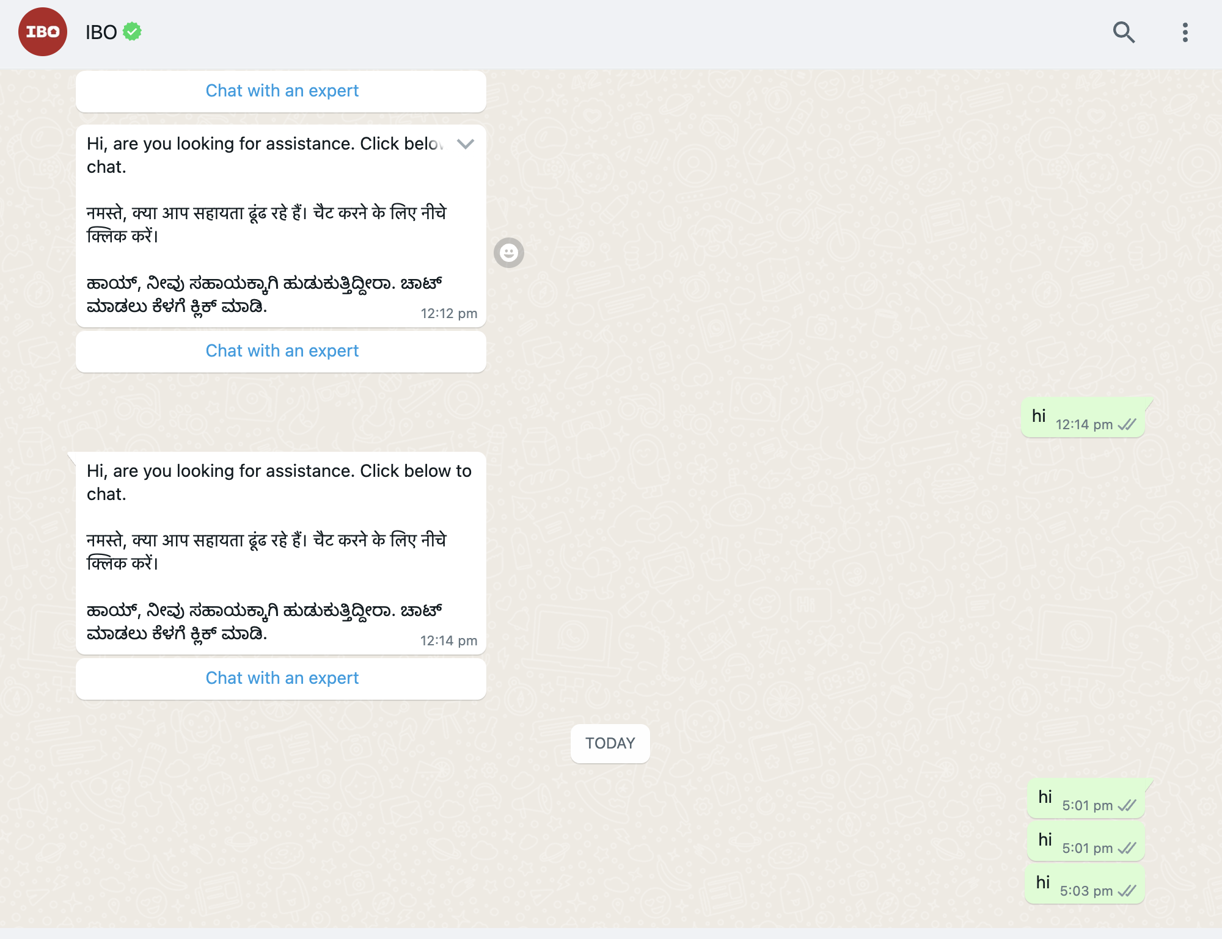

# **Source of Alert**

The issue has been reported through the Support Channel.

# **Impact Period**

* Duration: 4 hours and 17 minutes
* Start Time: Fri, 22 Sep 2023 at 3:42 PM
* End Time: Fri, 22 Sep 2023 at 7:59 PM

# **Service affected and impact**

Cobrowse app.

# **Timeline**

* Fri, 22 Sep 2023 at 3:42 PM: Issue reported to Cogno support.
* Fri, 22 Sep 2023 at 4:02 PM: Ticket was acknowledged and routed to Sr. support engineer.
* Fri, 22 Sep 2023 at 4:02 PM: Sr. support engineer shared initial findings, routed to sr. support developer.
* Fri, 22 Sep 2023 at 4:02 PM: Sr. support developer identified the root cause, routed to DevOps team for further check.
* Fri, 22 Sep 2023 at 7:59 PM: Issue was resolved and confirmation sent out on ticket.

## **Root Cause**

The websocket connections were failing.

The telnet was not happening on database server IP 192.168.20.13,' port number 6379.

DevOps to share other details.

**Corrective measures**

DevOps to share.

## **Preventive measures**

DevOps to share.