A DISSERTATION SUBMITTED TO THE GRADUATE SCHOOL IN PARTIAL FULFILLMENT FOR THE AWARD OF BACHELOR OF SCIENCE IN STATISTICS, BIOSTATISTICS AND INFORMATICS DEGREE AT UNIVERSITY OF DHAKA

Submitted By
Group-07
3-Sigma

“An Empirical analysis of Micro-credit Model:Yunus Equation and Impact of Micro-Credit on Poverty Alleviation and Women Empowerment of Poor People: A Case Study of Bangladesh”
Supervisor Mohammad Ahsan Uddin Associate Professor Department of Statistics, Biostatistics and informatics University of Dhaka

“An Empirical analysis of Micro-credit Model:Yunus Equation and Impact of Micro-Credit on Poverty Alleviation and Women Empowerment of Poor People: A Case Study of Bangladesh”



Submitted By

Group-07

3-Sigma

A DISSERTATION SUBMITTED TO THE GRADUATE SCHOOL IN PARTIAL FULFILLMENT FOR THE AWARD OF BACHELOR OF SCIENCE IN STATISTICS, BIOSTATISTICS AND INFORMATICS DEGREE AT UNIVERSITY OF DHAKA

Declaration

We hereby declare that the content of this paper is our original work (except where we have acknowledged) and to the best of my knowledge has never been presented for any award any where before.
All the group members of 3-sigma

Dedication

“I am working to achieve a world in which there will be a poverty museum in every country, so that people will be able to remember the time when poverty was a widespread affliction. And everyone will wonder why it took so long for this bane of mankind to be finally banished forever.”

….. Muhammad Yunus

Group: 07 (3-Sigma)

Supervisor

Mohammad Ahsan Uddin

Associate Professor

Department of Statistics, Biostatistics and informatics

University of Dhaka
Group Leader
Student Name | Class Roll
Sabbir Hossain | Roll: EK-35
Group Member
Student Name | Class Roll
Md.Musaib Ibn Rahman | Roll: EK-047
Pronob Kumar Barman | Roll: JN-036
Showaib Rahman Sarkar | Roll: EK-087
Sajedur Rahman Shawon | Roll: SH-086
Md. Shahed Hossain | Roll: FH-121
Sanad Biswas | Roll: JN-071
Mohammad Idris | Roll: SH-080
Most. Shovani Zamal | Roll: RK-55
Habiba Jannat | Roll: RK-082
Umme Habiba Benojir | Roll: RK-058
Sabrina Sultana | Roll: RK-037
Department of Statistics, Biostatistics and Informatics
University of Dhaka

Acknowledgements

First we wish to thank and give glory to the lord almighty for the precious gift of life and wisdom and whom without his will and blessing, it would not have been possible for us to write this work.

We would like to thank Mrs. Murshida Khanam, Associate professor of SBI Dept. University of Dhaka for conscientiously reading and commenting on an earlier version.
We also benefitted from Dr. Taslim Sazzad Mallick, Associate professor of SBI Dept. University of Dhaka for analysis in R programming.

My sincere gratitude goes to our supervisors Md. Ahsan Uddin, Associate professor of SBI Dept. University of Dhaka for accepting to see us through this study and his guideline and imperative supervision. His continuous encouragement and important suggestion helped us selecting the content of the project. He provided valuable suggestion, inspiration and advice untiringly whenever and whatever we had to seek and need in completing our research work.

At the same time, we want to thank our department, Department of Statistics, Biostatistics & Informatics for giving us permission to commence this project, to do the necessary research work and to use necessary analysis software packages & departmental data.

Especially, we would like to extend our heartfelt gratitude to all the respondents for their cordial cooperation without which this project would not have been possible.

Finally, we would like to thank to our family and friends for encouraging and inspiring us and also all those who gave us the possibility to complete this project.

However, none of them are responsible for any errors and short comings of this project. The views expressed in the paper are our own.

Abstract
Bangladesh is a pioneer and home of conceptualizing micro-credit program. It has undertaken a number of such programs to reduce poverty and bring about socio-economic changes in the rural community .This paper explores the relationship between microcredit and poverty reduction with women empowerment. To investigate this question, we posit a bare-bone, household model that outlines the economic environment within which various types of family microenterprises operate. It highlights a number of issues that impinge on household earnings such as the nature of the loan, interest rate ,technology and entrepreneurial skills. The project argues that the impact of microcredit is likely to be different across household types as well as across different economic environments. The project identifies several important demand and supply constraints to the household’s graduation from poverty. These constraints are difficult to overcome in a traditional economic environment, marked by stagnant technology and market saturation. Finally, it is suggested that microcredit has a positive effect on female empowerment—i.e., the agency to make household decisions which helps to improve the quality of family consumption and ‘human development indicators’ of the family. This claim may hold sway in some contexts. However, our a priori reasoning, as well as the available contrary empirical evidence, suggests that female empowerment does not spring automatically from the introduction of microcredit: female empowerment (or the lack there of) seems to closely track women’s trajectory of economic success.
Keywords: micro-credit,Yunus Equation, poverty alleviation, Women empowerment

Table of Contents
Title Page no.

Chapter 01
1.1: Background to the Study 18
1.2 Statement of the Problem 22
1.3: Purpose of the study 22
1.4 Research objectives 23
1.5 Significance of the study 23
1.6 Research Questions 23
1.7 Scope of the Study 24
1.8 Motivation for the study 24
1.9 Area Selection 25

Chapter 02
2.1 The Concept of Micro credit: 27
2.2 Accessing micro credit and Household income 27
2.3 Micro credit and Borrowers’ Characteristic 31
2.4 Borrowers’ Characteristics and Household income 35
2.5 Accessing micro credit, Borrowers’ characteristics, Business Type
and Household income 38
2.6 Micro-credit in Bangladesh 40
2.7 State of Micro-credit in Bangladesh 41

Chapter 03
3.1 Methodology 56
3.2: Research Design and Sampling Procedure 56
3.2.1 Research Design 56
3.2.2 Sampling Procedure 56
3.3 Survey design 57
3.4 Study setting 57
3.5 Unit of analysis 57
3.6 Type of Research 58
3.7 Data collection method 58
3.8 Statistical techniques 59
3.8.1 Percentage 59
3.8.2 Frequency 60
3.8.3 Mean 60
3.8.4 Standard deviation 60
3.9 Study Population and Sample Size 63
3.9.1 Population 63
3.9.2 Sample Size 63
3.10 Data Source 63
3.11 Data Collection methods and Instruments 63
3.12: Variables and their Measurement 64
3.13 Validity and Reliability of the instruments: 64
3.14 Data Processing and Data Analysis 66
3.15 Quality control 66
3.16 Limitations of the study 66

Chapter 04
4.1 Executive summary 68
4.2 Concept of capitalization 69
4.3 The Yunus Model : polynomial and equation 70
4.3 Modeling with lateness 71
4.3.1 Building of the model 71
4.3.2 Limit of this Model 72
4.3.3 Rates calculation 72
4.3.4 Effective average rate 73
4.3.5 Rate for a geometric distribution 75
4.4 Simulate a geometric distribution 75
4.5 Adaptation of the Yunus equation 76
4.6 Actuarial expected rate 77
4.7 Interest Rate from different aspects 77
4.7.1 Two last notes: 81
4.7.2 Interest rate from experimental results 82
4.8 Default calculation 83
4.8 .1 D-default utilization 84
4.9 Comparison with another model 85
4.10 Modeling with correlated lateness 85
4.11 Building of the model 85
4.12 Model with negative correlation 85
4.13 Model with positive correlation 87
4.14 Results 87
4.15 Positive correlation results 88
4.16 Negative correlation results 89
4.17 Analysis of the results 90
4.18 Consumer credit 90
4.18.1 Consumer credit model 90
4.19 Simulation 91
4.20 CONCLUSION 93

Chapter 05
5.1 Role of micro credit in poverty alleviation 95
5.2 Broad Problem area 97
5.3 Transmission Mechanism of Micro credit to Poverty Alleviation 98
5.4 Theoretical Frame Work 99
5.5 Variables 99
5.5.1 Dependent Variable 100
5.5.2 Independent Variable 100
5.5.3 Moderating Variable 100
5.6 Schematic diagram for the theoretical frame work 101
5.7 Hypothesis development 101
5.9 Data Presentation, Interpretation and Discussion 103
5.10 Logistic Regression 105
5.11Associate Relation between Access to Credit and Poverty Category: 108
5.12: Age of Respondents 117
5.13 Marital status 119
5.14 Number of years with the institutions. 119
5.15 The average loan size 123
5.16: Borrowers’ characteristic and house hold income 125
5.17 Predication Model for Household income 126
5.18 Nutrition and adequate food 137
5.19 Clean water and hygienic environment 142
5.20 Accommodation 144

Chapter 06
6.1 Conceptualizing Empowerment 154
6.2 Women empowerment 155
6.3: Microcredit and women empowerment 157
6.4 Descriptive data and patterns of empowerment 159
6.2. Table of some statistic of respondents 160
6.5 Limitations with the questionnaire methodology 163
6.6 Econometric Analysis 163
6.7: Model specification 164
6.8 Ownership of assets 167
6.9 Voice 169
6.10 Mobility 171
6.10 Conclusion 174

Chapter 07
7.1: CONCLUSION, RECOMMENDATION AND AREAS FOR FURTHER STUDY 177
7.2: INTRODUCTION 177
7.3: CONCLUSION 177
7.4: RECOMMENDATIONS 179
7.5 Areas of further research 180

References 181

Appendix 186

Questionnaire: 186

List of Table

Table Page No
Table-2.1: Basic Statistics of NGO-MFIs in Bangladesh 41
Table-2.2: Size-Wise Loan Outstanding and Savings Compositions 42
Table-2.3: Scenario of Micro Enterprise Loan 43
Table -5.1:monthly income now after taking microcredit with respect to respondent’s no of earning members , no. of family member & education status. 104
Table-5.2: satisfaction level of the rate of interest with respect to education, family income, husbands occupation, gender. 107
Table-5.3:Associate relation between access to credit and poverty category. 108
Table-5.4:Multiple Regression Coefficients of Contributing Factors on Total Income after Joining Micro-Credit Program. 111
Table-5.5 Coding table 113
Table-5.6:Association between education status and enough income. 117
Table-5.7: shows the frequency and percentages of beneficiaries according to age. 118
Table-5.8: frequency and percentages showing marital status of the Respondents 119
Table-5.9: Frequency and percentages showing respondent’s number of years with institution 120
Table-5.10 Living status of micro-credit borrowers 122
Table-5.9 Amount of micro-credit taking by respondents. 107
Table-5.11: frequency and percentages showing the average loan size of the respondents 124
Table-5.12: showing Relationship between Independent and Dependent variables 125
Table -5.13: presents the regression results. 126
Table-5.14:Descriptive statistics on respondents’ financial status. 128
Table-5.15:Chi-square test for testing change in economic status after taking microcredit 152
Table-6.1:frequency table of respondents taking microcredit from different institution 159
Table 6.3:frequency husband’s occupation 160
Table-6.4: table for empowerment indication 161
Table-6.5: table for simple linear regression of some important variables on total amount of loan taking 162

List of Figure
Figure Page No
Figure-4.1 Effective average rate in function of the payback probability 74
Figure4.2 Wanted interval for Geometric distribution 75
Figure4.3 Interest rate from experimental results 82
Figure 4.4 Default in function of the probability 83
Figure 4.5 Interest rate for 452 positive correlated distribution 88
Figure 4.6 Interest rate for 452 negative correlated distribution 89
Figure 4.7 Interest rate for consumer credit model 92
Figure-5.1 Change in economic status after accessing micro-credit 109
Figure-5.2 Ability to buy meat and fish before taking micro-credit. 110
Figure-5.3 Ability to buy meat and fish after taking micro-credit. 111
Figure-5.4:Sanitation versus family income 114
Figure-5.5 Gender versus using years of micro-credit. 115
Figure-5.6 Frequency of male and female taken micro-credit. 116
Figure-5.7:using year of micro-credit 121
Figure-5.8:Living status of respondents after taking micro-credit 122
Figure-5.10:Graphical representation of respondent’s demographic characteristics. 128
Figure-5.11:frequency of the sex of respondents 130
Figure-5.12:Frequency of the different age group of respondents. 131
Figure-5.13:Educational level of respondents 132
Figure-5.14:Number of children of respondents 133
Figure-5.15:respondents occupation. 134
Figure-5.16:Graphical representation of factors showing poverty reduction Training and education program 135
Figure-5.17:children getting any kind of training or education. 136
Figure-5.18:frequency education or training is expense or asset 137
Figure-5.19:frequency of children getting any kind of education or training. 138
Figure-5.20 Frequency of respondents average expense of food. 139
Figure-5.21:frequency of respondents live without food. 140
Figure-5.22:frequency of respondents difficult to manage food. 141
Figure-5.23:frequency of respondents mostly eat. 142
Figure-5.24:frequency of respondents drinking clean water & hygienic environment. 143
Figure-5.25:frequency of respondents face water shortage. 144
Figure-5.26:frequency of respondents having own house or rented. 145
Figure-5.27 Frequency of respondents having house enough for family member. 146
Figure-5.28: frequency of respondents having house strong enough to bear natural disaster 147
Figure-5.29:frequency of respondents having house enough for family member 148
Figure-5.30:frequency of respondents want other source of income 149
Figure-5.31:frequency of respondents able to save or difficult 150
Figure-5.32:frequency of objective of saving of the respondents 151
Figure-5.33:frequency of developing of lifestyle of the respondents 152
Figure 6.1: Determinants of Empowerment 155
Figure 6.2: frequency of respondents having own property 169
Figure 6.3: frequency of respondents having independent saving 169
Figure 6.4: frequency of respondents having land ownership 170
Figure 6.5: frequency of respondents comfortable giving opinion 171
Figure 6.6: frequency of respondents listening to new ideas and opinion 172
Figure 6.7: frequency of respondents willing to go outside for work 173
Figure 6.8: frequency of respondents comfortable giving opinion 174
Figure 6.9: frequency of respondents comfortable going local market 175

CHAPTER ONE

INTRODUCTION

1.1: Background to the Study
In the wake of the worst famine of Bangladesh in the post-Freedom fight era, Professor Muhammad Yunus launched in 1976 a microcredit experiment to assist a group of poor, highly indebted households in Chittagong, Bangladesh. This experiment that was later to emerge as the Grameen Bank marked the beginning of the modern-day microcredit movement, which in the last few decades has blossomed into a global phenomenon. While precise data are difficult to obtain, the total volume of microcredit lending (as of February 2011) is reported to be about US$65.2 billion, covering more than 94 million borrowers from 1,800 microfinance institutions in nearly 130 countries (MIX 2011). This phenomenal success of microcredit in such a short time span has attracted global attention from policy makers, development economists, and social thinkers—culminating in the award of the Nobel Peace Prize for Muhammad Yunus and the Grameen Bank in 2006.Notwithstanding this success, there is a good deal of skepticism about microcredit as a tool of poverty reduction. Despite a considerable increase in micro-lending in developing countries, poverty shows few signs of abating in many poor countries. This persistence of poverty has generated widespread doubt, which has been reflected in both public scholarship and academic studies, about the effectiveness of microcredit. For example, in an incisive commentary in New Yorker magazine, Surowiecki (2008) echoed this concern, ‘There’s no doubt that microfinance does a tremendous amount of good, yet there are also real limits to what it can accomplish. Microloans make poor borrowers better off. But, on their own, they often don’t do much to make poor countries richer.’

Similarly, a substantial body of academic studies by economists and other social scientists records a similar note of scepticism. In an earlier survey paper, Weiss and Montgomery (2004) reviewed empirical economic studies that delve into the question of the effectiveness of microcredit in poverty reduction. The central message that emerges from the paper is that the empirical evidence regarding the impact of microcredit on poverty is far from conclusive. In a recent review of the evidence, Duvenduck et al. (2011) sound
somewhat less central to the subject of this paper. Instead, this paper highlights such issues as the nature of the labour market, technology, product demand, entrepreneurship, and intra-household decision-making. We will argue that these are the aspects that have a critical bearing on household poverty in an impoverished, rural setting.
The organization of the paper is as follows. Section 2 spells out the basic model and traces its implications for household incomes and poverty. Section 3 explores numerically the link between microcredit and graduation from poverty under a set of plausible assumptions. Section 4 extends the basic model to examine the economic effects of expanding microcredit programe on microenterprises. Section 5 discusses the impact of microcredit on female empowerment and family consumption. Section 6 provides a brief summary of conclusions.

1.2 : Statement of the Problem
Problem statement is also often referred to, is a clear, precise and succinct statement of the question or issue that is to be investigated with the goal of finding an answer or solution.
Here in this study problem statement is:
“An Empirical analysis of Yunus Equation and Impact of Micro- Credit on Living Standard, Empowerment and Poverty Alleviation of Poor People.”
Despite government’s effort, aimed at improving household incomes for the rural poor people, through micro credit program.

1.3: Purpose of the study
The purpose of this study therefore is to analysis of Yunus Equation, finding interest rate, examine the relationship between accessing micro credit, borrowers’ characteristic, business type and household income in rural areas, and how all of this related to women empowerment.

1.4 Research objectives
- To analysis of Yunus Equation and investigate interest-rate.
- How Micro-credit is related with poverty reduction for poor people in Bangladesh
- To determine the relationship between accessing micro credit and household income.
- To establish the relationship between the borrowers’ characteristic and house-hold income.
- To find out if there is a relationship between accessing micro credit and borrowers’ characteristic.
- To investigate the relationship between accessing micro credit, borrowers’ characteristic, business type and household income.

1.5 Significance of the study
Study results would be useful
- In policy formulation and decision making in respect of government micro credit.
- To Government departments implementing micro credit programs.
- To have an idea about women empowerment in poor people .
- Contribute to existing body of literature and form a basis for further research.

1.6 Research Questions
- What is the effective average interest rate of Micro-credit?
- What is the relationship between accessing micro credit and household income?
- Is there a relationship between the borrowers’ characteristic and household income?
- Is it true that accessing micro credit and borrowers’ characteristic are related?
- Accessing micro credit, borrowers’ characteristic, business type and household income in rural areas are related, is this true?

1.7 Scope of the Study
This study looked at the relationship between accessing micro credit, borrowers’ characteristics, business type and household income in rural areas. Micro credit was looked at in terms of credit limit, resource mobilization, portfolio quality, outreach, gender and marital status. Borrowers’ characteristics in terms of education level, credit worthy, knowledge of business, character and collateral while business type in terms of business location, size/nature (retail/whole sale) of business and household income in terms of savings, source of income and business growth.

1.8 Motivation for the study
Inequality is increasing around the world while the world appears to come closer due to phenomenon of globalization. Even the wealthiest nation has the largest gap between rich and poor. In such scenario countries like Bangladesh is facing a great challenge in the form of poverty because by the time gap between rich and poor is increasing day by day. Majority of population of Bangladesh is living at poverty line or below poverty line. According to a survey about five million households in the country are living below poverty line.
This poverty is also becoming cause of many problems that are prevailing in our society such as crimes, suicides, illiteracy, unemployment and diseases like depression, anxiety, stress and many more.
In order to control these problems, first poverty should be controlled. At government level, many strategies are made every day, world bank and International monetary fund is also working for this purpose but now Dr. Yunus gave such a wonderful idea to alleviate poverty that really works in Bangladesh, and is now working all over the world i-e Micro Credit.
So; we decided to study what is the Role of Micro Credit in Poverty Alleviation.

1.9 Area Selection:
To find out the causes which are significant and which are insignificant for the Poverty reduction due to micro-credit among the all the division of Bangladesh the study is concluded on different parts of Division.
At first we had selected 07 Division and then selected 01 District from each Division. Then we select 03 villages from each District . Finally, we interviewed 25 women from each selected district allocated in 3villages.

CHAPTER TWO

LITERATURE REVIEW

2.1 The Concept of Micro credit:

Micro credit refers to the small loans made available to the poor (Mohammad, 2008). It can also be referred to as small scale financial services primarily aimed at providing credit and savings to individuals involved in small scale enterprises (Robinson, 2001). This is done through a collateral free group based lending strategy Yunus (1999), Sayma et al. (2009). Micro credit institutions have emerged as a substitute for formal financial institutions which have limited the accessibility to credit by the poor due to lack of collateral (Choudhury et al. (2005). It is an important source of income for many poor people in low developing countries. Recognising this, governments and donors have sought to promote small firms usually through credit programmes PEAP (2002) and Wali (2009). Many developing countries have supported it because it offers the rural poor access to flexible financial services as well as improving their well fare (Okurut, 2004). Micro credit institutions enhance household’s capacity through financing investments promoted by the poor (Mann, 2002). Micro credit covers abroad range of financial services including loans, deposit, payment service, insurance to the poor and their micro enterprises.

2.2 Accessing micro credit and Household income

This is where credit is made available to the poor people or to those who need it (Gautam, 2008). In many rural areas of developing countries, lack of access to formal financial services has be seen as a sever constraint that prevents low income households from improving their incomes (Wali, 2009). For instance as observed by Mohammad, 2008 over 500 million poor people in developing countries with small businesses have often cited limited access to formal financial institutions for credit as the biggest challenge to their business growth. With the success of Grameen bank a micro credit institution in Bangladash where the low income households have been able to access credit
.

2.3 Micro credit and Borrowers’ Characteristic
These are attributes borrowers’ should have if they are to benefit from or access micro credit institution services easily (Sayma et al. (2009). Accessibility to credit by the borrowers’ will depend on the seriousness MCIs attach to the borrowers’ characteristic before giving credit out (Wali, 2009). For instance borrowers who have collateral will easily access credit since it reduces the risk of the institution losing its funds. These characteristics include education, collateral, character and credit worthy of borrowers’. According to Harms (2007), Gunnana (2003) accessibility to credit by the poor people in rural areas is related to the borrowers’ characteristic above. Little field (2003) observed that, poor people in developing countries have no access to formal financial institution services due to lack of collateral. The emerging credit institutions have since reduced this gap through availing credit on the bases of trust and group based lending strategy.
According to Ajay (2006) accessibility to and usage of credit depends on the borrowers’ level of education. For instance people who earn a salary normally access credit easily, since salary acts as collateral. Vickers (1993) noted that education acts as a prerequisite and a key factor in raising awareness and empowering the poor people to participate in national development through easy accessibility to credit. Through different trainings to the poor, they end up acquiring skills if used well can make them access credit easily. At a world education forum held in daker in April 2000, the international community under scored the need to increase household incomes and gave its collective commitment to work towards this aim through education. Where as its important that education is necessary in order to improve household incomes, it’s also important to note that illiterate people often use credit better then the educated persons. Not only is education important in increasing household income, its also key in wealth creation (education & poverty eradication (2001). Thapa (2007) noted that education and micro enterprises are the only good factors to consider while giving out credit. Zahid (2003) however noted that illiterate people get credit because they are the majority who struggle to

2.4 Borrowers’ Characteristics and Household income

credit one and the social commitment is easily achieved if members are first contributing to the development of their credit institution through savings. By allowing this process of growth to take place the micro credit institution will be taken as one developed by the members to satisfy their particular needs. This will show them how tough it is to put money aside from the little available resources in the name of savings for future investment. Experience shows that; it’s financially more favorable to postpone the desired expenditure until the required money has been saved rather than taking credit and paying interest (Vogel, 2004). Bernard (2002) said that access alone to financial services provided by micro credit as a service might not be sufficient to improve the economic situation of households in the rural areas. It’s therefore important for the household to save if their incomes have to improve. Since savings give a clear picture of how much capital one has.
Households have different sources of income that enable them met their day to day needs (Gautam, 2008). These can include agriculture (farming), educated people earning a salary, engaging in businesses. All these sources contribute to the improvement of household income in one way or the other. The flow of income varies from household to household for example a family where a wife and husband are all working, where a family is engaged in commercial farming their levels of income will not be the some when compared to those families that are not involved in any of the above. Further to the above households that have a well defined source of income can easily increase or mobilise capital through accessing credit which they can use in different investments and end up improving household incomes.
Basil (2002), the key requirement for increasing household income is by increasing income sources of the poor people by availing credit which will enable them engage in businesses which will increase productivity assets ownership and thereafter improving household incomes. According to Ssendaula( 2000) a key element of increasing household income is through provision of sustainable financial services to the poor. Experience world over has shown that micro credit institutions can supply these services, effectively, provided they are free to charge interest rate, which covers the cost of operations. The easy access to the credit services enables poor people to engage in businesses that will improve their household income. Yunus (2003), the main goal of micro credit institution is to provide flexible and appropriate financial services, not usually available from commercial banks to a greater number of people.

2.5 Accessing micro credit, Borrowers’ characteristics, Business Type and Household income

Business is an occupation involving the regular production, purchase, sale of goods and services undertaken with an objective of earning profits and acquiring wealth. This is made possible by the availability or accessing credit to fund the different activities that lead to creation of wealth (Wali, 2009). Wasswa (2003) asserts that management’s failure to examine the question; what is our business? In a timely, manner is the most important single cause of business failure and poor performance. When the concept of an individuals business is not thought through and spelled out clearly, it will lack a solid foundation for establishing realistic objectives and strategies. It’s therefore important that micro credit schemes define what enterprises it is willing to finance. Vespar (1983) says that “lack of good knowledge of ones business idea has lead to difficult in raising capital and the end result is business failure which automatically leads to low household income.
rural poor(Semukono, 1996). According to Yaron (1994) two problems in particular confront MCIs: First, ensuring efficient and relatively low operational costs and procedure for screening borrowers, processing and monitoring loans. Second, always make sure that there is adequate loan recovery so that continued operations are feasible without constant reliance on state funds or bail outs.
Numerous studies as shown above strongly affirm the existence of a relationship between the study variables basing on data from more developed economy’s. This therefore creates need to use data from developing countries and see what conclusions one would reach. This study therefore attempts to address this gap in literature using data from one of the rural areas in a case of Bangladesh.

2.6 Micro-credit in Bangladesh
Microcredit programs in Bangladesh is implemented by NGOs, Grameen Bank, state-owned commercial banks, private commercial banks, and specialized programs of some ministries of Bangladesh government. In the microfinance sector total loan outstanding is around TK 248 billion (including Grammen Bank TK 72 billion) and savings TK168 billion. The total clients of this sector is 35 million (including 8.4 million clients from Grameen Bank) that accelerates overall economic development process of the country. Credit services of this sector can be categorized into six broad groups:
- General microcredit for small-scale self employment based activities,
- Microenterprise loans,
- Loans for ultra poor,
- Agricultural loans,
- Seasonal loans, and
- Loans for disaster management.
Loan amounts up to BDT 50,000 are generally considered as microcredit; loans above this amount are considered as microenterprise loans.
Since the founding of Grameen Bank by Mohammad Yunus in the late 1970‘s in Bangladesh, microcredit, or the provision of small collateral free loans targeted primarily to poor women has grown exponentially and has come to occupy an important position in poverty alleviation strategies. In just 30 years, micro-finance institutions are estimated to have reached over 100 million women all over the developing world. Proponents of microfinance believe that it has contributed significantly to the reduction of worldwide poverty and has forwarded the cause of achieving the Millennium Development Goals (MDG) (Microcredit Summit Campaign). The efforts of Mohammad Yunus and Grameen Bank were recently awarded the Nobel Peace Prize for their role in reducing world poverty. In Bangladesh, where the microcredit revolution began, it has come to play a central and critical role in its poverty alleviation strategies.

2.7 State of Micro-credit in Bangladesh
In the backdrop of global double-dip‘ recession and over-indebtedness crisis in microcredit sector in several countries, Bangladesh‘s microfinance sector shows strong resilience and continues to contribute towards enhancement of macroeconomic growth. Bangladesh microfinance sector is mature now and its assets constitute around 3 percent of GDP in 2011. Total outstanding loan of this sector (only licensed MFIs) has increased by 20.0 percent from BDT 145.0 billion in June 2010 to BDT 173.8 billion in June, 2011 disbursed among 20.7 million poor people, helping them to be self-employed and accelerating overall economic development process of the country. The total savings has also increased by 23.25 percent to BDT 63.3 billion in June 2011 compared to previous year from 26.1 million clients, over 93 percent of them are women.

Table-2.1: Basic Statistics of NGO-MFIs in Bangladesh

Particulars | June, 2008 | June , 2009 | June, 2010 | June, 2011
No. of Licensed NGO-
MFIs | 293 | 419 | 516 | 576
No of Branches | 15,077 | 16,851 | 17,252 | 18,066
No. of Employees | 98,896 | 107,175 | 109,597 | 111,828
No. of Clients (Million) | 23.45 | 24.85 | 25.28 | 26.08
Total borrowers (Million) | 17.79 | 18.89 | 19.21 | 20.65
Amount of Loan
Outstanding (Tk. Million ) | 134,680.96 | 143,134.03 | 145,022.66 | 1,73,797.60
Amount of Savings( Tk.
Million) | 47,386.19 | 50,610.04 | 51,362.93 | 63,304.44

Data source: secondary data

Table-2.1 shows the overall trend of microfinance statistics in Bangladesh. This sector has created direct job opportunities for over 111,800 people; 80 percent of them are male and 20 percent are female. At the end of June 2011, the sector had outstanding loans of BDT 173.8 billion disbursed to 20.7 million borrowers, and had accumulated BDT 63.3 billion as savings from around 26.10 million clients – over 93 percent of them are women – through more than 18,000 branches, by 576 NGO-MFIs licensed by MRA.

Table-2.2: Size-Wise Loan Outstanding and Savings Composition

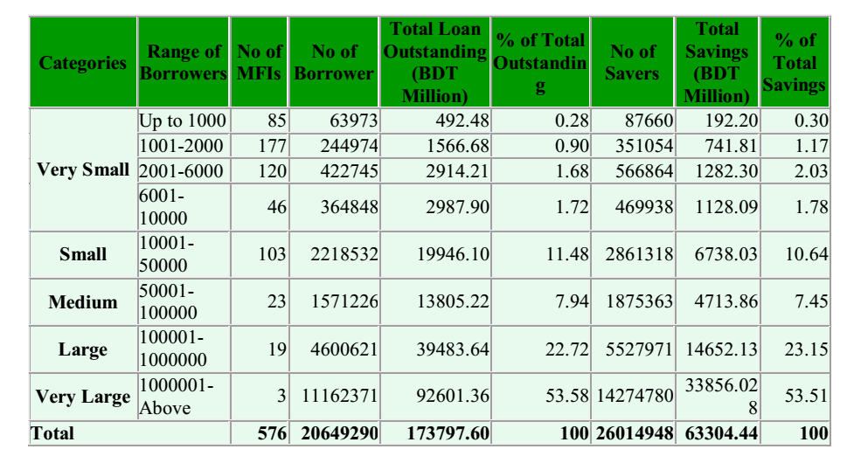
Data source: secondary data

Table-2.2 shows the market scenario of NGO-MFIs in Bangladesh. The top three MFIs contribute 54 percent of total loan outstanding as well as savings of the microfinance sector in Bangladesh. Two of the largest MFIs, viz., BRAC & ASA, are each serving over five million borrowers. There are a few more developing fast. On the other hand the smallest 428 NGO-MFIs have contributed only 4 percent of total loan outstanding and 5 percent of total savings. Institutional concentration ratio is highly skewed in favor of large MFIs: just 22 institutions are in control of 76 percent of the market share while three largest organizations have control of over 50 percent in terms of both clients and total financial portfolios.

Table-2.3: Scenario of Micro Enterprise Loan

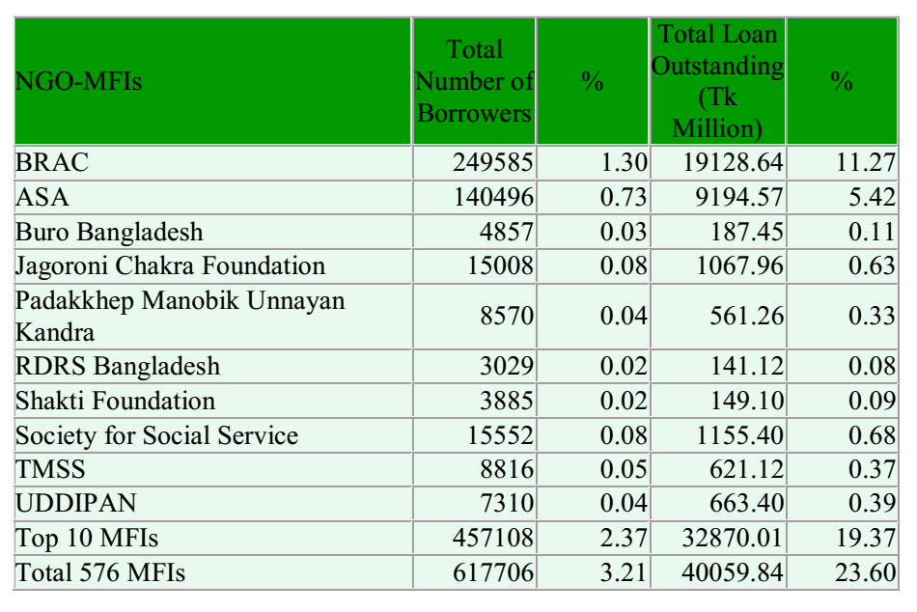

Data source :secondary data

Table-2.3 depicts the scenario of micro enterprise loan, i.e., loans aboveBDT 50,000, of different NGO-MFIs in Bangladesh. It is observed that microenterprise loan outstanding is BDT 40 billion which is around 24 percent oftotal loan outstanding in which the top ten NGO-MFIs contributed around 19percent. It also shows that BDT 40 billion is disbursed to around 6 lakhborrowers which are only 3 percent of total borrowers. The table expresses thatonly the top NGO-MFIs are capable to run micro enterprise loan.

In Bangladesh poverty has many dimensions. The poor in Bangladesh have not only low income but they also lack access to basic needs such as education, health, clean drinking water and proper sanitation. The latter undermines and limits their capabilities and their opportunities to secure employment, results in their social exclusion and exposes them to exogenous shocks. Then the vicious cycle of poverty is accentuated when government structures exclude the most vulnerable from the decision making process.

CHAPTER THREE

METHODOLOGY

3.1 Methodology

This chapter presents the methods used to obtain data from the respondents. It includes the following: - the research design, population and sample size, sampling procedure and measurements and analysis.

3.2: Research Design and Sampling Procedure

3.2.1 Research Design

A cross sectional survey design was used to explore whether access to micro credit, borrowers’ characteristics, business type have a relationship with household income. This design was chosen basing on the nature of the study. This chapter provides perspective on the research design used to investigate the research problem with specific reference to the Survey design, Study setting, Unit of analysis, Type of research, Selecting location, Data collection method, and Statistical techniques (Percentage, Frequency, Mean, Standard deviation, Range).

3.2.2 Sampling Procedure
Stratified and Systematic sampling techniques were used to decide on the micro credit institution and there beneficiaries to be considered for this study.

Stratified sampling technique was used while selecting credit institutions for this study. PKSF nongovernmental net work office (Dhaka) provided details regarding credit institutions in the region. It was revealed that Bangladesh district has 32 registered micro credit institutions. According to the office administrator of PKSF, almost every district has a credit institution. These MCIs where grouped in terms of regions (Dhaka, Chittagong, and so on…)

3.3 Survey design
Basically we are analyzing the role of micro credit in poverty alleviation. Micro credit is known as an effective tool for poverty alleviation. In poor countries like Bangladesh greater attention has been paid to poverty alleviation through micro credit, especially in the last decade. Many micro credit institutions are working in Bangladesh for poverty alleviation but still we can see that gap between poor and rich is increasing every day. Rich is becoming richer and richer and poor is becoming poorer and poorer.
So we take sample all over the country covering 07 Districts in order to analyze the role of micro credit in poverty alleviation. The sample size for this survey is 452 with 25 respondents per area. The study was based on questionnaires which were distributed after translating it into Bangla so that respondents can easily understand it and fill it accordingly. The dependent variable is Poverty reduction where as independent variable is micro credit. And moderating variable is Environment. Environment is taken in a sense that it covers Political environment, it means that what are the government strategies to reduce poverty and to improve living standard of its people. What are the banks policies to reduce poverty, what is the interest rate? What are the conditions on which bank is lending loan with interest-rate to people, are conditions acceptable by people, are conditions affordable by people?

3.4Study setting
Study setting can be contrived and non contrived.
This study is non contrived. When research is conducted in natural environment where work proceeds normally it is non contrived setting. During this study my interference was less in respondent’s routine life.

3.5 Unit of analysis
The unit of analysis refers to the level of aggregation of the data collected during the subsequent data analysis stage. As my problem statement is
Impact of micro credit on poverty alleviation
So; I required data from those individuals who have experienced or experiencing micro credit. In this way it can be observed that what impact micro credit has on their living standard. What was their living standard before utilization of micro credit and after micro credit?
So; here in this study unit of analysis is Individual.

3.6 Type of Research

Research can be undertaken for two different purposes. One is to solve a current problem, demanding a timely solution. For example, a particular product may not be selling well and the manager might want to find the reasons for this in order to take corrective action. Such research is called Applied Research.
The other research that I conducted in this study is Basic research. It is to generate a body of knowledge by trying to comprehend how certain problems that occur in organizations can be solved. Later on the knowledge gained by the findings of basic research can be applied to solve problems.

3.7 Data collection method
We used Questionnaire as a data collection tool. Questionnaire allows the researcher to gather structured information from a large number of individuals. The analysis of questionnaire is easy due to the structured information in it.
To get more relevant data we translated questionnaire into Bangla through In page and then we distributed them to respondents so that they can easily understand questions. Because if we asked them question in Bangla and they answer us. we will not be sure that they perceived my question in exactly that way in which we are asking. So; to overcome this problem we found it better to translate questionnaire into Bangla so that every one can easily read it, understand it and answer it accordingly.
Population consists of the totality of the observations with which researcher is concerned. Where as a Sample is a subset of a population.
Population in this study consisted of people of 07 Division who have taken micro credit and sample was of 452 with 25 respondents per area. Response rate was 100%.
We have used Purposive sampling which is type of Non probability sampling in which the elements in the population do not have any probability attached to their being chosen as sample subjects. Purposive sampling confines to specific type of people who can provide the desired information, either because they are the ones who have it, or confirm to some criteria set by the researcher. As we selected those people who are using micro credit or have used micro credit. Purposive sampling is of two types’ judgment sampling and quota sampling. We have used judgment sampling. This sampling involves the choice of subjects who are most advantageously placed or in the best position to provide the information required. Because those people are experiencing micro credit or have experienced micro credit so they can better tell what impact micro credit has or had on their living standard. Better comparison can be made of their living standard before and after utilization of micro credit.
The responses were tabulated and expressed in terms of percentage and frequencies. Thus the collected data were analyzed statistically using mean, Standard deviation and Range with the help of Statistical Package for Social Sciences (SPSS) and graphs were made on MS Excel and R programming language.

3.8 Statistical techniques

3.8.1 Percentage
A percentage is a special type of proportion where the ratio is multiplied by a constant, 100, so that the ratio is expressed per 100.

3.8.2 Frequency
The rate at which something happens or is repeated is called frequency.

3.8.3 Mean
In statistics, the mean is the mathematical average of a set of numbers. The average is calculated by adding up two or more scores and dividing the total by the number of scores. Consider the following number set: 2, 4, 6, 9, and 12. The average is calculated in the following manner: 2 + 4 + 6 + 9 + 12 = 33 / 5 = 6.6. So the average of the number set is 6.6.

3.8.4 Standard deviation

Standard deviation is a measure of the dispersion of outcomes around the mean (or expected value), used to measure total risk. It is the square root of the variance.

3.8.5 Regression analysis
In statistics, regression analysis is a statistical process for estimating the relationships among variables. It includes many techniques for modeling and analyzing several variables, when the focus is on the relationship between a dependent variable and one or more independent variables. More specifically, regression analysis helps one understand how the typical value of the dependent variable (or 'criterion variable') changes when any one of the independent variables is varied, while the other independent variables are held fixed. Most commonly, regression analysis estimates the conditional expectation of the dependent variable given the independent variables – that is, the average value of the dependent variable when the independent variables are fixed. Less commonly, the focus is on a quantile , or other location parameter of the conditional distribution of the dependent variable given the independent variables. In all cases, the estimation target is a function of the independent variables called the regression function. In regression analysis, it is also of interest to characterize the variation of the dependent variable around the regression function which can be described by a probability distribution.

3.8.6 Correlation and dependence
In statistics, dependence is any statistical relationship between two random variables or two sets of data. Correlation refers to any of a broad class of statistical relationships involving dependence.
Familiar examples of dependent phenomena include the correlation between the physical statures of parents and their offspring, and the correlation between the demand for a product and its price. Correlations are useful because they can indicate a predictive relationship that can be exploited in practice. For example, an electrical utility may produce less power on a mild day based on the correlation between electricity demand and weather. In this example there is a causal relationship, because extreme weather causes people to use more electricity for heating or cooling; however, statistical dependence is not sufficient to demonstrate the presence of such a causal relationship (i.e., correlation does not imply causation).
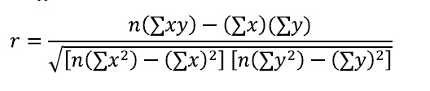

3.8.7 Chi-squared test

A chi-squared test, also referred to as test (or chi-square test), is any statistical hypothesis test in which the sampling distribution of the test statistic is a chi-squared distribution when the null hypothesis is true. Also considered a chi-squared test is a test in which this is asymptotically true, meaning that the sampling distribution (if the null hypothesis is true) can be made to approximate a chi-squared distribution as closely as desired by making the sample size large enough. The chi-squared (I) test is used to determine whether there is a significant difference between the expected frequencies and the observed frequencies in one or more categories.
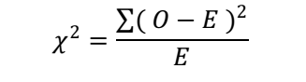

3.8.8 Logistic regression

In statistics, logistic regression, or logit regression, or logit model is a type of probabilistic statistical classification model.It is also used to predict a binary response from a binary predictor, used for predicting the outcome of a categorical dependent variable (i.e., a class label) based on one or more predictor variables (features). That is, it is used in estimating the parameters of a qualitative response model. The probabilities describing the possible outcomes of a single trial are modeled, as a function of the explanatory (predictor) variables, using a logistic function. Frequently (and hereafter in this article) "logistic regression" is used to refer specifically to the problem in which the dependent variable is binary—that is, the number of available categories is two—while problems with more than two categories are referred to as multinomial logistic regression or, if the multiple categories are ordered, as ordered logistic regression.
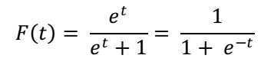
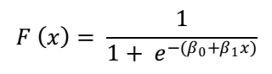
g(.)refers to the logit function. The equation for g(F(x))illustrates that the logit (i.e., log-odds or natural logarithm of the odds) is equivalent to the linear regression expression.
ln denotes the natural logarithm.F(x) is the probability that the dependent variable equals a case, given some linear combination of the predictors. The formula for F(x) illustrates that the probability of the dependent variable equaling a case is equal to the value of the logistic function of the linear regression expression. This is important in that it shows that the value of the linear regression expression can vary from negative to positive infinity and yet, after transformation, the resulting expression for the probability F(x) ranges between 0 and 1.
$β_{0}$ is the intercept from the linear regression equation (the value of the criterion when the predictor is equal to zero).
$β_{1}x$is the regression coefficient multiplied by some value of the predictor.
base e denotes the exponential function.

3.9 Study Population and Sample Size

3.9.1 Population

The study was carried out using beneficiaries who have benefited from micro credit (World Bank, 2007) and 32 registered micro credit institutions by the time of this study (PKSF, 2006).

3.9.2 Sample Size
The sample size was determined according to saunders, Lewi’s and and Thorhill (1997) formula as shown below:
n = p% x q% x (z/e %) ^{2;}
Where p = 0.15 (previous study by BRAC)
q = 1 – p = 0.85
z = standardized Z score for 95% level of confidence z ± 1.962
e = 3.3% (0.033) n=sample size
n=.15*.85*(1.962/.033)2
n= 452

Bailey (1994) noted that sample size can be 30-500. Therefore for this study sample size is 452.

3.10 Data Source

Primary data; this was the main source of data and it was obtained by using a self administered questionnaire which was given to the beneficiaries who were selected from the three institutions.
Also we collect data from previous study.

3.11 Data Collection methods and Instruments

A questionnaire was used to obtain data from the respondents. The selected beneficiaries per institution were called to three different points and the study was introduced to them. Informed consent was sought from the beneficiaries on individual basis before beginning to fill the questionnaires (appendix attached).

The questionnaire is open ended questions on: accessing micro credit, borrowers’ characteristic, business type and household income.

3.12: Variables and their Measurement
The independent variable is accessing micro credit, borrowers’ characteristic, moderated by business type, and the dependent variable is household income. A questionnaire was used to get data from individual respondents. Accessing micro credit was measured in respect of credit facility, resource mobilization, portfolio quality, outreach, gender and marital status on a 5 point likert scale developed by Morgan and Hunny (1994) and recommended by, Shoal and Wong (2000) and Ashok and Han (2000). Borrowers’ characteristic was measured by 5 major items, which include education level, credit worth, knowledge of business, character, collateral and repayment levels. A SERVQUAL instrument (Berry, 1998) developed in the USA using a five point scale ranging from strong agreement too strong disagreement, business type was measured in respect of size or nature of business on a five point as in the case of micro credit. House hold income level was measured in respect of savings, individual income levels, business growth on a 5 point likert scale of strongly agree(5), agree(4), uncertain(3), disagree(2), and strongly disagree(1) as used by Parasuraman, Berry and Zeitahmal (1988).

3.13 Validity and Reliability of the instruments:
While collecting data, every possible attempt to ensure accuracy is taken. These are
The purpose of the study to the respondents is clearly explained as per as possible.
It is tried to impress the respondent by expressing the fact the survey is undertaken by us only for academic purpose.
In a friendly way the questions are determined.
Entries are carefully examined and their consistencies are checked thoroughly.
Validity of the instruments was obtained using the content validity index (CVI). The instrument was given to two experts to give their opinion on the relevance of the questions using a four point scale starting from very relevant, relevant, fairly relevant and not relevant. The CVI’s for the two experts was above 0.6 (0.68, 7.2) respectively. The instrument was considered valid. the internal consistence of scales used on the instruments was measured using Cronbach’s alpha coefficient. Alpha (x) coefficient of 0.6 and above would indicate the instrument’s internal consistence (Sakaran, 2000). All the alphas for the variables were above 0.6, see table below.
Table-3.1: reliability results.
Item/Variable | Cronbach’s alpha
Micro credit access | .874
Borrowers’ characteristic | .889
Business Type | .777
Household income | .740

From the above table it can be concluded that all the constructs exhibited a high degree of reliability with cronbach alpha exceeding the suggested cut point of 0.6. Thus the measurement scales were deemed reliable and demonstrated high degree of internal consistency.

3.14 Data Processing and Data Analysis
Primary data was compiled, sorted, edited, classified and entered using an excel computer programme with a view of checking for completeness and accuracy. Thereafter an analysis involving descriptive statistics, such as frequencies, percentages and inferential analysis followed. This was done with the help of a statistical package for social scientist (SPSS). Specifically frequencies and percentages of the sample characteristics were obtained. This helped us to understand the respondents and institutions we are dealing with and how they relate to house hold income. Pearson’s correlations coefficients were used to generate a zero order correlations coefficients and to establish the significance of relationship.

3.15 Quality control

A protested and standardized tool was used for data collection (questionnaire). The researcher assistant was trained before starting data collection and all the questionnaires were checked for completeness before living the study site.

3.16 Limitations of the study

The major constraint the researcher found was non response from the targeted beneficiaries and also resistance to disclosing easily issues concerning with money. This was partly overcome by scheduling to meet the beneficiaries while they conducted their weekly meeting businesses and reaffirming to them that the information they give will be kept confidentially.
There are some sampling/non-sampling error that we had to deal.
There are some outliers that we have to manage.

CHAPTER FOUR

Analysis of Micro-credit model :yunus equation

4.1: Executive summary

Microcredit is a set of contracts taylored to provide very small loans to very poor people to help develop small businesses or activities generating income. The basic idea came from the finding that a large part of humanity has no access to traditional credit because banks require their borrowers to meet a range of criteria, such as being able to read and write, bears some identification documents, or to have already secured a minimum deposit. The first experiments date back to the 70s in Bangladesh as an initiative of Muhammad Yunus, then a professor of economics at Chittagong University. In 1974, he watched helplessly as a terrible famine in the little village Joha near to his University. He then with his students asks the craftsmen and peasants of the village in order to try to understand their needs and lists a demand for small loans for 42 women to whom he finally decides to pay himself a total of about 2700 BDT. Then he spends nearly 10 years trying to persuade banks to take on these loans before finally deciding to start his own bank, the Grameen Bank in 1983. This bank and himself receive the Nobel Prize for Peace in 2006. Currently microcredit activity has spread to most countries in the world, it is ensured by close 10 000 Micro Finance Institutes (MFIs) who lend 5000 billions euro to almost 500 millions beneficiaries. The main characteristics of microcredit are
- Very small loans over short periods (1000 BDT a year) with frequent (weekly) reimburse-ments.

02. Beneficiaries are mostly women.

03. Borrowers can’t provide personal wealth to secure the loan.

Usually loans are with joint liability of a group of borrowers (5 to 30) each borrower receiving her loan individually but all are interdependent in that they must assume all or part of the failure (called the “default”) of any member of the group.
Interest rates are high, around 20%, some of them up to 30%.
Possibility of a new loan granted automatically in case of timely refunds (dynamic incentive mechanism).
repayment rate close to 100%.

4.2 Concept of Capitalization
To begin, we will make a brief introduction to capitalization in order to well understand the subject. The main idea of capitalization is that one euro today isn’t worth one euro tomorrow but it will be worth more.

Thus, an amount $B_{0}$ invested during a period ∂t is increased of an interest $B_{0}p>0$and will
be worth ${B_{0}+B}_{0}p=B_{0}(1+p)$after this period.
We talk about simple interests when the accrued interest is the same at each period. So, after $T=n∂t$
n periods, it would be worth$B_{0}(1+np)$ .
But, generally, we consider that the increased interest during one period will be increased
during the next periods: it is the formula of compound interests. So, the amount $B_{0}$ will be worth:
• after one period, $B_{∂t }=B_{0}(1+p)$
• after two periods,$B_{2*∂t }={[B}_{0}\left(1+p\right)\left(1+p\right)={[B}_{0}{\left(1+p\right)}^{2}]$
• after n periods.$B_{n*∂t }=B_{T}={[B}_{0}{\left(1+p\right)}^{n}$
If we denote t the successive instants multiples of $∂t$and r
called the continuous interest rate, the real number such that:
$$e^{r∂t}=(1+p)$$
We can rewrite the equation:
$$B_{k*∂t }=B_{t}={[B}_{0}{\left(1+p\right)}^{k}$$
$B_{t}$=$B_{0}e^{r*k∂t}$
$B_{t}$=$B_{0}e^{rt}$
That is what we named capitalization: the fact that money gains value by accumulating interests.

4.3 The Yunus Model : polynomial and equation

Grameen lends 1000 BDT (Bangladesh Taka) to borrowers that pay back 22 BDTeach week during 50 weeks. Let’s denote by r the annual continuously compound interest rate. The present value of the 22 BDT refunded after one week is $22e^{-\frac{r}{52}}$ is value of those of the next payment is $22e^{-\frac{r}{52}}$ …….. and so on. So letting$q$₌$22e^{-\frac{r}{52}}$ as the 50 refundingbalance the 1000BDT received, we get the following equation for$q$:
$$1000=22\sum_{k=1}^{50}{q^{k}}=22\frac{q-q^{51}}{1-q}$$
that reduces to (the degree 51 polynomial equation) Y(q) = 0 where Y denotes what we shall call que Yunus polynomial

$$y\left(q\right)=22q^{51}-1022q+1000$$
We observe that Y has obviously $q$ = 1 as zero, has two other zeros $q_{-}< 0 <q_{+}< 1$, and all other zeros are complex conjugate. An approximation of $q_{+}$ gives $q_{+}$= 0.9962107 . . . which leads to $r$ = 19. 74 . . ., so nearly 20%.

But some borrowers don’t pay in time, so the n-th payment takes place at some random
time

$$T_{n }=T_{n-1}+\frac{1}{52}X_{n}=\frac{1}{52}(X_{1}+X_{2+ }+X_{n})$$
Lets assume $(Xi)i=1..50$ i.i.d, $Xi\sim G(p),$ the geometric distribution, $p$ = P(X_{i} = 1), close to 1 ; in other words each week the borrower has probability p to be able to pay the 22 BDT she should pay, weekly refunding accidents being assumed to be independent. So $r$ becomes a random variable, $R = r(X_{1}, . . . , X_{50}$), satisfying the “Yunus equation” :

$$1000=22\sum_{k=1}^{50}{e^{\frac{-R\left(X_{1}+X_{2+ }+X_{n}\right)}{2}}}=22\sum_{i=1}^{50}{u^{R\left(X_{1}+X_{2+ }+X_{n}\right)}}$$
_{where}$,u$₌$e^{-\frac{r}{52}}$
For the sake of getting a better understanding of the risks faced by the lender under these new assumptions we wish to have information on the probability law of the random variable $R$. The sequel of this paper is devoted to the results we got so far.

4.4 Modeling with lateness
In this part, we decided to model the same system of microcredit but with a risk of lateness. The person who receives the loan has a probability not to pay back on time. However, we supposed that lateness on a given refund would not have any impact on the following paybacks.

So, we still supposed that someone loan 1000 BDT to another person and that the borrower must pay back each week 22 BDT during 50 weeks. But this time, the person who loaned the money can be late on several paybacks. Given that microcredits are intended to very poor people, we can’t ask for lateness penalties. So the duration of the reimbursement is not 50 weeks anymore, but it will be varying according to the payback possibility of the person who need a loan.

4.3.1 Building of the model

Let $X_{n} be a random variable$ which describes the taken time to reimburse on the n^{th} week
By denoting p the payback probability on a given week, thus we can say that a person who borrows some money has a chance of p to reimburse his loan at the end of the first week, a chance (1-p).p to reimburse his loan at the end of the second week (because 1-p is the probability not to pay back on a given week), etc.

Thus, the probabilities associated to each value are: (w is the number of week taken to pay back on the n^{th} week)
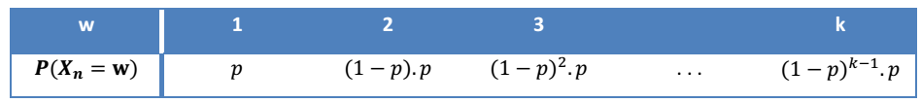
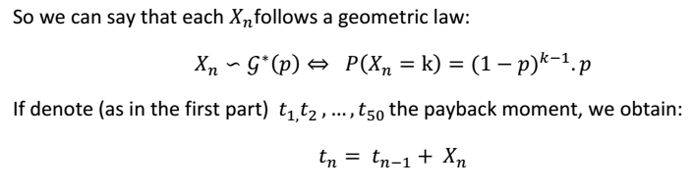

4.3.2 Limit of this Model

The main problem with this model is the independence of the random variables. Indeed we supposed that the lateness on a given week don’t have any effects on the following weeks. But in real life, if someone has an accident, an illness or an economic problem, he won’t be able to pay back on time. This problem could have an influence on the following paybacks. The person can still be sick or handicapped by this accident.

4.3.3 Rates calculation
We will now study rates with two different methods.
The first one, named the effective average rate, is in fact the expected value of the Yunus equation. And the second one is the mean of calculated rates for lots of examples of geometric distributions.
We are going to study these two values in order to see if the second tend to the first one.

4.3.4 Effective average rate
Let $\overline{r}$ be the effective average rate. This number satisfies the Yunus equation in expected value:
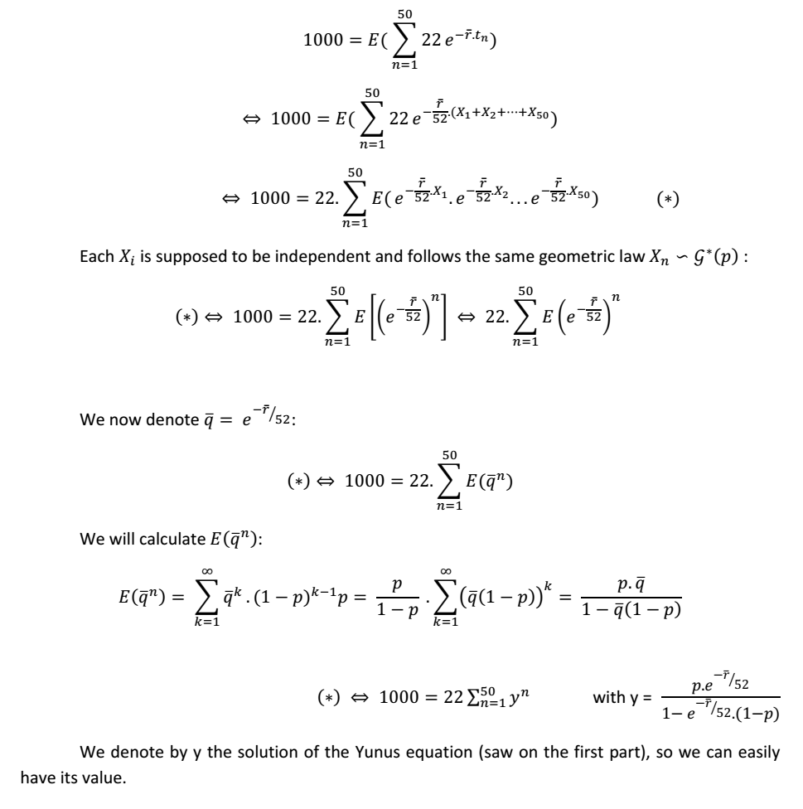
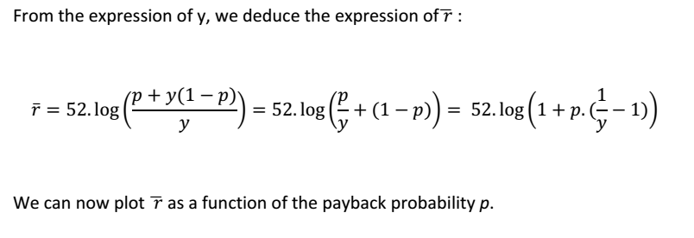

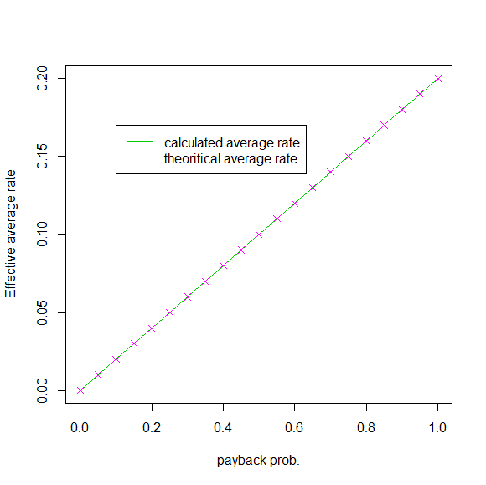

FIGURE 4.1 : eFFECTIVE AVERAGE RATE IN FUNCTION OF THE PAYBACK PROBABILITY
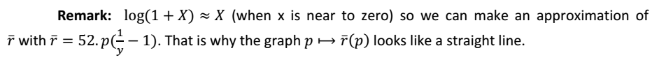

4.3.5 Rate for a geometric distribution
It should be reminded that we want now to calculate the rate for someone who pays back according to a geometric distribution. To do that, it is essential to be able to simulate a geometric distribution. Then we have to rewrite the equation which governs our new model. And finally we will be able to simulate lots of geometric distributions (which represent the payback times), find the associated rates of each distribution and calculate the average rate of these distributions.

4.4 Simulate a geometric distribution

Most of computing tools are able to give a random value equally distributed between 0 and 1. Our goal is to have value on distributed according to a geometric law… So we needed a function which can do that.

We are able to have a random number between 0 and 1. Moreover the sum of the probabilities of a geometric law is 1. So we will divide the interval [0;1] into an infinite number of intervals whose lengths correspond to the probabilities of a geometric law.

Thus we will generate a random number between 0 and 1 and look in which interval it is.
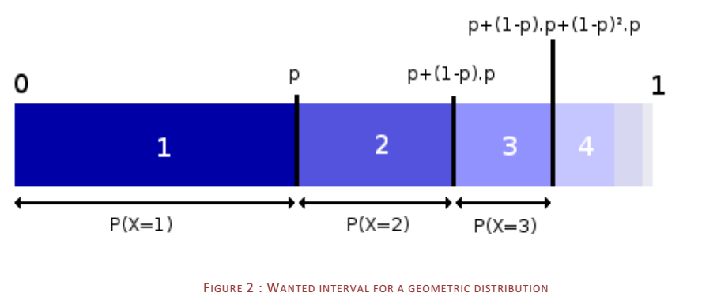

This solution can work but it can be costly to compute it like that. A calculation can help us to be more efficient. Indeed we can remark that:
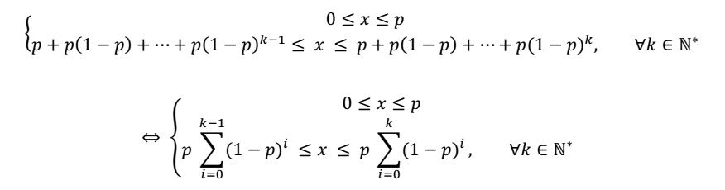
We will take an interest on the second equation. We want to find the term k+1 to have a number distributed according to the geometric law with parameter p:
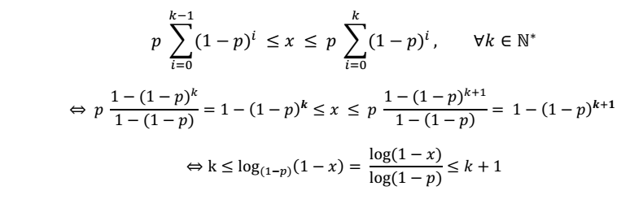 So we just need to take the upper integer of $\frac{log⁡(1-x)}{log⁡(1-p)}$to find the wanted distribution. It is now

easier and faster to simulate a geometric distribution.

4.5 Adaptation of the Yunus equation
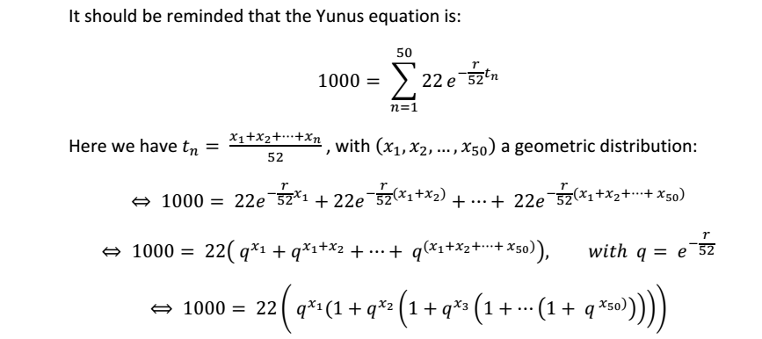
Let us call actuarial expected rate the positive real number $r$ such that, replacing$R$ by$r$, it satisfies the expectation of the Yunus equation :

$$1000=E\left(\sum_{n=1}^{50}{22}u^{-\overline{r}\left(X_{1}+X_{2+ }+X_{n}\right)}\right), u=e^{-\frac{r}{52}}$$
=$22\sum_{n=1}^{50}{E(u^{-\overline{r}X1}})………E\left(u^{-\overline{r}Xn}\right)as X_{1,…………….}X_{n} independent.$

$22\sum_{n=1}^{50}{q^{-n}}=22\frac{\overline{q}-{\overline{q}}^{51}}{1-\overline{q}}$ with $\overline{q}=E\left(e^{-\frac{\overline{r}}{52}X1}\right)=M_{X_{1}}\left(-\frac{\overline{r}}{52}\right)$

Where,
$$M_{X_{1}}\left(t\right)=\frac{pe^{t}}{1-\left(1-p\right)e^{t}} is the moment generating function of G\left(p\right).so$$

$$M_{X_{1}}\left(-\frac{\overline{p}}{52}\right)=\overline{q}=q_{+}$$
$$the positive non trivial zero of the Yunus polynomial, which leads to$$
to
$$e^{-\frac{\overline{r}}{52}=\frac{q_{+}}{q_{+}+p(1- q_{+)}}}=\frac{1}{1+p(\frac{1}{q_{+}}-1)}$$
So $\overline{r}=52ln⁡(1+p\left(\frac{1}{q_{+}}-1\right))$

4.7 Interest Rate from different aspects

Something we have been fuzzy on is what interest rate the Grameen Bank charges. Seems like the sort of thing an aspiring microfinance expert should know.

10 years, the borrower repays her last loan, takes out her accumulated Special savings (including interest), and leaves the Bank. I ignore the need to purchase the 100 taka share because of the wide uncertainty about Grameen's future dividend payments.

Our bottom line? 16.28%/year. But if I change the fraction of loans that borrowers are compelled to save from 2.5% to 5% (maybe some Grameen officers routinely block access to most savings), the credit interest rate rises to 18.75%. You can load the spreadsheet and change the parameters near the top in columns B and E, then view the resulting interest rate in cell H2.

4.7.1 Two last notes:
First, Borden did something else, quite special: he obtained weekly transaction data for all 43 borrowers in a Grameen "center" (borrowing group) in Rajbari District over eight years and used this to compute effective interest rates actually paid. Using a consistent (but flawed) methodology this lowered the rate from 44.1% to 35.6%. So it seems that deferred and missed payments are common enough to lower the effective interest rate substantially. The same should apply to my methodology: even for clients for whom my 24.28% is number is perfectly correct in theory may pay less in practice. On the other hand, clients who save money this way may pay with higher stress.
Inflation, consumer prices (annual %)
On balance, Grameen Bank loans, like most microcredit in South Asia, seem pretty cheap.

On whether Grameen Bank clients are properly informed that what is billed as "10%" works out to more like 24%, see last year's Reflections on Transparency.
Update: In response to Fehmeen's suggestion, I have incorporated the mandatory share purchase and the dividends into the spreadsheet. To keep it consistent with the results I quote above, I have added a parameter to turn off this consideration. Change "Factor in share purchase?" in the upper left from 0 to 1 to enable it. Using a dividend rate of 30 taka/share (the rate of the last two years) lowers the nominal credit interest rate from 24.28% to 23.33%. Keep in mind, however, that with the Grameen Bank, as with any investment, risk and return ought to go together. The spreadsheet assumes, probably incorrectly, that dividends will be paid at the same rate each year like clockwork. It therefore reflects the high recent returns to ownership of Grameen shares, but not the associated risk.

4.7.2 Interest rate from experimental results
We have the chance to have with R (effective average rate) by which we did some numerical experiments. It turns out that the law for R is impressively similar to a $N (µ, σ$), with $µ = \overline{r}$

Figure-4.3 Interest rate from experimental results
From the graph it is seen that interest rate is obviously 10 ≤ R ≤ 20%

4.8 Default calculation
We say that there is a d-default if Max{$x_{1}+x_{2}+………….x_{n}\}≥d$ . It means that we set a kind of tolerance limit d, and there is a d-default when someone doesn’t pay back one time before the d^{th} week.If we denote $π_{d}$the probability of a d-default for a given d, with p the payback
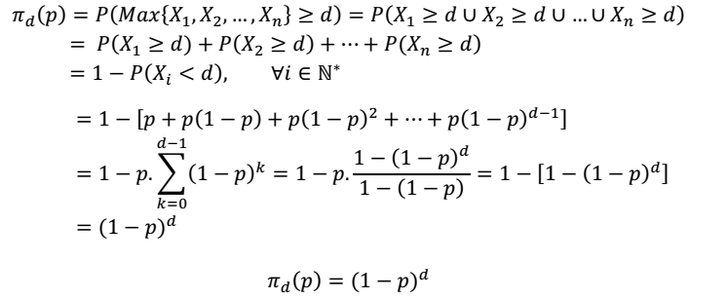
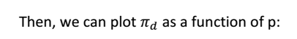

Figure 4.4 Default in function of the probability
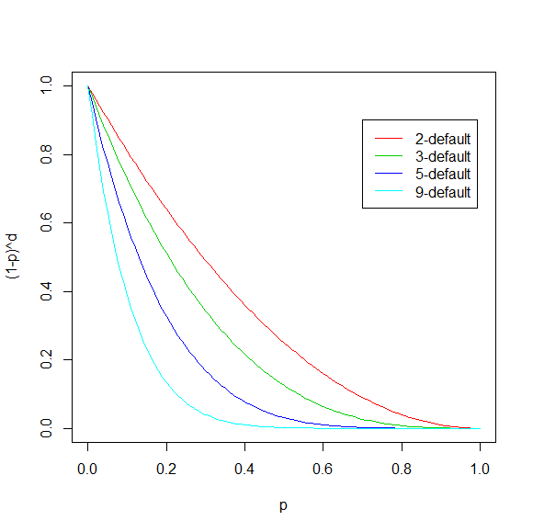

We can see on the graph that the default probability in function of the payback probability is a decreasing function. Moreover, the lower the tolerance level is (it means the smaller d is), the less decreasing is the function.

4.8 .1 D-default utilization

We will now suppose that we want a probability of d-default of 5% for a given d, it means: $π_{d}\left(p\right)=5\%$ where p is the probability of payback. Our goal is to find the
payback probability corresponding to this equation to see in which way the tolerance level has an effect on the probability of a d-default
so we have,
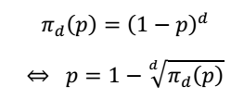
We can calculate easily the corresponding payback probability, and equally its related effective average rate, for example:
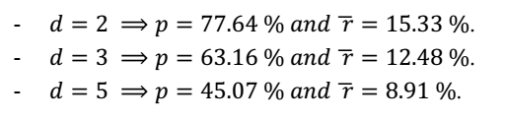

So we can see that the more tolerant the loaner is, the smaller is the rate

4.9 Comparison with another model
We decided to compare the Yunus model with a quite similar model. The Cambodian student who will study this subject for the next two years tell us that in Cambodia, people are used to payback every two weeks. So we assume now that borrowers will reimburse 44BDT every two weeks.
In this case, the interest rate is 19.34997%. If we compare it to the rate when people pay back every week (19.74175%), you can see that it is a little bite inferior. This can be explained by the fact that one euro today is not worth one euro tomorrow. Money lent to people don’t yield a profit for the lender during two weeks (whereas one week, in the previous model) because he hasn’t got it. So the lender “loose” money during this time. That is why, the interest rate is inferior. To pay-back at the same interest rate, every two weeks, the borrower should refund 44,084 BDT every two week. The rate is 19.74324%.

4.10 Modeling with correlated lateness
The model which uses geometric random variables is not accurate because we can’t say if at a time a person has a problem on his pay-back, that won’t have an influence on his next pay-back. That is why we introduced a correlation between two successive variables. In other words, that means the following variable depends on the previous one.

4.11 Building of the model
We built our model as a sum of a variable distributed according to a geometric law and a variable depending on the previous one. We initialised the first variable with its geometric part: it can’t depend on something that happens before.
In our model, the correlation is a ratio of the pay-back probability. We thought that the higher the probability to pay-back is, the less high the correlation between two variables is. Indeed, if the probability to pay-bay is high, people will refund their dues approximately each week: the correlation is near to zero. The contrary is equally true: if the probability to pay-back is low, people will refund their dues with lateness and the correlation his high. That is why the correlated term is a ratio of (1-p).
Another property of the correlation is that it can be positive or negative. You have to remind that a microcredit is used in poor countries. So, we can easily imagine at least two reasons for an inability to pay back:
We can first imagine that the lender is very sick and can’t go to his work. Because he doesn’t work, he won’t have money this week. The next week, when he will have money, he would prefer to spend it to feed his family than to refund his loan. In this case, there is a positive correlation.
Then we can imagine that the lender sell bamboo stools. During two weeks, his business is very bad, he won’t be able to pay is loan for two weeks, but on the third week his business is very great, he will be able to refund his loan. In this case, there is a negative correlation.

Then, in order to be consistent with the reality and don’t have very long time of refunds, we divided the correlation term by ten. We chose ten by trial and error method. If we denote by a the correlation term, we got:
$$a=\frac{1-p}{10}$$

4.12 Model with negative correlation
According to what we said before, mathematically speaking, the model can be written
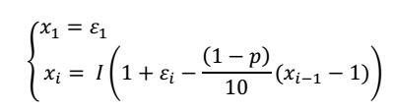
Where ( $x_{i})$ ,1≤ i≤ n is the vector which indicate the number of weeks between two refunds
${(ɛ}_{i})$ where 1≤ i≤ n is a vector of variables distributed according to the geometric law and I is the function integer part
We were obliged to use the integer part because ( $x_{i})$ ,1≤ i≤ n is a vector of integer and ,
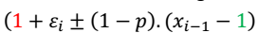
Was not an integer type.
We also added 1 (in red) to be sure the number of week between two refunds is at least one: it is not consistent to reality a person refund before one week. And, we took away 1 (in green) in order not to make our time of refunds explode.

4.13 Model with positive correlation

In the case of positive correlation, we don’t need any more the plus 1 to be sure the number of week between two refunds is at least one. So, the mathematical model can be written

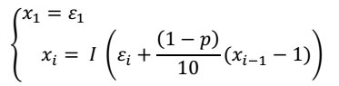

Where ( $x_{i})$ ,1≤ i≤ n is the vector which indicate the number of weeks between two refunds
${(ɛ}_{i})$ where 1≤ i≤ n is a vector of variables distributed according to the geometric law and I is the function integer part.

4.14 Results
We simulated lots of correlated distributions with parameter p=0.8, calculated the rate for each distribution and finally calculated the average of these rates.

We got these following histograms for 5,000 simulations with the same parameters values we used on part II. We weren’t able to get results for more simulations.

4.15 Positive correlation results
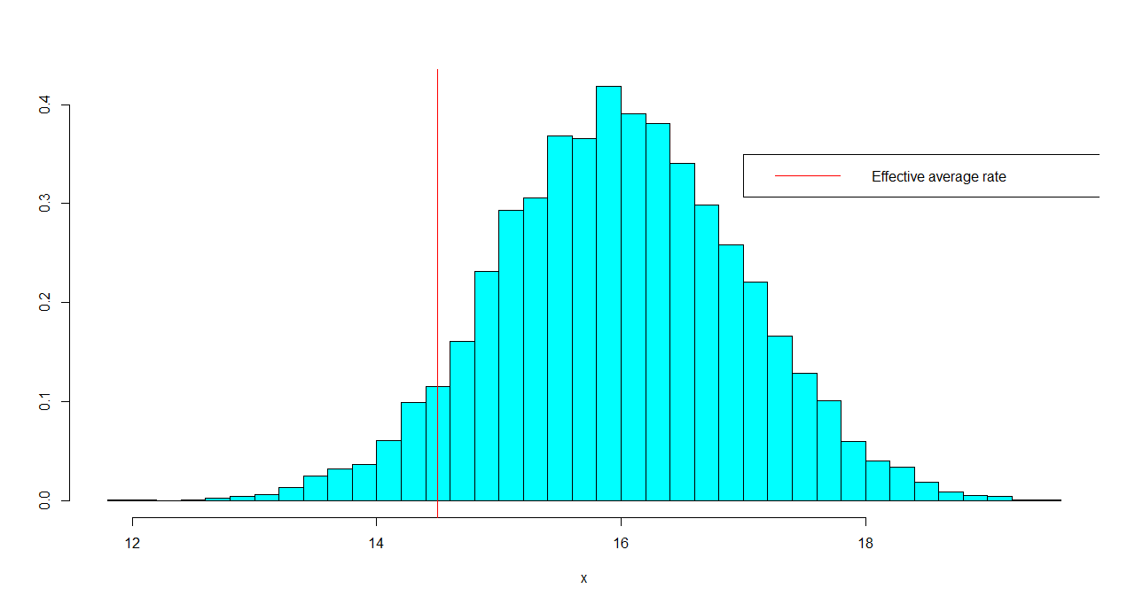

Figure 4.5 Interest rate for 452 positive correlated distribution

4.16 Negative correlation results
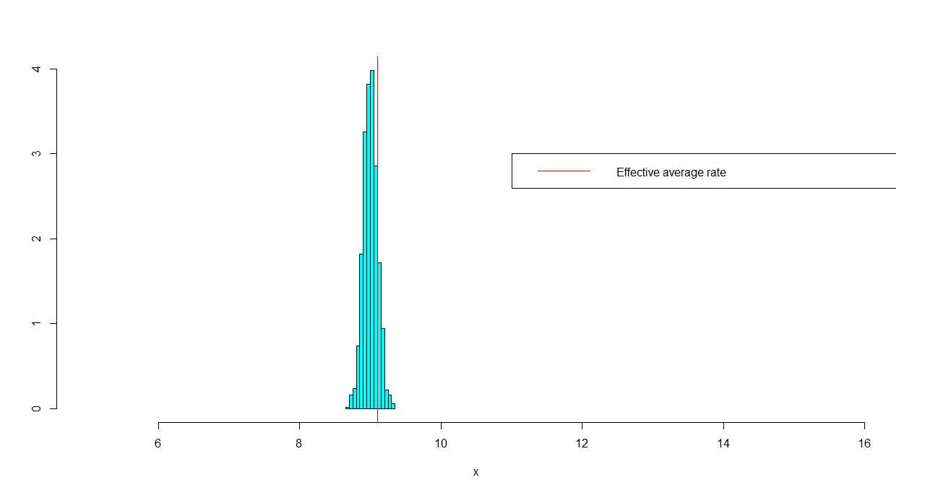

Figure 4.6 Interest rate for 452 negative correlated distribution

4.17 Analysis of the results
In the case of positive correlation, the average of the calculated interest rates is higher than in the case of negative correlation. This result seems very normal, because in the case of positive correlation, people will spend more time to refund money. And, because one euro today is not worth one euro tomorrow, the lender makes a rate inferior to the initial one and vice versa.
Now, if we compare the average of the calculated interest rates in case of positive correlation with the average of the calculated interest rates for a simple geometric distribution with lateness (15.86641%), we can see that they are quite the same.
Whereas, if we do the same thing but with the negative correlation, the two average rates are very different from each other. It is not necessarily a bad model given that we don’t have access to statistics that show what really happen with micro-credits.

4.18 Consumer credit
In this last part, we wanted to compare consumer credit with micro-credits. To do that, we had to build a consumer credit model.

4.18.1 Consumer credit model
In this model, we assumed that borrowers would have lateness penalties. Indeed, each time he couldn’t payback one week, he had to pay back his due the following week increased by 4% (in addition to the normal payback).
To compare the results with the results obtained with the Yunus model, we assumed that borrowers loaned BDT 1000 and had to refund BDT 22 each month.So the amounts to be refund are:
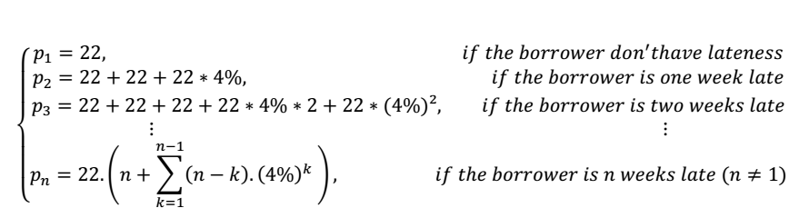

4.19 Simulation
Firstly, we decided to calculate the applied rates assuming that the borrower didn’t be late in any payback. We found a rate of 19.74%, it means the same as the one found with the Yunus model in the part I. This result is completely coherent because the borrower hadn’t any lateness in his payback, so he hadn’t to pay any lateness penalty.
Then we computed with R lots of geometric distributions and plotted as before the histogram of the calculated rates:

Figure 4.7 Interest rate for consumer credit model
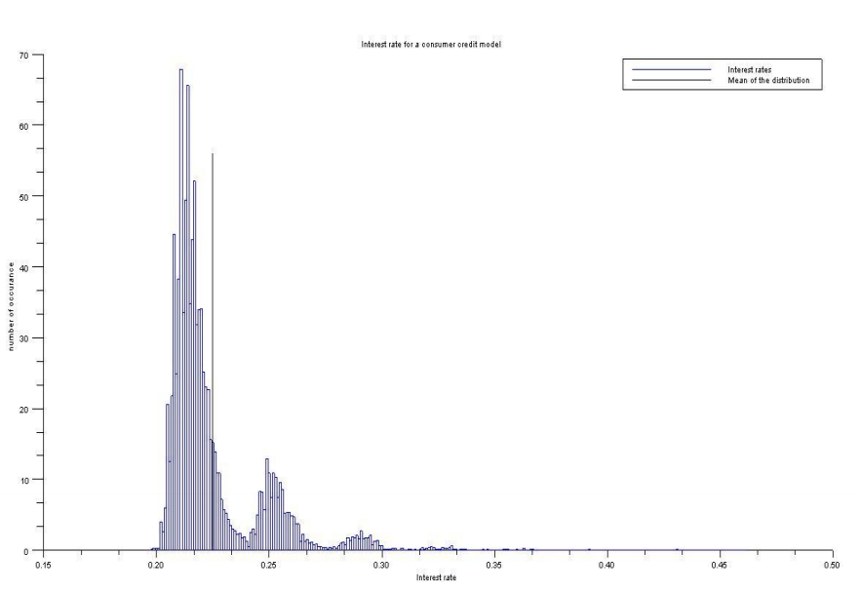

We can see on this graph that the average of the calculated rate (the black line) is higher than the rate applied for a person who is never late. Moreover we can see that interest rates can reach more than 35% for bad debtors.

But this model is not a quite realistic consumer credit system, because the interests are very high (even if borrowers were not late in any payback).

4.20 CONCLUSION
Through this project, we have seen a main characteristic of micro-credits. In comparison with credit interest rates charged in developed countries, micro-credits apply very high interest rates: in France, they are approximately of 3% in contrast to the 20% in the Yunus model.
But this interest rate is lower when people are late in their payments. These are the case of the geometric distribution, the negative and positive correlation. But the rate varies with each situation: it is lower on the model of lateness with positive correlation than on the geometric distribution or on the negative correlation. Indeed, it varies with the number of weeks in total for paying off the entire loan. The more weeks to refund is, the lower is the rate.
This phenomenon can be explained thanks to the fact that one euro today isn’t worth a euro tomorrow. So, according to capitalization, if a person doesn’t reimburse on time, his loaner will lose money: that is why the loaner charge a lower rate.
Nevertheless, we can say globally that the rates are very high. They aren’t inferior to 9%.
If consumer credit companies wanted to do microcredit with the same rules they do in developed countries. The average interest rate really charged will increase. It will be approximately of 22.5%. This is not a good thing for them because they are already poor. We don’t have to forget that microcredit has a social dimension: it was created to help people to exit poverty, not for making profits on them and to impoverish them more than they already are. So, if consumer credit companies wanted to really do microcredit they have to change their rules.

CHAPTER FIVE

ROLE OF MICRO CREDIT IN POVERTY ALLEVIATION

5.1 Role of micro credit in poverty alleviation
Micro credit Programs extend small loans to very poor people for self employment projects that generate income for their survival, allowing them to care for themselves and their families. Developed over the past twenty years, micro credit is now considered as one of the most effective tools that we used to fight poverty. It is not charity, but investment, and to understand it we need to look at poverty in the world today.

Poverty is a global issue. Despite changes in development paradigms in the last half of the 20th century, the promise to bring wellbeing to all human being remained unfulfilled. As it stands, more than 100 million children of primary school age have never stepped inside a class room, about 29000 children die each day from largely preventable malnutrition and disease and more than 1.2 billion people in the world are struggling to survive at the margin of human existence “on under a dollar a day”. Poverty is the problem for all the countries irrespective of their level of development. It can be observed in many forms. It has both income and non income dimensions. It may be a lack of income or resources, a lack of coping capacity, a lack of basic human capabilities, a lack of institutional defenses or in extreme cases a lack of all of these. In a wider sense, it may be a combination of economic, social and political deprivations.

In consideration of poverty line, people in each country can broadly be divided into two categories namely poor and non poor. The non poor are living above and the poor are living below the poverty line. The poor may be divided into destitute (Bottom 10 percent below the poverty line), extreme poor (those in the bottom 10 to 50 percentile of households below the poverty line), and moderate poor (those top 50 percent of households living below the poverty line are moderate poor). A further category of vulnerable non poor may also be recognized who may slip into category of poor anytime.

world. Professor Yunus compared his dream, complete eradication of poverty from this world, with the Wright brothers’ attempt to fly and the following success in flying and aviation. He mentioned that he would also be able to go to his moon, Poverty free world, in 55 years time through the micro credit program (Yunus, 1997).

In current overview it has been able to gain huge popularity, both in number of clients and organizations using microfinance, and in rate of loan return.
Where the traditional banks did not considered the poor as loan worthy because of the uncertainty of their returning ability, Grameen Bank (the largest micro credit organization of Bangladesh and joint winner of the Nobel Peace Prize) has claimed around 99% returning rate. It is interesting to note that the main borrowers of this money are women and this is a policy decided by the Bank. Women are regarded as more trustworthy and able to deal with money more skillfully than men and this in turn has lead to their empowerment. The high rates of loan return have helped microfinance organizations like the Grameen Bank to become self-reliant (not depending on the donors any more) and bring a lot of people out from the national poverty level (Yunus, 2006).

5.2 Broad Problem area

The greatest challenge that developing countries like Bangladeshis facing is POVERTY. Majority of population in Bangladesh is living below poverty line. This poverty is becoming cause of several problems like suicides, crimes, depression etc in order to control these problems poverty has to be controlled, for this purpose many strategies at government level and international level are made every day. Purpose of this study is basically to see how micro credit customers believe that micro credit has changed their lives. In Bangladesh many micro credit institutions are providing micro credit facilities. So; in this paper we tried to see how micro credit institutions are affecting consumer’s living standard.

5.3 Transmission Mechanism of Micro credit to Poverty Alleviation
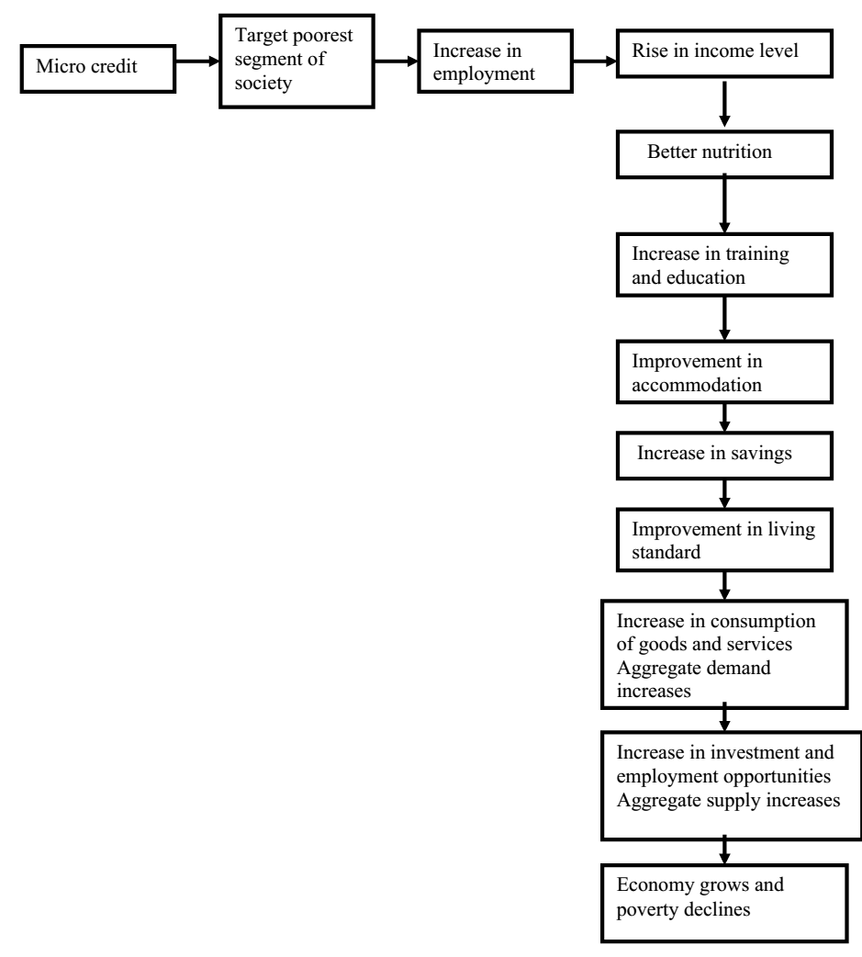

5.4 Theoretical Frame Work

After conducting surveys, completing a literature review and defining problem statement, one is ready to develop a theoretical frame work.

A theoretical frame work is a conceptual model of how one theorizes or makes logical senses of the relationships among the several factors that have been identified as important to the problem.

After theoretical frame work I developed hypothesis to examine whether the theory formulated is valid or not. The hypothesis relationships can therefore be tested through appropriate statistical analysis.
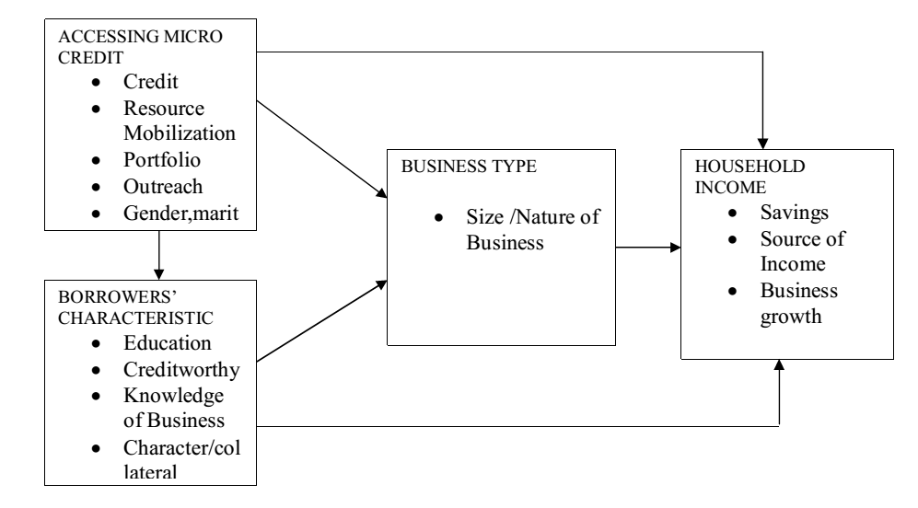

5.5 Variables

A variable is anything that can take on differing or varying values. The values can differ at various times for the same object or person, or at the same time for different objects or persons.

5.5.1 Dependent Variable

The dependent variable is the variable of primary interest to the researcher. The researcher’s goal is to understand and describe the dependent variable, or to explain its variability, or predict it. In my study dependent variable is Poverty reduction.

5.5.2 Independent Variable
An independent variable is one that influences the dependent variable in either positive or negative way. That is, when the independent variable is present, the dependent variable is also present, and with each unit of increase in the independent variable, there is an increase or decrease in the dependent variable also. In other words, the variance in the dependent variable is accounted for by the independent variable. In this case independent variable is Micro Credit.

5.5.3 Moderating Variable

The moderating variable is one that has a contingent effect on the independent and dependent variables relationship. That is, the presence of a variable (moderating variable) modifies the original relationship between independent and the dependent variables. I have taken environment as a Moderating Variable.

Environment is taken in a sense that it covers Political environment, it means that what are the government strategies to reduce poverty and to improve living standard of its people. What are the banks policies to reduce poverty, what is the interest rate? What are the conditions on which bank is lending loan to people, are conditions acceptable by people, are conditions affordable by people?

5.6 Schematic diagram for the theoretical frame work
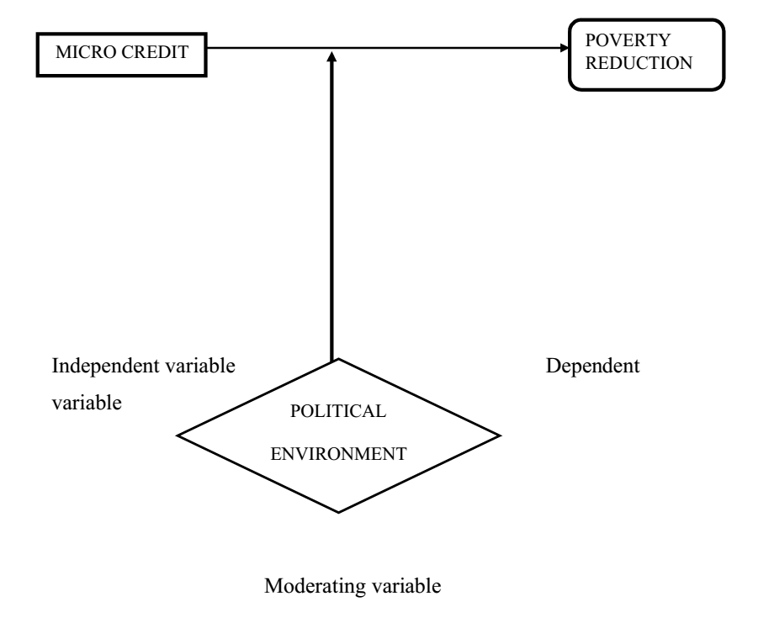

Here micro credit is taken as an independent variable and poverty reduction as a dependent variable. When micro credit increases poverty decreases so; poverty reduction is dependent on micro credit.

Some of the factors that show poverty reduction are Training and education, clean water and hygienic environment, Nutrition and adequate food, Accommodation, Income and savings.

5.7 Hypothesis development
Hypothesis can be defined as logically conjectured relationship between two or more variables expressed in the form of a testable statement.

Once the researcher identifies the important variables in a situation and establishes the relationships among them through logical reasoning in the theoretical frame work, now is a time to test whether the relationships that have been theorized do in fact hold true. By testing these relationships scientifically through appropriate statistical analysis researcher is able to obtain reliable information on what kind of relationship exist among the variables operating in the problem situation. The results of these tests offer some clues as to what could be changed in the situation to solve the problem. Formulating such testable statements is called hypothesis development.

5.8: Materials and Methods

The principal method employed for this study was a field survey using a semi-structured interview schedule. The study was conducted in 07 Division region of Bangladesh. The study villages and unions were selected based on availability of credit recipient people. Only the micro-credit recipients of the study area were considered as population for the study.

Impact of the credit program was assessed by comparing the situation of change in income, assets development, level of living, lifestyle patterns and poverty status before and after engagement with credit program. Change in living standard is a broad term and it was measured in terms of change in sources of drinking water, hygienic and sanitation practices, medicare, annual expenditure on clothing and electricity consumption. Different statistical tests (Chi-square, F-test) were used to analyse the association and extent of contribution within the variables. In order to assess the factors related to income, education and other variables of the borrowers, multiple regression analysis was performed.

5.9 Data Presentation, Interpretation and Discussion

The model used for this analysis can be explained as follows:

Y = a + b1 *x1 + b2 *x2 + b3* x3 + e

Where, Y is the monthly income now after taking microcredit

x1 is Respondent's education status

x2 is No. of members in respondent's family

x3 is number of earning members

b₁, b₂ and b₃ are regression coefficients of the corresponding independent variables and “e” is random error, which is normally and independently distributed with zero (0) mean and constant variance.

ANOVA
Model |  | Sum of Squares | Df | Mean Square | F | Sig.
1 | Regression | 168.518 | 4 | 42.130 | 27.517 | .000^{b}
 | Residual | 684.367 | 447 | 1.531
 | Total | 852.885 | 451
a. Dependent Variable: monthly income now after taking microcredit
b. Predictors: (Constant), Respondent's education status, No. of earning members in respondent's family, total amount of micro-credit have taken this year, Respondent's no. of family member

Coefficients
Model |  | Unstandardized Coefficients |  | Standardized Coefficients | t | Sig.
 |  | B | Std. Error | Beta
 | (Constant) | 3.048 | .234 |  | 13.032 | .000
 | No. of earning members in respondent's family | .410 | .100 | .188 | 4.099 | .000
 | Respondent's no. of family member | .067 | .040 | .077 | 1.682 | .093
 | Respondent's education status | .309 | .071 | .192 | 4.351 | .000
a. Dependent Variable: monthly income now after taking microcredit

Table -5.1:monthly income now after taking microcredit with respect to respondent’s no of earning members,no of family member & education status.

Comment:

For one unit change in number of earning members in respondents family,the monthly total income after taking microcredit will increase in 0.410 unit for one unit change in respondent number of family members,the monthly total income after taking microcredit will increase in 0.067 unit for one unit change in respondents education status(such as illiterate to primary) ,the monthly total income after taking microcredit will increase in 0.309 unit

5.10 Logistic Regression
In order to estimate the satisfaction level of a respondent house necessities, we consider a multiple logistic regression model which takes up the satisfaction level as the dependent variable and respondent’s education, family income,gender and husband occupation as independent variables. The reason behind the use of logistic regression model is that the outcome dependent variable -satisfaction status is dichotomous in nature. The logistic regression model can be used not only to identify risk factors but also to predict the probability of success. This model expresses a qualitative dependent variable as a function of several independent variables – both qualitative and quantitative (Fox, 1984).

Variables in the Equation
 |  | B | S.E. | Wald | df | Sig. | Exp(B)
 | Education |  |  | 4.332 | 3 | .228
 | Primary | .590 | .722 | .666 | 1 | .414 | 1.803
 | Secondary | .859 | .708 | 1.472 | 1 | .225 | 2.362
 | Higher | .133 | .721 | 2.469 | 1 | .116 | 1.142
 | Family_income |  |  | 24.057 | 7 | .001
 | Below 50000 | -21.230 | 40192.970 | .000 | 1 | 1.000 | .000
 | 50000-60000 | -1.808 | .565 | 10.251 | 1 | .001 | .164
 | 60000-70000 | -1.538 | .660 | 5.428 | 1 | .020 | .215
 | 70000-80000 | -.752 | .522 | 2.078 | 1 | .149 | .471
 | 80000-90000 | .003 | .470 | .000 | 1 | .995 | 1.003
 | 90000-100000 | .615 | .363 | 2.862 | 1 | .091 | 1.849
 | Above100000 | -.552 | .367 | 2.257 | 1 | .133 | .576
 | Husbands_occupatin |  |  | 2.220 | 5 | .818
 | Farmer | 19.696 | 40191.501 | .000 | 1 | 1.000 | 357900594.980
 | Labour | 19.212 | 40191.501 | .000 | 1 | 1.000 | 220581888.934
 | Business | 19.410 | 40191.501 | .000 | 1 | 1.000 | 268902208.559
 | Other | 19.365 | 40191.501 | .000 | 1 | 1.000 | 257181309.281
 | Gender(female) | -1.265 | 56840.405 | .000 | 1 | 1.000 | .282
 | Male | -.531 | .761 | .487 | 1 | .485 | .588
 | Constant | -19.997 | 40191.501 | .000 | 1 | 1.000 | .000
a. Variable(s) entered on step 1: education, Family_income, Husbands_occupation, gender.

Table-5.2: satisfaction level of the rate of interest with respect to education, family income, husbands occupation, gender.From Table (5.2), we may conclude that educated people are satisfied with the rate of interest, but higher educated people are not satisfied with the rate of interest in our study. Income level is an important factor to measure the level of satisfaction on interest rate. It has positive impact on satisfaction level. Gender (male) of the respondents is negatively related to the dependent variable .Male respondents does not improves the satisfaction level. Table 4 also indicates that satisfaction on interest rate also depend on how among the respondent’s husbands. Hence we may conclude that this interest rate make life easy, which is positively related to the satisfaction on respondents. We may also conclude that the high interest rate of the micro-credit result decrease in the satisfaction level on respondents. On the other hand, reasonable interest rate of the micro-credit of respondents increases the level of satisfaction.

5.11 Associate Relation between Access to Credit and Poverty Category:
Data contained in Table (5.3) are the basis for testing the research hypothesis which shows that micro-credit has a significant impact on poverty reduction.

Poverty category | Access to credit |  | d.f. | Chi-squarer value
 | Before | After
Poor | 369(81.6%) | 108(23.9%) |  | 62.454**
Non-poor | 83(18.4 %) | 344(76.1 %) | 1
Total | 452 | 452
Critical region at 1% level of significance is 6.635

Table-5.3:Associate relation between access to credit and poverty category.

Figure-5.1 Change in economic status after accessing micro-credit

This also indicates that before involvement with credit program the poor were 81.6% and thereafter decreased to 23.9%. Accordingly, before involving with micro-credit, the non-poor were 18.4% and then increased to76.1%. This implies that incidence of poverty decreased through access to credit.

Figure-5.2 Ability to buy meat and fish before taking micro-credit.

From the above figure (pie-chart) we can say that the ability to buy meat or fish before taking micro-credit among 452 respondents 9% of them have abundance of food, 11% of them can buy as much as they want, 15% have increased totally, 18% have improved a lot, and 47% have improved.

Figure-5.3 Ability to buy meat and fish after taking micro-credit.

Comment: From the above figure (pie-chart) we can say that the ability to buy meat or fish after taking micro-credit among 452 respondents 6% of them can buy as much as they want, 4% have abundance of food, 9% have improved a lot, 8% have increased totally, 23% better than before, 24% have improved, and 25% no response

Table-5.4:Multiple Regression Coefficients of Contributing Factors on Total Income after Joining Micro-Credit Program.

Dependent | Independent variables | Regression | Adjusted R² | F-value
variable |  | coefficient
 | Loan amount received | 1.180e-005****
Total income | Income through utilization of credit | 0.008**
after joining | Number of earning member | 0.0410** | 0.128 | 27.517***
credit program
 | Years of schooling | 0.309**
 | Household size of the respondent | 0..067

* and ** indicate significant at 5% and 1% level of significance respectively.

Table (5.4) shows that there is a significant contribution in loan amount received, income through utilization of credit, number of earning member and years of schooling after joining the micro-credit program. Among these, income through utilization of credit is the most important contributing factor (significant at 1% level of significance), whereas the coefficients of other factors are significant at 5% level of significance. conducted similar study who found that there was a positive and significant relationship between the amount of credit and the total income.

Table-5.5 Coding table
Chi-Square Tests
 | Value | df | Asymp. Sig. (2-sided)
Pearson Chi-Square | 44.200ª | 7 | .000
N of Valid Cases | 452
a. 2 cells (12.5%) have expected count less than 5. The minimum expected count is .31.
Hypothesis:

H0: There is no association between sanitation and total income

H1: There is association between them.

Decision:

We know that H0 is rejected if p-value is less than any level of significance. From the above table we have enough evidence to say that at 1% level of significance H0 is rejected i.e. there is association between sanitation and total family income.

Figure-5.4:Sanitation versus family income

Figure-5.5 Gender versus using years of micro-credit.

It has been observed from the table that out of 338 female 92(27.2%) take microcredit since (1-2) years, 86(25.4%) since (3-4)years, 65(19.2%)since (5-6)years,39(11.5%)since(7-8)years,32(9.5%)since (9-10)years,24(7.1%)since above 10 years and it has been observed from the table that out of 114 male 39(34.2%) take microcredit since (1-2) years, 30(26.3%) since (3-4)years, 17(14.9%)since (5-6)years,13(11.4%)since(7-8)years,7(6.1%)since (9-10)years, 8(7.0%)since above 10 years.

Comment: so we can conclude from the crosstab and histogram that females are using microcredit more than males and day by day the percentage of users increasing.

Figure-5.6 Frequency of male and female taken micro-credit.

From the above figure we can say that among 452 respondents 75% of female and 25% of male have taken microcredit in this year.

Table-5.6:Association between education status and enough income.
Chi-Square Tests
 | Value | df | Asymp. Sig. (2-sided)
Pearson Chi-Square | 30.296ª | 3 | .000
N of Valid Cases | 452
a. 0 cells (0.0%) have expected count less than 5. The minimum expected count is 6.29.
Hypothesis:

H0: There is no association between education status and enough income.

H1: There is association between them.

Decision: We know that H0 is rejected if p-value is less than any level of significance. From the above table we have enough evidence to say that at 1% level of significance H0 is rejected i.e there is association between education status and enough income.

5.12: Age of Respondents

20% of the beneficiaries were aged between 19 to 25 years while 21.3% were aged between 26 to 30 years, 22.7% were aged between 31 to 35 and 36 to 40 and 13.3% were above 40 years as presented in table 4.1 below. The results indicate that most of the beneficiaries are neither too old nor too young. According to the administrator s of the institutions, this is the most active age group amongst the beneficiaries. Olujide (2008) agrees with this observation. While talking to the beneficiaries it was clear that, this age group has many needs which call for hard work in order to fulfil them. When the potential borrowers’ access credits they always try and put it to better use for example by engaging in different businesses. This will lead to increased productivity, ownership of assets and the end result will be improved household incomes of the poor people. According to Mugerwa (2000) micro credit institutions always give funds to active people who clearly know why they want the funds.

Table-5.7: shows the frequency and percentages of beneficiaries according to age.

Variable –Age | Frequency | Percentage
19-25 | 90 | 20
26-30 | 95 | 21
31-35 | 100 | 22
36-40 | 100 | 22
Above 40 years | 67 | 13
 | 452 | 100
(Source: Primary data)

5.13 Marital status

2.7% of the beneficiaries were single while 97.3% were married as shown in the table below. The married form the majority of respondents, this can be linked to the fact that they are more responsible and have many financial needs as compared to single people. Married people will borrower in order to get start up capital. This enables them to engage in businesses which will increase their productivity and eventually their household incomes. Credit institutions also find it easy to give credit to married person then single persons since most of the time they give security to one other (Olijude, 2008).

Table-5.8: frequency and percentages showing marital status of the Respondents

Variable  Marital status | Frequency | Percentage
Single | 12 | 2.7
Married | 440 | 97.3
Total | 452 | 100
(Source: Primary data)

5.14 Number of years with the institutions.

72.78% of the respondents had stayed with the institutions for more than 5 years as per table 4.5 below. Implying that the respondents had a better understanding of micro credit operations and their answers can be relied upon greatly. It’s also important to note that for a beneficiary to stay for all this time in an institution means that he/she is benefiting from the operations of a micro credit institution. It was noted while talking to the beneficiaries that their incomes and assets had increased over time. For example most of them were involved in farming, fishing, retail business and second hand cloths and a number of them had bought bicycles and a few had motorcycles.

Table-5.9: Frequency and percentages showing respondent’s number of years with institution

Variable  number of years | Frequency | Percentage
1-2 | 131 | 28.98
3-4 | 116 | 25.66
5-6 | 82 | 18.14
7-8 | 52 | 11.50
9-10 | 39 | 8.63
Above 10 | 32 | 7.07
Total 452 100

Figure-5.7:using year of micro-credit

(Source: Primary data)

Comment: using years of micro credit from 1 to 6 years is 329 out of 452 which is 72.78%.

Figure-5.8:Living status of respondents after taking micro-credit

Table-5.10 Living status of micro-credit borrowers

Living status | frequency | Percentage
worse | 5 | 1.1
No change | 101 | 22.3
improved | 278 | 61.5
Improved a lot | 68 | 15
total | 452 | 100

Comment: From the table we see that 278 respondents improved their living status which is 61.5% as well as percentage of improved a lot respondents is 15%.

5.15 The average loan size

figure-5.9 Amount of micro-credit taking by respondents.

Table-5.11: frequency and percentages showing the average loan size of the respondents

Amount of loan | Frequency | Percentage
3000-5999 | 33 | 7.3
6000-9999 | 54 | 11.94
10000-12999 | 97 | 21.46
13000-16999 | 185 | 40.93
17000-19999 | 49 | 10.85
Above 20000 | 34 | 7.52
Total | 452 | 100

(Source: Primary data)

Table 4.7 shows how respondents were classified according to their loan amount they receive in order to establish whether it can support the beneficiaries start a small business. 40.7% of the beneficiaries got a loan amount of between 3000-12999 /= and 59.3% got above 13000/= The amount of 10000/= can facilitate a person to begin a small enterprise in the rural areas. This might lead to increased productivity as a result of the beneficiary’s involvement in different businesses and the end result is increased household income.

5.16: Borrowers’ characteristic and house hold income

Table-5.12: showing Relationship between Independent and Dependent variables

variables | 1 | 2 | 3 | 4
1)Micro-credit | 1.000
2)Education status | .570** | 1.000
3)Business type | 0.536** | 0.533** | 1.000
4)Family income | 0.528** | .676** | 0.601** | 1.000

(Source: Primary data)
** Correlation is significant at the 0.01 level (2tailed)

This study further reveals a significant positive relationship between borrowers’ characteristic and other variables of the study. Business type exhibited the highest degree of a significant positive relationship with education status(r=.533, p<0.01), followed by house hold income showing a significant correlation(r=.676, p<0.01) as presented in the table below. Borrowers’ with education status can easily access credit which they can use to start small businesses.

5.17 Predication Model for Household income
Regression analysis was used to determine the extent to which the independent variable explains/predicts the dependent variable. The result is shown in table (5.13) below.

Household income=$b_{0}$+$b_{1}*Total amount of loan +b_{2}*Respondents characteristics +b_{3}*with the money+e$

Table -5.13: presents the regression results.

Model | Unstanderdized coefficient |  |  | standerdized coefficient | T | Sig | R  Square | Adjusted R square | F | Sig
 | Beta | Std error |  | Beta
Total amount of loan | 2.207E-005 |  | .000 | .305 | 5.587 | .00 | .150 | .141 | 16.994 | .000
Respondents characteristics | .413 |  | .111 | .202 | 3.703 | .00
Work/bussiness with the money | .032 |  | .083 | .021 | .380 | .705

From the regression model the result we found that Household income increase .305 times per unit increase in loan amount they take Household income increase .202 times for their occupation Household income increase .021 times for which they used loan in business.

Model | Multi-collinearity
 | tolerance | VIF
Total amount of loan | .400 | 2.500
Respondents characteristics | .246 | 4.062
Work/ business with the money | .411 | 2.434

NB: According to Rockwell, 1975 when tolerance statistic is less the 0.1 and VIF is greater than10, then there is multicollinearity.

Figure-5.10:Graphical representation of respondent’s demographic characteristics.

Conclusion: from the above figure we can conclude that people who takes microcredit 41% takes from grameen bank ,19% from brac, 1% from pksf, 1% from asa and 38% from others(asa,jonota,jamal and islamic).

Table-5.14:Descriptive statistics on respondents’ financial status.

variables | Mean | Standard deviation
Monthly income after taking microcredit | 6995.42 | 733.34
Monthly expenditure after taking microcredit | 6530.82 | 720.75
Monthly income before taking microcredit | 6512.45 | 712.30
Monthly expenditure before taking microcredit | 5998.75 | 731.65
Respondent’s age | 36.72 | 4.836
Monthly saving | 758.13 | 75.25
Total amount taken in this year | 29102.88 | 998.92

Comment: From this table we see that after taking micro credit monthly income and expenditure both are increased.

Figure-5.11:frequency of the sex of respondents

As highlighted by above figure, the majority of the respondents in the sample are female with 344(N=452) ,rest of them are male with 108.

Figure-5.12:Frequency of the different age group of respondents.

As illustrated by above figure, 75 respondents (16.59%) fall into the age group 19-28 years. 98 respondents (21.68%) fall into the age group 29-33 years and 101(22.34%) respondents fall into the age group 34-38 years. 80 respondents (17.69%) fall into the age 39-43 years . The fewest respondents fall into the age group above 50 years.

Figure-5.13:Educational level of respondents

Above Figure 3.6 highlights the educational level of the sample. It can be noted that 135(29%) respondent are illiterate ,177(40%) have primary education, 122(27%) have secondary education, 18(3%) have higher education.

Figure-5.14:Number of children of respondents

From the above figure it is clear that 27 respondents (5%) have no children, 175 respondents (38%) have 1-2 children, 205 respondents (45%) have 3-4 children and 45 (10%) have 4 or more children.

Figure-5.15:respondents occupation.

It is clear from above figure that most of the respondents occupations are poultry farming and handicraft.

Figure-5.16:Graphical representation of factors showing poverty reduction Training and education program

From above figure we can see that 120 respondents 26.54% were involved in training and 332 respondents 73.46% were not involved in any kind of training or education program.

Figure-5.17:children getting any kind of training or education.

352 respondents (77.87%) are giving training and education to their children and 100 respondents (22.23%) are not giving training and education to their children.

Figure-5.18:frequency education or training is expense or asset

Above figure depicts that 90 respondents (19.91%) thinks that training or education is a way to solve your problems. and 362 respondents (80.09%) don’t think that training or education is a way to solve problems.

5.18 Nutrition and adequate food

Figure-5.19:frequency of children getting any kind of education or training.

352 respondents (77.87%) are giving training and education to their children and 100 respondents (22.23%) are not giving training and education to their children.

Figure-5.20 Frequency of respondents average expense of food.

We can see that 85 respondents (18.8%) have 100 daily average expenses on food, 125 respondents (27.65%) have 150 daily average expenses on food, 120 respondents (26.54%) have 200 daily average expenses on food and 122 respondents (26.99%) have other expenses such as 250 etc.

Figure-5.21:frequency of respondents live without food.

55 respondents (12.16%) live without food some times, and 397 respondents (87.83%) have not faced such situation of living without food.

Figure-5.22:frequency of respondents difficult to manage food.

Above figure depicts that 240 respondents (53%) feel difficult to manage food expenses and 212 respondents (46.9%) don’t feel it difficult.

Figure-5.23:frequency of respondents mostly eat.

Large number of respondents 402 respondents (88.93%) eat rice.

5.19 Clean water and hygienic environment

Figure-5.24:frequency of respondents drinking clean water & hygienic environment.

Only 340 respondents (75.22%) have clean drinking water and hygienic environment and 112 respondents (24.77%) don’t have clean drinking water and hygienic environment.

Figure-5.25:frequency of respondents face water shortage.

A small part of sample 60 respondents (13.27%) face water shortage and large part of sample 392 respondents (86.72%) don’t face it.

5.20 Accommodation

Figure-5.26:frequency of respondents having own house or rented.

From the graph we see that most of the micro credit holder have their own house.

Figure-5.27 Frequency of respondents having house enough for family member.

For 227 respondents (50%) their house is enough for their family members and for 225 respondents (49.77%) their house is not enough for their family members.

Figure-5.28:frequency of respondents having house strong enough to bear natural disaster

Most of respondents don’t have strong enough houses to bear natural disasters.

Figure-5.29:frequency of respondents having house enough for family member

For 227 respondents (50%) their house is enough for their family members and for 225 respondents (49.77%) their house is not enough for their family members.

Figure-5.30:frequency of respondents want other source of income

From the graph we see that a large number of people want other sources of income.

Figure-5.31:frequency of respondents able to save or difficult

In the above graph we see that still it is difficult to save money for most of respondents.

Figure-5.32:frequency of objective of saving of the respondents

From the graph we see that the objective of the saving is to meet any uncertain crisis in future.

Figure-5.33:frequency of developing of lifestyle of the respondents

Table-5.15:Chi-square test for testing change in economic status after taking microcredit

Associations | Economic status after micro credit utilization
 | Chi-square | d.f. | Significance | Gamma
Age | 12.470 | 6 | 0.050 | -0.449
Family size | 8.157 | 3 | 0.043 | 0.102
Total income after credit utilization | 11.990 | 3 | 0.007 | 0.620

From the test we see that there is a great significance relation with Economic status after micro credit utilization and Age, Family size, Total income after credit utilization

CHAPTER SIX

MICRO-CREDIT AND WOMEN EMPOWERMENT

6.1 Conceptualizing Empowerment
Measuring social processes such as empowerment is a complex task, which makes it difficult to deliver exact results. Therefore, it is imperative to come up with a clear and transparent definition of empowerment. In this sense empowerment is defined as fol-lows:
Empowerment happens when individuals and organised groups are able to imagine their world differently and to realise that vision by changing the relations and structures of power that have been keeping them in poverty (see Eyben et al. 2008: 6). Empowerment is a non-linear, multi-dimensional process evolving along different pathways – material, perceptual, cognitive and relational.
From this definition we developed the following conceptualisation of empowerment for the purpose of this study:

Figure 6.1: Determinants of Empowerment

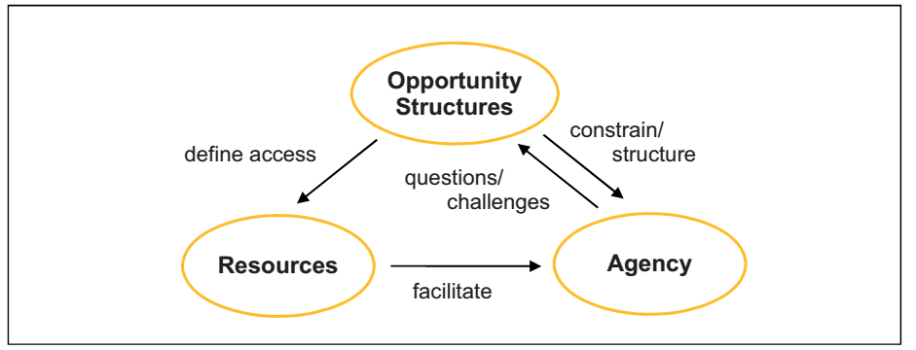
According to our understanding, empowerment is determined by the interaction of agency, access to resources and opportunity structures (see figure 1). Agency is de-fined as the ability of people to define their own goals and to act on them. Exercising agency is closely related to individual or collective access to resources. This access refers to both tangible resources, such as material and financial assets, and intangi-ble resources, including skills, knowledge, expertise and participation in networks. The framing institutions, rules, norms, social relationships and power relations that constrain and structure agency and access to resources make up the opportunity structures of empowerment (Kapitsa 2008: 2). The interplay of agency, access to re-sources and opportunity structures takes place in different locations at the micro- (lo-cal), meso- (regional) and macro-level (national) (see figure 2).

6.2 Women empowerment

In the Human Development Report from 2008, UNDP stated that 70 percent of the world’s population living on less than 1 USD a day are women (UNDP, 2008). In addition to being poorer than men, women are also more vulnerable, which in part is due to the fact that many developing countries are male dominated societies. A basic assumption is that poverty reduction strategies are related to the promotion of development. Dobra (2011) argues that while in the developmental process, speaking about development without seeking to reduce inequalities between men and women leads to both partial development and partial poverty reduction (Dobra, 2011 p. 136, 137). Furthermore, the World Bank (2012) has stressed that long lasting gender inequalities, characteristic of many developing countries, are restraints on economic growth and development (The World Bank, 2012). With the aim to reduce female fragility and poverty, there has been an increasing expectation on microcredit and other poverty strategies to positively affect women’s empowerment.

What is empowerment? The World Bank (2009) defines empowerment as “the process of increasing the capacity of individuals or groups to make choices and to transform those choices into desired actions and outcomes. Central to this process are actions which both build individual and collective assets, and improve the efficiency and fairness of the organizational and institutional context which govern the use of these assets” (World Bank, 2009). Amartya Sen (1993) explains that
division of power within the society and the household to be able to determine the level of women empowerment. Therefore, this study makes a distinction between the outcomes that lead to greater efficiency within the existing norms and outcomes that can be directly interpreted as women empowerment. This distinction builds on the thoughts of Bali Swain (2007) who argues that not all activities that lead to an increase in well being of a woman are necessarily empowering. For example, improvement in nutrition of children lead to greater efficiency for women in their role in the household, but it also reinforce existing gender roles within the society. When women are better able to perform such activities, it may lead to an increased feeling of well being. This might in turn create conditions that lead to women empowerment, but such activities are not empowering on their own (Bali Swain, 2007, p. 75).
Empowerment is not directly observable, and it may be valued differently depending on the views of individuals. As briefly shown above, empowerment is a complex concept with many definitions. This study argues for an interpretation of the concept using both the World Bank’s and Kabeer’s view of women empowerment. Thus, this study defines women empowerment as the process in which women challenge existing norms of the society, in which they live, to improve their well being. Furthermore, this study defines women’s empowerment within four subgroups: decision making power in the household, ownership of assets, voice, and mobility. These are defined and exemplified

6.3: Microcredit and women empowerment
How does microcredit lead to women’s empowerment? Microcredit enables women empowerment by placing capital in their hands and allowing them to earn independent income and contribute economically to their households and communities (Cheston and Kuhn, 2002, p. 14). In theory, women invest the microcredit in their own income earning activity, either in the form of a microenterprise or agricultural production, and accordingly their income, which they themselves control, increases. In other words, involvement in a successful income generating activity
program, women may be forced to cut their own, already inadequate, expenditure on food and health services to repay their loans. The combination of low incomes, lack of control, and repayment pressure may do little to increase women’s empowerment.

6.4 Descriptive data and patterns of empowerment
A total of 190 women answered questionnaire. 126 respondents had received microcredit from a microfinance institution. 64 of the respondents had been accepted into a microcredit program but had not yet received microcredit but is about to within a couple of weeks. As stated earlier, this group is defined as soontobe microcredit borrowers.

Table-6.1:frequency table of respondents taking microcredit from different institution

Micro finance institution | Frequency | Percentage
Grameen bank | 181 | 41
brac | 86 | 19
PKSF | 8 | 1
Buro bangladesh | 5 | 1
Others(asa,junota ,jamal and islamic) | 172 | 38

Table 2 tells us that of the 452 respondents that had received microcredit 89 respondents were part of BURO Bangladesh, 34 were part of BRAC, 12 were part of Grameen Bank and 8 were part of other microfinance institutions. Note that some of the respondents were enrolled in more than one microcredit program. These respondents will be counted as microcredit borrower. Thus, no further specification applies to those that received microcredit from more than one microfinance institution. This study aims at evaluating the effect of microcredit on women’s empowerment. Thus, no analysis will be made showing the difference in empowerment depending on which microfinance institution the respondent is member.

6.2. Table of some statistic of respondents
 | mean | median | Std. dev | Skewness | kurtosis | Range
Age | 36.72 | 35 | 8.836 | .752 | .937 | 51
Monthly expenditure | 7000 | 7500 | 139.8 | .553 | .831 | 80000
Number of children | 2.72 | 3 | 1.30 | .613 | 1.53 | 8
Number of income earner | 1.44 | 1 | .631 | 1.113 | 2.515 | 5

Table 6.2 gives selected characteristics of the sample for microcredit borrowers and soon To be microcredit borrowers. Microcredit borrowers tend to be older and have a slightly higher monthly expenditure. Also, microcredit borrowers have slightly more income earners in the household and children compared to soon to be microcredit borrowers. What is not noted in table 3 regarding demography was that all the respondents were either married, divorced, or widowed. Also, all the respondents had at least one child.

Table 6.3:frequency husband’s occupation
 | Frequency | Percentage
Farmer | 150 | 33.18
Labor | 121 | 26.76
Business | 106 | 23.45
Others | 75 | 16.59

Table 6.3 gives information regarding income earning activity for microcredit borrowers husband and soon to be microcredit borrowers. The picture that emerges is that soon to be microcredit borrowers seem to be, on average, more involved in the agricultural sector compared to microcredit borrowers. On the other hand, microcredit borrowers seem to be, on average, more involved in the non-agricultural sector. Furthermore, microcredit borrowers seem to be more likely, compared to soon to be microcredit borrowers, to be involved in an own business.

Table-6.4: table for empowerment indication
Empowerment idicators | Yes | % of yes | No | %of no
Make small purchase(e.g .dress)without consulting husband | 214 | 63% | 124 | 37%
Have a say in whether to purchase major goods for the household(eg:TV)- | 230 | 68% | 108 | 32%
Have a say in whether to work outside home | 218 | 64% | 120 | 36%
Are your children obeyed your words? | 257 | 76% | 81 | 24%
Have a say whether to buy or sell property- | 190 | 56% | 148 | 44%
Have a say in whether or not to send Children to- | 123 | 36% | 215 | 64%
Land ownership in own name- | 138 | 40% | 200 | 60%
Personally own property and/or valuables(eg:jewelry)- | 191 | 56% | 147 | 44%
Have independent savings- | 193 | 57% | 145 | 43%
Comfortable giving opinion in presence of husband- | 184 | 54% | 154 | 46%
People in the village listen to ideas and opinions | 180 | 53% | 158 | 47%
Comfortable going to local market without asking permission from husband or other family member- | 185 | 54% | 153 | 46%
Comfortable going to the neighboring village without asking for permission from husband or other family member- | 200 | 60% | 138 | 40%

6.5 Limitations with the questionnaire methodology
The method used in this thesis has, like most methods, some limitations. But the chosen method is believed to be appropriate due to the purpose of this study. To give credibility to this thesis, it is important to highlight and clarify the limitations of using the questionnaire method. Some argue that it may be problematic to use the questionnaire method since individuals have different frames of references, which results in the fact that the answer choices can have different meaning for different individuals. Another potential problem with using a questionnaire is that the questions often are broad and general, making room for individual interpretations that is not reflected in the limited answering choices (Gaiha and Thapa, 2006, p. 12). Furthermore, the questionnaire was conducted in English but most of the respondents that were involved in the study did not have sufficient language skills to answer the questions. Also, most of the women were unable to read both English and Bangladeshi. Therefore, an interpreter was required to translate the English questions into Bangladeshi, and then back to English. Consequently, it is possible that there was some divergence from the original question (Pan, 2007, p. 5). The same interpreter was used during all interviews, making all the respondents answer the same interpreted questions. It is therefore believed that the problem described above with using an interpreter is, to some degree, dealt with. Another limitation with the questionnaire and the sample as a whole is that it is rather small and only conducted in one district of Bangladesh. The sample might therefore not be entirely representative of all women living in Bangladesh, but the sample size is according to Scheyvens and Storey (2003) large enough for econometric methods and can be used to draw some conclusions (Scheyvens and Storey, 2003, p. 44).

6.6 Econometric Analysis
From the data gathered via the questionnaire, the relationship between microcredit and women’s empowerment is analyzed through a cross sectional impact methodology, referred to as the control group method. The quantitative data analysis has been conducted comparing microcredit borrowers with soon to be microcredit borrowers using the data gathered from the questionnaire. To further clarify, both the treatment group and the control group have been accepted into a microcredit program. The difference between the groups is that the treatment group, microcredit borrowers, has received microcredit and the control group, soon to be microcredit borrowers, has not received microcredit but is about to within a couple of weeks. To estimate the effect of microcredit on empowerment this study constructs a multiple linear regression model with the ordinary least squares (OLS) method.

6.7: Model specification
The method of ordinary least squares (OLS) has been used to analyze the data presented in the previous chapter. As mentioned earlier, the aim of this study is evaluate the impact of microcredit on women empowerment. The OLS model suits the purpose well in that a positive effect of microcredit on women empowerment is captured by the coefficient β2. The null hypothesis is that microcredit has no effect on women empowerment. If β2 obtains a significant positive value, it means that the null hypothesis can be rejected and that microcredit has a positive effect on women empowerment.
Women empowerment is measured via an empowerment index. The index is built on the

empowerment indicators presented earlier in table 5, which in turn are derived from the respondent’s answers on the thirteen empowerment questions in the questionnaire (found in appendix 1). To be able to measure the respondent’s answers to these questions; a yes is transformed to a 1 and a no is transformed to a 0. The values for each of the thirteen empowerment indicators are then summed into an aggregate index with one point increments from 0 to 13. An individual with a high aggregate empowerment index empowerment score is considered to be more empowered than an individual with a low aggregate empowerment index score.

The OLS model, in its most basic form, only includes the dependent variable empowerment index and the independent variable microcredit borrower. The model is then built up gradually by adding one independent control variable at a time. This is done to derive how the relationship between microcredit and women empowerment changes when independent control variables are added. There are a total of twelve independent variables conducted for in the model. Thus, there are twelve models, where the most comprehensive model includes twelve independent variables. Equation 1 below defines the most comprehensive model with all the independent variables.

Women Empowerment = β₁ + β₂ *family income after Micro-credit + β₃*total amount of loan + β₄ * Years of Micro-credit Program + β_{5*}Age + β_{6*} religion +$β_{7}*$ Expenditure + $β_{8}$* respondent occupation + β_{12*} Number of Children + β₁₃ *Number of Income earners in the Household + ε

Furthermore, this study aims to investigate the impact of microcredit on each of the empowerment indicators presented in table 5. The OLS models are, like before, built up gradually by adding one independent at a time. But the dependent variable is no longer empowerment index. Instead, each of the empowerment indicators is the dependent variable one at the time. In other words, the second OLS model has make small purchases as the dependent variable, the third OLS model has involved in decision to make large purchases as the dependent variable etc. As before, the relationship between the dependent variable and microcredit borrower is first tested, then independent control variables are gradually added.

Table-6.5: table for simple linear regression of some important variables on total amount of loan taking
Model | Un standardized coefficient |  |  |  | standardized coefficient | T | Sig | R  Square | Adjusted R square | Sig
 | Beta |  | Std error |  | Beta
Total amount of loan | 5.404E-006 |  |  | .00 | .075 | 2.180 | .030 | .716 | .707 | .000
Years of micro credit program | .050 | .021 |  |  | .084 | 2.378 | .018
Age | .011 | .009 |  |  | .043 | 1.128 | .002
Religion | .806 | .301 |  |  | .089 | 2.677 | .008
Expenditure | 1.197 | .057 |  |  | .769 | 21.025 | .000
Respondents occupation | .127 | .067 |  |  | .063 | 1.899 | .039
Number of children | -.034 | .066 |  |  | -.020 | -.512 | .609
Number of income earners | -.107 | .130 |  |  | -.029 | -.826 | .409
Dependent Variable :Empowerment index

So we see from this table that total amount of loan , years of micro-credit, age, religion, expenditure, occupation are positively related with women empowerment index, i.e. these things are significantly related with the empowerment of women in our society.

6.8 Ownership of assets
The subgroup ownership of assets shows if a woman owns land or any other property or valuable. This is measured in terms of own landownership, ownership of property and/or valuables, and independent savings. Microcredit shows to have no significant positive (or negative) impact on landownership in own name and personally own property and/or valuable. On the contrary, the positive relationship between microcredit and independent savings is significant at the 1 percent level in all the models, from the most basic without independent control variables to the most comprehensive model with all the independent control variables. This suggests that the relationship is robust. An explanation might be that the microcredit borrowers have built up a trust and relationship with the microcredit program, and thus been able to access the other financial services offered by the microfinance institutions. The soon to be microcredit borrowers have not yet built up this trust and relationship. Age, age of marriage and own business is positive significant, in most of the models, in explaining landownership in own name. In the case of ownership of assets, it seems as household traits and traditions are more important than microcredit. The OLS models for own landownership (table 14), ownership of property and/or valuables (table 15), and independent savings (table 16) are found in appendix 2.

Figure 6.2: frequency of respondents having own property

Comment :
From the above pie diagram we can conclude that 60% women have not personal own property and 40% have any personal own property.

Figure 6.3: frequency of respondents having independent saving

Comment:

from the above pie diagram we can conclude that 66% women have not any independent savings and 34% have independent savings.

Figure 6.4: frequency of respondents having land ownership

Comment:

from the above pie diagram we can conclude that 64% women have not any land ownership in own nameand 36% have land ownership in own name.

6.9 Voice
Voice is a variable showing the woman’s freedom of expression, if she is able to express her views in the presence of her husband, family members and others. Voice is examined via two variables: comfortable giving opinion in the presence of husband or other family member and village people listen to ideas and opinions. Microcredit is a positive significant explanatory variable in the most basic model without independent control variables for both comfortable giving opinion in the presence of family member and Village people listen to ideas and opinions. However, the relationship seems not to be that strong since when independent control variables are added, the relationships are no longer significant. Furthermore, expenditure seem to be positively correlated with comfortable giving opinion in the presence of family member while number of children is negatively significant in explaining comfortable giving opinion in the presence of family members. The OLS models for comfortable giving opinion in the presence of husband or family member (table 17) and Village people listen to ideas and opinions (table 18) are found in appendix 2.

Figure 6.5: frequency of respondents comfortable giving opinion

Comment:

from the above pie diagram we can conclude that 44% women are not comfortable giving opinion and 56% women are comfortable giving opinion.

Figure 6.6: frequency of respondents listening to new ideas and opinion

Comment:

from the above pie diagram we can conclude that people in village does not listen to ideas and opinion from 44% women and people in village listen to ideas and opinion from56% women.

6.10 Mobility

Mobility is the subgroup that defines a women’s freedom of movement. Mobility is divided into two indicators: comfortable going to the local market without asking for permission and comfortable going to the neighborhood village without asking for permission. Microcredit shows no significant relationship to either comfortable going to the local market without asking for permission or comfortable going to the neighborhood village without asking for permission. As presented in table 5 in chapter 4, both microcredit borrowers and soon to be microcredit borrowers are highly restricted in their freedom of movement. Also, husband’s business and agricultural work is negatively significant in explaining both comfortable going to the local market without asking for permission and comfortable going to the neighborhood village without asking for permission. This might be explained by the fact that most of the individuals involved in the agricultural activities live in their home village. Thus, a person whose income earning activity is located in, for example, another village is consequently more mobile. The OLS models for comfortable going to the local market without asking for permission (table 19) and comfortable going to the neighborhood village without asking for permission (table 20) are found in appendix 2.

Figure 6.7: frequency of respondents willing to go outside for work

Comment:

From the above pie diagram we can conclude that 75% women’s say there is problem to go outside home , only 25% can go outside home.

Figure 6.8: frequency of respondents comfortable giving opinion

Comment:

From the above pie diagram we can conclude that 75% women’s say they can purchase their own goods without consulting husband and 25% say they can’t.

Comment: From the above pie diagram we can conclude that 47% women are not comfortable going to the local market and 53% are comfortable going to the local market. Comfortable going the neighboring village

Figure 6.10: frequency of respondents comfortable going to neighbouring village

Comment:from the above pie diagram we can conclude that 47% women are not comfortable going to the neighbouring villageand 53% are comfortable going to the neighbouring village.

6.10 Conclusion
This study empirically evaluates the impact of microcredit on women’s empowerment in Bangladesh. The findings, derived from the OLS models, suggest that microcredit has a positive impact on women’s empowerment. The results indicate that microcredit strengthens women’s family standing represented by their greater role in the household decision making process. The result that microcredit has a positive effect on women’s decision making ability within the household is in line with the findings from Holvoet (2005) and Kabeer (2001). However, the impact of microcredit on women’s freedom of mobility is indistinct based on the empirical results. This suggest that it would be relevant to further investigate how microcredit impact different dimensions of women’s empowerment to improve the potential of microcredit as an empowerment tool.
Years of microcredit program membership was expected to have a positive impact on empowerment. The findings in this study suggest that this doesn’t have to be the case. Thus, there is room for empowerment related improvements within the microcredit programs. This study therefore suggests that more studies should evaluate the relationship between years of microcredit program membership and women’s empowerment in the future. It is important to keep in mind that a quantitative analysis of aggregated data has its limitations. Reality is not easily captured in numbers and most quantitative analysis is required to some simplification and generalization. This does not render the results meaningless, but they are to be interpreted carefully. Since this study was based on a small sample size from only a few villages in the Tangail district the results cannot be generalized to other districts of Bangladesh. More extensive studies that include a larger sample size from different districts could further shed light on how microcredit affects women empowerment

CHAPTER SEVEN

CONCLUSION

7.1: CONCLUSION, RECOMMENDATION AND AREAS FOR FURTHER STUDY

7.2: INTRODUCTION

This section presents the conclusions drawn from the study findings upon which recommendations are made and areas for further studies are identified.

7.3: CONCLUSION
Through this project, we have seen a main characteristic of microcredits. In comparison with credit interest rates charged in developed countries, microcredits apply very high interest rates: in France, they are approximately of 3% in contrast to the 20% in the Yunus model.
But this interest rate is lower when people are late in their payments. These are the case of the geometric distribution, the negative and positive correlation. But the rate varies with each situation: it is lower on the model of lateness with positive correlation than on the geometric distribution or on the negative correlation. Indeed, it varies with the number of weeks in total for paying off the entire loan. The more weeks to refund is, the lower is the rate.
This phenomenon can be explained thanks to the fact that one euro today isn’t worth a euro tomorrow. So, according to capitalization, if a person doesn’t reimburse on time, his loaner will lose money: that is why the loaner charge a lower rate.
Nevertheless, we can say globally that the rates are very high. They aren’t inferior to 9%.
If consumer credit companies wanted to do microcredit with the same rules they do in developed countries. The average interest rate really charged will increase. It will be approximately of 22.5%. This is not a good thing for them because they are already poor. We don’t have to forget that microcredit has a social dimension: it was created to help people to exit poverty, not for making profits on them and to impoverish them more than they already are. So, if consumer credit companies wanted to really do microcredit they have to change their rules.

It was found out that most people know about micro credit institution operations and was borrowing funds for small scale business. Accessing credit from these institutions is easy; since they don’t require collateral which is normally the hindrance factor to many potential borrowers from acquiring credit from formal commercial banks. There is hope however that micro credit institution will help our people live better lives as a result of accessing credit and engaging in different businesses. The institutions’ continued guidance and training given to the borrowers in relation to the usage of borrowed funds is further evidence to show how the beneficiaries will benefit. Micro credit institutions are encouraging every household to practice the culture of savings since its one of the surest ways of getting access to credit.
It was established that the micro credit access and household income are related. Meaning that if MCIs increase their resource base, increase the amount of credit they can give to the borrowers and reach out to the target group who in the end if they utilise the funds wisely their household incomes will improve. This study further revealed that micro credit access, borrowers’ characteristics and business type cause variance in household income up to 44.5%, which implies that there are other factors that supplement the three above in order to improve household income.
It was further observed that business type individuals engage in and borrowers’ characteristics play a big role while accessing credit. For example borrowers’ with collateral, good borrowing character and are credit worth have high chances of accessing more funds and utilising the funds wisely. This will definitely increase the individual involvement in businesses that are profitable and increase productivity which eventually leads to improved household income. The above conclusions therefore show that micro credit access, borrowers’ characteristics, business type and household income are strongly related. However there are other factors which can increase household income while working hand in hand with micro credit institutions operations, these may include lowering costs of production e.g labour, transport, interest rates, taxes and also getting involved in more than one business activities.

7.4: RECOMMENDATIONS
- Micro credit institutions should increase the amount of funds that the poor can access in order for the household to engage in businesses that will lead to increased productivity and eventually household income. It’s important for the MCIs to design better methods/procedure that will make the processing of credit fast and easy. In addition they should provide a verity of products that suite the borrowers demand/needs.

- Micro credit should always consider the borrowers characteristic before giving out any credit. This includes collateral, character of borrowers and credit worthiness of the borrowers. Micro credit institutions should ensure that these requirements are known by the potential borrowers. The borrowers should be aware of what is expected of them before they receive the credit for example they should have physical collateral or savings to substitute for collateral. The character of the borrowers should also be considered at the time of giving out money.

- Micro credit institutions should critically look at the type of business the borrowers’ are going to be involved in before releasing the funds to them. Only borrowers’ with businesses that show good returns should be considered for credit. Diversification of business should be encouraged by the MCIs with the aim of borrowers’ engaging in a number of businesses that are likely to yield highly. Good knowledge should also be considered always before giving out credit. This will unable the borrowers to utilise the funds according to plan. People with wider knowledge of business know what they can/should do in order to improve their household income levels.

7.5 Areas of further research

- This study concentrated on micro credit access, borrowers’ characteristic, business type and household income basing on micro credit institutions. A similar research however can be carried out on commercial banks.
- A study that involves people who benefit from micro credit institution operation and those that don’t benefit from them in relationship to their household income.
- Establishing the role of interest rate and savings on the household income.
- Alternatives to micro credit accessibility in relation to improving the poor household income

References

Adams, W.’ Dale. Using Credit Unions as conduits for micro enterprise lending Latin
– American insights. Ohio state University, Poverty oriented Banking workingpaper No.12
Asian Development Bank, (2000), Rural Asia study beyond the Green Revolution.
Asian Development Bank, 2000, ‘Finance for the poor. Micro finance Development strategy’
Campion Anita, (2001). ‘Challenges to microfinance commercialization.’ Volume 4 No.2
CGAP – Microfinance and the Millennium Development Goals
CGAP – About microfinance 2003 and Maguerite S. Robinson, The microfinance Revolution Finance for the poor, Washington DC 2001.
http://www.cmfnet.org.za/ Community Microfinance Network
03/October/2003
CGAP. “Measuring Micro credit delinquency: Ratios can be harmful to your health”.Occasional paper No.3, June 1999
CGAP – Microfinanace over View, 2004
CGAP – About microfinance frequently asked questions 2003.
CGAP – Microfinance and the Millennium Development Goals. A readers’ guide to the millennium Project Reports and other UN Documents, October 2005.
Christen. R., Rhyne, & Vogel. R. (1995) “Maximizing the Outreach of Micro enterprise finance. The emerging Lessons of successful program.” USAID program and operations report No. 10. Washington D.C.: USAID.
consultative Group to assist the poorest. (1995). “A policy Frame work for the Consultative group to assist the poorest (CGAP) – A Microfinance Programme”, Washington D.C., www.worldbank.org/html/cgap/pollicy.htm.
Dictterr, T. and Kamuntu. E. (1997), UNDP Micro finance assessment report 1997, UNDP Kampala.
Education and Poverty Eradication, International Workshop on Education and Poverty, Kampala Uganda, 30 July to 3 august 2001
http:/www.unesco.org/education/poverty/news.shffml
Hulme, D et al (1999), Use and impact of savings and services among the poor in Uganda.
Hulme, D. (1990) ‘Can the Grameen Bank be replicated? Recent experiments inMalaysia, Malawi and Sri Lanka, ‘Development policy Review, 8: 287 – 300
Kabuchu H & Drito A (1999) Area micro credit institutions exploiting the poor the voice December 1999
Kalyabe, M. (1989) pulling themselves out of poverty
Kayizzi Mugerwa, (2002), Fiscal Policy, Growth and Poverty Reduction in Uganda.
Discussion Paper No. 2002/33
Laurie J Mullins Management and Organisation behaviour sixth edition
Ledgerwood, j. (2000), Microfinance handbook. Institutional and financial perspective. Sustainaable Banking for the poor. Washington, D.C: World Bank.
Leila (1996) World Bank bending for SME World Bank Technical no.311 1989–93 M.K Khan & P.K. Jain, financial management second edition
Micro credit Summit (1996) ‘The micro credit summit Declaration and Plan for Action,’ Journal of Development enterprises, 1(2): 131 – 76.
Microfinance Summit. (1996) “The microfinance summit Declaration and Plan of Action” Journal of Development Enterprises, Vol.1, No.2, PP. 131 – 176
Morduch, J. Haley, B Wagner Graduate School of Public Service Nyu Wagner 2002).
Otero, M & Rhyne, E eds (1994). The New World Micro enterprise finance.
Building Healthy Financial Institutions for the poor. IT Publications, London.
Otero, M, Savings Mobilization and Micro enterprise programmes, in: Small enterprisedevelopment journal, vol.2, No.1, March 1991.
Maguerite Robinson, “Savings and the New microfinance”, in (The microfinance Revolution/Washington DC 2001).
Parasuraman, A; berry, L., & Zeitalhaml, V.A. (1988).SERVQUAL: amultiple-item for measuring consumer perception of service quality. Journal of Retailing, 64, spring, 12-40.
Report to Parliament by minister of state in charge of Endandikwa, Aug 2000
Rhyne, Elizabeth. (1998) “the Yin and Yang of microfinance: Reaching the poor and sustainability”, Micro banking Bulletin, No.2. 6-8
Robinson, M.S. (2001). The Micro finance resolution: sustainable finance for the poor. The World Bank, Washington D.C. open society institute, New York, U.S.A.
Sakaran. U., (2000). Research Methodology for business: a skill building approach. Sawyer (1995) Corporate credit analysis: current issue in financial services
Macmillan publishers
Seibel, D & Kumar, B (1998) “Micro finance in Nepal: Institutional viability and sustainability and their compatibility with the poor” working paper no 1993 – 3university of cologne, development – Research center.
Sergio Navaja, marrsk Schreiner, Richard. L. Meyer, Claudio Gonzalez –Vega, and Jorge Rodriguez –Mezaa (2000), ‘Micro credit and the poorest of the poor: Theory and Evidence from Bolivia papers No. 6070, http://www.microfinance.com.
Small and Micro enterprises Finance (n.d), 20/1/04. Guiding Principles for selecting and Supporting intermediaries World Bank – Micro finance Unit http:/www.gdrc.org/icm/ppp/ppp – s.html
Stuart Rutherford, The poor and Their Money (New Delhi, India: Oxford University Press, 2000)
Uganda (1997/2000), ‘Poverty Eradication Action Plan’, Kampala: Ministry of Finance, Planning and Economic Development.
Uganda (Various years), Background to the budget, ministry of Finance, Planning and Economic Development.
Sekaranan 2003, Research methods for business 4th edition. United States of America John Wiles & Son.Inc.
Uganda Bureau of Statistics: 2002 Uganda Population and Hosing Census – November 2002.
Uganda Parliamentary Research Service report, 2000; Evaluation of Endandikwa scheme Uganda Participatory Poverty assessment process report 2002
Uganda poverty status report 1999, Kampala: Ministry of Finance, Planning and Economic Development.
USAID, (1995), Maximizing the outreach of micro enterprise finance. The emerging lessons of successful programs” USAID.
Weiss, D. (1998) The informal sector in metropolitan areas of developing countries. Berlin: Free university of Berlin, Institute of economics and World economics.
World Bank (1996), Uganda: The challenges of growth and Poverty Reduction, Washington DC; World Bank
Wright (1996).
Yaron, J. Denald, M.C. Benjamin, P. Jr & Gerda, P. (1997) Rural Finance issues, design and best practices. The World Bank Washington, D.C. Environmental and Social sustainable development studies and monographs series 14.
Yunus, M. (1995) Statement and hearing before the U.S. committee or international relations, house of representatives, One hundred fourth Congress. First Session,June 27, 1995: U.S. Government printing office, Washington D.C
Yunus, M. (2000). Micro credit. The Grameen bank. Dhaka Bangladesh. Grameen Communication.
Zikmud W G (1995) Business: the challenge for competition. Austen, press Australia pg361
R.C Vogel, 2004. Savings mobilisation: “The forgotten half of Rural Finance” in understanding Rural Development Credit, ed D.Adams
Kofi Annan,United Nations Secretary – General, International year of micro credit 2005. Muhammad Yunus, Micro credit outreach to the Millennium Development Goals Internationally. Attacking poverty with Micro credit, Dhaka, Bangladesh, January, 2003. FINCA International 2005, Micro credit Over view.
Gert Van Maanen, Business and Development Instruments

Appendix

Questionnaire:

(personal information)

1.Name:
2.Gender
Male Female
3.Age
Answer: (numeric value)
4.Education
Primary secondary higher Illiterate
5.Marital status
Single Married
6.No. of children
Answer: (numeric value)
7. Husband Occupation
Answer: (specific)
8.How many members in your family?
Answer: (numeric value)
9.How many earning members in your family?
Answer: (numeric value)
10. What is your religion status?
a.Islam b. Hindu c. Buddhist d.Christian e. others

(credit information)
11. How many weeks delay in payment this year(2014-13)?
Answer: (numeric value)
12.What is your living status after taking microcredit?
a. improved b.improved a lot c.no change d.worsen
13. What is your total family income this year(2014-15)?
Answer: (numeric entry)
14. What was your monthly income before taking microcredit?
Answer: (numeric entry)
15.What is your monthly income now after taking microcredit?
Answer: (numeric entry)
16.What is your monthly expenditure before taking microcredit?
Answer: (numeric entry)
17.What is your monthly expenditure after taking microcredit?
Answer: (numeric entry)
18.What is your monthly savings?
Answer: (numeric entry)
19. how long you been using micro-credit?
Answer: (numeric value in month/yr)
20.What is the total amount of micro-credit you have taken this year?
Answer: (numeric value)
21.What did you do with the money?
Answer: (specific)
22.Are you satisfied with the interest rate you have to pay?
Yes No
23.Does the money you borrow from micro finance bank cover your needs?
a. Covers fully b .covers partially c.not covering
24. Do you have clean drinking water and hygienic environment?
Yes No
25. Do you have proper sanitation system?
Yes No
26. Do you have to face water shortage?
Yes No
27. Do you have your own house, or it is rented?
Own Rented
28. Is your house enough for family members?
Enough Not enough
29. What type of house it is?
Mud house tin shed bamboo made brick house
30. Is your house strong enough to bear thunderstorm or any other kind of natural disaster?
Strong enough Not enough
31. Does your house have basic necessities ?
a. electricity/tv/radio/fan b.nothing
32. how many rooms in your house?
Answer: (numeric value)
33. Is your income enough for family members?
Enough Not enough
34. Is your income enough to bear any uncertain expenses (sudden guest, child gets ill, breakage of any property (house) due to thunderstorm, earth quake etc)?
Enough Not enough
35.Are you the only earner of the family?
Yes No
36. Is your income enough to bear recreational activities for children?
Yes No
37. Do you want some other sources of income?
Yes No
38. Are you able to save, or it is difficult for you?
Able Difficult
39. How much part of income do you save?
5% 10% 15% None
40. What is the objective of your savings?
To meet any uncertain crisis in future For children welfare Other
41. Do you want to invest your savings in any form of business (rickshaw, taxi, shop etc)?
Yes No
42. Have you involved in any kind of training (Auto workshop etc) or education program?
Yes No
43. Do you think training or education is expense or asset?
Expense Asset
44. Have any of your children getting any kind of training or education?
Yes No
45. Do you have enough food every day?
Yes No
46. Do you feel difficult to manage food expenses?
Yes No
47. What is your daily average expense on food?
100 150 200 Other
48. Is there any day you live without food?
Yes No
49. Have you ever felt uncertain about whether I will get next time meal or not?
Yes No
50. What do you mostly eat?
Rice Meat Lintels Other
51. How do you see the difference in your life after you started using micro credit?
01.Improve accommodation 02. Clean water and hygienic environment
03.Increase income/ savings 04.Adequate food 05.Training and education
52.Is there any difference in ability to buy meat or fish (improve diet)?
BEFORE AFTER
a. difficult a. increased totally
b. bad before b. improved
c. couldn’t afford c. improved a lot
d. things were not up to d. can buy as much
standard as I want
e. no response e. abundance of food
f. can buy enough meat
g. better than before
h. no respons

53.Microfinance institution
Grameen Bank –
PKSF -
BRAC -
BURO Bangladesh-
Others (ASA ,Jonota ,Jamal and Islamic)-
54.Respondent occupation/Borrower’s characteristics-Ans-(specific)

Empowerment indicators
55. Make small purchase (e.g. dress) Without consulting husband-
Yes No
56. Have a say in whether to purchase major Goods for the household ( eg: TV)-
Yes No
57.Have a say in whether to work outside home
Yes No
58.Have a say in how many children to Have a say in whether to buy or sell
property-
Yes No
59.Have a say in whether or not to send Children to school-
Yes No

Ownership of assets indicators
60. Land ownership in own name-
Yes No
61. Personally own property (eg: jewelry)-
Yes No
62. Have independent savings-
Yes No

Voice indicators
63. Comfortable giving opinion in the Presence of husband-
Yes No
64. People in the village listen to ideas and Opinions-
Yes No

Mobility indicators
65. Comfortable going to the local market Without asking permission from Husband or other family member-
Yes No

66. Comfortable going to the neighboring Village without asking for permission From husband or other family member-
Yes No

