Data Visualisation
Assignment 2
Document Submission Cover Sheet
Please ensure that you complete all relevant sections below and that you make this the first page of your assignment submission.
For submission, you are required to put all aspects of the assignment into one document, including the cover sheer below and then to submit the assignment on Moodle in the relevant module location.
The assignment must be completed on or before the designated submission date and time. Students are recommended to keep a copy of the assignment, as submitted.
Please complete the following, in advance of submission.
If for some reason you cannot complete this form to attach to your assessment, please hand write the details, photograph and upload to Moodle.
Name:  Pronoti Saha | Student Id:  A00325358
Programme Year:  2025-2026 | Module Title:  Data Visualisation  (AL_KSAIM_9_1) 29448
Lecturer Name:
Mark Daly

Visualisation Title:
Economic Report Dashboard: Turkey

Declaration of Authenticity: (Please Sign)
By uploading this document, I confirm that I have read and understood the assignment
instructions and that the attached assignment is original (save for the visualisation being
analysed) and represents all my own work.

Economic Report Dashboard: Turkey

Contents
List of Figures 4
1 Introduction 5
1.1 Country Overview 5
2 Data Set 5
2.1 Data Sources 5
2.1.1 GDP Growth 5
2.1.2 Exports and Imports 6
2.1.3 Trade Balance 6
2.1.4 Youth Unemployment 6
2.1.5 Inflation Rate 6
2.2 Interesting Attributes 6
3 Visualisations and Analysis 7
3.1 KPI Overview 7
3.2 GDP Growth Rate 7
3.3 Exports and Imports 8
3.4 Trade Balance 9
3.5 Youth Unemployment by Gender 9
3.6 Inflation Rate 10
3.7 Turkey Economic Indicators Overview: 11
4 Conclusion 11
Appendix 12
1. Full Dashboard 12
References 13

List of Figures
Figure 1. Overview page of the Dashboard 7
Figure 2. GDP Growth 8
Figure 3. Export and Import 8
Figure 4. Trade Balance 9
Figure 5. Youth Unemployment by Gender 10
Figure 6. Inflation Rate 10
Figure 7. Turkey Economic Indicators Overview 11

Introduction
Turkey is one of the largest emerging economies in the world, bridging Europe and Asia with a population exceeding 85 million. In this assignment, the dashboard that was created will be used to explore various macroeconomic metrics that characterise Turkey's economic performance over recent decades. The visualisations aim to provide a comprehensive picture of Turkey's economic trajectory, highlighting both its growth potential and its structural vulnerabilities.

Country Overview
This project presents an interactive data visualisation dashboard analysing key economic indicators for Turkey, a country with dynamic GDP growth, significant trade activity, and a young but challenged labour force. The aim is to provide insights into Turkey’s economic performance over time and its position within the global economy. The dashboard incorporates several important metrics, including GDP growth rate, exports and imports as a percentage of GDP, trade balance, youth unemployment by gender, and inflation rate, as these collectively reflect the country’s macroeconomic health and level of global integration. By comparing Turkey’s data with world averages, the visualisations offer meaningful context and allow for a clearer understanding of trends, patterns, and economic challenges. Overall, the project uses Python-based visualisation tools to support data-driven analysis and improve understanding of Turkey’s economic strengths and weaknesses.

Data Set
In this section, the data sets used in the dashboard are discussed in more detail regarding the extent of attributes and insights provided by the World Bank's World Development Indicators (WDI) and the International Labour Organization (ILO).

Data Sources
The datasets were sourced from World Bank Data360 indicators, including data originally curated from WDI, ILO, and IMF WEO streams:
- GDP growth: World Bank WDI indicator WB_WDI_NY_GDP_MKTP_KD_ZG [1].
- Exports (% GDP): indicator WEF_GCIHH_EXPGDP [2].
- Imports (% GDP): indicator WEF_GCIHH_IMPGDP [3].
- Youth unemployment (%): indicator WB_GS_SL_UEM_ZS [4].
- CPI index used to derive inflation: indicator IMF_WEO_PCPI [5].
All source URLs are listed again in the References section.

GDP Growth
This dataset provides annual GDP growth rates expressed as a percentage change from the previous year, covering all World Bank member countries and regional aggregates. For this dashboard, data was filtered for Turkey (country code: TUR) and the World aggregate (WLD) to enable a direct comparison between Turkey's growth trajectory and the global average. The data spans multiple decades, allowing for long-term trend analysis including the identification of recession periods and recovery phases.

Exports and Imports
These datasets provide the value of exports and imports of goods and services as a percentage of GDP, sourced from the World Bank WDI. Expressing trade flows as a share of GDP allows for meaningful cross-year comparisons regardless of nominal economic size. The data was filtered to include only rows where the unit of measure is percentage of GDP (PT_GDP), ensuring consistency across the time series.

Trade Balance
The trade balance is a derived metric calculated as the difference between exports and imports as a percentage of GDP. A positive value indicates a trade surplus, while a negative value indicates a trade deficit. This metric was computed directly within the dashboard by merging the exports and imports datasets on the time period dimension.

Youth Unemployment
This dataset, sourced from the ILO, provides annual youth unemployment rates for individuals aged 15 to 24, disaggregated by sex (male and female). The data was filtered for Turkey using the reference area identifier, the total economy classification, and rows with confirmed observed values. This disaggregation allows for a gender-comparative analysis of labour market access among young people in Turkey.

Inflation Rate
The inflation dataset is derived from a Consumer Price Index (CPI) series sourced from the World Bank WDI. The annual inflation rate is calculated as the year-on-year percentage change in the CPI index. Only rows with confirmed observed status were retained. This approach provides a consistent measure of price level changes over time, capturing Turkey's well-documented episodes of high inflation.

Interesting Attributes
- GDP Growth: Turkey has experienced highly volatile GDP growth, with strong expansions in the early 2000s and mid-2010s, punctuated by sharp contractions in 2001, 2009, and 2018–2019. Compared to the world average, Turkey's growth has frequently outpaced global trends but with considerably higher variance.
- Trade Balance: Turkey consistently runs a trade deficit, with imports persistently exceeding exports as a percentage of GDP. This structural deficit reflects the economy's dependence on imported energy and intermediate goods and is a key vulnerability in its external accounts.
- Youth Unemployment: Youth unemployment in Turkey is significantly higher for females than males across all observed years, reflecting structural gender disparities in labour market participation. Both series remain elevated compared to developed economy benchmarks.
- Inflation: Turkey has experienced severe inflationary episodes, particularly in the early 2000s and again from 2021 onwards. The inflation rate has at times exceeded 80%, making it one of the most significant macroeconomic challenges facing the country and directly eroding household purchasing power.

The dashboard presents the latest available observation for each indicator, although the datasets do not all end in the same year. GDP data extends to 2024, trade data extends to 2017, and youth unemployment and inflation data extend to 2023. Therefore, the overview page should be interpreted as a summary of recent macroeconomic conditions rather than as a strict single-year comparison

Visualisations and Analysis
The visual design was selected to align chart form with analytical intent and to help users move from summary to detail. Line charts were used where continuity and volatility are central to the interpretation, grouped bars were used where direct side-by-side comparison is the primary task, and an area chart around a zero baseline was used where deficit magnitude needed emphasis. KPI cards were retained to provide a rapid first read of economic conditions, and the horizontal overview chart was used to compare latest values across different indicators in one compact frame.

KPI Overview
The overview page of the dashboard provides a set of KPI cards that allow a user to immediately grasp the current state of Turkey's key economic indicators without being overwhelmed by detail. As seen in Figure 1, the KPI cards display the latest values for GDP growth, exports, imports, trade balance, youth unemployment, and inflation. This page makes it immediately apparent that while Turkey has maintained positive GDP growth in recent years, it faces significant headwinds from a persistent trade deficit, elevated youth unemployment, and very high inflation. The use of colour coding — green for positive indicators and red for concerning ones allows for rapid visual interpretation.

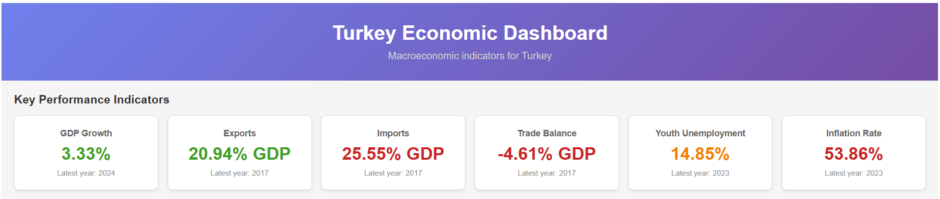
Figure 1. Overview page of the Dashboard

GDP Growth Rate
The GDP growth chart, shown in Figure 2, plots Turkey's annual GDP growth rate over time alongside the world average as an overlay. This dual-line view allows users to contextualise Turkey's performance relative to global trends. The chart clearly illustrates Turkey's boom-and-bust growth pattern, with notable peaks during the post-2001 recovery and the 2010–2011 period, and sharp troughs during the 2009 global financial crisis and the 2018 currency crisis. The world average line provides a stable reference, highlighting how frequently and dramatically Turkey's growth deviates from the global norm. A line chart is the correct choice here because the task is to reveal multi-decade trend structure, turning points, and volatility rather than isolated yearly values.
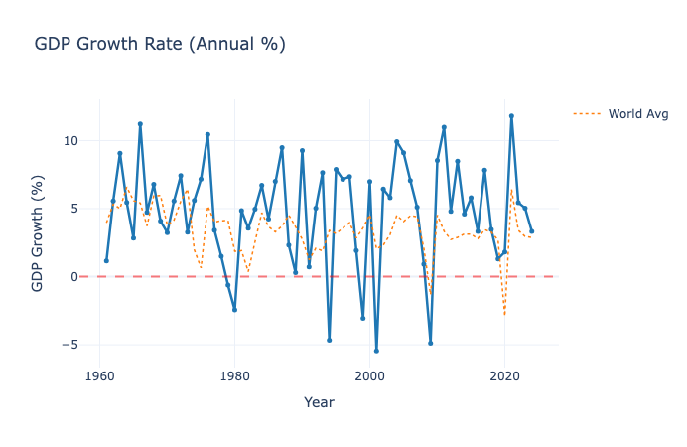
Figure 2. GDP Growth

Exports and Imports
The exports and imports chart in Figure 3 presents Turkey’s trade activity as a percentage of GDP from approximately 2007 to 2017 using a grouped bar chart, allowing for clear comparison between the two indicators over time. The visualisation shows that imports consistently exceed exports throughout this period, indicating a persistent trade deficit in the Turkish economy. While both exports and imports fluctuate between 2007 and 2017, there is a general upward trend, particularly after 2010, suggesting that Turkey has become increasingly integrated into global trade. The inclusion of world average reference lines provides additional context, showing that Turkey’s trade levels are broadly comparable to global patterns, although the gap between imports and exports remains evident. Overall, the chart highlights Turkey’s continued reliance on imports and the ongoing challenge of achieving a balanced trade position.
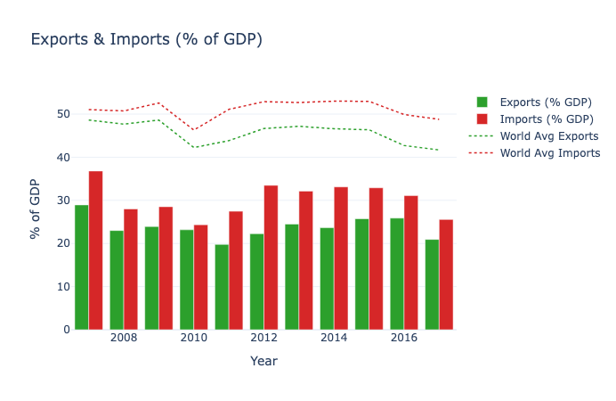
Figure 3. Export and Import

Trade Balance
The trade balance area chart in Figure 4 reinforces the findings from the exports and imports chart by directly plotting the difference between the two series. The area fills below zero visually emphasises the persistent deficit. The chart reveals that the trade deficit has deepened during periods of strong domestic demand and currency depreciation, as import costs rise while export competitiveness improves only gradually. This visualisation is particularly effective at communicating the magnitude and consistency of Turkey's external imbalance.
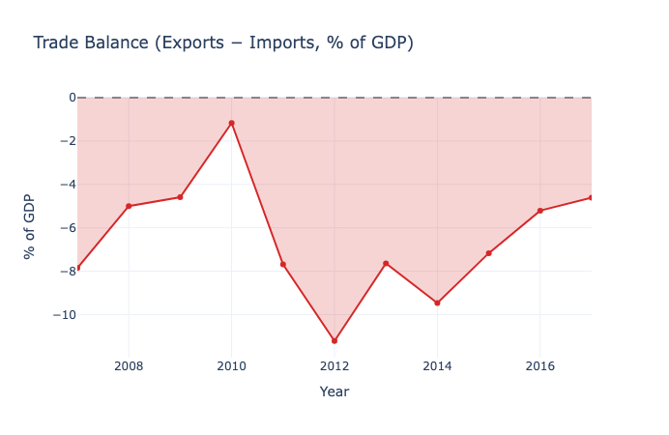
Figure 4. Trade Balance

Youth Unemployment by Gender
The youth unemployment multi-line chart in Figure 5 illustrates the unemployment rates for males and females aged 15–24 in Turkey from approximately 1990 to 2022, alongside global averages, allowing for a clear comparison over time. A key feature of the visualisation is the consistent gap between genders, with female youth unemployment remaining significantly higher than that of males throughout the period, often by a considerable margin. Both male and female unemployment rates show fluctuations in response to economic conditions, with noticeable increases during periods of economic downturn, particularly after 2008 and in the late 2010s. Compared to the relatively stable world averages, Turkey exhibits higher and more volatile youth unemployment levels, especially among females. Overall, the chart highlights persistent gender inequality in the labour market and the sensitivity of youth employment to economic instability in Turkey.

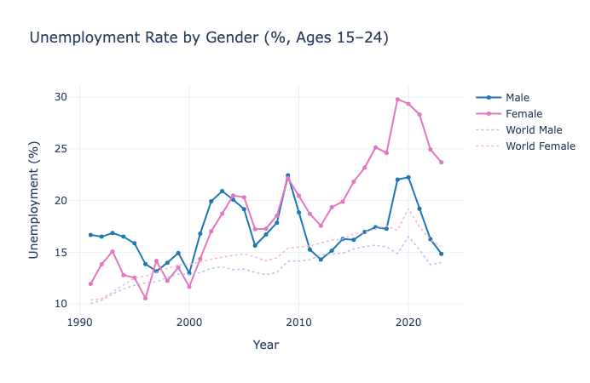
Figure 5. Youth Unemployment by Gender

Inflation Rate
The inflation rate line chart in Figure 6 captures one of Turkey's most defining economic characteristics. After a period of relative price stability between 2004 and 2017, inflation accelerated sharply from 2018 onwards, driven by currency depreciation, loose monetary policy, and supply-side pressures. The chart makes the severity and speed of this inflationary episode immediately apparent, providing essential context for understanding the erosion of real wages and purchasing power that has accompanied Turkey's recent growth figures.

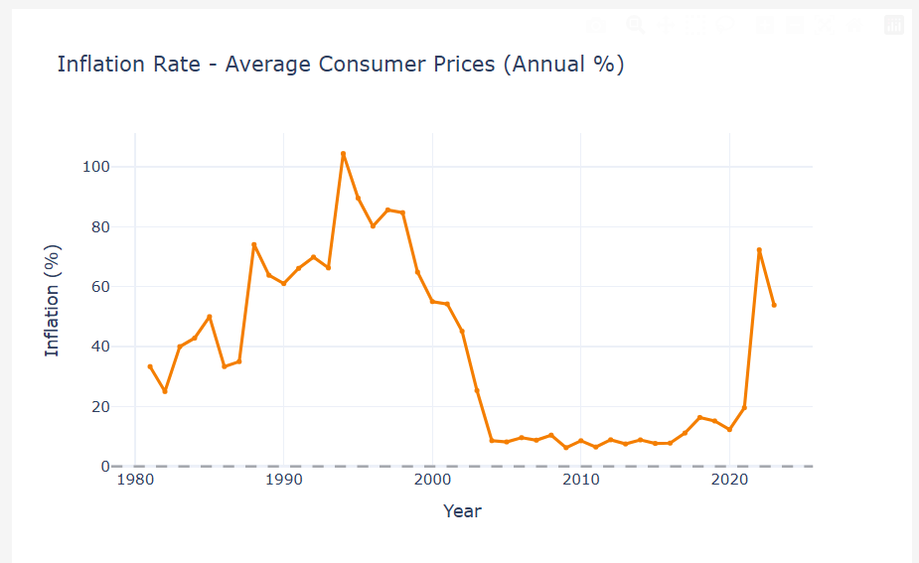
Figure 6. Inflation Rate

Turkey Economic Indicators Overview:
Turkey Economic Indicators Overview presents a concise snapshot of the country’s recent macroeconomic performance using key measures such as GDP growth, exports, imports, trade balance, youth unemployment, and inflation. The visualisation using horizontal bars is designed to help users quickly compare these indicators and identify the main strengths and weaknesses of the economy. It highlights that while Turkey continues to show positive economic activity in some areas, it also faces major challenges including high inflation, persistent trade deficits, and elevated youth unemployment.

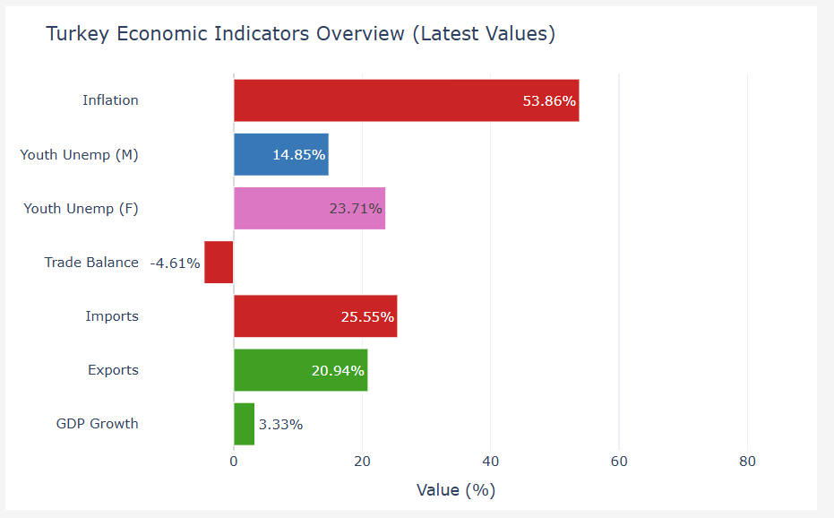
Figure 7. Turkey Economic Indicators Overview

Conclusion
This report has used the Turkey economic dashboard to explore five key macroeconomic dimensions: GDP growth, trade flows, trade balance, youth unemployment, and inflation. The analysis reveals a country of significant economic dynamism but also considerable structural fragility. Turkey's GDP growth has frequently outpaced the world average, yet this growth has been accompanied by persistent trade deficits, a stark gender gap in youth labour market participation, and increasingly severe inflationary pressures. Together, these indicators paint a picture of an economy with strong growth potential that is nonetheless constrained by structural imbalances. The dashboard provides an effective tool for exploring these dynamics interactively, enabling users to identify trends, compare periods, and draw their own conclusions about Turkey's economic trajectory.

Appendix

Full Dashboard

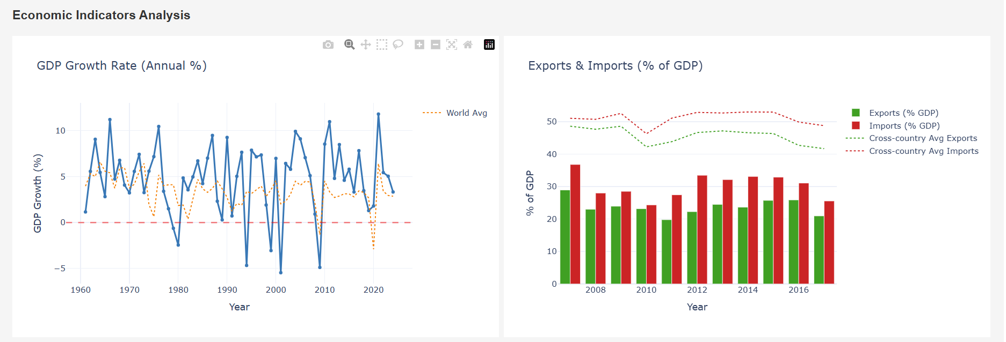
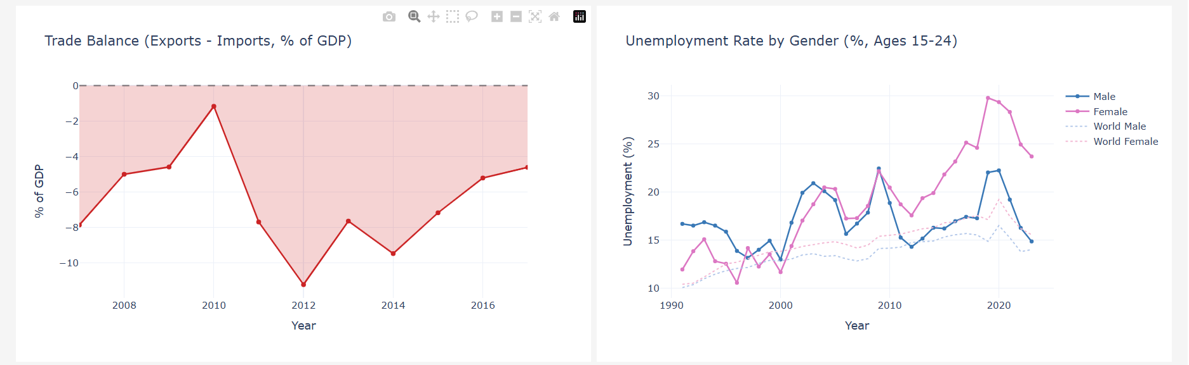
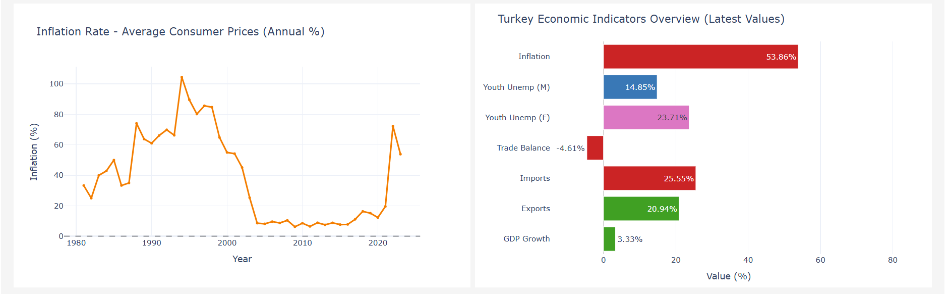

References
- World Bank. GDP growth (annual %) [Internet]. Data360; [cited 2026 Apr 7]. Available from: https://data360.worldbank.org/en/indicator/WB_WDI_NY_GDP_MKTP_KD_ZG
- World Bank. Exports as a percentage of GDP [Internet]. Data360; [cited 2026 Apr 7]. Available from: https://data360.worldbank.org/en/indicator/WEF_GCIHH_EXPGDP
- World Bank. Imports as a percentage of GDP [Internet]. Data360; [cited 2026 Apr 7]. Available from: https://data360.worldbank.org/en/indicator/WEF_GCIHH_IMPGDP
- World Bank. Unemployment (%) indicator (Gender Statistics source stream) [Internet]. Data360; [cited 2026 Apr 7]. Available from: https://data360.worldbank.org/en/indicator/WB_GS_SL_UEM_ZS
- International Monetary Fund. Inflation, average consumer prices, index [Internet]. Data360; [cited 2026 Apr 7]. Available from: https://data360.worldbank.org/en/indicator/IMF_WEO_PCPI
- McKinney W. Data structures for statistical computing in Python. In: Walt S van der, Millman J, editors. Proceedings of the 9th Python in Science Conference. Austin (TX): SciPy; 2010. p. 56-61.
- Plotly Technologies Inc. Plotly Python graphing library [Internet]. Montreal: Plotly; [cited 2026 Apr 7]. Available from: https://plotly.com/python/
- Plotly Technologies Inc. Dash documentation [Internet]. Montreal: Plotly; [cited 2026 Apr 7]. Available from: https://dash.plotly.com/

