Project Report
Library Management System
Object Oriented Programming 2 2025-2026
A00325358: Pronoti Saha
4-3-2026

Contents

Introduction 4
Purpose 4
Features 4
User Stories 5
1. Menu-based Operations 5
User Story: 5
Acceptance Criteria: 5
2. View All Items 5
User Story: 5
Acceptance Criteria: 5
3. Search Books by Title 5
User Story: 5
Acceptance Criteria: 5
4. Search Books by Author 6
User Story: 6
Acceptance Criteria: 6
5. Borrow a Book 6
User Story: 6
Acceptance Criteria: 6
6. Return a Book 6
User Story: 6
Acceptance Criteria: 6
7. As a user, I want to see active borrow records so that I can review who borrowed what and when it is due. 7
8. As a user, I want to add a new book so the catalogue can grow over time. 7
9. As a user, I want book IDs to be generated automatically so I do not need to manage IDs manually. 7
10. As a user, I want to add a magazine so non-borrowable items can also be stored. 7
11. As a user, I want catalogue insight reports so I can view grouped and partitioned information. 7
12. View Library Statistics 7
User Story: 7
Acceptance Criteria: 7
13. As a user, I want opening hours shown in different locales so localisation can be demonstrated. 7
14. As a user, I want the application to save data to files so the state is preserved between runs. 7
15. As a user, I want malformed saved rows to be skipped so the system does not fail to start because of one bad line. 7
Implementation 8
Fundamentals 8
Classes 8
Encapsulation 10
Interfaces 11
Inheritance 11
Exceptions (checked and unchecked) 13
Enums 14
Use of Java Core API (String, StringBuilder, List, Map, Date API) 14
Advanced: 15
Call-by-value and Defensive copying 15
private, default and static interface methods 16
Custom Immutable type 17
Lambdas 18
Switch expressions 20
Sealed classes and Interfaces 21
Records for immutable data 21
Java 25 Features: 22
Compact source files (no explicit class for main) 22
Flexible constructor bodies 23
IO Class 23
Challenges 24
Areas of Improvements 24
Appendix 1 - Class UML Diagram 25
References 26

Introduction
The Library Management System (LMS) is a Java-based application designed to manage library resources such as books and magazines. It provides a menu-driven interface for users to manage a small library catalogue, add books and magazines, borrow and return books, search the catalogue, view saved borrow records, and display reports.
The application uses file-based persistence instead of a database. Books, magazines, and active borrow records are stored in text files under the data directory. On startup, the system loads the saved state back into memory.
The project demonstrates fundamental and advanced Java (Java 25) features and adheres to object-oriented programming (OOP) principles.

This project is a Library Management System written in Java 25 using preview features where required. The application allows a user to manage a small library catalogue, add books and magazines, borrow and return books, search the catalogue, view saved borrow records, and display reports.
The main purpose of this project is not to create a business-ready library platform, but to use the library domain as a vehicle for demonstrating the Java language features required by the OOP2 assignment brief. Because of that, some features are surfaced in menu options and reports specifically so they can be clearly shown and explained during the screencast.
The application uses file-based persistence instead of a database. Books, magazines, and active borrow records are stored in text files under the data/ folder. On startup, the system loads the saved state back into memory and skips malformed rows instead of crashing.

Purpose
- Demonstrate OOP concepts, provide a modular, extensible, and maintainable codebase for educational use.
- Demonstrate advanced Java features – concurrency, NIO2, Localisation etc
- Utilize Java 25 features - compact source files, records, sealed interfaces, flexible constructors, scoped values, stream gathers etc.

Features
- View all library items (books and magazines)
- Search for books by title or author
- Borrow and return books
- View library statistics
- Exception handling with custom exceptions

User Stories

Menu-based Operations
User Story:
As a user, I want to perform various operations using a interactive menu.

Acceptance Criteria:
- The system displays a menu for various operations.
- The system performs the operation based on user input.
- The system displays appropriate error message for invalid input

View All Items
User Story:
As a user, I want to view all catalogue items so I can see all the books and magazines in the library so I can choose what interests me.

Acceptance Criteria:
- The system displays a list of all books with their status (available/borrowed).
- The system displays a list of all magazines.
- The output is clear and well-formatted.

Search Books by Title
User Story:
As a user, I want to search for books by title to find specific items quickly.

Acceptance Criteria:
- The user can enter a title.
- The system displays all matching books.
- If no matches are found, an appropriate message is shown.

Search Books by Author
User Story:
As a user, I want to search for books by author to find specific items quickly.

Acceptance Criteria:
- The user can enter a author name.
- The system displays all matching books.
- If no matches are found, an appropriate message is shown.

Borrow a Book
User Story:
As a user, I want to borrow a book by providing its ID and my name so that it becomes unavailable for other borrowers.

Acceptance Criteria:
- The user provides a valid book ID and their name.
- The system marks the book as borrowed if available.
- If the book is already borrowed or the ID is invalid, an appropriate message is shown.

Return a Book
User Story:
As a user, I want to return a borrowed book by providing its ID so it becomes available for others again.

Acceptance Criteria:
- The user provides a valid book ID.
- The system marks the book as available if it was borrowed.
- If the book was not borrowed or the ID is invalid, an appropriate message is shown.

As a user, I want to see active borrow records so that I can review who borrowed what and when it is due.

As a user, I want to add a new book so the catalogue can grow over time.

As a user, I want book IDs to be generated automatically so I do not need to manage IDs manually.

As a user, I want to add a magazine so non-borrowable items can also be stored.

As a user, I want catalogue insight reports so I can view grouped and partitioned information.

View Library Statistics
User Story:
As a user, I want to see statistics dashboard about the library’s collection and usage so that I can see counts and Java stream examples in action

Acceptance Criteria:
- The system displays the total number of books.
- The system displays the number of borrowed and available books.
- The system displays the number of magazines.

As a user, I want opening hours shown in different locales so localisation can be demonstrated.

As a user, I want the application to save data to files so the state is preserved between runs.

As a user, I want malformed saved rows to be skipped so the system does not fail to start because of one bad line.

Implementation

Fundamentals

Classes

this() and this
In the immutable Magazine class, this() – to call it own constructors and this – to refer to the instance properties are used to instantiate a Magazine object.

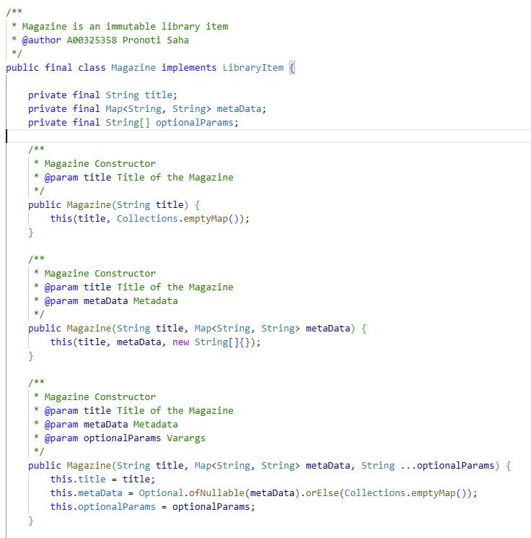

Method/Constructor overloading
Magazine class has 3 overloaded constructors
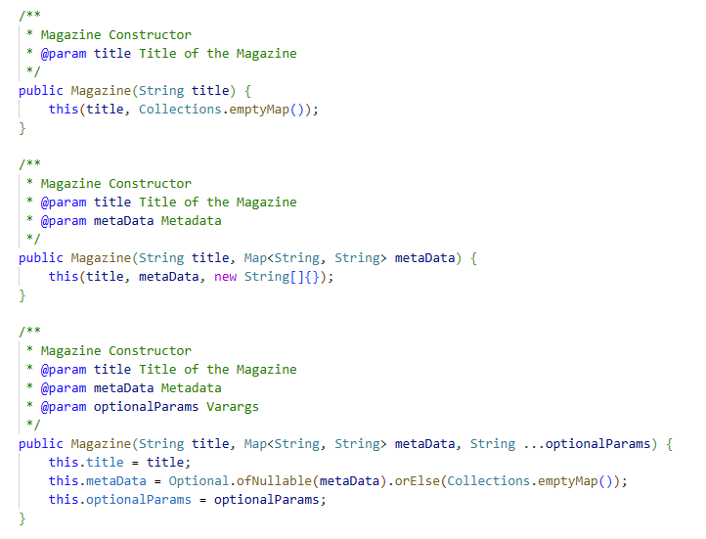

varargs
One of the constructors of the Magazine class takes in varargs optionalParams as an argument
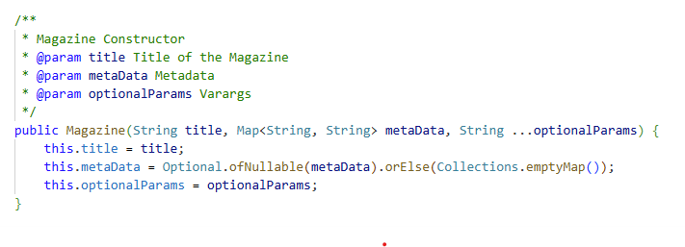

LVTI
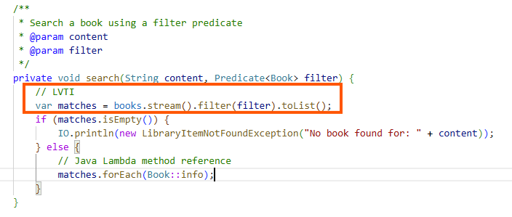

Encapsulation
The Library class encapsulates Books, Magazines and LibraryRecords in it
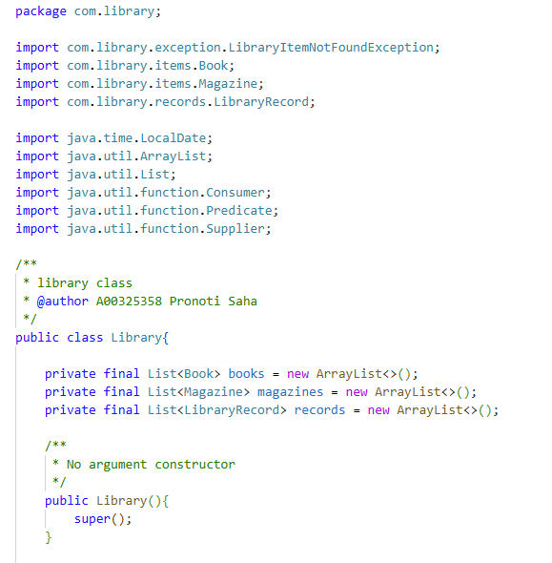

Interfaces
There are two main interfaces in the project - LibraryItem and Borrowable

LibraryItem
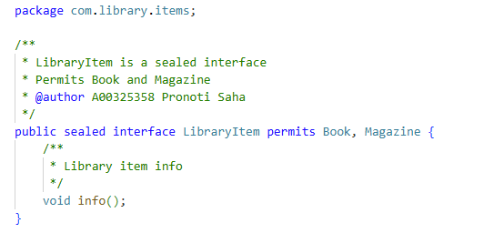

Borrowable
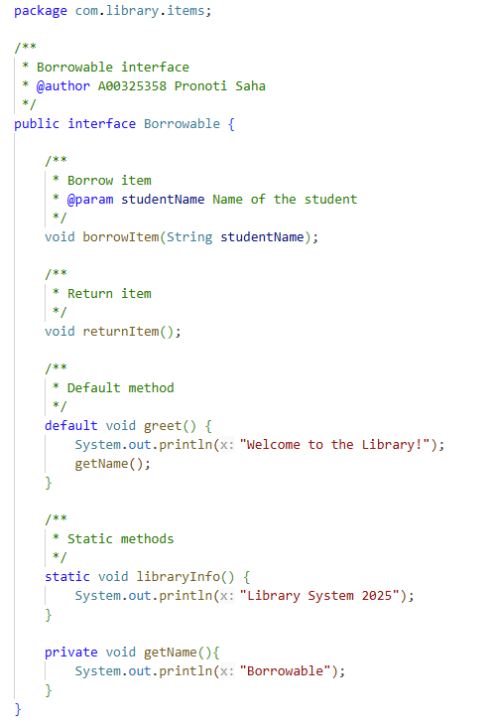

Inheritance

Overriding and Polymorphism
When a subclass provides a specific implementation for a method that is already defined in its parent class, it is called method overriding. The overridden method in the subclass must have the same name, parameters, and return type as the method in the parent class.
Polymorphism is one of the core concepts in Object Oriented Programming that allows objects to behave differently based on their specific class type. In Java, polymorphism allows the same method or object to behave differently based on the context, especially on the project's actual runtime class.
LibraryItem is a sealed interface for library items (Books and Magazines) (Appendix 1: Class UML Diagram).
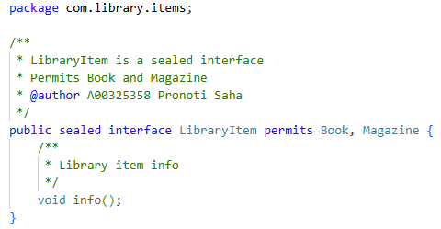

Contrast super() and super.
The super keyword in Java is a reference variable that is used to refer parent class objects. super can be used to call parent class' variables and methods.
The super() in Java is a reference variable that is used to refer parent class constructors. super() can be used to call parent class' constructors only.



Exceptions (checked and unchecked)

LibraryException (Checked Exception)
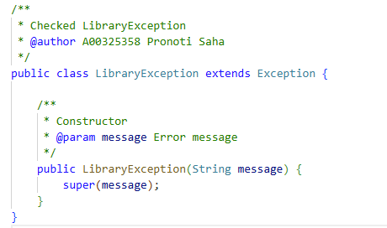

LibraryOperationException (Unchecked Exception)
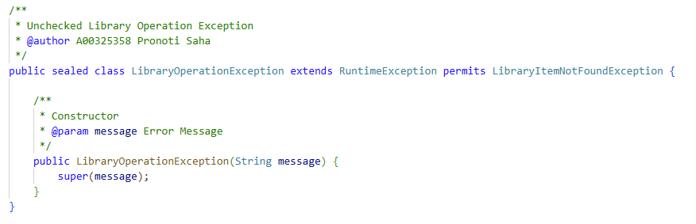

LibraryItemNotFoundException (Unchecked Exception)
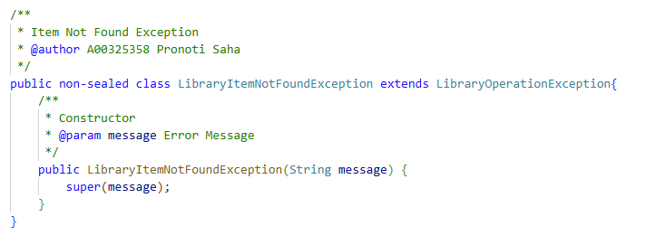

Enums
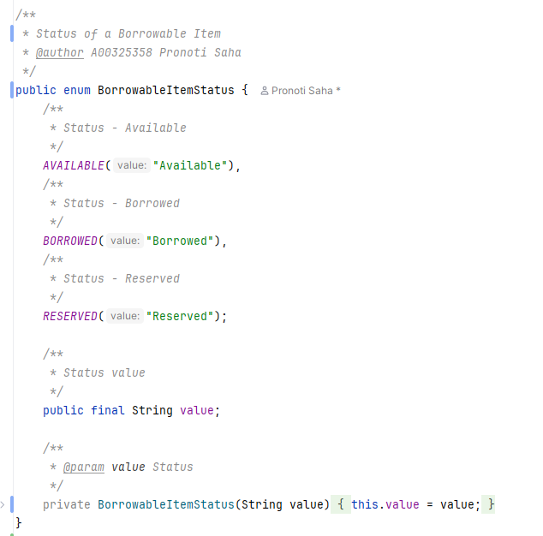

Use of Java Core API (String, StringBuilder, List, Map, Date API)

String Builder is used to generate receipt for a borrowed item
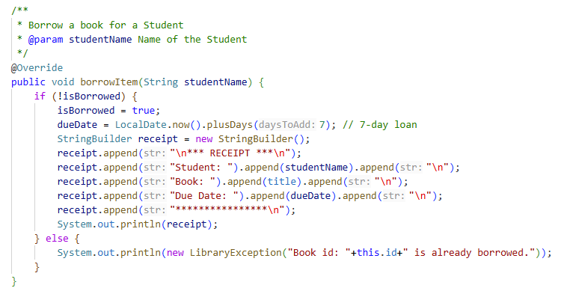

Date API is used to calculate late fine while returning a borrowed item
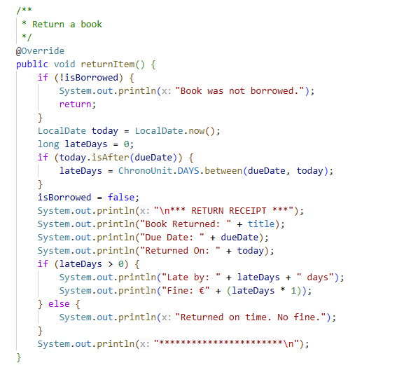

Advanced:

Call-by-value and Defensive copying
In Call-by-Value, method parameters values are copied to another variable and then the copied object is passed, that's why it's called pass by value where actual value does not change but the changes are done on the copied value.
If the mutable object field's state should be changed only by the native class, then a defensive copy of the mutable object must be made any time it's passed into (constructors and set methods) or out of (get methods) the class. If this is not done, then it is simple for the caller to break encapsulation, by changing the state of an object which is simultaneously visible to both the class and its caller.

Example
Magazine has a mutable object field metaData, which is defensively copied in getMetaData() method. Magazine represents an immutable class and has no setter methods for its fields. Note that if the defensive copy of metaData is not made, then Magazine is no longer immutable!
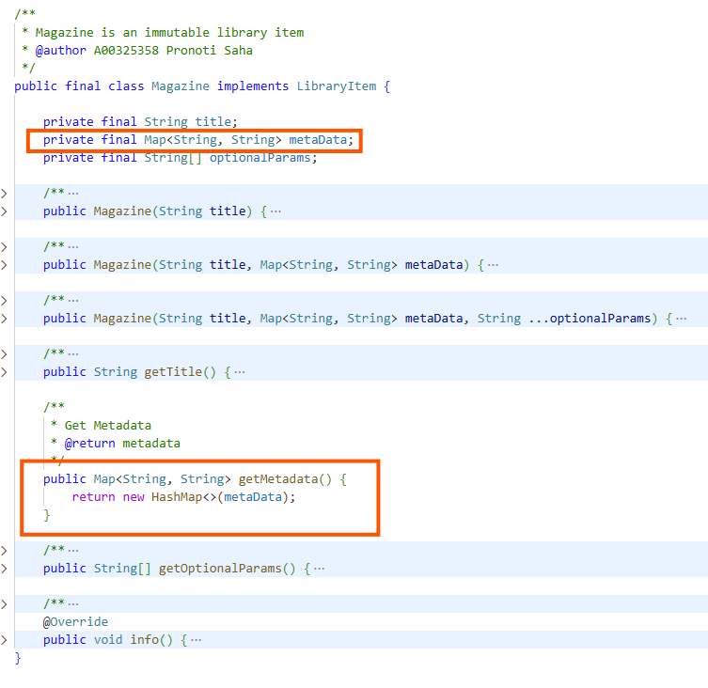

private, default and static interface methods


Custom Immutable type
Magazine is a custom immutable type implementing LibraryItem interface. It is declared a final class to prevent the class from being extended and no access to its properties directly or via any method that can modify the values after initialisation through constructor call.
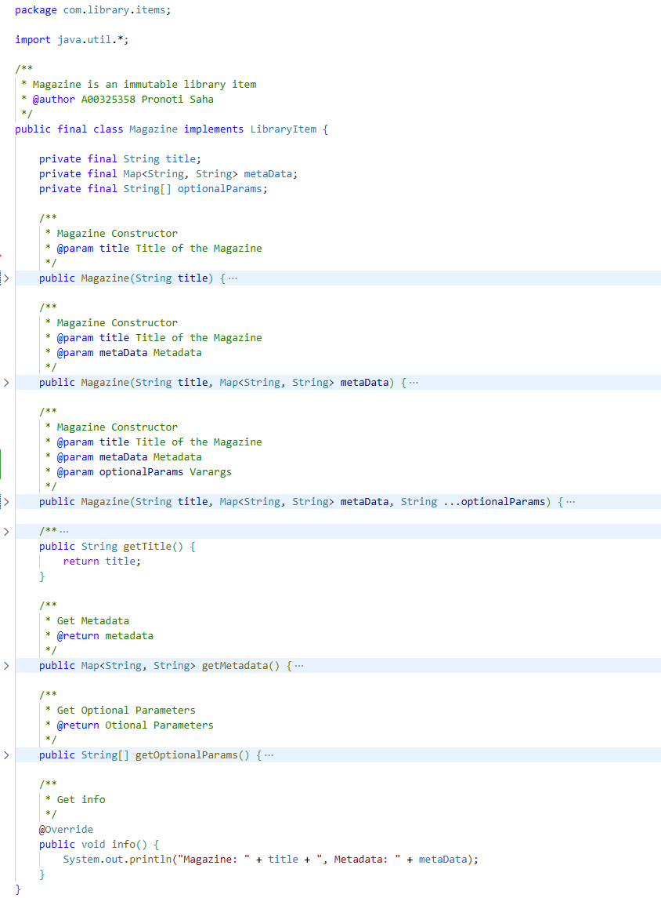

Lambdas

Discussion of ‘final’ or ‘effectively final’
A final variable is a variable that is declared with a keyword - ‘final’.
Eg – public static final int NUMBER=10;
The local variables that a lambda expression may use are referred to as "effectively final".
An effectively final variable is one whose value doesn't change after it is first assigned. There is no need to explicitly declare such a variable as final, although doing so would not be an error.

Predicate
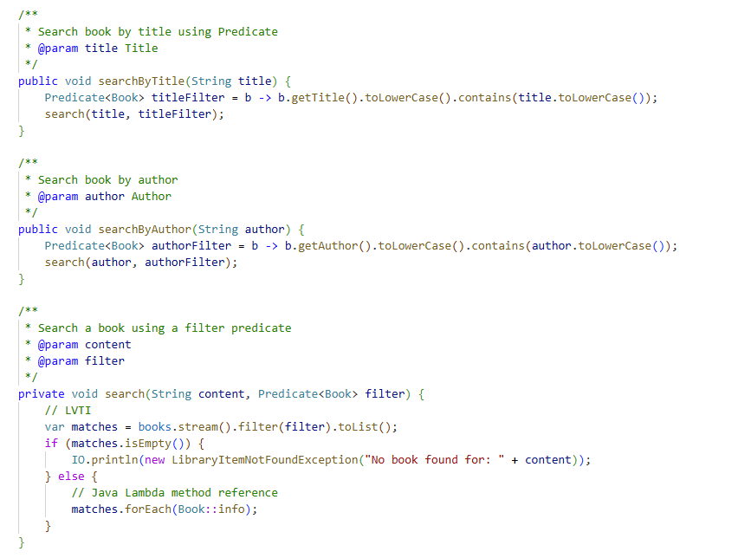

Consumer
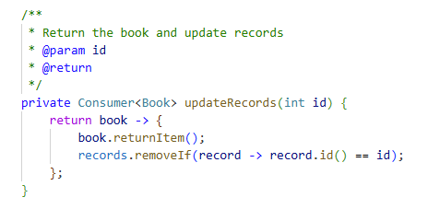

Supplier
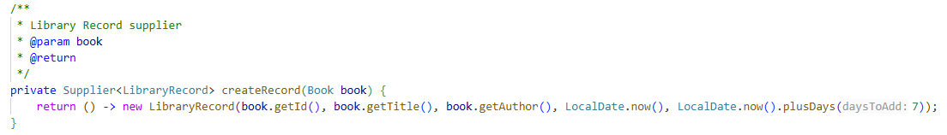

Stream
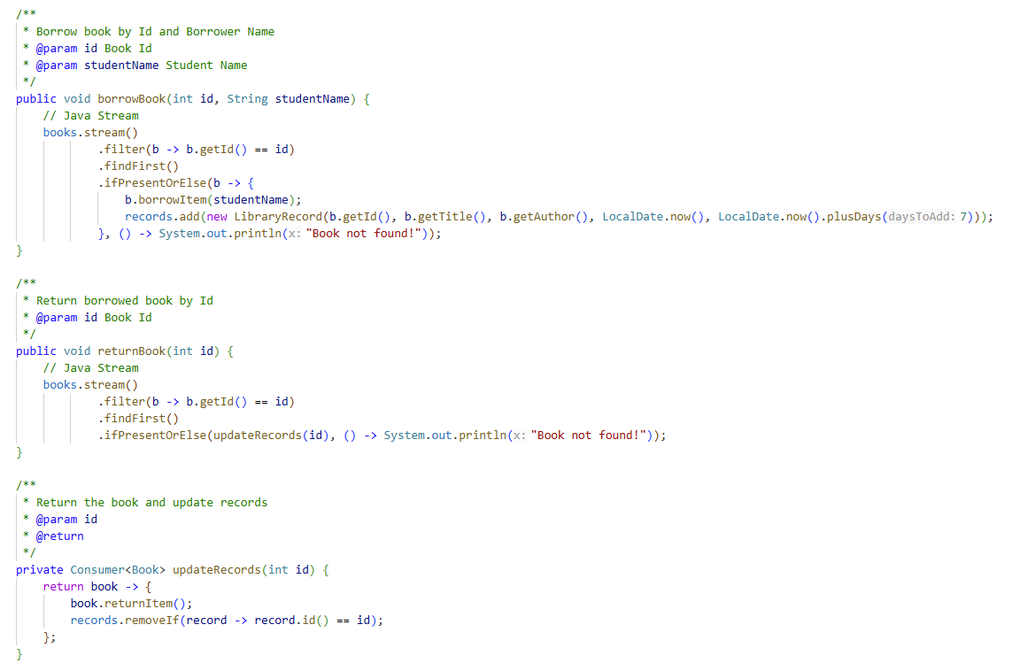

Method Reference
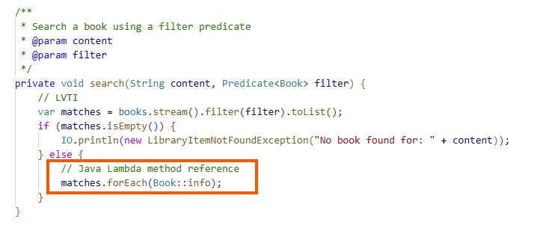

Switch expressions
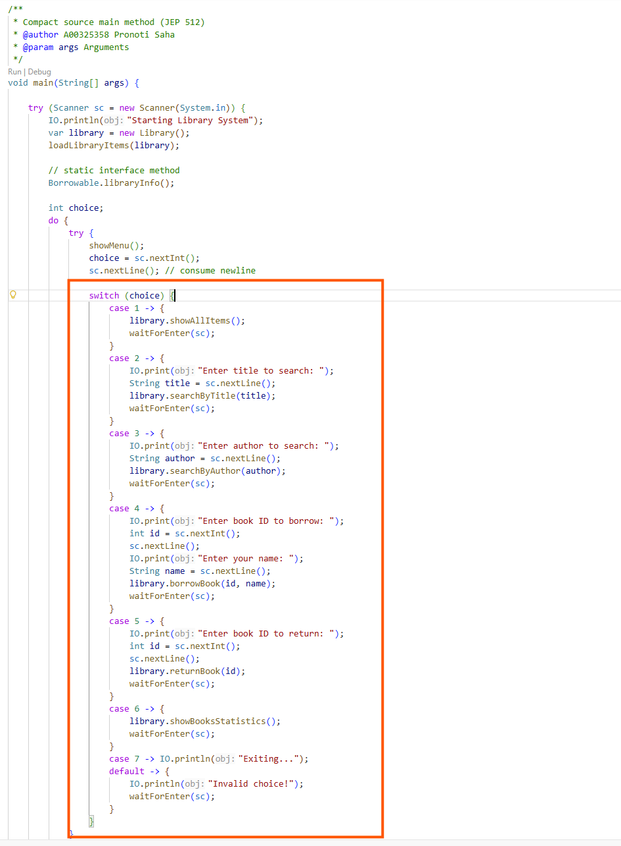

Sealed classes and Interfaces

Sealed class
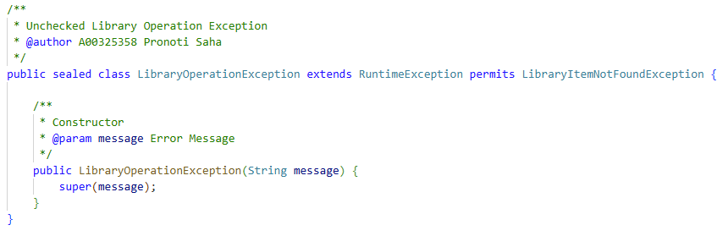

Sealed interface
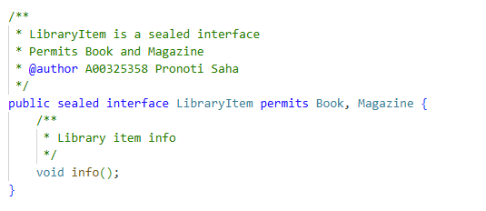

Records for immutable data
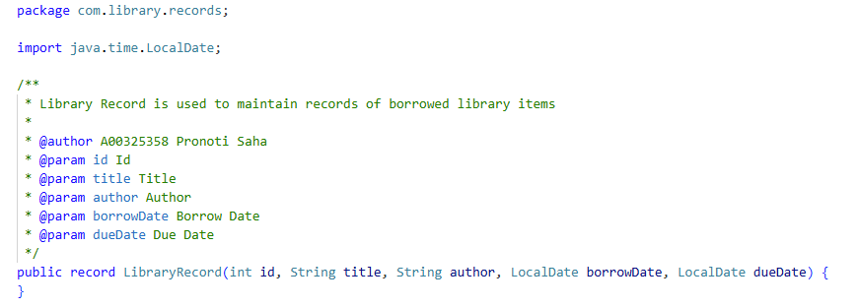

Java 25 Features:

Compact source files (no explicit class for main)
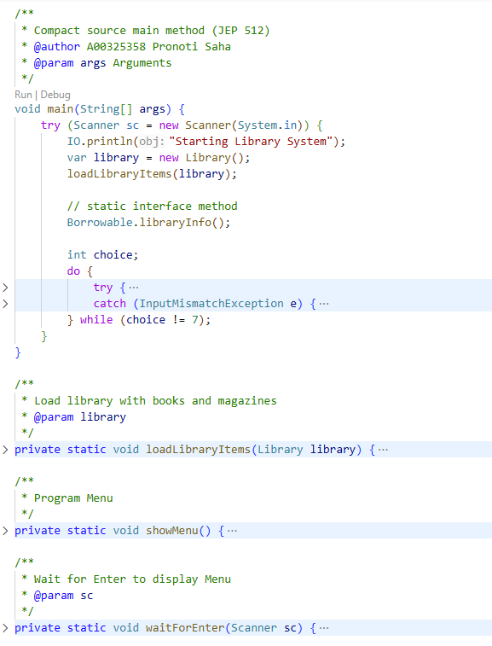

Flexible constructor bodies
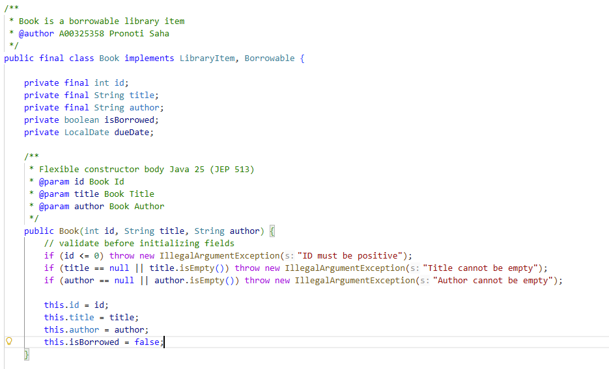

IO Class
Used IO class to access System.out directly
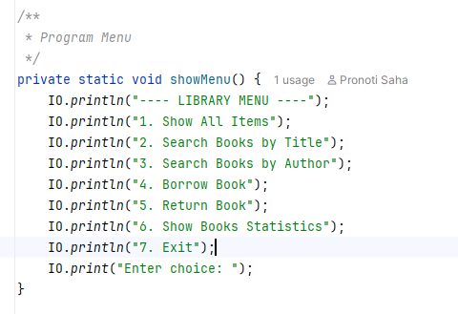

Challenges
- Integrating new Java 25 features with traditional OOP design.
- Ensuring robust exception handling for user input and library operations.
- Maintaining code readability and modularity while using advanced language features.

Areas of Improvements
- Add persistent storage (e.g., file or database) for library data.
- Implement user authentication and roles (e.g., admin, member).
- Enhance the search functionality with partial matches and filters.
- Develop a graphical user interface (GUI) for better usability.
- Add support for additional item types (e.g., DVDs, e-books).

Appendix 1 - Class UML Diagram

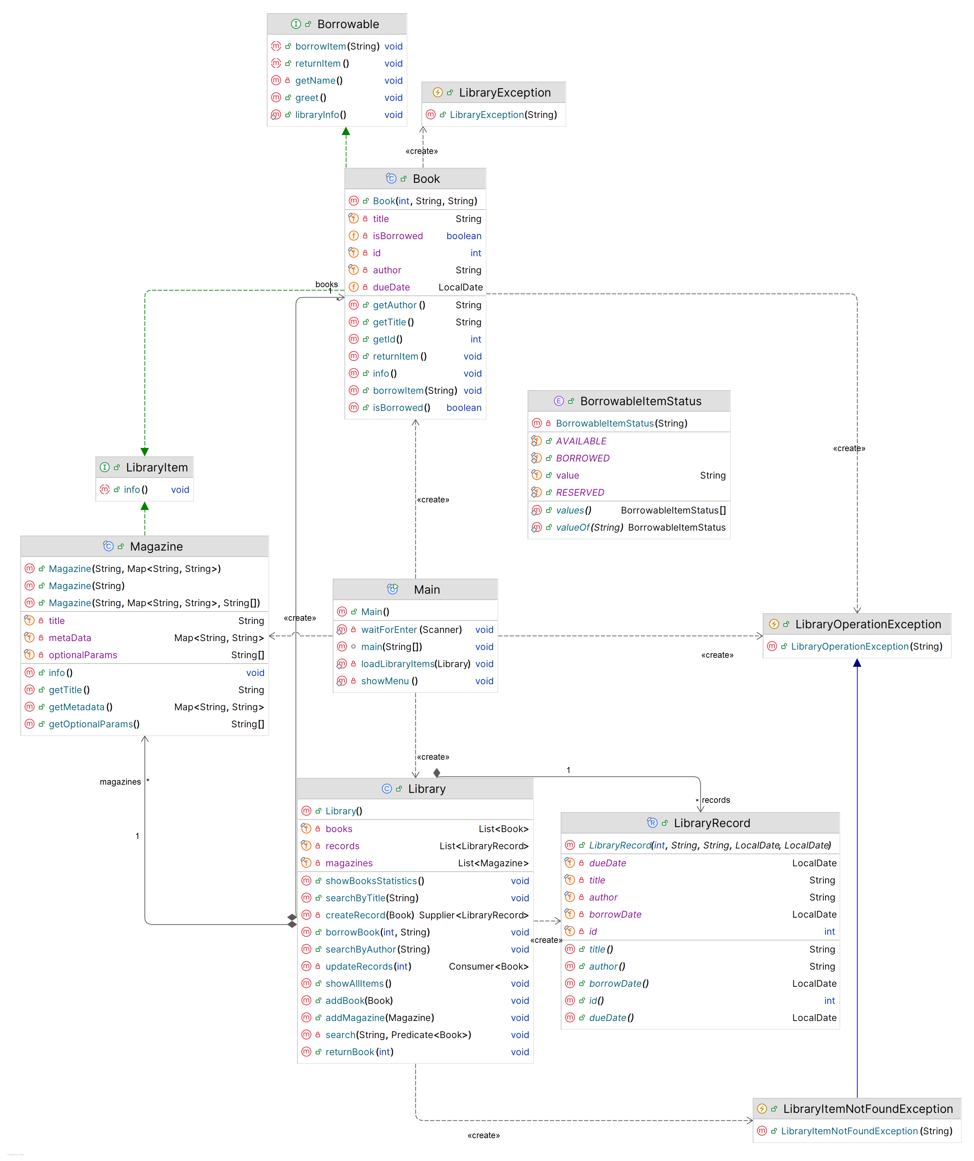

References
- Official Java Tutorials: https://docs.oracle.com/javase/tutorial/
- Java 25 Documentation: https://docs.oracle.com/en/java/javase/25/
- W3Schools: https://www.w3schools.com/
- GeeksforGeeks: https://www.geeksforgeeks.org/java/lambda-expressions-java-8/

