Chapter 1 – Prerequisites

# 1.1 Sensors and actuators

Any complex system shall always use multiple number of sensors and actuators to receive inputs from the surrounding environment and then take necessary actions concerning the same. Following are a list of sensors and actuators (in that order) used in a fueling machine whose basic knowledge is prerequisite.

**Sensors**

1. **LVDT (Linear Variable Displacement Transducer):**

LVDTs are robust, absolute linear position/displacement transducers; inherently frictionless, they have a virtually infinite cycle life when properly used. As AC operated LVDTs do not contain any electronics, they can be designed to operate at cryogenic temperatures or up to 1200 °F (650 °C), in harsh environments, under high vibration and shock levels. LVDTs have been widely used in applications such as power turbines, hydraulics, automation, aircraft, satellites, nuclear reactors, and many others. These transducers have low hysteresis and excellent repeatability.

The LVDT converts a position or linear displacement from a mechanical reference (zero or null position) into a proportional electrical signal containing phase (for direction) and amplitude (for distance) information. The LVDT operation does not require an electrical contact between the moving part (probe or core assembly) and the coil assembly, but instead relies on electromagnetic coupling.

The linear variable differential transformer has three solenoidal coils placed end-to-end around a tube. The center coil is the primary, and the two outer coils at the top and bottom are secondary coils. A cylindrical ferromagnetic core, attached to the object whose position is to be measured, slides along the axis of the tube. An alternating current drives the primary and `causes a voltage to be induced in each secondary proportional to the length of the core linking to the secondary. The frequency is usually in the range 1 to 10 kHz.

As the core moves, the primary's linkage to the two secondary coils changes and causes the induced voltages to change. The coils are connected so that the output voltage is the difference (hence "differential") between the top secondary voltage and the bottom secondary voltage. When the core is in its central position, equidistant between the two secondary coils equal voltages are induced in the two secondary coils, but the two signals cancel, so the output voltage is theoretically zero. In practice minor variations in the way in which the primary is coupled to each secondary means that a small voltage is output when the core is central.

This small residual voltage is due to phase shift and is often called quadrature error. It is a nuisance in closed loop control systems as it can result in oscillation about the null point, and may be unacceptable in simple measurement applications too. It is a consequence of using synchronous demodulation, with direct subtraction of the secondary voltages at AC. Modern systems, particularly those involving safety, require fault detection of the LVDT, and the normal method is to demodulate each secondary separately, using precision half wave or full wave rectifiers, based on op-amps, and compute the difference by subtracting the DC signals. Because, for constant excitation voltage, the sum of the two secondary voltages is almost constant throughout the operating stroke of the LVDT, its value remains within a small window and can be monitored such that any internal failures of the LVDT will cause the sum voltage to deviate from its limits and be rapidly detected, causing a fault to be indicated. There is no quadrature error with this scheme, and the position-dependent difference voltage passes smoothly through zero at the null point.

Where digital processing in the form of a microprocessor or FPGA is available in the system, it is customary for the processing device to carry out the fault detection, and possibly ratiometric processing to improve accuracy, by dividing the difference in secondary voltages by the sum of the secondary voltages, to make the measurement independent of the exact amplitude of the excitation signal. If sufficient digital processing capacity is available, it is becoming commonplace to use this to generate the sinusoidal excitation via a DAC and possibly also perform the secondary demodulation via a multiplexed ADC.

When the core is displaced toward the top, the voltage in the top secondary coil increases as the voltage in the bottom decreases. The resulting output voltage increases from zero. This voltage is in phase with the primary voltage. When the core moves in the other direction, the output voltage also increases from zero, but its phase is opposite to that of the primary. The phase of the output voltage determines the direction of the displacement (up or down) and amplitude indicates the amount of displacement. A synchronous detector can determine a signed output voltage that relates to the displacement.

The LVDT is designed with long slender coils to make the output voltage essentially linear over displacement up to several inches (several hundred millimeters) long.

The LVDT can be used as an absolute position sensor. Even if the power is switched off, on restarting it, the LVDT shows the same measurement, and no positional information is lost. Its biggest advantages are repeatability and reproducibility once it is properly configured. Also, apart from the uni-axial linear motion of the core, any other movements such as the rotation of the core around the axis will not affect its measurements.

Because the sliding core does not touch the inside of the tube, it can move without friction, making the LVDT a highly reliable device. The absence of any sliding or rotating contacts allows the LVDT to be completely sealed against the environment.

LVDTs are commonly used for position feedback in servomechanisms, and for automated measurement in machine tools and many other industrial and scientific applications. Following is an illustration of the same.

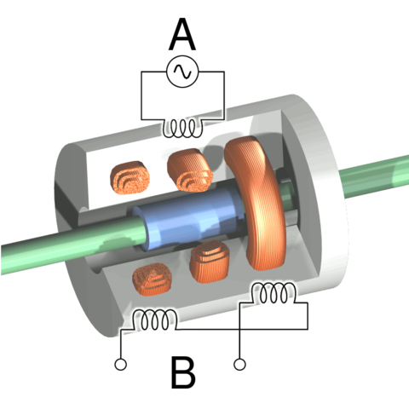

**Figure 1.1.a – 1** Cutaway view of an LVDT

Following is another illustration of an RVDT, this time highlighting the coils in symbolic notations.

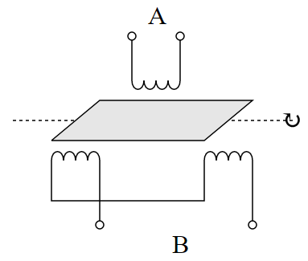

**Figure 1.1.a – 2** Principle of rotary variable differential transformer

1. **POT(Potentiometer):**

A potentiometer is a three-terminal resistor with a sliding or rotating contact that forms an adjustable voltage divider. If only two terminals are used, one end and the wiper, it acts as a variable resistor or rheostat. The measuring instrument called a potentiometer is essentially a voltage divider used for measuring electric potential (voltage); the component is an implementation of the same principle, hence its name. Potentiometers are commonly used to control electrical devices such as volume controls on audio equipment. Potentiometers operated by a mechanism can be used as position transducers, for example, in a joystick. Potentiometers are rarely used to directly control significant power (more than a watt), since the power dissipated in the potentiometer would be comparable to the power in the controlled load.

Potentiometers consist of a resistive element, a sliding contact (wiper) that moves along the element, making good electrical contact with one part of it, electrical terminals at each end of the element, a mechanism that moves the wiper from one end to the other, and a housing containing the element and wiper.

See drawing. Many inexpensive potentiometers are constructed with a resistive element (B) formed into an arc of a circle usually a little less than a full turn and a wiper (C) sliding on this element when rotated, making electrical contact. The resistive element can be flat or angled. Each end of the resistive element is connected to a terminal (E, G) on the case. The wiper is connected to a third terminal (F), usually between the other two. On panel potentiometers, the wiper is usually the center terminal of three. For single-turn potentiometers, this wiper typically travels just under one revolution around the contact. The only point of ingress for contamination is the narrow space between the shaft and the housing it rotates in.

Another type is the linear slider potentiometer, which has a wiper which slides along a linear element instead of rotating. Contamination can potentially enter anywhere along the slot the slider moves in, making effective sealing more difficult and compromising long-term reliability. An advantage of the slider potentiometer is that the slider position gives a visual indication of its setting. While the setting of a rotary potentiometer can be seen by the position of a marking on the knob, an array of sliders can give a visual impression of, for example, the effect of a multi-band equalizer (hence the term "graphic equalizer").

The resistive element of inexpensive potentiometers is often made of graphite. Other materials used include resistance wire, carbon particles in plastic, and a ceramic/metal mixture called cermet. Conductive track potentiometers use conductive polymer resistor pastes that contain hard-wearing resins and polymers, solvents, and lubricant, in addition to the carbon that provides the conductive properties.

Multiturn potentiometers are also operated by rotating a shaft, but by several turns rather than less than a full turn. Some multiturn potentiometers have a linear resistive element with a sliding contact moved by a lead screw; others have a helical resistive element and a wiper that turns through 10, 20, or more complete revolutions, moving along the helix as it rotates. Multiturn potentiometers, both user-accessible and preset, allow finer adjustments; rotation through the same angle changes the setting by typically a tenth as much as for a simple rotary potentiometer.

A string potentiometer is a multi-turn potentiometer operated by an attached reel of wire turning against a spring, enabling it to convert linear position to a variable resistance.

User-accessible rotary potentiometers can be fitted with a switch which operates usually at the anti-clockwise extreme of rotation. Before digital electronics became the norm such a component was used to allow radio and television receivers and other equipment to be switched on at minimum volume with an audible click, then the volume increased, by turning a knob. Multiple resistance elements can be ganged together with their sliding contacts on the same shaft, for example, in stereo audio amplifiers for volume control. In other applications, such as domestic light dimmers, the normal usage pattern is best satisfied if the potentiometer remains set at its current position, so the switch is operated by a push action, alternately on and off, by axial presses of the knob.

Others are enclosed within the equipment and are intended to be adjusted to calibrate equipment during manufacture or repair, and not otherwise touched. They are usually physically much smaller than user-accessible potentiometers, and may need to be operated by a screwdriver rather than having a knob. They are usually called "preset potentiometers" or "trimming pots". Some pre-sets are accessible by a small screwdriver poked through a hole in the case to allow servicing without dismantling.

Following is an illustration of a commonly used potentiometer in household appliances followed by its European electronic symbol

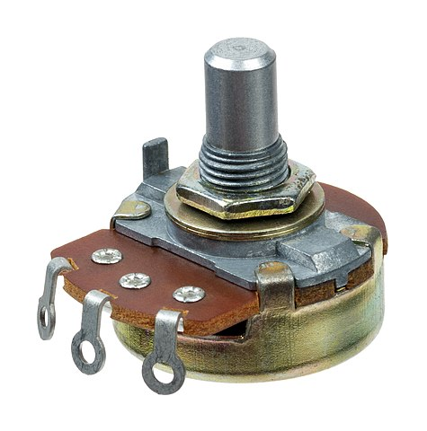

**Figure 1.1.b – 1** Potentiometer

**

**Figure 1.1.b - 2** Symbol for potentiometer (European)

1. **Pressure transducer/sensor/transmitter:**

A pressure transducer, often called a pressure transmitter, is a transducer that converts pressure into an analog electrical signal. Although there are various types of pressure transducers, one of the most common is the strain-gage base transducer. The conversion of pressure into an electrical signal is achieved by the physical deformation of strain gages which are bonded into the diaphragm of the pressure transducer and wired into a Wheatstone bridge configuration. Pressure applied to the pressure transducer produces a deflection of the diaphragm which introduces strain to the gages. The strain will produce an electrical resistance change proportional to the pressure.

Following is a digital pressure sensor chip

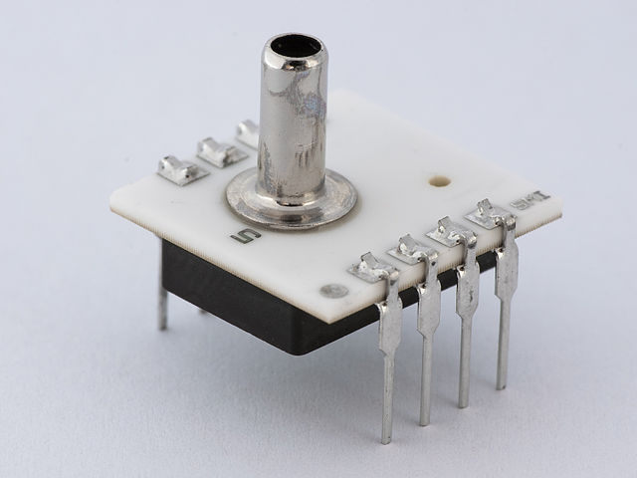

**Figure 1.1.c – 1** Digital air pressure sensor

**Differential pressure transmitter:**

There are already two answers. My humble opinion is that they miss the point.

Differential pressure Transmitter is used to measure flow of a liquid or a gas. To measure the difference between two pressures you require only two pressure gauges. Two measure flow in a pipe line where flow is happening you need to measure the pressure drop due to flow and hence a DP Transmitter is used.

They use the principle that there will be a pressure drop when a fluid passes through an orifice as when a restricted orifice is placed in a pipe line which is smaller than the pipe line the pressure upstream will be higher and immediately after the orifice downstream pressure will be lower due higher velocity. This is called differential pressure or called as Delta P. This is directly proportional to the flow rate. Thus the DP Transmitter will give a reading measuring the Delta P and a flow varies in a critical line from its set pressure an electrical signal is generated and set to a control valve to control the flow parameters to the Set Pressure and will adjust keeping process parameters.

This DP Transmitter enables constant control of flow or even reset the Set political from a remote location. This enables constant monitoring of a very critical parameter of a process.

Nowadays days we have corrialis meters which are even accurate that measure mass flow by using corrialis Principle very accurately capable measuring mass variation due to density variation or pressure variations. These are cen more precise and accurate leading to use in hazardous application in nuclear reactors, hazardous process requiring extreme precision and safety.

Following is an illustration of the same

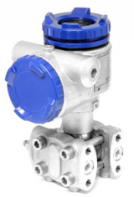

**Figure 1.1.c – 2** A high performance differential pressure transmitter

1. **RTD (Resistance Temperature Detector):**

RTD stands for Resistance Temperature Detector. RTDs are sometimes referred to generally as resistance thermometers. The American Society for Testing and Materials (ASTM) has defined the term resistance thermometer as follows:

Resistance thermometer is a temperature-measuring device composed of a resistance thermometer element, internal connecting wires, a protective shell with or without means for mounting a connection head, or connecting wire or other fittings, or both.

An RTD is a temperature sensor which measures temperature using the principle that the resistance of a metal changes with temperature. In practice, an electrical current is transmitted through a piece of metal (the RTD element or resistor) located in proximity to the area where temperature is to be measured. The resistance value of the RTD element is then measured by an instrument. This resistance value is then correlated to temperature based upon the known resistance characteristics of the RTD element.

RTDs work on a basic correlation between metals and temperature. As the temperature of a metal increases, the metal's resistance to the flow of electricity increases. Similarly, as the temperature of the RTD resistance element increases, the electrical resistance, measured in ohms (Ω), increases. RTD elements are commonly specified according to their resistance in ohms at zero degrees Celsius. The most common RTD specification is 100 Ω, which means that at the RTD element should demonstrate 100 Ω of resistance.

Platinum is the most commonly used metal for RTD elements due to a number of factors, including its:

(1) Chemical inertness

(2) Nearly linear temperature versus resistance relationship,

(3) Temperature coefficient of resistance that is large enough to give readily measurable resistance changes with temperature and

(4) Stability (in that its temperature resistance does not drastically change with time).

Other metals that are less frequently used as the resistor elements in an RTD include nickel, copper and Balco.

RTD elements are typically in one of three configurations:

(1) A platinum or metal glass slurry film deposited or screened onto a small flat ceramic substrate known as "thin film" RTD elements,

(2) Platinum or metal wire wound on a glass or ceramic bobbin and sealed with a coating of molten glass known as "wire wound" RTD elements.

(3) A partially supported wound element which is a small coil of wire inserted into a hole in a ceramic insulator and attached along one side of that hole. Of the three RTD elements, the thin film is most rugged and has become increasingly more accurate over time.

Following are the illustrations of a coil type RTD and a typical 2- wire configuration used in simple applications.

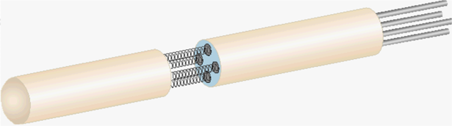

**Figure 1.1.d - 1** A coil element type PRT

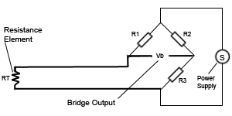

**Figure 1.1.d – 2** An RTD constructed out of a 2 – wire configuration

1. **Ultra-sonic transducer:**

Ultrasonic transducers or ultrasonic sensors are a type of acoustic sensor divided into three broad categories: transmitters, receivers and transceivers. Transmitters convert electrical signals into ultrasound, receivers convert ultrasound into electrical signals, and transceivers can both transmit and receive ultrasound.

In a similar way to radar and sonar, ultrasonic transducers are used in systems which evaluate targets by interpreting the reflected signals. For example, by measuring the time between sending a signal and receiving an echo the distance of an object can be calculated. Passive ultrasonic sensors are basically microphones that detect ultrasonic noise that is present under certain conditions.

Ultrasonic probes and ultrasonic baths apply ultrasonic energy to agitate particles in a wide range of materials

Following is an illustration of a simple ultrasonic transducer

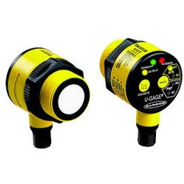

**Figure 1.1.e** Industry grade T30 ultrasonic transducer/sensor manufactured by Pyrotron India Inc.

**Actuators**

1. **Switches:**

In electrical engineering a limit switch is a switch operated by the motion of a machine part or presence of an object. They are used for controlling machinery as part of a control system, as a safety interlock system, or to count objects passing a point. A limit switch is an electromechanical device that consists of an actuator mechanically linked to a set of contacts. When an object comes into contact with the actuator, the device operates the contacts to make or break an electrical connection.

Limit switches are used in a variety of applications and environments because of their ruggedness, ease of installation, and reliability of operation. They can determine the presence or absence, passing, positioning, and end of travel of an object. They were first used to define the limit of travel of an object; hence the name "Limit Switch".

A limit switch with a roller-lever operator; this is installed on a gate on a canal lock, and indicates the position of a gate to a control system.

Standardized limit switches are industrial control components manufactured with a variety of operator types, including lever, roller plunger, and whisker type. Limit switches may be directly mechanically operated by the motion of the operating lever. A reed switch may be used to indicate proximity of a magnet mounted on some moving part. Proximity switches operate by the disturbance of an electromagnetic field, by capacitance, or by sensing a magnetic field.

Rarely, a final operating device such as a lamp or solenoid valve will be directly controlled by the contacts of an industrial limit switch, but more typically the limit switch will be wired through a control relay, a motor contactor control circuit, or as an input to a programmable logic controller.

Miniature snap-action switch may be used for example as components of such devices as photocopiers, computer printers, convertible tops or microwave ovens to ensure internal components are in the correct position for operation and to prevent operation when access doors are opened. A set of adjustable limit switches are installed on a garage door opener to shut off the motor when the door has reached the fully raised or fully lowered position. A numerical control machine such as a lathe will have limit switches to identify maximum limits for machine parts or to provide a known reference point.

Reed switch is a magnetic type switch which has been illustrated below

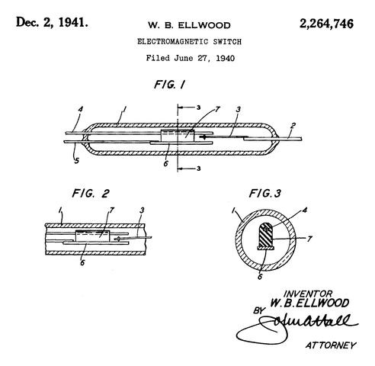

**Figure 1.1.f** Device shown in non-operated position Fig. 2 - device shown in operated position Fig. 3 - cross- section 1 - glass envelope 2 - terminal 3 - resilient magnetic member 4 - non-magnetic member 5 - conducting member 6 - magnetic member 7 - insulating p

1. **Commutator:**

A commutator is a rotary electrical switch in certain types of electric motors and electrical generators that periodically reverses the current direction between the rotor and the external circuit. It consists of a cylinder composed of multiple metal contact segments on the rotating armature of the machine. Two or more electrical contacts called "brushes" made of a soft conductive material like carbon press against the commutator, making sliding contact with successive segments of the commutator as it rotates. The windings (coils of wire) on the armature are connected to the commutator segments.

Commutators are used in direct current (DC) machines: dynamos (DC generators) and many DC motors as well as universal motors. In a motor the commutator applies electric current to the windings. By reversing the current direction in the rotating windings each half turn, a steady rotating force (torque) is produced. In a generator the commutator picks off the current generated in the windings, reversing the direction of the current with each half turn, serving as a mechanical rectifier to convert the alternating current from the windings to unidirectional direct current in the external load circuit. The first direct current commutator-type machine, the dynamo, was built by Hippolyte Pixii in 1832, based on a suggestion by André-Marie Ampère.

Commutators are relatively inefficient, and also require periodic maintenance such as brush replacement. Therefore, commutated machines are declining in use, being replaced by alternating current (AC) machines, and in recent years by brushless DC motors which use semiconductor switches.

A commutator consists of a set of contact bars fixed to the rotating shaft of a machine, and connected to the armature windings. As the shaft rotates, the commutator reverses the flow of current in a winding. For a single armature winding, when the shaft has made one-half complete turn, the winding is now connected so that current flows through it in the opposite of the initial direction. In a motor, the armature current causes the fixed magnetic field to exert a rotational force, or a torque, on the winding to make it turn. In a generator, the mechanical torque applied to the shaft maintains the motion of the armature winding through the stationary magnetic field, inducing a current in the winding. In both the motor and generator case, the commutator periodically reverses the direction of current flow through the winding so that current flow in the circuit external to the machine continues in only one direction.

Following is a cut away view of a universal commutator followed by a diagram illustrating the current flow in such a circuit

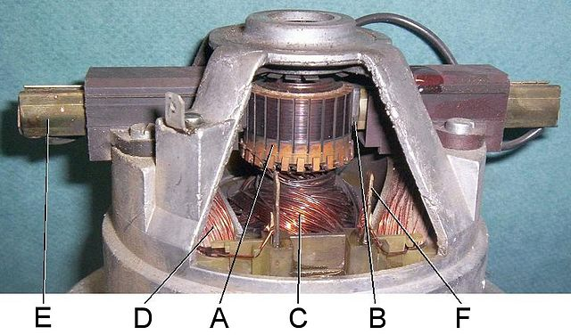

**Figure 1.1.g – 1** Commutator in a universal motor from a vacuum cleaner. Parts: (A) commutator, (B) brush, (C) rotor (armature) windings, (D) stator (F) (field) windings, (E) brush guides

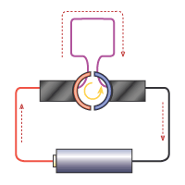

**Figure 1.1.g – 2** Current flow in commutator ring

1. **MDV (Motorized Directional Valve)/Solenoid valve:**

A solenoid valve is an electromechanical device in which the solenoid uses an electric current to generate a magnetic field and thereby operate a mechanism which regulates the opening of fluid flow in a valve.

Solenoid valves differ in the characteristics of the electric current they use, the strength of the magnetic field they generate, the mechanism they use to regulate the fluid and the type and characteristics of fluid they control. The mechanism varies from linear action, plunger-type actuators to pivoted-armature actuators and rocker actuators. The valve can use a two-port design to regulate a flow or use a three or more port design to switch flows between ports. Multiple solenoid valves can be placed together on a manifold. Solenoid valves are the most frequently used control elements in fluidics. Their tasks are to shut off, release, dose, distribute or mix fluids. They are found in many application areas. Solenoids offer fast and safe switching, high reliability, long service life, good medium compatibility of the materials used, low control power and compact design. Here are many valve design variations. Ordinary valves can have many ports and fluid paths. A 2-way valve, for example, has 2 ports; if the valve is open, then the two ports are connected and fluid may flow between the ports; if the valve is closed, then ports are isolated. If the valve is open when the solenoid is not energized, then the valve is termed normally open (N.O.). Similarly, if the valve is closed when the solenoid is not energized, then the valve is termed normally closed. There is also 3-way and more complicated designs. A 3-way valve has 3 ports; it connects one port to either of the two other ports (typically a supply port and an exhaust port).

Solenoid valves are also characterized by how they operate. A small solenoid can generate a limited force. If that force is sufficient to open and close the valve, then a direct acting solenoid valve is possible. An approximate relationship between the required solenoid force Fs, the fluid pressure P, and the orifice area A for a direct acting solenoid valve is:

$$F_{s}=PA=\frac{PπD^{2}}{4}$$

Where d is the orifice diameter. A typical solenoid force might be 15 N (3.4 lbf). An application might be a low pressure (e.g., 10 psi (69 kPa)) gas with a small orifice diameter (e.g., 3⁄8 in (9.5 mm) for an orifice area of 0.11 in2 (7.1×10−5 m2) and approximate force of 1.1 lbf (4.9 N)).

The solenoid valve (small black box at the top of the photo) with input airline (small green tube) used to actuate a larger rack and pinion actuator (gray box) which controls the water pipe valve.

When high pressures and large orifices are encountered, then high forces are required. To generate those forces, an internally piloted solenoid valve design may be possible. In such a design, the line pressure is used to generate the high valve forces; a small solenoid controls how the line pressure is used. Internally piloted valves are used in dishwashers and irrigation systems where the fluid is water, the pressure might be 80 psi (550 kPa) and the orifice diameter might be 3⁄4 in (19 mm).

In some solenoid valves the solenoid acts directly on the main valve. Others use a small, complete solenoid valve, known as a pilot, to actuate a larger valve. While the second type is actually a solenoid valve combined with a pneumatically actuated valve, they are sold and packaged as a single unit referred to as a solenoid valve. Piloted valves require much less power to control, but they are noticeably slower. Piloted solenoids usually need full power at all times to open and stay open, where a direct acting solenoid may only need full power for a short period of time to open it, and only low power to hold it.

A direct acting solenoid valve typically operates in 5 to 10 milliseconds. The operation time of a piloted valve depends on its size; typical values are 15 to 150 milliseconds.

Power consumption and supply requirements of the solenoid vary with application, being primarily determined by fluid pressure and line diameter. For example, a popular 3/4" 150 psi sprinkler valve, intended for 24 VAC (50 - 60 Hz) residential systems, has a momentary inrush of 7.2 VA, and a holding power requirement of 4.6 VA. Comparatively, an industrial 1/2" 10000 psi valve, intended for 12, 24, or 120 VAC systems in high pressure fluid and cryogenic applications, has an inrush of 300 VA and a holding power of 22 VA. Neither valve lists a minimum pressure required to remain closed in the un-powered state.

Following is an illustration of a universal solenoid valve(s).

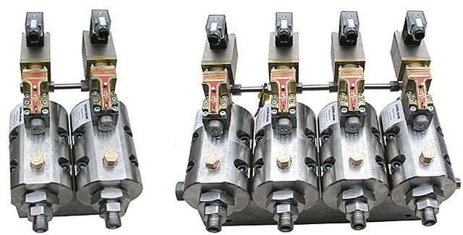

**Figure 1.1.h – 1** Solenoid valves

Following set of illustrations show typical SLV operation modes

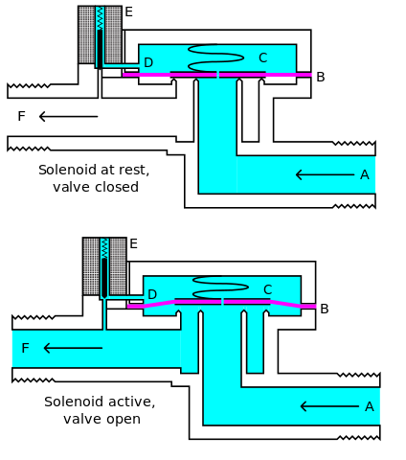

**Figure 1.1.h – 2** Two modes of operation of an SLV illustrating the necessary parts: A- Input Side B- Diaphragm C- Pressure Chamber D- Pressure relief passage E- Electro Mechanical Solenoid F- Output side

1. **EM BRAKE (Electromagnetic brake):**

Electromagnetic brakes (also called electro-mechanical brakes or EM brakes) slow or stop motion using electromagnetic force to apply mechanical resistance (friction). The original name was "electro-mechanical brakes" but over the years the name changed to "electromagnetic brakes", referring to their actuation method. Since becoming popular in the mid-20th century especially in trains and trams, the variety of applications and brake designs has increased dramatically, but the basic operation remains the same.

Both electromagnetic brakes and eddy current brakes use electromagnetic force but electromagnetic brakes ultimately depend on friction and eddy current brakes use magnetic force directly.

This is how a typical EM brake arrangement for a heavy RAM assembly looks like

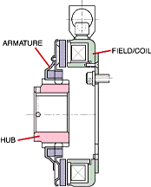

**Figure 1.1.i** Electromagnetic brake (such assembly is used to constraint the vertical motion of the large RAM structure)

# 1.2 The fuelling machine

Fuelling Machine consists of FM Head, Support Structure, Shielding, Trolley and Carriage. FM head is pressure boundary equipment and consists of snout assembly, separator assembly, magazine assembly and ram assembly. The FM head being vertical, shielded and travelling over deck plate, similar to DHRUVA reactor, the design experience and operational feedback of DHRUVA FM has been utilised for design of AHWR FM. However due to differences in certain FM design parameters like design pressure, length of fuel assembly, flow of coolant from FM head to Coolant Channel etc many deviations in the design are required. Some of the concepts like for Ram Assembly, Snout Assembly, Magazine and Magazine Drive assembly are incorporated from FM head of PHWRs.

Entire Shielding Assembly along with FM head and Support Structure is mounted on the Trolley assembly. Trolley Assembly along with the Shielding is mounted and movable on Carriage Assembly. Carriage is hydraulically driven on the fixed rails having span of 13.0m mounted on the reactor top face. The skirt remains in up condition during FM travel and will be lowered to make a leak tight contact with deck plate, during refuelling for V1 and V2 isolation. The FM is operated from control panel located in the main control room. The details of each sub assembly of the FM are presented in the following sections.

##### **1.2.1 Snout Assembly**

The snout assembly is the lowermost part of the FM head. This assembly is used for clamping on to top end fitting of coolant channel making a high pressure leak tight joint. This assembly is designed based on coolant channel 225 mm square lattice pitch and end fitting OD 177 mm. Most of the mechanism is housed in a member known as outer support, which is located around a tubular sleeve termed as centre support. Centre support is bolted to separator assembly. Centre support has a bore of about 139 mm in lower part and 148 mm in the upper part permitting movements of snout plug, seal plug, shield A & B, ram adaptor, fuel cluster etc. Higher size bore is required on upper side to facilitate approach of B-Ram having about 142 mm OD to pick up / deposit fuel assembly in the channel. At suitable location inside the centre support bore a groove is machined for snout plug jaws to engage in the expanded conditions. A screw is fitted by thrust roller bearings on to the centre support. Screw is rotated by oil hydraulic motor through worm, worm wheel and bevel gear arrangement. Front side of screw is having trapezoidal thread, which is connected with clamping barrel. Clamping barrel is actuated axially by rotation of screw. It is a single start self-locking screw thread, machined internally. The barrel is prevented from rotation by lever bearing key, which is engaged through a slot on clamping barrel and attached to outer support. Mounted around the barrel externally are four lever and cam mechanisms, which operate four wedge segments. The wedge segments close tightly inwards behind the coolant channel end fitting shoulder thereby clamping the FM head to the end fitting.

A seal holder is screwed on the front end of the centre support. A metallic face seal is fitted to the ID of seal holder. This seal seals the interface between the coolant channel end fitting and FM centre support. An ‘O’ ring seal is located in a groove on the ID of clamping barrel to prevent the entry of any outside water into trapezoidal screw region. On front face of the centre support there are four equispaced holes to house four LVDTs, of which two diagonally opposite initiate a permissive signal for the clamping operation when depressed.

Head Antenna is a mechanical sensor and is mounted at the front of snout assembly. Its function is to guide the FM head to end fitting of any reactor channel. Head antenna can sense +/-5 mm misalignment of FM head. Another special sensing arrangement is provided in front of snout assembly consisting of four ‘L’ shaped sensing members mounted equispaced on clamping barrel by cutting slots. As misalignment is sensed by these members, motion is transferred to LVDTs to actuate fine X and fine Y drives for proper alignment.

As a preventive measure against accidental unclamping of FM head from end fitting during on power refuelling, snout emergency lock is fitted on to the snout assembly. This emergency lock consists of a water operated short stroke hydraulic piston. This piston moves inward and outward in front of spline shaft sleeve. Inward condition piston is achieved by supplying water pressure into the cylinder for locking snout assembly. Once this water pressure falls, due to spring action, piston moves outward to unlock snout assembly.

The length of the snout assembly (along with head antenna and sensing arrangement) is 1567 mm. The overall diameter of the snout assembly is limited, as it has to penetrate through 1m diameter hole of deck plate for clamping on to the channel.

Normally hot water / steam is not allowed to enter in the FM head during refuelling by keeping higher pressure in the FM head as compared to coolant channel through control system. However in emergency condition if hot water or steam enters the machine, the centre support expands due to rise in temperature. The front end of centre support is attached to end fitting through wedge segments. The FM head is supported on the two ball screws of support structure. Ball screws are hung on the support system by spherical roller thrust bearings. This bearing arrangement allows upward movement of ball screw to cater to the thermal expansion of centre support.

For refuelling operation, FM head is advanced towards top end fitting and is clamped on to it. A part of snout assembly of FM head is in the upper header room below deck plate where temperature is about 558K. During refuelling operation oil hydraulic motor, seals and sensors of snout assembly should not see high temperature for their proper functioning. For this purpose arrangement for local air-cooling will be provided. Cool air from annular space between FM head and FM shielding flows towards the snout assembly.

##### **1.2.2 Separator Assembly**

Since the Fuel Assembly is in three parts, it is necessary for the Fuel Assembly to be held by the FM head during separation of its joints. This operation is carried out by the Separator Assembly. Separator Assembly, located between Snout and Magazine Assembly is mounted on the lower end cover of the magazine assembly. There are two separator mechanisms (RH and LH) mounted on the separator housing at an angle of 120° with each other. Each separator mechanism consists of a water hydraulically operated main cylinder. Pistons of these cylinders (in advanced position) support shield ‘B’ or fuel cluster during separation or joining operation. Two water hydraulically operated locking pin cylinders are provided to lock piston in either advanced or retracted positions. (The locking pins are designed to retract under hydraulic pressure and to advance under the action of springs, which operate under pressure equalised condition). The main pistons are also spring loaded to advance under pressure equalised condition for the initial sensing of fuel position. The piston of the main cylinder is attached with separator, which has a profile compatible with the groove of fuel cluster and shield ‘B’. The profile of the separator is designed to provide optimum area of contact with fuel cluster or shield ‘B’ under normal as well as emergency conditions.

The position of main piston is sensed by LVDT and 'GO switches', also provided as a backup sensing arrangement. The position of locking pin is sensed by Reed switches mounted in the Assembly.

##### **1.2.3 Magazine Assembly**

Magazine assembly is required to store new and spent fuel clusters and other various accessories required for carrying out the refuelling operation. The magazine assembly mainly consists of Pressure Housing in two parts viz. upper and lower pressure housing, two end covers viz. upper and lower end covers and rotating magazine. The Pressure Housing is a pressure vessel flange jointed to End Covers at either ends. Both End Covers are provided with hole of 148 mm dia for the passage of B-Ram assembly, fuel assembly and different accessories (like seal plug, snout plug etc). Separator Assembly is connected to lower end cover and Ram Assembly is connected to upper end cover of the magazine assembly. For sealing of the pressure boundary 'O' rings are used.

A rotating magazine is mounted inside the pressure housing supported on water-lubricated bearings. One pair of angular contact bearing at rear end (Ram Assembly side) and another pair of deep groove ball bearing at front end (Snout Assembly side) support the magazine rotor. Rotating magazine has eight machined tubes positioned around a central shaft. The following components are stored in the magazine tubes (with magazine station names indicated in the bracket).

1. Snout plug (station A)
2. Seal plug (station B)
3. Spare seal plug (station C)
4. New fuel cluster (station D)
5. Spare station (station E)
6. Shield ‘B’ (station F)
7. Shield ‘A’ (station H)
8. Spent fuel cluster (station J)

Three stations are having one ram adaptor each permanently housed inside the magazine tube to hang new and spent fuel clusters and shield ‘B’. The magazine has precise indexing mechanism (Geneva Mechanism) and oil hydraulic drive motor. The drive shaft is supported at one end by radial and at other end by a pair of angular contact bearings, which take axial loads. Alignment of the bore of E-station from snout side / ram side shall be within ± 0.10 mm. Alignment of other magazine stations with respect to snout centre / ram centre shall be within ± 0.50 mm.

Magazine drive arrangement is mounted on rear side of Magazine Assembly (i.e. Ram Assembly side) and is inside the shielding. The shielding is required to be opened during emergency for necessary access to the Magazine Drive. Provision for manual drive for magazine is also provided. This is achieved by providing spring loaded Geneva wheel, which can be disengaged from the driving crank by using special manual drive tool.

Potentiometer assembly is provided for monitoring the position of the magazine tubes. One potentiometer is attached to the output of Geneva mechanism and other potentiometer is connected to output shaft of the gearbox. The potentiometer assembly is similar to that used in magazine assembly of 540 MWe PHWR. Two sets of potentiometers are used which act as back up to each other. In addition to it, direct position sensing of magazine tubes is done by mounting a cam provided at the bottom of magazine rotor and LVDT on the end cover.

Overall dimensions of magazine assembly are 1200 mm OD and 5599 mm long (excluding drive system). Necessary tubing connections are provided to the magazine assembly for maintaining FM head pressure. These tubing connections and tubings for supplying cooling water to shaft seals are taken outside the FM shield through bulkhead plate. Hoses are connected at proper places where relative movement of FM head with stationary shield is required.

##### **1.2.4 Ram Assembly**

The Ram Assembly is required for handling fuel assembly, various plugs and other accessories stored in the magazine during refuelling operations.

Ram assembly is mounted at the rear end of the Magazine Assembly. It consists of three co-axial rams, B-Ram, Latch and C-Ram. Ram Head Assembly is attached in the front for pick up and release of different components stored in the Magazine Assembly. A major component of ram assembly, ram housing is in three parts viz. upper, middle and lower ram housing joined through flange joints. Lower ram housing is connected to the Pressure Housing through ram housing extension. Overall length of Ram Assembly is 11.579m.

The ram head is a separate subassembly of ram assembly and its components are screwed on to the rams. Similar concept to that of 220MWe PHWR ram head design has been adopted. However seal plug, snout plug, fuel assembly, ram adaptor etc are handled in vertical direction in AHWR. Therefore an extra load is always applied on ram head balls during travel of B-Ram. Accordingly ball diameter size has been suitably increased.

The B-Ram is driven by Rack and Pinion arrangement. Double drive arrangement has been provided for B-Ram to share load. Two racks are mounted on either side of the B-Ram tube. These racks are driven by pinions, which are driven by bevel gears. The bevel gear shafts are taken to the rear end of Ram Assembly, where these are connected to gearbox and hydraulic motors outside the Ram Housing. The B-Ram Pinion housing, which houses pinions and bevel gears for B-Ram is located at front end of Ram Assembly, however the B-Ram drive arrangement is kept at back side of Ram Assembly to reduce overall dimensions of B-Ram Pinion housing. The B-Ram Pinion Housing is housed inside fixed shielding and reduction in outside dimensions of B-Ram Pinion Housing reduces Shielding weight. B-Ram tube is connected to ram drive body at rear end.

Latch and C-Ram are driven by Ball screw arrangements. Latch tube and C-Ram rod are kept inside B-Ram tube. The ball screws for these Rams are mounted on the Ram Drive Body. One Ball screw and Nut Assembly (approximately 550 mm long) is connected to C-ram rod and another similar Ball screw and Nut assembly is connected to Latch tube. The Ball Nut is rotated by gear mounted on the Ball Nut. The gear is rotated by a pinion, which is mounted on the spline shaft. The spline shaft runs all along the length of the Ram Housing. The shafts are taken out at the rear end of Ram Housing and driven by a gearbox - hydraulic motor arrangement. In AHWR, seal plug design has been changed from face type seal to radial seal and for its installation C-Ram retract force required is less as compared to PHWR. Therefore as an alternative, compression type helical spring is also employed in the ram head for providing retract force to the C-Ram. This arrangement works when C-ram drive is disengaged from the C-Ram head. Design of Ram Head does not allow detaching of any plug or adaptor at any other position except the groove provided either in the end fitting or fuelling machine.

Total travel of B-Ram is about 7600 mm. Total available travel of Latch is about 50 mm. About 30 mm is used for plug operation. Total available travel of C-Ram is about 50 mm. About 20 mm is used for plug operation.

Potentiometer Assemblies are connected to B-Ram, Latch and C-Ram drives. Two coarse and two fine potentiometers are provided for B-Ram position monitoring. One set of coarse and fine potentiometer acts as back up for another set. Two potentiometers are provided for Latch and C-Ram drives each (with one as a back-up). The arrangements are similar to that used in 540 MWe PHWR.

#### 1.2.5 FM Support Structure

The FM Head is required to align with coolant channel top end fitting during refuelling operation. The coarse travel, in X and Y directions, is achieved by movement of Carriage and Trolley Assembly. Carriage and Trolley Assemblies, being heavy, cannot achieve final alignment of FM Head with channel. Hence this final alignment is achieved by Fine X and Fine Y drive assemblies. Also the FM Head requires Z travel of more than 1600 mm. The support structure provides fine X, fine Y and Z travel to the FM Head. Electromagnetic brake (spring engaged, power released type) is provided for stopping Z-drive at any particular position. Locking arrangement is provided for Z-drive frame when it is at the topmost position.

FM head is required to move vertically down for clamping on to the end fitting. Total weight of FM head without water is approximately 32.5 Te. Total weight of water filled FM head and moving parts of support structure during Z-travel is about 41.5 Te. The load on End Fitting due to FM has to be limited to as minimum as possible although positive contact is required between FM centre support and end fitting. In order to achieve this, a special arrangement consisting of springs stack is provided in the support structure and fixed shielding. This arrangement also caters to account for the variation in the end fitting elevation, varying deflection of the carriage etc.

Due to thermal expansion of end fitting E-face elevation varies. For design of support structure, thermal expansion of end fitting material (SS-304L / SS-403 combination) has been taken conservatively as 22 mm. During approach of FM towards the channel 40.5 Te of FM weight (moving components only) will be balanced by 4 nos. of pre-compressed spring arrangement mounted on shielding assembly. Further movement of FM towards E-face is controlled by compressing the above spring stacks thereby limiting the maximum load on end fitting to about 18 kN (1.8 Te) and a minimum load 2 kN.

The FM head and support structure along with shielding are mounted on trolley. The trolley is mounted and is movable on carriage assembly. Carriage assembly moves on rails laid on reactor top face. Fixed shielding is mounted on the trolley and shielding skirt is hung from the fixed shielding and is made movable vertically up and down by hydraulic cylinders. The support structure is mounted on top of the fixed shield. FM head is supported on support structure through a Gimbal and Z travel assembly.

The FM head is suspended by Gimbal Assembly at ram housing (middle) through X-trunnion. The Gimbal allows free swivelling of FM head about X and Y axes. Two spring actuated tilt control arrangements are provided to keep the FM Head vertical. Two frames, mounted on linear bearings support the Gimbal Assembly. Fine X and fine Y movements are achieved by providing hydraulic linear actuator drives to these two frames. Fine X and Fine Y drives are activated by taking feedback from the sensing arrangement, which is mounted on Snout Assembly. The Z travel is achieved by two diagonally located ball screws with associated drive arrangement consisting of gear box, EM brake, coupling, hydraulic motor etc.

#### 1.2.6 FM Shielding Assembly

The reactor top face and TFSB areas inside RB are accessible for limited occupancy (8 hr/day). Shielding is provided all around FM to meet this requirement. It also makes it possible to approach FM for retrieval operation in case of fuel stuck up situation. Shielding thickness and geometry was calculated based on IAEA specification on limited occupancy area i.e. dose rate 10 mR/hr at 1.0 m away from FM shielding surface. The dose rate on the surface of FM shall be less than 100 mR / hr. The minimum shielding thickness works out to be 580 mm which is a combination of various shielding materials viz. lead, steel and wax.

The shielding is divided in the following two parts

1. Fixed shielding
2. Movable shielding (which is also known as skirt)

The total weight of the shielding (fixed and skirt) is about 350 Te. This entire weight along with FM head is supported and moved by trolley and carriage assembly.

##### **1.2.6.1 Fixed Shielding**

For ease of fabrication and handling fixed shielding structure is made of three parts to ensure the weight of each part to be less than 100 Te (which is the maximum capacity of overhead crane in RB). Each part is joined by 200 mm thick, 2460 mm OD and 1300 mm ID flange. Sealing in the flange is achieved by ‘O’ rings provided between flanges. To avoid direct streaming of radiation through the gap between the flanges, stepped flanges are used. To keep the dose rate within acceptable limit hydrogenous material, Jabroc wood (thickness of the order of 300 mm) will be put around steel flanges. A lug support is welded to the fixed shielding for mounting it on the trolley.

Provision exists in the fixed shielding for handling of FM Head during its dismantling. Provision is also made for passing water / oil hydraulic tubing through the shielding. There is provision for measurements of shielding temperature and for air-cooling of the fixed shielding for the prevention of melting of wax (due to heating of Shielding) in view of attenuation of gamma rays from irradiated fuel assemblies being stored in the magazine. Maximum temperature of the shielding will be limited to 347K by air-cooling.

##### **1.2.6.2 Movable Shielding (Skirt)**

To limit the load on deck plate skirt is introduced. The movable part of the shielding i.e. Skirt Assembly, is circular in shape with approximately 3000 mm OD and 1700 mm ID. The movement (vertical) is provided by oil hydraulic cylinders. Arrangement is provided on the skirt assembly to lift the shielding block located in the Small Rotating Plug of deck plate and to store it inside the skirt temporarily. Skirt is in up condition by 100 mm, from the Deck plate, when FM is under non-operational mode or moving on the rails. It can be lifted up to 150 mm, if needed, under an emergency condition. Locking is provided for lifted condition of shielding skirt. Spring-loaded concentric rows of T-shaped lead blocks are provided at the bottom of skirt to prevent the streaming of radiation when the skirt is in the downward position and supported on deck plate. Sealing between V1 and V2 volumes is provided by a gasket (Ethylene Propylene) fixed to the bottom of shielding skirt and by inflatable elastomer seal between the shielding skirt and the fixed shield. Gasket gets compressed when shielding skirt rests on the deck plate. Deck plate surface flatness is of the order of 1 in 2000 for proper seating of skirt for V1 and V2 sealing and to avoid radiation streaming.

##### V1-V2 isolation arrangement

V1-V2 isolation arrangement is provided between:

1. fixed shielding and middle ram housing of ram assembly
2. fixed and movable shield
3. deck plate and skirt shielding.

SS balls allow Fine-X and Fine-Y movements of FM head maintaining V1-V2 isolation between fixed shielding and middle ram housing. Elastomeric O-rings provide the required sealing. Isolation is maintained during 1627 mm Z-motion of the FM head.

Isolation between fixed and movable shield is maintained by inflatable seals. V1-V2 isolation between deck plate and skirt shielding is maintained by elastomer seals.

#### 1.2.7 FM Carriage Assembly

FM Carriage assembly enables the FM head to locate the desired lattice position by moving it in two perpendicular directions in a horizontal plane at the top of the reactor. FM Carriage Assembly consists of following:

* Carriage Structure
* Trolley Structure
* Drive systems of Carriage and Trolley

FM head is hung from the support structure mounted on the FM fixed shield. Fixed Shield and Shielding Skirt of FM are supported on the Trolley structure. Trolley has a set of wheels, which travel along the rails (Trolley Rails) mounted on the Carriage. Trolley is guided by a set of horizontal rollers moving on the side rails. Carriage moves on the rails perpendicular to the Trolley Rails. Carriage is also guided by the set of wheels moving on the side rails. To prevent sliding of trolley and carriage, arresting mechanism (Piston cylinder arrangement) is provided. Extended piston of carriage advances in a hole in the ground. Holes are provided on a pitch of 225 mm. Similar arrangement is made for the trolley on the carriage. To prevent toppling of the carriage, arresting mechanism (Anti-toppling brackets in L-shape and inverted L-shape sections) is mounted on the carriage and the ground. Trolley and Carriage are driven by hydraulic motors through gearbox. The movement of Carriage is termed as long travel and is designated as X direction. The movement of the Trolley on the Carriage is termed as cross travel and is designated as Y direction. Positional accuracy achieved by carriage and trolley travel is 3 mm. Vertical direction is designated as Z direction.

1. Carriage Frame: Carriage frame consists of a rigid rectangular frame formed by two main girders and two end girders bolted to main girders. Frame size is 15m x 5m. Girders are in box section fabricated out of steel plates. A box section of 750 mm x 2000 mm is used for main girders. Flange plates of 63 mm thickness and web plates of 30 mm thickness are used for construction of box. For end girders a box section of 400 mm x 1000 mm is used. Flange plates of 36 mm thickness and web plates of 20 mm thickness are used for construction. Total weight of carriage frame is of the order of 55 Te. Entire weight of FM head, shielding, trolley, support structure etc is taken by carriage frame.
2. Carriage Wheels: There are 8 nos. of carriage wheels in the form of four balancer assemblies at four corners. Each balancer assembly is having two wheels. Based on load on carriage assembly, wheel diameter is selected as 1 m. These wheels are close-die forged of C55Mn75 material. Required hardness on the wheel surface is of the order of 300 - 350 BHN. When the trolley is either at extreme left or right, load on single wheel is maximum 110 Te. Weight of individual wheel is of the order of 1 ton. Two wheels of balancer assembly are assembled by balancer frame. One balancer pin is provided below the balancer frame to connect with carriage frame. Out of the two wheels one is driven and the other is trailing. All the wheels are provided with shrunk fit shaft with anti-friction bearing on either end. All the driven wheels are provided with the extension of shaft for coupling to gearbox with flexible couplings. Provision is made to connect shafts to separate front and rear wheel assemblies for synchronising. Electromagnetic brakes are provided at the input ends of gearboxes so that a small braking torque is sufficient to prevent rotation of wheels.
3. Carriage Rails: Rails are grouted on reactor top face on concrete floor El. 100m. Span of rails is 13m. Rails shall withstand the dead weight as well as seismic loads of FM assembly. Top rail surface elevation is maintained with an accuracy of +1 mm, -0 mm. On one of the rails, guide roller assemblies are provided for guiding the carriage. Each guide roller assembly consists of four symmetrically mounted wheels of 250 mm diameter. These wheels shall be adjusted to have a gap of 0.5mm on both sides of rail.
4. Drive System of Carriage: Out of the two wheels in the wheel assembly, one wheel is driving and the other is trailing wheel. All the driven wheels are coupled to individual gearboxes and motors. Oil hydraulic motors are used to drive the wheels. Driven wheels of opposite wheel assemblies are coupled by the synchronizing shafts to prevent the skewing of the carriage girder. Driven wheels are provided with Electro-magnetic brakes, which are de-energised to apply when the carriage is stationary during the on power refuelling operation cycle. Hydraulic power pack for all motors is placed on the trolley assembly. Power supply is given by trailing cables.
5. Trolley: Trolley is a rectangular frame of size 5m x 4m. It is a welded box section construction. 700 mm x 750 mm box section of 63 and 30 mm thick plates is used for the construction of the trolley frame. Two wheels of approximately 710 mm diameters are assembled in the Wheel Assembly. Four such wheel assemblies are mounted on the corners of the frame. Wheel assembly moves on 150 mm wide rails. Span of trolley rails is 5m wide. Wheels are flat wheels without double flanges on either side of tread. On one of the rail guide roller assemblies are provided for guiding the Trolley. Guide roller assembly consists of four symmetrically mounted wheels of 250 mm diameter. These wheels shall be adjusted to have a gap of 0.5 mm on both sides of rail.
6. Drive System of Trolley: Out of the two wheels in the Wheel Assembly, one wheel is driving and the other is trailing wheel. All the driven wheels are coupled to individual gearboxes and motors. Driven wheels of opposite wheel assemblies are coupled by the synchronizing shafts. Oil hydraulic motors are connected to the gearboxes to drive the wheels. Driven wheels are provided with EM brakes, which are de-energised to apply when the trolley is stationary during on power refuelling operation cycle. Hydraulic power pack for all motors is placed on the Trolley structure.
7. Carriage and Trolley Positioning: Positioning accuracy of carriage and trolley is ±5 mm before using the X and Y fine drives. It is planned to use ultrasonic sensors for Carriage and Trolley Positioning which will be tested first at AHWR FMTF, Tarapur for implementing in reactor.
8. FM Rails and Stoppers

Carriage moves on rails which are laid on 100m El floor across N-S direction inside ICW. Distance between rails is 13m and width of top face of each rail is 150 mm. Top face of rails has the same elevation as the reactor top face. Stoppers are provided on both sides of travel to avoid impact load on ICW or gantry of TFSB.

1. Shielding Block Lifting Arrangement

To facilitate the entry of FM snout assembly a stepped hole of 1m diameter is provided in small rotating plug of the deck plate. In normal condition the hole is covered by placing a shielding block in it. The hole has a step of 50 mm to provide a proper support to the shielding block and also to avoid radiation streaming. Deck plate hole / shielding block is aligned with the desired channel by indexing of the deck plate i.e. by rotating the large rotating plug and small rotating plug. After indexing, the FM is advanced toward the channel for refuelling operation. Lifting and temporary storage of shielding block in FM skirt is done before the snout enters into the hole.

The mechanism to lift the shielding block consists of two parts i.e. gripper subassembly and lifting subassembly. Lifting of the shielding block is done with the help of lifting subassembly having two hydraulic cylinder connected to gripper subassembly using wire ropes. During raising / lowering of gripper assembly using hydraulic cylinders, the movement is guided with the help of two rods attached to the gripper, these guides prevent rotation of gripper during movement. On lifting of the shielding block in the skirt, the shielding block is locked with the help of two locking rods provided in the skirt. The locking rods are actuated with the help of hydraulic cylinders and ensured that shielding block will not fall on deck place due to any failure in the lifting system. Features such as mechanical locking of shielding block, guides to prevent rotation, double rope system etc. makes the mechanism more reliable and failsafe.

#### 1.2.8 Snout Plug and Ram Adaptors

##### **1.2.8.1 Snout Plug**

The basic function of snout plug is to hold the liquid column of light water inside FM Head by sealing the centre support against the leakage of water, and thus sealing the pressure boundary of the FM Head. The snout plug is also used in checking the leakage from seal plug and metallic face seal while performing the refuelling operation. Snout plug is located in centre support of snout assembly of the FM Head. At the time of refuelling the snout plug is removed from the centre support and stored into the magazine, which clears the path in centre support to perform the further refuelling operation.

Based on concept of PHWRs snout plug, AHWR snout plug is designed. Like PHWR, when the fuelling machine is not performing the refuelling operation or when it is in parked condition, the pressure inside the FM Head is kept as 1200 kPa. At this condition the snout plug is kept in installed condition to prevent the leakage from FM to outside atmosphere. To prevent the leakage from FM head, the snout plug consists of a radial `O’ Ring and is designed for zero leakage at pressure up to 2 MPa. To provide a positive gripping of snout plug in centre support a set of jaws is provided in the snout plug. The jaws, which remain in normally expanded condition, rest in a groove provided in the centre support of FM snout assembly. The groove is made compatible to the size of jaws. The snout plug is designed in such a way that when it is installed in snout area for sealing, the `O’ ring remains in squeezed condition so that its diameter increases and proper sealing is achieved. When the snout plug is detached from its position, the arrangement is made in such a way that `O’ ring comes in relaxed condition and its diameter decreases; hence it does not rub against the ID of centre support while moving in it. This relaxation technique reduces the chances of twisting of `O’ ring while moving hence increases its life.

The rear part of snout plug is designed in such a way that it will be operated with FM rams; hence the plug does not require any other mechanism for its installation and removal from the centre support or magazine. The material of casing and front part of the snout plug is selected in such a way that it does not wear or damage the other part of FM Head while moving in it.

The rear end of snout plug operating mechanism consists of a casing, a six fingered spider, spider return springs, a safety latch sleeve bearing against safety latch with two safety latch springs, a support ring and a support ring clamp screwed into the casing. The stem slides over a plunger, which is retained by a retaining ring.

Axial movement of spider is guided by six internal splines of the casing. The support ring supports the tip of the spider fingers. The six jaws are laterally supported by the flat face of support ring on one side and the casing on the other. Whenever the support ring clamp forces the support ring, the operating clearances over the faces of the jaws is provided and ensured by three spacer pins. The force exerted by spider return spring is so as to keep the jaws radially outwards from the casing i.e., in the locked position. The safety latch comprises of safety latch sleeve and safety latch itself. Normally, safety latch is constrained to reside just below the jaws by the force exerted by safety latch springs, which are guided by spring guide pin. The safety latch along with its sleeve is mounted on the stem and is retained by the safety latch spring against stem shoulder. To retract the jaws into the casing, correct operation of mechanical ram ‘B’, latch and ram ‘C’ is required.

The front end of snout plug assembly essentially consists of an ‘O’ ring seal, a front squeeze, a squeeze ring, a retaining ring, a link holder, a link actuator, three links, a spring holder, two coaxial helical compression springs, an actuator stop pin and an adjustment pin. The link holder is screwed in to the casing and is locked by a pin. Rotary movement between front squeezer and link holder is prevented by a lock pin. Similarly, one more lock pin which is longer one prevents the rotation between squeeze ring, link holder and link actuator. Retaining ring which retains the links in their position is also locked to the squeeze ring by a locking plunger and a spring.

When the snout plug is installed into the snout of FM head, the ‘O’ ring seal is always subjected to axial compression by the two coaxial actuator springs through the links and one of them i.e. (inner) spring is mounted on an actuator stop pin. The outer spring is housed inside the front squeezer. Thus the sealing is achieved by O-Ring against the centre support bore.

When the ram ‘B’ engages with the plug, actuator springs are depressed by ram ‘B’ through plunger and link actuator to release the axial compressive force on the O-Ring seal through the links. Before the jaws are retracted into the casing, the O-Ring seal is kept unloaded during the subsequent operation of the latch. The snout plug is made to move freely with ram ’B’ after retracting the jaws from the centre support groove into the casing.

##### **1.2.8.2 Ram Adaptors**

Three ram adaptors are provided in the magazine for holding Shield ‘B’, new fuel cluster and spent fuel cluster respectively. Top side of the ram adaptor is compatible with ram head for its operation. Fingers of collet joint are part of ram adaptor on its bottom side to engage with shield ‘B’ or fuel cluster.

#### 1.2.9 Sealing Plug, Shields ‘A’ & ‘B’ and Collet Joints

##### **1.2.9.1 Seal Plug**

The function of seal plug is to close pressure boundary of coolant channel from topside of the channel. It is located in top portion of top end fitting.

Initially when lattice pitch of AHWR was 245 mm or more, face seal type seal plug similar in concept to PHWRs was designed and tested. But for the latest pitch of 225 mm, seal plug design was required to be changed to radial seal plug due to space limitation. It is not possible to provide required step in the end fitting ID to accommodate face type seal. Hence radial seal plug has been conceptualised and designed. Overall length of seal plug is approximately 300 mm and dia. is 139 mm.

Spider and jaw mechanism is used as operating mechanism for installation and removal of the plug. Plug operation is compatible with FM rams. Metallic radial seal is used for providing the sealing. Sealing is achieved by radial expansion of seal element by conical mandrel. In installed condition, seal remains in expanded condition by spring force and plug is held in the end fitting through expanded jaws in the end-fitting groove. Plug is supported in the end-fitting groove against the load due to internal pressure of the channel. Operating mechanism of the plug is such that seal element collapses radially while picking up the plug from end fitting and plug can be moved. Seal is collapsed by moving mandrel against the spring with ram forces of the FM head.

During installation of the seal plug under equalised pressure condition, seal gets expanded due to force from preloaded Belleville spring through mandrel. On unclamping of FM Head from the end fitting and in pressurised condition of the coolant channel, more force is available for expanding the seal for better sealing. While removing the seal plug from the channel end fitting, ram forces push the mandrel through stem plunger and seal support, thus collapsing the seal and reducing its OD enabling free movement of the plug.

During fuel change it is necessary to remove seal plug from End Fitting. This is accomplished by FM Head, which is operated from control room. FM Head connects on to end fitting; plug is withdrawn and stored in magazine of FM head to clear the path for fuel changing operation. After the fuelling operation is completed, sealing plug is reinstalled in the end fitting, leakage checking is done and the FM head is disconnected from the channel.

The seal element has been successfully tested in reactor simulated operating condition. The leak rate achieved was 0.3 cc / hr against 100 cc / hr (allowable in Gentilly Reactor). The seal will be subjected to prolonged testing for performance at AHWR FMTF Tarapur and, if required, appropriate modification will be done in the sealing arrangement.

##### **1.2.9.2 Shields ‘A’ and ‘B’**

Operating mechanism of Shield ‘A’ is compatible with FM rams. Shield ‘B’ is joined to Shield ‘A’ through Collet Joint. Separation of Shield ‘A’ from Shield ‘B’ is done by using B-ram and separators of FM Head.

