**Application Changes for Migration**

In this document listed the modifications performed for the services in NCL project.

**Application Level changes:**

1. **Logical order:**

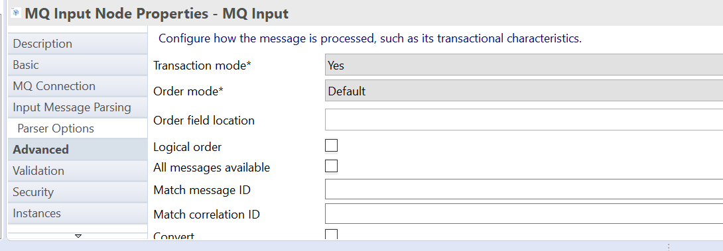

Unchecked the logical order for every MQ Input nodes.

1. **Policy property:**

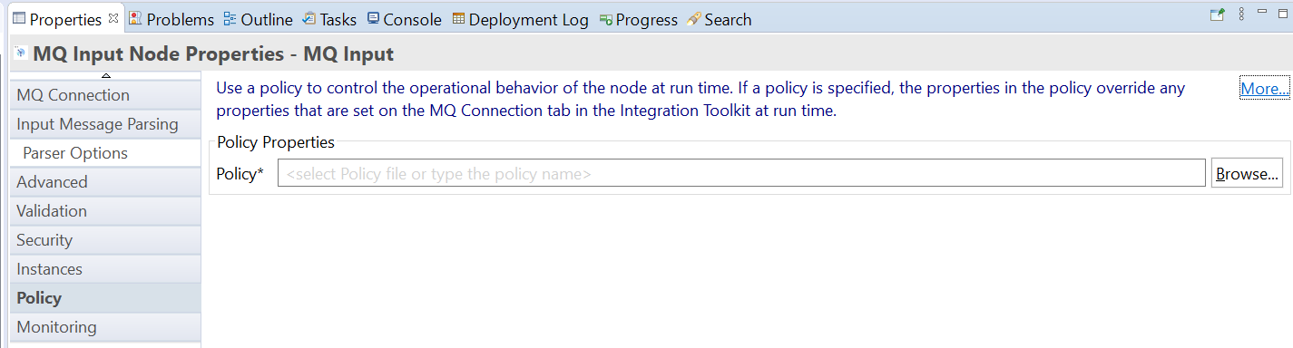

Removed the policies for every MQ nodes.

1. **Log payload:**

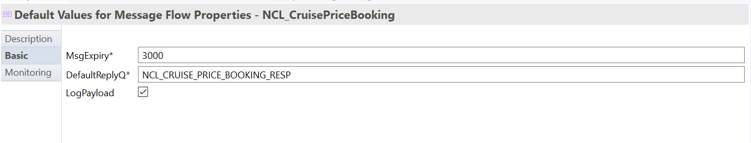

Checked the logs for logging events.

1. **SFTP credentials**

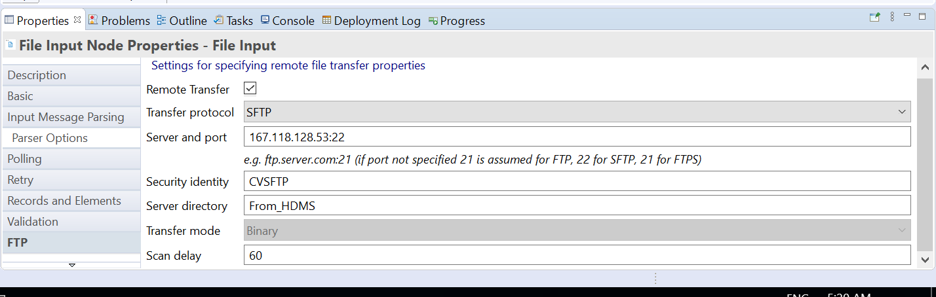

Modified the SFTP server and port for all file nodes in the services.

1. **Java Code changes.**



Modified the java code in NCL_CacheUtils_Java project. The updated java code file attached above.

**Integration level changes:**

1. **NCLSF Credentails:**

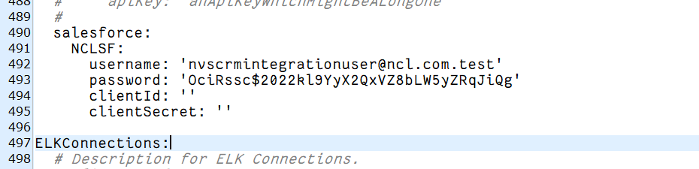

Salesforce credentials added in yaml.

1. **JVM Heap size:**

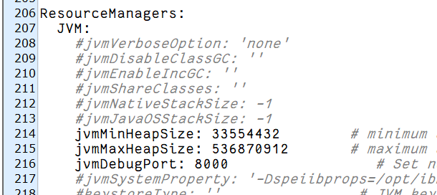

Changed the maximum heap size.

1. **Trust store:**

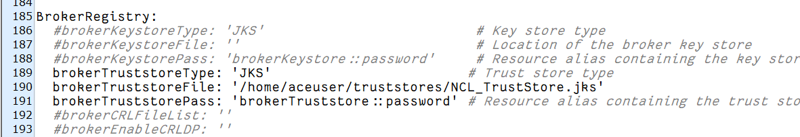

Added trust store file path in the server conf.yaml.

1. **Flow Monitoring:**

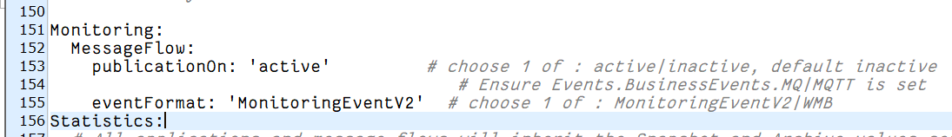

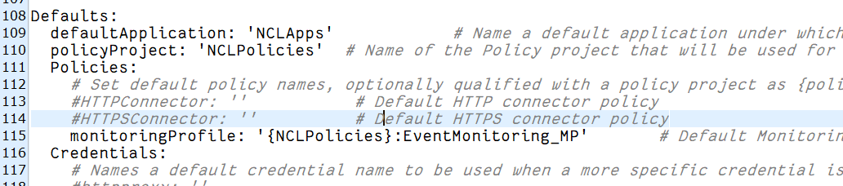

Added the flow monitoring policy in yaml file for event logging.