**USER TRACE LOGS**

We can enable the user logs with help of REST URL’s also.

To enable logs hit the below URL’s in the postman.

<http://hdqqibmace01lv:7600/apiv2/reset-user-trace>

<http://hdqqibmace01lv:7600/apiv2/start-user-trace>

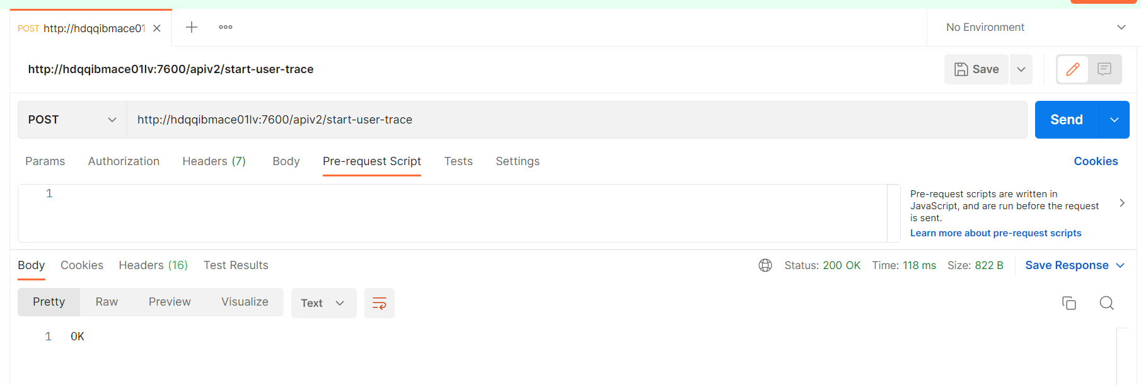

After enabling, we get response as “OK”.

**Open the server bash in terminal:**

podman exec -it ACE1_TAP01 bash

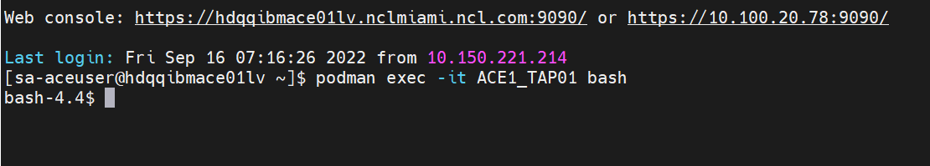

**Logs location in integration server:**

cd /home/aceuser/ace-server/config/common/log

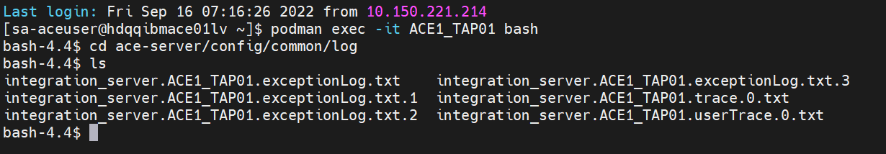

cat integration_server.ACE1_TAP01.userTrace.0.txt

tail -10f <fileExtensionPath>

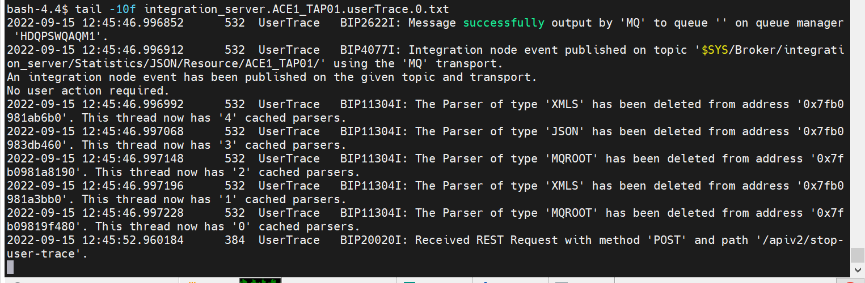

**To move file from one location to another location use below command:**

podman cp ACE1_TAP01:/home/aceuser/ace-server/config/common/log /tmp

**To Stop the user trace in server:**

<http://hdqqibmace01lv:7600/apiv2/stop-user-trace>

