Normality:

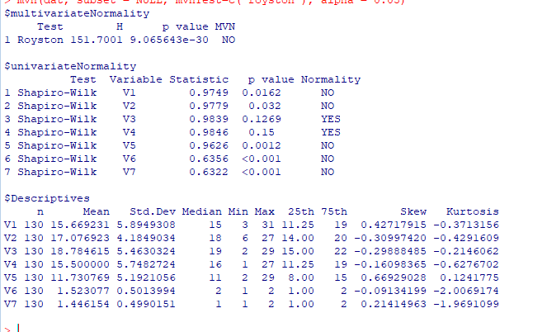

Univariate Outliers:

V1 Outliers: None

V2 Outliers: None

V3 Outliers: “2”

V4 Outliers: None

V5 Outliers: “29”

V6 Outliers: Binomial Distribution

V7 Outliers: Binomial Distribution