Module 3

Ryan Richardson

11/12/2020

## R Markdown

data = read.csv("politeness_data.csv")  
data$gender = as.factor(data$gender)  
data$attitude = as.factor(data$attitude)  
data$scenario = as.factor(data$scenario)

## Including Plots

You can also embed plots, for example:

randomIntercept = lmer(frequency ~ (1|subject) + gender + attitude, data = data)   
  
randomSlope = lmer(frequency ~ (attitude|subject) + gender + attitude, data = data)

## boundary (singular) fit: see ?isSingular

multipleRandom = lmer(frequency ~ (1|subject) + gender + attitude + (1|scenario), data = data)

### Random Intercept Model

summary(randomIntercept)

## Linear mixed model fit by REML. t-tests use Satterthwaite's method [  
## lmerModLmerTest]  
## Formula: frequency ~ (1 | subject) + gender + attitude  
## Data: data  
##   
## REML criterion at convergence: 786.7  
##   
## Scaled residuals:   
## Min 1Q Median 3Q Max   
## -2.3619 -0.5305 -0.1724 0.4647 3.2260   
##   
## Random effects:  
## Groups Name Variance Std.Dev.  
## subject (Intercept) 603.9 24.57   
## Residual 850.9 29.17   
## Number of obs: 83, groups: subject, 6  
##   
## Fixed effects:  
## Estimate Std. Error df t value Pr(>|t|)   
## (Intercept) 256.691 15.226 4.378 16.859 3.78e-05 ***  
## genderM -108.205 21.063 4.009 -5.137 0.00677 **   
## attitudepol -19.410 6.407 76.018 -3.030 0.00334 **   
## ---  
## Signif. codes: 0 '***' 0.001 '**' 0.01 '*' 0.05 '.' 0.1 ' ' 1  
##   
## Correlation of Fixed Effects:  
## (Intr) gendrM  
## genderM -0.692   
## attitudepol -0.210 0.004

randomInterceptVariance = 603.9 + 850.9  
subjectVariance = 603.9/randomInterceptVariance  
residualVariance = 850.9/randomInterceptVariance  
subjectVariance

## [1] 0.4151086

randomInterceptF = lmer(frequency ~ (1|subject) + gender + attitude, data = data, REML = FALSE)   
randomInterceptEffects = ranef(randomIntercept)$subject  
ranef(randomIntercept)

## $subject  
## (Intercept)  
## F1 -13.582929  
## F2 10.175840  
## F3 3.407089  
## M3 27.436373  
## M4 5.818871  
## M7 -33.255244  
##   
## with conditional variances for "subject"

plot(density(unlist(randomInterceptEffects)))

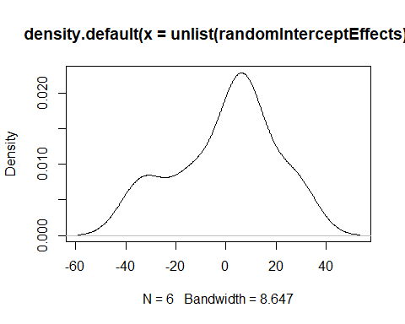 The fixed effects of the model are about as expected. The baseline fequency for informal female participants have a pitch around 256.7 hz. Males tend to have a lower pitch compared to females, and speaking in a polite voice also tends to lower the pitch of the individual’s voice. However, there is an effect on the frequency by subject which indicates that there is some variation in frequency by subject.

Testing the residuals for the random effects, variance by subject accounted for 41.5% of the total variance in the model, which is substantial and indicates that subject plays a significant role in determining pitch. There were 2 males that had more extreme variation that the others, but I think this signals it is proper to try and account for the subject as a random effect.

The KDE for the plot indicates that the random effects are not normally distributed.

### Random Intercept + Slope Model

summary(randomSlope)

## Linear mixed model fit by REML. t-tests use Satterthwaite's method [  
## lmerModLmerTest]  
## Formula: frequency ~ (attitude | subject) + gender + attitude  
## Data: data  
##   
## REML criterion at convergence: 786.7  
##   
## Scaled residuals:   
## Min 1Q Median 3Q Max   
## -2.3484 -0.5488 -0.2010 0.4838 3.2156   
##   
## Random effects:  
## Groups Name Variance Std.Dev. Corr  
## subject (Intercept) 572.596 23.929   
## attitudepol 1.749 1.322 1.00  
## Residual 850.548 29.164   
## Number of obs: 83, groups: subject, 6  
##   
## Fixed effects:  
## Estimate Std. Error df t value Pr(>|t|)   
## (Intercept) 257.749 15.031 4.116 17.148 5.53e-05 ***  
## genderM -110.322 21.001 4.009 -5.253 0.00624 **   
## attitudepol -19.402 6.428 59.004 -3.018 0.00375 **   
## ---  
## Signif. codes: 0 '***' 0.001 '**' 0.01 '*' 0.05 '.' 0.1 ' ' 1  
##   
## Correlation of Fixed Effects:  
## (Intr) gendrM  
## genderM -0.699   
## attitudepol -0.157 0.003  
## optimizer (nloptwrap) convergence code: 0 (OK)  
## boundary (singular) fit: see ?isSingular

randomSlopeF = lmer(frequency ~ (attitude|subject) + gender + attitude, data = data, REML=FALSE)

## boundary (singular) fit: see ?isSingular

randomSlopeSubjectEffect = ranef(randomSlope)$subject  
  
contour(kde2d(randomSlopeSubjectEffect[,1], randomSlopeSubjectEffect[,2]))

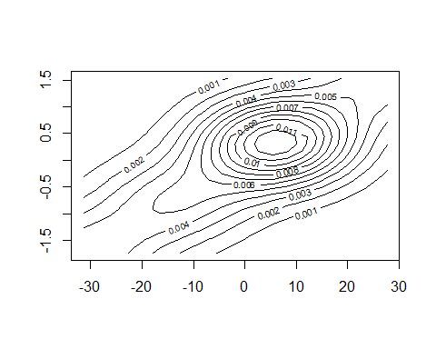

varianceCorrelation = VarCorr(randomSlope) %>% as_data_frame() %>% mutate(icc=vcov/sum(vcov))

## Warning: `as_data_frame()` is deprecated as of tibble 2.0.0.  
## Please use `as_tibble()` instead.  
## The signature and semantics have changed, see `?as_tibble`.  
## This warning is displayed once every 8 hours.  
## Call `lifecycle::last_warnings()` to see where this warning was generated.

VPC = data.frame(varianceCorrelation$grp, varianceCorrelation$icc)  
VPC

## varianceCorrelation.grp varianceCorrelation.icc  
## 1 subject 0.393121313  
## 2 subject 0.001200757  
## 3 subject 0.021726557  
## 4 Residual 0.583951373

The fixed effects for this model were slightly different from the other two models. THe base line pitch was 1hz lower, and the effects of being a male were more pronounced, but the polite attitude effect did not change.

The random effects for each indidvual were still fairly pronounced with the same two male participants as found in model 1.

For the slop effect, the VPC for the subject is 39.3%, .1%, and 2% for each attitude, with 58% of the variance being explained by the residuals. This is inline with the ICC where the subject accounted for 41.5% of the Variance overall, in this case the subject still takes up ~40% dependent on the attitude they are asked to used.

Based on the 2d KDE, the random effects are nearly normally distributed, though as they move away from the centers, they become less and less normal based on the warping of the contours towards the extremes. This is consistent with the near normality of the other models’ KDEs.

### Multiple Random Effects Model

summary(multipleRandom)

## Linear mixed model fit by REML. t-tests use Satterthwaite's method [  
## lmerModLmerTest]  
## Formula: frequency ~ (1 | subject) + gender + attitude + (1 | scenario)  
## Data: data  
##   
## REML criterion at convergence: 775.5  
##   
## Scaled residuals:   
## Min 1Q Median 3Q Max   
## -2.2591 -0.6236 -0.0772 0.5388 3.4795   
##   
## Random effects:  
## Groups Name Variance Std.Dev.  
## scenario (Intercept) 219.5 14.81   
## subject (Intercept) 615.6 24.81   
## Residual 645.9 25.41   
## Number of obs: 83, groups: scenario, 7; subject, 6  
##   
## Fixed effects:  
## Estimate Std. Error df t value Pr(>|t|)   
## (Intercept) 256.846 16.116 5.432 15.938 9.06e-06 ***  
## genderM -108.516 21.013 4.007 -5.164 0.006647 **   
## attitudepol -19.721 5.584 70.054 -3.532 0.000735 ***  
## ---  
## Signif. codes: 0 '***' 0.001 '**' 0.01 '*' 0.05 '.' 0.1 ' ' 1  
##   
## Correlation of Fixed Effects:  
## (Intr) gendrM  
## genderM -0.652   
## attitudepol -0.173 0.004

multipleRandomVariance = 219.5 + 615.6 + 645.9  
multipleScenarioVariance =219.5/multipleRandomVariance  
multipleSubjectVariance = 615.6/multipleRandomVariance  
multipleScenarioVariance

## [1] 0.1482107

multipleSubjectVariance

## [1] 0.4156651

multipleRandomF = lmer(frequency ~ (1|subject) + gender + attitude + (1|scenario), data = data, REML = FALSE)  
multipleRandomInterceptEffect = ranef(multipleRandom)$subject  
multipleRandomInterceptEffectScenario = ranef(multipleRandom)$scenario  
ranef(multipleRandom)

## $scenario  
## (Intercept)  
## 1 -13.506509  
## 2 6.582894  
## 3 11.407831  
## 4 20.629415  
## 5 -1.936030  
## 6 -12.173903  
## 7 -11.003698  
##   
## $subject  
## (Intercept)  
## F1 -13.907651  
## F2 10.419110  
## F3 3.488541  
## M3 28.382033  
## M4 5.378484  
## M7 -33.760517  
##   
## with conditional variances for "scenario" "subject"

plot(density(unlist(multipleRandomInterceptEffect)))

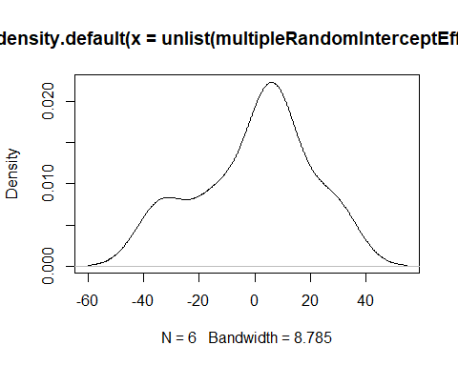

plot(density(unlist(multipleRandomInterceptEffectScenario)))

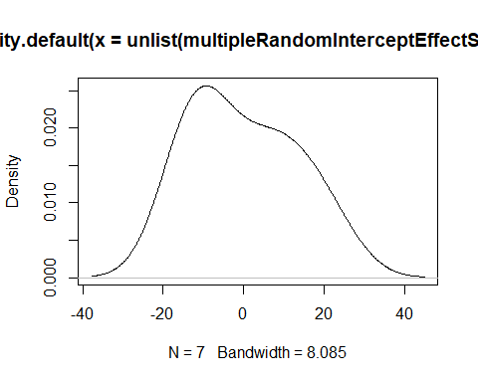

The fixed effects of the model mimic what we saw in model 1. The baseline fequency for informal female participants have a pitch around 256.8 hz. Males tend to have a lower pitch compared to females, and speaking in a polite voice also tends to lower the pitch of the individual’s voice.

However, there is more variation in the random efffects in this case. There is still 41.5% variance for the Subject, and an additional 14.8% of the variance is explained by the scenario that the subject was in, suggesting that subject is still a significant random effect when it comes to determining pitch, and also suggesting that scenario plays an important role.

The two male subjects still had more extreme values compared to the others, and secnario 4 seemed to stand out as well, suggesting it is correct to treat scenario as a separate random effect.

The KDE for the plot indicates that the random effects are more closely normally distributed than the other models, though they still appear to be bimodal for the subject.

The scenario effect KDE is close to normal but still skewe.

### AIC Comparison

AIC(randomInterceptF, randomSlopeF, multipleRandomF)

## df AIC  
## randomInterceptF 5 816.3376  
## randomSlopeF 7 820.3094  
## multipleRandomF 6 807.1015

anova(randomInterceptF, randomSlopeF)

## Data: data  
## Models:  
## randomInterceptF: frequency ~ (1 | subject) + gender + attitude  
## randomSlopeF: frequency ~ (attitude | subject) + gender + attitude  
## npar AIC BIC logLik deviance Chisq Df Pr(>Chisq)  
## randomInterceptF 5 816.34 828.43 -403.17 806.34   
## randomSlopeF 7 820.31 837.24 -403.15 806.31 0.0282 2 0.986

anova(randomSlopeF, multipleRandomF)

## Data: data  
## Models:  
## multipleRandomF: frequency ~ (1 | subject) + gender + attitude + (1 | scenario)  
## randomSlopeF: frequency ~ (attitude | subject) + gender + attitude  
## npar AIC BIC logLik deviance Chisq Df Pr(>Chisq)  
## multipleRandomF 6 807.10 821.61 -397.55 795.10   
## randomSlopeF 7 820.31 837.24 -403.15 806.31 0 1 1

anova(randomInterceptF, multipleRandomF)

## Data: data  
## Models:  
## randomInterceptF: frequency ~ (1 | subject) + gender + attitude  
## multipleRandomF: frequency ~ (1 | subject) + gender + attitude + (1 | scenario)  
## npar AIC BIC logLik deviance Chisq Df Pr(>Chisq)   
## randomInterceptF 5 816.34 828.43 -403.17 806.34   
## multipleRandomF 6 807.10 821.61 -397.55 795.10 11.236 1 0.0008022 ***  
## ---  
## Signif. codes: 0 '***' 0.001 '**' 0.01 '*' 0.05 '.' 0.1 ' ' 1

Based on the AIC rating, the bvest model was model 3 due to the lowest AIC. the Anova comparison also shows that the multipleRAndomEffects is one of the better models, as it is the only model significantly different from the other models, and contains the least overall Deviance.