Compiler Design Documentation

# Dependency Installation:

## Pydot:

The compiler requires the pthon plugin Pydot to draw the parse tree and output it to a file. To install Pydot run the command:  
 python -m pip install pydot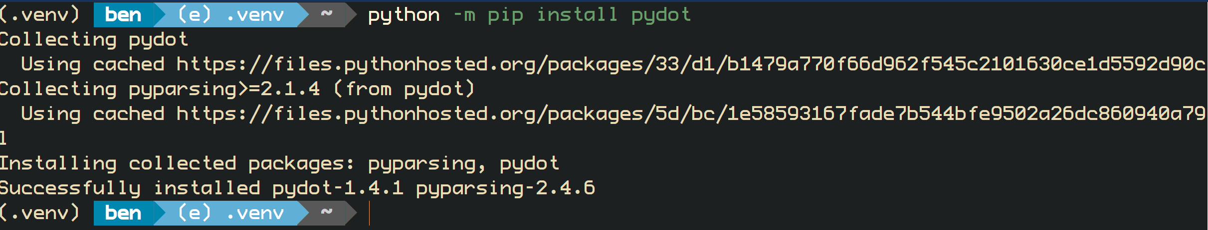

## Graphviz:

The compiler requires graphviz in order to create the parse tree as it is a dependency of the pydot plugin. Follow these installation steps:

1. Download graphviz for windows from this URL [https://graphviz.gitlab.io/_pages/Download/windows/graphviz-2.38.zip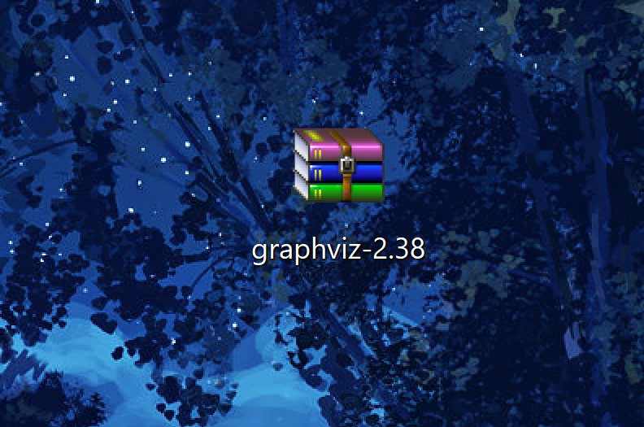](https://graphviz.gitlab.io/_pages/Download/windows/graphviz-2.38.zip#)

2. Extract the release folder from the downloaded zip file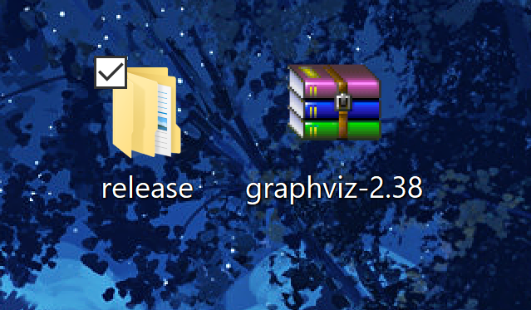

3. Copy the path of the bin folder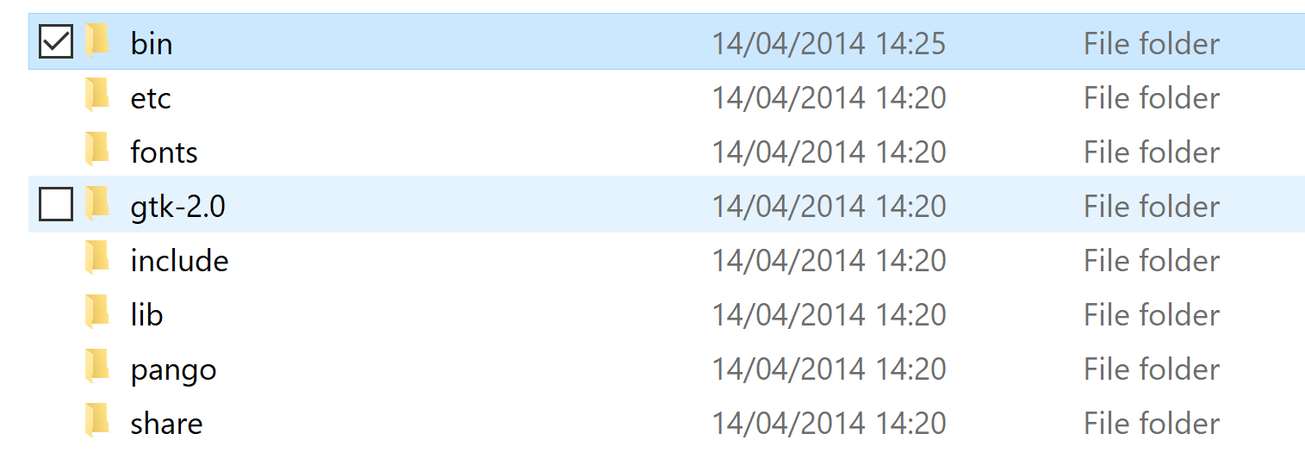

4. Edit your user environment variables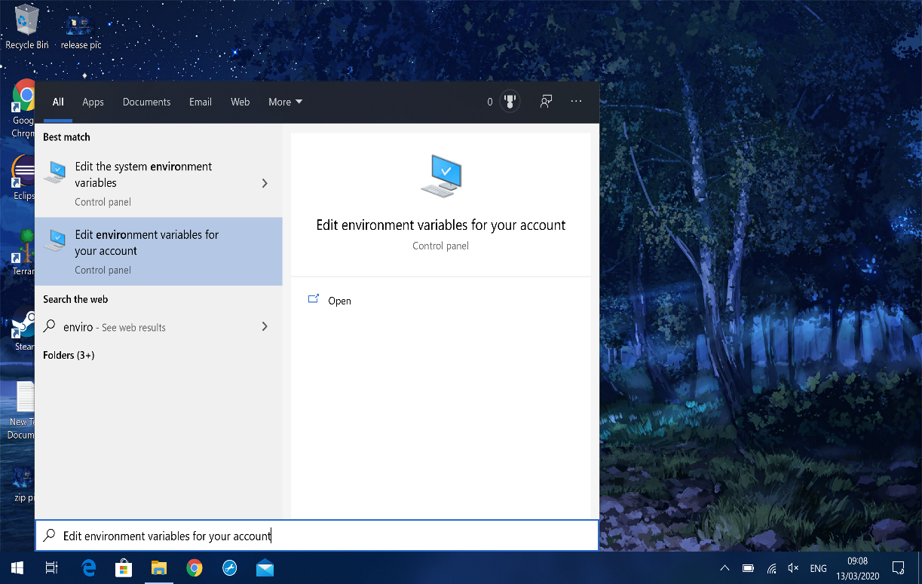

5. Add the bin path to your user path variable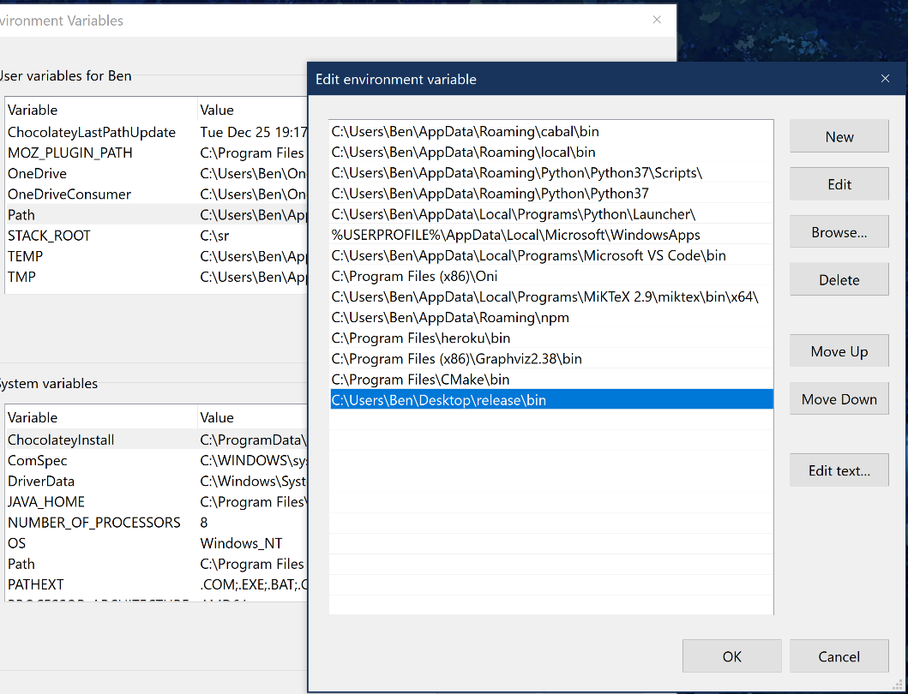

# Running the compiler:

Running the command “python compiler.py -h” presents instructions for running

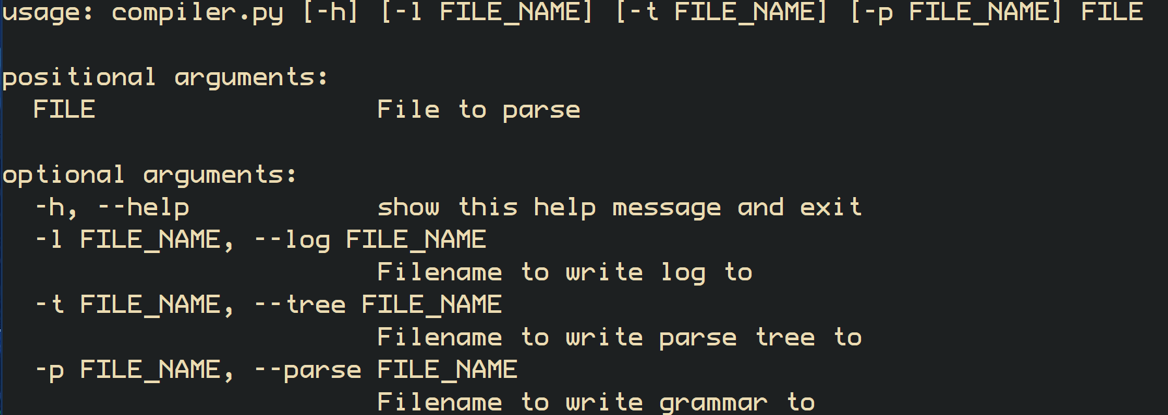

The log, tree, and grammar files are all save prepended with the current date and time for easier sorting.

# Input file format:

The input file is as specified in the specification. You can omit the Variables, Constants, and Predicates rows from the input file as they will be assumed to be empty if omitted.

Variables, Constants, and Predicates can only contain alphanumeric characters and underscore.

Quantifiers and Connectives can contain alphanumeric characters, underscores, and backslash

Equality can contain alphanumeric characters, underscores, backslash, and =

# Errors:

There are various errors produced by the compiler. The first are input file validation errors  
and parsing errors. Parsing errors take the same form, showing what was expected in a position in the formula and what was actually found e.g. 

Input file validation errros occur if:  
1. There are duplicate field names e.g. defining the set of variables twice  
2. There are invalid field names e.g. INVALID:  
3. There are 2 symbols defined that are the same e.g. a variable called X and a constant called X  
4. A symbol contains invalid characters e.g. a variable contains a backslash

5. Not enough connectives, quantifiers, or equality symbols specified