Bayesian Inference of Parameters for Numerical Storm Surge Models

Student Name: Benjamin Russell

Sponsor Name: Tobias Weinzierl

[1] 

*Abstract* – These instructions give you guidelines for preparing the final paper*.* DO NOT change any settings, such as margins and font sizes. Just use this as a template and modify the contents into your final paper. Do not cite references in the abstract.

The abstract must be a Structured Abstract with the heading **Context/Background**, **Aims**, and **Method**.

*Keywords* – Put a few keywords here.

# **Introduction**

This section briefly introduces the general project background, the research question you are addressing, and the project objectives. It should be between 2 to 3 pages in length. Do not change the font sizes or line spacing in order to put in more text.

Note that the whole report, including the references, should not be longer than 10 pages in length. The system will not accept any report longer than 10 pages.

# **Related Work**

This section presents a survey of existing work on the problems that this project addresses. It should be about 2 pages in length. The rest of this section shows the formats of subsections as well as some general formatting information for tables, figures, references and equations.

## **Main Text**

The font used for the main text should be Times New Roman and the font size should be 12. The first line of all paragraphs should be indented by 0.25in, except for the first paragraph of each section, subsection, subsubsection, etc. (the paragraph immediately after the header) where no indentation is needed.

## **Figures and Tables**

In general, figures and tables should not appear before they are cited. Place figure captions below the figures; place table titles above the tables. If your figure has two parts, for example, include the labels "(a)" and "(b)" as part of the artwork. Please verify that figures and tables that you mention in the text actually exist. Make sure that all tables and figures are numbered as shown in Table 1 and Figure 1.

**Table 1.** Units for Magnetic Properties. There is a period after the table number, followed by two spaces.

|  |  |  |
| --- | --- | --- |
| **Symbol** | **Quantity** | **Conversion from Gaussian and**  **CGS EMU to SI a** |
| ☞ | magnetic flux | 1 Mx  108 Wb = 108 V·s |
| *B* | magnetic flux density,  magnetic induction | 1 G  104 T = 104 Wb/m2 |
| *H* | magnetic field strength | 1 Oe  103/(4) A/m |
| *m* | magnetic moment | 1 erg/G = 1 emu   103 A·m2 = 103 J/T |
| *M* | magnetization | 1 erg/(G·cm3) = 1 emu/cm3  103 A/m |

Figure axis labels are often a source of confusion. Use words rather than symbols. As an example, write the quantity "Magnetization" or "Magnetization (*M*)" not just "*M*." Put units in parentheses. Do not label axes only with units. As in Figure 1, for example, write "Magnetization (A/m)" or "Magnetization (Am1)", not just "A/m". Do not label axes with a ratio of quantities and units. For example, write "Temperature (K)", not "Temperature/K".

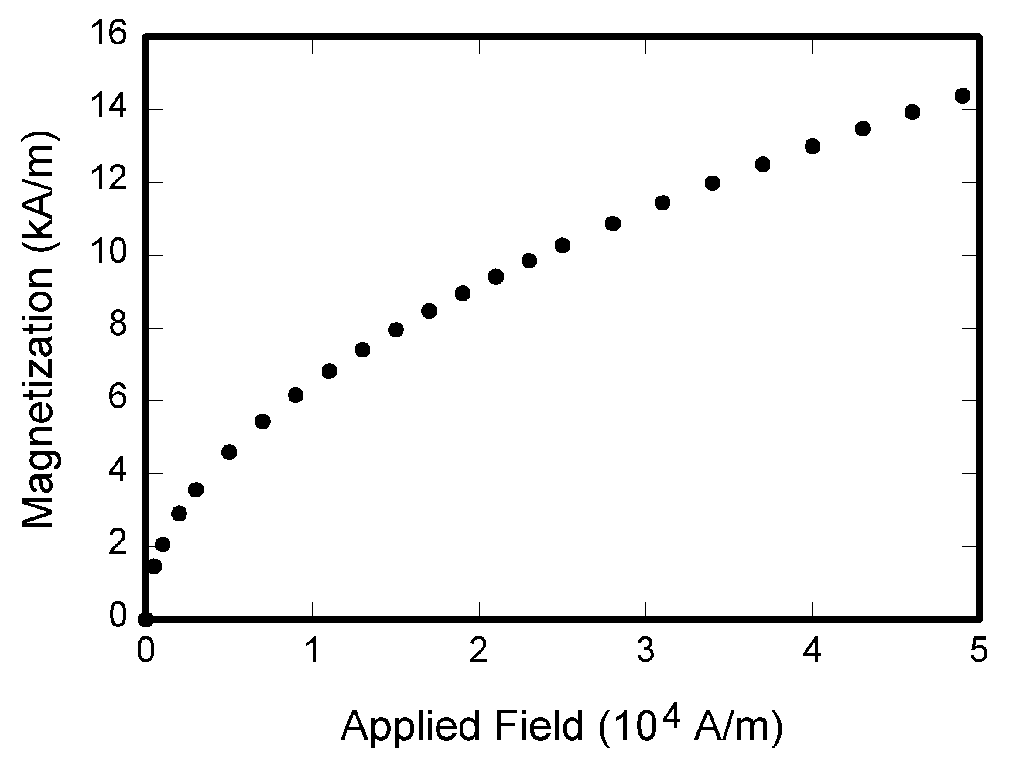

**Figure 1.** Magnetization as a function of applied field. There is a period after the figure number, followed by two spaces. It is good practice to explain the significance of the figure in the caption.

## **References**

The list of cited references should appear at the end of the report, ordered alphabetically by the surnames of the first authors. The default style for references cited in the main text is the Harvard (author, date) format and is described again now. When citing a section in a book, please give the relevant page numbers as in (Budgen, 2003: 293). When citing, where there are either one or two authors, use the names, but if there are more than two, give the first one and use “et al.” as in (Kitchenham *et al.*, 2004), except where this would be ambiguous, in which case use all author names.

You need to give all authors’ names in each reference. Do not use "et al." unless there are more than five authors. Papers that have not been published should be cited as "unpublished" (Euther, 2006) Papers that have been submitted or accepted for publication should be cited as "submitted for publication" as in (Futher, 2006). You can also cite using just the year when the author’s name appears in the text, as in “but according to Futher (2006), we…”. Where an author has more than one publication in a year, add ‘a’, ‘b’ etc. after the year.

## **Equations**

Number equations consecutively with equation numbers in parentheses flush with the right margin, as in Eq. (1). Try to avoid ambiguities in equations. For example, should “*j* / 3 + *i*”be “(*j* / 3) + *i*” or “*j* / (3 + *i*)”?

 (1)

Be sure that the symbols in your equation have been defined before the equation appears or immediately following it. Italicize symbols (*s* might refer to the speed of an object, but s is the unit second). Refer to “Eq. (1),” not “(1)” nor “equation (1)”.

## **Other Recommendations**

Use one space after periods and colons. Hyphenate complex modifiers: "zero-field-cooled magnetization." Avoid dangling participles, such as, "Using Eq. (1), the potential was calculated." [It is not clear who or what used (1).] Write instead, "The potential was calculated by using (1)," or "Using Eq. (1), we calculated the potential."

Use a zero before decimal points: "0.25," not ".25." When expressing a range of values, write “7 to 9” or “7-9”, not “7~9”.

Avoid contractions; for example, write "do not" instead of "don't." When listing more than two items, the serial comma is preferred: “A, B, and C” instead of “A, B and C”.

If you wish, you may write in the first person singular or plural and use the active voice (“I observed that ...” or “We observed that ...”, instead of “It was observed that ...”).

# **Solution**

**[The Proposed Methodology]**

This section presents your proposed methodology and data analysis to examine a potential solution for your problem in detail. The proposed design and analysis details should all be placed in this section. You may create a number of subsections, each focusing on one issue.

This section should be between 2 to 3 pages in length.

# **Validity**

This section will address how you have ensured the validity of the previous sections. Is the research problem and question acceptable, have you ensured that the related work section covers the appropriate subject domains and represents current state of the art knowledge, and finally how your proposed methodology will ensure the validity of your potential findings?

This section should be no more than 1 page in length.

# **Results**

Include this section but leave it blank.

# **Evaluation**

Include this section but leave it blank.

# **Conclusion**

Include this section but leave it blank.

**References**

Author A., Author B., and Author C., (2006). “Title of Journal Paper”, *Name of Journal*, **3**(4):105-115.

Author A.B., Author C-D, and Author E., (2004). “Title of Conference Paper”, in *Proc. of Conference Name*, pp. 105-115.

Buther G., Noble B., and Sneddon I.N., (1955). “On Certain Integrals of Lipschitz-Hankel Type Involving Products of Bessel Functions”, *Phil. Trans. Roy. Soc.* London, **A247**:529-551.

Cuther J., (1992). *A Treatise on Electricity and Magnetism,* 3rd Ed., Vol. 2. Addison Wesley.

Duther I.S. and Bean C.P. , (1963). “Fine Particles, Thin Films and Exchange Anisotropy”, *Magnetism,* Vol. III, G. T. Rado and H. Suhl (Eds.), New York: Academic, pp. 271-350.

Euther K. (2006). “Title of Paper”, unpublished.

Futher R. (2006). “Title of Paper 2,” *J. Name Stand. Abbrev.*, submitted for publication.

Guther Y., Hirano M., Oka K., and Tagawa Y., (1997). “Electron Spectroscopy Studies on Magneto-Optical Media and Plastic Substrate Interface”, *IEEE Trans. on Some Topics.,* **2**(1):740-741.

Huther M., (2007). *The Technical Writer's Handbook.* Available at:

http//www.somewhere.ac.uk/Huther/herpapers/handbook (Accessed: 30 January 2009).

1.   