**SME ONLINE ACCOUNT OPENING**

**INTRODUCTION**

Fidelity Small Business Account (FSBA) is a tailor-made account for your business. We see the potential in every business – whether small or big.

This is why we have designed the Fidelity Small Business Account (for individuals and corporates) to help grow your business to attain its right potentials. With FSBA, you get the support required to take your business to the next level.

**Why FSBA?**

1. The Fidelity Small Business Account (FSBA) is the answer to your needs as a growing business.
2. It gives you a flexible, zero cost opportunity to run your business transactions through a bank

**Features and Benefits of FSBA Variants:**

**FSBA (Corporate)**

* No Account Maintenance Fee for all Debit Turnover Amounts**\***
* No Monthly Charges
* No Limit on Number of Withdrawals, etc.
* Easy Access to Loans
* Free Business Advisory Services
* Assistance to Register your company/Business Name

**There Is Something for Every Business**

Depending on the size of your business as measured by its Monthly Turnover, there is a type of **FSBA** made for it as shown in the table below:

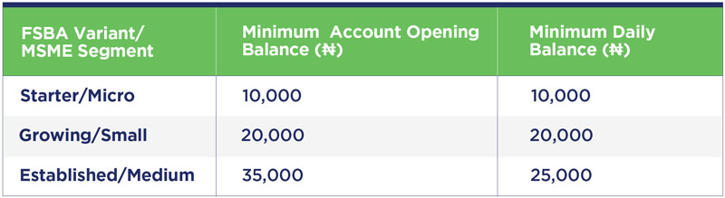

**OPENING A SME ACCOUNT**

The SME account can be opened by visiting the link [here](https://digital.fidelitybank.ng/accountopening/#/).

**Step 1**

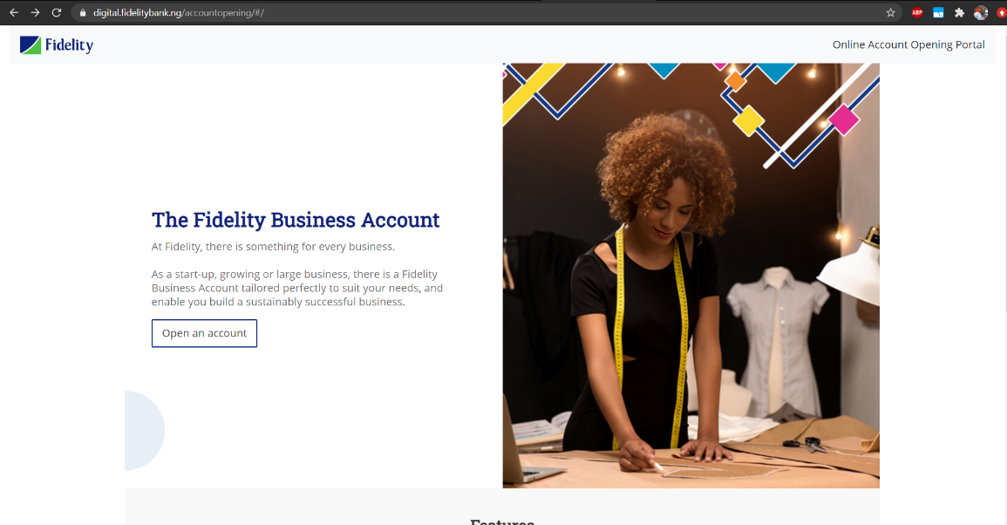Click Open an Account.

**Step 2**

Enter Registration Code (if any) or click the I don’t have a registration code to proceed.

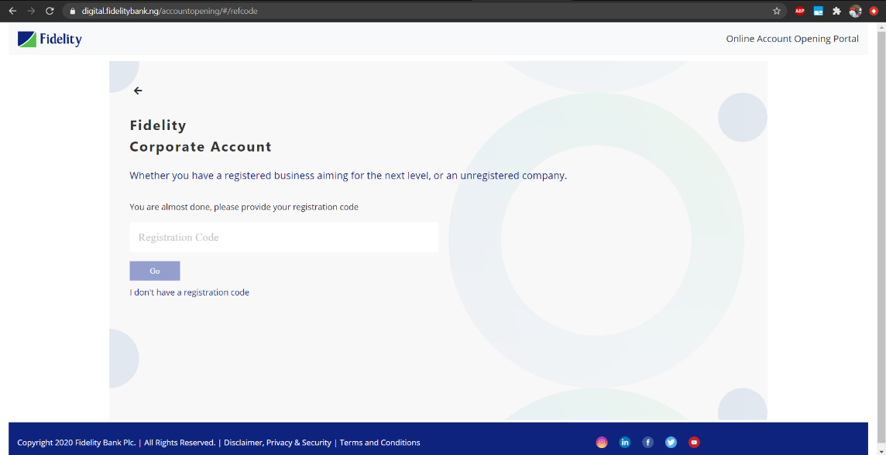

**Step 3**

Enter Preferred Business name to proceed and click Let’s Go to proceed

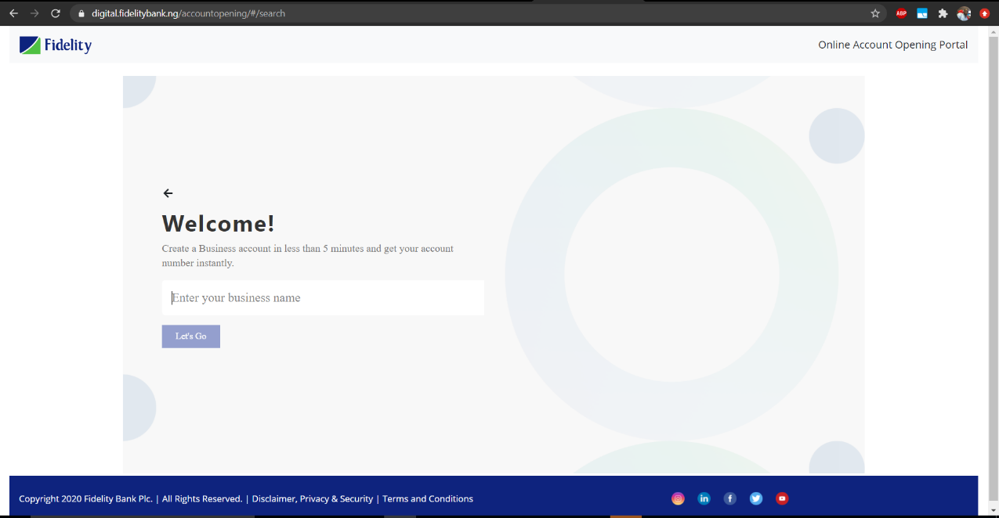

**Step 4**

Enter BVN and click Verify to continue

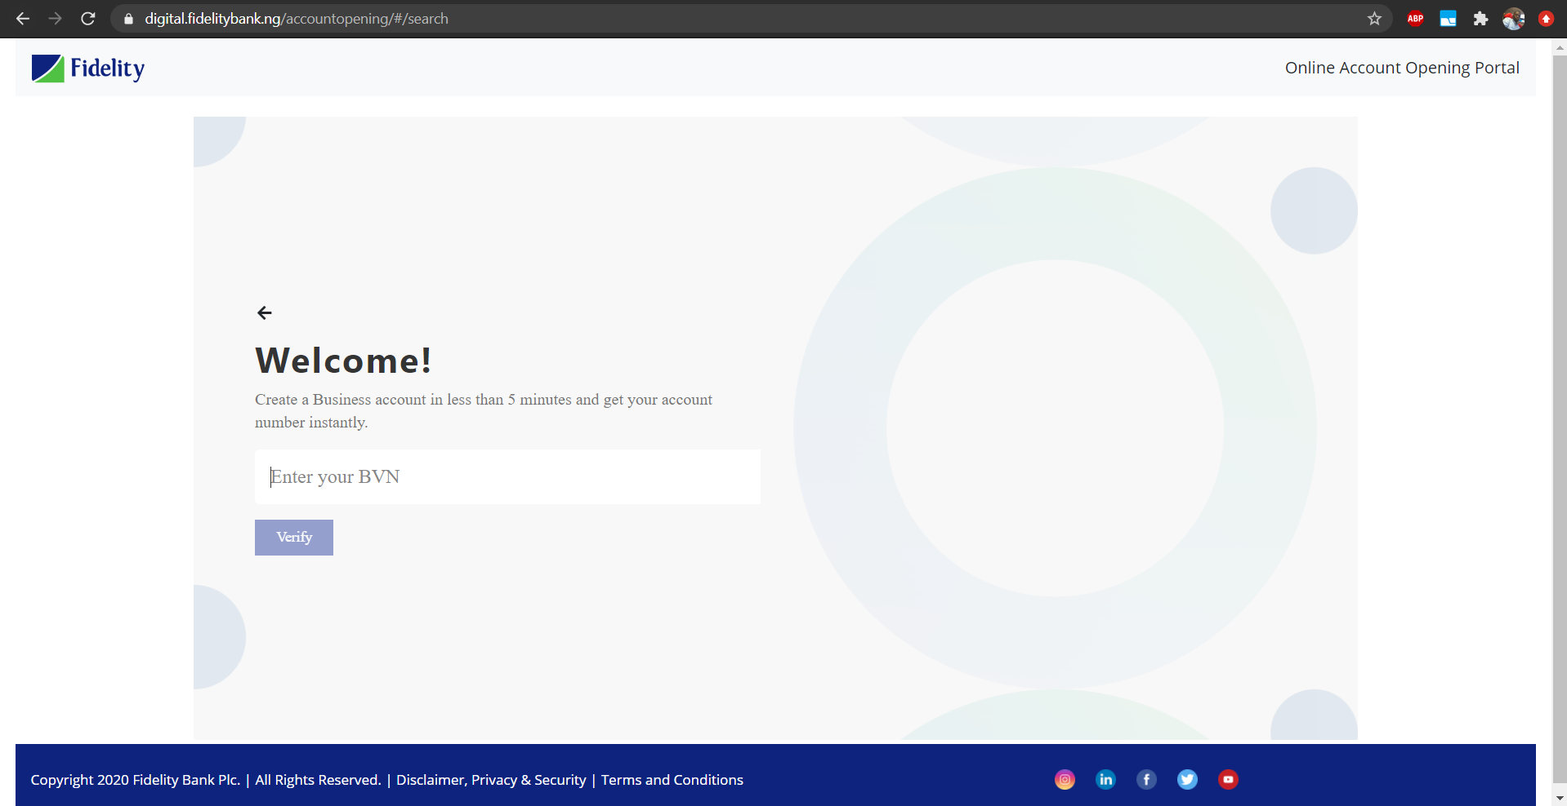

**Step 5**

Enter OTP sent to phone number linked to BVN.

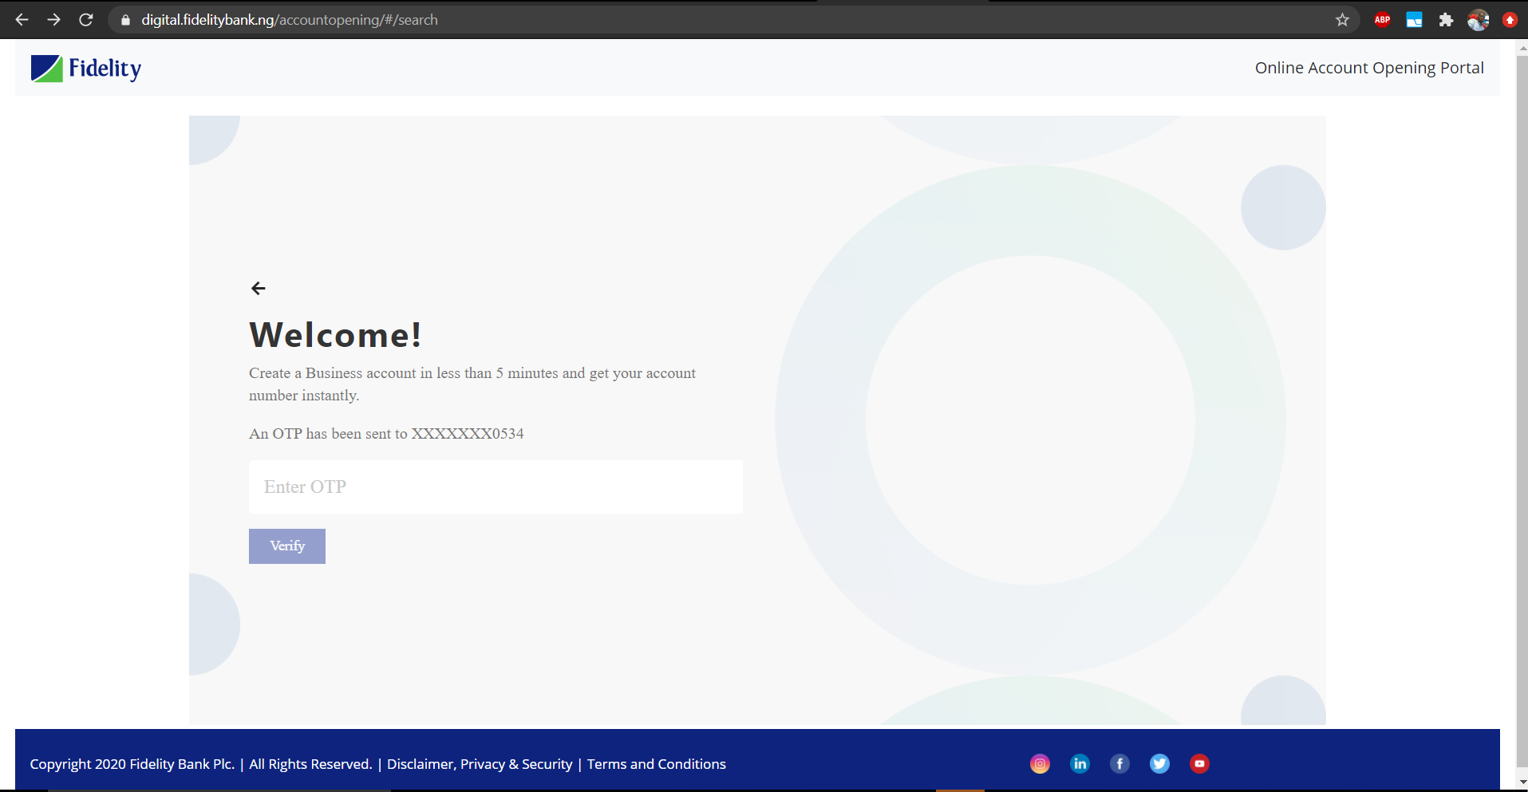

**Step 6**

Fill in Information about the business.

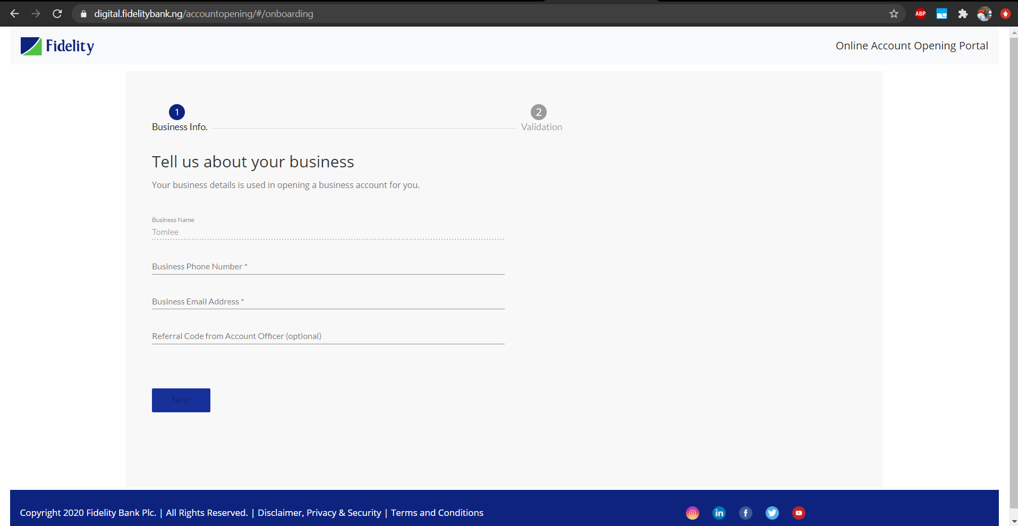

**Step 7**

Continue to fill the Application form for validation.

Ensure all details are filled correctly.

Accept the Terms and conditions

Follow the captcha process (Check the “I am not a robot” box)

Click Submit to complete the process.

