Name | Joshua Werner | Team | Nitrogen Interactive | TL | #2+ | Date | November 18 2025 | Time | 10:00AM
Fill in the underlined areas (and the boxes above), now but don’t write on the remainder of this form.
Contribution: Briefly describe what your feature(s) is/are:  For our game I did Implemented Boss fight and the Boss scene. So starting from building the Scene with castle wall the ground with brick laid walkable ground, to Sauce pits and obstacles in the form of pillars. Then in order to make the NavMesh for the Ai to not go through wall or pillars or step into the Sauce pit. The next part was the implementation of a skeleton for the boss and adding the animations for idle, walk, casting, attacking, and death. With that all set up now we come to the code for the map the sauce pit deals damage to the player and an image is looped around the tile. For the boss itself there is a lot to get through but the rough overview is that we have 3 phases each 1/3 of his health in each phase when it gets triggered we first of all change the speed he attacks and walks and the cooldowns a bit and then we build a Ai graph for the boss which will decide what he is going to do but that is quiet the graph to explain in the oral exam I can draw it out to explain it more in detail what is happening. The last part I added was to make the abilities for the boss so we have something to fill the graph with.  ___________________________________________________________________  Walk me through your Gantt chart. How long did this take? How long did you estimate it would take? What did you learn about your skill as an estimator?  I did not get the hours quit right but I would not say I am terrible about estimating time, rather I am autistic and a perfectionist so I want cool stuff so while coding or building the map I come up with more things that would be cool to add, which led to adding a way to complicated AI for the boss which is supper modular, but I ran out of time to add more abilities which I can put in the graph so in some way I did plan poorly but when we needed to set the hours for the contribution I had not fully figured out where to go with the boss and what possibilities are there to create the AI and if I had till the end of the semester I would have definitely dove down that rabbit hole and made a full connected graph with an algorithm that reweights everything automatically on how successful the attack where or something in that direction because it is super interesting so the limited time and last minute assignments for this class made it quit complicated.  Run your game and point out places where your code is called and run. (I will cycle through asking you this question and the next one until you either run out of interesting things to talk about or it is clear that you have made an above average contribution.)  There is a lot to talk about but I think that is something for the oral exam  Show the C++/C# code that was run. Walk me through the methods called from the time it enters your section of code.  We start from the moment we enter the Portal on The first Map that is where my code starts more information in the Oralexam. | /10
Technical:  Walk me through your test plan. Give an example where a test case later found a bug in your code by things a teammate added later. (Or explain why you chose a test case specifically because you wanted to ensure that a teammate would know if they broke your code.)  Not a team mate but I found a bug in my Map set up I used a test where the player walks into the walls and tries to escape the Boss Map and it worked fine till I tried a corner piece of the wall, which should have not happened since the hole corner was one piece and it had a Mesh Collider on it but somehow after a few wiggle the player could slip through the Mesh and fling of the Map.  ________________________________________________________________  Pick a Prefab you have created that is documented well in a separate readme file.  (I will point to several places in your code documentation and ask) What question where you trying to answer here? Who do you anticipate would be asking that question? What other questions might this person need the answers to?  Prefab Name: Sauce Pit  And SaucePit_Readmefile.txt in docs on the github, also that feels more like a thing I explain in the oral exam.  Show me a class in your code where there could be either static or dynamic binding. Write some mock code on this paper showing how you would set the static type and dynamic type of a variable.  Super Class: _______________BossPhase_________________________  Sub Class: ___________Phase1, Phase2, Phase3____________________  Virtual Function: ____________virtual Init()_________________________  public class BossPhase  {  public virtual void Init(BossLevel bossContext)  {  Debug.Log("BossPhase Init()");  }  }  public class Phase1 : BossPhase  {  public override void Init(BossLevel bossContext)  {  Debug.Log("Phase1 Init()");  }  }  Choose a dynamically bound method. What method gets called now?  Static is the BossPhase phase;  Dynamic is phase = new Phase1(); is called  Change the dynamic type. What method gets called now?  I don’t know if I understand correctly but if we remove the override of void Init() then the virtual Init() gets called.  Pick a statically bound method. Which one would be called in each of the two previous cases?  Ok so if we make a statical bound method in BossPhase and one in Phase1 and call it with phase.method() it would always call the one in BossPhase since it I statical bound.  Show me an example of reuse in your code where you violate copyright law.  How does it violate copyright?____For the SaucePit the image of the sauce________  What did you have to do to integrate it with the code you wrote? What are the legal implications if you market your code with the re-used portion? Use fair use argue that you can use this anyway.  I just imported an image to use for the lava/sauce the image already violates copyright law since the it is a creative Image which is automatically protected by law with out licensing. For in the code it is looped around a tile and visible in the game. For my argument I used just a portion like a ¼ of the original picture so I transformed it and additional to that it has a completely different use as the marketed use of the picture. Adding on to that it is very difficult to get Everyday objects like food or dirt to be copyrighted.  4. One big or two small, well-chosen patterns.  Small Patterns = {Singleton, Private Class Data}  Which patterns did you choose?  1._______________________State Pattern________________________  2.______________________________________________________________  Why did you choose each pattern? (Justify your use of it).  I choose the pattern since when I was thinking about video game Bosses they usually have multiple Phases so when we got introduced to patterns and I took a look on all of them that State Pattern matched the Phases perfectly so I already had the idea for the boss and then got the patter in order to implement this Idea in the code.  Draw the class diagram for your pattern(s).  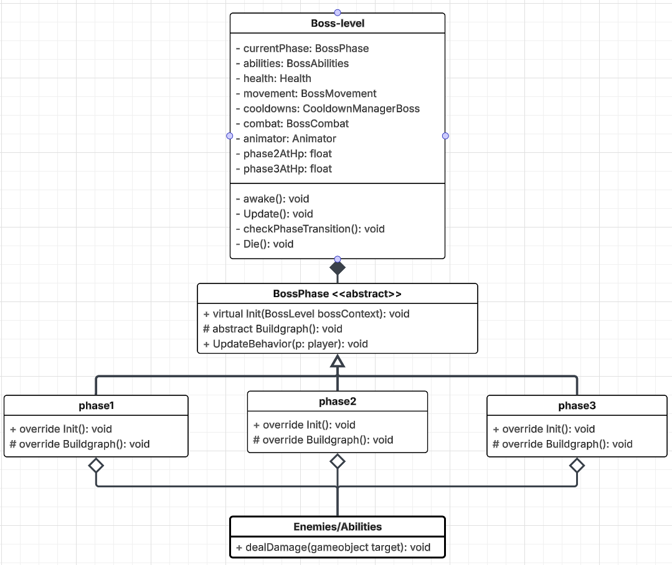  Would something else have worked as well or better than this pattern? When would be a bad time to use this pattern?  Yes the other one I was thinking first was the Strategy Pattern for the boss behavior, but it is not ideal because it would mean to replace the algorithm how the boss behaves which is more time consuming and it is partially in the code just not exactly like the strategy pattern since the way I do it in my states I build the graph so you could probably encapsulate that and make it work so it falls under Strategy pattern but the state pattern was easier to accomplish.  The pattern is bad if first of all if you just have one state of something or two and if each behavior of the states is the same or differs not a lot. It would also be bad if you had two states you just switch back and forth like every second or so. | /4  /3  /3  /4  /4

