Name: Zheng Qingping 152063Q Comments: w/ Leong Jun Xiang

Group: LAB02

**Proposal/Report: Assignment 2 (MSGBOARD + FSM)**

________________________________________________________________________

Design 2 FSMs (minimum 3 states) for your game scene by bolding states, conditions in written descriptive text in the space below. Draw the State Transition Diagram.

**FSM # 1 Berserker** States

Berserker will start as **idle or on Rampage**.

If enemy is nearby, **Move Towards Enemy**

If enemy in attack range, **attack enemy**

If Berserker health is low, **Go on Rampage or RunAway**

If Berserker health is 0, **dies**.

If Enemy out of Range go back to **idle**.

Conditions

Berserker will start as idle on Rampage.

If enemy is **nearby**, Move Towards Enemy

If enemy **in attack range**, attack enemy

If Berserker **health is low,** Go on Rampage or RunAway

If Berserker **health is 0**, dies.

If **Enemy out of Range** go back to idle.

State Transition Diagram

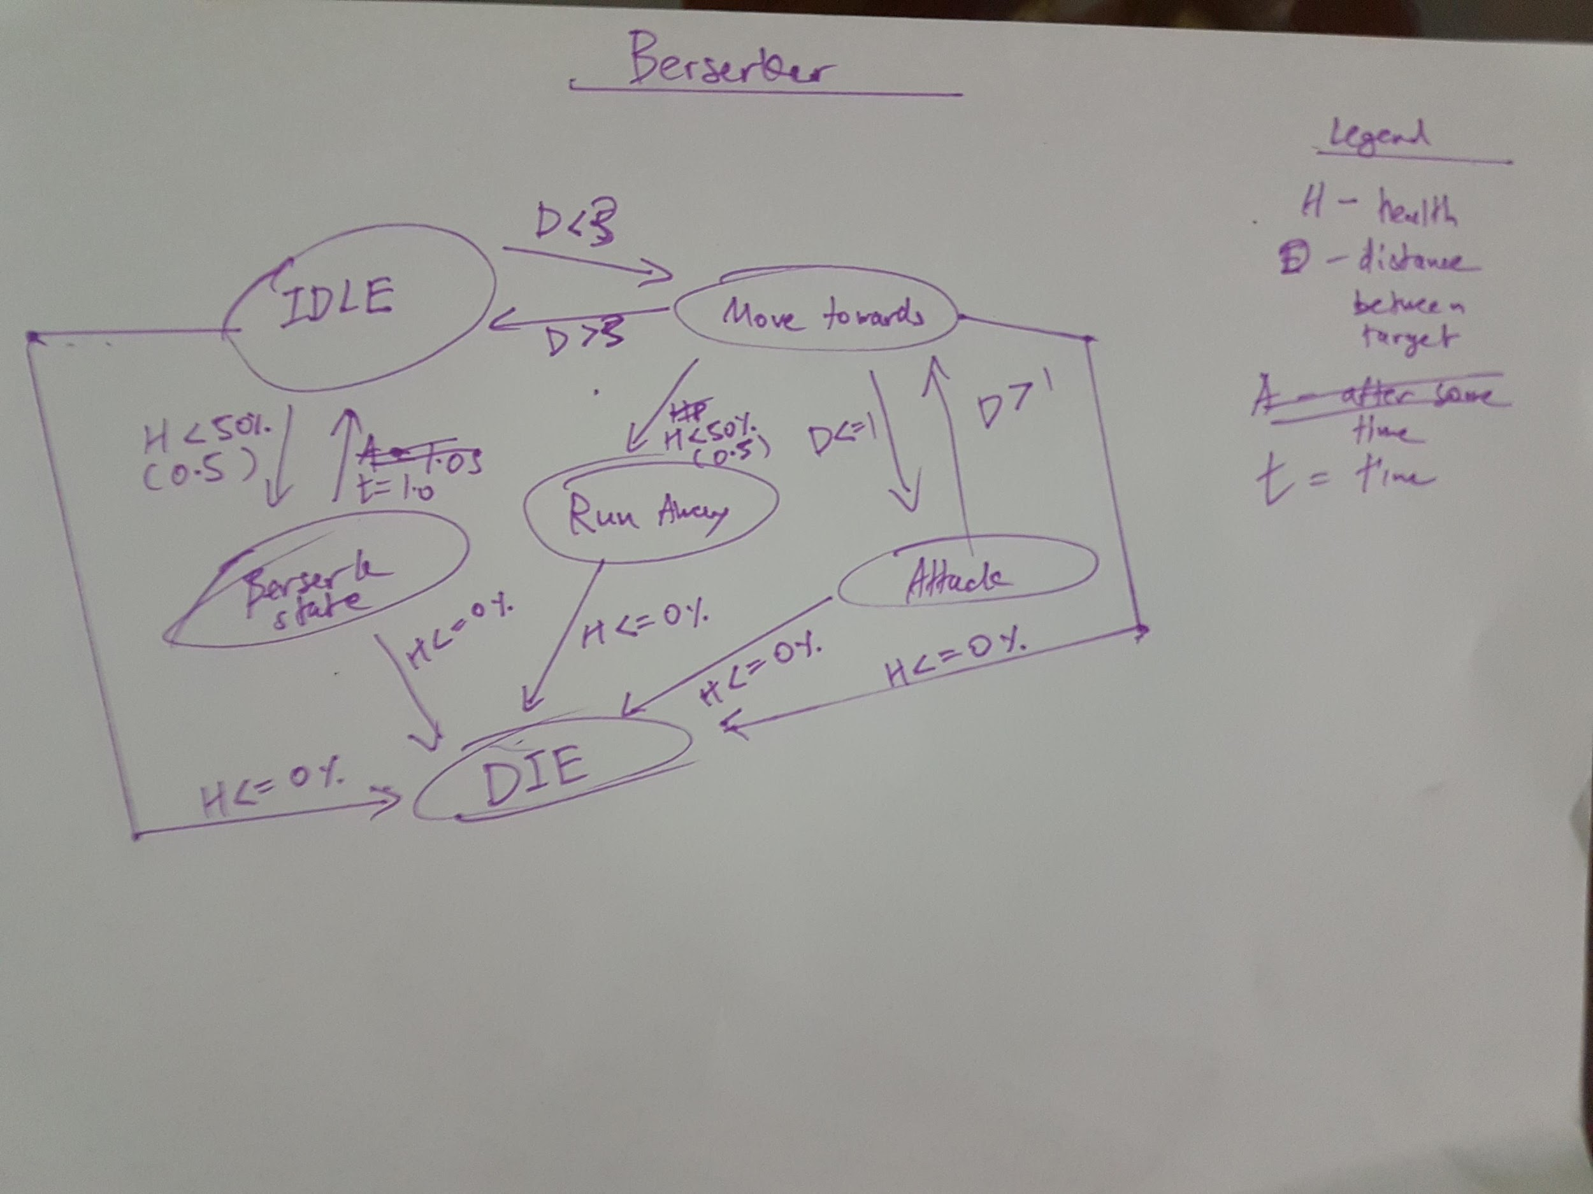

**FSM # 2 (Knight)** States

Knight will start as **idle**.

If enemy is nearby, **Move Towards Enemy**

If enemy in attack range, **attack enemy**

If Knight health is low **Block and Heal or Charge at Enemy**

If health is not low anymore continue attacking

If Knight health is 0, **dies**.

If enemy is out of range go back to **idle**

Conditions

Knight will start as idle.

If **enemy is nearby**, Move Towards Enemy

If **enemy in attack range**, attack enemy

If Knight **health is low** Block and Heal or Charge at Enemy

If **health is not low** anymore continue attacking

If Knight **health is 0**, dies.

If **enemy is out of range** go back to idle

State Transition Diagram

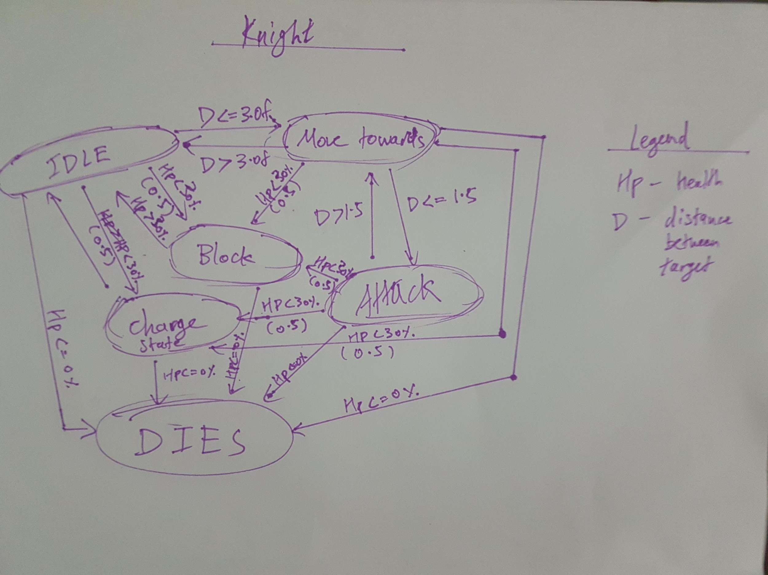

**FSM # 3 (Archer)** States

When Archer is IDLE, Archer do nothing.

When Archer is ALERTED, Archer attack player.

When Archer is TRIGGERED, Archer run from player.

When Archer is DEAD, Archer is not rendered.

Conditions

When the Player is far from the Archer, Archer is IDLE

When Player goes near Archer, Archer is ALERTED

When Player is too near Archer, Archer is TRIGGERED

When Archer health <= 0, Archer is DEAD

State Transition Diagram

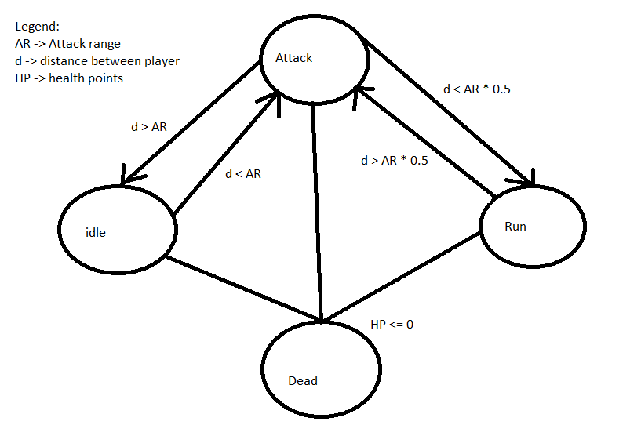

**FSM # 4 (Mage)** States

When Mage is IDLE, Mage do nothing.

When Mage is ALERTED, Mage attack player.

When Mage is TRIGGERED, 50% Mage self teleport, 25% teleport Player, 25% teleport both.

When Mage is DEAD, Mage is not rendered.

Conditions

When the Player is far from the Mage, Mage is IDLE

When Player goes near mage, Mage is ALERTED

When Player is too near Mage && Mage health <= 50%, Mage is TRIGGERED

When Mage health <= 0, Mage is DEAD.

State Transition Diagram

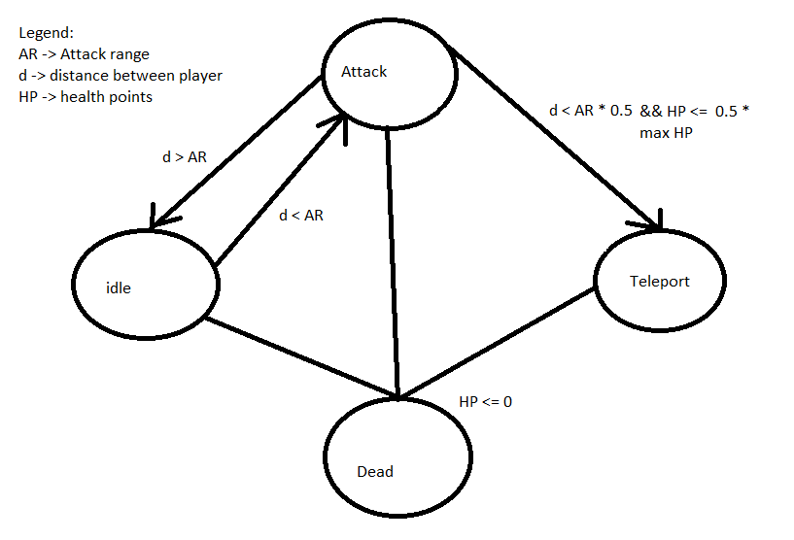

**FSM #5 (Ally)** States

Ally will start as **Patrol**.

If enemy is nearby, **Move Towards Enemy**

If enemy in attack range, **attack enemy**

If Ally health is 0, **dies**.

If enemy is out of range go back to **Patrol**

Conditions

Ally will **start as** Patrol.

If **enemy is nearby**, Move Towards Enemy

If **enemy in attack range**, attack enemy

If Ally **health is 0**, dies.

If **enemy is out of range** go back to Patrol

State Transition Diagram

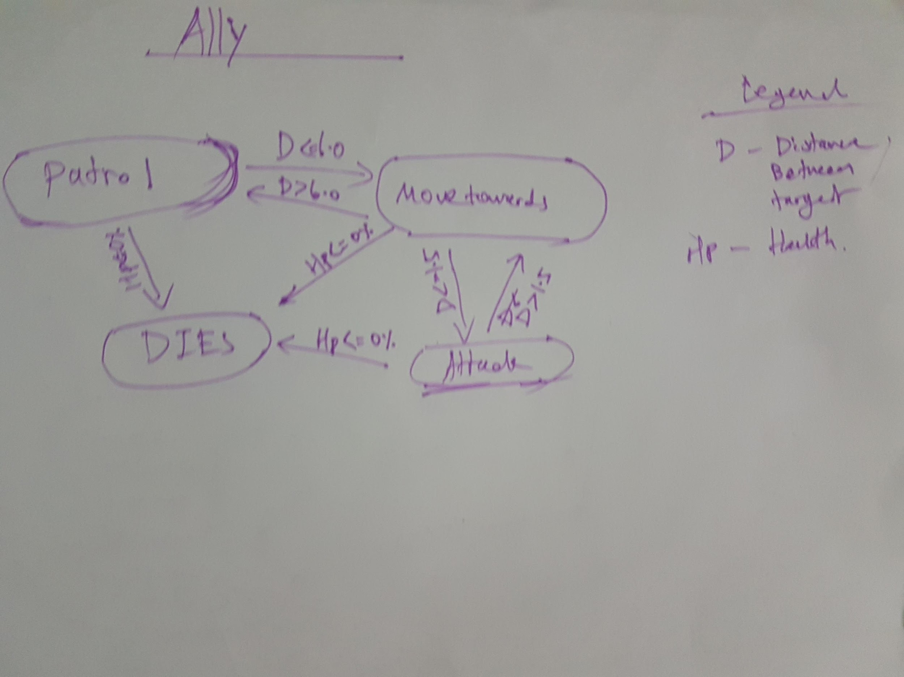

|  |  |  |  |  |
| --- | --- | --- | --- | --- |
| Message Board | | | | |
| Text | From | To | Response(Output) | Remarks |
| “Knight! Protect me!” | Mage | Knight | Knight moves to mage, state becomes BlockState | Only happens if a knight exists |
| “Archer! I need cover fire!” | Knight | Archer | Archer moves to engage Player. | Only happens if an Archer exists and knight is under attack. |
| “Berserker! The enemy is here!” | Archer | Berserker | Berserker goes into Berserk State, moves to engage player | Only happens if a Berserker exists and Archer is in the RUNAWAY state. |
| “Let’s wreck these fools, Mage!” | Berserker | Mage | Mage teleports to Berserker. | Only happens if a Mage exists and Berserker is under attack. |
| “Form up on me!” | Knight | All alive | Everyone moves to knight | 50 % chance for knight to call this |

10% chance for enemy to be bribed by player to become non-hostile.