Coleccion

How to play:

The goal of Coleccion is to find sets of three cards that fulfill the requirements for matching as rapidly as possible.

There are 4 properties that define the image on each card:

Color
Each card has 1 of 4 possible colors: Blue, Orange, Green, and Red.

Number
The number of shapes present on the card: 1, 2, or 3.

Type
There are 4 different kinds of shapes in the game: Triangles, Parallelograms, Semicircles, and Rectangles.

Fill
Each shape will have 1 of 3 patterns: Solid, Empty, or Grid.

_

A “coleccion” is a set where 3 cards either share the same characteristic for a property, or have different, unique characteristics, for all 4 properties.

Example – Color
If three cards are all Blue, the color property for a coleccion is satisfied.
If one card is Blue, the second Red, and the third Green, the color property is likewise satisfied.
If two cards are Orange, and one Blue, the color property is NOT satisfied.

Example – Number
If three cards each have one shape on them, the number property is satisfied.
If one card has one shape, another, two shapes, and the third has three shapes, the number property is likewise satisfied.
If one card has two shapes, and the other two have three shapes, the number property is NOT satisfied.

Example – Type
If all three cards are semicircle shaped, the type property is satisfied.
If one card is rectangular, another, triangular, and the last, a parallelogram, the type property is likewise satisfied.
If two cards are semicircles, and the third is a triangle, the type property is NOT satisfied.

Example – Fill
If all three cards have a fill of empty, the fill property is satisfied.
If one card has a solid fill, another, grid, and a third, empty, the fill property is satisfied.
If two cards have a grid filling, and the third, solid, the fill property is NOT satisfied.
A coleccion is not valid unless the requirements for ALL four properties are fulfilled.
___________________________________________________________________________________

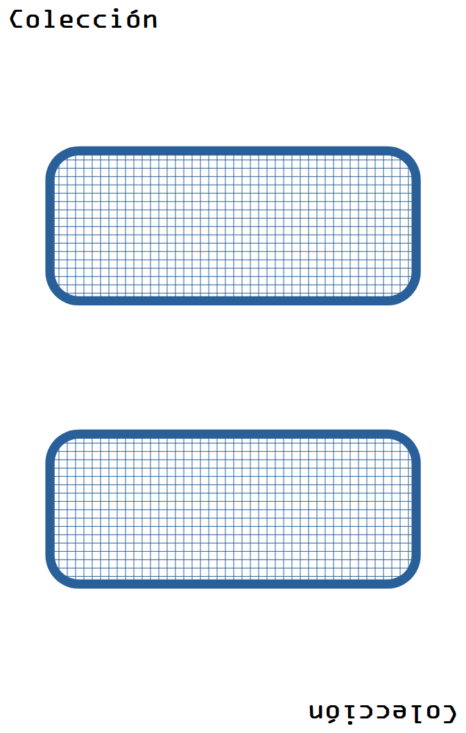
Color
Blue
____________

Number
2
____________

Type
Rectangle
____________

Fill
Grid

