Colección

How to play:

The goal of Colección is to find sets of three cards that fulfill the requirements for a match as rapidly as possible.

There are 4 properties that define the image on each card:

Color
Each card has 1 of 4 possible colors: Blue, Orange, Green, and Red.

Number
The number of shapes present on the card: 1, 2, or 3.

Type
There are 4 different kinds of shapes in the game: Triangles, Parallelograms, Semicircles, and Rectangles.

Fill
Each shape will have 1 of 3 patterns: Solid, Empty, or Grid.

_

A “Colección” is a set where 3 cards either share the same characteristic for a property, or have different, unique characteristics, for all 4 properties.

Example – Color
If three cards are all Blue, the color property for a Colección is satisfied.
If one card is Blue, the second Red, and the third Green, the color property is likewise satisfied.
If two cards are Orange, and one Blue, the color property is NOT satisfied.

Example – Number
If three cards each have one shape on them, the number property is satisfied.
If one card has one shape, another, two shapes, and the third has three shapes, the number property is likewise satisfied.
If one card has two shapes, and the other two have three shapes, the number property is NOT satisfied.

Example – Type
If all three cards are semicircle shaped, the type property is satisfied.
If one card is rectangular, another, triangular, and the last, a parallelogram, the type property is likewise satisfied.
If two cards are semicircles, and the third is a triangle, the type property is NOT satisfied.

Example – Fill
If all three cards have a fill of empty, the fill property is satisfied.
If one card has a solid fill, another, grid, and a third, empty, the fill property is satisfied.
If two cards have a grid filling, and the third, solid, the fill property is NOT satisfied.
A Colección is not valid unless the requirements for ALL four properties are fulfilled.

Gameplay:

Upon selecting a card, a green border will appear to indicate it is activated. Deselecting the card will remove the border. The same will occur when a second card is selected. When a third card is chosen, two outcomes are possible:
1) If the choices are a Colección, the cards are added to the scorepile, and new cards are added to the gameboard.
2) If the choices are NOT a Colección, active cards are deselected, and a prompt will display a message indicating that the selection does not meet the criteria.

The game screen contains 3 buttons:
1) Pause – the active game is put on hold, and the timer is suspended.
3) Randomize Button – the cards on the game board are discarded, and 12 new cards are added.
2) Hint – 2 cards will be highlighted (a red border will appear) to indicate that these are part of a Colección. The player then only needs to find the 3rd card necessary to complete the Colección.
* Rarely, a board will not contain any Coleccións, in which a prompt will appear to instruct the player to press the Randomize Button.

When the game timer runs out, the game over screen will appear.
→

The goal of Colección is to find sets of three cards that fulfill the requirements for a match as rapidly as possible

.

There are 4 properties that define the image on each card:

Color - Each card has 1 of 4 possible colors:
Blue, Orange, Green, and Red

Number - The number of shapes present on the card:
1, 2, or 3

Type - There are 4 kinds of shapes in the game:
Triangles, Parallelograms,
Semicircles, and Rectangles

Fill - Each shape will have 1 of 3 patterns:
Solid, Empty, or Grid

A Colección is a set where 3 cards either share the same characteristics, or have different, unique characteristics, for all 4 properties

Example - Color
If 3 cards are all Blue, the color property is satisfied.
If one card is Blue, the second Red, and the third Green,
the color property is likewise satisfied.
If 2 cards are Red, & 1 Blue, the color property is NOT satisfied.

Example - Number
If 3 cards have 1 shape on them, the number property is satisfied.
If one card has one shape, another, two shapes, and the third has three shapes, the number property is likewise satisfied.
If one card has two shapes, and the other two have three shapes, the number property is NOT satisfied.

Example - Type
If all 3 cards are semicircles, the type property is satisfied.
If one card is rectangular, another, triangular, and the last,
a parallelogram, the type property is likewise satisfied.
If 2 cards are semicircles, and the third is a triangle,
the type property is NOT satisfied.

Example - Fill
If all 3 cards have a fill of empty, the fill property is satisfied.
If one card has a solid fill, another, grid, and a third, empty, the fill property is satisfied.
If two cards have a grid filling, and the third, solid,
the fill property is NOT satisfied.

A Colección is not valid unless the requirements for ALL four properties are fulfilled!

Upon selecting a card, a green border will appear to indicate that it is activated.
Deselecting the card will remove the border.
The same will occur when a second card is selected.

When a third card is chosen, 2 outcomes are possible:

1) If the choices are a Colección, the cards are added to the score pile,
and new cards are added to the gameboard.

2) If the choices are NOT a Colección, active cards are deselected, and a prompt will display a message that the selections do not meet the criteria.

The game screen contains 3 buttons:

1) Pause - the active game is put on hold, and the timer is suspended.

2) Randomize - the cards on the game board are discarded, and 12 new cards are added.

3) Hint - 2 cards will be highlighted (a red border will appear) to indicate that these are part of a Colección. The player then only needs to find the third card necessary to complete the Colección.

* Rarely, a board will not contain any Coleccións, in which a prompt will appear to instruct the player to press the Randomize Button.

When the game timer runs out,
the game over screen will appear.

←

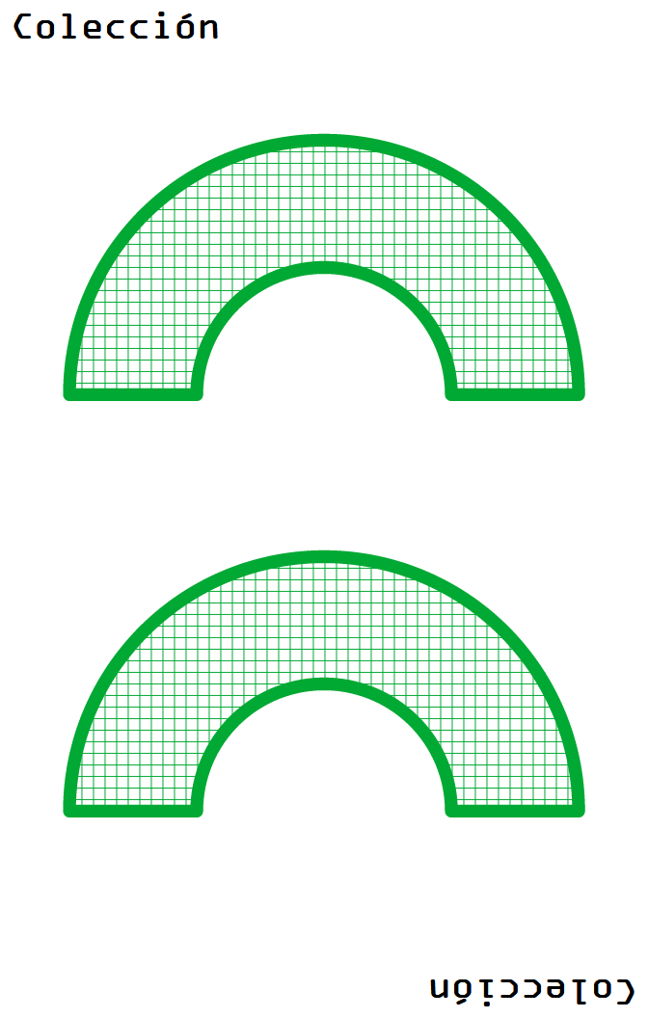
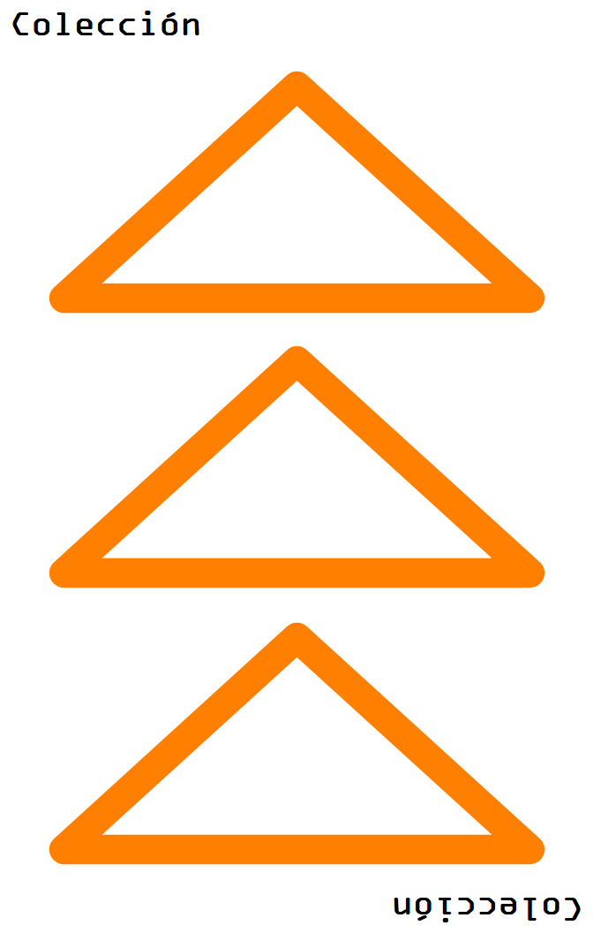
← Color
Orange

← Number
3

← Type
Triangle

← Fill
Empty

