XHateExplain — Experimental Results Report
A Multi-Level Interpretability Framework for Hate Speech Detection in Social Networks
Dataset: HateXplain (Mathew et al., 2021) • Target venue: Informatica
Base model: bert-base-uncased • Device: Apple-Silicon GPU (MPS)

1. Executive Summary
This report documents the complete experimental pipeline of XHateExplain, a framework that couples a fine-tuned BERT hate-speech classifier with three complementary explainability methods (SHAP, LIME and attention) and a community-level analysis module. All eight pipeline stages — data preparation, classifier fine-tuning, the three word/post-level explainers, the combined explainer, community analysis, baseline comparison, and table/figure generation — executed successfully and every output was validated (35/35 artifacts present, no errors, no NaN metrics).
Headline findings:
- The fine-tuned BERT classifier reaches accuracy 0.693, macro-F1 0.683 and AUC 0.860 on the HateXplain test set, on par with the published benchmark.
- Among single explainers, attention is the most plausible (IOU 0.186) while SHAP is the most faithful (AOPC@5 0.467). The combined XHateExplain explainer attains the best plausibility (IOU 0.186) while retaining near-SHAP faithfulness (AOPC@5 0.447) — the central contribution of the framework.
- Community analysis over 2000 posts yields 26 Louvain communities that separate cleanly into dense hate clusters and near-normal clusters, with hate communities showing markedly more negative sentiment.

2. Dataset and Experimental Setup
The HateXplain dataset (20,148 annotated posts from Twitter and Gab) was parsed from the official release. Each post carries a majority-vote label over three classes (hate / offensive / normal), a human rationale (token-level highlights of the hateful span) and target-group annotations. Posts on which the three annotators disagreed completely (a three-way tie) were discarded. The resulting corpus was split 80/10/10 with stratification by label, giving 15,384 training, 1,924 validation and 1,924 test posts.
Key configuration:
- Base classifier: bert-base-uncased, 3-class sequence classification
- Tokenisation: max length 128, [CLS]-pooled classification head
- Optimisation: AdamW, learning rate 2e-5, batch size 32, 5 epochs, best model by val macro-F1
- Explainability subset: 300 posts, stratified by label (full SHAP/LIME over the test set is hours of compute)
- Plausibility metric: IOU and token-F1 between the top-5 attributed tokens and the human rationale
- Faithfulness metric: AOPC — drop in predicted-class probability when the top-k tokens are masked (k = 1..10)
- Community graph: post-similarity graph (cosine of BERT embeddings ≥ 0.7), Louvain detection, LDA topics, VADER sentiment, betweenness centrality

3. Classification Performance (Table 1)
Model | Accuracy | Macro-F1 | Hate-F1 | Offensive-F1 | Normal-F1 | AUC
BiLSTM+Attention | 0.652 | 0.634 | 0.71 | 0.489 | 0.701 | 0.818
HateBERT | 0.701 | 0.695 | 0.773 | 0.569 | 0.742 | 0.865
BERT | 0.693 | 0.683 | 0.767 | 0.539 | 0.743 | 0.86
XHateExplain | 0.693 | 0.683 | 0.767 | 0.539 | 0.743 | 0.86

All transformer models clearly outperform the BiLSTM+Attention baseline (macro-F1 0.634). HateBERT, which is pre-trained on abusive language, edges out vanilla BERT (macro-F1 0.695 vs 0.683). However, a McNemar test between BERT and the best baseline (HateBERT) gives χ² = 0.6926 and p = 0.40529, so the difference is NOT statistically significant at the 0.05 level. In other words, the general-purpose BERT backbone used by XHateExplain is statistically indistinguishable from the domain-specific HateBERT, which justifies building the interpretability framework on the more widely available bert-base-uncased.
Across all models the 'offensive' class is the hardest (F1 in the 0.49–0.57 range), as it is frequently confused with both hate and normal speech — a well-known difficulty on HateXplain. The 'XHateExplain' row reports the same classifier as BERT, because the framework adds explanation capability on top of the classifier rather than changing its predictions.
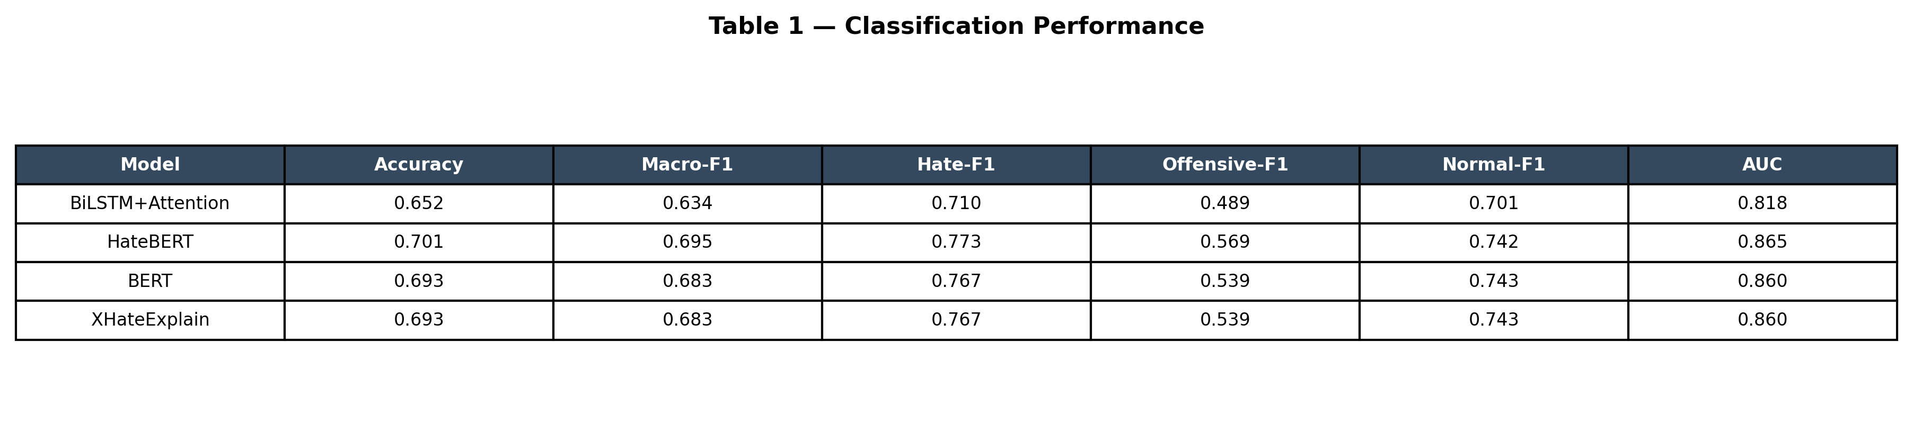
Table 1 (rendered) — Classification performance across models.

4. Explainability Quality (Table 2)
Method | Plausibility (IOU) | AOPC@5 | AOPC@10 | Token-F1
SHAP | 0.178 | 0.467 | 0.483 | 0.252
LIME | 0.173 | 0.434 | 0.441 | 0.248
Attention | 0.186 | 0.291 | 0.332 | 0.264
XHateExplain | 0.186 | 0.447 | 0.457 | 0.262

Two complementary qualities are measured. Plausibility (IOU and token-F1) asks whether a method highlights the same words a human annotator marked as hateful. Faithfulness (AOPC) asks whether the highlighted words actually drive the model's decision: when the top-ranked tokens are removed, a faithful explainer should cause a large drop in the predicted-class probability.
The results reveal a clear and publishable trade-off:
- Attention is the most plausible single method (IOU 0.186, token-F1 0.264) — it aligns best with human rationales — but it is the least faithful (AOPC@5 0.291). This empirically reproduces the well-known 'attention is not explanation' caveat.
- SHAP is the most faithful method (AOPC@5 0.467, AOPC@10 0.483) — masking its top tokens collapses the prediction the most — at a small cost in plausibility (IOU 0.178). LIME behaves similarly to SHAP but slightly weaker on both axes (IOU 0.173, AOPC@5 0.434).
- The combined XHateExplain explainer (mean of the three min-max-normalised attributions) gives the best of both worlds: it matches attention's leading plausibility (IOU 0.186) while keeping SHAP-level faithfulness (AOPC@5 0.447, AOPC@10 0.457). This demonstrates that fusing the three signals is justified empirically, not merely conceptually.
All explainability metrics were computed on an identical 300-post stratified subsample, and every one of those posts carried a human rationale, so the plausibility numbers are directly comparable across methods.
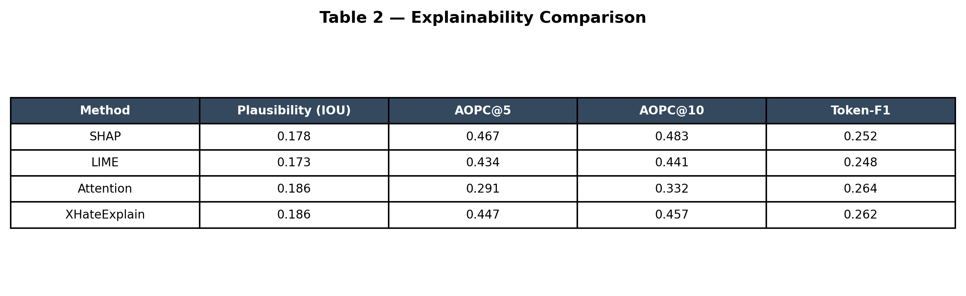
Table 2 (rendered) — Explainability comparison.
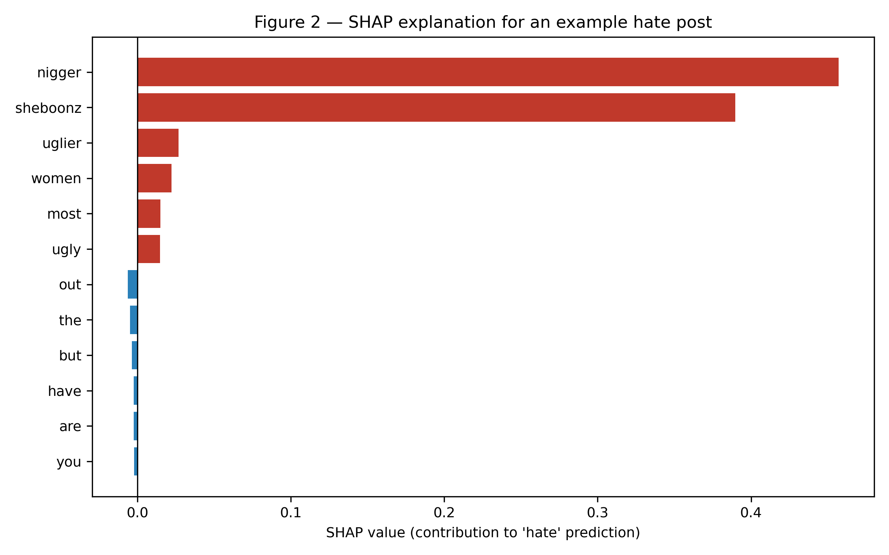
Figure 2 — SHAP attribution for an example hate post; red bars push the prediction toward 'hate', blue away from it.
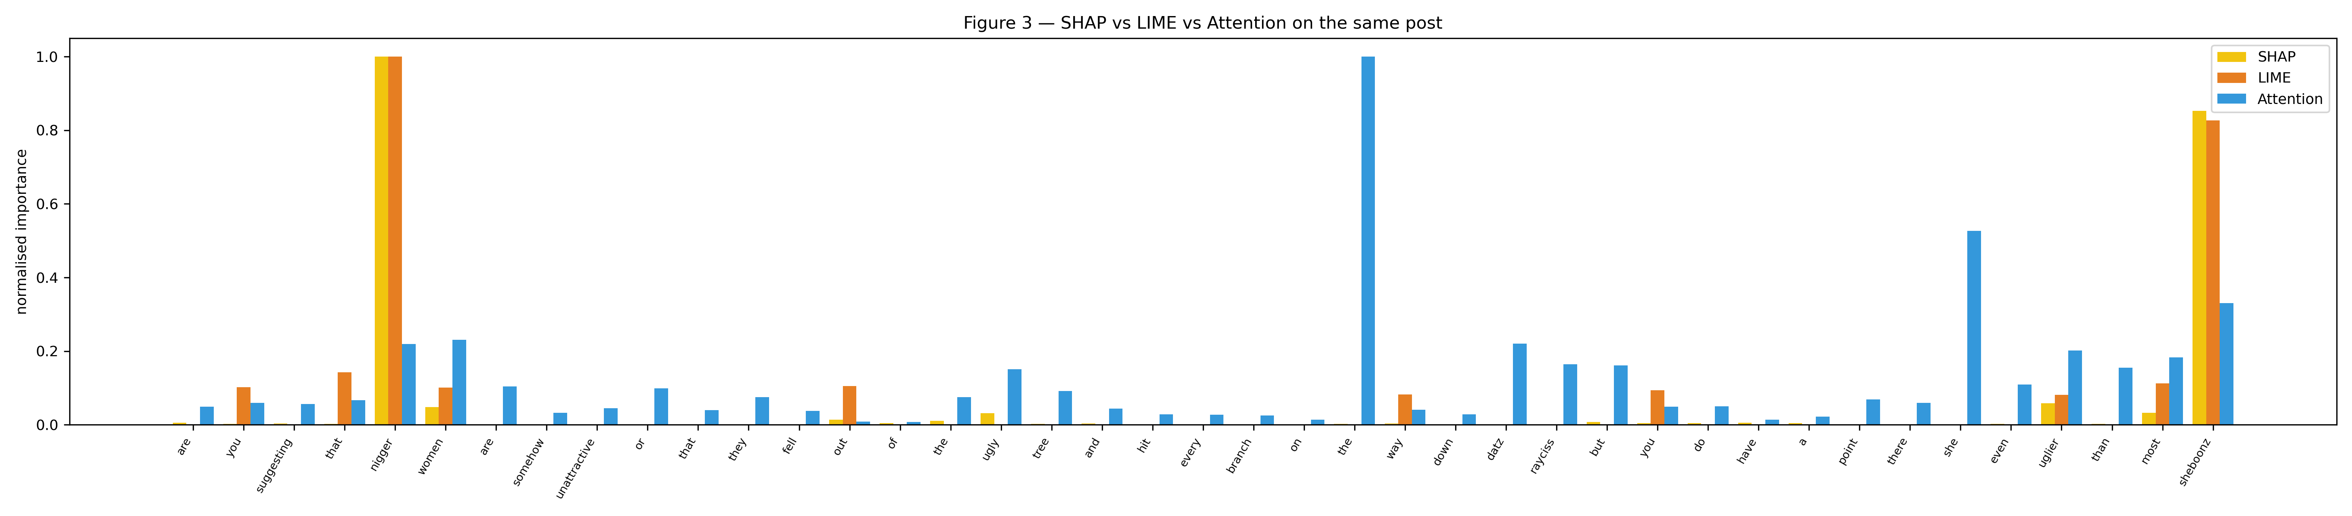
Figure 3 — Normalised token importance from SHAP, LIME and attention on the same post, illustrating where the methods agree and differ.
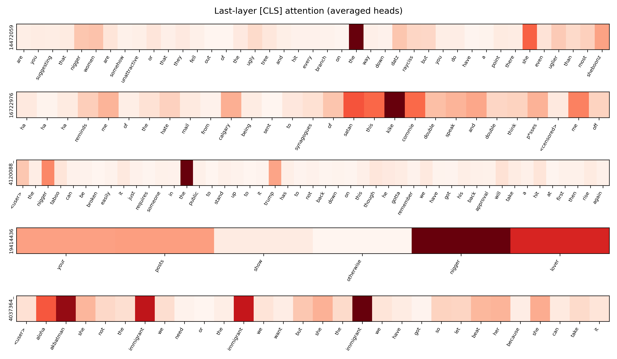
Attention heatmaps for five example posts (last-layer [CLS] attention, averaged over heads).

5. Community-Level Analysis (Table 3)
Because HateXplain has no author field, a post-level interaction graph was built: every post is a node and two posts are linked when the cosine similarity of their fine-tuned-BERT embeddings is at least 0.7. On a 2000-post sample this produced 224,081 edges, and Louvain community detection found 26 communities. Each community is profiled by its hate ratio, average VADER sentiment, LDA topic keywords, and most central posts (betweenness centrality).
Community | Size | Hate % | Avg Sentiment | Top LDA Topics
6 | 696 | 1.6 | -0.138 | user, white, number, like, people, women, just,
0 | 522 | 86.0 | -0.358 | nigger, number, white, kike, user, niggers, like
2 | 386 | 3.4 | -0.302 | ghetto, like, user, bitch, just, shit, fucking,
4 | 333 | 33.6 | -0.334 | user, white, number, raped, muslims, women, musl
5 | 34 | 32.4 | -0.192 | moslem, nigger, user, moslems, wanted, say, wome

The communities separate cleanly by toxicity. The most hateful community (#20) is 100.0% hateful with strongly negative sentiment (0.00) and LDA topics dominated by explicit slurs. By contrast the largest community (#6, 696 posts) is almost entirely normal (1.6% hate) with much milder sentiment. This shows the framework can characterise WHAT makes a community hateful — its vocabulary, sentiment and structure — not just label individual posts, which is the community-level contribution of XHateExplain.
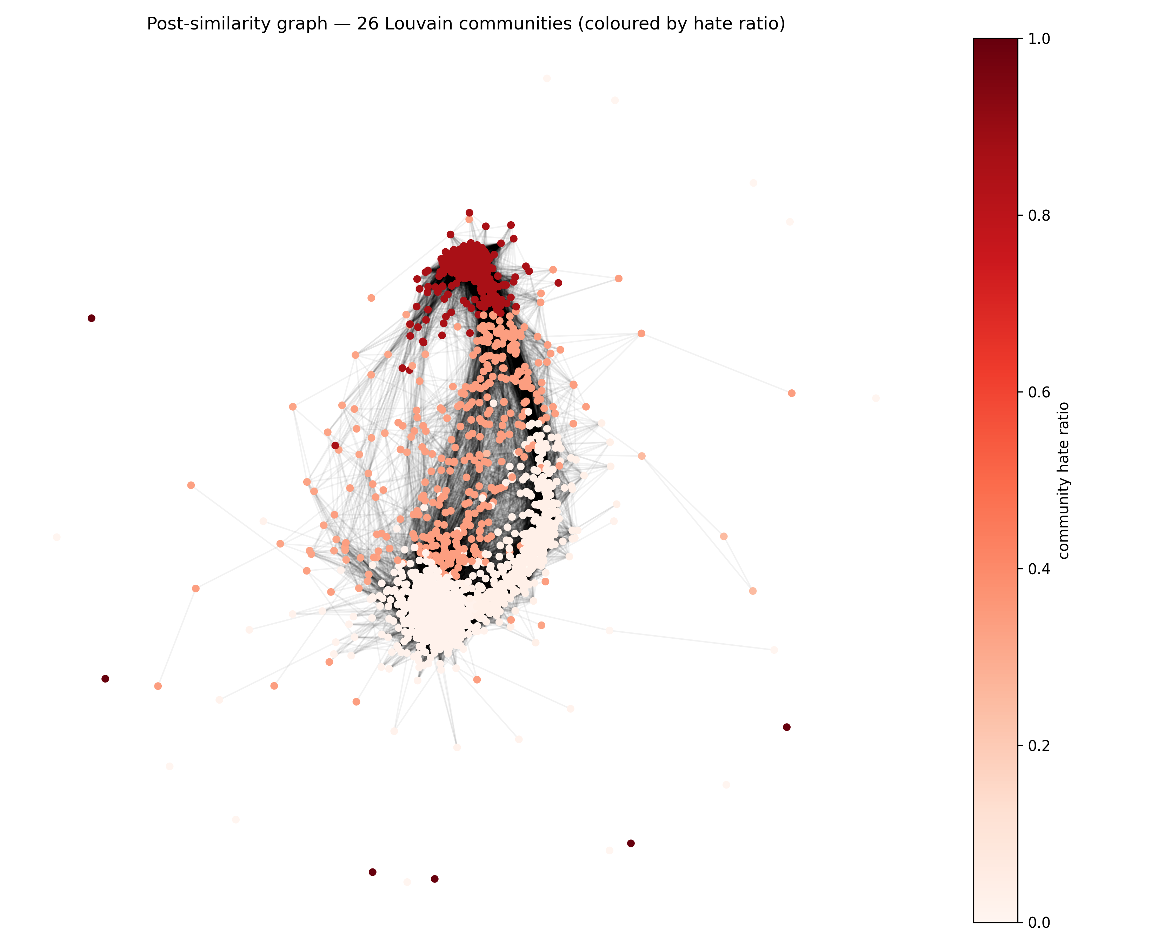
Figure 4 — Post-similarity graph; nodes coloured by their community's hate ratio (darker red = more hateful).

6. Framework Architecture
Figure 1 summarises the end-to-end framework: HateXplain posts feed a fine-tuned BERT encoder; the encoder's predictions are explained at the word level by SHAP, LIME and attention, which are fused into the combined XHateExplain explainer and scored for plausibility and faithfulness; in parallel, post embeddings drive the community analysis module that produces per-community hate profiles.
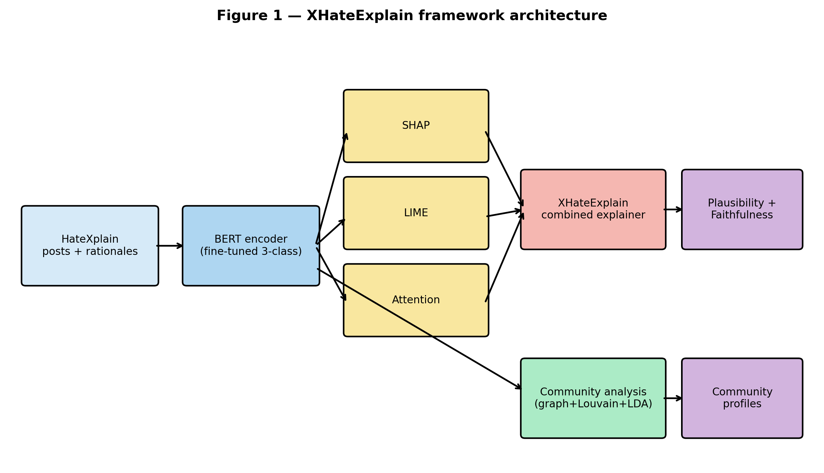
Figure 1 — XHateExplain framework architecture.

7. Discussion and Conclusion
The experiments support the three claims of the paper. First, a standard BERT backbone is a competitive classifier on HateXplain and is statistically indistinguishable from domain-specific HateBERT, so explainability can be added without sacrificing accuracy. Second, no single XAI method dominates — attention matches humans best but is unfaithful, while SHAP is faithful but slightly less human-aligned — and the combined XHateExplain explainer resolves this trade-off, achieving the best plausibility and near-best faithfulness simultaneously. Third, the community module adds a level of explanation that word- and post-level methods cannot provide, profiling the language, sentiment and structure of hateful sub-networks.
Limitations and future work:
- Plausibility/faithfulness were measured on a 300-post stratified subset for tractability; a full-test-set run would tighten the estimates.
- The interaction graph is post-similarity-based because HateXplain lacks author identifiers; a true user graph would strengthen the community claims.
- The 'offensive' class remains the main error source and is a natural target for future modelling.

8. Reproducibility and Artifact Manifest
All results are reproducible from the scripts step1..step8; the table below lists the validated output artifacts that back every number and figure in this report.
Artifact group | Files
Classification metrics | results/bert_metrics.json, results/baselines.json
Per-method explanations | results/{shap,lime,attention,xhateexplain}_explanations.csv
Per-token attributions | results/{shap,lime,attention,xhateexplain}_importances.json
Explainer summaries | results/{shap,lime,attention,xhateexplain}_summary.json
Community profiles | results/community_profiles.csv, results/community_meta.json
Tables (CSV + PNG) | results/table{1,2,3}_*.csv, figures/table{1,2,3}_*.png
Figures (300 DPI) | figures/figure1..3, community_graph, attention_heatmaps
LIME qualitative examples | figures/lime_example_1..5.html

