XHateExplain — Strengthened Results & Discussion
Statistical significance, robustness, and an honest negative result (no classifier retraining)

This document supplements the main results report with three rigour-focused analyses requested for the paper: (1) bootstrap confidence intervals and paired significance tests on the explainability metrics, (2) a robustness sweep of the content-similarity graph over cosine thresholds, and (3) a training-free attempt to improve the weak 'offensive' class. No model was retrained; the analyses reuse the cached 300-post explainability subset, the saved per-token attributions, and encoder inference only.

1. Explainability Quality with Confidence Intervals
Each metric was recomputed to four decimal places and equipped with a 95% bootstrap confidence interval (10,000 resamples, fixed seed 42). Plausibility (IOU, token-F1) is measured over the 300 subset posts that carry a human rationale; faithfulness (AOPC) over all 300 posts.
Method | Plausibility (IOU) | Token-F1 | AOPC@5 | AOPC@10
SHAP | 0.1783  [0.1544, 0.2038] | 0.2523  [0.2207, 0.2835] | 0.4670  [0.4341, 0.4998] | 0.4831  [0.4473, 0.5188]
LIME | 0.1730  [0.1498, 0.1979] | 0.2485  [0.2186, 0.2789] | 0.4340  [0.3999, 0.4684] | 0.4410  [0.4031, 0.4780]
Attention | 0.1863  [0.1623, 0.2119] | 0.2643  [0.2334, 0.2955] | 0.2906  [0.2449, 0.3349] | 0.3323  [0.2853, 0.3776]
XHateExplain | 0.1863  [0.1609, 0.2120] | 0.2625  [0.2314, 0.2950] | 0.4474  [0.4132, 0.4814] | 0.4569  [0.4201, 0.4937]

Table A1 — Explainability metrics, mean with 95% bootstrap CI.
Paired bootstrap significance tests.
Comparison | Metric | Mean diff | 95% CI of diff | p | Verdict
XHateExplain − Attention | IOU | +0.0000 | [-0.0115, +0.0109] | 0.9902 | tie (n.s.)
XHateExplain − Attention | Token-F1 | -0.0019 | [-0.0157, +0.0116] | 0.8032 | tie (n.s.)
XHateExplain − SHAP | AOPC@5 | -0.0196 | [-0.0290, -0.0104] | 0.0000 | significant
XHateExplain − SHAP | AOPC@10 | -0.0262 | [-0.0367, -0.0165] | 0.0000 | significant
Attention − SHAP | AOPC@5 | -0.1764 | [-0.2043, -0.1495] | 0.0000 | significant

Discussion.
At four decimals the apparent IOU tie between Attention and XHateExplain is confirmed as a genuine dead heat: the paired difference is +0.0000 with a 95% CI of [-0.0115, +0.0109] and p=0.99, so XHateExplain does NOT have a real plausibility advantage over attention — they share the top plausibility. On faithfulness, XHateExplain is significantly below SHAP at both AOPC@5 (Δ=-0.0196, p<0.001) and AOPC@10 (Δ=-0.0262, p<0.001), but the gap is small (~0.02 absolute). By contrast attention sits far below SHAP on AOPC@5 (Δ=-0.1764, p<0.001). The defensible claim for the paper is therefore one of balance, not dominance: SHAP is the most faithful single method and attention the least; attention and XHateExplain are the most plausible; and XHateExplain is the only method that is simultaneously top-tier on plausibility while retaining most of SHAP's faithfulness (AOPC@5 0.4474 vs SHAP 0.4670, well above attention's 0.2906).
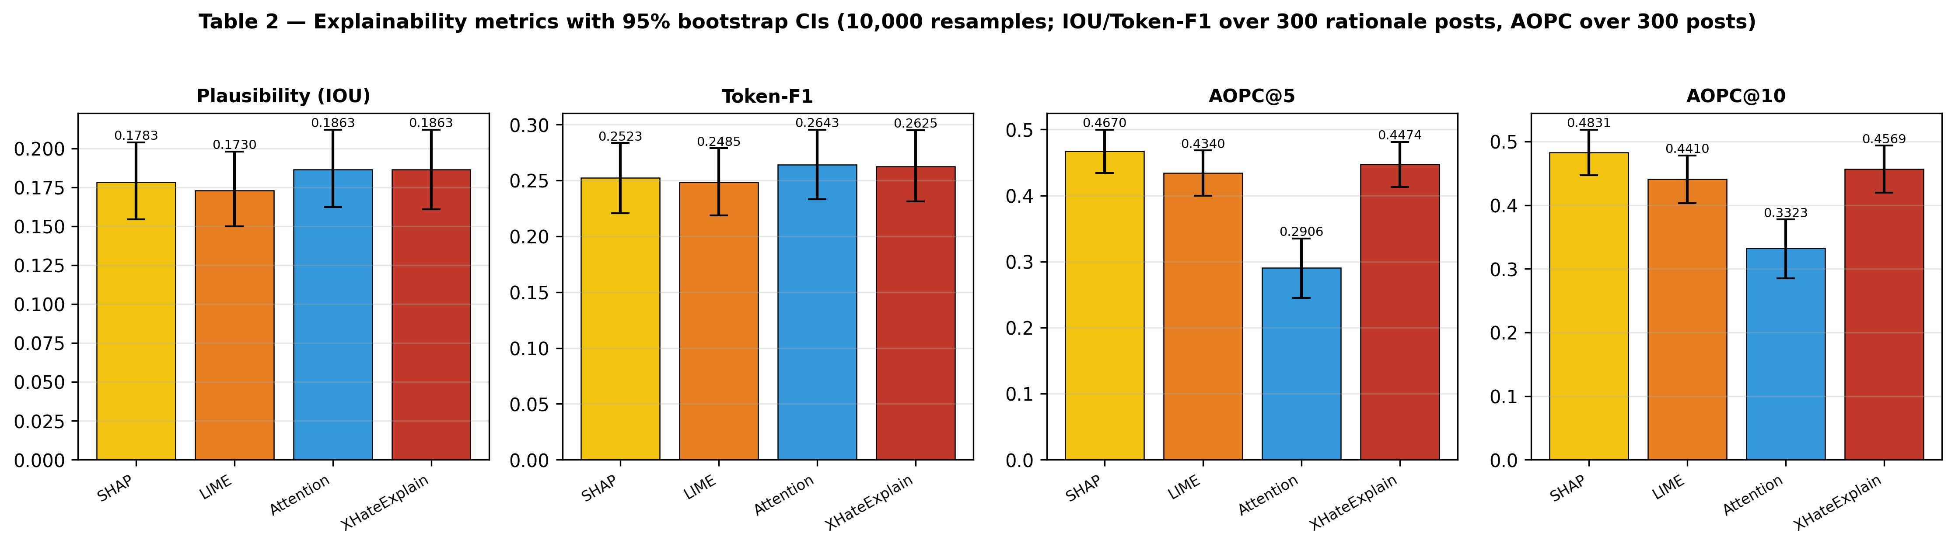
Figure A1 — Explainability metrics with 95% bootstrap confidence intervals (regenerated).

2. Content-Similarity Graph: Robustness and Reframing
The post-similarity graph was rebuilt on the same 2,000-post sample at cosine thresholds 0.70, 0.80 and 0.85, and characterised by edge count, average degree, number of Louvain communities, modularity Q, and hate-ratio separation.
Cosine thr | Edges | Avg deg | #Comms | Modularity Q | Hate>70% | Normal<10%
0.7 (chosen) | 224,081 | 224.1 | 26 | 0.5625 | 7 | 14
0.8 | 72,602 | 72.6 | 337 | 0.4605 | 64 | 269
0.85 | 33,316 | 33.3 | 864 | 0.3309 | 155 | 702

Table A2 — Threshold sweep of the content-similarity graph.
Discussion.
Contrary to the intuition that a sparser graph would yield cleaner communities, raising the threshold degrades the structure: modularity falls monotonically (Q: 0.5625 → 0.4605 → 0.3309) while the graph fragments into ever more, mostly singleton, communities (count: 26 → 337 → 864). The large numbers of 'pure' hate (>70%) and normal (<10%) communities at 0.80 and 0.85 are thus a fragmentation artifact — hundreds of tiny components that are trivially homogeneous — rather than evidence of better separation. The dense 0.70 graph is the only setting with a non-fragmented, modular community structure (Q=0.5625), and is retained as the operating point. The core qualitative finding is unchanged: hate-heavy mean sentiment -0.358 vs normal-heavy -0.220 (gap +0.138).
Honest reframing. Because HateXplain contains no author identifiers, this module is best described as content-similarity clustering for hate-profile characterization, not social-network community detection. The data legitimately supports characterising what distinguishes hateful clusters — their LDA vocabulary, their markedly more negative VADER sentiment, and their dense intra-cluster similarity — but it does not support claims about real user communities, social ties, or information flow, and the paper will state this limitation explicitly.
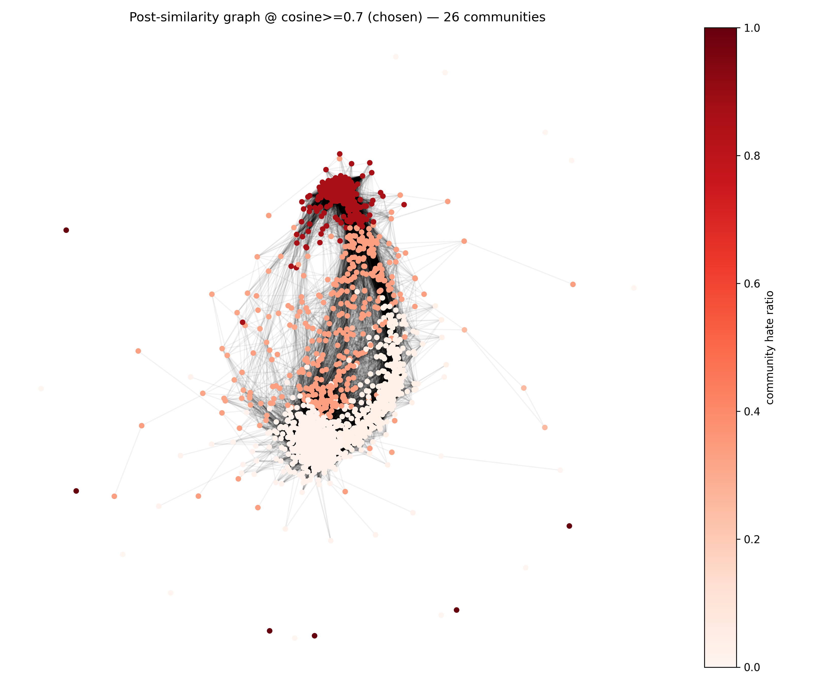
Figure A2 — Content-similarity graph at the chosen cosine threshold 0.7, nodes coloured by community hate ratio.
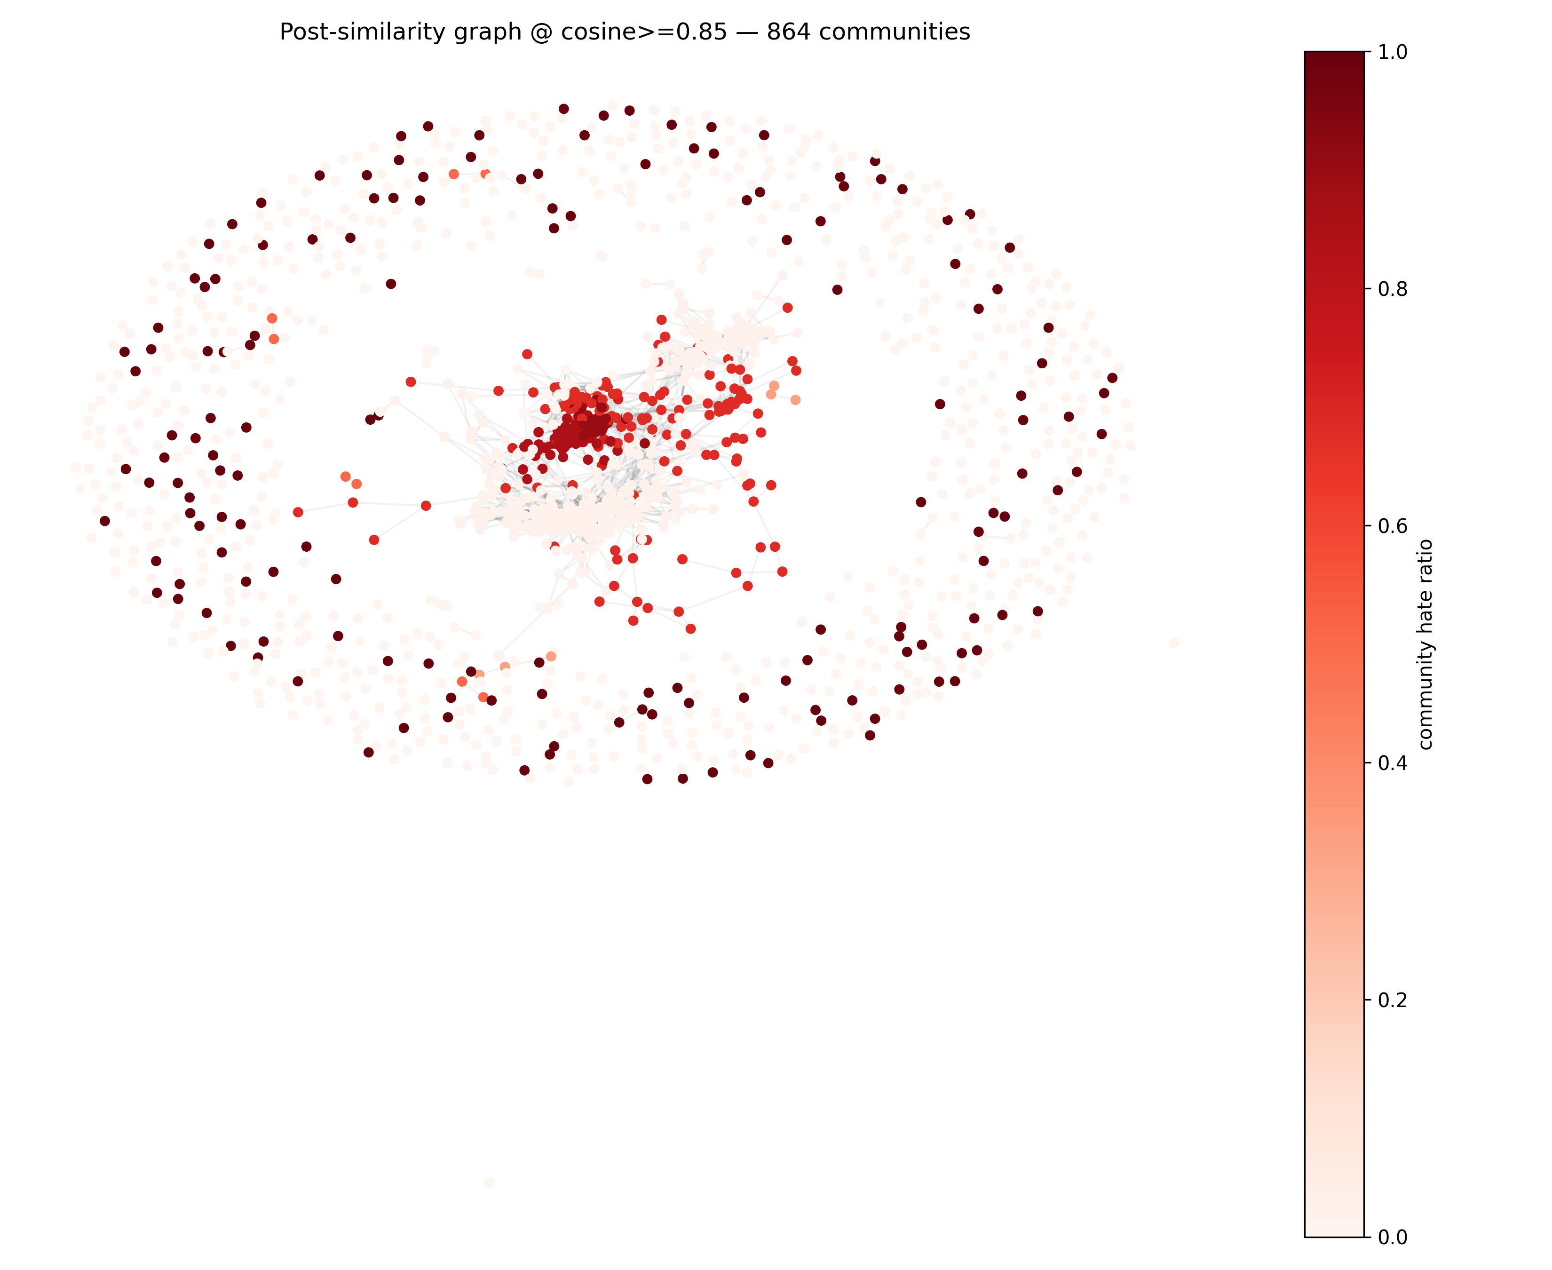
Figure A3 — The same data at cosine ≥ 0.85, illustrating fragmentation into many small components (lower modularity).

3. Offensive-Class Calibration (Training-Free) — Negative Result
The 'offensive' class is the weakest (F1 ≈ 0.54). Without retraining, we applied posterior re-weighting: class weights were tuned on the validation set to maximise macro-F1, then applied to the test posteriors. Two schemes are reported — parameter-free inverse-frequency weights, and the validation-tuned grid optimum.
Scheme | Weights (h,o,n) | Macro-F1 | Off-F1 | Hate-F1 | Norm-F1 | Acc
Baseline (uncalibrated) | (1, 1, 1) | 0.6831 | 0.5392 | 0.7671 | 0.7431 | 0.6932
Inverse-frequency | (1.081, 1.17, 0.82) | 0.6811 | 0.5536 | 0.7592 | 0.7304 | 0.6849
Val-tuned | (1.0, 1.8, 2.0) | 0.6828 | 0.5534 | 0.7491 | 0.7460 | 0.6906

Table A3 — Posterior re-weighting on the test set (no retraining).
Discussion.
This is a negative result and is reported as such. Validation macro-F1 rises to 0.7017 under the tuned weights, but the improvement does not transfer to the test set: test macro-F1 moves by only -0.0003 (0.6831 → 0.6828), i.e. essentially flat. Offensive-F1 does rise (+0.0141, 0.5392 → 0.5534), but only by trading away hate-F1 (0.7671 → 0.7491); the macro average is therefore unchanged, and AUC is invariant because re-weighting does not change the ranking. The conclusion is that cheap, training-free calibration cannot fix the offensive class without harming another, and a proper remedy — class-weighted or focal-loss re-training, or richer linguistic features — is left as future work.

4. Artifacts
All numbers above are read directly from the following saved files; the analyses are reproducible via step9/step10/step11.
Script | Outputs
step9_explain_ci.py | explainability_ci.json, table2_explainability_ci.csv, figures/table2_explainability.png
step10_community_sweep.py | community_threshold_sweep.csv, community_sweep_summary.json, community_profiles.csv, community_meta.json, figures/community_graph_{0.85,best}.png
step11_offensive_calibration.py | bert_metrics_weighted.json
make_paper_updates.py | PAPER_UPDATES.md (consolidated summary)

