|  |  |
| --- | --- |
| Systems Requirements Specification | Document Type |
|  | Created by |
| Syrian high and middle school | Created For |
| Ahmad-Zahloote  E-Mail: ahmadzahloote@gmail.com  Mobile: +963 991 953 560 | Contact Person |

Pro educational platform

Version 1.0

October 15, 2022

**Table of contents**

1. Introduction 3

1. Scope 3

2. Glossary 4

2. Overall Description 4

2.1 System Environment 4

2.2Functional Requirements specification 4

2.3Use Cases **خطأ! الإشارة المرجعية غير معرّفة.**

2.3.1 User Registration 7

2.3.2 User login 8

2.3.3 Course registration 10

2.3.4 View User Page 11

2.3.5 View course videos 11

# Introduction

## Scope

This project is a course site for Syrian high and middle school students, it will help them with their studies and remove obstacles and difficulties, there will three kinds of users:

**Anonymous:** the user is only able to roam the site without doing anything.

**Registered:** when the user registers on the site he/she will be set to a **deactivated** user, then an email is sent to the admin, admin will change the user status **activated** after that the user can enroll in a specific course, he/she must pay the fee of the course so he/she can view all the contents of the course

**Admin:**

* Admin user responsible for accepting and activating users
* Admin user can view add, remove and update courses
* Admin user can log in to the system.
* Admin can view all the registered user's accounts.
* Admin can delete or modify any vendor/user from the dashboard.
* Admin user can set an X (offers) which is specific period (month, day, year). After this period, regular users whose accounts are more active than this period can get their own discount.
* Admin user can set an Y which is specific number, regular users whose number of courses they have registered is greater than Y can get their own discount.
* Admin user can control home page, contact us page, social links and privacy policy using CMS.

**Payment**

Payment Can be done in two ways:

1. Cash (Out the system)
2. Using Syriatel cash service where each user will receive a request or a notification through phone SMS and Email to pay the number specified by the admin

**Homepage:**

The homepage will contain snippets, banners, navigation menu, login and so on…

## Glossary

|  |  |
| --- | --- |
| **TERM** | **Definition** |
| Admin | A user with the role of a manager of the platform, possesses the highest authority among users. |
| Active user | A user that has registered for a course or more. |
| Deactivated user | A user that has registered in the site but hasn’t registered for course |
| Database | A collection of all information that is stored by the system. |
| Server | The device that provides service for all users of the system |
| MCQ | Multiple choice quiz |
| Calendar | A scheduling interface for the user to set deadlines and tasks, also to get notified to continue the course. |

# Overall Description

## System Environment

The system will run on a remote server that will provide most of the functionality, a database with users information and personal data along with the resources of the website, users must be able to register for and reach the courses and the server will host less than 100k users approximately, the database must be able to handle all client and admin operations including queries and transactions

## 2.2Functional Requirements specification

Functional Requirements are those that refer to the functionality of the system, i.e., what services it will provide to the user. Nonfunctional (supplementary) requirements pertain to other information needed to produce the correct system and are detailed separately.

**Admin Functionality:**

* Admin can activate user accounts after they register
* Admin can manage homepage
* Admin can add, delete and update courses
* Admin can ban users any time in case of any rule violation
* Admin can manage the notifications page
* Admin can manually add a user
* Admin can manage test sheets at courses

**User functionality:**

* User can view courses when connected to the internet
* User can submit answers to tests once they are active after registration
* User can change password and username
* User can get a refund within three weeks after payment in case of dissatisfaction

**Site Registration, Permissions and Payment:**

The system must provide a way for logging in, accounts can only be activated by the admin, and the user must apply for a course to be activated for that course,

Payment will be done through the Syriatel Cash service or it will be manually transmitted through a third-party fund transfer company

**Course Registration:**

A user must be able to register for a course if he is logged in and his accounts was activated by the admin, once the user submits a request with valid payment info the user will be able to view the course till his account has been deleted or deactivated by the admin for any reasons.

**Offers:**

As time advances active users should get offers and discounts based on the amount of active time and number of courses they joined or submitted to view

**Resources and Site management:**

Admins should be able add new courses, update and delete existing courses, manage discounts and offers, they also should be able to activate users after they register for courses, add tests to any section when they want to

**Tests and exams:**

An activated user must be able to reach Test sheets, the sheets are MCQs with detailed solution to each question being available after the user submits the answers, the user can resubmit the answers every 3 days

## functionality Assumptions and Constraints

### Assumptions:

Assumptions are future situations, beyond the control of the project, whose outcomes influence the success of a project. The following are the assumptions:

* Availability of admin users when the users request activation
* Operations delaying due to external component failure or other reasons like the Syriatel cash payment service

### Constraints:

Constraints are conditions outside the control of the project that limit the design alternatives. The following are constraints:

* Government regulations
* Standards imposed on the solution
* Strategic decisions

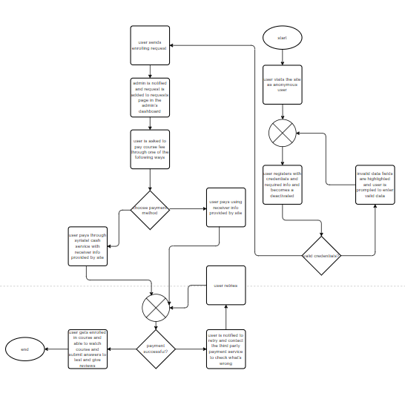

## Use Cases

### User Registration

In order for the user to register, the user only has to enter required data

**Scenario: Submit Request**

Given a user wants to create an account

And the user doesn’t have an account

And the user entered his/her full name

And the user provided an email or a phone number

And the user created a password

And the user provided password confirmation

And the user provided an address (optional)

When the user submits the request

Then an email is sent to the admin informing him about the request.

**Scenario: Accept Request**

Given the admin was on request page

And the data was valid

When the admin clicks the accept button

Then the account is created as a deactivated user account

And an email is sent to the user informing him about the request.

**Scenario: False Info Provided**

Given admin is on a request page

And the info is invalid

When the admin clicks the reject button

Then the request is deleted and an email is sent to that user.

### User login

Every registered user should be able access all registered user rules and functionality including registering for courses and so on.

**Scenario: Normal Login**

Given the user is on the login page

And the user is registered

And the user entered an email or a phone number

And the user entered a password

When the user clicks the submit button

Then the user gets logged in for one day

And the user is redirected to the home page.

**Scenario: Login for a Month**

Given the user is on the login page

And the user is registered

And the user entered an email or a phone number

And the user entered a password

And the user clicks the “log me in for a month” check box

When the user clicks the submit button

Then the user gets logged in for one month

And the user is redirected to the home page.

**Scenario: Password Reset Via Email**

Given the user is on the password reset page

And the user has an account

And the user forgot his password

And the user entered his email

When the user clicks the submit button

Then the user should receive an email link containing a one-time link to set his

Password.

**Scenario: Password Reset Via Phone Number**

Given the user is on the password reset page

And the user has an account

And the user forgot his password

And the user entered his phone number

When the user clicks the submit button

Then the user should receive an SMS message containing a one-time link to set his

password.

**Scenario: Change Phone Number**

Given the user is on the password reset page

And the user wants to change the phone number

And the user entered his new phone number

When the user clicks the submit button

Then the user should receive an email with verification code

And is redirected to verification page

### Course registration

Every registered user must be able to sign up for a course and view all of its contents

**Scenario: Course Registration Via Fund Transfer Company Receipt**

Given the user is logged in

And the user is on course registration page

And the user is not activated for the course

And the user entered an image of the receipt

When the user clicks the submit button

Then an email is sent to the admin informing him about the request.

**Scenario: Course Registration Via Syriatel Cash service**

Given the user is logged in

And the user is on course registration page

And the user is not activated for the course

And the user transferred the course fee via Syriatel cash service

When the user clicks the submit button

Then an email is sent to the admin informing him about the request.

**Scenario: False info Provided**

Given the admin is on the course request page

And the user provided false info or payment process is in complete

When the admin clicks the reject button

Then the request is deleted and a notification email and an SMS message is sent to the user

### View User Page

Every user should have a page that contains finished courses with test grades for each test, current courses, calendar, profile

**Scenario: View Page**

Given the user is logged in

And the user is on the home page

When the user clicks the personal profile button

Then the user must be redirected to his profile with all the info listed above

### View course videos

Every user registered to a course must be able to view all of its content and milestones, tests and so on…

**Scenario: View course Content(Tests, Videos, Readings):**

Given the user is registered

And the user is logged in

And the user is registered for a course

When the user clicks on a content element of the course

Then the user must be able to clearly view the content

The following Use case diagram will specify what services the system will provide: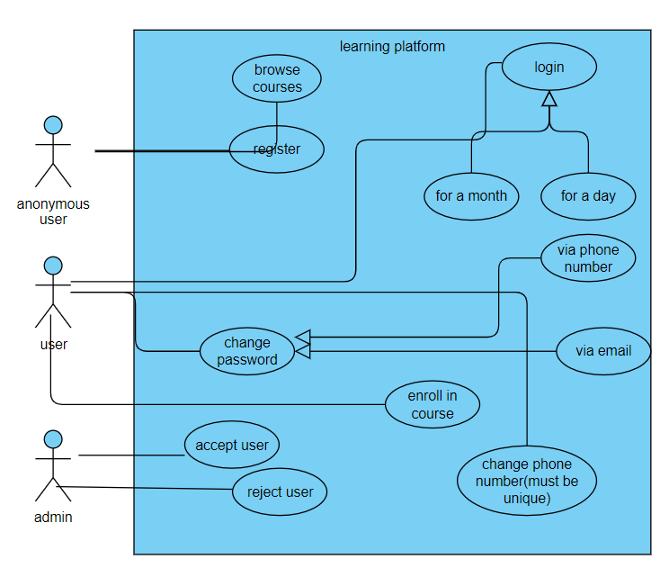

Figure system services

## Website pages with explanation

## Registration page:

Figure register form

### Login page

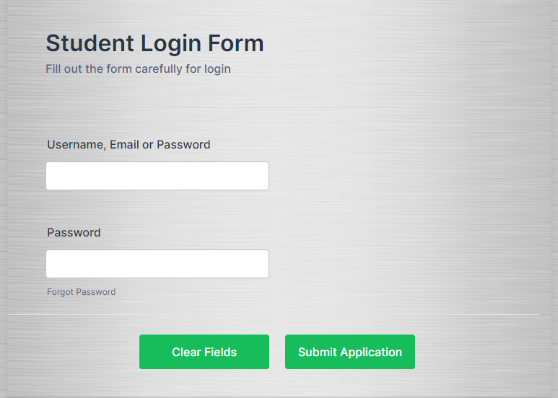

Figure Login form