



***Assignment on***

**Blog Management System**

**Course Title: Web Engineering**

**Course Code: CIS332**

**Submitted to:**

Mr. Md. Minhaj Hosen

Sr. Lecturer

Department of Computing & Information System (CIS)

Daffodil International University.

**Submitted by:**

Prosenjit Chowdhury

ID: 183-16-346

Department of Computing & Information System (CIS)

Daffodil International University.

**Date of Submission: 28/08/2020**

**Task 1**

**The functionality of my website (blog management system) is given below including required image:**

1. For login, user need to go to the login page and insert vaild username and passwoord.

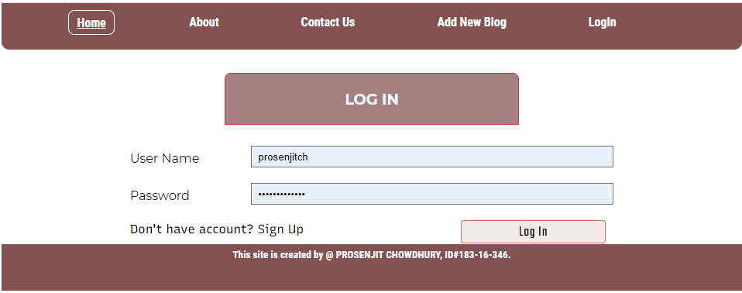

1. If user input any invalid username or password can see an error message

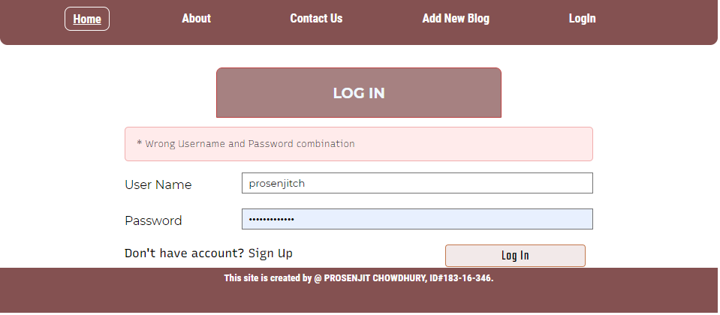

1. If user have any account, need to create an account. For create account click Signup option then create account

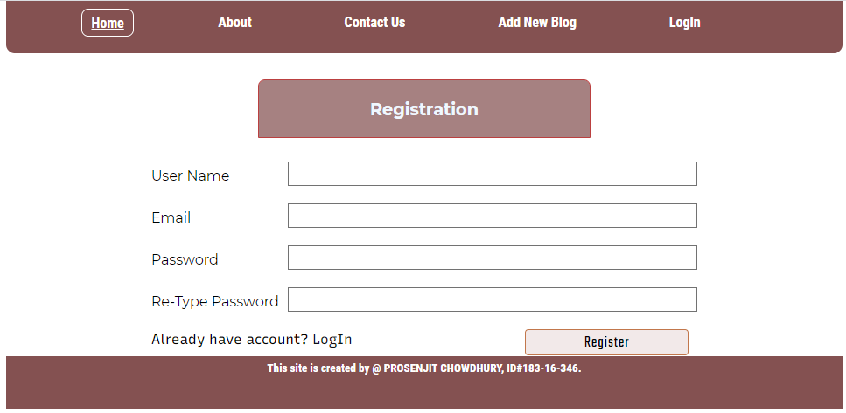

1. If the user is in the block-list, he cant login.

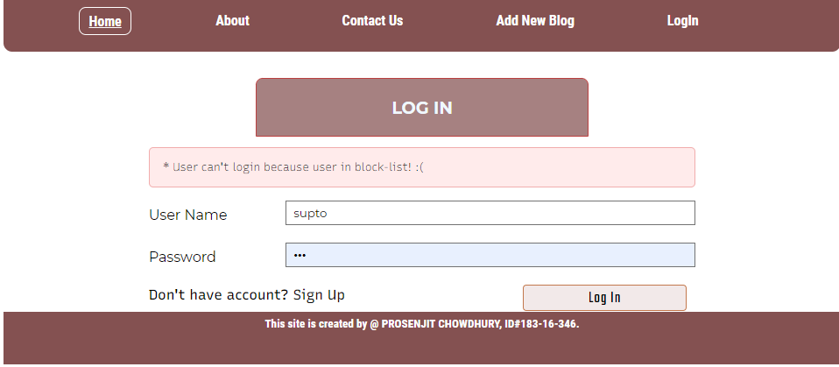

1. After successful Login user can got a notification from site.

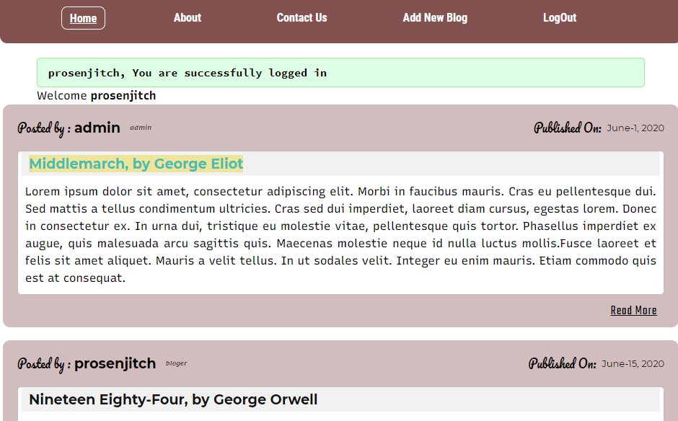

1. If a user hasn’t any account user can see the blogs posted by various user.

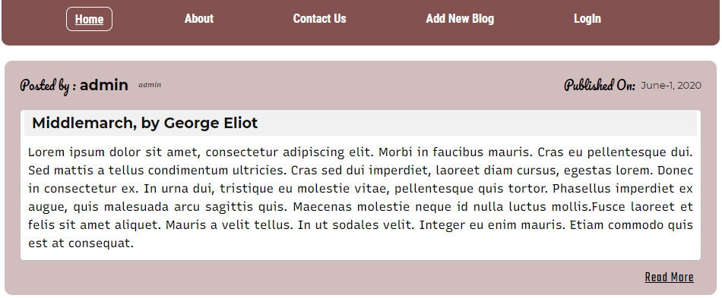

1. Without account user can’t comment in any blog

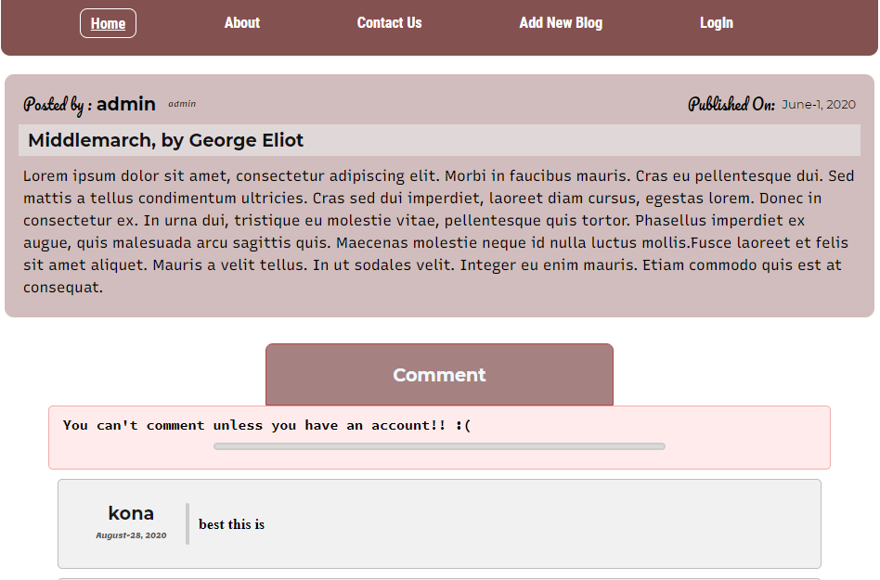

1. Without account user also can’t add any new blog

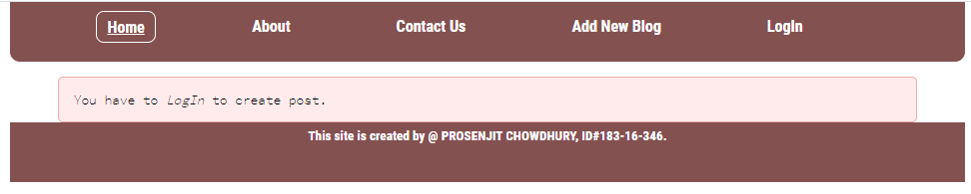

1. After successfully Login user can see all page of About

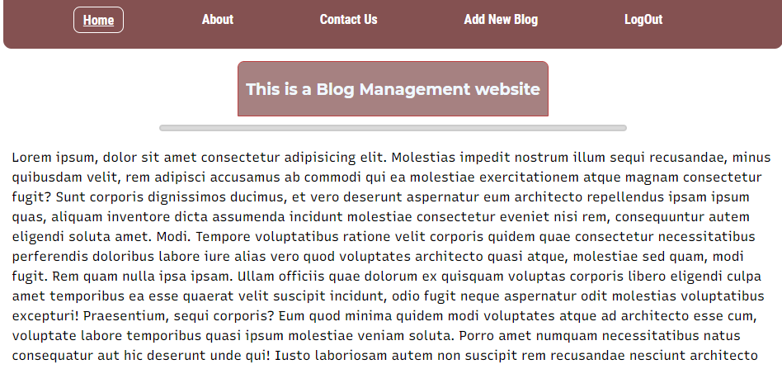

1. After successfully Login user can see all page of Contract Us

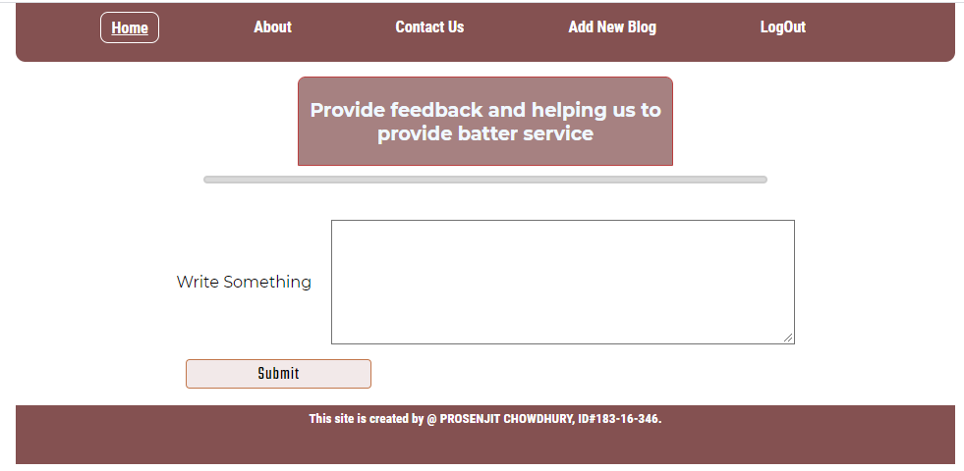

1. After login, user can add post

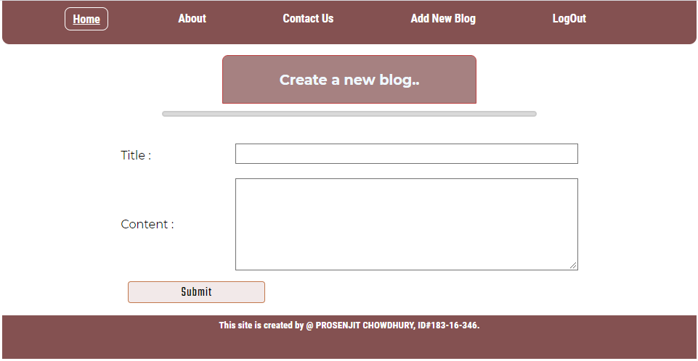

1. After login, user can comment on any post.

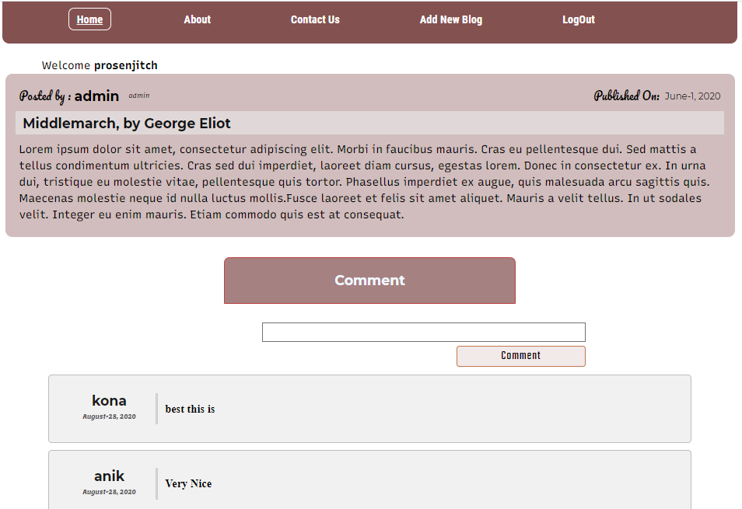

1. When user want to add a new post, go to the Add New Blog page and add title and content and click on sumit. The post will added and show in home page.

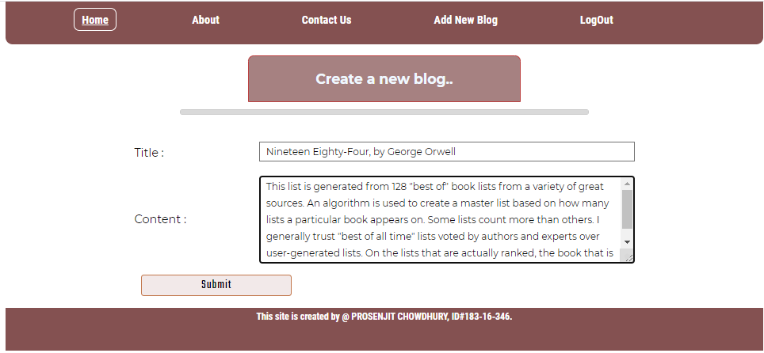

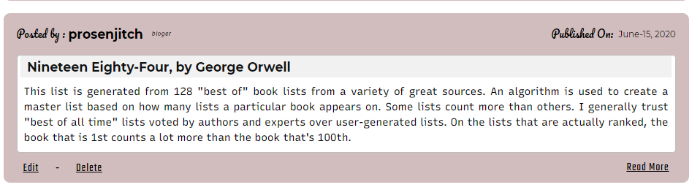

1. You can edit only your own post; without your post you can’t edit others post

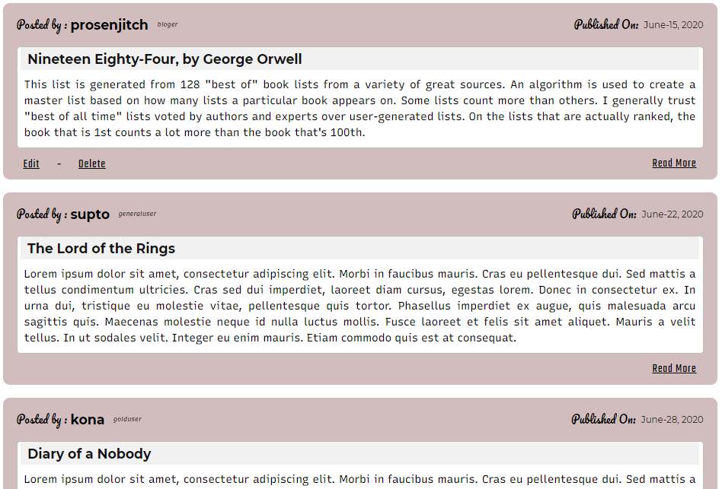

1. If the user want to update his post, click on edit button system will redirect user to upsate blog page 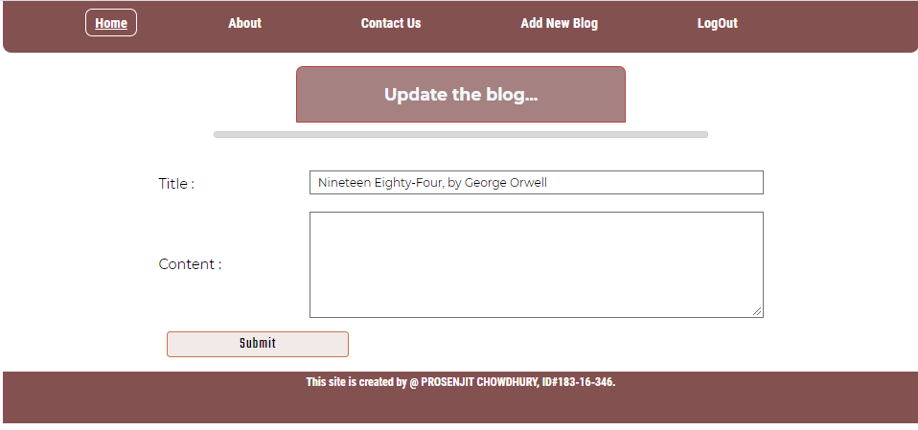
2. User need to write the updated blog and submit and then system will show the updated post.

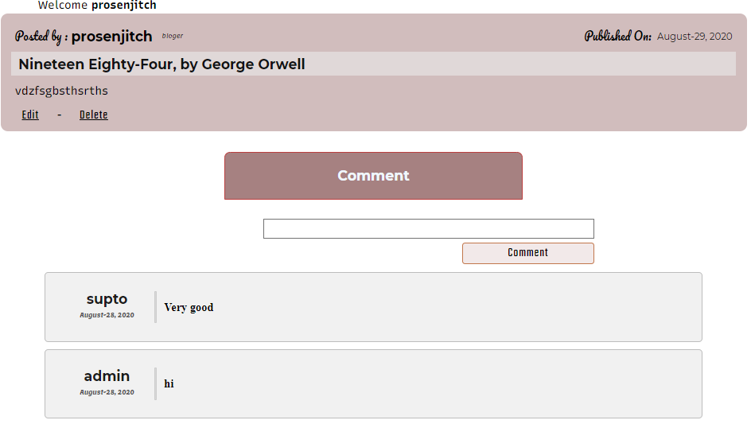

1. The user want to delete the post, just click on delete button the post will be deleted.

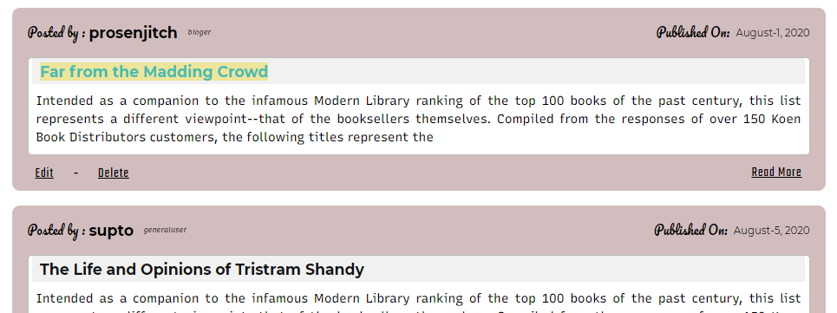

1. User can comment on any post.

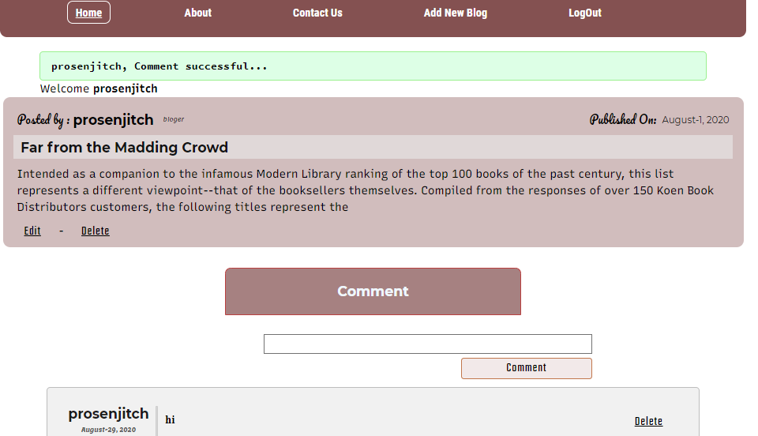

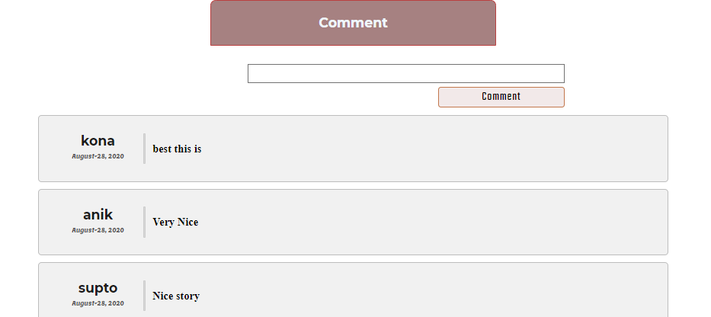

1. If the user isnt author of any post or comment , he cant delete or edit it.

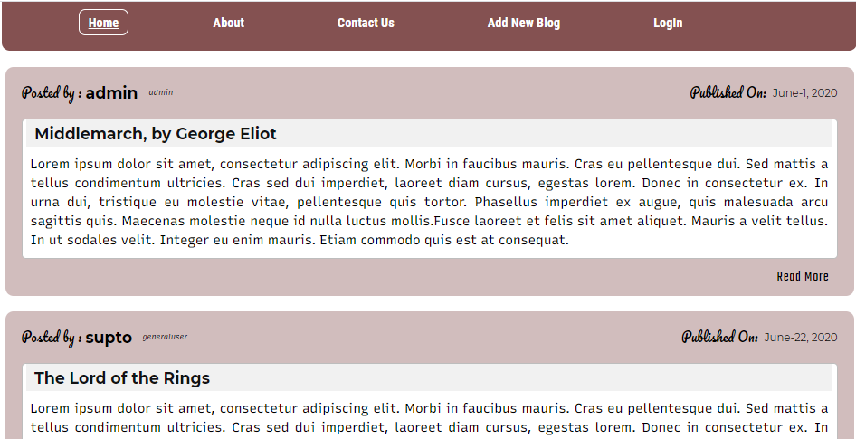

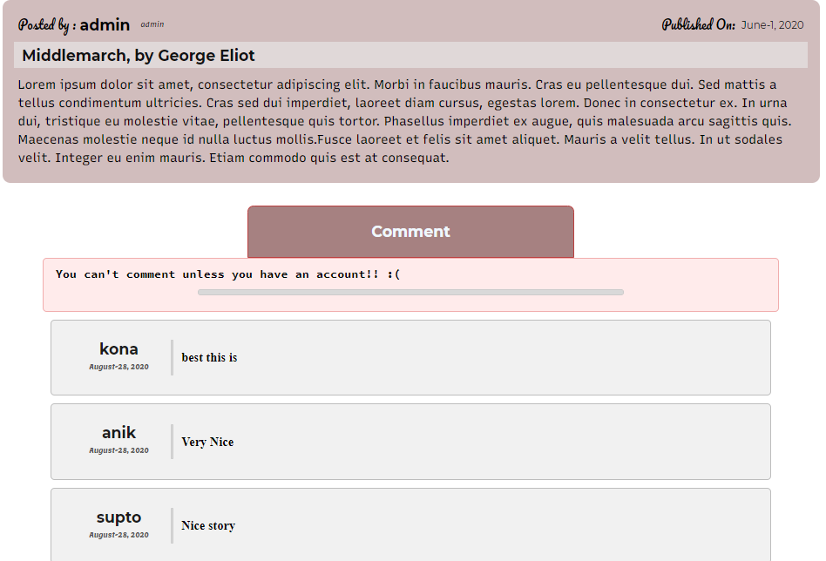

1. When user click Logout button suceesfully Logout

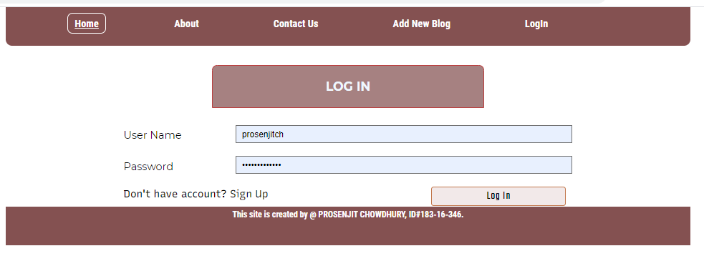

**Task 4**

I use PHP, HTML5 and CSS for make the blog website. Any user from web can visit my web blog. But they can’t add post or comment in any blog. For add blog or comment user need to create an account here. For create account firstly, user go to Login option, then see a Sing Up option. User must fill-up registration page with valid information. When user complete registration now they can add post, comment and delete option. If user need any help from admin, he/she can help from help option. Admin can blog any user. Blog-listed user can’t Login in this site. User see an error message from site. Admin can manage all the user. Without admin approvement no blog can’t be published.

After the testing, All the pages of the website run in both Google Chrome and Mozilla Firefox software without any trouble. There is no major difference between these browsers. All the pictures and documents are looks almost same.

Now most of the web developer use Laravel and Java script for their web development. So, in the future I make it more beautiful by using Laravel and Java script. My website has some little problem in codes. In the future I try to solve. At this moment I can’t solve this because everything can’t design properly by using HTML5 and CSS.

When I am designed my website that time, I use height, weight, textbox, password, marine, border, padding etc. I made it for prototype. There are no code errors in my php, html and CSS. In the future when it needs more update the website, I make it better. Now my website works smoothly in all browses.

**---: The End: ----**