



***Assignment on***

**Artificial Intelligence**

**Course Title:**  **Software Artificial Intelligence**

**Course Code: CIS412**

**Submitted to:**

Mr. Nazmus Sakib Akash

Lecturer

Department of Computing & Information System (CIS)

Daffodil International University.

**Submitted by:**

Prosenjit Chowdhury

ID: 183-16-346

Department of Computing & Information System (CIS)

Daffodil International University.

**Date of Submission: 15/12/2020**

**Theory Part**

**Task 1 (Design):**





**Task 2 (Simulation):**

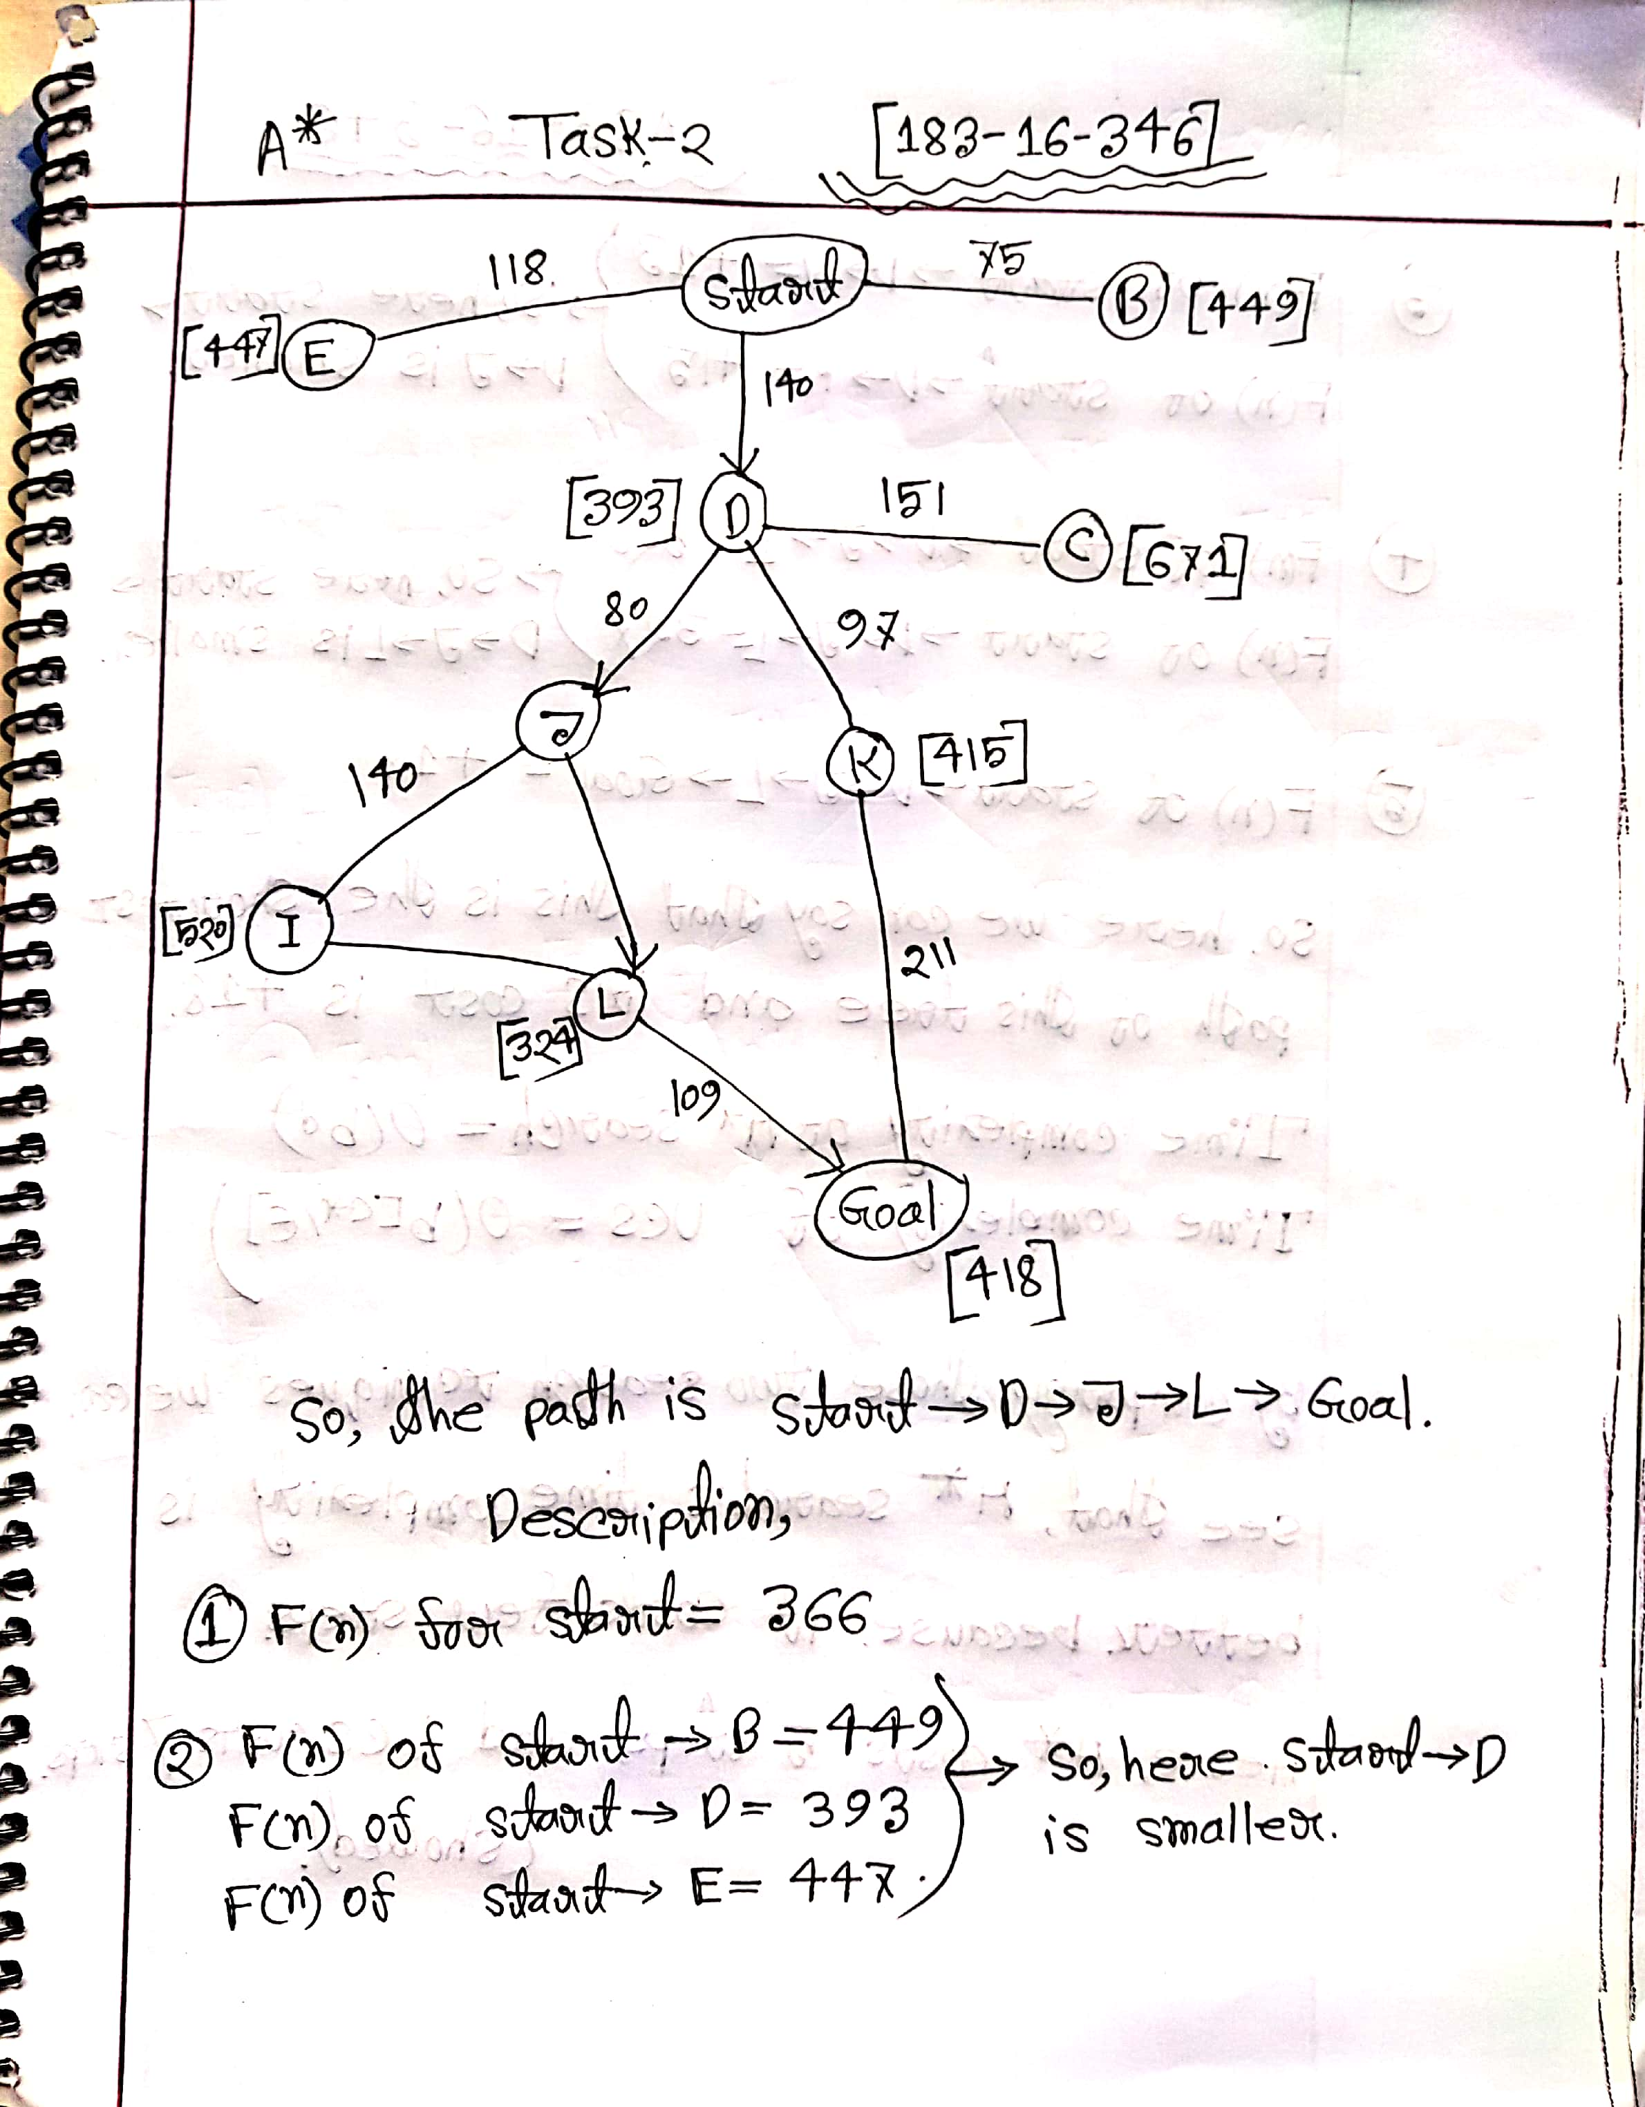



**Task 3 (Critical Evaluation):**

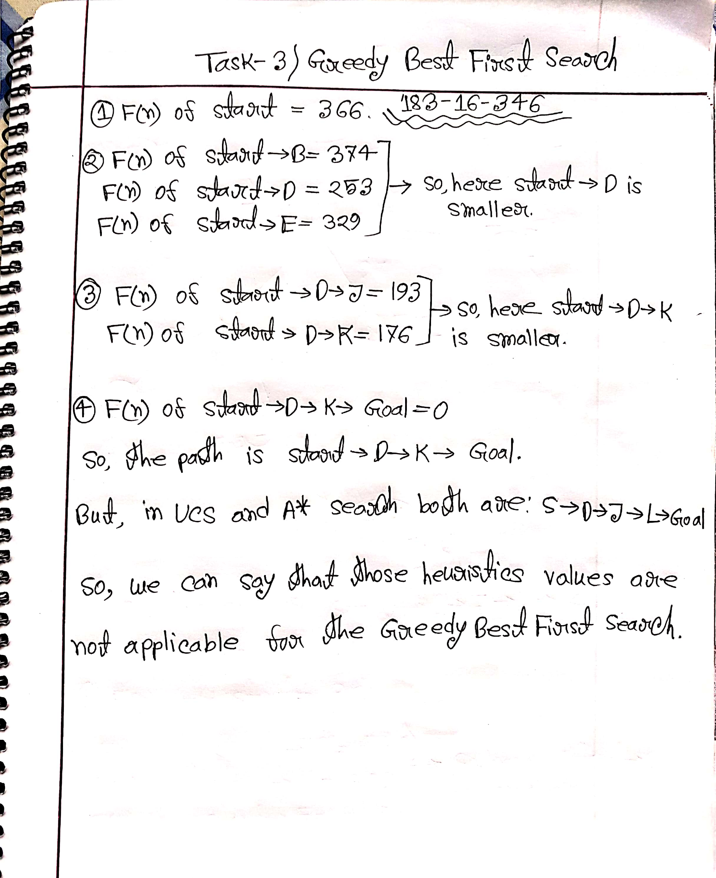

**Lab Part**

**Task 1:**

1. Remove the first row of the dataset

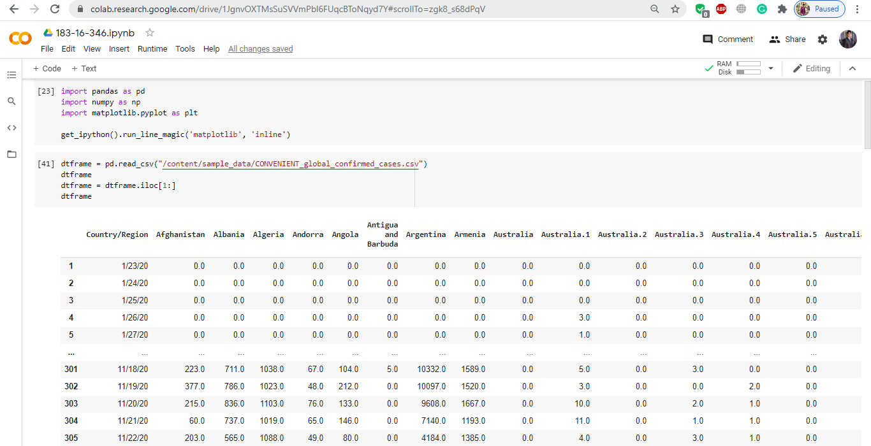

1. Add the values of the rows of Australia, Canada, China, Denmark, France, Netherlands, United Kingdom into one column for each country instead of separate ones based on their provinces.

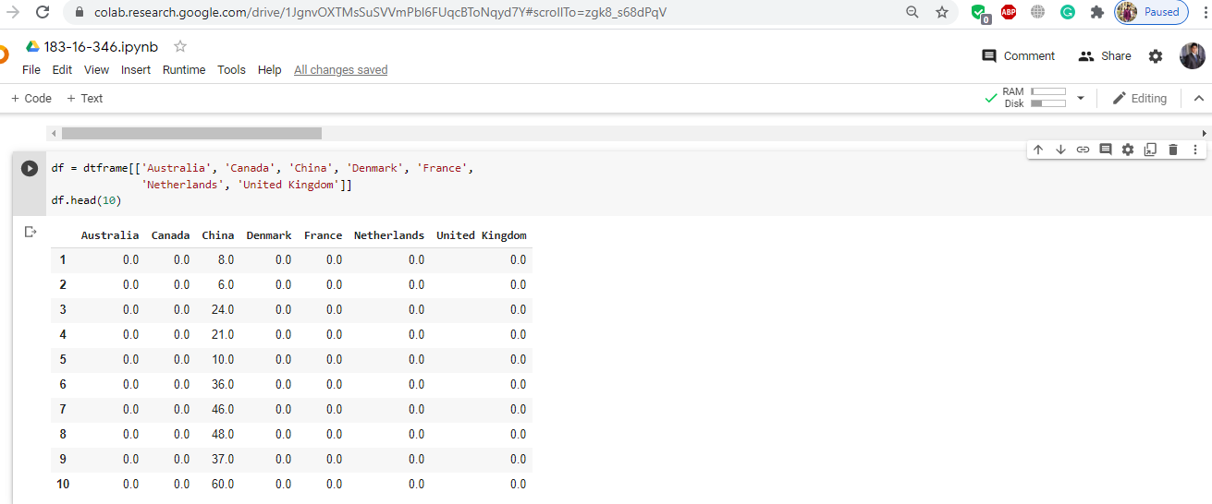

**Task 2:**

1. a) Create a column in the data frame called “confirmed_globally” and add all the values of each row in that column.

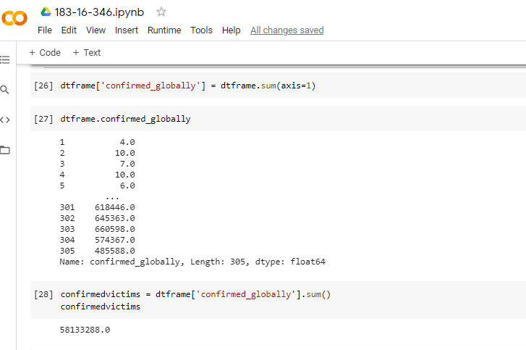

1. b) Calculate the total number of confirmed victims and store them in a variable.

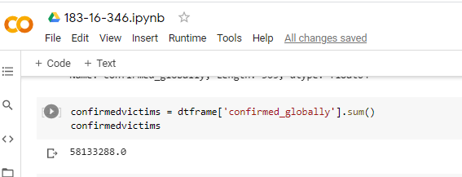

**Task-3:**

1. a) Use the following code snippet to create an epidemics dataframe.

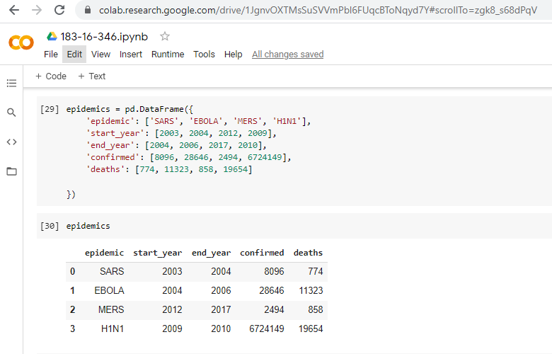

1. b) Add another row in this dataframe named ‘COVID-19’ with the start year being 2019, the end year being 2020, and the number of confirmed coming from the calculations in the previous task and number of deaths being 1388051.

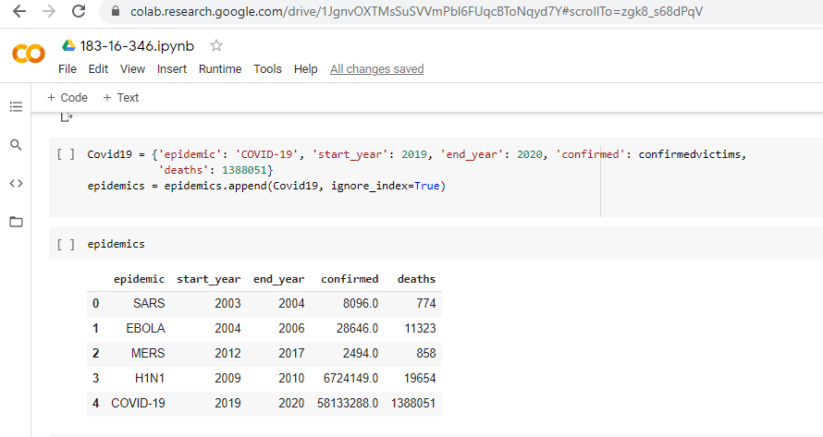

1. c) Calculate Mortality using the following formula – deaths/confirmed*100 and keep until 2 decimal points.

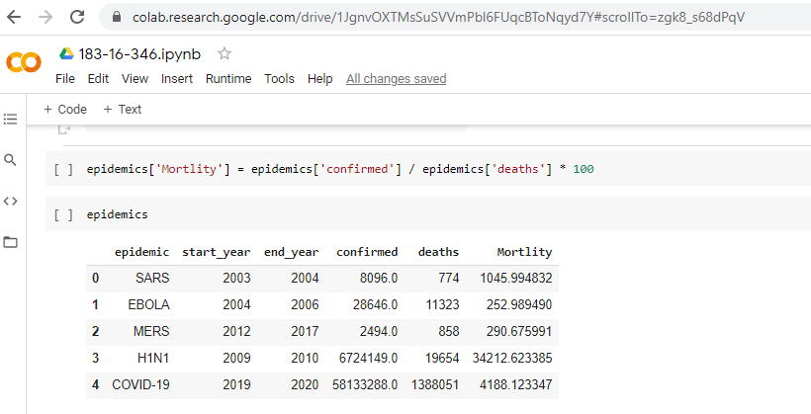

1. d) Show the bar chart of the Mortality of every epidemic using matplotlib.

