**SE_PREP_02**

**Project Title: Cab Booking System**

**Aim:** To develop a user-friendly cab booking system that efficiently connects passengers with available taxis, streamlining the process of booking, tracking, and managing cab rides.

**Description:** The cab booking system will consist of a user interface accessible via web and mobile platforms, allowing users to easily book a cab, track its location, and manage their bookings. It will also include an admin interface for managing drivers, vehicles, and overseeing the entire system.

**Hardware Requirements:**

* Servers for hosting the system
* Internet connectivity
* Computers or mobile devices for accessing the system

**Software Requirements:**

* Database management system
* Web development framework
* Mobile development framework
* Payment gateway integration
* GPS tracking system

**Feasibility Report:** The project is deemed feasible based on market demand for efficient cab booking systems, available technology, and potential profitability. A thorough market analysis and cost-benefit assessment indicate a positive outcome.

**Proposal Status:** The proposal is currently under review by stakeholders for funding and approval.

**Modules:**

1. User Registration and Authentication
2. Cab Booking
3. Cab Tracking
4. Payment Processing
5. Admin Dashboard
6. Driver Management
7. Vehicle Management

**User Stories:**

1. As a user, I want to be able to register and login to the system.
2. As a user, I want to book a cab with ease, specifying my pickup and drop-off locations.
3. As a user, I want to track the location of my booked cab in real-time.
4. As a user, I want to be able to pay for my ride securely within the app.
5. As an admin, I want to manage drivers and their schedules efficiently.
6. As an admin, I want to oversee cab bookings and ensure smooth operations.

**Use Case UML Diagram:**

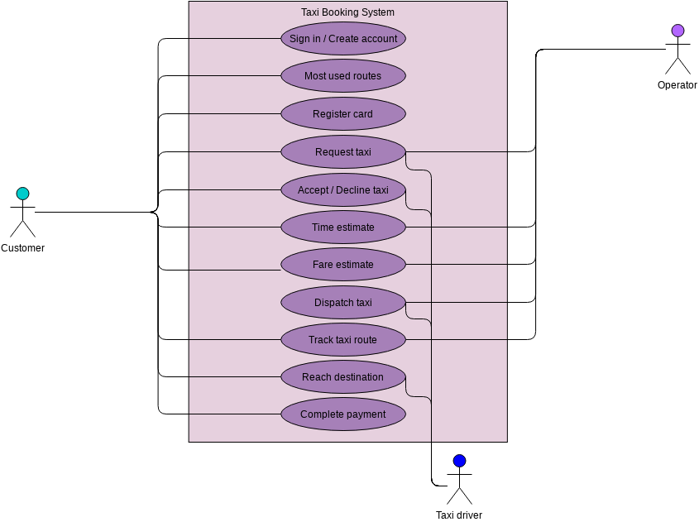

[Diagram not included]

**Test Cases:**

1. Test Case 1:
   * Scenario: User successfully books a cab
   * Steps: Login to the system -> Enter pickup and drop-off locations -> Confirm booking
   * Expected Result: Booking confirmed and cab assigned.
2. Test Case 2:
   * Scenario: Admin adds a new driver to the system
   * Steps: Login to admin dashboard -> Add new driver details -> Save changes
   * Expected Result: Driver successfully added to the system.

**Risks:**

1. Technical issues such as server downtime or system crashes.
2. Security breaches leading to unauthorized access to user data.

**Advantages of the Project:**

* Streamlines the cab booking process for users.
* Provides real-time tracking for better convenience.
* Improves efficiency for cab drivers and operators.
* Enhances overall customer satisfaction.

**Conclusion:** The cab booking system project holds significant potential to revolutionize the transportation industry by providing a convenient and efficient solution for both passengers and cab operators. With careful planning and execution, it promises to deliver substantial benefits to all stakeholders involved.

**Project – 03**

1. **Project Aim and Description:**
   * Aim: To develop an airline booking system that allows users to book flights online.
   * Description: The system will provide users with a user-friendly interface to search for flights, view available options, book tickets, and manage their reservations.
2. **Hardware and Software Requirements:**
   * Hardware: Server infrastructure, network equipment, client devices (computers, smartphones, tablets).
   * Software: Web server (e.g., Apache), database server (e.g., MySQL), programming languages (e.g., Java, Python), web development frameworks (e.g., Django, Spring), front-end technologies (e.g., HTML, CSS, JavaScript), payment gateway integration, security measures (e.g., encryption, firewalls).
3. **Feasibility Report (10 lines):**
   * The proposed airline booking system aims to streamline the ticket booking process, enhancing user experience and increasing efficiency.
   * Market research indicates a high demand for online booking systems in the airline industry.
   * The availability of necessary technology and expertise makes the project technically feasible.
   * Financial analysis suggests a positive return on investment with potential revenue from ticket sales and ancillary services.
   * The system aligns with current industry trends towards digitalization and online services.
   * Regulatory compliance and security concerns have been addressed in the project plan.
   * Initial discussions with stakeholders have shown support for the project.
   * The project team possesses the required skills and experience to execute the development and implementation phases.
   * Risks such as technological challenges and competitive pressures have been identified and mitigation strategies are in place.
   * Overall, the feasibility report indicates a favorable outlook for the successful implementation of the airline booking system.
4. **Proposal Status:**
   * The proposal for the airline booking system has been submitted to stakeholders for review and approval.
   * Initial feedback from stakeholders has been positive, indicating interest and support for the project.
   * Further discussions and refinements may be required before final approval and commencement of the project.
5. **Modules:**
   * User Authentication
   * Flight Search and Booking
   * Payment Processing
   * Reservation Management
   * Admin Panel
6. **User Stories:** (e.g., As a user, I want to be able to search for flights based on my preferred dates and destinations so that I can find suitable options for my travel plans.)
7. **Use Case UML Diagram:** 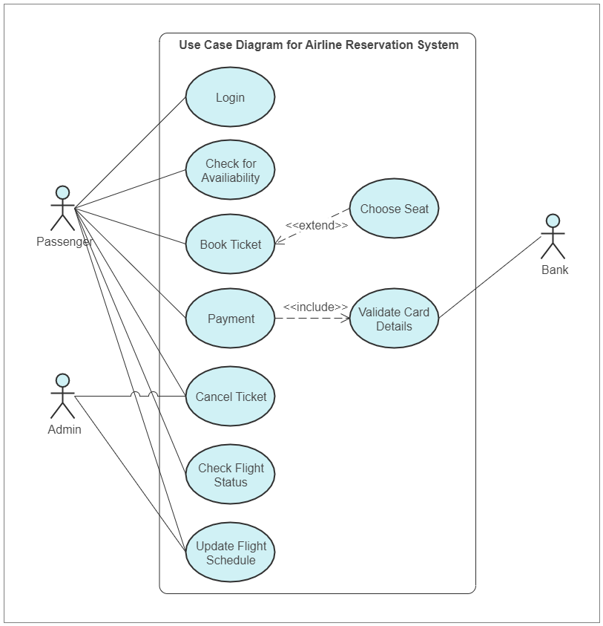
8. **Test Cases:** (e.g., Test case 1: Verify that users can successfully log in to their accounts with valid credentials. Test case 2: Ensure that the booking process calculates the correct total amount including taxes and fees.)
9. **Risks:**
   * **Technical risk**: Potential challenges in integrating with third-party systems or APIs

**Technical Risk Mitigation Techniques:**

1. **Thorough Requirements Analysis**
2. **Prototyping and Proof of Concepts**
3. **Continuous Testing and Quality Assurance**
4. **Scalable Architecture Design**
5. **Regular Monitoring and Maintenance**
6. **Backup and Disaster Recovery Plan**

.

**Competitive risk**: The emergence of new competitors offering similar booking services.

### Competitive Risk Mitigation Techniques:

1. **Market Analysis and Differentiation**
2. **Continuous Innovation and Improvement**
3. **Customer Relationship Management**
4. **Partnerships and Alliances**
5. **Agile and Adaptive Approach**
6. **Brand Building and Marketing**
7. **Advantages of the Project:**

* Improved user experience through streamlined booking process.
* Increased efficiency for airlines in managing bookings and reservations.
* Potential for increased revenue through online sales and ancillary services.

1. **Conclusion:** The proposed airline booking system offers significant advantages in terms of improving user experience, increasing efficiency, and potentially generating additional revenue for airlines. While there are inherent risks and challenges, the feasibility analysis indicates a favourable outlook for the successful implementation of the project. With stakeholder support and careful planning, the project has the potential to deliver substantial benefits to both users and airline operators.

**PROJECT-01**

1**).Banking application** aim, description, hardware and software Requirements, feasibility report and proposed status ,list and explain modules and user stories, draw the use case UML diagram, 2 test cases, explain any 2 risks with mitigations for each,Advantages of the project and conclusion.

Ans:

**1. Aim:** The aim of the banking application project is to develop a user-friendly, secure, and efficient platform for banking operations. The application will provide customers with seamless access to various banking services such as account management, fund transfers, bill payments, loan applications, and more.

**2. Description:** The banking application will be a web-based platform accessible through both desktop and mobile devices. It will offer a modern and intuitive user interface for customers to perform their banking activities conveniently. The application will prioritize security measures to safeguard sensitive financial information and transactions.

**3. Hardware and Software Requirements:** Hardware:

* Server infrastructure capable of handling concurrent user requests
* Network equipment for data transmission
* Secure storage devices for customer data

Software:

* Operating system (e.g., Linux, Windows Server)
* Web server (e.g., Apache, Nginx)
* Database management system (e.g., MySQL, PostgreSQL)
* Programming languages (e.g., Java, Python)
* Security protocols and encryption algorithms
* Development tools (e.g., IDEs, version control systems)

**4. Feasibility Report and Proposed Status:** The feasibility report indicates that the project is technically feasible with the available resources and technology. Proposed status: In progress (or Proposed start date: [date]).

**5. Modules and User Stories:**

Modules:

1. Authentication
2. Account Management
3. Fund Transfers
4. Bill Payments
5. Loan Applications
6. Customer Support

User Stories:

1. As a user, I want to securely log in to my account using multi-factor authentication.
2. As a user, I want to view my account balance and transaction history.
3. As a user, I want to transfer funds between my accounts or to other beneficiaries.
4. As a user, I want to pay bills such as utilities, credit cards, and loans.
5. As a user, I want to apply for a loan with a simple and straightforward process.
6. As a user, I want to contact customer support for assistance with my account or transactions.

**6. Use Case UML Diagram:**

[Insert Use Case Diagram Here]

**7. Test Cases:**

in rough note

**8. Risks and Mitigations:**

* **Security Risk:** There is a risk of data breaches and unauthorized access to sensitive information. Mitigation: Implement robust encryption techniques, employ multi-factor authentication, regularly update security protocols, and conduct security audits.
* **Technical Risk:** There may be technical issues such as system crashes or software bugs. Mitigation: Conduct thorough testing at each stage of development, implement error handling mechanisms, and have a dedicated team for maintenance and support.

**9. Advantages of the Project:**

* Improved accessibility: Customers can access banking services conveniently from anywhere, at any time.
* Enhanced efficiency: Automation of processes reduces manual errors and speeds up transaction times.
* Better customer experience: Intuitive user interface and seamless navigation contribute to a positive customer experience.
* Increased security: Implementation of modern security measures ensures the safety of sensitive financial information.

**10. Conclusion:** The banking application project aims to revolutionize the way customers interact with banking services by providing a secure, efficient, and user-friendly platform. By addressing the needs of modern banking customers, the project is poised to deliver significant advantages and contribute to the overall growth and success of the banking institution. With careful planning, robust development, and proactive risk management, the project is positioned for success in meeting its objectives.

**PROJECT-02**

2).**shopping cart** application aim, description, hardware and software Requirements, feasibility report and proposed status ,list and explain modules and user stories, draw the use case UML diagram, 2 test cases, explain any 2 risks and mitigation for each,Advantages of the project and conclusion.

ans:

**Aim:** The aim of the shopping cart application is to provide users with a convenient platform to browse, select, and purchase products online.

**Description:** The shopping cart application will allow users to create accounts, browse through various product categories, add items to their cart, and proceed with the checkout process. Users will be able to view their order history, manage their account details, and receive notifications about their orders.

**Hardware and Software Requirements:**

**Hardware Requirements:**

* Server infrastructure (cloud-based or physical)
* Storage space for product data and user information
* Network infrastructure for internet connectivity

**Software Requirements:**

* Operating System: Linux, Windows, or macOS
* Web server (e.g., Apache, Nginx)
* Database Management System (e.g., MySQL, PostgreSQL)
* Programming languages (e.g., Python, JavaScript)
* Frameworks (e.g., Django, Flask for backend; React, Angular for frontend)
* Payment gateway integration (e.g., Stripe, PayPal)
* Security measures (e.g., SSL/TLS encryption, firewalls)

**Feasibility Report and Proposed Status:** The feasibility report will assess the technical, economic, and operational aspects of the project. It will evaluate the resources required, potential risks, and estimated costs. The proposed status will outline the project's current stage, including any completed tasks and future milestones.

**Modules and User Stories:**

1. **User Authentication Module:**
   * User Story: As a user, I want to be able to create an account and login securely to access the shopping cart features.
2. **Product Management Module:**
   * User Story: As an admin, I want to be able to add, update, and delete products from the catalog.
3. **Shopping Cart Module:**
   * User Story: As a user, I want to be able to add items to my cart, update quantities, and remove items if needed.
4. **Checkout Module:**
   * User Story: As a user, I want to be able to proceed to checkout, enter shipping and payment information, and place my order.
5. **Order Management Module:**
   * User Story: As an admin, I want to be able to view and manage orders, update order status, and generate invoices.

**Use Case UML Diagram:** [Use Case Diagram]

**Test Cases:**

1. **Test Case 1: User Authentication**
   * Test Scenario: Verify that users can create accounts and log in securely.
   * Test Steps:
     1. Navigate to the registration page.
     2. Enter valid user details and submit the form.
     3. Log out and attempt to log in using the newly created credentials.
   * Expected Result: User should be able to create an account and log in successfully.
2. **Test Case 2: Adding Items to Cart**
   * Test Scenario: Verify that users can add items to their shopping cart.
   * Test Steps:
     1. Navigate to the product catalog.
     2. Select a product and add it to the cart.
     3. View the cart to confirm the added item.
   * Expected Result: The selected item should be added to the cart.

**Risks and Mitigation:**

1. **Security Risks:**
   * Risk: Vulnerabilities in the system may lead to data breaches or unauthorized access to user information.
   * Mitigation: Implement security measures such as encryption, secure authentication protocols, and regular security audits to prevent breaches.
2. **Scalability Risks:**
   * Risk: The application may face performance issues or downtime as the user base grows.
   * Mitigation: Design the system with scalability in mind, using cloud-based infrastructure, load balancing, and optimizing database queries to handle increased traffic.

**Advantages of the Project:**

* Convenience: Users can shop from the comfort of their homes at any time.
* Wide Selection: Access to a diverse range of products from various vendors.
* Efficiency: Streamlined checkout process and order management.

**Conclusion:** The shopping cart application aims to provide users with a convenient and efficient platform for online shopping. By addressing user needs, implementing robust security measures, and ensuring scalability, the project aims to deliver a reliable and user-friendly shopping experience.

Top of Form