FOOD ORDERING SYSTEM

Submitted as Mini Project for Special Topics: Programming with C++ Semester III

**BACHELOR OF TECHNOLOGY**

in

Computer Science and Engineering

Niharika Pentapati

PES1201700215

Shivangi Gupta

PES1201700274

Under Guidance of

Prof. Jamuna S Murthy

BE (CSE), M.Tech (SSE)

Assistant Professor

**Aug 2018- Dec 2018**

**Department of Computer Science and Engineering**

**PES UNIVERSITY**

Outer Ring Rd, Banashankari 3rd Stage, Banashankari, Bengaluru, Karnataka 560085

[www.pes.edu](http://www.pes.edu)

**INTRODUCTION**

The Food Ordering System is based on the concept of ordering food items and generating total food cost. The user must provide the Login Details, which include Login ID and Password to access the menu of the system. The user can then see a menu which includes starters, main course and desserts with their costs. The user can choose an item based on the key and can change it if he/she wishes. Based on the requirement, more food can be ordered. Finally, once the user is done with the ordering, the user is asked for his/her personal details which include name, phone number and address. The bill is then generated with the bill number, order number, name of the cashier, the food ordered, personal details of the user and the total bill amount.

This C++ Project mainly uses Object Oriented Programming and mostly deals with the concepts of inheritance. It includes various libraries like conio.h, string.h, iostream, fstream, unistd.h and windows.h for different uses. The code has three classes in which the first class includes the Menu, the second class deals with the Food Ordering, Bill and Personal Details and the last class contains the Login Credentials.

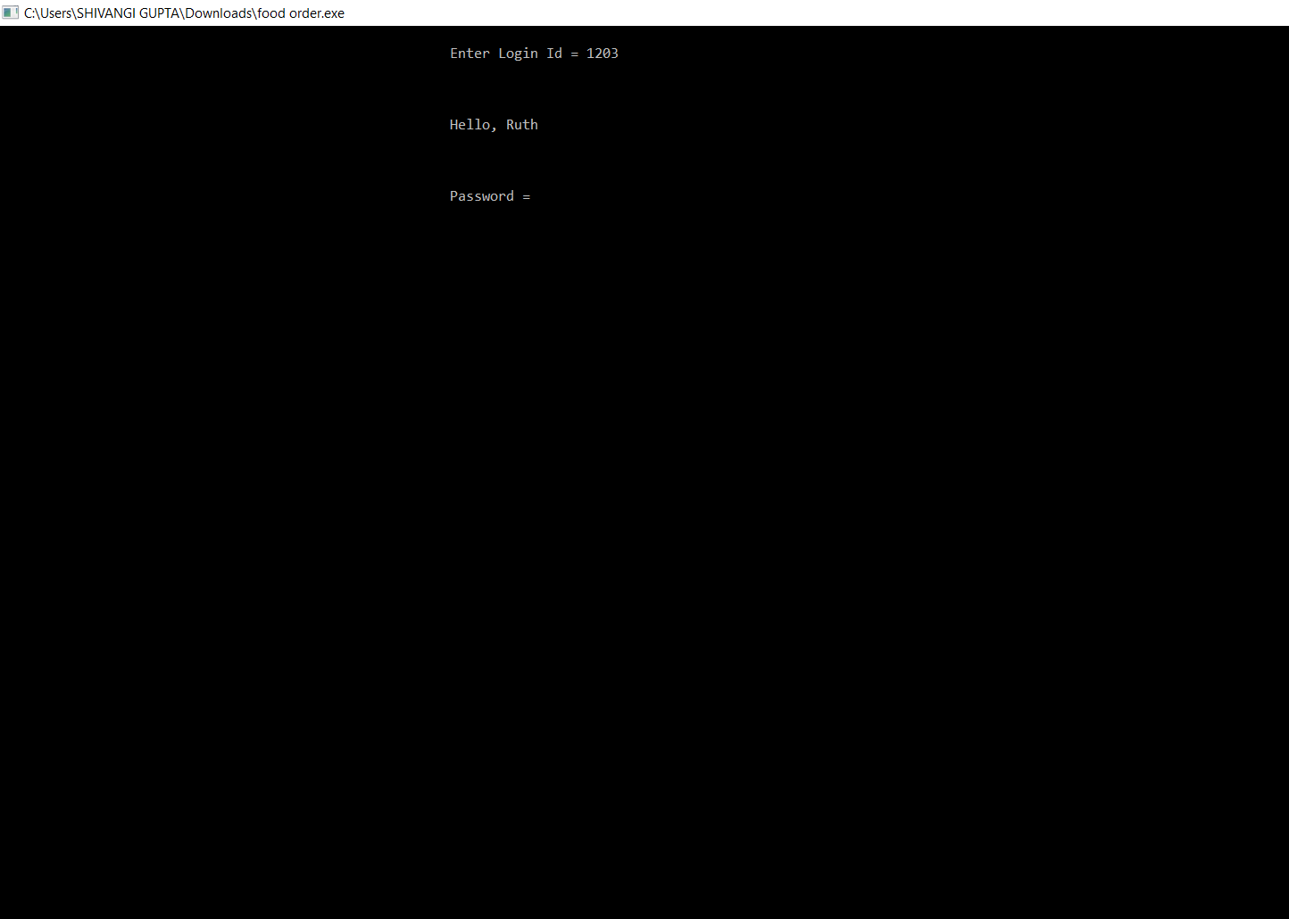

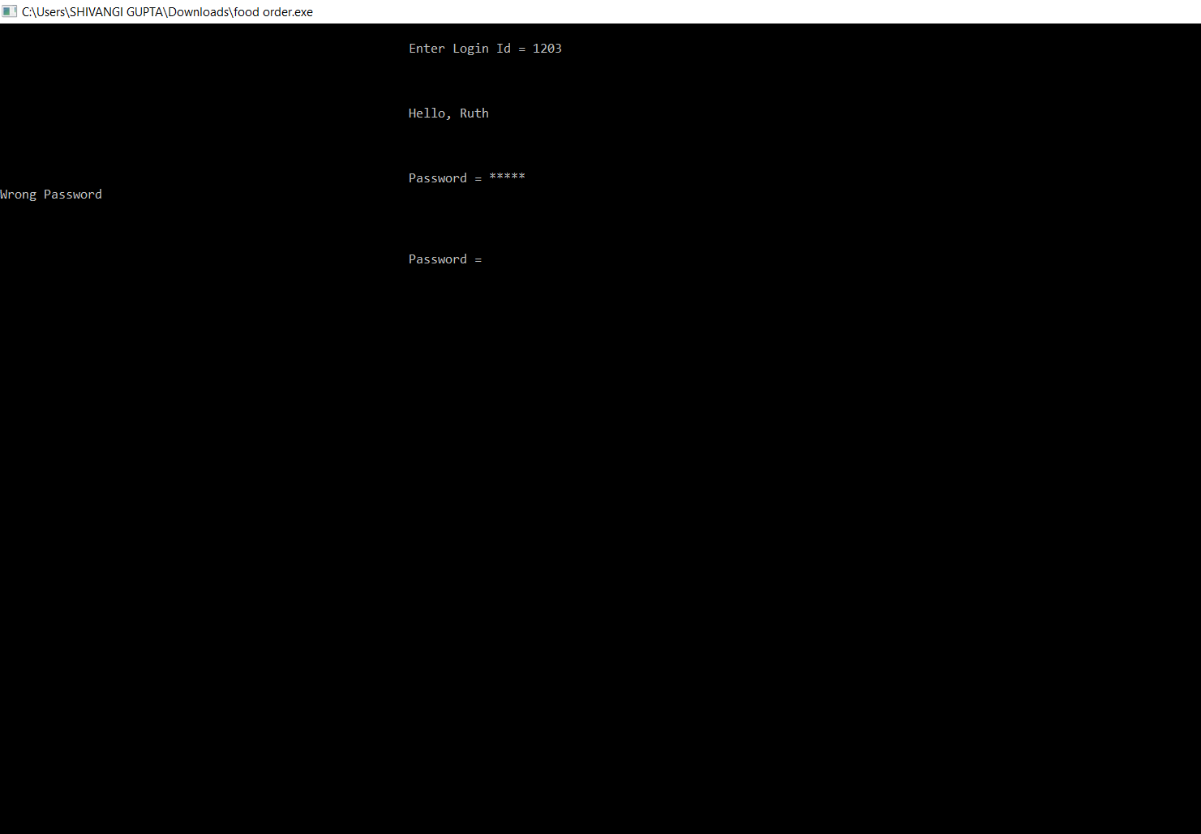

The above screenshots display the Login Page. The Login ID and password is asked from the cashier. If the Login ID or password is incorrect the access is not granted to the cashier. Once the correct details are entered, access will be granted as shown below.

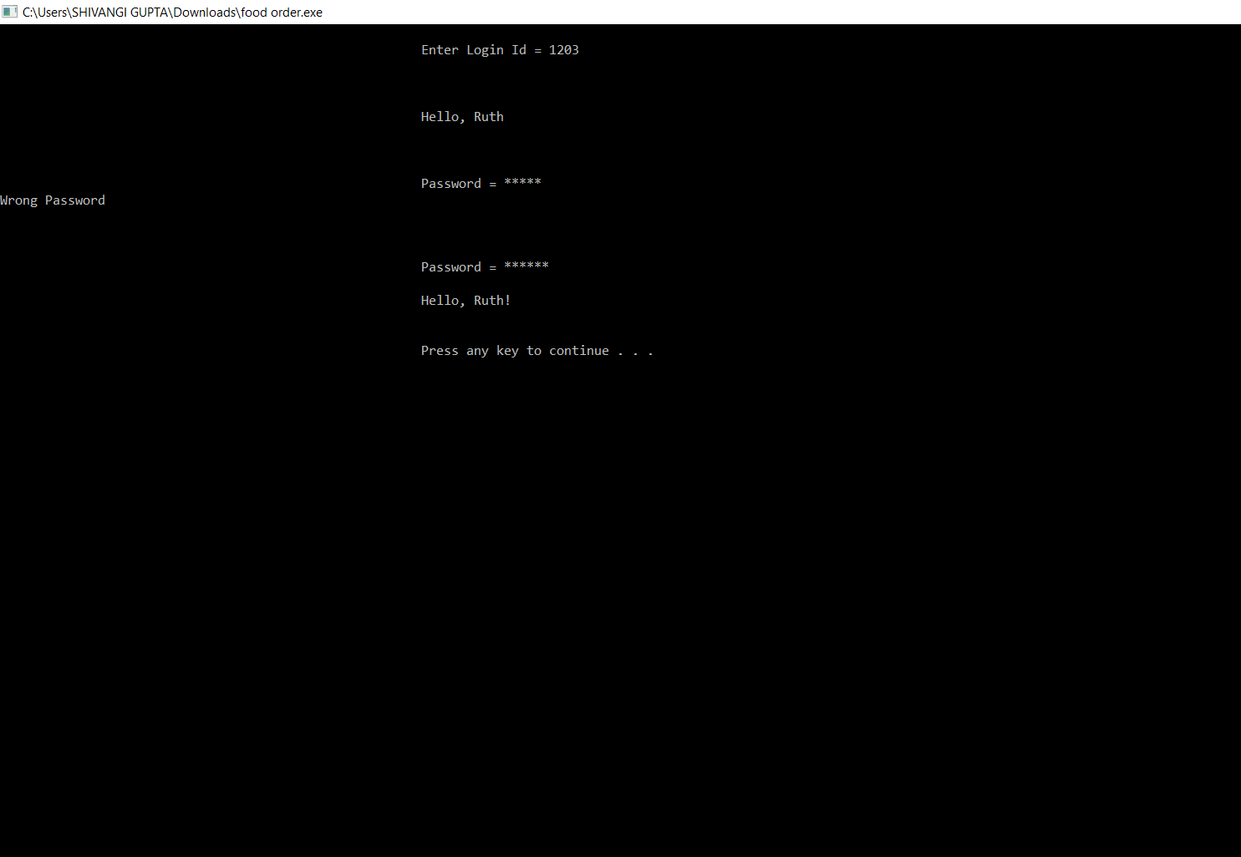

The below screenshot displays the menu which include starters, main course and desserts along with their keys and costs.

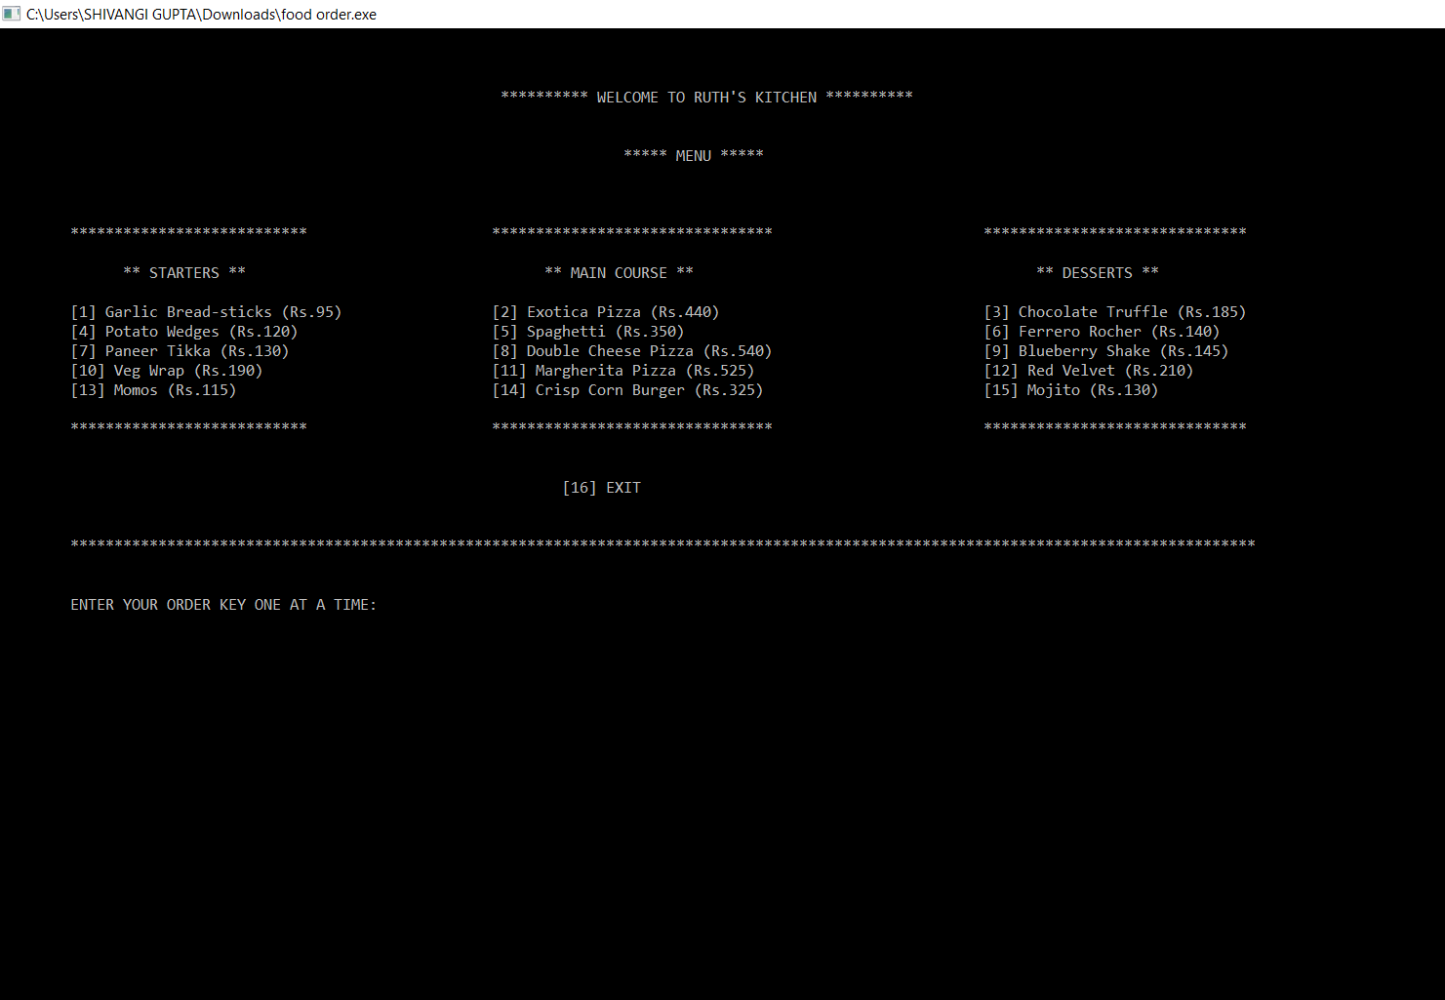

The below screenshots display the ordering process. The user is asked for the key of the food item and allows him/her to change the selected key.

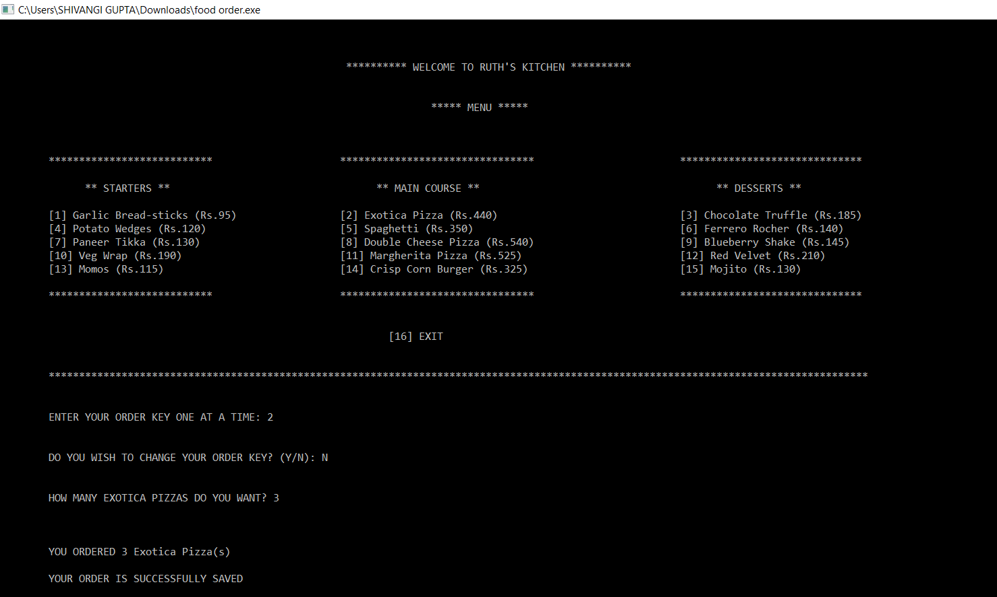

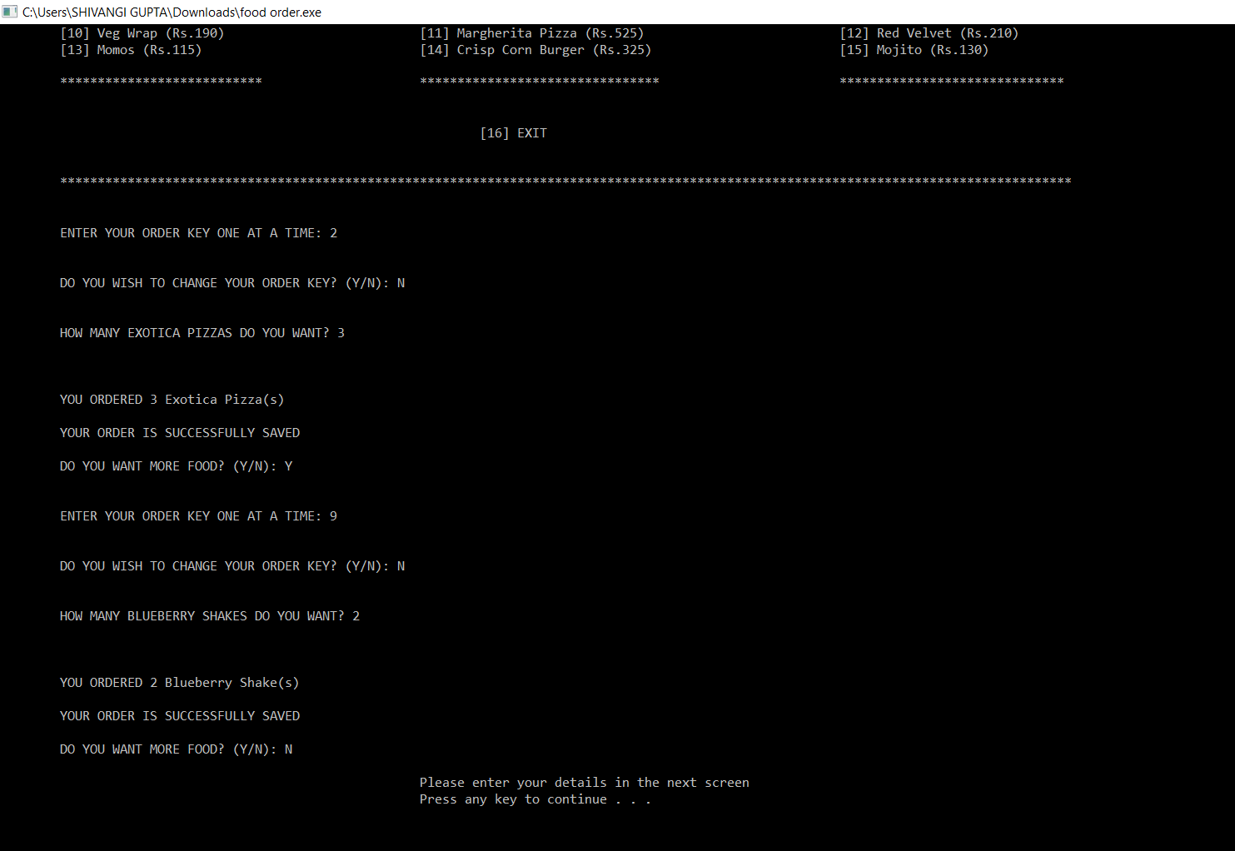

The above screenshot displays the ordering process. On choosing the food item the user is then asked for the quantity. This then displays the chosen food item along with the quantity. If the user wants more food, the process repeats. Else the bill is generated.

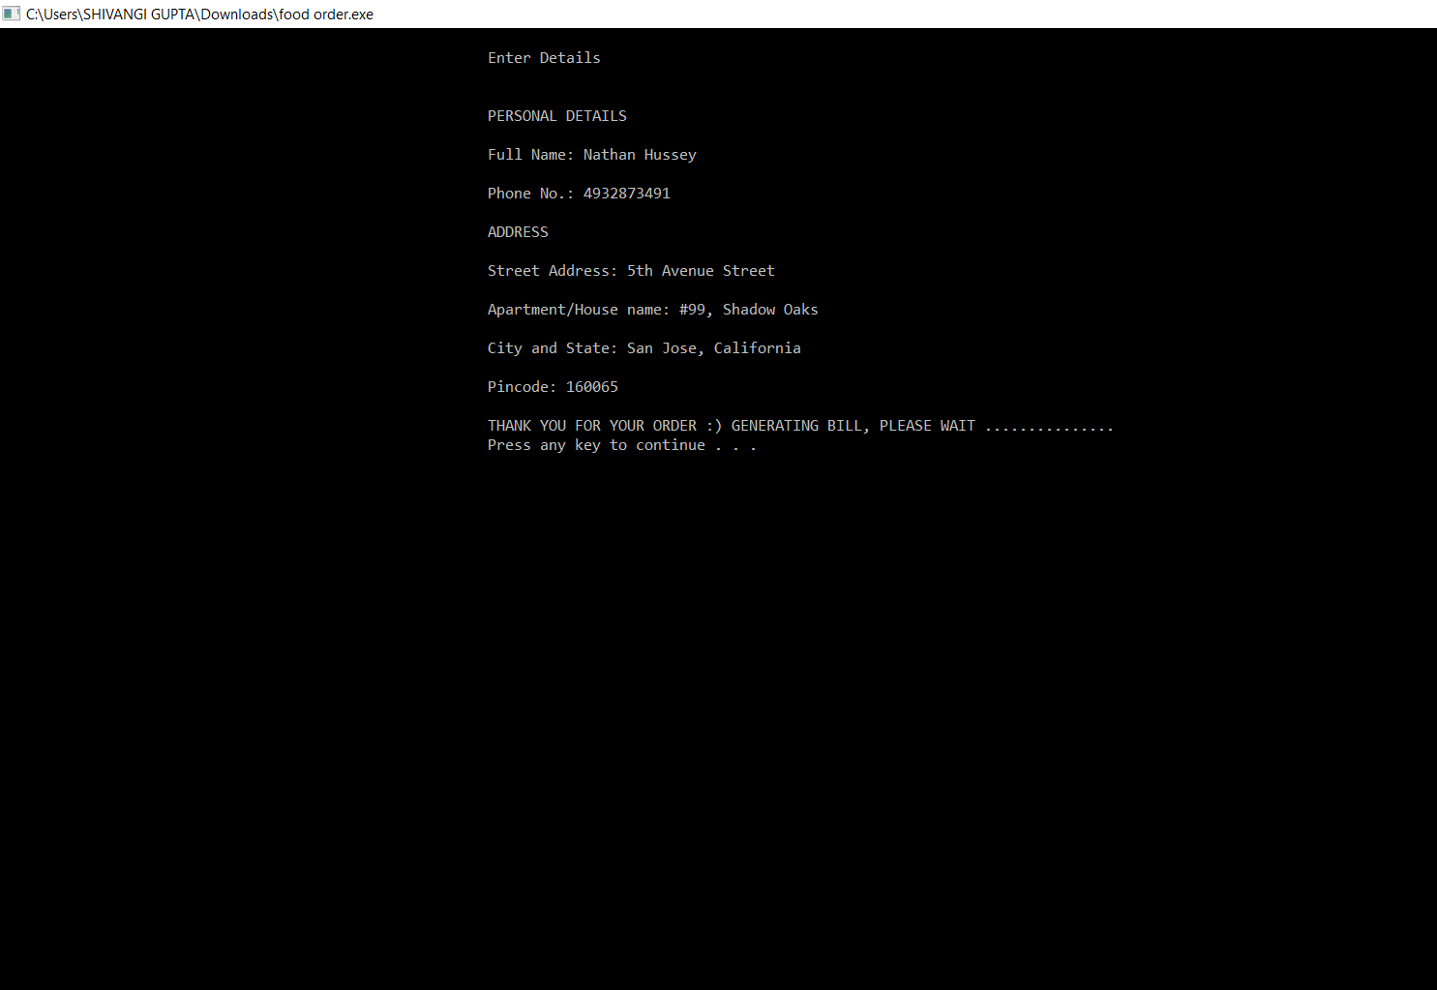

The above screenshot displays the Personal Details of the user. This includes the name, phone number and the address of the user.

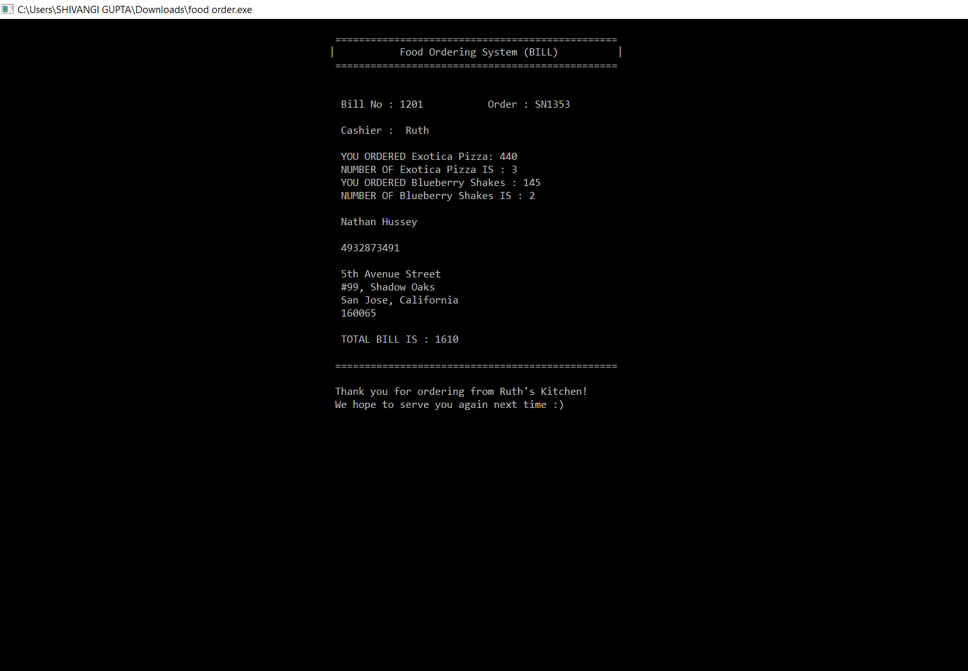

The above screenshot displays the final bill with the total cost and the details of the customer.