**SMART LEARNING MANAGEMENT SYSTEM**

## **BY**

**Edward Fumnanya Prosper**

**170408047**



**THE DEPARTMENT OF ELECTRICAL AND ELECTRONICS ENGINEERING**

**UNIVERSITY OF LAGOS**

**SUPERVISED BY**

**DR. IBUKUN DEWALE**

*MARCH 2024*

# **CERTIFICATION**

This is to certify that this project was carried out by **Edward Fumnanya Prosper** with matriculation number **170408047** in the Department of Computer Engineering, Faculty of Engineering, University of Lagos under the supervision of **Dr. Ibukun Adewale**.

– – – – – – – – – – – –– – –– – – – – – – – – – –

Edward Fumnanya Prosper Date

*Author*

– – – – – – – – – – – – – – – – – – – – – – – – – –

Dr. Ibukun Adewale Date

*Supervisor*

– – – – – – – – – – – – – – – – – – – – – – – – – –

Dr. (Mrs.) Gbenga-Ilori Date

*Project Coordinator*

– – – – – – – – – – – – – – – – – – – – – – – – – –

Prof. Akinbulire (H.O.D) Date

**ACKNOWLEDGEMENT**

I foremost give glory to the Almighty God for completing my final year project.

I am grateful to the entire management of the University Of Lagos for making my undergraduate journey enlightening, educational, and worthwhile.

My sincere gratitude goes to my Project supervisor, **Dr. Ibukun Adewale**, and my **IT supervisor Dr. (Mrs.) Gbenga-Ilori** and the management of the Electrical and Electronics Department and the University of Lagos for their relentless effort to equip me with a bright future, to them all, I say God Bless you, Amen.

My regards to my ever-supportive parents, Mr. and Mrs. Edward for creating an environment that puts me in a good mental state to remain strong and be an integral part of society.

**ABSTRACT**

This final-year project revolves around developing and implementing a cutting-edge **Smart Learning Management System (Smart LMS)** aimed at revolutionizing traditional educational paradigms.

The proposed LMS focuses on personalized learning experiences, catering to diverse learning styles and preferences. Through the incorporation of intelligent algorithms and analytics, the system adapts to individual progress and provides targeted content recommendations. This ensures a more engaging and tailored educational journey for each user.

Furthermore, the Smart LMS emphasizes collaborative learning by integrating robust communication and collaboration tools. Real-time discussions, collaborative projects, and interactive forums foster a sense of community among learners, enhancing their overall educational experience. The system also supports multimedia content, allowing for a more immersive and interactive learning environment.

Security and data privacy are paramount considerations in the development of my Smart LMS. Stringent measures are implemented to safeguard user information, ensuring a secure and confidential learning platform. Additionally, the system is designed to be scalable, allowing for future expansions and updates to accommodate emerging technologies and educational methodologies.

This project aims to contribute significantly to the field of education by providing a robust, innovative, and user-centric Smart Learning Management System. By combining personalized learning experiences, collaborative tools, and advanced security measures, the Smart LMS aspires to redefine the way education is delivered and received in the digital age.

**TABLE OF CONTENTS**

**CHAPTER 1. INTRODUCTION**

1.1 Introduction to subject matter……………………………………………… 9

1.2 Problem Statement…………………………………………………………. 12

1.2.1 Research Questions………………………………………………………. 13

1.3 Project Aim………………………………………………………………… 13

1.4 Project Objectives………………………………………………………….. 13

1.5 Scope of project …………………………………………………………… 15

1.6 Justification of the study …………………………………………………. 15

1.7 Project Outline ……………………………………………………………. 17

1.8 Project Structure ………………………………………………………….. 18

**CHAPTER 2. LITERATURE REVIEW**

2.1 Overview ………………………………………………………………… 19

2.2 Introduction ……………………………………………………………… 19

2.3 Aspects of LMS ………………………………………………………….. 20

2.4 Benefits of LMS ………………………………………………………….. 22

2.5 Challenges encountered ………………………………………………….. 24

**CHAPTER 3. METHODOLOGY**

3.1 Introduction ……………………………………………………………….. 26

3.2 Research Design ………………………………………………………….. 27

3.3.Development Process …………………………………………………….. 29

3.4 Flow Chart Representation ……………………………………………….. 44

3.5 Testing and Validation ……………………………………………………. 44

3.6 Security and Privacy Measures …………………………………………… 45

3.6 Conclusion ………………………………………………………………… 45

3.7 References ………………………………………………………………… 47

**FIGURE LISTING**

***Figure 1.1:*** Structure of the project ……………………………………………. 18

***Figure 3.0:*** Agile SDLC Software Development Life Cycle …………………….. 28

***Figure 3.1:*** Wireframe of Smart LMS…………………………………………...30

***Figure 3.2:*** npx create-react-app command*……*…………*…………………………*31

***Figure 3.3:***npm start command*……………………*…..*………………………….….*.32

***Figure 3.4:*** File organization of the frontend……………………………………33

***Figure 3.5:*** Navbar components ………………………………………………...34

***Figure 3.6:*** File organization of the backend…………………………………….36

***Figure 3.7:*** Content-based recommendation system…………………………….39

***Figure 3.8:*** Collaborative filtering recommendation system…………………….40

***Figure 3.9:***Flowchart of hybrid recommendation technique…………………... 45

**LIST OF ABBREVIATIONS**

**LMS …………………………………………….Learning Management System**

**CBT……………………………………………...………...Computer Based Test**

**Smart LMS …………………………….Smart Learning Management System**

**DRY …………………..………..………………………. Don’t Repeat Yourself**

**CHAPTER 1: INTRODUCTION**

**1.1 INTRODUCTION**

Nigeria, the giant of Africa, prides itself on a rich and diverse cultural heritage that is reflected in all its sectors; religious, political, social, and even educational. Over the years, education in Nigeria has undergone significant changes shaped by social, economic, historical, and political factors. Education plays a crucial role in shaping the future of any country and empowering its citizens; hence making it a pivotal pillar of national development.

Today, the educational system in Nigeria is divided into three main levels: primary education, secondary education, and tertiary education. Typically the pattern is structured according to the 6-3-3-4 model which entails spending six years for primary education, followed by three years in junior secondary school, after which another three years is spent in senior secondary school, and last but not least, four years for tertiary education which includes colleges of education, polytechnics, universities and other specialized institutions.

Over the years, education in Nigeria has made some significant progress and has also encountered numerous challenges. These challenges include a lack of basic infrastructure, inadequate funding, insufficient trained teachers, gender disparities, low enrollment rates, etc. Efforts have been made to address the shortcomings in the educational system through policy reforms, increased investment in education, and initiatives aimed at improving access, equity, and quality.

As Nigeria strives towards sustainable development and growth, education remains paramount on the national agenda. By tackling the issues facing education in the country, Nigeria may provide chances for innovation, entrepreneurship, and socioeconomic growth thereby utilizing its human capital potential, hence, guaranteeing a better future for future generations.

Education in Nigeria has evolved over the years, from the period of slates to chalkboards, to whiteboards, down to markers, all the way to computer-based tests (CBTs). The integration of technology into it has become more of a necessity than a luxury. As we welcome the digital revolution in education, the traditional method of learning is being transformed into an interactive, dynamic, and personalized experience. At the heart of this transformation lies the concept of a Smart Learning Management System (LMS), a groundbreaking innovation designed to revolutionize learning on a global scale.

The journey towards creating a Smart Learning Management System is not merely about embracing technology; it is about harnessing its transformative power to enhance educational outcomes, adapt to the diverse needs of learners, and promote inclusivity. It represents a paradigm shift from passive instruction to active engagement, from one-size-fits-all approaches to tailored, adaptive, and personalized learning experiences.

This project seeks to embark on this journey, charting a course towards the development of a Smart Learning Managment System that transcends the limitations of traditional educational platforms. Drawing inspiration from the latest advancements in artificial intelligence, data analytics, and human-computer interaction, The Smart LMS aims to create a cutting-edge system that not only facilitates learning but empowers learners to thrive in an increasingly complex and interconnected world.

At its core, the Smart LMS is envisioned as a dynamic ecosystem that seamlessly integrates content, communication, and assessment, providing learners with a personalized and immersive learning experience. Through intelligent algorithms and predictive analytics, the system will adapt to individual learning styles, preferences, and progress, fostering self-directed learning and mastery.

Moreover, the Smart LMS will prioritize accessibility and inclusivity, ensuring that all learners, regardless of their background or abilities, have equal access to educational opportunities. By incorporating features such as multi-modal content delivery, assistive technologies, and language translation capabilities, we aim to break down barriers to learning and create a truly inclusive learning environment.

As we embark on this ambitious endeavor, we are guided by a shared vision of harnessing the power of technology to democratize education, empower learners, and unlock their full potential. Through collaboration, innovation, and a relentless pursuit of excellence, we are poised to redefine the future of learning and usher in a new era of educational possibilities with our Smart Learning Management System.

**1.2 PROBLEM STATEMENT**

In the current educational landscape, the traditional **one-size-fits-all approach/ unified learning model** fails to address the diverse learning needs, preferences, and paces of individual students, leading to a significant gap in personalized and effective learning experiences. As educational institutions increasingly adopt Learning Management Systems (LMS) to facilitate remote and blended learning, there emerges a critical challenge in creating an adaptive and inclusive digital environment that caters to the unique requirements of each learner.

The conventional educational model, characterized by standardized content delivery and uniform assessment methods, does not consider the inherent variations in students' learning styles, strengths, and areas of improvement. This rigid approach hinders the optimization of educational outcomes, as it fails to engage and motivate learners with differing needs and abilities. Furthermore, the inadequacy of traditional systems in accommodating diverse learning modalities, such as visual, auditory, kinesthetic, or individualized pacing, contributes to disparities in student performance and overall satisfaction with the learning process.

To address these shortcomings, there is an urgent need to develop and implement an innovative Learning Management System that prioritizes adaptability, personalization, and inclusivity. Such a system should seamlessly integrate technology to tailor educational content, assessments, and feedback, fostering a dynamic and learner-centric ecosystem capable of meeting the unique requirements of each student. The successful resolution of this issue holds the potential to revolutionize education, providing a more equitable and enriching learning experience for all.

**1.2.1 RESEARCH QUESTIONS**

1. How easy is online learning?

2. Is there a need for integrating artificial intelligence into learning?

3. What are the current drawbacks of Moodle?

4. What feature of the Smart Learning Management System would help you learn as an individual?

**1.3 PROJECT AIM**

The major aim of the **Smart Learning Management System (Smart LMS)** is to enhance the learning experience for individual users by tailoring content, activities, and assessments to their specific needs, preferences, and progress. The objectives of the Smart LMS are highlighted in the next section.

**1.4 PROBLEM OBJECTIVES**

**1. Personalized Learning Paths**

The **Smart LMS** is designed to provide personalized learning paths for each student based on their learning history, preferences, and performance. With this feature, students get to learn and understand rather than just pass exams.

**2. Adaptive Assessments**

With the adoption of the **Smart LMS**, students can take demo tests, mock exams, etc all being simulated from previous exams over the years which students can use to identify areas of concentration in the course. The **Smart LMS** is designed to provide adaptive assessment modules that dynamically adjust difficulty levels based on a student's proficiency, ensuring a more accurate evaluation of their knowledge and skills.

**3. Intelligent Recommendations**

The Smart LMS comes with an intelligent recommendation engine that suggests relevant learning materials, resources, and activities based on individual learning goals and preferences.

**4. Centralized Content Management**

The **Smart Learning Management System** is designed to centralize the storage and management of educational content, including course materials, assessments, multimedia resources, and other learning materials.

**5. Efficient Administration and Tracking**

The adoption of the **Smart LMS** will help with administrative tasks such as course enrollment, course creation, monitoring learner’s progress, etc by providing lecturers and administrators with efficient tools for tracking and assessment.

**6. Collaborative Learning Environment**

Introducing the **Smart LMS** into the educational system will foster collaboration, coordination, and communication among students, lecturers, and administrative staff through chat features, discussion forums, and collaborative tools, enhancing the overall learning experience.

**7. Proper Data Analysis and Reporting**

The **Smart LMS** ships with tools that utilize data analytics and reporting tools to gather insights into learner performance, engagement, and overall effectiveness of learning materials, enabling continuous improvement of educational content and delivery.

**1.5 SCOPE OF PROJECT**

The purpose of this project is strictly for the development and implementation of a **Smart Learning Management System (Smart LMS)** tailored exclusively for the Faculty of Engineering at the University of Lagos. This Smart LMS initiative is specifically focused on enhancing the educational experience within the Faculty and will be limited to the integration of three distinct courses.

**1.6 JUSTIFICATION OF THE STUDY**

In the rapidly evolving landscape of education, technological advancements have become indispensable. A final-year project focused on the development and implementation of a **Smart Learning Management System (Smart LMS)** is justified to contribute to this transformative shift. By integrating cutting-edge technologies, the project aims to enhance the learning experience and facilitate efficient management of educational resources.

The project seeks to address challenges in traditional educational approaches related to engagement, assessment, and accessibility. It endeavors to overcome these hurdles through features such as adaptive learning, intelligent assessments, and user-friendly interfaces, fostering a more conducive learning atmosphere.

Recognizing the global shift towards remote and blended learning, the LMS project aims to create a platform that seamlessly facilitates both scenarios, ensuring continuity of education in diverse contexts. Additionally, with a focus on data-driven insights, the project empowers educators and administrators with valuable information on student performance, engagement patterns, and content effectiveness, contributing to informed decision-making.

Positioning itself as a proactive response to future trends, the project incorporates scalability and flexibility in its design to align with emerging technologies and pedagogical methodologies. Furthermore, it serves as a demonstration of technical proficiency and the practical application of acquired skills, showcasing the ability to tackle real-world challenges and contribute meaningfully to the field of educational technology.

In conclusion, the Final Year LMS Project is justified by its potential to revolutionize educational practices, address contemporary challenges, and prepare for the future of learning. It represents a unique opportunity to contribute to the intersection of technology and education, ultimately shaping a more effective and inclusive learning environment.

**1.7 PROJECT OUTLINE**

**Project Name** **Project Manager Project Leader**

| **Smart Learning Management System** | **Edward F. Prosper** | **Edward F. Prosper** |
| --- | --- | --- |

| **PROJECT**  **SUMMARY** |  |
| --- | --- |
| **PROJECT**  **OBJECTIVES** | * Provide a centralized platform for managing and delivering educational content, making it easily accessible to learners and educators. * Enable personalized learning experiences by tailoring content and assessments to individual learners based on their needs, preferences, and progress. * Facilitate collaboration among learners through discussion forums, group projects, and interactive activities, fostering a sense of community and engagement. |
| **SCOPE OF WORK** | This Smart LMS initiative is specifically focused on enhancing the educational experience within the Faculty Of Engineering and will be limited to the integration of three distinct courses. |
| **KEY DELIVERABLES** | * Increased student engagement through personalized learning experiences and relevant content recommendations. * Improved learning outcomes as a result of adaptive assessments that accurately gauge student knowledge and skills. * More efficient monitoring for educators through a user-friendly learning analytics dashboard. * Increased accessibility with a mobile-optimized version and a dedicated web application. |
| **PROJECT**  **TIMELINE** | **Estimated Duration: 6 months**  **Phase 1:** Developing the web process  **Phase 2:** Building the machine learning pipeline  **Phase 3:** Implementing the worker process |

**1.8 PROJECT STRUCTURE**



***Figure 1.1:*** *Structure of the project*

**CHAPTER 2: LITERATURE REVIEW**

**2. 1 OVERVIEW**

Various studies related to using Learning Management Systems [1], [13], [27] have been carried out by several researchers. [27] conducted a comparative analysis of research methodologies, research approaches, and data collection methods employed in contemporary study options in Australia and China. [1], found and described tendencies in the use of LMS, and [4] discussed the Effect of a learning management system on students' performance in educational measurement and evaluation. These authors provided a comprehensive account of the usability and software functionality of LMS frameworks. However, these various literature reviews have not explored the introduction of artificial intelligence into the Learning Management System. This literature review aims to explore the current state of research on LMS, explain key concepts, highlight the need for artificial intelligence, and synthesize findings from diverse key scholarly articles in the field.

**2.2 INTRODUCTION**

It is a daunting task to find a universal definition for e-learning management systems as different authors use different terms to explain this concept. Some of the terms used over the years include internet-based learning, networked learning, virtual learning system, web-based learning, etc. Although all these words mentioned are well-suited, one factor remains constant in every one of them which is the use of technology to aid learning. Knowing this, a learning management system is defined as a *“system that handles all administrative processes associated with learning. Administrative processes include content gathering, sorting, delivery, monitoring, etc.”*

[5] highlights lecture delivery as one of the most influential factors affecting the academic performance of students. In regards to this, the development of methodologies of lecture delivery to further improve the academic performance of students is necessary. Incorporating learning management systems enables educators (lecturers, instructors, teachers) to communicate with their students in a synchronized manner, unlike the traditional method where the message gets delayed until the student is present physically [3]. The proper utilization of learning management systems saves resources and time for the lecturer and students [12]. The university itself benefits from the LMS as utility resources such as water, electricity, and paper will no longer be a problem as students can easily attend lectures from the comfort of their homes rather than traveling to the campus [12].

**2.3 ASPECTS OF LEARNING MANAGEMENT SYSTEMS**

Learning Management Systems consists of four(4) major components that will be discussed in this section:

1. Course curriculum planning
2. Content management
3. Instant evaluation
4. learner engagement

**2.3.1 Course Curriculum Planning**

Lecturers and administrative staff are in charge of planning the curriculum, and this is usually done before the beginning of the semester. This feature is used to create a course plan [18]. The course plan is a detailed structure that contains the lecture schedule, an overview of the chapters, what will be covered, learning resources, a timetable, and the total number of hours required for the course [11].

**2.3.2 Content Management**

Learning management systems cater to a variety of file types such as videos, photos, audio, etc thus the need for effective management is important. Effective content management helps users in creating, maintaining, and storing content for future use. Furthermore, lecturers who teach the same modules every semester or year can use the same material and Students use this feature for revision even though they have passed the module [17].

**2.3.3 Instant Evaluation**

This feature is also known also known as the instant grading feature. It plays a very crucial role in multiple-choice tests. Gone are the days when exams were written solely via pen and paper. The introduction of the LMS into learning enables students to take quizzes, tests, and assignments and get graded immediately saving the students' anxiety. This feature improves the turnaround time for marking scripts and also reduces the anxiety of the lecturers caused by marking students’ scripts [23].

**2.3.4 Learner Engagement**

[6] reveals a significant decline in the number of students(secondary school) interested in a science-based career, and this can be attributed to the poor method of teaching, lack of adequate teaching resources, and lack of qualified teachers amongst other factors.

This feature is the real game-changer. The existence of this component knocks off the traditional notion that learning is confined to the four walls of the classroom. Learner engagement ensures that the students and instructors are in an ecosystem that fosters communication in and out of the classrooms. Students can upload assignments, have them graded, receive feedback, etc without necessarily being near their instructor.

**2.4 BENEFITS OF LEARNING MANAGEMENT SYSTEMS**

**1. Enhanced Accessibility and Flexibility:** The research carried out by [16] outlines how learning management systems can enhance accessibility, diversity, and flexibility in the educational sector. Emerging features such as asynchronous learning, multimedia content delivery, and mobile compatibility provide learners with opportunities to access educational resources anytime, anywhere, catering to diverse learning styles and preferences.

**2. Improved Collaboration and Communication:** [14] emphasizes the role of LMS in fostering collaboration and communication among learners and instructors. Through discussion forums, messaging systems, and collaborative tools, LMS facilitates interactive learning experiences, enabling learners to engage in meaningful peer-to-peer interactions and receive timely feedback from instructors.

**3. Improved Student Performance:** The utilization of LMS has an impact on the academic performance of students across multiple disciplines, such as language [8], [12], mathematics [7], [9], [10], science [21], education [4], health [11], and technology [23], [19]. The positive impact of using the LMS on learning achievement can be seen from the difference in scores between students who use the LMS and those who do not use the LMS [23], [10], [12] or the difference in scores between students before using the LMS and after using the LMS [22].

**4. Efficient Course Management and Administration**

[11] discusses the efficiency gains associated with LMS in course management and administration. LMS streamlines administrative tasks such as course registration, grade management, and assessment tracking, allowing instructors to focus more on instructional design and personalized support for learners.

**5. Data-Driven Decision-Making:** [19] explores how LMS supports data-driven decision-making in education. By collecting and analyzing data on learner engagement, performance, and progress, LMS enables educators to identify trends, assess learning outcomes, and tailor instructional interventions to meet individual learner needs effectively.

**6. Scalability and Cost-Effectiveness:** [16] discusses the scalability and cost-effectiveness of LMS implementation. Compared to traditional classroom-based instruction, LMS offers scalable solutions for delivering education to large numbers of learners without significant increases in infrastructure costs. Additionally, LMS reduces expenses associated with printing materials and physical classroom resources.

**2.5 CHALLENGES ENCOUNTERED WHEN TRANSITIONING TO AN ONLINE LEARNING MANAGEMENT SYSTEM**

A Greek Philosopher once said – *“the only constant in life is change”*. Yet, when change happens, we are often surprised. This statement applies to all walks of life and the learning management system isn’t exempted.

This section highlights all the challenges associated with the transition from the traditional method to the learning management system.

1. **Variation of users:** Believe it or not, many students find it easier to understand lessons in a conventional learning environment (in a classroom), with classmates rather than in virtual sessions [14]. This can pose a challenge in the acceptance and adoption of smart learning management systems.
2. **Technical Prowess:** Although most students are technologically savvy in general, some of them find it difficult to use some software related to LMS, and therefore cannot follow the lecturer/faculty’s instructions and honor their duties on the application [2].
3. **Limitation in Applications:** Courses that require hands-on or experiential learning, such as laboratory-based sciences, performing arts, or vocational training, may be challenging to translate effectively into an online format within an LMS. This is because you can't touch or feel them like you would in a real classroom or workshop which makes it difficult to learn [2].

**CHAPTER 3: METHODOLOGY**

**3.1 INTRODUCTION**

This section presents the methodological tradition concerning worldviews, research philosophy, research methodology, methods for data collection and data analysis, and the validity and reliability of the research. The section ends with a discussion of the ethical considerations for this study.

This project is a full-stack web-based application designed to serve as a learning management system for the faculty of engineering, at the University of Lagos. This case study will help to capture the needed information to accomplish the study. The study included respondents such as lecturers, students, and other professionals of the University Of Lagos and outside the compass; they are so vital factors in completing the study. The **Smart LMS** is an improvement on the existing LMS model Modular Object-Oriented Dynamic Learning Environment(Moodle) which is currently used in the university. After thorough research and user feedback, the key objectives of the project are highlighted below.

Some of the key objectives in this project include:

1. To build the front-end and back-end of the application.
2. To create a database for the collection of data.
3. Implement an intuitive and responsive interface.
4. Train a machine model using my dataset
5. Implement a smart recommendation system using a hybrid technique (Collaborative filtering Technique and Content-Based Filtering)
6. Apply best practices for data encryption and secure communication.

**3.2 RESEARCH DESIGN**

In the course of development, the following decisions were made. The project adopted the agile software development technique to meet the ever-changing project requirements and ensure users' feedback is considered. Using this technique involves decomposing the entire project into smaller components that are easier to manage and build. This technique enabled me to refine and improve my project at each phase to guarantee the best results.

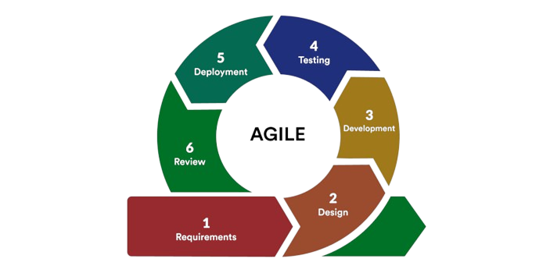

***Figure 3.0****: Agile SDLC Software Development Life Cycle*

The research design encompasses the following key phases:

**3.1.1. Needs Analysis**

Before starting my project, a preliminary need analysis survey was carried out to grasp the entire requirements of both students and educators at the University of Lagos. The essence of the survey at the early stage of the project is to ensure the Smart LMS meets the demands and needs of the users (educators and students). Although it is not possible to cater to all the needs of the users at once, carrying out a requirement/needs analysis helps to model the Smart LMS in such a way that supports scalability.

**3.1.2 Prototyping And User Feedback**

A prototype is an early sample, model, or release of a product built to test a concept or process. For the Smart LMS project, prototypes were developed using a collaborative Interface design tool called **Figma,** allowing for quick visualization of the application's interface. The project was put forward to potential users to get regular feedback to refine the user interface and overall user experience.

**3.1.3 System Architecture Design**

The system architecture was designed to accommodate scalability and modularity. Microservices architecture was chosen to facilitate independent development and deployment of services. A microservices architecture refers to a type of application architecture where the application is developed as a collection of services. Key technologies selected included React for the front end, Django for the back end, PostgreSQL as the database, and Figma for visualization of the applications’ interface.

**3.3 DEVELOPMENT PROCESS**

The development process followed an Agile methodology as said earlier. A cross-functional team collaborated throughout the project, including front-end and back-end developers, UI/UX designers, and a project manager.

**3.2.1 User Interface And User Experience Design**

In this stage of development, the project adopted some questions developed by [5] to collect both qualitative and quantitative data relevant to the research via surveys and physical interviews. Upon analysis of the collected data, the needs, attitudes, and behaviors of users to the project were clearly understood thereby influencing the design and development of the wireframe.

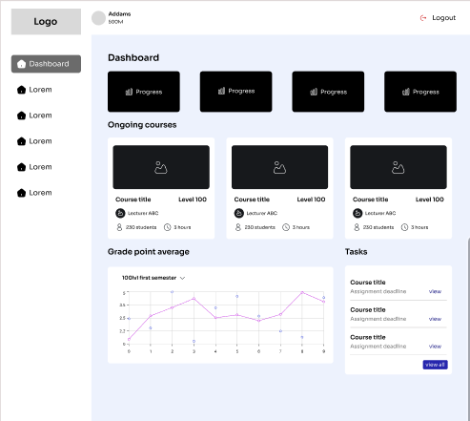

***Figure 3.1:*** Wireframe of Smart LMS

**3.2.2 Frontend Development**

Front-end web development entails the development of the graphical user interface of a web project (website or web app), through the use of tools like HTML, CSS, React, and JavaScript, so that users can view and interact with that website. It is the part of the website users interact with the most. The goal of the front end is to render the entire interface elegant, easy to use, fast, and secure, fostering user engagement and interaction. Efficient front-end development should allow more work to be done with fewer clicks and fewer lines of code. Some of the dependencies used include:

1. **React-Router-dom:** This package enables dynamic routing in the application.
2. **Material UI Icons:** This enabled the retrieval of icons used in the application
3. **Axios:** This is a technology that enables communication between the frontend and the backend (basically, it is used for fetching API calls from the server-side)

The development of the frontend component began with the creation of a react application via the “npx create-react-app [app_name]” in the terminal. This command initiates a new single-phase react application.

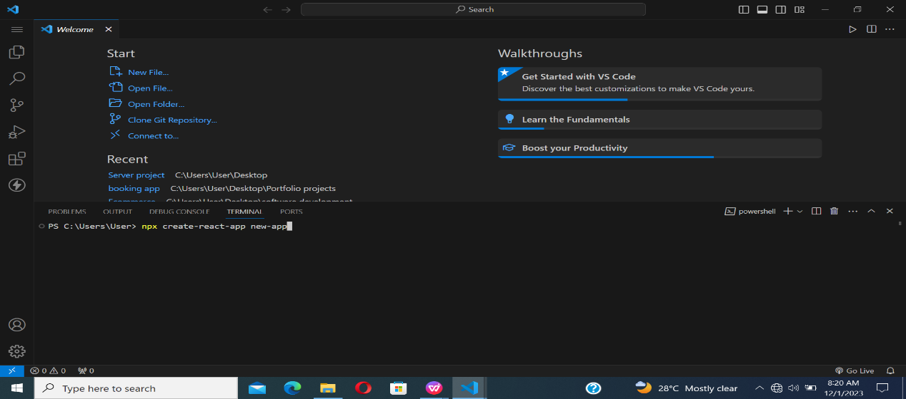

***Figure 3.2:*** *A picture of the “npx create-react-app” command*

Once the react application has been created, we then navigate into the new app and run the command “npm start” to get the application running on the browser.

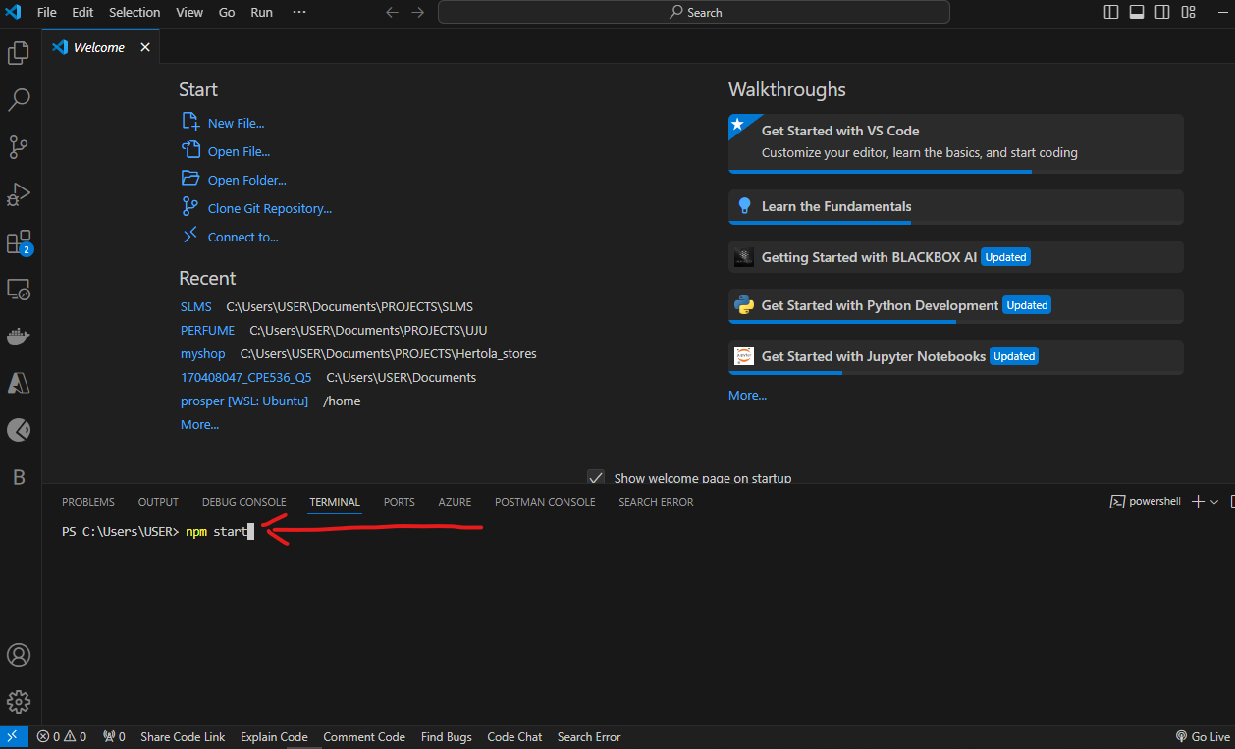

***Figure 3.3:*** *A picture of the “npm start” command*

In structuring my project, a specific filing system was followed using folders and subdirectories to house similar codes and their functionalities. The essence of this was to follow the **D.R.Y principle** and improve troubleshooting.

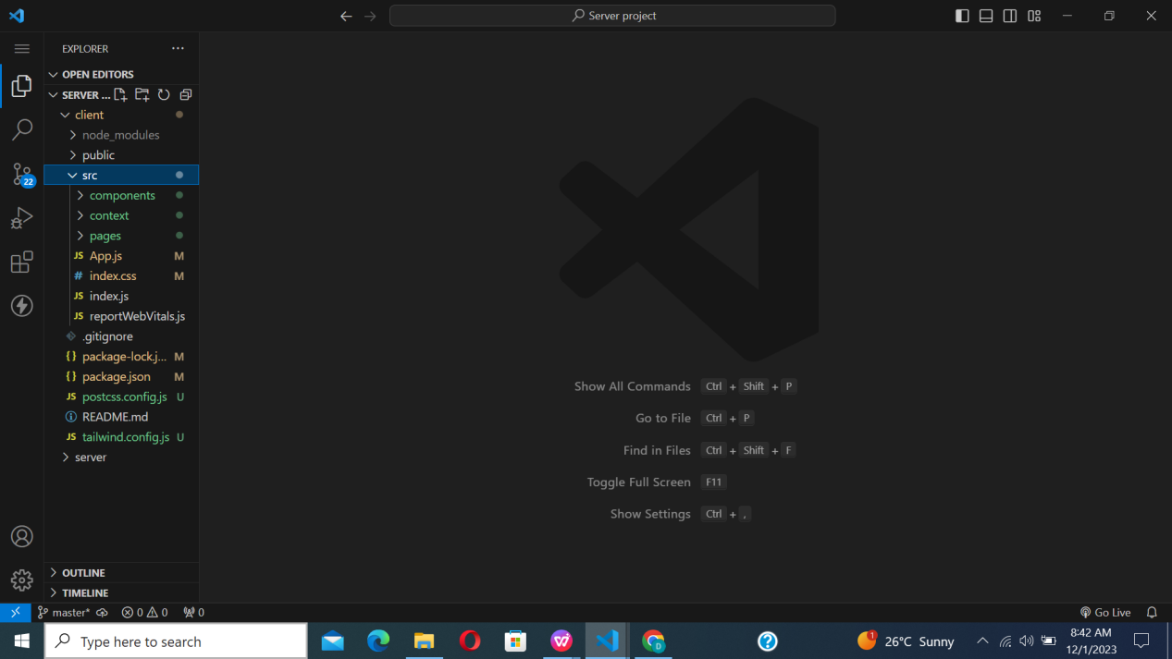

***Figure 3.4:*** *File Orgaisation of the frontend*

The pages folder contains code snippets of the different pages that users navigate to while using the application. Some of these pages included the login page, register page, home page, etc.

Snippets of code that are reusable in different pages of the application e.g Navigation bar, footers, etc, were placed in a components folder for easy retrieval. With this setup, we simply import the particular snippet of code or functionality that is needed into the desired page. Some of these components include: Navbar component, Banner component, NavMenu component, etc

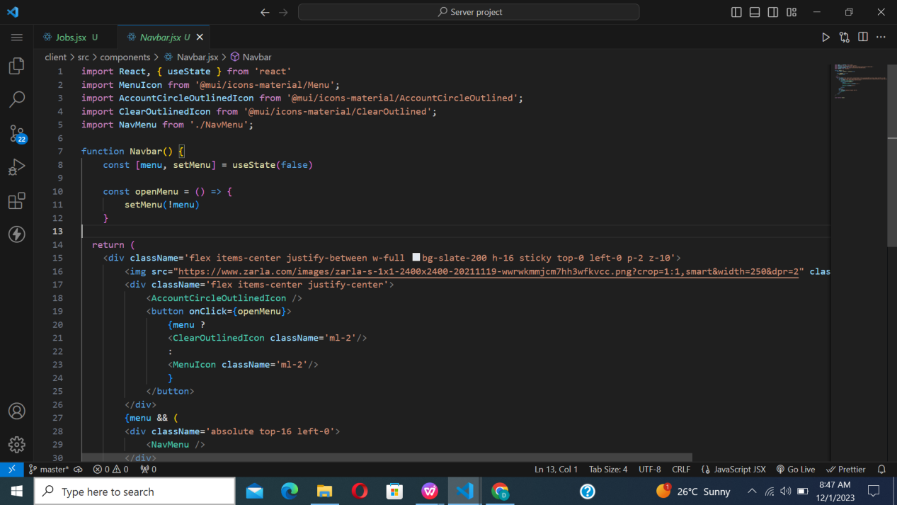

***Figure 3.5:*** *The navbar components in the react application*

**3.2.3 Backend Development**

The backend represents the backbone of every application. It focuses primarily on server-side logic i.e. the part of the project that users can’t see. The backend ensures that the website performs correctly, focusing on databases, back-end logic, Application Programming Interface (APIs), architecture, and servers. Features such as user authentication, authorization, and outlining of courses rely heavily on the backend.

Another focus of this project was the integration of the database. Django and Railway provided a robust server-side foundation. PostgreSQL, an SQL database, was employed to store dynamic and unstructured data efficiently. Several dependencies were also installed in the back-end to help in successfully getting it running. Some of these dependencies and their functionalities include:

1. **.env** - This file contains all environment variables(sensitive data that’s unique to users) e.g third party passwords, secret keys etc
2. **JWT** - JSON Web Token mechanism was used for authentication of users on the Smart LMS platform.
3. **Redis** - This is an open-source tool that serves as a message broker for scheduling tasks in the Smart LMS.
4. **CORS** - This mechanism enables restricted resources on a web page to be accessed from another domain outside the domain from which the first resource was served.

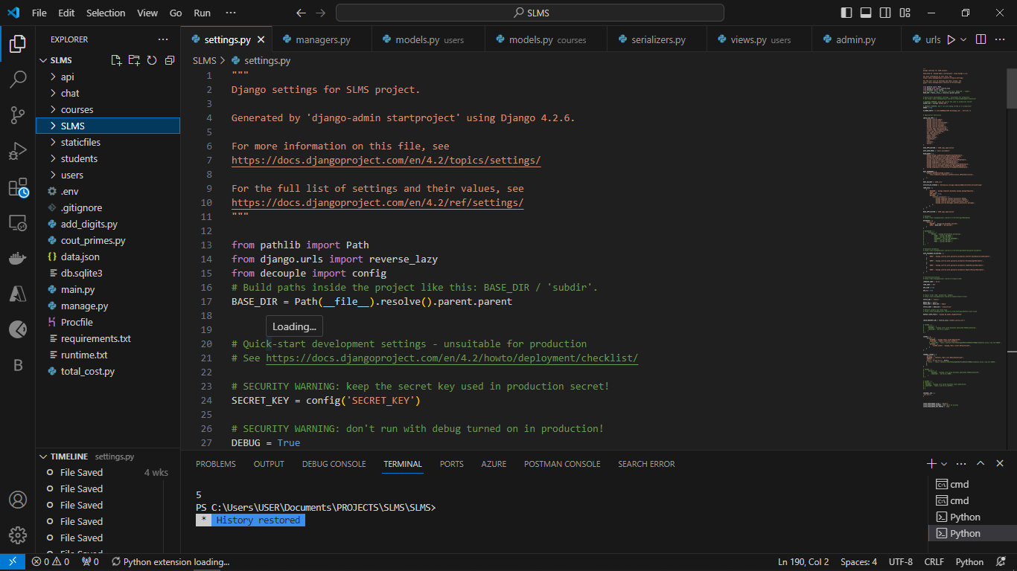

***Figure 3.6:*** *File organization of the backend*

**3.2.4 Recommendation System Development**

Recommendation systems are one of the most used applications of data science and machine learning. In building the Smart Learning Management System, the project utilized a data-driven methodology to offer recommendations tailored to a user's preference.

To build the recommendation system, data with high integrity (the accuracy and consistency (validity) of data over its lifecycle) and algorithms were made use of to forecast and suggest content (courses, videos, books, etc) that a user might find useful. These systems are essential in applications where users may become overwhelmed by large volumes of information, such as social media, streaming services, e-commerce, and in this context learning management.

The two common techniques for building recommendation systems are content-based filtering (which takes into account the characteristics of products and user profiles) and collaborative filtering (which generates recommendations based on user behavior and preferences). Hybrid strategies that integrate the two approaches are also popular and in this project, This project utilizes a new recommendation technique called the **“MERGER”.** The integration of a recommendation system will help to improve user experiences, boost user involvement, and propel corporate expansion.

**3.2.5 Content-Based Recommendation System**

Content-based systems recommend items to the customer similar to previously high-rated items by the customer. It is a [supervised machine learning](https://www.geeksforgeeks.org/supervised-machine-learning/amp/) model used to induce a classifier to discriminate between interesting and uninteresting items for the user. Simply put, it is a recommender system that provides users with suggestions based on similarity in content. Let’s take a simple example to understand how this algorithm works:

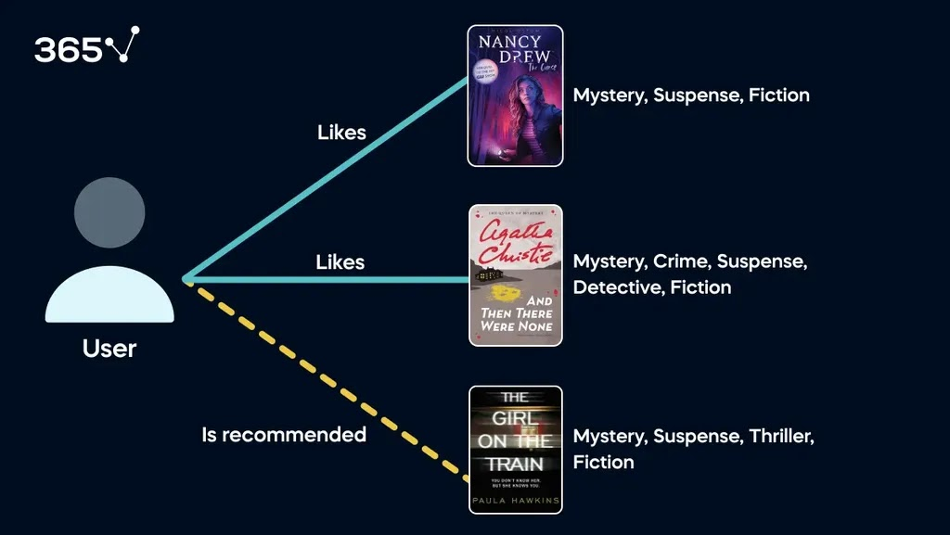

***Figure 3.7:*** *Content-Based Recommendation System*

From the image, it is shown that the user in the image above liked reading a novel written by Nancy Drew and another written by Agatha Christie, both of which fall under many of the same categories. The recommendation system then suggests that the user should also read “The Girl on The Train,” since this book is similar to the other items they enjoyed.

From the example above, it is clear that the content-based recommendation system is a simple method of providing recommendations based on a customer’s preferences for particular content. However, the main disadvantage of this approach is that it will not be able to suggest a product that the user has never seen before. For instance, the reader above read two crime-based novels, and the model will never suggest that they read a comedy or romance book. This means that the user will never get a recommendation outside genres they have already interacted with.

This drawback of content-based recommender systems can be overcome using a technique called collaborative filtering, which will be described in the next section.

## 

## **3.2.6 Collaborative Filtering Recommendation System**

Collaborative filtering is based on the idea that similar people (based on the data) generally tend to like similar things. It predicts which item a user will like based on the item preferences of other similar users. C[ollaborative Filtering](https://www.geeksforgeeks.org/collaborative-filtering-ml/amp/) recommends items based on similarity measures between users and/or items. The basic assumption behind the algorithm is that users with similar interests have common preferences.

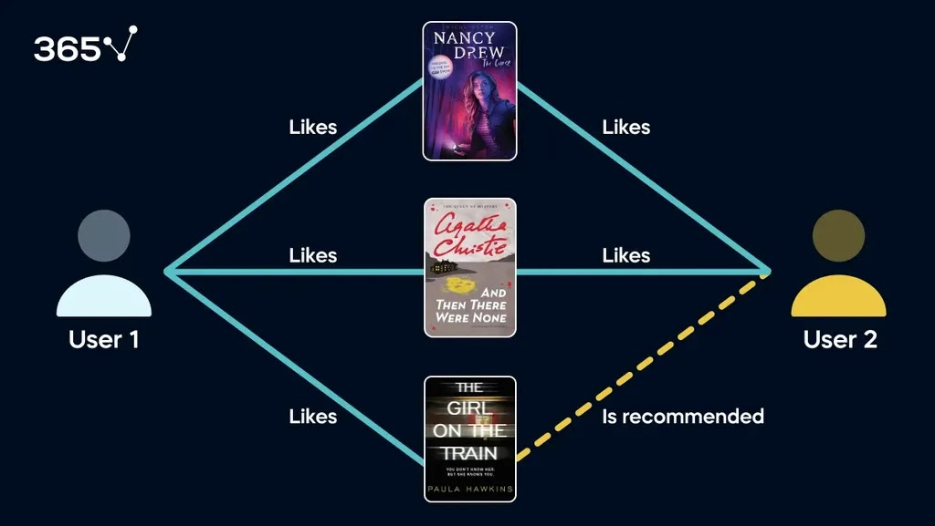

***Figure 3.8:*** *Collaborative Filtering*

[Collaborative filtering](https://www.geeksforgeeks.org/item-to-item-based-collaborative-filtering/amp/) uses a user-item matrix to generate recommendations. This matrix contains the values that indicate a user’s preference towards a given item. These values can represent either explicit feedback (direct user ratings) or implicit feedback (indirect user behavior such as listening, purchasing, and watching).

In this project, machine learning models will be trained using a dataset containing high-integrity data to integrate intelligent recommendations. As said earlier, the recommendation system used will be based on a hybrid filtering method. Unlike content-based recommendation systems, collaborative filtering only considers customer preferences and does not factor in the item's content.

The collaborative filtering technique is based on the idea that users who have agreed in the past tend to agree in the future. It makes predictions about a user's interests by collecting preferences from many users (collaborating). The system identifies users similar to the target user based on their interactions with items (like ratings or views). It then recommends items liked by similar users that the target user has not interacted with.

There are two main types of collaborative filtering: **user-based and item-based.**

**Why Collaborative Filtering was chosen as the foundation for this project:**

* **Personalization:** Collaborative filtering provides personalized recommendations based on user behavior. It considers the preferences and actions of similar users to suggest items tailored to an individual’s tastes.
* **Scalability:** It scales well with a large number of users and items since it focuses on the relationships between users and items rather than the intrinsic characteristics of items.
* **Adaptability:** Collaborative filtering adapts to changes in user preferences over time. As users interact with new items, the system updates recommendations accordingly.

**3.2.7 Hybrid Recommendation System**

As said earlier, This project adopted a new recommendation technique called the **“MERGER”.** It’s a hybrid technique developed to overcome the cold start problem of the regular collaborative filtering technique and address the limited exploration challenge posed by the content-based filtering technique. The “merger” technique was developed using several mathematical concepts such as cosine similarity, percentiles, matrices, vectors, etc.

In creating the merger recommendation system, the following steps were followed:

1. **Obtaining a dataset:** The choice of the right dataset is vital when training a machine language model. It directly influences the model's ability to generalize, handle diverse scenarios, avoid biases, and produce accurate and relevant predictions. A high-quality, representative, and diverse dataset ensures the model's effectiveness in real-world applications and contributes to ethical and responsible AI development. Recall from the scope of this project that the smart LMS would be implemented project with three(3) distinct engineering courses. An initial dataset containing **EEG 329 (Circuits & Systems II), EEG 213 (Signals & Systems Theory), and GEG 113 (Engineering Applied Mathematics I)** was utilized as the courses, and several textbooks were added to each one of the courses. Bear in mind that the goal of the recommendation system is to suggest content based on relevance and preference.

### **Pre-processing the data:** Pre-processing of data is like getting your ingredients ready before cooking a meal. In the context of machine learning, it's the step where you clean, organize, and prepare your data to make it suitable for training a model. This involves handling missing values, removing irrelevant information, scaling features to a consistent range, and generally making sure the data is in a form that the machine learning algorithm can effectively learn from. The goal is to set the stage for the model to learn patterns and make accurate predictions when it's later fed with new, unseen data. In this stage of development, The merger algorithm was trained to receive input via the web interface and save it to a table which is later exported into a .csv where the data is then extracted, analyzed, and visualized using libraries such as Pandas, Numpy, skit-learn etc. The algorithm was also trained to cater to edge cases such as sparse data from the user using syntax like NaN to represent missing values.

1. **Creating the CountVectorizer:** After the data has been processed, it is converted into a word vector which is necessary for the count vectorization process. CountVectorizer is a tool used in natural language processing and text analysis, particularly in machine learning. In simple terms, it's a way to convert a collection of text documents into a numerical format that machine learning algorithms can use. The function of the CountVectorizer is to create a vocabulary of all unique words or terms present in the text corpus and then represent each item (e.g., course, textbook, article) as a vector where each dimension corresponds to a term in the vocabulary, and the value represents the frequency of that term in the item's text.
2. **Building the recommendation system:** Now, we will use a distance measure called cosine similarity to find the resemblance between each bag of words. Cosine similarity is a metric that calculates the cosine of the angle between two or more vectors to determine if they are pointing in the same direction.

Cosine similarity ranges between 0 and 1. A value of 0 indicates that the two vectors are not similar at all, while 1 tells us that they are identical.

### **Displaying User Recommendations:** Once a user’s pattern has been identified, the system makes accurate recommendations based on a subset of similar users. The system maps similar users within the same course and makes accurate predictions based on the preferences of other users.

**3.4 FLOWCHART REPRESENTATION OF HYBRID RECOMMENDATION TECHNIQUE**

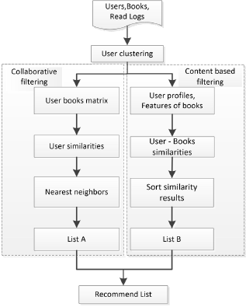

***Figure 3.9:***Flowchart of hybrid recommendation technique

**3.5 TESTING AND VALIDATION**

This phase involves carrying out tests on the coded functionality to ascertain its performance in real-life applications. This project underwent unit tests(testing out small bits of code) and integrated tests(testing several modules of an application as a combined unit) to prove its viability.

**3.6 SECURITY AND PRIVACY MEASURES**

A robust security mechanism will be implemented to protect users (students, lecturers, administrative staff, etc) data and ensure privacy compliance with relevant regulations. Secure Sockets Layer (SSL) was also set up on the web application to ensure the safety of sensitive information during its transfer.

**3.7 CONCLUSION**

In conclusion, the **Smart Learning Management System (Smart LMS)** poses a significant advancement in modern educational technology, revolutionizing traditional teaching and learning paradigms. The Smart LMS offers a robust solution that meets several needs of both learners and educators through its multifaceted features and user-centric design.

At its core, the Smart Learning Management System is based upon the principle of accessibility and inclusivity, thereby fostering a personalized and user-friendly interface that caters to a vast number of users with different abilities and skill levels. Due to its seamless design, learners have access to educational resources, anytime and anywhere, hence promoting a culture of flexibility and lifelong learning.

The Smart Learning Management System prioritizes personalized learning experiences as one of its major transformative features. By harnessing the power of data analysis and machine learning, the system analyzes learner behavior, preferences, and performance metrics to tailor educational content and pathways that cater to individual needs. This personalized approach maximizes learning outcomes by catering to each learner's unique strengths and challenges, hence, enhancing user engagement and motivation.

Furthermore, the Smart Learning Management System(Smart LMS) serves as a hub for collaboration and communication, facilitating seamless interaction between students and lecturers. Through integrated communication tools, discussion forums, and collaborative workspaces, the system fosters a sense of community and collaboration, encouraging knowledge sharing and peer-to-peer support.

In essence, the Smart LMS represents more than just a technological tool; it embodies a significant improvement in the way education is delivered and experienced. It uses the power of technology to personalize learning, empower educators, and foster collaboration, the Smart LMS holds the potential to transform education and unlock new opportunities for learners of all ages and backgrounds. It’s time to embrace the future of education, the Smart LMS, one learner at a time.

**CHAPTER FOUR: EXPERIMENTAL RESULTS AND ANALYSIS**

**4.1 EXPERIMENTAL DATA**

The experimental data employed to train the recommendation algorithm was randomly generated. This dataset consists of a comprehensive collection of 1,000 books with features(author, title, genre, ISBN, publication date, publisher), selected to represent a diverse range of genres and categories. The variety within the dataset is intended to ensure that the recommendation model can generalize well across different types of content.

To evaluate the performance of the trained model, a series of 50 tests were conducted. These tests were designed to measure various aspects of the recommendation algorithm's effectiveness, including its accuracy in predicting user preferences and the relevance of the recommendations provided.

The training process utilized a **supervised learning** approach. In this setup, the model was trained on a dataset where user interactions and ratings were already provided. This supervised methodology enabled the algorithm to learn from these predefined labels, allowing it to improve its ability to predict and recommend books based on user preferences and historical data.

Overall, the experimental data setup was structured to provide a thorough assessment of the recommendation algorithm’s performance, leveraging a substantial and varied dataset to achieve robust and meaningful results.

**4.2 EXPERIMENTAL RESULTS**

This section begins by presenting the findings about demographic information. A total of 133 responses were collected via a Google form survey. The essence of this survey was to identify the key areas users(students in this context) would want the Smart Learning Management System to meet. This survey was assigned to Undergraduate students during the 2023/2024 session. The survey instructed students to provide feedback about their experiences with the current e-learning system (Moodle) and areas of improvement. The survey targeted first-year, second-year, and third-year students at the Faculty of Engineering. Respondents were majority female (56.6%) compared to males (43.4%). By age, respondents were grouped into 16 to 19 (57.2%), 21 to 24 (26.8%) (10.6%), and 23 to 25 (5.4%). In terms of students’ level, the first-year student level is represented by 26.4%, the second-year student level is represented by 58.7%, and the third-year student level is represented by 14.9%. From this survey, I was able to gather that the three main features desired by students were personalized learning, adaptive assessments, and quality recommendation, thus reinforcing the objectives of the project.

For the recommendation feature, to verify the effectiveness of the hybrid recommender system, the experiments of a single algorithm and hybrid algorithm are respectively performed to compare the precision of three algorithms (content-based, collaborative filtering, and the MERGER). Precision is a very important indicator for evaluating the performance of recommender systems. Mathematically, precision is defined as:

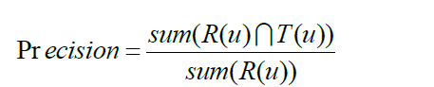

Where R(u) represents the list of recommended books according to the behavior on the training dataset, and T(u) denotes the list of books on the test set. Running all three algorithms to different training set sizes, Fig. 4 Shows variation in precision as the size of the training sets increases from 10 to 50. It is clear that the precision of each algorithm increases gradually.

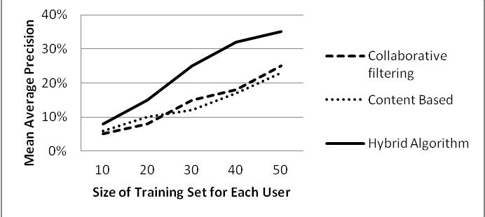

***Fig. 4.0:*** *The precision of different recommendation algorithm****s***

**4.3 EXPERIMENTAL ANALYSIS**

The first two research questions were answered through the survey as data gathered showed more than 81% of engineering students were conversant with online learning platforms and would appreciate the introduction of artificial intelligence in them. In building the recommendation algorithm, I gathered that the number of books read by users affects the performance of the recommendation algorithm. For a small data training set, the preferences of users are not fully expressed, while, a large collection incorporates diverse user preferences. To solve the issue of data sparsity, an improved collaborative filtering algorithm was used to combine clustering algorithms. Hybrid algorithms, combining the strengths of collaborative filtering and content-based approaches, significantly enhance recommendation system performance. By effectively addressing the challenge of item cold start, they emerge as the superior choice for generating accurate and relevant recommendations.

For adaptive assessments, a mini-test was carried out between two groups of students, one group that didn’t use the SLMS and another that made use of the SLMS. The positive impact of using the LMS on learning achievement was seen from the difference in scores between students who used the LMS and those who did not use the LMS [13], [27], or the difference in scores between students before using the LMS and after using the SLMS [13].

Akay & Gumusoglu [12], identified the effect of LMS on the English proficiency exam with logistic regression. The findings of the study indicate that the LMS has a noteworthy and favorable impact on the English language proficiency assessment. This can be seen from the significance value of p = 0.01 or <0.05. Furthermore, Shaame [9], analyzed the effectiveness of LMS in Geometry learning with ANCOVA. The results of his research show that LMS is effective in helping students understand mathematical concepts and improve their performance in learning. This can be seen from the average score of students who use the LMS of 9.15 and those who do not use the LMS of 7.97.

**CHAPTER FIVE: SUMMARY, CONCLUSIONS, RECOMMENDATIONS AND RECOMMENDATIONS FOR FURTHER STUDIES**

This chapter provides the purpose of this research, research questions, summary of the results, limitations of the study, recommendations for future research, discussion, and conclusion.

**5.1 SUMMARY OF FINDINGS**

After conducting a thorough investigation, it appears that artificial intelligence has been minimally explored within the realm of Learning Management Systems (LMS). I identified two main factors contributing to this gap. First, some lecturers expressed concern that LMS platforms might encourage student laziness, leading to decreased attendance in physical classes when materials are available online. This observation aligns with Anderson’s interaction equivalency theory, which suggests that students may be satisfied with one type of interaction and neglect others. Second, there are limitations to LMS in that not all courses can be effectively taught online due to their specific requirements for in-person interaction or hands-on activities.

Despite the concerns expressed above, the use of the SLMS in educational methods has still led to a statistically significant improvement in students' mathematical proficiency compared to those who only received traditional instruction [7]. Despite these concerns, LMS positively impacts student learning by aiding in assignment completion, facilitating the exploration of new concepts, and fostering communication between lecturers and students[22]. Students' perceptions of LMS are positive [19] as it helps in terms of learning and educational interaction. It ensures that students remain focused on their academic objectives, thereby enhancing their learning experience. Additionally, the LMS effectively communicates crucial information to students, thereby enabling them to comprehend and plan.

**5.2 CONCLUSION**

Over the last decade, online learning has become a vital tool in learning and teaching as it focuses on meaningful, self-directed, student-centered, life-long learning[15]. Since the COVID-19 incident, the number of online students has increased by 47%, making it one of the fastest-growing technology trends. Of the LMS tools facilitating interactivity, students rated online quizzes most highly, indicating their preference for interactions focussed on course content and including automatic feedback. Furthermore, integrating the Smart Learning Management System (SLMS) into university education presents a transformative opportunity to enhance the learning experience and streamline academic processes. Through the use of LMS platforms, universities can offer a more flexible, accessible, and personalized education that caters to diverse learning styles and needs. The ability to centralize resources, facilitate collaboration, and provide timely feedback empowers both students and educators, promoting a more engaging and efficient learning environment.

However, successful implementation of an LMS requires careful planning, training, and ongoing support to address potential challenges such as technological issues, resistance to change, and ensuring equitable access. By addressing these challenges proactively, universities can harness the full potential of LMS technology to support academic excellence and foster an inclusive, dynamic educational community.

In addition to this, I find that developing a fully AI-assisted Learning Management System is not an easy task as it requires a lot of knowledge of database design, machine learning, mathematics, and several programming concepts. I wish I could develop the system to cater to all courses but due to the limited time, I couldn’t. It would be very helpful if the University could allocate some of its resources and efforts towards this project, as it promises a revolution in all faculties and not only the Faculty of Engineering.

Finally, I would like to express how I find this process of developing a system to be very awakening to the mind of a student and to teach how to teach themselves things. I have built a skill of how to search for things and develop them to my needs. It has indeed been a great experience.

Ultimately, the inclusion of LMS into university learning represents a significant step towards modernizing education and preparing students for the increasingly digital and interconnected world. As universities continue to innovate and adapt, the thoughtful integration of LMS will play a pivotal role in shaping the future of higher education.

**5.3 RECOMMENDATIONS**

One immediate suggestion is to start a group of dedicated lecturers with the ambition to act as a generator of ideas on how to use the SLMS and/or other tools for specific teaching approaches, based on the emerging new pedagogies. In addition, Institutions and lecturers should provide adequate technical support and training to students, monitor and evaluate student perceptions and satisfaction, and actively engage with students through the SLMS.

Finally, future research should investigate the long-term impact of LMS usage on students' achievement and views. Future research may also utilize a different methodology to explore the same subject matter.

**REFERENCES**

[1]. H. Altinpulluk and M. Kesim, “A systematic review of the tendencies in the use of learning management systems,” *Turk. Online J. Distance Educ.*, vol. 22, no. 3, pp. 40-54, 2021. doi:[10.17718/tojde.961812](https://doi.org/10.17718/tojde.961812).

[2] T. Snoussi, “Learning management system in education: Opportunities and challenges,” *IJITEE*, vol. 8, no. 12S, pp. 664-667, 2019 [doi:[10.35940/ijitee.L1161.10812S19](https://doi.org/10.35940/ijitee.L1161.10812S19)].

[3] O. Emmamoge et al., “The impact of learning management system in Federal college of forestry, Jos -A case study,” *IIARD Int. J. Geogr. Environ. Manag.*, vol. 6, no. 1, pp. 60-72. Available at: https://www.researchgate.net/publication/342430103, 2020.

[4]. B. C. E. Oguguo et al., “Effect of learning management system on students’ performance in educational measurement and evaluation,” *Educ. Inf. Technol.*, vol. 26, no. 2, pp. 1471-1483, 2021. doi:[10.1007/s10639-020-10318-w](https://doi.org/10.1007/s10639-020-10318-w).

[5] “Institutional factors affecting academic performance of marketing students in Nueva Ecija Vol-5,Issue-1,”, Jan.-Febr. 2020, Kim Edward S. Santos, Antonio Jose D. Celis.

[6] M. O. Afuwape et al., *J. Sci. Teach. Assoc. Niger.*, vol. 39, no. 12, pp. 1-16, 2019.

[7].S. Widodo et al., “Autonomy and Creative Thinking Skills of Prospective Elementary School Teacher Students in Learning Mathematics with Science Phenomena assisted by the Learning Management System,” *Int. J. Learn. Teach. Educ. Res.*, vol. 20, no. 8, pp. 160-175, 2021. doi:[10.26803/ijlter.20.8.10](https://doi.org/10.26803/ijlter.20.8.10).

[8]. Z. Zainuddin and C. J. Perera, “Supporting students’ self-directed learning in the flipped classroom through the LMS TES BlendSpace,”, *OTH*, vol. 26, no. 4, pp. 281-290, 2019. doi:[10.1108/OTH-04-2017-0016](https://doi.org/10.1108/oth-04-2017-0016).

[9]. A. A. Shaame et al., “Exploring a learning management system as a way to improve students’ understanding of geometry in secondary schools,” *Afr. Educ. Rev.*, vol. 17, no. 4, pp. 17-40, 2020. doi:[10.1080/18146627.2020.1868070](https://doi.org/10.1080/18146627.2020.1868070).

[10]. A. M. Ojeda-Castro et al., “Learning management system use to increase mathematics knowledge and skills in Puerto Rico,” *Int. J. Technol. Hum. Interact.*, vol. 13, no. 2, pp. 89-100, 2017. doi:[10.4018/IJTHI.2017040106](https://doi.org/10.4018/ijthi.2017040106).

[11]. I. Thepwongsa et al., “The effects of a newly established online learning management system: The perspectives of Thai medical students in a public medical school,” *Heliyon*, vol. 7, no. 10, p. e08182, 2021.

doi:[10.1016/j.heliyon.2021.e08182](https://doi.org/10.1016/j.heliyon.2021.e08182).

[12]. E. Akay and E. K. Koral Gumusoglu, “The impact of learning management systems on students’ achievement in language exams,” *Turk. Online J. Distance Educ.*, pp. 206-222, 2020. doi:[10.17718/tojde.803410](https://doi.org/10.17718/tojde.803410).

[13]. R. Kraleva, Mehrudin Sabani and Velin Kralev “An analysis of some learning management systems,” *Int. J. Adv. Sci. Eng. Inf. Technol.*, vol. 9, no. 4, p. 1190-1198, 2019. doi:[10.18517/ijaseit.9.4.9437](https://doi.org/10.18517/ijaseit.9.4.9437).

[14]. S. F. Dlalisa and D. W. Govender, “Challenges of acceptance and usage of a learning management system amongst academics,” *IJEBEG*, vol. 12, no. 1, pp. 63-78, 2020, doi:[10.34111/ijebeg.202012105](https://doi.org/10.34111/ijebeg.202012105).

[15]. T. Snoussi, “Learning management system in education: Opportunities and challenges,” *IJITEE*, vol. 8, no. 12S, pp. 664-667, 2019 [doi:[10.35940/ijitee.L1161.10812S19](https://doi.org/10.35940/ijitee.l1161.10812s19)].

[16]. T. Teo et al., “Factors that influence university students’ intention to use Moodle: A study in Macau,” *Educ. Technol. Res. Dev.*, vol. 67, no. 3, pp. 749-766, 2019 [doi:[10.1007/s11423-019-09650-x](https://doi.org/10.1007/s11423-019-09650-x)].

[17]. C. Vrasidas, *Issues of Pedagogy and Design in E-learning Systems*, 2004 [doi:[10.1145/967900.968086](https://doi.org/10.1145/967900.968086)].ACM Symposium on Applied Computing, pp. 911-915.

[18]. G. Onofrei and P. Ferry, “Reusable learning objects: A blended learning tool in teaching computer-aided design to engineering undergraduates,” *Int. J. Educ. Manag.*, vol. 34, no. 10, pp. 1559-1575, 2020, doi:[10.1108/IJEM-12-2019-0418](https://doi.org/10.1108/ijem-12-2019-0418).

[19]. M. Lubabalo, 2019, “Of Learning Management Systems on Academic Performance, viewed n.d.” Available at: https://openscholar.dut.ac.za/handle/10321/3346. Computing Departments’ Academics’ Perceptions on the Impact.

[20]. W. T. Nakamura et al., “Are scale-based techniques enough for learners to convey their UX when using a LMS?,” *Rev. Bras. de*, 2019.

]Informatica na Educaç~ao, Vol. 27 No. 01, pp. 104-131.

[21]. Y. Limani, 2020, “Design education: Challenges and opportunities resulting from technological developments, UBT International Conference, viewed n.d.”Available at: <https://knowledgecenter.ubtuni.net/conference/2020/all_events/86.>

[22]. S. W. Hanafie Das et al., “Developing a sociocultural approach in Learning Management System through Moodle in the era of the Covid-19,” *Int. J. Innov. Creativity Change*, vol. 13, no. 27, pp. 941-958, 2020.

[23]. B. T. Gamede et al., “Exploring the adoption and usage of learning management system as alternative for curriculum delivery in south African higher education institutions during COVID-19 lockdown,” *Int. J. Higher Educ.*, vol. 11, no. 1, pp. 71-84, 2021. doi:[10.5430/ijhe.v11n1p71](https://doi.org/10.5430/ijhe.v11n1p71).

[24]. E. Araka et al., “University students’ perception on the usefulness of learning management system features in promoting self-regulated learning in online learning,” *Int. J. Educ. Dev. Using Inf. Commun. Technol. (IJEDICT)*, vol. 17, 2021.

[25]. M. Tezer and B. T. Çimşir, “The impact of using mobile-supported learning management systems in teaching web design on the academic success of students and their opinions on the course,” *Interact. Learn. Environ.*, vol. 26, no. 3, pp. 402-410, 2018. doi:[10.1080/10494820.2017.1337037](https://doi.org/10.1080/10494820.2017.1337037).

[26]. A. N. Ganeser and T. P. Robert, “The perception and effectiveness of OpenLearning portal as A central Learning Management System (LMS) among private higher education institution students,” *Asian J. Res. Educ. Soc. Sci.*, vol. 3, no. 2, pp. 54-62, 2021.

[27]. D. Turnbull et al., “Issues in learning management systems implementation: A comparison of research perspectives between Australia and China,” *Educ. Inf. Technol.*, vol. 26, no. 4, pp. 3789-3810, 2021 [doi:[10.1007/s10639-021-10431-4](https://doi.org/10.1007/s10639-021-10431-4)].