Grazioso Salvare Rescue Dashboard
Project Two — README
Author: Prosper Ashanga
Course: CS 340 – Client/Server Development
Date: October 22, 2026

1. Project Overview
Global Rain was contracted by Grazioso Salvare, an international rescue-animal training company, to build a full-stack web application on top of shelter data from a non-profit agency operating five animal shelters around Austin, Texas. Grazioso Salvare identifies dogs that are strong candidates for search-and-rescue training, and different breeds are better suited to different rescue specialties: water rescue, mountain or wilderness rescue, and disaster or individual tracking.
This project builds on the MongoDB database and CRUD_Python_Module.py Python module developed in Project One, and the interactive data table and geolocation chart first prototyped in the Module Six Milestone. Project Two completes the dashboard by adding interactive rescue-type filtering, a second chart (a breed-distribution pie chart), and full MVC wiring between all of the dashboard's components.

2. Required Functionality
The completed dashboard (ProjectTwoDashboard.ipynb) provides the following, all of which are demonstrated in the screenshots below:
- The Grazioso Salvare logo, wrapped in a clickable link to the client's home page (www.snhu.edu) per the branding requirement, and a unique identifier (the author's name) displayed at the top of the dashboard.
- An interactive data table showing an unfiltered view of the Austin Animal Center Outcomes data set on load, populated through the CRUD Python module's read({}) method -- not direct MongoDB access.
- Interactive filtering options (radio buttons) for Water Rescue, Mountain or Wilderness Rescue, Disaster or Individual Tracking, and Reset, each backed by its own MongoDB query run through the CRUD Python module.
- The data table dynamically updates to show only the animals matching the selected rescue type, with sorting, native filtering, pagination, and single-row selection enabled for ease of use.
- A geolocation chart (built with dash-leaflet) that places a marker at the selected animal's location and updates automatically as the table's selection or filtered contents change.
- A second chart -- a pie chart of breed distribution -- that also updates dynamically based on the table's currently filtered contents.

2.1 Starting State
The dashboard immediately after it loads, before any filter is applied.
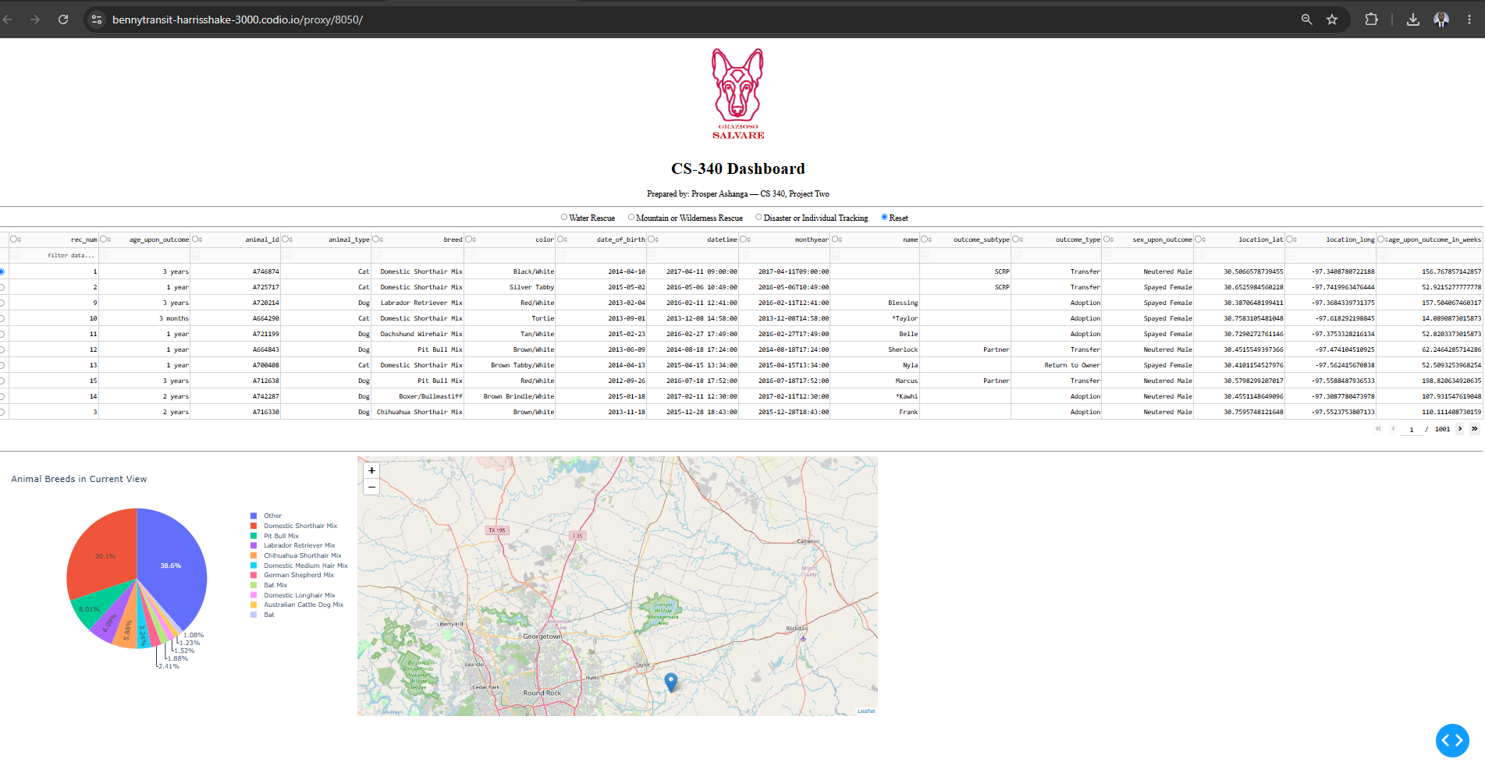

2.2 Execution: Water Rescue Filter
The dashboard after selecting the "Water Rescue" radio button: the data table filtered to Labrador Retriever Mix, Chesapeake Bay Retriever, and Newfoundland dogs, with the pie chart and map updated accordingly.
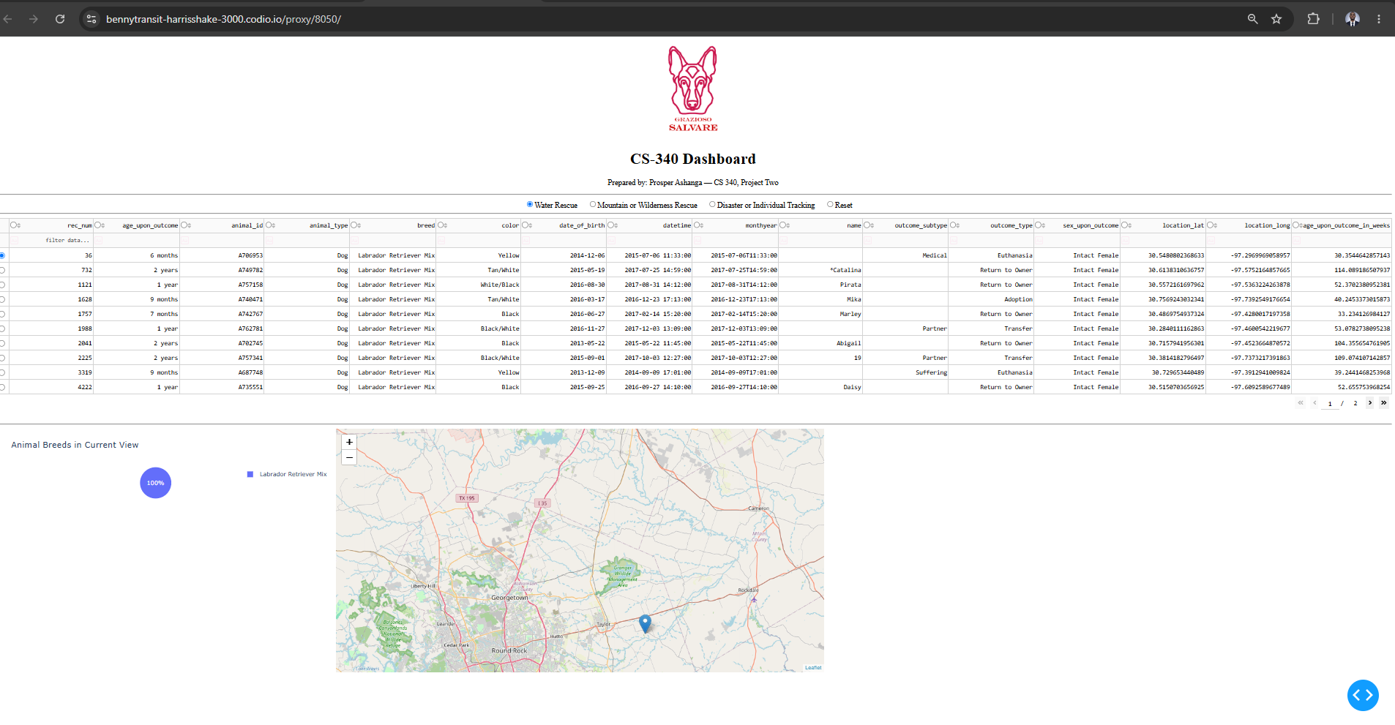

2.3 Execution: Mountain or Wilderness Rescue Filter
The dashboard after selecting "Mountain or Wilderness Rescue": the table filtered to German Shepherd, Alaskan Malamute, Old English Sheepdog, Siberian Husky, and Rottweiler dogs, with the pie chart and map updated accordingly.
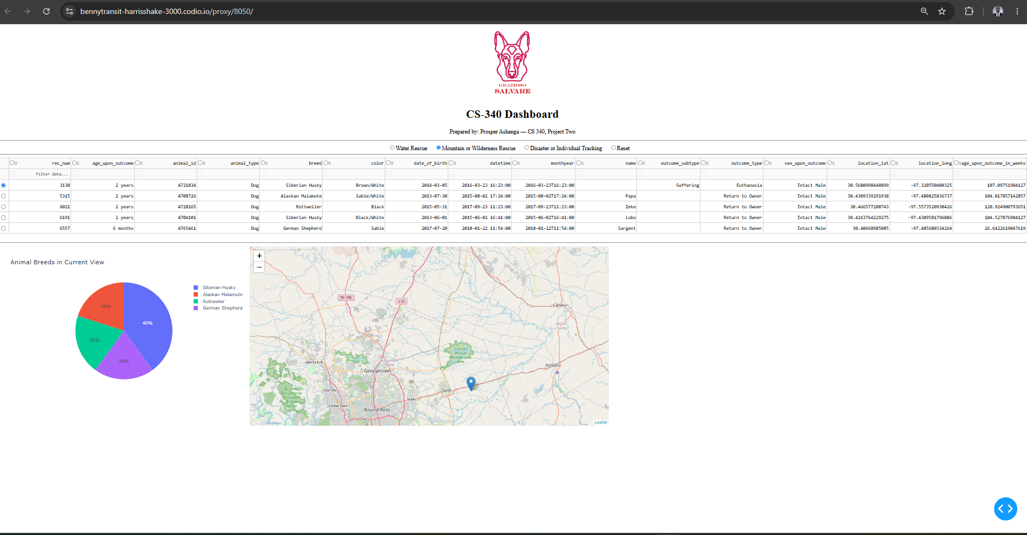

2.4 Execution: Disaster or Individual Tracking Filter
The dashboard after selecting "Disaster or Individual Tracking": the table filtered to Doberman Pinscher, German Shepherd, Golden Retriever, Bloodhound, and Rottweiler dogs, with the pie chart and map updated accordingly.
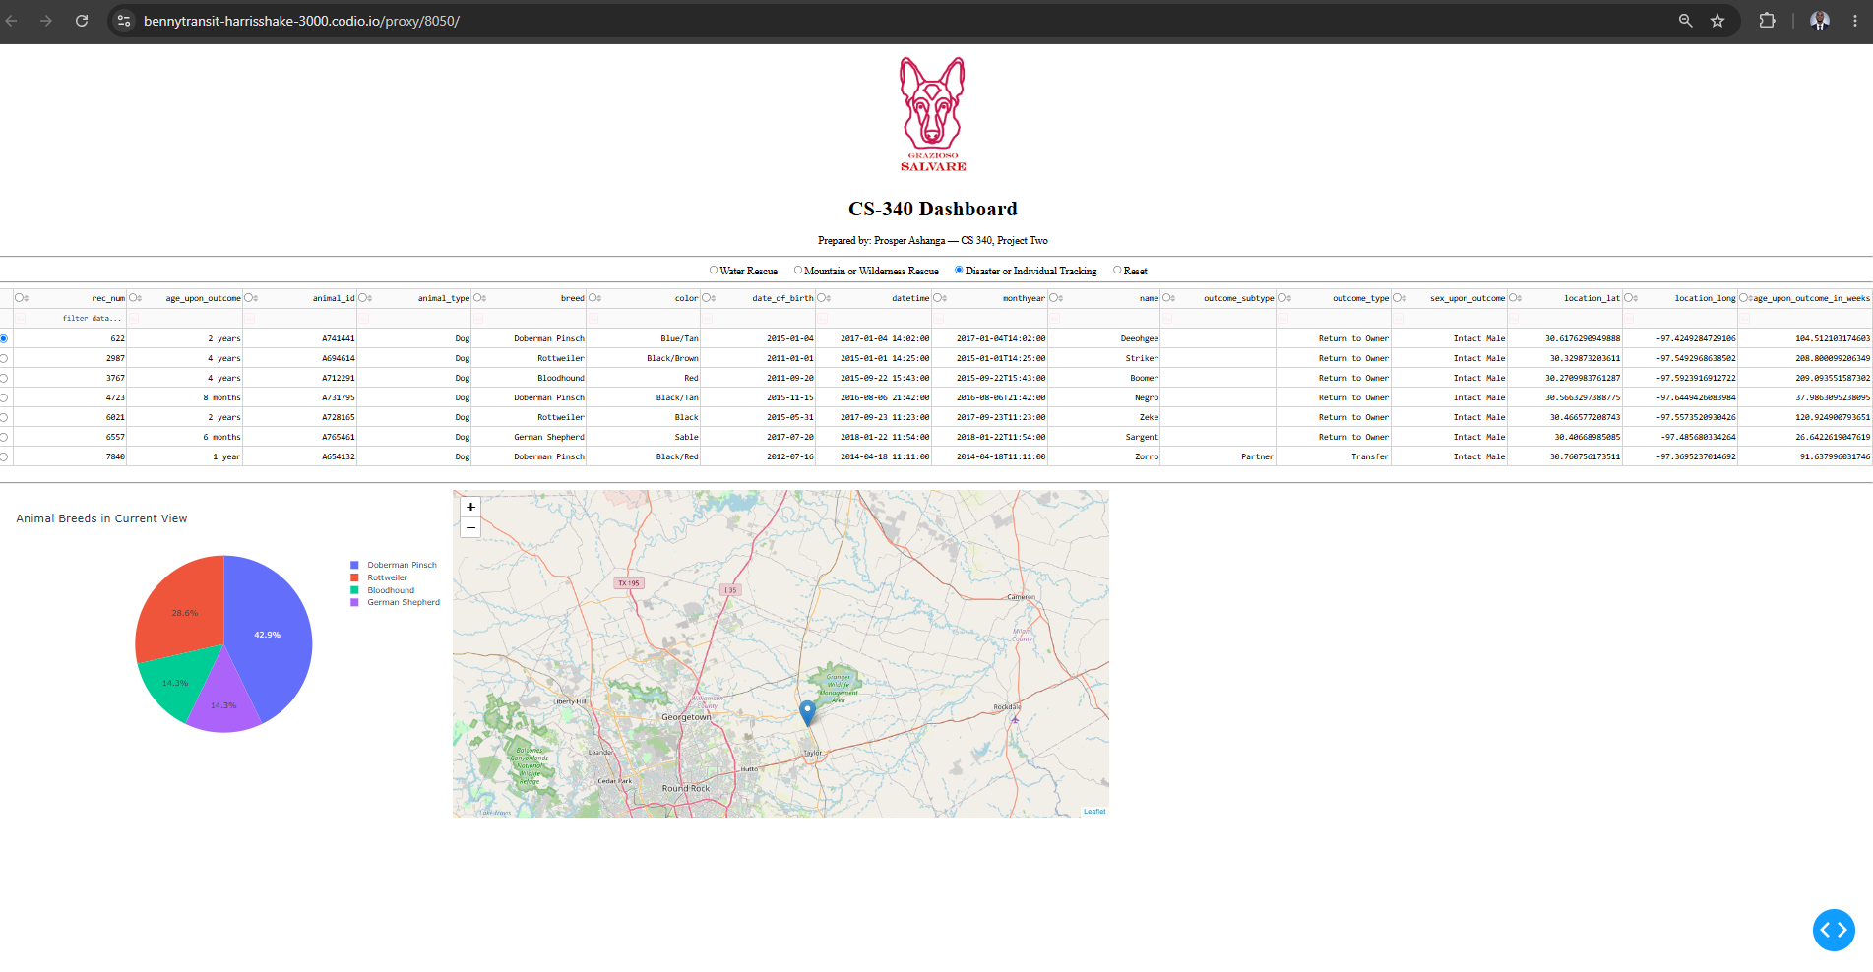

2.5 Execution: Reset
The dashboard after selecting "Reset": every widget returned to its original, unfiltered state, matching the starting-state screenshot above.

3. Tools Used and Rationale

3.1 MongoDB
MongoDB was used as the Model layer of the application's MVC architecture. Its document-oriented, schema-flexible design is a natural fit for shelter intake/outcome records, where fields can vary slightly between entries without requiring a rigid relational schema or costly migrations. MongoDB's query language supports the exact operations this dashboard needed: $in for matching a dog against a list of preferred breeds, and $gte/$lte for the required age-range filtering, both of which can be combined into a single query document and executed in one round trip. The PyMongo driver gives Python direct, efficient access to these documents, and all of that access is centralized behind the AnimalShelter CRUD Python module built in Project One, so the dashboard code never has to construct raw MongoDB queries itself -- it only ever calls create(), read(), update(), or delete().

3.2 Dash (Plotly Dash / JupyterDash)
Dash supplies both the View and the Controller in this project's MVC design. The View is built from Dash's reactive HTML components -- dash_table.DataTable, dcc.RadioItems, dcc.Graph (rendering Plotly Express charts), and dash-leaflet's dl.Map -- which render as an interactive, modern web page without hand-written JavaScript. The Controller is built from Dash's @app.callback decorators: each callback declares which component property it listens to (an Input) and which component property it updates (an Output), and Dash's underlying React/Flask architecture handles firing the right callback whenever the user interacts with the page. This reactive, declarative model is what lets selecting a radio button automatically re-query the data table, which in turn automatically redraws both the pie chart and the geolocation map, with no manual page refresh or client-side code required.

3.3 Resources Used
Dash Documentation
Dash DataTable Reference
dash-leaflet Documentation
PyMongo Documentation
Plotly Express Documentation
Austin Animal Center Outcomes data set, provided by Grazioso Salvare/Global Rain (modified with location_lat, location_long, and age_upon_outcome_in_weeks columns).
CS 340 Dashboard Specifications Document, provided by the Global Rain UI/UX developer, used to confirm rescue-type breed lists, sex, and age-range criteria for the interactive filters.

4. Steps Taken to Complete the Project
- Reviewed the Dashboard Specifications Document and the ProjectTwoDashboard.ipynb starter code to understand the required widgets and the MVC structure already scaffolded.
- Carried forward the unfiltered interactive data table built in the Module Six Milestone, connected to the CRUD Python module's read({}) method, and reused its sorting/filtering/pagination/single-row-selection configuration.
- Built one MongoDB query per rescue type (Water Rescue, Mountain or Wilderness Rescue, Disaster or Individual Tracking), each combining a breed list ($in), a required sex, and an inclusive age range ($gte/$lte) into a single query document, cross-checked against the raw Austin Animal Center data set to confirm exact breed-name spellings.
- Added interactive radio-button filtering options and wired them to a callback that re-queries MongoDB (through the CRUD module) and updates the data table's data property, with a "Reset" option that restores the original unfiltered view.
- Added a geolocation chart callback (adapted from the Module Six Milestone) that reads the table's currently filtered/selected row and places a map marker at that animal's coordinates.
- Added a second chart -- a Plotly Express pie chart of breed distribution -- driven by the table's derived_virtual_data, so it updates automatically whenever the filter or table contents change.
- Added the Grazioso Salvare logo (base64-encoded and embedded via an html.Img component, wrapped in an html.A anchor tag linking to www.snhu.edu to satisfy the branding requirement) and a unique "Prepared by" identifier to the dashboard layout.
- Tested the dashboard end-to-end in Codio/JupyterLab, applying each filter option in turn and confirming the table, pie chart, and map all update correctly, then captured the required screenshots.
- Documented the project, tools, and process in this README.

5. Challenges Encountered and How They Were Overcome
ObjectId crashing the data table: MongoDB automatically returns an _id field of type ObjectId, which dash_table.DataTable cannot serialize and will crash on. This was resolved by dropping the _id column from the pandas DataFrame immediately after every read() call, both on initial load and inside the filter callback.
Keeping callbacks from conflicting: Early on, it was tempting to have a single callback try to update the table's data, styling, and selection all at once. Because Dash callbacks are scoped to a single component property, this was resolved by splitting responsibilities across separate callbacks -- one for data (driven by the filter), one for style_data_conditional (driven by selected_columns), and the chart/map callbacks reading from derived_virtual_data and derived_virtual_selected_rows -- so each concern stays independent and Dash can fire only the callbacks that are actually affected by a given interaction.
Stale row selection after filtering: Selecting a row near the bottom of the full table and then applying a filter that returns fewer rows could leave the geolocation callback trying to access a row index past the end of the new, smaller DataFrame, raising an IndexError. This was resolved by bounds-checking the selected index against the filtered DataFrame's length before calling .iloc, falling back to row 0 when the previous selection is no longer valid.
Breed-name mismatches: The Dashboard Specifications Document's breed table lists "Doberman Pinscher" as a preferred breed for Disaster or Individual Tracking, but a query using that exact spelling against the live collection returned zero matches. Cross-referencing the raw Austin Animal Center CSV showed the breed is stored truncated as "Doberman Pinsch," a known quirk of this data set. The query was corrected to match the breed name as it is actually stored in MongoDB rather than the full display name from the specifications document.

