# HOW REMOTE SENSING CAN BE APPLIED IN AGRICULTURE

Remote sensing is the acquisition or collection of due information about an object or phenomenon without making physical contact with the object and thus in contrast to on-site observation, especially the Earth.

Remote sensing can also be said to be the art and science of acquiring information about the earth surface without having any physical contact with it .This is mainly done by observing and recording of reflected and emitted energy.

Generally remote sensing refers to the use of satellite- or aircraft-based sensor technologies to detect and classify objects on Earth, including on the surface and in the atmosphere and oceans, based on propagated signals (e.g. electromagnetic radiation). It may be split into "active" remote sensing (such as when a signal is emitted by a satellite or aircraft and its reflection by the object is detected by the sensor) and "passive" remote sensing (such as when the reflection of sunlight is detected by the sensor).

### THE COMPONENTS OF REMOTE SENSING;

1. Energy Source: The first requirement for remote sensing is an energy source which provides electromagnetic energy.
2. Radiation and the Atmosphere: As the energy travels from its source to the target, it will come in contact with and interact with the atmosphere it passes through. This interaction may take place a second time (active remote sensing) as the energy travels from the target to the sensor.
3. Interaction with the Target: once the energy makes its way to the target through the atmosphere, it interacts with the target depending on the properties of both the target and the radiation.
4. Recording of Energy by the Sensor: after the energy has been reflected by, or emitted from the target, we require a sensor (remote-not in contact with the target) to detect and record the electromagnetic radiation.
5. Transmission, Reception, and Processing: The energy recorded by the sensor has to be transmitted, often in electronic form, to a receiving and processing station where the data are processed into an image.
6. Interpretation and Analysis: The processed image is interpreted, visually or digitally, to extract information about the target.
7. Application: The final element of the remote sensing process is achieved when we apply the information we have been able to extract from the imagery about the target in order to better understand it, reveal some new information, or assist in solving a particular problem.

### Principle of remote sensing

The basic principle of remote sensing is that different objects based on their structural, physical or chemical properties reflect or emit different amount of energy in different wavelength ranges of electro-magnetic spectrum. The sensors measures the amount of energy reflected from that object and represents it through an image.

In the process of Remote Sensing involves an interaction between the incoming radiation and interest of target. This is done by using imaging and non-imaging system; however the following steps are involved in the process

[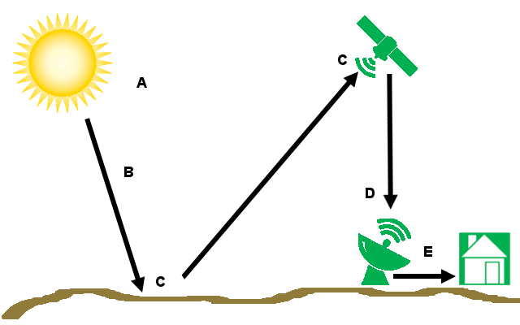](https://i2.wp.com/grindgis.com/wp-content/uploads/2015/05/Remote-Sensing.png?fit=640,400&ssl=1)

#### Fig 1.1

### TYPES OF REMOTE SENSING

1. ACTIVE REMOTE SENSING
2. PASSIVE REMOTE SENSING

Active Remote Sensing: when remote sensing work is carried out with a man made source of radiations which is used to illuminate a body and to detect the signal reflected form. Example. Radar and Lidar remote sensing.

Passive Remote Sensing: when remote sensing work is carried out with the help of electromagnetic radiations (signals) reflected by a natural body (sun and earth). Example visible, NIR and Microwave remote sensing. Nowadays, remote sensing is employed in precision agriculture to manage and monitor farming practices at different levels. The data can be used to farm optimization and spatially-enable management of technical operations. The images can help determine the location and extent of crop stress and then can be used to develop and implement a spot treatment plan that optimizes the use of agricultural chemicals. National governments can use remote sensing data, in order to make important decisions about the policies they will adopt, or how to tackle national issues regarding agriculture. Individual farmers can also receive useful information from remote sensing images, when dealing with their individual crops, about their health status and how to deal with any problems.

The main disadvantage of passive sensors is that they can collect or detect objects in the day time only because sun’s illumination is not there at night, however they can record the naturally emitted energy like Thermal infrared. On the other hand Active sensor gives own energy for illumination so it enables to detect and record the images at any time. They are weather independent also; artificial microwaves can penetrate clouds, light and shadow. But Passive sensors are not weather independent. Radar signals can penetrate into vegetation and soil and even can give you the surface information at mm to m depth level at the same time major disadvantage is that radar signals do not contain any spectral characters while Passive Remote Sensing signals have spectral characters. Unlike active sensors passive sensor have the ability to produce fine resolution image. Active Remote sensors are cost intensive also when compared to passive sensor.

[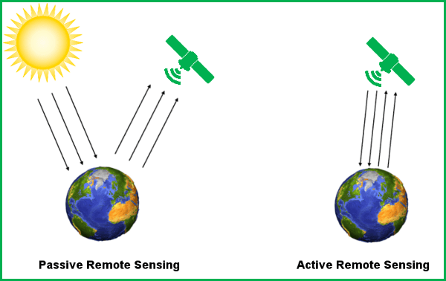](https://i1.wp.com/grindgis.com/wp-content/uploads/2015/05/active-and-passive.png)

# APPLICATIONS OF REMOTE SENSING IN AGRICULTURE

**CROP IDENTIFICATION:** The agricultural managers require information on the spatial distribution and area of cultivated crops for planning purposes. The can adequately plan the import and export of food products based on such information. Although some agricultural ministries annually commission their staff to map different crop types, these ground surveys are expensive and yet cover only a sample of farms. This serves the purpose of forecasting grain supplies (yield prediction), collecting crop production statistics, facilitating crop rotation records, mapping soil productivity, identification of factors influencing crop stress, assessment of crop damage due to storms and drought, and monitoring farming activity.

Key activities include identifying the crop types and delineating their extent (often measured in acres). Traditional methods of obtaining this information are census and ground surveying. In order to standardize measurements however, particularly for multinational agencies and consortiums, remote sensing can provide common data collection and information extraction strategies.

#### WHY DO WE USE REMOTE SENSING?

Remote sensing offers an efficient and reliable means of collecting the information required, in order to map crop type and acreage. Besides providing a synoptic view, remote sensing can provide structure information about the health of the vegetation. The spectral reflection of a field will vary with respect to changes in the phenology (growth), stage type, and crop health, and thus can be measured and monitored by multispectral sensors. Radar is sensitive to the structure, alignment, and moisture content of the crop, and thus can provide complementary information to the optical data. Combining the information from these two types of sensors increases the information available for distinguishing each target class and its respective signature, and thus there is a better chance of performing a more accurate classification.

Interpretations from remotely sensed data can be input to a geographic information system (GIS) and crop rotation systems, and combined with ancillary data, to provide information of ownership, management practices etc.

**A case study in Mali:** For example in a study in Mali, the boundaries of 48 fields representing six dominant crops were mapped during an extensive field campaign, from which the temporal profiles of each crop were extracted. Figure 2.1 shows typical temporal profiles of dominant crops in Mali based on NDVI images for different crop types calculated from Digital Globe data. It shows the typical growth cycle of each crop during the cropping season (May – October)

.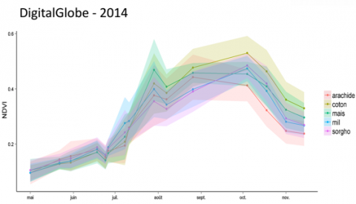

Figure 2.1 based spectral signatures of major crop types in Mali

Based on the potential uniqueness of these temporal profiles, UAV and satellite images can be classified to reveal the spatial distribution of crops in the area of interest.

Apart from spectral information, several other information layers can be added to improve the accuracy with which different crops can be identified. An example is textural information (Haack and Bechdol, 2000; Sheoran and Haack, 2013).

Texture represents the degree of local spatial variations in an image. Different crop types, by virtue of their spatial arrangement, have different textural properties. Derivation and addition of textural measures to the spectral information can therefore improve classification accuracies.

Both texture and context are adding important information for the classification of image segments. Context refers to the relation between coarse and fine image segments. Texture serves as a valuable parameter in addition to spectral reflectance for characterizing the different segments.  The texture parameters, which worked best, were GLCM (Grey Level Co-occurrence Matrix) and GLDV (gray-level difference vector) (Conrad et al., 2010; Novack et al., 2011).

Despite acquiring sufficient UAV/satellite and field data, crop classification can be very challenging and result in low accuracies. At the core of this difficulty is high variability in the spectral characteristics of the crops under study. In other words, the temporal profiles of the crops under study, are ideally unique for each crop, but this is often not the case.

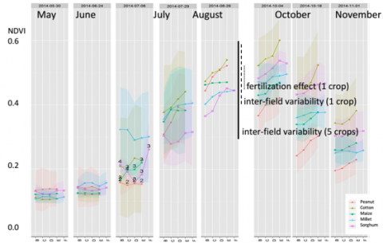

Figure 4.9 Monthly NDVI temporal profiles of major crop types in Mali (Source: STARS MALI TEAM).

Figure 4.9 (above), for example, shows the monthly temporal profiles of the dominant crops in our test site in Mali. Each column (labelled with a month name) depict the spectral patterns extracted from five quadrats within a field. The figure shows high similarity in the profiles, which could make crop identification and separation from satellite/UAV images quite challenging.

This high spectral and spatial variability can be attributed to a number of reasons. These include:

* Overlaps in cropping calendar, especially in rainfed dominated agricultural areas where different crop types are planted and harvested around the same time, leading to similarities in their temporal profiles.
* Differences in management practices (e.g. tillage, weeding, fertilization, etc.) between and within fields result in high spectral and spatial variability.
* Variations in soil type, depth and fertility
* Intercropping, i.e. cultivation of different crop types on the same land
* Proximity of natural/semi-natural vegetation to cultivated areas
* Occurrence of excessive trees on agricultural plots
* Water accumulation
* Occurrence of pest and diseases in some portions of a field

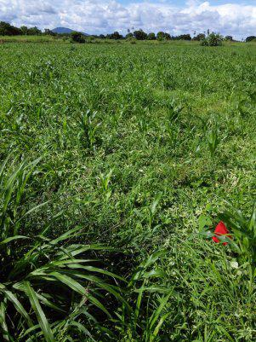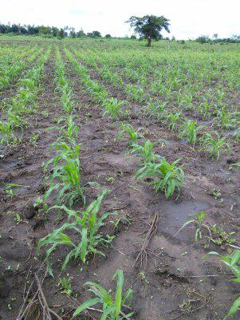

Figure 4.10: Un-weeded and weeded field in Njombe District, Tanzania (Source: AgriSense)

In order to reduce the effects of the above-mentioned factors on crop classification, a number of measures can be pursued: These include:

* Inclusion of additional RS data, e.g. Synthetic Aperture Radar (SAR) data (Forkuor et al., 2014; McNairn et al., 2009).
* Landscape stratification based on soil, topography, climate, etc.
* Performing object, instead of pixel-based, image analysis (Peña-Barragán et al., 2011).
* Testing different classification approaches such as the sequential masking classification algorithm (Forkuor et al., 2015; Van Niel and McVicar, 2004).

**SOIL MAPPING:** Soil is a fundamental natural resource, and it plays an essential role in the biophysical and biogeochemical functioning of the planet. Soil is a fundamental natural resource. Soil plays an essential role in the biophysical and biogeochemical functioning of the planet. Soil systems, like most natural systems, are dynamic in nature. Most changes are slow and imperceptible particularly when viewed in the time frame of human lifespan. However, catastrophic events such as high intensity storms can accelerate erosion processes resulting in measurable changes. The changes are mainly in the structure and composition of the material and such changes are referred to as structural changes (Manchanda et al., 2002). It is necessary to have an intimate knowledge of the kind of soils their spatial distribution for developing rational land use plan for agriculture, forestry, irrigation, drainage, etc. or for measuring the amount of soil erosion, desertification and damage caused by landslides, floods, etc. With the help of soil mapping of various properties of soil we gain an insight into the potentialities and limitation of soil for its effective exploitation. The soil systems, like most natural systems, are dynamic in nature. Most changes are slow and imperceptible particularly when viewed in the time frame of human lifespan. However, catastrophic events such as high intensity storms can accelerate erosion processes resulting in measurable changes. The changes are mainly in the structure and composition of the material and such changes are referred to as structural changes. It is necessary to have an intimate knowledge of the kind of soils their spatial distribution for developing rational land use plan for agriculture, forestry, irrigation, drainage, etc. or for measuring the amount of soil erosion, desertification and damage caused by landslides, floods, etc. With the help of soil mapping of various properties of soil we gain an insight into the potentialities and limitation of soil for its effective exploitation.

#### WHY DO WE USE REMOTE SENSING?

Remote sensing techniques have significantly contributed to speeding up conventional soil surveys by reducing field work to a considerable extent. Remote sensing is the acquisition of information about an object or phenomenon without making physical contact with the object. In India, initially aerial photographs were used in deriving information on degraded lands (Kamphorst and Iyer, 1972). The application of remotely sensed data in mapping degraded lands space borne sensors started with the launch of the first Earth Resources Technology Satellite ERTS-1 /Landsat-1. However, the satellites Landsat-TM, SPOT and Indian Remote Sensing Satellites with better spatial and spectral resolution, enabled to map and monitor degraded lands more efficiently (Tagore et al., 2012). The use of digital image processing for soil survey and mapping was initiated in India with the establishment of National Remote Sensing Agency and Regional Remote Sensing Service Centres. The works carried out by Venkatratnam (1980), Kudrat et al. (1990), Karale (1992), etc. demonstrated the potential of digital image processing techniques for soil survey. Following this, a number of modeling studies were carried out to develop a variety of soil maps, e.g. land evaluation, land productivity, soil erosion and hydrologic budget (Kudrat et al., 1990; Saha et al., 1991; Kudrat 1996; Kudrat et al., 1995; Kudrat et al., 1997) to derive information about the various phenomenon of soil.

**METHODS OF SOIL MAPPING**

There are different types of soils on the Earth. Hence, mapping of various properties of soil is essential. Soil mapping provides us an insight of the various properties of soil which are required to analyse the various potentialities and limitations of soil. There are various methods of soil mapping. Remote sensing has proved to be an important part of soil survey and mapping. Various properties of soil can be mapped with the help of remote sensing. Optical remote sensing helps in the mapping of properties like land cover, land type, vegetation and soil moisture. Thermal infrared remote sensing is commonly used to estimate moisture and salinity. Visual image interpretation technique helps in the identification and mapping of soil elements like land type, vegetation, land use, slope and relief. Microwave remote sensing is a new and effective technique for mapping of soil moisture and salinity which is being commonly used today. Hyperspectral remote sensing is another recent method which is applied in soil salinity mapping as well as identification and mapping of minerals in the soil.

**Optical Remote Sensing**: This has been used to monitoring of various properties of soil like land cover, land type, vegetation and even soil moisture. Optical remote sensing provides a quantitative measure of surface reflectance, that is, the reflected radiation of the sun from the Earth’s surface, which is related to some soil properties. Organic matter, particle size and moisture content influence soil reflectance primarily through a NES Geo-Congress 2013 62 change in average surface reflectance, and produce only broad spectral expression (Irons et al., 1989). Optical remote sensing is the most commonly used for soil moisture estimation. Lobell and Asner (2002) developed a physical model to explain the soil reflectance variations due to moisture change based on their analysis of the reflectance for four different soils at various moisture contents. Liu et al. (2003) analyzed 18 different soils that represent a large range of permanent soil characteristics and investigated the potential of estimating soil moisture from reflectance measurements in the solar domain.

**Thermal Infrared Remote Sensing:** The thermal infrared remote sensing is commonly used to estimate moisture and salinity. Thermal infrared remote sensing measures the thermal emission of the Earth with an electromagnetic wavelength region between 3.5 and 14μm (Curran, 1985). The moisture content is mainly measured by the thermal inertia method and the temperature/vegetation index method (Wang and Qu, 2009). Thermal infrared remote sensing is also commonly used to detect salt-affected areas from the relationship between crop water stress and temperatures of the crop canopy (Metternicht and Zinck, 2003). Although thermal infrared remote sensing has many scopes, the potential use of thermal systems for soil monitoring appears to be little investigated.

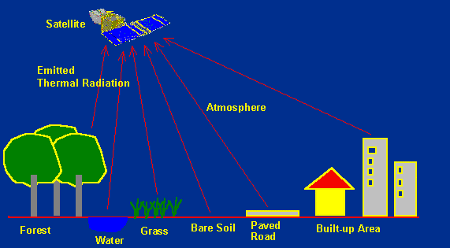

Infrared remote sensing makes use of infrared sensors to detect infrared radiation emitted from the Earth's surface. The [middle-wave infrared (MWIR) and long-wave infrared (LWIR)](https://crisp.nus.edu.sg/~research/tutorial/em.htm#irbands) are within the thermal infrared region. These radiations are emitted from warm objects such as the Earth's surface. They are used in satellite remote sensing for measurements of the earth's land and sea surface temperature. Thermal infrared remote sensing is also often used for detection of forest fires.

**Visual Image Interpretation:** Visual interpretation is based on shape, size, tone, shadow, texture, pattern, site and association. This has the advantage of being relatively simple and inexpensive. Soils are surveyed and mapped, following a three tier approach, comprising interpretation of remote sensing imagery and/or aerial photograph (Mulder, 1987), field survey (including laboratory analysis of soil samples) and cartography (Sehgal et al., 1989). This technique helps in the identification and mapping of soil elements like land type, vegetation, land use, slope and relief. Interpretation of aerial photographs have also been used in soil salinity mapping, especially colour-infrared photographs in which barren saline soils (in white) and salt-stressed crops (in reddish brown) can be easily discriminated from other soil surface and vegetation features (Rao and Venkataratnam, 1991; Wiegand, Rhoades, et al., 1994).

**Microwave Remote Sensing:** Microwave remote sensing is an effective technique for mapping of soil moisture and salinity, with advantages for all-weather observations and solid physics. It presents advantages in special soil conditions, such as salt-affected areas (Taylor et al., 1996), sandy coastal and desert zones, waterlogged areas, and places with irregular micro-topography such as puffy crusts and cloddy surfaces (Metternicht, 1998; Singh and Srivastav, 1990). There are two methods of microwave sensing - active microwave sensing and passive microwave sensing. Great progress has been made in mapping regional soil moisture with active microwave sensors. In active microwave methods, a microwave pulse is sent and received. The power of the received signal is compared with which was sent to determine the backscattering coefficient of the surface, which has been shown to be sensitive to soil moisture (Wang and Qu, 2009). The most common imaging active microwave configuration is Application of Remote Sensing in Soil Mapping: A Review ` 63 the synthetic aperture radar (SAR), which transmits a series of pulses as the radar antenna traverses the scene (Moran et al., 2004). Active sensors, although having the capability to provide high spatial resolution in the order of tens of meters, have a poor resolution in time with repeat time excess of 1 month. On the other hand, the space borne passive systems can provide spatial resolutions only in the order of tens of kilometres but with a higher temporal resolution. Passive microwave remote sensors can be used to monitor surface soil moisture over land surfaces (Eagleman and Lin, 1976; Ulaby et al., 1986; Schmugge and Jackson, 1994; Jackson et al., 1995; Wigneron et al., 2004). These sensors measure the intensity of microwave emission from the soil, which is proportional to the brightness temperature, a product of the surface temperature and emissivity (Wang and Qu, 2009). Because of the differential behaviour of the real and imaginary parts of the dielectric constant of soil, microwaves also are efficient in detecting soil salinity. While the real part is independent of soil salinity and alkalinity, the imaginary part is highly sensitive to variations in soil electrical conductivity, but with no bearing on variations in alkalinity. This allows the separation of saline soils from others (Sreenivas, Venkataratnam and Rao, 1995).

**Hyperspectral Remote Sensing:** Recent developments in hyperspectral remote sensing offer the potential of significantly improving data input to predictive soil models. The key characteristic of hyperspectral imagery data is the high spectral resolution that is provided over a large and continuous wavelength region. Each pixel in a hyperspectral image is associated with hundreds of data points that represent the spectral signature of the materials within the spatial area of the pixel. The result is a three-dimensional data set that has two axes of spatial information and one axis of spectral information (Rogers and Luna, 2004). The high resolution of hyperspectral imagery makes it possible to uniquely identify different materials at the earth's surface. The large number of spectral bands permits direct identification of minerals in surface soils. Clark and Swayze (1996) mapped over 30 minerals using hyperspectral sensor, Airborne Visible/Infrared Imaging Spectrometer (AVIRIS) at Cuprites, Nevada. AVIRIS measures a contiguous spectrum in the visible and near-infrared, and thereby better characterize atmospheric and surface properties (Goetz et al., 1985). The capabilities of hyperspectral imagery for soil salinity mapping have been recently investigated by Ben-Dor, Patkin, Banin, and Karnieli (2002) and Taylor and Dehaan (2000).

**PEST AND DISEASE CONTROL**

Pests and diseases cause serious economic losses in yield and quality of cultivated plants [Tatchell, 1989; Walker, 1983;MacLeod, et al, 2004]. As a result, detecting and assessing their symptoms is very paramount and of utmost importance in commercial agriculture and that’s where remote sensing comes in.

In time past, disease and pest damage assessment in plant populations is being done by visual approach, i.e. relying upon the human eye and brain to assess the incidence of disease or pest in crops. However, the problem with the traditional approaches is that they are often time-consuming and labour intensive [Lucas, 1998, p. 54].

Therefore, there is a need to develop different approaches that can enhance or supplement traditional techniques. Remote sensing has been used in agriculture for many decades [see, for example, the review of Moran, et al., 1997].

One of its earliest applications was on crop disease assessment. Reflectance data was found to be capable of detecting changes in the biophysical properties of plant leaf and canopy associated with pathogens and insect pests. Additionally, remote sensing may provide a better means to objectively quantify disease stress than visual assessment methods, and it can be used to repeatedly collect sample measurements non-destructively and non-invasively.

**REMOTE SENSING OF PESTS AND DISEASES IN CROPS**

Studies on the use of remote sensing for crop disease assessment started long time ago. For example, in the late 1920s,to aerial photography was used in detecting cotton root rot [Taubenhaus et. al.,1929].

The use of infrared photographs wasfirst reported in determining the prevalence of certain cereal crop diseases [Colwell, 1956]. In the early 1980s, Toler, etal., [1981] used aerial colour infrared photography to detect root rot of cotton and wheat stem rust. In these studies,airborne cameras were used to record the reflected electromagnetic energy on analogue films covering broad spectralbands. Since then, remote sensing technology has changed significantly. Satellite based imaging sensors, equipped with improved spatial, spectral and radiometric resolutions, offer enhanced capabilities over

those of previous systems.

Pathogens and pests can induce physiological stresses and physical changes in plants, such as chlorosis or yellowing(reduction in plant pigment), necrosis (damage on cells), abnormal growth, wilting, stunting, leaf curling, etc. [Nutterand Gaunt, 1996]. Incidentally, these changes can alter the reflectance properties of plants. In the visible portion of the electromagnetic spectrum (approx. 400nm to 700nm), the reflectance of green healthy vegetation is relatively low due

to strong absorption by pigments (e.g. chlorophyll) in plant leaves. If there is a reduction in pigments due to pests or diseases, the reflectance in this spectral region will increase. Vigier et al. [2004] found that reflectance in the red wavelengths (e.g. 675–685nm) contributed the most in the detection of sclerotinia stem rot infection in soybeans.

At about 700nm to 1300nm (i.e. the near-infrared portion (NIR)), the reflection of healthy vegetation is significantly high. With a disease or pest that damaged the leaves (e.g. cell collapse), the overall reflectance in the NIR region is expected to be lower. Ausmus and Hilty [1972], in their study of maize dwarf mosaic virus, concluded that the NIR wavelengths were useful in reflectance studies of crop disease. On stress in tomatoes induced by late blight disease, it was found that the near-infrared region, was much more valuable than the visible range to detect disease [Zhang, et al.,

2003]. In a different spectral region of the shortwave infrared (SWIR) range (1300nm to 2500μm), the spectral properties of vegetation are dominated by water absorption bands. Less water on leaves and canopies will increase reflectance in this region. Apan et al. [2005] noted the key role of the SWIR narrowbands in the spectral discrimination of healthy and diseased (orange rust) sugarcane crops.

Hyperspectral remote sensing increases our ability to accurately map vegetation attributes [see review of Kumar, et al.,2001].

Images acquired simultaneously in narrow spectral bands may allow the capture of specific plant attributes (e.g.foliar biochemical contents) previously not viable with broadband sensors. Although the broadband multispectral sensors may be helpful in discriminating diseased and healthy crops, the best results for identifying diseases were obtained with hyperspectral information [Moran, et al., 1997]. Thus, there are indications that the use of hyperspectral sensing can be valuable to disease/pest detection and crop damage assessment. Our present study aspired contribute to the body of knowledge of how spectral data can be utilised to enhance crop disease and pest assessment.

**A CASE STUDY ON THE USE OF REMOTE SENSING IN PEST AND DISEASE CONTROL**

The study area is located near Toowoomba, Queensland, Australia. With sub-tropical climate, the site is part of a smallscale (approx. 0.25 ha) organic, pesticide-free garden of various vegetable crops. The tomato crops were affected by a fungal “early blight” disease (*Alternaria solani*), with symptoms characterised by a yellowing senescence (chlorosis)

and drying-off of the affected leaves (Table 1 and Figure 1). Conversely, the eggplants exhibited skeletal interveinal damage on mostly older leaves that created irregularly shaped “holes”

These symptoms were characteristic of leaf damage caused by the 28-spotted ladybird (*Epilachna vigintioctopunctata*).

The research was carried out using a handheld ASD *FieldSpec Pro FR* spectrometer [Analytical Spectral Devices, 2002] operating in the 350nm to 2500nm range, sample measurements of diseased/infested and non-diseased/non-infested leaves were collected separately from the tomato and eggplant crops. Following the sampling procedures and considerations provided in the User’s Guide, each sample corresponded to a field of view of about 1.5 cm diameter, collected between 1030 to 1200 hr on 10th February 2005. While there was no ordinal measurement scale used to categorise disease severity, the “diseased” or “insect-infested” samples were taken from leaves where symptoms are visually obvious.

NB; Further details of this research was withheld due to the nature of this article.

The following conclusion was drawn up from the research;

This study demonstrated that it is feasible to detect the effects of insect pest and disease in vegetable crops using hyperspectral measurements (Remote sensing). Different sets of pest and disease symptoms provided different sets of diagnostic spectral regions.

The most significant spectral bands for the tomato disease prediction corresponded to the reflectance red-edge, as well as the visible region and part of near-infrared wavelengths. For the eggplant’s insect infestation, the nearinfrared region was identified by the regression model to be as equally significant as the red-edge in the prediction.

However, the inclusion of the shortwave infrared bands as significant variables has indicated the effect of other contributing factors.

It was recognised in this project that the use of a portable field spectrometer can provide a means for rapid observation and digital recording of hundreds of plant samples in a few hours of scouting through the fields.

Combined with Global Positioning Systems (GPS) location data collected simultaneously, field level maps can be created by spatial interpolation among the sampling points. By creating spectral libraries of specific crops comprising a wide range of healthy and diseased crop spectra, such site-specific crop data can be used routinely with various spectral-matching type algorithms for automated detection of disease spots. More work is being done to test other analytical techniques (e.g. SIMCA) to substantiate the results obtained in this study, as well as to analyse the data collected from other vegetable crops with disease severity ratings.