# FEDERAL UNIVERSITY OF TECHNOLOGY

# P.M.B 1526

# OWERRI, IMO STATE

## A TERM PAPER ON

# EVOLUTION OF RADAR

## WRITTEN BY

# CHIMA PROSPER UKOMA

# 20151010176

## DEPARTMENT OF INFORRMATION MANAGEMENT TECHNOLOGY

## SUBMITTED TO

## ENGR. B.C. OKEKE

## IN PARTIAL FULFILLMENT OF THE REQUIREMENT FOR THE AWARD OF BACHELOR OF TECHNOLOGY (B.TECH) DEGREE IN INFORMATION MANAGEMENT TECHNOLOGY

## APRIL 2019

# EVOLUTION OF RADAR

## What is RADAR?

RADAR stands for Radio Detection and Ranging System. It is basically an electromagnetic system used to detect the location and distance of an object from the point where the RADAR is placed. It works by radiating energy into space and monitoring the echo or reflected signal from the objects. It operates in the UHF and microwave range.

RADAR is a detection system that uses radio waves to determine the range, angle, or velocity of objects. It can be used to detect aircraft, ships, ship craft, guided missiles, motor vehicles, weather formation and terrain. A radar system consists of a transmitter producing electromagnetic waves in the radio or micro wave domain, a transmitting antenna, a receiving antenna (often the same antenna is used for transmitting and receiving) and a receiver and processor to determine properties of the object(s). Radio waves (pulsed or continuous) from the transmitter reflect off the object and return to the receiver, giving information about the object's location and speed.

The RADAR system generally consists of a transmitter which produces an electromagnetic signal which is radiated into space by an antenna. When this signal strikes any object, it gets reflected or reradiated in many directions. This reflected or echo signal is received by the radar antenna which delivers it to the receiver, where it is processed to determine the geographical statistics of the object. The range is determined by the calculating the time taken by the signal to travel from the RADAR to the target and back. The target’s location is measured in angle, from the direction of maximum amplitude echo signal, the antenna points to. To measure range and location of moving objects, Doppler Effect is used.

RADAR was developed secretly for military use by several nations in the period before and during World War II. A key development was the cavity magnetron in the UK, which allowed the creation of relatively small systems with sub-meter resolution. The term *RADAR* was coined in 1940 by the United States Navy as an acronym for **Ra**dio **D**etection **A**nd **R**anging.  The term *radar* has since entered English and other languages as a common noun, losing all capitalization.

The modern uses of radar are highly diverse, including air and terrestrial traffic control, radar astronomy,  air-defence systems, antimissile systems, marine radars to locate landmarks and other ships, aircraft anti-collision systems, ocean surveillance systems, outer space surveillance and rendezvous  systems, meteorological  precipitation monitoring, altimetry and flight control systems, guided missile  target locating systems, ground-penetrating radar  for geological observations, and range-controlled radar for public health surveillance.  High tech radar systems are associated with digital signal processing, machine learning and are capable of extracting useful information from very high noise levels. Radar is a key technology that the self-driving systems are mainly designed to use, along with sonar and other sensors.

# 2.1 Brief History of RADAR

The RADAR which is also known as  **Ra**dio **D**etection **A**nd **R**anging started with experiments by [Heinrich Hertz](https://en.wikipedia.org/wiki/Heinrich_Hertz)in the late 19th century that showed that radio waves were reflected by metallic objects. This possibility was suggested in [James Clerk Maxwell](https://en.wikipedia.org/wiki/James_Clerk_Maxwell)’s seminal work on electromagnectic However, it was not until the early 20th century that systems able to use these principles were becoming widely available, and it was German inventor [Christian Hülsmeyer](https://en.wikipedia.org/wiki/Christian_H%C3%BClsmeyer) who first used them to build a simple ship detection device intended to help avoid collisions in fog (Reichspatent Nr. 165546). Numerous similar systems, which provided directional information to objects over short ranges, were developed over the next two decades.

The development of systems able to produce short pulses of radio energy was the key advance that allowed modern [radar](https://en.wikipedia.org/wiki/Radar) systems to come into existence. By timing the pulses on an [oscilloscope](https://en.wikipedia.org/wiki/Oscilloscope), the range could be determined and the direction of the antenna revealed the angular location of the targets. The two, combined, produced a “fix”, locating the target relative to the antenna. In the 1934–1939 period, eight nations developed independently, and in great secrecy, systems of this type: the [United Kingdom](https://en.wikipedia.org/wiki/United_Kingdom), [Germany](https://en.wikipedia.org/wiki/Germany), the [United States](https://en.wikipedia.org/wiki/United_States), the [USSR](https://en.wikipedia.org/wiki/USSR), [Japan](https://en.wikipedia.org/wiki/Japan), the [Netherlands](https://en.wikipedia.org/wiki/Netherlands), [France](https://en.wikipedia.org/wiki/France), and [Italy](https://en.wikipedia.org/wiki/Italy). In addition, Britain shared their information with the United States and four Commonwealth countries: [Australia](https://en.wikipedia.org/wiki/Australia), [Canada](https://en.wikipedia.org/wiki/Canada), [New Zealand](https://en.wikipedia.org/wiki/New_Zealand), and [South Africa](https://en.wikipedia.org/wiki/South_Africa), and these countries also developed their own radar systems. During the war, [Hungary](https://en.wikipedia.org/wiki/Hungary" \o "Hungary)was added to this list.[[1]](https://en.wikipedia.org/wiki/History_of_radar#cite_note-1) The term *RADAR* was coined in 1939 by the United States Signal Corps as it worked on these systems for the Navy.[[2]](https://en.wikipedia.org/wiki/History_of_radar#cite_note-2)

Progress during the war was rapid and of great importance, probably one of the decisive factors for the victory of the [Allies](https://en.wikipedia.org/wiki/Allies_of_World_War_II). A key development was the [magnetron](https://en.wikipedia.org/wiki/Magnetron) in the UK,[[3]](https://en.wikipedia.org/wiki/History_of_radar" \l "cite_note-3) which allowed the creation of relatively small systems with sub-meter resolution. By the end of hostilities, Britain, Germany, the United States, the USSR, and Japan had a wide diversity of land- and sea-based radars as well as small airborne systems. After the war, radar use was widened to numerous fields including: [civil aviation](https://en.wikipedia.org/wiki/Civil_aviation), marine navigation, [radar guns](https://en.wikipedia.org/wiki/Radar_gun) for police, [meteorology](https://en.wikipedia.org/wiki/Meteorology) and even medicine. Key developments in the post-war period include the [travelling wave tube](https://en.wikipedia.org/wiki/Travelling_wave_tube) as a way to produce large quantities of coherent micro wave the development of signal delay systems that led to phased array radar, and ever-increasing frequencies that allow higher resolutions. An increase in signal processing capability due to the introduction of solid state computers has also had a large impact on radar use.

The place of radar in the larger story of science and technology is argued differently by different authors. On the one hand, radar contributed very little to theory, which was largely known since the days of Maxwell and Hertz. Therefore, radar did not advance science, but was simply a matter of technology and engineering. Maurice Ponte, one of the developers of radar in France, states:

The fundamental principle of the radar belongs to the common patrimony of the physicists; after all, what is left to the real credit of the technicians is measured by the effective realisation of operational materials.

But others point out the immense practical consequences of the development of radar. Far more than the atomic bomb, radar contributed to the Allied victory in World War II.Robert Buderistates that it was also the precursor of much modern technology. From a review of his book

radar has been the root of a wide range of achievements since the war, producing a veritable family tree of modern technologies. Because of radar, astronomers can map the contours of far-off planets, physicians can see images of internal organs, meteorologists can measure rain falling in distant places, air travel is hundreds of times safer than travel by road, long-distance telephone calls are cheaper than postage, computers have become ubiquitous and ordinary people can cook their daily dinners in the time between sitcoms, with what used to be called a *radar range.*

In later years radar was used in scientific instruments, such as weather radar and radar astronomy.

## BASIC RADAR SYSEM

There are six major parts of a radar system

* Transmitter
* Waveguides
* Antenna
* Duplexer
* Receiver
* Threshold Decision
* **A Transmitter:** It can be a power amplifier like a Klystron, Travelling Wave Tube or a power Oscillator like a Magnetron. The signal is first generated using a waveform generator and then amplified in the power amplifier.
* **Waveguides:** The waveguides are transmission lines for transmission of the RADAR signals.
* **Antenna:** The antenna used can be a parabolic reflector, planar arrays or electronically steered phased arrays.
* **Duplexer:** A duplexer allows the antenna to be used as a transmitter or a receiver. It can be a gaseous device that would produce a short circuit at the input to the receiver when transmitter is working.
* **Receiver:** It can be super heterodyne receiver or any other receiver which consists of a processor to process the signal and detect it.
* **Threshold Decision:** The output of the receiver is compared with a threshold to detect the presence of any object. If the output is below any threshold, the presence of noise is assumed.

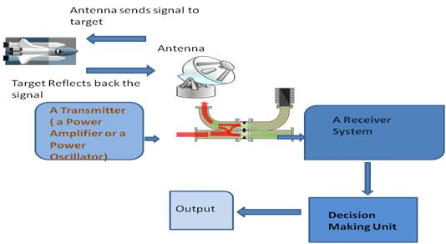

*Fig1 illustration of a RADAR system*

# THE PULSED RADAR

Pulsed RADAR sends high power and high frequency pulses towards the target object. It then waits for the echo signal from the object before another pulse is send. The range and resolution of the RADAR depends on the pulse repetition frequency. It uses the Doppler shift method.

The principle of RADAR detecting moving objects using the Doppler shift works on the fact that echo signals from stationary objects are in same phase and hence get cancelled while echo signals from moving object will have some changes in phase.

### Two types of Pulsed RADAR are:

**Pulse Doppler RADAR:**It transmits high pulse repetition frequency to avoid Doppler ambiguities. The transmitted signal and the received echo signal are mixed in a detector to get the Doppler shift and the difference signal is filtered using a Doppler filter where the unwanted noise signals are rejected.

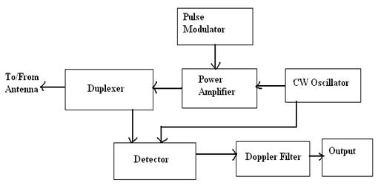

*Fig2 Block diagram of pulsed Doppler RADAR*

**Moving Target Indicator RADAR:** It transmits low pulse repetition frequency to avoid range ambiguities. In a MTI RADAR system, the received echo signals from the object are directed towards the mixer, where they are mixed with the signal from a stable local oscillator (STALO) to produce the IF signal. This IF signal is amplified and then given to the phase detector where its phase is compared with the phase of the signal from the Coherent Oscillator (COHO) and the difference signal is produced. The Coherent signal has the same phase as the transmitter signal. The coherent signal and the STALO signal are mixed and given to the power amplifier which is switched on and off using the pulse modulator.

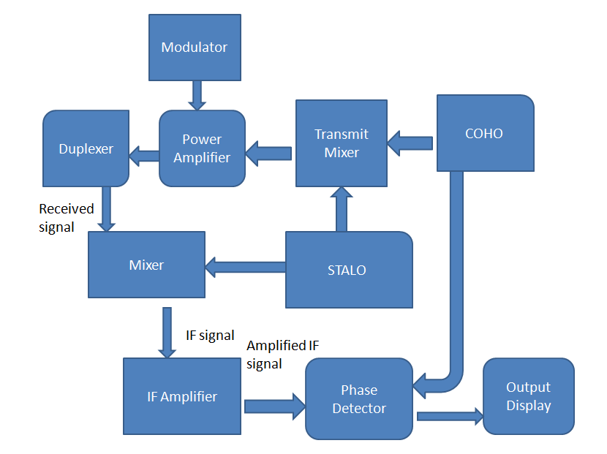fig 2.1 *Block Diagram Showing MTI RADAR by Edgefx Kits*

### Application of RADAR in 5 different areas:

**Military Applications:**

The RADAR has 3 major applications in Military:

* In air defense it is used for target detection, target recognition and weapon control (directing the weapon to the tracked targets).
* In missile system to guide the weapon.
* Identifying enemy locations in map.

**Air Traffic Control:**

The RADAR has 3 major applications in Air Traffic control:

* To control air traffic near airports. The Air Surveillance RADAR is used to detect and display the aircraft’s position in the airport terminals.
* To guide the aircraft to land in bad weather using Precision Approach RADAR.
* To scan the airport surface for aircraft and ground vehicle positions

**Remote Sensing:** RADAR can be used for observing weather or observing planetary positions and monitoring sea ice to ensure smooth route for ships.

**Ground Traffic Control:**RADAR can also be used by traffic police to determine speed of the vehicle, controlling the movement of vehicles by giving warnings about presence of other vehicles or any other obstacles behind them.

**Space:**

RADAR has 3 major applications:

* To guide the space vehicle for safe landing on moon
* To observe the planetary systems
* To detect and track satellites
* To monitor the meteors

### Radar equation

The power *Pr* returning to the receiving antenna is given by the equation:

{\displaystyle P\_{r}={\frac {P\_{t}G\_{t}A\_{r}\sigma F^{4}}{{(4\pi )}^{2}R\_{t}^{2}R\_{r}^{2}}}}

where

* *P*t = transmitter power
* *G*t = gain of the transmitting antenna
* *A*r = effective aperture  (area) of the receiving antenna; this can also be expressed as {\displaystyle {G\_{r}\lambda ^{2}} \over {4\pi }}, where
* {\displaystyle \lambda } = transmitted wavelength
* *G*r = gain of receiving antenna
* *σ* = radar cross section, or scattering coefficient, of the target
* *F* = pattern propagation factor
* *R*t = distance from the transmitter to the target
* *R*r = distance from the target to the receiver.

In the common case where the transmitter and the receiver are at the same location, *R*t = *R*r and the term *R*t² *R*r² can be replaced by *R*4, where *R* is the range. This yields:

{\displaystyle P\_{r}={{P\_{t}G\_{t}A\_{r}\sigma F^{4}} \over {{(4\pi )}^{2}R^{4}}}.}

This shows that the received power declines as the fourth power of the range, which means that the received power from distant targets is relatively very small.

Additional filtering and pulse integration modifies the radar equation slightly for pulse-Doppler radar performance, which can be used to increase detection range and reduce transmit power.

The equation above with *F* = 1 is a simplification for transmission in a vacuum without interference. The propagation factor accounts for the effects of multipath and shadowing and depends on the details of the environment. In a real-world situation, pathloss effects should also be considered.

|  |  |  |  |
| --- | --- | --- | --- |
| **Radar frequency bands** | | | |
| **Band name** | **Frequency range** | **Wavelength range** | **Notes** |
| [HF](https://en.wikipedia.org/wiki/High_frequency) | 3–30 [MHz](https://en.wikipedia.org/wiki/Megahertz) | 10–100 [m](https://en.wikipedia.org/wiki/Metre) | Coastal radar systems, [over-the-horizon radar](https://en.wikipedia.org/wiki/Over-the-horizon_radar) (OTH) radars; 'high frequency' |
| [VHF](https://en.wikipedia.org/wiki/VHF) | 30–300 MHz | 1–10 m | Very long range, ground penetrating; 'very high frequency' |
| P | < 300 MHz | > 1 m | 'P' for 'previous', applied retrospectively to early radar systems; essentially HF + VHF |
| [UHF](https://en.wikipedia.org/wiki/UHF) | 300–1000 MHz | 0.3–1 m | Very long range (e.g. [ballistic missile early warning](https://en.wikipedia.org/wiki/Ballistic_Missile_Early_Warning_System)), ground penetrating, foliage penetrating; 'ultra high frequency' |
| [L](https://en.wikipedia.org/wiki/L_band) | 1–2 [GHz](https://en.wikipedia.org/wiki/Gigahertz) | 15–30 [cm](https://en.wikipedia.org/wiki/Centimetre) | Long range air traffic control and [surveillance](https://en.wikipedia.org/wiki/Surveillance); 'L' for 'long' |
| [S](https://en.wikipedia.org/wiki/S_band) | 2–4 GHz | 7.5–15 cm | Moderate range surveillance, Terminal air traffic control, long-range weather, marine radar; 'S' for 'short' |
| [C](https://en.wikipedia.org/wiki/C_band_(IEEE)) | 4–8 GHz | 3.75–7.5 cm | Satellite transponders; a compromise (hence 'C') between X and S bands; weather; long range tracking |
| [X](https://en.wikipedia.org/wiki/X_band) | 8–12 GHz | 2.5–3.75 cm | [Missile](https://en.wikipedia.org/wiki/Missile) guidance, [marine radar](https://en.wikipedia.org/wiki/Marine_radar), weather, medium-resolution mapping and ground surveillance; in the United States the narrow range 10.525 GHz ±25 MHz is used for [airport](https://en.wikipedia.org/wiki/Airport) radar; short range tracking. Named X band because the frequency was a secret during WW2. |
| [Ku](https://en.wikipedia.org/wiki/Ku_band) | 12–18 GHz | 1.67–2.5 cm | High-resolution, also used for satellite transponders, frequency under K band (hence 'u') |
| [K](https://en.wikipedia.org/wiki/K_band_(IEEE)) | 18–24 GHz | 1.11–1.67 cm | From [German](https://en.wikipedia.org/wiki/German_language) *kurz*, meaning 'short'; limited use due to absorption by [water vapour](https://en.wikipedia.org/wiki/Water_vapor), so Ku and Ka were used instead for surveillance. K-band is used for detecting clouds by meteorologists, and by police for detecting speeding motorists. K-band radar guns operate at 24.150 ± 0.100 GHz. |
| [Ka](https://en.wikipedia.org/wiki/Ka_band) | 24–40 GHz | 0.75–1.11 cm | Mapping, short range, airport surveillance; frequency just above K band (hence 'a') Photo radar, used to trigger cameras which take pictures of license plates of cars running red lights, operates at 34.300 ± 0.100 GHz. |
| mm | 40–300 GHz | 1.0–7.5 [mm](https://en.wikipedia.org/wiki/Millimetre) | [Millimetre band](https://en.wikipedia.org/wiki/Millimetre_band), subdivided as below. The frequency ranges depend on waveguide size. Multiple letters are assigned to these bands by different groups. These are from Baytron, a now defunct company that made test equipment. |
| [V](https://en.wikipedia.org/wiki/V_band) | 40–75 GHz | 4.0–7.5 mm | Very strongly absorbed by atmospheric oxygen, which resonates at 60 GHz. |
| [W](https://en.wikipedia.org/wiki/W_band) | 75–110 GHz | 2.7–4.0 mm | Used as a visual sensor for experimental autonomous vehicles, high-resolution meteorological observation, and imaging. |