**CreateStaffDb: A Graphical User Interface (GUI) to Add a Staff Member**

**To the Staff Database.**

**Author: Mikhail Rezazadeh April 2017**

**Purpose:** This interface allows for the addition of a new staff member’s information to be entered into the staff database.

**Who will use it?** Anyone in the company, even people who are not familiar with software programming.

**Database Format:** The database is a CSV file “staffDatabase.txt”. Each row corresponds to a single staff member. The fields, in order, are:

* Staff ID (10 digits)
* Full Name (eg. John Smith)
* Date of Birth (eg 06/18/1980)
* Social Security Number (9 digits)
* Start Date (eg. 05/16/2000)
* Title (Software engineer, etc.
* Status (Active vs Retired vs Resigned)

**Design:**

1. **Data-Entry page**: The page where the user enters new data
2. **Data-Review page:** The page where the user sees that is about to be entered into the database
3. **Submission page:** The page where the user sees whether the submission was successful

**Data Entry Page:**

The data entry page will need to have locations where the user can enter in each of the fields that go into the database. Some fields are going to be required, while others are not. Staff ID and Social Security Number will be required because these should be unique for each staff member, and thus they will be used to compare staff members with each other (this is how conflicts will be avoided when adding to the database).

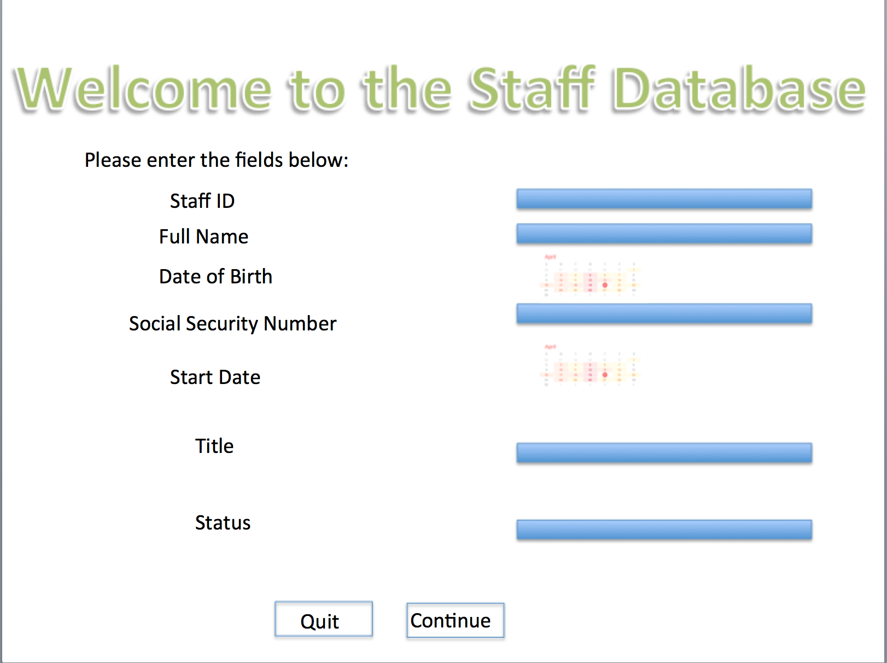

* **Data Entry Page - Welcome Message** A short message introducing the interface to the user and telling them what to do (e.g. “please enter the fields below”).
* **Data Entry Page - Staff ID Field** A place to enter the staff id. This must reject all text that does not correspond to an integer value. It must also reject all input that is not exactly 10 characters long. It will also be a nice feature to the user to highlight this box when the mouse hovers over it.
* **Data Entry Page – Full Name Field** A place to enter the full name. This is not required since it does not uniquely identify a staff member (two people could have the same names). So conflicts can be avoided without the full name. This field will reject any input longer than 50 characters. It will also be a nice feature to the user to highlight this box when the mouse hovers over it.
* **Data Entry Page – Date of Birth Field** A place to enter the date of birth. This must reject dates more recent than 18 years ago, because no one younger than 18 years of age is allowed to work at the company. It should also reject dates prior to 100 years ago, because no one older than 100 works for the company.
* **Data Entry Page – Social Security Number Field** A place to enter the social security number. This must reject all text that does not correspond to an integer value. It must also reject all input that is not exactly 9 characters long. It will also be a nice feature to the user to highlight this box when the mouse hovers over it.
* **Data Entry Page – Start Date Field** A place to enter the date that the employee started working at the company. This must reject dates later than today, and older than 82 years ago (assuming people are at least 18 years old before they start working, this rejects people older than 100 years old). It finally cannot be closer than 18 years within the date of birth selected by the user.
* **Data Entry Page – Title Field** A place to enter the title of the employee. Since we already know all possible titles, we can make this a drop-down box.
* **Data Entry Page – Status Field** A place to enter the status of the employee. Since we already know all possible titles, we can make this a drop-down box. It will have a default value of ‘Active’.
* **Date Entry Page – Quit Button** A button that allows the user to quit. A warning should be displayed before quit notifying the user that no data has yet been submitted to the database.
* **Data Entry Page – Continue Button** A button that allows the user to proceed to the data review page. This button will show a warning if the staff id or social security number are missing.

**Data Review Page:** This page allows the user to see what the GUI received when they clicked “Continue”.

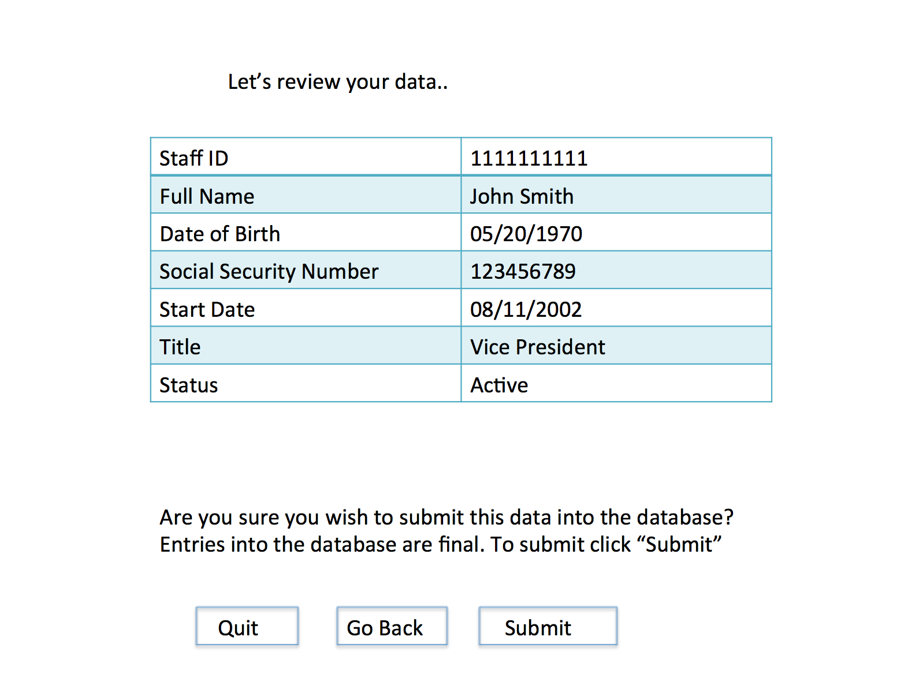

* **Data Review Page – Welcome Message** A simple message letting the user know that this is the review section
* **Data Review Page – Review Table** A table of information displaying all of the information the user just entered.
* **Data Review Page – Warning message** “Submissions are final, are you sure you want to submit?”
* **Data Review Page – Quit Button** A button that allows the user to quit. A warning should be displayed before quit notifying the user that no data has yet been submitted to the database.
* **Data Review Page – Back Button** A button that allows the user to go back and enter in new data.
* **Data Review Page – Submit Button** If the user is happy with his or her entered data, he or she can choose to submit. This will take them to the submission page.

**Submission Page:** A page to let the viewer know if the submission was successful. If there is already someone in the database with the proposed staff if or the proposed social security number, the user is notified and they are given a “back” button. Otherwise, they are given a quit button.

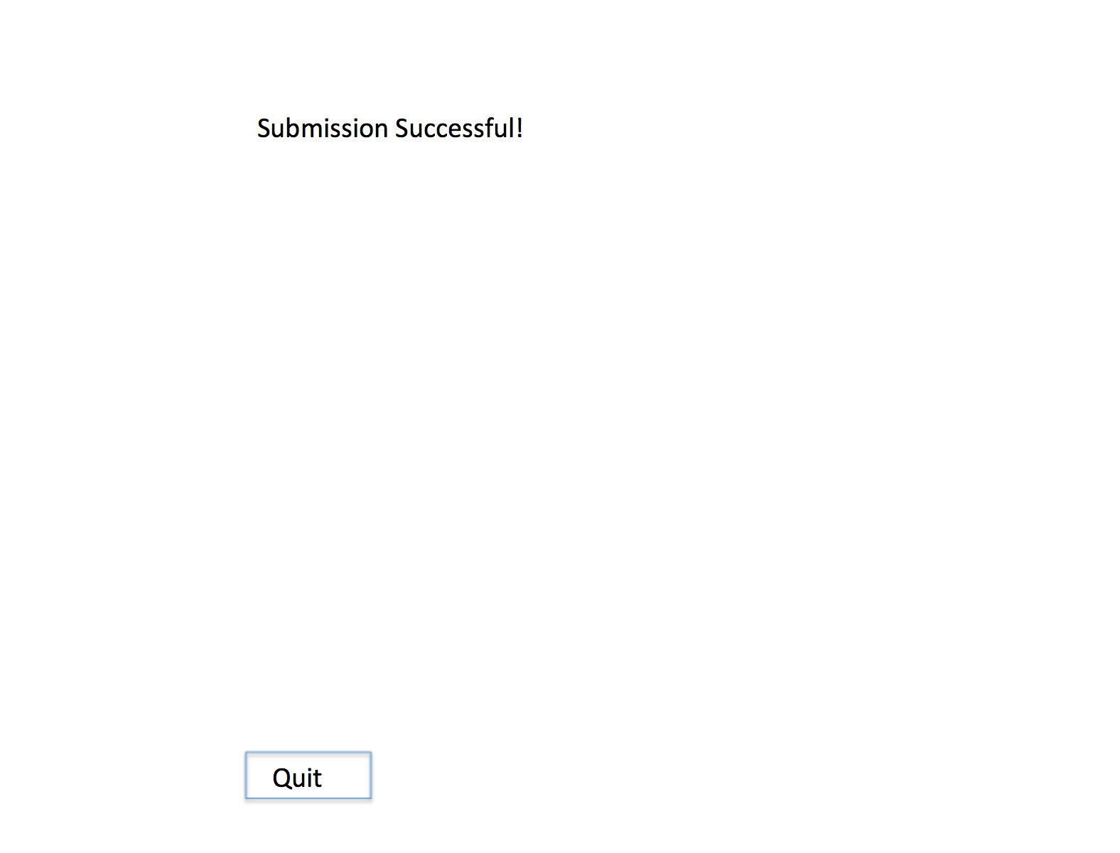

* **Data Review Page – Message** Either “error!” or “success!”
* **Data Review Page – Button** Either “back” (takes them back to the data entry page) or “quit” (exits the program with no warning message).