**SearchStaffDb: A Graphical User Interface (GUI) to Search**

**the Staff Database.**

**Author – Mikhail Rezazadeh April 2017**

**Purpose:** This interface allows a user to search the staff database for matches to a value of a staff attribute. For example, a user can find all people with the start date “05/08/1999”, or all the people with the Title “Junior Software Engineer”.

**Who will use it?** Anyone in the company, even people who are not familiar with software programming.

**Database Format:** The database is a CSV file “staffDatabase.txt”. Each row corresponds to a single staff member. The fields, in order, are:

* Staff ID (10 digits)
* Full Name (eg. John Smith)
* Date of Birth (eg 06/18/1980)
* Social Security Number (9 digits)
* Start Date (eg. 05/16/2000)
* Title (Software engineer, etc.
* Status (Active vs Retired vs Resigned)

**Design:**

1. **Search-Page** The page where the user searches for database matches

**Search Page**

The search page will be the only page of this GUI. A user will be able to select a staff attribute (e.g. “Title” or “Start Date”), and fill in a value for that attribute that they would like to match.

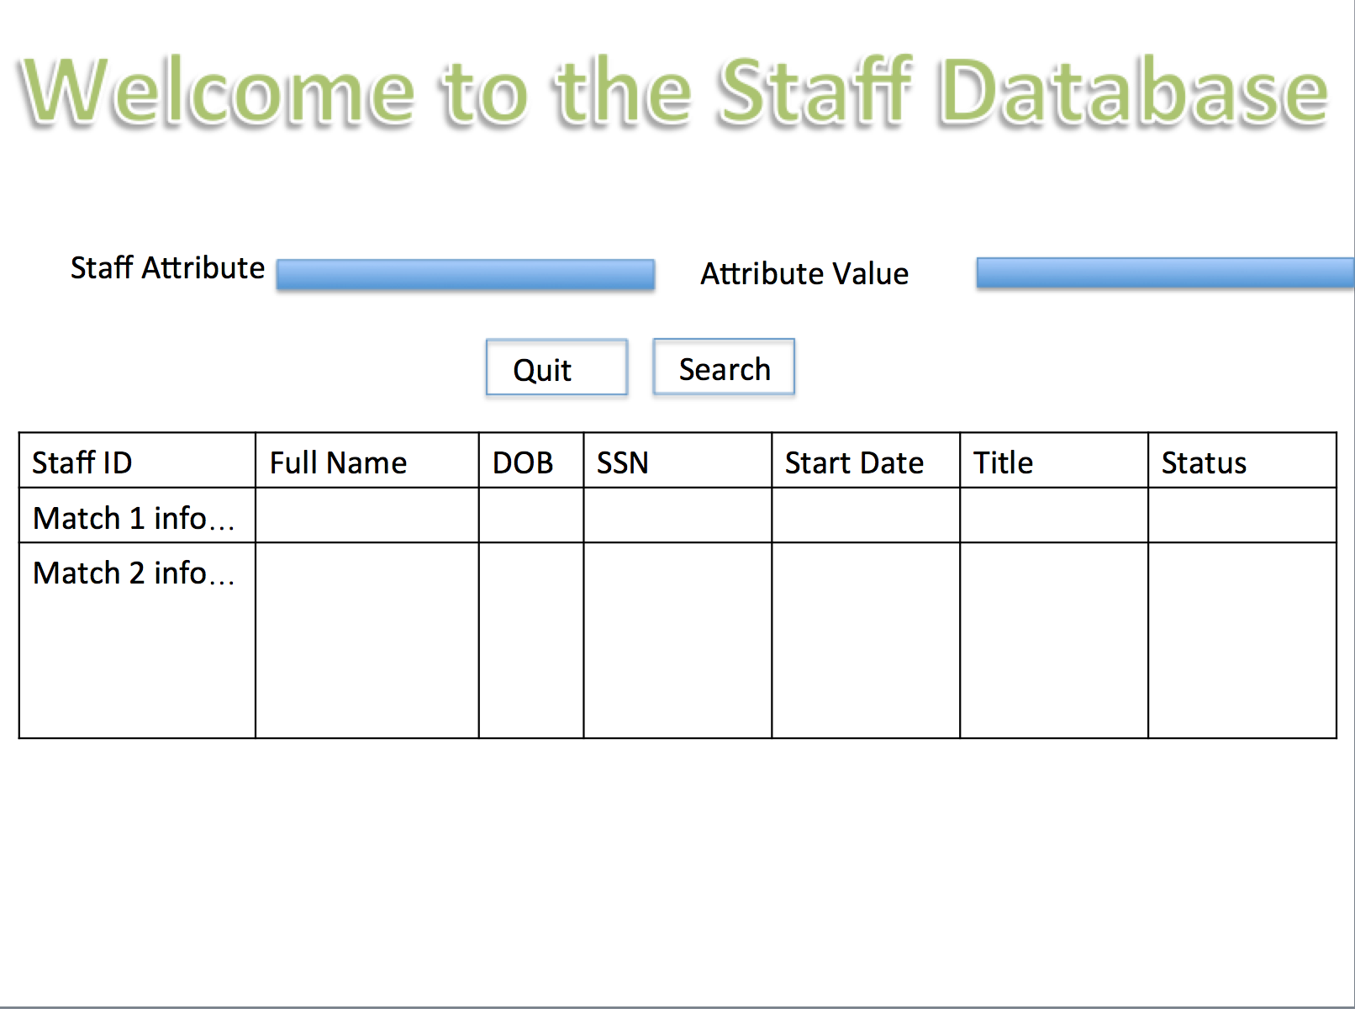

* **Search Page - Welcome Message** A short message introducing the interface to the user and telling them what to do (e.g. “please enter the fields below”).
* **Search Page - Attribute Field** A place to enter the attribute. This can be a drop box because the only options are “Staff ID”, “Full Name”, “Date of Birth”, “Social Security Number”, “Start Date”, “Title”, and “Status”.

* **Search Page – Value Field** A place to enter the value. The maximum allowable characters must change depending on the selection of the attribute field (if the user selects SSN, the maximum allowable characters is 9).

* **Search Page – Quit Button** An option to the user to quit the program. No warning is given when clicked.
* **Search Page – Search Button** Searches the database when clicked.
* **Search Page – Result Table** This displays the matches in the database. It must be scrollable in case the database is big. It must also be sortable if the user clicks on one of the column headers.