|  |  |  |  |  |
| --- | --- | --- | --- | --- |
| |  |  | | --- | --- | | prostep ivip   |  | | --- | | VDA | | | Automated Functional Data Exchange in the Automotive Industry | PSI 20  VDA 5550  Part 3.x 0.1 |
| How to work with this document:  Update some fields, because they are used for repeated use in the document text  Document specific fields (File -> Properties -> Details  Subject = Component / Part Name (Default “COMPONENT_NAME”)  Title = Version No. (Default “”0.1”)  Categories = Recommendation No (Default “3.x”)  All yellow highlighted text is hidden = not printed  Text in turquoise highlighting can be used or adopted  Text in red highlighting has to be added/modified  **Teil 3.x: Wheel Brake**  This VDA / PSI recommendation was drawn up by the Functional Data Exchange (FDX) working group and defines a standard format and a machine-readable specification of a data model/data format for the transfer of functional data (e.g. characteristic diagrams, characteristic curves, characteristic values) between customers and their suppliers.  It enables the exchange of highly structured data. This recommendation aims at facilitating consistent and efficient implementation of these processes in the automotive industry.  Objectives:   * Harmonization of the exchange of functional data between OEMs and suppliers * Improved quality and availability of functional data for CAE/simulation purposes * Elimination of discrepancies in functional data between ordered and delivered data * Higher level of automation for data generation, data exchange and data use  |  | | --- | | **Version 0.1 from 7. October 2021** | | | |
| |  | | --- | | **prostep ivip / VDA Functional Data Exchange FDX working group** | | | |
| |  |  |  |  |  |  |  | | --- | --- | --- | --- | --- | --- | --- | | |  |  |  |  |  |  | | --- | --- | --- | --- | --- | --- | | |  |  | | --- | --- | | |  | | --- | | Publisher: Verband der Automobilindustrie (VDA) Copyright  Behrenstraße 35 Reprints and any other form  Postfach 8 04 62 of reproduction is permitted  D-10004 Berlin only if the source is cited.  Telephone +49 (0)30 897842-221  Telefax +49 (0)30 897842-606  Internet: [www.vda.de](http://www.vda.de) | | |  | | |  | | --- | | prostep ivip Association  Dolivostr. 11  64293 Darmstadt  Telephone +49 (0)6151/ 9287-336  Telefax +49 (0)6151/9287-326  Internet: [www.prostep.org](http://www.prostep.org) | | | | | | |

***Disclaimer***

VDA recommendations are recommendations that are available for general use. Although VDA recommendations provide a cross-company guide, they do not take account of any case-specific constraints. They require further examination and interpretation by the business partners involved in the process.

VDA recommendations give due consideration to the prevailing state-of-the-art at the time of publication. Anyone using VDA / PSI Recommendations must assume responsibility for their actions and acts at their own risk. The VDA and the parties involved in drawing up the VDA recommendations assume no liability whatsoever.

Users are asked to point out any errors or inconsistencies that still need to be addressed and to participate in the ongoing standardization process via the VDA.

**List of changes**

|  |  |  |  |
| --- | --- | --- | --- |
| **Date** | **Version** | **Action** | **Description** |
| 09/2021 | 0.1 | Provide basic approach | Initial version |
|  |  |  |  |
|  |  |  |  |
|  |  |  |  |
|  |  |  |  |

Content

1 Introduction 5

1.1 Background and objectives 5

1.2 Structure of the VDA recommendation 5

1.3 Formatting conventions 5

2 Definitions 6

2.1 Coordinate systems 6

2.2 Conventions for operational signs 6

3 Part Specific Information {AddInfoPartSpec} 6

4 Test Equipment Setup {Test Equipment} 7

5 Test Equipment Parameters (part-specific) {Test Sequence} 8

5.1 General 8

5.1.1 Classification 8

5.1.2 Specifying data points 8

5.2 Preload {Preload} 8

5.3 Additional Preload {Preload2} 8

5.4 Preconditioning {PreConditioning} 8

*5.4.1**Bedding-in or burnishing procedure of wheel brakes {TPmBedIn}* 8

5.5 Test programs 9

*5.5.1**AK-Master SAE-J2522 {TPmAKMasterMS}* 9

*5.5.2**Wear Test Procedure SAE-J2707 {TPmBrkWearMS}* 9

5.6 Environmental Parameters {EnvironmentPara} 9

5.6.1 Environmental Temperature {EnvironTempPara} 9

5.6.2 Air Flow {EnvironAirFlowPara} 9

6 Instance data 10

6.1 Functional Data (part-specific) {FunctionalData} 10

*6.1.1**Friction value characteristic*  10

Brake lining wear characteristic 12

6.1.2 Volume Consumption of Brake Caliper x 13

6.2 Derived Characteristics (part-specific) 13

7 Closing remarks 14

8 Table of Attributes 14

# Introduction

Background and objectives

This VDA 5550 / PSI 20 recommendation describes a data model and format for the standardized and traceable exchange of functional data and relevant, associated meta data.

This document, Part 3.x, describes the data format for the part-specific elements ofWheel Brake, the wheel attached parts of the brake system. An explanation of the functional data relevant for Wheel Brake and the test programs used in particular is provided.

The data model is suitable for the exchange of function data for conventional passive and infinitely adjustable telescopic dampers. Special valve functions not fully covered by this model (e.g. frequency- or amplitude-selective function) may have to be transferred in a data format that needs to be agreed separately.

Structure of the VDA recommendation

This VDA recommendation is structured as shown in

***Figure*** *1.1*. It comprises the main document (Part 1 of the recommendation) covering the topic in general, Part 2, which contains more detailed information about the attribute list and the data model, and Parts 3.x, which contain part-specific contents provided in the form of PDF documents and templates, i.e. ATFX files that contain part-specific application administration. More detailed information is provided in a number of appendixes. An overview of a component in its entirety is therefore provided by Part 1, Part 2 and the respective part-specific section in Part 3.x.

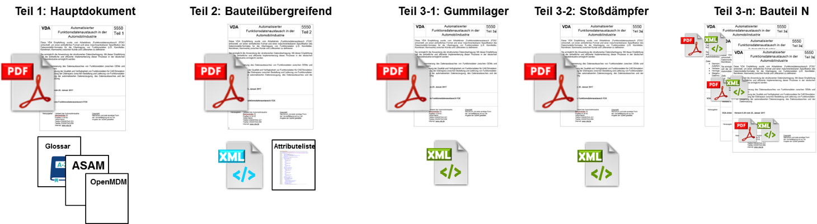

*Figure 1.1*: Structure of the VDA recommendation

Formatting conventions

References to the Attributes Data Sheet (Annex A of Part 2 of the PSI 20 / VDA 5550 Recommen-dation) have the following format: *LabelName {FieldName}*.

The notation *LabelName {Category.Subcategory.FieldName}* is used as needed to improve under-standing, e.g. eliminate ambiguities. The values for fields are enclosed in double quotes.

Categories, subcategories and field names for the basic prostep ivip / VDA model start with the prefix *"BASE__"*.This allows user-specific extensions (with their own prefix) to be used for a field name with the same name within a subcategory.

# Definitions

Coordinate systems

The functional characteristics of brakes are mainly described in 0D/1D. For this reason, a coordinate system is not applicable.

When describing the movement of parts, the x-axis is represented as the axis along the movement.

Conventions for operational signs

In brake applies, torque on wheels is considered to be positive.

# Part Specific Information {AddInfoPartSpec}

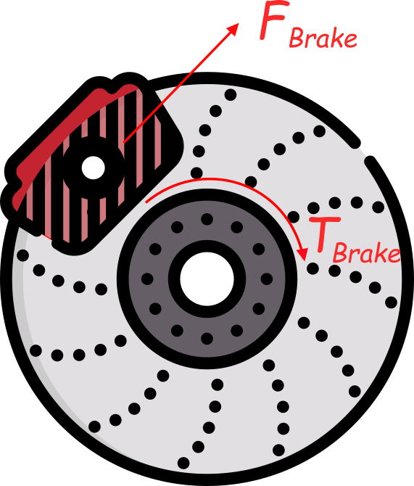

Figure 3‑1 Schematic of a disc brake

The part-specific additional information allows further detailed information to be provided on Wheel Brake. In some cases, data is entered directly (e.g. length values) and in some cases values are selected from a drop-down menu.

The most important distinction between Wheel Brake is done by the part type. This can be specified by selecting attributes from a predefined list (multiple selection possible). It is possible, and in some cases expedient, to select multiple attributes. No check is made to determine whether the selected combination is reasonable.

The following attributes can be selected for *Part Type {PartType}:*

* *Disc Brake*
* *Drum Brake*

This enumeration is purely informative in nature and has no impact on the attribute file list.

The Disc Brake Type is used to distinguish between the main concepts of the caliper representation:

* ‘Sliding Caliper’
* ‘Fixed Caliper’

For either type of Disc Brake Type, the number of pistons inside the caliper is required to further specify the design of the brake caliper.

* BrakeNumberOfPistons

The Axle Type is used to select the respective axle the wheel brake is applied to:

* ‘Front’
* ‘Rear’

In the case of axle type (‘AxleType’ = ‘Rear’), the type of park brake mechanism needs to be specified:

* ‘Mechanical Park Brake’
* ‘Electric Park Brake’

For definition if brake has recuperating feature (BrakeRecuperation) the following toggle attributes are valid:

* ‘Yes’
* ‘No’

In addition, a variety of geometrical dimensions can be specified. These are relevant to calculate the brake torque.

* Effective radius Distance from wheel center to center of brake caliper piston diameter
* Piston diameter : Diameter of piston in brake caliper, in case of >1 piston, quantity and diameter of the piston is required.
* Pad wear thickness }: Wearable thickness of brake pad

Attributes with relationship and dependencies should be described in this section. E.g. If attribute “xy” is selected than the list of functional data (attributes) changes

Please specify all listed attributes in detail.

In part 6.1 additional part specific attributes could be defined and described

# Test Equipment Setup {Test Equipment}

This section describes the test rig, including the adaptation for clamping the unit under test to the test rig. The latter information in particular is important, since the measurement result normally depends on how the test rig adaptation is designed.

In case simulation is used, the name of the software product and specific model used can be included in this section to accommodate the generation of functional data on the basis of simulations. In this context, the software product is considered a digital test rig.

Functional data can be estimated if neither measurements nor simulations are available. The procedure used for the estimation can be named and a free text can be used to provide further details.

Alongside the attributes for describing the test bench, it is also possible to use the following characteristics to describe adaptation of the part for the test in greater detail:

Test programs for wheel brakes are typically carried out on an inertia brake dynamometer. The unit under test is the complete wheel brake assembly consisting of e.g. brake caliper including brake pad, brake rotor, wheel bearing and knuckle.

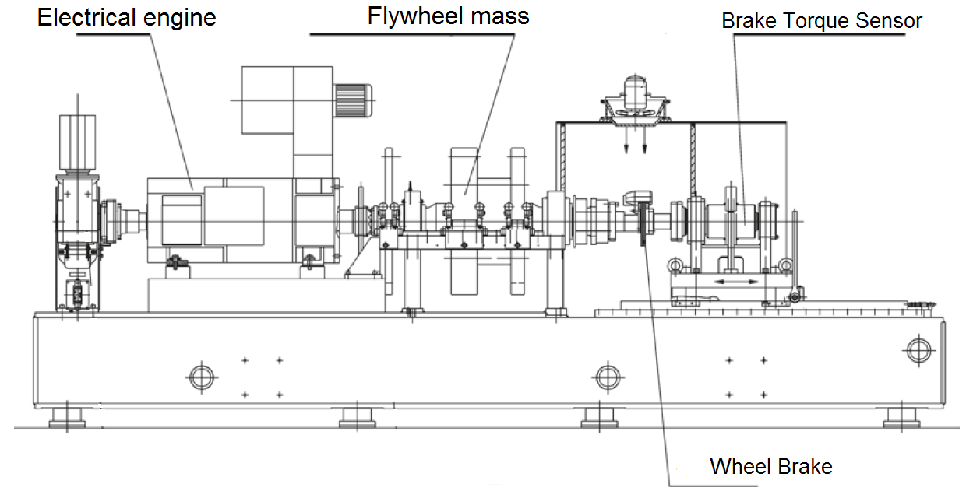

# Test Equipment Parameters (part-specific) {Test Sequence}

General

### Classification

Test equipment parameters bring together information required to determine the instance data. They will reflect the way in which the instance data is determined on the test rig and form a considerably simplified basis for the testing program used.

Please add classification information

### Specifying data points

See prostep ivip / VDA Recommendation 5550 Part 2.

Preload {Preload}

Please describe test preload(s) conditions

Additional Preload {Preload2}

Preconditioning {PreConditioning}

Test programs can be used for both the actual testing and for preconditioning the component prior to testing. A bedding in, also known as burnishing, procedure for brake pads and rotor is to be run before testing.

Please describe here which preconditions are required before executing the tests.

The test programs used for preconditioning and the actual measurement are independent of each other, i.e. they can be different and can also include different parameters.

### *Bedding-in or burnishing procedure of wheel brakes {TPmBedIn}*

The pre-conditioning is applied before testing to prepare brake pads and rotors to run in stabilized condition at brake applies.

In general the bedding-in or burnishing is realized by performing multiple brake applies from an initial speed, e.g. 50kph to 0kph.

Test programs

Description test program 1

Describe the program by defining attribute like maximum ecitation velocity or frequency, signal shape, number of cycles. It is recommended to add (a) diagram(s) as example

### *AK-Master SAE-J2522 {TPmAKMasterMS}*

The „AK-Master” – Dynamometer Global Brake Effectiveness provides an overall picture of the friction value for a wheel brake. This test procedure evaluates the effective indicators of friction material, taking into account the different pressure, temperature and speed conditions for motor vehicles equipped with hydraulic brakes. The main purpose of SAE J2522 is to compare the friction material as closely as possible under similar conditions. To take into account the different characteristics of the brake cooling systems of different dynamometers, the fade section is temperature controlled.

[J2522A: Dynamometer Global Brake Effectiveness - SAE International](https://www.sae.org/standards/content/j2522_201409/?_ga=2.212262615.2112543266.1631161021-652078133.1630906703)

### *Wear Test Procedure SAE-J2707 {TPmBrkWearMS}*

The SAE J2707 describes a Wear Test Procedure on inertia dynamometer for brake friction materials. With that, it is possible to compare wear characteristics of brake pad and rotor for different combinations and set-ups.

The following parameters on the inertia dynamometer are to be documented:

* Inertia
* Number of stops per temperature slot
* Average Deceleration
* Initial velocity
* Static loaded radius

[J2707A: Wear Test Procedure on Inertia Dynamometer for Brake Friction Materials - SAE International](https://www.sae.org/standards/content/j2707_202106/?_ga=2.43851750.2112543266.1631161021-652078133.1630906703)

Environmental Parameters {EnvironmentPara}

Due to the temperature dependency of measurements for wheel brakes environmental parameters shall be controlled.

### Environmental Temperature {EnvironTempPara}

The environmental temperature shall be kept at a value of 15°C or 20°C unless otherwise specified

### Air Flow {EnvironAirFlowPara}

The airflow used for cooling of the wheel brake between and during brake applies. This airflow needs to be set according to the specific test run on the dynamometer.   
The two main applications are

1. simulation of airflow of moving vehicle and
2. cooling of wheel brake assembly to reach test specified initial brake rotor temperature.

# Instance data

Functional Data (part-specific) {FunctionalData}

This section contains a description of the utilizable result data and a reference to the test program that should typically be used to determine the values.

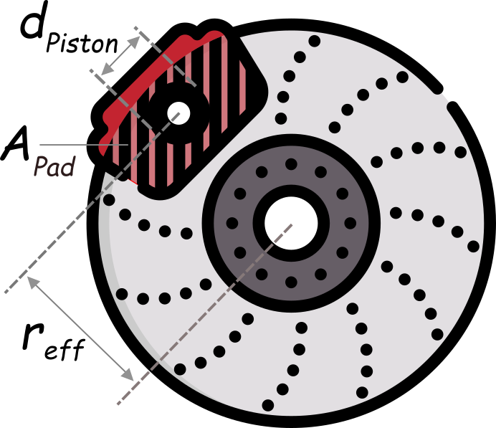Figure 6‑1 Geometrical terms of a disc brake

### *Friction value characteristic*

The friction value characteristic of a wheel brake can be determined using the AK-Master – Dynamometer Global Brake Effectiveness measurement.

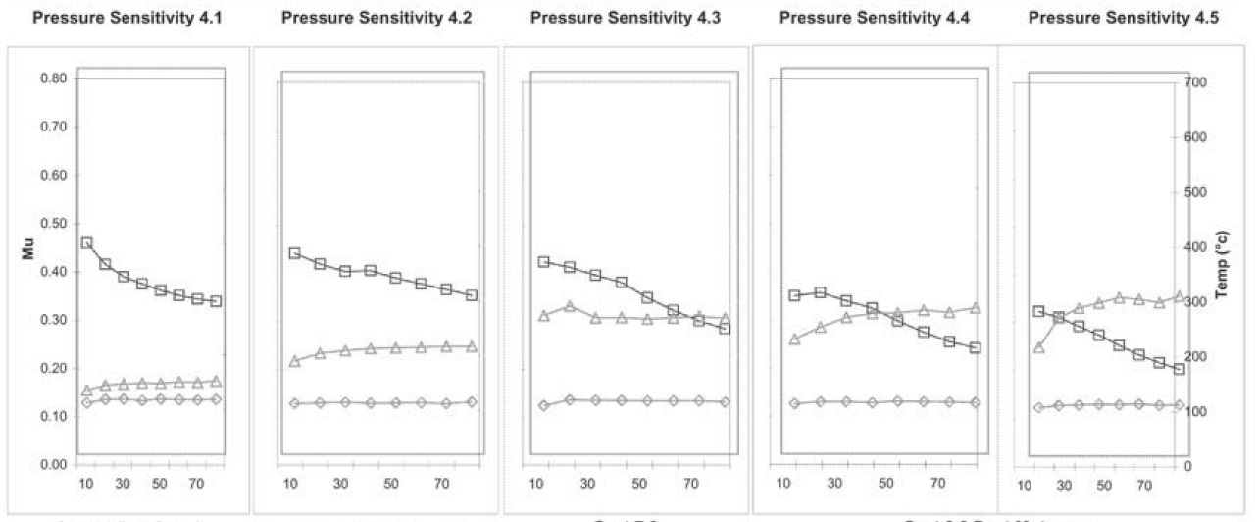

Figure 6‑2: Friction coefficient at pressure applies

In order to measure the friction coefficient the wheel brake is excited with various pressure applies (Figure 6‑3) and different initial brake rotor temperatures (Figure 6‑4). Pressure in this context is the hydraulic pressure inside brake lines and brake caliper (not the mechanic pressure between pad and disc).   
Because the friction coefficient varies over time for each brake snub, an average friction coefficient is calculated for each snub. Therefore, the measurement results have to contain the following vectors:

* *Velocity*
* *Pressure*
* *Temperature Friction Coefficient*

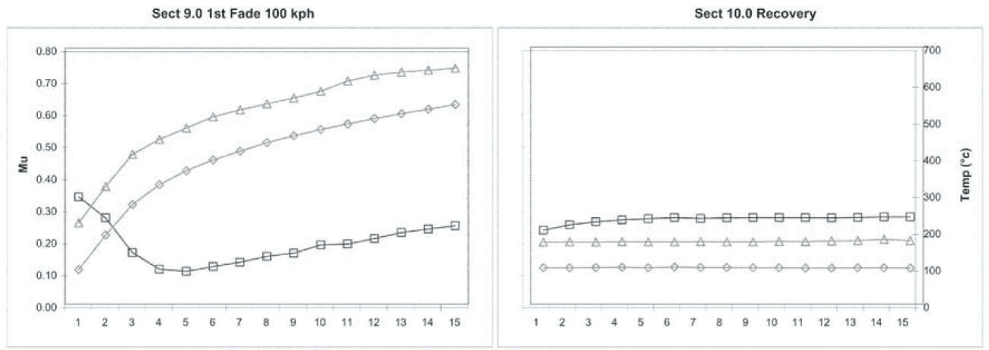

Figure 6‑5: Friction coefficient over temperature

As result of the different measurements a friction map should be generated with Friction Coefficient {Mu} is described over Pressure {Pressure} and Temperature {Temperature}. An Example of a friction map is shown in Table 6‑2Table 6‑1 or visualized in Figure 6‑6:

|  |  |  |  |  |  |
| --- | --- | --- | --- | --- | --- |
| **Pressure [bar]**  **Temperature [°C]** | **5** | **10** | **25** | **50** | **120** |
| **20** | 0.21 | 0.27 | 0.30 | 0.32 | 0.32 |
| **100** | 0.24 | 0.30 | 0.34 | 0.36 | 0.36 |
| **200** | 0.22 | 0.28 | 0.32 | 0.33 | 0.34 |
| **…** | … | … | … | … | … |
| **600** | 0.16 | 0.20 | 0.22 | 0.23 | 0.24 |

Table 6‑2: Example of MapBrkFricVal

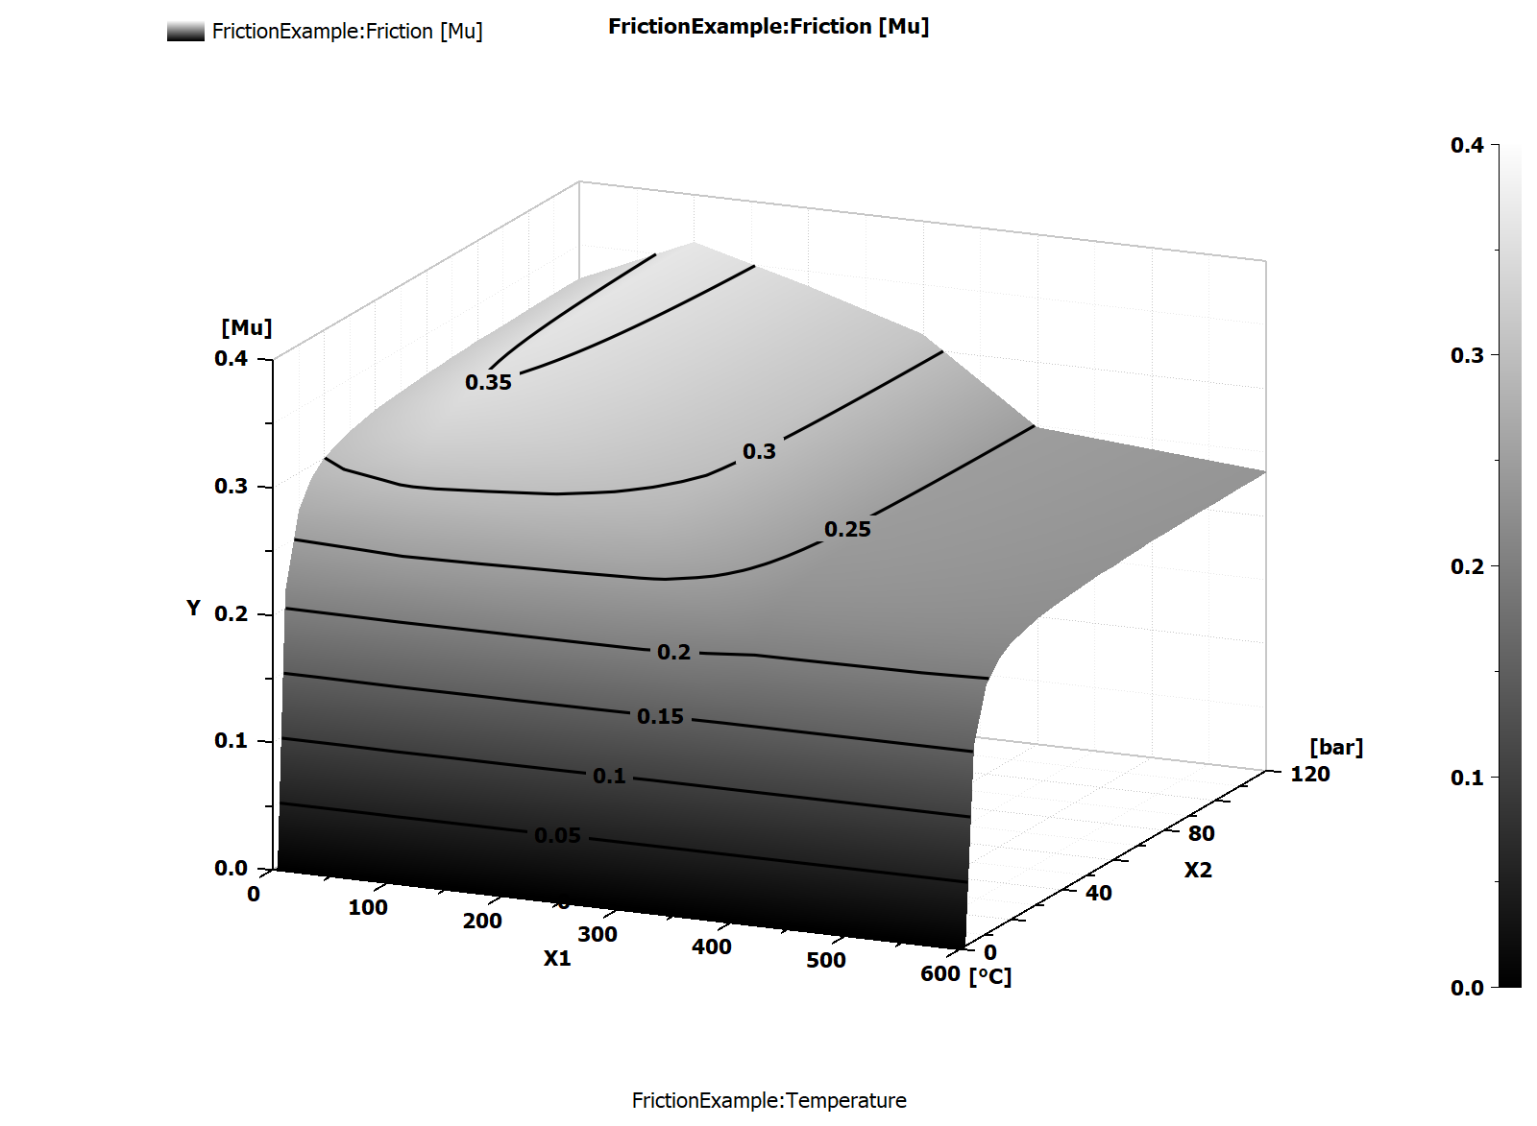

Figure 6‑7: Field of friction coefficient over pressure and temperature

### Brake lining wear characteristic

The brake lining wear characteristic is commonly generated by measuring the brake lining thickness at several measurement points at the brake lining surface before and after a series of brake applies at a specific initial temperature of the brake rotor. A series hereby usually consists of 500 or 1000 repetitive brake snubs. It is also foreseen to perform this series at the different brake rotor temperatures in an ascending and descending walk of temperature steps like shown in **Table 6‑3:**

|  |  |
| --- | --- |
| Temperature [°C] | Pad (mm) |
| 40°C | 0.1 |
| 100°C | 0.1 |
| 200°C | 0.15 |
| 300°C | 0.35 |
| 200°C | 0.15 |
| 100°C | 0.10 |
| 40°C | 0.05 |

Table 6‑4

In that way not only stepwise heating up the brake is considered in the lining wear measurement, but also a second measurement when the lining has experienced the higher temperatures.

Beside of this the *Wear Test Procedure SAE-J2707 {TPmBrkWearMS}* might be a test procedure to use when measuring brake lining wear.

In the end, either test scenario should account to result in the following vectors:

* *Temperature*
* *Lining wear*

### Volume Consumption of Brake Caliper x

A representative volume consumption is measured either at different levels of hydraulic pressures for hydraulic or of force for non-hydraulic applied brake. To have a complete picture of a brake calipers volume consumption, application levels shall comprise the complete range of application, e.g. for hydraulic brakes pressures from 5 bar to 120 bar are usually applied. The measurement results are described using the following vectors:

* *Pressure*
* Consumed Volume

The derivate of the measurement is a characteristic curve representing the volume consumption like shown in Table 6‑5:

|  |  |
| --- | --- |
| bar | cm³ |
| 0 | 0 |
| 5 | 0.77 |
| 20 | 1.115 |
| 40 | 1.47 |
| 60 | 1.81 |
| 100 | 2.375 |
| 160 | 3.1 |

Table 6‑6: Example of volume consumption (CurveVolConsCaliper)

Beside the characteristic curve of volume consumption (CurveVolConsCaliper) the following parameters should be provided as derived characteristics

* Push-out pressure
* Running clearance
* Parameters of approximation function V = A*p/(B+p) + C*p:  
  A: Pressure compliance factor [cm³]

B: Curvature factor of the non-linear share of the pad characteristic [bar]  
C: Compliance of brake caliper and linear share of pad characteristic [cm³/bar]

V: volume consumption (CurveVolConsCaliper)

Derived Characteristics (part-specific)

For the AK-Master SAE-J2522 {TPmAKMasterMS} measurement the following characteristic values can be derived and are typically shared

|  |  |  |
| --- | --- | --- |
|  | Reference | Description |
| *General Characteristic Value* | 3 |  |
| *Pressure Sensitivity Value 1* | 4.3 |  |
| *Pressure Sensitivity Value 2* | 4.5 |  |
| *Post Speed Characteristic Value* | 5 |  |
| *40°C Brake Apply* | 6 |  |
| *Second Motorway Apply* | 7 |  |
| *Post Motorway Characteristic Value* | 8 |  |
| *Fade 1* | 9 |  |
| *Recovery Characteristic Value* | 10 |  |
| *Temperature Sensitivity Value* | 12 |  |
| *Characteristic Check Value* | 13 |  |
| *Fade 2* | 14 |  |
| *Post Fade Characteristic Value* | 15 |  |

Table 6‑7 Characteristic values from AK Master

The stipulations for calculating each of the characteristic values will be agreed on an individual basis between the client and the supplier.

# Closing remarks

A description of the generally applicable, non-part-specific concepts can be found in Part 2. A complete overview and brief description of all part-specific and non-part-specific attributes can be found in the Attributes Data Sheet (Annex A to Part 2).

# Table of Attributes

Please use Right-Click and “Update field” to update the list of attributes.

AvgDecel, 9

AxleType, 7

BrakeNumberOfPistons, 7

BrakeRecuperation, 7

CurveBrkLiningWear, 12

*CurveBrkLiningWear.Lining wear*, 13

*CurveBrkLiningWear.Temperature*, 13

CurveVolConsCaliper, 13

CurveVolConsCaliper.ConsumedVolume, 13

*CurveVolConsCaliper.Pressure*, 13

DiscBrakeType, 6

*DrumBrakeType*, 6

DynoInertia, 9

EffectRadius, 7

InitVel, 9

*MapBrkFrictVal*, 10

*MapBrkFrictVal.FrictionCoefficient*, 10

*MapBrkFrictVal.Pressure*, 10

*MapBrkFrictVal.Temperature*, 10

*MapBrkFrictVal.Velocity*, 10

NumberStopsPerSlot, 9

PadWearThickness, 7

ParkBrakeMechanism, 7

PistDiameter, 7

TireStaticLoadedRadius, 9

*TPmAKMasterMS.CheckChar*, 14

*TPmAKMasterMS.ColdBrakeApply*, 13

*TPmAKMasterMS.Fade1Char*, 13

*TPmAKMasterMS.Fade2Char*, 14

*TPmAKMasterMS.GenCharValue*, 13

*TPmAKMasterMS.PostFadeChar*, 14

*TPmAKMasterMS.PostMotorwayChar*, 13

*TPmAKMasterMS.PostSpdChar*, 13

*TPmAKMasterMS.PressSens1*, 13

*TPmAKMasterMS.PressSens2*, 13

*TPmAKMasterMS.RecChar*, 14

*TPmAKMasterMS.SecMotorwayApply*, 13

*TPmAKMasterMS.TempSensChar*, 14