Documentation


Vehicle Electric Container (VEC)

prostep ivip Documentation

Vehicle Electric Container (VEC)
Model Documentation
Version 2.2.0, 19 September 2025
Status: published

Document History

Version | Date | Author | Description
2.2.0 | 19.09.2025 | Becker | Publication after final review.

Abstract

This is the printable version of the Vehicle Electric Container (VEC) Online Model Description, available at https://ecad-wiki.prostep.org/specifications/vec/. Its main purpose is to provide a useful representation for reading and reviewing.

This is the not officially published VEC PSI recommendation.

Disclaimer

prostep ivip documents (PSI documents) are available for anyone to use. Anyone using these documents is responsible for ensuring that they are used correctly.

This PSI documentation gives due consideration to the prevailing state-of-the-art at the time of publication. Anyone using PSI documentations must assume responsibility for his or her actions and acts at their own risk. The prostep ivip Association and the parties involved in drawing up the PSI documentation assume no liability whatsoever.

We request that anyone encountering an error or the possibility of an incorrect interpretation when using the PSI documentations contact the prostep ivip Association (psi-issues@prostep.org) so that any errors can be rectified.

Copyright

- All rights to this PSI documentation, in particular the right to reproduction, distribution and translation remain exclusively with the prostep ivip Association and its members.
- The PSI documentation may be duplicated and distributed unchanged in case it is used for creating software or services.
- It is not permitted to change or edit this PSI documentation.
- A notice of copyright and other restrictions of use must appear in all copies made by the user.

Content
Table of Content
Content 4
1.1 Key Concepts 22
1.1.1 Parts, Documents and Resources 22
1.1.2 Assignment Group 25
1.1.3 Variants 26
1.1.4 Variant Structure 28
1.1.5 Usage Node 29
1.1.6 Usage Constraints 30
1.1.7 VEC-Root 31
1.1.8 Information Reuse 32
1.2 Basic Datatypes 33
1.2.1 Structured Primitives 33
1.2.2 Localization of Strings 34
1.2.3 Numerical Values & Units 35
1.2.4 Multidimensional Values 37
1.2.5 Extensibility with Custom Properties 38
1.2.6 Foundation Classes for Physical Properties 39
1.2.7 Alias Identifications 40
1.2.8 Open and Closed Enumerations 40
1.2.9 Open and Closed Pattern Restrictions 41
1.3 PDM Information 42
1.3.1 Lifecycle Information 42
1.3.2 Baselines 44
1.3.3 Item History 45
1.3.4 Item Equivalence 47
1.4 General Component Data 48
1.4.1 Description of Parts 48
1.4.2 General Technical Part 50
1.4.3 Supplementary Parts 51
1.4.4 Placeable Elements 52
1.4.5 Coordinate Systems of Components 54
1.4.6 Part Substitutions 56
1.4.7 Conformance to Requirements 58
1.4.8 Labeling 59
1.5 Component Characteristics 60
1.5.1 Wire 61
1.5.2 Wire Tuple 63
1.5.3 Terminals 65
1.5.4 Terminal Dimensions 67
1.5.5 Terminal Coordinate System 69
1.5.6 Crimp Details 70
1.5.7 Wire End Accessory and Terminal Protections 71
1.5.8 Terminal Pairing 72
1.5.9 Connector Housings 74
1.5.10 Modular Connector Housings 75
1.5.11 Geometric Properties of Connector Housings (Definitions) 76
1.5.12 Geometric Properties of Connector Housings (Model) 78
1.5.13 Cavity Mapping 79
1.5.14 Cavity Seals and Cavity Plugs 81
1.5.15 Cable Seal & Plugs 82
1.5.16 Wire Protections 83
1.5.17 Fixings, Cable Ducts, Cable Ties and Similar 84
1.5.18 Fixings Coordinates and Dimensions 85
1.5.19 Grommets 86
1.6 EE-Components 87
1.6.1 EE-Components 87
1.6.2 Segment Connection Points 89
1.6.3 Internal Connectivity 91
1.6.4 EE-Component subclasses 92
1.6.5 Multi Fuse 93
1.6.6 Pinning Information & Pinning Variance 94
1.7 Instances of Components 95
1.7.1 Instantiation of Components 96
1.7.2 Instances of Wires 98
1.7.3 Instances of Terminals 99
1.7.4 Instances of Connector Housings 100
1.7.5 Instances of Cavity Seals and Cavity Plugs 101
1.7.6 Instances of Cable Seals and Plugs 102
1.7.7 Instances of EE-Components 103
1.7.8 Instances of EE-Components subclasses 104
1.7.9 Instances of Wire Protections 104
1.7.10 Instances of Fixings, Cable Ducts, Cable Ties and Similar 106
1.7.11 Instances of Grommets 108
1.7.12 Instances of undefined Components 109
1.7.13 Instances of Placeable Components 110
1.7.14 Installation Instructions 112
1.7.15 Instances of Labels 114
1.8 Composite Part Descriptions 114
1.8.1 Multi-level Part Structure 115
1.8.2 Assemblies, Modules and Harness (Configurations) 117
1.8.3 Instantiation Approaches 120
1.8.4 Module Lists and -Families 122
1.9 Topology and Geometry 123
1.9.1 Topology- and Topology Group Specification 124
1.9.2 Topology Zones 126
1.9.3 Hierarchical Topologies 128
1.9.4 Bending Restrictions 131
1.9.5 2D-Geometry 133
1.9.6 3D-Geometry 135
1.9.7 3D Curves 137
1.9.8 Locations 139
1.9.9 Placement and Dimensions 140
1.9.10 Default Dimensions 143
1.9.11 Routing 145
1.10 Connectivity 146
1.10.1 Signal Specification 146
1.10.2 Net Specification 148
1.10.3 Net View Specification 150
1.10.4 Connection Specification 151
1.10.5 Connection View Specification 153
1.10.6 Wiring Specification 154
1.10.7 Contacting Specification 156
1.10.8 Coupling Specification 157
1.10.9 Wire Grouping Specification 158
1.10.10 Wire Tuple Termination 160
1.10.11 Pin Wire Mapping 162
1.10.12 Signal Graphs 163
1.11 External Mapping 164
1.11.1 External Mapping 164
2 VEC Classes 169
2.1 Module assignment_groups 169
2.1.1 Class AssignmentGroup 169
2.1.2 Class AssignmentGroupSpecification 169
2.1.3 Class DocumentRelatedAssignmentGroup 169
2.1.4 Class FunctionalAssignmentGroup 170
2.1.5 Class FunctionalRequirement 171
2.1.6 Class FunctionalStructureNode 171
2.1.7 Class FunctionalStructureSpecification 172
2.1.8 Enumeration DocumentRelationType 172
2.1.9 Enumeration FunctionalRequirementType 172
2.2 Module contacting 173
2.2.1 Class CavityMounting 173
2.2.2 Class CavityMountingDetail 174
2.2.3 Class ContactingSpecification 174
2.2.4 Class ContactPoint 175
2.2.5 Class WireMounting 176
2.2.6 Class WireMountingDetail 176
2.3 Module core 178
2.3.1 Class AbstractLocalizedString 178
2.3.2 Class AliasIdentification 178
2.3.3 Class BaselineSpecification 178
2.3.4 Class ConfigurableElement 179
2.3.5 Class ConfigurationConstraint 180
2.3.6 Class ConfigurationConstraintSpecification 181
2.3.7 Class DocumentClassification 181
2.3.8 Class DocumentVersion 182
2.3.9 Class ExtendableElement 184
2.3.10 Class ItemVersion 185
2.3.11 Class LocalizedString 186
2.3.12 Class LocalizedTypedString 186
2.3.13 Class PartOrUsageRelatedSpecification 186
2.3.14 Class PartSubstitutionSpecification 187
2.3.15 Class PartVersion 188
2.3.16 Class ResourceVersion 190
2.3.17 Class RoutableElement 190
2.3.18 Class SheetOrChapter 191
2.3.19 Class Specification 192
2.3.20 Class VecContent 192
2.3.21 Enumeration AliasIdentificationType 194
2.3.22 Enumeration BaselineContent 194
2.3.23 Enumeration BaselineState 194
2.3.24 Enumeration ChangeRestrictionType 195
2.3.25 Enumeration ConfidentialityLevel 195
2.3.26 Enumeration DocumentType 195
2.3.27 Enumeration LanguageCode 197
2.3.28 Enumeration LocalizedTypedStringType 201
2.3.29 Enumeration PartNature 201
2.3.30 Enumeration PartNumberType 202
2.3.31 Enumeration PrimaryPartType 202
2.3.32 Enumeration PrimaryResourceType 204
2.3.33 Enumeration VecVersion 204
2.4 Module coupling 205
2.4.1 Class CavityCoupling 205
2.4.2 Class CouplingPoint 205
2.4.3 Class CouplingSpecification 206
2.4.4 Class MatingDetail 206
2.4.5 Class MatingPoint 207
2.4.6 Class SlotCoupling 208
2.5 Module custom_properties 208
2.5.1 Class BooleanValueProperty 208
2.5.2 Class ComplexProperty 209
2.5.3 Class CustomProperty 209
2.5.4 Class DateValueProperty 209
2.5.5 Class DoubleValueProperty 210
2.5.6 Class IntegerValueProperty 210
2.5.7 Class LocalizedStringProperty 210
2.5.8 Class MultiDimensionalValueProperty 211
2.5.9 Class NumericalValueProperty 211
2.5.10 Class SimpleValueProperty 211
2.5.11 Class ValueRangeProperty 211
2.6 Module electrical_parts 212
2.6.1 Class AbstractSlot 212
2.6.2 Class AntennaSpecification 212
2.6.3 Class BatterySpecification 213
2.6.4 Class BoltTerminalSpecification 213
2.6.5 Class BridgeTerminalSpecification 214
2.6.6 Class CableSealEntry 214
2.6.7 Class CableSealPlugSpecification 215
2.6.8 Class CableSealSpecification 215
2.6.9 Class CapacitorSpecification 216
2.6.10 Class Cavity 216
2.6.11 Class CavityAccessorySpecification 217
2.6.12 Class CavityAddOn 218
2.6.13 Class CavityLayout 218
2.6.14 Class CavityPartSpecification 219
2.6.15 Class CavityPlugSpecification 220
2.6.16 Class CavityPositionDetail 220
2.6.17 Class CavitySealSpecification 221
2.6.18 Class CavitySpecification 221
2.6.19 Class CoatingSpecification 222
2.6.20 Class Coding 222
2.6.21 Class ConductorCurrentInformation 223
2.6.22 Class ConductorMaterial 223
2.6.23 Class ConductorSpecification 224
2.6.24 Class ConnectorHousingCapSpecification 226
2.6.25 Class ConnectorHousingCoverSpecification 226
2.6.26 Class ConnectorHousingSpecification 227
2.6.27 Class CoreCrimpDetail 228
2.6.28 Class CoreSpecification 228
2.6.29 Class CrimpDetail 229
2.6.30 Class DiodeSpecification 229
2.6.31 Class EEComponentSpecification 230
2.6.32 Class ExtensionSlot 231
2.6.33 Class FillerSpecification 231
2.6.34 Class FlatCoreSpecification 232
2.6.35 Class FuseCharacteristic 232
2.6.36 Class FuseComponent 233
2.6.37 Class FuseSpecification 233
2.6.38 Class GeneralTechnicalPartSpecification 234
2.6.39 Class HoleTerminalSpecification 235
2.6.40 Class HousingComponent 235
2.6.41 Class InsulationCrimpDetail 236
2.6.42 Class InsulationSpecification 237
2.6.43 Class InternalComponentConnection 238
2.6.44 Class InternalTerminalConnection 239
2.6.45 Class LabelingSpecification 240
2.6.46 Class ModularSlot 240
2.6.47 Class ModularSlotAddOn 241
2.6.48 Class ModularSlotConfiguration 242
2.6.49 Class MultiCavityPlugSpecification 242
2.6.50 Class MultiCavitySealSpecification 243
2.6.51 Class MultiFuseSpecification 244
2.6.52 Class OpenCavitiesAssignment 244
2.6.53 Class OpenWireEndTerminalSpecification 245
2.6.54 Class PartRelation 245
2.6.55 Class PinComponent 247
2.6.56 Class PinComponentBehavior 248
2.6.57 Class PinCurrentInformation 249
2.6.58 Class PinOpticalInformation 250
2.6.59 Class PinTiming 250
2.6.60 Class PinVoltageInformation 250
2.6.61 Class PluggableTerminalSpecification 251
2.6.62 Class PotentialDistributorSpecification 252
2.6.63 Class PowerConsumption 252
2.6.64 Class ReferenceSurfaceDefinition 252
2.6.65 Class RelaySpecification 253
2.6.66 Class RingTerminalSpecification 253
2.6.67 Class SealedCavitiesAssignment 254
2.6.68 Class SealingPin 254
2.6.69 Class SegmentConnectionPoint 255
2.6.70 Class SegmentConnectionPointHC 256
2.6.71 Class ShieldSpecification 257
2.6.72 Class Slot 257
2.6.73 Class SlotLayout 258
2.6.74 Class SlotSpecification 259
2.6.75 Class SpliceTerminalSpecification 259
2.6.76 Class SwitchingState 260
2.6.77 Class TerminalCurrentInformation 260
2.6.78 Class TerminalDistanceInformation 261
2.6.79 Class TerminalProtectionSpecification 262
2.6.80 Class TerminalReception 263
2.6.81 Class TerminalReceptionSpecification 263
2.6.82 Class TerminalSpecification 264
2.6.83 Class TerminalType 265
2.6.84 Class WireElement 266
2.6.85 Class WireElementSpecification 267
2.6.86 Class WireEndAccessorySpecification 269
2.6.87 Class WireGroupSpecification 269
2.6.88 Class WireReception 270
2.6.89 Class WireReceptionAddOn 271
2.6.90 Class WireReceptionSpecification 271
2.6.91 Class WireSpecification 273
2.6.92 Class WireTupleSpecification 274
2.6.93 Class WireType 275
2.6.94 Enumeration ApplicationType 275
2.6.95 Enumeration CavityGeometry 276
2.6.96 Enumeration ConductorStructure 276
2.6.97 Enumeration ConductorType 276
2.6.98 Enumeration ConnectorLockingType 276
2.6.99 Enumeration ConnectorOutletDirection 277
2.6.100 Enumeration ConnectorPositionAssuranceType 277
2.6.101 Enumeration CrimpBarrelType 277
2.6.102 Enumeration CrimpShape 278
2.6.103 Enumeration FoilShieldWindingType 278
2.6.104 Enumeration FuseType 278
2.6.105 Enumeration GrommetMountingType 279
2.6.106 Enumeration GrommetType 279
2.6.107 Enumeration HousingComponentType 279
2.6.108 Enumeration LabelingTechnology 280
2.6.109 Enumeration LabelType 280
2.6.110 Enumeration MultiFuseType 280
2.6.111 Enumeration PartRelationType 281
2.6.112 Enumeration PinApplianceType 281
2.6.113 Enumeration PinComponentType 281
2.6.114 Enumeration PinCurrentType 282
2.6.115 Enumeration PinTimingType 282
2.6.116 Enumeration PinType 283
2.6.117 Enumeration PinVoltageType 283
2.6.118 Enumeration PluggableTerminalType 283
2.6.119 Enumeration PowerConsumptionType 284
2.6.120 Enumeration PrimaryLockingType 284
2.6.121 Enumeration RelaisApplianceType 284
2.6.122 Enumeration RelaisType 285
2.6.123 Enumeration SealingGeometry 285
2.6.124 Enumeration SecondaryLockingType 285
2.6.125 Enumeration SlotGender 286
2.6.126 Enumeration SlotLayoutType 286
2.6.127 Enumeration SlotSealingType 287
2.6.128 Enumeration TerminalBoltNominalSize 287
2.6.129 Enumeration TerminalBoltType 289
2.6.130 Enumeration TerminalDistanceType 289
2.6.131 Enumeration TerminalReceptionGender 290
2.6.132 Enumeration TerminalSealingType 290
2.6.133 Enumeration TransmissionMediumType 290
2.6.134 Enumeration WireAddOnType 291
2.6.135 Enumeration WireElementShape 291
2.6.136 Enumeration WireGroupType 291
2.6.137 Enumeration WireReceptionType 291
2.6.138 Primitive CodingName 292
2.7 Module external_mapping 292
2.7.1 Class ExternalMapping 292
2.7.2 Class ExternalMappingSpecification 293
2.8 Module geo_2d 293
2.8.1 Class BuildingBlockPositioning2D 293
2.8.2 Class BuildingBlockSpecification2D 294
2.8.3 Class CartesianDimension 295
2.8.4 Class CartesianPoint2D 295
2.8.5 Class CartesianVector2D 296
2.8.6 Class GeometryNode2D 296
2.8.7 Class GeometrySegment2D 297
2.8.8 Class HarnessDrawingSpecification2D 297
2.8.9 Class OccurrenceOrUsageViewItem2D 298
2.8.10 Class PathSegment 299
2.8.11 Class Transformation2D 299
2.9 Module geo_3d 300
2.9.1 Class BuildingBlockPositioning3D 300
2.9.2 Class BuildingBlockSpecification3D 301
2.9.3 Class CartesianPoint3D 302
2.9.4 Class CartesianVector3D 302
2.9.5 Class Curve3D 303
2.9.6 Class GeometryNode3D 303
2.9.7 Class GeometrySegment3D 304
2.9.8 Class HarnessGeometrySpecification3D 304
2.9.9 Class NURBSControlPoint 305
2.9.10 Class NURBSCurve 306
2.9.11 Class OccurrenceOrUsageViewItem3D 307
2.9.12 Class Transformation3D 308
2.9.13 Enumeration GeometryType 309
2.10 Module instancing 309
2.10.1 Class OccurrenceOrUsage 309
2.10.2 Class PartWithSubComponentsRole 311
2.10.3 Class Role 312
2.10.4 Class SpecificRole 312
2.11 Module instancing_electrical_parts 312
2.11.1 Class AbstractSlotReference 312
2.11.2 Class AntennaRole 313
2.11.3 Class BatteryRole 313
2.11.4 Class BoltTerminalRole 313
2.11.5 Class BridgeTerminalRole 314
2.11.6 Class CableSealEntryReference 314
2.11.7 Class CableSealPlugRole 315
2.11.8 Class CableSealRole 315
2.11.9 Class CapacitorRole 316
2.11.10 Class CavityAccessoryRole 316
2.11.11 Class CavityPartRole 316
2.11.12 Class CavityPlugRole 317
2.11.13 Class CavityReference 317
2.11.14 Class CavitySealRole 318
2.11.15 Class CoatingRole 319
2.11.16 Class ConnectorHousingCapRole 319
2.11.17 Class ConnectorHousingCoverRole 319
2.11.18 Class ConnectorHousingRole 320
2.11.19 Class DiodeRole 321
2.11.20 Class EEComponentRole 321
2.11.21 Class ExtensionSlotReference 322
2.11.22 Class FuseRole 322
2.11.23 Class HoleTerminalRole 322
2.11.24 Class HousingComponentReference 323
2.11.25 Class LabelingRole 323
2.11.26 Class ModularSlotReference 324
2.11.27 Class MultiCavityPlugRole 324
2.11.28 Class MultiCavitySealRole 324
2.11.29 Class MultiFuseRole 325
2.11.30 Class OpenWireEndTerminalRole 325
2.11.31 Class PinComponentReference 325
2.11.32 Class PluggableTerminalRole 326
2.11.33 Class PotentialDistributorRole 326
2.11.34 Class RelayRole 326
2.11.35 Class RingTerminalRole 326
2.11.36 Class SealingPinReference 327
2.11.37 Class SlotReference 327
2.11.38 Class SpliceTerminalRole 328
2.11.39 Class TerminalProtectionRole 328
2.11.40 Class TerminalReceptionReference 328
2.11.41 Class TerminalRole 329
2.11.42 Class WireElementReference 330
2.11.43 Class WireEnd 331
2.11.44 Class WireEndAccessoryRole 333
2.11.45 Class WireGrouping 333
2.11.46 Class WireGroupingSpecification 334
2.11.47 Class WireLength 334
2.11.48 Class WireReceptionReference 335
2.11.49 Class WireRole 335
2.11.50 Class WireTupleTermination 336
2.11.51 Class WireTupleTerminationSpecification 336
2.11.52 Enumeration ConnectorLockingState 337
2.11.53 Enumeration ConnectorPositionAssuranceState 337
2.11.54 Enumeration InsulationState 337
2.11.55 Enumeration LabelPosition 338
2.11.56 Enumeration SealState 338
2.11.57 Enumeration SpliceType 338
2.11.58 Enumeration TerminalPositionAssuranceState 338
2.11.59 Enumeration WireLengthType 339
2.12 Module instancing_non_electrical_parts 339
2.12.1 Class BoltMountedFixingRole 339
2.12.2 Class CableDuctRole 339
2.12.3 Class CableLeadThroughOutletReference 340
2.12.4 Class CableLeadThroughReference 340
2.12.5 Class CableTieRole 341
2.12.6 Class CorrugatedPipeRole 342
2.12.7 Class EdgeMountedFixingRole 342
2.12.8 Class FerriteRole 342
2.12.9 Class FittingRole 342
2.12.10 Class FixingRole 343
2.12.11 Class GrommetRole 343
2.12.12 Class HoleMountedFixingRole 343
2.12.13 Class ShrinkableTubeRole 344
2.12.14 Class StripeRole 344
2.12.15 Class TapeRole 344
2.12.16 Class TubeRole 345
2.12.17 Class WireProtectionRole 345
2.12.18 Enumeration TapingDirection 346
2.12.19 Enumeration WindingFirmness 346
2.12.20 Enumeration WindingType 346
2.13 Module instructions 347
2.13.1 Class DocumentBasedInstruction 347
2.13.2 Class FileBasedInstruction 347
2.13.3 Class Instruction 348
2.13.4 Class TextBasedInstruction 348
2.14 Module local_geometry 348
2.14.1 Class LocalGeometrySpecification 348
2.14.2 Class LocalPosition 349
2.14.3 Class MeasurePointPosition 349
2.14.4 Class PlacementPointPosition 350
2.15 Module mapping 350
2.15.1 Class CavityMapping 350
2.15.2 Class Mapping 351
2.15.3 Class MappingSpecification 351
2.15.4 Class SlotMapping 352
2.16 Module modules 352
2.16.1 Class ModuleFamily 352
2.16.2 Class ModuleFamilySpecification 353
2.16.3 Class ModuleList 353
2.16.4 Class ModuleListSpecification 354
2.17 Module net 355
2.17.1 Class Net 355
2.17.2 Class NetGroup 355
2.17.3 Class NetSpecification 356
2.17.4 Class NetType 357
2.17.5 Class NetViewSpecification 357
2.17.6 Class NetworkNode 358
2.17.7 Class NetworkNodeViewItem 359
2.17.8 Class NetworkPort 359
2.17.9 Class NetworkPortViewItem 360
2.17.10 Enumeration NetworkNodeSubType 361
2.17.11 Enumeration NetworkNodeType 361
2.17.12 Enumeration NetworkPortViewItemSide 362
2.17.13 Enumeration SignalDirection 362
2.18 Module non_electrical_parts 363
2.18.1 Class BoltMountedFixingSpecification 363
2.18.2 Class CableDuctOutlet 363
2.18.3 Class CableDuctSpecification 364
2.18.4 Class CableLeadThrough 364
2.18.5 Class CableLeadThroughOutlet 365
2.18.6 Class CableLeadThroughSpecification 366
2.18.7 Class CableTieSpecification 366
2.18.8 Class CorrugatedPipeSpecification 367
2.18.9 Class EdgeMountedFixingSpecification 367
2.18.10 Class FerriteSpecification 367
2.18.11 Class FittingOutlet 368
2.18.12 Class FittingSpecification 368
2.18.13 Class FixingSpecification 369
2.18.14 Class GrommetSpecification 369
2.18.15 Class HoleMountedFixingSpecification 370
2.18.16 Class ProtectionMaterialLength 370
2.18.17 Class ShrinkableTubeSpecification 371
2.18.18 Class StripeSpecification 371
2.18.19 Class TapeSpecification 372
2.18.20 Class TubeSpecification 372
2.18.21 Class WireProtectionGroup 373
2.18.22 Class WireProtectionGroupSpecification 374
2.18.23 Class WireProtectionSpecification 374
2.18.24 Enumeration BoltMountedFixingBoltShape 374
2.18.25 Enumeration BoltMountedFixingBoltType 375
2.18.26 Enumeration CableLeadThroughGeometry 375
2.18.27 Enumeration CableLeadThroughType 375
2.18.28 Enumeration FittingForm 376
2.18.29 Enumeration HoleMountedFixingHoleShape 376
2.18.30 Enumeration HoleMountedFixingHoleType 376
2.18.31 Enumeration TubeShape 377
2.18.32 Enumeration TubeSlitStyle 377
2.19 Module part_structure 377
2.19.1 Class CompositionSpecification 377
2.19.2 Class PartOccurrence 378
2.19.3 Class PartStructureSpecification 379
2.19.4 Enumeration PartStructureContentType 379
2.20 Module part_usage 380
2.20.1 Class PartUsage 380
2.20.2 Class PartUsageSpecification 381
2.21 Module pdm 381
2.21.1 Class Approval 381
2.21.2 Class ChangeDescription 382
2.21.3 Class Contract 383
2.21.4 Class CopyrightInformation 383
2.21.5 Class Creation 384
2.21.6 Class ItemEquivalence 384
2.21.7 Class ItemHistoryEntry 385
2.21.8 Class Permission 386
2.21.9 Class Person 386
2.21.10 Class Project 387
2.21.11 Enumeration ContractRole 388
2.21.12 Enumeration HistoryEntryType 388
2.21.13 Enumeration LevelOfApproval 388
2.21.14 Enumeration StatusOfApproval 389
2.21.15 Enumeration TypeOfPermission 389
2.22 Module physical_information 389
2.22.1 Class BoundingBox 389
2.22.2 Class Color 390
2.22.3 Class CompositeUnit 390
2.22.4 Class CustomUnit 391
2.22.5 Class DataPoint 391
2.22.6 Class DataPointValue 391
2.22.7 Class IECUnit 392
2.22.8 Class ImperialUnit 392
2.22.9 Class MassInformation 393
2.22.10 Class Material 393
2.22.11 Class MaterialComposition 393
2.22.12 Class MultiDimensionalValue 394
2.22.13 Class NumericalValue 394
2.22.14 Class OtherUnit 395
2.22.15 Class QuantityKind 395
2.22.16 Class RobustnessProperties 396
2.22.17 Class SIUnit 397
2.22.18 Class Size 397
2.22.19 Class SoundDampingClass 397
2.22.20 Class TemperatureInformation 398
2.22.21 Class Tolerance 398
2.22.22 Class Unit 398
2.22.23 Class USUnit 399
2.22.24 Class ValueRange 400
2.22.25 Class ValueWithUnit 400
2.22.26 Enumeration ColorReferenceSystem 400
2.22.27 Enumeration IECPrefix 401
2.22.28 Enumeration IECUnitName 401
2.22.29 Enumeration ImperialUnitName 401
2.22.30 Enumeration MassInformationSource 402
2.22.31 Enumeration OtherUnitName 402
2.22.32 Enumeration RobustnessClass 403
2.22.33 Enumeration RobustnessClassReferenceSystem 403
2.22.34 Enumeration SiPrefix 404
2.22.35 Enumeration SiUnitName 404
2.22.36 Enumeration TemperatureType 405
2.22.37 Enumeration USUnitName 406
2.22.38 Enumeration ValueDetermination 406
2.23 Module pin_wire_mapping 407
2.23.1 Class PinWireMappingPoint 407
2.23.2 Class PinWireMappingSpecification 407
2.24 Module placeable_element 408
2.24.1 Class MeasurementPoint 408
2.24.2 Class PlaceableElementSpecification 408
2.24.3 Class PlacementPoint 409
2.24.4 Enumeration PlacementType 410
2.25 Module placement 410
2.25.1 Class DefaultDimension 410
2.25.2 Class DefaultDimensionSpecification 411
2.25.3 Class Dimension 411
2.25.4 Class DimensionAnchor 412
2.25.5 Class MeasurementPointReference 413
2.25.6 Class OnPointPlacement 413
2.25.7 Class OnWayPlacement 414
2.25.8 Class PlaceableElementRole 414
2.25.9 Class Placement 415
2.25.10 Class PlacementPointReference 416
2.25.11 Class PlacementSpecification 416
2.25.12 Enumeration DefaultDimensionType 417
2.26 Module requirements_conformance 417
2.26.1 Class RequirementsConformanceSpecification 417
2.26.2 Class RequirementsConformanceStatement 418
2.27 Module reusage 418
2.27.1 Class Reusage 418
2.27.2 Class ReusageSpecification 419
2.28 Module routing 419
2.28.1 Class Routing 419
2.28.2 Class RoutingSpecification 420
2.29 Module schematic 420
2.29.1 Class ComponentConnector 420
2.29.2 Class ComponentNode 421
2.29.3 Class ComponentNodeViewItem 423
2.29.4 Class ComponentPort 423
2.29.5 Class ComponentPortViewItem 424
2.29.6 Class Connection 425
2.29.7 Class ConnectionEnd 427
2.29.8 Class ConnectionGroup 427
2.29.9 Class ConnectionNodeViewItem 428
2.29.10 Class ConnectionSpecification 429
2.29.11 Class ConnectionViewSpecification 430
2.29.12 Enumeration ComponentNodeSubType 430
2.29.13 Enumeration ComponentNodeType 431
2.29.14 Enumeration ComponentPortViewItemSide 431
2.29.15 Enumeration ConnectionEndGender 432
2.29.16 Enumeration ConnectionGroupType 432
2.30 Module signal 432
2.30.1 Class Signal 432
2.30.2 Class SignalSpecification 434
2.30.3 Enumeration CurrentType 434
2.30.4 Enumeration NominalVoltage 434
2.30.5 Enumeration SignalCurve 435
2.30.6 Enumeration SignalForm 435
2.30.7 Enumeration SignalInformationType 436
2.30.8 Enumeration SignalSubType 436
2.30.9 Enumeration SignalTransmissionMediumType 437
2.30.10 Enumeration SignalType 437
2.31 Module signal_graph 437
2.31.1 Class SignalGraph 437
2.31.2 Class SignalGraphEdge 438
2.31.3 Class SignalGraphNode 439
2.31.4 Class SignalGraphRelation 439
2.31.5 Class SignalGraphSpecification 440
2.31.6 Enumeration SignalGraphRelationType 441
2.32 Module terminal_pairing 441
2.32.1 Class TerminalPairing 441
2.32.2 Class TerminalPairingSpecification 442
2.33 Module topology 442
2.33.1 Class CartesianVector 442
2.33.2 Class GeometryNode 442
2.33.3 Class GeometrySegment 443
2.33.4 Class Location 444
2.33.5 Class NodeLocation 444
2.33.6 Class NodeMapping 445
2.33.7 Class Path 445
2.33.8 Class SegmentCrossSectionArea 446
2.33.9 Class SegmentLength 446
2.33.10 Class SegmentLocation 447
2.33.11 Class SegmentMapping 447
2.33.12 Class TopologyBendingRestriction 448
2.33.13 Class TopologyBendingRestrictionSpecification 449
2.33.14 Class TopologyGroupSpecification 449
2.33.15 Class TopologyMappingSpecification 450
2.33.16 Class TopologyNode 450
2.33.17 Class TopologySegment 451
2.33.18 Class TopologySpecification 453
2.33.19 Class TopologyZone 453
2.33.20 Class TopologyZoneSpecification 454
2.33.21 Class ZoneAssignment 455
2.33.22 Class ZoneCoverage 455
2.33.23 Enumeration AnchorType 456
2.33.24 Enumeration LengthClassification 456
2.33.25 Enumeration NodeType 457
2.33.26 Enumeration SegmentCrossSectionAreaType 457
2.33.27 Enumeration SegmentForm 457
2.33.28 Enumeration TopologyZoneType 457
2.34 Module usage_constraint 458
2.34.1 Class UsageConstraint 458
2.34.2 Class UsageConstraintSpecification 459
2.34.3 Enumeration UsageConstraintType 459
2.35 Module usage_node 460
2.35.1 Class UsageNode 460
2.35.2 Class UsageNodeSpecification 461
2.35.3 Enumeration UsageNodeType 461
2.36 Module variants 462
2.36.1 Class ApplicationConstraint 462
2.36.2 Class ApplicationConstraintSpecification 463
2.36.3 Class VariantCode 464
2.36.4 Class VariantCodeSpecification 464
2.36.5 Class VariantConfiguration 464
2.36.6 Class VariantConfigurationSpecification 465
2.36.7 Class VariantGroup 466
2.36.8 Class VariantGroupSpecification 467
2.36.9 Class VariantStructureNode 467
2.36.10 Class VariantStructureSpecification 468
2.36.11 Enumeration ApplicationConstraintType 468
2.36.12 Enumeration VariantCodeType 468
2.36.13 Enumeration VariantConfigurationType 469
2.36.14 Enumeration VariantGroupType 469
2.37 Module VEC 469
2.37.1 Primitive Boolean 469
2.37.2 Primitive Date 469
2.37.3 Primitive Double 470
2.37.4 Primitive Integer 470
2.37.5 Primitive String 470

- Model of the VEC data format

Key Concepts
NA

Parts, Documents and Resources

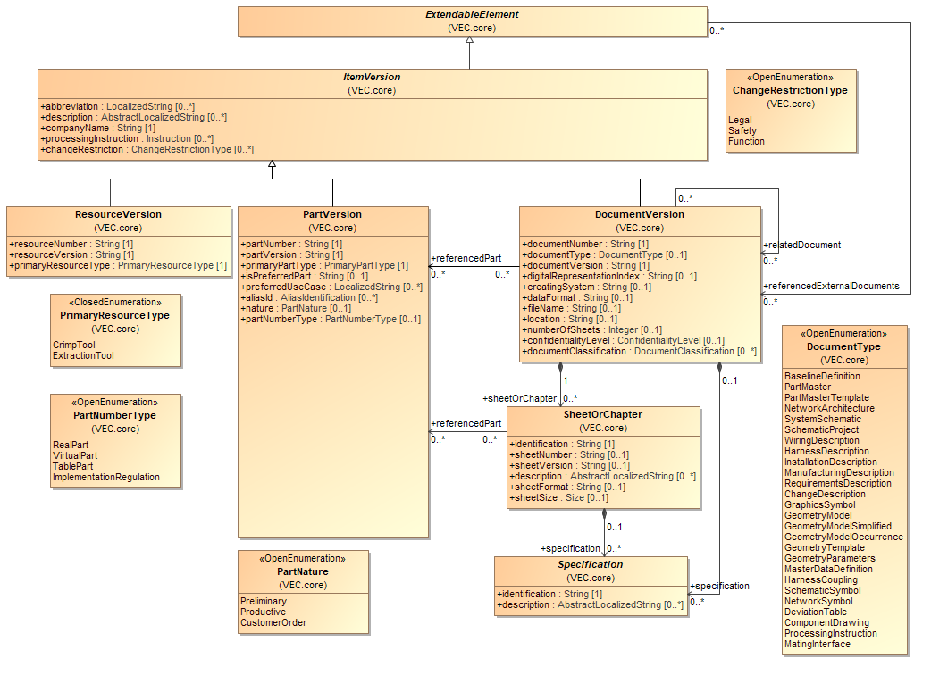
Figure 1: Parts, Documents and Resources
DocumentVersion, PartVersion and ResourceVersion are representing one of the most fundamental key concepts of the VEC. They are the only classes in the VEC model that are defining version information. In combination with the attributes companyName and partNumber or respectively documentNumber or resourceNumber they define an unambiguous context for data exchange. If two instances of the VEC are containing PartVersions, DocumentVersions or ResourceVersions with equal values of the attributes companyName, partNumber and partVersion or companyName, documentNumber and documentVersion, or companyName, resourceNumber and resourceVersion, then the two objects can be trusted to be unchanged.
Unchanged in this context does not mean binary identical content of the resulting XML-Subtree, but unchanged user data. So if the content of a DocumentVersion is transferred from one VEC-file to another (e.g. for documents describing part master data), the binary representation can be different (e.g. order of the xml elements, technical ids for xml idrefs), but the information represented by the DocumentVersion must not be different (e.g. property values of a Specification). However, it is explicitly allowed that the scope of the information contained in different instances of the same DocumentVersion may differ. For example, in most processes a component (e.g. a connector) is specified by a technical document, in the VEC represented as a DocumentVersion. In the use case of part master data exchange the VEC for the component might contain very detailed information. For the use case of harness description not all of this detailed information is required (e.g. for a connector the information about slots and cavities might sufficient) and therefore it should not be included. However, the component is still specified by the same technical document. Another example of a scenario where this might occur, is the update of a VEC exporting system. A later export might contain more information, even if the original document has not changed.
These cases are allowed with an unchanged documentNumber, documentVersion, if the shared part of the represented information in both DocumentVersion instances is still consistent.
More specific possibilities to track changes of DocumentVersions are supported by the digitalRepresentationIndex. In some cases, the DocumentVersion represents a version of a real document in the domain. The Specifications in the DocumentVersion represent the values defined in the original document. Thus, the DocumentVersion in the VEC is not a managed document by itself, but only a specific digital representation of another document. In other words, it is only a translation of the original document into the language of the VEC. For example, there is a connector described by a drawing / data sheet, which is available in some arbitrary format (e.g. PDF). This document has a number and a version. When the document is transferred (e.g. with a converter or manual input) into the VEC, the DocumentVersion containing the Specifications might have the same documentNumber and documentVersion as the original data sheet, since it is not a managed document in the process, but only a different representation of the same information. In such a scenario, it is possible that the content of a DocumentVersion changes without a change of the original document (e.g. there was an input error during the manual transfer of information, there is a new version of the converter / exporter and many more). However, the original document has an unmodified DocumentNumber & DocumentVersion. To indicate such (potential) changes of the content of a DocumentVersion the DigitalRepresentationIndex was introduced. DocumentVersions that contain a different amount of information (see above) shall also have different digitalRepresentationIndex values (if defined).
That means, if no DigitalRepresentationIndex is defined, the rules from above apply. If a DigitalRepresentationIndex is defined, the content of the DocumentVersion can only be trusted to be unchanged, if companyName, documentNumber, documentVersion and digitalRepresentationIndex are the same.
Since all tree classes can define PDM information they are derived from the abstract class ItemVersion.
The differentiation between PartVersion and DocumentVersion in the VEC is necessary, because a part can be described by multiple documents (e.g. a technical data sheet, a drawing and a 3D-model) and one document can describe multiple parts (e.g. a drawing for a contact family that displays multiple terminals and their corresponding seals). As a result, a part can be changed (requiring a new PartVersion) without the need of changing all of its describing DocumentVersions. For example, if a single property of a component changes, a new version of the part itself and its technical data sheet is necessary, but its 3D model might remain unchanged. Another example is, that a document describing multiple parts might be changed (requiring a new DocumentVersion), but in fact only one of its represented parts is changed (requiring a new PartVersion). This relationship between a PartVersion and its describing DocumentVersions is expressed in the model by the association DocumentVersion.referencedPart.
The relationship DocumentVersion.relatedDocument can be used to describe general relationships between DocumentVersions (e.g. the relationship between a technical drawing and a given standard the drawing is compliant with). The composition of SheetOrChapter considers the fact that DocumentVersions may be composed of several sheets or chapters.
The VEC is designed as a format for data exchange. This requires that all content data can be related to a certain unambiguous version context, in order to allow a receiver of the information to easily check if and what has changed since the last data exchange. For this reason, all content data that is not constant is defined with information specific subclasses of the class Specification. A Specification is always contained in a DocumentVersion and thereby related to an unambiguous version context.

Assignment Group
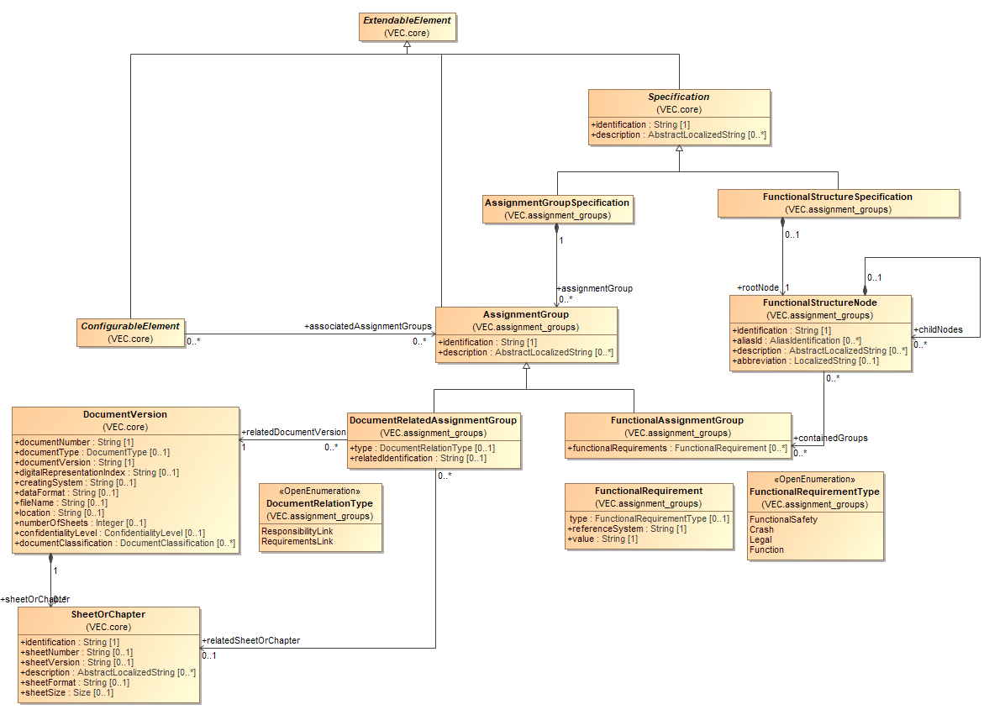
Figure 2: Assignment Group
An AssignmentGroup is a concept that allows the clustering of arbitrary elements in ways that are orthogonal to hierarchical and semantic structure of the VEC. Specific use cases are represented as subclasses of the AssignmentGroup and enriched with additional information. Proprietary groupings can be created with the AssignmentGroup itself and additional information in custom properties.
The FunctionalAssignmentGroup can be used to assign elements to a function across the different layers of abstraction.
The DocumentRelatedAssignmentGroup can used to relate elements to a specific document or an element within the document (e.g. a requirement).
The assignment to a group originates from the ConfigurableElement itself. This is designed intentionally and has two reasons:
- In the use cases for this grouping concept, it is intended that the groups exist first (e.g. a function) and the assignment is created together with elements along the process. For example, a connection in a system schematic is assigned to a function. When a wire is derived from the connection, the wire inherits this assignment. Therefore, it wouldn't be practicable to be enforced to modify the DocumentVersion containing the AssignmentGroup for every added element.
- In today's processes the assignment of elements to such groups are done in the same documents where the elements themselves are defined.
This concept adds another layer of extensibility to the VEC. CustomProperties allow the addition of user-defined properties to a single object. The assignment groups allow the creation of custom grouping of objects. However, it is not permitted to use this concept to express relationships that have well defined concepts in the VEC (e.g. assignment of occurrences to composite parts or usage nodes).

Variants
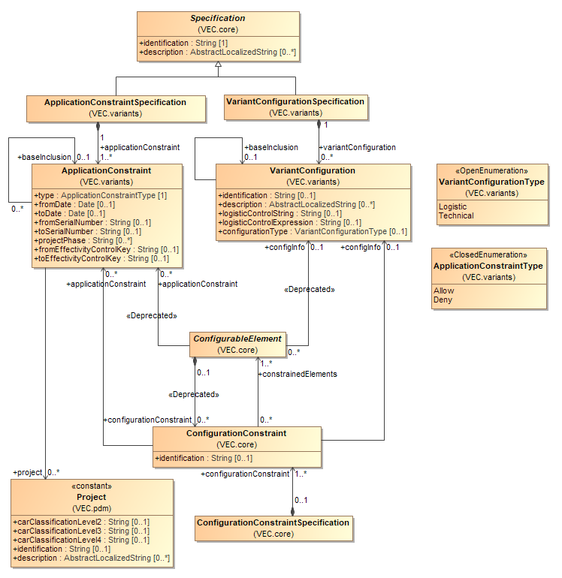
Figure 3: Variants
With variance management features, the VEC supports two dimensions of variance. VariantConfigurations and ApplicationConstraints. VariantConfigurations define the validity of an element based on characteristics of the product itself, such as features, functions, options or technical characteristics. ApplicationConstraints define the validity of an element based on conditions "around" the product like manufacturing schedules and change management, association with a specific product derivative or factory dependencies. VariantConfigurations are expressed by a LogisticalControlString or LogisticalControlExpression, typically some kind of Boolean logic in a company specific syntax. ApplicationConstraints are expressed by a concise semantic with attributes and relations or by using EffectivityControlKeys, which are unique references in the logistics/change/scheduling control systems of an organization.
All elements in the VEC that could be subject to product variance are ConfigurableElements (classes that are derived from ConfigurableElement). Since most variant management conditions do not exclusively affect only one element, ApplicationConstraints and VariantConfigurations are embedded in their own container Specifications, the ApplicationConstraintSpecification and the VariantConfigurationSpecification.
Till VEC 2.0 a ConfigurableElement could only reference a single VariantConfiguration. This is true, if you consider only one specific context, however, there can be different variant management contexts for a single element. Different contexts might be defined by ApplicationConstraints, such as differing variant conditions for different product derivatives or the change of VariantConfigurations over the time. Another reason for different contexts might be, that VariantConfigurations are based on a defined set of variant codes (a universe of variance). Multiple universes can coexist in an organization and there are a variety of reasons that justify their existence, for example product lines might define their own variant codes and semantics, the variant codes (e.g. feature model) might different for a set of building blocks compared to an actual vehicle, or the variant codes of a generic E/E-component might different from the ones in a specific usage.
Such a context is defined by a combination of ApplicationConstraints and a specific VariantConfiguration.ConfigurationType and is represented by a ConfigurationConstraint. With the ConfigurationConstraint, a ConfigurableElement can have multiple VariantConfigurations. However, an element shall only have one VariantConfiguration for a specific context (combination of ApplicationConstraints & VariantConfiguration.ConfigurationType). If an element has multiple variant conditions within a context, those shall be expressed by the Boolean logic within the VariantConfiguration.LogisticControlExpression.
Note: With VEC 2.0.2 the direction of the association between ConfigurableElement and ConfigurationConstraint has been inverted and the ConfigurationConstraintSpecification has been introduced as container for the ConfigurationConstraints. The former approach, with the ConfigurationConstraint contained in the ConfigurableElement, had the effect, that a change of the configuration information resulted in a change of the ConfigurableElement itself. This in turn means a change or addition of configuration information results always in change of the original document. However, when reusing engineering artifacts, it is a common approach to configure the elements not until they are used. Configuration information is added in the context of usage and not in the context of definition. By extracting the ConfigurationConstraint into an independent specification it is now possible to add configuration information in a later stage of the process.
Note: The direct associations between ConfigurableElement and ApplicationConstraints and VariantConfigurations have been deprecated with VEC 2.0 and have been kept only for backwards compatibility. They will be removed in a future version. It is not valid to use these associations in combination with ConfigurationConstraints.
Note: Please refer to the detailed class description for information about which elements inherit from ConfigurableElement.
Note: VariantConfiguration.logisticControlExpression has been introduced as an alternative attribute for VariantConfiguration.logisticControlString. For the logisticControlExpression the prostep ivip project group "VES-WF" wants to introduce a defined syntax in the future.

Variant Structure
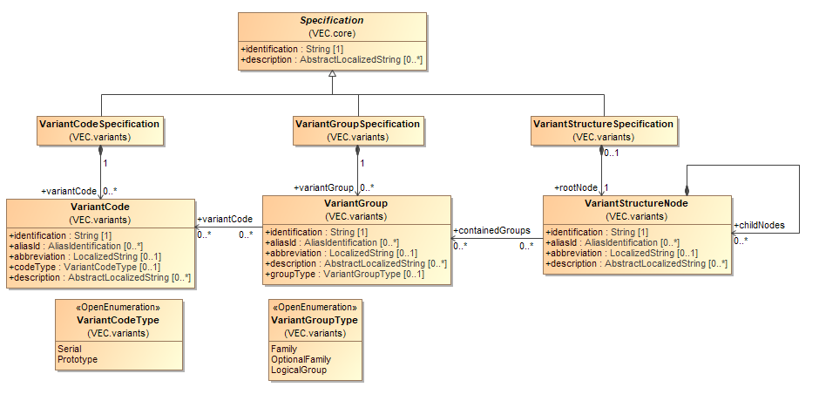
Figure 4: Variant Structure
The classes displayed in this diagram can be used to describe meta information about the elements used to described variance properties. The description of the variance information of a concrete element (ConfigurableElement) is done with a VariantConfiguration and the contained logisticControlString. These strings are normally created from VariantCodes and a proprietary Boolean syntax.
A VariantCodeSpecification is a container for various VariantCodes. Each VariantCode describes an elementary literal which can be used as part of a VariantConfiguration.logisticControlString or VariantConfiguration.logisticControlExpression.
A VariantGroupSpecification is a container for various VariantGroups. A VariantGroup describes a grouping for VariantCodes. There can be a wide variety of reasons to group VariantCodes. However, the most common is to mark VariantCodes that belong to the same family (mutually exclusive) variant codes.
A VariantStructureSpecification with its VariantStructureSpecificationNode can be used to define any kind of hierarchical structure upon the VariantGroups.
Note: The VEC does not constrain a VariantCodeSpecification or a VariantGroup­Specification to a precondition for use in VariantConfigurations. VariantCodeSpecification and VariantGroupsSpecification are intended as an optional means to exchange information independently about the “vocabulary” which is possible to express VariantConfigurations.

Usage Node

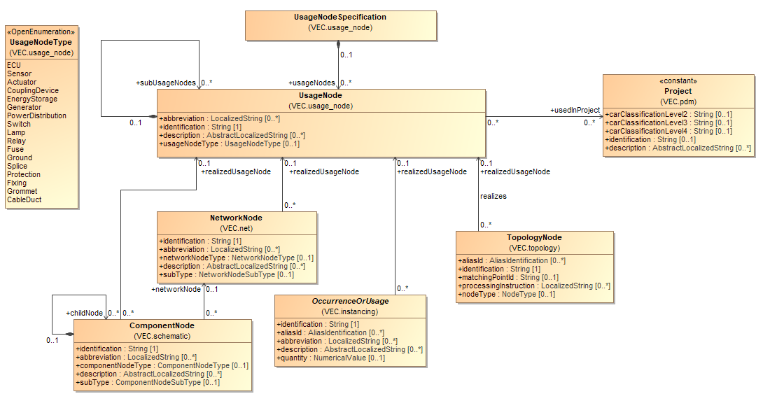
Figure 5: Usage Node
A UsageNode represents a position in an abstract vehicle, but it does not imply a certain location in space. For example, the "Head Light Left". UsageNodes belong to the master data, and they are defined on some companywide level. They can be used to enforce consistent naming over different projects and different development streams (e.g. between Geometry and Electrologics).
A UsageNode can be realized by different elements in the VEC (e.g. NetworkNode, OccurrenceOrUsage, TopologyNode, ComponentNode).

Usage Constraints

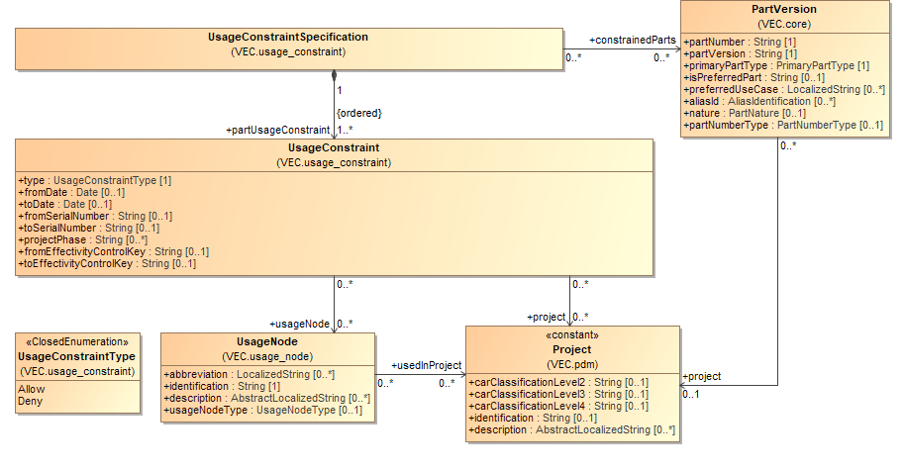
Figure 6: Usage Constraints
A UsageConstraintSpecification is intended to describe the allowed usage of the constrainedParts.
A UsageConstraintSpecification is a container for various UsageConstraints each representing a single constraint. The sequencing of the UsageConstraints specifies the priority: a general denial may be relativized by a following UsageConstraint and vice-versa. In other words, the ordering of the UsageConstraintSpecification.partUsageConstraints collection has a semantic and is highly relevant. UsageConstraints further back in the collection have a higher priority than UsageConstraints further ahead. Successive UsageConstraints of the same type shall be interpreted as concatenation, whereas successive UsageConstraints of different types shall be interpreted as exceptions to the preceding statement.
The relationships UsageConstraint.usageNode and UsageConstraint.project make it possible to specify at which UsageNodes respectively in which Projects the usage of the constrained PartVersions is allowed/denied.

VEC-Root
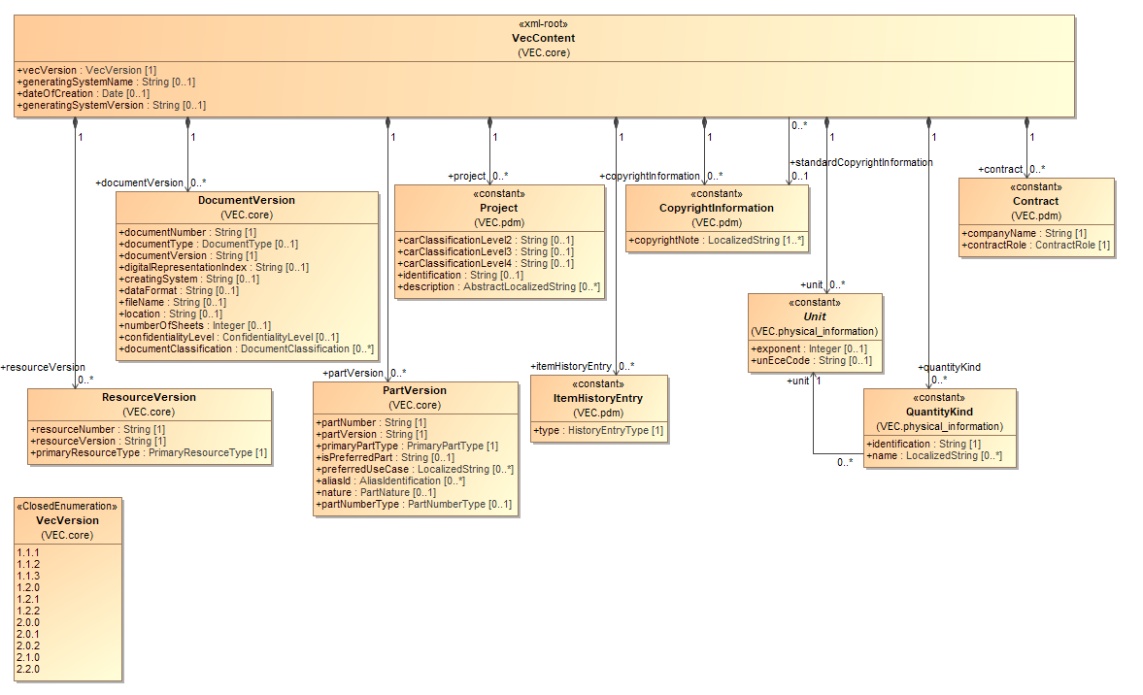
Figure 7: VEC-Root
The diagram above defines the class VecContent which is intended to be regarded as the top-level root element for VEC documents. It is the declared entry point to the information that a VEC file contains.
A VecContent is a container for various DocumentVersions, PartVersions, Projects, ItemHistoryEntries, CopyrightInformations, Units, and Contracts. DocumentVersion and PartVersion are the only two classes in the VEC model that define and contain version information. Almost all information a VEC document can contain is subordinated to one of those two classes. This means, that every piece of information which is represented as an instance of a class of a certain attribute value is distinctly related to a dedicated PartVersion or DocumentVersion.
The only exceptions are classes with the stereotype <<constant>> as shown in the diagram.

Information Reuse
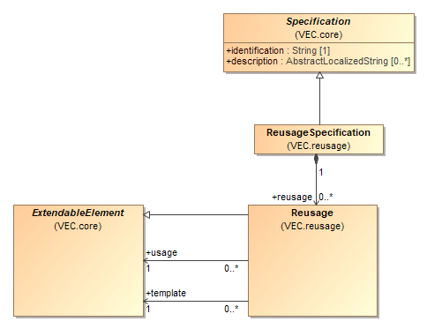
Figure 8: Information Reuse
In engineering processes - particularly in harness development - the reuse or derivation of new information from existing data is a common practice. Specific examples include libraries, building blocks, or modular systems, where certain information, such as a partial system description, is predefined and then adapted to fit the context of a specific vehicle. In the following sections, the source of the information will be referred to as the template, while the location where it is reused or the derived information itself will be referred to as the usage.
Information reuse differs from a classic instantiation model that typically involves distinct classes for type and instance, such as PartVersion and PartOccurrence. In an instantiation model, the structure clearly specifies which attributes are defined by the type and which by the instance. For example, the cross-section area of a wire might be defined by the "wire type," while the length is defined by the "wire instance."
In a reuse scenario, however, the same model elements (VEC classes) are employed both in the template and in describing the usage. For instance, a system schematic building block is described using Connections and ComponentNodes, and its usage is also described using Connections and ComponentNodes. Essentially, information reuse involves copying the original data, which can then be supplemented with additional information, redefined, or even overridden. The extent to which the usage is allowed to deviate from the template is specific to each case and depends on business rules that apply to the scenario. Typically, the usage is fully self-contained and can function independently.
The traceability provided by the ReusageSpecification and Reusage-Elements allows the enforcement of business rules between template and usage. Scenarios that exemplify this traceability include:
- Downstream Change Propagation: When the template is updated, changes could be propagated to the derived elements.
- Limitation of Deviation: Information defined in the template might be restricted or flexible for modification in the usage or only changeable in specific ways. For instance, a template could define standard aspects of a component (such as a standard cavity or conductor). Some template attributes might be mandatory in the usage, while others could be redefined.
An individual ReusageSpecification shall be defined when reusing a specific block of information within a particular context. For example, reusing a partial schematic within a vehicle-specific schematic represents one ReusageSpecification. Adding a second partial schematic to the vehicle constitutes a second ReusageSpecification. Reusing the same partial system schematic in another vehicle-specific schematic would require a third ReusageSpecification.
Within a ReusageSpecification, a Reusage-Element is created for every ExtendableElement from the template that is utilized in the usage.

Basic Datatypes
The VEC supports the following a number of primitive standard data types:
- Boolean
- Date
- Double
- Integer
- String
In addition, the VEC defines various more complex general-purpose data types that are used within the specification. Those are defined in the following sections.

Structured Primitives
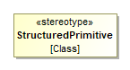
Figure 9: Structured Primitives
The StructuredPrimitive stereotype is used to mark model classes that represent structured value containers. These classes group multiple primitive attributes (e.g., strings, numbers, enumerations) into a cohesive structure, typically for the purpose of expressing a concept such as a value with unit, a localized string, or a categorized length.
StructuredPrimitives are semantically like primitive types in that:
- They are used as attribute types in other model elements.
- They are not independently identifiable.
- They shall not be referenced from other parts of the model.
- They shall not be an ExtendableElement.
Since they are not independently identifiable and shall not be referenced from other parts of the model, the following is true:
- StructuredPrimitives are compared by value in a diff- or change-scenario and not by ID. Meaning, if all attributes are the same, the object is the same.
- They do not require an object identity in an overall scenario (no IRI/URI).
- In RDF representations those objects can be represented as BNodes.

Localization of Strings

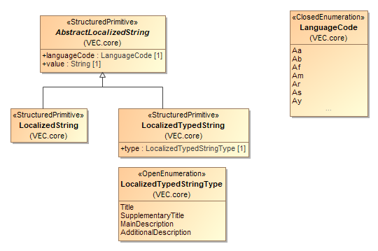
Figure 10: Localization of Strings
The VEC provides a concept for the localization of string values. Every attribute that can be localized has the type of AbstractLocalizedString or one of its subclasses.
An AbstractLocalizedString consists of an ISO languageCode and a value. Attributes of this type have a multiplicity of [0..*].
In the case of a LocalizedString the attribute represents a human readable text with a specific semantic. All LocalizedString instances for a single attribute must represent the same meaning in different languages.
When a LocalizedTypedString is used, the semantics of the attribute values can be further detailed by the type attribute. For example, an ItemVersion can have more than one description with a more specific semantic of each description type. In this case, all LocalizedTypedString instances for an attribute must represent the same meaning for their type value in different languages.

Numerical Values & Units

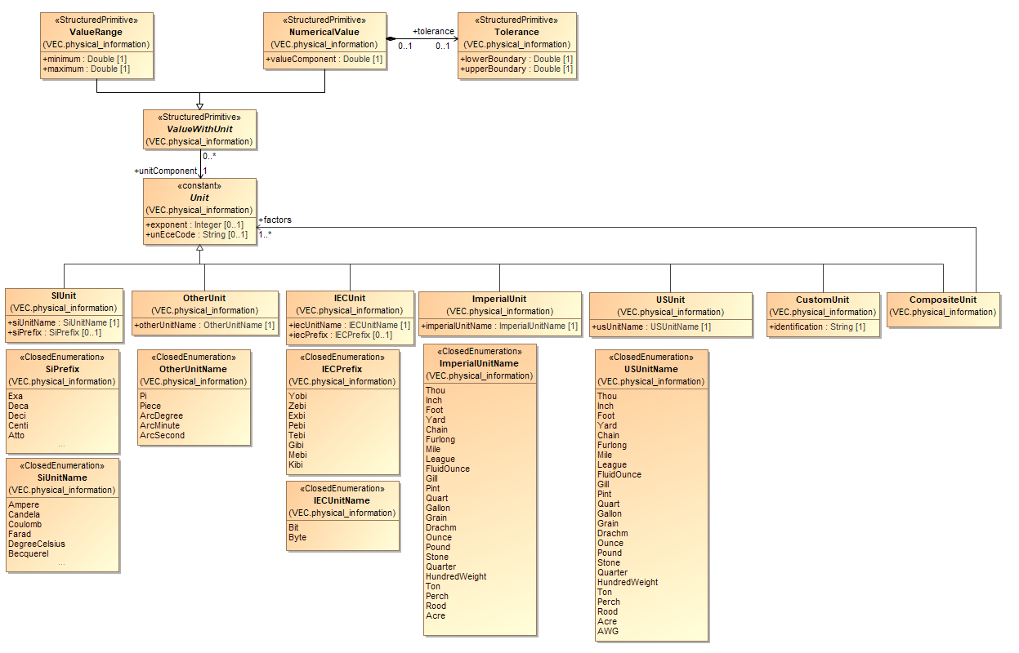
Figure 11: Numerical Values & Units
With Version 1.1.0 a more flexible and meaningful unit system has been introduced. A unit is used to define the dimension of a numerical value. In the VEC a unit is expressed by the abstract class Unit. The different existing types of units are represented by its concrete subclasses. Every unit can have an optional exponent. If no exponent is defined, this is interpreted as an exponent of 1.
The class SIUnit defines a unit in the terms of the SI-System. A SIUnit is defined by a combination of an optional SiPrefix (e.g. Milli) and SIUnitName (e.g. Metre).
The class IECUnit defines a unit in the terms of the IEC-System which is used for measurement of digital data amounts.
The class ImperialUnit defines a unit in the terms of the imperial unit system (e.g. Inch).
The class OtherUnit is used to define units that do not belong to any standardized unit system, but which are relevant in the context of the VEC. Currently these are the units Pi (as a unit for angular frequency or circular measure) and Piece.
The class CustomUnit can be used to define units that are necessary for a specific use case and that are currently not considered in the VEC.
The class CompositeUnit is used to define units that are created by the multiplication of other units (Association CompositeUnit.factors). For example, the Unit "Ohm per Metre" will be created with two instances of SIUnit. One SIUnit Ohm (without prefix and exponent) and one SIUnit Metre (without prefix and an exponent of "-1").
Mainly these Units are used by the class ValueWithUnit which can be either a ValueRange or a NumericalValue. A ValueRange defines a range of a value between minimum and maximum. A NumericalValue defines a single value with an optional Tolerance.
Note:
- For the purpose of clarity, not all literals of all enumerations are displayed. If literals are omitted in the graphical representation a "..." is shown.
- Currently the VEC does not support the definition of the same attribute value in different units at the same time (e.g. a single length value in m and ft at same time).

Multidimensional Values
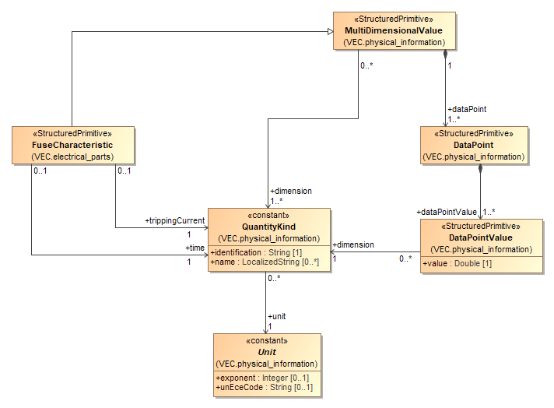
Figure 12: Multidimensional Values
The MultiDimensionalValue concept is used to describe properties that are represented by multiple values across different dimensions — for example, a characteristic curve.
The dimensions, e.g., tripping time and current for a fuse characteristic, of a MultiDimensionalValue are defined by referencing the corresponding QuantityKinds in which the dimensions are expressed. The QuantityKind also defines a consistent Unit of measurement for values in a specific dimension.
To provide a standardized semantic meaning for specific use cases, subclasses of MultiDimensionalValue are introduced. These subclasses reference the defined QuantityKind in role-specific contexts. However, those references only define a specific semantic for the dimensions defined by the MultiDimensionalValue itself. That means, those specific QuantityKinds shall also be included in the dimension-association of the MultiDimensionalValue.
For instance, a FuseCharacteristic must reference at least two dimensions:
- I = the tripping current
- T = the time it takes for the fuse to disconnect
Additional dimensions may be included in certain use cases (e.g., temperature). By explicitly referencing the required dimensions in the FuseCharacteristic, these are marked as mandatory and receive a clearly defined semantic meaning.
The value definition consists of a series of DataPoints. Each DataPoint of a MultiDimensionalValue shall define exactly one DataPointValue for each QuantityKind that is defined as dimension of the MultiDimensionalValue, and only for those.

Extensibility with Custom Properties

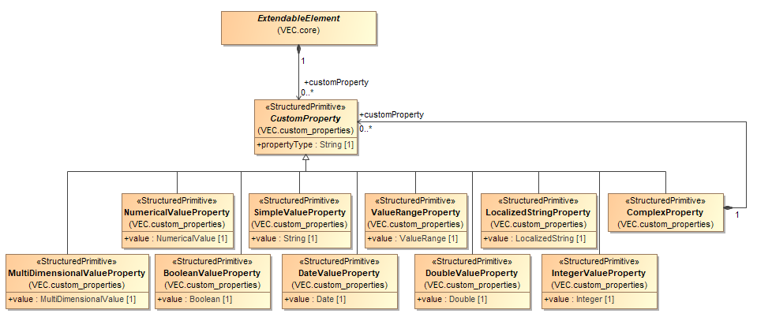
Figure 13: Extensibility with Custom Properties
CustomProperties have been introduced to the VEC as the dedicated extension mechanism. All subclasses of ExtendableElement class are extendable by providing the possibility to define CustomProperties. CustomProperties allow the definition and transport of almost any piece of data in an embedded way, for which the VEC does not define a different means of expression.
If a VEC entity shall be extended with multivalued property this is done by adding multiple CustomProperties with the same propertyType. In cases where a custom property value consists of a tuple of other values, a ComplexProperty can be used. This is especially useful, when the respective property is multivalued. An example for such a property / structure that is already represented in the VEC are Colors where each color consists of a referenceSystem and a key in that referenceSystem and each entity can have multiple colors (the same color in different reference systems).
Note: According to this data format specification it is strictly forbidden to store data within CustomProperties for which the VEC knows a special predefined way of expression. VEC-Files that do not obey to this rule are not compliant to this data format specification.
Note: Please refer to the detailed class description for information about which elements inherit from ExtendableElement.

Foundation Classes for Physical Properties

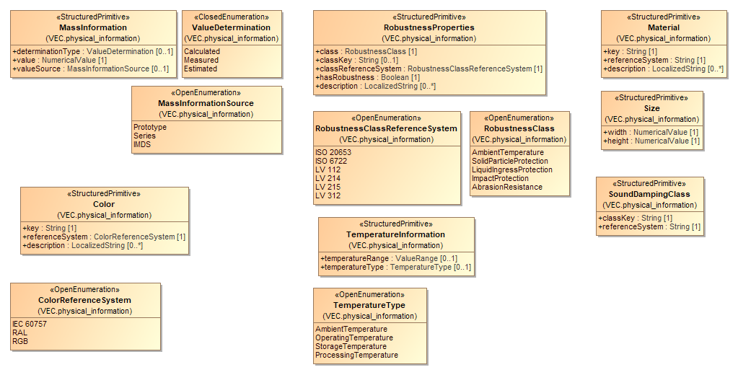
Figure 14: Foundation Classes for Physical Properties
The diagram displays the common foundation classes necessary for the description of physical properties of a part (e.g. material, mass and size). Most of these classes either define a type of their value (e.g. TemperatureInformation.temperatureType) or a reference system (e.g. Color.referenceSystem). In these cases attributes of these types normally have the multiplicity of [0..*] in order to define different values for different types (e.g. environment temperature, storage temperature, operating temperature) or to define the same value in different references systems (e.g. the same color in RAL, RGB or a company specific value).

Alias Identifications

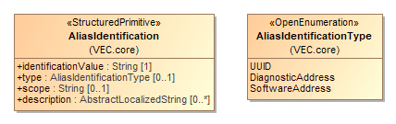
Figure 15: Alias Identifications
There are many applications where an element can have various technical and functional keys at the same time. The AliasIdentification provides a possibility to transfer these keys along with meta information about their type and scope.

Open and Closed Enumerations

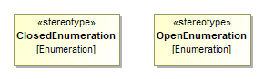
Figure 16: Open and Closed Enumerations
In the VEC model we distinguish between two kinds of enumerations:
- Closed lists
- Open lists
For a closed list, the enumeration values are fixed. At the time of the UML model generation, it is known which values an attribute can take. There is no possibility to use other values later without changing the XML schema definition as the model defines the acceptable values inherently. An example would be the PartVersion.primaryPartType as it closely related to the existing PartOrUsageRelatedSpecification-class. Another example would be the referenceNode for Locations on TopologySegments. Since one TopologySegment only has one StartNode and one EndNode this is a typical ClosedEnumeration.
For an open list the allowed values for an attribute are not completely known at the point of the UML model generation or might change in future due to new technical developments. There may be a pre-defined set of values. But it must be possible to add further values in a later stage. An example might be the Gender of a Terminal which is currently restricted to Male and Female. In future new technologies might emerge, where the existing values are not enough. Motivation for this open list concept is, that for known values, standardized literals shall be used, but reading systems must be able to handle additional literals, since they can emerge quite quickly due to technology improvements.
The diagram shows the representation of open and closed enumeration lists as stereotypes.
During the UML to XML transformation, closed enumerations are transformed into XML “xs:enumeration”. Open enumerations will be translated into XML „xs:string“.
The VEC model defines for open enumerations a pre-defined list of commonly agreed values. The idea behind is, that these pre-defined values are used if applicable, and further values should be used only, if the pre-defined ones do not fit. However, this cannot be enforced by the XML schema. If an open enumeration is translated into “xs:string”, it is not possible to check if the predefined values are used.
Therefore, in addition to the standard VEC XML schema, a further XML schema, called the “Strict VEC XML schema” is defined. In this schema, an open enumeration is transformed into XML “xs:enumeration”, too. The enumeration values are restricted to the pre-defined ones. With this schema it is possible to check if a VEC used pre-defined values, only.

Open and Closed Pattern Restrictions

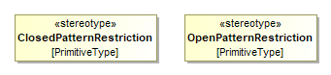
Figure 17: Open and Closed Pattern Restrictions
The concept of open enumerations mentioned before is useful in cases where a restriction to a limited number of well-known values is necessary. However, the continuous evolution of the VEC has shown, that this approach is not feasible in all situations.
Therefore, the concept of pattern restrictions has been introduced. A pattern restriction is a regular expression that defines valid attribute values. Those restrictions can be used when a valid pattern is known, but the explicit enumeration of the values is not possible. For example, it is known that valid values for the coding of a connector are only strings with two digits of alphanumerical characters. To represent this as an enumeration would require 1296 enumeration literals.
In the UML model attributes that shall be restricted with a pattern are defined like regular class attributes with a custom PrimitiveType as datatype (e.g. +coding: CodingName[1]). The PrimitiveType is stereotyped either with ClosedPatternRestriction or OpenPatternRestriction. The semantic for open and closed is the same as for enumerations. ClosedPatternRestrictions are included in all schema versions, OpenPatternRestrictions only in the strict schema versions. The actual pattern of the restriction is defined as "class constraint" on the Primitive Type.
In the XML Schema the PrimitiveTypes are translated as <xs:simpleType> based on xs:string with a xs:pattern restriction.

PDM Information
The content of this chapter describes the various aspects of PDM information contained in the VEC. PDM information is every information that is no actual content data, but all meta data about ItemVersions contained in the VEC.
Since most of the PDM information (product data management relevant information) is in principle equally relevant for both, parts and documents, the VEC defines the abstract superclass ItemVersion as anchor for the definition of PDM information.

Lifecycle Information

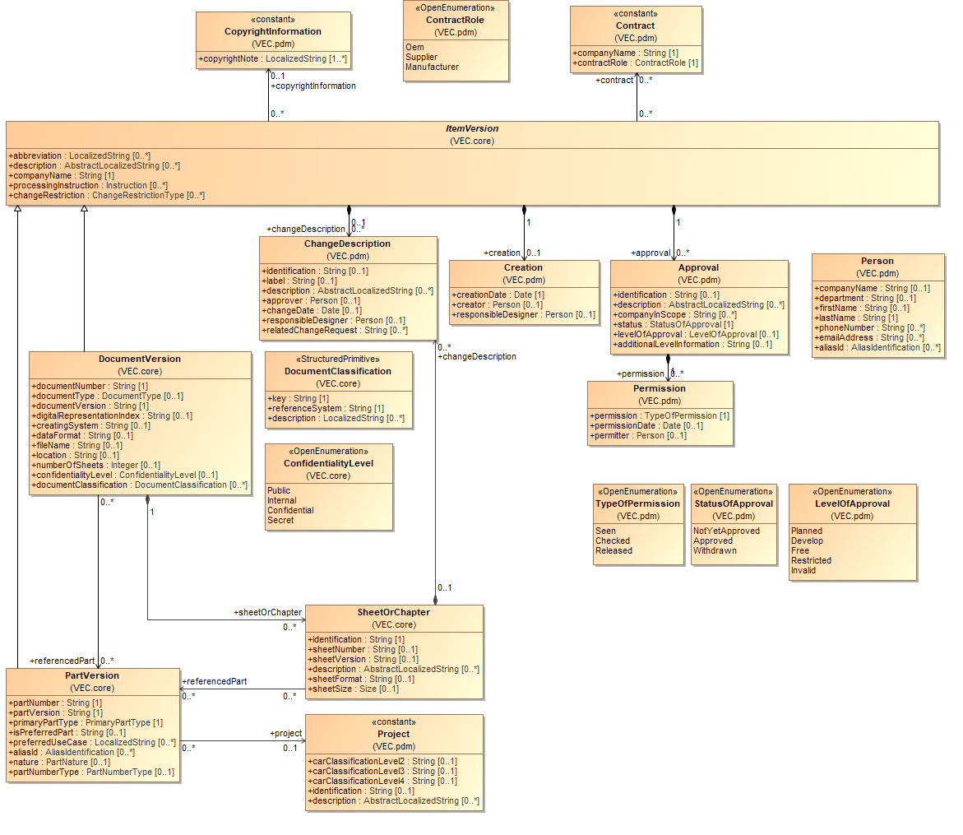
Figure 18: Lifecycle Information
An ItemVersion can carry information about the creation of the item. This means the creating timestamp and an optionally information regarding the creator or responsible person.
An ItemVersion normally has approval information and can be specified within the VEC by the relationship ItemVersion.approval. The class Permission allows the documentation of the persons involved in the approval-process.
The class ChangeDescription expresses the changes of an ItemVersion compared to its direct predecessorVersion(s).
The class CopyrightInformation enables the description of copyright information of ItemVersions. Instances of the class CopyrightInformation are assumed to be constant and so do not require a dedicated belonging to a versioned instance (PartVersion or DocumentVersion).
An ItemVersion can have contract information with company role information. Instances of the class Contract are assumed to be constant and so do not require a dedicated belonging to a versioned instance (PartVersion or DocumentVersion).
A PartVersion can reference a Project in order to describe for which Project it is relevant. Instances of the class Project are assumed to be constant and so do not need to have a dedicated belonging to a versioned instance (PartVersion or DocumentVersion).

Baselines

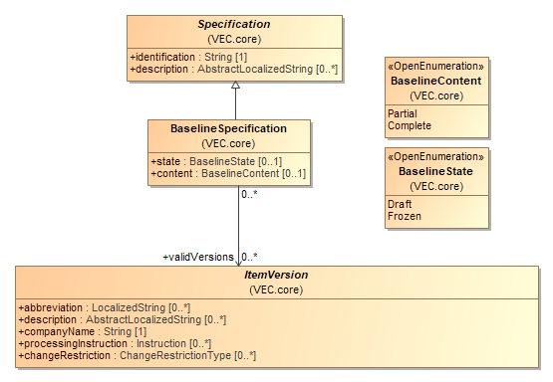
Figure 19: Baselines
A BaselineSpecification defines a set of ItemVersions (Document- and PartVersions) that relate to each other in a certain way e.g. all parts and documents in their specific versions that contributed to a specific manufactured result.
Baselines are a standard mechanism to support change, release and configuration management and are often used throughout the whole product life cycle. In the VEC, baselines themselves are Specifications and thus content of a DocumentVersion, which is equivalent to the fact that they are versioned information themselves.
In a product development for wiring harnesses, the content of a baseline is growing over a period (e.g. system schematics are created before the definition of the physical wiring harness). In this process, items are created and added to the baseline (based on other items from the baseline). Additionally, items in the baseline can be changed, following the rules of the respective development process. Such a baseline has the BaselineState.Draft. At a well-defined point in time, the content of baseline is checked and released. After this, the baseline cannot be changed without creating a new version of the baseline itself. Such a baseline has the BaselineState.Frozen.
Baselines are normally defined for a certain scope (e.g. a specific vehicle, a specific product). During the product development it is possible, that a baseline is incomplete. A reason for this might be, that not all development artefacts (e.g. wiring harnesses) are defined in this phase of the development process even though all artefacts are required for the final product. Such BaselineSpecifications have a Partial content.

Item History

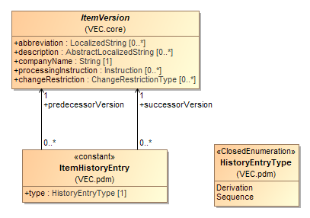
Figure 20: Item History
In a development process items (parts or documents) are often refined incrementally, so one ItemVersion originates from another. The class ItemHistoryEntry enables the description of predecessor / successor relationships between ItemVersions. The description of both linear and branching relationships is possible. The relationship can be classified in order to distinguish between two cases:
- The successor ItemVersion is an instance of the same item (type = "Sequence")
- The successor ItemVersion is an instance of a new but somehow similar item (type = "derivation").

Item Equivalence

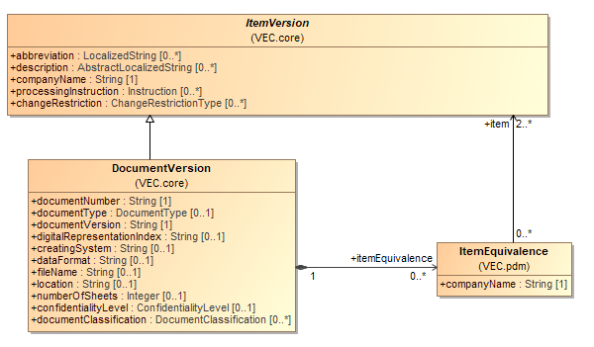
Figure 21: Item Equivalence
ItemVersions (DocumentVersions and PartVersions) are company specific keys / identifiers for a part (component) or a piece of information. However, this also means that the same part, or piece of information, can have different identifiers depending on the context. The keys refer semantically to the same element or in other words, they are equivalent. The class ItemEquivalence enables the description of such equivalence relationships between two or more ItemVersions. A standard use case is to relate PartVersions defined in the context of different companies for part number translation (e.g. OEM part number -> Tier 1 part number -> component supplier part number).
Note: That equivalent ItemVersions refer to the semantically same element does not mean, that the information associated with the ItemVersions has to be identical. For example, the same component might have different approved operating conditions depending on the company scope, which results in differing technical attributes.

General Component Data
The description of components and their properties is quantitatively the largest part of the VEC model. The following sections explain the basic methods for describing components and defining the information that applies to all types of components.
The properties of certain component types are defined in the next chapter.

Description of Parts

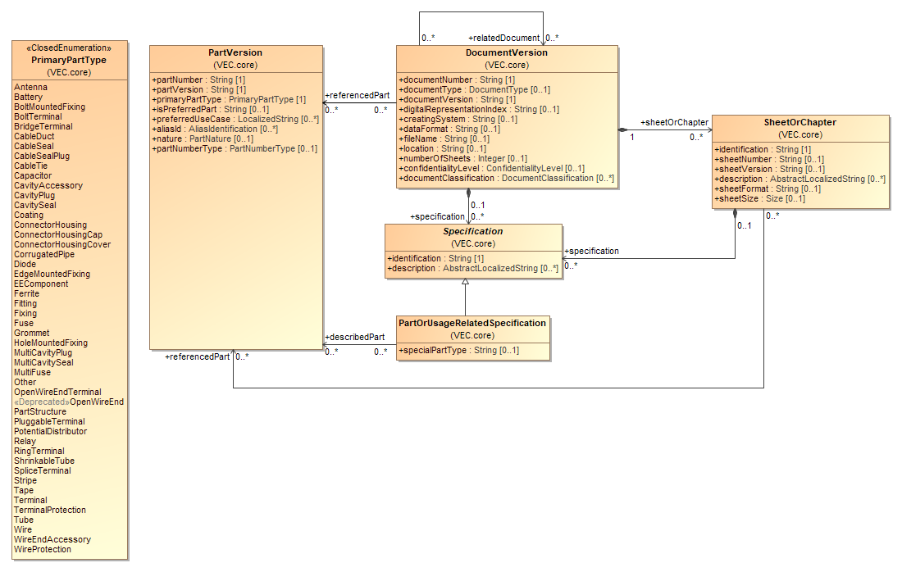
Figure 22: Description of Parts
In traditional data formats the diverse types of parts (e.g. connector housing, terminal, wire) are differentiated with individual subclasses for each type inheriting from the type corresponding to PartVersion. These subclasses define all specific information of the component type (e.g. the cavities of a connector). Due to the great diversity of components used in wiring harnesses a different approach is implemented in the VEC.
The general technical / physical properties of a component are described by PartOrUsageRelatedSpecifications (and its subclasses). For each aspect of a component an independent subclass of PartOrUsageRelatedSpecification is defined (e.g. a ConnectorHousingSpecification, a TerminalSpecification). This approach allows to describe a PartVersion by more than one PartOrUsageRelatedSpecifications (Association PartOrUsageRelatedSpecification.describedPart). It offers the possibility to extract information, which is shared between component types, into separate specifications so that the structural definition can be reused without having to modify the inheritance tree (e.g. GeneralTechnicalPartSpecification). Furthermore, some components cannot be mapped onto such a strict type hierarchy (e.g. a connector housing used as an inliner might have a fixing bolt for vehicle body in order to keep it in place). Representing this by an inheritance tree would result in a huge variety of different classes. With the concept of PartOrUsageRelatedSpecifications a component like the mentioned connector housing can be easily described by using a ConnectorHousingSpecification for the connector housing aspects and a FixingSpecification for the fixing aspects. However, most parts have a primary characteristic. For example, the mentioned connector housing will most probably only be used if a connector is necessary. This primary characteristic is defined by the PartVersion.primaryPartType. The PrimaryPartType always refers by a naming convention to a corresponding PartOrUsageRelatedSpecification. If the PrimaryPartType is ABC, the corresponding Specification is named ABCSpecification (e.g. ConnectorHousing and ConnectorHousingSpecification). The PrimaryPartType serves the purpose of defining the primary characteristic of a part. It is not required to describe every PartVersion in a specific VEC file with a corresponding PartOrUsageRelatedSpecification, if the information is not required in the context of the VEC file. For example, in the context of geometry data exchange it might be perfectly valid to have PartVersions with PrimaryPartType=ConnectorHousing that are only associated with a PlaceableElementSpecification (and/or a GeneralTechnicalPartSpecification) while the ConnectorHousingSpecification is not provided.
In some cases, there might be a need to specify attributes of a part that is not related to any of the existing subtypes of PartOrUsageRelatedSpecification. (e.g. it might be relevant to describe a screw nut used as an accessory for a connector housing). In this case the class PartOrUsageRelatedSpecification is instanced, and the relevant attributes are added as CustomProperties.
Since the PartOrUsageRelatedSpecification is a subclass of Specification, which is a sub element of a dedicated DocumentVersion, all information defined by it can be related to a precise development state.
The relationship PartOrUsageRelatedSpecification.describedPart might be seen as redundant to the relationship DocumentVersion.referencedPart but considers the fact that there are use cases, where only information on the level of PartVersions and DocumentVersions is exchanged, but not on the very detailed level of PartOrUsageRelatedSpecifications. In addition, it is possible, that several PartVersions are described by a single DocumentVersion containing a couple of specifications, each of them describing a single PartVersion (e.g. a drawing with a major part and its accessory parts).

General Technical Part

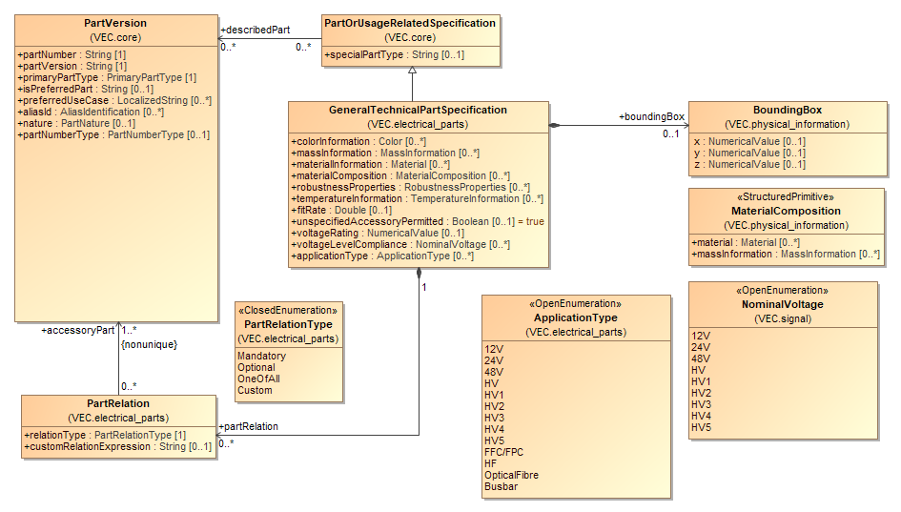
Figure 23: General Technical Part
The class GeneralTechnicalPartSpecification is intended to aggregate common technical attributes that are relevant for most kinds of parts (e.g. massInformation or information about valid temperature environments).

Supplementary Parts

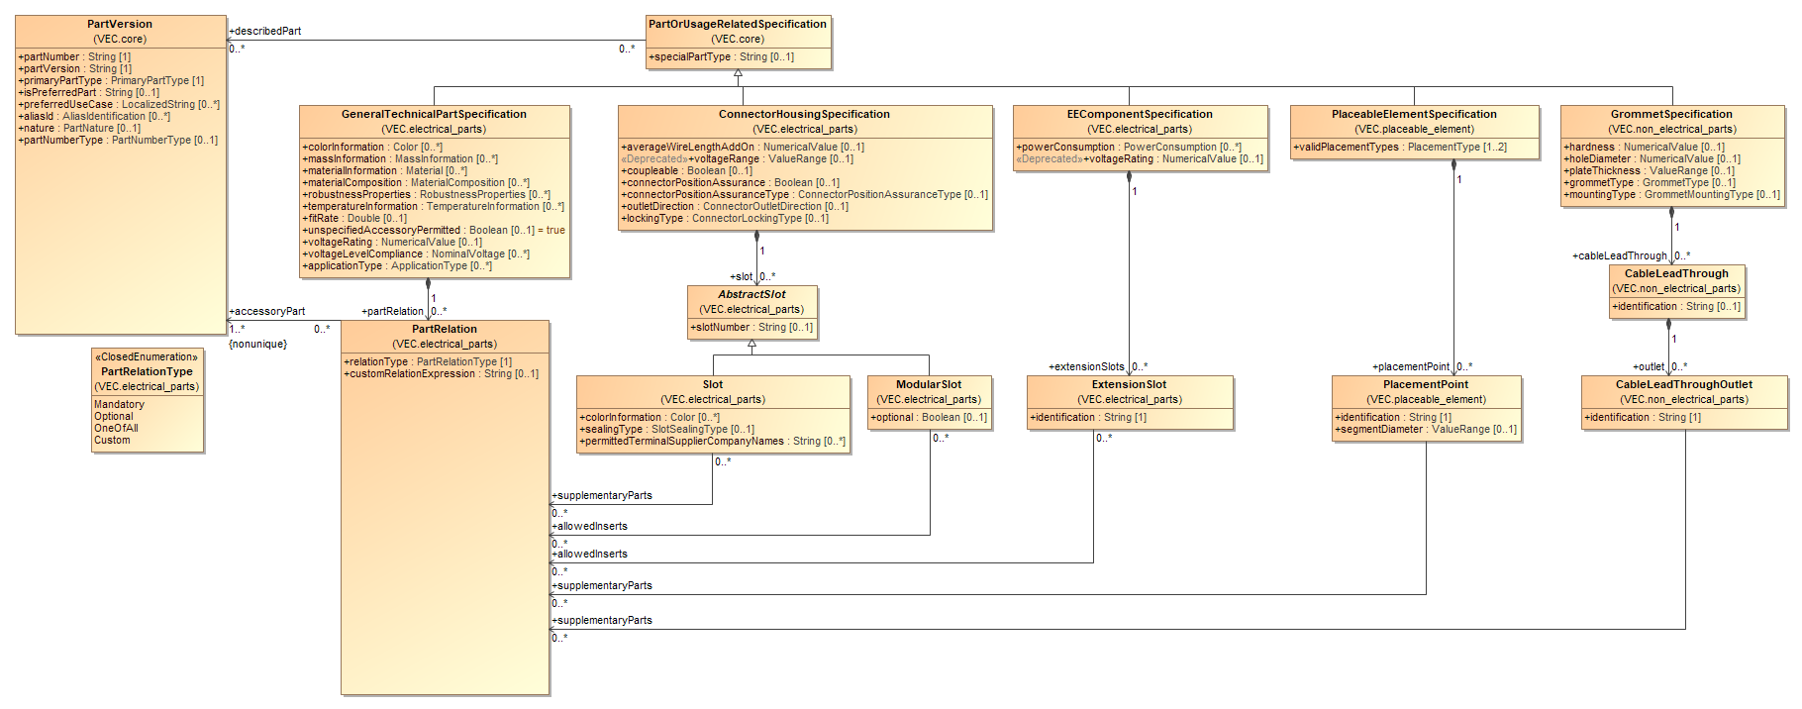
Figure 24: Supplementary Parts
With the PartRelations other PartVersions (those) can be defined as supplementary parts for the PartVersions that are described by the containing GeneralTechnicalPartSpecification (this).
The semantic is, that if this PartVersion shall be used in a correct way in a product, those referenced PartVersions can or shall be added to the product as well (depending on the used PartRelationType). That can be for example caps, bars or levers in case of a connector.
The PartRelation.relationType defines how the set of referenced PartVersions of one PartRelation must be interpreted. For details see the description of class PartRelation.
The association via the PartRelation just defines what other components may be used together with this component. It does not further specify the location of the usage or its function. However, in some cases a more detailed specification of the location is needed, e.g. if the supplementary part is required for a specific slot in a connector housing. In such a case, the PartRelation is specified by the GeneralTechnicalPartSpecification and may be referenced by its specific usage location (currently from a Slot, ModularSlot, ExtensionSlot or a PlacementPoint).

Placeable Elements

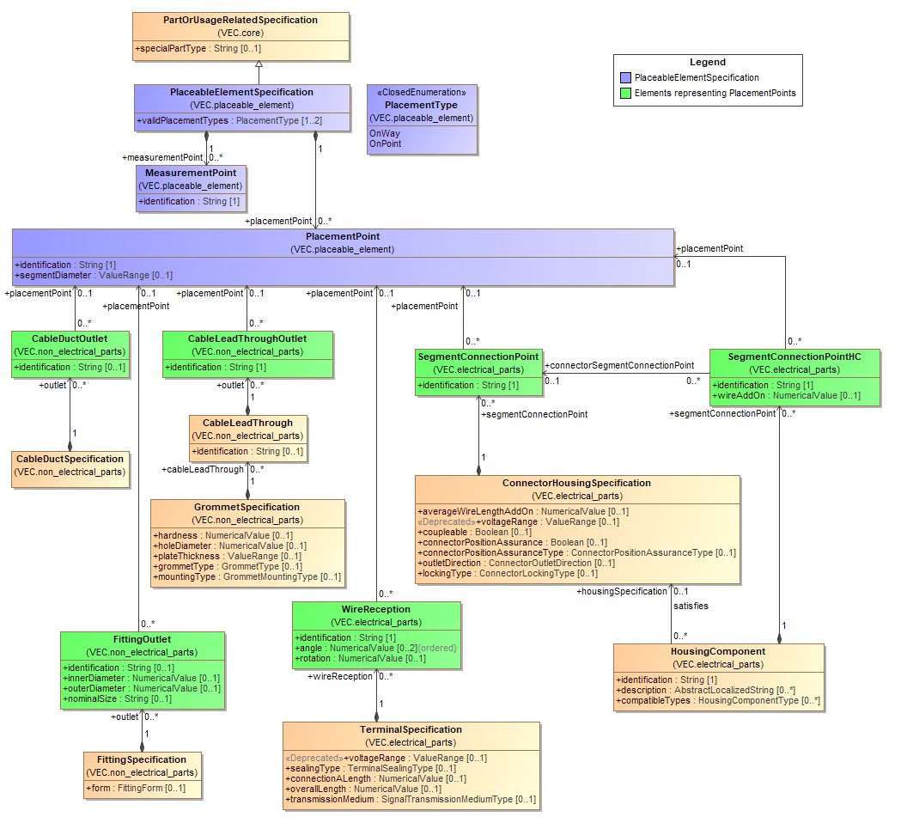
Figure 25: Placeable Elements
In a wiring harness many components can be placed directly onto the topology (e.g. connectors, fixings). To specify the aspect of placeability the VEC defines a PlaceableElementSpecification. Every component to be placed directly onto the topology must have a PlaceableElementSpecification in addition to its regular type specific PartOrUsageRelatedSpecification (e.g. ConnectorHousingSpecification).
A PlaceableElementSpecification defines at minimum the validPlacementTypes for the component (e.g. a connector can be placed on a point, a tape can be placed on a path in the topology).
In addition, the PlaceableElementSpecification can define important points of the component, MeasurementPoints and PlacementPoints.
MeasurementPoints are locations on the component that can be used to define a dimensioning. To make a MeasurementPoint locatable by a person more information is needed. This information is normally provided with a drawing of the component. The identification can be used to find the MeasurementPoint on the drawing (if it is labelled). To make a MeasurementPoint locatable by a system, the external mapping mechanism can be used.
PlacementPoints are locations on the component, where it can be attached to the wiring harness. Therefore, it can define a segmentDiameter for which it is usable. To locate a PlacementPoint on the component, the same approach as for MeasurementPoints can be used.
Often these PlacementPoints have additional properties depending on the component type. In these cases, the corresponding PartOrUsageRelatedSpecification redefines these elements, with a reference to the PlacementPoint which represents them (e.g. the SegmentConnectionPoint). However, a PlacementPoint can be defined without such a corresponding element, if no additional information is necessary.

Coordinate Systems of Components

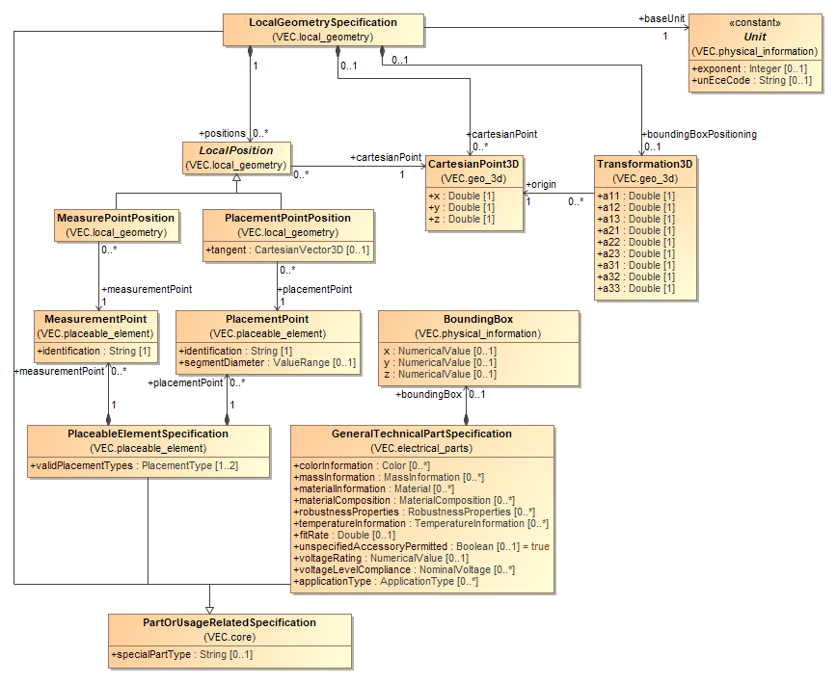
Figure 26: Coordinate Systems of Components
A LocalGeometrySpecification defines a mapping between the entities of the VEC and the 3D model of a component. The 'Local' in the name refers to the fact that all definitions within this specification are 'local' to the 3D model of a specific component (a component in a library, not in a specific usage).
The coordinate system of a component is defined by its 3D model, which often follows certain guidelines or conventions (e.g. the coordinate systems of connectors have their origin in the center of cavity 1). The Transformation3D of an OccurrenceOrUsageViewItem3D (see section 3D-Geometry) defines how the 3D model of the component shall be transformed in order to represent the correct positioning of its usage. This transformation is defined in regard to the origin and the axis of the component's coordinate system.
The BoundingBox specifies a box that has the extent to completely enclose the volume of the component. It is defined to have one corner in the origin of its coordinate system and to grow along the respective axes in positive direction. This means, that the origin of bounding box is on a corner of the represented volume, the origin of the 3D model of the component is at some arbitrary point within the represented volume. As a result, the bounding box will most likely not enclose the component's 3D model in "usage space" when placed with the same transformation as the original 3D model. To overcome this problem, the LocalGeometrySpecification defines a Transformation3D as boundingBoxPositioning, which puts the generally defined bounding box into the coordinate system of the component. The transformed bounding box is then placed into the "usage space" with the same transformation as the 3D model of the component.
In addition, the LocalGeometrySpecification also defines LocalPositions of important points of the component. The position of these points is defined within the coordinate system of the component. Positions can be defined for:
- PlacementPoints: Points where a TopologySegment is attached to the component (e.g. a Bundle / Segment Connection Point of a Connector).
- MeasurementPoints: Significant points on the component on to which dimension can be defined (e.g. for QA purposes).

Part Substitutions

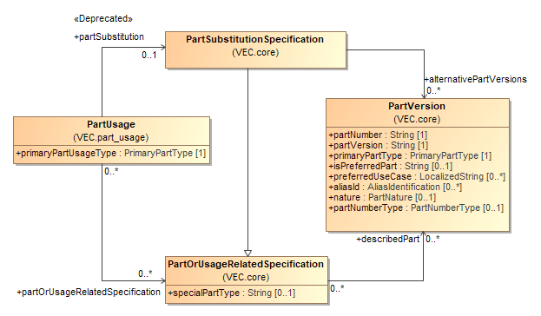
Figure 27: Part Substitutions
A PartSubstitutionSpecification defines a set of PartVersions that can be used alternatively, due to an incomplete specification for the 150% product description. For a concrete wiring harness only one valid PartVersion remains. The selection logic for valid PartVersions is not included in the VEC. It is NOT valid to use a PartSubstitutionSpecification for PartVersions with identical properties that just have different PartNumbers in different contexts (e.g. multi supplier topics). For these cases an ItemEquivalence shall be used.
A PartSubstitutionSpecification can be used e.g. for tubes or ring terminals, where a part of the specification is known at design time, but not yet the complete specification. E.g. for tubes the required inside diameter is not known at design time, since it depends on the bundle diameter of a specific configuration.
In order to represent a component instance that utilizes such a PartSubstitutionSpecification a PartUsage or a PartOccurrence can be used.
The PartUsage is the element in the VEC which defines instances of components, where a specific PartVersion is not yet known. It references one or more PartOrUsageRelatedSpecifications to describe the known properties of the component. If the PartUsage references an additional PartSubstitutionSpecification the set of valid PartVersions can be further constrained.
However, there are business processes that utilize actual PartVersion to define such replacement options in a part master data management (compare PartVersion.partNumberType).

Conformance to Requirements

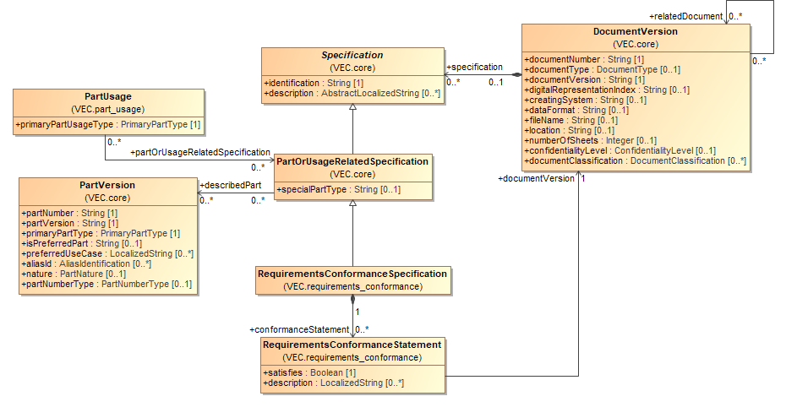
Figure 28: Conformance to Requirements
During the life cycle of a given PartVersion manifold situations are existing, where the conformance of that PartVersion to a set of requirements must be demonstrated or is required to be known. To represent the result of such a conformance test, the VEC offers the RequirementsConformanceSpecification and the RequirementsConformanceStatement.
As the RequirementsConformanceSpecification is a PartOrUsageRelatedSpecification, it can be used to express conformance for a set of PartVersions or PartUsages. The DocumentVersion in which the RequirementsConformanceSpecification is contained, normally represents the original document by which the conformance was approved (e.g. a type rating).
The actual conformance is expressed with RequirementsConformanceStatements. It can be used to document a successful or explicitly failed conformance test. The requirements for which the state is valid, are referenced as a DocumentVersion via the requirementsSpecification association.
If a RequirementsConformanceStatement is omitted for a PartVersion, this does not imply any conformance information at all. The RequirementsConformanceStatement can be missing because the component has never been tested according to the specification, or it has been tested, but the information was not transferred within this specific VEC instance, or the information is just not available in a digitally analyzable form.
The VEC does not impose any restrictions on the kind of requirements specifications for which conformance can be expressed. This can be for example:
- A standard (company or public) like an ISO or a DIN.
- A definition of requirements in the sense of a specification sheet.
- Requirements that allow certain handling procedures (e.g. suitability for production automation)
The VEC does not impose any restrictions on how the conformance must be demonstrated. This can be done with well-defined testing procedure, a manual assessment, an audit, a type examination or anything else. Normally the requirements specification itself defines how conformance to it must be demonstrated.

Labeling

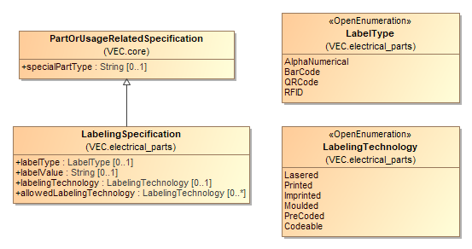
Figure 29: Labeling
A component (of any type) can be labeled in many ways either during the manufacturing process, for example a label that is imprinted on the component during the general manufacturing process (e.g. the part number), or in its concrete use (e.g. with wire number or a usage node id). The LabelingSpecification defines general labeling properties of the component. Labeling properties in its concrete use are defined with the corresponding role.

Component Characteristics
NA

Wire

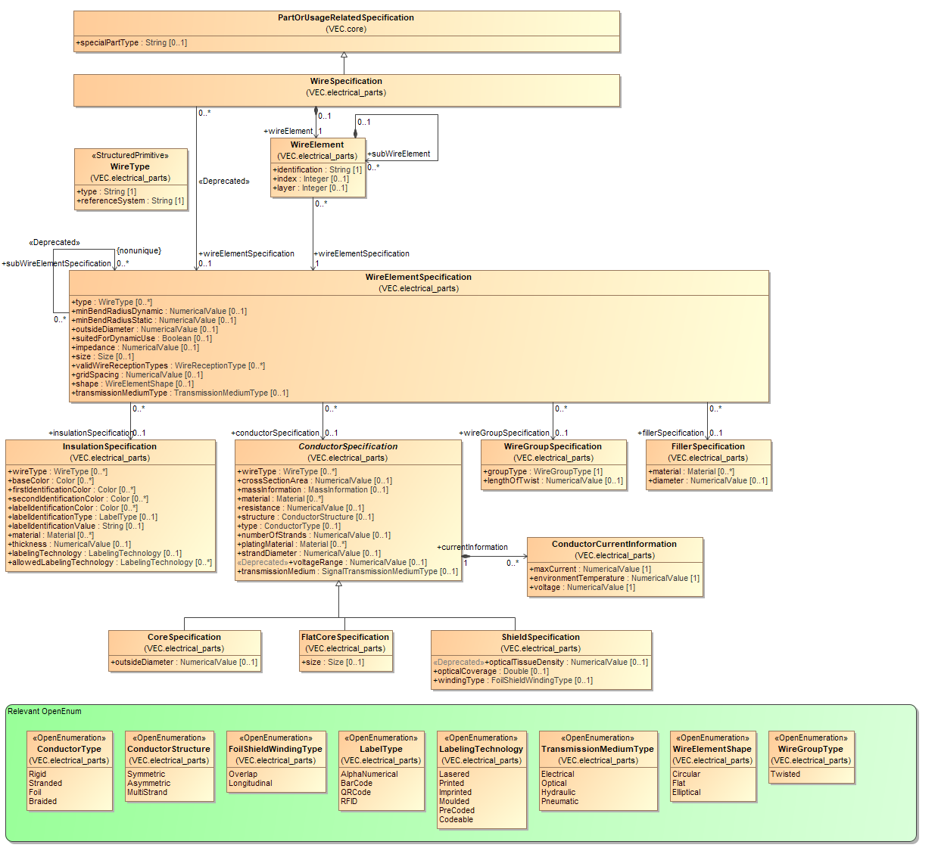
Figure 30: Wire
In the VEC wires are defined through a WireSpecification, regardless of their type. This means, for all types of wires (e.g. normal single core, multi core or coax wires) the same structure is used to describe them. Since a wire can be a hierarchical structure the actual definition of the structure is delegated to a WireElementSpecification. A WireElementSpecification can define a certain wire element and more complex structures by referencing the appropriate subWireElementSpecifications.
This model structure is required, because some WireElements can exist as individual parts and as an element of one or more complex wires with the same technical properties (e.g. a FLRY-0.75 wire can be used standalone or as part of a multi core or twisted wire). In order to allow the reuse of such elements, the structure of a wire element is defined with WireElementSpecifications which can be shared and reused between different other WireElementSpecifications and WireSpecifications. This means a WireSpecification references the root WireElementSpecification that describes its structure, while the subWireElementSpecifications can be used by different WireSpecifications at the same time. Due to increasing complexity of the data structures, the reuse of WireElementSpecifications between WireSpecifications shall be limited to single cores.
In order to allow an unambiguous identification of a particular WireElementSpecification within the context of a WireSpecification, the WireSpecification defines a list of WireElements for each WireElementSpecification that belongs to the hierarchy of the wire. The WireElement defines the identification of a WireElementSpecification within the context of a wire.
For complex wires, it may be necessary to define the order and layering of WireElement objects that are subWireElements of the same WireElement. This is relevant, for example, in multi-core wires where multiple WireElements are arranged circularly around an inner WireElement. Similarly, the order is also important for flat ribbon cables. This is defined with the index- and layer-attributes in the WireElement. As a consequence, order and layering cannot be reused between WireSpecifications, offering the advantage of a significantly simpler model structure.
A WireElementSpecification can reference an InsulationSpecification, a CoreSpecification, a ShieldSpecification, a FillerSpecification and/or a WireGroupSpecification in order to describe its technical details. These aspects are separated into individual Specifications in order to allow the reuse of them. For example, the CoreSpecification of a FLRY-0.75 is the same for a group of wires, regardless of their insulation color. In turn the InsulationSpecification of a blue & green FLRY wire might be the same for a group of wires, regardless of their cross-section area.
When creating the hierarchy of WireElementSpecifications for a wire the representation with the minimal amount of WireElementSpecifications shall be used. This means that a single core shall be represented by a single WireElementSpecification with an InsulationSpecification and a ConductorSpecification and not with individual hierarchical WireElementSpecifications for the insulation and the conductor.
In most cases, a WireElement has a physical representation within the wire. However, there are cases were the WireElementSpecification is just a group of WireElementSpecifications with no real physical manifestation. For example, a twisted pair wire, consists of two single core WireElementSpecifications and a parent WireElementSpecification that just defines the type of twist.
Note: All Specification in this diagram, where no superclass is displayed inherit directly from Specification.

Wire Tuple

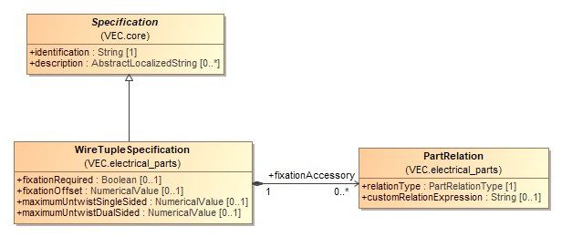
Figure 31: Wire Tuple
A Specification to define requirements for the handling of wire / wire element tuples (pairs, triple...) with the focus on twisting. More precisely, the allowed untwisting at the wire ends and required measures against it.
This definition is made independent from the WireGroup, as the WireGroup might be defined for the part master data (the wire on the roller). The specifications for untwisting are always based on a concrete usage.

Terminals

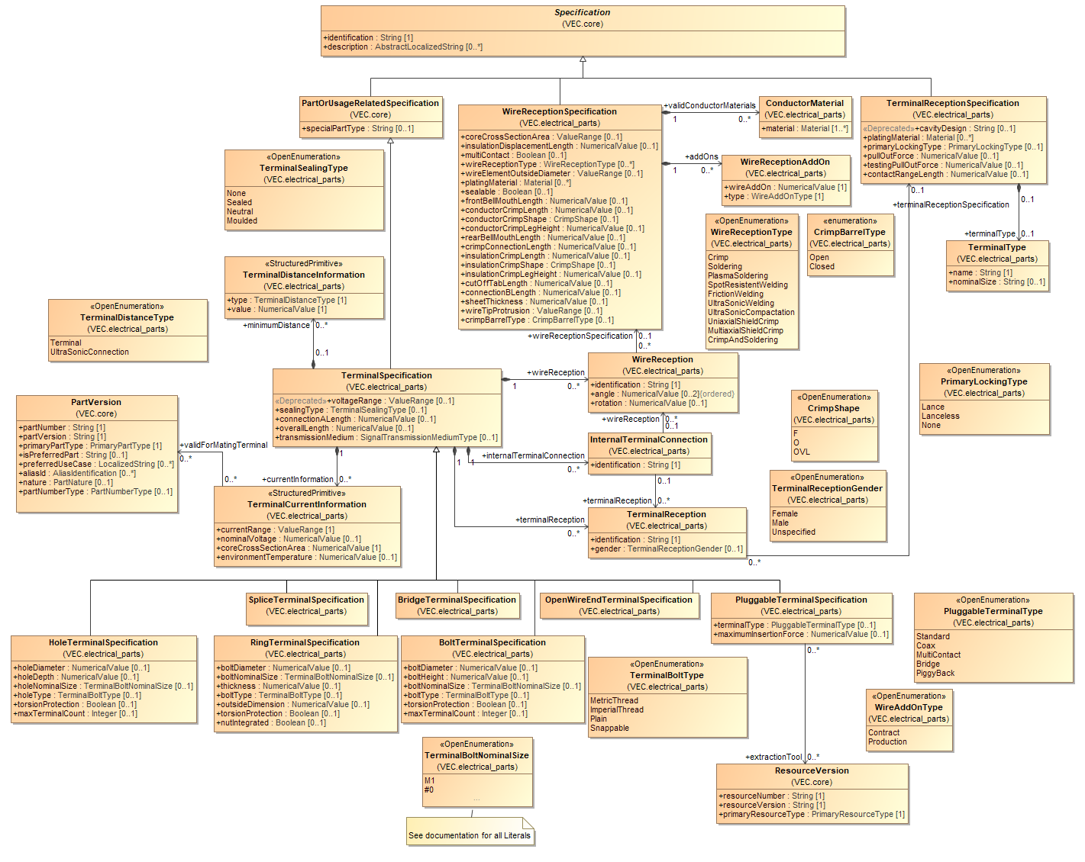
Figure 32: Terminals
A TerminalSpecification can define WireReceptions and TerminalReceptions and on that basis InternalTerminalConnections. A WireReception can reference a WireReceptionSpecification in order to provide technical details about the wires which can be accommodated. A TerminalReception can reference a TerminalReceptionSpecification which provides technical details about compatible cavities and mating-terminals. An InternalTerminalConnection states which WireReceptions and Terminal­Receptions are electrically connected. This is especially important in case of a coax terminal.

Terminal Dimensions

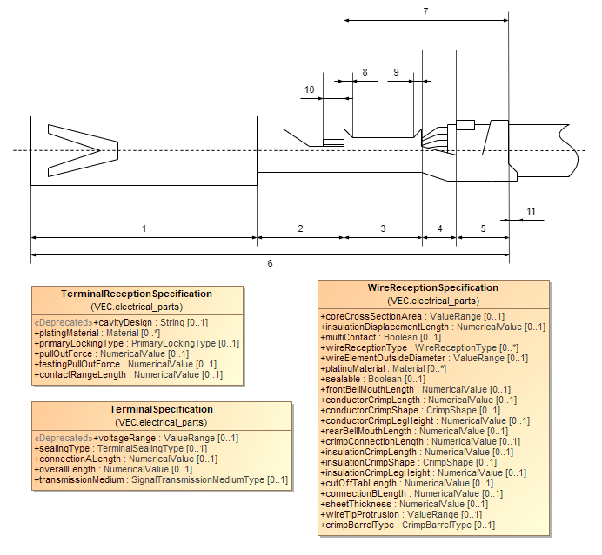
Figure 33: Terminal Dimensions
This diagram shows common terminal dimensions. The corresponding attributes in the VEC are:
- TerminalReceptionSpecification.ContactRangeLength
- TerminalSpecification.ConnectionALength

- WireReceptionSpecification.ConductorCrimpLength
- WireReceptionSpecification.ConnectionBLength

- WireReceptionSpecification.InsulationCrimpLength
- TerminalSpecification.OverallLength
- WireReceptionSpecification.CrimpConnectionLength
- WireReceptionSpecification.FrontBellMouthLength
- WireReceptionSpecification.RearBellMouthLength
- WireReceptionSpecification.WireTipProtrusion
- WireReceptionSpecification.CutOffTabLength

Terminal Coordinate System

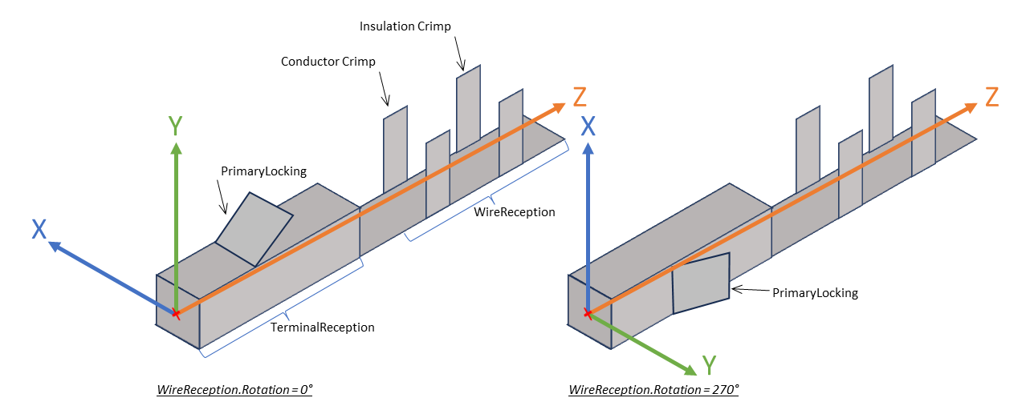
Figure 34: Terminal Coordinate System
The coordinate system of a terminal defines a reference system for the definition of other values (e.g. the WireReception.Rotation). The definition is the following (see illustration).
- The origin (0,0,0) is in the intersection point the centerline of terminal (z-axis) and the perpendicular plane through the most forward end position of the terminal in its cavity.
- The y-axis points in the direction of the primary locking.
- The x-axis is the cross product of y and z, x = y ⨯ z).
The rotation of the WireReception is the angle between the normal vector on base plane of the crimp area and the y-axis, which is a rotation around the z-axis (right hand rule, compare illustration).

Crimp Details

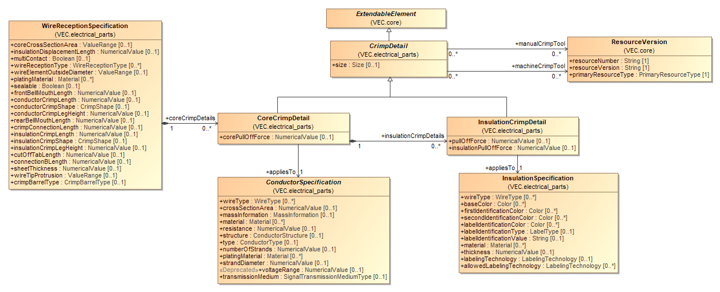
Figure 35: Crimp Details
Height & Width of the crimp are important quality criteria for the crimping process defined in the part master data of the terminal.
The core crimp and the insulation crimp have different heights & width depending on multiple parameter cross-section, material, insulation thickness etc. Each CrimpDetail represents a pair of Height & Width (with optional Tolerance) for specific parameter combination.
Those parameters are not defined in the CrimpDetail itself, but in the referenced Conductor- & InsulationSpecification. There are two possibilities here:
- The Conductor- & InsulationSpecification can belong to the description of a specific wire. In this case, the specifications will most likely contain more information than the information required to determine the crimp parameters.
- The Conductor- & InsulationSpecification can belong to the description of the terminal itself. In this case, the specifications represent a pattern for matching wires, by defining only the relevant attributes (e.g. CrossSectionArea & Material in the ConductorSpecification and InsulationThickness & Material in the InsulationSpecification.

Wire End Accessory and Terminal Protections

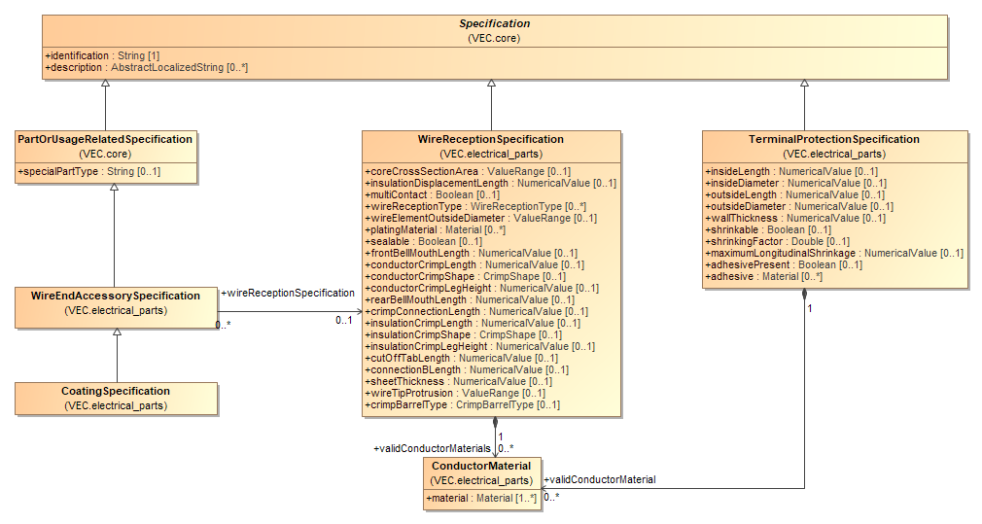
Figure 36: Wire End Accessory and Terminal Protections
WireEndAccessorySpecifications are describing parts that are used for a treatment of a wire end before the actual terminal is attached to the WireEnd (e.g. a ferrule). In contrast to this a TerminalProtection is something that is applied after the joining process.

Terminal Pairing

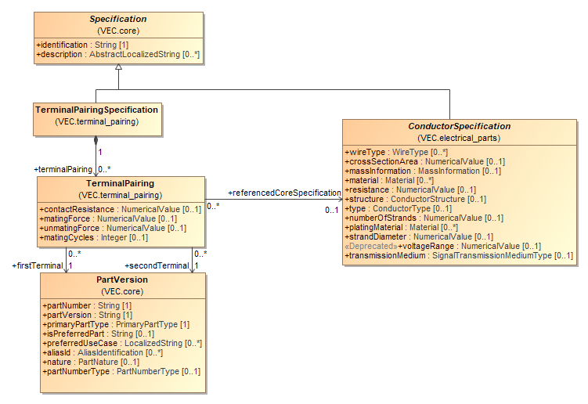
Figure 37: Terminal Pairing
A TerminalPairingSpecification is a container for various TerminalPairing. A TerminalPairing is an aspect of part master definition of terminals and represents a specific pair of terminals pluggable to each other. It specifies properties of that terminal pair in combination with a specific ConductorSpecification.

Connector Housings

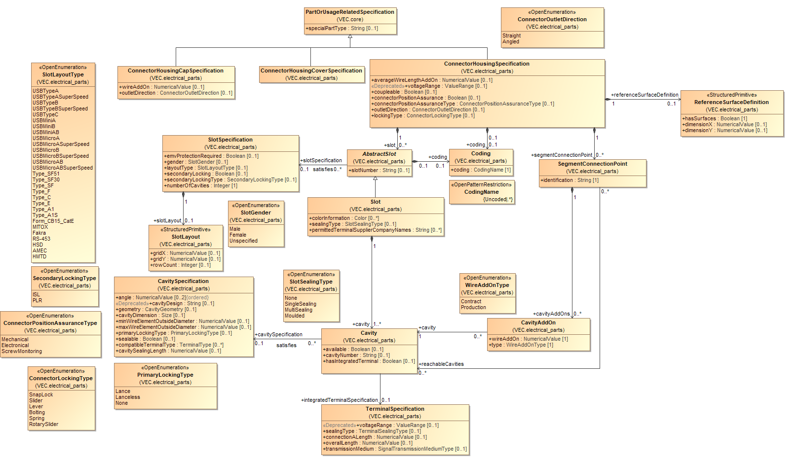
Figure 38: Connector Housings
A ConnectorHousingSpecification defines the technical properties of a connector housing or similar items (e.g. modular connectors, contact modules, connector shells). A connector is normally plugged into a mating connector in order to create connectivity (this is in most cases electrical connectivity but not limited to it). The actual electrical connection is normally established by terminals, mated to each other, which are placed in cavities. The VEC supports two primary types of connectors: normal (conventional) connectors and modular connectors.
A conventional connector defines a fixed number of Cavities, which are grouped into a fixed number of Slots. A modular connector defines a geometrical shape into which another component (a contact module) can be placed (see Diagram "Modular Connector Housings). The cavities are then defined by the used contact module. The combination of both is possible as well.
Therefore, the ConnectorHousingSpecification consists of AbstractSlots, which either can be Slots or ModularSlots in an arbitrary combination.
A Slot is used if the cavities are part of the connector housing. Therefore, a Slot consists of Cavities. A Cavity is defined in detail with a CavitySpecification.

A SegmentConnectionPoint can be used if a connector housing has more than one entry point for wires (segments). The SegmentConnectionPoint is used to define which Cavity is reachable through which entry point. In the latter this is a necessary information to support auto routing for connectors with more than one SegmentConnectionPoint.

Modular Connector Housings
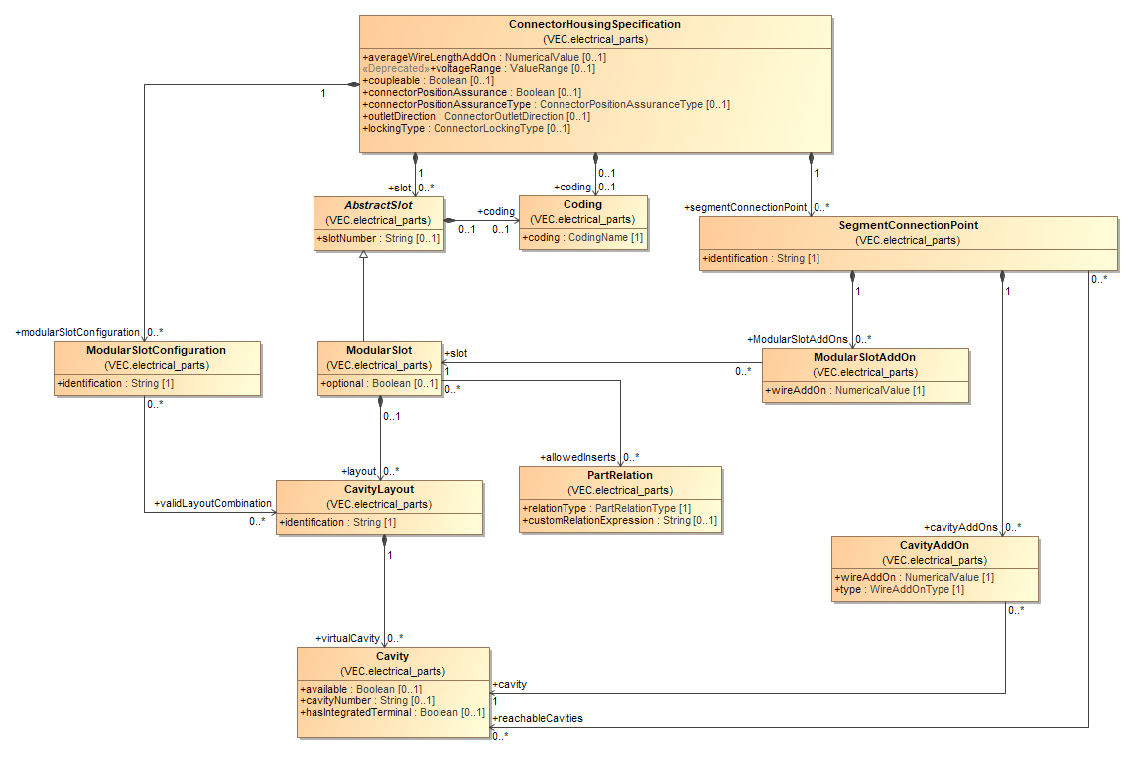
Figure 39: Modular Connector Housings
A modular connector defines a geometrical feature, the ModularSlot, into which another component—a contact module—can be inserted. The actual cavities are defined by the contact module used. It is also possible to combine regular Slots and ModularSlots within the same connector. The inserts themselves are defined by a ConnectorHousingSpecification, allowing the creation of recursive structures. A ModularSlot can reference multiple inserts, since different insert variants often fit into the same ModularSlot. The allowed inserts are referenced via a PartRelation, enabling part master data to be distributed across multiple VEC files.
In the perspective of many use cases, an assembled modular connector is treated in the same way as a regular one-piece connector. For example, the system schematic will typically define a single ComponentConnector with continuous pin numbering. The same applies in many cases to the mating connector, such as the interface on an E/E component. In both scenarios, the decision whether to use a one-piece or a modular connector is often made later in the process.
The ConnectorHousingSpecification of the contact module, on the other hand, is independent of its usage context. This means that both the cavity numbering and any defined MappingSpecification apply to the contact module itself, regardless of the collector housing. For example, cavity 1 in a contact module may correspond to cavity 1 in one collector housing, and to cavity 11 in another. Similarly, the same contact module may fit into different ModularSlots within a housing, causing its logical cavity positions to vary depending on the context.
Therefore, even in the case of modular connectors, it is necessary to define a consistent cavity numbering across its different assembly variants. This is essential to enable the mapping to potential mating connectors and to ensure continuity with upstream data, such as the system schematic.
The CavityLayout serves as a template for a valid configuration of a ModularSlot. A ModularSlot can support various configuration variants (e.g., single-pole, five-pole, ten-pole, etc.). The cavities defined within the CavityLayout are referred to as virtualCavities, as they merely act as placeholders for the actual cavities defined by the contact module. The technical properties of the cavities are determined by the contact module itself.
The virtual cavities serve multiple purposes. Using a MappingSpecification, it is possible to define a mapping between the cavities of a modular connector and those of a mating connector. The MappingSpecification can also be used to map virtual cavities to the actual cavities of a valid contact module (see Diagram "Cavity Mapping").
In addition, virtual cavities allow the assignment of individual CavityAddOns to specific cavities within modular assemblies.
Depending on the specific methodology used for such modular connectors, certain ModularSlotLayouts may only be valid in relation to the configuration of other ModularSlots. For example, if continuous cavity numbering is required, the same insert may have different cavity numbers depending on how many cavities a preceding slot is populated with. The ModularSlotConfiguration allows the definition of such valid combinations.

However, it should be noted that applying such a methodology can led to a rapid, potentially exponential increase in the number of valid configuration variants, depending on the degree of flexibility in the connector’s population.

Geometric Properties of Connector Housings (Definitions)

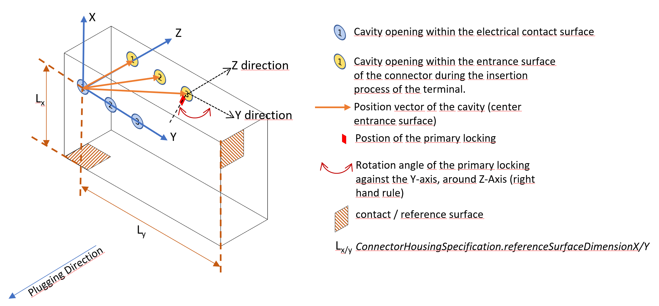
Figure 40: Geometric Properties of Connector Housings (Definitions)
The following section contains all relevant definitions that are required for the corresponding model elements in the VEC.
The geometric properties of connector housings are closely related to the LocalGeometrySpecification, described in the section "Coordinate Systems of Components". All coordinates and values are defined within the same coordinate system. All geometric properties that do not apply exclusively to connector housings are defined there (e.g. BoundingBox, PlacementPoints / SegmentConnectionPoints).
The 3D model and coordinate system of a connector housing is defined as follows:
- The origin of the plug is in the plane of the electrical contact surface in the center of the hole of the cavity/pin with the smallest alphanumeric identifier (e.g. cavity/pin 1 or A1).
- The Y-axis is in the plane of the electrical contact surface and points towards the center of the cavity/pin with the next higher alphanumeric identifier (e.g. cavity/pin 2 or A2). For single-pole connector housings, in the direction of the coding, if present.
- The Z-axis is normal to the plane of the electrical contact surface and points into the housing for female connectors and to the outside for male connectors (the connector in the illustration above is a female connector). So, for female connectors the Z-axis points in the opposite direction of the plugging direction. For male connectors it points in direction of the plugging direction.
- The X-axis is the vector product of Y and Z.
For cavities there are two relevant positions in the connector:
- The position in the electrical contact surface (highlighted in blue), and
- The position in the entrance surface during the insertion process (highlighted in yellow).
The rotation of the cavity within the connector will be defined as the angle between the Y-axis and the primary locking in the cavity.

Geometric Properties of Connector Housings (Model)

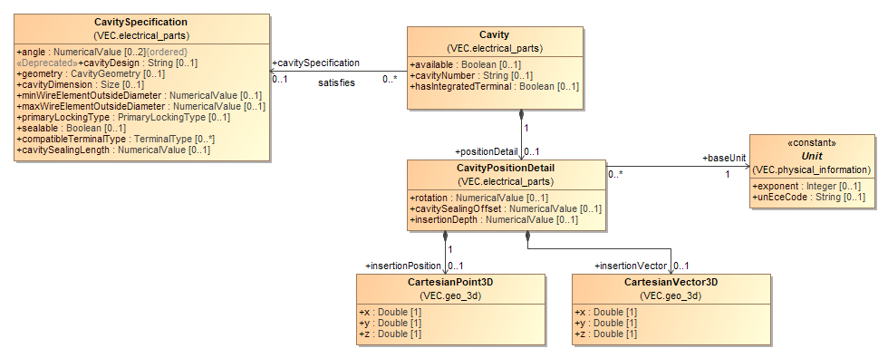
Figure 41: Geometric Properties of Connector Housings (Model)
The geometric properties of connector housings are closely related to the LocalGeometrySpecification, described in the section "Coordinate Systems of Components". Positions of common elements (e.g. BoundingBox, PlacementPoint / SegmentConnectionPoint) are defined in a LocalGeometrySpecification. Within the ConnectorHousingSpecification only those aspects that apply exclusively to connectors are defined. All definitions & conventions that are required to define these geometric properties are described in the previous section.
All geometric properties of a cavity within the context of a connector are aggregated in the optional CavityPositionDetail.

Cavity Mapping

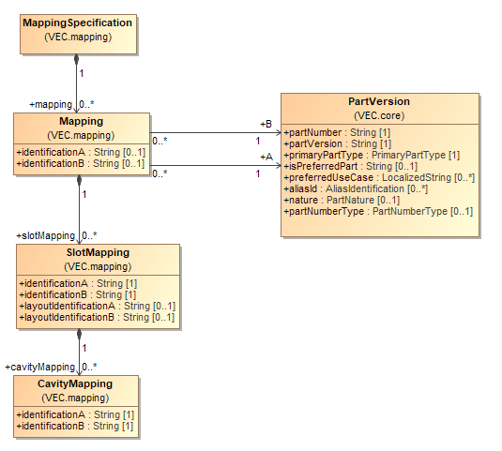
Figure 42: Cavity Mapping
A MappingSpecification defines the mapping of cavities in one connector housing onto the cavities in another connector housing. In order to create a compact data structure, the mapping is not done with direct references to Cavities, but with Mapping elements referencing two PartVersions for which the mapping is valid.
The Mapping element contains SlotMappings and CavityMappings to define which Cavity of one side gets plugged into which Cavity of the other side. The mappings are based on functional keys (e.g. cavity number), not technical keys like ID/IDREF, to ensure flexibility when partitioning the data into different VEC files.
For a valid Mapping, the referenced PartVersions shall represent parts that have "related" ConnectorHousingSpecifications (e.g. connectors or E/E-components, inliner). The identification-Attributes in the Mapping class are used in cases where the "related" ConnectorHousingSpecification cannot be resolved unambiguously. Most regular connectors are described directly by a single ConnectorHousingSpecification. In these cases, the identification-Attributes in the Mapping class can be omitted. In the case of E/E-components, it is not clear from the PartVersion alone against which ConnectorHousingSpecification the mapping is defined, as each HousingComponent can reference its own. In these cases, the identifications in the Mapping are used to reference the relevant ConnectorHousingSpecification. If the Slots of all relevant ConnectorHousingSpecifications have unique identifiers within the E/E-component, the identifications in the Mapping can be omitted.
the component is only described indirectly by the ConnectorHousingSpecifications for each HousingComponent.
The identificationA & B of the SlotMapping / CavityMapping shall have correspondent Slot.identification & Cavity.identification in the respective part master definition of the referenced PartVersions.

Cavity Seals and Cavity Plugs

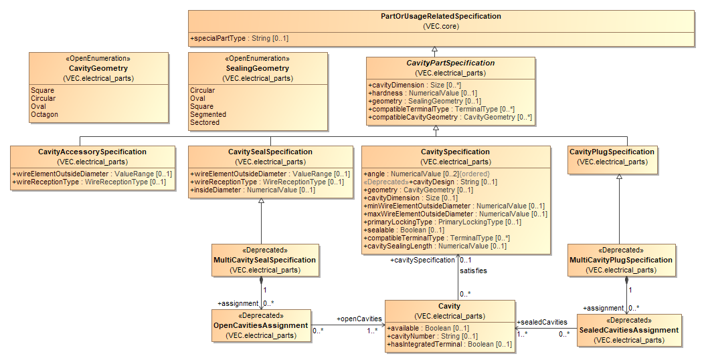
Figure 43: Cavity Seals and Cavity Plugs
The diagram displays the PartOrUsageRelatedSpecifications for Cavity seals and plugs. Both are used to seal Cavities. A cavity plug is used for a single cavity that has no wire in it, a cavity seal is used to seal a single cavity together with a terminal and a wire (single wire seal).
The MultiCavitySeal and the MultiCavityPlug represent parts which are sealing more than one cavity at the same time (multi wire seal). For more details see the description of the corresponding classes.

Cable Seal & Plugs
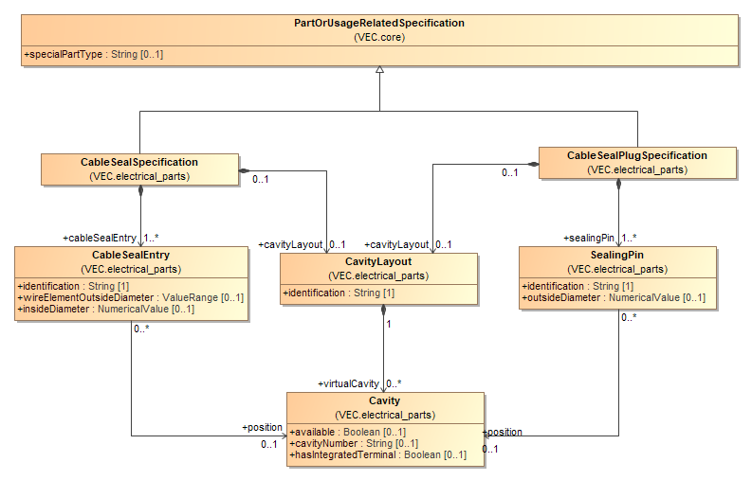
Figure 44: Cable Seal & Plugs
CableSeals are seals that are used on a wire/cable, outside of the actual crimp, but often within a complex connector housing. A CableSealSpecification defines one or more CableSealEntries. A CableSealPlug is a plug that can seal one or more CableSealEntry that are not occupied by a wire element. The CableSealPlugSpecification defines SealingPins for each CableSealEntry that it might seal.
Both Specifications can define a CavityLayout with virtualCavities. Those Cavities serve multiple purposes:
- By utilizing a CavityMapping it is possible to create a mapping between a CableSealSpecification and its compatible CableSealPlugSpecification and to define which CableSealEntry is plugged by which SealingPin.
- Also, by utilizing a CavityMapping it is possible to create a mapping between a CableSealSpecification/CableSealPlugSpecification and a ConnectorHousingSpecification specifying which CableSealEntry is associated with which Cavity of the connector housing. This information is required for example to determine which CableSealEntry has to be used for specific wire, when it is contacted in a specific cavity of the connector housing.

Wire Protections

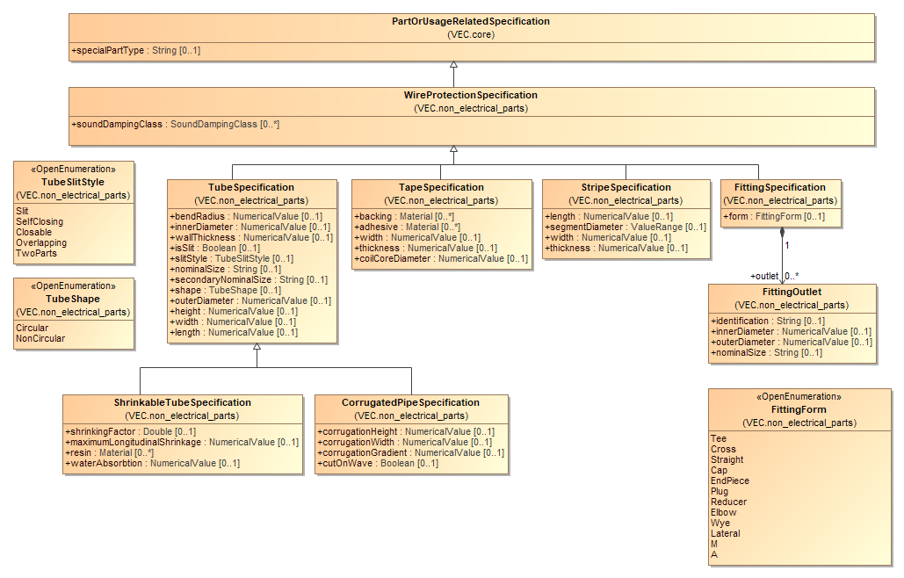
Figure 45: Wire Protections
The diagram displays the type hierarchy for WireProtectionSpecifications. These PartOrUsageRelatedSpecifications are used to describe the technical aspects of wire protections like tapes, tubes, fittings and stripes.

Fixings, Cable Ducts, Cable Ties and Similar

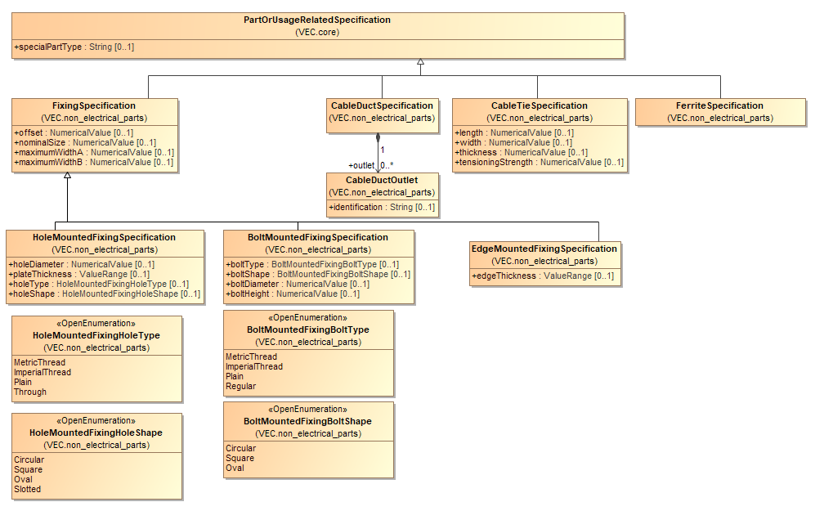
Figure 46: Fixings, Cable Ducts, Cable Ties and Similar
The diagram displays the type hierarchy for parts that are usually mounted onto the topology of a wiring harness. These PartOrUsageRelatedSpecifications are used to describe the technical aspects of components like fixings and cable ducts.

Fixings Coordinates and Dimensions
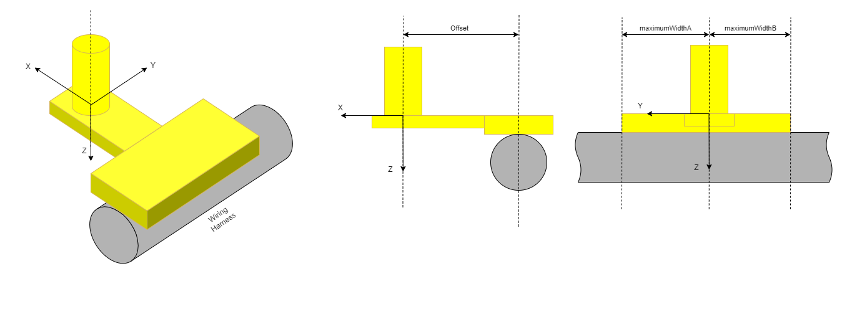
Figure 47: Fixings Coordinates and Dimensions
The following section contains specifications for the definition of coordinate systems of fixings, clips, cable ties and similar (and their 3D models). These coordinate definitions form the basis for various attribute definitions and the placement of components on the wire harness (see PlacementSpecification) and in the 3D model (see BuildingBlockSpecification3D). For components whose geometry changes upon installation, the installed state must be used.
The orientation of the coordinate system of cable ties shall be as follows:
- The origin of the cable tie lies centrally at the edge of the lock on the side of the cable tie.
- The Y-axis is positioned in the plane of the wire harness support surface and is oriented parallel to the direction in which the wire harness passes through the cable tie.
- The XZ-plane intersects the wire harness.
For fixings with cable tie (including those with attached cable ties), only the fastening is represented. The cable tie itself (which varies in diameter) and its closure are omitted.
The orientation of the coordinate system of fixings shall be as follows:
- The origin of the component lies at the intersection of the support surface of the fixing (in the installed state) with the central axis of the locking pin, bolt holder, or hole/slot (depending on the fastening method).
- The Y-axis is in the plane of the support surface and oriented parallel to the direction in which the cable harness passes through the fixing.
- The Z-axis is perpendicular to the plane of the support surface and points in the opposite direction to the clip's mounting direction.
For fastening elements attached to an edge, the origin of the component is located at the intersection of the support surface of the component (in the installed state) with the center of the side contact surface of the component on the sheet metal.
If the conditions described above cannot be met, the following priorities should be applied:
- The Y-axis is oriented parallel to the direction in which the cable harness passes through the fixing and lies in the plane of a support or contact surface.
- The XZ plane must intersect the cable at the point where the position of the component on the segment is dimensioned (e.g., in the middle of the cable tie for cable tie holders).
- The YZ plane lies in the middle of the component.
Definitions were adopted from the CES guidelines.

Grommets

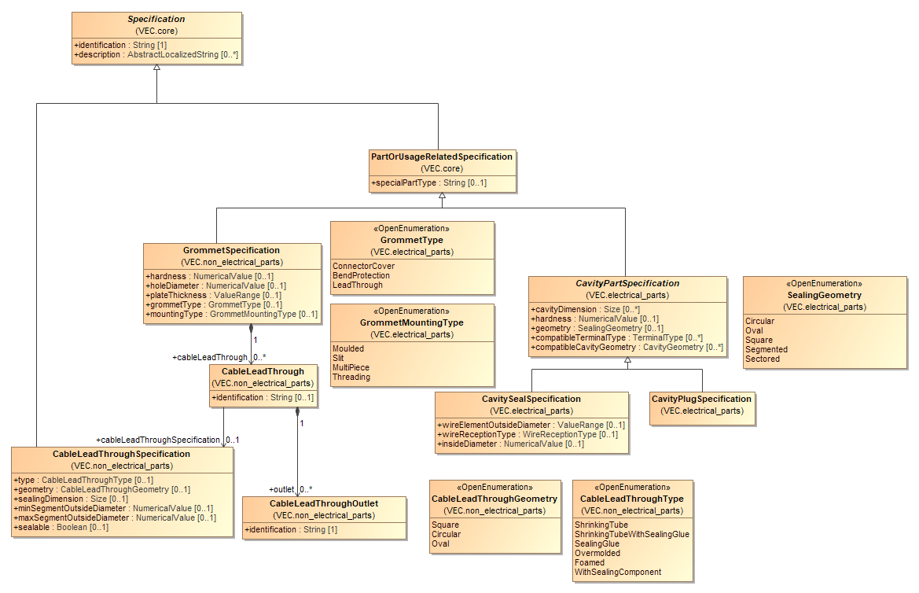
Figure 48: Grommets
This diagram displays the relevant classes for grommets. Basically, grommets belong to the same category of parts like fixings and cable ducts. Grommets are mounted onto a harness topology and are used to guide cables safely, and in some cases sealed, through openings, for example in the car body.
There are cases, where additional sealing of a cable lead through is not done with some kind of manufacturing steps (e.g. Foamed), but with additional sealing components. These are common case e.g. in high voltage applications where one lead through per wire is used. Those are often sealed with an additional single wire seal. In the VEC those seals are represented by a CavitySeal- or CavityPlugSpecification. Even if the name "Cavity..." seems awkward in the combination with grommets & cable lead throughs, the properties remain the same.
The CableLeadThroughSpecification includes all attributes that are necessary to calculate appropriate seals.

EE-Components
NA

EE-Components

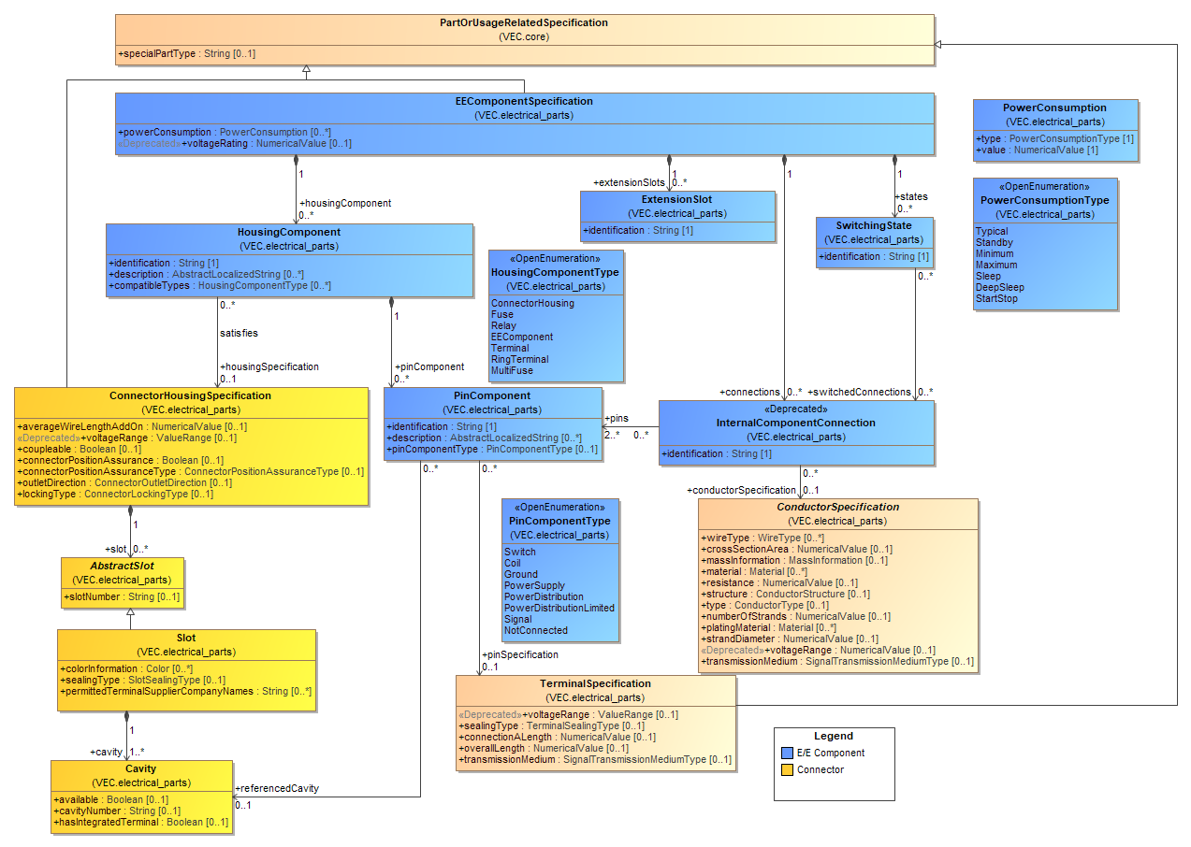
Figure 49: EE-Components
An EEComponentSpecification is used to describe the technical aspects of an EE-component. An EE-component is an electrical component to which the wiring harness is attached to (e.g. an ECU, a sensor, a relay, an antenna, a battery, a fuse). All EE-components have in common that they have a certain electrical interface (e.g. to which the wiring harness is attached). To describe this interface, the EEComponentSpecification is used. The content of an EEComponentSpecification is highlighted in blue.
An EEComponentSpecification can define a couple of HousingComponents. A HousingComponent is one interface to which other components can be attached (e.g. the wiring harness). To describe a HousingComponent satisfyingly two aspects are necessary:
- its geometrical shape and,
- its electrical behavior.
In order to describe the geometrical shape of a HousingComponent it can reference a ConnectorHousingSpecification, so the same concept is used in the wiring harness and in an EE-component (highlighted in yellow). The electrical behavior of a HousingComponent is defined by several PinComponents. A PinComponent references a Cavity to define its location in the geometrical shape of the HousingComponent. To define its physical properties a PinComponent references a TerminalSpecification. These properties are defined inherently by the material and the type of the pin. It is a common case that some of the PinComponents (sometimes all) of a single HousingComponent are referencing the same TerminalSpecification. The definition of properties regarding the behavior of a PinComponent (e.g. defined by the software deployed on an ECU) is explained in the diagram "Pinning Information & Pinning Variance".

Segment Connection Points

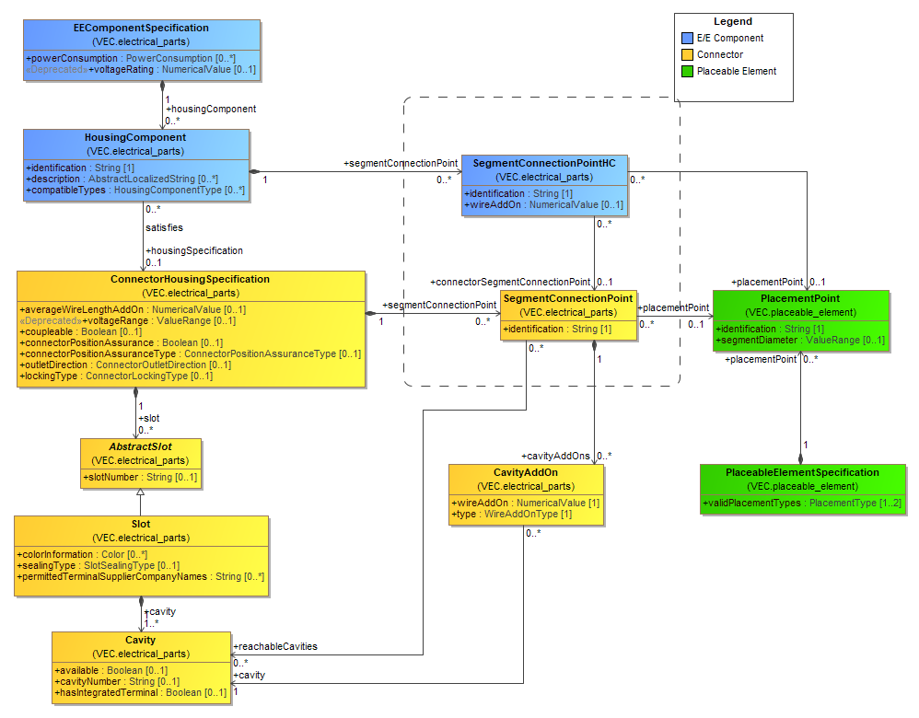
Figure 50: Segment Connection Points
The HousingComponent of an E/E-Component has two major use cases:
- Other E/E-Components can be plugged into it (e.g. Fuses, Relays, Harnesses).
- Wire can be contacted directly into the HousingComponent (without an additional connector)
In the first case, no connection to the harness topology is required. Either because there is no harness topology (e.g. a Fuse), or because the end point of the topology is the harness connector itself (which is plugged into the housing component). However, for the latter case, HousingComponent itself is the endpoint of the wires and thus of the harness topology. Like a connector, an E/E-component and its HousingComponents can have multiple different points at which TopologyNode can be connected and not all HousingComponents and Cavities are reachable from a connecting point.
Reusing the SegmentConnectionPoint of the ConnectorHousingSpecification is not sufficient, because a single ConnectorHousingSpecification can be used by different HousingComponents and the definition would be ambiguous.
Therefore, a HousingComponent can define multiple SegmentConnectionPointHC representing the valid options for this specific HousingComponent to attach to a TopologyNode. The definition of cavity reachability and wire addons is specified with the SegmentConnectionPoint of the ConnectorHousingSpecification. SegmentConnectionPointHC can reference the SegmentConnectionPoint which is used to "enter" the connector housing.

Internal Connectivity
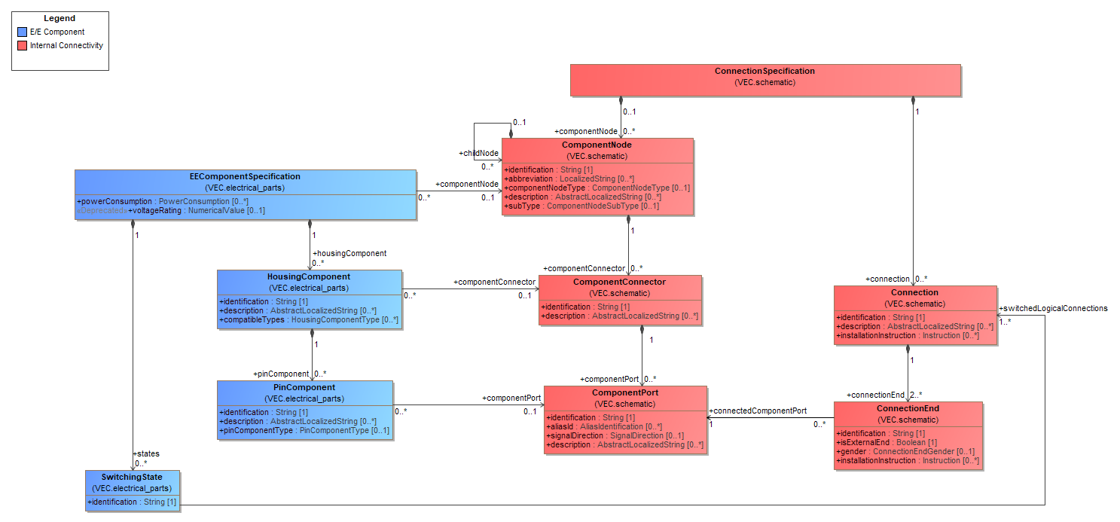
Figure 51: Internal Connectivity
The model elements above enable the explicit modelling of the internal electrical connectivity of E/E-Components in the VEC. The ConnectionSpecification, a core concept in the VEC is used to represent the logical internal connectivity between PinComponents within an EEComponentSpecification. For more details of the ConnectionSpecification see "Connectivity / Connection Specification".
The ConnectionSpecification should be co-located with the EEComponentSpecification in the DocumentVersion that defines the E/E-component. It contains a single ComponentNode representing the E/E-component itself. The HousingComponents and PinComponents are represented by ComponentConnectors and ComponentPorts on this ComponentNode. The internal connectivity is represented by Connections. If the E/E-component contains integrated subcomponents, those are represented as childNodes of the ComponentNode of the E/E-component.

Traceability Links

To ensure semantic consistency and enable model traceability, dedicated references are introduced between the following elements:
- EEComponentSpecification → ComponentNode
- HousingComponent → ComponentConnector
- PinComponent → ComponentPort
These links allow navigation between the specification of a component and its internal connectivity representation.

Representation of Physical Properties

The ConnectionSpecification is the layer to describe logical connectivity, and it does not contain any physical properties (such as conducting properties of a Connection). However, it is possible to define physical properties with PartOrUsageRelatedSpecifications and Roles and link this information with the logical connectivity (see Wiring Specification).
- If the physical entity is a component (e.g. a fuse) it is represented as a ChildNode of the ComponentNode representing the E/E-component.
- If it is a conductor of any kind, it is represented by a Connection.
- A PartUsageSpecification and a PartStructureSpecification is added to the definition of the E/E-component. If the subcomponents should be represented as actual PartOccurrences, instead of PartUsages, a CompositionSpecification is used instead of the PartUsageSpecification.
- For each element with physical properties a PartUsage (with corresponding PartOrUsageRelatedSpecification and Role) is created. This includes traceability links to the corresponding ConnectionSpecification elements (e.g. WireElementReference -> Connection, FuseRole -> ComponentNode (a childNode)).
This approach ensures a separation of concerns between logical connectivity and physical embodiment while maintaining full traceability.

EE-Component subclasses

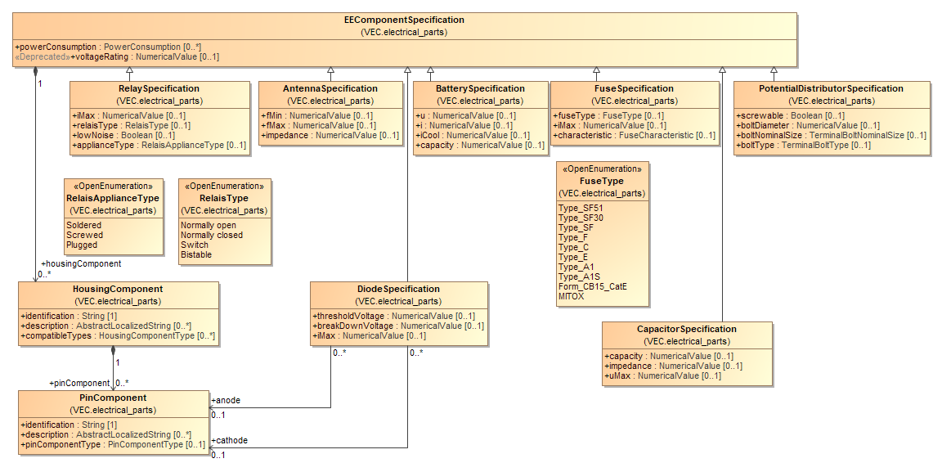
Figure 52: EE-Component subclasses
In order to define additional aspects of an EE-component there are some subclasses of the EEComponentSpecification. This diagram displays these subclasses.

Multi Fuse

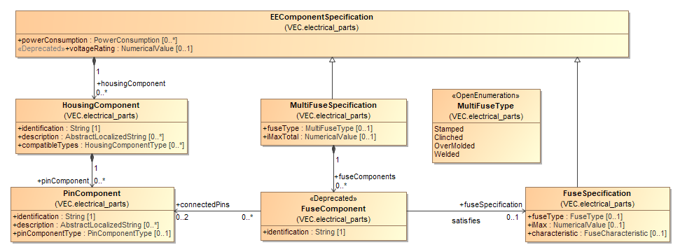
Figure 53: Multi Fuse
A multi-fuse is a metal structure that combines several fuses with a common power feed in a fixed layout. It is used to distribute a power supply to different fuse paths.

Pinning Information & Pinning Variance

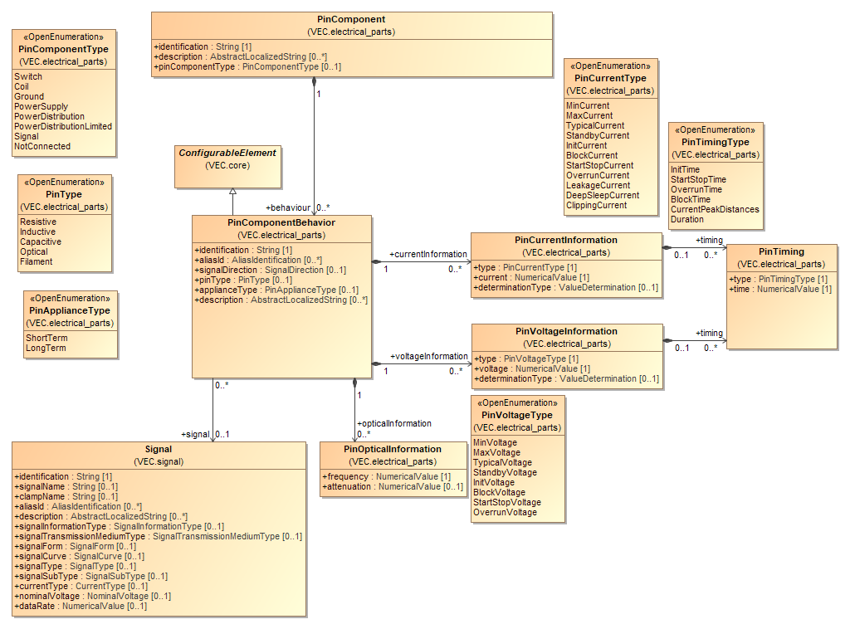
Figure 54: Pinning Information & Pinning Variance
The electrical behavior of a PinComponent can be fixed for a certain EE-component but does not have to be fixed. For example, in the case of an ECU, the behavior depends on the deployed software.
Therefore, the electrical behavior of a PinComponent is not defined directly and fixed in the PinComponent. In fact, a PinComponent can define PinComponentBehaviors, which are ConfigurableElements. This means the actual valid PinComponentBehavior for a PinComponent can be determined when the necessary variant information is available. When no variant information is necessary (the PinComponent has a fixed behavior) then the PinComponent just defines a single PinComponentBehavior.
The PinCurrentInformation and PinVoltageInformation can be used to describe the characteristic curves for different types and times of currents and voltages.

Instances of Components
NA

Instantiation of Components

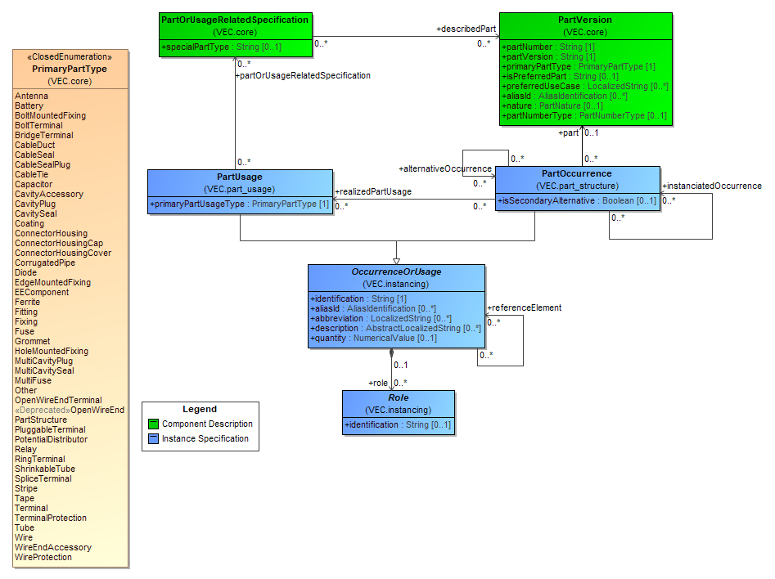
Figure 55: Instantiation of Components
It is a quite common pattern for complex product descriptions, to differentiate between types and their instances. A type is a general description that applies to all instances of this type. In the VEC the types of components are described with PartVersions and PartOrUsageRelatedSpecifications. They are describing the general properties of a certain component type (e.g. a connector housing with a certain partNumber). In order to define a more complex product with these elements, instances of the components are necessary (e.g. the connector housing for the left front light). To create such instances of components, the VEC provides two concepts: PartOccurrence and PartUsage.
The two concepts are necessary to fulfil the requirement for the VEC, that equal design elements are represented equally in the model, regardless of the level abstraction. This means for example, that the specification of a contacting must be represented always in the same way, regardless of the context either in an electrological specification or in a finalized product specification. The difference is that in an electrological specification in many cases defines only requirements for a component (e.g. the wire color, cross section area or number of cavities). In a finalized product specification, all components normally have assigned part numbers.
A PartOccurrence is a concrete occurrence of a certain PartVersion in a real product (Metaphorically spoken: if the product is broken into pieces, there will be a good chance that one of the pieces is the PartOccurrence one is searching for). Therefore, the PartOccurrence references directly a PartVersion.
PartUsages shall be used for the specification of the elements on a more abstract level. This is the case either when not all technical properties required to select a correct PartVersion are known (e.g. only the cross-section area of a wire is known, but not the color) or when not all usage properties are known that are required to create a PartOccurrence. This is true for example for a connectivity description and for a pure geometry description. The final occurrences come first into being when a connectivity description and a geometry description is combined. This is even true in the case of connectivity description where the part numbers for the wiring connections are already defined. The reason is that the wire lengths are still undefined, because the length information is dependent on a certain geometry. Additionally, it is possible that the same wiring definition is instantiated within different geometries, which might result in different PartOccurrences. For reasons of traceability, each PartOccurrence can reference back to the PartUsage it realizes.
In order to describe technical properties for a PartUsage without requiring a concrete PartVersion or a pseudo PartVersion the PartUsage can reference several PartOrUsageRelatedSpecifications like the PartVersion. As described in the chapter "part master data" the VEC allows the description of components through the combination of different characteristics (the PartOrUsageRelatedSpecifications). Therefore, a PartUsage can reference multiple PartOrUsageRelatedSpecification. Its primary characteristic is defined with the PrimaryPartType.
However different characteristics of component types may require different properties for instances of them. Therefore, a symmetrical concept to the PartOrUsageRelatedSpecification for instances was created in the VEC: The Role. Quite simplified: A Role is an instance of a PartOrUsageRelatedSpecification in the context of an OccurrenceOrUsage which is an instance of an abstract or concrete part (difference between PartUsage and PartOccurrence).
Roles, their subclasses and the sub elements of them are used whenever type specific usage information is required (e.g. a reference to a cavity in a certain use of a connector). Every other concept in VEC that requires references to instances uses these elements (e.g. the contacting). Since a Role can be used without knowing if it belongs to a PartUsage or a PartOccurrence concepts like the contacting can be reused regardless of the level of abstract (e.g. in a system wiring without concrete part numbers or in the product specification of wiring harness).

Instances of Wires

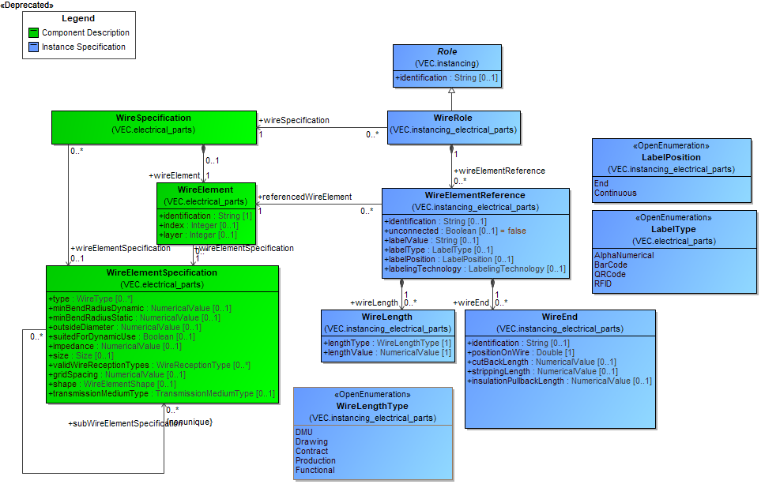
Figure 56: Instances of Wires
The diagram shows the mapping between the part master data of a wire (partly displayed on the left side) and the instance specific information (displayed on the right side).

Instances of Terminals

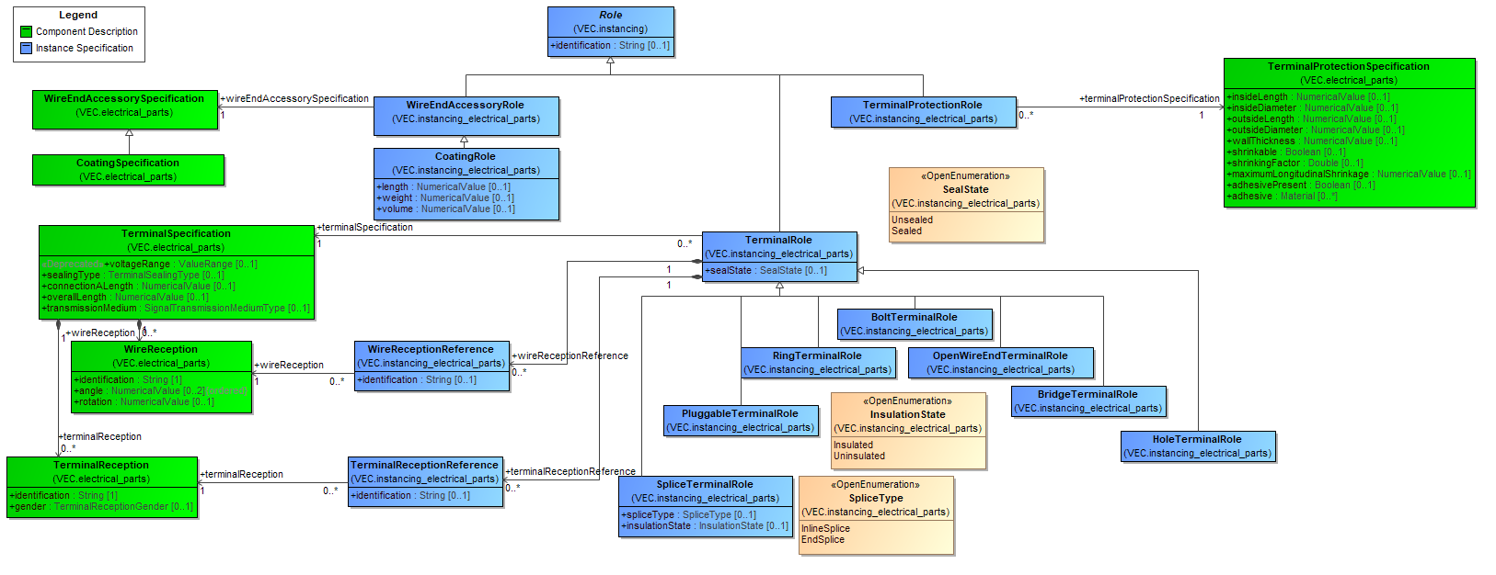
Figure 57: Instances of Terminals
The diagram shows the mapping between the part master data of a terminal (partly displayed on the left side) and the instance specific information (displayed on the right side).

Instances of Connector Housings

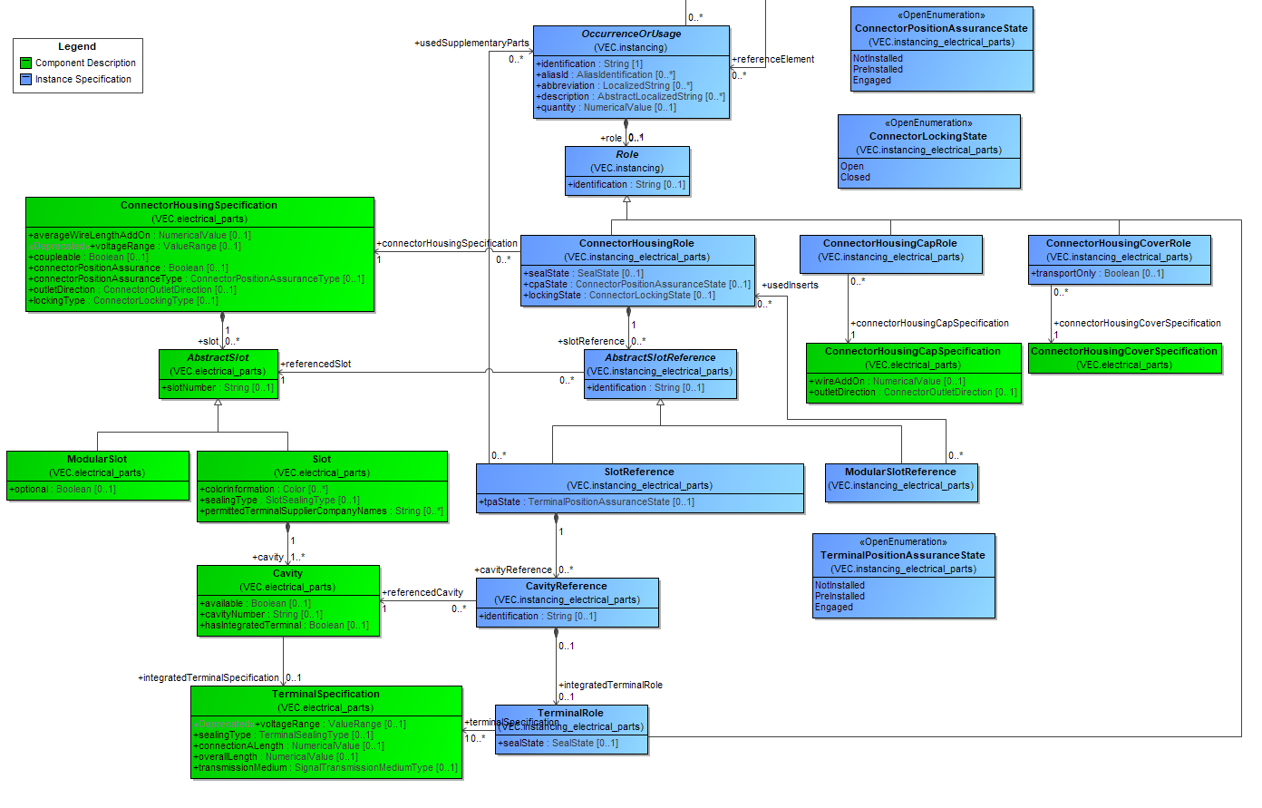
Figure 58: Instances of Connector Housings
The diagram shows the mapping between the part master data of a connector housing (partly displayed on the left side) and the instance specific information (displayed on the right side).

Instances of Cavity Seals and Cavity Plugs

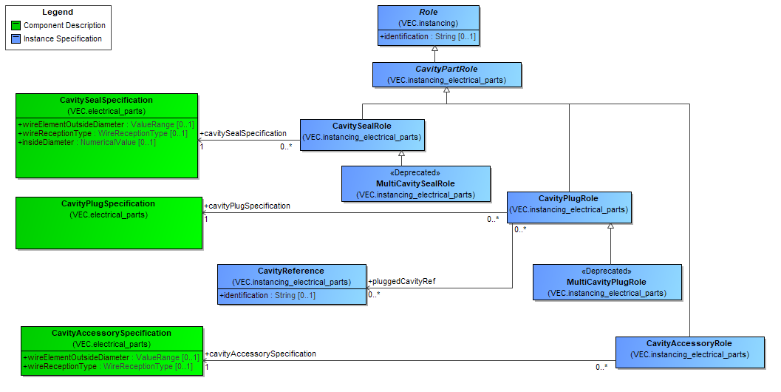
Figure 59: Instances of Cavity Seals and Cavity Plugs
The diagram shows the mapping between the part master data of cavity seals and cavity plugs (partly displayed on the left side) and the instance specific information (displayed on the right side).

Instances of Cable Seals and Plugs
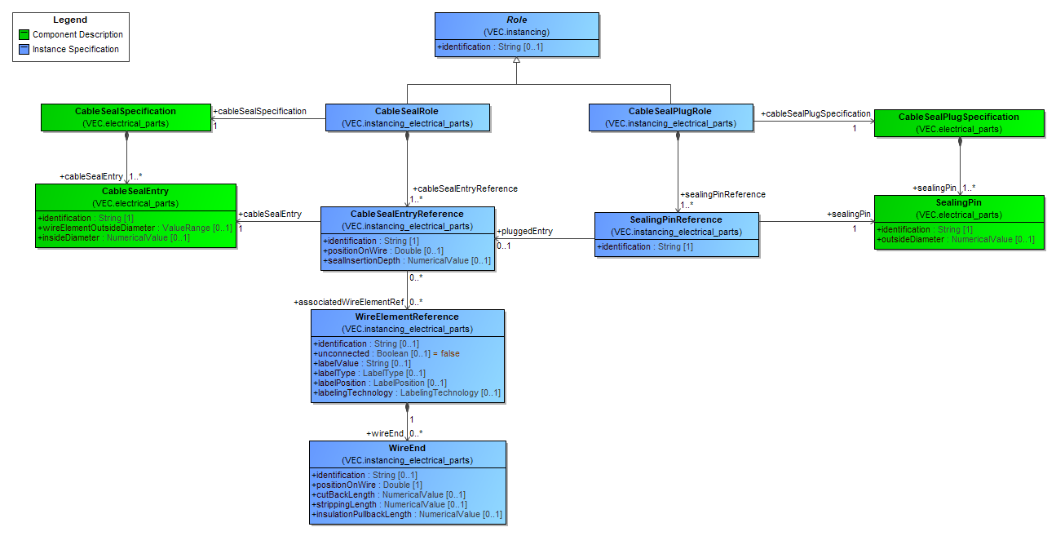
Figure 60: Instances of Cable Seals and Plugs
The diagram shows the mapping between the part master data of cable seals and cable plugs (partly displayed on the left side) and the instance specific information (displayed on the right side).

Instances of EE-Components

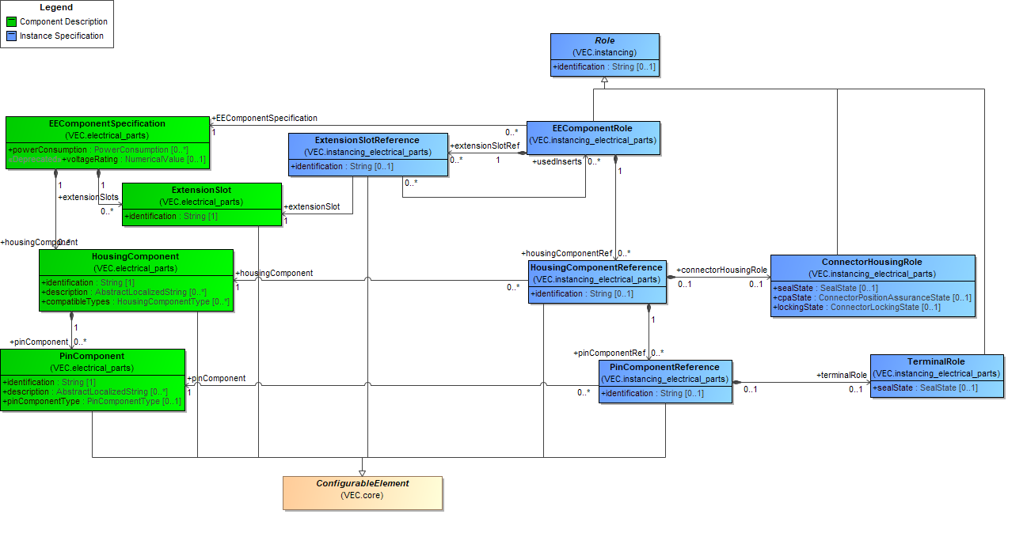
Figure 61: Instances of EE-Components
The diagram shows the mapping between the part master data of an EE-component (partly displayed on the left side) and the instance specific information (displayed on the right side). Additionally, an EEComponentRole can reference one or more ConnectorHousingRoles, AbstractSlotRoles or CavityReferences onto which it is mounted.

Instances of EE-Components subclasses

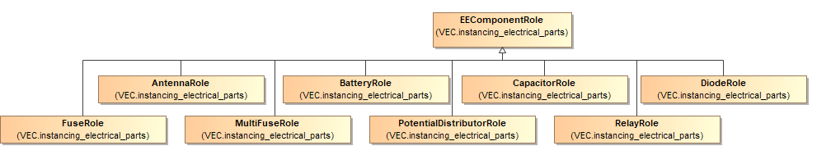
Figure 62: Instances of EE-Components subclasses
In order to define additional aspects of an EE-component instance there are some subclasses of the EEComponentRole symmetrical to EEComponentSpecification inheritance hierarchy. This diagram displays these subclasses.

Instances of Wire Protections

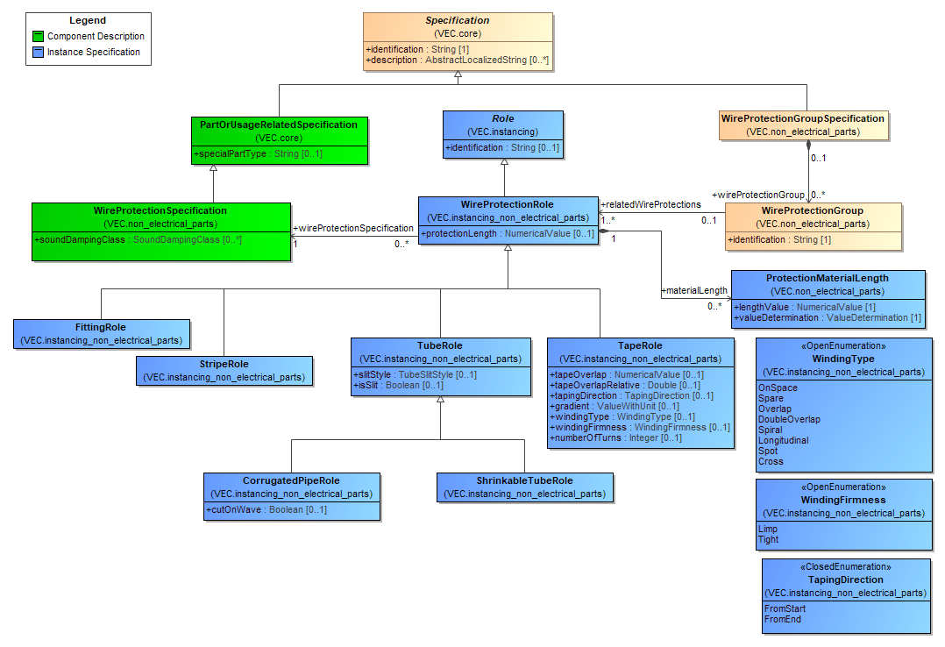
Figure 63: Instances of Wire Protections
The diagram shows the mapping between the part master data of a wire protection (partly displayed on the left side) and the instance specific information (displayed on the right side).

Instances of Fixings, Cable Ducts, Cable Ties and Similar

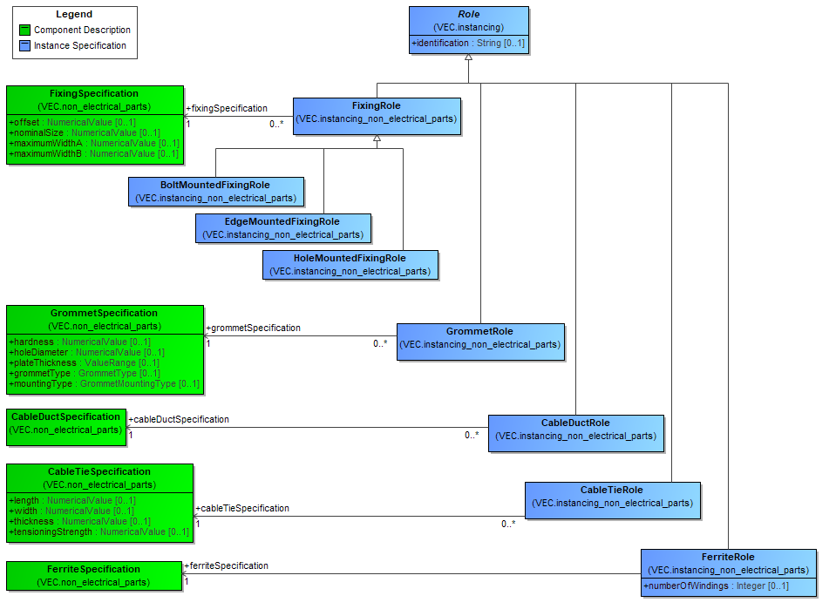
Figure 64: Instances of Fixings, Cable Ducts, Cable Ties and Similar
The diagram shows the mapping between the part master data of fixings and cable ducts (partly displayed on the left side) and the instance specific information (displayed on the right side).

Instances of Grommets

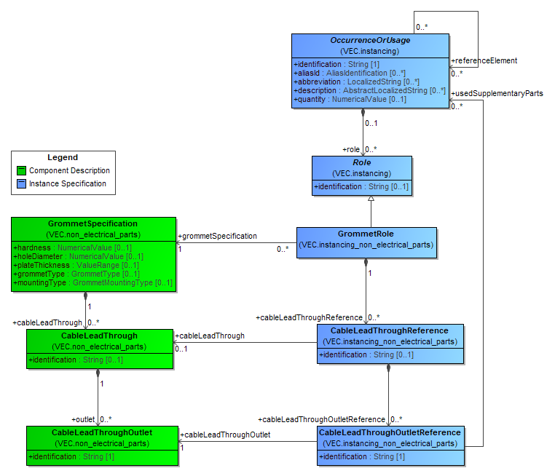
Figure 65: Instances of Grommets

Instances of undefined Components

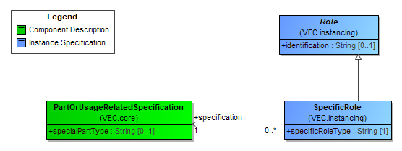
Figure 66: Instances of undefined Components
In some cases, it is necessary to specify and to use a component which is not defined in detail by the VEC. The recommended approach in such a case is to use a PartOrUsageRelatedSpecification with CustomProperties to specify such a component. When this component must be instanced, a SpecificRole shall be used.

Instances of Placeable Components

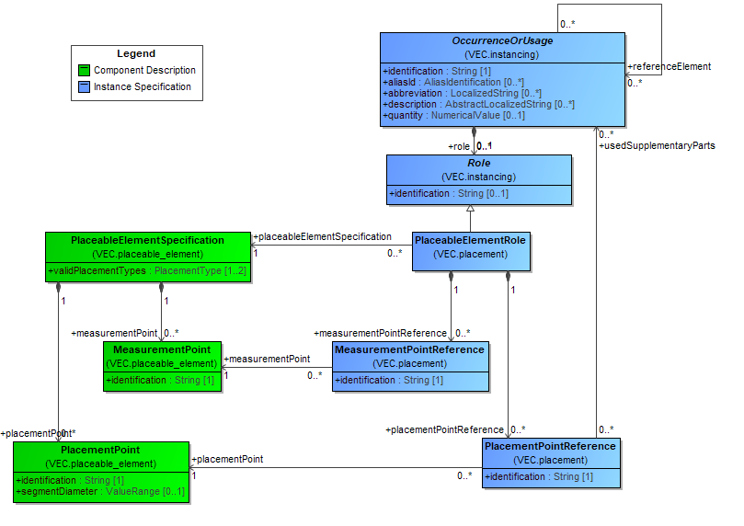
Figure 67: Instances of Placeable Components
The diagram shows the mapping between the part master data of a PlaceableElement (partly displayed on the left side) and the corresponding instance specific information (displayed on the right side).

Installation Instructions

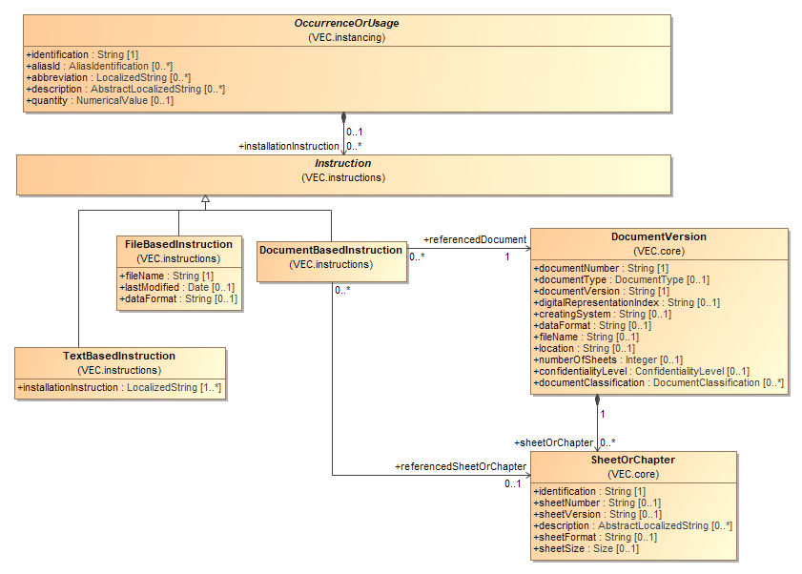
Figure 68: Installation Instructions
Basis for the definition of installation instructions is the abstract class Instruction which allows instructions to be specified as TextBasedInstructions, FileBasedInstructions or DocumentBasedInstructions.
Note: This diagram only shows the Instruction concept in the context of OccurrenceOrUsage. However, the Instruction concept is used in the context of PartVersions and several elements of a ConnectionSpecification as well.
Each OccurrenceOrUsage can define various TextBasedInstructions in order to exchange (normally) human readable installation instruction information.
Note: Unlike the KBL a TextBasedInstruction does not contain a type attribute. This is because a TextBasedInstruction is explicitly not wanted to be used as an extension mechanism. The declared extension concept of the VEC is the CustomProperty concept.
In addition, each OccurrenceOrUsage can define various FileBasedInstructions. This may be useful to reference for example files that contain graphical information e.g. in form of SVG.
In addition, each OccurrenceOrUsage can define various DocumentBasedInstructions. This allows to reference a DocumentVersion or alternatively a certain SheetOrChapter in a DocumentVersion that contains the instruction.

Instances of Labels

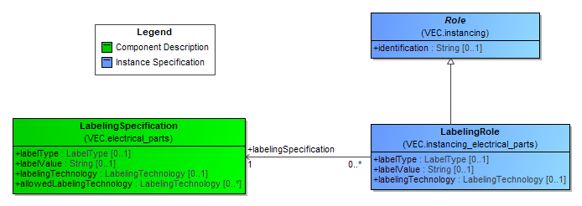
Figure 69: Instances of Labels
If a component is labelled in its concrete usage, label information is defined with the LabelingRole.

Composite Part Descriptions
The KBL defined a fixed hierarchy for composite parts, where different concepts covered specific aspects. These concepts were all represented in the model individually: Harness, Module, HarnessConfiguration, Assembly. From a structural point of view, all of them where quite the same, a composition of components (parts), the only real difference is the handling in process. However, the point of view might change the handling in the process.
For example, a module is assembled of components like connector housings, wires and terminals or pre-assembled parts (assembly) that are again assembled of connector housings, wires and terminals. From an abstract point of view a part regarded as a module by one process partner could be regarded as an assembly by another process partner and vice versa.
The VEC harmonizes these different concepts into one general concept for all these aspects. The following sections are describing this concept.

Multi-level Part Structure

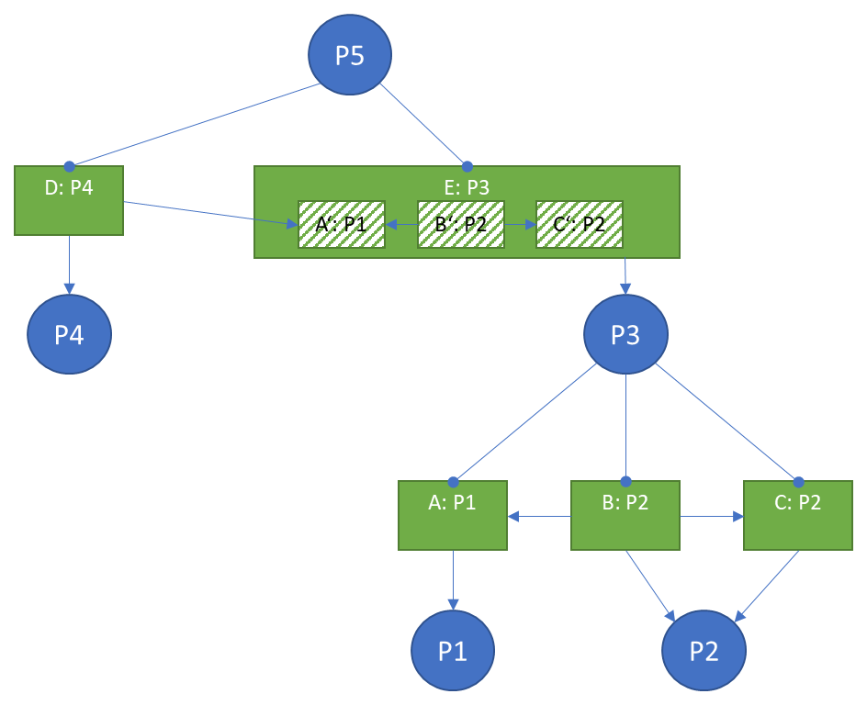
Figure 70: Multi-level Part Structure
The basic idea is the same as for multi-level bill of materials (BOM), where a product is defined in a parent-child, top-down method. It lists all raw materials, semi-finished goods and sub-assemblies that are required to build the product in a hierarchical way. A component in such bill of material can consist of child components, which in-turn can have their own child components, and so on.
However, a regular bill of material just defines quantities of parts required (e.g. 4x P1, 1x P2, ...). Since the VEC not only describes the quantities of materials required to build a product, but also the way how the materials should interact (e.g. a specific terminal on a wire end in a defined cavity), the VEC requires an extended approach.
The diagram above illustrates an example for this and will be explained from bottom to top. P1 and P2 are basic components (parts with a part number). P1 could be a wire, P2 a terminal. To define some sort of composite component, the occurrences A, B and C are necessary (VEC class OccurrenceOrUsage). Those are required to specify the details of the composition with relationships among the occurrences and usage specific properties (e.g. wire length and contacting relationships). A composite component P3 is defined as consisting of occurrences A, B, and C.
The composite component P3 is used together with P4 to build P5. Again, occurrences are required. However, a single occurrence E for the composite part P3 is not sufficient, to specify the detailed composition of P5. Individual occurrences A', B' and C' of the sub-components of E are required for this. For example, to correctly specify the usage of a pre-assembled cable in a harness (a wire with connectors already attached to it), references to the sub-components are necessary (e.g. routing of the wire, position of connectors).
The PartStructureSpecification is used to define composite components based on occurrences (e.g. P3), the PartWithSubComponentsRole is used for the instancing of such composite parts (e.g. E: P3). For details see the next diagram.

Assemblies, Modules and Harness (Configurations)

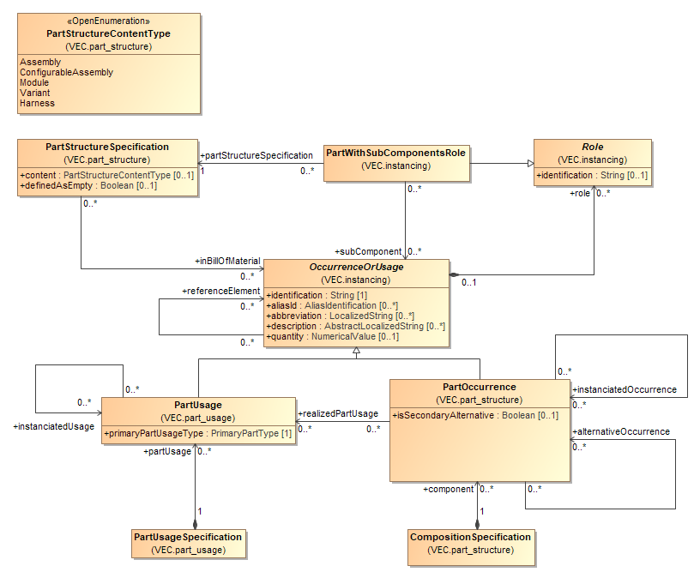
Figure 71: Assemblies, Modules and Harness (Configurations)
The VEC composite part concept has four key classes: the PartStructureSpecification, the PartWithSubComponentsRole, the CompositionSpecification and the PartUsageSpecification.
As mentioned in the example before, the PartStructureSpecification is used to define the bill of material for a composite part based on occurrences. Specific occurrences are used in favor of just referencing parts, to define not only quantities of material, but also the details of the composition. The PartWithSubComponentsRole is the corresponding instance of such a composite part.
Composite parts consist of OccurrenceOrUsages, so they can contain PartOccurrences (instances of a specific PartVersion) as well as PartUsages (instances of components where a specific PartVersion is not yet known). From a pure bill of material point of view this seems counter intuitive, since all materials in a bill of material should be well defined. However, there are scenarios where this is necessary. For instance, if a pre-assembled part (e.g. a cable) shall be used in a certain context, it is necessary, as mentioned before, to be able to reference the subcomponents. But if the subcomponents are not known in detail (no specific part number) PartOccurrences could not be used. Therefore, it is necessary to allow PartUsages in a composite part.
The OccurrenceOrUsages used for a composite part are just referenced and not owned (contained) by the PartStructureSpecification and PartWithSubComponentsRole. As a result, they can be shared among them. This is especially useful in scenarios where a 150% product specification is done. Different variants of the product can reuse the same OccurrenceOrUsages without the need to copy them. The available OccurrenceOrUsages are defined by a CompositionSpecification (in case of PartOccurrences) or by a PartUsageSpecification (in case of PartUsages).
Note: A PartVersion without a separate PartStructureSpecification shall be regarded as one atomic part out of a bill of material perspective even if it is referenced by a DocumentVersion containing a CompositionSpecificiation with several occurrences.

Instantiation Approaches

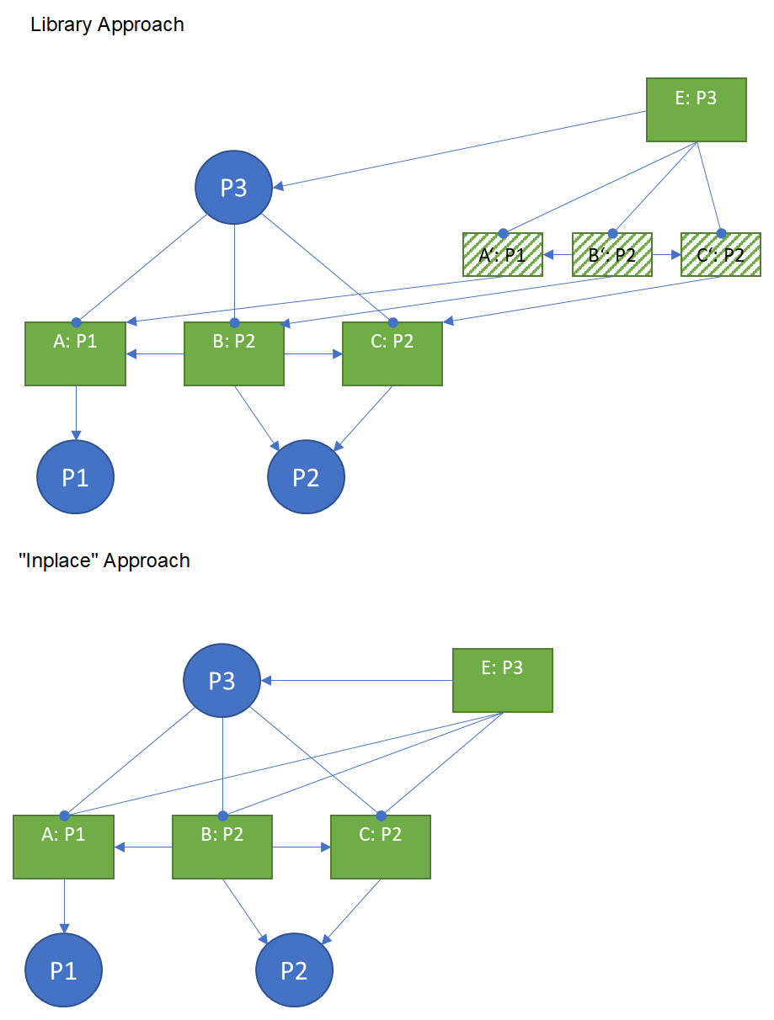
Figure 72: Instantiation Approaches
When a composite part is instantiated, an OccurrenceOrUsage with a PartWithSubComponentsRole is created and references the instantiated OccurenceOrUsages that belong to the composite part instance. The instantiated occurrences are owned by a PartUsageSpecification / CompositionSpecification that is related to the context where the composite part is instantiated.
There are two approaches of how the definition and instantiation of composite parts is achieved: the library approach and the "in place" definition.
In the library approach, a composite part (e.g. a predefined USB cable) is defined in the component library and later used in different products. In this case, the part master definition of the composite part contains the OccurrenceOrUsages ("A: P1", "B: P2", "C: P2") that are required by the composite part and those are referenced by the PartStructureSpecification (P3). When the composite part is used (instantiated), the OccurrenceOrUsages from the part master definition are instantiated (copied) into the using context ("A': P1", "B': P2", "C': P2"). Those are then referenced by the PartWithSubComponentsRole (E: P3) and additional information can be attached to them. For traceability reasons, the OccurrenceOrUsages shall reference their origin in the part master definition via the instantiatedUsage/instantiatedOccurrence association.
The "in place" definition is used for example for modules of a 150% harness. In this case, the composite part is not defined in a library, but in its only and single usage. In other words, the part master definition coincides with an instantiation of part. Therefore, the PartStructureSpecification (P3) and the PartWithSubComponentsRole (E: P3) reference the same set of OccurrenceOrUsages ("A: P1", "B: P2", "C: P2"). In this case both relationships of the PartWithSubComponentsRole and a PartStructureSpecification to the OccurrenceOrUsage (inBillOfMaterial & subComponents) shall be maintained consistently.

Module Lists and -Families

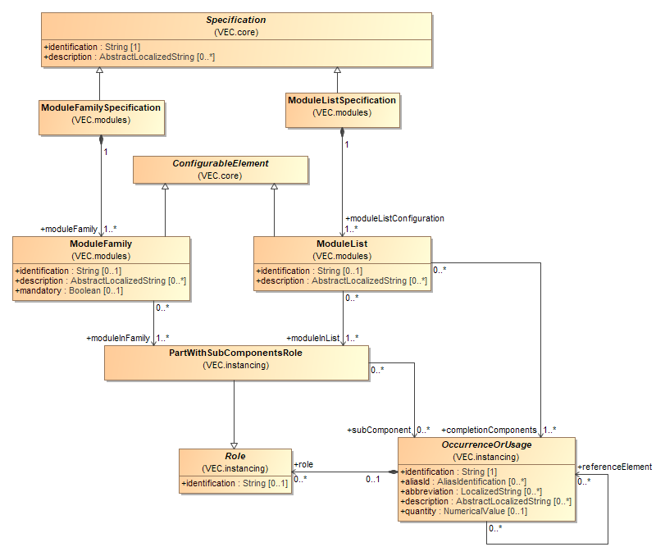
Figure 73: Module Lists and -Families
In addition to the CompositionSpecification and the PartStructureSpecification, the VEC defines two other concepts to control occurrences, especially composite parts (e.g. modules): ModuleFamily and ModuleList.
PartWithSubComponentsRoles referenced by a ModuleFamily respectively the OccurrenceOrUsage these PartWithSubComponentsRoles belong to are mutually exclusive.
A ModuleList specifies a set of PartWithSubComponentsRoles. The definition requires that if one or more of this PartWithSubComponentsRoles respectively the OccurrenceOrUsage these PartWithSubComponentsRoles belong to are part of an assembly the referenced completionComponents have to be added.

Topology and Geometry
This section covers the general definition of a topology, the definition geometric views of that topology, placement of OccurrenceOrUsages on a topology and other geometric aspects like dimensioning.
All geometric coordinate systems used in the VEC are right-handed (Right-hand rule). This also means, the direction of the z-Axis is in the direction of the cross product (X-Axis x Y-Axis).

Topology- and Topology Group Specification

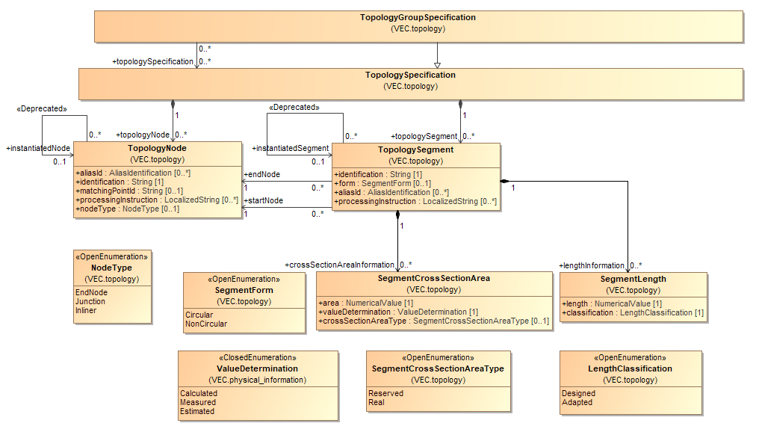
Figure 74: Topology- and Topology Group Specification
A TopologySpecification is a container for various TopologyNodes, TopologySegments and Zones. A TopologyNode represents an abstract place (meaning without concrete coordinates) in the wiring harness that can be typed either as EndNode, JunctionPoint or Inliner.
A TopologySegment represents a section of a wiring harness where no intermediate electrical contacts appear. In consequence, at the beginning and at the end of a TopologySegment the same wires go in and out. The beginning and the end are each defined by a dedicated reference to a TopologyNode. A TopologySegment can specify various SegmentCrossSectionAreas. These SegmentCrossSectionAreas are not supposed to express configuration-dependent values but different views (Calculated, Measured or Estimated) on the same type-dependent value whereupon the default-type is “reserved design space”. The same applies to SegmentLength.
In contrast to GEO 1.0 the VEC recognizes an explicit grouping mechanism for topology. For this the VEC has introduced the class TopologyGroupSpecification which primary acts as a “normal” TopologySpecification being a container for various TopologyNodes, TopologySegments. However, a TopologyGroupSpecification can additionally reference the TopologySpecifications that it groups.
In some cases, a topology can be an instance of another topology. If a more complex assembly or small harness (e.g. like a door) is defined in some place (e.g. in a component library) and then reused elsewhere it might be necessary to instantiate the topology in the target. To keep traceability in these cases, the TopologySegment and the TopologyNode have an instantiated... association to their source element.

Topology Zones

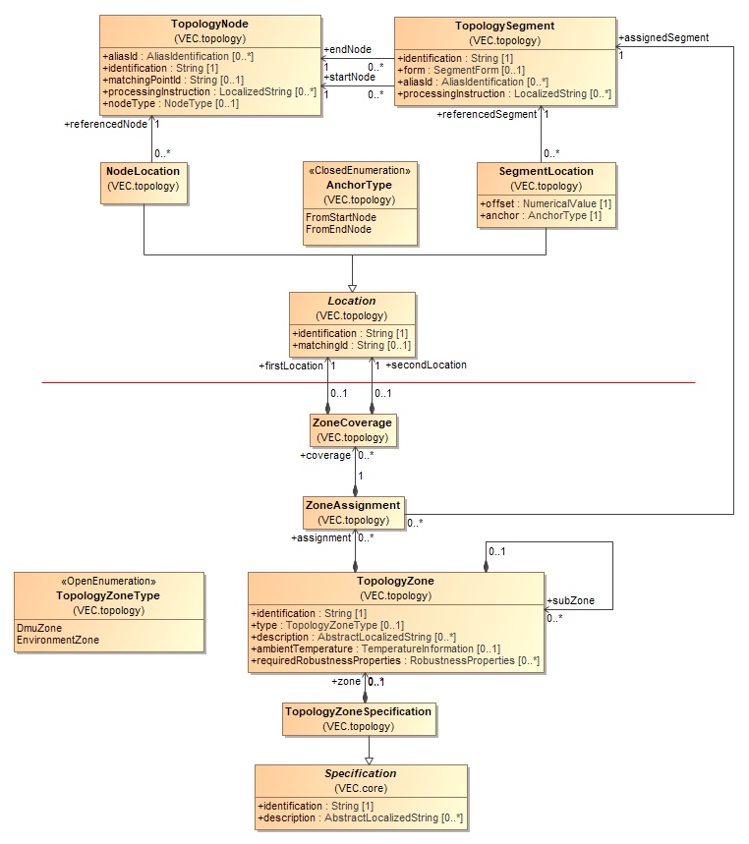
Figure 75: Topology Zones
A TopologyZoneSpecification is a container to define TopologyZones. A TopologyZone is a way to define areas on that share a set of properties (e.g. environmental influence).
To define the TopologyZone unambiguously an assignment of the topology elements to their zones is necessary. TopologyNodes are only connecting points for TopologySegments or for the placement of components and do not have any own extent in space. Therefore, ZoneAssignments are only possible for TopologySegments.
For more details, see the description of the relevant classes.

Hierarchical Topologies

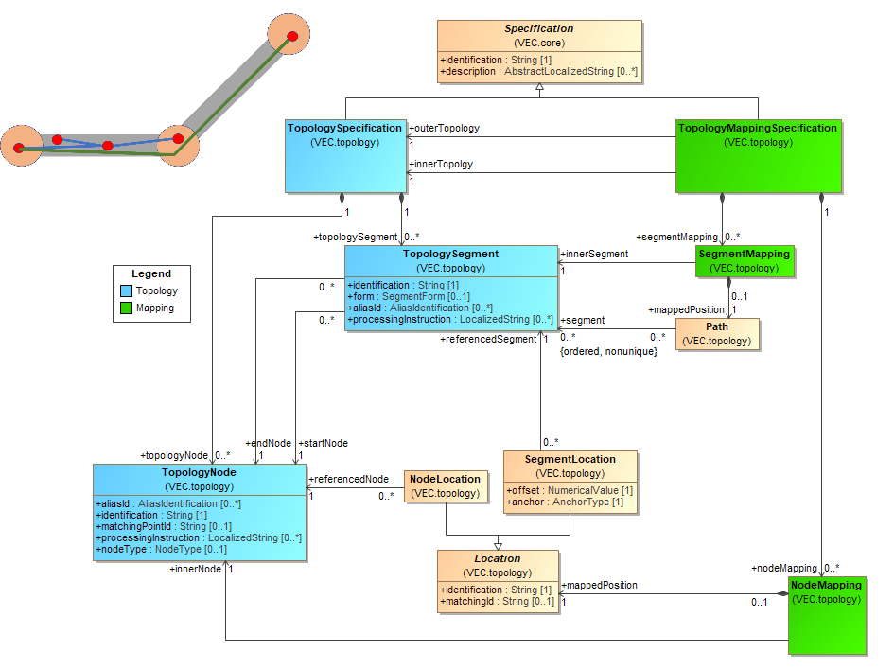
Figure 76: Hierarchical Topologies
Hierarchical topologies are a versatile concept to create harness topologies that have an advanced structural design. For historical reasons, the semantics defined by the VEC for topologies are quite strict and simple, yet sufficient for most cases of traditional wiring harnesses. However, with the advent of modern wiring harness requirements, more advanced concepts are needed for certain applications.
In a regular topology, all wires are routed equally "inside" through a TopologySegment. All wires end at a TopologyNode, there are no connectors or splices positioned within a TopologySegment. All protections, fixings, tapings etc. are placed "around" the wires in a definable order.
With the integration of new technologies (e.g. high voltage, high data rate bus systems) and the improvements of design processes (e.g. integrated 3D design process with traceability and round-trip capabilities) more complex designs must be expressed in a concise, digital evaluable way. Examples for such use cases are:
- Structured harness bundles (e.g. specific wires in a bundle taped together).
- Segments of splices folded into a main bundle in a specific way.
- Reuse of shared parts (e.g. assemblies, right / left back door)
- Refinement of a topology in the design process (e.g. splice positioning after the "geometry design".
To address these requirements, the VEC introduced the concept of hierarchical topologies. In the top left corner of the diagram a simplified illustration shall serve as small example to make the concept more understandable.
A TopologyMappingSpecification is used to associate an "inner" topology with an outer topology. In the illustration the "outer" topology is displayed with grey segments and orange nodes. The two "inner" topologies are displayed with blue & green segments and red nodes.
A NodeMapping is used to define how the nodes of the inner topology relate to the outer topology. An inner node can be either placed exactly on / in an outer node or somewhere within a segment. For the definition of the position of the inner node, the concept of locations is reused.
A SegmentMapping is used to define how the segments of the inner topology relate to the outer topology. An inner segment can run through multiple segments or to stay in a single one. In any case, all outer TopologySegments to which it relates are referenced by a Path.
Some additional restrictions apply on the mapping:
- The representation of the inner / outer relationship with a TopologyMappingSpecification allows the creation of n:m relationships between topologies. However, it is forbidden to create "circular" mappings. If n:m mappings are created, it must be ensured that those mappings shall not exist at same time, or in other words they must be the result of product variance or reuse in different variants.
- "Cross Topology assignment of Components" is forbidden. That means wires are routed strictly in the elements of a single TopologySpecification and other components are placed strictly on a single TopologySpecification.
- If a TopologySpecification is mapped as an inner topology, all its elements shall be mapped.
- A creating system is responsible that the constraints of the topologies are maintained (e.g. that length constraints between inner and outer topologies are satisfied.
Note: This concept was introduced newly with VEC Version 1.2.0. As there are currently no known systems that implement such a concept further detailing of its usage will be done in the Implementation Guidelines accompanying implementations as they occur.

Bending Restrictions

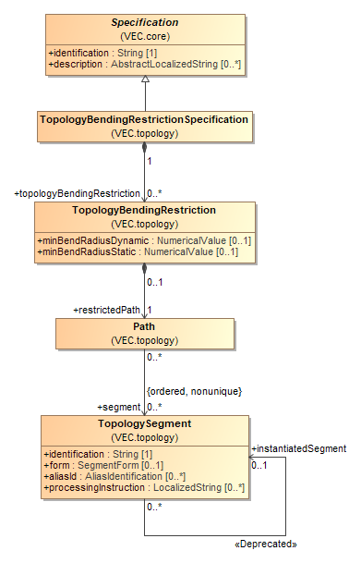
Figure 77: Bending Restrictions
A bending restriction defines restrictions on the bendability of a path in the topology. See TopologyBendingRestriction for a detailed description.

2D-Geometry

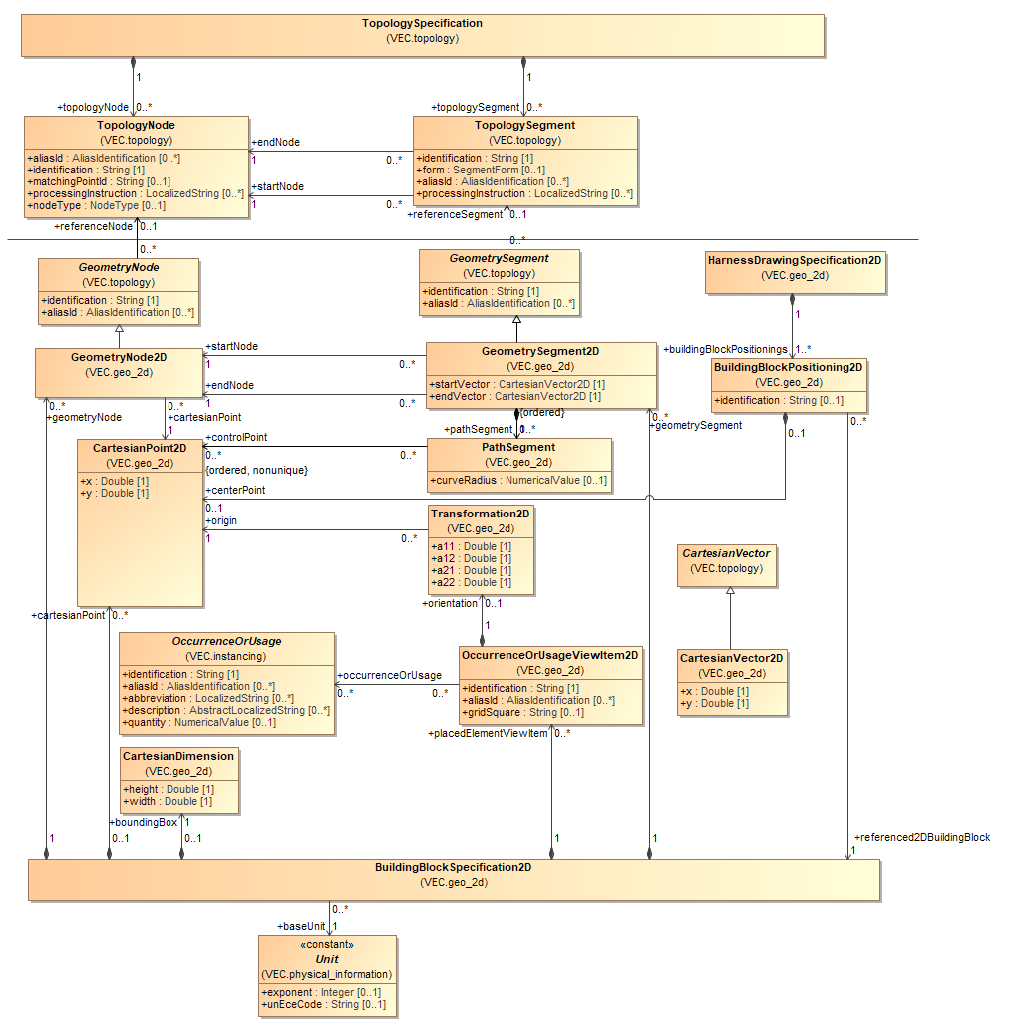
Figure 78: 2D-Geometry
A HarnessDrawingSpecification2D represents a specific harness drawing. The coordinates are defined in the coordinate system of the respective drawing. Each HarnessDrawingSpecification2D is a container for various instances of the class BuildingBlockPositioning2D. Each BuildingBlockPositioning2D determines the positioning of a certain BuildingBlockSpecification2D in the context of the HarnessDrawingSpecification2D by referencing the relevant BuildingBlockSpecification2D and specifying the target centerPoint as CartesianPoint2D.
A BuildingBlockSpecification2D represents a specific subset of one or more harness drawings. Each BulidingBlockSpecification2D specifies its own CartesianDimension. Furthermore, each BulidingBlockSpecification2D is a container for various instances of the classes GeometryNode2D, GeometrySegment2D, ContactPoint2D and OccurrenceOrUsageViewItem2D.
Each GeometryNode2D references a CartesianPoint2D which determines its graphical position within the BuildingBlockSpecification2D. Moreover, it can specify which TopologyNode it represents.
Each GeometrySegment2D can specify an ordered set of PathSegments each defining a certain section of its graphical representation. Moreover, it can specify which TopologySegment it represents.
Note: The data model does not constrain a GeometryNode2D respectively a GeometrySegment2D to reference a TopologyNode respectively a TopologySegment. This allows a VEC e.g. to transport graphical 2D-information for its own. However, for the description of lengths and dimensions as well as segment cross-section-areas and placements the VEC requires adequate references to the relevant elements in the topology.
Each OccurrenceOrUsageViewItem2D can reference which OccurrenceOrUsages it represents. Furthermore, it can specify a Transformation2D which determines its graphical position and orientation within the BuildingBlockSpecification2D.

3D-Geometry

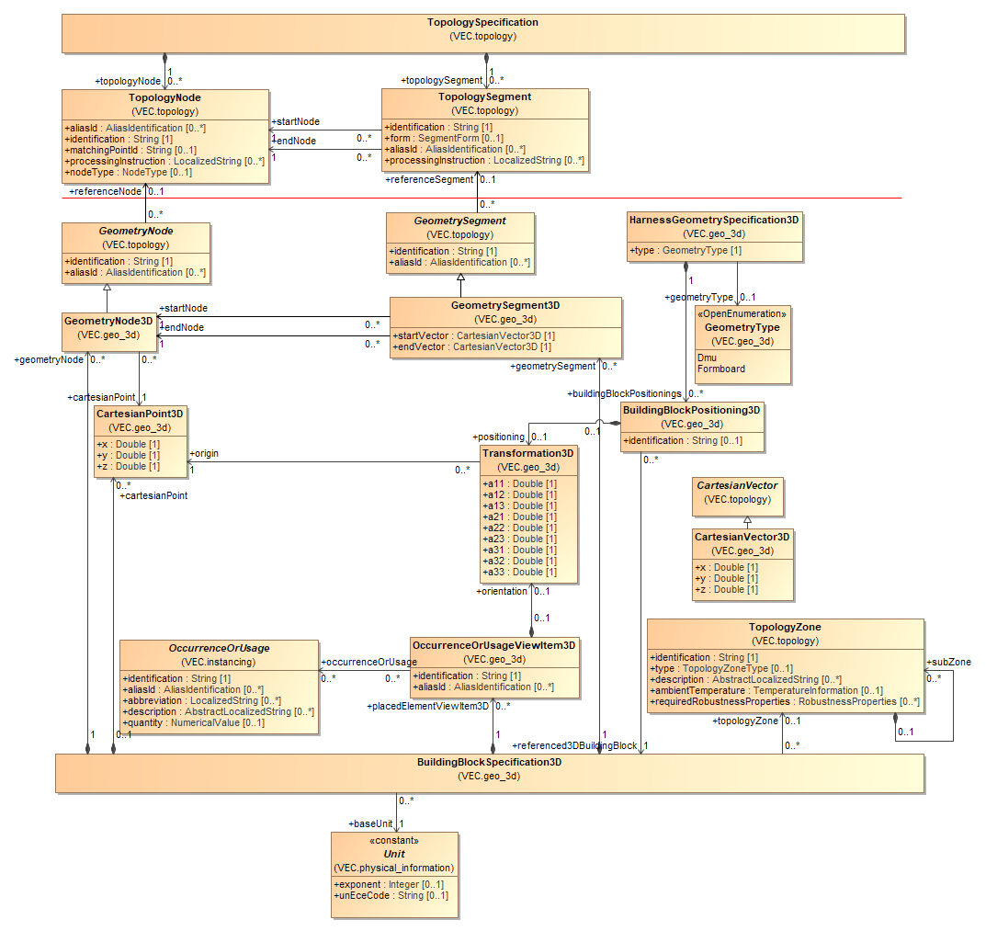
Figure 79: 3D-Geometry
A HarnessGeometrySpecification3D represents either a 3D-model in the car coordinate system or a 3D-model in the formboard system. Each HarnessGeometrySpecification3D is a container for various instances of the class BuildingBlockPositioning3D. Each BuildingBlockPositioning3D determines the positioning of a specific BuildingBlockSpecification3D in the context of the HarnessGeometrySpecification3D by referencing a BuildingBlockSpecification3D and optionally specifying a Transformation3D for the case that a coordinate transformation is required.
A BuildingBlockSpecification3D represents a specific geometrical subset normally belonging to a certain Zone. Each BuildingBlockSpecification3D is a container for various instances of the classes GeometryNode3D, GeometrySegment3D, CartesianPoint3D and OccurrenceOrUsageViewItem3D.
Each GeometryNode3D references a CartesianPoint3D which determines its position within the BuildingBlockSpecification3D. Moreover, it can specify which TopologyNode it represents.
Each GeometrySegment3D can specify an ordered set of Curves in order to approximate its geometry (explained in detail on the next diagram). Moreover, it can specify which TopologySegment it represents.
Note: The data model does not constrain a GeometryNode3D respectively a GeometrySegment3D to reference a TopologyNode respectively a TopologySegment. This allows a VEC e.g. to transport 3D-information independently from a TopologySpecification. However, for the description of dimensions including tolerances as well as segment cross-section-areas and placements especially OnWayPlacements the VEC requires adequate references to the relevant elements in the topology.
Each OccurrenceOrUsageViewItem3D can reference which OccurrenceOrUsages it represents. Furthermore, it can specify a Transformation3D which determines its position and orientation of the component's 3D model within the space of the BuildingBlockSpecification3D. If no Transformation3D is defined, the OccurrenceOrUsageViewItem3D is meant to be placed implicitly by its position in the topology (e.g. wire protections with an OnWayPlacement.

3D Curves

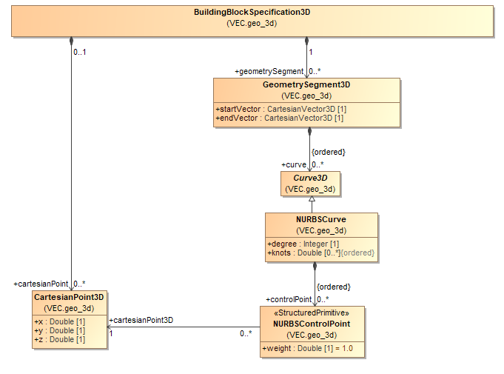
Figure 80: 3D Curves
The center line of a GeometrySegment3D is defined by one or more Curve3D. This abstract class is designed to be an extension point for different curve implementations. At the moment the only curve implementation that is supported by the VEC are NURBSCurves. The details are described in the documentation of the individual classes.

Locations

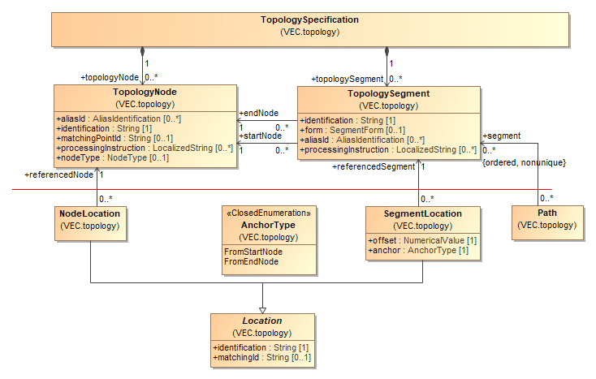
Figure 81: Locations
In order to describe a wiring harness, the abstract information of a topology must be enhanced with information about the concrete positions of components in the topology. For purposes of clarity the explanation of this concept is split into two diagrams. This diagram explains how Locations are defined onto the Topology. The next diagram shows how these locations can be used to define Placements of components and Dimensions.
The VEC defines two types of Locations: NodeLocations and SegmentLocations. A NodeLocation references one TopologyNode. A SegmentLocation defines a single point on a TopologySegment located between its startNode and endNode. To achieve this, a SegmentLocation references the relevant TopologySegment and specifies as anchor the start- or end node as well as the offset from that anchor.
Note: In contrast to KBL 2.3 and GEO the VEC locations on segments are expressed by anchor and offset and not through relative measurements. This enables ease of handling in case of segment-length changes.

Placement and Dimensions

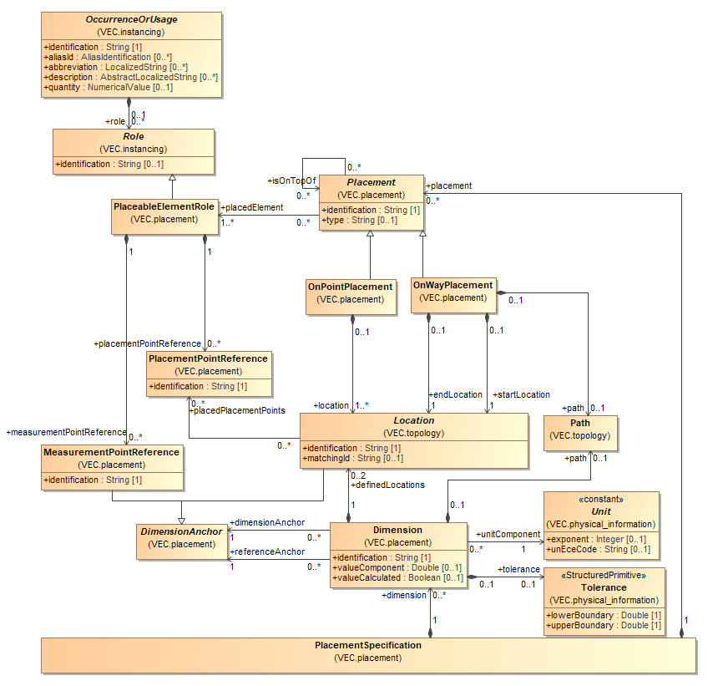
Figure 82: Placement and Dimensions
A PlacementSpecification is used to define the Placement of OccurrenceOrUsages in a topology as physical elements that build this topology and to define Dimensions between these elements. Each PlacementSpecification is a container for various Placements and Dimensions.
Each OccurrenceOrUsage that is placeable in the topology defines a PlaceableElementRole. A PlaceableElementRole can define various PlacementPointReferences and MeasurementPointReferences, which are instances of the corresponding elements PlacementPoint and MeasurementPoint defined in the part master data of the component. The position in the topology of a PlaceableElementRole is defined with a Placement. The multiplicity of this association is caused by the support of variance in the VEC. For a concrete configuration, there should be only one Placement for one PlaceableElementRole.
The VEC specifies two individual types of Placements: OnPointPlacements and OnWayPlacements.
Each OnPointPlacement defines one or more Locations in order to determine the positioning of the placedElement. More than one Location is necessary to specify the exact Placement of placedElements with more than one PlacementPointReferences, e.g. the different entries in case of a cable duct. Each Location can therefore reference a PlacementPointReference.
An OnWayPlacement references one Location as startLocation and another Location as endLocation in order to determine the positioning of placedElements like tapes that cover a way in the topology. The positioning can be described even more precise by using the OnWayPlacement with a Path through the topology.
Both OnPointPlacements and OnWayPlacements reference one or more PlaceableElementRoles as placedElements. The possibility to reference more than just one PlaceableElementRole permits to express that configuration dependent the one or other PlaceableElementRole is placed. Finally, both OnPointPlacements and OnWayPlacements can reference other Placements on which they are placed on top of in order to determine the arrangement of layering (e.g. a tape around a tube).
Note: When using the isOnTopOf-relationship all other underlying Placements shall be referenced on which the referencing Placement is on top of and not only the direct neighbor. The reason for this is that Placements are ConfigurableElements and so are potentially not present in all configurations.
Since the VEC can be used to exchange a product definition, it must be possible to define Dimensions with tolerances between the elements in addition to its exact positions in the topology.
Each Dimension references two DimensionAnchor, one as referenceAnchor and one as dimensionAnchor and defines the distance in between as dimensionValue, optionally together with a tolerance (included in the definition of NumericalValue). In case of ambiguity regarding the path between the two Locations, the Dimension shall specify the relevant Path.
A DimensionAnchor can be either a MeasurementPointReference or a Location. A MeasurementPointReference is used when the dimension refers to a specific point on the component that is not part of the topology, such as a bolt on a cable duct or a seam on a grommet. If a Location is used, it can either be a Location defined by a Placement (when referencing the position of a placed component, such as the entry point of a connector or the start of a wire protection) or a Location defined directly by the Dimension itself. The latter is used when the dimension references a point in the topology where no physical component is placed, for example to specify a tolerance over a section of the topology, such as across multiple segments.

Default Dimensions

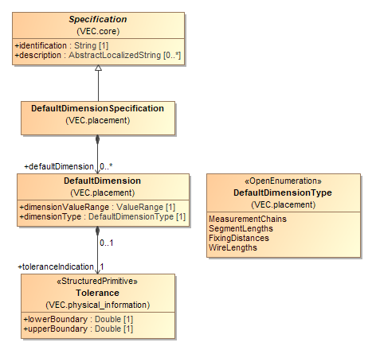
Figure 83: Default Dimensions
DefaultDimension can be used to define standard tolerances that apply to certain elements. Typically, they are represented in a document or a drawing as a table (e.g. for wires with length < x; tolerance a, x < length < y; tolerance b and so on).

Routing

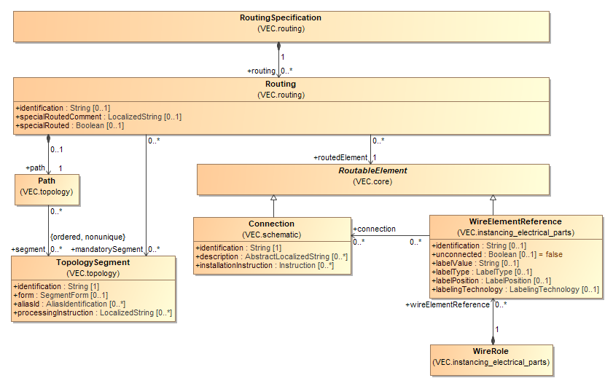
Figure 84: Routing
A RoutingSpecification is a container for various Routings. Each Routing specifies a dedicated Path as an ordered list of TopologySegments through which the referenced RoutableElement is routed. A RoutableElement can either be a Connection or a WireElement (which can alternatively belong to a PartUsage or a PartOccurrence).
In addition, a Routing can reference some segments on the Path as mandatorySegments. This can be helpful in cases where otherwise a simple redefinition respectively recalculation would not consider these segments.

Connectivity
NA

Signal Specification

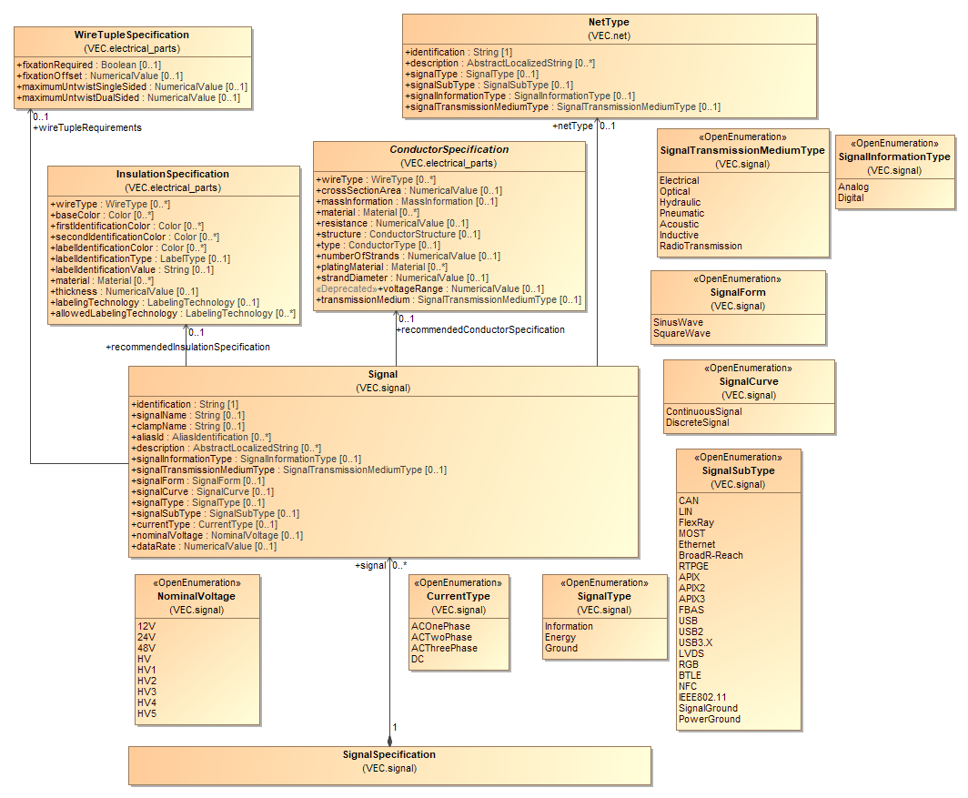
Figure 85: Signal Specification
A SignalSpecification defines a set of Signals used in the vehicle electrical system. A Signal is a more general concept than Nets, Connections or Wires, as they are defined in the scope of a certain vehicle electrical system or a wiring harness. A Signal in the VEC represents a physical signal in contrast to abstract messages that are often used to define ECUs and their interfaces (e.g. in AUTOSAR). Typically, the same Signals are used in different vehicles or different sections of a wiring harness. A Signal can define various properties e.g. the SignalType or the SignalForm. Furthermore, a Signal can define a recommended ConductorSpecification and a recommended InsulationSpecification. This mechanism can be used for example to provide information about the recommended color coding of a certain Signal, regardless of the vehicle electrical system or wiring harness section where it is implemented.

Net Specification

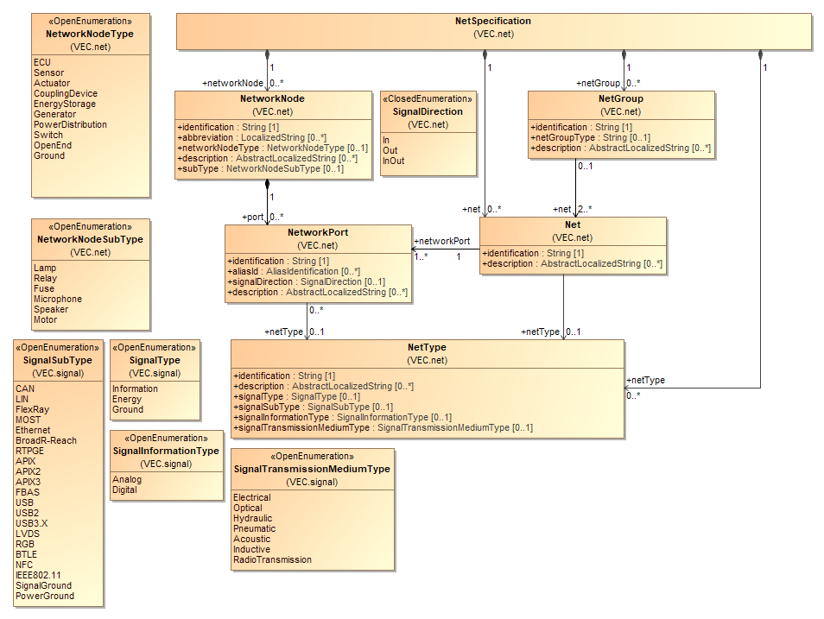
Figure 86: Net Specification
A NetSpecification is the most abstract way to describe a vehicle electrical system. It is a container for various NetworkNodes, Nets and NetGroups. A NetSpecification is used if the physical links between electrical components are specified without specifying a concrete network topology and a physical realization. In many processes and applications this is defined as "Architectural Layer".
A NetworkNode is a representative for an actor in the electric system, e.g. an actuator, a sensor, an ECU. It can define various NetworkPorts, which can be classified as a signal source (in the case that the attribute signalDirection has got the value Out) or as a signal sink (in the case that the attribute signalDirection has got the value In) or with changing behavior (in the case that the attribute signalDirection has got the value InOut).
Note: According to the definition above, inliners (normally) and splices are no NetworkNodes and so are not represented within a NetSpecification. In some cases, there are architectural relevant inliners (NetworkNodeType = CouplingDevice) that represented in the architectural layer.
A Net is a representative of an abstract link between the referenced NetworkPorts and can be related to a NetType.
Note: A Net itself doesn’t define:
- How the topology of the conducting connection must be realized (e.g. if three NetworkPorts are interconnected, the Net makes no definition if this physical three-point connection is realized with a splice, an insulation displacement connector or a double contact.).
- How the physical connections must be realized (e.g. if a certain BUS Connection is realized by a pair of wires or four wires).
Note: Normally, a Net references at least two NetworkPorts. However, in the very early stages of product development it might be the case that some NetworkNodes with NetworkPorts which are source of a dedicated Net are already defined – but the counterparts are not. This is an example where it can be useful to define Nets referencing only one NetworkPort.

Net View Specification

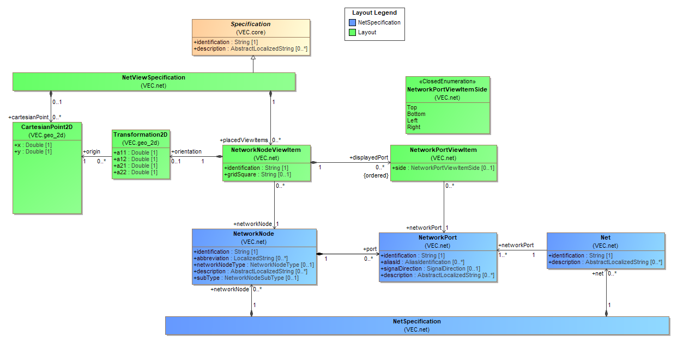
Figure 87: Net View Specification
The NetViewSpecification supports the exchange of a basic layout for a NetSpecification. The objective is not a pixel perfect representation of a network / architecture diagram in the VEC (with label positions, font sizes etc.). Such use cases are supported via the external mapping with other standards like SVG. However, a reasonable arrangement of the NetworkNodes on a diagram sheet greatly improves the understanding and cannot (easily) be found by an automatic algorithm. Therefore, a basic layout has value in the context of data exchange and is in scope of the VEC.
A NetViewSpecification represents the layout of a network diagram / sheet. The layout is defined with NetworkNodeViewItems, each representing a NetworkNode. A NetViewSpecification does not have to represent the complete content of a NetSpecification. It is perfectly valid to split the layout of a NetSpecification into multiple NetViewSpecifications, one for each view (e.g. sheet) and each layouting a subset of a NetSpecification. It is also valid to have multiple NetworkNodeViewItems for a NetworkNode.
The NetworkNodeViewItem contains NetworkPortViewItems for each NetworkPort displayed on this NetworkNodeViewItem. This can be a subset of all NetwortPorts of the corresponding NetworkNode.
For Nets there are no explicit view items defined. The representation and routing path of a Net is not considered as basic information. All Nets that are connected to a displayed NetworkPort are considered to be display on the diagram represented by NetViewSpecification.

Connection Specification

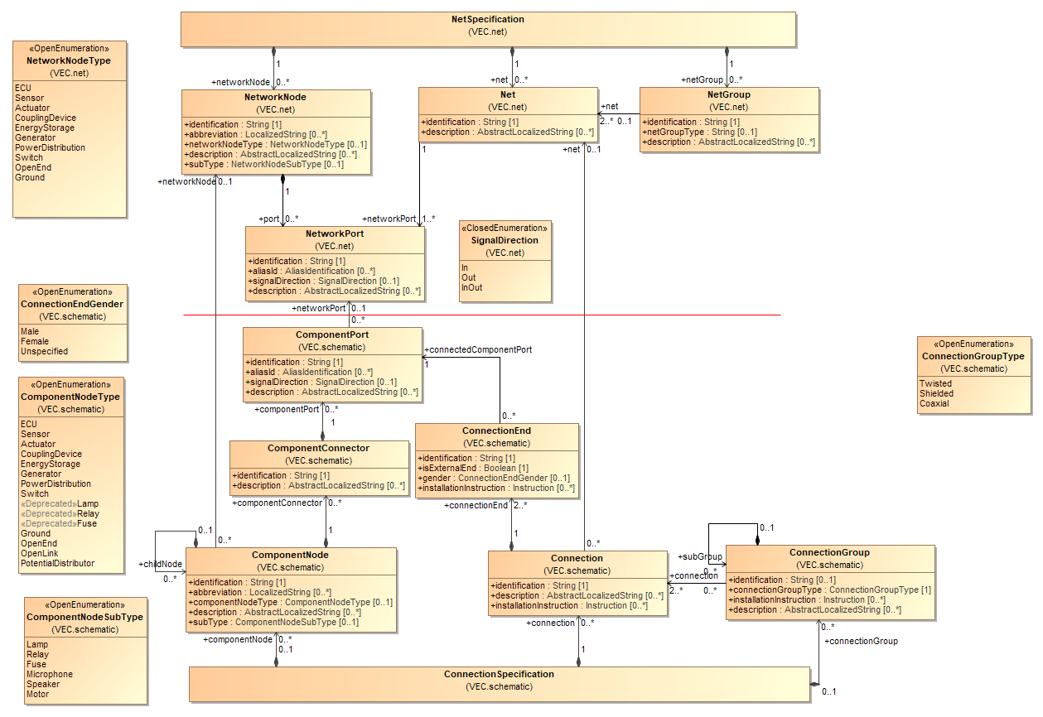
Figure 88: Connection Specification
A ConnectionSpecification is intended to contain the logical information that is usually included on an electrical system connection plan (system schematic). It can either stand alone or detail the information of a NetSpecification. A ConnectionSpecification is a container for various ComponentNodes, Connections and ConnectionGroups. A ConnectionSpecification is used, if requirements for realization of the network should be specified (e.g. should a Net be realized with a single or multiple connection (BUS-Systems)).
Note: Logical information means a ConnectionSpecification doesn’t contain layout information. Layout information can be exchanged by other formats like SVG, PDF or DXF.
A ComponentNode is a representative for an element in the electric system, e.g. an actuator, a sensor, an ECUs. In this way it is quite similar to a NetworkNode and may even reference the corresponding NetworkNode in this case. Moreover, a ComponentNode can define childNodes in order to describe its internal structure.
There is no general rule if inliners shall appear in the system schematic or not. In many cases there is a detail of the physical design of the harness (like splices). Their creation is done implicitly when an electrological design is routed into a specific topology and the routing crosses an inliner definition of the topology. In these cases, the inliner definition should not appear in the system schematic. However, there are other scenarios where the inliner definition is done on purpose and as part of the electrological design (e.g. for providing a pluggable modularity in the system). In these cases, an inliner can appear in the ConnectionSpecification.
A ComponentNode can specify various ComponentPorts. Each ComponentPort can reference its corresponding NetworkPort (if it has one).
Connections represent the physical realization of a Net (without a topology). A Net (e.g. the BODY-CAN-BUS) can be realized by one or more physical connections (e.g. a CAN-BUS is normally realized by two physical connections (HI & LOW)). The Connections do not define a topology of the realization. This means that a CAN Connection with three ConnectionEnds can be realized in different ways (e.g. three wires with splice, two wires with a double contact or an IDC / IDS contact).
A ConnectionGroup references two or more Connections expressing the physical realization of the referenced Connection shall be somehow grouped e.g. twisted. For complex structures a ConnectionGroup can specify subgroups. Finally, a ConnectionGroup can reference a NetGroup in order to express a refinement-relationship.

Connection View Specification

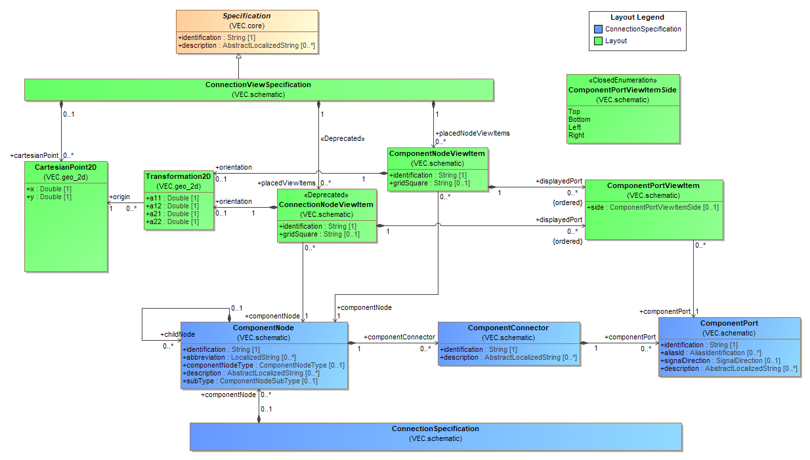
Figure 89: Connection View Specification
The ConnectionViewSpecification supports the exchange of a basic layout for a ConnectionSpecification. The objective is not a pixel perfect representation of a schematic diagram in the VEC (with label positions, font sizes etc.) Such use cases are supported via the external mapping with other standards like SVG. However, a reasonable arrangement of the ComponentNodes on a diagram sheet greatly improves the understanding and cannot (easily) be found by an automatic algorithm. Therefore, a basic layout has value in the context of data exchange and is in scope of the VEC.
A ConnectionViewSpecification represents the layout of a schematic diagram / sheet. The layout is defined with ComponentNodeViewItems, each representing a ComponentNode. A ConnectionViewSpecification does not have to represent the complete content of a ConnectionSpecification. It is perfectly valid to split the layout of a ConnectionSpecification into multiple ConnectionViewSpecifications, one for each view (e.g. sheet) and each layouting a subset of a ConnectionSpecification. It is also valid to have multiple ComponentNodeViewItems for a ComponentNode.
The ComponentNodeViewItem contains ComponentPortViewItems for each ComponentPort displayed on this ComponentNodeViewItem. This can be a subset of all ComponentPorts of the corresponding ComponentNode.
For Connections there are no explicit view items defined. The representation and routing path of a Connection is not considered as basic layout information. All Connections that are connected to a displayed ComponentPort are considered to be display on the diagram represented by ConnectionViewSpecification.

Wiring Specification

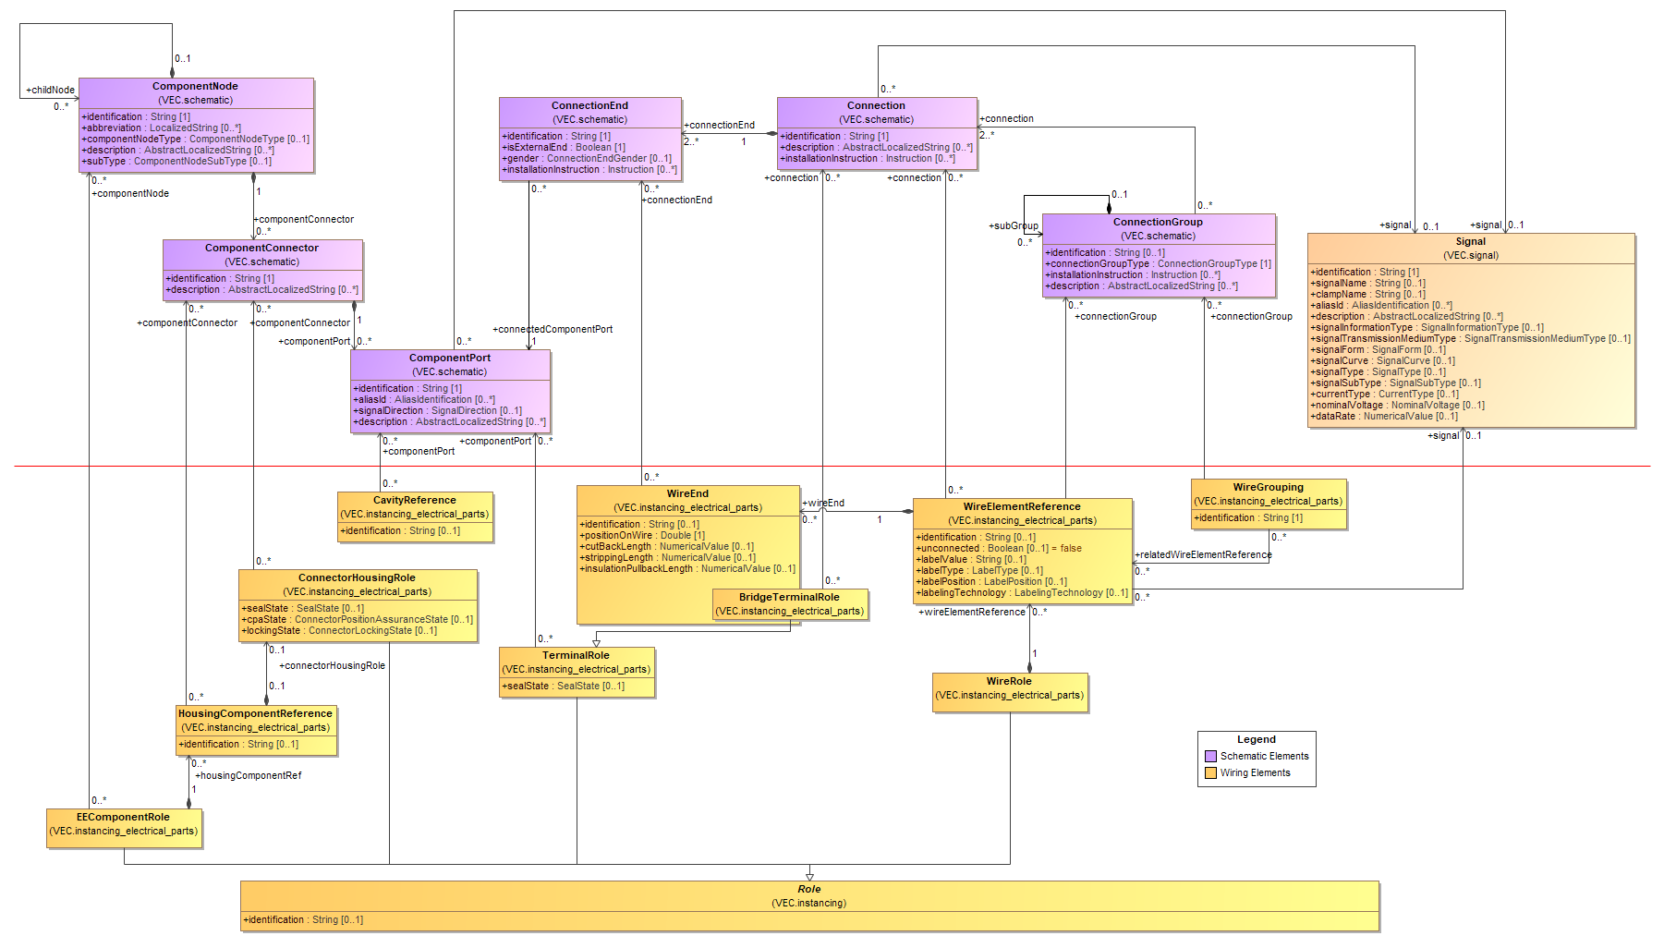
Figure 90: Wiring Specification
The VEC model breaks down the information that is usually included on an electrical system wiring plan into three aspects: part usage information, contacting information and mating information. As part usage information is for instance also relevant in the geometry respectively part placement context and as contacting and mating information is also relevant in the KBL context (the final definition of wiring harnesses and harness modules), the VEC model does not define an integrated WiringSpecification class for all these aspects. Instead, the VEC model defines for each of the three mentioned aspects a separate specification class, which can be reused when necessary (see also "Instances of Components").
EE-components in a wiring diagram are intended to be described as PartUsages with an EEComponentRole. Each of these PartUsages can reference an EEComponentSpecification in order to describe relevant technical properties. The EEComponentRole can specify a TerminalRole for each EE-component pin. This can act as the basis for a mating definition between the EE-component pins and harness connector pins.
Harness connectors in a wiring diagram are intended to be described as PartUsages with a ConnectorHousingRole. Each of these PartUsages can reference a ConnectorHousingSpecification in order to describe relevant technical properties.
Harness connector pins in a wiring diagram are intended to be described as PartUsages with a PluggableTerminalRole. Each of these PartUsages can reference a PluggableTerminalSpecification in order to describe relevant technical properties. The relationship between harness connector and harness connector pin is intended to be described by a ContactingSpecification which defines an appropriate CavityMounting.
Wiring connections are intended to be described as PartUsages with a WireRole in combination with a ContactingSpecification which defines an appropriate WireMounting. Each of these PartUsages can reference a WireSpecification in order to describe relevant technical properties.
The PartUsages with EEComponentRole respectively ConnectorHousingRole, TerminalRole or WireRole can each reference their specific corresponding element within a ConnectionSpecification in order to express a refinement-relationship.

Contacting Specification

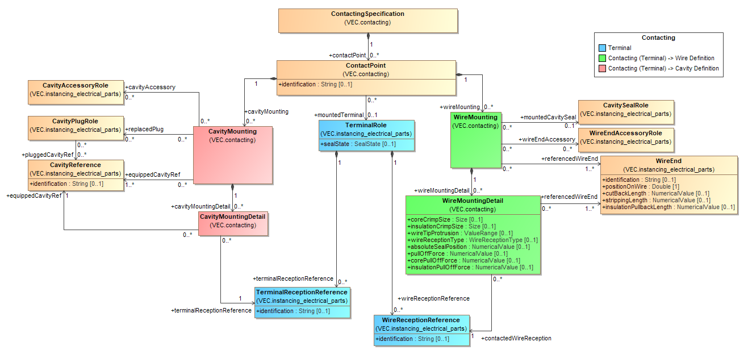
Figure 91: Contacting Specification
A ContactingSpecification is used to describe contacting information in several uses cases: It can be used to describe both the more abstract contacting information which is contained on an electrical system wiring plan and the very concrete contacting of an assembly / module/ harness configuration or even a 150% harness description.
A ContactingSpecification is a container for various ContactPoints. Each ContactPoint can specify several CavityMountings and WireMountings and will in most cases reference a TerminalRole.
A WiringMounting references one or more WireEnds stating they are contacted with the TerminalRole referenced by the ContactPoint. In cases of ambiguity a WireMounting can specify various WireMountingDetails in order to describe which WireEnd is contacted to which WireReception of the referenced TerminalRole. Finally, a WireMounting can reference a CavitySealRole.
A CavityMounting references one or more CavityReferences expressing they are equipped by the TerminalRole referenced by the ContactPoint. In cases of ambiguity a CavityMounting can specify various CavityMountingDetails in order to describe which TerminalReception is mounted in which CavityReference. Finally, a CavityMounting can reference various CavityPlugRoles stating the CavityMounting replaces those CavityPlugs.
Note: ContactPoints are ConfigurableElements and therefore can reference a VariantConfiguration.
Note: There may be use cases where a ContactingSpecification is wanted to describe an incomplete contacting. An example might be an assembly or module with wires together with mounted terminals but without a mounting of the terminals into a connector housing. The missing contacting information (the mounting of the terminals into a connector housings) may be subject of other ContactingSpecifications respectively ContactPoints which may be specified configuration dependent.

Coupling Specification

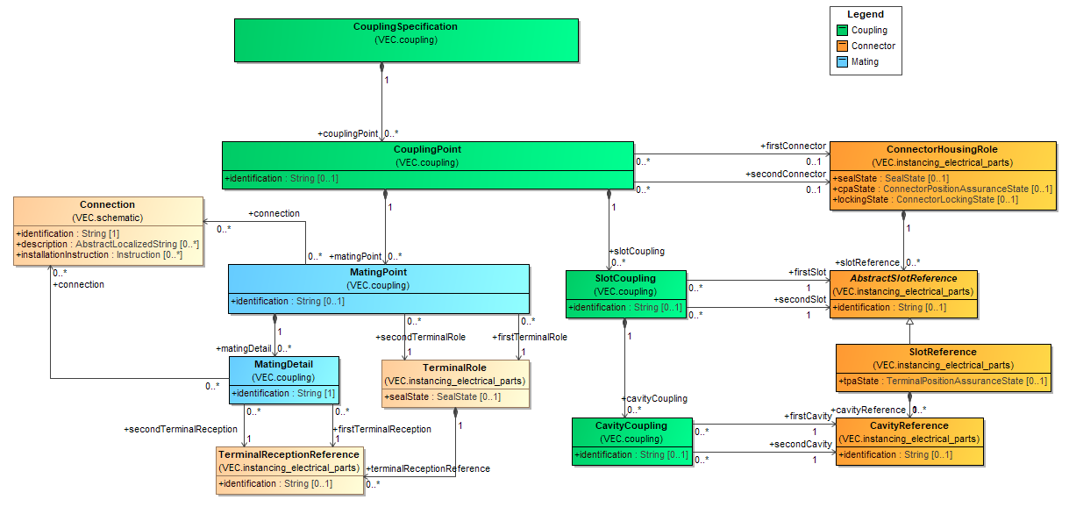
Figure 92: Coupling Specification
A CouplingSpecification is a container for various CouplingPoints. Each CouplingPoint defines a pluggable connection. All sub elements are disconnected if the coupling is disconnected. A coupling can occur with a connector (e.g. Inliner) or without a connector (e.g. ring terminal).
The CouplingPoint, the SlotCoupling and the CavityCoupling defines the mapping between two coupled connectors.
The MatingPoint defines the mapping between terminals and therefore the electrical properties of the coupling.
Each MatingPoint references two TerminalRoles as a pair of terminals that are intended to be connected in the vehicle electric system. This can either be a female and a male pluggable terminal or a ring terminal and a bolt. In cases of ambiguity a MatingPoint can additionally specify various MatingDetails in order to reference the relevant TerminalReceptions.
Note: MatingPoints are ConfigurableElements and so can reference a VariantCondition.
In the development process exist multiple scenarios, where a coupling will not be specified completely. E.g. in the electro logical design, a coupling might be defined based on terminals only (e.g. between the wiring harness and an ECU), while the used connector is not yet known. The opposite scenario can occur in the geometric development.

Wire Grouping Specification

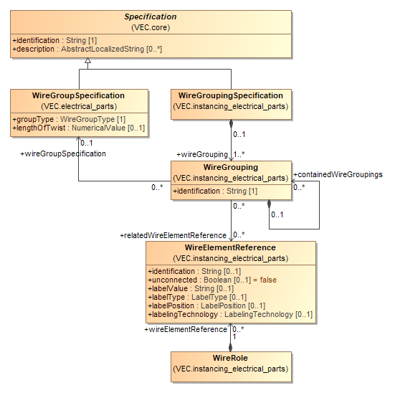
Figure 93: Wire Grouping Specification
A WireGroupingSpecification is used to describe grouping requirements (e.g. twisted pair) in a certain context of usage (e.g. in the context of a 150% harness description). For this, a WireGroupingSpecification is a container for various WireGroupings. For more details, please refer to the description of the WireGrouping.

Wire Tuple Termination

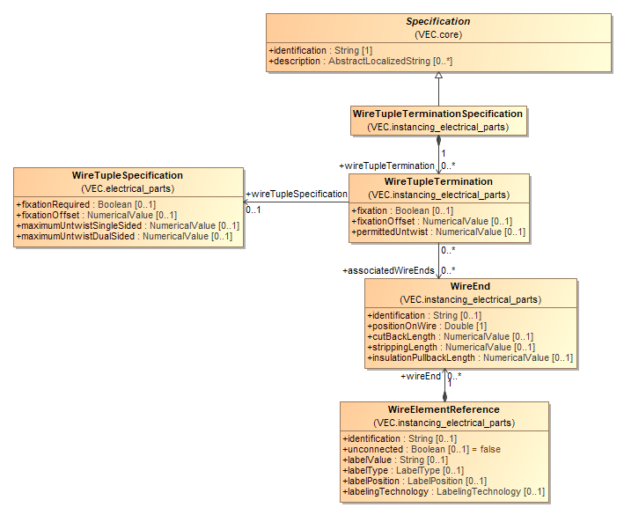
Figure 94: Wire Tuple Termination
A Specification to define requirements for the handling of wire / wire element tuples (pairs, triple...) with the focus on twisting / untwisting. The WireTupleSpecification defines the technical properties of the untwisting from a part master data perspective (see also the diagram "Wire Tuple" in "Component Characteristics"). The WireTupleTermination defines properties for a specific end of a specific wire tuple (a concrete usage).

Pin Wire Mapping

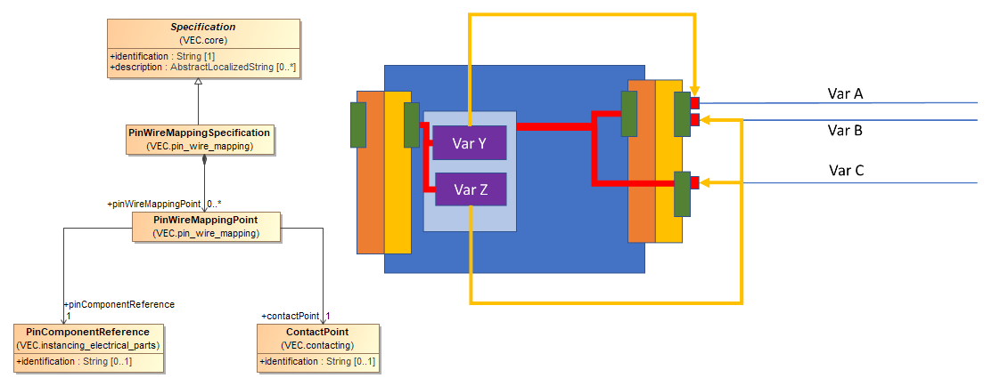
Figure 95: Pin Wire Mapping
A PinWireMappingSpecification can be used to create variance free mappings between a wire (represented by the contact point) and the pin of an E/E component. This is a possibility to create a shortcut in the model between a wire and its connected E/E-component (e.g. a fuse) that might be only indirectly connected to a wire (e.g. via a fuse and relay carrier). This is a relevant information for e.g. the validation of fusing.
In a specific 100% variant, this is an information that could be derived from the data provided by the VEC, if available. Informally spoken, the way in the model would be from the WireEnd over to the ContactPoint and from there to the cavity of the harness connector. From the harness connector to the fuse and relay carrier PinComponentReference, via the CouplingPoint. From the PinComponentReference, via the InternalComponentConnection to the slot of the fuse and then via another CouplingPoint to the fuse.
However, in a 150% scenario, even if all component assignments to modules are known, this information cannot be derived unambiguously without extensive knowledge of the variant management mechanisms. This is illustrated with the graphic representation in the diagram. There are two wires (controlled by Variant A & B) attached to a single cavity (green). Via an internal connection of the carrier, they are connected to a single component slot (light blue). This slot contains two different fuses (controlled by variant Y & Z). Without knowledge of the conditions between the variant A, B, Y & Z it is impossible to say what fuse is responsible for the protection of which wire. That knowledge might not be available at all times, for all partners in the process.
The PinWireMappingPoint provides a possibility to define this information in the VEC (the golden / yellow arrows in the illustration).

Signal Graphs

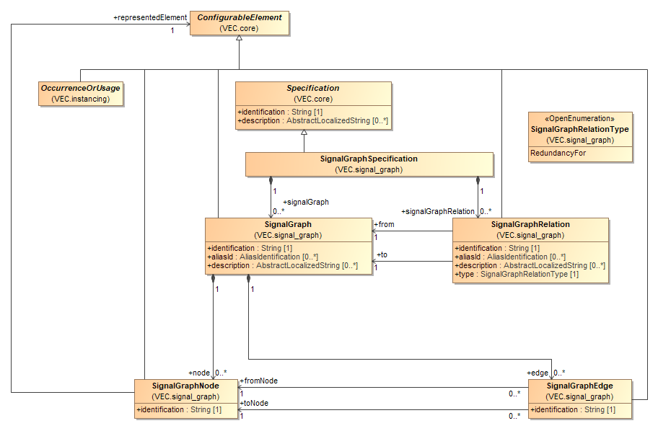
Figure 96: Signal Graphs
A SignalGraph is a directed graph of elements in the vehicle network that participate in the transmission of a signal / function / power / ground etc. A SignalGraph is expected to be a unilaterally connected graph at least, meaning it contains a directed path from u to v or a directed path from v to u for every pair u and v of SignalGraphNodes in the SignalGraph.
A SignalGraph might be the result of a complex calculation based on existing information (e.g. a power supply or grounding graph) or it might user defined (e.g. to apply specific requirements to a chain of elements). Relations between SignalGraphs can be expressed with a SignalGraphRelation, for example if one graph is the redundant implementation of another one.

Note: The "signal" concept of a SignalGraph is much broader than that of the Signal class. Due to the lack of a better term, the same term was used for slightly different concepts. For example, a SignalGraph might be used to represent all possible elements that are involved in the power supply for a specific component. This involves all elements on the way from the component to the battery. However, the electrical signal (Signal-class) will be named differently for the supply and distribution sides of a power distributor / fuse box.

External Mapping
The external mapping in the VEC defines a mechanism to provide a link between the content data of the VEC and external data sources (e.g. SVG images, JT models, requirements, ...). The only requirement on the external data source for this mapping approach is, that the contained data is in some way structured and that the elements are identifiable with a unique key.
The reasons for embedding the mapping information in the VEC are:
- The mapping can be easily read and recreated together with VEC and references to VEC elements can be followed in a simple way since the mapping can reference the elements directly within a single file (IDREF).
- No additional format definition is necessary.

External Mapping

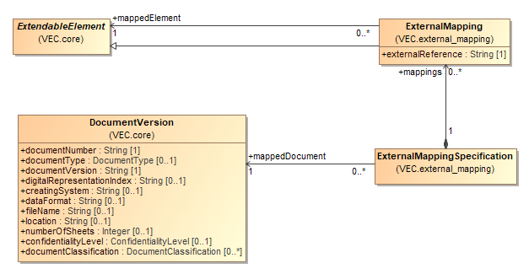
Figure 97: External Mapping
The diagram displays the extensions in the VEC Modell necessary to support a mapping to external sources. The extension consists of two classes ExternalMappingSpecification and ExternalMapping. An ExternalMappingSpecification defines a mapping for a single DocumentVersion specified by the association mappedDocument. The referenced DocumentVersion itself identifies by its attributes the external document which should be mapped (e.g. an SVG-File, a requirements-document).
The mapping of the individual elements in the VEC is defined with the class ExternalMapping. It points to an ExtendableElement (which can be almost any VEC-Element) as mappedElement. The attribute externalReference contains the unique key of the same element in the context of the mapped DocumentVersion.
The reason for defining the ExternalMapping elements within a separate Specification is that the ExternalMappingSpecification can be placed in the VEC within its own DocumentVersion. The creation of mapping does not require a modification and thus a versioning of the mapped content in the VEC.

VEC Classes

Module assignment_groups

Class AssignmentGroup
An AssignmentGroup is a concept that allows the clustering of arbitrary elements in ways that are orthogonal to hierarchical and semantic structure of the VEC.
General Information
Base Classifier | ExtendableElement
Applied Stereotype | NA
Is Abstract | false
Attributes
Name | Type | Mult | Comment
identification | String | 1 | Specifies a unique identification of the AssignmentGroup. The identification is guaranteed to be unique within the specification.
description | AbstractLocalizedString | 0..* | Specifies additional, human readable information about the AssignmentGroup.
Incoming Relations
This End |  |  | Other End |  | General
Role | Mult. | Agg. | Type | Mult. | Comment
assignmentGroup | 0..* | Y | AssignmentGroupSpecification | 1 | Contains the AssignmentGroups that are defined by this AssignmentGroupSpecification.
associatedAssignmentGroups | 0..* | N | ConfigurableElement | 0..* | NA

Class AssignmentGroupSpecification
Specification that contains AssignmentGroups.
General Information
Base Classifier | Specification
Applied Stereotype | NA
Is Abstract | false
Outgoing Relations
Other End |  |  |  |  | This | General
Role | Type | Multiplicity | Unique | Ordered | Multiplicity | Aggregation | Comment
assignmentGroup | AssignmentGroup | 0..* | Y | N | 1 | Y | Contains the AssignmentGroups that are defined by this AssignmentGroupSpecification.

Class DocumentRelatedAssignmentGroup
A DocumentRelatedAssignmentGroup allows the creation of traceability links to elements in a DocumentVersion for a set of VEC objects. The semantic of the traceability link is defined by the DocumentRelationType.
General Information
Base Classifier | AssignmentGroup
Applied Stereotype | NA
Is Abstract | false
Attributes
Name | Type | Mult | Comment
type | DocumentRelationType | 0..1 | NA
relatedIdentification | String | 0..1 | If this group relates to a specific element in the relatedDocumentVersion the identifier of the element is defined in this attribute (e.g. a requirements number).
Outgoing Relations
Other End |  |  |  |  | This | General
Role | Type | Multiplicity | Unique | Ordered | Multiplicity | Aggregation | Comment
relatedDocumentVersion | DocumentVersion | 1 | Y | N | 0..* | N | References the DocumentVersion to which this group relates.
relatedSheetOrChapter | SheetOrChapter | 0..1 | Y | N | 0..* | N | Allows a more specific relationship to a SheetOrChapter within the relatedDocumentVersion.

Class FunctionalAssignmentGroup
The FunctionalAssignmentGroup clusters elements that contribute to a specific function or a functional aspect. With such a group, certain functional requirements can be associated.
General Information
Base Classifier | AssignmentGroup
Applied Stereotype | NA
Is Abstract | false
Attributes
Name | Type | Mult | Comment
functionalRequirements | FunctionalRequirement | 0..* | Functional requirements that apply to the members of this group.
Incoming Relations
This End |  |  | Other End |  | General
Role | Mult. | Agg. | Type | Mult. | Comment
containedGroups | 0..* | N | FunctionalStructureNode | 0..* | NA

Class FunctionalRequirement
Allows the definition of functional requirements in an enumerable way (e.g. conformance to a certain ASIL level). Attributes of this type have the multiplicity of [0..*]. The following restrictions apply:
- For a combination of type & referenceSystem only a single value is allowed. For single type
- For a specific type and different references systems, multiple values are allowed. However, they must express the same semantic value.
- For different types multiple values are allowed.

General Information
Base Classifier | ExtendableElement
Applied Stereotype | NA
Is Abstract | false
Attributes
Name | Type | Mult | Comment
type | FunctionalRequirementType | 0..1 | The type defines to which category a requirement belongs (e.g. Functional Safety).
referenceSystem | String | 1 | The reference system identifies the system in which the values are defined (e.g. ISO26262)
value | String | 1 | The value that represents the functional requirement (e.g. ASIL D).

Class FunctionalStructureNode
FunctionalStructureNodes can be used to define a hierarchical structure on FunctionalAssignmentGroups. Every FunctionalStructureNode can reference FunctionalAssignmentGroups and FunctionalStructureNodes as children.
General Information
Base Classifier | ExtendableElement
Applied Stereotype | NA
Is Abstract | false
Attributes
Name | Type | Mult | Comment
identification | String | 1 | Specifies a unique identification of the FunctionalStructureNode.
aliasId | AliasIdentification | 0..* | Room to specify additional identifiers for the FunctionalStructureNode.
description | AbstractLocalizedString | 0..* | On optional human readable description of the FunctionalStructureNode.
abbreviation | LocalizedString | 0..1 | Room for a human readable short name, title etc. of the FunctionalStructureNode.
Outgoing Relations
Other End |  |  |  |  | This | General
Role | Type | Multiplicity | Unique | Ordered | Multiplicity | Aggregation | Comment
childNodes | FunctionalStructureNode | 0..* | Y | N | 0..1 | Y | NA
containedGroups | FunctionalAssignmentGroup | 0..* | Y | N | 0..* | N | NA
Incoming Relations
This End |  |  | Other End |  | General
Role | Mult. | Agg. | Type | Mult. | Comment
childNodes | 0..* | Y | FunctionalStructureNode | 0..1 | NA
rootNode | 1 | Y | FunctionalStructureSpecification | 0..1

Class FunctionalStructureSpecification
Specification to define any hierarchical structure on functional assignment groups (e.g. by the means of a functional organization). The hierarchy starts with a single root node.
General Information
Base Classifier | Specification
Applied Stereotype | NA
Is Abstract | false
Outgoing Relations
Other End |  |  |  |  | This | General
Role | Type | Multiplicity | Unique | Ordered | Multiplicity | Aggregation | Comment
rootNode | FunctionalStructureNode | 1 | Y | N | 0..1 | Y

Enumeration DocumentRelationType
NA
General Information
Applied Stereotype | OpenEnumeration
Enumeration Literals
Name |  | Comment
ResponsibilityLink |  | NA
RequirementsLink |  | NA

Enumeration FunctionalRequirementType
NA
General Information
Applied Stereotype | OpenEnumeration
Enumeration Literals
Name |  | Comment
FunctionalSafety |  | Functional safety requirements e.g. ASIL Level.
Crash |  | Crash requirements e.g. post-crash functionality.
Legal |  | Legal Requirements.
Function |  | Requirements from a functional point of view (e.g. standby current).

Module contacting

Class CavityMounting
A CavityMounting defines the cavities (CavityReference) where the contacted elements (Terminal) will be mounted.
General Information
Base Classifier | ExtendableElement
Applied Stereotype | NA
Is Abstract | false
Outgoing Relations
Other End |  |  |  |  | This | General
Role | Type | Multiplicity | Unique | Ordered | Multiplicity | Aggregation | Comment
cavityAccessory | CavityAccessoryRole | 0..* | Y | N | 0..* | N | NA
cavityMountingDetail | CavityMountingDetail | 0..* | Y | N | 1 | Y | Specifies the CavityMoutingDetails, if a detailed description of the relationships between Cavities and TerminalReceptions is needed.
equippedCavityRef | CavityReference | 1..* | Y | N | 0..* | N | References the cavities that are used for the cavity mounting.
replacedPlug | CavityPlugRole | 0..* | Y | N | 0..* | N | References the cavity plugs that are obsolete if the cavity mounting is realized.
Incoming Relations
This End |  |  | Other End |  | General
Role | Mult. | Agg. | Type | Mult. | Comment
cavityMounting | 0..* | Y | ContactPoint | 1 | Defines the mounting to a cavity of the terminal associated with the ContactPoint.  The cardinality is 0..* in order to allow a variant dependent cavity mounting. In such a scenario a cavity mounting is valid in a configuration if all addressed cavities and therefore the associated connector housing is available.

Class CavityMountingDetail
With a CavityMountingDetail it is possible to describe a detailed cavity mounting.
This is needed if the information which terminal reception is mounted into which cavity is important. There are cases where this information can be relevant (e.g. bridge contacts with an asymmetric wire mounting).
General Information
Base Classifier | ExtendableElement
Applied Stereotype | NA
Is Abstract | false
Outgoing Relations
Other End |  |  |  |  | This | General
Role | Type | Multiplicity | Unique | Ordered | Multiplicity | Aggregation | Comment
equippedCavityRef | CavityReference | 1 | Y | N | 0..* | N | References the cavity that is used for the detailed description of the cavity mounting.
terminalReceptionReference | TerminalReceptionReference | 1 | Y | N | 0..* | N | References the TerminalReception that is used for the detailed description of the cavity mounting.
Incoming Relations
This End |  |  | Other End |  | General
Role | Mult. | Agg. | Type | Mult. | Comment
cavityMountingDetail | 0..* | Y | CavityMounting | 1 | Specifies the CavityMoutingDetails, if a detailed description of the relationships between Cavities and TerminalReceptions is needed.

Class ContactingSpecification
Specification for the description of the contacting. A contacting defines the relationships between Terminals, Seals, Plugs, Cavities and Wires.
General Information
Base Classifier | Specification
Applied Stereotype | NA
Is Abstract | false
Outgoing Relations
Other End |  |  |  |  | This | General
Role | Type | Multiplicity | Unique | Ordered | Multiplicity | Aggregation | Comment
contactPoint | ContactPoint | 0..* | Y | N | 1 | Y | Specifies the ContactPoints defined by the ContactingSpecification.

Class ContactPoint
A contact point defines the relationship between Terminals, Seals, Plugs, Cavities and Wires. It specifies a single contacting variant. This means that the contacting is manufactured, as specified by the ContactPoint. Either all participants (Cavities, Terminals, Seals, Wires) set into a relationship by the ContactPoint exist in a specific harness or none. There is no requirement, to filter the participants of a contacting situation with information derived from VariantConfigurations or assembly / module associations in order to create a manufacturing variant.
The ContactPoint represents a single potential. Consequently, all cavities and wires referencing / being referenced by a ContactPoint are short-circuited and have the same potential (even if the signals on the wires are named differently. If a contacting of a terminal has more than one potential (e.g. a coax-contact) one contact point for each potential is needed.
General Information
Base Classifier | ConfigurableElement
Applied Stereotype | NA
Is Abstract | false
Attributes
Name | Type | Mult | Comment
identification | String | 0..1 | Specifies a unique identification of the ContactPoint. The identification is guaranteed to be unique within the ContactingSpecification.
Outgoing Relations
Other End |  |  |  |  | This | General
Role | Type | Multiplicity | Unique | Ordered | Multiplicity | Aggregation | Comment
cavityMounting | CavityMounting | 0..* | Y | N | 1 | Y | Defines the mounting to a cavity of the terminal associated with the ContactPoint.  The cardinality is 0..* in order to allow a variant dependent cavity mounting. In such a scenario a cavity mounting is valid in a configuration if all addressed cavities and therefore the associated connector housing is available.
mountedTerminal | TerminalRole | 0..1 | Y | N | 0..* | N | References the terminal that is used for contacting defined by the ContactPoint.
wireMounting | WireMounting | 0..* | Y | N | 1 | Y | Specifies the WireMouting defined by ContactPoint. More than one WireMounting is allowed in order to support variance. In concrete configuration the WireMounting with all referenced elements present is used.
Incoming Relations
This End |  |  | Other End |  | General
Role | Mult. | Agg. | Type | Mult. | Comment
contactPoint | 0..* | Y | ContactingSpecification | 1 | Specifies the ContactPoints defined by the ContactingSpecification.
contactPoint | 1 | N | PinWireMappingPoint | NA | NA

Class WireMounting
A WireMounting defines the mounting of a wire end to terminal. If the contacting is required to be waterproof a cavity seal can be mounted additionally.
General Information
Base Classifier | ExtendableElement
Applied Stereotype | NA
Is Abstract | false
Outgoing Relations
Other End |  |  |  |  | This | General
Role | Type | Multiplicity | Unique | Ordered | Multiplicity | Aggregation | Comment
mountedCavitySeal | CavitySealRole | 0..1 | Y | N | 0..* | N | References the cavity seal that is used for the wire mounting.
referencedWireEnd | WireEnd | 1..* | Y | N | 0..* | N | References the wire ends that are used for the wire mounting. The minimum cardinality is one, because a wire mounting without wire end makes no sense.  The maximum cardinality is * in order to support multi crimps.
wireEndAccessory | WireEndAccessoryRole | 0..* | Y | N | 0..* | N | NA
wireMountingDetail | WireMountingDetail | 0..* | Y | N | 1 | Y | Specifies the WireMoutingDetails, if a detailed description of the relationships between WireEnds and WireReceptions is needed.
Incoming Relations
This End |  |  | Other End |  | General
Role | Mult. | Agg. | Type | Mult. | Comment
wireMounting | 0..* | Y | ContactPoint | 1 | Specifies the WireMouting defined by ContactPoint. More than one WireMounting is allowed in order to support variance. In concrete configuration the WireMounting with all referenced elements present is used.

Class WireMountingDetail
With a WireMountingDetail it is possible to describe a detailed wire mounting.
This is needed if the information which wire end is mounted onto which wire reception is important (e.g. coax contacts).
General Information
Base Classifier | ExtendableElement
Applied Stereotype | NA
Is Abstract | false
Attributes
Name | Type | Mult | Comment
coreCrimpSize | Size | 0..1 | Defines the required core crimp size (width & height) of this specific wire mounting situation.
insulationCrimpSize | Size | 0..1 | Defines the required insulation crimp size (width & height) of this specific wire mounting situation.
wireTipProtrusion | ValueRange | 0..1 | Defines the valid length range in which the protrusion of the conductor from the conductor crimp must be located.
wireReceptionType | WireReceptionType | 0..1 | Defines the joining method to be applied for this WireMountingDetail. This is particularly relevant for wire receptions that support multiple joining methods (see WireReceptionSpecification.WireReceptionType).
absoluteSealPosition | NumericalValue | 0..1 | The absoluteSealPosition defines the distance between the conductor tip and edge of the CavitySeal facing the conductor tip.
pullOffForce | NumericalValue | 0..1 | The minimum force, of this specific wire mounting situation, that the completed crimp should withstand when the wire is being pulled off the terminal. Above that force, the crimp can be expected to be destroyed at any time. This value applies when both core & insulation crimp are functional.
corePullOffForce | NumericalValue | 0..1 | The minimum force, of this specific wire mounting situation, that the completed crimp should withstand when the wire is being pulled off the terminal. Above that force, the crimp can be expected to be destroyed at any time. This value applies when only the core crimp is present or functional (insulation crimp is either not present or disabled).
insulationPullOffForce | NumericalValue | 0..1 | The minimum force, of this specific wire mounting situation, that the completed crimp should withstand when the wire is being pulled off the terminal. Above that force, the crimp can be expected to be destroyed at any time. This value applies when only the insulation crimp is functional.
Outgoing Relations
Other End |  |  |  |  | This | General
Role | Type | Multiplicity | Unique | Ordered | Multiplicity | Aggregation | Comment
contactedWireReception | WireReceptionReference | 1 | Y | N | 0..* | N | References the WireReception that is used for the WireMounting.
referencedWireEnd | WireEnd | 1..* | Y | N | 0..* | N | References the WireEnds that are mounted to referenced WireReception. A cardinality of more than one is allowed in order support parallel connectors, where multiple wire ends are placed on one side of the connector (one wire reception) and the other wire ends are placed on the other side of the connector (the other wire reception).
Incoming Relations
This End |  |  | Other End |  | General
Role | Mult. | Agg. | Type | Mult. | Comment
wireMountingDetail | 0..* | Y | WireMounting | 1 | Specifies the WireMoutingDetails, if a detailed description of the relationships between WireEnds and WireReceptions is needed.

Module core

Class AbstractLocalizedString
Abstract super-class for Localized text values.
General Information
Base Classifier | NA
Applied Stereotype | StructuredPrimitive
Is Abstract | true
Attributes
Name | Type | Mult | Comment
languageCode | LanguageCode | 1 | References the corresponding languageCode of the value.
value | String | 1 | The value of the LocalizedString in language defined by the languageCode.

Class AliasIdentification
Class for the definition of alias identifications. Alias identifications are additional identifications for VEC-elements, which are valid in a certain scope (e.g. PPS-ID's).
General Information
Base Classifier | NA
Applied Stereotype | StructuredPrimitive
Is Abstract | false
Attributes
Name | Type | Mult | Comment
identificationValue | String | 1 | Specifies the identification value.
type | AliasIdentificationType | 0..1 | Defines the type (or the role) of the AliasIdentification. Defined literals are contained in an OpenEnumeration.
scope | String | 0..1 | The scope in which the AliasIdentification is valid / or the issuer of the alias id. This could be for example a certain process, a company or an IT-System.
description | AbstractLocalizedString | 0..* | On optional human readable description of the AliasIdentification.

Class BaselineSpecification
A BaselineSpecification defines a set of ItemVersions (Document- and PartVersions) that relate to each other in a certain way e.g. all parts and documents in their specific versions that contributed to a specific manufactured result.
Baselines are a standard mechanism to support change, release and configuration management.
General Information
Base Classifier | Specification
Applied Stereotype | NA
Is Abstract | false
Attributes
Name | Type | Mult | Comment
state | BaselineState | 0..1 | Defines the state of the baseline itself (e.g. if it is finalized or work in progress).
content | BaselineContent | 0..1 | Defines the state of the content of the baseline in regard of its defined scope.
Outgoing Relations
Other End |  |  |  |  | This | General
Role | Type | Multiplicity | Unique | Ordered | Multiplicity | Aggregation | Comment
validVersions | ItemVersion | 0..* | Y | N | 0..* | N | References the ItemVersions that are the content of the baseline.

Class ConfigurableElement
Abstract base class for all elements which can be configured with a VariantConfiguration.
General Information
Base Classifier | ExtendableElement
Applied Stereotype | NA
Is Abstract | true
Outgoing Relations
Other End |  |  |  |  | This | General
Role | Type | Multiplicity | Unique | Ordered | Multiplicity | Aggregation | Comment
applicationConstraint | ApplicationConstraint | 0..* | Y | N | NA | N | Deprecated since 2.0.0;  Reason: Replaced with ConfigurationConstraint.  References the application constraints that apply to the ConfigurableElement.
associatedAssignmentGroups | AssignmentGroup | 0..* | Y | N | 0..* | N | NA
configInfo | VariantConfiguration | 0..1 | Y | N | 0..* | N | Deprecated since 2.0.0;  Reason: Replaced with ConfigurationConstraint.  References the configuration information that applies to the ConfigurableElement.
configurationConstraint | ConfigurationConstraint | 0..* | Y | N | 0..1 | Y | Deprecated since 2.0.2;  Reason: The relationship has been inverted, allowing external configuration of ConfigurableElements. The ConfigurationConstraint is now contained in its own Specification.  Contains or more ConfigurationContraints that apply to this ConfigurableElement. This is explained in more details in the recommendation chapter / model diagram "Variants".
Incoming Relations
This End |  |  | Other End |  | General
Role | Mult. | Agg. | Type | Mult. | Comment
constrainedElements | 1..* | N | ConfigurationConstraint | 0..* | Introduced with VEC V2.0.2. References the ConfigurableElements that are constrained by this ConfigurationConstraint. This association shall only be used in combination with a containment in a ConfigurationConstraintSpecification. When using the deprecated containment in the ConfigurableElement it shall not be used.
representedElement | 1 | N | SignalGraphNode | NA | References the ConfigurableElement that is represented by a SignalGraphNode. This is expected to be some physical element of the vehicle network, which participates in signal transmission. In many cases this will be an OccurrenceOrUsage, however in some cases sub elements of the OccurrenceOrUsage might be relevant, e.g. a PinComponentReference or a WireElementReference.

Class ConfigurationConstraint
Represents a ConfigurationContraint ("When does this element exist?") for a specific application (ApplicationConstraint) and a "configuration universe" (VariantConfiguration.configurationType)
General Information
Base Classifier | ExtendableElement
Applied Stereotype | NA
Is Abstract | false
Attributes
Name | Type | Mult | Comment
identification | String | 0..1 | Specifies a unique identification of the ConfigurationConstraint. The identification is guaranteed to be unique within the ConfigurableElement and does not change over the time.
Outgoing Relations
Other End |  |  |  |  | This | General
Role | Type | Multiplicity | Unique | Ordered | Multiplicity | Aggregation | Comment
applicationConstraint | ApplicationConstraint | 0..* | Y | N | NA | N | References the application constraint that applies to the ConfigurationConstraint.
configInfo | VariantConfiguration | 0..1 | Y | N | NA | N | References the configuration information that applies to the ConfigurationConstraint.
constrainedElements | ConfigurableElement | 1..* | Y | N | 0..* | N | Introduced with VEC V2.0.2. References the ConfigurableElements that are constrained by this ConfigurationConstraint. This association shall only be used in combination with a containment in a ConfigurationConstraintSpecification. When using the deprecated containment in the ConfigurableElement it shall not be used.
Incoming Relations
This End |  |  | Other End |  | General
Role | Mult. | Agg. | Type | Mult. | Comment
configurationConstraint | 0..* | Y | ConfigurableElement | 0..1 | Contains or more ConfigurationContraints that apply to this ConfigurableElement. This is explained in more details in the recommendation chapter / model diagram "Variants".
configurationConstraint | 1..* | Y | ConfigurationConstraintSpecification | 0..1 | Specifies the individual ConfigurationConstraint defined in the ConfigurationConstraintSpecification.

Class ConfigurationConstraintSpecification
Specification container for the definition of ConfigurationConstraints.
General Information
Base Classifier | Specification
Applied Stereotype | NA
Is Abstract | false
Outgoing Relations
Other End |  |  |  |  | This | General
Role | Type | Multiplicity | Unique | Ordered | Multiplicity | Aggregation | Comment
configurationConstraint | ConfigurationConstraint | 1..* | Y | N | 0..1 | Y | Specifies the individual ConfigurationConstraint defined in the ConfigurationConstraintSpecification.

Class DocumentClassification
A DocumentClassification is used to categorize and classify a document in the context of a document management system. It helps to maintain consistency and compliance by ensuring that documents are appropriately handled according to their classification. Classifications can be used for example to define retention periods or disposal dates. A classification is defined by a Key in a corresponding ReferenceSystem.
General Information
Base Classifier | NA
Applied Stereotype | StructuredPrimitive
Is Abstract | false
Attributes
Name | Type | Mult | Comment
key | String | 1 | The Key of the DocumentClassification in the corresponding classification reference system.
referenceSystem | String | 1 | The identification of the classification reference system, which is defining possible values and the semantic of DocumentClassification keys.
description | LocalizedString | 0..* | On optional human readable description of the classification (e.g. the name or clear text, for example "max. 99 Years").

Class DocumentVersion
A DocumentVersion is a unique identifier for a piece of information in a company context. The DocumentVersion is one of the three anchors for PDM information in the VEC. All technical information about a PartVersion is contained in one or more documents. The documents are containing the actual content of the VEC since all Specifications are an element of a document.
General Information
Base Classifier | ItemVersion
Applied Stereotype | NA
Is Abstract | false
Attributes
Name | Type | Mult | Comment
documentNumber | String | 1 | The documentNumber is the major identifier of a DocumentVersion. The format is user defined and respectively company specific.
documentType | DocumentType | 0..1 | The type of the document, which is defined in an OpenEnumeration and gives a hint about the content of the document. Values for typical types of documents in the process are predefined (e.g. a part master document for the specification of a PartVersion).  At later point, further constraint might be attached to documentType defining a minimum content for certain types of documents.
documentVersion | String | 1 | The documentVersion specifies the version index of a document (see also documentNumber).
digitalRepresentationIndex | String | 0..1 | An arbitrary change index that indicates if the digital representation (the content in VEC) of this DocumentVersion has been changed / regenerated. This can be for example an index, a timestamp or a checksum. This allows the detection of changes in the content, even when the DocumentNumber & DocumentVersion is the same.  For a more detailed explanation in the context see "Parts & Documents". KBLFRM-837.
creatingSystem | String | 0..1 | The creatingSystem specifies the computer application or the machine which is used to create the document.
dataFormat | String | 0..1 | The dataFormat specifies the convention that was used to structure the information in the document. This is useful if the DocumentVersion is a pointer to an external document, which is not contained in the VEC or if the content of this DocumentVersion was automatically generated by the extraction of the information out of the original document.
fileName | String | 0..1 | The name of the file as it appears in the VEC-Package, including the folder structure (fully qualified name) that contains this DocumentVersion. If this DocumentVersion is a link to an external document (e.g. a ComponentSymbol), then the fileName attribute points to the file containing the original document. The usage of this attribute is only valid, if the original document is distributed along with the VEC-file in a VEC-Package. It must not point to any file location which is not part of the VEC-Package (e.g. a File on a central server file share). The fileName is relative to the VEC-Package root. It MUST NOT contain a drive or device letter, or a leading slash. All slashes MUST be forward slashes '/' (UNIX-style).
location | String | 0..1 | The location is a possibility to provide a reference to the source location of the DocumentVersion (e.g. a document management system or an archive system) where the original document can be found. The location shall be provided either as an URN or URL.
numberOfSheets | Integer | 0..1 | The number of sheets contained in the document.
confidentialityLevel | ConfidentialityLevel | 0..1 | The ConfidentialityLevel of this DocumentVersion.
documentClassification | DocumentClassification | 0..* | Defines the DocumentClassifications of this DocumentVersion.
Outgoing Relations
Other End |  |  |  |  | This | General
Role | Type | Multiplicity | Unique | Ordered | Multiplicity | Aggregation | Comment
itemEquivalence | ItemEquivalence | 0..* | Y | N | 1 | Y | Specifies ItemEquivalences defined by the DocumentVersion.
referencedPart | PartVersion | 0..* | Y | N | 0..* | N | The association is an informative link which PartVersions are described by the DocumentVersion.
relatedDocument | DocumentVersion | 0..* | Y | N | 0..* | N | The association is an informative link which DocumentVersion are related to each other (e.g. by derivation, A Harness-Drawing is related to a 3D-Model).
sheetOrChapter | SheetOrChapter | 0..* | Y | N | 1 | Y | Specifies SheetOrChapters defined in this DocumentVersion. These are especially useful if the DocumentVersion represents an external reference.
specification | Specification | 0..* | Y | N | 0..1 | Y | Specifies the Specifications contained in the DocumentVersion. All structured, technical information in the VEC is described by such Specifications.
Incoming Relations
This End |  |  | Other End |  | General
Role | Mult. | Agg. | Type | Mult. | Comment
documentVersion | 0..* | Y | VecContent | 1 | Specifies the DocumentVersions contained in the VEC-file.
documentVersion | 1 | N | RequirementsConformanceStatement | NA | References the DocumentVersion that contains the requirements to which a conformance statement shall be expressed.
mappedDocument | 1 | N | ExternalMappingSpecification | 0..* | Reference to the DocumentVersion that represents the external data source that connected to the VEC content by the ExternalMappingSpecification.
referencedDocument | 1 | N | DocumentBasedInstruction | 0..* | References the DocumentVersion that is used as an Instruction.
referencedExternalDocuments | 0..* | N | ExtendableElement | 0..* | This association allows all ExtendableElements in the VEC to reference DocumentVersions as "external reference".  This association shall be used for the extension of elements in the VEC with information that cannot be represented in the VEC in an appropriate way but can be expressed in some external format (e.g. a specific symbol for a ComponentNode).  DocumentVersions referenced by this association shall not contain any Specifications.  This association is no replacement for associations with a more precise semantic like the DocumentBasedInstruction or the associations between PartVersion and DocumentVersion.
relatedDocument | 0..* | N | DocumentVersion | 0..* | The association is an informative link which DocumentVersion are related to each other (e.g. by derivation, A Harness-Drawing is related to a 3D-Model).
relatedDocumentVersion | 1 | N | DocumentRelatedAssignmentGroup | 0..* | References the DocumentVersion to which this group relates.

Class ExtendableElement
Abstract base class for extendable elements. Extendable elements have the possibility to define non-standard custom properties. The ExtendableElement is also used as base class for all higher-level entities in the VEC (in contrast to a StructuredPrimitive). So, in general, referencing ExtendableElement should be possible.
General Information
Base Classifier | NA
Applied Stereotype | NA
Is Abstract | true
Outgoing Relations
Other End |  |  |  |  | This | General
Role | Type | Multiplicity | Unique | Ordered | Multiplicity | Aggregation | Comment
customProperty | CustomProperty | 0..* | Y | N | 1 | Y | Specifies the CustomProperties of the ExtendableElement.
referencedExternalDocuments | DocumentVersion | 0..* | Y | N | 0..* | N | This association allows all ExtendableElements in the VEC to reference DocumentVersions as "external reference".  This association shall be used for the extension of elements in the VEC with information that cannot be represented in the VEC in an appropriate way but can be expressed in some external format (e.g. a specific symbol for a ComponentNode).  DocumentVersions referenced by this association shall not contain any Specifications.  This association is no replacement for associations with a more precise semantic like the DocumentBasedInstruction or the associations between PartVersion and DocumentVersion.
Incoming Relations
This End |  |  | Other End |  | General
Role | Mult. | Agg. | Type | Mult. | Comment
mappedElement | 1 | N | ExternalMapping | 0..* | NA
template | 1 | N | Reusage | 0..* | The template references a model element that is used as "source" of information.
usage | 1 | N | Reusage | 0..* | The usage references a model element that is the reuse of the template. The types of elements referenced by usage and template shall be the same.

Class ItemVersion
Abstract super-class for physical objects (e.g. a Terminal), virtual objects (e.g. a 150% Harness) as well as documents (e.g. a wiring diagram). In difference to AP 212 the VEC makes it only possible to describe/exchange information about Versions since Master-Objects cannot exist without one or more Versions.
General Information
Base Classifier | ExtendableElement
Applied Stereotype | NA
Is Abstract | true
Attributes
Name | Type | Mult | Comment
abbreviation | LocalizedString | 0..* | Room for a short name of the Item. In case of a document the attribute is wanted to contain its title.
description | AbstractLocalizedString | 0..* | Room for additional, human readable information about the ItemVersion. e.g. Buchsengehäuse 26-polig
companyName | String | 1 | Defines the publishing company of the ItemVersion. The companyName is part of the main identifier of an ItemVersion together with the corresponding number (partNumber or documentNumber) and version (partVersion or documentVersion).
processingInstruction | Instruction | 0..* | Processing instructions for the application of the part or the document.
changeRestriction | ChangeRestrictionType | 0..* | This attribute defines if the ItemVersion is subject to some kind of change restriction. For example, some parts or document might not be changeable anymore after a certain stage in the homologation process for a product. The ChangeRestrictionType defines the reason for the changeRestriction.
Outgoing Relations
Other End |  |  |  |  | This | General
Role | Type | Multiplicity | Unique | Ordered | Multiplicity | Aggregation | Comment
approval | Approval | 0..* | Y | N | 1 | Y | Specifies the approval information of the ItemVersion.
changeDescription | ChangeDescription | 0..* | Y | N | 0..1 | Y | Specifies the change history of the ItemVersion.
contract | Contract | 0..* | Y | N | 0..* | N | References the contracts that apply to an ItemVersion.
copyrightInformation | CopyrightInformation | 0..1 | Y | N | 0..* | N | References the CopyrightInformation that is in effect for this ItemVersion. If no CopyrightInformation is referenced by the ItemVersion, the CopyrightInformation that is referenced by the VecContent (if defined) shall be considered as in effect for this ItemVersion.
creation | Creation | 0..1 | Y | N | 1 | Y | Specifies the information about the creation of the ItemVersion.
Incoming Relations
This End |  |  | Other End |  | General
Role | Mult. | Agg. | Type | Mult. | Comment
item | 2..* | N | ItemEquivalence | 0..* | References all ItemVersion that are considered to be equivalent by the ItemEquivalence. A single ItemEquivalence shall only reference ItemVersions of the same class (either DocumentVersions or PartVersions).
predecessorVersion | 1 | N | ItemHistoryEntry | 0..* | References the ItemVersion that is the predecessor in the ItemHistoryEntry.
successorVersion | 1 | N | ItemHistoryEntry | 0..* | References the ItemVersion that is the successor in the ItemHistoryEntry.
validVersions | 0..* | N | BaselineSpecification | 0..* | References the ItemVersions that are the content of the baseline.

Class LocalizedString
Allows the internationalization of text contents. Attributes of the type LocalizedString normally have the multiplicity [0..*]. This means that such an attribute can have multiple values for different locales. It must not have multiple values for the same locale.
General Information
Base Classifier | AbstractLocalizedString
Applied Stereotype | StructuredPrimitive
Is Abstract | false

Class LocalizedTypedString
Allows the internationalization of text contents in a typed way. Attributes of the type LocalizedTypedString normally have the multiplicity [0..*]. This means that such an attribute can have multiple values for different locales and types. It must not have multiple values for the same locale and type.
General Information
Base Classifier | AbstractLocalizedString
Applied Stereotype | StructuredPrimitive
Is Abstract | false
Attributes
Name | Type | Mult | Comment
type | LocalizedTypedStringType | 1 | Defines the type of the LocalizedTypedString. This allows the definition of a more detailed semantic than the semantic of the attribute itself with the type LocalizedTypedString. Agreed type values are defined in an OpenEnumeration.

Class PartOrUsageRelatedSpecification
Base class for all specifications which are describing a PartVersion or a PartUsage. A PartOrUsageRelatedSpecification specifies a certain aspect of the described part or usage (e.g. general technical part information, connector housing aspects or wire aspects).
General Information
Base Classifier | Specification
Applied Stereotype | NA
Is Abstract | false
Attributes
Name | Type | Mult | Comment
specialPartType | String | 0..1 | The specialPartType allows the specification of subclassifications for a PartOrUsageRelatedSpecification (e.g. different types of connector housings).
Outgoing Relations
Other End |  |  |  |  | This | General
Role | Type | Multiplicity | Unique | Ordered | Multiplicity | Aggregation | Comment
describedPart | PartVersion | 0..* | Y | N | 0..* | N | References the PartVersion(s) to which the information defined in this specification applies.  Example: If the PartOrUsageRelatedSpecification is a GeneralTechnicalPartSpecification and it defines that the color is "green" then all PartVersion referenced by this association are "green".
Incoming Relations
This End |  |  | Other End |  | General
Role | Mult. | Agg. | Type | Mult. | Comment
partOrUsageRelatedSpecification | 0..* | N | PartUsage | 0..* | References the PartOrUsageRelatedSpecification(s) that describe the PartOrUsageRelatedSpecification.  KBLFRM-399
specification | 1 | N | SpecificRole | 0..* | References the PartOrUsageRelatedSpecification that is instantiated by this SpecificRole.

Class PartSubstitutionSpecification
A PartSubstitutionSpecification defines a set of PartVersions that can be used alternatively, due to an incomplete specification for the 150% product description. For a concrete wiring harness only on valid PartVersion remains. The selection logic for valid PartVersions is not included in the VEC.
A PartSubstitutionSpecification can be used for example tubes or ring terminals, where a part of the specification is known at design time, but not yet the complete specification. For tubes for example the tube diameter is not known at design time, since it depends on the bundle diameter of a specific configuration.
General Information
Base Classifier | PartOrUsageRelatedSpecification
Applied Stereotype | NA
Is Abstract | false
Outgoing Relations
Other End |  |  |  |  | This | General
Role | Type | Multiplicity | Unique | Ordered | Multiplicity | Aggregation | Comment
alternativePartVersions | PartVersion | 0..* | Y | N | NA | N | NA
Incoming Relations
This End |  |  | Other End |  | General
Role | Mult. | Agg. | Type | Mult. | Comment
partSubstitution | 0..1 | N | PartUsage | NA | NA

Class PartVersion
A PartVersion is unique identifier for a part in a company context. A part can be any components within a vehicle. The PartVersion is one of the three anchors for PDM information in the VEC. All technical information about a PartVersion is contained in one or more documents. These describing elements are normally referencing to the PartVersion.
General Information
Base Classifier | ItemVersion
Applied Stereotype | NA
Is Abstract | false
Attributes
Name | Type | Mult | Comment
partNumber | String | 1 | The partNumber is the major identifier of a PartVersion. The format is user defined and respectively company specific. For all VEC-documents a PartVersion-instance can be trusted to be identical if the combination of partNumber, partVersion and companyName is identical.
partVersion | String | 1 | The partVersion specifies the version index of a part (see also partNumber).
primaryPartType | PrimaryPartType | 1 | The primary type of the part defines the type of the part (e.g. ConnectorHousing, Fixing, etc.) Since the VEC supports dual use parts (e.g. Fixing & WireProtection) the primary part type is necessary to define which specification associated to part is the primary character of the part. Therefore, all primary part types correspond to a PartOrUsageRelatedSpecification and a Role (e.g. ConnectorHousing --> ConnectorHousingSpecification --> ConnectorHousingRole).
isPreferredPart | String | 0..1 | Flags a part as "preferred" by the means of being a preferred part out of a group of parts with identical technical properties. The preferred part should be used, if the other properties of a couple of parts do not allow a distinct decision.  Even though the name suggests a Boolean value, this attribute has the type "string". The way in which preference is expressed varies greatly between the process and usually it is a multi-value flag and not just a yes/no answer.
preferredUseCase | LocalizedString | 0..* | Contains a part description from the point of view of the preferred use case. Defines the function for which the part was initially designed. (e.g. "Grommet for Hatch", "...passenger compartment"). This can be an important information for searching and selecting parts.
aliasId | AliasIdentification | 0..* | Room to specify additional identifiers for the PartVersion. This field must not be used for alternative PartNumbers. It is intended for identifiers others than PartNumbers, such as human readable identifiers printed on the part e.g. a number of fuse or a relay. Therefore, it does not have to be strictly unique.
nature | PartNature | 0..1 | The nature specifies how the PartVersion can be used in the different processes or the significance of the PartVersion in the process.  The nature of a PartVersion is normally inherent and does not change. If the nature the underlying part changes a new (other) partNumber is assigned to the part and respectively a new PartVersion is created.  It used to differentiate for example normal (productive) part numbers from preliminary (prototypic) part numbers.
partNumberType | PartNumberType | 0..1 | Specifies the classification of the part number associated with this PartVersion, indicating its semantic role within the BOM methodology of the issuing process (see PartNumberType for more details).
Outgoing Relations
Other End |  |  |  |  | This | General
Role | Type | Multiplicity | Unique | Ordered | Multiplicity | Aggregation | Comment
project | Project | 0..1 | Y | N | 0..* | N | References the project that develops the PartVersion.
Incoming Relations
This End |  |  | Other End |  | General
Role | Mult. | Agg. | Type | Mult. | Comment
A | 1 | N | Mapping | 0..* | NA
accessoryPart | 1..* | N | PartRelation | 0..* | References the PartVersions that are related by the PartRelation.
alternativePartVersions | 0..* | N | PartSubstitutionSpecification | NA | NA
B | 1 | N | Mapping | 0..* | NA
constrainedParts | 0..* | N | UsageConstraintSpecification | 0..* | References the PartVersions to which this UsageConstraintSpecification applies.
describedPart | 0..* | N | PartOrUsageRelatedSpecification | 0..* | References the PartVersion(s) to which the information defined in this specification applies.  Example: If the PartOrUsageRelatedSpecification is a GeneralTechnicalPartSpecification and it defines that the color is "green" then all PartVersion referenced by this association are "green".
firstTerminal | 1 | N | TerminalPairing | 0..* | References the first terminal of the TerminalPairing.
part | 0..1 | N | PartOccurrence | 0..* | References the PartVersion that is instantiated by this PartOccurrence.
partVersion | 0..* | Y | VecContent | 1 | Specifies the PartVersions contained in the VEC-file.
referencedPart | 0..* | N | DocumentVersion | 0..* | The association is an informative link which PartVersions are described by the DocumentVersion.
referencedPart | 0..* | N | SheetOrChapter | 0..* | The association is an informative link which PartVersions are described by the SheetOrChapter.
secondTerminal | 1 | N | TerminalPairing | 0..* | References the second terminal of the TerminalPairing (first and second does not imply any specific order).
validForMatingTerminal | 0..* | N | TerminalCurrentInformation | 0..* | PartVersions of mating terminals for which this TerminalCurrentInformation is valid. This is a relevant information, because the thermal absorption of the counterpart is a relevant influence factor for possible current.

Class ResourceVersion
A ResourceVersion is unique identifier for a resource in a company context. Resources are elements used to produce, handle or service a harness, e.g. tools or machines, which do not end up in the product (see PartVersion). The ResourceVersion is one of the three anchors for PDM information in the VEC.
General Information
Base Classifier | ItemVersion
Applied Stereotype | NA
Is Abstract | false
Attributes
Name | Type | Mult | Comment
resourceNumber | String | 1 | The ResourceNumber is the major identifier of a ResourceVersion. The format is user defined and respectively company specific. For all VEC-documents a ResourceVersion-instance can be trusted to be identical if the combination of ResourceNumber, ResourceVersion and CompanyName is identical.
resourceVersion | String | 1 | The ResourceVersion specifies the version index of a resource (see also ResourceNumber).
primaryResourceType | PrimaryResourceType | 1 | The primary type of the resource defines the type of the resource. In a future version of the VEC the PrimaryResourceType might correspond to Specifications describing the ResourceVersion (see PrimaryPartType).
Incoming Relations
This End |  |  | Other End |  | General
Role | Mult. | Agg. | Type | Mult. | Comment
extractionTool | 0..* | N | PluggableTerminalSpecification | 0..* | NA
machineCrimpTool | 0..* | N | CrimpDetail | 0..* | A list of tools that are permitted for machine crimping processes.
manualCrimpTool | 0..* | N | CrimpDetail | 0..* | A list of tools that are permitted for manual crimping processes.
resourceVersion | 0..* | Y | VecContent | 1 | NA

Class RoutableElement
A RoutableElement is an element that can be routed, which mean it is possible to assign it to a Path in the Topology.
General Information
Base Classifier | ConfigurableElement
Applied Stereotype | NA
Is Abstract | true
Incoming Relations
This End |  |  | Other End |  | General
Role | Mult. | Agg. | Type | Mult. | Comment
routedElement | 1 | N | Routing | 0..* | Specifies the Element that is routed.

Class SheetOrChapter
Documents can be structured into sheets or chapters. Since it is possible, that one document describes a couple of parts it is necessary to be able to specify which sheet, or chapter contains the description of which part. (see KBLFRM-308)
General Information
Base Classifier | ExtendableElement
Applied Stereotype | NA
Is Abstract | false
Attributes
Name | Type | Mult | Comment
identification | String | 1 | The identification of the sheet or chapter within the document. This value must be distinct within the context of a document.
sheetNumber | String | 0..1 | The sheetNumber is the major identifier of a SheetOrChapter. The format is user defined and respectively company specific. This field has to be used if a SheetOrChapter has its own "DocumentNumber".
sheetVersion | String | 0..1 | The sheetVersion specifies the version index of a sheet (see also sheetNumber)
description | AbstractLocalizedString | 0..* | Room for additional, human readable information about the SheetOrChapter.
sheetFormat | String | 0..1 | Defines the format of the SheetOrChapter. This is an alias for a specific sheet / paper size (e.g. DINA4). If both attributes are defined the SheetSize takes precedence.
sheetSize | Size | 0..1 | Defines the size of the sheet with numerical values. This is the size of the "paper", the actual drawing area might be smaller for example due to drawing frames.
Outgoing Relations
Other End |  |  |  |  | This | General
Role | Type | Multiplicity | Unique | Ordered | Multiplicity | Aggregation | Comment
changeDescription | ChangeDescription | 0..* | Y | N | 0..1 | Y | Specifies the change history of the SheetOrChapter.
referencedPart | PartVersion | 0..* | Y | N | 0..* | N | The association is an informative link which PartVersions are described by the SheetOrChapter.
specification | Specification | 0..* | Y | N | 0..1 | Y | Specifies the Specifications contained in the SheetOrChapter. All structured, technical information in the VEC is described by such Specifications.
Incoming Relations
This End |  |  | Other End |  | General
Role | Mult. | Agg. | Type | Mult. | Comment
referencedSheetOrChapter | 0..1 | N | DocumentBasedInstruction | 0..* | References the SheetOrChapter that is used as an Instruction.
relatedSheetOrChapter | 0..1 | N | DocumentRelatedAssignmentGroup | 0..* | Allows a more specific relationship to a SheetOrChapter within the relatedDocumentVersion.
sheetOrChapter | 0..* | Y | DocumentVersion | 1 | Specifies SheetOrChapters defined in this DocumentVersion. These are especially useful if the DocumentVersion represents an external reference.

Class Specification
Abstract super-class for all specifications. Every technical information exchanged with the VEC is contained in the different specializations of a specification.
General Information
Base Classifier | ExtendableElement
Applied Stereotype | NA
Is Abstract | true
Attributes
Name | Type | Mult | Comment
identification | String | 1 | Specifies a unique identification of the specification. The identification is guaranteed to be unique within the document containing the specification. For all VEC-documents a Specification-instance can be trusted to be identical if the DocumentVersion-instance is the same (see DocumentVersion) and the identification of the Specification is the same.
description | AbstractLocalizedString | 0..* | Specifies additional, human readable information about the specification.
Incoming Relations
This End |  |  | Other End |  | General
Role | Mult. | Agg. | Type | Mult. | Comment
specification | 0..* | Y | SheetOrChapter | 0..1 | Specifies the Specifications contained in the SheetOrChapter. All structured, technical information in the VEC is described by such Specifications.
specification | 0..* | Y | DocumentVersion | 0..1 | Specifies the Specifications contained in the DocumentVersion. All structured, technical information in the VEC is described by such Specifications.

Class VecContent
The VecContent is the XML-Root node for any VEC-Document.

Note about GeneratingSystemName and GeneratingSystemVersion: Both together are intended to provide meta information to identify the generating system and its version for reasons of traceability (system is used as general term and can also be a system landscape, a highly modularized micro service architecture or a tool chain). It is not intended to provide detailed information about the composition or configuration of a system and its modules. Especially in a scenario where a system is highly modularized (e.g. a micro service architecture) any detailed information would be subject to very individual interpretation.
Therefore, the VEC provides only the means to identify a specific system configuration, not to describe it. The GeneratingSystemName allows identification in space (who did it), and the GeneratingSystemVersion provides identification in time (when was it done, with which version of the configuration). The generator of the dataset is responsible to provide meaningful identifications for both, that satisfy the traceability requirements in the context.
The following scenarios are explicitly allowed:
- Single System: Single identifiers are used which are mapping directly to a system / system version (e.g. "Component DB" / "V7.1.0")
- Combined System: The identifiers are a combination of the participating modules (e.g. "Design System X+Userware ACME+DBExport" / "V3+V2.7+V1.2.3").
- Baseline / System Configuration: The identifiers are pointing to a baseline in the configuration management of a system landscape. The systems and their versions are tracked there, outside the VEC (e.g. "Harness Tool Chain" / "V12-2023-5").

General Information
Base Classifier | ExtendableElement
Applied Stereotype | xml-root
Is Abstract | false
Attributes
Name | Type | Mult | Comment
vecVersion | VecVersion | 1 | Specifies the version of the VEC used for the file.
generatingSystemName | String | 0..1 | Specifies the name of the system that has generated the VEC-file (see note in class documentation).
dateOfCreation | Date | 0..1 | Specifies the date of creation of the VEC-file.
generatingSystemVersion | String | 0..1 | Specifies the version of the system that has generated the VEC-file (see note in class documentation).
Outgoing Relations
Other End |  |  |  |  | This | General
Role | Type | Multiplicity | Unique | Ordered | Multiplicity | Aggregation | Comment
contract | Contract | 0..* | Y | N | 1 | Y | Specifies the contracts used in the VEC-file.
copyrightInformation | CopyrightInformation | 0..* | Y | N | 1 | Y | Specifies the CopyrightInformation used in the VEC-file.
documentVersion | DocumentVersion | 0..* | Y | N | 1 | Y | Specifies the DocumentVersions contained in the VEC-file.
itemHistoryEntry | ItemHistoryEntry | 0..* | Y | N | 1 | Y | Specifies the ItemVersionHistoryEntries for ItemVersions contained in the VEC-file.
partVersion | PartVersion | 0..* | Y | N | 1 | Y | Specifies the PartVersions contained in the VEC-file.
project | Project | 0..* | Y | N | 1 | Y | Specifies the Projects used in the VEC-file.
quantityKind | QuantityKind | 0..* | Y | N | 1 | Y | Specifies the QuantityKind used in the VEC-file.
resourceVersion | ResourceVersion | 0..* | Y | N | 1 | Y | NA
standardCopyrightInformation | CopyrightInformation | 0..1 | Y | N | 0..* | N | References the CopyrightInformation that is in effect for the complete content of this VecContent. It is applied to all ItemVersions that do not references their own individual CopyrightInformation.
unit | Unit | 0..* | Y | N | 1 | Y | Specifies the Units used in the VEC-file.

Enumeration AliasIdentificationType
NA
General Information
Applied Stereotype | OpenEnumeration
Enumeration Literals
Name |  | Comment
UUID |  | Defines that this AliasIdentification represents a "Universally Unique Identifier". Although a UUID is technical definition of a 128-Bit number, the primary relevance of this type is not its technical representation, but it's other properties. An AliasIdentification with the type "UUID" of an element is its unique identifier, which is constant over time, never changes and is never reused for other elements. Such an AliasIdentification can be used to trace elements through different systems, companies and processes.
DiagnosticAddress |  | A DiagnosticAddress identifies a vehicle network participant during diagnosis. This is normally used on NetworkPorts, ComponentPorts and PinComponentBehaviours.
SoftwareAddress |  | A SoftwareAddress identifies a vehicle network participant during regular operation. This is normally used on NetworkPorts, ComponentPorts and PinComponentBehaviours.

Enumeration BaselineContent
Enumeration to define the state of the content of the baseline in regard of its defined scope.
General Information
Applied Stereotype | OpenEnumeration
Enumeration Literals
Name |  | Comment
Partial |  | A partial baseline does not contain all elements of the final scope of the baseline (e.g. it is a baseline created during the development process).
Complete |  | A complete baseline contains all elements of the final scope of the baseline.

Enumeration BaselineState
Enumeration the define the valid states of a baseline.
General Information
Applied Stereotype | OpenEnumeration
Enumeration Literals
Name |  | Comment
Draft |  | Draft means that the baseline is not finalized yet and new ItemVersions can be added without the necessity to create a new version of the baseline itself.
Frozen |  | Frozen means that the baseline is finalized and new ItemVersions must not be added without creating a new version of the baseline itself.

Enumeration ChangeRestrictionType
The ChangeRestrictionType defines the reason for a changeRestriction (see ItemVersion.changeRestriction for more details).
General Information
Applied Stereotype | OpenEnumeration
Enumeration Literals
Name |  | Comment
Legal |  | The ItemVersion falls under legal and other regulatory aspects (e.g. it defines type approval characteristics).
Safety |  | The ItemVersion influences safety critical elements, and their changes are underlying specific restrictions.
Function |  | A change of the ItemVersion might create a heavy impact on the function of the product, e.g. because of critical interdependencies like a bearing fit.

Enumeration ConfidentialityLevel
Defines different levels of confidentiality for DocumentVersions.
General Information
Applied Stereotype | OpenEnumeration
Enumeration Literals
Name |  | Comment
Public |  | NA
Internal |  | NA
Confidential |  | NA
Secret |  | NA

Enumeration DocumentType
Defines the predefined DocumentTypes of a PartVersion. A certain DocumentType has normally a typical set of information that is defined within its scope. E.g. a part master document contains Specifications that are used for the description of a defined PartVersion.
The content and the degree of information a DocumentType may vary in the different processes.
General Information
Applied Stereotype | OpenEnumeration
Enumeration Literals
Name |  | Comment
BaselineDefinition |  | The DocumentVersion represents the definition of a baseline (see BaselineSpecification).
PartMaster |  | Documents of this type describe the master data of a part / component (e.g. a ConnectorHousing, a Terminal, a Wire).
PartMasterTemplate |  | Documents of this type describe reusable snippets of component master data (e.g. a standard cavities or wire receptions, wires without color or interface definition for E/E components).
NetworkArchitecture
SystemSchematic
SchematicProject |  | The SchematicProject is a bracket around multiple SystemSchematics which are by itself often versioned documents.
WiringDescription
HarnessDescription |  | Documents of this type contain the description of a Harness (which is for example the scope of the KBL).
InstallationDescription
ManufacturingDescription
RequirementsDescription |  | A requirements description is some kind of document that contains requirements for a certain part or a group of parts, their design or their properties. A requirements description can be a requirements specification (e.g. REQ-IF) or any other document containing requirements (e.g. a norm).
ChangeDescription
GraphicsSymbol |  | Documents of this type represent a graphical symbol (2D), which is normally an external file (e.g. an SVG, PNG). The use case for this document type are symbols that are used in 2D harness and form board drawings.
GeometryModel |  | Documents of this type represent a geometry model (3D) of a component or part, normally as a reference to an external file (e.g. a JT File or some native file of a 3D modelling tool). GeometryModels are original CAD Models and not simplified. Typical use cases are for example the models of components (e.g. connectors) used in a 3D model or the 3D visualization of a Harness.
GeometryModelSimplified |  | Documents of this type represent a geometry model (3D) of a component or part, normally as a reference to an external file (e.g. a JT File or some native file of a 3D modelling tool). Simplified means, that those models contain only details necessary for representation in wiring harness and not every detail (e.g. for production of the component itself). For example, a simplified connector model might not contain cavity details.  However, a simplified model could contain additional (meta-)information necessary in the harness development process (e.g. segment connection points).
GeometryModelOccurrence |  | Documents of this type represent a geometry model (3D) of a component or part, normally as a reference to an external file (e.g. a JT File or some native file of a 3D modelling tool). "Occurrence" means, that the model represents the component in a specific usage situation, meaning in a specific shape and position (e.g. a deformed grommet).
GeometryTemplate |  | A GeometryTemplate is a GeometryModelSimplified who's actual appearance can be modified with a set of parameters, e.g. a tube can have a variable length, diameter and deformation. A specific set of parameters is defined in GeometryParameters.
GeometryParameters |  | An actual set of parameters for a GeometryTemplate.
MasterDataDefinition |  | Documents of this type contain master data definitions e.g. list valid UsageNodes or list valid Signals.
HarnessCoupling |  | DocumentVersions of this type define the coupling information of wiring harnesses in a vehicle network. The DocumentVersion contains the necessary CouplingSpecifications and the PartUsages for the coupling devices.
SchematicSymbol |  | Documents of this type represent a graphical symbol (2D), which is normally an external file (e.g. an SVG, PNG). The use case for this document type are symbols that are used in schematic diagrams.
NetworkSymbol |  | Documents of this type represent a graphical symbol (2D), which is normally an external file (e.g. an SVG, PNG). The use case for this document type are symbols that are used in network / architecture diagrams.
DeviationTable |  | Documents that define allowed deviations from specified part numbers.
ComponentDrawing |  | DocumentVersion of this type represent the drawing of a component (Deutsch: Einzelteilezeichnung). Those DocumentVersion are normally used as external reference to the document containing the graphical representation of the component and do not contain Specifications. DocumentVersion describing a component in terms of the VEC (with Specifications) shall have the DocumentType PartMaster.
ProcessingInstruction |  | Documents of this type specify the processing / handling of a part during production (e.g. a crimp specification for terminals).
MatingInterface |  | Documents of this type are a specification of the geometrical interface for a connector family. All connectors satisfying this interface are plugging compatible with the corresponding component connector, provided that a matching coding is selected.

Enumeration LanguageCode
Enumeration for the definition of ISO language codes. (see KBLFRM-317)
General Information
Applied Stereotype | ClosedEnumeration
Enumeration Literals
Name |  | Comment
Aa |  | Afar
Ab |  | Abkhazian
Af |  | NA
Am |  | NA
Ar |  | NA
As |  | NA
Ay |  | NA
Az |  | NA
Ba |  | NA
Be |  | NA
Bg |  | NA
Bh |  | NA
Bi |  | NA
Bn |  | NA
Bo |  | NA
Br |  | NA
Ca |  | NA
Co |  | NA
Cs |  | NA
Cy |  | NA
Da |  | NA
De |  | NA
Dz |  | NA
El |  | NA
En |  | NA
Eo |  | NA
Es |  | NA
Et |  | NA
Eu |  | NA
Fa |  | NA
Fi |  | NA
Fj |  | NA
Fo |  | NA
Fr |  | NA
Fy |  | NA
Ga |  | NA
Gd |  | NA
Gl |  | NA
Gn |  | NA
Gu |  | NA
Ha |  | NA
Hi |  | NA
He |  | NA
Hr |  | NA
Hu |  | NA
Hy |  | NA
Ia |  | NA
Id |  | NA
Ie |  | NA
Ik |  | NA
In |  | NA
Is |  | NA
It |  | NA
Iu |  | NA
Iw |  | NA
Ja |  | NA
Ji |  | NA
Jw |  | NA
Ka |  | NA
Kk |  | NA
Kl |  | NA
Km |  | NA
Kn |  | NA
Ko |  | NA
Ks |  | NA
Ku |  | NA
Ky |  | NA
La |  | NA
Ln |  | NA
Lo |  | NA
Lt |  | NA
Lv |  | NA
Mg |  | NA
Mi |  | NA
Mk |  | NA
Ml |  | NA
Mn |  | NA
Mo |  | NA
Mr |  | NA
Ms |  | NA
Mt |  | NA
My |  | NA
Na |  | NA
Ne |  | NA
Nl |  | NA
No |  | NA
Oc |  | NA
Om |  | NA
Or |  | NA
Pa |  | NA
Pl |  | NA
Ps |  | NA
Pt |  | NA
Qu |  | NA
Rm |  | NA
Rn |  | NA
Ro |  | NA
Ru |  | NA
Rw |  | NA
Sa |  | NA
Sd |  | NA
Sg |  | NA
Sh |  | NA
Si |  | NA
Sk |  | NA
Sl |  | NA
Sm |  | NA
Sn |  | NA
So |  | NA
Sq |  | NA
Sr |  | NA
Ss |  | NA
St |  | NA
Su |  | NA
Sv |  | NA
Sw |  | NA
Ta |  | NA
Te |  | NA
Tg |  | NA
Th |  | NA
Zi |  | NA
Tk |  | NA
Tl |  | NA
Tn |  | NA
To |  | NA
Tr |  | NA
Ts |  | NA
Tt |  | NA
Tw |  | NA
Ug |  | NA
Uk |  | NA
Ur |  | NA
Uz |  | NA
Vi |  | NA
Vo |  | NA
Wo |  | NA
Xh |  | NA
Yi |  | NA
Yo |  | NA
Za |  | NA
Zh |  | Chinese
Zu |  | Zulu

Enumeration LocalizedTypedStringType
NA
General Information
Applied Stereotype | OpenEnumeration
Enumeration Literals
Name |  | Comment
Title |  | The LocalizedTypedString represents a Title in accordance with ISO 7200.
SupplementaryTitle |  | The LocalizedTypedString represents a SupplementaryTitle in accordance with ISO 7200.
MainDescription |  | The primary description of an element, possibly inherited from a parent element (e.g. a ComponentNode might inherit its description from the assigned UsageNode).
AdditionalDescription |  | An additional description that is an extension or a detailing of the MainDescription.

Enumeration PartNature
OpenEnumeration that defines the nature of a PartVersion. The nature specifies how the PartVersion can be used in the different processes or the significance of the PartVersion in the process.
General Information
Applied Stereotype | OpenEnumeration
Enumeration Literals
Name |  | Comment
Preliminary |  | Preliminary PartVersion represent part numbers which are used as place holders for parts that are not yet developed, or which are representing prototype parts that are not allowed in serial production.
Productive |  | Productive PartVersions represent regular part numbers that are used in serial production.
CustomerOrder |  | CustomerOrder PartVersions represent part numbers that are not regularly used in serial production. They are only used to fulfil special customer orders (e.g. an adapter connector for equipment of a special purpose vehicle).

Enumeration PartNumberType
Specifies the classification of a part number associated, indicating its semantic role within the BOM methodology of the issuing process. This enables the distinction between different types of part numbers, such as those referencing actual physical parts and those used to represent virtual constructs or implementation logic. In some cases, positions in the bill of material are created to express specific aspects of the product structure, even though they do not (directly) refer to a concrete part.
General Information
Applied Stereotype | OpenEnumeration
Enumeration Literals
Name |  | Comment
RealPart |  | The part number identifies a physically existing part. It uniquely refers to a concrete, realizable item in the finished product.
VirtualPart |  | The part number identifies a virtual part, which is used for structuring or modeling purposes. It does not refer to a physically existing component in the final product.
TablePart |  | The part number identifies a table or list of possible part numbers. A specific real part must be selected from this table during subsequent steps of the development or configuration process (e.g. an appropriate ring terminal for a specific configuration of a harness).
ImplementationRegulation |  | The part number refers to a rule or instruction that governs how a part or system must be implemented. It does not directly identify a physical or virtual part but rather describes a processing step, constraints or requirements (e.g. an ultra-sonic splice).

Enumeration PrimaryPartType
The primary type of the part defines the type of the part (e.g. ConnectorHousing, Fixing, etc.) Since the VEC supports dual use parts (e.g. Fixing & WireProtection) the primary part type is necessary to define which specification associated to part is the primary character of the part. Therefore, all primary part types correspond to a PartOrUsageRelatedSpecification (e.g. ConnectorHousing --> ConnectorHousingSpecification).
The primary part type 'Other' is used if the PartVersion is not further specified by the VEC, which means it has no PartOrUsageRelatedSpecification, only a GeneralTechnicalPartSpecification or a direct instance of PartOrUsageRelatedSpecification.
General Information
Applied Stereotype | ClosedEnumeration
Enumeration Literals
Name |  | Comment
Antenna |  | NA
Battery |  | NA
BoltMountedFixing |  | NA
BoltTerminal |  | NA
BridgeTerminal |  | NA
CableDuct |  | NA
CableSeal |  | NA
CableSealPlug |  | NA
CableTie |  | NA
Capacitor |  | NA
CavityAccessory |  | NA
CavityPlug |  | NA
CavitySeal |  | NA
Coating |  | NA
ConnectorHousing |  | NA
ConnectorHousingCap |  | NA
ConnectorHousingCover |  | NA
CorrugatedPipe |  | NA
Diode |  | NA
EdgeMountedFixing |  | NA
EEComponent |  | NA
Ferrite |  | NA
Fitting |  | NA
Fixing |  | NA
Fuse |  | NA
Grommet |  | NA
HoleMountedFixing |  | NA
MultiCavityPlug |  | NA
MultiCavitySeal |  | NA
MultiFuse |  | NA
Other |  | The PrimaryPartType "Other" is used for parts that are described by a direct instance of PartOrUsageRelatedSpecification. These are parts that do not have a specific classification in the VEC and can be described with a PartOrUsageRelatedSpecification and CustomProperties. The corresponding Role is the SpecificRole.
OpenWireEndTerminal |  | NA
OpenWireEnd |  | Deprecated since 2.1.0;  Reason: The literal is violating VEC conventions. OpenWireEndTerminal shall be used.  NA
PartStructure |  | The PrimaryPartType "PartStructure" has an inconsistency with VEC conventions for historical reasons, which is kept for backwards compatibility. The corresponding PartOrUsageRelatedSpecification is the PartStructureSpecification. However, the corresponding Role is the PartWithSubComponentsRole.
PluggableTerminal |  | NA
PotentialDistributor |  | NA
Relay |  | NA
RingTerminal |  | NA
ShrinkableTube |  | NA
SpliceTerminal |  | NA
Stripe |  | NA
Tape |  | NA
Terminal |  | NA
TerminalProtection |  | NA
Tube |  | NA
Wire |  | NA
WireEndAccessory |  | NA
WireProtection |  | NA

Enumeration PrimaryResourceType
The primary type of the resource defines the type of the resource. In a future version of the VEC the PrimaryResourceType might correspond to Specifications describing the ResourceVersion (see PrimaryPartType).
General Information
Applied Stereotype | ClosedEnumeration
Enumeration Literals
Name |  | Comment
CrimpTool |  | NA
ExtractionTool |  | A tool for safely extracting a terminal from a cavity without causing any damage.

Enumeration VecVersion
NA
General Information
Applied Stereotype | ClosedEnumeration
Enumeration Literals
Name |  | Comment
1.1.1 |  | NA
1.1.2 |  | NA
1.1.3 |  | NA
1.2.0 |  | NA
1.2.1 |  | NA
1.2.2 |  | NA
2.0.0 |  | NA
2.0.1 |  | NA
2.0.2 |  | NA
2.1.0 |  | NA
2.2.0 |  | NA

Module coupling

Class CavityCoupling
A CavityCoupling defines the mapping between two cavities of the ConnectorHousingRoles associated with the CouplingPoint.
General Information
Base Classifier | ConfigurableElement
Applied Stereotype | NA
Is Abstract | false
Attributes
Name | Type | Mult | Comment
identification | String | 0..1 | NA
Outgoing Relations
Other End |  |  |  |  | This | General
Role | Type | Multiplicity | Unique | Ordered | Multiplicity | Aggregation | Comment
firstCavity | CavityReference | 1 | Y | N | 0..* | N | NA
secondCavity | CavityReference | 1 | Y | N | 0..* | N | NA
Incoming Relations
This End |  |  | Other End |  | General
Role | Mult. | Agg. | Type | Mult. | Comment
cavityCoupling | 0..* | Y | SlotCoupling | 1 | NA

Class CouplingPoint
A CouplingPoint defines a single coupling. If a coupling takes place, all sub elements are connected. If the coupling is disconnected, all sub elements are disconnected.
If a coupling occurs between two connectors, and not just between two terminals, the CouplingPoint references the respective ConnectorHousingRoles.
General Information
Base Classifier | ConfigurableElement
Applied Stereotype | NA
Is Abstract | false
Attributes
Name | Type | Mult | Comment
identification | String | 0..1 | NA
Outgoing Relations
Other End |  |  |  |  | This | General
Role | Type | Multiplicity | Unique | Ordered | Multiplicity | Aggregation | Comment
firstConnector | ConnectorHousingRole | 0..1 | Y | N | 0..* | N | NA
matingPoint | MatingPoint | 0..* | Y | N | 1 | Y | Specifies the MatingPoints defined within the CouplingPoint.
secondConnector | ConnectorHousingRole | 0..1 | Y | N | 0..* | N | NA
slotCoupling | SlotCoupling | 0..* | Y | N | 1 | Y | NA
Incoming Relations
This End |  |  | Other End |  | General
Role | Mult. | Agg. | Type | Mult. | Comment
couplingPoint | 0..* | Y | CouplingSpecification | 1 | NA

Class CouplingSpecification
Specification for the description of a Coupling. A coupling allows the mapping between independent harness sections or EEComponents of the electrical system. This is done by the mapping of either-or both, ConnectorHousingRoles & TerminalRoles of one side to the other.
General Information
Base Classifier | Specification
Applied Stereotype | NA
Is Abstract | false
Outgoing Relations
Other End |  |  |  |  | This | General
Role | Type | Multiplicity | Unique | Ordered | Multiplicity | Aggregation | Comment
couplingPoint | CouplingPoint | 0..* | Y | N | 1 | Y | NA

Class MatingDetail
If the mating of the two terminals is not unambiguously, a MatingDetail can specify the TerminalReceptions that are mated.
General Information
Base Classifier | ExtendableElement
Applied Stereotype | NA
Is Abstract | false
Attributes
Name | Type | Mult | Comment
identification | String | 1 | NA
Outgoing Relations
Other End |  |  |  |  | This | General
Role | Type | Multiplicity | Unique | Ordered | Multiplicity | Aggregation | Comment
connection | Connection | 0..* | Y | N | 0..* | N | References the Connection that is realized by this MatingPointDetail. For example, when a connection is realized by directly plugging or screwing two E/E components together.  The definition at level of the MatingDetail might be required if the TerminalRole of the MatingPoint carries multiple different potentials (e.g. Coax).
firstTerminalReception | TerminalReceptionReference | 1 | Y | N | 0..* | N | References the first terminal reception that is mated.
secondTerminalReception | TerminalReceptionReference | 1 | Y | N | 0..* | N | References the second terminal reception that is mated.
Incoming Relations
This End |  |  | Other End |  | General
Role | Mult. | Agg. | Type | Mult. | Comment
matingDetail | 0..* | Y | MatingPoint | 1 | Specifies the MatingDetails, if a detailed description of the relationships between TerminalReceptions and TerminalReceptions is needed.

Class MatingPoint
A MatingPoint defines the Mating of two terminals. This normally occurs when two inliners are connected. Then terminals of one side (female) are mated with terminals of the other side (male).
General Information
Base Classifier | ConfigurableElement
Applied Stereotype | NA
Is Abstract | false
Attributes
Name | Type | Mult | Comment
identification | String | 0..1 | Specifies a unique identification of the MatingPoint. The identification is guaranteed to be unique within a CouplingPoint.
Outgoing Relations
Other End |  |  |  |  | This | General
Role | Type | Multiplicity | Unique | Ordered | Multiplicity | Aggregation | Comment
connection | Connection | 0..* | Y | N | 0..* | N | References the Connection that is realized by this MatingPoint. For example, when a connection is realized by directly plugging or screwing two E/E components together.
firstTerminalRole | TerminalRole | 1 | Y | N | 0..* | N | References the first terminal that is mated.
matingDetail | MatingDetail | 0..* | Y | N | 1 | Y | Specifies the MatingDetails, if a detailed description of the relationships between TerminalReceptions and TerminalReceptions is needed.
secondTerminalRole | TerminalRole | 1 | Y | N | 0..* | N | References the second terminal that is mated.
Incoming Relations
This End |  |  | Other End |  | General
Role | Mult. | Agg. | Type | Mult. | Comment
matingPoint | 0..* | Y | CouplingPoint | 1 | Specifies the MatingPoints defined within the CouplingPoint.

Class SlotCoupling
A SlotCoupling defines the mapping between two slots of the ConnectorHousingRoles associated with the CouplingPoint.
General Information
Base Classifier | ConfigurableElement
Applied Stereotype | NA
Is Abstract | false
Attributes
Name | Type | Mult | Comment
identification | String | 0..1 | NA
Outgoing Relations
Other End |  |  |  |  | This | General
Role | Type | Multiplicity | Unique | Ordered | Multiplicity | Aggregation | Comment
cavityCoupling | CavityCoupling | 0..* | Y | N | 1 | Y | NA
firstSlot | AbstractSlotReference | 1 | Y | N | 0..* | N | NA
secondSlot | AbstractSlotReference | 1 | Y | N | 0..* | N | NA
Incoming Relations
This End |  |  | Other End |  | General
Role | Mult. | Agg. | Type | Mult. | Comment
slotCoupling | 0..* | Y | CouplingPoint | 1 | NA

Module custom_properties

Class BooleanValueProperty
A custom property with a Boolean value.
General Information
Base Classifier | CustomProperty
Applied Stereotype | StructuredPrimitive
Is Abstract | false
Attributes
Name | Type | Mult | Comment
value | Boolean | 1 | Defines the value of the CustomProperty.

Class ComplexProperty
A custom property that represents a tuple of values.
General Information
Base Classifier | CustomProperty
Applied Stereotype | StructuredPrimitive
Is Abstract | false
Outgoing Relations
Other End |  |  |  |  | This | General
Role | Type | Multiplicity | Unique | Ordered | Multiplicity | Aggregation | Comment
customProperty | CustomProperty | 0..* | Y | N | 1 | Y | The customProperties that represent the individual values of the complex property.

Class CustomProperty
Abstract base class for custom properties. Basically, a custom property is key / value pair. The key (propertyType) defines the meaning of the value. A custom property can either be a simple value (string), a numerical value or a value range.
General Information
Base Classifier | NA
Applied Stereotype | StructuredPrimitive
Is Abstract | true
Attributes
Name | Type | Mult | Comment
propertyType | String | 1 | NA
Incoming Relations
This End |  |  | Other End |  | General
Role | Mult. | Agg. | Type | Mult. | Comment
customProperty | 0..* | Y | ComplexProperty | 1 | The customProperties that represent the individual values of the complex property.
customProperty | 0..* | Y | ExtendableElement | 1 | Specifies the CustomProperties of the ExtendableElement.

Class DateValueProperty
A custom property with a date value.
General Information
Base Classifier | CustomProperty
Applied Stereotype | StructuredPrimitive
Is Abstract | false
Attributes
Name | Type | Mult | Comment
value | Date | 1 | Defines the value of the CustomProperty.

Class DoubleValueProperty
A custom property with a double value.
General Information
Base Classifier | CustomProperty
Applied Stereotype | StructuredPrimitive
Is Abstract | false
Attributes
Name | Type | Mult | Comment
value | Double | 1 | Defines the value of the CustomProperty.

Class IntegerValueProperty
A custom property with an integer value.
General Information
Base Classifier | CustomProperty
Applied Stereotype | StructuredPrimitive
Is Abstract | false
Attributes
Name | Type | Mult | Comment
value | Integer | 1 | Defines the value of the CustomProperty.

Class LocalizedStringProperty
NA
General Information
Base Classifier | CustomProperty
Applied Stereotype | StructuredPrimitive
Is Abstract | false
Attributes
Name | Type | Mult | Comment
value | LocalizedString | 1 | Defines the value of the CustomProperty.

Class MultiDimensionalValueProperty
NA
General Information
Base Classifier | CustomProperty
Applied Stereotype | StructuredPrimitive
Is Abstract | false
Attributes
Name | Type | Mult | Comment
value | MultiDimensionalValue | 1 | NA

Class NumericalValueProperty
A custom property with a numerical value. (see KBLFRM-319)
General Information
Base Classifier | CustomProperty
Applied Stereotype | StructuredPrimitive
Is Abstract | false
Attributes
Name | Type | Mult | Comment
value | NumericalValue | 1 | Defines the value of the CustomProperty.

Class SimpleValueProperty
A custom property with a simple value (string).
General Information
Base Classifier | CustomProperty
Applied Stereotype | StructuredPrimitive
Is Abstract | false
Attributes
Name | Type | Mult | Comment
value | String | 1 | Defines the value of the CustomProperty.

Class ValueRangeProperty
A custom property with a value range. (see KBLFRM-319)
General Information
Base Classifier | CustomProperty
Applied Stereotype | StructuredPrimitive
Is Abstract | false
Attributes
Name | Type | Mult | Comment
value | ValueRange | 1 | Defines the value of the CustomProperty.

Module electrical_parts

Class AbstractSlot
An AbstractSlot represents a geometrical location in a connector housing that can contain or group one or more cavities. This grouping can happen in two different ways:
- Directly, via a Slot, where the slot is an inseparable part of the connector housing, formed during the manufacturing process.
- Indirectly, via a ModularSlot, which serves as a placeholder where other connector housings (modules) can be inserted during assembly.
The AbstractSlot is primarily relevant on the mating side of the connector. It enables a logical and geometrical grouping of cavities that may affect how mating is performed.
General Information
Base Classifier | ExtendableElement
Applied Stereotype | NA
Is Abstract | true
Attributes
Name | Type | Mult | Comment
slotNumber | String | 0..1 | Specifies the number of the slot. This must be unique within a ConnectorHousingSpecification.
Outgoing Relations
Other End |  |  |  |  | This | General
Role | Type | Multiplicity | Unique | Ordered | Multiplicity | Aggregation | Comment
coding | Coding | 0..1 | Y | N | 0..1 | Y | Defines coding of the slot that is satisfied by the Slot.
slotSpecification | SlotSpecification | 0..1 | Y | N | 0..* | N | References the SlotSpecification that is satisfied by the slot.
Incoming Relations
This End |  |  | Other End |  | General
Role | Mult. | Agg. | Type | Mult. | Comment
referencedSlot | 1 | N | AbstractSlotReference | 0..* | Points to the slot referenced by the slot reference.
slot | 0..* | Y | ConnectorHousingSpecification | 1 | Specifies the slots forming the ConnectorHousing.

Class AntennaSpecification
Specification of the electrological aspects of an antenna.
General Information
Base Classifier | EEComponentSpecification
Applied Stereotype | NA
Is Abstract | false
Attributes
Name | Type | Mult | Comment
fMin | NumericalValue | 0..1 | Specifies the minimum operating frequency of the antenna.
fMax | NumericalValue | 0..1 | Specifies the maximum operating frequency of the antenna.
impedance | NumericalValue | 0..1 | Specifies the impedance of the antenna.

Class BatterySpecification
Specification of the electrological aspects of a battery.
General Information
Base Classifier | EEComponentSpecification
Applied Stereotype | NA
Is Abstract | false
Attributes
Name | Type | Mult | Comment
u | NumericalValue | 0..1 | Specifies the nominal voltage of the battery.
i | NumericalValue | 0..1 | Specifies the current the battery provides.
iCool | NumericalValue | 0..1 | Specifies the battery's current in cool state.
capacity | NumericalValue | 0..1 | Specifies the power capacity of the battery.

Class BoltTerminalSpecification
Specification for the definition of bolt terminals. These are the counterparts to ring terminals.
General Information
Base Classifier | TerminalSpecification
Applied Stereotype | NA
Is Abstract | false
Attributes
Name | Type | Mult | Comment
boltDiameter | NumericalValue | 0..1 | Specifies the diameter of the bolt in a numerical way.
boltHeight | NumericalValue | 0..1 | Specifies the height of the bolt (the height of the part to which ring terminals can be attached).
boltNominalSize | TerminalBoltNominalSize | 0..1 | Defines the size (diameter) of the bolt in a nominal way (e.g. "M8").
boltType | TerminalBoltType | 0..1 | Specifies the type of the bolt.
torsionProtection | Boolean | 0..1 | Specifies if the bolt provides torsion protected or not.
maxTerminalCount | Integer | 0..1 | Defines the maximum number of (ring) terminals that can be attached to this bolt at the same time.

Class BridgeTerminalSpecification
A bridge terminal is a part that behaves like terminal but has no WireReceptions. It is used to create short circuit between different pins in a connector. In its use, it can realize a schematic connection on its own and independently of other components.
General Information
Base Classifier | TerminalSpecification
Applied Stereotype | NA
Is Abstract | false

Class CableSealEntry
Specifies an opening in the cable seal.
General Information
Base Classifier | ExtendableElement
Applied Stereotype | NA
Is Abstract | false
Attributes
Name | Type | Mult | Comment
identification | String | 1 | Provides an identifier for the CableSealEntry. The Identification shall be unique within a CableSealSpecification.
wireElementOutsideDiameter | ValueRange | 0..1 | Specifies a range of valid wire diameters to which the CableSealEntry fits.
insideDiameter | NumericalValue | 0..1 | Defines the inside diameter in the relaxed state for the opening in the cable seal.
Outgoing Relations
Other End |  |  |  |  | This | General
Role | Type | Multiplicity | Unique | Ordered | Multiplicity | Aggregation | Comment
position | Cavity | 0..1 | Y | N | 0..* | N | Specifies the Cavity in the CavityLayout of the CableSealSpecification where this CableSealEntry is positioned.
Incoming Relations
This End |  |  | Other End |  | General
Role | Mult. | Agg. | Type | Mult. | Comment
cableSealEntry | 1..* | Y | CableSealSpecification | NA | NA
cableSealEntry | 1 | N | CableSealEntryReference | NA | NA

Class CableSealPlugSpecification
A cable seal plug is a plug that is used to seal entries of a cable seal. A cable seal plug can seal multiple CableSealEntry at the same time. A cable seal plug can have additional feature/functions at the same time. For example, it might also serve as a seal retainer in connector housing.
General Information
Base Classifier | PartOrUsageRelatedSpecification
Applied Stereotype | NA
Is Abstract | false
Outgoing Relations
Other End |  |  |  |  | This | General
Role | Type | Multiplicity | Unique | Ordered | Multiplicity | Aggregation | Comment
cavityLayout | CavityLayout | 0..1 | Y | N | 0..1 | Y | NA
sealingPin | SealingPin | 1..* | Y | N | NA | Y | NA
Incoming Relations
This End |  |  | Other End |  | General
Role | Mult. | Agg. | Type | Mult. | Comment
cableSealPlugSpecification | 1 | N | CableSealPlugRole | NA | NA

Class CableSealSpecification
Specification for seals that are associated with one or more wires and not with specific cavity or crimp. A CavitySeal is a watertight non-electrical object to fill a populated Cavity. Cable seals are designed to seals specific areas (covering one or more wires) in a connector or a grommet. A cable seal is used on a cable outside the crimp. A CableSealSpecification defines one or more CableSealEntries. Cable seals can have more than one entry with different wire sizes.

There are two variants of cable seals:
- The cable seal has openings for all possible assignments. Openings that are unpopulated in a specific configuration must be sealed with a cable seal plug. A cable seal plug can seal one or multiple openings at the same time and can also provide additional functions, like serving as seal retainer.
- The cable seal is available in different versions, each with different openings of the theoretically possible ones that are actually open.

General Information
Base Classifier | PartOrUsageRelatedSpecification
Applied Stereotype | NA
Is Abstract | false
Outgoing Relations
Other End |  |  |  |  | This | General
Role | Type | Multiplicity | Unique | Ordered | Multiplicity | Aggregation | Comment
cableSealEntry | CableSealEntry | 1..* | Y | N | NA | Y | NA
cavityLayout | CavityLayout | 0..1 | Y | N | 0..1 | Y | NA
Incoming Relations
This End |  |  | Other End |  | General
Role | Mult. | Agg. | Type | Mult. | Comment
cableSealSpecification | 1 | N | CableSealRole | NA | NA

Class CapacitorSpecification
Specification of the electrological aspects of a capacitor.
General Information
Base Classifier | EEComponentSpecification
Applied Stereotype | NA
Is Abstract | false
Attributes
Name | Type | Mult | Comment
capacity | NumericalValue | 0..1 | NA
impedance | NumericalValue | 0..1 | NA
uMax | NumericalValue | 0..1 | The breakdown voltage of the capacitor.

Class Cavity
A cavity is a defined space in a connector housing for location of an electrical terminal or cavity plug or seal. A cavity may also be empty.
General Information
Base Classifier | ExtendableElement
Applied Stereotype | NA
Is Abstract | false
Attributes
Name | Type | Mult | Comment
available | Boolean | 0..1 | Defines whether the cavity is available for contacting. If the cavity is not available, it means that it is completely closed.
cavityNumber | String | 0..1 | Provides an identifier for the cavity. The cavity number needs to be unique within a Slot.
hasIntegratedTerminal | Boolean | 0..1 | Defines whether the cavity has an integrated terminal (for example an IDC cavity) or if an additional terminal is required.  If this attribute is "true", the cavity can reference a TerminalSpecification as integratedTerminalSpecification in order to specify the integrated terminal.
Outgoing Relations
Other End |  |  |  |  | This | General
Role | Type | Multiplicity | Unique | Ordered | Multiplicity | Aggregation | Comment
cavitySpecification | CavitySpecification | 0..1 | Y | N | 0..* | N | References the CavitySpecification that is satisfied by the cavity.
integratedTerminalSpecification | TerminalSpecification | 0..1 | Y | N | NA | N | Specifies the terminal, if the cavity has an integrated terminal (e.g. an IDC).
positionDetail | CavityPositionDetail | 0..1 | Y | N | 1 | Y | Optional details for geometric properties of the cavity in the connector.
Incoming Relations
This End |  |  | Other End |  | General
Role | Mult. | Agg. | Type | Mult. | Comment
cavity | 1..* | Y | Slot | 1 | Specifies the Cavities forming the Slot.
cavity | 1 | N | CavityAddOn | 0..* | NA
openCavities | 1..* | N | OpenCavitiesAssignment | 0..* | Specifies the cavities that are open.
position | 0..1 | N | SealingPin | 0..* | Specifies the Cavity in the CavityLayout of the CableSealPlugSpecification where this SealingPin is positioned.
position | 0..1 | N | CableSealEntry | 0..* | Specifies the Cavity in the CavityLayout of the CableSealSpecification where this CableSealEntry is positioned.
reachableCavities | 0..* | N | SegmentConnectionPoint | 0..* | Specifies the Cavities that are reachable with wires through this SegmentConnectionPoint.
referencedCavity | 0..1 | N | PinComponent | 0..* | Defines the cavity in the corresponding ConnectorHousingSpecification of the HousingComponent where the PinComponent is located.  (see KBLFRM-300)
referencedCavity | 1 | N | CavityReference | 0..* | Points to the cavity referenced by the cavity reference.
sealedCavities | 1..* | N | SealedCavitiesAssignment | 0..* | Specifies the Cavities that are sealed.
virtualCavity | 0..* | Y | CavityLayout | 1 | NA

Class CavityAccessorySpecification
A CavityAccessory is a non-electrical part used in a cavity with no sealing properties (e.g. a wire fixation).
General Information
Base Classifier | CavityPartSpecification
Applied Stereotype | NA
Is Abstract | false
Attributes
Name | Type | Mult | Comment
wireElementOutsideDiameter | ValueRange | 0..1 | Specifies a range of valid wire diameters to which the cavity accessory fits.
wireReceptionType | WireReceptionType | 0..1 | Specifies the wireReceptionType to which the cavity accessory fits.
Incoming Relations
This End |  |  | Other End |  | General
Role | Mult. | Agg. | Type | Mult. | Comment
cavityAccessorySpecification | 1 | N | CavityAccessoryRole | 0..* | NA

Class CavityAddOn
Specifies the wire addon needed to reach a Cavity from a specific SegmentConnectionPoint. More specifically, it is the addon required to calculate the cutting length of a wire. It is not a measured distance between the segment connection point and the insertion point of the cavity. For each SegmentConnectionPoint there shall be no more than one add-on value per cavity and type.
General Information
Base Classifier | ExtendableElement
Applied Stereotype | NA
Is Abstract | false
Attributes
Name | Type | Mult | Comment
wireAddOn | NumericalValue | 1 | Specifies the wire length add on needed for the cavity.
type | WireAddOnType | 1 | Defines the type of the add-on (see CavityAddOn).
Outgoing Relations
Other End |  |  |  |  | This | General
Role | Type | Multiplicity | Unique | Ordered | Multiplicity | Aggregation | Comment
cavity | Cavity | 1 | Y | N | 0..* | N | NA
Incoming Relations
This End |  |  | Other End |  | General
Role | Mult. | Agg. | Type | Mult. | Comment
cavityAddOns | 0..* | Y | SegmentConnectionPoint | 1 | NA

Class CavityLayout
A CavityLayout represents a specific configuration pattern for a component with cavities. It defines a set of virtualCavities that serve as placeholders for the actual cavities provided by component that satisfies this layout (e.g. a contact module).
It acts as a structural template, such as single-pole, five-pole, or multi-row configurations, that allows the definition of properties (e.g. a cavity mapping) for all components that satisfy this layout, instead of specifying those for each component individually (e.g. a cavity mapping for a contact modules within a specific modular slot of a collector housing). Its purpose is to create a layer of indirection between.
General Information
Base Classifier | ExtendableElement
Applied Stereotype | NA
Is Abstract | false
Attributes
Name | Type | Mult | Comment
identification | String | 1 | Specifies a unique identification of the ModularSlotLayout. The identification is guaranteed to be unique within the ModularSlot.
Outgoing Relations
Other End |  |  |  |  | This | General
Role | Type | Multiplicity | Unique | Ordered | Multiplicity | Aggregation | Comment
virtualCavity | Cavity | 0..* | Y | N | 1 | Y | NA
Incoming Relations
This End |  |  | Other End |  | General
Role | Mult. | Agg. | Type | Mult. | Comment
cavityLayout | 0..1 | Y | CableSealSpecification | 0..1 | NA
cavityLayout | 0..1 | Y | CableSealPlugSpecification | 0..1 | NA
layout | 0..* | Y | ModularSlot | 0..1 | NA
validLayoutCombination | 0..* | N | ModularSlotConfiguration | 0..* | NA

Class CavityPartSpecification
The CavityPartSpecification is an abstract class for common properties of non-electrical parts that are used in Cavities.
General Information
Base Classifier | PartOrUsageRelatedSpecification
Applied Stereotype | NA
Is Abstract | true
Attributes
Name | Type | Mult | Comment
cavityDimension | Size | 0..* | Specifies a valid cavity dimension to which the cavity part fits. The dimension defines the size of the sealing area of the cavity (crimp end), not in the contacting area (box end).  Note: CavityDimension is of type Size which is defined as x & y with type NumericalValue. NumericalValue can define tolerances. So, a cavity dimension is not necessarily a single fixed value.
hardness | NumericalValue | 0..1 | Specifies the hardness of the cavity seal.
geometry | SealingGeometry | 0..1 | Defines the geometry of the cavity sealing.  This attribute is defined as an OpenEnumeration.
compatibleTerminalType | TerminalType | 0..* | Defines a list of terminal types that are compatible to this CavitySealSpecification. This defines the compatible cavities as well, since a plug is normally used when no terminals are present.
compatibleCavityGeometry | CavityGeometry | 0..* | Defines a list of CavityGeometries that are compatible with this cavity part.

Class CavityPlugSpecification
Specification for the definition of cavity seals. A cavity plug is a watertight non-electrical object to fill an empty cavity.
General Information
Base Classifier | CavityPartSpecification
Applied Stereotype | NA
Is Abstract | false
Incoming Relations
This End |  |  | Other End |  | General
Role | Mult. | Agg. | Type | Mult. | Comment
cavityPlugSpecification | 1 | N | CavityPlugRole | 0..* | References the CavityPlugSpecification that is instanced by this CavityPlugRole.

Class CavityPositionDetail
CavityPositionDetail is an aggregator class for all geometric properties of a cavity within the connector (e.g. rotation, position).
General Information
Base Classifier | ExtendableElement
Applied Stereotype | NA
Is Abstract | false
Attributes
Name | Type | Mult | Comment
rotation | NumericalValue | 0..1 | The rotation of the cavity is defined as the angle between the primary locking of the cavity and the Y-axis of the connector housing coordinate system.
cavitySealingOffset | NumericalValue | 0..1 | Defines the offset (length) by which the starting point of the sealing area is displaced insertionPosition in insertion direction.
insertionDepth | NumericalValue | 0..1 | The insertionDepth of a cavity is the length of the insertion path for a terminal. The distance a terminal must travel from the InsertionPosition to its final position.
Outgoing Relations
Other End |  |  |  |  | This | General
Role | Type | Multiplicity | Unique | Ordered | Multiplicity | Aggregation | Comment
baseUnit | Unit | 1 | Y | N | 0..* | N | The Unit in which all coordinates (e.g. cartesian points) of this CavityPositionDetail are defined. Shall be a unit of length (e.g. millimetre).
insertionPosition | CartesianPoint3D | 0..1 | Y | N | 1 | Y | The position of the center of the cavity in the entrance surface of the connector during the insertion process.
insertionVector | CartesianVector3D | 0..1 | Y | N | NA | Y | A unit vector that points in the direction in which a terminal is inserted from the InsertionPosition into the connector.
Incoming Relations
This End |  |  | Other End |  | General
Role | Mult. | Agg. | Type | Mult. | Comment
positionDetail | 0..1 | Y | Cavity | 1 | Optional details for geometric properties of the cavity in the connector.

Class CavitySealSpecification
Specification for the definition of cavity seals. A CavitySeal is a watertight non-electrical object to fill a populated Cavity. A CavitySeal is normally used at a WireEnd within the crimp of a terminal.
General Information
Base Classifier | CavityPartSpecification
Applied Stereotype | NA
Is Abstract | false
Attributes
Name | Type | Mult | Comment
wireElementOutsideDiameter | ValueRange | 0..1 | Specifies a range of valid wire diameters to which the cavity seal fits.
wireReceptionType | WireReceptionType | 0..1 | Specifies the wireReceptionType to which the cavity seal fits.
insideDiameter | NumericalValue | 0..1 | Defines the inside diameter in the relaxed state for a cavity seal.
Incoming Relations
This End |  |  | Other End |  | General
Role | Mult. | Agg. | Type | Mult. | Comment
cavitySealSpecification | 1 | N | CavitySealRole | 0..* | References the CavitySealSpecification that is instanced by this CavitySealRole.

Class CavitySpecification
Specification for the definition of cavities.
General Information
Base Classifier | Specification
Applied Stereotype | NA
Is Abstract | false
Attributes
Name | Type | Mult | Comment
angle | NumericalValue | 0..2 | Specifies the angle against two planes of the connector housing a terminal used in this cavity can be buckled.
cavityDesign | String | 0..1 | Deprecated since 1.1.4;  Reason: Replaced by the more meaningful mechanism TerminalTypes.
geometry | CavityGeometry | 0..1 | Defines the geometry of a cavity in the sealing area (crimp end).
cavityDimension | Size | 0..1 | Specifies the dimension of the cavity in the sealing area of the cavity (crimp end), not in the contacting area (box end).  The Height of a cavity is defined as the dimension of cavity in the direction of the primary locking. The Width is the dimension orthogonal to the Height.  For cavities with Geometry = Circular the Size.Width shall be equal to Size.Height.
minWireElementOutsideDiameter | NumericalValue | 0..1 | Specifies the minimum diameter a wire is allowed to have to fit into the cavity. This definition is necessary, since wires that are too small might cause movements and in acceptable torsion forces on terminals.
maxWireElementOutsideDiameter | NumericalValue | 0..1 | Specifies the maximum diameter a wire is allowed to have to fit into the cavity.
primaryLockingType | PrimaryLockingType | 0..1 | Specifies if the cavity has a primary locking and of what type it is.
sealable | Boolean | 0..1 | Specifies if the cavity is sealable.
compatibleTerminalType | TerminalType | 0..* | Defines a list of terminal types that are compatible to this CavitySpecification.
cavitySealingLength | NumericalValue | 0..1 | Defines the length of the sealing area in the cavity.
Incoming Relations
This End |  |  | Other End |  | General
Role | Mult. | Agg. | Type | Mult. | Comment
cavitySpecification | 0..1 | N | Cavity | 0..* | References the CavitySpecification that is satisfied by the cavity.

Class CoatingSpecification
A CoatingSpecification is a special WireEndAccessorySpecifications are describing parts / procedures with which the wire end is treated before the actual terminal is attached to the WireEnd (e.g. a tin coating of the wire end). Properties of the procedure are defined by the referenced WireReceptionSpecification, e.g. the coating material is defined by the GeneralTechnicalPartSpecification.MaterialInformation.

General Information
Base Classifier | WireEndAccessorySpecification
Applied Stereotype | NA
Is Abstract | false

Class Coding
Specifies the coding of a slot or a connector housing.
General Information
Base Classifier | ExtendableElement
Applied Stereotype | NA
Is Abstract | false
Attributes
Name | Type | Mult | Comment
coding | CodingName | 1 | Specifies the name of the coding.
Incoming Relations
This End |  |  | Other End |  | General
Role | Mult. | Agg. | Type | Mult. | Comment
coding | 0..1 | Y | ConnectorHousingSpecification | 0..1 | Defines coding of the connector housing that is satisfied by the connector housing.
coding | 0..1 | Y | AbstractSlot | 0..1 | Defines coding of the slot that is satisfied by the Slot.

Class ConductorCurrentInformation
The ConductorCurrentInformation specifies the maximum current for which a conductor is approved. As the maximum current is dependent from the voltage and the environment temperature it is modelled as a class and not only as an attribute.
General Information
Base Classifier | ExtendableElement
Applied Stereotype | NA
Is Abstract | false
Attributes
Name | Type | Mult | Comment
maxCurrent | NumericalValue | 1 | The maximum current value.
environmentTemperature | NumericalValue | 1 | The environment temperature for which this maximum current value is applicable.
voltage | NumericalValue | 1 | The voltage for which this maximum current value is applicable.
Incoming Relations
This End |  |  | Other End |  | General
Role | Mult. | Agg. | Type | Mult. | Comment
currentInformation | 0..* | Y | ConductorSpecification | 1 | Specifies the current information of the conductor. These are the maximum currents for which the conductor is approved.

Class ConductorMaterial
ConductorMaterial is a helper class to specify validConductorMaterials. This is necessary, since all attributes of the type Material have a multiplicity of * with the semantics that it always defines one Material with the possibility to define it in different reference systems.
Since a wire reception can have more than one validConductorMaterial this container class is necessary to keep the semantics clear.
General Information
Base Classifier | ExtendableElement
Applied Stereotype | NA
Is Abstract | false
Attributes
Name | Type | Mult | Comment
material | Material | 1..* | Specifies the material.
Incoming Relations
This End |  |  | Other End |  | General
Role | Mult. | Agg. | Type | Mult. | Comment
validConductorMaterial | 0..* | Y | TerminalProtectionSpecification | 1 | Specifies the materials of a conductor, which are valid to use with this TerminalProtectionSpecification. This material shall be matched against the ConductorSpecification.material.
validConductorMaterials | 0..* | Y | WireReceptionSpecification | 1 | Specifies the materials of a conductor, which are valid to use with this WireReceptionSpecification. This material shall be matched against the ConductorSpecification.material.

Class ConductorSpecification
Specification for the definition of conducting properties of a WireElement.
General Information
Base Classifier | Specification
Applied Stereotype | NA
Is Abstract | true
Attributes
Name | Type | Mult | Comment
wireType | WireType | 0..* | Defines the type of the conductor. A WireType is a key in a reference system for the definition of wires. Some reference systems define independent type fragment for insulations and conductors and the WireType of a WireElement is the combination of both.  A conductor must not have more than one type. This attribute allows more than one value for the reason, that the same type can be expressed in multiple reference systems.
crossSectionArea | NumericalValue | 0..1 | Specifies the cross-section area of the conductor (e.g. 0,5 mm²). The cross-section area is a nominal value, which refers to the conducting properties of the conductor normalized to the properties of a full material core.
massInformation | MassInformation | 0..1 | Specifies the mass information of the conductor. In most cases this mass information is known as copper weight and is normally specified as mass per length (e.g. gram per meter).
material | Material | 0..* | Specifies the material of the conductor.
resistance | NumericalValue | 0..1 | Specifies the electrical resistance of the conductor. In most cases this is specified as resistance per length (e.g. Ohm per meter).
structure | ConductorStructure | 0..1 | Specifies the structure of the conductor according to ISO 6722-1 for ConductorSpecifications with Type = Stranded.  Should only be used for ConductorSpecifications with type=Stranded.
type | ConductorType | 0..1 | Specifies the type of the conductor, e.g. if it is rigid or stranded.
numberOfStrands | NumericalValue | 0..1 | Specifies the number of individual strands used to construct the conductor. If the conductor is solid than the number of strands would be one.  This value indicates the total number of strands forming the conductor. While typically an integer, this attribute is intentionally modelled as a NumericalValue to support tolerances, as found in technical data sheets — especially for high-voltage / large cross-section cables, where manufacturers may specify strand count as a range or with a deviation (e.g., 1.070 ± 5%).  Usage Notes:  - If a precise strand count is known and no variation applies, a NumericalValue without tolerance (e.g., 19) should be used.  - If the strand count includes a tolerance, the tolerance properties of NumericalValue should be utilized.  - The Unit used should be set to Piece.
platingMaterial | Material | 0..* | Specifies the plating material of the conductor.
strandDiameter | NumericalValue | 0..1 | Specifies the diameter of a single strand in the conductor.
voltageRange | NumericalValue | 0..1 | Deprecated since 2.2.0;  Reason: Replaced by GeneralTechnicalPartSpecification.VoltageRating.  Specifies the voltageRange for which the conductor is approved.
transmissionMedium | SignalTransmissionMediumType | 0..1 | Specifies the type of the transmission medium for the conductor.
Outgoing Relations
Other End |  |  |  |  | This | General
Role | Type | Multiplicity | Unique | Ordered | Multiplicity | Aggregation | Comment
currentInformation | ConductorCurrentInformation | 0..* | Y | N | 1 | Y | Specifies the current information of the conductor. These are the maximum currents for which the conductor is approved.
Incoming Relations
This End |  |  | Other End |  | General
Role | Mult. | Agg. | Type | Mult. | Comment
appliesTo | 1 | N | CoreCrimpDetail | NA | NA
conductorSpecification | 0..1 | N | InternalComponentConnection | 0..* | NA
conductorSpecification | 0..1 | N | WireElementSpecification | 0..* | If the WireElement has a core then the specification of the core is referenced here.
recommendedConductorSpecification | 0..1 | N | Signal | NA | Defines a recommended Specification for the cores that implement this signal.
referencedCoreSpecification | 0..1 | N | TerminalPairing | 0..* | References the CoreSpecification that is used on both sides of the ContactSystem.

Class ConnectorHousingCapSpecification
Specification for the definition of caps (backshells) of connectors. Different caps can add additional wire length addons to a connector housing.
A 'cap' which already defines the number of cavities, coding etc. is in the VEC defined by ConnectorHousingSpecification with ModularSlots and not by a ConnectorHousingCapSpecification.
General Information
Base Classifier | PartOrUsageRelatedSpecification
Applied Stereotype | NA
Is Abstract | false
Attributes
Name | Type | Mult | Comment
wireAddOn | NumericalValue | 0..1 | Specifies the wire length add on needed for the cap.
outletDirection | ConnectorOutletDirection | 0..1 | Defines the OutletDirection for wires.  This attribute is defined as an OpenEnumeration.
Incoming Relations
This End |  |  | Other End |  | General
Role | Mult. | Agg. | Type | Mult. | Comment
connectorHousingCapSpecification | 1 | N | ConnectorHousingCapRole | 0..* | References the ConnectorHousingCapSpecification that is instanced by this ConnectorHousingCapRole.

Class ConnectorHousingCoverSpecification
Specification for the definition of covers for connectors. A ConnectorHousingCover is used to protect the contacting side (front) of the connector during transport of the harness or in the vehicle, if the connector remains unconnected (e.g. in case of "give-away" features or retrofit options).
There are two types of covers, on the one hand components whose sole purpose is to be used as a cover and on the other hand normal harness connectors which can also be used as covers, if necessary sealed with additional plugs. The former have the PrimaryPartType="ConnectorCover" and are only specified by a ConnectorHousingCoverSpecification, the latter have the PrimaryPartType="ConnectorHousing" and have an additional ConnectorHousingCoverSpecification.
The relation between a connect and its covers is established in part master data with the PartRelation.
General Information
Base Classifier | PartOrUsageRelatedSpecification
Applied Stereotype | NA
Is Abstract | false
Incoming Relations
This End |  |  | Other End |  | General
Role | Mult. | Agg. | Type | Mult. | Comment
connectorHousingCoverSpecification | 1 | N | ConnectorHousingCoverRole | 0..* | NA

Class ConnectorHousingSpecification
Specification for the definition of connector housings. A connector housing consists of a one or more slots. In the means of the VEC, a connector housing can be a conventional connector housing, a contact module or a connector shell.
General Information
Base Classifier | PartOrUsageRelatedSpecification
Applied Stereotype | NA
Is Abstract | false
Attributes
Name | Type | Mult | Comment
averageWireLengthAddOn | NumericalValue | 0..1 | Specifies the average wire length add on for this connector.
voltageRange | ValueRange | 0..1 | Deprecated since 2.2.0;  Reason: Replaced by GeneralTechnicalPartSpecification.VoltageRating.  Specifies the allowed voltage range for the connector housing.
coupleable | Boolean | 0..1 | Defines whether the connector is coupleable or not. Connectors that are coupleable can be used in an inline position. Connectors that are not coupleable can be connected only to an ECU or something similar.
connectorPositionAssurance | Boolean | 0..1 | If true the ConnectorHousing has a connector position assurance (CPA).  A CPA is some sort of feature of a connector, which ensures that the connector in its correctly assembled position with its mating part.
connectorPositionAssuranceType | ConnectorPositionAssuranceType | 0..1 | Defines the type of the connector position assurance. This is only valid of connectorPositionAssurance = true.
outletDirection | ConnectorOutletDirection | 0..1 | Defines the OutletDirection for wires.  This attribute is defined as an OpenEnumeration.
lockingType | ConnectorLockingType | 0..1 | Defines the type of locking of this connector against its counterpart.
Outgoing Relations
Other End |  |  |  |  | This | General
Role | Type | Multiplicity | Unique | Ordered | Multiplicity | Aggregation | Comment
coding | Coding | 0..1 | Y | N | 0..1 | Y | Defines coding of the connector housing that is satisfied by the connector housing.
modularSlotConfiguration | ModularSlotConfiguration | 0..* | Y | N | 1 | Y | NA
referenceSurfaceDefinition | ReferenceSurfaceDefinition | 0..1 | Y | N | 1 | Y | Contains the information about reference surfaces of the connector.
segmentConnectionPoint | SegmentConnectionPoint | 0..* | Y | N | 1 | Y | Specifies the SegmentConnectionPoints the connector housing.
slot | AbstractSlot | 0..* | Y | N | 1 | Y | Specifies the slots forming the ConnectorHousing.
Incoming Relations
This End |  |  | Other End |  | General
Role | Mult. | Agg. | Type | Mult. | Comment
connectorHousingSpecification | 1 | N | ConnectorHousingRole | 0..* | References the ConnectorHousingSpecification that is instanced by this ConnectorHousingRole.
housingSpecification | 0..1 | N | HousingComponent | 0..* | References the ConnectorHousingSpecification that is describing the connector interface of the HousingComponent (e.g. Slots, Cavities, Design, Coding).

Class CoreCrimpDetail
The CoreCrimpDetail defines crimp values for a conductor crimp (wire crimp). The selection criteria to which the CoreCrimpDetail applies are defined by the referenced ConductorSpecification.
General Information
Base Classifier | CrimpDetail
Applied Stereotype | NA
Is Abstract | false
Attributes
Name | Type | Mult | Comment
corePullOffForce | NumericalValue | 0..1 | The minimum force that the completed crimp should withstand when wire is being pulled off the terminal. Above that force, the crimp can be expected to be destroyed at any time. This value applies when only the core crimp is present or functional (insulation crimp is either not present or disabled).
Outgoing Relations
Other End |  |  |  |  | This | General
Role | Type | Multiplicity | Unique | Ordered | Multiplicity | Aggregation | Comment
appliesTo | ConductorSpecification | 1 | Y | N | NA | N | NA
insulationCrimpDetails | InsulationCrimpDetail | 0..* | Y | N | 1 | Y | Defines the different InsulationCrimpDetails that are valid combinations for this CoreCrimpDetail.
Incoming Relations
This End |  |  | Other End |  | General
Role | Mult. | Agg. | Type | Mult. | Comment
coreCrimpDetails | 0..* | Y | WireReceptionSpecification | 1 | Defines the CrimpDetails for this WireReception.

Class CoreSpecification
Defines the properties of a circular conductor (core) which are specific for them.
General Information
Base Classifier | ConductorSpecification
Applied Stereotype | NA
Is Abstract | false
Attributes
Name | Type | Mult | Comment
outsideDiameter | NumericalValue | 0..1 | Specifies the outside diameter of the core.

Class CrimpDetail
Abstract base class for the definition of CrimpDetail-information. See CoreCrimpDetail & InsulationCrimpDetail.
General Information
Base Classifier | ExtendableElement
Applied Stereotype | NA
Is Abstract | true
Attributes
Name | Type | Mult | Comment
size | Size | 0..1 | Defines the expected size of the crimp. The height is measured in direction of the crimp opening. The width is measured in orthogonal to the height and orthogonal to main axis of the terminal (TerminalSpecification.OverallLength).
Outgoing Relations
Other End |  |  |  |  | This | General
Role | Type | Multiplicity | Unique | Ordered | Multiplicity | Aggregation | Comment
machineCrimpTool | ResourceVersion | 0..* | Y | N | 0..* | N | A list of tools that are permitted for machine crimping processes.
manualCrimpTool | ResourceVersion | 0..* | Y | N | 0..* | N | A list of tools that are permitted for manual crimping processes.

Class DiodeSpecification
Specification of the electrological aspects of a diode.
General Information
Base Classifier | EEComponentSpecification
Applied Stereotype | NA
Is Abstract | false
Attributes
Name | Type | Mult | Comment
thresholdVoltage | NumericalValue | 0..1 | Voltage at which the diode starts conducting in forward direction.
breakDownVoltage | NumericalValue | 0..1 | Voltage at which the diode starts conducting in reverse direction.
iMax | NumericalValue | 0..1 | Specifies the maximum electric current tolerated by the diode.
Outgoing Relations
Other End |  |  |  |  | This | General
Role | Type | Multiplicity | Unique | Ordered | Multiplicity | Aggregation | Comment
anode | PinComponent | 0..1 | Y | N | 0..* | N | NA
cathode | PinComponent | 0..1 | Y | N | 0..* | N | NA

Class EEComponentSpecification
Base-class for the specification of electrological components, which are connected to the harness. Usually, electrological components are not part of the harness e.g. a fuse, a switch or a control device. All EEComponents can have one or more HousingComponents which are possible interfaces for the connection to a harness.
General Information
Base Classifier | PartOrUsageRelatedSpecification
Applied Stereotype | NA
Is Abstract | false
Attributes
Name | Type | Mult | Comment
powerConsumption | PowerConsumption | 0..* | Specifies the PowerConsumptions of this EEComponentSpecification. This refers to the internal power consumption of this E/E-component, not the power-consumption that might occur indirectly over other E/E-components that are supplied through this component.
voltageRating | NumericalValue | 0..1 | Deprecated since 2.2.0;  Reason: Replaced by GeneralTechnicalPartSpecification.VoltageRating.  The voltageRating of an EEComponentSpecification indicates the maximum voltage of the circuit for which the E/E component (e.g. a fuse) is designed to operate safely.
Outgoing Relations
Other End |  |  |  |  | This | General
Role | Type | Multiplicity | Unique | Ordered | Multiplicity | Aggregation | Comment
componentNode | ComponentNode | 0..1 | Y | N | 0..* | N | The ComponentNode that defines the internal connectivity of this EEComponentSpecification.
connections | InternalComponentConnection | 0..* | Y | N | 1 | Y | NA
extensionSlots | ExtensionSlot | 0..* | Y | N | 1 | Y | Specifies the available ExtensionSlots of the EEComponent.
housingComponent | HousingComponent | 0..* | Y | N | 1 | Y | Specifies the available connector interfaces of the EEComponent.
states | SwitchingState | 0..* | Y | N | 1 | Y | Specifies the available SwitchingStates of the EEComponent.
Incoming Relations
This End |  |  | Other End |  | General
Role | Mult. | Agg. | Type | Mult. | Comment
EEComponentSpecification | 1 | N | EEComponentRole | 0..* | References the EEComponentSpecification that is instanced by this EEComponentRole.

Class ExtensionSlot
An ExtensionSlot defines a slot within an EE-Component where other EE-Components can be plugged into (modular extension). This is necessary for example for modular power distributions.
General Information
Base Classifier | ConfigurableElement
Applied Stereotype | NA
Is Abstract | false
Attributes
Name | Type | Mult | Comment
identification | String | 1 | Identification of the ExtensionSlot, which must be distinct for all ExtensionSlots of an EEComponent.
Outgoing Relations
Other End |  |  |  |  | This | General
Role | Type | Multiplicity | Unique | Ordered | Multiplicity | Aggregation | Comment
allowedInserts | PartRelation | 0..* | Y | N | 0..* | N | References the PartRelations that are valid inserts for this ExtensionSlot.  This reference points to PartRelations in order to allow referencing indirectly a PartVersion if the description of individual PartVersions is done with one physical VEC file per PartVersion and to allow the expression of optional inserts, choices etc. However, inserts for an ExtensionSlot are always EEComponents by itself. Therefore, the referenced PartVersion shall have a PrimaryPartType = EEComponent.
Incoming Relations
This End |  |  | Other End |  | General
Role | Mult. | Agg. | Type | Mult. | Comment
extensionSlot | 1 | N | ExtensionSlotReference | NA | NA
extensionSlots | 0..* | Y | EEComponentSpecification | 1 | Specifies the available ExtensionSlots of the EEComponent.

Class FillerSpecification
Specification for the definition of filler elements in the wire.
General Information
Base Classifier | Specification
Applied Stereotype | NA
Is Abstract | false
Attributes
Name | Type | Mult | Comment
material | Material | 0..* | Specifies the material of the filler.
diameter | NumericalValue | 0..1 | Specifies the diameter of the filler.
Incoming Relations
This End |  |  | Other End |  | General
Role | Mult. | Agg. | Type | Mult. | Comment
fillerSpecification | 0..1 | N | WireElementSpecification | 0..* | If the WireElement is a filler then the specification of the filler is referenced here.

Class FlatCoreSpecification
Defines the properties of a flat (rectangular) conductor which are specific for them.
General Information
Base Classifier | ConductorSpecification
Applied Stereotype | NA
Is Abstract | false
Attributes
Name | Type | Mult | Comment
size | Size | 0..1 | Defines the size (width & height) of the flat core.

Class FuseCharacteristic
The FuseCharacteristic specializes the MultiDimensionalValue for describing fuse behavior. It references two mandatory dimensions: one for current (I) and one for tripping time (T). Additional dimensions may be included as needed (e.g., temperature).
General Information
Base Classifier | MultiDimensionalValue
Applied Stereotype | StructuredPrimitive
Is Abstract | false
Outgoing Relations
Other End |  |  |  |  | This | General
Role | Type | Multiplicity | Unique | Ordered | Multiplicity | Aggregation | Comment
time | QuantityKind | 1 | Y | N | 0..1 | N | NA
trippingCurrent | QuantityKind | 1 | Y | N | 0..1 | N | NA

Class FuseComponent
Deprecated since 2.2;
Reason: The FuseComponent was a very specific model element for internal connectivity and has been replaced with the more generic approach of adding a ConnectionSpecification to a E/E component description (see "Internal Connectivity").
NA
General Information
Base Classifier | ExtendableElement
Applied Stereotype | Deprecated
Is Abstract | false
Attributes
Name | Type | Mult | Comment
identification | String | 1 | Identification of the FuseComponent, which must be distinct for all FuseComponents of an MultiFuseSpecification.
Outgoing Relations
Other End |  |  |  |  | This | General
Role | Type | Multiplicity | Unique | Ordered | Multiplicity | Aggregation | Comment
connectedPins | PinComponent | 0..2 | Y | N | 0..* | N | NA
fuseSpecification | FuseSpecification | 0..1 | Y | N | NA | N | NA
Incoming Relations
This End |  |  | Other End |  | General
Role | Mult. | Agg. | Type | Mult. | Comment
fuseComponents | 0..* | Y | MultiFuseSpecification | 1 | NA

Class FuseSpecification
Specification of the electrological aspects of a fuse.
General Information
Base Classifier | EEComponentSpecification
Applied Stereotype | NA
Is Abstract | false
Attributes
Name | Type | Mult | Comment
fuseType | FuseType | 0..1 | The geometric type of a fuse.
iMax | NumericalValue | 0..1 | Specifies the maximum electric current tolerated by the fuse.
characteristic | FuseCharacteristic | 0..1 | The characteristics of a fuse design refers to how rapidly the fuse responds to various current overloads.
Incoming Relations
This End |  |  | Other End |  | General
Role | Mult. | Agg. | Type | Mult. | Comment
fuseSpecification | 0..1 | N | FuseComponent | NA | NA

Class GeneralTechnicalPartSpecification
Specification for the definition of common properties for technical parts.
General Information
Base Classifier | PartOrUsageRelatedSpecification
Applied Stereotype | NA
Is Abstract | false
Attributes
Name | Type | Mult | Comment
colorInformation | Color | 0..* | Specifies the color of the part.
massInformation | MassInformation | 0..* | Specifies the overall mass of the part per Unit of quantity (e.g. g/piece or g/meter...)
materialInformation | Material | 0..* | Specifies the material of a part with the syntax and nomenclature of an arbitrary reference system. Multiple Material entries in this attribute are only allowed to express the same value in the different reference systems. For parts that are composed of different materials, e.g. wiring harness modules, these materials and their weight proportions can be defined via the MaterialComposition.
materialComposition | MaterialComposition | 0..* | Parts and components are often composed from a material-mix. The MaterialComposition allows the definition of the various Materials in a part and their mass. For example, the proportion of copper or other precious metals in a component. It is permissible to list only individual relevant components. A complete listing of all components is not required.
robustnessProperties | RobustnessProperties | 0..* | Specifies the robustness of a part.
temperatureInformation | TemperatureInformation | 0..* | Specifies valid temperatures for a part.
fitRate | Double | 0..1 | The Failures In Time (FIT) rate of a device is the number of failures that can be expected in one billion (109) device-hours of operation.[14] (E.g. 1000 devices for 1 million hours, or 1 million devices for 1000 hours each, or some other combination.) (see https://en.wikipedia.org/wiki/Failure_rate#Units)
unspecifiedAccessoryPermitted | Boolean | 0..1 | Defines whether accessories which are not explicitly defined by a PartRelation may be used with instances of this part. If this attribute is not specified the default value is true.
voltageRating | NumericalValue | 0..1 | The voltageRating of a component indicates the maximum voltage for which the component (e.g. a fuse, connector housing,...) is designed to operate safely.
voltageLevelCompliance | NominalVoltage | 0..* | Defines the voltage levels (in terms of NominalVoltage) for which the part is approved.
applicationType | ApplicationType | 0..* | Defines the valid application types (or fields of application) for the PartVersion described by this GeneralTechnicalPartSpecification. An application type usually implies a wide variety of aspects, such as process requirements, specifications, applicable standards, procedures to be followed etc.  Differentiation from VoltageComplianceLevel: Although there is an overlap between the literals of the NominalVoltage and the ApplicationType the statements expressed with the applicationType and the voltageComplianceLevel are different. The voltageComplianceLevel only refers to a statement about the voltage compatibility of a part, but does not include the other aspects, e.g. process requirements. For example, a connector or cable might withstand high voltage levels (voltageLevelCompliance) but might not be allowed for high voltage applications in a vehicle due to an insufficient color coding.
Outgoing Relations
Other End |  |  |  |  | This | General
Role | Type | Multiplicity | Unique | Ordered | Multiplicity | Aggregation | Comment
boundingBox | BoundingBox | 0..1 | Y | N | NA | Y | Defines the bounding box of the part.
partRelation | PartRelation | 0..* | Y | N | 1 | Y | Specifies possible relations (accessories) of the specified part with other PartVersion (e.g. caps, clips).

Class HoleTerminalSpecification
Specification for the definition of hole terminals. These are used for example as attachment points of ring terminals at the car body.
General Information
Base Classifier | TerminalSpecification
Applied Stereotype | NA
Is Abstract | false
Attributes
Name | Type | Mult | Comment
holeDiameter | NumericalValue | 0..1 | Specifies the diameter of the hole in a numerical way.
holeDepth | NumericalValue | 0..1 | Specifies the depth of the hole.
holeNominalSize | TerminalBoltNominalSize | 0..1 | Defines the size (diameter) of the hole in a nominal way (e.g. "M8").
holeType | TerminalBoltType | 0..1 | Specifies the type of the hole.
torsionProtection | Boolean | 0..1 | Specifies if the hole provides torsion protected or not.
maxTerminalCount | Integer | 0..1 | Defines the maximum number of (ring) terminals that can be attached to this hole at the same time.

Class HousingComponent
A HousingComponent describes the interface of an EEComponent with which it can be connected to another EEComponent or a harness. The characteristics of the interface can be described with a referenced ConnectorHousingSpecification. (see KBLFRM-300)
General Information
Base Classifier | ConfigurableElement
Applied Stereotype | NA
Is Abstract | false
Attributes
Name | Type | Mult | Comment
identification | String | 1 | Identification of the HousingComponent, which must be distinct for all HousingComponents of an EEComponent.
description | AbstractLocalizedString | 0..* | Specifies additional, human readable information about the HousingComponent.
compatibleTypes | HousingComponentType | 0..* | The values of this attribute define the HousingComponentTypes that are valid to be associated with this HousingComponent. In other word, if this HousingComponent can be associated with a relay, a fuse, a connector housing of a harness. The values are matching the PrimaryPartType of the PartVersion of the component that should be associated (plugged) into this housing component.
Outgoing Relations
Other End |  |  |  |  | This | General
Role | Type | Multiplicity | Unique | Ordered | Multiplicity | Aggregation | Comment
componentConnector | ComponentConnector | 0..1 | Y | N | 0..* | N | The ComponentConnector that represents this HousingComponent in the internal connectivity of the EEComponentSpecification.
housingSpecification | ConnectorHousingSpecification | 0..1 | Y | N | 0..* | N | References the ConnectorHousingSpecification that is describing the connector interface of the HousingComponent (e.g. Slots, Cavities, Design, Coding).
pinComponent | PinComponent | 0..* | Y | N | 1 | Y | Specifies the PinComponents of HousingComponent.  (see KBLFRM-300)
segmentConnectionPoint | SegmentConnectionPointHC | 0..* | Y | N | 1 | Y | Specifies the SegmentConnectionPoints the HousingComponent.
Incoming Relations
This End |  |  | Other End |  | General
Role | Mult. | Agg. | Type | Mult. | Comment
housingComponent | 0..* | Y | EEComponentSpecification | 1 | Specifies the available connector interfaces of the EEComponent.
housingComponent | 1 | N | HousingComponentReference | 0..* | Points to the HousingComponent referenced by the HousingComponent reference.  (KBLFRM-401)

Class InsulationCrimpDetail
The InsulationCrimpDetail defines crimp values for an insulation crimp. The selection criteria to which the InsulationCrimpDetail applies are defined by the referenced InsulationSpecification and the ConductorSpecification referenced by the containing CoreCrimpDetail.
General Information
Base Classifier | CrimpDetail
Applied Stereotype | NA
Is Abstract | false
Attributes
Name | Type | Mult | Comment
pullOffForce | NumericalValue | 0..1 | The minimum force that the completed crimp should withstand when wire is being pulled off the terminal. Above that force, the crimp can be expected to be destroyed at any time. This value applies when core & insulation crimp are functional.
insulationPullOffForce | NumericalValue | 0..1 | The minimum force that the completed crimp should withstand when wire is being pulled off the terminal. Above that force, the crimp can be expected to be destroyed at any time. This value applies when only the insulation crimp is functional.
Outgoing Relations
Other End |  |  |  |  | This | General
Role | Type | Multiplicity | Unique | Ordered | Multiplicity | Aggregation | Comment
appliesTo | InsulationSpecification | 1 | Y | N | NA | N | NA
Incoming Relations
This End |  |  | Other End |  | General
Role | Mult. | Agg. | Type | Mult. | Comment
insulationCrimpDetails | 0..* | Y | CoreCrimpDetail | 1 | Defines the different InsulationCrimpDetails that are valid combinations for this CoreCrimpDetail.

Class InsulationSpecification
Specification for the definition of insulation properties of a WireElement.
General Information
Base Classifier | Specification
Applied Stereotype | NA
Is Abstract | false
Attributes
Name | Type | Mult | Comment
wireType | WireType | 0..* | Defines the type of the insulation. A WireType is a key in a reference system for the definition of wires. Some reference systems define independent type fragments for insulations and conductors and the WireType of a WireElement is the combination of both.  An insulation must not have more than one type. This attribute allows more than one value for the reason, that the same type can be expressed in multiple reference systems.
baseColor | Color | 0..* | Specifies the base color of the insulation.
firstIdentificationColor | Color | 0..* | Specifies the first identification color of the insulation.
secondIdentificationColor | Color | 0..* | Specifies the second identification color of the insulation.
labelIdentificationColor | Color | 0..* | Specifies the color of a label printed on the insulation of the wire.
labelIdentificationType | LabelType | 0..1 | Specifies the type of a label printed, stamped or integrated on or in the insulation of the wire (e.g. alpha numerical, bar code).
labelIdentificationValue | String | 0..1 | Specifies the value of a label printed on the insulation of the wire. This value applies to all wire elements that satisfy this specification, so all instances share the same label value (e.g. a wire type or a core number in a multi core wire).  If instances of a wire require individual labelling it has to be defined on the WireElementReference.
material | Material | 0..* | Specifies the material of the insulation.
thickness | NumericalValue | 0..1 | Specifies the thickness of the insulation.
labelingTechnology | LabelingTechnology | 0..1 | Specifies used labeling technology if the label is already defined in this specification.
allowedLabelingTechnology | LabelingTechnology | 0..* | Specifies the allowed labeling technologies if the insulation is not yet labeled, but support labeling in its usage.
Incoming Relations
This End |  |  | Other End |  | General
Role | Mult. | Agg. | Type | Mult. | Comment
appliesTo | 1 | N | InsulationCrimpDetail | NA | NA
insulationSpecification | 0..1 | N | WireElementSpecification | 0..* | If the WireElement has an insulation then the specification of the insulation is referenced here.
recommendedInsulationSpecification | 0..1 | N | Signal | NA | Defines a recommended Specification for the insulation (e.g. the color) that implements this signal.

Class InternalComponentConnection
Deprecated since 2.2;
Reason:
The InternalComponentConnection has been replaced with the more generic approach of adding a ConnectionSpecification to a E/E component description (see "Internal Connectivity").
An InternalComponentConnection defines a conductive connection between PinComponents within an EEComponent. Such a connection can be statically permanent or dynamically switch (e.g. by a relais). This behavior can be defined with a SwitchingState.
The electrical behavior of an InternalComponentConnection can be further specified by a referenced ConductorSpecification.
General Information
Base Classifier | ConfigurableElement
Applied Stereotype | Deprecated
Is Abstract | false
Attributes
Name | Type | Mult | Comment
identification | String | 1 | Identification of the InternalComponentConnection, which must be distinct for all InternalComponentConnection of an EEComponent.
Outgoing Relations
Other End |  |  |  |  | This | General
Role | Type | Multiplicity | Unique | Ordered | Multiplicity | Aggregation | Comment
conductorSpecification | ConductorSpecification | 0..1 | Y | N | 0..* | N | NA
pins | PinComponent | 2..* | Y | N | 0..* | N | NA
Incoming Relations
This End |  |  | Other End |  | General
Role | Mult. | Agg. | Type | Mult. | Comment
connections | 0..* | Y | EEComponentSpecification | 1 | NA
switchedConnections | 0..* | N | SwitchingState | 0..* | Specifies the InternalComponentConnections that are switched by this SwitchingState.

Class InternalTerminalConnection
An InternalTerminalConnection represents an electrical connection within a terminal. For standard terminals all receptions (wire- and terminal-receptions) have an electrical connection. For non-standard terminals (e.g. coax) only some receptions have an electrical connection. The InternalTerminalConnection is modelled as a separate class and not as relationship between wire- and terminal-reception, since it is possible that a terminal has only one kind of reception (e.g. a parallel connector, a cavity bridge). (see KBLFRM-302)
General Information
Base Classifier | ExtendableElement
Applied Stereotype | NA
Is Abstract | false
Attributes
Name | Type | Mult | Comment
identification | String | 1 | Specifies a unique identification of the InternalTerminalConnection. The identification is guaranteed to be unique within the TerminalSpecification (this might be for example an internal connection number).
Outgoing Relations
Other End |  |  |  |  | This | General
Role | Type | Multiplicity | Unique | Ordered | Multiplicity | Aggregation | Comment
terminalReception | TerminalReception | 0..* | Y | N | 0..1 | N | References the TerminalReceptions that participate in the InternalTerminalConnection.
wireReception | WireReception | 0..* | Y | N | 0..1 | N | References the WireReceptions that participate in the InternalTerminalConnection.
Incoming Relations
This End |  |  | Other End |  | General
Role | Mult. | Agg. | Type | Mult. | Comment
internalTerminalConnection | 0..* | Y | TerminalSpecification | 1 | Specifies the InternalTerminalConnections of the terminal.

Class LabelingSpecification
A component (of any type) can labeled in many ways either during the manufacturing process, for example a label that is imprinted on the component during the general manufacturing process (e.g. the part number), or in its concrete use (e.g. with wire number or a usage node id). The LabelingSpecification defines general labeling properties of the component. Labeling properties in its concrete use are defined with the corresponding role.
General Information
Base Classifier | PartOrUsageRelatedSpecification
Applied Stereotype | NA
Is Abstract | false
Attributes
Name | Type | Mult | Comment
labelType | LabelType | 0..1 | Specifies the type of a label printed, stamped or integrated on or in component (e.g. alpha numerical, bar code).
labelValue | String | 0..1 | Specifies the value of a label printed on the component. This value applies to all components that satisfy this specification, so all instances share the same label value (e.g. a part number).  If instances of a component require individual labeling it has to be defined on the LabelingRole.
labelingTechnology | LabelingTechnology | 0..1 | Specifies the used labeling technology if the label is already defined in this specification.
allowedLabelingTechnology | LabelingTechnology | 0..* | Specifies the allowed labeling technologies if the component is not yet labeled, but support labeling in its usage.
Incoming Relations
This End |  |  | Other End |  | General
Role | Mult. | Agg. | Type | Mult. | Comment
labelingSpecification | 1 | N | LabelingRole | 0..* | NA

Class ModularSlot
A ModularSlot is a specialization of AbstractSlot. Unlike a Slot, it does not contain cavities itself but serves as a mounting location for other connector housings (modules) during assembly. This enables flexible, modular assembly and potentially reusable mating strategies.

General Information
Base Classifier | AbstractSlot
Applied Stereotype | NA
Is Abstract | false
Attributes
Name | Type | Mult | Comment
optional | Boolean | 0..1 | Specifies whether the allocation of the ModularSlot is optional or not (can a usage of the connector housing leave this ModularSlot empty.
Outgoing Relations
Other End |  |  |  |  | This | General
Role | Type | Multiplicity | Unique | Ordered | Multiplicity | Aggregation | Comment
allowedInserts | PartRelation | 0..* | Y | N | 0..* | N | References the PartRelations that are valid inserts for this ModularSlot.  This reference points to PartRelations in order to allow referencing indirectly a PartVersion if the description of individual PartVersions is done with one physical VEC file per PartVersion and to allow the expression of optional inserts, choices etc. However, inserts for a ModularSlot are always ConnectorHousings by itself. Therefore, the referenced PartVersion shall have a PrimaryPartType = ConnectorHousing
layout | CavityLayout | 0..* | Y | N | 0..1 | Y | NA
Incoming Relations
This End |  |  | Other End |  | General
Role | Mult. | Agg. | Type | Mult. | Comment
slot | 1 | N | ModularSlotAddOn | 0..* | NA

Class ModularSlotAddOn
Specifies the wire addon needed to reach a ModularSlot from a specific SegmentConnectionPoint. The addon needed to reach the cavities of the insert(s) from this point is defined by the ConnectorHousingSpecification of the insert.
General Information
Base Classifier | ExtendableElement
Applied Stereotype | NA
Is Abstract | false
Attributes
Name | Type | Mult | Comment
wireAddOn | NumericalValue | 1 | Specifies the wire length add on needed for the modular slot.
Outgoing Relations
Other End |  |  |  |  | This | General
Role | Type | Multiplicity | Unique | Ordered | Multiplicity | Aggregation | Comment
slot | ModularSlot | 1 | Y | N | 0..* | N | NA
Incoming Relations
This End |  |  | Other End |  | General
Role | Mult. | Agg. | Type | Mult. | Comment
ModularSlotAddOns | 0..* | Y | SegmentConnectionPoint | 1 | NA

Class ModularSlotConfiguration
A ModularSlotConfiguration defines a valid combination of ModularSlotLayouts for a set of modular slots within a connector housing.
This class enables the modeling of complex interdependencies between modular slots—particularly when the validity of one layout depends on the configuration of other slots. It is essential for ensuring consistency in use cases requiring continuous cavity numbering or where spatial constraints affect insert placement.
General Information
Base Classifier | ExtendableElement
Applied Stereotype | NA
Is Abstract | false
Attributes
Name | Type | Mult | Comment
identification | String | 1 | Specifies a unique identification of the ModularSlotConfiguration. The identification is guaranteed to be unique within the ConnectorHousingSpecification.
Outgoing Relations
Other End |  |  |  |  | This | General
Role | Type | Multiplicity | Unique | Ordered | Multiplicity | Aggregation | Comment
validLayoutCombination | CavityLayout | 0..* | Y | N | 0..* | N | NA
Incoming Relations
This End |  |  | Other End |  | General
Role | Mult. | Agg. | Type | Mult. | Comment
modularSlotConfiguration | 0..* | Y | ConnectorHousingSpecification | 1 | NA

Class MultiCavityPlugSpecification
Deprecated since 2.2.0;
Reason: Was replaced by the more powerful concept of CablePlugs (see documentation of MultiCavitySealSpecification for a detailed explanation).
Specification for the definition of cavity plugs that apply to more than one cavity. A cavity plug is a watertight non-electrical object to fill an empty cavity. MultiCavityPlugs are formed to fit into one connector / slot and to seal more than one cavity at once. Normally there are different variants of these MultiCavityPlugs that can seal a connector in different pinning scenarios. The cavities that are plugged by a MultiCavityPlug are defined with a SealedCavitiesAssignment.
General Information
Base Classifier | CavityPlugSpecification
Applied Stereotype | Deprecated
Is Abstract | false
Outgoing Relations
Other End |  |  |  |  | This | General
Role | Type | Multiplicity | Unique | Ordered | Multiplicity | Aggregation | Comment
assignment | SealedCavitiesAssignment | 0..* | Y | N | 1 | Y | References the SealedCavitiesAssignments that are valid for this MultiCavityPlug. One individual SealedCavitiesAssignment is used for each connector housing that matches this MultiCavityPlug.

Class MultiCavitySealSpecification
Deprecated since 2.2.0;
Reason: Was replaced by the more powerful concept of CableSeals (see documentation of MultiCavitySealSpecification).
Specification for cavity seals that apply to more than one cavity. A CavitySeal is a watertight non-electrical object to fill a populated Cavity. MultiCavitySeals are formed to fit into one connector / slot and to seal more than one cavity at once.
There are two types of MultiCavitySeals:
- In first type the MultiCavitySeal has an opening for all cavities of the connector. Each opening can be filled either with a wire (without an individual seal) or with a CavityPlug (e.g. a synthetic pin) or a MultiCavityPlug.
- In the second type, the MultiCavitySeal has a specific configuration of openings for some cavities of the connector. These MultiCavitySeals are sealing all cavities with an opening and a wire in it and all cavities where no opening in the MultiCavitySeal exists. For each opening that has no wire it an additional CavityPlug is needed.
The cavities that are left open by a MultiCavitySeal are defined with a SealedCavitiesAssignment.

Note: With Version 2.2.0 The MultiCavitySealSpecification (and all associated concepts like the MultiCavityPlugSpecification and the corresponding Roles) has been replaced by the CableSealSpecification. The MultiCavitySeal(Specification) has multiple design flaws that became obvious, when more complex connector assemblies were taken into account (e.g. modern high-voltage or high-frequency connector systems). The main reason for deprecation of this concept were:
- The MultiCavitySealSpecification inherits from CavitySealSpecification. Therefore, all openings in a MultiCavitySeal have to share the same properties.
- A ContactPoint is required to introduce an occurrence of a MultiCavitySeal. However, such seals are often placed at certain position on the wire and are not associated directly with specific ContactPoint. They also might be used on multi-core wires before those are split up into individual wire elements (that are contracted individually).
- It is not possible to assign a wire to a specific opening in the seal, which means an incomplete product definition.
- Such seals are often used in addition to a conventional cavity seal. However, the ContactPoint only permits one CavitySeal per contacting situation. This is true for conventional cavity seals that are associated with a specific crimp. This is not true for cable seals where multiple seals can be added to the wire.
General Information
Base Classifier | CavitySealSpecification
Applied Stereotype | Deprecated
Is Abstract | false
Outgoing Relations
Other End |  |  |  |  | This | General
Role | Type | Multiplicity | Unique | Ordered | Multiplicity | Aggregation | Comment
assignment | OpenCavitiesAssignment | 0..* | Y | N | 1 | Y | References the OpenCavitiesAssignments that are valid for this MultiCavitySeal. One individual OpenCavitiesAssignment is used for each connector housing that matches this MultiCavitySeal.

Class MultiFuseSpecification
NA
General Information
Base Classifier | EEComponentSpecification
Applied Stereotype | NA
Is Abstract | false
Attributes
Name | Type | Mult | Comment
fuseType | MultiFuseType | 0..1 | Defines the manufacturing types of a multi-fuse.
iMaxTotal | NumericalValue | 0..1 | Specifies the maximum electric current tolerated by the multi-fuse in total.
Outgoing Relations
Other End |  |  |  |  | This | General
Role | Type | Multiplicity | Unique | Ordered | Multiplicity | Aggregation | Comment
fuseComponents | FuseComponent | 0..* | Y | N | 1 | Y | NA

Class OpenCavitiesAssignment
Deprecated since 2.2.0;
Reason: see MultiCavitySealSpecification
An OpenCavitiesAssignment groups the cavities of ONE connector that are open in a MultiCavitySeal. If a MultiCavitySeal fits into more than one connector, than there are as many OpenCavitiesAssignments.
General Information
Base Classifier | ExtendableElement
Applied Stereotype | Deprecated
Is Abstract | false
Outgoing Relations
Other End |  |  |  |  | This | General
Role | Type | Multiplicity | Unique | Ordered | Multiplicity | Aggregation | Comment
openCavities | Cavity | 1..* | Y | N | 0..* | N | Specifies the cavities that are open.
Incoming Relations
This End |  |  | Other End |  | General
Role | Mult. | Agg. | Type | Mult. | Comment
assignment | 0..* | Y | MultiCavitySealSpecification | 1 | References the OpenCavitiesAssignments that are valid for this MultiCavitySeal. One individual OpenCavitiesAssignment is used for each connector housing that matches this MultiCavitySeal.

Class OpenWireEndTerminalSpecification
Specification for the definition of open wire ends. An open wire end is an end of wire located at a specific location in the harness. Open wire ends are not connected to some other component, in contrast to regular connectors or ring terminals. Only one wire is ending at a single open wire end, otherwise it would be a splice.
General Information
Base Classifier | TerminalSpecification
Applied Stereotype | NA
Is Abstract | false

Class PartRelation
A PartRelation defines additional parts (e.g. accessories) for a specific part. These parts are in some way or usage scenario required for the part itself to be used. However, they are not included with the part number and have to ordered separately. This can be used for example for caps, cable ties etc.
The associated PartRelations of a GeneralTechnicalPartSpecification represent a configurable bill of material that can/must be ordered together with the part, when it is used. Each PartRelation represents an item / line in this bill of material. The semantic by which a PartRelation is resolved to PartVersions is defined by the PartRelationType. If multiple PartRelations resolve to the same PartVersions the resulting bill of material is the sum of them.
If a PartRelation references more than one accessoryPart the PartRelationType defines the semantic to resolve this reference for a resulting bill of material. If the type is Mandatory all referenced PartVersions shall be in the resulting bill of material. If the type is Optional, the referenced PartVersions can be selected by choice into the resulting bill of material. However, the choice applies to all PartVersions of one PartRelation. For Mandatory it is semantically equivalent to have one PartRelation referencing N PartVersions or to have N PartRelations, each referencing one PartVersion. The PartRelationType OneOfAll defines, that exactly one of the referenced PartVersions shall be chosen for the resulting bill of material.
If the same PartVersion is referenced multiple times, each reference counts as its own position.
Example: To express that a PartVersion shall be used at least three times and with a maximum of 6 times, three mandatory and three optional PartRelations to this PartVersion would be created.
With these concepts, simple yes/no decisions can be represented. However, there cases where there are constraints between accessory parts (e.g. if part A, then choice of 2 x B or 1 x C). To express such logic in a static object model is not very feasible and inflexible. For such cases, the relationType 'Custom' was introduced. In this case, the relationships and constraints between all referenced accessoryPart can be expressed with some custom expression language in the customRelationExpression attribute. Even if it is custom, the expression shall only refer to elements that are contained in the accessoryPart relation and shall not influence other PartRelations of the same GeneralTechnicalPartSpecification.

General Information
Base Classifier | ExtendableElement
Applied Stereotype | NA
Is Abstract | false
Attributes
Name | Type | Mult | Comment
relationType | PartRelationType | 1 | Specifies the type of the relation.
customRelationExpression | String | 0..1 | Defines the relationship between the accessory parts in a proprietary expression language. This attribute shall only be used, if the relationType = 'Custom'.
Outgoing Relations
Other End |  |  |  |  | This | General
Role | Type | Multiplicity | Unique | Ordered | Multiplicity | Aggregation | Comment
accessoryPart | PartVersion | 1..* | N | N | 0..* | N | References the PartVersions that are related by the PartRelation.
Incoming Relations
This End |  |  | Other End |  | General
Role | Mult. | Agg. | Type | Mult. | Comment
allowedInserts | 0..* | N | ExtensionSlot | 0..* | References the PartRelations that are valid inserts for this ExtensionSlot.  This reference points to PartRelations in order to allow referencing indirectly a PartVersion if the description of individual PartVersions is done with one physical VEC file per PartVersion and to allow the expression of optional inserts, choices etc. However, inserts for an ExtensionSlot are always EEComponents by itself. Therefore, the referenced PartVersion shall have a PrimaryPartType = EEComponent.
allowedInserts | 0..* | N | ModularSlot | 0..* | References the PartRelations that are valid inserts for this ModularSlot.  This reference points to PartRelations in order to allow referencing indirectly a PartVersion if the description of individual PartVersions is done with one physical VEC file per PartVersion and to allow the expression of optional inserts, choices etc. However, inserts for a ModularSlot are always ConnectorHousings by itself. Therefore, the referenced PartVersion shall have a PrimaryPartType = ConnectorHousing
fixationAccessory | 0..* | Y | WireTupleSpecification | 1 | Specifies PartRelations that can / have to be used for the fixation.
partRelation | 0..* | Y | GeneralTechnicalPartSpecification | 1 | Specifies possible relations (accessories) of the specified part with other PartVersion (e.g. caps, clips).
supplementaryParts | 0..* | N | PlacementPoint | NA | References the PartRelations that specify supplementary parts for this PlacementPoint, e.g. cable ties for attaching the component on the harness.
supplementaryParts | 0..* | N | CableLeadThroughOutlet | NA | References the PartRelations that specify supplementary parts for this CableLeadThroughOutlet.
supplementaryParts | 0..* | N | Slot | 0..* | References the PartRelations that specify supplementary parts for this slot.

Class PinComponent
A PinComponent describes a pin of an EEComponent. A PinComponent is part of a HousingComponent and is defined by three aspects.
- Its geometric position in the HousingComponent, which is defined by the referencedCavity.
- Its physical electrical properties, which are defined by the referenced TerminalSpecification.
- Its electrical behavior, which is defined configuration dependent by its PinComponentBehaviour.
General Information
Base Classifier | ConfigurableElement
Applied Stereotype | NA
Is Abstract | false
Attributes
Name | Type | Mult | Comment
identification | String | 1 | Identification of the PinComponent, which must be distinct for all PinComponent of a HousingComponents.
description | AbstractLocalizedString | 0..* | Specifies additional, human readable information about the PinComponent.
pinComponentType | PinComponentType | 0..1 | Specifies the type of a PinComponent.
Outgoing Relations
Other End |  |  |  |  | This | General
Role | Type | Multiplicity | Unique | Ordered | Multiplicity | Aggregation | Comment
behaviour | PinComponentBehavior | 0..* | Y | N | 1 | Y | Specifies the configuration dependent electrical behavior of the PinComponent.
componentPort | ComponentPort | 0..1 | Y | N | 0..* | N | The ComponentPort that represents this PinComponent in the internal connectivity of the EEComponentSpecification.
pinSpecification | TerminalSpecification | 0..1 | Y | N | 0..* | N | References the TerminalSpecification describing the electrical connectivity aspect of the PinComponent.  (see KBLFRM-300)
referencedCavity | Cavity | 0..1 | Y | N | 0..* | N | Defines the cavity in the corresponding ConnectorHousingSpecification of the HousingComponent where the PinComponent is located.  (see KBLFRM-300)
Incoming Relations
This End |  |  | Other End |  | General
Role | Mult. | Agg. | Type | Mult. | Comment
anode | 0..1 | N | DiodeSpecification | 0..* | NA
cathode | 0..1 | N | DiodeSpecification | 0..* | NA
connectedPins | 0..2 | N | FuseComponent | 0..* | NA
pinComponent | 0..* | Y | HousingComponent | 1 | Specifies the PinComponents of HousingComponent.  (see KBLFRM-300)
pinComponent | 1 | N | PinComponentReference | 0..* | Points to the PinComponent referenced by the PinComponentReference.
pins | 2..* | N | InternalComponentConnection | 0..* | NA

Class PinComponentBehavior
A PinComponentBehavior specifies the electrical behavior of a PinComponent. Since the behavior of a pin is configuration dependent (e.g. the software deployed on an ECU) the PinComponentBehavior inherits from ConfigurableElement. Therefore, a PinComponent can specify multiple PinComponentBehavior.
General Information
Base Classifier | ConfigurableElement
Applied Stereotype | NA
Is Abstract | false
Attributes
Name | Type | Mult | Comment
identification | String | 1 | Identification of the PinComponentBehavior which identifies it from a user perspective, and which must be distinct for all PinComponentBehaviors of a PinComponent.
aliasId | AliasIdentification | 0..* | Specifies additional identifiers for the element.
signalDirection | SignalDirection | 0..1 | The direction of the signal on this pin.
pinType | PinType | 0..1 | Specifies the PinType of the PinComponent.
applianceType | PinApplianceType | 0..1 | Classifies the appliance of a Pin in terms of the duration of the appliance (see PinApplianceType).
description | AbstractLocalizedString | 0..* | Specifies additional, human readable information about the PinComponentBehaviour.
Outgoing Relations
Other End |  |  |  |  | This | General
Role | Type | Multiplicity | Unique | Ordered | Multiplicity | Aggregation | Comment
currentInformation | PinCurrentInformation | 0..* | Y | N | 1 | Y | Specifies the current information of the PinComponent in this PinComponentBehavior. Since the current values of a pin can be defined for different types and times it is possible to define multiple PinCurrentInformations for a PinComponentBehavior.
opticalInformation | PinOpticalInformation | 0..* | Y | N | 1 | Y | Specifies the optical information of the pin, if it has the type optical.
signal | Signal | 0..1 | Y | N | 0..* | N | Specifies the Signal associated with the pin in this behavior.
voltageInformation | PinVoltageInformation | 0..* | Y | N | 1 | Y | Specifies the voltage information of the PinComponent in this PinComponentBehavior. Since the voltage values of a pin can be defined for different types and times it is possible to define multiple PinVoltageInformations for a PinComponentBehavior.
Incoming Relations
This End |  |  | Other End |  | General
Role | Mult. | Agg. | Type | Mult. | Comment
behaviour | 0..* | Y | PinComponent | 1 | Specifies the configuration dependent electrical behavior of the PinComponent.

Class PinCurrentInformation
Allows the definition of currents for a pin of an EEComponent. A current can be further specified by a duration. Attributes of the type PinCurrentInformation normally have the multiplicity [0..*]. This means that such an attribute can have PinCurrentInformation entries for different types and durations. It must not have multiple entries for the same type and duration.
General Information
Base Classifier | ExtendableElement
Applied Stereotype | NA
Is Abstract | false
Attributes
Name | Type | Mult | Comment
type | PinCurrentType | 1 | Defines the type of the current.
current | NumericalValue | 1 | The current of the pin.
determinationType | ValueDetermination | 0..1 | Specifies the determination type of the PinCurrentInformation.
Outgoing Relations
Other End |  |  |  |  | This | General
Role | Type | Multiplicity | Unique | Ordered | Multiplicity | Aggregation | Comment
timing | PinTiming | 0..* | Y | N | 0..1 | Y | Specifies the timing of the PinCurrentInformation.
Incoming Relations
This End |  |  | Other End |  | General
Role | Mult. | Agg. | Type | Mult. | Comment
currentInformation | 0..* | Y | PinComponentBehavior | 1 | Specifies the current information of the PinComponent in this PinComponentBehavior. Since the current values of a pin can be defined for different types and times it is possible to define multiple PinCurrentInformations for a PinComponentBehavior.

Class PinOpticalInformation
Allows the specification of optical information in a PinComponentBehavior.
General Information
Base Classifier | ExtendableElement
Applied Stereotype | NA
Is Abstract | false
Attributes
Name | Type | Mult | Comment
frequency | NumericalValue | 1 | The frequency of the optical signal.
attenuation | NumericalValue | 0..1 | The attenuation of the optical pin at the defined frequency.
Incoming Relations
This End |  |  | Other End |  | General
Role | Mult. | Agg. | Type | Mult. | Comment
opticalInformation | 0..* | Y | PinComponentBehavior | 1 | Specifies the optical information of the pin, if it has the type optical.

Class PinTiming
Specifies the timing for a PinCurrentInformation or a PinVoltageInformation.
General Information
Base Classifier | ExtendableElement
Applied Stereotype | NA
Is Abstract | false
Attributes
Name | Type | Mult | Comment
type | PinTimingType | 1 | Specifies the type of the timing.
time | NumericalValue | 1 | Specifies the time value of the timing.
Incoming Relations
This End |  |  | Other End |  | General
Role | Mult. | Agg. | Type | Mult. | Comment
timing | 0..* | Y | PinVoltageInformation | 0..1 | Specifies the timing of the PinVoltageInformation.
timing | 0..* | Y | PinCurrentInformation | 0..1 | Specifies the timing of the PinCurrentInformation.

Class PinVoltageInformation
Allows the definition of voltages for a pin of an EEComponent. A current can be further specified by a duration. Attributes of the type PinVoltageInformation normally have the multiplicity [0..*]. This means that such an attribute can have PinVoltageInformation entries for different types and durations. It must not have multiple entries for the same type and duration.
General Information
Base Classifier | ExtendableElement
Applied Stereotype | NA
Is Abstract | false
Attributes
Name | Type | Mult | Comment
type | PinVoltageType | 1 | Defines the type of the voltage.
voltage | NumericalValue | 1 | The voltage of the pin.
determinationType | ValueDetermination | 0..1 | Specifies the determination type of the PinVoltageInformation.
Outgoing Relations
Other End |  |  |  |  | This | General
Role | Type | Multiplicity | Unique | Ordered | Multiplicity | Aggregation | Comment
timing | PinTiming | 0..* | Y | N | 0..1 | Y | Specifies the timing of the PinVoltageInformation.
Incoming Relations
This End |  |  | Other End |  | General
Role | Mult. | Agg. | Type | Mult. | Comment
voltageInformation | 0..* | Y | PinComponentBehavior | 1 | Specifies the voltage information of the PinComponent in this PinComponentBehavior. Since the voltage values of a pin can be defined for different types and times it is possible to define multiple PinVoltageInformations for a PinComponentBehavior.

Class PluggableTerminalSpecification
Specification for the definition of pluggable terminals.
General Information
Base Classifier | TerminalSpecification
Applied Stereotype | NA
Is Abstract | false
Attributes
Name | Type | Mult | Comment
terminalType | PluggableTerminalType | 0..1 | Defines the type of the terminal. The type defines constraints about the numbers of wire and terminal receptions and their relations.
maximumInsertionForce | NumericalValue | 0..1 | The maximum force that may be applied to the terminal during the insertion process of the terminal into the housing
Outgoing Relations
Other End |  |  |  |  | This | General
Role | Type | Multiplicity | Unique | Ordered | Multiplicity | Aggregation | Comment
extractionTool | ResourceVersion | 0..* | Y | N | 0..* | N | NA

Class PotentialDistributorSpecification
Specifies the properties of a potential distributor (e.g. a joint connector).
General Information
Base Classifier | EEComponentSpecification
Applied Stereotype | NA
Is Abstract | false
Attributes
Name | Type | Mult | Comment
screwable | Boolean | 0..1 | Defines if the PotentialDistributor can be screwed by itself to be fixed. This fixation is a non-electrical connection. If the PotentialDistributor can be fixated electrical (like a ring terminal) it shall have one PinComponent with a RingTerminalSpecification.
boltDiameter | NumericalValue | 0..1 | Specifies the diameter of the bolt for which the potential distributor is designed for.
boltNominalSize | TerminalBoltNominalSize | 0..1 | Defines the size (diameter) of the bolt for which the potential distributor is designed for in a nominal way (e.g. "M8").
boltType | TerminalBoltType | 0..1 | Specifies the type of the bolt to which the potential distributor is compatible.

Class PowerConsumption
Defines the power consumption of an EEComponent. An EEComponent can have multiple different PowerConsumptions e.g. standby, maximum. An EEComponent can have multiple PowerConsumptions but must not have more than one PowerConsumptions of the same type.
General Information
Base Classifier | ExtendableElement
Applied Stereotype | NA
Is Abstract | false
Attributes
Name | Type | Mult | Comment
type | PowerConsumptionType | 1 | The type of a PowerConsumption. This should be an enumeration of values defined in a conformance class.
value | NumericalValue | 1 | Specifies the power consumption for this type of PowerConsumption.

Class ReferenceSurfaceDefinition
A connector housing can define reference surfaces that serve as contact surfaces in a work piece holder. Those reference surfaces normally have defined tolerance limits to support accurate determination of cavity positions for example during the insertion process.
General Information
Base Classifier | NA
Applied Stereotype | StructuredPrimitive
Is Abstract | false
Attributes
Name | Type | Mult | Comment
hasSurfaces | Boolean | 1 | Specifies whether the connector has defined references surfaces or not.
dimensionX | NumericalValue | 0..1 | Specifies the distance and tolerance between the middle axis of the lowest alpha numerical cavity (origin of the connector coordinate system) and the reference surface in direction of the X-axis.
dimensionY | NumericalValue | 0..1 | Specifies the distance and tolerance between the middle axis of the lowest alpha numerical cavity (origin of the connector coordinate system) and the reference surface in direction of the X-axis.
Incoming Relations
This End |  |  | Other End |  | General
Role | Mult. | Agg. | Type | Mult. | Comment
referenceSurfaceDefinition | 0..1 | Y | ConnectorHousingSpecification | 1 | Contains the information about reference surfaces of the connector.

Class RelaySpecification
Specification of the electrological aspects of a relay.
General Information
Base Classifier | EEComponentSpecification
Applied Stereotype | NA
Is Abstract | false
Attributes
Name | Type | Mult | Comment
iMax | NumericalValue | 0..1 | Specifies the maximum current allowed for the relais.
relaisType | RelaisType | 0..1 | The type of the relay (switching behavior). This is an OpenEnumeration, for values see RelaisType.
lowNoise | Boolean | 0..1 | Defines if the relais switch with low noise / silently or not.
applianceType | RelaisApplianceType | 0..1 | Specifies the appliance type of a relais.

Class RingTerminalSpecification
Specification for the definition of ring terminals. These are the counterparts to bolt terminals.
General Information
Base Classifier | TerminalSpecification
Applied Stereotype | NA
Is Abstract | false
Attributes
Name | Type | Mult | Comment
boltDiameter | NumericalValue | 0..1 | Specifies the diameter of the bolt for which the ring terminal is designed for in a numerical way.
boltNominalSize | TerminalBoltNominalSize | 0..1 | Defines the size (diameter) of the bolt for which the ring terminal is designed for in a nominal way (e.g. "M8").
thickness | NumericalValue | 0..1 | Specifies the thickness of the contact surface of the ring terminal.
boltType | TerminalBoltType | 0..1 | Specifies the type of the bolt to which the ring terminal is compatible.
outsideDimension | NumericalValue | 0..1 | Specifies the diameter of the circle around the center of the bolt which passes through the farthest outside point of the contact surface of the ring terminal.
torsionProtection | Boolean | 0..1 | Specifies if the ring terminal is torsion protected or not. (see KBLFRM-311)
nutIntegrated | Boolean | 0..1 | Defines if the ring terminal has nut integrated for the fixation on the corresponding bolt terminal.

Class SealedCavitiesAssignment
Deprecated since 2.2.0;
Reason: see MultiCavityPlugSpecification
A SealedCavitiesAssignment groups the cavities of ONE connector that are sealed by a MultiCavityPlug. If a MultiCavityPlug fits into more than one connector, than there are as many SealedCavitiesAssignments.
General Information
Base Classifier | ExtendableElement
Applied Stereotype | Deprecated
Is Abstract | false
Outgoing Relations
Other End |  |  |  |  | This | General
Role | Type | Multiplicity | Unique | Ordered | Multiplicity | Aggregation | Comment
sealedCavities | Cavity | 1..* | Y | N | 0..* | N | Specifies the Cavities that are sealed.
Incoming Relations
This End |  |  | Other End |  | General
Role | Mult. | Agg. | Type | Mult. | Comment
assignment | 0..* | Y | MultiCavityPlugSpecification | 1 | References the SealedCavitiesAssignments that are valid for this MultiCavityPlug. One individual SealedCavitiesAssignment is used for each connector housing that matches this MultiCavityPlug.

Class SealingPin
Specifies a pin to seal a CableSealEntry.
General Information
Base Classifier | ExtendableElement
Applied Stereotype | NA
Is Abstract | false
Attributes
Name | Type | Mult | Comment
identification | String | 1 | Provides an identifier for the SealingPin. The Identification shall be unique within a CableSealPlugSpecification.
outsideDiameter | NumericalValue | 0..1 | Defines the outside diameter in the relaxed state for the SealingPin.
Outgoing Relations
Other End |  |  |  |  | This | General
Role | Type | Multiplicity | Unique | Ordered | Multiplicity | Aggregation | Comment
position | Cavity | 0..1 | Y | N | 0..* | N | Specifies the Cavity in the CavityLayout of the CableSealPlugSpecification where this SealingPin is positioned.
Incoming Relations
This End |  |  | Other End |  | General
Role | Mult. | Agg. | Type | Mult. | Comment
sealingPin | 1..* | Y | CableSealPlugSpecification | NA | NA
sealingPin | 1 | N | SealingPinReference | NA | NA

Class SegmentConnectionPoint
Specifies a point where the connector can be attached to the topology (sometimes called bundle position point or insertion point).
General Information
Base Classifier | ExtendableElement
Applied Stereotype | NA
Is Abstract | false
Attributes
Name | Type | Mult | Comment
identification | String | 1 | Specifies a unique identification of the SegmentConnectionPoint. The identification is guaranteed to be unique within the ConnectorHousingSpecification.
Outgoing Relations
Other End |  |  |  |  | This | General
Role | Type | Multiplicity | Unique | Ordered | Multiplicity | Aggregation | Comment
cavityAddOns | CavityAddOn | 0..* | Y | N | 1 | Y | NA
ModularSlotAddOns | ModularSlotAddOn | 0..* | Y | N | 1 | Y | NA
placementPoint | PlacementPoint | 0..1 | Y | N | 0..* | N | Specifies the PlacementPoint that represents this SegmentConnectionPoint in a PlaceableElementSpecification.
reachableCavities | Cavity | 0..* | Y | N | 0..* | N | Specifies the Cavities that are reachable with wires through this SegmentConnectionPoint.
Incoming Relations
This End |  |  | Other End |  | General
Role | Mult. | Agg. | Type | Mult. | Comment
connectorSegmentConnectionPoint | 0..1 | N | SegmentConnectionPointHC | 0..* | References the SegementConnectionPoint of the ConnectorHousingSpecification that is used to "enter" the connector housing.
segmentConnectionPoint | 0..* | Y | ConnectorHousingSpecification | 1 | Specifies the SegmentConnectionPoints the connector housing.

Class SegmentConnectionPointHC
Specifies a point where the HousingComponent can be attached to the topology [if required] (sometimes called bundle position point or insertion point).

Note: The suffix HC is justified by the fact that class names must be unique within the model and the name SegmentConnectionPoint is already used within the ConnectorHousingSpecification. However, the represented semantics of the two connection points are so similar that the use of actually different names for both would rather have led to confusion. So SegmentConnectionPointHC actually is shorthand for "SegmentConnectionPoint within HousingComponent".
General Information
Base Classifier | ExtendableElement
Applied Stereotype | NA
Is Abstract | false
Attributes
Name | Type | Mult | Comment
identification | String | 1 | NA
wireAddOn | NumericalValue | 0..1 | Defines the wire add-on that is required the reach the referenced SegmentConnectionPoint from this SegmentConnectionPointHC with which the individual cavity add-ons are defined.
Outgoing Relations
Other End |  |  |  |  | This | General
Role | Type | Multiplicity | Unique | Ordered | Multiplicity | Aggregation | Comment
connectorSegmentConnectionPoint | SegmentConnectionPoint | 0..1 | Y | N | 0..* | N | References the SegementConnectionPoint of the ConnectorHousingSpecification that is used to "enter" the connector housing.
placementPoint | PlacementPoint | 0..1 | Y | N | 0..* | N | Specifies the PlacementPoint that represents this SegmentConnectionPoint in a PlaceableElementSpecification.
Incoming Relations
This End |  |  | Other End |  | General
Role | Mult. | Agg. | Type | Mult. | Comment
segmentConnectionPoint | 0..* | Y | HousingComponent | 1 | Specifies the SegmentConnectionPoints the HousingComponent.

Class ShieldSpecification
Specifies the properties of a shield.
General Information
Base Classifier | ConductorSpecification
Applied Stereotype | NA
Is Abstract | false
Attributes
Name | Type | Mult | Comment
opticalTissueDensity | NumericalValue | 0..1 | Deprecated since 2.1.0;  Reason: Attribute had incorrectly the data NumericalValue, a value with unit, which is not correct for a value representing a ratio. Use OpticalCoverage instead.  Defines the optical tissue density of the strands of a shield. This is defined as a value in percentage.  Should only be used for ShieldSpecifications with type=Braided.
opticalCoverage | Double | 0..1 | Defines the optical coverage of the strands of a shield. This value is defined as the ratio of overall area to the area covered by the shield. A value of 0.0 would mean no cover at all, a value of 1.0 means a gapless covering by the shield.  Should only be used for ShieldSpecifications with type=Braided.
windingType | FoilShieldWindingType | 0..1 | Defines the type of winding of the shield.  Should only be used for ShieldSpecifications with type=Foil.

Class Slot
A Slot is a specific type of AbstractSlot that represents a group of cavities integrated directly into a connector housing. The design of a slot is described by a SlotSpecification.

Slots serve two primary purposes:
- Cavity grouping within a housing: Each slot contains or groups cavities with specific properties and geometric placement.
- Definition of mating-side structure: A slot represents a logical and physical mating region of a connector. This makes it a fundamental unit for modular mating. For example, a connector with three slots can be mated with another connector that has only one slot, occupying just one slot on the multi-slot connector. This supports asymmetric or partial mating scenarios.
General Information
Base Classifier | AbstractSlot
Applied Stereotype | NA
Is Abstract | false
Attributes
Name | Type | Mult | Comment
colorInformation | Color | 0..* | Specifies the color of the slot.
sealingType | SlotSealingType | 0..1 | Specifies the type of the sealing of the slot, if sealed. The values are defined in an OpenEnumeration.
permittedTerminalSupplierCompanyNames | String | 0..* | If this attribute is defined, it is only permitted to use terminals of one of the listed terminal suppliers.  The used company name shall be same as the one used as PartVersion.companyName for part numbers of this supplier.
Outgoing Relations
Other End |  |  |  |  | This | General
Role | Type | Multiplicity | Unique | Ordered | Multiplicity | Aggregation | Comment
cavity | Cavity | 1..* | Y | N | 1 | Y | Specifies the Cavities forming the Slot.
supplementaryParts | PartRelation | 0..* | Y | N | 0..* | N | References the PartRelations that specify supplementary parts for this slot.

Class SlotLayout
For regularly laid out slots the slot layout describes the positions of the cavities
General Information
Base Classifier | NA
Applied Stereotype | StructuredPrimitive
Is Abstract | false
Attributes
Name | Type | Mult | Comment
gridX | NumericalValue | 0..1 | The horizontal distance between the center points of two cavities.
gridY | NumericalValue | 0..1 | The vertical distance between the center points of two cavities.
rowCount | Integer | 0..1 | The number of cavity rows of the slot.
Incoming Relations
This End |  |  | Other End |  | General
Role | Mult. | Agg. | Type | Mult. | Comment
slotLayout | 0..1 | Y | SlotSpecification | 1 | References the layout associated with this slot.

Class SlotSpecification
Specification for the definition of slots.
General Information
Base Classifier | Specification
Applied Stereotype | NA
Is Abstract | false
Attributes
Name | Type | Mult | Comment
emvProtectionRequired | Boolean | 0..1 | Specifies whether the slot needs EMV protection.
gender | SlotGender | 0..1 | Specifies the gender of the slot. Valid values are defined in an open enumeration.
layoutType | SlotLayoutType | 0..1 | Specifies the layout of the slot from a mechanical / geometrical point of view.
secondaryLocking | Boolean | 0..1 | Specifies whether the slot supports "secondary locking", which refers to a locking or a lock reinforcement of the terminals in the connector, in addition to the primary locking of terminal itself (e.g. lances on the terminal). This is also often referred to as TPA (Terminal Position Assurance).
secondaryLockingType | SecondaryLockingType | 0..1 | Defines the type of the secondary locking, if the slot features a secondary locking (secondaryLocking=true).
numberOfCavities | Integer | 1 | The possible number of cavities in the layout defined by the SlotSpecification. This includes all cavities in the layout. The actual Slot can define specific cavities in the layout as "not available".
Outgoing Relations
Other End |  |  |  |  | This | General
Role | Type | Multiplicity | Unique | Ordered | Multiplicity | Aggregation | Comment
slotLayout | SlotLayout | 0..1 | Y | N | 1 | Y | References the layout associated with this slot.
Incoming Relations
This End |  |  | Other End |  | General
Role | Mult. | Agg. | Type | Mult. | Comment
slotSpecification | 0..1 | N | AbstractSlot | 0..* | References the SlotSpecification that is satisfied by the slot.

Class SpliceTerminalSpecification
Specification for the definition of splice terminals.
General Information
Base Classifier | TerminalSpecification
Applied Stereotype | NA
Is Abstract | false

Class SwitchingState
A SwitchingState defines a certain static state of an EEComponent. Under which conditions or when such a state applies, should be described in an external description model.
A SwitchingState references a collection of InternalComponentConnections, with the semantic that these connections exist (and only these connections) when the switching state is active.
General Information
Base Classifier | ConfigurableElement
Applied Stereotype | NA
Is Abstract | false
Attributes
Name | Type | Mult | Comment
identification | String | 1 | Identification of the SwitchingState, which must be distinct for all SwitchingStates of an EEComponent.
Outgoing Relations
Other End |  |  |  |  | This | General
Role | Type | Multiplicity | Unique | Ordered | Multiplicity | Aggregation | Comment
switchedConnections | InternalComponentConnection | 0..* | Y | N | 0..* | N | Specifies the InternalComponentConnections that are switched by this SwitchingState.
switchedLogicalConnections | Connection | 1..* | Y | N | NA | N | Specifies the Connections in the internal connectivity of the EEComponentSpecification, that are switched by this SwitchingState.
Incoming Relations
This End |  |  | Other End |  | General
Role | Mult. | Agg. | Type | Mult. | Comment
states | 0..* | Y | EEComponentSpecification | 1 | Specifies the available SwitchingStates of the EEComponent.

Class TerminalCurrentInformation
Allows the definition of valid current ranges for a terminal. A current range is always defined for a coreCrossSectionArea and a nominalVoltage. Attributes of the type TerminalCurrentInformation normally have the multiplicity [0..*]. This means that such an attribute can have TerminalCurrentInformation entries for different coreCrossSectionAreas, nominalVoltages, environmentTemperature and mating terminals. It must not have multiple entries for the same values.
General Information
Base Classifier | NA
Applied Stereotype | StructuredPrimitive
Is Abstract | false
Attributes
Name | Type | Mult | Comment
currentRange | ValueRange | 1 | Specifies the valid current range for the terminal. It is defined as a value range, because there are terminals where minimum current is needed to avoid corrosion.
nominalVoltage | NumericalValue | 0..1 | Specifies the nominalVoltage for which the CurrentRangeInformation is valid.
coreCrossSectionArea | NumericalValue | 1 | Specifies the coreCrossSectionArea for which the CurrentRangeInformation is valid. The coreCrossSectionArea is a relevant information, because the thermal absorption of the core depends on the cross-section area and thus is an influence factor for the valid current range.
environmentTemperature | NumericalValue | 0..1 | The environment temperature for which this maximum current value is applicable.
Outgoing Relations
Other End |  |  |  |  | This | General
Role | Type | Multiplicity | Unique | Ordered | Multiplicity | Aggregation | Comment
validForMatingTerminal | PartVersion | 0..* | Y | N | 0..* | N | PartVersions of mating terminals for which this TerminalCurrentInformation is valid. This is a relevant information, because the thermal absorption of the counterpart is a relevant influence factor for possible current.
Incoming Relations
This End |  |  | Other End |  | General
Role | Mult. | Agg. | Type | Mult. | Comment
currentInformation | 0..* | Y | TerminalSpecification | 1 | Specifies the TerminalCurrentInformation that is applicable for the terminal.

Class TerminalDistanceInformation
Allows the definition of valid minimum distances for a terminal. A minimum distance is always a NumericalValue defined for a TerminalDistanceType. Attributes of the type TerminalDistanceInformation normally have the multiplicity [0..*]. This means that such an attribute can have TerminalDistanceInformation entries for different TerminalDistanceType. It must not have multiple entries for the same TerminalDistanceType.
General Information
Base Classifier | NA
Applied Stereotype | StructuredPrimitive
Is Abstract | false
Attributes
Name | Type | Mult | Comment
type | TerminalDistanceType | 1 | The type of the TerminalDistanceInformation.
value | NumericalValue | 1 | Defines the valid minimum distance.
Incoming Relations
This End |  |  | Other End |  | General
Role | Mult. | Agg. | Type | Mult. | Comment
minimumDistance | 0..* | Y | TerminalSpecification | 0..1 | A terminal can have minimum distance requirements to other elements in the harness. These are defined with the TerminalDistanceInformation.

Class TerminalProtectionSpecification
A TerminalProtection is an insulation or sealing that is applied after the joining process between the terminal and the wire, typically in the contact area of the WireReception. Examples include caps for splices or heat shrink tubing for ring terminals.
General Information
Base Classifier | Specification
Applied Stereotype | NA
Is Abstract | false
Attributes
Name | Type | Mult | Comment
insideLength | NumericalValue | 0..1 | The length on the inside of the terminal protection. For a splice cap, for example, this is the measurement how far wires can be inserted.
insideDiameter | NumericalValue | 0..1 | The inside diameter of the terminal protection.
outsideLength | NumericalValue | 0..1 | The length of the terminal protection on the outside.
outsideDiameter | NumericalValue | 0..1 | The outside diameter of the terminal protection.
wallThickness | NumericalValue | 0..1 | The wall thickness of the terminal protection. Usually, this should be (outsideDiameter - insideDiameter) / 2.
shrinkable | Boolean | 0..1 | Specifies if the terminal protection is heat shrinkable.
shrinkingFactor | Double | 0..1 | Defines the factor of shrinking for the terminal protection.
maximumLongitudinalShrinkage | NumericalValue | 0..1 | Defines the shrinkage in longitudinal direction.
adhesivePresent | Boolean | 0..1 | Defines if an adhesive / sealing is already present in the terminal protection.
adhesive | Material | 0..* | Defines the material used as adhesive / sealing, if present.
Outgoing Relations
Other End |  |  |  |  | This | General
Role | Type | Multiplicity | Unique | Ordered | Multiplicity | Aggregation | Comment
validConductorMaterial | ConductorMaterial | 0..* | Y | N | 1 | Y | Specifies the materials of a conductor, which are valid to use with this TerminalProtectionSpecification. This material shall be matched against the ConductorSpecification.material.
Incoming Relations
This End |  |  | Other End |  | General
Role | Mult. | Agg. | Type | Mult. | Comment
terminalProtectionSpecification | 1 | N | TerminalProtectionRole | 0..* | NA

Class TerminalReception
A TerminalReception is the area of a terminal where the contacting with another terminal (e.g. between a connector housing and a control unit) takes place. Normally the terminal reception is placed in a cavity of a connector housing.
This class represents such an area on the terminal.
General Information
Base Classifier | ExtendableElement
Applied Stereotype | NA
Is Abstract | false
Attributes
Name | Type | Mult | Comment
identification | String | 1 | Specifies a unique identification of the TerminalReception. The identification is guaranteed to be unique within the TerminalSpecification (this might be for example a reception number).
gender | TerminalReceptionGender | 0..1 | Specifies the gender of the TerminalReception. The gender is included in the TerminalReception class in order to be able to refer the same TerminalReceptionSpecification gender independent.
Outgoing Relations
Other End |  |  |  |  | This | General
Role | Type | Multiplicity | Unique | Ordered | Multiplicity | Aggregation | Comment
terminalReceptionSpecification | TerminalReceptionSpecification | 0..1 | Y | N | 0..* | N | References the TerminalReceptionSpecification that specifies the TerminalReception.
Incoming Relations
This End |  |  | Other End |  | General
Role | Mult. | Agg. | Type | Mult. | Comment
terminalReception | 0..* | Y | TerminalSpecification | 1 | Specifies the TerminalReceptions of the terminal described by the TerminalSpecification.
terminalReception | 1 | N | TerminalReceptionReference | 0..* | References the TerminalReception that is instanced by this TerminalReceptionReference.
terminalReception | 0..* | N | InternalTerminalConnection | 0..1 | References the TerminalReceptions that participate in the InternalTerminalConnection.

Class TerminalReceptionSpecification
Specification for the definition of terminal receptions. A TerminalReception is the area of a terminal where the contacting with another terminal (e.g. between a connector housing and a control unit) takes place. Normally the terminal reception is placed in a cavity of a connector housing.
General Information
Base Classifier | Specification
Applied Stereotype | NA
Is Abstract | false
Attributes
Name | Type | Mult | Comment
cavityDesign | String | 0..1 | Deprecated since 1.1.4;  Reason: Has been replaced by the more meaningful mechanism with TerminalTypes.
platingMaterial | Material | 0..* | Specifies the plating material of the terminal reception.
primaryLockingType | PrimaryLockingType | 0..1 | Specifies if the terminal reception has a primary locking and of what type it is.
pullOutForce | NumericalValue | 0..1 | The force that the terminal can withstand when being pulled out of the housing. Above that force, the terminal should be expected to be pulled out of the housing (destructive).
testingPullOutForce | NumericalValue | 0..1 | The force that must be applied when the terminal is pulled back out of the housing (without further movement) in order to be able to assume that the terminal is securely latched in the housing (check that the terminal is correctly seated in the connector) and that an insertion process was successful.
contactRangeLength | NumericalValue | 0..1 | Specifies the length of the contact area (see diagram "Terminal Dimensions").
Outgoing Relations
Other End |  |  |  |  | This | General
Role | Type | Multiplicity | Unique | Ordered | Multiplicity | Aggregation | Comment
terminalType | TerminalType | 0..1 | Y | N | 0..1 | Y | Specifies the terminal type that is associated with the terminal reception.
Incoming Relations
This End |  |  | Other End |  | General
Role | Mult. | Agg. | Type | Mult. | Comment
terminalReceptionSpecification | 0..1 | N | TerminalReception | 0..* | References the TerminalReceptionSpecification that specifies the TerminalReception.

Class TerminalSpecification
Specification for the definition of terminals. A terminal can own multiple WireReceptions & TerminalReceptions.
General Information
Base Classifier | PartOrUsageRelatedSpecification
Applied Stereotype | NA
Is Abstract | false
Attributes
Name | Type | Mult | Comment
voltageRange | ValueRange | 0..1 | Deprecated since 2.2.0;  Reason: Replaced by GeneralTechnicalPartSpecification.VoltageRating.  Specifies the allowed voltage range for the connector housing.
sealingType | TerminalSealingType | 0..1 | Defines the SealingType of the Terminal. This type always refers to the sealing of the terminal itself. However, even a terminal which is not sealable can be used in sealed locations with additional measures (e.g. on the slot).
connectionALength | NumericalValue | 0..1 | Specifies the length of the terminal between the contact area (terminal reception) and the crimp are (wire reception, see diagram "Terminal Dimensions").
overallLength | NumericalValue | 0..1 | Specifies the overall length the terminal (see diagram "Terminal Dimensions").
transmissionMedium | SignalTransmissionMediumType | 0..1 | Specifies the type of the transmission medium for the terminal.
Outgoing Relations
Other End |  |  |  |  | This | General
Role | Type | Multiplicity | Unique | Ordered | Multiplicity | Aggregation | Comment
currentInformation | TerminalCurrentInformation | 0..* | Y | N | 1 | Y | Specifies the TerminalCurrentInformation that is applicable for the terminal.
internalTerminalConnection | InternalTerminalConnection | 0..* | Y | N | 1 | Y | Specifies the InternalTerminalConnections of the terminal.
minimumDistance | TerminalDistanceInformation | 0..* | Y | N | 0..1 | Y | A terminal can have minimum distance requirements to other elements in the harness. These are defined with the TerminalDistanceInformation.
terminalReception | TerminalReception | 0..* | Y | N | 1 | Y | Specifies the TerminalReceptions of the terminal described by the TerminalSpecification.
wireReception | WireReception | 0..* | Y | N | 1 | Y | Specifies the WireReceptions of the terminal described by the TerminalSpecification.
Incoming Relations
This End |  |  | Other End |  | General
Role | Mult. | Agg. | Type | Mult. | Comment
integratedTerminalSpecification | 0..1 | N | Cavity | NA | Specifies the terminal, if the cavity has an integrated terminal (e.g. an IDC).
pinSpecification | 0..1 | N | PinComponent | 0..* | References the TerminalSpecification describing the electrical connectivity aspect of the PinComponent.  (see KBLFRM-300)
terminalSpecification | 1 | N | TerminalRole | 0..* | References the TerminalSpecification that is instanced by this TerminalRole.

Class TerminalType
Defines the type (system) of a terminal. The type is specified by a combination of a name for the system and an optional nominalSize.
In some processes the terminal type is referred as cavity system, because the system of cavities, terminals, seals, plugs and other cavity accessories must match / be compatible.
However, since a terminal has only one since type and a cavity can be compatible to more than one it is named TerminalType in the VEC.
General Information
Base Classifier | ExtendableElement
Applied Stereotype | NA
Is Abstract | false
Attributes
Name | Type | Mult | Comment
name | String | 1 | Specifies the type of the cavity (e.g. MQS, DFK, ...).
nominalSize | String | 0..1 | Specifies the nominal size of terminals that fit into the cavity. (e.g. 2x4).
Incoming Relations
This End |  |  | Other End |  | General
Role | Mult. | Agg. | Type | Mult. | Comment
terminalType | 0..1 | Y | TerminalReceptionSpecification | 0..1 | Specifies the terminal type that is associated with the terminal reception.

Class WireElement
A WireElement specifies a WireElementSpecification in the context of a WireSpecification. This is necessary to define a unique identification of a WireElementSpecification in the context of a WireSpecification. Additionally, the WireElement serves as anchor for the instancing of a wire (WireElementReference) as the WireElementSpecifications are not uniquely related to a WireSpecification for reasons of reusability.
General Information
Base Classifier | ExtendableElement
Applied Stereotype | NA
Is Abstract | false
Attributes
Name | Type | Mult | Comment
identification | String | 1 | The identification of the WireElement. The identification is guaranteed to be unique within a wire and immutable. The identification is guaranteed to be the same for the same WireElement over different VEC documents.
index | Integer | 0..1 | The index defines an order on the WireElements that are SubWireElements of the same WireElement and that are on the same layer. If defined for an individual WireElement, the index shall be defined for all SubWireElements within the same WireElement. The order defined for a specific wire can be interpreted either clockwise or counterclockwise, or from left to right and vice versa, depending on the respective direction of view.
layer | Integer | 0..1 | The layer defines the layering of WireElements that are subWireElements of the same WireElement. WireElements with lower layer values are positioned further inward. If defined for an individual WireElement, the layer shall be defined for all SubWireElements within the same WireElement.
Outgoing Relations
Other End |  |  |  |  | This | General
Role | Type | Multiplicity | Unique | Ordered | Multiplicity | Aggregation | Comment
subWireElement | WireElement | 0..* | Y | N | 0..1 | Y | Defines the subWireElements of this WireElement. The subWireElements shall be consistent with the subWireElementSpecifications of the WireElementSpecification referenced by this WireElement and shall resemble that hierarchy.
wireElementSpecification | WireElementSpecification | 1 | Y | N | 0..* | N | Reference the WireElementSpecification that is represented by the WireElement.
Incoming Relations
This End |  |  | Other End |  | General
Role | Mult. | Agg. | Type | Mult. | Comment
referencedWireElement | 1 | N | WireElementReference | 0..* | References the WireElement that is represented by the WireElementReference.
subWireElement | 0..* | Y | WireElement | 0..1 | Defines the subWireElements of this WireElement. The subWireElements shall be consistent with the subWireElementSpecifications of the WireElementSpecification referenced by this WireElement and shall resemble that hierarchy.
wireElement | 1 | Y | WireSpecification | 0..1 | Specifies the WireElement that represents the root of the WireSpecification.

Class WireElementSpecification
A WireElementSpecification is the basic element to describe a wire in the VEC. A WireElementSpecification can be atomic or composed recursively out of other WireElementSpecifications. A WireElementSpecification can reference an InsulationSpecification, if it has an insulation, a CoreSpecification, if it has a core or a WireGroupSpecification if it is a grouping of other WireElementSpecifications in the Wire (e.g. a multi-core wire with twisted pairs).
General Information
Base Classifier | Specification
Applied Stereotype | NA
Is Abstract | false
Attributes
Name | Type | Mult | Comment
type | WireType | 0..* | Defines the type of the wire. A wire must not have more than one type. This attribute allows more than one value for the reason, that the same type can be expressed in multiple reference systems.
minBendRadiusDynamic | NumericalValue | 0..1 | Specifies the minimum bend radius for wire element, if it is used in a dynamic environment, where it is bended repeatedly (e.g. in grommet of the back door). (see KLBFRM-311)
minBendRadiusStatic | NumericalValue | 0..1 | Specifies the minimum bend radius for wire element, if it is used in a static environment, where it is bended once during installation. After that it remains unchanged in its bended position during usage. (see KLBFRM-311)
outsideDiameter | NumericalValue | 0..1 | Specifies the outside diameter of the WireElement.
suitedForDynamicUse | Boolean | 0..1 | Specifies if it is allowed to use the WireElement in a dynamic environment. (see KBLFRM-311)
impedance | NumericalValue | 0..1 | Defines the impedance of this wireElement. Typically used for WireElements that have subWireElements e.g. twisted pair or coax wires.
size | Size | 0..1 | Defines the size of a WireElement if it has not the shape of circle. If it has the shape of a circle the size is normally defined by its outside diameter.
validWireReceptionTypes | WireReceptionType | 0..* | Defines the WireReceptionTypes that are allowed for joining with the specified WireElement.
gridSpacing | NumericalValue | 0..1 | Defines the grid spacing. The grid spacing is the distance between the centers of two adjacent sub wire elements.  This attribute is only valid for WireElementSpecifications that have SubWireElementSpecifications.
shape | WireElementShape | 0..1 | Defines the shape of a WireElement. Circular wire elements are defined by their outsideDiameter, all others are defined by their size.
transmissionMediumType | TransmissionMediumType | 0..1 | Defines the transmission medium in this wire element.
Outgoing Relations
Other End |  |  |  |  | This | General
Role | Type | Multiplicity | Unique | Ordered | Multiplicity | Aggregation | Comment
conductorSpecification | ConductorSpecification | 0..1 | Y | N | 0..* | N | If the WireElement has a core then the specification of the core is referenced here.
fillerSpecification | FillerSpecification | 0..1 | Y | N | 0..* | N | If the WireElement is a filler then the specification of the filler is referenced here.
insulationSpecification | InsulationSpecification | 0..1 | Y | N | 0..* | N | If the WireElement has an insulation then the specification of the insulation is referenced here.
subWireElementSpecification | WireElementSpecification | 0..* | N | N | 0..* | N | Deprecated since 2.2.0;  Reason: Redundant to WireElement->SubWireElement (exists for historical reasons and reuse of complex wire structures is not recommended).  Specifies the contained subWireElements if the WireElement has sub elements. If a WireElementSpecification contains the same WireElementSpecification multiple times, then it shall be referenced as often as it occurs in the reality. Otherwise, the WireElementSpecification wouldn't specify a wire element unambiguously, because the representation in the model would be the same, regardless of the number of sub elements. Therefore, this association must not be realized with a "set" semantic.
wireGroupSpecification | WireGroupSpecification | 0..1 | Y | N | 0..* | N | If the WireElementSpecification is representing a wire group, then the specification of the wire group is referenced here. That means as well, that the WireElementSpecification shall have subWireElementSpecifications.
Incoming Relations
This End |  |  | Other End |  | General
Role | Mult. | Agg. | Type | Mult. | Comment
subWireElementSpecification | 0..* | N | WireElementSpecification | 0..* | Specifies the contained subWireElements if the WireElement has sub elements. If a WireElementSpecification contains the same WireElementSpecification multiple times, then it shall be referenced as often as it occurs in the reality. Otherwise, the WireElementSpecification wouldn't specify a wire element unambiguously, because the representation in the model would be the same, regardless of the number of sub elements. Therefore, this association must not be realized with a "set" semantic.
wireElementSpecification | 0..1 | N | WireSpecification | 0..* | References the WireElementSpecification that defines the properties of the top-most WireElement.
wireElementSpecification | 1 | N | WireElement | 0..* | Reference the WireElementSpecification that is represented by the WireElement.

Class WireEndAccessorySpecification
WireEndAccessorySpecifications are describing parts that are used for a treatment of a wire end before the actual terminal is attached to the WireEnd (e.g. a ferrule).
The actual specification of the properties of the wire end accessory is done by the referenced WireReceptionSpecification since this is the Specification to describe joining properties of a part with a wire end.
General Information
Base Classifier | PartOrUsageRelatedSpecification
Applied Stereotype | NA
Is Abstract | false
Outgoing Relations
Other End |  |  |  |  | This | General
Role | Type | Multiplicity | Unique | Ordered | Multiplicity | Aggregation | Comment
wireReceptionSpecification | WireReceptionSpecification | 0..1 | Y | N | 0..* | N | References the single WireReceptionSpecification that is specifying the properties of the WireEndAccessory that are related to wire.
Incoming Relations
This End |  |  | Other End |  | General
Role | Mult. | Agg. | Type | Mult. | Comment
wireEndAccessorySpecification | 1 | N | WireEndAccessoryRole | NA | References the WireEndAccessorySpecification that is instanced by this WireEndAccessoryRole.

Class WireGroupSpecification
Specification for the definition of WireGroups. Wire groups are for example used for the representation of twisted pairs.
General Information
Base Classifier | Specification
Applied Stereotype | NA
Is Abstract | false
Attributes
Name | Type | Mult | Comment
groupType | WireGroupType | 1 | Specifies the type of the group (e.g. twisted pair, ...).
lengthOfTwist | NumericalValue | 0..1 | Specifies the length of twist if the wire group is representing a twisted pair.
Incoming Relations
This End |  |  | Other End |  | General
Role | Mult. | Agg. | Type | Mult. | Comment
wireGroupSpecification | 0..1 | N | WireGrouping | 0..* | References the WireGroupSpecification that applies to the WireGrouping.
wireGroupSpecification | 0..1 | N | WireElementSpecification | 0..* | If the WireElementSpecification is representing a wire group, then the specification of the wire group is referenced here. That means as well, that the WireElementSpecification shall have subWireElementSpecifications.

Class WireReception
A WireReception is the area of a terminal where the contacting with a wire element (e.g. by crimping) takes place. This class represents such an area on the terminal. Its description is done with a WireReceptionSpecification, which is independent from the TerminalSpecification. This allows the reuse of the specification of similar WireReception on different terminals.
General Information
Base Classifier | ExtendableElement
Applied Stereotype | NA
Is Abstract | false
Attributes
Name | Type | Mult | Comment
identification | String | 1 | Specifies a unique identification of the WireReception. The identification is guaranteed to be unique within the TerminalSpecification (this might be for example a reception number).
angle | NumericalValue | 0..2 | Specifies the angles against two planes of the connector housing a wire reception can be buckled. The planes are defined in a way, that angles of [0.0, 0.0] specify an unbuckled (regular) terminal. The two planes are perpendicular to each other and parallel to the plugging direction of the terminal (the direction of the pin).  The plane for the first angle is the plane in which the uncrimped wire reception would be, if the terminal has not been buckled. Since most terminals are cut or punched in some way out of a sheet of metal, this plane would be the same as metal sheet before further deformation.  For ring terminals, the first plane is perpendicular to the bolt direction.  With a viewing direction from the wire reception to the terminal reception and the intended wire position above the terminal, buckling directions up and right are expressed by positive angles, down and left by negative angles.
rotation | NumericalValue | 0..1 | Defines the rotation of a WireReception relative to the TerminalReception. The rotation of the WireReception is the angle between the normal vector on base plane of the crimp area and the y-axis, which is a rotation around the z-axis (right hand rule, compare illustration in "Terminal Coordinate System").
Outgoing Relations
Other End |  |  |  |  | This | General
Role | Type | Multiplicity | Unique | Ordered | Multiplicity | Aggregation | Comment
placementPoint | PlacementPoint | 0..1 | Y | N | 0..* | N | Specifies the PlacementPoint that represents this WireReception in a PlaceableElementSpecification.
wireReceptionSpecification | WireReceptionSpecification | 0..1 | Y | N | 0..* | N | References the WireReceptionSpecification that specifies the WireReception.
Incoming Relations
This End |  |  | Other End |  | General
Role | Mult. | Agg. | Type | Mult. | Comment
wireReception | 0..* | Y | TerminalSpecification | 1 | Specifies the WireReceptions of the terminal described by the TerminalSpecification.
wireReception | 1 | N | WireReceptionReference | 0..* | References the WireReception that is instanced by this WireReceptionReference.
wireReception | 0..* | N | InternalTerminalConnection | 0..1 | References the WireReceptions that participate in the InternalTerminalConnection.

Class WireReceptionAddOn
Specifies the wire addon required for this wire reception.
General Information
Base Classifier | ExtendableElement
Applied Stereotype | NA
Is Abstract | false
Attributes
Name | Type | Mult | Comment
wireAddOn | NumericalValue | 1 | Specifies the wire length add on needed for the wire reception.
type | WireAddOnType | 1 | Defines the type of the add-on.
Incoming Relations
This End |  |  | Other End |  | General
Role | Mult. | Agg. | Type | Mult. | Comment
addOns | 0..* | Y | WireReceptionSpecification | 1 | NA

Class WireReceptionSpecification
Specification for the definition of wire receptions. A WireReception is the area of a terminal where the contacting with a wire element (e.g. by crimping) takes place.
General Information
Base Classifier | Specification
Applied Stereotype | NA
Is Abstract | false
Attributes
Name | Type | Mult | Comment
coreCrossSectionArea | ValueRange | 0..1 | Specifies a value range for cross-section areas of cores that are compatible with the wire reception.  For wire receptions where a single core is attached to, this value defines the ValueRange of the crossSectionArea of the core. For wire receptions where more than one core is attached to (e.g. ring terminals, splices), this attribute defines the valid value range for the sum of the cross-section areas of all attached cores.
insulationDisplacementLength | NumericalValue | 0..1 | Specifies the length of the insulation which must be stripped off to fit to this wire reception.
multiContact | Boolean | 0..1 | Specifies if it is possible to contact more than one core at the wire reception. If this attribute is set to true, the wire reception is allowed for more than one wire, but one wire is possible as well. If set to false, only one wire is allowed.
wireReceptionType | WireReceptionType | 0..* | Specifies the type of the wire reception. The WireReceptionType defines how the wire is joined with the wire reception.  This attribute is defined in an OpenEnumeration. As there are terminals that support multiple joining techniques, e.g. crimping, soldering and a combination of both, it is possible to define multiple values for this attribute.  Joining methods that are a combination of other joining methods are represented as a separate literal. For example, a WireReceptionSpecification with WireReceptionType = [Crimp,Soldering] supports crimping or soldering, but not a combination of both, where as the definition [Crimp,CrimpAndSoldering] would support crimping and crimping with subsequent soldering, but not soldering alone.
wireElementOutsideDiameter | ValueRange | 0..1 | Specifies a value range for valid diameters a WireElement must have to fit to the wire reception.
platingMaterial | Material | 0..* | Specifies the plating material of the wire reception.
sealable | Boolean | 0..1 | Specifies if the wire reception can be sealed. (see KBLFRM-311)
frontBellMouthLength | NumericalValue | 0..1 | Specifies the length of the front (facing the terminal reception) bell mouth of the conductor crimp (wire reception, see diagram "Terminal Dimensions").
conductorCrimpLength | NumericalValue | 0..1 | Specifies the length of the conductor crimp (wire reception, see diagram "Terminal Dimensions").
conductorCrimpShape | CrimpShape | 0..1 | The shape of the conductor crimp (e.g. F).
conductorCrimpLegHeight | NumericalValue | 0..1 | The maximum height of the legs above the normal plane of the terminal (uncrimped state).
rearBellMouthLength | NumericalValue | 0..1 | Specifies the length of the rear bell mouth of the conductor crimp (wire reception, see diagram "Terminal Dimensions").
crimpConnectionLength | NumericalValue | 0..1 | Specifies the length of the crimp area, conductor + insulation crimp (wire reception, see diagram "Terminal Dimensions").
insulationCrimpLength | NumericalValue | 0..1 | Specifies the length of the insulation crimp (wire reception, see diagram "Terminal Dimensions").
insulationCrimpShape | CrimpShape | 0..1 | The shape of the insulation crimp (e.g. O).
insulationCrimpLegHeight | NumericalValue | 0..1 | The maximum height of the legs above the normal plane of the terminal (uncrimped state).
cutOffTabLength | NumericalValue | 0..1 | Specifies the length of the cut off tab (wire reception, see diagram "Terminal Dimensions").
connectionBLength | NumericalValue | 0..1 | Specifies the length of the connection between the conductor and the insulation crimp (wire reception, see diagram "Terminal Dimensions").
sheetThickness | NumericalValue | 0..1 | The thickness of the material of terminal (metal sheet) in the crimp area.
wireTipProtrusion | ValueRange | 0..1 | Defines the valid length range in which the protrusion of the conductor from the conductor crimp must be located.
crimpBarrelType | CrimpBarrelType | 0..1 | The CrimpBarrelType defines the shape of the crimp barrel in its unprocessed state. When the crimp barrel is open the wire can be laid into the terminal from above. If the crimp barrel is closed the wire must be fed in from the front.
Outgoing Relations
Other End |  |  |  |  | This | General
Role | Type | Multiplicity | Unique | Ordered | Multiplicity | Aggregation | Comment
addOns | WireReceptionAddOn | 0..* | Y | N | 1 | Y | NA
coreCrimpDetails | CoreCrimpDetail | 0..* | Y | N | 1 | Y | Defines the CrimpDetails for this WireReception.
validConductorMaterials | ConductorMaterial | 0..* | Y | N | 1 | Y | Specifies the materials of a conductor, which are valid to use with this WireReceptionSpecification. This material shall be matched against the ConductorSpecification.material.
Incoming Relations
This End |  |  | Other End |  | General
Role | Mult. | Agg. | Type | Mult. | Comment
wireReceptionSpecification | 0..1 | N | WireEndAccessorySpecification | 0..* | References the single WireReceptionSpecification that is specifying the properties of the WireEndAccessory that are related to wire.
wireReceptionSpecification | 0..1 | N | WireReception | 0..* | References the WireReceptionSpecification that specifies the WireReception.

Class WireSpecification
Specification for the definition of a wire. This can either be a complex multicore wire or a normal single core. In the VEC a wire is defined by one WireElement, which may be composed from other WireElements.
General Information
Base Classifier | PartOrUsageRelatedSpecification
Applied Stereotype | NA
Is Abstract | false
Outgoing Relations
Other End |  |  |  |  | This | General
Role | Type | Multiplicity | Unique | Ordered | Multiplicity | Aggregation | Comment
wireElement | WireElement | 1 | Y | N | 0..1 | Y | Specifies the WireElement that represents the root of the WireSpecification.
wireElementSpecification | WireElementSpecification | 0..1 | Y | N | 0..* | N | Deprecated since 2.2.0;  Reason: Redundant to WireSpecification->WireElement->WireElementSpecification (exists for historical reasons).  References the WireElementSpecification that defines the properties of the top-most WireElement.
Incoming Relations
This End |  |  | Other End |  | General
Role | Mult. | Agg. | Type | Mult. | Comment
wireSpecification | 1 | N | WireRole | 0..* | References the WireSpecification that is instanced by this WireRole.

Class WireTupleSpecification
A Specification to define requirements for the handling of wire / wire element tuples (pairs, triple,...) with the focus on twisting. More precisely, the allowed untwisting at the wire ends and required measures against it.
This definition is made independent from the WireGroup, as it might be defined for the part master data (the wire on the roller). The specifications for untwisting are based on the concrete usage.
General Information
Base Classifier | Specification
Applied Stereotype | NA
Is Abstract | false
Attributes
Name | Type | Mult | Comment
fixationRequired | Boolean | 0..1 | Specifies if an implementation of this specification in a concrete harness required to define a fixation against untwisting of the wire ends.
fixationOffset | NumericalValue | 0..1 | The offset from the wire end, at which the fixation has to be placed.
maximumUntwistSingleSided | NumericalValue | 0..1 | Specifies the maximum untwist for one side.
maximumUntwistDualSided | NumericalValue | 0..1 | Specifies the maximum untwist for both sides together (A+B).
Outgoing Relations
Other End |  |  |  |  | This | General
Role | Type | Multiplicity | Unique | Ordered | Multiplicity | Aggregation | Comment
fixationAccessory | PartRelation | 0..* | Y | N | 1 | Y | Specifies PartRelations that can / have to be used for the fixation.
Incoming Relations
This End |  |  | Other End |  | General
Role | Mult. | Agg. | Type | Mult. | Comment
wireTupleRequirements | 0..1 | N | Signal | NA | Defines a requirement for wire tuples.
wireTupleSpecification | 0..1 | N | WireTupleTermination | NA | NA

Class WireType
Specifies a wire type. A wire type is always defined by a key value. What wire type is meant by this key value is defined by a standard reference system.
General Information
Base Classifier | NA
Applied Stereotype | StructuredPrimitive
Is Abstract | false
Attributes
Name | Type | Mult | Comment
type | String | 1 | Specifies the type of the wire (e.g. FLRY, NYFAZw). Valid values are defined by the wireTypeReferenceSystem.
referenceSystem | String | 1 | Specifies the reference system for the wire type.

Enumeration ApplicationType
OpenEnumeration defines different fields of application / application types for and within wiring harnesses.

For definitions of 12V to HV5 see NominalVoltage.
General Information
Applied Stereotype | OpenEnumeration
Enumeration Literals
Name |  | Comment
12V |  | NA
24V |  | NA
48V |  | NA
HV |  | NA
HV1 |  | NA
HV2 |  | NA
HV3 |  | NA
HV4 |  | NA
HV5 |  | NA
FFC/FPC |  | Flat conductors, FFC = Flat Flexible Cable, FPC = Flexible Printed Circuitry.
HF |  | High Frequency
OpticalFibre |  | NA
Busbar |  | NA

Enumeration CavityGeometry
Defines valid values of the geometry of cavities in the sealing area (crimp end).
General Information
Applied Stereotype | OpenEnumeration
Enumeration Literals
Name |  | Comment
Square
Circular
Oval
Octagon |  | NA

Enumeration ConductorStructure
Specifies the structure of the conductor according to ISO 6722-1 for ConductorSpecifications with Type = Stranded.
General Information
Applied Stereotype | OpenEnumeration
Enumeration Literals
Name |  | Comment
Symmetric |  | Symmetric conductor structure in accordance with ISO 6722-1 (Type A)
Asymmetric |  | Asymmetric conductor structure in accordance with ISO 6722-1 (Type B)
MultiStrand |  | Multi-Strand conductor structure in accordance with ISO 6722-1 (Type C)

Enumeration ConductorType
Specifies the type of the conductor, e.g. if it is rigid or stranded.
General Information
Applied Stereotype | OpenEnumeration
Enumeration Literals
Name |  | Comment
Rigid |  | Used for conductors that are made of solid material.
Stranded |  | Used for conductors that are made of multiple individual strands (used for most automotive cores).
Foil |  | Used for conductors that are a foil (e.g. some shields).
Braided |  | Used for conductors that are made of multiple individual strands that are braided together (often used for shields).

Enumeration ConnectorLockingType
Defines the valid primary locking types for connectors.
General Information
Applied Stereotype | OpenEnumeration
Enumeration Literals
Name |  | Comment
SnapLock |  | The plastic of connector has some notches, lances, retainer (or its counterpart) that snap into position when connector is placed.
Slider |  | NA
Lever |  | NA
Bolting |  | NA
Spring |  | NA
RotarySlider |  | NA

Enumeration ConnectorOutletDirection
Defines the OutletDirection of a connector for wires.
General Information
Applied Stereotype | OpenEnumeration
Enumeration Literals
Name |  | Comment
Straight |  | NA
Angled |  | NA

Enumeration ConnectorPositionAssuranceType
Defines the valid connector position assurance types for connectors.
General Information
Applied Stereotype | OpenEnumeration
Enumeration Literals
Name |  | Comment
Mechanical |  | The connector features some sort of mechanical device (switch, snapper, slider, spring), that ensure the correct placement and closing of the primary locking of the connector.
Electronical
ScrewMonitoring |  | The correct positioning of the connector can be ensured by a screw monitoring.

Enumeration CrimpBarrelType
The CrimpBarrelType defines in an OpenEnumeration the shape of the crimp barrel in its unprocessed state.
General Information
Applied Stereotype | NA
Enumeration Literals
Name |  | Comment
Open |  | NA
Closed |  | NA

Enumeration CrimpShape
OpenEnumeration of possible CrimpShapes for Core- and InsulationCrimps.
General Information
Applied Stereotype | OpenEnumeration
Enumeration Literals
Name |  | Comment
F |  | NA
O |  | NA
OVL |  | NA

Enumeration FoilShieldWindingType
Defines the type of winding for foil shields. It can be folded around and along the inner wire elements like a cigarette paper or it can be wound around them in a spiral. Both types result in different manufacturing and EMC properties.
General Information
Applied Stereotype | OpenEnumeration
Enumeration Literals
Name |  | Comment
Overlap |  | Spirally wound around the shielded elements with minimal overlap (i.e. without gaps)
Longitudinal |  | Folded lengthwise around the shielded elements (like a cigarette paper).

Enumeration FuseType
Defines the values for the type a fuse. This is the geometrical type.
General Information
Applied Stereotype | OpenEnumeration
Enumeration Literals
Name |  | Comment
Type_SF51 |  | also known as: mega
Type_SF30 |  | also known as: midi
Type_SF |  | also known as: strip
Type_F |  | also known as: mini
Type_C |  | also known as: ato
Type_E |  | also known as: maxi
Type_A1 |  | also known as: jcase
Type_A1S |  | also known as: flat
Form_CB15_CatE |  | also known as: auto
MITOX |  | NA

Enumeration GrommetMountingType
OpenEnumeration to define different mounting possibilities of a grommet onto a wiring harness.
General Information
Applied Stereotype | OpenEnumeration
Enumeration Literals
Name |  | Comment
Moulded |  | The grommet created in place around the harness with some kind of moulding or foaming manufacturing process.
Slit |  | The grommet has a longitudinal slit through which the wires can be inserted.
MultiPiece |  | The grommet consists of multiple parts that are assembled around the harness to create the final appearance.
Threading |  | The wires must threaded through the grommet.

Enumeration GrommetType
General Information
Applied Stereotype | OpenEnumeration
Enumeration Literals
Name |  | Comment
ConnectorCover |  | NA
BendProtection |  | NA
LeadThrough |  | NA

Enumeration HousingComponentType
Defines the valid HousingComponentTypes. The values in this Enumeration are matching the relevant PrimaryPartTypes. For a description of the values see PrimaryPartType.
General Information
Applied Stereotype | OpenEnumeration
Enumeration Literals
Name |  | Comment
ConnectorHousing |  | NA
Fuse |  | NA
Relay |  | NA
EEComponent |  | NA
Terminal |  | NA
RingTerminal |  | NA
MultiFuse |  | NA

Enumeration LabelingTechnology
OpenEnumeration of standard labeling technologies.
General Information
Applied Stereotype | OpenEnumeration
Enumeration Literals
Name |  | Comment
Lasered |  | NA
Printed |  | NA
Imprinted |  | NA
Moulded |  | NA
PreCoded |  | In case precoded labels (e.g. RFID).
Codeable |  | In case of labels that can be coded at a later stage (e.g. RFID).

Enumeration LabelType
OpenEnumeration of different labeling types. This refers to the way the information is encoded.
General Information
Applied Stereotype | OpenEnumeration
Enumeration Literals
Name |  | Comment
AlphaNumerical |  | NA
BarCode |  | NA
QRCode |  | NA
RFID |  | NA

Enumeration MultiFuseType
OpenEnumeration for the manufacturing types of the multi-fuses.
General Information
Applied Stereotype | OpenEnumeration
Enumeration Literals
Name |  | Comment
Stamped |  | NA
Clinched |  | NA
OverMolded |  | NA
Welded |  | NA

Enumeration PartRelationType
Defines how the set of acessoryParts referenced by a PartRelation should be interpreted.
General Information
Applied Stereotype | ClosedEnumeration
Enumeration Literals
Name |  | Comment
Mandatory |  | Mandatory means that in a usage of a component all referenced acessoryParts must be used.
Optional |  | Optional means that in a usage of a component some referenced acessoryParts can be used by choice.
OneOfAll |  | OneOfAll means that in a usage of a component exactly one of the referenced acessoryParts must be selected.
Custom |  | Custom means, that there is some kind of custom constraints / logic between referenced PartVersions that has to be evaluated to determine the selected accessories.

Enumeration PinApplianceType
Classifies the appliance of a Pin in terms of the duration of the appliance.
E.g. the power supply pin of a power window has "shortTerm" PinApplianceType, in contrast to the head light which is a "long term".
General Information
Applied Stereotype | OpenEnumeration
Enumeration Literals
Name |  | Comment
ShortTerm |  | NA
LongTerm |  | NA

Enumeration PinComponentType
Specifies the type of a PinComponent.
General Information
Applied Stereotype | OpenEnumeration
Enumeration Literals
Name |  | Comment
Switch |  | NA
Coil |  | NA
Ground |  | NA
PowerSupply |  | PowerSupply defines a PinComponent that is used to supply the component itself with power (in contrast to PowerDistribution). PinComponentBehaviours of PinComponents with this type always have the SignalDirection "In".
PowerDistribution |  | PowerDistribution defines a PinComponent that is used to distribute power to other components (in contrast to PowerSupply). The semantic of this type depends on the SignalDirection. In means, that this PinComponent is used to supply power to the EEComponent for further distribution to other components. Out means that the PinComponent is a source of power for other EEComponents. It is undefined whether the pin is fused/limited or not.
PowerDistributionLimited |  | PowerDistributionLimited has the same meaning as PowerDistribution, except that PowerDistributionLimited defines a pin that is limited by an electronic measure within the parent component (eFuse). Limitation with a conventional fuse is not within the semantic of PowerDistributionLimited since conventional fusing can be recognized with the internal connectivity.
Signal |  | NA
NotConnected |  | NA

Enumeration PinCurrentType
Defines the different available current types of a pin.
General Information
Applied Stereotype | OpenEnumeration
Enumeration Literals
Name |  | Comment
MinCurrent |  | NA
MaxCurrent |  | NA
TypicalCurrent |  | NA
StandbyCurrent |  | NA
InitCurrent |  | NA
BlockCurrent |  | NA
StartStopCurrent |  | NA
OverrunCurrent |  | NA
LeakageCurrent |  | Defines the current that leaks at this pin.
DeepSleepCurrent |  | Defines the current on the pin, when the EEComponent is in deep sleep mode.
ClippingCurrent |  | Current at which the output driver of an ECU turns off or limits the current on an output in (a behavior similar to a fuse).

Enumeration PinTimingType
Defines the different available timing types of a pin.
General Information
Applied Stereotype | OpenEnumeration
Enumeration Literals
Name |  | Comment
InitTime |  | NA
StartStopTime |  | NA
OverrunTime |  | NA
BlockTime |  | NA
CurrentPeakDistances |  | NA
Duration |  | NA

Enumeration PinType
Defines the type of a pin.
General Information
Applied Stereotype | OpenEnumeration
Enumeration Literals
Name |  | Comment
Resistive |  | NA
Inductive |  | NA
Capacitive |  | NA
Optical |  | NA
Filament |  | NA

Enumeration PinVoltageType
Defines the different available voltage types of a pin.
General Information
Applied Stereotype | OpenEnumeration
Enumeration Literals
Name |  | Comment
MinVoltage |  | NA
MaxVoltage |  | NA
TypicalVoltage |  | NA
StandbyVoltage |  | NA
InitVoltage |  | NA
BlockVoltage |  | NA
StartStopVoltage |  | NA
OverrunVoltage |  | NA

Enumeration PluggableTerminalType
Defines valid values for the type of PluggableTerminals. The type defines constraints about the numbers of wire and terminal receptions and their relations.
General Information
Applied Stereotype | OpenEnumeration
Enumeration Literals
Name |  | Comment
Standard |  | NA
Coax |  | NA
MultiContact |  | NA
Bridge |  | NA
PiggyBack |  | NA

Enumeration PowerConsumptionType
OpenEnumeration for predefined PowerConsumptionTypes.
General Information
Applied Stereotype | OpenEnumeration
Enumeration Literals
Name |  | Comment
Typical |  | NA
Standby |  | NA
Minimum |  | NA
Maximum |  | NA
Sleep |  | NA
DeepSleep |  | NA
StartStop |  | NA

Enumeration PrimaryLockingType
Defines the valid primary locking types for terminals.
General Information
Applied Stereotype | OpenEnumeration
Enumeration Literals
Name |  | Comment
Lance |  | Lance specifies, that the terminal has a lance or lances (syn. tang) to lock itself in the cavity.
Lanceless |  | Lanceless specifies, that the terminal itself has no lance (syn. tang) to lock itself in the cavity. However, it is locked in the cavity by some mechanical feature of the cavity (e.g. a lance).
None |  | NA

Enumeration RelaisApplianceType
Specifies the appliance type of a relais.
General Information
Applied Stereotype | OpenEnumeration
Enumeration Literals
Name |  | Comment
Soldered |  | NA
Screwed |  | NA
Plugged |  | NA

Enumeration RelaisType
Defines the type of a relais (switching behavior).
General Information
Applied Stereotype | OpenEnumeration
Enumeration Literals
Name |  | Comment
Normally open
Normally closed |  | Defines a relais that is closed in its normal state.
Switch |  | Defines a relais that is a switch.
Bistable |  | Defines a relais that is bistable.

Enumeration SealingGeometry
Defines valid values of the geometry of a cavity sealing. It defines the cross-section geometry.
General Information
Applied Stereotype | OpenEnumeration
Enumeration Literals
Name |  | Comment
Circular |  | NA
Oval |  | NA
Square |  | NA
Segmented |  | NA
Sectored |  | NA

Enumeration SecondaryLockingType
Defines the valid secondary locking types within slots (syn. Terminal Position Assurance).
General Information
Applied Stereotype | OpenEnumeration
Enumeration Literals
Name |  | Comment
ISL |  | ISL stands for "Independent Secondary Lock" and means, that the slot as some mechanical slider (or similar) to lock (and ensure) the terminals in their position in the connector. The ISL works independent form the primary locking.
PLR |  | PLR stands for "Primary Lock Reinforcement" and means, that the slot as some mechanical slider (or similar) to lock (and ensure) the terminals in their position in the connect. However, this system is not independent from the primary locking (see ISL), but by ensuring (reinforcement) that the primary lock is in place and cannot be opened again.

Enumeration SlotGender
Defines the gender of a slot.
General Information
Applied Stereotype | OpenEnumeration
Enumeration Literals
Name |  | Comment
Male |  | NA
Female |  | NA
Unspecified |  | NA

Enumeration SlotLayoutType
OpenEnumeration that defines standard slot layouts. A slot layout represents the mechanical / geometrical properties / layout of the slot, not the electrical properties.
General Information
Applied Stereotype | OpenEnumeration
Enumeration Literals
Name |  | Comment
USBTypeA |  | NA
USBTypeASuperSpeed |  | NA
USBTypeB |  | NA
USBTypeBSuperSpeed |  | NA
USBTypeC |  | NA
USBMiniA |  | NA
USBMiniB |  | NA
USBMiniAB |  | NA
USBMicroA |  | NA
USBMicroASuperSpeed |  | NA
USBMicroB |  | NA
USBMicroBSuperSpeed |  | NA
USBMicroAB |  | NA
USBMicroABSuperSpeed |  | NA
Type_SF51 |  | Fuse type according to ISO8820, also known as: mega
Type_SF30 |  | Fuse type according to ISO8820, also known as: midi
Type_SF |  | Fuse type according to ISO8820, also known as: strip
Type_F |  | Fuse type according to ISO8820, also known as: mini
Type_C |  | Fuse type according to ISO8820, also known as: ato
Type_E |  | Fuse type according to ISO8820, also known as: maxi
Type_A1 |  | Fuse type according to ISO8820, also known as: jcase
Type_A1S |  | Fuse type according to ISO8820, also known as: flat
Form_CB15_CatE |  | Fuse type according to ISO8820, also known as: auto
MITOX |  | Fuse type according to ISO8820
Fakra |  | Fakra (ISO-20860)
RS-453 |  | IEC 60603-11
HSD |  | High Speed Data Connectors
AMEC |  | NA
HMTD |  | High-Speed Modular Twisted-Pair Data

Enumeration SlotSealingType
Defines the possible sealing types for a slot, if the slot shall be sealed in its usage.
General Information
Applied Stereotype | OpenEnumeration
Enumeration Literals
Name |  | Comment
None |  | The Slot cannot be sealed at all.
SingleSealing |  | The Slot is sealed with a single Seal per Cavity e.g. a CavitySeal or a CavityPlug.
MultiSealing |  | The Slot is sealed with a more complex sealing variant, typically sealing multiple cavities with a single seal (e.g. a MultiCavityPlug or a combination of those).
Moulded |  | The Slot is sealed by moulding it with some sort of sealing compound.

Enumeration TerminalBoltNominalSize
Defines the nominal sizes for threaded bolts as "ISO metric screw thread" or as "Unified Thread Standard" (Imperial).
See also TerminalBoltType.MetricThread / ImperialThread.

For the definition of the values see https://en.wikipedia.org/wiki/ISO_metric_screw_thread and https://de.wikipedia.org/wiki/Unified_Thread_Standard.
General Information
Applied Stereotype | OpenEnumeration
Enumeration Literals
Name |  | Comment
M1 |  | NA
M1.2 |  | NA
M1.4 |  | NA
M1.6 |  | NA
M1.8 |  | NA
M2 |  | NA
M2.5 |  | NA
M3 |  | NA
M3.5 |  | NA
M4 |  | NA
M5 |  | NA
M5.5 |  | NA
M6 |  | NA
M7 |  | NA
M8 |  | NA
M10 |  | NA
M12 |  | NA
M14 |  | NA
M16 |  | NA
M18 |  | NA
M20 |  | NA
M22 |  | NA
M24 |  | NA
M27 |  | NA
M30 |  | NA
M33 |  | NA
M36 |  | NA
M39 |  | NA
M42 |  | NA
M45 |  | NA
M48 |  | NA
M52 |  | NA
M56 |  | NA
M60 |  | NA
M64 |  | NA
#0 |  | NA
#1 |  | NA
#2 |  | NA
#3 |  | NA
#4 |  | NA
#5 |  | NA
#6 |  | NA
#8 |  | NA
#10 |  | NA
#12 |  | NA
1/4 |  | NA
5/16 |  | NA
3/8 |  | NA
7/16 |  | NA
1/2 |  | NA
9/16 |  | NA
5/8 |  | NA
3/4 |  | NA
7/8 |  | NA
1 |  | NA

Enumeration TerminalBoltType
Open Enumeration to define different types of bolts for bolt / ring terminals.
General Information
Applied Stereotype | OpenEnumeration
Enumeration Literals
Name |  | Comment
MetricThread |  | A bolt with a metric scale thread.
ImperialThread |  | A bolt with an imperial scale thread.
Plain |  | A plain bolt without any specific features.
Snappable |  | A bolt with a groove or similar that allows the counterpart to snap on.

Enumeration TerminalDistanceType
OpenEnumeration of possible TerminalDistanceTypes for TerminalDistanceInformation.
General Information
Applied Stereotype | OpenEnumeration
Enumeration Literals
Name |  | Comment
Terminal |  | The distance to the next terminal (e.g. for handling reasons).
UltraSonicConnection |  | The distance to the next ultra-sonic-welding connection, e.g. a splice or a terminal (on the same wire).

Enumeration TerminalReceptionGender
OpenEnumeration of possible genders for TerminalReception
General Information
Applied Stereotype | OpenEnumeration
Enumeration Literals
Name |  | Comment
Female |  | NA
Male |  | NA
Unspecified |  | NA

Enumeration TerminalSealingType
Defines the possible sealing types for a terminal, if the terminal shall be sealed in its usage.
General Information
Applied Stereotype | OpenEnumeration
Enumeration Literals
Name |  | Comment
None |  | The Terminal cannot be sealed by itself (e.g. a CavitySeal)
Sealed |  | The Terminal can be sealed and can only be used together with a cavity seal. It is not allowed to be used unsealed.
Neutral |  | The terminal can be sealed (with a cavity seal), but a seal is not mandatory for this terminal.
Moulded |  | The terminal can be used in a moulded slot.

Enumeration TransmissionMediumType
OpenEnumeration of the different transmission mediums in wire elements.
General Information
Applied Stereotype | OpenEnumeration
Enumeration Literals
Name |  | Comment
Electrical |  | NA
Optical |  | NA
Hydraulic |  | NA
Pneumatic |  | NA

Enumeration WireAddOnType
Specifies possible values for the type of wire add-ons (e.g. CavityAddOn).
General Information
Applied Stereotype | OpenEnumeration
Enumeration Literals
Name |  | Comment
Contract |  | The agreed add-on for any negotiations and calculations.
Production |  | The add-on length for the use in production environments.

Enumeration WireElementShape
Defines the shape of a wire element.
General Information
Applied Stereotype | OpenEnumeration
Enumeration Literals
Name |  | Comment
Circular |  | NA
Flat |  | NA
Elliptical |  | NA

Enumeration WireGroupType
OpenEnumeration for the types of wire groups.
General Information
Applied Stereotype | OpenEnumeration
Enumeration Literals
Name |  | Comment
Twisted |  | NA

Enumeration WireReceptionType
The WireReceptionType defines in an OpenEnumeration how a wire is joined with a wire reception.
General Information
Applied Stereotype | OpenEnumeration
Enumeration Literals
Name |  | Comment
Crimp |  | NA
Soldering |  | NA
PlasmaSoldering |  | NA
SpotResistentWelding |  | NA
FrictionWelding |  | NA
UltraSonicWelding |  | NA
UltraSonicCompactation |  | UltraSonicCompactation, typically used for aluminum wires.
UniaxialShieldCrimp |  | A crimping method for coaxial shields, where the crimping process is performed only in the direction of a of single axis.
MultiaxialShieldCrimp |  | A crimping method for coaxial shields, where the crimping process is performed in the directions of a of multiple axis.
CrimpAndSoldering |  | A crimp connection with subsequent soldering of the joining area.

Primitive CodingName
NA
General Information
Applied Stereotype | OpenPatternRestriction

Module external_mapping

Class ExternalMapping
An ExternalMapping is used to relate an ExtendableElement in the VEC with an element located in an external data source. The element in the VEC is referenced by the mappedElement, the external element is identified by the attribute externalReference.
General Information
Base Classifier | ExtendableElement
Applied Stereotype | NA
Is Abstract | false
Attributes
Name | Type | Mult | Comment
externalReference | String | 1 | Defines the unique key of the external element. How this key shall be interpreted is dependent from the format of the external data source.
Outgoing Relations
Other End |  |  |  |  | This | General
Role | Type | Multiplicity | Unique | Ordered | Multiplicity | Aggregation | Comment
mappedElement | ExtendableElement | 1 | Y | N | 0..* | N | NA
Incoming Relations
This End |  |  | Other End |  | General
Role | Mult. | Agg. | Type | Mult. | Comment
mappings | 0..* | Y | ExternalMappingSpecification | 1 | Specifies the mappings of individual element.

Class ExternalMappingSpecification
An ExternalMappingSpecification is used to define a mapping between an external data source (represented by the referenced mappedDocument) and the content of a VEC file.
General Information
Base Classifier | Specification
Applied Stereotype | NA
Is Abstract | false
Outgoing Relations
Other End |  |  |  |  | This | General
Role | Type | Multiplicity | Unique | Ordered | Multiplicity | Aggregation | Comment
mappedDocument | DocumentVersion | 1 | Y | N | 0..* | N | Reference to the DocumentVersion that represents the external data source that connected to the VEC content by the ExternalMappingSpecification.
mappings | ExternalMapping | 0..* | Y | N | 1 | Y | Specifies the mappings of individual element.

Module geo_2d

Class BuildingBlockPositioning2D
Defines the position of a BuildingBlock2D on a HarnessDrawing.
General Information
Base Classifier | ConfigurableElement
Applied Stereotype | NA
Is Abstract | false
Attributes
Name | Type | Mult | Comment
identification | String | 0..1 | Specifies a unique (optional) identification of the BuildingBlockPositioning2D. The identification is guaranteed to be unique within the HarnessDrawingSpecification2D.
Outgoing Relations
Other End |  |  |  |  | This | General
Role | Type | Multiplicity | Unique | Ordered | Multiplicity | Aggregation | Comment
centerPoint | CartesianPoint2D | 0..1 | Y | N | 0..1 | Y | Specifies the center point of the BuildingBlock in the coordinate system of the harness drawing.
referenced2DBuildingBlock | BuildingBlockSpecification2D | 1 | Y | N | 0..* | N | References the building block which is placed on the harness drawing.
Incoming Relations
This End |  |  | Other End |  | General
Role | Mult. | Agg. | Type | Mult. | Comment
buildingBlockPositionings | 1..* | Y | HarnessDrawingSpecification2D | 1 | Specifies the BuildingBlockPositioning2Ds that are forming the 2D harness drawing.

Class BuildingBlockSpecification2D
Specification for the description of a two-dimensional building block. A building block is a reusable section of a geometry.
General Information
Base Classifier | Specification
Applied Stereotype | NA
Is Abstract | false
Outgoing Relations
Other End |  |  |  |  | This | General
Role | Type | Multiplicity | Unique | Ordered | Multiplicity | Aggregation | Comment
baseUnit | Unit | 1 | Y | N | 0..* | N | NA
boundingBox | CartesianDimension | 1 | Y | N | 0..1 | Y | Specifies the size of the area described by the BuildingBlockSpecification2D in Cartesian dimensions.
cartesianPoint | CartesianPoint2D | 0..* | Y | N | 0..1 | Y | Specifies the CartesianPoint2Ds that are used in the BuildingBlockSpecification2D.
geometryNode | GeometryNode2D | 0..* | Y | N | 1 | Y | Specifies the GeometryNode2Ds defined by the BuildingBlockSpecification2D.
geometrySegment | GeometrySegment2D | 0..* | Y | N | 1 | Y | Specifies the GeometrySegment2Ds defined by the BuildingBlockSpecification2D.
placedElementViewItem | OccurrenceOrUsageViewItem2D | 0..* | Y | N | 1 | Y | Specifies the view items for OccurrenceOrUsages on a BuildingBlockSpecification2D.
Incoming Relations
This End |  |  | Other End |  | General
Role | Mult. | Agg. | Type | Mult. | Comment
referenced2DBuildingBlock | 1 | N | BuildingBlockPositioning2D | 0..* | References the building block which is placed on the harness drawing.

Class CartesianDimension
The CartesianDimension specifies the size of an object in 2D-space.
General Information
Base Classifier | ExtendableElement
Applied Stereotype | NA
Is Abstract | false
Attributes
Name | Type | Mult | Comment
height | Double | 1 | Specifies the height of the object. The unit of this value is the baseUnit of containing BuildingBlockSpecification2D.
width | Double | 1 | Specifies the width of the object. The unit of this value is the baseUnit of containing BuildingBlockSpecification2D.
Incoming Relations
This End |  |  | Other End |  | General
Role | Mult. | Agg. | Type | Mult. | Comment
boundingBox | 1 | Y | BuildingBlockSpecification2D | 0..1 | Specifies the size of the area described by the BuildingBlockSpecification2D in Cartesian dimensions.

Class CartesianPoint2D
A CartesianPoint2D is a point that is defined by its coordinates in a rectangular two-dimensional Cartesian coordinate system.
General Information
Base Classifier | ExtendableElement
Applied Stereotype | NA
Is Abstract | false
Attributes
Name | Type | Mult | Comment
x | Double | 1 | Specifies the value of x-coordinate of the Cartesian point. The unit of this value is the baseUnit of containing BuildingBlockSpecification2D.
y | Double | 1 | Specifies the value of y-coordinate of the Cartesian point. The unit of this value is the baseUnit of containing BuildingBlockSpecification2D.
Incoming Relations
This End |  |  | Other End |  | General
Role | Mult. | Agg. | Type | Mult. | Comment
cartesianPoint | 1 | N | GeometryNode2D | 0..* | References the CartesianPoint2D where the GeometryNode2D is located.
cartesianPoint | 0..* | Y | NetViewSpecification | 0..1 | Specifies all the CartesianPoint2Ds that are used within the NetViewSpecification.
cartesianPoint | 0..* | Y | ConnectionViewSpecification | 0..1 | Specifies all the CartesianPoint2Ds that are used within the ConnectionViewSpecification.
cartesianPoint | 0..* | Y | BuildingBlockSpecification2D | 0..1 | Specifies the CartesianPoint2Ds that are used in the BuildingBlockSpecification2D.
centerPoint | 0..1 | Y | BuildingBlockPositioning2D | 0..1 | Specifies the center point of the BuildingBlock in the coordinate system of the harness drawing.
controlPoint | 0..* | N | PathSegment | 0..* | The ordered list of control points through which the PathSegment goes.
origin | 1 | N | Transformation2D | 0..* | References the CartesianPoint2D that is the origin of the Transformation2D.

Class CartesianVector2D
A Cartesian vector in the two-dimensional space.
General Information
Base Classifier | CartesianVector
Applied Stereotype | NA
Is Abstract | false
Attributes
Name | Type | Mult | Comment
x | Double | 1 | Specifies the x-coordinate in 2D space.
y | Double | 1 | Specifies the y-coordinate in 2D space.

Class GeometryNode2D
A GeometryNode2D is the geometric representation of a TopologyNode in 2D-space.
General Information
Base Classifier | GeometryNode
Applied Stereotype | NA
Is Abstract | false
Outgoing Relations
Other End |  |  |  |  | This | General
Role | Type | Multiplicity | Unique | Ordered | Multiplicity | Aggregation | Comment
cartesianPoint | CartesianPoint2D | 1 | Y | N | 0..* | N | References the CartesianPoint2D where the GeometryNode2D is located.
Incoming Relations
This End |  |  | Other End |  | General
Role | Mult. | Agg. | Type | Mult. | Comment
endNode | 1 | N | GeometrySegment2D | 0..* | References the GeometryNode2D where the GeometrySegment2D ends.
geometryNode | 0..* | Y | BuildingBlockSpecification2D | 1 | Specifies the GeometryNode2Ds defined by the BuildingBlockSpecification2D.
startNode | 1 | N | GeometrySegment2D | 0..* | References the GeometryNode2D where the GeometrySegment2D starts.

Class GeometrySegment2D
A GeometrySegment2D is the geometric representation of a TopologySegment in 2D-space.
General Information
Base Classifier | GeometrySegment
Applied Stereotype | NA
Is Abstract | false
Attributes
Name | Type | Mult | Comment
startVector | CartesianVector2D | 1 | Specifies the start vector of the geometry segment. The start vector is a tangent to the segment at the start position.
endVector | CartesianVector2D | 1 | Specifies the end vector of the geometry segment. The end vector is a tangent to the segment at the end position.
Outgoing Relations
Other End |  |  |  |  | This | General
Role | Type | Multiplicity | Unique | Ordered | Multiplicity | Aggregation | Comment
endNode | GeometryNode2D | 1 | Y | N | 0..* | N | References the GeometryNode2D where the GeometrySegment2D ends.
pathSegment | PathSegment | 0..* | Y | Y | 1 | Y | Specifies an ordered list of PathSegments that describe the appearance of the GeometrySegment2D. The appearance is described by the concatenation of the PathSegments beginning at the startNode of the GeometrySegment2D.
startNode | GeometryNode2D | 1 | Y | N | 0..* | N | References the GeometryNode2D where the GeometrySegment2D starts.
Incoming Relations
This End |  |  | Other End |  | General
Role | Mult. | Agg. | Type | Mult. | Comment
geometrySegment | 0..* | Y | BuildingBlockSpecification2D | 1 | Specifies the GeometrySegment2Ds defined by the BuildingBlockSpecification2D.

Class HarnessDrawingSpecification2D
The HarnessDrawingSpecification2D specifies a two-dimensional drawing of a harness. A harness drawing is composed of one or more BuildingBlockSpecifaction2D which are placed on the drawing.
General Information
Base Classifier | Specification
Applied Stereotype | NA
Is Abstract | false
Outgoing Relations
Other End |  |  |  |  | This | General
Role | Type | Multiplicity | Unique | Ordered | Multiplicity | Aggregation | Comment
buildingBlockPositionings | BuildingBlockPositioning2D | 1..* | Y | N | 1 | Y | Specifies the BuildingBlockPositioning2Ds that are forming the 2D harness drawing.

Class OccurrenceOrUsageViewItem2D
An OccurrenceOrUsageViewItem2D specifies the representation of an OccurrenceOrUsage in a 2DDrawing.
General Information
Base Classifier | ExtendableElement
Applied Stereotype | NA
Is Abstract | false
Attributes
Name | Type | Mult | Comment
identification | String | 1 | Specifies a unique identification of the OccurrenceOrUsageViewItem2D. The identification is guaranteed to be unique within the BuildingBlockSpecification2D.
aliasId | AliasIdentification | 0..* | Specifies additional identifiers for the OccurrenceOrUsageViewItem2D.
gridSquare | String | 0..1 | Specifies the grid square in which the OccurrenceOrUsageViewItem2D is placed (e.g. E/40).
Outgoing Relations
Other End |  |  |  |  | This | General
Role | Type | Multiplicity | Unique | Ordered | Multiplicity | Aggregation | Comment
occurrenceOrUsage | OccurrenceOrUsage | 0..* | Y | N | 0..* | N | Specifies the OccurrenceOrUsages which are represented by the view item.  Important: To use one OccurenceOrUsageViewItem for multiple OccurrenceOrUsages is only valid, if the referenced items are true alternatives to each other. That means, they must have an identical placement, the geometrical models used for each item must be substitutable and the item must be mutually exclusive to each other.
orientation | Transformation2D | 0..1 | Y | N | 1 | Y | Specifies the orientation of the view item.
Incoming Relations
This End |  |  | Other End |  | General
Role | Mult. | Agg. | Type | Mult. | Comment
placedElementViewItem | 0..* | Y | BuildingBlockSpecification2D | 1 | Specifies the view items for OccurrenceOrUsages on a BuildingBlockSpecification2D.

Class PathSegment
A PathSegment is a part of the 2D presentation of a GeometrySegment2D. The complete presentation of a GeometrySegment2D is built from an ordered list of PathSegments. Each PathSegment has an ordered list of control points through which the path goes. If no curveRadius is specified the control points are connected by a direct straight line. If a curveRadius is specified, the PathSegment can be drawn by a segment of a circle which touches all control points and has the radius specified.
General Information
Base Classifier | ExtendableElement
Applied Stereotype | NA
Is Abstract | false
Attributes
Name | Type | Mult | Comment
curveRadius | NumericalValue | 0..1 | The radius of the curve which describes the appearance of the path segment.
Outgoing Relations
Other End |  |  |  |  | This | General
Role | Type | Multiplicity | Unique | Ordered | Multiplicity | Aggregation | Comment
controlPoint | CartesianPoint2D | 0..* | N | Y | 0..* | N | The ordered list of control points through which the PathSegment goes.
Incoming Relations
This End |  |  | Other End |  | General
Role | Mult. | Agg. | Type | Mult. | Comment
pathSegment | 0..* | Y | GeometrySegment2D | 1 | Specifies an ordered list of PathSegments that describe the appearance of the GeometrySegment2D. The appearance is described by the concatenation of the PathSegments beginning at the startNode of the GeometrySegment2D.

Class Transformation2D
A Transformation2D is used to position an object in 2D space (e.g. on a drawing).
It consists of a reference to a CartesianPoint2D as origin and a 2 ⨯ 2 matrix a. The matrix is given by the attributes [a11...a22], with the numbers representing the index of the matrix element a_{ij} where i is the row and j the column index of the matrix.
To place an object with a Transformation2D its origin is translated in space to the CartesianPoint2D origin and every point P = (x,y) of the object is transformed to P' by applying the matrix multiplication: P'= a · P
With a suitable definition of the transformation matrix, a wide variety of geometric operations can be mapped. Which of these operations are permissible depends on the respective application and cannot be defined in general terms. For example, scaling and mirroring are probably not permissible operations when creating drawings in true scale.
General Information
Base Classifier | ExtendableElement
Applied Stereotype | NA
Is Abstract | false
Attributes
Name | Type | Mult | Comment
a11 | Double | 1 | NA
a12 | Double | 1 | NA
a21 | Double | 1 | NA
a22 | Double | 1 | NA
Outgoing Relations
Other End |  |  |  |  | This | General
Role | Type | Multiplicity | Unique | Ordered | Multiplicity | Aggregation | Comment
origin | CartesianPoint2D | 1 | Y | N | 0..* | N | References the CartesianPoint2D that is the origin of the Transformation2D.
Incoming Relations
This End |  |  | Other End |  | General
Role | Mult. | Agg. | Type | Mult. | Comment
orientation | 0..1 | Y | ComponentNodeViewItem | 1 | Specifies the position / placement of the ConnectionNodeViewItem within the layout.
orientation | 0..1 | Y | NetworkNodeViewItem | 1 | Specifies the position / placement of the NetworkNodeViewItem within the layout.
orientation | 0..1 | Y | OccurrenceOrUsageViewItem2D | 1 | Specifies the orientation of the view item.
orientation | 0..1 | Y | ConnectionNodeViewItem | 1 | Specifies the position / placement of the ConnectionNodeViewItem within the layout.

Module geo_3d

Class BuildingBlockPositioning3D
Defines the position of a BuildingBlock3D in the HarnessGeometry.
General Information
Base Classifier | ConfigurableElement
Applied Stereotype | NA
Is Abstract | false
Attributes
Name | Type | Mult | Comment
identification | String | 0..1 | Specifies a unique (optional) identification of the BuildingBlockPositioning3D. The identification is guaranteed to be unique within the HarnessGeometrySpecification3D.
Outgoing Relations
Other End |  |  |  |  | This | General
Role | Type | Multiplicity | Unique | Ordered | Multiplicity | Aggregation | Comment
positioning | Transformation3D | 0..1 | Y | N | 0..1 | Y | Specifies the positioning of the building block in the harness geometry.
referenced3DBuildingBlock | BuildingBlockSpecification3D | 1 | Y | N | 0..* | N | References the building block that is positioned.
Incoming Relations
This End |  |  | Other End |  | General
Role | Mult. | Agg. | Type | Mult. | Comment
buildingBlockPositionings | 0..* | Y | HarnessGeometrySpecification3D | 1 | Specifies the BuildingBlockPositioning3Ds that are forming the HarnessGeometrySpecification3D.

Class BuildingBlockSpecification3D
Specification for the description of a three-dimensional building block. A building block is a reusable section of a geometry.
General Information
Base Classifier | Specification
Applied Stereotype | NA
Is Abstract | false
Outgoing Relations
Other End |  |  |  |  | This | General
Role | Type | Multiplicity | Unique | Ordered | Multiplicity | Aggregation | Comment
baseUnit | Unit | 1 | Y | N | 0..* | N | NA
cartesianPoint | CartesianPoint3D | 0..* | Y | N | 0..1 | Y | Specifies the CartesianPoint3Ds that are used in the BuildingBlockSpecification3D.
geometryNode | GeometryNode3D | 0..* | Y | N | 1 | Y | Specifies the GeometryNode3Ds defined by the BuildingBlockSpecification3D.
geometrySegment | GeometrySegment3D | 0..* | Y | N | 1 | Y | Specifies the GeometrySegment3Ds defined by the BuildingBlockSpecification3D.
placedElementViewItem3D | OccurrenceOrUsageViewItem3D | 0..* | Y | N | 1 | Y | Specifies the view items for OccurrenceOrUsages in a BuildingBlockSpecification3D.
topologyZone | TopologyZone | 0..1 | Y | N | 0..* | N | References the Zone that is building block represents. This shall be a TopologyZone with the type "DmuZone".
Incoming Relations
This End |  |  | Other End |  | General
Role | Mult. | Agg. | Type | Mult. | Comment
referenced3DBuildingBlock | 1 | N | BuildingBlockPositioning3D | 0..* | References the building block that is positioned.

Class CartesianPoint3D
A CartesianPoint3D is a point that is defined by its coordinates in a rectangular three-dimensional Cartesian coordinate system.
General Information
Base Classifier | ExtendableElement
Applied Stereotype | NA
Is Abstract | false
Attributes
Name | Type | Mult | Comment
x | Double | 1 | Specifies the value of x-coordinate of the Cartesian point. The unit of this value is the baseUnit of containing BuildingBlockSpecification3D.
y | Double | 1 | Specifies the value of y-coordinate of the Cartesian point. The unit of this value is the baseUnit of containing BuildingBlockSpecification3D.
z | Double | 1 | Specifies the value of z-coordinate of the Cartesian point. The unit of this value is the baseUnit of containing BuildingBlockSpecification3D.
Incoming Relations
This End |  |  | Other End |  | General
Role | Mult. | Agg. | Type | Mult. | Comment
cartesianPoint | 1 | N | LocalPosition | 0..* | NA
cartesianPoint | 0..* | Y | BuildingBlockSpecification3D | 0..1 | Specifies the CartesianPoint3Ds that are used in the BuildingBlockSpecification3D.
cartesianPoint | 1 | N | GeometryNode3D | 0..* | References the CartesianPoint3D where the GeometryNode3D is located.
cartesianPoint | 0..* | Y | LocalGeometrySpecification | 0..1 | All CartesianPoint3Ds that are used in this LocalGeometrySpecification. All CartesianPoint3Ds are defined in relation to the coordinate system of the component.
cartesianPoint3D | 1 | N | NURBSControlPoint | 0..* | The CartesionPoint3D that defines the position of this NURBSControlPoint.
insertionPosition | 0..1 | Y | CavityPositionDetail | 1 | The position of the center of the cavity in the entrance surface of the connector during the insertion process.
origin | 1 | N | Transformation3D | 0..* | Specifies the coordinates of the translation.

Class CartesianVector3D
A Cartesian vector in three-dimensional space.
General Information
Base Classifier | CartesianVector
Applied Stereotype | NA
Is Abstract | false
Attributes
Name | Type | Mult | Comment
x | Double | 1 | Specifies the x-coordinate in 3D space.
y | Double | 1 | Specifies the y-coordinate in 3D space.
z | Double | 1 | Specifies the z-coordinate in 3D space.
Incoming Relations
This End |  |  | Other End |  | General
Role | Mult. | Agg. | Type | Mult. | Comment
insertionVector | 0..1 | Y | CavityPositionDetail | NA | A unit vector that points in the direction in which a terminal is inserted from the InsertionPosition into the connector.

Class Curve3D
The Curve3D is an abstract representation of a curve, which defines the three-dimensional appearance of the centerline of a segment. The concrete type of the curve (e.g. NURBSCurve) defines the mathematical function that applies to curve and stores the required parameter set for this function in the VEC.
General Information
Base Classifier | ExtendableElement
Applied Stereotype | NA
Is Abstract | true
Incoming Relations
This End |  |  | Other End |  | General
Role | Mult. | Agg. | Type | Mult. | Comment
curve | 0..* | Y | GeometrySegment3D | NA | Specifies an ordered list of curves which describe the centerline of the segment. If a segment is described by more than one curve, the centerlines of the individual curves are aligned in the order of this association.

Class GeometryNode3D
A GeometryNode3D is the geometric representation of a TopologyNode in 3D-space.
General Information
Base Classifier | GeometryNode
Applied Stereotype | NA
Is Abstract | false
Outgoing Relations
Other End |  |  |  |  | This | General
Role | Type | Multiplicity | Unique | Ordered | Multiplicity | Aggregation | Comment
cartesianPoint | CartesianPoint3D | 1 | Y | N | 0..* | N | References the CartesianPoint3D where the GeometryNode3D is located.
Incoming Relations
This End |  |  | Other End |  | General
Role | Mult. | Agg. | Type | Mult. | Comment
endNode | 1 | N | GeometrySegment3D | 0..* | References the GeometryNode3D where the GeometrySegment3D ends.
geometryNode | 0..* | Y | BuildingBlockSpecification3D | 1 | Specifies the GeometryNode3Ds defined by the BuildingBlockSpecification3D.
startNode | 1 | N | GeometrySegment3D | 0..* | References the GeometryNode3D where the GeometrySegment3D starts.

Class GeometrySegment3D
A GeometrySegment3D is the geometric representation of a TopologySegment in 3D-space.
General Information
Base Classifier | GeometrySegment
Applied Stereotype | NA
Is Abstract | false
Attributes
Name | Type | Mult | Comment
startVector | CartesianVector3D | 1 | Specifies the start vector of the geometry segment. The start vector is a tangent to the segment at the start position.
endVector | CartesianVector3D | 1 | Specifies the end vector of the geometry segment. The end vector is a tangent to the segment at the end position.
Outgoing Relations
Other End |  |  |  |  | This | General
Role | Type | Multiplicity | Unique | Ordered | Multiplicity | Aggregation | Comment
curve | Curve3D | 0..* | Y | Y | NA | Y | Specifies an ordered list of curves which describe the centerline of the segment. If a segment is described by more than one curve, the centerlines of the individual curves are aligned in the order of this association.
endNode | GeometryNode3D | 1 | Y | N | 0..* | N | References the GeometryNode3D where the GeometrySegment3D ends.
startNode | GeometryNode3D | 1 | Y | N | 0..* | N | References the GeometryNode3D where the GeometrySegment3D starts.
Incoming Relations
This End |  |  | Other End |  | General
Role | Mult. | Agg. | Type | Mult. | Comment
geometrySegment | 0..* | Y | BuildingBlockSpecification3D | 1 | Specifies the GeometrySegment3Ds defined by the BuildingBlockSpecification3D.

Class HarnessGeometrySpecification3D
The HarnessGeometrieSpecification3D specifies a three-dimensional model of a harness. A harness model is composed of one or more BuildingBlockSpecifaction3D which are placed in the model.
General Information
Base Classifier | Specification
Applied Stereotype | NA
Is Abstract | false
Attributes
Name | Type | Mult | Comment
type | GeometryType | 1 | Specifies the type of the harness geometry.
Outgoing Relations
Other End |  |  |  |  | This | General
Role | Type | Multiplicity | Unique | Ordered | Multiplicity | Aggregation | Comment
buildingBlockPositionings | BuildingBlockPositioning3D | 0..* | Y | N | 1 | Y | Specifies the BuildingBlockPositioning3Ds that are forming the HarnessGeometrySpecification3D.

Class NURBSControlPoint
Represents a control point of a NURBSCurve. It consists of a referenced CartesianPoint3D for the position and a weight.
General Information
Base Classifier | NA
Applied Stereotype | StructuredPrimitive
Is Abstract | false
Attributes
Name | Type | Mult | Comment
weight | Double | 1 | The weight of the NURBSControlPoint.
Outgoing Relations
Other End |  |  |  |  | This | General
Role | Type | Multiplicity | Unique | Ordered | Multiplicity | Aggregation | Comment
cartesianPoint3D | CartesianPoint3D | 1 | Y | N | 0..* | N | The CartesionPoint3D that defines the position of this NURBSControlPoint.
Incoming Relations
This End |  |  | Other End |  | General
Role | Mult. | Agg. | Type | Mult. | Comment
controlPoint | 0..* | Y | NURBSCurve | NA | Defines the control points of the NURBS curve (for details see the class description of NURBSCurve)

Class NURBSCurve
The NURBSCurve represents the parameter set of a NURBS (Non-Uniform rational B-Spline) in the VEC. For a complete definition of NURBS see for example (https://en.wikipedia.org/wiki/Non-uniform_rational_B-spline).

Basically, a NURBS curve is defined by:
- a degree
- a list of control points: with at least degree + 1 points.
- a weight for each control point.
- a knots vector: a list of numbers, with (degree + #controlpoints +1) elements. Every number must be equal or greater than its predecessor, and the same value must not be repeated more than degree times. It seems that modern NURBS algorithms just require (degree + #controlpoints -1) control points.
Commonly used default assignments for the parameters are:
- weight = 1 for all control points: In this case the curve is called "non-rational".
- knot vector: equidistant and increasing values in the knot vector (e.g. 1,2,3,4,5,6,7) means the curve is "uniform" which exists in two variants.
  - clamped (or pinned): If the knot vector starts and ends with degree times the same value (e.g. degree = 3, knots = [0,0,0,1,2,3,4,5,5,5], then it is clamped. This has the effect, that the first and last control point coincide with the start and end point of the curve.
  - unclamped (or unpinned): If there are no repeated values in the knot vector (e.g. 1,2,3,4,5,6,7) it is unclamped.
The VEC NURBSCurve corresponds to removed BSplineCurve (VEC Version <= 1.1.3 and KBL). However, the BSplineCurve did not define weight and knot vector, so default assignments where assumed. Existing implementations are using "uniform non-rational b splines", unfortunately some implementations use "uniform clamped" and some "unclamped".
Since a NURBS cannot be rendered correctly without the knowledge of all parameters and to avoid further misconceptions the VEC allows the definition of all parameters of a NURBS. Furthermore, it requires the specification of all parameters, even if some known default assignment (e.g. non-rational) is used.
General Information
Base Classifier | Curve3D
Applied Stereotype | NA
Is Abstract | false
Attributes
Name | Type | Mult | Comment
degree | Integer | 1 | Defines the degree of the NURBS (for details see the class description of NURBSCurve).
knots | Double | 0..* | Defines the knot-vector of the NURBS(for details see the class description of NURBSCurve).
Outgoing Relations
Other End |  |  |  |  | This | General
Role | Type | Multiplicity | Unique | Ordered | Multiplicity | Aggregation | Comment
controlPoint | NURBSControlPoint | 0..* | Y | Y | NA | Y | Defines the control points of the NURBS curve (for details see the class description of NURBSCurve)

Class OccurrenceOrUsageViewItem3D
An OccurrenceOrUsageViewItem3D specifies the existence and representation of an OccurrenceOrUsage in a 3D-model.
The definition of the existence is necessary because a 150% model of a harness might contain different geometric variants and not all of them must be represented in the same BuildingBlockSpecification3D.
There are two different cases for the representation of OccurrenceOrUsages in a 3D model. There are components that can be represented explicitly by a 3D model of the component (e.g. connectors, cable ducts, fixings) and there are components that are represented implicitly by a generic visualization and their placement on the topology (e.g. tapes, tubes). If an OccurrenceOrUsage has a 3D model and it shall be placed explicitly in 3D space, the OccurrenceOrUsageViewItem3D defines a Transformation3D in the orientation role. If no orientation is defined the OccurrenceOrUsage is represented implicitly.
General Information
Base Classifier | ExtendableElement
Applied Stereotype | NA
Is Abstract | false
Attributes
Name | Type | Mult | Comment
identification | String | 1 | Specifies a unique identification of the OccurrenceOrUsageViewItem. The identification is guaranteed to be unique within the BuildingBlockSpecification3D.
aliasId | AliasIdentification | 0..* | Specifies additional identifiers for the OccurrenceOrUsageViewItem3D.
Outgoing Relations
Other End |  |  |  |  | This | General
Role | Type | Multiplicity | Unique | Ordered | Multiplicity | Aggregation | Comment
occurrenceOrUsage | OccurrenceOrUsage | 0..* | Y | N | 0..* | N | Specifies the OccurrenceOrUsages which are represented by the view item.  Important: To use one OccurenceOrUsageViewItem for multiple OccurrenceOrUsages is only valid, if the referenced items are true alternatives to each other. That means, they must have an identical placement, the geometrical models used for each item must be substitutable and the item must be mutually exclusive to each other.
orientation | Transformation3D | 0..1 | Y | N | 0..1 | Y | Specifies the orientation of the view item.
Incoming Relations
This End |  |  | Other End |  | General
Role | Mult. | Agg. | Type | Mult. | Comment
placedElementViewItem3D | 0..* | Y | BuildingBlockSpecification3D | 1 | Specifies the view items for OccurrenceOrUsages in a BuildingBlockSpecification3D.

Class Transformation3D
A Transformation3D is used to position an object in 3D space (e.g. on a DMU model).
It consists of a reference to a CartesianPoint3D as origin and a 3 ⨯ 3 matrix a. The matrix is given by the attributes [a11...a33], with the numbers representing the index of the matrix element a_{ij} where i is the row and j the column index of the matrix.
To place an object with a Transformation3D its origin is translated in space to the CartesianPoint3D origin and every point P = (x,y,z) of the object is transformed to P' by applying the matrix multiplication: P'= a · P.
With a suitable definition of the transformation matrix, a wide variety of geometric operations can be mapped. Which of these operations are permissible depends on the respective application and cannot be defined in general terms. For example, scaling and mirroring are probably not permissible operations in a normal DMU process with harmonized 3D models.

General Information
Base Classifier | ExtendableElement
Applied Stereotype | NA
Is Abstract | false
Attributes
Name | Type | Mult | Comment
a11 | Double | 1 | NA
a12 | Double | 1 | NA
a13 | Double | 1 | NA
a21 | Double | 1 | NA
a22 | Double | 1 | NA
a23 | Double | 1 | NA
a31 | Double | 1 | NA
a32 | Double | 1 | NA
a33 | Double | 1 | NA
Outgoing Relations
Other End |  |  |  |  | This | General
Role | Type | Multiplicity | Unique | Ordered | Multiplicity | Aggregation | Comment
origin | CartesianPoint3D | 1 | Y | N | 0..* | N | Specifies the coordinates of the translation.
Incoming Relations
This End |  |  | Other End |  | General
Role | Mult. | Agg. | Type | Mult. | Comment
boundingBoxPositioning | 0..1 | Y | LocalGeometrySpecification | 0..1 | The transformation that defines the positioning of the bounding box in coordinate system of the component.
orientation | 0..1 | Y | OccurrenceOrUsageViewItem3D | 0..1 | Specifies the orientation of the view item.
positioning | 0..1 | Y | BuildingBlockPositioning3D | 0..1 | Specifies the positioning of the building block in the harness geometry.

Enumeration GeometryType
Enumeration for the definition of the GeometryType.
General Information
Applied Stereotype | OpenEnumeration
Enumeration Literals
Name |  | Comment
Dmu |  | The geometry is a DMU model of the vehicle.
Formboard |  | The geometry is a model of a formboard.

Module instancing

Class OccurrenceOrUsage
An OccurrenceOrUsage is an abstract appearance of a part in the harness. This can either be a concrete part (with a part number or something similar) or the description (specification / requirements) of a part that should be used at that position. In the first case it would be a PartOccurrence in the second case a PartUsage.
General Information
Base Classifier | ConfigurableElement
Applied Stereotype | NA
Is Abstract | true
Attributes
Name | Type | Mult | Comment
identification | String | 1 | Specifies a unique identification of the OccurrenceOrUsage. The identification is guaranteed to be unique within the context. For all VEC-documents an OccurrenceOrUsage-instance can be trusted to be the same if the context-instance is the same and the identification of the OccurrenceOrUsage is the same.
aliasId | AliasIdentification | 0..* | Room to specify additional identifiers for the OccurrenceOrUsage.
abbreviation | LocalizedString | 0..* | Specifies an abbreviation of the OccurrenceOrUsage. Normally this a human readable short name.
description | AbstractLocalizedString | 0..* | Specifies additional, human readable information about the OccurrenceOrUsage.
quantity | NumericalValue | 0..1 | Specifies the actual amount of material consumed by this OccurrenceOrUsage. Allows modelling in arbitrary units (e.g. grams, centimetres, piece). If omitted the default is 1 piece. Use whenever the OccurrenceOrUsage does not consume exactly one discrete item (e.g. 5 gram of glue). There are specialized roles (e.g. WireRole or WireProtectionRole) that define their own, more specific quantity information (e.g. WireLength). Those definitions have precedence over this quantity attribute.
Outgoing Relations
Other End |  |  |  |  | This | General
Role | Type | Multiplicity | Unique | Ordered | Multiplicity | Aggregation | Comment
installationInstruction | Instruction | 0..* | Y | N | 0..1 | Y | Room to specify InstallationInstruction(s) for the OccurrenceOrUsage.
realizedUsageNode | UsageNode | 0..1 | Y | N | 0..* | N | References the UsageNode that is realized by this OccurrenceOrUsage.
referenceElement | OccurrenceOrUsage | 0..* | Y | N | 0..* | N | References the OccurrenceOrUsage for which this OccurrenceOrUsage is an accessory / supplementary component. If an OccurrenceOrUsage defines more than one referenceElement, the semantic is that it is related to the combination all "reference elements" and not to each individually. In other words, in a variable product definition the OccurrenceOrUsage only exists if all referenceElements exist.
role | Role | 0..* | Y | N | 0..1 | Y | Specifies the different roles of the OccurrenceOrUsage.
Incoming Relations
This End |  |  | Other End |  | General
Role | Mult. | Agg. | Type | Mult. | Comment
completionComponents | 1..* | N | ModuleList | 0..* | References the components that are used as completion, if any of the Modules in the ModuleList appears in a configuration.
inBillOfMaterial | 0..* | N | PartStructureSpecification | 0..* | References the PartOccurrences that are building the bill of material of a composite part.
occurrenceOrUsage | 0..* | N | OccurrenceOrUsageViewItem3D | 0..* | Specifies the OccurrenceOrUsages which are represented by the view item.  Important: To use one OccurenceOrUsageViewItem for multiple OccurrenceOrUsages is only valid, if the referenced items are true alternatives to each other. That means, they must have an identical placement, the geometrical models used for each item must be substitutable and the item must be mutually exclusive to each other.
occurrenceOrUsage | 0..* | N | OccurrenceOrUsageViewItem2D | 0..* | Specifies the OccurrenceOrUsages which are represented by the view item.  Important: To use one OccurenceOrUsageViewItem for multiple OccurrenceOrUsages is only valid, if the referenced items are true alternatives to each other. That means, they must have an identical placement, the geometrical models used for each item must be substitutable and the item must be mutually exclusive to each other.
referenceElement | 0..* | N | OccurrenceOrUsage | 0..* | References the OccurrenceOrUsage for which this OccurrenceOrUsage is an accessory / supplementary component. If an OccurrenceOrUsage defines more than one referenceElement, the semantic is that it is related to the combination all "reference elements" and not to each individually. In other words, in a variable product definition the OccurrenceOrUsage only exists if all referenceElements exist.
subComponent | 0..* | N | PartWithSubComponentsRole | 0..* | References the subcomponents that belong to this instance of a PartWithSubComponents.
usedSupplementaryParts | 0..* | N | PlacementPointReference | 0..* | NA
usedSupplementaryParts | 0..* | N | SlotReference | 0..* | This is the relationship of the supplementary parts actually used in this SlotReference. This is the actual selection of the potential supplementary parts defined in the corresponding Slot.supplementaryParts association.
usedSupplementaryParts | 0..* | N | CableLeadThroughOutletReference | NA | This is the relationship of the supplementary parts actually used in this CableLeadThroughOutletReference. This is the actual selection of the potential supplementary parts defined in the corresponding Slot.supplementaryParts association.

Class PartWithSubComponentsRole
A PartWithSubComponentsRole defines the instance specific properties and relationships of a part with subcomponents. A PartWithSubComponents is a composite part like an Assembly, a Module, Harness.
General Information
Base Classifier | Role
Applied Stereotype | NA
Is Abstract | false
Outgoing Relations
Other End |  |  |  |  | This | General
Role | Type | Multiplicity | Unique | Ordered | Multiplicity | Aggregation | Comment
partStructureSpecification | PartStructureSpecification | 1 | Y | N | 0..* | N | References the PartStructureSpecification that is instantiated by this PartWithSubComponentsRole.
subComponent | OccurrenceOrUsage | 0..* | Y | N | 0..* | N | References the subcomponents that belong to this instance of a PartWithSubComponents.
Incoming Relations
This End |  |  | Other End |  | General
Role | Mult. | Agg. | Type | Mult. | Comment
moduleInFamily | 1..* | N | ModuleFamily | 0..* | References the Modules that belong to the ModuleFamily.
moduleInList | 1..* | N | ModuleList | 0..* | References the Modules that belong to the ModuleList. If any of the referenced Modules participates in a configuration the completion components participate, too.

Class Role
A Role is the corresponding mechanism for OccurrenceOrUsages to the PartOrUsageRelatedSpecifcations for PartVersions or PartUsages. The PartOrUsageRelatedSpecifcations are describing a certain aspect of the master data of a part. A Role describes the corresponding properties and relationships for instances of a part (e.g. the usage specific properties of a wire occurrence like the length or the contacting).
General Information
Base Classifier | ExtendableElement
Applied Stereotype | NA
Is Abstract | true
Attributes
Name | Type | Mult | Comment
identification | String | 0..1 | Specifies a unique identification of the Role. The identification is guaranteed to be unique within the OccurrenceOrUsage.
Incoming Relations
This End |  |  | Other End |  | General
Role | Mult. | Agg. | Type | Mult. | Comment
role | 0..* | Y | OccurrenceOrUsage | 0..1 | Specifies the different roles of the OccurrenceOrUsage.

Class SpecificRole
A SpecificRole is the possibility to define instance specific properties with custom properties (see ExtendableElement). This is necessary, if the part is described by custom properties of a PartOrUsageRelatedSpecification.
General Information
Base Classifier | Role
Applied Stereotype | NA
Is Abstract | false
Attributes
Name | Type | Mult | Comment
specificRoleType | String | 1 | Specifies the type for role.
Outgoing Relations
Other End |  |  |  |  | This | General
Role | Type | Multiplicity | Unique | Ordered | Multiplicity | Aggregation | Comment
specification | PartOrUsageRelatedSpecification | 1 | Y | N | 0..* | N | References the PartOrUsageRelatedSpecification that is instantiated by this SpecificRole.

Module instancing_electrical_parts

Class AbstractSlotReference
An AbstractSlotReference represents the usage of an AbstractSlot in the context of PartUsage or PartOccurrence.
General Information
Base Classifier | ExtendableElement
Applied Stereotype | NA
Is Abstract | true
Attributes
Name | Type | Mult | Comment
identification | String | 0..1 | Specifies a unique identification of the SlotReference. The identification is guaranteed to be unique within the ConnectorHousingRole. The cavity & slot number is defined by the associated cavity and slot.
Outgoing Relations
Other End |  |  |  |  | This | General
Role | Type | Multiplicity | Unique | Ordered | Multiplicity | Aggregation | Comment
referencedSlot | AbstractSlot | 1 | Y | N | 0..* | N | Points to the slot referenced by the slot reference.
Incoming Relations
This End |  |  | Other End |  | General
Role | Mult. | Agg. | Type | Mult. | Comment
firstSlot | 1 | N | SlotCoupling | 0..* | NA
secondSlot | 1 | N | SlotCoupling | 0..* | NA
slotReference | 0..* | Y | ConnectorHousingRole | 1 | Specifies the SlotReferences used in the ConnectorHousingRole.

Class AntennaRole
An AntennaRole defines the instance specific properties and relationships of an antenna.
General Information
Base Classifier | EEComponentRole
Applied Stereotype | NA
Is Abstract | false

Class BatteryRole
An BatteryRole defines the instance specific properties and relationships of a battery.
General Information
Base Classifier | EEComponentRole
Applied Stereotype | NA
Is Abstract | false

Class BoltTerminalRole
A BoltTerminalRole defines the instance specific properties and relationships of a bolt terminal.
General Information
Base Classifier | TerminalRole
Applied Stereotype | NA
Is Abstract | false

Class BridgeTerminalRole
A BridgeTerminalRole defines the instance specific properties and relationships of a bridge terminal (see BridgeTerminalSpecification).
A bridge terminal is a part that behaves like terminal but has no WireReceptions. It is used to create short circuit between different pins in a connector. In its use, it can realize a schematic connection on its own and independently of other components.
General Information
Base Classifier | TerminalRole
Applied Stereotype | NA
Is Abstract | false
Outgoing Relations
Other End |  |  |  |  | This | General
Role | Type | Multiplicity | Unique | Ordered | Multiplicity | Aggregation | Comment
connection | Connection | 0..* | Y | N | 0..* | N | References the Connection that is realized by this BridgeTerminalRole.

Class CableSealEntryReference
Provides an identifier for the CableSealEntryReference. The Identification shall be unique within a CableSealRole.
General Information
Base Classifier | ExtendableElement
Applied Stereotype | NA
Is Abstract | false
Attributes
Name | Type | Mult | Comment
identification | String | 1 | NA
positionOnWire | Double | 0..1 | Specifies the position of this CableSealEntryReference on its associated WireElementReference. This value is analogous to WireEnd.PositionOnWire (see that documentation for details) and must be between 0 and 1. Note that it is not a fraction of the wire's total length used to compute an exact physical location.  Its primary purpose is to indicate which side of the wire the seal entry is associated with. By definition, all WireEnd instances sharing the same PositionOnWire lie on the same side of the wire - and the same rule applies to CableSealEntryReference.PositionOnWire. Accordingly, properties such as sealInsertionDepth are always measured relative to the WireEnd with the matching PositionOnWire.  In cases where the seal's position is determined by other topology elements (for example, the placement of a grommet) rather than a specific WireEnd, the PositionOnWire attribute may be omitted.
sealInsertionDepth | NumericalValue | 0..1 | Defines how far the cable seal is pushed onto the wire, measured from the tip of the corresponding WireEnd.
Outgoing Relations
Other End |  |  |  |  | This | General
Role | Type | Multiplicity | Unique | Ordered | Multiplicity | Aggregation | Comment
associatedWireElementRef | WireElementReference | 0..* | Y | N | 0..* | N | NA
cableSealEntry | CableSealEntry | 1 | Y | N | NA | N | NA
Incoming Relations
This End |  |  | Other End |  | General
Role | Mult. | Agg. | Type | Mult. | Comment
cableSealEntryReference | 1..* | Y | CableSealRole | NA | NA
pluggedEntry | 0..1 | N | SealingPinReference | NA | NA

Class CableSealPlugRole
A CableSealPlugRole defines the instance specific properties and relationships of a cable seal plug.
General Information
Base Classifier | Role
Applied Stereotype | NA
Is Abstract | false
Outgoing Relations
Other End |  |  |  |  | This | General
Role | Type | Multiplicity | Unique | Ordered | Multiplicity | Aggregation | Comment
cableSealPlugSpecification | CableSealPlugSpecification | 1 | Y | N | NA | N | NA
sealingPinReference | SealingPinReference | 1..* | Y | N | NA | Y | NA

Class CableSealRole
A CableSealRole defines the instance specific properties and relationships of a cable seal.
General Information
Base Classifier | Role
Applied Stereotype | NA
Is Abstract | false
Outgoing Relations
Other End |  |  |  |  | This | General
Role | Type | Multiplicity | Unique | Ordered | Multiplicity | Aggregation | Comment
cableSealEntryReference | CableSealEntryReference | 1..* | Y | N | NA | Y | NA
cableSealSpecification | CableSealSpecification | 1 | Y | N | NA | N | NA

Class CapacitorRole
An CapacitorRole defines the instance specific properties and relationships of a capacitor.
General Information
Base Classifier | EEComponentRole
Applied Stereotype | NA
Is Abstract | false

Class CavityAccessoryRole
A CavityAccessoryRole defines the instance specific properties and relationships of a cavity accessory.
General Information
Base Classifier | CavityPartRole
Applied Stereotype | NA
Is Abstract | false
Outgoing Relations
Other End |  |  |  |  | This | General
Role | Type | Multiplicity | Unique | Ordered | Multiplicity | Aggregation | Comment
cavityAccessorySpecification | CavityAccessorySpecification | 1 | Y | N | 0..* | N | NA
Incoming Relations
This End |  |  | Other End |  | General
Role | Mult. | Agg. | Type | Mult. | Comment
cavityAccessory | 0..* | N | CavityMounting | 0..* | NA

Class CavityPartRole
NA
General Information
Base Classifier | Role
Applied Stereotype | NA
Is Abstract | true

Class CavityPlugRole
A CavityPlugRole defines the instance specific properties and relationships of a cavity plug.
General Information
Base Classifier | CavityPartRole
Applied Stereotype | NA
Is Abstract | false
Outgoing Relations
Other End |  |  |  |  | This | General
Role | Type | Multiplicity | Unique | Ordered | Multiplicity | Aggregation | Comment
cavityPlugSpecification | CavityPlugSpecification | 1 | Y | N | 0..* | N | References the CavityPlugSpecification that is instanced by this CavityPlugRole.
pluggedCavityRef | CavityReference | 0..* | Y | N | 0..* | N | Defines which cavity / cavities in a connector instance is sealed by the plug.
Incoming Relations
This End |  |  | Other End |  | General
Role | Mult. | Agg. | Type | Mult. | Comment
replacedPlug | 0..* | N | CavityMounting | 0..* | References the cavity plugs that are obsolete if the cavity mounting is realized.
usedPlugs | 0..* | N | CableLeadThroughReference | 0..* | References the plugs that are used with this CableLeadThroughReference. This association might be a 150% selection.

Class CavityReference
A CavityReference represents the usage of a Cavity in the context of PartUsage or PartOccurrence.
General Information
Base Classifier | ExtendableElement
Applied Stereotype | NA
Is Abstract | false
Attributes
Name | Type | Mult | Comment
identification | String | 0..1 | Specifies a unique identification of the CavityReference. The identification is guaranteed to be unique within the ConnectorHousingRole. The cavity & slot number is defined by the associated cavity and slot.
Outgoing Relations
Other End |  |  |  |  | This | General
Role | Type | Multiplicity | Unique | Ordered | Multiplicity | Aggregation | Comment
componentPort | ComponentPort | 0..* | Y | N | 0..* | N | References the ComponentPort that is implemented by this CavityReference.
integratedTerminalRole | TerminalRole | 0..1 | Y | N | 0..1 | Y | Contains the terminal role if the cavity has an integrated terminal (e.g. an IDC).
referencedCavity | Cavity | 1 | Y | N | 0..* | N | Points to the cavity referenced by the cavity reference.
Incoming Relations
This End |  |  | Other End |  | General
Role | Mult. | Agg. | Type | Mult. | Comment
cavityReference | 0..* | Y | SlotReference | 1 | Specifies the CavityReferences used in the SlotReference.
equippedCavityRef | 1 | N | CavityMountingDetail | 0..* | References the cavity that is used for the detailed description of the cavity mounting.
equippedCavityRef | 1..* | N | CavityMounting | 0..* | References the cavities that are used for the cavity mounting.
firstCavity | 1 | N | CavityCoupling | 0..* | NA
pluggedCavityRef | 0..* | N | CavityPlugRole | 0..* | Defines which cavity / cavities in a connector instance is sealed by the plug.
secondCavity | 1 | N | CavityCoupling | 0..* | NA

Class CavitySealRole
A CavitySealRole defines the instance specific properties and relationships of a cavity seal.
General Information
Base Classifier | CavityPartRole
Applied Stereotype | NA
Is Abstract | false
Outgoing Relations
Other End |  |  |  |  | This | General
Role | Type | Multiplicity | Unique | Ordered | Multiplicity | Aggregation | Comment
cavitySealSpecification | CavitySealSpecification | 1 | Y | N | 0..* | N | References the CavitySealSpecification that is instanced by this CavitySealRole.
Incoming Relations
This End |  |  | Other End |  | General
Role | Mult. | Agg. | Type | Mult. | Comment
mountedCavitySeal | 0..1 | N | WireMounting | 0..* | References the cavity seal that is used for the wire mounting.
usedSeals | 0..* | N | CableLeadThroughReference | 0..*

Class CoatingRole
A CoatingRole defines the instance specific properties of a coating for a WireEnd.
General Information
Base Classifier | WireEndAccessoryRole
Applied Stereotype | NA
Is Abstract | false
Attributes
Name | Type | Mult | Comment
length | NumericalValue | 0..1 | The length over which the coating is applied at the WireEnd, measured from the wire tip.
weight | NumericalValue | 0..1 | The weight of material that shall be used for the coating of WireEnd.
volume | NumericalValue | 0..1 | The volume of material that shall be used for the coating of WireEnd.

Class ConnectorHousingCapRole
A ConnectorHousingCapRole defines the instance-specific properties of a cap for a connector (backshells).
General Information
Base Classifier | Role
Applied Stereotype | NA
Is Abstract | false
Outgoing Relations
Other End |  |  |  |  | This | General
Role | Type | Multiplicity | Unique | Ordered | Multiplicity | Aggregation | Comment
connectorHousingCapSpecification | ConnectorHousingCapSpecification | 1 | Y | N | 0..* | N | References the ConnectorHousingCapSpecification that is instanced by this ConnectorHousingCapRole.

Class ConnectorHousingCoverRole
A ConnectorHousingCoverRole defines the instance-specific properties of a cover for a connector.
The association to the ConnectorHousing is established with the OccurrenceOrUsage.ReferenceElement association.
General Information
Base Classifier | Role
Applied Stereotype | NA
Is Abstract | false
Attributes
Name | Type | Mult | Comment
transportOnly | Boolean | 0..1 | Specifies if the cover is only used during transportation of the harness. Conversely, transportOnly=false means that the cover might remain in the vehicle, depending on the specific circumstances (e.g. the variant configuration of the vehicle).
Outgoing Relations
Other End |  |  |  |  | This | General
Role | Type | Multiplicity | Unique | Ordered | Multiplicity | Aggregation | Comment
connectorHousingCoverSpecification | ConnectorHousingCoverSpecification | 1 | Y | N | 0..* | N | NA

Class ConnectorHousingRole
A ConnectorHousingRole defines the instance specific properties and relationships of a connector housing.
General Information
Base Classifier | Role
Applied Stereotype | NA
Is Abstract | false
Attributes
Name | Type | Mult | Comment
sealState | SealState | 0..1 | Specifies if this instance of a connector housing should be sealed (waterproof).
cpaState | ConnectorPositionAssuranceState | 0..1 | The state of the connector position assurance (CPA), if applicable. This is the state of the connector in the integration level described by the model to which the ConnectorHousingRole belongs. For example, if the ConnectorHousingRole is part of a harness specification from the OEM to the Tier1, it is the state the OEM expects for the delivered product, not the final state in the vehicle.
lockingState | ConnectorLockingState | 0..1 | The state of the primary locking mechanism of the connector, if applicable. This is the state of the connector in the integration level described by the model to which the ConnectorHousingRole belongs. For example, if the ConnectorHousingRole is part of a harness specification from the OEM to the Tier1, it is the state the OEM expects for the delivered product, not the final state in the vehicle.
Outgoing Relations
Other End |  |  |  |  | This | General
Role | Type | Multiplicity | Unique | Ordered | Multiplicity | Aggregation | Comment
componentConnector | ComponentConnector | 0..* | Y | N | 0..* | N | References the ComponentConnector that is realized by the referenced ConnectorHousing (OccurrenceOrUsage with ConnectorHousingRole). This can especially be relevant for inliners. KBLFRM-341.
connectorHousingSpecification | ConnectorHousingSpecification | 1 | Y | N | 0..* | N | References the ConnectorHousingSpecification that is instanced by this ConnectorHousingRole.
slotReference | AbstractSlotReference | 0..* | Y | N | 1 | Y | Specifies the SlotReferences used in the ConnectorHousingRole.
Incoming Relations
This End |  |  | Other End |  | General
Role | Mult. | Agg. | Type | Mult. | Comment
connectorHousingRole | 0..1 | Y | HousingComponentReference | 0..1 | NA
firstConnector | 0..1 | N | CouplingPoint | 0..* | NA
secondConnector | 0..1 | N | CouplingPoint | 0..* | NA
usedInserts | 0..* | N | ModularSlotReference | 0..* | References the inserts that are used in this ModularSlotReference. More than one insert is valid in the case variant dependent equipment of the slot.

Class DiodeRole
An DiodeRole defines the instance specific properties and relationships of a diode.
General Information
Base Classifier | EEComponentRole
Applied Stereotype | NA
Is Abstract | false

Class EEComponentRole
An EEComponentRole defines the instance specific properties and relationships of an EE-component.
General Information
Base Classifier | Role
Applied Stereotype | NA
Is Abstract | false
Outgoing Relations
Other End |  |  |  |  | This | General
Role | Type | Multiplicity | Unique | Ordered | Multiplicity | Aggregation | Comment
componentNode | ComponentNode | 0..* | Y | N | 0..* | N | References the ComponentNode that is realized by the referenced EEComponent (OccurrenceOrUsage with EEComponentRole).  KBLFRM-341
EEComponentSpecification | EEComponentSpecification | 1 | Y | N | 0..* | N | References the EEComponentSpecification that is instanced by this EEComponentRole.
extensionSlotRef | ExtensionSlotReference | 0..* | Y | N | 1 | Y | Specifies the ExtensionSlotReferences used in the EEComponentRole.
housingComponentRef | HousingComponentReference | 0..* | Y | N | 1 | Y | Specifies the HousingComponentReferences used in the EEComponentRole.  (KBLFRM-401)
Incoming Relations
This End |  |  | Other End |  | General
Role | Mult. | Agg. | Type | Mult. | Comment
usedInserts | 0..* | N | ExtensionSlotReference | 0..* | Defines the inserts used for extension slot in a defined instance. These can be more than one EEComponentRole, because of variance in a 150% specification.

Class ExtensionSlotReference
An ExtensionSlotReference represents the usage of an ExtensionSlot in the context of a PartUsage or PartOccurrence.
General Information
Base Classifier | ConfigurableElement
Applied Stereotype | NA
Is Abstract | false
Attributes
Name | Type | Mult | Comment
identification | String | 0..1 | NA
Outgoing Relations
Other End |  |  |  |  | This | General
Role | Type | Multiplicity | Unique | Ordered | Multiplicity | Aggregation | Comment
extensionSlot | ExtensionSlot | 1 | Y | N | NA | N | NA
usedInserts | EEComponentRole | 0..* | Y | N | 0..* | N | Defines the inserts used for extension slot in a defined instance. These can be more than one EEComponentRole, because of variance in a 150% specification.
Incoming Relations
This End |  |  | Other End |  | General
Role | Mult. | Agg. | Type | Mult. | Comment
extensionSlotRef | 0..* | Y | EEComponentRole | 1 | Specifies the ExtensionSlotReferences used in the EEComponentRole.

Class FuseRole
An FuseRole defines the instance specific properties and relationships of a fuse.
General Information
Base Classifier | EEComponentRole
Applied Stereotype | NA
Is Abstract | false

Class HoleTerminalRole
An HoleTerminalRole defines the instance specific properties and relationships of a hole terminal.
General Information
Base Classifier | TerminalRole
Applied Stereotype | NA
Is Abstract | false

Class HousingComponentReference
A HousingComponentReference represents the usage of a HousingComponent in the context of a PartUsage or PartOccurrence. (KBLFRM-401)
General Information
Base Classifier | ConfigurableElement
Applied Stereotype | NA
Is Abstract | false
Attributes
Name | Type | Mult | Comment
identification | String | 0..1 | Specifies a unique identification of the HousingComponentReference. The identification is guaranteed to be unique within the EEComponentRole.
Outgoing Relations
Other End |  |  |  |  | This | General
Role | Type | Multiplicity | Unique | Ordered | Multiplicity | Aggregation | Comment
componentConnector | ComponentConnector | 0..* | Y | N | 0..* | N | References the ComponentConnector that is realized by the referenced HousingComponentReference.
connectorHousingRole | ConnectorHousingRole | 0..1 | Y | N | 0..1 | Y | NA
housingComponent | HousingComponent | 1 | Y | N | 0..* | N | Points to the HousingComponent referenced by the HousingComponent reference.  (KBLFRM-401)
pinComponentRef | PinComponentReference | 0..* | Y | N | 1 | Y | Specifies the PinComponentReferences used in the HousingComponentReference.  (KBLFRM-401)
Incoming Relations
This End |  |  | Other End |  | General
Role | Mult. | Agg. | Type | Mult. | Comment
housingComponentRef | 0..* | Y | EEComponentRole | 1 | Specifies the HousingComponentReferences used in the EEComponentRole.  (KBLFRM-401)

Class LabelingRole
If a component is labeled in its concrete usage, label information is defined with the LabelingRole.
General Information
Base Classifier | Role
Applied Stereotype | NA
Is Abstract | false
Attributes
Name | Type | Mult | Comment
labelType | LabelType | 0..1 | Specifies the type of a label printed, stamped or integrated on or in component (e.g. alpha numerical, bar code).
labelValue | String | 0..1 | Specifies the value of a label printed on the component.
labelingTechnology | LabelingTechnology | 0..1 | Specifies the used labeling technology.
Outgoing Relations
Other End |  |  |  |  | This | General
Role | Type | Multiplicity | Unique | Ordered | Multiplicity | Aggregation | Comment
labelingSpecification | LabelingSpecification | 1 | Y | N | 0..* | N | NA

Class ModularSlotReference
A ModularSlotReference represents the usage of a ModularSlot in the context of PartUsage or PartOccurrence.
General Information
Base Classifier | AbstractSlotReference
Applied Stereotype | NA
Is Abstract | false
Outgoing Relations
Other End |  |  |  |  | This | General
Role | Type | Multiplicity | Unique | Ordered | Multiplicity | Aggregation | Comment
usedInserts | ConnectorHousingRole | 0..* | Y | N | 0..* | N | References the inserts that are used in this ModularSlotReference. More than one insert is valid in the case variant dependent equipment of the slot.

Class MultiCavityPlugRole
Deprecated since 2.2.0;
Reason: see MultiCavityPlugSpecification
A MultiCavityPlugRole defines the instance specific properties and relationships of a multi cavity plug.
General Information
Base Classifier | CavityPlugRole
Applied Stereotype | Deprecated
Is Abstract | false

Class MultiCavitySealRole
Deprecated since 2.2.0;
Reason: see MultiCavitySealSpecification
A MultiCavitySealRole defines the instance specific properties and relationships of a multi cavity seal.
General Information
Base Classifier | CavitySealRole
Applied Stereotype | Deprecated
Is Abstract | false

Class MultiFuseRole
NA
General Information
Base Classifier | EEComponentRole
Applied Stereotype | NA
Is Abstract | false

Class OpenWireEndTerminalRole
An OpenWireEndTerminalRole defines the instance specific properties and relationships of an open wire end.
General Information
Base Classifier | TerminalRole
Applied Stereotype | NA
Is Abstract | false

Class PinComponentReference
A PinComponentReference represents the usage of a PinComponent in the context of a PartUsage or PartOccurrence. (KBLFRM-401)
General Information
Base Classifier | ConfigurableElement
Applied Stereotype | NA
Is Abstract | false
Attributes
Name | Type | Mult | Comment
identification | String | 0..1 | Specifies a unique identification of the PinComponentReference. The identification is guaranteed to be unique within the HousingComponentReference.
Outgoing Relations
Other End |  |  |  |  | This | General
Role | Type | Multiplicity | Unique | Ordered | Multiplicity | Aggregation | Comment
pinComponent | PinComponent | 1 | Y | N | 0..* | N | Points to the PinComponent referenced by the PinComponentReference.
terminalRole | TerminalRole | 0..1 | Y | N | 0..1 | Y | References the TerminalRole of PinComponentReference. This is required to specify a Mating for EEComponents with other EEComponents or a Harness.  (KBLFRM-401)
Incoming Relations
This End |  |  | Other End |  | General
Role | Mult. | Agg. | Type | Mult. | Comment
pinComponentRef | 0..* | Y | HousingComponentReference | 1 | Specifies the PinComponentReferences used in the HousingComponentReference.  (KBLFRM-401)
pinComponentReference | 1 | N | PinWireMappingPoint | NA | NA

Class PluggableTerminalRole
A PluggableTerminalRole defines the instance specific properties and relationships of a pluggable terminal.
General Information
Base Classifier | TerminalRole
Applied Stereotype | NA
Is Abstract | false

Class PotentialDistributorRole
An PotentialDistributorRole defines the instance specific properties and relationships of a potential distributor.
General Information
Base Classifier | EEComponentRole
Applied Stereotype | NA
Is Abstract | false

Class RelayRole
An RelayRole defines the instance specific properties and relationships of a relay.
General Information
Base Classifier | EEComponentRole
Applied Stereotype | NA
Is Abstract | false

Class RingTerminalRole
A RingTerminalRole defines the instance specific properties and relationships of a ring terminal.
General Information
Base Classifier | TerminalRole
Applied Stereotype | NA
Is Abstract | false

Class SealingPinReference
A SealingPinReference is an instance of a CableSealEntry.
General Information
Base Classifier | ExtendableElement
Applied Stereotype | NA
Is Abstract | false
Attributes
Name | Type | Mult | Comment
identification | String | 1 | Provides an identifier for the SealingPinReference. The Identification shall be unique within a CableSealPlugRole.
Outgoing Relations
Other End |  |  |  |  | This | General
Role | Type | Multiplicity | Unique | Ordered | Multiplicity | Aggregation | Comment
pluggedEntry | CableSealEntryReference | 0..1 | Y | N | NA | N | NA
sealingPin | SealingPin | 1 | Y | N | NA | N | NA
Incoming Relations
This End |  |  | Other End |  | General
Role | Mult. | Agg. | Type | Mult. | Comment
sealingPinReference | 1..* | Y | CableSealPlugRole | NA | NA

Class SlotReference
A SlotReference represents the usage of a Slot in the context of PartUsage or PartOccurrence.
General Information
Base Classifier | AbstractSlotReference
Applied Stereotype | NA
Is Abstract | false
Attributes
Name | Type | Mult | Comment
tpaState | TerminalPositionAssuranceState | 0..1 | The state of the terminal position assurance (TPA, syn. secondary locking), if applicable. This is the state of the slot in the integration level described by the model to which the SlotReference belongs. For example, if the SlotReference is part of a harness specification from the OEM to the Tier1, it is the state the OEM expects for the delivered product, not the final state in the vehicle.
Outgoing Relations
Other End |  |  |  |  | This | General
Role | Type | Multiplicity | Unique | Ordered | Multiplicity | Aggregation | Comment
cavityReference | CavityReference | 0..* | Y | N | 1 | Y | Specifies the CavityReferences used in the SlotReference.
usedSupplementaryParts | OccurrenceOrUsage | 0..* | Y | N | 0..* | N | This is the relationship of the supplementary parts actually used in this SlotReference. This is the actual selection of the potential supplementary parts defined in the corresponding Slot.supplementaryParts association.

Class SpliceTerminalRole
A SpliceTerminalRole defines the instance specific properties and relationships of a splice terminal.
General Information
Base Classifier | TerminalRole
Applied Stereotype | NA
Is Abstract | false
Attributes
Name | Type | Mult | Comment
spliceType | SpliceType | 0..1 | Specifies the type of splice (inline, end).
insulationState | InsulationState | 0..1 | Specifies the insulation state of the splice, in other words is electrically insulated or not.

Class TerminalProtectionRole
A TerminalProtectionRole defines the instance specific properties and relationships of a TerminalProtection.
General Information
Base Classifier | Role
Applied Stereotype | NA
Is Abstract | false
Outgoing Relations
Other End |  |  |  |  | This | General
Role | Type | Multiplicity | Unique | Ordered | Multiplicity | Aggregation | Comment
terminalProtectionSpecification | TerminalProtectionSpecification | 1 | Y | N | 0..* | N | NA

Class TerminalReceptionReference
A TerminalReceptionReference is an instance of a TerminalReception.
General Information
Base Classifier | ExtendableElement
Applied Stereotype | NA
Is Abstract | false
Attributes
Name | Type | Mult | Comment
identification | String | 0..1 | Specifies a unique identification of the TerminalReceptionReference. The identification is guaranteed to be unique within the TerminalRole (this might be for example a reception number).
Outgoing Relations
Other End |  |  |  |  | This | General
Role | Type | Multiplicity | Unique | Ordered | Multiplicity | Aggregation | Comment
terminalReception | TerminalReception | 1 | Y | N | 0..* | N | References the TerminalReception that is instanced by this TerminalReceptionReference.
Incoming Relations
This End |  |  | Other End |  | General
Role | Mult. | Agg. | Type | Mult. | Comment
firstTerminalReception | 1 | N | MatingDetail | 0..* | References the first terminal reception that is mated.
secondTerminalReception | 1 | N | MatingDetail | 0..* | References the second terminal reception that is mated.
terminalReceptionReference | 1 | N | CavityMountingDetail | 0..* | References the TerminalReception that is used for the detailed description of the cavity mounting.
terminalReceptionReference | 0..* | Y | TerminalRole | 1 | Specifies the TerminalReceptionReferences of this TerminalRole.

Class TerminalRole
A TerminalRole defines the instance specific properties and relationships of a terminal.
General Information
Base Classifier | Role
Applied Stereotype | NA
Is Abstract | false
Attributes
Name | Type | Mult | Comment
sealState | SealState | 0..1 | Specifies if this instance of a terminal should be sealed (waterproof). This applies for example to SpliceTerminals.
Outgoing Relations
Other End |  |  |  |  | This | General
Role | Type | Multiplicity | Unique | Ordered | Multiplicity | Aggregation | Comment
componentPort | ComponentPort | 0..* | Y | N | 0..* | N | References the ComponentPort that is realized by the referenced Terminal (OccurrenceOrUsage with TerminalRole).  KBLFRM-341
terminalReceptionReference | TerminalReceptionReference | 0..* | Y | N | 1 | Y | Specifies the TerminalReceptionReferences of this TerminalRole.
terminalSpecification | TerminalSpecification | 1 | Y | N | 0..* | N | References the TerminalSpecification that is instanced by this TerminalRole.
wireReceptionReference | WireReceptionReference | 0..* | Y | N | 1 | Y | Specifies the WireReceptionReferences of this TerminalRole.
Incoming Relations
This End |  |  | Other End |  | General
Role | Mult. | Agg. | Type | Mult. | Comment
firstTerminalRole | 1 | N | MatingPoint | 0..* | References the first terminal that is mated.
integratedTerminalRole | 0..1 | Y | CavityReference | 0..1 | Contains the terminal role if the cavity has an integrated terminal (e.g. an IDC).
mountedTerminal | 0..1 | N | ContactPoint | 0..* | References the terminal that is used for contacting defined by the ContactPoint.
secondTerminalRole | 1 | N | MatingPoint | 0..* | References the second terminal that is mated.
terminalRole | 0..1 | Y | PinComponentReference | 0..1 | References the TerminalRole of PinComponentReference. This is required to specify a Mating for EEComponents with other EEComponents or a Harness.  (KBLFRM-401)

Class WireElementReference
A WireElementReference represents the usage of a WireElement in the context of a PartUsage or PartOccurrence. For contacting purposes, a WireElementReference has WireEnds. KBLFRM-384
General Information
Base Classifier | RoutableElement
Applied Stereotype | NA
Is Abstract | false
Attributes
Name | Type | Mult | Comment
identification | String | 0..1 | Specifies a unique identification of the WireElementReference. The identification is guaranteed to be unique within the WireRole.
unconnected | Boolean | 0..1 | If this attribute is true, the WireElementReference is not connected (unused) on purpose. This can be the case for example if a multi core is used, but not all cores are necessary in a specific situation.  However, for all WireElements defined in the WireSpecification a corresponding WireElementReference shall exist. This attribute can be used to mark these unused cores explicitly.
labelValue | String | 0..1 | Specifies the value of label, if this WireElementReference is labled.
labelType | LabelType | 0..1 | NA
labelPosition | LabelPosition | 0..1 | Specifies the position of label, if this WireElementReference is labled.
labelingTechnology | LabelingTechnology | 0..1 | Specifies the used LabelingTechnology, if this WireElementReference is labled.
Outgoing Relations
Other End |  |  |  |  | This | General
Role | Type | Multiplicity | Unique | Ordered | Multiplicity | Aggregation | Comment
connection | Connection | 0..* | Y | N | 0..* | N | References the Connection that is realized by the referenced WireElement (WireElementReference).  KBLFRM-341
connectionGroup | ConnectionGroup | 0..* | Y | N | NA | N | References the ConnectionGroup that is realized by this WireElementReference. This applies normally to WireElementReference that have subWireElements.
referencedWireElement | WireElement | 1 | Y | N | 0..* | N | References the WireElement that is represented by the WireElementReference.
signal | Signal | 0..1 | Y | N | 0..* | N | References the signal that is transmitted by the WireElementReference.
wireEnd | WireEnd | 0..* | Y | N | 1 | Y | Specifies the ends of the WireElementReference for contacting purposes.
wireLength | WireLength | 0..* | Y | N | 1 | Y | Specifies the different length of a wire.
Incoming Relations
This End |  |  | Other End |  | General
Role | Mult. | Agg. | Type | Mult. | Comment
associatedWireElementRef | 0..* | N | CableSealEntryReference | 0..* | NA
relatedWireElementReference | 0..* | N | WireGrouping | 0..* | References the concrete wire elements (WireElementReference) that are grouped by the WireGrouping.
wireElementReference | 0..* | Y | WireRole | 1 | Specifies the WireElementReferences used in the WireRole. For multi core wires more than one WireElementReference is needed.

Class WireEnd
A WireEnd is the end of a wire. This class mainly needed for the definition of a contacting. As a wire can be contacted on more than two ends (e.g. IDC) the WireEnd has a position on the wire.
General Information
Base Classifier | ExtendableElement
Applied Stereotype | NA
Is Abstract | false
Attributes
Name | Type | Mult | Comment
identification | String | 0..1 | Specifies a unique identification of the WireEnd. The identification is guaranteed to be unique within the WireElementReference.
positionOnWire | Double | 1 | Specifies the order of the WireEnds on the WireElementReference. This must be a value between 0 and 1. The PositionOnWire is defined as a floating-point number, to allow the ordering of an arbitrary number of WireEnds while having constant known values for the first and last WireEnd ("0.0" & "1.0"). The PositionOnWire is not defined as a relative factor with respect to the WireLength to determine an exact position of the WireEnd on the wire. This would not be defined unambiguously, since a WireElementReference can define multiple lengths of different WireLengthTypes. If such an interpretation can be made, it is tool or process specific definition.  In case of WireRole with multiple WireElementReferences the ordering of the WireEnds shall be consistent for all WireElementReferences. That means that all WireEnds with PositionOnWire = 0.0 are on the same side of the WireRole.
cutBackLength | NumericalValue | 0..1 | Defines the length, by which this WireEnd is cut back relative to the cut length of the outer most WireElementReference (see strippingLength for an example).
strippingLength | NumericalValue | 0..1 | Defines the length by which an insulation on this stripped relative to this WireEnd, defined by the cutBackLength. E.g. a cutBackLength of 20mm and a strippingLength of 10mm means, that this WireElementReference is cutback by 20mm relative to length of whole wire, on the side of the defining WireEnd. Form the remaining WireElementReference are then 10mm insulation removed.
insulationPullbackLength | NumericalValue | 0..1 | Defines a partial stripping process in which the insulation is pulled back by the insulationPullbackLength after being cut at the strippingLength and is left on the WireEnd e.g. for logistic reasons. The insulationPullbackLength must be shorter than the strippingLength; otherwise, it would not qualify as partial stripping.
Outgoing Relations
Other End |  |  |  |  | This | General
Role | Type | Multiplicity | Unique | Ordered | Multiplicity | Aggregation | Comment
connectionEnd | ConnectionEnd | 0..* | Y | N | 0..* | N | NA
Incoming Relations
This End |  |  | Other End |  | General
Role | Mult. | Agg. | Type | Mult. | Comment
associatedWireEnds | 0..* | N | WireTupleTermination | 0..* | NA
referencedWireEnd | 1..* | N | WireMounting | 0..* | References the wire ends that are used for the wire mounting. The minimum cardinality is one, because a wire mounting without wire end makes no sense.  The maximum cardinality is * in order to support multi crimps.
referencedWireEnd | 1..* | N | WireMountingDetail | 0..* | References the WireEnds that are mounted to referenced WireReception. A cardinality of more than one is allowed in order support parallel connectors, where multiple wire ends are placed on one side of the connector (one wire reception) and the other wire ends are placed on the other side of the connector (the other wire reception).
wireEnd | 0..* | Y | WireElementReference | 1 | Specifies the ends of the WireElementReference for contacting purposes.

Class WireEndAccessoryRole
A WireEndAccessoryRole defines the instance specific properties and relationships of a WireEndAccessory.
General Information
Base Classifier | Role
Applied Stereotype | NA
Is Abstract | false
Outgoing Relations
Other End |  |  |  |  | This | General
Role | Type | Multiplicity | Unique | Ordered | Multiplicity | Aggregation | Comment
wireEndAccessorySpecification | WireEndAccessorySpecification | 1 | Y | N | NA | N | References the WireEndAccessorySpecification that is instanced by this WireEndAccessoryRole.
Incoming Relations
This End |  |  | Other End |  | General
Role | Mult. | Agg. | Type | Mult. | Comment
wireEndAccessory | 0..* | N | WireMounting | 0..* | NA

Class WireGrouping
A WireGrouping is the definition of a multi core wire in its usage. The elements of a WireGrouping are well defined wires (e.g. with a part number). The grouping itself is only created in its concrete usage. The most common use case is the individual definition of unshielded twisted pair wires without creating the full combinatorics of every possible core / insulation / twist combination in a part master data system (and by this creating part numbers for all of them). However, there are other use cases as well.
A WireGrouping groups the relatedWireElementReferences on an equal level containedWireGroupings are on a lower level. So, in order to create something like a shielded twisted pair, one WireGrouping "A" that references two WireElementReferences is required to represent the twisted pair and another WireGrouping "B" that contains WireGrouping "A" and references the "shield wire element".
The referenced WireGroupSpecification defines the handling of the WireGrouping during its assembly (e.g. twist).
General Information
Base Classifier | ExtendableElement
Applied Stereotype | NA
Is Abstract | false
Attributes
Name | Type | Mult | Comment
identification | String | 1 | Specifies a unique identification of the WireGrouping. The identification is guaranteed to be unique within the WireGroupingSpecification.
Outgoing Relations
Other End |  |  |  |  | This | General
Role | Type | Multiplicity | Unique | Ordered | Multiplicity | Aggregation | Comment
connectionGroup | ConnectionGroup | 0..* | Y | N | NA | N | References the ConnectionGroup that is realized by this WireGrouping.
containedWireGroupings | WireGrouping | 0..* | Y | N | 0..1 | Y | References the WireGroupings that are contained in this WireGrouping.
relatedWireElementReference | WireElementReference | 0..* | Y | N | 0..* | N | References the concrete wire elements (WireElementReference) that are grouped by the WireGrouping.
wireGroupSpecification | WireGroupSpecification | 0..1 | Y | N | 0..* | N | References the WireGroupSpecification that applies to the WireGrouping.
Incoming Relations
This End |  |  | Other End |  | General
Role | Mult. | Agg. | Type | Mult. | Comment
containedWireGroupings | 0..* | Y | WireGrouping | 0..1 | References the WireGroupings that are contained in this WireGrouping.
wireGrouping | 1..* | Y | WireGroupingSpecification | 0..1 | Specifies the WireGroupings described by the WireGroupingSpecification.

Class WireGroupingSpecification
Specification for the description of WireGroupings.
General Information
Base Classifier | Specification
Applied Stereotype | NA
Is Abstract | false
Outgoing Relations
Other End |  |  |  |  | This | General
Role | Type | Multiplicity | Unique | Ordered | Multiplicity | Aggregation | Comment
wireGrouping | WireGrouping | 1..* | Y | N | 0..1 | Y | Specifies the WireGroupings described by the WireGroupingSpecification.

Class WireLength
Defines the length of a WireElementReference. A WireElementReference can have multiple lengths of different types but must not have more than one length of the same type.
General Information
Base Classifier | ExtendableElement
Applied Stereotype | NA
Is Abstract | false
Attributes
Name | Type | Mult | Comment
lengthType | WireLengthType | 1 | The type of the length. Possible values are defined in an open enumeration (see WireLengthType).
lengthValue | NumericalValue | 1 | The length value for the type.
Incoming Relations
This End |  |  | Other End |  | General
Role | Mult. | Agg. | Type | Mult. | Comment
wireLength | 0..* | Y | WireElementReference | 1 | Specifies the different length of a wire.

Class WireReceptionReference
A WireReceptionReference is an instance of a WireReception.
General Information
Base Classifier | ExtendableElement
Applied Stereotype | NA
Is Abstract | false
Attributes
Name | Type | Mult | Comment
identification | String | 0..1 | Specifies a unique identification of the WireReceptionReference. The identification is guaranteed to be unique within the TerminalRole (this might be for example a reception number).
Outgoing Relations
Other End |  |  |  |  | This | General
Role | Type | Multiplicity | Unique | Ordered | Multiplicity | Aggregation | Comment
wireReception | WireReception | 1 | Y | N | 0..* | N | References the WireReception that is instanced by this WireReceptionReference.
Incoming Relations
This End |  |  | Other End |  | General
Role | Mult. | Agg. | Type | Mult. | Comment
contactedWireReception | 1 | N | WireMountingDetail | 0..* | References the WireReception that is used for the WireMounting.
wireReceptionReference | 0..* | Y | TerminalRole | 1 | Specifies the WireReceptionReferences of this TerminalRole.

Class WireRole
A WireRole defines the instance specific properties and relationships of a wire.
General Information
Base Classifier | Role
Applied Stereotype | NA
Is Abstract | false
Outgoing Relations
Other End |  |  |  |  | This | General
Role | Type | Multiplicity | Unique | Ordered | Multiplicity | Aggregation | Comment
wireElementReference | WireElementReference | 0..* | Y | N | 1 | Y | Specifies the WireElementReferences used in the WireRole. For multi core wires more than one WireElementReference is needed.
wireSpecification | WireSpecification | 1 | Y | N | 0..* | N | References the WireSpecification that is instanced by this WireRole.

Class WireTupleTermination
A WireTupleTermination is to define the handling of wire ends in a tuple (group). This is mostly relevant for twisted pairs / triple / tuple to define the handling of untwisting.
General Information
Base Classifier | ExtendableElement
Applied Stereotype | NA
Is Abstract | false
Attributes
Name | Type | Mult | Comment
fixation | Boolean | 0..1 | Defines whether a fixation to prevent untwisting must be applied to associatedWireEnds of this WireTupleTermination.
fixationOffset | NumericalValue | 0..1 | Specifies the offset of the fixation.
permittedUntwist | NumericalValue | 0..1 | Specifies the allowed length of untwist for the WireElementReferences on the sides of associated WireEnds.
Outgoing Relations
Other End |  |  |  |  | This | General
Role | Type | Multiplicity | Unique | Ordered | Multiplicity | Aggregation | Comment
associatedWireEnds | WireEnd | 0..* | Y | N | 0..* | N | NA
wireTupleSpecification | WireTupleSpecification | 0..1 | Y | N | NA | N | NA
Incoming Relations
This End |  |  | Other End |  | General
Role | Mult. | Agg. | Type | Mult. | Comment
wireTupleTermination | 0..* | Y | WireTupleTerminationSpecification | 1 | NA

Class WireTupleTerminationSpecification
A WireTupleTerminationSpecification is the container specification for WireTupleTerminations.
General Information
Base Classifier | Specification
Applied Stereotype | NA
Is Abstract | false
Outgoing Relations
Other End |  |  |  |  | This | General
Role | Type | Multiplicity | Unique | Ordered | Multiplicity | Aggregation | Comment
wireTupleTermination | WireTupleTermination | 0..* | Y | N | 1 | Y | NA

Enumeration ConnectorLockingState
Defines the valid states for the connector locking.
General Information
Applied Stereotype | OpenEnumeration
Enumeration Literals
Name |  | Comment
Open |  | NA
Closed |  | NA

Enumeration ConnectorPositionAssuranceState
Defines the valid states for the connector position assurance (CPA).
General Information
Applied Stereotype | OpenEnumeration
Enumeration Literals
Name |  | Comment
NotInstalled |  | NA
PreInstalled |  | NA
Engaged |  | NA

Enumeration InsulationState
Enumeration for the definition of the insulation state of the splice.
General Information
Applied Stereotype | OpenEnumeration
Enumeration Literals
Name |  | Comment
Insulated |  | The splice is electrically insulated.
Uninsulated |  | The splice is not electrically insulated.

Enumeration LabelPosition
Open Enumeration of standard label positions on WireElementReferences.
General Information
Applied Stereotype | OpenEnumeration
Enumeration Literals
Name |  | Comment
End |  | NA
Continuous |  | NA

Enumeration SealState
Enumeration for the definition of the sealing state of the splice.
General Information
Applied Stereotype | OpenEnumeration
Enumeration Literals
Name |  | Comment
Unsealed |  | The splice is not waterproof.
Sealed |  | The splice is waterproof.

Enumeration SpliceType
Enumeration for the definition of type of splice.
General Information
Applied Stereotype | OpenEnumeration
Enumeration Literals
Name |  | Comment
InlineSplice |  | An InlineSplice is a splice where wires from both sides are connected.
EndSplice |  | An EndSplice is a splice where wires only from one side are connected.

Enumeration TerminalPositionAssuranceState
Defines the valid states for the terminal position assurance (TPA, syn. secondary locking).
General Information
Applied Stereotype | OpenEnumeration
Enumeration Literals
Name |  | Comment
NotInstalled |  | NA
PreInstalled |  | NA
Engaged |  | NA

Enumeration WireLengthType
Specifies possible values for the lengthType of WireLength.
General Information
Applied Stereotype | OpenEnumeration
Enumeration Literals
Name |  | Comment
DMU |  | The length of the wire is calculated from the sum of the lengths of the neutral axes of the corresponding segments in the DMU model.
Drawing |  | The length is rounded length from the DMU model (shown on the drawing), without any add-ons
Contract |  | The agreed length for any negotiations and calculations.
Production |  | The cutting length for the used in production environments.
Functional |  | A Functional length is a length specification which must be precisely adhered to in production, and which results from the design, for example due to signal/wave characteristics. This is in contrast to the DMU / Drawing Length which only specifies the length of the routed neutral phase.

Module instancing_non_electrical_parts

Class BoltMountedFixingRole
An BoltMountedFixingRole defines the instance specific properties and relationships of a bolt mounted fixing.
General Information
Base Classifier | FixingRole
Applied Stereotype | NA
Is Abstract | false

Class CableDuctRole
A CableDuctRole defines the instance specific properties and relationships of a cable duct.
General Information
Base Classifier | Role
Applied Stereotype | NA
Is Abstract | false
Outgoing Relations
Other End |  |  |  |  | This | General
Role | Type | Multiplicity | Unique | Ordered | Multiplicity | Aggregation | Comment
cableDuctSpecification | CableDuctSpecification | 1 | Y | N | 0..* | N | References the CableDuctSpecification that is instanced by this CableDuctRole.

Class CableLeadThroughOutletReference
A CableLeadThroughOutletReference is the instance of a CableLeadThroughOutlet. It can define a set of cable seals or plugs as supplementary parts. Plugs are used if no wire is present, seals are used together with a wire.
General Information
Base Classifier | ExtendableElement
Applied Stereotype | NA
Is Abstract | false
Attributes
Name | Type | Mult | Comment
identification | String | 1 | Specifies a unique identification of the CableLeadThroughReference. The identification is guaranteed to be unique within the GrommetRole.
Outgoing Relations
Other End |  |  |  |  | This | General
Role | Type | Multiplicity | Unique | Ordered | Multiplicity | Aggregation | Comment
cableLeadThroughOutlet | CableLeadThroughOutlet | 1 | Y | N | NA | N | NA
usedSupplementaryParts | OccurrenceOrUsage | 0..* | Y | N | NA | N | This is the relationship of the supplementary parts actually used in this CableLeadThroughOutletReference. This is the actual selection of the potential supplementary parts defined in the corresponding Slot.supplementaryParts association.
Incoming Relations
This End |  |  | Other End |  | General
Role | Mult. | Agg. | Type | Mult. | Comment
cableLeadThroughOutletReference | 0..* | Y | CableLeadThroughReference | NA | NA

Class CableLeadThroughReference
A CableLeadThroughReference is the instance of a CableLeadThrough.
General Information
Base Classifier | ExtendableElement
Applied Stereotype | NA
Is Abstract | false
Attributes
Name | Type | Mult | Comment
identification | String | 0..1 | Specifies a unique identification of the CableLeadThroughReference. The identification is guaranteed to be unique within the GrommetRole.
Outgoing Relations
Other End |  |  |  |  | This | General
Role | Type | Multiplicity | Unique | Ordered | Multiplicity | Aggregation | Comment
cableLeadThrough | CableLeadThrough | 0..1 | Y | N | NA | N | NA
cableLeadThroughOutletReference | CableLeadThroughOutletReference | 0..* | Y | N | NA | Y | NA
usedPlugs | CavityPlugRole | 0..* | Y | N | 0..* | N | Deprecated since 2.2.0;  Reason: Use a cable seal plug as supplementary part instead.  References the plugs that are used with this CableLeadThroughReference. This association might be a 150% selection.
usedSeals | CavitySealRole | 0..* | Y | N | 0..* | N | Deprecated since 2.2.0;  Reason: Use a cable seal as supplementary part instead.
Incoming Relations
This End |  |  | Other End |  | General
Role | Mult. | Agg. | Type | Mult. | Comment
cableLeadThroughReference | 0..* | Y | GrommetRole | 1 | NA

Class CableTieRole
A CableTieRole defines the instance specific properties and relationships of a cable tie.
General Information
Base Classifier | Role
Applied Stereotype | NA
Is Abstract | false
Outgoing Relations
Other End |  |  |  |  | This | General
Role | Type | Multiplicity | Unique | Ordered | Multiplicity | Aggregation | Comment
cableTieSpecification | CableTieSpecification | 1 | Y | N | 0..* | N | NA

Class CorrugatedPipeRole
Specific WireProtectionRole for instances of CorrugatedPipeSpecification.
General Information
Base Classifier | TubeRole
Applied Stereotype | NA
Is Abstract | false
Attributes
Name | Type | Mult | Comment
cutOnWave | Boolean | 0..1 | Defines if the corrugated pipe is cut on top of the corrugation. This applies only to corrugated pipes specified as bulk material. For parts with a predefined length the cutting is defined in the CorrugatedPipeSpecification.

Class EdgeMountedFixingRole
An EdgeMountedFixingRole defines the instance specific properties and relationships of an edge mounted fixing.
General Information
Base Classifier | FixingRole
Applied Stereotype | NA
Is Abstract | false

Class FerriteRole
A FerriteRole defines the instance specific properties and relationships of a ferrite.
General Information
Base Classifier | Role
Applied Stereotype | NA
Is Abstract | false
Attributes
Name | Type | Mult | Comment
numberOfWindings | Integer | 0..1 | Defines the of windings that the wires are wound around the ferrite.
Outgoing Relations
Other End |  |  |  |  | This | General
Role | Type | Multiplicity | Unique | Ordered | Multiplicity | Aggregation | Comment
ferriteSpecification | FerriteSpecification | 1 | Y | N | NA | N | NA

Class FittingRole
Specific WireProtectionRole for instances of FittingSpecification.
General Information
Base Classifier | WireProtectionRole
Applied Stereotype | NA
Is Abstract | false

Class FixingRole
A FixingRole defines the instance specific properties and relationships of a fixing.
General Information
Base Classifier | Role
Applied Stereotype | NA
Is Abstract | false
Outgoing Relations
Other End |  |  |  |  | This | General
Role | Type | Multiplicity | Unique | Ordered | Multiplicity | Aggregation | Comment
fixingSpecification | FixingSpecification | 1 | Y | N | 0..* | N | References the FixingSpecification that is instanced by this FixingRole.

Class GrommetRole
A GrommetRole defines the instance specific properties and relationships of a grommet.
General Information
Base Classifier | Role
Applied Stereotype | NA
Is Abstract | false
Outgoing Relations
Other End |  |  |  |  | This | General
Role | Type | Multiplicity | Unique | Ordered | Multiplicity | Aggregation | Comment
cableLeadThroughReference | CableLeadThroughReference | 0..* | Y | N | 1 | Y | NA
grommetSpecification | GrommetSpecification | 1 | Y | N | 0..* | N | References the GrommetSpecification that is instanced by this GrommetRole.

Class HoleMountedFixingRole
An HoleMountedFixingRole defines the instance specific properties and relationships of a hole mounted fixing.
General Information
Base Classifier | FixingRole
Applied Stereotype | NA
Is Abstract | false

Class ShrinkableTubeRole
Specific WireProtectionRole for instances of ShrinkableTubeSpecification.
General Information
Base Classifier | TubeRole
Applied Stereotype | NA
Is Abstract | false

Class StripeRole
Specific WireProtectionRole for instances of StripeSpecification.
General Information
Base Classifier | WireProtectionRole
Applied Stereotype | NA
Is Abstract | false

Class TapeRole
Specific WireProtectionRole for instances of TapeSpecification. This Role is used for all kinds of taping and the WindingType defines the actual type of execution. Not all attributes in the TapeRole are relevant for all WingingTypes. Generating processes and systems are responsible to fill only attributes relevant for the selected WindingType.

General Information
Base Classifier | WireProtectionRole
Applied Stereotype | NA
Is Abstract | false
Attributes
Name | Type | Mult | Comment
tapeOverlap | NumericalValue | 0..1 | Specifies the amount of overlap two rounds of taping around a segment have, as an absolute value. A negative value means, that there is a gap between two rounds.
tapeOverlapRelative | Double | 0..1 | Specifies the amount of overlap two rounds of taping around a segment have, as a relative value. A negative value means, that there is a gap between two rounds. Values are defined as a factor, not as a percentage. Values can be between 1.0 and negative "infinity".  Examples: An overlap of 1.0 defines that the second round is placed exactly on top of the first one. An overlap of 0.5 specifies that one half of the second round is on top of the first round (50% overlapping), a value of 0 specifies, that there is no overlap, but also no gap. A value of -2.0 specifies that there is a gap twice the width of the tape between two rounds.
tapingDirection | TapingDirection | 0..1 | Specifies the direction of the taping.
gradient | ValueWithUnit | 0..1 | Specifies the gradient of the taping.
windingType | WindingType | 0..1 | Defines the type of the tape's winding (see WindingType).
windingFirmness | WindingFirmness | 0..1 | Defines the firmness of the tape's winding (see WindingFirmness).
numberOfTurns | Integer | 0..1 | Specifies the number of turns, the tape is wrapped around a segment. This is mainly a relevant definition for Spot and Cross tapes.

Class TubeRole
Specific WireProtectionRole for instances of TubeSpecification.
General Information
Base Classifier | WireProtectionRole
Applied Stereotype | NA
Is Abstract | false
Attributes
Name | Type | Mult | Comment
slitStyle | TubeSlitStyle | 0..1 | Specifies the style of the slitting of the tube. If a slitStyle is defined, it implies that isSlit=true.  This attribute is defined as an OpenEnumeration.
isSlit | Boolean | 0..1 | Specifies whether the tube is slit or not. The style of the slitting can be defined with the slitStyle. If a slitStyle is defined, it implies that isSlit=true.

Class WireProtectionRole
A WireProtectionRole defines the instance specific properties and relationships of a wire protection. This is a general-purpose role for instances of all types of WireProtectionSpecifications that do not have specific instance attributes. For TapeSpecifications the more specific TapeRole shall be used.
General Information
Base Classifier | Role
Applied Stereotype | NA
Is Abstract | false
Attributes
Name | Type | Mult | Comment
protectionLength | NumericalValue | 0..1 | The ProtectionLength specifies the length of the area covered by the protection. As a consequence, the ProtectionLength may differ from the real length of the material (e.g. for tapes).
Outgoing Relations
Other End |  |  |  |  | This | General
Role | Type | Multiplicity | Unique | Ordered | Multiplicity | Aggregation | Comment
materialLength | ProtectionMaterialLength | 0..* | Y | N | 1 | Y | NA
wireProtectionSpecification | WireProtectionSpecification | 1 | Y | N | 0..* | N | References the WireProtectionSpecification that is instanced by this WireProtectionRole.
Incoming Relations
This End |  |  | Other End |  | General
Role | Mult. | Agg. | Type | Mult. | Comment
relatedWireProtections | 1..* | N | WireProtectionGroup | 0..1 | References the members in the WireProtectionGroup.

Enumeration TapingDirection
Defines the direction in relation to the start & end-Location of the corresponding placement. If no TapingDirection is defined it is arbitrary.
General Information
Applied Stereotype | ClosedEnumeration
Enumeration Literals
Name |  | Comment
FromStart |  | NA
FromEnd |  | NA

Enumeration WindingFirmness
Defines the firmness with which a tape is applied to a segment.
General Information
Applied Stereotype | OpenEnumeration
Enumeration Literals
Name |  | Comment
Limp |  | The taping is applied limp (loose taping).
Tight |  | The taping is applied tight.

Enumeration WindingType
Defines the type of taping.
General Information
Applied Stereotype | OpenEnumeration
Enumeration Literals
Name |  | Comment
OnSpace |  | OnSpace describes a taping with gaps between the rounds (German: Luecke)
Spare |  | Spare describes a taping with larger gaps between the rounds (German: Spar)
Overlap |  | Overlap describes a taping where each round overlaps the preceding round.
DoubleOverlap |  | DoubleOverlap describes a taping where each round overlaps the preceding round and the taping is done twice (forward and backwards).
Spiral |  | Spiral defines a taping with the least overlapping (German: Spiral).
Longitudinal |  | Longitudinal defines a taping with where the tape is folded around a segment.
Spot |  | Spot defines a taping where all rounds are placed at the same location (SpotTape).
Cross |  | Cross describes a special taping method at intersections where the rounds around the segment form a cross (German: Kreuzwickel)

Module instructions

Class DocumentBasedInstruction
A DocumentBasedInstruction is an Instruction to a SheetOrChapter in a DocumentVersion or to a complete DocumentVersion.
General Information
Base Classifier | Instruction
Applied Stereotype | NA
Is Abstract | false
Outgoing Relations
Other End |  |  |  |  | This | General
Role | Type | Multiplicity | Unique | Ordered | Multiplicity | Aggregation | Comment
referencedDocument | DocumentVersion | 1 | Y | N | 0..* | N | References the DocumentVersion that is used as an Instruction.
referencedSheetOrChapter | SheetOrChapter | 0..1 | Y | N | 0..* | N | References the SheetOrChapter that is used as an Instruction.

Class FileBasedInstruction
A FileBasedInstruction is an Instruction that references a file packaged (VEC-Package) together with a VEC-file. Such a file can be for example an image.
General Information
Base Classifier | Instruction
Applied Stereotype | NA
Is Abstract | false
Attributes
Name | Type | Mult | Comment
fileName | String | 1 | The name of the file as it appears in the VEC-Package, including the folder structure (fully qualified name) that contains this FileBasedInstruction. The usage of this attribute is only valid, if the original document is distributed along with the VEC-file in a VEC-Package. It must not point to any file location which is not part of the VEC-Package (e.g. a file on a central server file share). The fileName is relative to the VEC-Package root. It MUST NOT contain a drive or device letter, or a leading slash. All slashes MUST be forward slashes '/' (UNIX-style).
lastModified | Date | 0..1 | The last modified timestamp of the file.
dataFormat | String | 0..1 | The dataFormat specifies the format of the FileReference. The dataFormat has to be a valid "Internet Media Type" (see https://www.iana.org/assignments/media-types/media-types.xhtml).

Class Instruction
Abstract super class to specify different types of instructions. Possible instructions are text, file or document based.
General Information
Base Classifier | ExtendableElement
Applied Stereotype | NA
Is Abstract | true
Incoming Relations
This End |  |  | Other End |  | General
Role | Mult. | Agg. | Type | Mult. | Comment
installationInstruction | 0..* | Y | OccurrenceOrUsage | 0..1 | Room to specify InstallationInstruction(s) for the OccurrenceOrUsage.

Class TextBasedInstruction
A TextBasedInstruction is used to specify human readable instructions in text.
General Information
Base Classifier | Instruction
Applied Stereotype | NA
Is Abstract | false
Attributes
Name | Type | Mult | Comment
installationInstruction | LocalizedString | 1..* | Specifies the instruction in a human readable form. Different languages are possible.

Module local_geometry

Class LocalGeometrySpecification
A LocalGeometrySpecification is responsible to create a relationship between the 3D model of a component (e.g. a connector, a cable duct or a fixing) and entities of the VEC. The 'Local' in the name refers to the fact that all definitions within this specification are 'local' to the 3D model of a specific component (a component in a library, not in a specific usage).
Specifically, it defines a transformation to transform the BoundingBox of a component into to coordinate system of the component and it defines the positions of Placement- and MeasurementPoints in this coordinate system.
General Information
Base Classifier | PartOrUsageRelatedSpecification
Applied Stereotype | NA
Is Abstract | false
Outgoing Relations
Other End |  |  |  |  | This | General
Role | Type | Multiplicity | Unique | Ordered | Multiplicity | Aggregation | Comment
baseUnit | Unit | 1 | Y | N | NA | N | The Unit in which all coordinates (e.g. cartesian points) are defined. Shall be a unit of length (e.g. millimetre).
boundingBoxPositioning | Transformation3D | 0..1 | Y | N | 0..1 | Y | The transformation that defines the positioning of the bounding box in coordinate system of the component.
cartesianPoint | CartesianPoint3D | 0..* | Y | N | 0..1 | Y | All CartesianPoint3Ds that are used in this LocalGeometrySpecification. All CartesianPoint3Ds are defined in relation to the coordinate system of the component.
positions | LocalPosition | 0..* | Y | N | 1 | Y | All position defined by this LocalGeometrySpecification.

Class LocalPosition
A LocalPosition defines the position of a relevant point of component within the coordinate system of the component.
General Information
Base Classifier | ExtendableElement
Applied Stereotype | NA
Is Abstract | true
Outgoing Relations
Other End |  |  |  |  | This | General
Role | Type | Multiplicity | Unique | Ordered | Multiplicity | Aggregation | Comment
cartesianPoint | CartesianPoint3D | 1 | Y | N | 0..* | N | NA
Incoming Relations
This End |  |  | Other End |  | General
Role | Mult. | Agg. | Type | Mult. | Comment
positions | 0..* | Y | LocalGeometrySpecification | 1 | All position defined by this LocalGeometrySpecification.

Class MeasurePointPosition
Defines the position of a MeasurementPoint within the coordinate system of the component. MeasurementPoint onto which dimension can be defined.
General Information
Base Classifier | LocalPosition
Applied Stereotype | NA
Is Abstract | false
Outgoing Relations
Other End |  |  |  |  | This | General
Role | Type | Multiplicity | Unique | Ordered | Multiplicity | Aggregation | Comment
measurementPoint | MeasurementPoint | 1 | Y | N | 0..* | N | NA

Class PlacementPointPosition
Defines the position of a PlacementPoint within the coordinate system of the component. PlacementPoints are points where a component is attached to a TopologySegment. Therefor a PlacementPointPosition can define a tangent vector (in the coordinate system of the component) for a segment that is connected to the PlacementPoint.
General Information
Base Classifier | LocalPosition
Applied Stereotype | NA
Is Abstract | false
Attributes
Name | Type | Mult | Comment
tangent | CartesianVector3D | 0..1 | A vector in the direction of the tangent on the TopologySegment that is attached to the PlacementPoint represented by this instance. The vector is defined in the coordinate system of the 3D model of the component.
Outgoing Relations
Other End |  |  |  |  | This | General
Role | Type | Multiplicity | Unique | Ordered | Multiplicity | Aggregation | Comment
placementPoint | PlacementPoint | 1 | Y | N | 0..* | N | NA

Module mapping

Class CavityMapping
Defines the mapping of two cavities contained Slot A & B of the containing SlotMapping-object.
General Information
Base Classifier | ExtendableElement
Applied Stereotype | NA
Is Abstract | false
Attributes
Name | Type | Mult | Comment
identificationA | String | 1 | The identification of the Cavity on side A
identificationB | String | 1 | The identification of the Cavity on side B
Incoming Relations
This End |  |  | Other End |  | General
Role | Mult. | Agg. | Type | Mult. | Comment
cavityMapping | 0..* | Y | SlotMapping | 1 | NA

Class Mapping
The Mapping defines the concrete mapping two parts aliased as A & B. For performance reasons the roles PartSideA and PartSideB are abbreviated to A & B.
General Information
Base Classifier | ExtendableElement
Applied Stereotype | NA
Is Abstract | false
Attributes
Name | Type | Mult | Comment
identificationA | String | 0..1 | Identification of the ConnectorHousingSpecification on side A.
identificationB | String | 0..1 | Identification of the ConnectorHousingSpecification on side A.
Outgoing Relations
Other End |  |  |  |  | This | General
Role | Type | Multiplicity | Unique | Ordered | Multiplicity | Aggregation | Comment
A | PartVersion | 1 | Y | N | 0..* | N | NA
B | PartVersion | 1 | Y | N | 0..* | N | NA
slotMapping | SlotMapping | 0..* | Y | N | 1 | Y | NA
Incoming Relations
This End |  |  | Other End |  | General
Role | Mult. | Agg. | Type | Mult. | Comment
mapping | 0..* | Y | MappingSpecification | 1 | NA

Class MappingSpecification
Specification for the description of a CavityMappings. A CavityMapping allows the mapping between the Cavities of two independent ConnectorHousingSpecifications. This is for example needed to determine the mating for an inliner or for the mating between an EE-Component and a ConnectorHousing. The CavityMapping is a part master data.
General Information
Base Classifier | Specification
Applied Stereotype | NA
Is Abstract | false
Outgoing Relations
Other End |  |  |  |  | This | General
Role | Type | Multiplicity | Unique | Ordered | Multiplicity | Aggregation | Comment
mapping | Mapping | 0..* | Y | N | 1 | Y | NA

Class SlotMapping
Defines the mapping of two slots contained PartVersion A & B of the containing Mapping-object.
General Information
Base Classifier | ExtendableElement
Applied Stereotype | NA
Is Abstract | false
Attributes
Name | Type | Mult | Comment
identificationA | String | 1 | The identification of the Slot on side A
identificationB | String | 1 | The identification of the Slot on side B
layoutIdentificationA | String | 0..1 | The identification of a ModularSlotLayout, if the Slot on side A refers to a ModularSlot.
layoutIdentificationB | String | 0..1 | The identification of a ModularSlotLayout, if the Slot on side B refers to a ModularSlot.
Outgoing Relations
Other End |  |  |  |  | This | General
Role | Type | Multiplicity | Unique | Ordered | Multiplicity | Aggregation | Comment
cavityMapping | CavityMapping | 0..* | Y | N | 1 | Y | NA
Incoming Relations
This End |  |  | Other End |  | General
Role | Mult. | Agg. | Type | Mult. | Comment
slotMapping | 0..* | Y | Mapping | 1 | NA

Module modules

Class ModuleFamily
A ModuleFamily is a mechanism to group mutually exclusive modules. This could be for example something like "audio equipment", "diesel engine".
In other words, a module family groups different variants of the same basic feature. In a real car configuration only one member of the family can participate. For the example module family "audio equipment" the members may be named: "Basic Audio Equipment", "Standard Audio Equipment", "Premium / High End Audio Equipment".
General Information
Base Classifier | ConfigurableElement
Applied Stereotype | NA
Is Abstract | false
Attributes
Name | Type | Mult | Comment
identification | String | 0..1 | Specifies a unique identification of the ModuleFamily. The identification is guaranteed to be unique within the ModuleFamilySpecification. For all VEC-documents a ModuleFamily-instance can be trusted to be the same if the ModuleFamilySpecification-instance is the same and the identification of the ModuleFamily is the same.
description | AbstractLocalizedString | 0..* | Room for additional, human readable information about the ModuleFamily.
mandatory | Boolean | 0..1 | If 'mandatory=true' applies, then exactly one PartWithSubComponentsRole from the ModuleFamily the must be contained in a valid vehicle configuration, provided that the ModuleFamily itself is valid for the vehicle configuration. This is implied by the fact that the ModuleFamily itself is a ConfigurableElement. If this attribute is false or not defined, then at most one PartWithSubComponentsRole can be selected from the ModuleFamily.
Outgoing Relations
Other End |  |  |  |  | This | General
Role | Type | Multiplicity | Unique | Ordered | Multiplicity | Aggregation | Comment
moduleInFamily | PartWithSubComponentsRole | 1..* | Y | N | 0..* | N | References the Modules that belong to the ModuleFamily.
Incoming Relations
This End |  |  | Other End |  | General
Role | Mult. | Agg. | Type | Mult. | Comment
moduleFamily | 1..* | Y | ModuleFamilySpecification | 1 | Specifies the ModuleFamilies defined in the ModuleFamilySpecification.

Class ModuleFamilySpecification
Specification for the description of module families (see ModuleFamily).
General Information
Base Classifier | Specification
Applied Stereotype | NA
Is Abstract | false
Outgoing Relations
Other End |  |  |  |  | This | General
Role | Type | Multiplicity | Unique | Ordered | Multiplicity | Aggregation | Comment
moduleFamily | ModuleFamily | 1..* | Y | N | 1 | Y | Specifies the ModuleFamilies defined in the ModuleFamilySpecification.

Class ModuleList
A ModuleList is a mechanism to control additional / completion PartOccurrences. This means for a car configuration, if at least one of the modules in the list participates in the configuration, the "completionComponent" participates, too.
General Information
Base Classifier | ConfigurableElement
Applied Stereotype | NA
Is Abstract | false
Attributes
Name | Type | Mult | Comment
identification | String | 0..1 | Specifies a unique identification of the ModuleList. The identification is guaranteed to be unique within the ModuleListSpecification. For all VEC-documents a ModuleList-instance can be trusted to be the same if the ModuleListSpecification-instance is the same and the identification of the ModuleList is the same.
description | AbstractLocalizedString | 0..* | Room for additional, human readable information about the ModuleList.
Outgoing Relations
Other End |  |  |  |  | This | General
Role | Type | Multiplicity | Unique | Ordered | Multiplicity | Aggregation | Comment
completionComponents | OccurrenceOrUsage | 1..* | Y | N | 0..* | N | References the components that are used as completion, if any of the Modules in the ModuleList appears in a configuration.
moduleInList | PartWithSubComponentsRole | 1..* | Y | N | 0..* | N | References the Modules that belong to the ModuleList. If any of the referenced Modules participates in a configuration the completion components participate, too.
Incoming Relations
This End |  |  | Other End |  | General
Role | Mult. | Agg. | Type | Mult. | Comment
moduleListConfiguration | 1..* | Y | ModuleListSpecification | 1 | Specifies the ModuleLists defined in the ModuleListSpecification.

Class ModuleListSpecification
Specification for the description of module lists (see ModuleList).
General Information
Base Classifier | Specification
Applied Stereotype | NA
Is Abstract | false
Outgoing Relations
Other End |  |  |  |  | This | General
Role | Type | Multiplicity | Unique | Ordered | Multiplicity | Aggregation | Comment
moduleListConfiguration | ModuleList | 1..* | Y | N | 1 | Y | Specifies the ModuleLists defined in the ModuleListSpecification.

Module net

Class Net
A Net is an undirected link between NetworkPorts. It defines that the NetworkPorts are related to each other with the Net.
A Net is normally an instance of a NetType. E.g. if "CAN-BUS" is defined as a NetType typical Nets would be "BODY-CAN", "AUDIO-CAN".
General Information
Base Classifier | ConfigurableElement
Applied Stereotype | NA
Is Abstract | false
Attributes
Name | Type | Mult | Comment
identification | String | 1 | Specifies a unique identification of the Net. The identification is guaranteed to be unique within the NetSpecification.
description | AbstractLocalizedString | 0..* | Room for additional, human readable information about the Net.
Outgoing Relations
Other End |  |  |  |  | This | General
Role | Type | Multiplicity | Unique | Ordered | Multiplicity | Aggregation | Comment
netType | NetType | 0..1 | Y | N | NA | N | NA
networkPort | NetworkPort | 1..* | Y | N | 1 | N | References the NetworkPorts that are connected by the Net.
Incoming Relations
This End |  |  | Other End |  | General
Role | Mult. | Agg. | Type | Mult. | Comment
net | 2..* | N | NetGroup | 0..1 | References the Nets that are grouped by the NetGroup.
net | 0..* | Y | NetSpecification | 1 | Specifies the Nets defined in the NetSpecification.
net | 0..1 | N | Connection | 0..* | References the Net that is realized by the Connection.

Class NetGroup
Defines a logical grouping of specific Nets. For example, it can be used to identify all Nets of specific CAN domain, a function, a requirement level (e.g. Safety & Security).
General Information
Base Classifier | ConfigurableElement
Applied Stereotype | NA
Is Abstract | false
Attributes
Name | Type | Mult | Comment
identification | String | 1 | Specifies a unique identification of the NetGroup. The identification is guaranteed to be unique within the NetSpecification.
netGroupType | String | 0..1 | Specifies the type of the group.
description | AbstractLocalizedString | 0..* | Room for additional, human readable information about the NetGroup.
Outgoing Relations
Other End |  |  |  |  | This | General
Role | Type | Multiplicity | Unique | Ordered | Multiplicity | Aggregation | Comment
net | Net | 2..* | Y | N | 0..1 | N | References the Nets that are grouped by the NetGroup.
Incoming Relations
This End |  |  | Other End |  | General
Role | Mult. | Agg. | Type | Mult. | Comment
netGroup | 0..* | Y | NetSpecification | 1 | Specifies the NetGroup defined in the NetSpecification.

Class NetSpecification
Specification for the description of electrological nets.
General Information
Base Classifier | Specification
Applied Stereotype | NA
Is Abstract | false
Outgoing Relations
Other End |  |  |  |  | This | General
Role | Type | Multiplicity | Unique | Ordered | Multiplicity | Aggregation | Comment
net | Net | 0..* | Y | N | 1 | Y | Specifies the Nets defined in the NetSpecification.
netGroup | NetGroup | 0..* | Y | N | 1 | Y | Specifies the NetGroup defined in the NetSpecification.
netType | NetType | 0..* | Y | N | 1 | Y | NA
networkNode | NetworkNode | 0..* | Y | N | 1 | Y | Specifies the NetworkNodes defined in the NetSpecification.

Class NetType
A NetType defines the different types of Nets used in the NetSpecification. The level of detail of the NetTypes for the can be process dependent.
A NetType could be just used to differentiate between conventional (analogue) communication and bus communication (digital), it can also already define the different types of digital communication (e.g. CAN, MOST, Ethernet).
General Information
Base Classifier | ExtendableElement
Applied Stereotype | NA
Is Abstract | false
Attributes
Name | Type | Mult | Comment
identification | String | 1 | Specifies a unique identification of the NetType. The identification is guaranteed to be unique within the NetSpecification.
description | AbstractLocalizedString | 0..* | Room for additional, human readable information about the NetType.
signalType | SignalType | 0..1 | NA
signalSubType | SignalSubType | 0..1 | NA
signalInformationType | SignalInformationType | 0..1 | NA
signalTransmissionMediumType | SignalTransmissionMediumType | 0..1 | Specifies the type of the transmission medium for signals of this type.
Incoming Relations
This End |  |  | Other End |  | General
Role | Mult. | Agg. | Type | Mult. | Comment
netType | 0..* | Y | NetSpecification | 1 | NA
netType | 0..1 | N | Signal | NA | NA
netType | 0..1 | N | NetworkPort | 0..* | NA
netType | 0..1 | N | Net | NA | NA

Class NetViewSpecification
The NetViewSpecification supports the exchange of a basic layout for a NetSpecification.
General Information
Base Classifier | Specification
Applied Stereotype | NA
Is Abstract | false
Outgoing Relations
Other End |  |  |  |  | This | General
Role | Type | Multiplicity | Unique | Ordered | Multiplicity | Aggregation | Comment
cartesianPoint | CartesianPoint2D | 0..* | Y | N | 0..1 | Y | Specifies all the CartesianPoint2Ds that are used within the NetViewSpecification.
placedViewItems | NetworkNodeViewItem | 0..* | Y | N | 1 | Y | Specifies all NetworkNodeViewItems that are displayed within a NetViewSpecification.

Class NetworkNode
A NetworkNode is a representative for an actor in the electric system, e.g. an actuator, a sensor, an ECU.
General Information
Base Classifier | ConfigurableElement
Applied Stereotype | NA
Is Abstract | false
Attributes
Name | Type | Mult | Comment
identification | String | 1 | Specifies a unique identification of the NetworkNode. The identification is guaranteed to be unique within the NetSpecification.
abbreviation | LocalizedString | 0..* | Room for a short name of the NetworkNode.
networkNodeType | NetworkNodeType | 0..1 | Specifies the type of a NetworkNode. Common values are agreed as an OpenEnumeration.
description | AbstractLocalizedString | 0..* | Room for additional, human readable information about the NetworkNode.
subType | NetworkNodeSubType | 0..1 | Specifies the sub type of a NetworkNode. The sub type allows a differentiation within a specific type. E.g. an actuator can be differentiated into lamps, speakers, motors.
Outgoing Relations
Other End |  |  |  |  | This | General
Role | Type | Multiplicity | Unique | Ordered | Multiplicity | Aggregation | Comment
port | NetworkPort | 0..* | Y | N | 1 | Y | Specifies the NetworkPorts of a NetworkNode.
realizedUsageNode | UsageNode | 0..1 | Y | N | 0..* | N | References the UsageNode that is realized by this NetworkNode.
Incoming Relations
This End |  |  | Other End |  | General
Role | Mult. | Agg. | Type | Mult. | Comment
networkNode | 1 | N | NetworkNodeViewItem | 0..* | References the NetworkNode that is represented by this NetworkNodeViewItem.
networkNode | 0..* | Y | NetSpecification | 1 | Specifies the NetworkNodes defined in the NetSpecification.
networkNode | 0..1 | N | ComponentNode | 0..* | References the NetworkNode that is realized by the ComponentNode.

Class NetworkNodeViewItem
A NetworkNodeViewItem represents a NetworkNode within a NetViewSpecification and defines its position within the layout.
General Information
Base Classifier | ExtendableElement
Applied Stereotype | NA
Is Abstract | false
Attributes
Name | Type | Mult | Comment
identification | String | 1 | Specifies a unique identification of the NetworkNodeViewItem. The identification is guaranteed to be unique within the NetViewSpecification.
gridSquare | String | 0..1 | Specifies the grid square in which the NodeViewItem is placed (e.g. E/40).
Outgoing Relations
Other End |  |  |  |  | This | General
Role | Type | Multiplicity | Unique | Ordered | Multiplicity | Aggregation | Comment
displayedPort | NetworkPortViewItem | 0..* | Y | Y | 1 | Y | Specifies all NetworkPortViewItems that are displayed on this NetworkNodeViewItem. The order of this association defines the clockwise arrangement of the ports on the node. As each NetworkPortViewItem can also define the side on which it is placed, side definitions take precedence over order.  Caution: This association is ordered!
networkNode | NetworkNode | 1 | Y | N | 0..* | N | References the NetworkNode that is represented by this NetworkNodeViewItem.
orientation | Transformation2D | 0..1 | Y | N | 1 | Y | Specifies the position / placement of the NetworkNodeViewItem within the layout.
Incoming Relations
This End |  |  | Other End |  | General
Role | Mult. | Agg. | Type | Mult. | Comment
placedViewItems | 0..* | Y | NetViewSpecification | 1 | Specifies all NetworkNodeViewItems that are displayed within a NetViewSpecification.

Class NetworkPort
NetworkPort is the source or the receiver of a of a Net.
General Information
Base Classifier | ConfigurableElement
Applied Stereotype | NA
Is Abstract | false
Attributes
Name | Type | Mult | Comment
identification | String | 1 | Specifies a unique identification of the NetworkPort. The identification is guaranteed to be unique within the NetSpecification.
aliasId | AliasIdentification | 0..* | Specifies additional identifiers for the element.
signalDirection | SignalDirection | 0..1 | Specifies the direction of the signal on this NetworkPort.
description | AbstractLocalizedString | 0..* | Room for additional, human readable information about the NetworkPort.
Outgoing Relations
Other End |  |  |  |  | This | General
Role | Type | Multiplicity | Unique | Ordered | Multiplicity | Aggregation | Comment
netType | NetType | 0..1 | Y | N | 0..* | N | NA
Incoming Relations
This End |  |  | Other End |  | General
Role | Mult. | Agg. | Type | Mult. | Comment
networkPort | 1 | N | NetworkPortViewItem | 0..* | References the NetworkPort that is represented by this NetworkPortViewItem.
networkPort | 1..* | N | Net | 1 | References the NetworkPorts that are connected by the Net.
networkPort | 0..1 | N | ComponentPort | 0..* | References the NetworkPort that is realized by the ComponentPort.
port | 0..* | Y | NetworkNode | 1 | Specifies the NetworkPorts of a NetworkNode.

Class NetworkPortViewItem
A NetworkPortViewItem represents a NetworkPort within a NetworkNodeViewItem and defines its position on the node.
General Information
Base Classifier | ExtendableElement
Applied Stereotype | NA
Is Abstract | false
Attributes
Name | Type | Mult | Comment
side | NetworkPortViewItemSide | 0..1 | Specifies the side of the NetworkNodeViewItem on which the port should be displayed.
Outgoing Relations
Other End |  |  |  |  | This | General
Role | Type | Multiplicity | Unique | Ordered | Multiplicity | Aggregation | Comment
networkPort | NetworkPort | 1 | Y | N | 0..* | N | References the NetworkPort that is represented by this NetworkPortViewItem.
Incoming Relations
This End |  |  | Other End |  | General
Role | Mult. | Agg. | Type | Mult. | Comment
displayedPort | 0..* | Y | NetworkNodeViewItem | 1 | Specifies all NetworkPortViewItems that are displayed on this NetworkNodeViewItem. The order of this association defines the clockwise arrangement of the ports on the node. As each NetworkPortViewItem can also define the side on which it is placed, side definitions take precedence over order.  Caution: This association is ordered!

Enumeration NetworkNodeSubType
Defines agreed values for NetworkNodeSubTypes. Not all combinations of NetworkNodeSubTypes and NetworkNodeTypes are semantically correct (e.g. Lamp, Microphone, Speaker, Motor are all Actuators).
General Information
Applied Stereotype | OpenEnumeration
Enumeration Literals
Name |  | Comment
Lamp |  | NA
Relay |  | NA
Fuse |  | NA
Microphone |  | NA
Speaker |  | NA
Motor |  | NA

Enumeration NetworkNodeType
Defines the common agreed values for the Types of a NetworkNode.
General Information
Applied Stereotype | OpenEnumeration
Enumeration Literals
Name |  | Comment
ECU |  | Electronic Control Unit. An electronic control unit (ECU) is any embedded system in automotive electronics that controls one or more of the electrical systems or subsystems in a vehicle.
Sensor |  | A sensor is a device that detects changes to the environment and sends them as information to other devices (e.g. an ECU).
Actuator |  | An actuator is a device that is responsible for controlling or moving a mechanism.
CouplingDevice |  | A CouplingDevice is the (virtual) device that separates / connects two or more wiring harnesses. "Virtual" because it can be interpreted as a device / interface definition between the harnesses, where one harness behaves like an E/E component form the point of view of the other harness.
EnergyStorage |  | A device that stores energy in some kind of way (e.g. a battery).
Generator |  | A device that can generate energy.
PowerDistribution |  | A device that distributes power to other devices (e.g. a fuse box).
Switch |  | A "Switch" is a device that can change its internal connectivity in reaction to some external action (e.g. connect / disconnect some pins). A switch has no "active" logic (in contrast to an ECU).
OpenEnd |  | Defines that this NetworkNode is the end point for some unconnected nets that require wires and routings in the resulting harness (e.g. an antenna). A NetworkNode of this type is used whenever nets shall not be connected (on one side).
Ground |  | Defines that this NetworkNode is a grounding point.

Enumeration NetworkPortViewItemSide
NA
General Information
Applied Stereotype | ClosedEnumeration
Enumeration Literals
Name |  | Comment
Top |  | NA
Bottom |  | NA
Left |  | NA
Right |  | NA

Enumeration SignalDirection
Enumeration for the definition of SignalDirections.
General Information
Applied Stereotype | ClosedEnumeration
Enumeration Literals
Name |  | Comment
In |  | NA
Out |  | NA
InOut |  | NA

Module non_electrical_parts

Class BoltMountedFixingSpecification
Specification for fixings that are mounted onto a bolt. This means the fixing itself has got a hole, which is mounted onto a bolt of the surrounding.
General Information
Base Classifier | FixingSpecification
Applied Stereotype | NA
Is Abstract | false
Attributes
Name | Type | Mult | Comment
boltType | BoltMountedFixingBoltType | 0..1 | Specifies the type of the bolt on which the fixing can be mounted.
boltShape | BoltMountedFixingBoltShape | 0..1 | Specifies the shape of the bolt on which the fixing can be mounted.
boltDiameter | NumericalValue | 0..1 | Specifies the diameter of the bolt on which the fixing can be mounted.
boltHeight | NumericalValue | 0..1 | Specifies the height of the bolt on which the fixing can be mounted.

Class CableDuctOutlet
Specifies one outlet of the cable duct.
General Information
Base Classifier | ExtendableElement
Applied Stereotype | NA
Is Abstract | false
Attributes
Name | Type | Mult | Comment
identification | String | 0..1 | Specifies the identification of the Outlet. This must be unique within a CableDuctSpecification.
Outgoing Relations
Other End |  |  |  |  | This | General
Role | Type | Multiplicity | Unique | Ordered | Multiplicity | Aggregation | Comment
placementPoint | PlacementPoint | 0..1 | Y | N | 0..* | N | Specifies the PlacementPoint that represents this CableDuctOutlet in a PlaceableElementSpecification.
Incoming Relations
This End |  |  | Other End |  | General
Role | Mult. | Agg. | Type | Mult. | Comment
outlet | 0..* | Y | CableDuctSpecification | 1 | NA

Class CableDuctSpecification
Specification for cable ducts. A cable duct can have one or more outlets.
General Information
Base Classifier | PartOrUsageRelatedSpecification
Applied Stereotype | NA
Is Abstract | false
Outgoing Relations
Other End |  |  |  |  | This | General
Role | Type | Multiplicity | Unique | Ordered | Multiplicity | Aggregation | Comment
outlet | CableDuctOutlet | 0..* | Y | N | 1 | Y | NA
Incoming Relations
This End |  |  | Other End |  | General
Role | Mult. | Agg. | Type | Mult. | Comment
cableDuctSpecification | 1 | N | CableDuctRole | 0..* | References the CableDuctSpecification that is instanced by this CableDuctRole.

Class CableLeadThrough
A CableLeadThrough specifies a hole in the grommet through which wires can pass through the grommet. There can be different technical realizations of a lead through, e.g. it can be realized with a shrinking material or an additional seal. The properties of a CableLeadThrough are defined in the referenced CableLeadThroughSpecification.
For a precise placement in topology, a CableLeadThrough specifies outlets.
General Information
Base Classifier | ExtendableElement
Applied Stereotype | NA
Is Abstract | false
Attributes
Name | Type | Mult | Comment
identification | String | 0..1 | Specifies the identification of the CableLeadThrough. This must be unique within a GrommetSpecification.
Outgoing Relations
Other End |  |  |  |  | This | General
Role | Type | Multiplicity | Unique | Ordered | Multiplicity | Aggregation | Comment
cableLeadThroughSpecification | CableLeadThroughSpecification | 0..1 | Y | N | NA | N | References the CableLeadThroughSpecification that defines the technical properties of this CableLeadThrough.
outlet | CableLeadThroughOutlet | 0..* | Y | N | 1 | Y | Specifies the outlets of a CableLeadThrough.
Incoming Relations
This End |  |  | Other End |  | General
Role | Mult. | Agg. | Type | Mult. | Comment
cableLeadThrough | 0..1 | N | CableLeadThroughReference | NA | NA
cableLeadThrough | 0..* | Y | GrommetSpecification | 1 | Specifies the CableLeadThroughs of the Grommet.

Class CableLeadThroughOutlet
Specifies one outlet of a CableLeadThrough. For most CableLeadThroughs, there will be two.
General Information
Base Classifier | ExtendableElement
Applied Stereotype | NA
Is Abstract | false
Attributes
Name | Type | Mult | Comment
identification | String | 1 | Specifies the identification of the CableLeadThroughOutlet. This must be unique within a CableLeadThrough.
Outgoing Relations
Other End |  |  |  |  | This | General
Role | Type | Multiplicity | Unique | Ordered | Multiplicity | Aggregation | Comment
placementPoint | PlacementPoint | 0..1 | Y | N | 0..* | N | Specifies the PlacementPoint that represents this CableLeadThroughOutlet in a PlaceableElementSpecification.

supplementaryParts | PartRelation | 0..* | Y | N | NA | N | References the PartRelations that specify supplementary parts for this CableLeadThroughOutlet.
Incoming Relations
This End |  |  | Other End |  | General
Role | Mult. | Agg. | Type | Mult. | Comment
cableLeadThroughOutlet | 1 | N | CableLeadThroughOutletReference | NA | NA
outlet | 0..* | Y | CableLeadThrough | 1 | Specifies the outlets of a CableLeadThrough.

Class CableLeadThroughSpecification
A CableLeadThrough specifies a hole in the grommet through which wires can pass through the grommet. The CableLeadThroughSpecification defines the technical properties of a CableLeadThrough (or a set of similar ones).
General Information
Base Classifier | Specification
Applied Stereotype | NA
Is Abstract | false
Attributes
Name | Type | Mult | Comment
type | CableLeadThroughType | 0..1 | Defines the type of a cable lead through. Standardized values are defined in an OpenEnumeration.
geometry | CableLeadThroughGeometry | 0..1 | Defines the geometry of a cable lead through in the sealing area. Standardized values are defined in an OpenEnumeration.
sealingDimension | Size | 0..1 | Specifies the dimension of the cable lead through in the sealing area.
minSegmentOutsideDiameter | NumericalValue | 0..1 | Specifies the minimum diameter a segment can have to fit through the cable lead through. This definition is necessary, since segments that are too small might cause movements and unacceptable torsion forces or they are not sealable.
maxSegmentOutsideDiameter | NumericalValue | 0..1 | Specifies the maximum diameter a segment can have to fit into the cable lead through.
sealable | Boolean | 0..1 | Specifies if the cable lead through is sealable.
Incoming Relations
This End |  |  | Other End |  | General
Role | Mult. | Agg. | Type | Mult. | Comment
cableLeadThroughSpecification | 0..1 | N | CableLeadThrough | NA | References the CableLeadThroughSpecification that defines the technical properties of this CableLeadThrough.

Class CableTieSpecification
Specification for the definition of cable ties.
General Information
Base Classifier | PartOrUsageRelatedSpecification
Applied Stereotype | NA
Is Abstract | false
Attributes
Name | Type | Mult | Comment
length | NumericalValue | 0..1 | NA
width | NumericalValue | 0..1 | NA
thickness | NumericalValue | 0..1 | NA
tensioningStrength | NumericalValue | 0..1 | NA
Incoming Relations
This End |  |  | Other End |  | General
Role | Mult. | Agg. | Type | Mult. | Comment
cableTieSpecification | 1 | N | CableTieRole | 0..* | NA

Class CorrugatedPipeSpecification
Specification for the definition of corrugated pipes.
General Information
Base Classifier | TubeSpecification
Applied Stereotype | NA
Is Abstract | false
Attributes
Name | Type | Mult | Comment
corrugationHeight | NumericalValue | 0..1 | Specifies the height of a corrugation of the pipe.
corrugationWidth | NumericalValue | 0..1 | Specifies the width of a corrugation of the pipe.
corrugationGradient | NumericalValue | 0..1 | Specifies the gradient of a corrugation of the pipe.
cutOnWave | Boolean | 0..1 | Defines if the corrugated pipe is cut on top of the corrugation. This applies only to corrugated pipes that have a defined length. For bulk material in the cutting is defined in the CorrugatedPipeRole.

Class EdgeMountedFixingSpecification
Specification for fixings that are mounted onto an edge.
General Information
Base Classifier | FixingSpecification
Applied Stereotype | NA
Is Abstract | false
Attributes
Name | Type | Mult | Comment
edgeThickness | ValueRange | 0..1 | Defines a range of valid thicknesses, onto which the fixing can be mounted.

Class FerriteSpecification
Specification for the definition of ferrites.
General Information
Base Classifier | PartOrUsageRelatedSpecification
Applied Stereotype | NA
Is Abstract | false
Incoming Relations
This End |  |  | Other End |  | General
Role | Mult. | Agg. | Type | Mult. | Comment
ferriteSpecification | 1 | N | FerriteRole | NA | NA

Class FittingOutlet
Specifies one outlet of the fitting.
General Information
Base Classifier | ExtendableElement
Applied Stereotype | NA
Is Abstract | false
Attributes
Name | Type | Mult | Comment
identification | String | 0..1 | Specifies the identification of the Outlet. This must be unique within a FittingSpecification.
innerDiameter | NumericalValue | 0..1 | Specifies the inner diameter of the outlet.
outerDiameter | NumericalValue | 0..1 | Specifies the outer diameter of the outlet.
nominalSize | String | 0..1 | Defines the nominal size of a tube. The nominal size is a name for the size of the tube that is somehow related to the inner diameter of the tube. However, it is not the inner diameter (e.g. "10.5").
Outgoing Relations
Other End |  |  |  |  | This | General
Role | Type | Multiplicity | Unique | Ordered | Multiplicity | Aggregation | Comment
placementPoint | PlacementPoint | 0..1 | Y | N | 0..* | N | Specifies the PlacementPoint that represents this FittingOutlet in a PlaceableElementSpecification.
Incoming Relations
This End |  |  | Other End |  | General
Role | Mult. | Agg. | Type | Mult. | Comment
outlet | 0..* | Y | FittingSpecification | 1 | NA

Class FittingSpecification
Specification for the definition of fittings. A fitting is a part that is used to connect pipes or tube. A fitting has a specific form (e.g. Y,T)
General Information
Base Classifier | WireProtectionSpecification
Applied Stereotype | NA
Is Abstract | false
Attributes
Name | Type | Mult | Comment
form | FittingForm | 0..1 | Specifies the form of the fitting (e.g. Y, T).
Outgoing Relations
Other End |  |  |  |  | This | General
Role | Type | Multiplicity | Unique | Ordered | Multiplicity | Aggregation | Comment
outlet | FittingOutlet | 0..* | Y | N | 1 | Y | NA

Class FixingSpecification
Specification for the definition of fixings. A fixing is used to fix the harness in a certain position (e.g. at the car body, a seat, an ECU etc.). The FixingSpecification describes how the fixing is attached to the "non-harness" element. The attachment to harness is described by a PlaceableElementSpecification.
General Information
Base Classifier | PartOrUsageRelatedSpecification
Applied Stereotype | NA
Is Abstract | false
Attributes
Name | Type | Mult | Comment
offset | NumericalValue | 0..1 | Offset between the origin of a fixing (which is defined by its installed position on the car body), and the placement point on the harness. See Diagram "Fixing Coordinates and Dimensions" for details.
nominalSize | NumericalValue | 0..1 | NA
maximumWidthA | NumericalValue | 0..1 | The maximum width of the fixing, measured from the placement plane (XZ-plane) in the direction of the Y-axis (direction of the harness, passing through the fixing). See Diagram "Fixing Coordinates and Dimensions" for details.
maximumWidthB | NumericalValue | 0..1 | The maximum width of the fixing, measured from the placement plane (XZ-plane) in the opposite direction of the Y-axis (direction of the harness, passing through the fixing). See Diagram "Fixing Coordinates and Dimensions" for details.
Incoming Relations
This End |  |  | Other End |  | General
Role | Mult. | Agg. | Type | Mult. | Comment
fixingSpecification | 1 | N | FixingRole | 0..* | References the FixingSpecification that is instanced by this FixingRole.

Class GrommetSpecification
Specification for the definition of grommets.
General Information
Base Classifier | PartOrUsageRelatedSpecification
Applied Stereotype | NA
Is Abstract | false
Attributes
Name | Type | Mult | Comment
hardness | NumericalValue | 0..1 | Specifies the hardness of the grommet.
holeDiameter | NumericalValue | 0..1 | Specifies the valid diameter of a hole into which the grommet fits.
plateThickness | ValueRange | 0..1 | Specifies valid the plate thickness at the hole into which the grommet fits.
grommetType | GrommetType | 0..1 | Specifies the type of the grommet.
mountingType | GrommetMountingType | 0..1 | Defines how the grommet is mounted onto the harness (not the vehicle body).
Outgoing Relations
Other End |  |  |  |  | This | General
Role | Type | Multiplicity | Unique | Ordered | Multiplicity | Aggregation | Comment
cableLeadThrough | CableLeadThrough | 0..* | Y | N | 1 | Y | Specifies the CableLeadThroughs of the Grommet.
Incoming Relations
This End |  |  | Other End |  | General
Role | Mult. | Agg. | Type | Mult. | Comment
grommetSpecification | 1 | N | GrommetRole | 0..* | References the GrommetSpecification that is instanced by this GrommetRole.

Class HoleMountedFixingSpecification
Specification for fixings that are mounted into a hole. This means the fixing has got a bolt which is mounted into a hole of the surrounding.
General Information
Base Classifier | FixingSpecification
Applied Stereotype | NA
Is Abstract | false
Attributes
Name | Type | Mult | Comment
holeDiameter | NumericalValue | 0..1 | Specifies the diameter of the hole in which the fixing is mounted.
plateThickness | ValueRange | 0..1 | Specifies the thickness of the plate in which the hole is positioned.
holeType | HoleMountedFixingHoleType | 0..1 | Specifies the type of how the fixing is fixated in the hole. In other words, it defines what features the hole has to provide to allow a fixation of the fixing.
holeShape | HoleMountedFixingHoleShape | 0..1 | Specifies the shape of the hole in horizontal direction (the plain on which the fixing is fixated).

Class ProtectionMaterialLength
Defines the material length of a WireProtectionRole. A WireProtectionRole can have multiple lengths of different types but must not have more than one length of the same type.
General Information
Base Classifier | ExtendableElement
Applied Stereotype | NA
Is Abstract | false
Attributes
Name | Type | Mult | Comment
lengthValue | NumericalValue | 1 | NA
valueDetermination | ValueDetermination | 1 | NA
Incoming Relations
This End |  |  | Other End |  | General
Role | Mult. | Agg. | Type | Mult. | Comment
materialLength | 0..* | Y | WireProtectionRole | 1 | NA

Class ShrinkableTubeSpecification
Specification of tubes that are shrinkable.
General Information
Base Classifier | TubeSpecification
Applied Stereotype | NA
Is Abstract | false
Attributes
Name | Type | Mult | Comment
shrinkingFactor | Double | 0..1 | Defines the factor of shrinking for the tube.
maximumLongitudinalShrinkage | NumericalValue | 0..1 | Defines the shrinkage in longitudinal direction.
resin | Material | 0..* | Defines the material of the resin usable for this shrinkable tube.
waterAbsorbtion | NumericalValue | 0..1 | Defines the water absorption of the shrinkable tube specification.

Class StripeSpecification
Specifies a stripe which has fixed length and width. A stripe is a textile, foam or similar piece with fixed length & width that is wrapped around the harness.
General Information
Base Classifier | WireProtectionSpecification
Applied Stereotype | NA
Is Abstract | false
Attributes
Name | Type | Mult | Comment
length | NumericalValue | 0..1 | Specifies the length of the stripe.
segmentDiameter | ValueRange | 0..1 | Specifies the valid segment diameter range for which the stripe can be used.
width | NumericalValue | 0..1 | Specifies the width of the stripe.
thickness | NumericalValue | 0..1 | Specifies the thickness of the stripe (adhesive + backing).

Class TapeSpecification
Specification for the description of tapes.
General Information
Base Classifier | WireProtectionSpecification
Applied Stereotype | NA
Is Abstract | false
Attributes
Name | Type | Mult | Comment
backing | Material | 0..* | Specifies the material of carrier of the tape, on which the adhesive material is applied.
adhesive | Material | 0..* | Specifies the adhesive material of the tape.
width | NumericalValue | 0..1 | Specifies the width of the tape.
thickness | NumericalValue | 0..1 | Specifies the thickness of the tape (adhesive + backing).
coilCoreDiameter | NumericalValue | 0..1 | Specifies the inner diameter of the coil on which the tape is delivered.

Class TubeSpecification
Specifies tubes.
General Information
Base Classifier | WireProtectionSpecification
Applied Stereotype | NA
Is Abstract | false
Attributes
Name | Type | Mult | Comment
bendRadius | NumericalValue | 0..1 | Specifies the bend radius of the tube.
innerDiameter | NumericalValue | 0..1 | Defines the inner diameter of a tube. In the case of a shrinkable tube, it is the diameter of the tube in the unshrinked state.
wallThickness | NumericalValue | 0..1 | Specifies the thickness of the wall of the tube.
isSlit | Boolean | 0..1 | Specifies whether the tube is slit or not. The style of the slitting can be defined with the slitStyle. If a slitStyle is defined, it implies that isSlit=true.
slitStyle | TubeSlitStyle | 0..1 | Specifies the style of the slitting of the tube. If a slitStyle is defined, it implies that isSlit=true.  This attribute is defined as an OpenEnumeration.
nominalSize | String | 0..1 | Defines the nominal size of a tube. The nominal size is a name for the size of the tube that is somehow related to the inner diameter of the tube. However, it is not the inner diameter (e.g. "10.5").
secondaryNominalSize | String | 0..1 | Defines the secondary nominal size of a tube. The nominal size is a name for the size of the tube that is somehow related to the inner diameter of the tube. However, it is not the inner diameter (e.g. "10.5").  The secondary nominal size shall only be used for two-parted tubes (see TubeSlitStyle = TwoParts). The secondary nominal size defines the size of the outer (larger) tube of a two-parted tube.
shape | TubeShape | 0..1 | Specifies the shape of the cross section of the tube.  This attribute is defined as an OpenEnumeration
outerDiameter | NumericalValue | 0..1 | Specifies the outer diameter of the tube. The outer diameter of a tube shall only be used for circular tubes (shape = Circular). For other shapes, height and width shall be used.
height | NumericalValue | 0..1 | Specifies the height of the tube. If the height is defined, a width shall be defined, too. The height and width of a tube shall only be used for tubes that are not circular (shape != Circular). For circular shapes, the outside diameter shall be used.
width | NumericalValue | 0..1 | Specifies the width of the tube. If the width is defined, a height shall be defined, too. The height and width of a tube shall only be used for tubes that are not circular (shape != Circular). For circular shapes, the outside diameter shall be used.
length | NumericalValue | 0..1 | Specifies the length of the tube if it is a predefined value.

Class WireProtectionGroup
A WireProtectionGroup is the definition of a set of WireProtectionRoles to which the following rules apply:
- The WireProtectionGroup defines a processing instruction, not a precise product specification.
- All transitions between adjacent elements in group shall be implemented continuous, without interruption, wherever technically possible.
- The elements of a WireProtectionGroup can be subject to variance depending on the scenario in a specific 100% configuration. Meaning, some elements of the group might only be applicable in some scenarios, e.g. a cross-taping might only occur, if at least three segments with wires in them exist in a configuration.
- The existence of the elements of a group in a specific 100% configuration is not controlled by the WireProtectionGroup, but by the individual variance control applied to the participating Roles and the corresponding OccurrenceOrUsages.

General Information
Base Classifier | ExtendableElement
Applied Stereotype | NA
Is Abstract | false
Attributes
Name | Type | Mult | Comment
identification | String | 1 | Specifies a unique identification of the WireProtectionGroup. The identification is guaranteed to be unique within the WireProtectionGroupSpecification.
Outgoing Relations
Other End |  |  |  |  | This | General
Role | Type | Multiplicity | Unique | Ordered | Multiplicity | Aggregation | Comment
relatedWireProtections | WireProtectionRole | 1..* | Y | N | 0..1 | N | References the members in the WireProtectionGroup.
Incoming Relations
This End |  |  | Other End |  | General
Role | Mult. | Agg. | Type | Mult. | Comment
wireProtectionGroup | 0..* | Y | WireProtectionGroupSpecification | 0..1 | NA

Class WireProtectionGroupSpecification
Specification for the description of WireProtectionGroups.
General Information
Base Classifier | Specification
Applied Stereotype | NA
Is Abstract | false
Outgoing Relations
Other End |  |  |  |  | This | General
Role | Type | Multiplicity | Unique | Ordered | Multiplicity | Aggregation | Comment
wireProtectionGroup | WireProtectionGroup | 0..* | Y | N | 0..1 | Y | NA

Class WireProtectionSpecification
Specification for the description of wire protections.
General Information
Base Classifier | PartOrUsageRelatedSpecification
Applied Stereotype | NA
Is Abstract | false
Attributes
Name | Type | Mult | Comment
soundDampingClass | SoundDampingClass | 0..* | Specifies the class of sound damping. According to the VDA this is a value between A & E. KBLFRM-311
Incoming Relations
This End |  |  | Other End |  | General
Role | Mult. | Agg. | Type | Mult. | Comment
wireProtectionSpecification | 1 | N | WireProtectionRole | 0..* | References the WireProtectionSpecification that is instanced by this WireProtectionRole.

Enumeration BoltMountedFixingBoltShape
OpenEnumeration for the shapes of the bolts on which the fixing can be mounted.
General Information
Applied Stereotype | OpenEnumeration
Enumeration Literals
Name |  | Comment
Circular |  | NA
Square |  | NA
Oval |  | NA

Enumeration BoltMountedFixingBoltType
OpenEnumeration for the types of the bolts on which the fixing can be mounted.
General Information
Applied Stereotype | OpenEnumeration
Enumeration Literals
Name |  | Comment
MetricThread |  | A bolt with a metric scale thread.
ImperialThread |  | A bolt with an imperial scale thread.
Plain |  | A plain bolt without any specific features.
Regular |  | A bolt with some kind of corrugation for fixing to lock on.

Enumeration CableLeadThroughGeometry
Defines valid values for the geometry of a CableLeadThrough in the sealing area.
General Information
Applied Stereotype | OpenEnumeration
Enumeration Literals
Name |  | Comment
Square |  | NA
Circular |  | NA
Oval |  | NA

Enumeration CableLeadThroughType
Defines valid types for CableLeadThroughs.
General Information
Applied Stereotype | OpenEnumeration
Enumeration Literals
Name |  | Comment
ShrinkingTube
ShrinkingTubeWithSealingGlue |  | NA
SealingGlue |  | NA
Overmolded |  | NA
Foamed |  | NA
WithSealingComponent |  | Literal used when the CableLeadThrough is sealed with an additional sealing component (a "cavity seal").

Enumeration FittingForm
OpenEnumeration to define different fitting forms.
General Information
Applied Stereotype | OpenEnumeration
Enumeration Literals
Name |  | Comment
Tee |  | NA
Cross |  | NA
Straight |  | Straight 1:1 coupling e.g. used for the coupling of different pipe sections.
Cap |  | Cap for the closure of tubes and pipes.
EndPiece |  | For covering pipe ends when no screw fitting is used. Allows cables to be inserted level to avoid damage.
Plug |  | Plug for the closure of tubes and pipes.
Reducer |  | Straight 1:1 coupling used for changes of the nominal size.
Elbow |  | Angled 1:1 coupling.
Wye |  | Symmetric division (2 ways).
Lateral |  | A "wye" with one straight and one lateral outlet.
M |  | A "wye" with more than 2 outlets (one inlet).
A |  | A pipe / tube connector (1:1) with an additional outlet for wires (without a pipe / tube).

Enumeration HoleMountedFixingHoleShape
Open Enumeration of standard hole shapes (see HoleMountedFixingSpecification.holeShape).
General Information
Applied Stereotype | OpenEnumeration
Enumeration Literals
Name |  | Comment
Circular |  | NA
Square |  | NA
Oval |  | NA
Slotted |  | NA

Enumeration HoleMountedFixingHoleType
Open Enumeration of standard hole types (see HoleMountedFixingSpecification.holeType).
General Information
Applied Stereotype | OpenEnumeration
Enumeration Literals
Name |  | Comment
MetricThread |  | The hole provides a metric thread for fixation.
ImperialThread |  | The hole provides an imperial thread for fixation.
Plain |  | The hole itself is plain and provides no specific features.
Through |  | The hole is in some kind metal sheet or similar. The fixing is stuck through the hole and expands in some way on the other side to reach a fixation.

Enumeration TubeShape
Defines valid shapes of the cross section of a tube.
General Information
Applied Stereotype | OpenEnumeration
Enumeration Literals
Name |  | Comment
Circular |  | The tube has circular cross section.
NonCircular |  | The tube has a cross section that is not circular.

Enumeration TubeSlitStyle
Defines valid types / styles of a slitted tube.
General Information
Applied Stereotype | OpenEnumeration
Enumeration Literals
Name |  | Comment
Slit |  | The tube has just a simple slit.
SelfClosing |  | The slit of the tube is self-closing.
Closable |  | The slit can be closed manually.
Overlapping |  | The edges of the slit are overlapping.
TwoParts |  | Two-parted tubes consist of inner tube and an outer tube (normally defined as one PartNumber). Both tubes are slit and are combined into each other during assembly, thus creating one closed tube.

Module part_structure

Class CompositionSpecification
The CompositionSpecificiation is used to define a set of occurrences required to describe unambiguously the design of a composite part. This does not have to be necessarily the same occurrences which are building the bill of material. Example: A company might want to regard an antenna cable as one part out of a bill of material perspective. However, at the same time it may be useful for the company to be able to describe the contacting of the antenna cable within the VEC. (see also PartStructureSpecification)
General Information
Base Classifier | Specification
Applied Stereotype | NA
Is Abstract | false
Outgoing Relations
Other End |  |  |  |  | This | General
Role | Type | Multiplicity | Unique | Ordered | Multiplicity | Aggregation | Comment
component | PartOccurrence | 0..* | Y | N | 1 | Y | Specifies the PartOccurrences defined in the CompositionSpecification.

Class PartOccurrence
A PartOccurrence is an instance of a component with a specified part number (PartVersion).
General Information
Base Classifier | OccurrenceOrUsage
Applied Stereotype | NA
Is Abstract | false
Attributes
Name | Type | Mult | Comment
isSecondaryAlternative | Boolean | 0..1 | If a PartUsage is realized by more than one PartOccurrence it is possible to specify which one is the preferred. (see KBLFRM-264)
Outgoing Relations
Other End |  |  |  |  | This | General
Role | Type | Multiplicity | Unique | Ordered | Multiplicity | Aggregation | Comment
alternativeOccurrence | PartOccurrence | 0..* | Y | N | 0..* | N | References the PartOccurrences that are an alternative for this PartOccurrence.
instanciatedOccurrence | PartOccurrence | 0..* | Y | N | 0..* | N | References the PartOccurrence which is instantiated by the PartOccurrence. This reference is for example needed in the case of usage of assemblies.
part | PartVersion | 0..1 | Y | N | 0..* | N | References the PartVersion that is instantiated by this PartOccurrence.
realizedPartUsage | PartUsage | 0..* | Y | N | 0..* | N | References the PartUsages that are realized by the PartOccurrence.
Incoming Relations
This End |  |  | Other End |  | General
Role | Mult. | Agg. | Type | Mult. | Comment
alternativeOccurrence | 0..* | N | PartOccurrence | 0..* | References the PartOccurrences that are an alternative for this PartOccurrence.
component | 0..* | Y | CompositionSpecification | 1 | Specifies the PartOccurrences defined in the CompositionSpecification.
instanciatedOccurrence | 0..* | N | PartOccurrence | 0..* | References the PartOccurrence which is instantiated by the PartOccurrence. This reference is for example needed in the case of usage of assemblies.

Class PartStructureSpecification
Specification for the description of a part structure. This specification defines the PartOccurrences that are in the bill of material of the described PartOrUsage. This is necessary, because it is possible, that for a definite description a Part more PartOccurrences are needed than the ones that are in the bill of material (see CompositionSpecification).
General Information
Base Classifier | PartOrUsageRelatedSpecification
Applied Stereotype | NA
Is Abstract | false
Attributes
Name | Type | Mult | Comment
content | PartStructureContentType | 0..1 | Specifies the type of content of the bill of material (e.g. module, harness complete set)
definedAsEmpty | Boolean | 0..1 | If true the PartStructureSpecification defines a part that has no OccurrenceOrUsage in its inBillOfMaterial on purpose. Such parts are sometimes required to satisfy certain variant management methods. This attribute serves as flag to clearly separate such parts from the ones whose bill of material is not yet defined.
Outgoing Relations
Other End |  |  |  |  | This | General
Role | Type | Multiplicity | Unique | Ordered | Multiplicity | Aggregation | Comment
inBillOfMaterial | OccurrenceOrUsage | 0..* | Y | N | 0..* | N | References the PartOccurrences that are building the bill of material of a composite part.
Incoming Relations
This End |  |  | Other End |  | General
Role | Mult. | Agg. | Type | Mult. | Comment
partStructureSpecification | 1 | N | PartWithSubComponentsRole | 0..* | References the PartStructureSpecification that is instantiated by this PartWithSubComponentsRole.

Enumeration PartStructureContentType
OpenEnumeration that defines standard content types for the PartStructureSpecification.
General Information
Applied Stereotype | OpenEnumeration
Enumeration Literals
Name |  | Comment
Assembly |  | Definition of part / component without variance, which has a bill of material (100%).
ConfigurableAssembly |  | Definition of part / component that has variance, which has a bill of material (150%).
Module |  | A module / option in a customer specific or configurable harness (KSK / Stufenleitungssatz). The content of a module is normally free of variance but does not represent a functional subset on its own. (10%)
Variant |  | A concrete variant of a harness (100%).
Harness |  | A definition of harness, containing variance (150%).

Module part_usage

Class PartUsage
PartUsages shall be used for the specification of the elements on an electrical system wiring plan and for the specification of the elements on a pure geometry description. PartUsages shall more than ever be used in cases where it is necessary to describe a certain instance of a part or part group, possibly together with certain technical properties, but where it is at the same time yet not possible to define a concrete part number.
General Information
Base Classifier | OccurrenceOrUsage
Applied Stereotype | NA
Is Abstract | false
Attributes
Name | Type | Mult | Comment
primaryPartUsageType | PrimaryPartType | 1 | The primary type of the PartUsage defines the type of the described part (e.g. ConnectorHousing, Fixing, etc.) Since the VEC supports dual use parts (e.g. Fixing & WireProtection) there is no direct connection between the primaryPartUsageType and the allowed specifications for the description of a PartUsage.
Outgoing Relations
Other End |  |  |  |  | This | General
Role | Type | Multiplicity | Unique | Ordered | Multiplicity | Aggregation | Comment
instanciatedUsage | PartUsage | 0..* | Y | N | 0..* | N | NA
partOrUsageRelatedSpecification | PartOrUsageRelatedSpecification | 0..* | Y | N | 0..* | N | References the PartOrUsageRelatedSpecification(s) that describe the PartOrUsageRelatedSpecification.  KBLFRM-399
partSubstitution | PartSubstitutionSpecification | 0..1 | Y | N | NA | N | Deprecated since 2.2.0;  Reason: Replaced by the common concept that the PartSubstitutionSpecification is a PartOrUsageRelatedSpecification.  NA
Incoming Relations
This End |  |  | Other End |  | General
Role | Mult. | Agg. | Type | Mult. | Comment
instanciatedUsage | 0..* | N | PartUsage | 0..* | NA
partUsage | 0..* | Y | PartUsageSpecification | 1 | Specifies the PartUsages defined by the PartUsageSpecification.
realizedPartUsage | 0..* | N | PartOccurrence | 0..* | References the PartUsages that are realized by the PartOccurrence.

Class PartUsageSpecification
Specification for the definition of PartUsages.
General Information
Base Classifier | Specification
Applied Stereotype | NA
Is Abstract | false
Outgoing Relations
Other End |  |  |  |  | This | General
Role | Type | Multiplicity | Unique | Ordered | Multiplicity | Aggregation | Comment
partUsage | PartUsage | 0..* | Y | N | 1 | Y | Specifies the PartUsages defined by the PartUsageSpecification.

Module pdm

Class Approval
Defines the approval of an ItemVersion. This consists of the StatusOfApproval, and the Permissions issued for the approval.
General Information
Base Classifier | ExtendableElement
Applied Stereotype | NA
Is Abstract | false
Attributes
Name | Type | Mult | Comment
identification | String | 0..1 | Specifies a unique identification of the approval. The identification is guaranteed to be unique over all VEC-documents. Normally this would reference to a company specific approval number or something similar. KBLFRM-349
description | AbstractLocalizedString | 0..* | Room for additional information about the item.
companyInScope | String | 0..* | Room to specify for which companies the Approval is valid. It might be e.g. that an approved Item may only be delivered by some specific company.
status | StatusOfApproval | 1 | The approval level concerning approval status. Predefined are the values: NotYetApproved, Approved and Withdrawn. The status refers to the status of the Approval, not the status of the ItemVersion. So, e.g. withdrawn means the approval (with its corresponding level) has been withdrawn, not the ItemVersion itself.
levelOfApproval | LevelOfApproval | 0..1 | Relates to activities that are allowed with the ItemVersion after release for example building pilot tools or production tools. The levelOfApproval applies to the ItemVersion itself without further detailing or additional context. So, for example "Free" means, that from a component's perspective the corresponding PartVersion has satisfied all qualification procedures and can be used within its specified limits without restriction.  The levels Planned, Free, Invalid refer to a single approval level. The levels Develop and Restricted refer to a category of approval levels in the lifecycle of an ItemVersion that all belong to the same phase but are highly company specific. For example, develop approvals might be a "a start of construction approval" or a "building of prototypes or tools allowed approval". "Restricted" approvals might be "only for special purpose vehicles", "spare part only" or "residual parts may be used up".  In these cases, the additionalLevelInformation can be used to provide further information (e.g. a company specific approval level).
additionalLevelInformation | String | 0..1 | Additional potentially company specific information about the level of approval (e.g. further detailing of a "Restricted" approval.
Outgoing Relations
Other End |  |  |  |  | This | General
Role | Type | Multiplicity | Unique | Ordered | Multiplicity | Aggregation | Comment
permission | Permission | 0..* | Y | N | 1 | Y | Specifies the permission issued with the approval.
Incoming Relations
This End |  |  | Other End |  | General
Role | Mult. | Agg. | Type | Mult. | Comment
approval | 0..* | Y | ItemVersion | 1 | Specifies the approval information of the ItemVersion.

Class ChangeDescription
A ChangeDescription describes the implemented issues that are reason for the aggregating ItemVersion to be either an initial or successor version. A ChangeDescription can optionally define the person who has approved the change.
General Information
Base Classifier | ExtendableElement
Applied Stereotype | NA
Is Abstract | false
Attributes
Name | Type | Mult | Comment
identification | String | 0..1 | Specifies an identifier for the ChangeDescription. This can be the ID of a change order or an ID which indicates model upgrading. (see KBLFRM-249)
label | String | 0..1 | Specifies the label of the change on a drawing for example. If more than one change is issued with one ItemVersion (e.g. change 0001, 0002), in some cases the different changes are labelled on the drawing (e.g. A, B, C).
description | AbstractLocalizedString | 0..* | Specifies additional, human readable, information about the ChangeDescription.
approver | Person | 0..1 | Specifies the person who has approved the change.
changeDate | Date | 0..1 | Specifies the date when the change was performed.
responsibleDesigner | Person | 0..1 | Specifies the design engineer who is/was responsible to perform the change.
relatedChangeRequest | String | 0..* | Specifies the identification of a corresponding change request. (see KBLFRM-249)
Incoming Relations
This End |  |  | Other End |  | General
Role | Mult. | Agg. | Type | Mult. | Comment
changeDescription | 0..* | Y | ItemVersion | 0..1 | Specifies the change history of the ItemVersion.
changeDescription | 0..* | Y | SheetOrChapter | 0..1 | Specifies the change history of the SheetOrChapter.

Class Contract
A Contract-instance describes the relationship between an ItemVersion-instance and a Company-instance additionally defining the role the company takes in reference to the ItemVersion.
General Information
Base Classifier | ExtendableElement
Applied Stereotype | constant
Is Abstract | false
Attributes
Name | Type | Mult | Comment
companyName | String | 1 | Specifies the company which acts in the specified Role in the Contract Relationship.
contractRole | ContractRole | 1 | The role the company takes in reference to the associated ItemVersion. Predefined are the values: OEM, Supplier and Manufacturer.
Incoming Relations
This End |  |  | Other End |  | General
Role | Mult. | Agg. | Type | Mult. | Comment
contract | 0..* | Y | VecContent | 1 | Specifies the contracts used in the VEC-file.
contract | 0..* | N | ItemVersion | 0..* | References the contracts that apply to an ItemVersion.

Class CopyrightInformation
A CopyrightInformation-instance specifies copyright information for one or more Items.
General Information
Base Classifier | ExtendableElement
Applied Stereotype | constant
Is Abstract | false
Attributes
Name | Type | Mult | Comment
copyrightNote | LocalizedString | 1..* | An informal text which specifies copyright information.
Incoming Relations
This End |  |  | Other End |  | General
Role | Mult. | Agg. | Type | Mult. | Comment
copyrightInformation | 0..1 | N | ItemVersion | 0..* | References the CopyrightInformation that is in effect for this ItemVersion. If no CopyrightInformation is referenced by the ItemVersion, the CopyrightInformation that is referenced by the VecContent (if defined) shall be considered as in effect for this ItemVersion.
copyrightInformation | 0..* | Y | VecContent | 1 | Specifies the CopyrightInformation used in the VEC-file.
standardCopyrightInformation | 0..1 | N | VecContent | 0..* | References the CopyrightInformation that is in effect for the complete content of this VecContent. It is applied to all ItemVersions that do not references their own individual CopyrightInformation.

Class Creation
A Creation-instance provides additional information to the owning ItemVersion stating personal information on the creator and the creation date.
General Information
Base Classifier | ExtendableElement
Applied Stereotype | NA
Is Abstract | false
Attributes
Name | Type | Mult | Comment
creationDate | Date | 1 | Specifies the date when the associated ItemVersion was created. (see KBLFRM-241)
creator | Person | 0..1 | Specifies the person who has created the Item.
responsibleDesigner | Person | 0..1 | Specifies the person, which is the responsible designer for the ItemVersion at the point of creation.
Incoming Relations
This End |  |  | Other End |  | General
Role | Mult. | Agg. | Type | Mult. | Comment
creation | 0..1 | Y | ItemVersion | 1 | Specifies the information about the creation of the ItemVersion.

Class ItemEquivalence
Defines two or more ItemVersions to be equivalent out of the view of a certain company. The ItemEquivalence class will most likely be used by a company to express which PartNumber a certain PartVersion has in the context of other companies (same applies to DocumentVersions). However, for every other company separate ItemEquivalences are needed as the statement of equivalence can be very subjective.
General Information
Base Classifier | ExtendableElement
Applied Stereotype | NA
Is Abstract | false
Attributes
Name | Type | Mult | Comment
companyName | String | 1 | Specifies the company which states the ItemEquivalence.
Outgoing Relations
Other End |  |  |  |  | This | General
Role | Type | Multiplicity | Unique | Ordered | Multiplicity | Aggregation | Comment
item | ItemVersion | 2..* | Y | N | 0..* | N | References all ItemVersion that are considered to be equivalent by the ItemEquivalence. A single ItemEquivalence shall only reference ItemVersions of the same class (either DocumentVersions or PartVersions).
Incoming Relations
This End |  |  | Other End |  | General
Role | Mult. | Agg. | Type | Mult. | Comment
itemEquivalence | 0..* | Y | DocumentVersion | 1 | Specifies ItemEquivalences defined by the DocumentVersion.

Class ItemHistoryEntry
An ItemHistoryEntry defines the direct relationship between ItemVersions in the terms of predecessor and successor. There are two possible types of relationships between ItemVersions, derivation and sequence. Derivation means for example for parts, that the successor version is a new part developed on the base of the predecessor version. Sequence means the successor version is an improvement of the predecessor version. By the combination of more than one ItemHistoryEntry a linear sequence of ItemVersions can be represented.
General Information
Base Classifier | ExtendableElement
Applied Stereotype | constant
Is Abstract | false
Attributes
Name | Type | Mult | Comment
type | HistoryEntryType | 1 | Specifies the type of relationship between the ItemVersions.
Outgoing Relations
Other End |  |  |  |  | This | General
Role | Type | Multiplicity | Unique | Ordered | Multiplicity | Aggregation | Comment
predecessorVersion | ItemVersion | 1 | Y | N | 0..* | N | References the ItemVersion that is the predecessor in the ItemHistoryEntry.
successorVersion | ItemVersion | 1 | Y | N | 0..* | N | References the ItemVersion that is the successor in the ItemHistoryEntry.
Incoming Relations
This End |  |  | Other End |  | General
Role | Mult. | Agg. | Type | Mult. | Comment
itemHistoryEntry | 0..* | Y | VecContent | 1 | Specifies the ItemVersionHistoryEntries for ItemVersions contained in the VEC-file.

Class Permission
Describes an act of acceptance together with information about the responsible person, department and company who directly provoked the approval level and status as described in the referenced Approval-instance. (see KBLFRM-229)
General Information
Base Classifier | ExtendableElement
Applied Stereotype | NA
Is Abstract | false
Attributes
Name | Type | Mult | Comment
permission | TypeOfPermission | 1 | Specifies the type of permission. Predefined values are: Seen, Checked, Released.
permissionDate | Date | 0..1 | Specifies the date when the permission was stated.
permitter | Person | 0..1 | Specifies the person who was involved in the approval process giving a certain Permission.
Incoming Relations
This End |  |  | Other End |  | General
Role | Mult. | Agg. | Type | Mult. | Comment
permission | 0..* | Y | Approval | 1 | Specifies the permission issued with the approval.

Class Person
Specifies all relevant data of a person.
General Information
Base Classifier | ExtendableElement
Applied Stereotype | NA
Is Abstract | false
Attributes
Name | Type | Mult | Comment
companyName | String | 0..1 | Specifies the name of the company the person belongs to.
department | String | 0..1 | Specifies the department the person belongs to.
firstName | String | 0..1 | Specifies the person's first name.
lastName | String | 1 | Specifies the person's last name.
phoneNumber | String | 0..* | Specifies the person's phone number.
emailAddress | String | 0..* | Specifies the person's email address.
aliasId | AliasIdentification | 0..* | Specifies identifiers for the Person in different contexts.

Class Project
Specifies a certain vehicle project. Instances of this class are assumed to be constant. Thus, this is located directly under VEC-root element.
A vehicle project can be some abstract or concrete node in the product structure, addressed by the car classification levels.
General Information
Base Classifier | ExtendableElement
Applied Stereotype | constant
Is Abstract | false
Attributes
Name | Type | Mult | Comment
carClassificationLevel2 | String | 0..1 | Provides a classification according to "CC8 Recommended Practices Specification and Configuration, Product Structures". Car classification is the identification of a set of similar cars to be offered to the market. Level 2 stands for "Technical information / platform" and reflects the level of a product class in a BoM system which represents a main technical product base (e.g. project, platform, engineering series etc.). In some cases, this level carries a complete BoM ("Maximum BoM") for a project, platform, engineering series etc. This level is in some cases called technical documentation.
carClassificationLevel3 | String | 0..1 | Provides a classification according to "CC8 Recommended Practices Specification and Configuration, Product Structures". Car classification is the identification of a set of similar cars to be offered to the market. Level 3 stands for "Configuration information / product family" where all variant control mechanisms are attached.
carClassificationLevel4 | String | 0..1 | Provides a classification according to "CC8 Recommended Practices Specification and Configuration, Product Structures". Car classification is the identification of a set of similar cars to be offered to the market. Level 4 stands for "Furthest pre-configured abstract product class" and represents the furthest configured class of a product, which is not yet a real product. E.g. this could be a complete vehicle, engine, gearbox etc. which has not been evaluated against customer special choices or an abstract vehicle, engine, gearbox etc. which could become a real one after the associated BoM is evaluated. The purpose of this level of a product class instance is in any case to reflect that level of product class of a BoM system which leads to the individual BoM for a single product.
identification | String | 0..1 | Specifies the development order number (car or engine project)
description | AbstractLocalizedString | 0..* | Room for additional information about the item.
Incoming Relations
This End |  |  | Other End |  | General
Role | Mult. | Agg. | Type | Mult. | Comment
project | 0..* | N | UsageConstraint | 0..* | References the Projects to which the UsageConstraint applies. This means the described PartVersion is allowed / denied in the referenced UsageConstraint.
project | 0..* | N | ApplicationConstraint | NA | Defines the projects for which the application constraint applies.
project | 0..* | Y | VecContent | 1 | Specifies the Projects used in the VEC-file.
project | 0..1 | N | PartVersion | 0..* | References the project that develops the PartVersion.
usedInProject | 0..* | N | UsageNode | 0..* | Specifies the Projects in which the UsageNode can be used.

Enumeration ContractRole
Enumeration for the definition of roles a contractor has in a contract.
General Information
Applied Stereotype | OpenEnumeration
Enumeration Literals
Name |  | Comment
Oem |  | NA
Supplier |  | NA
Manufacturer |  | NA

Enumeration HistoryEntryType
Enumeration for the definition of the type of relationship represented by an ItemHistoryEntry. (see KBLFRM-271)
General Information
Applied Stereotype | ClosedEnumeration
Enumeration Literals
Name |  | Comment
Derivation |  | NA
Sequence |  | NA

Enumeration LevelOfApproval
The LevelOfApproval standardizes the approval levels most engineering processes have in common. See Approval.levelOfApproval for more details.
General Information
Applied Stereotype | OpenEnumeration
Enumeration Literals
Name |  | Comment
Planned |  | The ItemVersion has been created.
Develop |  | An approval during the development process. There might process specific different approvals out of this category. See Approval.additionalLevelInformation for more information about the details.
Free |  | The ItemVersion can be used without restriction.
Restricted |  | The Usage of the ItemVersion is restricted in some way. See additionalLevelInformation for more details.
Invalid |  | The ItemVersion shall not be used anymore.

Enumeration StatusOfApproval
Enumeration for the definition of the state of an approval.
General Information
Applied Stereotype | OpenEnumeration
Enumeration Literals
Name |  | Comment
NotYetApproved |  | NA
Approved |  | NA
Withdrawn |  | NA

Enumeration TypeOfPermission
Enumeration for the definition of the type of a permission.
General Information
Applied Stereotype | OpenEnumeration
Enumeration Literals
Name |  | Comment
Seen |  | NA
Checked |  | NA
Released |  | NA

Module physical_information

Class BoundingBox
The bounding box is defined for the processed state of the component, as it appears in the finished product. Therefore, it is valid to use the bounding box as simplified geometry of the component for viewing or simple DMU operations. For correct 3D positioning, the bounding might require a transformation in the coordinate system of the component (see LocalGeometrySpecification.BoundingBoxPositioning).
The bounding box defines the smallest cuboid (box) that can contain a described part completely. If a component has multiple variants, the bounding box is the smallest cuboid that can contain every variant, while maintaining the spatial orientation of the bounding box and component variants.
It is valid to use the BoundingBox to describe the dimensions of a component, even if not all dimensions are known (e.g. only length and width). However, it must be possible to transform such a partial bounding box into a complete bounding box by adding the missing dimensions.
General Information
Base Classifier | ExtendableElement
Applied Stereotype | NA
Is Abstract | false
Attributes
Name | Type | Mult | Comment
x | NumericalValue | 0..1 | Defines the extent of the bounding box in the direction of x (length).
y | NumericalValue | 0..1 | Defines the extent of the bounding box in the direction of y (width).
z | NumericalValue | 0..1 | Defines the extent of the bounding box in the direction of z (height).
Incoming Relations
This End |  |  | Other End |  | General
Role | Mult. | Agg. | Type | Mult. | Comment
boundingBox | 0..1 | Y | GeneralTechnicalPartSpecification | NA | Defines the bounding box of the part.

Class Color
Specifies a color value. A color is always defined by a key value. What color is meant by this key value is defined by a standard reference system (e.g. RAL).
For example, if a RAL color should be expressed in the terms of the VEC the referenceSystem would be "RAL", the key would be the RAL number defined by the standard (e.g. "1003" for signal yellow).
Color-attributes normally have the multiplicity [0..*]. This means that such an attribute can have a value for different referenceSystems (e.g. RAL, RGB,...). It must not have multiple values for the same ReferenceSystem.
General Information
Base Classifier | NA
Applied Stereotype | StructuredPrimitive
Is Abstract | false
Attributes
Name | Type | Mult | Comment
key | String | 1 | The key of the color in the corresponding color reference system.
referenceSystem | ColorReferenceSystem | 1 | The identification of the color reference system, which is defining possible values and the semantic of color keys. (see KBLFRM-315). For common color reference systems, the literals defined in the open enumeration ColorReferenceSystem shall be used.
description | LocalizedString | 0..* | On optional human readable description of the color (e.g. the name).

Class CompositeUnit
Defines a unit as a composition of other units. The composition is done by multiplying the different other units. By this way combined units like kg/m can be formed.
General Information
Base Classifier | Unit
Applied Stereotype | NA
Is Abstract | false
Outgoing Relations
Other End |  |  |  |  | This | General
Role | Type | Multiplicity | Unique | Ordered | Multiplicity | Aggregation | Comment
factors | Unit | 1..* | Y | N | NA | N | References the Units that are used as factors to create the CompositeUnit.

Class CustomUnit
A CustomUnit can be used to define "Free Text"-Units. Custom units must not be used for units that can be expressed by any of the other subclasses of Unit. Custom units are only allowed if a unit is needed that cannot be handled by any of the other classes.
General Information
Base Classifier | Unit
Applied Stereotype | NA
Is Abstract | false
Attributes
Name | Type | Mult | Comment
identification | String | 1 | A unique identification of the custom unit.

Class DataPoint
A DataPoint represents one set of values in a MultiDimensionalValue. It contains multiple DataPointValues, one for each QuantityKind referenced as dimension. Each DataPoint thereby defines a complete point in the value space.
Each DataPoint shall define a DataPointValue for all dimensions of its MultiDimensionalValue.
General Information
Base Classifier | NA
Applied Stereotype | StructuredPrimitive
Is Abstract | false
Outgoing Relations
Other End |  |  |  |  | This | General
Role | Type | Multiplicity | Unique | Ordered | Multiplicity | Aggregation | Comment
dataPointValue | DataPointValue | 1..* | Y | N | NA | Y | NA
Incoming Relations
This End |  |  | Other End |  | General
Role | Mult. | Agg. | Type | Mult. | Comment
dataPoint | 1..* | Y | MultiDimensionalValue | 1 | NA

Class DataPointValue
A DataPointValue assigns a concrete numeric value to one dimension within a DataPoint. Each DataPointValue must only reference a QuantityKind that is defined as Dimension of its owning MultiDimensionalValue.
General Information
Base Classifier | NA
Applied Stereotype | StructuredPrimitive
Is Abstract | false
Attributes
Name | Type | Mult | Comment
value | Double | 1 | NA
Outgoing Relations
Other End |  |  |  |  | This | General
Role | Type | Multiplicity | Unique | Ordered | Multiplicity | Aggregation | Comment
dimension | QuantityKind | 1 | Y | N | 0..* | N | NA
Incoming Relations
This End |  |  | Other End |  | General
Role | Mult. | Agg. | Type | Mult. | Comment
dataPointValue | 1..* | Y | DataPoint | NA | NA

Class IECUnit
The IECUnit class can define quantities in the terms of the IEC-Unit-System by specifying the corresponding IEC prefix (optional) and an IEC unit name.
General Information
Base Classifier | Unit
Applied Stereotype | NA
Is Abstract | false
Attributes
Name | Type | Mult | Comment
iecUnitName | IECUnitName | 1 | Specifies the name of the IEC unit.
iecPrefix | IECPrefix | 0..1 | Specifies the prefix of the IEC unit.

Class ImperialUnit
The ImperialUnit class can define quantities in the terms of the Imperial-Unit-System by specifying the corresponding Imperial unit name.
General Information
Base Classifier | Unit
Applied Stereotype | NA
Is Abstract | false
Attributes
Name | Type | Mult | Comment
imperialUnitName | ImperialUnitName | 1 | Specifies the name of the imperial unit.

Class MassInformation
Allows the definition of mass information. Attributes of the type MassInformation normally have the multiplicity [0..*]. This means that such an attribute can have mass values for different determinationTypes and valueSources. It must not have multiple values for the same determinationType and valueSource.
General Information
Base Classifier | NA
Applied Stereotype | StructuredPrimitive
Is Abstract | false
Attributes
Name | Type | Mult | Comment
determinationType | ValueDetermination | 0..1 | Specifies the determination type of the mass information.
value | NumericalValue | 1 | Specifies the mass as numerical value.
valueSource | MassInformationSource | 0..1 | The valueSource defines in an OpenEnumeration the source from which the MassInformation has been retrieved. This information, in combination with the ValueDetermination gives a hint about the reliability of the MassInformation

Class Material
Allows the definition of material information. Material-attributes normally have the multiplicity [0..*]. This means that such an attribute can have material values for different referenceSystems. It must not have multiple values for the same referenceSystems.
General Information
Base Classifier | NA
Applied Stereotype | StructuredPrimitive
Is Abstract | false
Attributes
Name | Type | Mult | Comment
key | String | 1 | The key of the material in the corresponding material reference system.
referenceSystem | String | 1 | The identification of the material reference system, which is defining possible values and the semantic of material keys.
description | LocalizedString | 0..* | On optional human readable description of the material (e.g. the name).

Class MaterialComposition
Parts and components are often composed from a material-mix. The MaterialComposition allows the definition of the various Materials in a part and their mass.
General Information
Base Classifier | NA
Applied Stereotype | StructuredPrimitive
Is Abstract | false
Attributes
Name | Type | Mult | Comment
material | Material | 0..* | Specifies the material of this composition entry with the syntax and nomenclature of an arbitrary reference system.
massInformation | MassInformation | 0..* | Specifies the mass of this corresponding Material in a part per Unit of quantity (e.g. g/piece or g/meter...) of the part.

Class MultiDimensionalValue
The MultiDimensionalValue represents a set of values defined across multiple Dimensions. It is used to describe properties that vary along several axes, such as characteristic curves. Each DataPoint assigned to a MultiDimensionalValue must define one DataPointValue per Dimension.
General Information
Base Classifier | NA
Applied Stereotype | StructuredPrimitive
Is Abstract | false
Outgoing Relations
Other End |  |  |  |  | This | General
Role | Type | Multiplicity | Unique | Ordered | Multiplicity | Aggregation | Comment
dataPoint | DataPoint | 1..* | Y | N | 1 | Y | NA
dimension | QuantityKind | 1..* | Y | N | 0..* | N | NA

Class NumericalValue
A quantity expressed with a numerical value and a unit.
General Information
Base Classifier | ValueWithUnit
Applied Stereotype | StructuredPrimitive
Is Abstract | false
Attributes
Name | Type | Mult | Comment
valueComponent | Double | 1 | Specifies the value of the numerical value.
Outgoing Relations
Other End |  |  |  |  | This | General
Role | Type | Multiplicity | Unique | Ordered | Multiplicity | Aggregation | Comment
tolerance | Tolerance | 0..1 | Y | N | 0..1 | Y | Specifies the tolerance for the dimension.

Class OtherUnit
The OtherUnit class can be used to define a unit, which is necessary in the context of data exchange but not contained in the standard systems (e.g. Piece).
General Information
Base Classifier | Unit
Applied Stereotype | NA
Is Abstract | false
Attributes
Name | Type | Mult | Comment
otherUnitName | OtherUnitName | 1 | Specifies the name of the unit.

Class QuantityKind
A QuantityKind is any observable property that can be measured and quantified numerically. Familiar examples include physical properties such as length, mass, time, force, energy, power, electric charge, etc. A quantity (not represented as class in the VEC) would always be associated with the context of measurement (i.e. the thing measured, the measured value, the accuracy of measurement, etc.) whereas the underlying QuantityKind is independent of any particular measurement.
A QuantityKind provides an identifier and an optional human-readable name and is associated with a Unit that specifies how magnitudes of this QuantityKind are expressed within this VEC.
General Information
Base Classifier | ExtendableElement
Applied Stereotype | constant
Is Abstract | false
Attributes
Name | Type | Mult | Comment
identification | String | 1 | Specifies a unique identification of the QuantityKind. The identification is guaranteed to be unique within a VEC. Furthermore, the same QuantityKind shall have the same Identification for different VECs in the same a data exchange context. For example, if using the identification trippingTime for the time-Quantity of a FuseCharacteristic all appearances of this QuantityKind shall have the same Identification, when created by the same publisher.
name | LocalizedString | 0..* | A human readable name of the QuantityKind for example used as axis label in a visual diagram.
Outgoing Relations
Other End |  |  |  |  | This | General
Role | Type | Multiplicity | Unique | Ordered | Multiplicity | Aggregation | Comment
unit | Unit | 1 | Y | N | 0..* | N | The Unit in which the magnitudes of this QuantityKind are defined.
Incoming Relations
This End |  |  | Other End |  | General
Role | Mult. | Agg. | Type | Mult. | Comment
dimension | 1..* | N | MultiDimensionalValue | 0..* | NA
dimension | 1 | N | DataPointValue | 0..* | NA
quantityKind | 0..* | Y | VecContent | 1 | Specifies the QuantityKind used in the VEC-file.
time | 1 | N | FuseCharacteristic | 0..1 | NA
trippingCurrent | 1 | N | FuseCharacteristic | 0..1 | NA

Class RobustnessProperties
Allows the definition of robustness properties. Robustness of a component is specified as a level of robustness against a specific influence (e.g. oil, water, UV-light). The influence is specified by the class and the level is specified by the classKey. Valid robustness classes and keys are specified by the reference system. Attributes of the type RobustnessProperties normally have the multiplicity [0..*]. This means that such an attribute can have RobustnessProperties entries for different classReferenceSystems and classes.
Constraints for the multiplicity of entries for the same class and classReferenceSystem are defined by the reference system. It most cases an element can have only one single value for a class and classReferenceSystem. This applies for example to cumulative ratings where a "higher" rating includes all "lower" ratings. However, there are reference systems where this is not true, for example in the "ISO 20653 - Liquid Ingress Protection" a component rated as IPX7 is not automatically rated IPX5 and vice versa. In these case, multiple values (classKey) for a single class and classReferenceSystem are allowed.
Note: Most reference systems just define one class or at least some of the possible classes, but not all (e.g. the ISO 20653 defines "Solid Particle Protection" and "Liquid Ingress Protection", whereas the ISO 6722 defines "Ambient Temperature" among others).
General Information
Base Classifier | NA
Applied Stereotype | StructuredPrimitive
Is Abstract | false
Attributes
Name | Type | Mult | Comment
class | RobustnessClass | 1 | Specifies the identifier of a robustness class defined by the robustness class reference system. Robustness classes are for example: oil, petrol, UV, water. Specific known and used classes are defined in an open enumeration.
classKey | String | 0..1 | Specifies a key for the robustness level defined in the specified robustness class (e.g. A, B, C). The classKey is the key as specified in the reference system and no additional syntax or prefixes, e.g. for ISO 20653 (Ingress Protection) it is "9K" and not "IPX9K".
classReferenceSystem | RobustnessClassReferenceSystem | 1 | The identification of the robustness class reference system, which is defining possible values and the semantic of robustness classes and robustness class keys. Specific known and used reference systems are defined in an open enumeration.
hasRobustness | Boolean | 1 | Specifies if the described element has a robustness in the specified robustness class. (see KBLFRM-260)
description | LocalizedString | 0..* | On optional human readable description of the robustness (e.g. the name).

Class SIUnit
The SIUnit class can define quantities in the terms of the SI-Unit-System by specifying the corresponding SI prefix (optional) and a SI unit name. The usage of SI units must be the preferred way of expressing units, since these units can be easily translated into other SI units.
General Information
Base Classifier | Unit
Applied Stereotype | NA
Is Abstract | false
Attributes
Name | Type | Mult | Comment
siUnitName | SiUnitName | 1 | Specifies the name of SI unit (e.g. metre, second,...)
siPrefix | SiPrefix | 0..1 | Specifies the prefix of the SI unit (e.g. milli, centi, micro,...)

Class Size
Defines the size of an element by width & height. Per definition is width >= height.
General Information
Base Classifier | NA
Applied Stereotype | StructuredPrimitive
Is Abstract | false
Attributes
Name | Type | Mult | Comment
width | NumericalValue | 1 | The width of the element.
height | NumericalValue | 1 | The height of the element.

Class SoundDampingClass
Allows the definition of a sound damping class. The sound damping class of a component is specified as a level of sound damping. The level is specified by the classKey. Valid keys are specified by the referenceSystem. Attributes of the type SoundDampingClass normally have the multiplicity [0..*]. This means that such an attribute can have SoundDampingClass entries for different referenceSystems. It must not have multiple entries for the same referenceSystem.
General Information
Base Classifier | NA
Applied Stereotype | StructuredPrimitive
Is Abstract | false
Attributes
Name | Type | Mult | Comment
classKey | String | 1 | Specifies a key for the level defined in the sound damping class (e.g. A, B, C).
referenceSystem | String | 1 | The identification of the sound damping class reference system, which is defining possible values and the semantic of sound damping keys.

Class TemperatureInformation
Defines valid temperature ranges for a general technical part. A part can have different valid temperature ranges in different scenarios e.g. operating temperature, storage temperature, processing temperature, environment temperature. A class can own multiple TemperatureInformations but must not have more than one TemperatureInformations of the same temperatureType.
General Information
Base Classifier | NA
Applied Stereotype | StructuredPrimitive
Is Abstract | false
Attributes
Name | Type | Mult | Comment
temperatureRange | ValueRange | 0..1 | Specifies the allowed temperature range for this type of temperature.
temperatureType | TemperatureType | 0..1 | The type of a TemperatureInformation.

Class Tolerance
A Tolerance defines the permissible limit or limits of variation for defined values (e.g. a NumericalValue). The tolerated value is defined by the context in which the Tolerance is contained / used.
The values of the limits of the Tolerance, LowerBoundary and UpperBoundary, shall be interpreted as "modifiers" to the actual value. To obtain an absolute range of valid values, the values of boundaries shall be added to the actual value, regardless of the Upper or Lower prefix. For example, to define a value of 100mm with a tolerated variation between 95mm and 105mm, the definition would be Value = 100 mm, LowerBoundary=-5, UpperBoundary=+5. The Unit of the Tolerance boundaries is always the same as in the defining context.

General Information
Base Classifier | NA
Applied Stereotype | StructuredPrimitive
Is Abstract | false
Attributes
Name | Type | Mult | Comment
lowerBoundary | Double | 1 | Specifies the lower boundary for the tolerance.
upperBoundary | Double | 1 | Specifies the upper boundary for the tolerance.
Incoming Relations
This End |  |  | Other End |  | General
Role | Mult. | Agg. | Type | Mult. | Comment
tolerance | 0..1 | Y | NumericalValue | 0..1 | Specifies the tolerance for the dimension.
tolerance | 0..1 | Y | Dimension | 0..1 | NA
toleranceIndication | 1 | Y | DefaultDimension | 0..1 | NA

Class Unit
A precisely specified quantity in terms of which the magnitudes of other quantities of the same kind can be stated. The different systems to define units are represented by the subclasses of this class (e.g. SIUnit, ImperialUnit).
General Information
Base Classifier | ExtendableElement
Applied Stereotype | constant
Is Abstract | true
Attributes
Name | Type | Mult | Comment
exponent | Integer | 0..1 | Defines the exponent with which this unit instance should be used. In order to define square meters for example, the SIUnit "metre" with an exponent of 2 will be used. If no exponent is defined it is equivalent to the value 1.
unEceCode | String | 0..1 | The UNECE provides a list of "Codes for Units of Measurement used in the International Trade". This attribute shall be used for traceability of Units defined in the VEC into the UNECE system only. It provides additional meta information about the unit but shall not be used as the only definition of a Unit. Specifying a UNECE code does not exempt the creating system from generating a correct VEC mapping of the corresponding unit. In case of doubt, the VEC mapping has priority.
Incoming Relations
This End |  |  | Other End |  | General
Role | Mult. | Agg. | Type | Mult. | Comment
baseUnit | 1 | N | LocalGeometrySpecification | NA | The Unit in which all coordinates (e.g. cartesian points) are defined. Shall be a unit of length (e.g. millimetre).
baseUnit | 1 | N | BuildingBlockSpecification3D | 0..* | NA
baseUnit | 1 | N | BuildingBlockSpecification2D | 0..* | NA
baseUnit | 1 | N | CavityPositionDetail | 0..* | The Unit in which all coordinates (e.g. cartesian points) of this CavityPositionDetail are defined. Shall be a unit of length (e.g. millimetre).
factors | 1..* | N | CompositeUnit | NA | References the Units that are used as factors to create the CompositeUnit.
unit | 0..* | Y | VecContent | 1 | Specifies the Units used in the VEC-file.
unit | 1 | N | QuantityKind | 0..* | The Unit in which the magnitudes of this QuantityKind are defined.
unitComponent | 1 | N | ValueWithUnit | 0..* | References the unit of the value.
unitComponent | 1 | N | Dimension | 0..* | NA

Class USUnit
The USUnit class can define quantities in the terms of the US-Unit-System by specifying the corresponding US unit name. The US Unit System is quite similar to the imperial unit system; however, some units are defined slightly different.
General Information
Base Classifier | Unit
Applied Stereotype | NA
Is Abstract | false
Attributes
Name | Type | Mult | Comment
usUnitName | USUnitName | 1 | Specifies the name of the USUnit.

Class ValueRange
A pair of numerical values representing a value range.
General Information
Base Classifier | ValueWithUnit
Applied Stereotype | StructuredPrimitive
Is Abstract | false
Attributes
Name | Type | Mult | Comment
minimum | Double | 1 | Lower bound of the value range.
maximum | Double | 1 | Upper bound of the value range.

Class ValueWithUnit
Abstract class either for a single numerical measure or a range of numerical measures with upper, lower, or upper and lower bounds.
General Information
Base Classifier | NA
Applied Stereotype | StructuredPrimitive
Is Abstract | true
Outgoing Relations
Other End |  |  |  |  | This | General
Role | Type | Multiplicity | Unique | Ordered | Multiplicity | Aggregation | Comment
unitComponent | Unit | 1 | Y | N | 0..* | N | References the unit of the value.

Enumeration ColorReferenceSystem
Defines the literals that shall be used for specific color reference systems.
General Information
Applied Stereotype | OpenEnumeration
Enumeration Literals
Name |  | Comment
IEC 60757 |  | The literal shall be used for the IEC 60757 "Electrotechnical engineering; code for designation of colours"
RAL |  | NA
RGB |  | NA

Enumeration IECPrefix
Enumeration for the definition of IEC unit prefixes.
General Information
Applied Stereotype | ClosedEnumeration
Enumeration Literals
Name |  | Comment
Yobi |  | NA
Zebi |  | NA
Exbi |  | NA
Pebi |  | NA
Tebi |  | NA
Gibi |  | NA
Mebi |  | NA
Kibi |  | NA

Enumeration IECUnitName
Enumeration for the definition of IEC unit names.
General Information
Applied Stereotype | ClosedEnumeration
Enumeration Literals
Name |  | Comment
Bit |  | NA
Byte |  | NA

Enumeration ImperialUnitName
Enumeration for the definition of imperial unit names.
General Information
Applied Stereotype | ClosedEnumeration
Enumeration Literals
Name |  | Comment
Thou |  | NA
Inch |  | NA
Foot |  | NA
Yard |  | NA
Chain |  | NA
Furlong |  | NA
Mile |  | NA
League |  | NA
FluidOunce |  | NA
Gill |  | NA
Pint |  | NA
Quart |  | NA
Gallon |  | NA
Grain |  | NA
Drachm |  | NA
Ounce |  | NA
Pound |  | NA
Stone |  | NA
Quarter |  | NA
HundredWeight |  | NA
Ton |  | NA
Perch |  | NA
Rood |  | NA
Acre |  | NA

Enumeration MassInformationSource
Defines possible sources for MassInformations.
General Information
Applied Stereotype | OpenEnumeration
Enumeration Literals
Name |  | Comment
Prototype |  | A MassInformation with this valueSource has been determined based on a preproduction part.
Series |  | A MassInformation with this valueSource has been determined based on a serial production part.
IMDS |  | A MassInformation with this valueSource has been retrieved from the IMDS (see http://www.mdsystem.com).

Enumeration OtherUnitName
Enumeration for the definition of other unit names.
General Information
Applied Stereotype | ClosedEnumeration
Enumeration Literals
Name |  | Comment
Pi |  | NA
Piece |  | NA
ArcDegree |  | ArcDegree is a unit of angle (1° = π/180 rad). This unit belongs to the special group of units called "non-SI units that are accepted for use with the SI".
ArcMinute |  | ArcMinute is a unit of angle (see ArcDegree).
ArcSecond |  | ArcSecond is a unit of angle (see ArcDegree).

Enumeration RobustnessClass
Defines the literals that shall be used for specific robustness classes.
General Information
Applied Stereotype | OpenEnumeration
Enumeration Literals
Name |  | Comment
AmbientTemperature |  | NA
SolidParticleProtection |  | NA
LiquidIngressProtection |  | NA
ImpactProtection |  | NA
AbrasionResistance |  | NA

Enumeration RobustnessClassReferenceSystem
Defines the literals that shall be used for specific robustness class reference systems.
General Information
Applied Stereotype | OpenEnumeration
Enumeration Literals
Name |  | Comment
ISO 20653 |  | The literal that shall be used for the ISO 20653 "Road vehicles - Degrees of protection (IP code) - Protection of electrical equipment against foreign objects, water and access".
ISO 6722 |  | The literal that shall be used for the ISO 6722 "Road vehicles -- 60 V and 600 V single-core cables".  Note: ISO 6722-1 & 6722-2 define the same temperature classes, except that 6722-1 defines two additional (G & H). Therefore 6722-1 & 6722-2 are not differentiated here.
LV 112 |  | The literal that shall be used for the LV 112.
LV 214 |  | OEM Connector Test Specification
LV 215 |  | OEM Specification for High Voltage contacting.
LV 312 |  | Protective systems for wiring harnesses in motor vehicles Hoses

Enumeration SiPrefix
Enumeration for the definition of SI unit prefixes.
General Information
Applied Stereotype | ClosedEnumeration
Enumeration Literals
Name |  | Comment
Yotta |  | NA
Zetta |  | NA
Exa |  | NA
Peta |  | NA
Tera |  | NA
Giga |  | NA
Mega |  | NA
Kilo |  | NA
Hecto |  | NA
Deca |  | NA
Deci |  | NA
Centi |  | NA
Milli |  | NA
Micro |  | NA
Nano |  | NA
Pico |  | NA
Femto |  | NA
Atto |  | NA
Zepto |  | NA
Yocto |  | NA

Enumeration SiUnitName
Enumeration for the definition of SI unit names. In difference to the SI-System gram is used as literal for the measurement of mass, instead of kilogram. Since a unit is formed with prefix and unit name gram would have to be defined as milli kilogram otherwise.
General Information
Applied Stereotype | ClosedEnumeration
Enumeration Literals
Name |  | Comment
Metre |  | NA
Gram |  | NA
Second |  | NA
Ampere |  | NA
Kelvin |  | NA
Mole |  | NA
Candela |  | NA
Radian |  | NA
Steradian |  | NA
Hertz |  | NA
Newton |  | NA
Pascal |  | NA
Joule |  | NA
Watt |  | NA
Coulomb |  | NA
Volt |  | NA
Farad |  | NA
Ohm |  | NA
Siemens |  | NA
Weber |  | NA
Tesla |  | NA
Henry |  | NA
DegreeCelsius |  | NA
Lumen |  | NA
Lux |  | NA
Becquerel |  | NA
Gray |  | NA
Sievert |  | NA
Katal |  | NA

Enumeration TemperatureType
Defines the type (scenario) for which a TemperatureInformation applies.
General Information
Applied Stereotype | OpenEnumeration
Enumeration Literals
Name |  | Comment
AmbientTemperature |  | NA
OperatingTemperature |  | NA
StorageTemperature |  | NA
ProcessingTemperature |  | NA

Enumeration USUnitName
Enumeration for the definition of US unit names.
General Information
Applied Stereotype | ClosedEnumeration
Enumeration Literals
Name |  | Comment
Thou |  | NA
Inch |  | NA
Foot |  | NA
Yard |  | NA
Chain |  | NA
Furlong |  | NA
Mile |  | NA
League |  | NA
FluidOunce |  | NA
Gill |  | NA
Pint |  | NA
Quart |  | NA
Gallon |  | NA
Grain |  | NA
Drachm |  | NA
Ounce |  | NA
Pound |  | NA
Stone |  | NA
Quarter |  | NA
HundredWeight |  | NA
Ton |  | NA
Perch |  | NA
Rood |  | NA
Acre |  | NA
AWG |  | American wire gauge (AWG), also known as the Brown & Sharpe wire gauge, is a standardized wire gauge system used in the United States and Canada.

Enumeration ValueDetermination
Enumeration for the definition of a value determination. (see KBLFRM-316)
General Information
Applied Stereotype | ClosedEnumeration
Enumeration Literals
Name |  | Comment
Calculated |  | The value is determined by a calculation algorithm.
Measured |  | The value is determined by an exact measurement.
Estimated |  | The value is estimated by a person.

Module pin_wire_mapping

Class PinWireMappingPoint
The PinWireMappingPoint creates a single variance free mapping between a ContactPoint and a PinComponentReference within a PinWireMappingSpecification (more details there).
General Information
Base Classifier | ExtendableElement
Applied Stereotype | NA
Is Abstract | false
Outgoing Relations
Other End |  |  |  |  | This | General
Role | Type | Multiplicity | Unique | Ordered | Multiplicity | Aggregation | Comment
contactPoint | ContactPoint | 1 | Y | N | NA | N | NA
pinComponentReference | PinComponentReference | 1 | Y | N | NA | N | NA
Incoming Relations
This End |  |  | Other End |  | General
Role | Mult. | Agg. | Type | Mult. | Comment
pinWireMappingPoint | 0..* | Y | PinWireMappingSpecification | NA | NA

Class PinWireMappingSpecification
A PinWireMappingSpecification can be used create variance free mappings between a wire (represented by the contact point) and the pin of an E/E component. This is a possibility to create a shortcut in the model between a wire and its connected E/E-component (e.g. a fuse) that might be only indirectly connected to a wire (e.g. via a fuse and relay carrier). This is a relevant information for e.g. the validation of fusing. See the Pin Wire Mapping Diagram for more details.
General Information
Base Classifier | Specification
Applied Stereotype | NA
Is Abstract | false
Outgoing Relations
Other End |  |  |  |  | This | General
Role | Type | Multiplicity | Unique | Ordered | Multiplicity | Aggregation | Comment
pinWireMappingPoint | PinWireMappingPoint | 0..* | Y | N | NA | Y | NA

Module placeable_element

Class MeasurementPoint
Defines a reference point on a component that can be used to apply a Dimension. This is normally a significant point of the component e.g. an edge, a hole, a bolt or something similar.
General Information
Base Classifier | ExtendableElement
Applied Stereotype | NA
Is Abstract | false
Attributes
Name | Type | Mult | Comment
identification | String | 1 | Specifies a unique identification of the MeasurementPoint. The identification is guaranteed to be unique within a component.
Incoming Relations
This End |  |  | Other End |  | General
Role | Mult. | Agg. | Type | Mult. | Comment
measurementPoint | 1 | N | MeasurePointPosition | 0..* | NA
measurementPoint | 0..* | Y | PlaceableElementSpecification | 1 | Specifies the MeasurementPoints of a PlaceableElement.
measurementPoint | 1 | N | MeasurementPointReference | 0..* | References the MeasurementPoint that is instanced by this MeasurementPointReference.

Class PlaceableElementSpecification
Specification for the general aspects of a component that are enabling the component to be placed in a topology. All components that should have the ability to be placed on a certain position in the topology must have a PlaceableElementSpecification.
General Information
Base Classifier | PartOrUsageRelatedSpecification
Applied Stereotype | NA
Is Abstract | false
Attributes
Name | Type | Mult | Comment
validPlacementTypes | PlacementType | 1..2 | Defines the PlacementTypes that are valid for this element.
Outgoing Relations
Other End |  |  |  |  | This | General
Role | Type | Multiplicity | Unique | Ordered | Multiplicity | Aggregation | Comment
measurementPoint | MeasurementPoint | 0..* | Y | N | 1 | Y | Specifies the MeasurementPoints of a PlaceableElement.
placementPoint | PlacementPoint | 0..* | Y | N | 1 | Y | Specifies the PlacementPoints of a PlaceableElementSpecification.
Incoming Relations
This End |  |  | Other End |  | General
Role | Mult. | Agg. | Type | Mult. | Comment
placeableElementSpecification | 1 | N | PlaceableElementRole | 0..* | References the PlaceableElementSpecification that is instanced by this PlaceableElementRole.

Class PlacementPoint
Defines a point on the component which can be placed explicitly in the topology (e.g. opening in a grommet, the entry point of a connector housing). If a PlacementPoint requires further specification for a certain component type (e.g. the entry point of a connector housing), this is done by an element specific for the component type, which related to the placement point.
General Information
Base Classifier | ExtendableElement
Applied Stereotype | NA
Is Abstract | false
Attributes
Name | Type | Mult | Comment
identification | String | 1 | Specifies a unique identification of the PlacementPoint. The identification is guaranteed to be unique within a component.
segmentDiameter | ValueRange | 0..1 | Specifies the valid segment diameter range for which this PlacementPoint is suitable.
Outgoing Relations
Other End |  |  |  |  | This | General
Role | Type | Multiplicity | Unique | Ordered | Multiplicity | Aggregation | Comment
supplementaryParts | PartRelation | 0..* | Y | N | NA | N | References the PartRelations that specify supplementary parts for this PlacementPoint, e.g. cable ties for attaching the component on the harness.
Incoming Relations
This End |  |  | Other End |  | General
Role | Mult. | Agg. | Type | Mult. | Comment
placementPoint | 0..1 | N | FittingOutlet | 0..* | Specifies the PlacementPoint that represents this FittingOutlet in a PlaceableElementSpecification.
placementPoint | 0..1 | N | SegmentConnectionPoint | 0..* | Specifies the PlacementPoint that represents this SegmentConnectionPoint in a PlaceableElementSpecification.
placementPoint | 1 | N | PlacementPointReference | 0..* | References the PlacementPoint that is instanced by this PlacementPointReference.
placementPoint | 0..1 | N | WireReception | 0..* | Specifies the PlacementPoint that represents this WireReception in a PlaceableElementSpecification.
placementPoint | 0..1 | N | CableDuctOutlet | 0..* | Specifies the PlacementPoint that represents this CableDuctOutlet in a PlaceableElementSpecification.
placementPoint | 0..1 | N | CableLeadThroughOutlet | 0..* | Specifies the PlacementPoint that represents this CableLeadThroughOutlet in a PlaceableElementSpecification.
placementPoint | 1 | N | PlacementPointPosition | 0..* | NA
placementPoint | 0..1 | N | SegmentConnectionPointHC | 0..* | Specifies the PlacementPoint that represents this SegmentConnectionPoint in a PlaceableElementSpecification.
placementPoint | 0..* | Y | PlaceableElementSpecification | 1 | Specifies the PlacementPoints of a PlaceableElementSpecification.

Enumeration PlacementType
Defines the type for which a PlaceableElement can be used.
General Information
Applied Stereotype | ClosedEnumeration
Enumeration Literals
Name |  | Comment
OnWay |  | OnWay refers to an OnWayPlacement.
OnPoint |  | OnPoint refers to an OnPointPlacement.

Module placement

Class DefaultDimension
A DefaultDimension defines a tolerance value that shall be applied to a part, if no explicit tolerance value has been defined.
General Information
Base Classifier | ExtendableElement
Applied Stereotype | NA
Is Abstract | false
Attributes
Name | Type | Mult | Comment
dimensionValueRange | ValueRange | 1 | dimensionValueRange defines the magnitude of measurements for which the tolerance applies (e.g. length from 500mm - 1500mm).
dimensionType | DefaultDimensionType | 1 | The dimensionType defines to which measurements this DefaultDimension applies.
Outgoing Relations
Other End |  |  |  |  | This | General
Role | Type | Multiplicity | Unique | Ordered | Multiplicity | Aggregation | Comment
toleranceIndication | Tolerance | 1 | Y | N | 0..1 | Y | NA
Incoming Relations
This End |  |  | Other End |  | General
Role | Mult. | Agg. | Type | Mult. | Comment
defaultDimension | 0..* | Y | DefaultDimensionSpecification | NA | NA

Class DefaultDimensionSpecification
A DefaultDimensionSpecification defines tolerances that shall be applied to a part, if no explicit tolerance value has been defined.
General Information
Base Classifier | Specification
Applied Stereotype | NA
Is Abstract | false
Outgoing Relations
Other End |  |  |  |  | This | General
Role | Type | Multiplicity | Unique | Ordered | Multiplicity | Aggregation | Comment
defaultDimension | DefaultDimension | 0..* | Y | N | NA | Y | NA

Class Dimension
A Dimension defines a measurement for the distance between two Locations. An acceptable tolerance can be specified additionally. If the Locations are not located on adjacent topology-elements it is possible to specify a Path for the dimension along which the measurement must be taken.
The value for the Dimension is not specified as NumericalValue (which can define a Tolerance as well). This is because the "valueComponent" of the NumericalValue is mandatory. For Dimensions it shall be optional since there are scenarios where the dimension only specifies a Tolerance for a distance defined by the topology (segment length + placement information).
General Information
Base Classifier | ConfigurableElement
Applied Stereotype | NA
Is Abstract | false
Attributes
Name | Type | Mult | Comment
identification | String | 1 | Specifies a unique identification of the Dimension. The identification is guaranteed to be unique within the containing PlacementSpecification.
valueComponent | Double | 0..1 | Defines the value of the dimension. This value can be null, if it shall be calculated and only a tolerance shall be defined.
valueCalculated | Boolean | 0..1 | Defines if the value of the Dimension was calculated (e.g. the sum of segment lengths in the topology) or if it was defined manually.
Outgoing Relations
Other End |  |  |  |  | This | General
Role | Type | Multiplicity | Unique | Ordered | Multiplicity | Aggregation | Comment
definedLocations | Location | 0..2 | Y | N | 1 | Y | NA
dimensionAnchor | DimensionAnchor | 1 | Y | N | 0..* | N | References the location that is used as dimension point for the dimensioning (e.g. the entry point of a bundle into a connector housing).  See KBLFRM-329 and KBLFRM-391.
path | Path | 0..1 | Y | N | 0..1 | Y | Specifies a path in the topology along which the dimension is defined.
referenceAnchor | DimensionAnchor | 1 | Y | N | 0..* | N | References the location that is used as reference point for the dimensioning (e.g. the location of a fixing as this relates to a fixpoint of the body in white).  See KBLFRM-329 and KBLFRM-391.
tolerance | Tolerance | 0..1 | Y | N | 0..1 | Y | NA
unitComponent | Unit | 1 | Y | N | 0..* | N | NA
Incoming Relations
This End |  |  | Other End |  | General
Role | Mult. | Agg. | Type | Mult. | Comment
dimension | 0..* | Y | PlacementSpecification | 1 | Specifies the Dimensions defined by the PlacementSpecification.

Class DimensionAnchor
A DimensionAnchor represents an abstract anchor onto which a Dimension can be specified.
General Information
Base Classifier | ExtendableElement
Applied Stereotype | NA
Is Abstract | true
Incoming Relations
This End |  |  | Other End |  | General
Role | Mult. | Agg. | Type | Mult. | Comment
dimensionAnchor | 1 | N | Dimension | 0..* | References the location that is used as dimension point for the dimensioning (e.g. the entry point of a bundle into a connector housing).  See KBLFRM-329 and KBLFRM-391.
referenceAnchor | 1 | N | Dimension | 0..* | References the location that is used as reference point for the dimensioning (e.g. the location of a fixing as this relates to a fixpoint of the body in white).  See KBLFRM-329 and KBLFRM-391.

Class MeasurementPointReference
A MeasurementPointReference is the instance of a MeasurementPoint in the context of an OccurrenceOrUsage.
General Information
Base Classifier | DimensionAnchor
Applied Stereotype | NA
Is Abstract | false
Attributes
Name | Type | Mult | Comment
identification | String | 1 | Specifies a unique identification of the MeasurementPointReference. The identification is guaranteed to be unique within the containing PlaceableElementRole.
Outgoing Relations
Other End |  |  |  |  | This | General
Role | Type | Multiplicity | Unique | Ordered | Multiplicity | Aggregation | Comment
measurementPoint | MeasurementPoint | 1 | Y | N | 0..* | N | References the MeasurementPoint that is instanced by this MeasurementPointReference.
Incoming Relations
This End |  |  | Other End |  | General
Role | Mult. | Agg. | Type | Mult. | Comment
measurementPointReference | 0..* | Y | PlaceableElementRole | 1 | NA

Class OnPointPlacement
An OnPointPlacement is a placement of an OccurrenceOrUsage that places it onto discrete points, in most cases one point. In some cases, it is necessary to place a component (with more than one reference point) onto multiple points (e.g. a cable duct).
General Information
Base Classifier | Placement
Applied Stereotype | NA
Is Abstract | false
Outgoing Relations
Other End |  |  |  |  | This | General
Role | Type | Multiplicity | Unique | Ordered | Multiplicity | Aggregation | Comment
location | Location | 1..* | Y | N | 0..1 | Y | References the Locations where Placement places the reference points of the placed element.

Class OnWayPlacement
An OnWayPlacement places an OccurrenceOrUsage onto an area of the Topology (e.g. a tape or a tube). The area is defined by a startLocation and an endLocation. If startLocation and endLocation are not located on the same TopologySegment it is possible to specify a Path of TopologySegments over which the OnWayPlacement goes.
The names start- and endLocation are used to distinguish between the two ends. It does not indicate a direction as property of the product (e.g. for tapes).
General Information
Base Classifier | Placement
Applied Stereotype | NA
Is Abstract | false
Outgoing Relations
Other End |  |  |  |  | This | General
Role | Type | Multiplicity | Unique | Ordered | Multiplicity | Aggregation | Comment
endLocation | Location | 1 | Y | N | 0..1 | Y | References the Location where OnWayPlacement ends.
path | Path | 0..1 | Y | N | 0..1 | Y | Specifies the topology path defining the way the OnWayPlacement takes in the topology.
startLocation | Location | 1 | Y | N | 0..1 | Y | References the Location where OnWayPlacement starts.

Class PlaceableElementRole
A PlaceableElementRole defines the instance specific properties and relationships of a PlaceableElement.
General Information
Base Classifier | Role
Applied Stereotype | NA
Is Abstract | false
Outgoing Relations
Other End |  |  |  |  | This | General
Role | Type | Multiplicity | Unique | Ordered | Multiplicity | Aggregation | Comment
measurementPointReference | MeasurementPointReference | 0..* | Y | N | 1 | Y | NA
placeableElementSpecification | PlaceableElementSpecification | 1 | Y | N | 0..* | N | References the PlaceableElementSpecification that is instanced by this PlaceableElementRole.
placementPointReference | PlacementPointReference | 0..* | Y | N | 1 | Y
Incoming Relations
This End |  |  | Other End |  | General
Role | Mult. | Agg. | Type | Mult. | Comment
placedElement | 1..* | N | Placement | 0..* | References the PlaceableElementRoles placed by the Placement.

Class Placement
A placement defines the placement of a PlaceableElementRole onto a Topology. For the definition of the place on the Topology, Locations are used. A Placement can either be a placement on discrete points (OnPointPlacement) or on an area of the topology (OnWayPlacement).
General Information
Base Classifier | ConfigurableElement
Applied Stereotype | NA
Is Abstract | true
Attributes
Name | Type | Mult | Comment
identification | String | 1 | Specifies a unique identification of the Location. The identification is guaranteed to be unique within the PlacementSpecification.
type | String | 0..1 | Room to specify additional type information of the placement.
Outgoing Relations
Other End |  |  |  |  | This | General
Role | Type | Multiplicity | Unique | Ordered | Multiplicity | Aggregation | Comment
isOnTopOf | Placement | 0..* | Y | N | 0..* | N | Specifies constraints on ordering of Placements. All referenced Placements must be below (nearer to the center of the Segment) this Placement.  (see KBLFRM-171)
placedElement | PlaceableElementRole | 1..* | Y | N | 0..* | N | References the PlaceableElementRoles placed by the Placement.
Incoming Relations
This End |  |  | Other End |  | General
Role | Mult. | Agg. | Type | Mult. | Comment
isOnTopOf | 0..* | N | Placement | 0..* | Specifies constraints on ordering of Placements. All referenced Placements must be below (nearer to the center of the Segment) this Placement.  (see KBLFRM-171)
placement | 0..* | Y | PlacementSpecification | 1 | Specifies the Placements defined by the PlacementSpecification.

Class PlacementPointReference
A PlacementPointReference is the instance of a PlacementPoint in the context of an OccurrenceOrUsage.
General Information
Base Classifier | ExtendableElement
Applied Stereotype | NA
Is Abstract | false
Attributes
Name | Type | Mult | Comment
identification | String | 1 | Specifies a unique identification of the PlacementPointReference. The identification is guaranteed to be unique within the containing PlaceableElementRole.
Outgoing Relations
Other End |  |  |  |  | This | General
Role | Type | Multiplicity | Unique | Ordered | Multiplicity | Aggregation | Comment
placementPoint | PlacementPoint | 1 | Y | N | 0..* | N | References the PlacementPoint that is instanced by this PlacementPointReference.
usedSupplementaryParts | OccurrenceOrUsage | 0..* | Y | N | 0..* | N | NA
Incoming Relations
This End |  |  | Other End |  | General
Role | Mult. | Agg. | Type | Mult. | Comment
placedPlacementPoints | 0..* | N | Location | 0..* | References the PlacementPointReference that is placed by this location.
placementPointReference | 0..* | Y | PlaceableElementRole | 1

Class PlacementSpecification
Specification for the description of placements. Placements are used to connect OccurrenceOrUsages with a topology.
General Information
Base Classifier | Specification
Applied Stereotype | NA
Is Abstract | false
Outgoing Relations
Other End |  |  |  |  | This | General
Role | Type | Multiplicity | Unique | Ordered | Multiplicity | Aggregation | Comment
dimension | Dimension | 0..* | Y | N | 1 | Y | Specifies the Dimensions defined by the PlacementSpecification.
placement | Placement | 0..* | Y | N | 1 | Y | Specifies the Placements defined by the PlacementSpecification.

Enumeration DefaultDimensionType
The dimensionType defines to which measurements this DefaultDimension applies.
General Information
Applied Stereotype | OpenEnumeration
Enumeration Literals
Name |  | Comment
MeasurementChains |  | Applies to all measurements without specific tolerance definitions or a more specific DefaultDimensionType. Sums of individual dimensions must also not exceed these tolerances.
SegmentLengths |  | Applies to length values for segments.
FixingDistances |  | Applies to the measurements between individual fixings.
WireLengths |  | Applies to length values for WireElementReferences.

Module requirements_conformance

Class RequirementsConformanceSpecification
A RequirementsConformanceSpecification can be used to express the conformance of a PartVersion (or a group of PartVersions). The PartVersions to which this RequirementsConformanceSpecification applies are expressed through the describedPart reference.
General Information
Base Classifier | PartOrUsageRelatedSpecification
Applied Stereotype | NA
Is Abstract | false
Outgoing Relations
Other End |  |  |  |  | This | General
Role | Type | Multiplicity | Unique | Ordered | Multiplicity | Aggregation | Comment
conformanceStatement | RequirementsConformanceStatement | 0..* | Y | N | 1 | Y | NA

Class RequirementsConformanceStatement
A RequirementsConformanceStatement states that the PartVersions referenced by the parent RequirementsConformanceSpecification satisfy or do not satisfy the requirements defined in the associated DocumentVersion (via the requirementsSpecification association).
General Information
Base Classifier | ExtendableElement
Applied Stereotype | NA
Is Abstract | false
Attributes
Name | Type | Mult | Comment
satisfies | Boolean | 1 | Defines if the describedParts satisfy (satisfy = true) or explicitly fail (satisfy = false) to conform with the requirementsSpecification.
description | LocalizedString | 0..* | A free text description / additional information / comment for the RequirementsConformanceStatement.
Outgoing Relations
Other End |  |  |  |  | This | General
Role | Type | Multiplicity | Unique | Ordered | Multiplicity | Aggregation | Comment
documentVersion | DocumentVersion | 1 | Y | N | NA | N | References the DocumentVersion that contains the requirements to which a conformance statement shall be expressed.
Incoming Relations
This End |  |  | Other End |  | General
Role | Mult. | Agg. | Type | Mult. | Comment
conformanceStatement | 0..* | Y | RequirementsConformanceSpecification | 1 | NA

Module reusage

Class Reusage
A Reusage defines a link for of information reuse between model elements that are reused in a different context. The source of information (template) and the destination (usage) shall have the same type (VEC model class). For more information see Chapter "Information Reuse".
General Information
Base Classifier | ExtendableElement
Applied Stereotype | NA
Is Abstract | false
Outgoing Relations
Other End |  |  |  |  | This | General
Role | Type | Multiplicity | Unique | Ordered | Multiplicity | Aggregation | Comment
template | ExtendableElement | 1 | Y | N | 0..* | N | The template references a model element that is used as "source" of information.
usage | ExtendableElement | 1 | Y | N | 0..* | N | The usage references a model element that is the reuse of the template. The types of elements referenced by usage and template shall be the same.
Incoming Relations
This End |  |  | Other End |  | General
Role | Mult. | Agg. | Type | Mult. | Comment
reusage | 0..* | Y | ReusageSpecification | 1 | The Reusages that define the actual mapping between information source and

Class ReusageSpecification
A ReusageSpecification enables the traceability of information reuse or derivation in different contexts. A mapping between the source (template) and the destination (usage) model elements is created with the contained Reusage-Elements. For more information see Chapter "Information Reuse".
General Information
Base Classifier | Specification
Applied Stereotype | NA
Is Abstract | false
Outgoing Relations
Other End |  |  |  |  | This | General
Role | Type | Multiplicity | Unique | Ordered | Multiplicity | Aggregation | Comment
reusage | Reusage | 0..* | Y | N | 1 | Y | The Reusages that define the actual mapping between information source and

Module routing

Class Routing
A Routing is the assignment of a RoutableElement (Connection or WireElementReference) to a path in the topology.
General Information
Base Classifier | ConfigurableElement
Applied Stereotype | NA
Is Abstract | false
Attributes
Name | Type | Mult | Comment
identification | String | 0..1 | Specifies a unique identification of the Routing. The identification is guaranteed to be unique within the RoutingSpecification.
specialRoutedComment | LocalizedString | 0..1 | Allows the specification of an explanation why this routing has been routed in a special way.
specialRouted | Boolean | 0..1 | Specifies that routing has been created in a special way. This means it has not been calculated in the standard way, because for some reason the result of the standard calculation has been inconvenient.
Outgoing Relations
Other End |  |  |  |  | This | General
Role | Type | Multiplicity | Unique | Ordered | Multiplicity | Aggregation | Comment
mandatorySegment | TopologySegment | 0..* | Y | N | 0..* | N | Specifies some constraints for the routing. If the path of the routing is recalculated the referenced segments must be visited.
path | Path | 1 | Y | N | 0..1 | Y | Specifies a Path on the topology that is used for the routing.
routedElement | RoutableElement | 1 | Y | N | 0..* | N | Specifies the Element that is routed.
Incoming Relations
This End |  |  | Other End |  | General
Role | Mult. | Agg. | Type | Mult. | Comment
routing | 0..* | Y | RoutingSpecification | 1 | Specifies the Routings described by the RoutingSpecification.

Class RoutingSpecification
Specification for the description of Routings.
General Information
Base Classifier | Specification
Applied Stereotype | NA
Is Abstract | false
Outgoing Relations
Other End |  |  |  |  | This | General
Role | Type | Multiplicity | Unique | Ordered | Multiplicity | Aggregation | Comment
routing | Routing | 0..* | Y | N | 1 | Y | Specifies the Routings described by the RoutingSpecification.

Module schematic

Class ComponentConnector
A ComponentConnector is a grouping of ComponentPorts and represents a logical abstraction of a connector of an EEComponent. When the ComponentNode is realized by an EEComponentRole the ComponentConnector will result in a HousingComponent.
It is permitted that a ComponentConnector is a 150% definition of connector.
General Information
Base Classifier | ConfigurableElement
Applied Stereotype | NA
Is Abstract | false
Attributes
Name | Type | Mult | Comment
identification | String | 1 | Specifies a unique identification of the ComponentConnector. The identification is guaranteed to be unique within the ComponentNode.
description | AbstractLocalizedString | 0..* | NA
Outgoing Relations
Other End |  |  |  |  | This | General
Role | Type | Multiplicity | Unique | Ordered | Multiplicity | Aggregation | Comment
componentPort | ComponentPort | 0..* | Y | N | 1 | Y | Specifies the ComponentPorts of the ComponentConnector.
Incoming Relations
This End |  |  | Other End |  | General
Role | Mult. | Agg. | Type | Mult. | Comment
componentConnector | 0..1 | N | HousingComponent | 0..* | The ComponentConnector that represents this HousingComponent in the internal connectivity of the EEComponentSpecification.
componentConnector | 0..* | N | ConnectorHousingRole | 0..* | References the ComponentConnector that is realized by the referenced ConnectorHousing (OccurrenceOrUsage with ConnectorHousingRole). This can especially be relevant for inliners. KBLFRM-341.
componentConnector | 0..* | Y | ComponentNode | 1 | Specifies the ComponentConnectors of a ComponentNode.
componentConnector | 0..* | N | HousingComponentReference | 0..* | References the ComponentConnector that is realized by the referenced HousingComponentReference.

Class ComponentNode
A ComponentNode is a node where an electrological component is located. It is a representative for an element in the electric system, e.g. an actuator, a sensor, an ECU. In this way it is quite similar to a NetworkNode and may even reference the corresponding NetworkNode in this case. However, a ComponentNode is more likely to be used as a representative of an inliner or a splice. Moreover, a ComponentNode can define childNodes in order to describe its internal structure.
General Information
Base Classifier | ConfigurableElement
Applied Stereotype | NA
Is Abstract | false
Attributes
Name | Type | Mult | Comment
identification | String | 1 | Specifies a unique identification of the ComponentNode. The identification is guaranteed to be unique within the ConnectionSpecification.
abbreviation | LocalizedString | 0..* | Room for a short name of the ComponentNode.
componentNodeType | ComponentNodeType | 0..1 | Specifies the type of the ComponentNode.
description | AbstractLocalizedString | 0..* | Room for additional, human readable information about the ComponentNode.
subType | ComponentNodeSubType | 0..1 | Specifies the sub type of a ComponentNode. The sub type allows a differentiation within a specific type. E.g. an actuator can be differentiated into lamps, speakers, motors.
Outgoing Relations
Other End |  |  |  |  | This | General
Role | Type | Multiplicity | Unique | Ordered | Multiplicity | Aggregation | Comment
childNode | ComponentNode | 0..* | Y | N | 0..1 | Y | Specifies the ComponentNodes that are a child of this ComponentNode.
componentConnector | ComponentConnector | 0..* | Y | N | 1 | Y | Specifies the ComponentConnectors of a ComponentNode.
networkNode | NetworkNode | 0..1 | Y | N | 0..* | N | References the NetworkNode that is realized by the ComponentNode.
realizedUsageNode | UsageNode | 0..1 | Y | N | 0..* | N | References the UsageNode that is realized by this ComponentNode.
Incoming Relations
This End |  |  | Other End |  | General
Role | Mult. | Agg. | Type | Mult. | Comment
childNode | 0..* | Y | ComponentNode | 0..1 | Specifies the ComponentNodes that are a child of this ComponentNode.
componentNode | 1 | N | ConnectionNodeViewItem | 0..* | References the ComponentNode that is represented by this ComponentNodeViewItem.
componentNode | 1 | N | ComponentNodeViewItem | 0..* | NA
componentNode | 0..* | Y | ConnectionSpecification | 0..1 | Specifies the ComponentNodes defined by the ConnectionSpecification.
componentNode | 0..1 | N | EEComponentSpecification | 0..* | The ComponentNode that defines the internal connectivity of this EEComponentSpecification.
componentNode | 0..* | N | EEComponentRole | 0..* | References the ComponentNode that is realized by the referenced EEComponent (OccurrenceOrUsage with EEComponentRole).  KBLFRM-341

Class ComponentNodeViewItem
A ComponentNodeViewItem represents a ComponentNode within a ConnectionViewSpecification and defines its position within the layout.
General Information
Base Classifier | ExtendableElement
Applied Stereotype | NA
Is Abstract | false
Attributes
Name | Type | Mult | Comment
identification | String | 1 | Specifies a unique identification of the ComponentNodeViewItem. The identification is guaranteed to be unique within the ConnectionViewSpecification.
gridSquare | String | 0..1 | Specifies the grid square in which the ComponentNodeViewItem is placed (e.g. E/40).
Outgoing Relations
Other End |  |  |  |  | This | General
Role | Type | Multiplicity | Unique | Ordered | Multiplicity | Aggregation | Comment
componentNode | ComponentNode | 1 | Y | N | 0..* | N | NA
displayedPort | ComponentPortViewItem | 0..* | Y | Y | 1 | Y | Specifies all ComponentPortViewItems that are displayed on this ComponentNodeViewItem. The order of this association defines the clockwise arrangement of the ports on the node. As each ComponentPortViewItem can also define the side on which it is placed, side definitions take precedence over order.  Caution: This association is ordered!
orientation | Transformation2D | 0..1 | Y | N | 1 | Y | Specifies the position / placement of the ConnectionNodeViewItem within the layout.
Incoming Relations
This End |  |  | Other End |  | General
Role | Mult. | Agg. | Type | Mult. | Comment
placedNodeViewItems | 0..* | Y | ConnectionViewSpecification | 1 | Specifies all ComponentNodeViewItems that are displayed within a ConnectionViewSpecification.

Class ComponentPort
Defines a port of ComponentNode. A ComponentPort is usually the realization of a NetworkPort. Electrological connections are defined between two or more ComponentPorts.
General Information
Base Classifier | ConfigurableElement
Applied Stereotype | NA
Is Abstract | false
Attributes
Name | Type | Mult | Comment
identification | String | 1 | Specifies a unique identification of the ComponentPort. The identification is guaranteed to be unique within the ComponentConnector.
aliasId | AliasIdentification | 0..* | Specifies additional identifiers for the element.
signalDirection | SignalDirection | 0..1 | Specifies the direction of the signal on this ComponentPort.
description | AbstractLocalizedString | 0..* | Room for additional, human readable information about the ComponentPort.
Outgoing Relations
Other End |  |  |  |  | This | General
Role | Type | Multiplicity | Unique | Ordered | Multiplicity | Aggregation | Comment
networkPort | NetworkPort | 0..1 | Y | N | 0..* | N | References the NetworkPort that is realized by the ComponentPort.
signal | Signal | 0..1 | Y | N | 0..* | N | References the Signal that is associated with the ComponentPort.
Incoming Relations
This End |  |  | Other End |  | General
Role | Mult. | Agg. | Type | Mult. | Comment
componentPort | 1 | N | ComponentPortViewItem | 0..* | References the ComponentPort that is represented by this ComponentPortViewItem.
componentPort | 0..* | Y | ComponentConnector | 1 | Specifies the ComponentPorts of the ComponentConnector.
componentPort | 0..1 | N | PinComponent | 0..* | The ComponentPort that represents this PinComponent in the internal connectivity of the EEComponentSpecification.
componentPort | 0..* | N | CavityReference | 0..* | References the ComponentPort that is implemented by this CavityReference.
componentPort | 0..* | N | TerminalRole | 0..* | References the ComponentPort that is realized by the referenced Terminal (OccurrenceOrUsage with TerminalRole).  KBLFRM-341
connectedComponentPort | 1 | N | ConnectionEnd | 0..* | References the ComponentPort that is connected by the ConnectionEnd.

Class ComponentPortViewItem
A ComponentPortViewItem represents a ComponentPort within a ComponentNodeViewItem and defines its position on the node.
General Information
Base Classifier | ExtendableElement
Applied Stereotype | NA
Is Abstract | false
Attributes
Name | Type | Mult | Comment
side | ComponentPortViewItemSide | 0..1 | Specifies the side of the ComponentNodeViewItem on which the port should be displayed.
Outgoing Relations
Other End |  |  |  |  | This | General
Role | Type | Multiplicity | Unique | Ordered | Multiplicity | Aggregation | Comment
componentPort | ComponentPort | 1 | Y | N | 0..* | N | References the ComponentPort that is represented by this ComponentPortViewItem.
Incoming Relations
This End |  |  | Other End |  | General
Role | Mult. | Agg. | Type | Mult. | Comment
displayedPort | 0..* | Y | ConnectionNodeViewItem | 1 | Specifies all ComponentPortViewItems that are displayed on this ComponentNodeViewItem. The order of this association defines the clockwise arrangement of the ports on the node. As each ComponentPortViewItem can also define the side on which it is placed, side definitions take precedence over order.  Caution: This association is ordered!
displayedPort | 0..* | Y | ComponentNodeViewItem | 1 | Specifies all ComponentPortViewItems that are displayed on this ComponentNodeViewItem. The order of this association defines the clockwise arrangement of the ports on the node. As each ComponentPortViewItem can also define the side on which it is placed, side definitions take precedence over order.  Caution: This association is ordered!

Class Connection
A Connection is an electrological connection between two or more ComponentPorts.
General Information
Base Classifier | RoutableElement
Applied Stereotype | NA
Is Abstract | false
Attributes
Name | Type | Mult | Comment
identification | String | 1 | Specifies a unique identification of the Connection. The identification is guaranteed to be unique within the ConnectionSpecification.
description | AbstractLocalizedString | 0..* | Specifies additional, human readable information about the Connection.
installationInstruction | Instruction | 0..* | Specifies installation instruction for the connection.
Outgoing Relations
Other End |  |  |  |  | This | General
Role | Type | Multiplicity | Unique | Ordered | Multiplicity | Aggregation | Comment
connectionEnd | ConnectionEnd | 2..* | Y | N | 1 | Y | Specifies the ConnectionEnds of the Connection.
net | Net | 0..1 | Y | N | 0..* | N | References the Net that is realized by the Connection.
signal | Signal | 0..1 | Y | N | 0..* | N | References the signal that is transmitted by the connection.
Incoming Relations
This End |  |  | Other End |  | General
Role | Mult. | Agg. | Type | Mult. | Comment
connection | 0..* | N | MatingDetail | 0..* | References the Connection that is realized by this MatingPointDetail. For example, when a connection is realized by directly plugging or screwing two E/E components together.  The definition at level of the MatingDetail might be required if the TerminalRole of the MatingPoint carries multiple different potentials (e.g. Coax).
connection | 0..* | Y | ConnectionSpecification | 1 | Specifies the Connection defined by the ConnectionSpecification.
connection | 0..* | N | WireElementReference | 0..* | References the Connection that is realized by the referenced WireElement (WireElementReference).  KBLFRM-341
connection | 0..* | N | BridgeTerminalRole | 0..* | References the Connection that is realized by this BridgeTerminalRole.
connection | 0..* | N | MatingPoint | 0..* | References the Connection that is realized by this MatingPoint. For example, when a connection is realized by directly plugging or screwing two E/E components together.
connection | 2..* | N | ConnectionGroup | 0..* | References the Connections that are grouped by the ConnectionGroup.
switchedLogicalConnections | 1..* | N | SwitchingState | NA | Specifies the Connections in the internal connectivity of the EEComponentSpecification, that are switched by this SwitchingState.

Class ConnectionEnd
A connection end is the end of a Connection at a ComponentPort.
General Information
Base Classifier | ConfigurableElement
Applied Stereotype | NA
Is Abstract | false
Attributes
Name | Type | Mult | Comment
identification | String | 1 | Specifies a unique identification of the ConnectionEnd. The identification is guaranteed to be unique within the ConnectionSpecification.
isExternalEnd | Boolean | 1 | Specifies if the ConnectionEnd is connected to the internal or the external side of the ComponentPort.
gender | ConnectionEndGender | 0..1 | Specifies if the ConnectionEnd is male or female. This may be e.g. important in case of an inliner.
installationInstruction | Instruction | 0..* | Specifies installation instruction for the ConnectionEnd.
Outgoing Relations
Other End |  |  |  |  | This | General
Role | Type | Multiplicity | Unique | Ordered | Multiplicity | Aggregation | Comment
connectedComponentPort | ComponentPort | 1 | Y | N | 0..* | N | References the ComponentPort that is connected by the ConnectionEnd.
Incoming Relations
This End |  |  | Other End |  | General
Role | Mult. | Agg. | Type | Mult. | Comment
connectionEnd | 2..* | Y | Connection | 1 | Specifies the ConnectionEnds of the Connection.
connectionEnd | 0..* | N | WireEnd | 0..* | NA

Class ConnectionGroup
A ConnectionGroup references two or more Connections expressing that the physical realization of the referenced Connection shall be somehow grouped e.g. twisted. For complex structures a ConnectionGroup can specify subgroups.
General Information
Base Classifier | ConfigurableElement
Applied Stereotype | NA
Is Abstract | false
Attributes
Name | Type | Mult | Comment
identification | String | 0..1 | Specifies a unique identification of the ConnectionGroup. The identification is guaranteed to be unique within the ConnectionSpecification.
connectionGroupType | ConnectionGroupType | 1 | Specifies the type of the connectionGroup, valid literals are defined in the open enumeration ConnectionGroupType.
installationInstruction | Instruction | 0..* | Specifies additional InstallationInstructions for the ConnectionGroup.
description | AbstractLocalizedString | 0..* | Room for additional, human readable information about the ConnectionGroup.
Outgoing Relations
Other End |  |  |  |  | This | General
Role | Type | Multiplicity | Unique | Ordered | Multiplicity | Aggregation | Comment
connection | Connection | 2..* | Y | N | 0..* | N | References the Connections that are grouped by the ConnectionGroup.
subGroup | ConnectionGroup | 0..* | Y | N | 0..1 | Y | Specifies the ConnectionGroups that are a subgroup of this ConnectionGroup.
Incoming Relations
This End |  |  | Other End |  | General
Role | Mult. | Agg. | Type | Mult. | Comment
connectionGroup | 0..* | N | WireElementReference | NA | References the ConnectionGroup that is realized by this WireElementReference. This applies normally to WireElementReference that have subWireElements.
connectionGroup | 0..* | Y | ConnectionSpecification | 0..1 | Specifies the ConnectionGroup defined by the ConnectionSpecification.
connectionGroup | 0..* | N | WireGrouping | NA | References the ConnectionGroup that is realized by this WireGrouping.
subGroup | 0..* | Y | ConnectionGroup | 0..1 | Specifies the ConnectionGroups that are a subgroup of this ConnectionGroup.

Class ConnectionNodeViewItem
Deprecated since 2.0.2;
Reason: Class was accidentally named incorrectly in 2.0.0. Use ComponentNodeViewItem instead.
A ComponentNodeViewItem represents a ComponentNode within a ConnectionViewSpecification and defines its position within the layout.
General Information
Base Classifier | ExtendableElement
Applied Stereotype | Deprecated
Is Abstract | false
Attributes
Name | Type | Mult | Comment
identification | String | 1 | Specifies a unique identification of the ComponentNodeViewItem. The identification is guaranteed to be unique within the ConnectionViewSpecification.
gridSquare | String | 0..1 | Specifies the grid square in which the ComponentNodeViewItem is placed (e.g. E/40).
Outgoing Relations
Other End |  |  |  |  | This | General
Role | Type | Multiplicity | Unique | Ordered | Multiplicity | Aggregation | Comment
componentNode | ComponentNode | 1 | Y | N | 0..* | N | References the ComponentNode that is represented by this ComponentNodeViewItem.
displayedPort | ComponentPortViewItem | 0..* | Y | Y | 1 | Y | Specifies all ComponentPortViewItems that are displayed on this ComponentNodeViewItem. The order of this association defines the clockwise arrangement of the ports on the node. As each ComponentPortViewItem can also define the side on which it is placed, side definitions take precedence over order.  Caution: This association is ordered!
orientation | Transformation2D | 0..1 | Y | N | 1 | Y | Specifies the position / placement of the ConnectionNodeViewItem within the layout.
Incoming Relations
This End |  |  | Other End |  | General
Role | Mult. | Agg. | Type | Mult. | Comment
placedViewItems | 0..* | Y | ConnectionViewSpecification | 1 | Specifies all ComponentNodeViewItems that are displayed within a ConnectionViewSpecification.

Class ConnectionSpecification
A ConnectionSpecification is used to define electrological connectivity.
General Information
Base Classifier | Specification
Applied Stereotype | NA
Is Abstract | false
Outgoing Relations
Other End |  |  |  |  | This | General
Role | Type | Multiplicity | Unique | Ordered | Multiplicity | Aggregation | Comment
componentNode | ComponentNode | 0..* | Y | N | 0..1 | Y | Specifies the ComponentNodes defined by the ConnectionSpecification.
connection | Connection | 0..* | Y | N | 1 | Y | Specifies the Connection defined by the ConnectionSpecification.
connectionGroup | ConnectionGroup | 0..* | Y | N | 0..1 | Y | Specifies the ConnectionGroup defined by the ConnectionSpecification.

Class ConnectionViewSpecification
The ConnectionViewSpecification supports the exchange of a basic layout for a ConnectionSpecification.
General Information
Base Classifier | Specification
Applied Stereotype | NA
Is Abstract | false
Outgoing Relations
Other End |  |  |  |  | This | General
Role | Type | Multiplicity | Unique | Ordered | Multiplicity | Aggregation | Comment
cartesianPoint | CartesianPoint2D | 0..* | Y | N | 0..1 | Y | Specifies all the CartesianPoint2Ds that are used within the ConnectionViewSpecification.
placedNodeViewItems | ComponentNodeViewItem | 0..* | Y | N | 1 | Y | Specifies all ComponentNodeViewItems that are displayed within a ConnectionViewSpecification.
placedViewItems | ConnectionNodeViewItem | 0..* | Y | N | 1 | Y | Deprecated since 2.0.2;  Reason: Target class was accidentally named incorrectly in 2.0.0. Use ComponentNodeViewItem instead.  Specifies all ComponentNodeViewItems that are displayed within a ConnectionViewSpecification.

Enumeration ComponentNodeSubType
Defines agreed values for ComponentNodeSubTypes. Not all combinations of ComponentNodeSubTypes and ComponentNodeTypes are semantically correct (e.g. Lamp, Microphone, Speaker, Motor are all Actuators).
General Information
Applied Stereotype | OpenEnumeration
Enumeration Literals
Name |  | Comment
Lamp |  | NA
Relay |  | NA
Fuse |  | NA
Microphone |  | NA
Speaker |  | NA
Motor |  | NA

Enumeration ComponentNodeType
Defines the common agreed values for the types of a ComponentNode.
General Information
Applied Stereotype | OpenEnumeration
Enumeration Literals
Name |  | Comment
ECU |  | Electronic Control Unit. An electronic control unit (ECU) is any embedded system in automotive electronics that controls one or more of the electrical systems or subsystems in a vehicle.
Sensor |  | A sensor is a device that detects changes to the environment and sends them as information to other devices (e.g. an ECU).
Actuator |  | An actuator is a device that is responsible for controlling or moving a mechanism.
CouplingDevice |  | A CouplingDevice is the (virtual) device that separates / connects two or more wiring harnesses. "Virtual" because it can be interpreted as a device / interface definition between the harnesses, where one harness behaves like an E/E component form the point of view of the other harness.
EnergyStorage |  | A device that stores energy in some kind of way (e.g. a battery).
Generator |  | A device that can generate energy.
PowerDistribution |  | A device that distributes power to other devices (e.g. a fuse box).
Switch |  | A "Switch" is a device that can change its internal connectivity in reaction to some external action (e.g. connect / disconnect some pins). A switch has no "active" logic (in contrast to an ECU).
Lamp |  | Deprecated since 1.2.0;  Reason: Use ComponentNodeType Actuator instead and ComponentSubType Lamp.
Relay |  | Deprecated since 1.2.0;  Reason: Use instead ComponentSubType Relay.
Fuse |  | Deprecated since 1.2.0;  Reason: Use instead ComponentSubType Fuse.
Ground |  | Defines that this ComponentNode is a grounding point.
OpenEnd |  | Defines that this ComponentNode is the end point for some unconnected connections that require wires and routings in the resulting harness (e.g. an antenna). A component node of this type is used whenever connections shall not be connected (on one side), regardless of if it is an individual wire or a core of a multi core wire.
OpenLink |  | Defines that this ComponentNode is an OpenLink. In the description of partial systems, it can be necessary to reference a ComponentNode that is not defined in the scope of the partial system (e.g. vehicle infrastructure like power, ground, bus systems). OpenLinks must be resolved and replaced by a determined ComponentNode when a partial system is integrated into a vehicle system.
PotentialDistributor |  | A passive device that distributes one or more potentials. Splits a network into different Connections with the same Signal.

Enumeration ComponentPortViewItemSide
NA
General Information
Applied Stereotype | ClosedEnumeration
Enumeration Literals
Name |  | Comment
Top |  | NA
Bottom |  | NA
Left |  | NA
Right |  | NA

Enumeration ConnectionEndGender
Defines the gender of a connection end.
General Information
Applied Stereotype | OpenEnumeration
Enumeration Literals
Name |  | Comment
Male |  | NA
Female |  | NA
Unspecified |  | NA

Enumeration ConnectionGroupType
Defines the type of physical realization that is expressed by a ConnectionGroup.
General Information
Applied Stereotype | OpenEnumeration
Enumeration Literals
Name |  | Comment
Twisted |  | NA
Shielded |  | NA
Coaxial |  | NA

Module signal

Class Signal
Specifies a signal.
General Information
Base Classifier | ExtendableElement
Applied Stereotype | NA
Is Abstract | false
Attributes
Name | Type | Mult | Comment
identification | String | 1 | Specifies a unique identification of the Signal. The identification is guaranteed to be unique within the SignalSpecification.
signalName | String | 0..1 | Name of the Signal, which is not guaranteed to be unique and is normally function oriented.
clampName | String | 0..1 | Specifies the name of the clamp e.g. KL15, KL30, KL31.
aliasId | AliasIdentification | 0..* | Specifies additional identifiers for the Signal.
description | AbstractLocalizedString | 0..* | A human readable description of the signal.
signalInformationType | SignalInformationType | 0..1 | Specifies the information type of the signal.
signalTransmissionMediumType | SignalTransmissionMediumType | 0..1 | Specifies the type of the transmission medium for the signal.
signalForm | SignalForm | 0..1 | Specifies the form of the signal.
signalCurve | SignalCurve | 0..1 | Specifies the curve of the signal.
signalType | SignalType | 0..1 | NA
signalSubType | SignalSubType | 0..1 | NA
currentType | CurrentType | 0..1 | NA
nominalVoltage | NominalVoltage | 0..1 | NA
dataRate | NumericalValue | 0..1 | Defines the data rate of the signal. This applies only to signals with signalType = 'information' and signalInformationType = 'digital'. For the numerical value, an appropriate IECUnit combination shall be used (e.g. GBit / Second).
Outgoing Relations
Other End |  |  |  |  | This | General
Role | Type | Multiplicity | Unique | Ordered | Multiplicity | Aggregation | Comment
netType | NetType | 0..1 | Y | N | NA | N | NA
recommendedConductorSpecification | ConductorSpecification | 0..1 | Y | N | NA | N | Defines a recommended Specification for the cores that implement this signal.
recommendedInsulationSpecification | InsulationSpecification | 0..1 | Y | N | NA | N | Defines a recommended Specification for the insulation (e.g. the color) that implements this signal.
wireTupleRequirements | WireTupleSpecification | 0..1 | Y | N | NA | N | Defines a requirement for wire tuples.
Incoming Relations
This End |  |  | Other End |  | General
Role | Mult. | Agg. | Type | Mult. | Comment
signal | 0..1 | N | Connection | 0..* | References the signal that is transmitted by the connection.
signal | 0..1 | N | ComponentPort | 0..* | References the Signal that is associated with the ComponentPort.
signal | 0..1 | N | WireElementReference | 0..* | References the signal that is transmitted by the WireElementReference.
signal | 0..1 | N | PinComponentBehavior | 0..* | Specifies the Signal associated with the pin in this behavior.
signal | 0..* | Y | SignalSpecification | 1 | Specifies the signals.

Class SignalSpecification
Specification for the definition of a list of valid signals.
General Information
Base Classifier | Specification
Applied Stereotype | NA
Is Abstract | false
Outgoing Relations
Other End |  |  |  |  | This | General
Role | Type | Multiplicity | Unique | Ordered | Multiplicity | Aggregation | Comment
signal | Signal | 0..* | Y | N | 1 | Y | Specifies the signals.

Enumeration CurrentType
NA
General Information
Applied Stereotype | OpenEnumeration
Enumeration Literals
Name |  | Comment
ACOnePhase |  | NA
ACTwoPhase |  | NA
ACThreePhase |  | NA
DC |  | NA

Enumeration NominalVoltage

OpenEnumeration defines the nominal voltage levels currently known and used in vehicles.
General Information
Applied Stereotype | OpenEnumeration
Enumeration Literals
Name |  | Comment
12V |  | NA
24V |  | NA
48V |  | NA
HV |  | HV defines all voltages that are dangerous to health or life, regardless of alternating (AC) or direct current (DC). This literal should be used if the concrete class is not known, not defined or not specified.

HV1 |  | HV Class 1 (200V DC)
HV2 |  | HV Class 2 (300V DC)
HV3 |  | HV Class 3 (600V DC)
HV4 |  | HV Class 4 (900V DC)
HV5 |  | HV Class 5 (1200V DC)

Enumeration SignalCurve
NA
General Information
Applied Stereotype | OpenEnumeration
Enumeration Literals
Name |  | Comment
ContinuousSignal |  | NA
DiscreteSignal |  | NA

Enumeration SignalForm
NA
General Information
Applied Stereotype | OpenEnumeration
Enumeration Literals
Name |  | Comment
SinusWave |  | NA
SquareWave |  | NA

Enumeration SignalInformationType
NA
General Information
Applied Stereotype | OpenEnumeration
Enumeration Literals
Name |  | Comment
Analog |  | NA
Digital |  | NA

Enumeration SignalSubType
NA
General Information
Applied Stereotype | OpenEnumeration
Enumeration Literals
Name |  | Comment
CAN |  | Controller Area Network
LIN |  | Local Interconnect Network
FlexRay |  | NA
MOST |  | NA
Ethernet |  | NA
BroadR-Reach |  | NA
RTPGE |  | NA
APIX |  | Automotive Pixel Link
APIX2 |  | NA
APIX3 |  | NA
FBAS |  | NA
USB |  | Universal Serial Bus Version 1.X: The "USB" literal represents all USB 1.X Versions for USB 2.0 or USB 3.X the corresponding literals shall be used.
USB2 |  | Universal Serial Bus Version 2.0
USB3.X |  | Universal Serial Bus Version 3.X
LVDS |  | low-voltage differential signalling
RGB |  | NA
BTLE |  | Bluetooth Low Energy
NFC |  | Near Field Communication
IEEE802.11 |  | also: Wi-Fi, Wireless LAN
SignalGround |  | NA
PowerGround |  | NA

Enumeration SignalTransmissionMediumType
NA
General Information
Applied Stereotype | OpenEnumeration
Enumeration Literals
Name |  | Comment
Electrical |  | NA
Optical |  | NA
Hydraulic |  | NA
Pneumatic |  | NA
Acoustic |  | NA
Inductive |  | NA
RadioTransmission |  | Signal transmission via electromagnetic waves (e.g. Wi-Fi, 4G, 5G)

Enumeration SignalType
NA
General Information
Applied Stereotype | OpenEnumeration
Enumeration Literals
Name |  | Comment
Information |  | NA
Energy |  | NA
Ground |  | NA

Module signal_graph

Class SignalGraph
A SignalGraph is a directed graph of elements in the vehicle network that participate in the transmission of a signal / function / power / ground etc. A SignalGraph is expected to be at least a unilaterally connected graph, meaning it contains a directed path from u to v or a directed path from v to u for every pair u and v of SignalGraphNodes in the SignalGraph.
General Information
Base Classifier | ConfigurableElement
Applied Stereotype | NA
Is Abstract | false
Attributes
Name | Type | Mult | Comment
identification | String | 1 | Specifies a unique identification of the SignalGraph. The identification is guaranteed to be unique within the SignalGraphSpecification.
aliasId | AliasIdentification | 0..* | Defines additional identifiers for the SignalGraph.
description | AbstractLocalizedString | 0..* | Specifies additional, human readable information about the SignalGraph.
Outgoing Relations
Other End |  |  |  |  | This | General
Role | Type | Multiplicity | Unique | Ordered | Multiplicity | Aggregation | Comment
edge | SignalGraphEdge | 0..* | Y | N | 1 | Y | The SignalGraphEdges in the SignalGraph.
node | SignalGraphNode | 0..* | Y | N | 1 | Y | The SignalGraphNodes in the SignalGraph.
Incoming Relations
This End |  |  | Other End |  | General
Role | Mult. | Agg. | Type | Mult. | Comment
from | 1 | N | SignalGraphRelation | NA | NA
signalGraph | 0..* | Y | SignalGraphSpecification | 1 | NA
to | 1 | N | SignalGraphRelation | NA | NA

Class SignalGraphEdge
A SignalGraphEdge connects two SignalGraphNodes directed from "fromNode" to "toNode" and represents the direction of signal flow.
General Information
Base Classifier | ConfigurableElement
Applied Stereotype | NA
Is Abstract | false
Attributes
Name | Type | Mult | Comment
identification | String | 1 | Specifies a unique identification of the SignalGraphEdge. The identification is guaranteed to be unique within the SignalGraph.
Outgoing Relations
Other End |  |  |  |  | This | General
Role | Type | Multiplicity | Unique | Ordered | Multiplicity | Aggregation | Comment
fromNode | SignalGraphNode | 1 | Y | N | 0..* | N | NA
toNode | SignalGraphNode | 1 | Y | N | 0..* | N | NA
Incoming Relations
This End |  |  | Other End |  | General
Role | Mult. | Agg. | Type | Mult. | Comment
edge | 0..* | Y | SignalGraph | 1 | The SignalGraphEdges in the SignalGraph.

Class SignalGraphNode
A SignalGraphNode represent some physical element that participates in the signal transmission related to a SignalGraph. If the representedElement fails or is not present in a network, some paths in the SignalGraph maybe disrupted.
General Information
Base Classifier | ConfigurableElement
Applied Stereotype | NA
Is Abstract | false
Attributes
Name | Type | Mult | Comment
identification | String | 1 | Specifies a unique identification of the SignalGraphNode. The identification is guaranteed to be unique within the SignalGraph.
Outgoing Relations
Other End |  |  |  |  | This | General
Role | Type | Multiplicity | Unique | Ordered | Multiplicity | Aggregation | Comment
representedElement | ConfigurableElement | 1 | Y | N | NA | N | References the ConfigurableElement that is represented by a SignalGraphNode. This is expected to be some physical element of the vehicle network, which participates in signal transmission. In many cases this will be an OccurrenceOrUsage, however in some cases sub elements of the OccurrenceOrUsage might be relevant, e.g. a PinComponentReference or a WireElementReference.
Incoming Relations
This End |  |  | Other End |  | General
Role | Mult. | Agg. | Type | Mult. | Comment
fromNode | 1 | N | SignalGraphEdge | 0..* | NA
node | 0..* | Y | SignalGraph | 1 | The SignalGraphNodes in the SignalGraph.
toNode | 1 | N | SignalGraphEdge | 0..* | NA

Class SignalGraphRelation
A SignalGraphRelation represents a directed association between two SignalGraphs. The direction of the relationship is defined as "from" --> "to" and the semantic is defined by the type.
General Information
Base Classifier | ConfigurableElement
Applied Stereotype | NA
Is Abstract | false
Attributes
Name | Type | Mult | Comment
identification | String | 1 | Specifies a unique identification of the SignalGraphRelation. The identification is guaranteed to be unique within the SignalGraphSpecification.
aliasId | AliasIdentification | 0..* | Defines additional identifiers for the SignalGraphRelation.
description | AbstractLocalizedString | 0..* | Specifies additional, human readable information about the SignalGraphRelation.
type | SignalGraphRelationType | 1 | Defines the semantic of the relationship between the "from"- and "to"-SignalGraph.
Outgoing Relations
Other End |  |  |  |  | This | General
Role | Type | Multiplicity | Unique | Ordered | Multiplicity | Aggregation | Comment
from | SignalGraph | 1 | Y | N | NA | N | NA
to | SignalGraph | 1 | Y | N | NA | N | NA
Incoming Relations
This End |  |  | Other End |  | General
Role | Mult. | Agg. | Type | Mult. | Comment
signalGraphRelation | 0..* | Y | SignalGraphSpecification | 1 | NA

Class SignalGraphSpecification
Specification to define a list of SignalGraphs in a vehicle network.
General Information
Base Classifier | Specification
Applied Stereotype | NA
Is Abstract | false
Outgoing Relations
Other End |  |  |  |  | This | General
Role | Type | Multiplicity | Unique | Ordered | Multiplicity | Aggregation | Comment
signalGraph | SignalGraph | 0..* | Y | N | 1 | Y | NA
signalGraphRelation | SignalGraphRelation | 0..* | Y | N | 1 | Y | NA

Enumeration SignalGraphRelationType
This OpenEnumeration defines a set of predefined semantics for the SignalGraphRelation between two SignalGraph ("from" & "to").
General Information
Applied Stereotype | OpenEnumeration
Enumeration Literals
Name |  | Comment
RedundancyFor |  | RedundancyFor specifies, that "from"-SignalGraph of a SignalGraphRelation is a redundant implementation for the "to"-SignalGraph.

Module terminal_pairing

Class TerminalPairing
A TerminalPairing is a standard reference setup of exactly two terminals and a defined length of a core contacted to both terminals. The TerminalPairing defines physical properties that apply to this combination (e.g. contactResistance). Other values might be independent from a specific conductor (e.g. matingForce). Therefore, the referencedCoreSpecification is optional.

General Information
Base Classifier | ExtendableElement
Applied Stereotype | NA
Is Abstract | false
Attributes
Name | Type | Mult | Comment
contactResistance | NumericalValue | 0..1 | Specifies the resistance of the terminal pairing.
matingForce | NumericalValue | 0..1 | Specifies the joining force of the two terminals.
unmatingForce | NumericalValue | 0..1 | Specifies the force required to unmate the two terminals.
matingCycles | Integer | 0..1 | The maximum number of mating cycles, this terminal combination is certified for.
Outgoing Relations
Other End |  |  |  |  | This | General
Role | Type | Multiplicity | Unique | Ordered | Multiplicity | Aggregation | Comment
firstTerminal | PartVersion | 1 | Y | N | 0..* | N | References the first terminal of the TerminalPairing.
referencedCoreSpecification | ConductorSpecification | 0..1 | Y | N | 0..* | N | References the CoreSpecification that is used on both sides of the ContactSystem.
secondTerminal | PartVersion | 1 | Y | N | 0..* | N | References the second terminal of the TerminalPairing (first and second does not imply any specific order).
Incoming Relations
This End |  |  | Other End |  | General
Role | Mult. | Agg. | Type | Mult. | Comment
terminalPairing | 0..* | Y | TerminalPairingSpecification | 1 | Specifies the TerminalPairings described by this TerminalPairingSpecification.

Class TerminalPairingSpecification
Specification for the definition of TerminalPairings.
General Information
Base Classifier | Specification
Applied Stereotype | NA
Is Abstract | false
Outgoing Relations
Other End |  |  |  |  | This | General
Role | Type | Multiplicity | Unique | Ordered | Multiplicity | Aggregation | Comment
terminalPairing | TerminalPairing | 0..* | Y | N | 1 | Y | Specifies the TerminalPairings described by this TerminalPairingSpecification.

Module topology

Class CartesianVector
Abstract super class for vectors, either 2D or 3D.
General Information
Base Classifier | ExtendableElement
Applied Stereotype | NA
Is Abstract | true

Class GeometryNode
A GeometryNode is the geometric representation of a TopologyNode. A TopologyNode may be represented by more than one GeometryNodes, but only within different BuildingBlockSpecification2D/3D. That means, in a single BuildingBlockSpecification a TopologyNode shall only be represent once (or not).
A GeometryNode is either a GeometryNode2D or a GeometryNode3D.
General Information
Base Classifier | ConfigurableElement
Applied Stereotype | NA
Is Abstract | true
Attributes
Name | Type | Mult | Comment
identification | String | 1 | Specifies a unique identification of the GeometryNode. The identification is guaranteed to be unique within the corresponding BuildingBlockSpecification. For all VEC-documents a GeometryNode-instance can be trusted to be the same if the BuildingBlockSpecification-instance is the same (see BuildingBlockSpecification) and the identification of the GeometryNode is the same.
aliasId | AliasIdentification | 0..* | Specifies additional identifiers for the GeometryNode.
Outgoing Relations
Other End |  |  |  |  | This | General
Role | Type | Multiplicity | Unique | Ordered | Multiplicity | Aggregation | Comment
referenceNode | TopologyNode | 0..1 | Y | N | 0..* | N | References the TopologyNode that is represented by the GeometryNode.

Class GeometrySegment
A GeometrySegment is the geometric representation of a TopologySegment. A TopologySegment may be represented by more than one GeometrySegments, but only within different BuildingBlockSpecification2D/3D. That means, in a single BuildingBlockSpecification a TopologySegment shall only be represent once (or not).
Furthermore, the definition of the GeometrySegment shall be consistent to the definition in the TopologySpecification. That means, that a GeometrySegment shall have those GeometryNodes as start- & endNode that represent the TopologyNodes referenced from the corresponding TopologySegment.
A GeometrySegment is either a GeometrySegment2D or a GeometrySegment3D.
General Information
Base Classifier | ConfigurableElement
Applied Stereotype | NA
Is Abstract | true
Attributes
Name | Type | Mult | Comment
identification | String | 1 | Specifies a unique identification of the GeometrySegment. The identification is guaranteed to be unique within the corresponding BuildingBlockSpecification. For all VEC-documents a GeometrySegment-instance can be trusted to be the same if the BuildingBlockSpecification-instance is the same (see BuildingBlockSpecification) and the identification of the GeometrySegment is the same.
aliasId | AliasIdentification | 0..* | Specifies additional identifiers for the GeometrySegment.
Outgoing Relations
Other End |  |  |  |  | This | General
Role | Type | Multiplicity | Unique | Ordered | Multiplicity | Aggregation | Comment
referenceSegment | TopologySegment | 0..1 | Y | N | 0..* | N | References the TopologySegment that is represented by the GeometrySegment.

Class Location
A Location specifies a distinct position on a topology. Locations can be used for the placement of components or for the definition of Dimensions.
General Information
Base Classifier | DimensionAnchor
Applied Stereotype | NA
Is Abstract | true
Attributes
Name | Type | Mult | Comment
identification | String | 1 | Specifies a unique identification of the Location. The identification is guaranteed to be unique within the PlacementSpecification.
matchingId | String | 0..1 | Specifies an identification for matching the location with a reference point of component (e.g. a cable channel).
Outgoing Relations
Other End |  |  |  |  | This | General
Role | Type | Multiplicity | Unique | Ordered | Multiplicity | Aggregation | Comment
placedPlacementPoints | PlacementPointReference | 0..* | Y | N | 0..* | N | References the PlacementPointReference that is placed by this location.
Incoming Relations
This End |  |  | Other End |  | General
Role | Mult. | Agg. | Type | Mult. | Comment
definedLocations | 0..2 | Y | Dimension | 1 | NA
endLocation | 1 | Y | OnWayPlacement | 0..1 | References the Location where OnWayPlacement ends.
firstLocation | 1 | Y | ZoneCoverage | 0..1 | NA
location | 1..* | Y | OnPointPlacement | 0..1 | References the Locations where Placement places the reference points of the placed element.
mappedPosition | 1 | Y | NodeMapping | 0..1 | NA
secondLocation | 1 | Y | ZoneCoverage | 0..1 | NA
startLocation | 1 | Y | OnWayPlacement | 0..1 | References the Location where OnWayPlacement starts.

Class NodeLocation
Specifies a TopologyNode as a Location.
General Information
Base Classifier | Location
Applied Stereotype | NA
Is Abstract | false
Outgoing Relations
Other End |  |  |  |  | This | General
Role | Type | Multiplicity | Unique | Ordered | Multiplicity | Aggregation | Comment
referencedNode | TopologyNode | 1 | Y | N | 0..* | N | References the TopologyNode on which the Location is located.

Class NodeMapping
Defines the relationship of an inner node to its outer topology. The relationship to the outer topology is expressed with a Location.
General Information
Base Classifier | ExtendableElement
Applied Stereotype | NA
Is Abstract | false
Outgoing Relations
Other End |  |  |  |  | This | General
Role | Type | Multiplicity | Unique | Ordered | Multiplicity | Aggregation | Comment
innerNode | TopologyNode | 1 | Y | N | NA | N | NA
mappedPosition | Location | 1 | Y | N | 0..1 | Y | NA
Incoming Relations
This End |  |  | Other End |  | General
Role | Mult. | Agg. | Type | Mult. | Comment
nodeMapping | 0..* | Y | TopologyMappingSpecification | 1 | NA

Class Path
Describes a path in the topology. A Path is a continuous way through a topology without interruptions, defined by an ordered list of TopologySegments.
General Information
Base Classifier | ExtendableElement
Applied Stereotype | NA
Is Abstract | false
Outgoing Relations
Other End |  |  |  |  | This | General
Role | Type | Multiplicity | Unique | Ordered | Multiplicity | Aggregation | Comment
segment | TopologySegment | 0..* | N | Y | 0..* | N | Specifies an ordered list of TopologySegments the routing goes through.
Incoming Relations
This End |  |  | Other End |  | General
Role | Mult. | Agg. | Type | Mult. | Comment
mappedPosition | 1 | Y | SegmentMapping | 0..1 | NA
path | 0..1 | Y | Dimension | 0..1 | Specifies a path in the topology along which the dimension is defined.
path | 0..1 | Y | OnWayPlacement | 0..1 | Specifies the topology path defining the way the OnWayPlacement takes in the topology.
path | 1 | Y | Routing | 0..1 | Specifies a Path on the topology that is used for the routing.
restrictedPath | 1 | Y | TopologyBendingRestriction | 0..1 | The path that defines the restricted way in the topology.

Class SegmentCrossSectionArea
Specifies the cross-section area of a segment. For the data exchange the cross-section area is used and not the diameter, because the diameter is only a valid measure for circular segments. For circular segments, the diameter and the cross-section area can be translated into each other without the loss of information. Attributes of the type SegmentCrossSectionArea normally have the multiplicity [0..*]. This means that such an attribute can have SegmentCrossSectionArea entries for different crossSectionAreaTypes and valueDeterminations. It must not have multiple entries with the same crossSectionAreaType and valueDetermination.
General Information
Base Classifier | ExtendableElement
Applied Stereotype | NA
Is Abstract | false
Attributes
Name | Type | Mult | Comment
area | NumericalValue | 1 | Specifies the value of the cross-section area of the segment.
valueDetermination | ValueDetermination | 1 | Specifies the method for determination of the value.
crossSectionAreaType | SegmentCrossSectionAreaType | 0..1 | Specifies the type of the cross-section area of the segment. Different types are for example needed to differentiate between the designed space of a segment and the required space (e.g. calculated from the wires going through the segment).  Attribute is defined as an OpenEnumeration.
Incoming Relations
This End |  |  | Other End |  | General
Role | Mult. | Agg. | Type | Mult. | Comment
crossSectionAreaInformation | 0..* | Y | TopologySegment | 1 | Specifies the different SegmentCrossSectionAreas of the TopologySegment.

Class SegmentLength
Specifies the length of a TopologySegment. The length of a TopologySegment is defined as the length of the centerline of the segment.
Attributes of the type SegmentLength normally have the multiplicity [0..*]. This means that such an attribute can have SegmentLength-entries for different classifications. It must not have multiple entries with the same classification.
General Information
Base Classifier | ExtendableElement
Applied Stereotype | NA
Is Abstract | false
Attributes
Name | Type | Mult | Comment
length | NumericalValue | 1 | Specifies the length of the TopologySegment.
classification | LengthClassification | 1 | Specifies the classification of the segment length.
Incoming Relations
This End |  |  | Other End |  | General
Role | Mult. | Agg. | Type | Mult. | Comment
lengthInformation | 0..* | Y | TopologySegment | 1 | Specifies the different SegmentLengths of the TopologySegment.

Class SegmentLocation
Specifies a point on a TopologySegment as a Location.
General Information
Base Classifier | Location
Applied Stereotype | NA
Is Abstract | false
Attributes
Name | Type | Mult | Comment
offset | NumericalValue | 1 | Specifies the offset / distance of the Location to the anchor of the location.
anchor | AnchorType | 1 | Specifies if the location on the TopologySegment is defined as on offset relative to the startNode of the TopologySegment or the endNode.
Outgoing Relations
Other End |  |  |  |  | This | General
Role | Type | Multiplicity | Unique | Ordered | Multiplicity | Aggregation | Comment
referencedSegment | TopologySegment | 1 | Y | N | 0..* | N | References the TopologySegment on which the Location is located.

Class SegmentMapping
Defines the relationship of an inner segment to its outer topology. The relationship to the outer topology is expressed with a Path.

General Information
Base Classifier | ExtendableElement
Applied Stereotype | NA
Is Abstract | false
Outgoing Relations
Other End |  |  |  |  | This | General
Role | Type | Multiplicity | Unique | Ordered | Multiplicity | Aggregation | Comment
innerSegment | TopologySegment | 1 | Y | N | NA | N | NA
mappedPosition | Path | 1 | Y | N | 0..1 | Y | NA
Incoming Relations
This End |  |  | Other End |  | General
Role | Mult. | Agg. | Type | Mult. | Comment
segmentMapping | 0..* | Y | TopologyMappingSpecification | NA | NA

Class TopologyBendingRestriction
As the name implies, a TopologyBendingRestriction defines restrictions on the bendability a path in the Topology. There are multiple reasons, why such restrictions exist, for example:
- There is a bending restriction for a wire in the segment.
- The number of wires and the segment diameter is such, that excessive bending causes intolerable torsion forces on wires in the segment.
- Other technical reasons
Since these restrictions can be determined using a variety of methods the VEC provides a concept to store this information for later use. This makes the information available in the downstream processes, without detailed knowledge of the determination procedure (e.g. during form board design, packaging or installation).
The restriction applies to a path of segments as this can cover different case:
- a single segment
- two adjacent segments at a node
- the complete path of a wire
General Information
Base Classifier | ExtendableElement
Applied Stereotype | NA
Is Abstract | false
Attributes
Name | Type | Mult | Comment
minBendRadiusDynamic | NumericalValue | 0..1 | Specifies the minimum bend radius for the restricted path, if it is used in a dynamic environment, where it is bended repeatedly (e.g. in the grommet of the back door).
minBendRadiusStatic | NumericalValue | 0..1 | Specifies the minimum bend radius for the restricted path, if it is used in a static environment, where it is bended once during installation. After that it remains unchanged in its bended position during usage.
Outgoing Relations
Other End |  |  |  |  | This | General
Role | Type | Multiplicity | Unique | Ordered | Multiplicity | Aggregation | Comment
restrictedPath | Path | 1 | Y | N | 0..1 | Y | The path that defines the restricted way in the topology.
Incoming Relations
This End |  |  | Other End |  | General
Role | Mult. | Agg. | Type | Mult. | Comment
topologyBendingRestriction | 0..* | Y | TopologyBendingRestrictionSpecification | 1 | NA

Class TopologyBendingRestrictionSpecification
A TopologyBendingRestrictionSpecification can be used to define TopologyBendingRestrictions.
General Information
Base Classifier | Specification
Applied Stereotype | NA
Is Abstract | false
Outgoing Relations
Other End |  |  |  |  | This | General
Role | Type | Multiplicity | Unique | Ordered | Multiplicity | Aggregation | Comment
topologyBendingRestriction | TopologyBendingRestriction | 0..* | Y | N | 1 | Y | NA

Class TopologyGroupSpecification
A TopologyGroupSpecification defines a new Topology based on the grouped Topologies. (see KBLFRM-240)
General Information
Base Classifier | TopologySpecification
Applied Stereotype | NA
Is Abstract | false
Outgoing Relations
Other End |  |  |  |  | This | General
Role | Type | Multiplicity | Unique | Ordered | Multiplicity | Aggregation | Comment
topologySpecification | TopologySpecification | 0..* | Y | N | 0..* | N | NA

Class TopologyMappingSpecification
A TopologyMappingSpecification allows the definition of hierarchical topologies. It relates an outer topology with an enclosed inner topology.
General Information
Base Classifier | Specification
Applied Stereotype | NA
Is Abstract | false
Outgoing Relations
Other End |  |  |  |  | This | General
Role | Type | Multiplicity | Unique | Ordered | Multiplicity | Aggregation | Comment
innerTopolgy | TopologySpecification | 1 | Y | N | NA | N | NA
nodeMapping | NodeMapping | 0..* | Y | N | 1 | Y | NA
outerTopology | TopologySpecification | 1 | Y | N | NA | N | NA
segmentMapping | SegmentMapping | 0..* | Y | N | NA | Y | NA

Class TopologyNode
A TopologyNode is a point in the Topology where TopologySegments are starting and ending.
General Information
Base Classifier | ConfigurableElement
Applied Stereotype | NA
Is Abstract | false
Attributes
Name | Type | Mult | Comment
aliasId | AliasIdentification | 0..* | Specifies additional identifiers for the TopologyNode.  Example: TopologyNode Ids may vary from one CAD system export to another. Therefore, the CAD system Id is improper for identification attribute. The identification shall have a value which is unique within the Topology. AliasId may be used for the CAD system Id.
identification | String | 1 | Specifies a unique identification of the TopologyNode. The identification is guaranteed to be unique within the TopologySpecification. For all VEC-documents a TopologyNode-instance can be trusted to be the same if the TopologySpecification-instance is the same (see TopologySpecification) and the identification of the TopologyNode is the same.
matchingPointId | String | 0..1 | Specifies an identifier that can be used for matching TopologyNodes that belong to different TopologySpecifications and are actually representing the same node. Example: There are two TopologySpecifications, each specifying the topology of a certain zone of the car. If the zones are adjacent, it is possible that there are TopologyNodes in both zones where the two topologies are connected / have contact. These "connection-nodes" would then define the same matchingPointId.
processingInstruction | LocalizedString | 0..* | Specifies processing instructions for the TopologyNode.
nodeType | NodeType | 0..1 | Specifies the type of the TopologyNode. A Node can either be an EndNode, a Junction or an Inliner.
Outgoing Relations
Other End |  |  |  |  | This | General
Role | Type | Multiplicity | Unique | Ordered | Multiplicity | Aggregation | Comment
instantiatedNode | TopologyNode | 0..1 | Y | N | 0..* | N | Deprecated since 2.2;  Reason: Replaced by general concept, see "ReusageSpecification"  If this TopologyNode is an instance of another TopologyNode that is defined elsewhere (e.g. the topology of an assembly), then the instantiated may be referenced here.
realizedUsageNode | UsageNode | 0..1 | Y | N | 0..* | N | References the UsageNode that is realized by this TopologyNode.
Incoming Relations
This End |  |  | Other End |  | General
Role | Mult. | Agg. | Type | Mult. | Comment
endNode | 1 | N | TopologySegment | 0..* | References the TopologyNode where the TopologySegment ends.
innerNode | 1 | N | NodeMapping | NA | NA
instantiatedNode | 0..1 | N | TopologyNode | 0..* | If this TopologyNode is an instance of another TopologyNode that is defined elsewhere (e.g. the topology of an assembly), then the instantiated may be referenced here.
referencedNode | 1 | N | NodeLocation | 0..* | References the TopologyNode on which the Location is located.
referenceNode | 0..1 | N | GeometryNode | 0..* | References the TopologyNode that is represented by the GeometryNode.
startNode | 1 | N | TopologySegment | 0..* | References the TopologyNode where the TopologySegment starts.
topologyNode | 0..* | Y | TopologySpecification | 1 | Specifies the TopologyNodes defined by the TopologySpecification.

Class TopologySegment
A TopologySegment is a distance in the Topology where no intermediate electrical contacts appear. If a Topology contains routed wires, then the wire at the beginning of a TopologySegment must be the same as in the ending.
TopologySegments are a logical construct to describe the physical representation of a wiring harness topology. Therefore, a TopologySegment is only valid if it has a physical manifestation. TopologySegments with a length of 0 or less do not have a physical manifestation and are therefore not valid.
Additionally, the usage of TopologySegments with a length of 0 create problems in the overall process. For example, the synchronization of 3D / 2D systems becomes harder or even impossible and the handling of wire protections on those TopologySegment is also unclear.
General Information
Base Classifier | ConfigurableElement
Applied Stereotype | NA
Is Abstract | false
Attributes
Name | Type | Mult | Comment
identification | String | 1 | Specifies a unique identification of the TopologySegment. The identification is guaranteed to be unique within the TopologySpecification. For all VEC-documents a TopologySegment-instance can be trusted to be the same if the TopologySpecification-instance is the same (see TopologySpecification) and the identification of the TopologySegment is the same.
form | SegmentForm | 0..1 | Specifies the form of the TopologySegment. A TopologySegment can either be circular or noncircular.
aliasId | AliasIdentification | 0..* | Specifies additional identifiers for the TopologySegment.  Example: TopologySegment Ids may vary from one CAD system export to another. Therefore, the CAD system Id is improper for identification attribute. The identification shall have a value which is unique within the Topology. AliasId may be used for the CAD system Id.
processingInstruction | LocalizedString | 0..* | Specifies processing instructions for the TopologySegment.
Outgoing Relations
Other End |  |  |  |  | This | General
Role | Type | Multiplicity | Unique | Ordered | Multiplicity | Aggregation | Comment
crossSectionAreaInformation | SegmentCrossSectionArea | 0..* | Y | N | 1 | Y | Specifies the different SegmentCrossSectionAreas of the TopologySegment.
endNode | TopologyNode | 1 | Y | N | 0..* | N | References the TopologyNode where the TopologySegment ends.
instantiatedSegment | TopologySegment | 0..1 | Y | N | 0..* | N | Deprecated since 2.2;  Reason: Replaced by general concept, see "ReusageSpecification"  If this TopologySegment is an instance of another TopologySegment that is defined elsewhere (e.g. the topology of an assembly), then the instantiated may be referenced here.
lengthInformation | SegmentLength | 0..* | Y | N | 1 | Y | Specifies the different SegmentLengths of the TopologySegment.
startNode | TopologyNode | 1 | Y | N | 0..* | N | References the TopologyNode where the TopologySegment starts.
Incoming Relations
This End |  |  | Other End |  | General
Role | Mult. | Agg. | Type | Mult. | Comment
assignedSegment | 1 | N | ZoneAssignment | 0..* | The TopologySegment that is assigned to TopologyZone with this ZoneAssignment.
innerSegment | 1 | N | SegmentMapping | NA | NA
instantiatedSegment | 0..1 | N | TopologySegment | 0..* | If this TopologySegment is an instance of another TopologySegment that is defined elsewhere (e.g. the topology of an assembly), then the instantiated may be referenced here.
mandatorySegment | 0..* | N | Routing | 0..* | Specifies some constraints for the routing. If the path of the routing is recalculated the referenced segments must be visited.
referencedSegment | 1 | N | SegmentLocation | 0..* | References the TopologySegment on which the Location is located.
referenceSegment | 0..1 | N | GeometrySegment | 0..* | References the TopologySegment that is represented by the GeometrySegment.
segment | 0..* | N | Path | 0..* | Specifies an ordered list of TopologySegments the routing goes through.
topologySegment | 0..* | Y | TopologySpecification | 1 | Specifies the TopologySegments defined by the TopologySpecification.

Class TopologySpecification
Specification for the definition of a topology. A topology consists of TopologyNodes, TopologySegments.
General Information
Base Classifier | Specification
Applied Stereotype | NA
Is Abstract | false
Outgoing Relations
Other End |  |  |  |  | This | General
Role | Type | Multiplicity | Unique | Ordered | Multiplicity | Aggregation | Comment
topologyNode | TopologyNode | 0..* | Y | N | 1 | Y | Specifies the TopologyNodes defined by the TopologySpecification.
topologySegment | TopologySegment | 0..* | Y | N | 1 | Y | Specifies the TopologySegments defined by the TopologySpecification.
Incoming Relations
This End |  |  | Other End |  | General
Role | Mult. | Agg. | Type | Mult. | Comment
innerTopolgy | 1 | N | TopologyMappingSpecification | NA | NA
outerTopology | 1 | N | TopologyMappingSpecification | NA | NA
topologySpecification | 0..* | N | TopologyGroupSpecification | 0..* | NA

Class TopologyZone
A TopologyZone divides a topology in different sections / design spaces. A TopologyZone may be subdivided in further TopologyZone. There can be multiple reasons for creating an orthogonal sectioning on a Topology. Therefore, TopologyZones can be overlapping.
General Information
Base Classifier | ConfigurableElement
Applied Stereotype | NA
Is Abstract | false
Attributes
Name | Type | Mult | Comment
identification | String | 1 | Specifies a unique identification of the Zone (normally the name). The identification is guaranteed to be unique within the TopologySpecification. For all VEC-documents a Zone-instance can be trusted to be the same if the TopologySpecification-instance is the same (see TopologySpecification) and the identification of the Zone is the same.
type | TopologyZoneType | 0..1 | The type of the TopologyZone. Valid values are defined in an OpenEnumeration.
description | AbstractLocalizedString | 0..* | Specifies additional, human readable information about the zone.
ambientTemperature | TemperatureInformation | 0..1 | Defines the ambient temperature that can occur in this zone. This can result in specific requirements for the used components.
requiredRobustnessProperties | RobustnessProperties | 0..* | Defines the robustness properties that are required in this zone. This can result in specific requirements for the used components (e.g. the ability for sealing).
Outgoing Relations
Other End |  |  |  |  | This | General
Role | Type | Multiplicity | Unique | Ordered | Multiplicity | Aggregation | Comment
assignment | ZoneAssignment | 0..* | Y | N | NA | Y | The assignments of specific topology elements to this zone.
subZone | TopologyZone | 0..* | Y | N | 0..1 | Y | Specifies the sub TopologyZones that are part the TopologyZone. All ZoneAssignments defined for subZones are automatically inherited by the parent zone.
Incoming Relations
This End |  |  | Other End |  | General
Role | Mult. | Agg. | Type | Mult. | Comment
subZone | 0..* | Y | TopologyZone | 0..1 | Specifies the sub TopologyZones that are part the TopologyZone. All ZoneAssignments defined for subZones are automatically inherited by the parent zone.
topologyZone | 0..1 | N | BuildingBlockSpecification3D | 0..* | References the Zone that is building block represents. This shall be a TopologyZone with the type "DmuZone".
zone | 0..* | Y | TopologyZoneSpecification | 0..1 | Specifies the TopologyZones that are part of the TopologyZoneSpecification.

Class TopologyZoneSpecification
Specification for the definition of TopologyZones.
General Information
Base Classifier | Specification
Applied Stereotype | NA
Is Abstract | false
Outgoing Relations
Other End |  |  |  |  | This | General
Role | Type | Multiplicity | Unique | Ordered | Multiplicity | Aggregation | Comment
zone | TopologyZone | 0..* | Y | N | 0..1 | Y | Specifies the TopologyZones that are part of the TopologyZoneSpecification.

Class ZoneAssignment
A ZoneAssignment defines that a specific TopologySegment is affected by the TopologyZone. If a coverage is defined, only the parts of the Segment that have a coverage are affected. If no coverage is defined, the whole segment is affected.
General Information
Base Classifier | ExtendableElement
Applied Stereotype | NA
Is Abstract | false
Outgoing Relations
Other End |  |  |  |  | This | General
Role | Type | Multiplicity | Unique | Ordered | Multiplicity | Aggregation | Comment
assignedSegment | TopologySegment | 1 | Y | N | 0..* | N | The TopologySegment that is assigned to TopologyZone with this ZoneAssignment.
coverage | ZoneCoverage | 0..* | Y | N | 1 | Y | Contains a set of ZoneCoverages that define the areas of a TopologySegment that is affected by the TopologyZone. If no coverage is defined, the complete segment is affected. Multiple coverages can be necessary if the TopologySegment zigzags in and out of the TopologyZone.
Incoming Relations
This End |  |  | Other End |  | General
Role | Mult. | Agg. | Type | Mult. | Comment
assignment | 0..* | Y | TopologyZone | NA | The assignments of specific topology elements to this zone.

Class ZoneCoverage
A ZoneCoverage defines an area on a TopologySegment that lies within a TopologyZone. The area is defined with two Locations. Locations are the same mechanism that is used to define placements for components. The area that is in the TopologyZone is the area between the two locations. There is no semantic in the direction of the definition, so the assignment of first & second Location is completely arbitrary.
However, there are some restrictions for the definition of the locations. All locations have to be in relation to the TopologySegment that is referenced by the containing ZoneAssignment. This means the Locations have to be either a SegmentLocation on the respective TopologySegment or a NodeLocation on the start or end node of this particular TopologySegment. A ZoneCoverage from start to end node of a TopologySegment is equivalent to the complete omission of ZoneCoverages for a particular ZoneAssignment.

General Information
Base Classifier | ExtendableElement
Applied Stereotype | NA
Is Abstract | false
Outgoing Relations
Other End |  |  |  |  | This | General
Role | Type | Multiplicity | Unique | Ordered | Multiplicity | Aggregation | Comment
firstLocation | Location | 1 | Y | N | 0..1 | Y | NA
secondLocation | Location | 1 | Y | N | 0..1 | Y | NA
Incoming Relations
This End |  |  | Other End |  | General
Role | Mult. | Agg. | Type | Mult. | Comment
coverage | 0..* | Y | ZoneAssignment | 1 | Contains a set of ZoneCoverages that define the areas of a TopologySegment that is affected by the TopologyZone. If no coverage is defined, the complete segment is affected. Multiple coverages can be necessary if the TopologySegment zigzags in and out of the TopologyZone.

Enumeration AnchorType
Enumeration for the definition of AnchorType of the SegmentLocation.
General Information
Applied Stereotype | ClosedEnumeration
Enumeration Literals
Name |  | Comment
FromStartNode |  | The offset of the location is measured from the startNode of the TopologySegment.
FromEndNode |  | The offset of the location is measured from the endNode of the TopologySegment.

Enumeration LengthClassification
Enumeration for the definition of a LengthClassification.
General Information
Applied Stereotype | OpenEnumeration
Enumeration Literals
Name |  | Comment
Designed |  | A designed length means that the value is derived automatically in a CAD Tool (e.g. from a 3D Geometry).
Adapted |  | An adapted length means that the value is not the exact value taken from the CAD tool but is adapted in some way. Adapted values are supposed for further use in the process, especially as basis for the product specification. Adapted values are normally created for example by rounding the designed values.

Enumeration NodeType
Enumeration for the definition of the type of a TopologyNode.
General Information
Applied Stereotype | OpenEnumeration
Enumeration Literals
Name |  | Comment
EndNode |  | Electrical components are normally placed on an EndNode.
Junction |  | A Junction is a TopologyNode where no electrical component is placed.
Inliner |  | An Inliner is a TopologyNode where one section of the electrical system is connected to another section.

Enumeration SegmentCrossSectionAreaType
Defines valid values the type of the cross-section area of a TopologySegment, since a TopologySegment can have different cross section areas with different meanings in the process.
General Information
Applied Stereotype | OpenEnumeration
Enumeration Literals
Name |  | Comment
Reserved |  | Reserved is the type for cross section areas that define a reserved space in the DMU for the TopologySegment.
Real |  | Real is the type for cross section areas that can be observed for TopologySegments with variants of a Harness that are producible.

Enumeration SegmentForm
Enumeration for the definition of the SegmentForm.
General Information
Applied Stereotype | OpenEnumeration
Enumeration Literals
Name |  | Comment
Circular |  | NA
NonCircular |  | NA

Enumeration TopologyZoneType
There can be various reasons to define TopologyZones. These can be differentiated with these type literals.
General Information
Applied Stereotype | OpenEnumeration
Enumeration Literals
Name |  | Comment
DmuZone |  | NA
EnvironmentZone |  | NA

Module usage_constraint

Class UsageConstraint
Specifies a constraint of the possible usages for PartVersion or PartUsages. UsageConstraints are of part master data information. UsageConstraints specify general restrictions for the application of a PartVersion or PartUsage (e.g. a certain period of time in which the part is allowed to be used). (see KBLFRM-229)
General Information
Base Classifier | ExtendableElement
Applied Stereotype | NA
Is Abstract | false
Attributes
Name | Type | Mult | Comment
type | UsageConstraintType | 1 | Defines if the usage constraint is positive (allowance) or negative (denial).
fromDate | Date | 0..1 | Specifies the lower bound of the time period to which the usage constraint applies.
toDate | Date | 0..1 | Specifies the upper bound of the time period to which the usage constraint applies.
fromSerialNumber | String | 0..1 | Specifies the lower bound of a serial number range to which the usage constraint applies.
toSerialNumber | String | 0..1 | Specifies the upper bound of a serial number range to which the usage constraint applies.
projectPhase | String | 0..* | Specifies the project phases to which the usage constraint applies.
fromEffectivityControlKey | String | 0..1 | In the production logistics of complex products (like vehicles), the control of operation and cancellation dates of changes, features, components or the like is usually not carried out via concrete dates but via "date keys". These keys are then mapped in planning systems with concrete time specifications for certain plants or production steps. In the VEC these keys are called EffectivityControlKey.  With the FromEffectivityControlKey and ToEffectivityControlKey a validity interval can be defined. If one of the two values is defined and the other is omitted, the meaning shall be "unbounded".
toEffectivityControlKey | String | 0..1 | See FromEffectivityControlKey.
Outgoing Relations
Other End |  |  |  |  | This | General
Role | Type | Multiplicity | Unique | Ordered | Multiplicity | Aggregation | Comment
project | Project | 0..* | Y | N | 0..* | N | References the Projects to which the UsageConstraint applies. This means the described PartVersion is allowed / denied in the referenced UsageConstraint.
usageNode | UsageNode | 0..* | Y | N | 0..* | N | References the UsageNode to which the UsageConstraint applies. This means the described PartVersion is allowed / denied in the referenced UsageNode.
Incoming Relations
This End |  |  | Other End |  | General
Role | Mult. | Agg. | Type | Mult. | Comment
partUsageConstraint | 1..* | Y | UsageConstraintSpecification | 1 | Specifies the UsageConstraints that apply to the PartVersion or PartUsages described by the UsageConstraintSpecification. The ordering of this association is relevant. The elements shall be arranged in the order of ascending priority. That means, elements further back in the collection have a higher priority.

Class UsageConstraintSpecification
Specification for the definition of usage constraints. The associated UsageConstraints are restricting the possible usages of the associated PartVersions and PartUsages.
General Information
Base Classifier | Specification
Applied Stereotype | NA
Is Abstract | false
Outgoing Relations
Other End |  |  |  |  | This | General
Role | Type | Multiplicity | Unique | Ordered | Multiplicity | Aggregation | Comment
constrainedParts | PartVersion | 0..* | Y | N | 0..* | N | References the PartVersions to which this UsageConstraintSpecification applies.
partUsageConstraint | UsageConstraint | 1..* | Y | Y | 1 | Y | Specifies the UsageConstraints that apply to the PartVersion or PartUsages described by the UsageConstraintSpecification. The ordering of this association is relevant. The elements shall be arranged in the order of ascending priority. That means, elements further back in the collection have a higher priority.

Enumeration UsageConstraintType
Enumeration for the definition of the type of a UsageConstraint. Valid values are Allow and Deny.
General Information
Applied Stereotype | ClosedEnumeration
Enumeration Literals
Name |  | Comment
Allow |  | NA
Deny |  | NA

Module usage_node

Class UsageNode
A UsageNode represents a position in an abstract vehicle. For example, the "Head Light Left". UsageNodes belong to the master data, and they are defined on some companywide level. They can be used to enforce consistent naming over different projects and different development streams (e.g. between Geometry and Electrologic).
A UsageNode can be realized by different elements in the VEC (e.g. NetworkNode, OccurrenceOrUsage, TopologyNode, ComponentNode).
General Information
Base Classifier | ConfigurableElement
Applied Stereotype | NA
Is Abstract | false
Attributes
Name | Type | Mult | Comment
abbreviation | LocalizedString | 0..* | Specifies an abbreviation of the UsageNode. Normally this a human readable short name.
identification | String | 1 | Specifies a unique identification of the UsageNode. The identification is guaranteed to be unique within the context. For all VEC-documents a UsageNode-instance can be trusted to be the same if the context-instance is the same and the identification of the UsageNode is the same.
description | AbstractLocalizedString | 0..* | Specifies additional, human readable information about the UsageNode.
usageNodeType | UsageNodeType | 0..1 | Defines the type of the UsageNode. The type determines how the UsageNode is handled in the latter processes.
Outgoing Relations
Other End |  |  |  |  | This | General
Role | Type | Multiplicity | Unique | Ordered | Multiplicity | Aggregation | Comment
subUsageNodes | UsageNode | 0..* | Y | N | 0..1 | Y | NA
usedInProject | Project | 0..* | Y | N | 0..* | N | Specifies the Projects in which the UsageNode can be used.
Incoming Relations
This End |  |  | Other End |  | General
Role | Mult. | Agg. | Type | Mult. | Comment
realizedUsageNode | 0..1 | N | OccurrenceOrUsage | 0..* | References the UsageNode that is realized by this OccurrenceOrUsage.
realizedUsageNode | 0..1 | N | TopologyNode | 0..* | References the UsageNode that is realized by this TopologyNode.
realizedUsageNode | 0..1 | N | NetworkNode | 0..* | References the UsageNode that is realized by this NetworkNode.
realizedUsageNode | 0..1 | N | ComponentNode | 0..* | References the UsageNode that is realized by this ComponentNode.
subUsageNodes | 0..* | Y | UsageNode | 0..1 | NA
usageNode | 0..* | N | UsageConstraint | 0..* | References the UsageNode to which the UsageConstraint applies. This means the described PartVersion is allowed / denied in the referenced UsageNode.
usageNodes | 0..* | Y | UsageNodeSpecification | 0..1 | Specifies the UsageNodes defined by this UsageNodeSpecification.

Class UsageNodeSpecification
A UsageNodeSpecification is a container for the specification of UsageNodes.
General Information
Base Classifier | Specification
Applied Stereotype | NA
Is Abstract | false
Outgoing Relations
Other End |  |  |  |  | This | General
Role | Type | Multiplicity | Unique | Ordered | Multiplicity | Aggregation | Comment
usageNodes | UsageNode | 0..* | Y | N | 0..1 | Y | Specifies the UsageNodes defined by this UsageNodeSpecification.

Enumeration UsageNodeType
Enumeration for the different types of UsageNodes.
General Information
Applied Stereotype | OpenEnumeration
Enumeration Literals
Name |  | Comment
ECU |  | NA
Sensor |  | NA
Actuator |  | NA
CouplingDevice |  | NA
EnergyStorage |  | NA
Generator |  | NA
PowerDistribution |  | NA
Switch |  | NA
Lamp |  | NA
Relay |  | NA
Fuse |  | NA
Ground |  | Defines that this ComponentNode is a grounding point.
Splice |  | NA
Protection |  | NA
Fixing |  | NA
Grommet |  | NA
CableDuct |  | NA

Module variants

Class ApplicationConstraint
An ApplicationConstraint defines a condition with which it is possible to express the inclusion or exclusion of ConfigurableElements in different variants of a product. The ApplicationConstraint is focused to express validity rules based on time periods or elements of the product hierarchy in a concise way (attributes and relationships). It is complementary to the VariantConfiguration which expresses validity rules based on control strings.
An ApplicationConstraint can reference another ApplicationConstraint as baseInclusion. In this case, an ApplicationConstraint can only be satisfied if its baseInclusion is also satisfied.
General Information
Base Classifier | ExtendableElement
Applied Stereotype | NA
Is Abstract | false
Attributes
Name | Type | Mult | Comment
type | ApplicationConstraintType | 1 | Defines if the application constraint is positive (allowance) or negative (denial). If the ApplicationConstraint has a baseInclusion that baseInclusion shall define the same type.
fromDate | Date | 0..1 | Specifies the lower bound of the time period to which the application constraint applies.
toDate | Date | 0..1 | Specifies the upper bound of the time period to which the application constraint applies.
fromSerialNumber | String | 0..1 | Specifies the lower bound of a serial number range to which the application constraint applies.
toSerialNumber | String | 0..1 | Specifies the upper bound of a serial number range to which the application constraint applies.
projectPhase | String | 0..* | Specifies the project phases to which the application constraint applies.
fromEffectivityControlKey | String | 0..1 | In the production logistics of complex products (like vehicles), the control of operation and cancellation dates of changes, features, components or the like is usually not carried out via concrete dates but via "date keys". These keys are then mapped in planning systems with concrete time specifications for certain plants or production steps. In the VEC these keys are called EffectivityControlKey.  With the FromEffectivityControlKey and ToEffectivityControlKey a validity interval can be defined. If one of the two values is defined and the other is omitted, the meaning shall be "unbounded".
toEffectivityControlKey | String | 0..1 | See FromEffectivityControlKey.
Outgoing Relations
Other End |  |  |  |  | This | General
Role | Type | Multiplicity | Unique | Ordered | Multiplicity | Aggregation | Comment
baseInclusion | ApplicationConstraint | 0..1 | Y | N | 0..* | N | An ApplicationConstraint can only be satisfied if its baseInclusion is satisfied as well.
project | Project | 0..* | Y | N | NA | N | Defines the projects for which the application constraint applies.
Incoming Relations
This End |  |  | Other End |  | General
Role | Mult. | Agg. | Type | Mult. | Comment
applicationConstraint | 0..* | N | ConfigurableElement | NA | References the application constraints that apply to the ConfigurableElement.
applicationConstraint | 0..* | N | ConfigurationConstraint | NA | References the application constraint that applies to the ConfigurationConstraint.
applicationConstraint | 1..* | Y | ApplicationConstraintSpecification | 1 | Specifies the ApplicationConstraints.
baseInclusion | 0..1 | N | ApplicationConstraint | 0..* | An ApplicationConstraint can only be satisfied if its baseInclusion is satisfied as well.

Class ApplicationConstraintSpecification
Specification for the definition of application constraints. The associated ApplicationConstraints are restricting the possible usages of the associated ConfigurableElements.
General Information
Base Classifier | Specification
Applied Stereotype | NA
Is Abstract | false
Outgoing Relations
Other End |  |  |  |  | This | General
Role | Type | Multiplicity | Unique | Ordered | Multiplicity | Aggregation | Comment
applicationConstraint | ApplicationConstraint | 1..* | Y | N | 1 | Y | Specifies the ApplicationConstraints.

Class VariantCode
VariantCodes are defining the literals on which VariantConfiguration are stated. Possible VariantCodes might be different for steering types, optional equipment, engine-power class.
General Information
Base Classifier | ExtendableElement
Applied Stereotype | NA
Is Abstract | false
Attributes
Name | Type | Mult | Comment
identification | String | 1 | Specifies a unique identification of the variant code. This is also the literal value for the VariantCode, which shall be used in the logisticControlExpressions of VariantConfigurations.
aliasId | AliasIdentification | 0..* | Room to specify additional identifiers for the VariantCode.
abbreviation | LocalizedString | 0..1 | Room for a human readable short name, title etc. of the VariantConfiguration.
codeType | VariantCodeType | 0..1 | Allows the classification of a VariantCodes.
description | AbstractLocalizedString | 0..* | On optional human readable description of the variant code.
Incoming Relations
This End |  |  | Other End |  | General
Role | Mult. | Agg. | Type | Mult. | Comment
variantCode | 0..* | Y | VariantCodeSpecification | 1 | Specifies the individual VariantCodes defined in the VariantCodeSpecification.
variantCode | 0..* | N | VariantGroup | 0..* | References the VariantCodes that are member of the VariantGroup.

Class VariantCodeSpecification
Specification for the definition of variant codes.
General Information
Base Classifier | Specification
Applied Stereotype | NA
Is Abstract | false
Outgoing Relations
Other End |  |  |  |  | This | General
Role | Type | Multiplicity | Unique | Ordered | Multiplicity | Aggregation | Comment
variantCode | VariantCode | 0..* | Y | N | 1 | Y | Specifies the individual VariantCodes defined in the VariantCodeSpecification.

Class VariantConfiguration
A variant configuration defines a condition with which it is possible to express the inclusion or exclusion of ConfigurableElements in different variants of a product.
A VariantConfiguration can reference another VariantConfiguration as baseInclusion. In this case, a VariantConfiguration can only be satisfied if its baseInclusion is also satisfied.
General Information
Base Classifier | ExtendableElement
Applied Stereotype | NA
Is Abstract | false
Attributes
Name | Type | Mult | Comment
identification | String | 0..1 | Specifies a unique identification of the variant configuration. The identification is guaranteed to be unique within the specification and does not change over the time.
description | AbstractLocalizedString | 0..* | On optional human readable description of the variant configuration.
logisticControlString | String | 0..1 | Specifies a logisticControlString which can be used if the variant management is not done by Boolean logic.
logisticControlExpression | String | 0..1 | Specifies a logisticControlExpression expressed as Boolean term.
configurationType | VariantConfigurationType | 0..1 | Allows the classification of a VariantConfiguration.  (see KBLFRM-250, KBLFRM-314, KBLFRM-290)
Outgoing Relations
Other End |  |  |  |  | This | General
Role | Type | Multiplicity | Unique | Ordered | Multiplicity | Aggregation | Comment
baseInclusion | VariantConfiguration | 0..1 | Y | N | NA | N | A VariantConfiguration can only be satisfied if its baseInclusion is satisfied as well.
Incoming Relations
This End |  |  | Other End |  | General
Role | Mult. | Agg. | Type | Mult. | Comment
baseInclusion | 0..1 | N | VariantConfiguration | NA | A VariantConfiguration can only be satisfied if its baseInclusion is satisfied as well.
configInfo | 0..1 | N | ConfigurableElement | 0..* | References the configuration information that applies to the ConfigurableElement.
configInfo | 0..1 | N | ConfigurationConstraint | NA | References the configuration information that applies to the ConfigurationConstraint.
variantConfiguration | 0..* | Y | VariantConfigurationSpecification | 1 | Specifies the individual VariantConfigurations defined in the VariantConfigurationSpecification.

Class VariantConfigurationSpecification
Specification for the definition of variant configurations.
General Information
Base Classifier | Specification
Applied Stereotype | NA
Is Abstract | false
Outgoing Relations
Other End |  |  |  |  | This | General
Role | Type | Multiplicity | Unique | Ordered | Multiplicity | Aggregation | Comment
variantConfiguration | VariantConfiguration | 0..* | Y | N | 1 | Y | Specifies the individual VariantConfigurations defined in the VariantConfigurationSpecification.

Class VariantGroup
With a VariantGroup it is possible to group VariantCodes. The semantic of this grouping should be defined with the groupType (e.g. composition, choice, etc.).
General Information
Base Classifier | ExtendableElement
Applied Stereotype | NA
Is Abstract | false
Attributes
Name | Type | Mult | Comment
identification | String | 1 | Specifies a unique identification of the variant code.
aliasId | AliasIdentification | 0..* | Room to specify additional identifiers for the VariantGroup.
abbreviation | LocalizedString | 0..1 | Room for a human readable short name, title etc. of the VariantGroup.
description | AbstractLocalizedString | 0..* | On optional human readable description of the variant group.
groupType | VariantGroupType | 0..1 | Allows the classification of a VariantGroups into different types. For example: - composition (e.g. winter package) - choice (e.g. right hand / left hand driving). Agreed literals for this attribute are defined in the OpenEnumeration VariantGroupType.
Outgoing Relations
Other End |  |  |  |  | This | General
Role | Type | Multiplicity | Unique | Ordered | Multiplicity | Aggregation | Comment
variantCode | VariantCode | 0..* | Y | N | 0..* | N | References the VariantCodes that are member of the VariantGroup.
Incoming Relations
This End |  |  | Other End |  | General
Role | Mult. | Agg. | Type | Mult. | Comment
containedGroups | 0..* | N | VariantStructureNode | 0..* | NA
variantGroup | 0..* | Y | VariantGroupSpecification | 1 | Specifies the individual VariantGroups defined in the VariantGroupSpecification.

Class VariantGroupSpecification
Specification for the definition of variant groups.
General Information
Base Classifier | Specification
Applied Stereotype | NA
Is Abstract | false
Outgoing Relations
Other End |  |  |  |  | This | General
Role | Type | Multiplicity | Unique | Ordered | Multiplicity | Aggregation | Comment
variantGroup | VariantGroup | 0..* | Y | N | 1 | Y | Specifies the individual VariantGroups defined in the VariantGroupSpecification.

Class VariantStructureNode
VariantStructureNodes can be used to define a hierarchical structure on VariantGroups. Every VariantStructureNodes can reference VariantGroups and VariantStructureNodes as children.
General Information
Base Classifier | ExtendableElement
Applied Stereotype | NA
Is Abstract | false
Attributes
Name | Type | Mult | Comment
identification | String | 1 | Specifies a unique identification of the VariantStructureNode.
aliasId | AliasIdentification | 0..* | Room to specify additional identifiers for the VariantStructureNode.
abbreviation | LocalizedString | 0..1 | Room for a human readable short name, title etc. of the VariantStructureNode.
description | AbstractLocalizedString | 0..* | On optional human readable description of the VariantStructureNode.
Outgoing Relations
Other End |  |  |  |  | This | General
Role | Type | Multiplicity | Unique | Ordered | Multiplicity | Aggregation | Comment
childNodes | VariantStructureNode | 0..* | Y | N | NA | Y | NA
containedGroups | VariantGroup | 0..* | Y | N | 0..* | N | NA
Incoming Relations
This End |  |  | Other End |  | General
Role | Mult. | Agg. | Type | Mult. | Comment
childNodes | 0..* | Y | VariantStructureNode | NA | NA
rootNode | 1 | Y | VariantStructureSpecification | 0..1

Class VariantStructureSpecification
Specification to define any hierarchical structure on variant groups (e.g. by the means of a functional organization). The hierarchy starts with a single root node.
General Information
Base Classifier | Specification
Applied Stereotype | NA
Is Abstract | false
Outgoing Relations
Other End |  |  |  |  | This | General
Role | Type | Multiplicity | Unique | Ordered | Multiplicity | Aggregation | Comment
rootNode | VariantStructureNode | 1 | Y | N | 0..1 | Y

Enumeration ApplicationConstraintType
Enumeration for the definition of the type of an ApplicationConstraints. Valid values are Allow and Deny.
General Information
Applied Stereotype | ClosedEnumeration
Enumeration Literals
Name |  | Comment
Allow |  | NA
Deny |  | NA

Enumeration VariantCodeType
OpenEnumeration for the available types of the variant codes.
General Information
Applied Stereotype | OpenEnumeration
Enumeration Literals
Name |  | Comment
Serial
Prototype

Enumeration VariantConfigurationType
Defines an OpenEnumeration for VariantConfigurationTypes. The configuration type defines in which "variant code universe" the logistic control expression is defined.
General Information
Applied Stereotype | OpenEnumeration
Enumeration Literals
Name |  | Comment
Logistic |  | The VariantConfiguration is a concrete logistic key (e.g. within a vehicle project) that used for example in order / delivery systems.
Technical |  | The VariantConfiguration is a technical (feature or function oriented) key normally used in a building block set. In a concrete vehicle project those keys are mapped to specific logistic keys within the project.

Enumeration VariantGroupType
Defines valid values for the type of VariantGroups.
General Information
Applied Stereotype | OpenEnumeration
Enumeration Literals
Name |  | Comment
Family |  | A group with the type "Family" defines a set of variant codes that are mutually exclusive, and a valid configuration must contain one variant code from the group.
OptionalFamily |  | A group with the type "OptionalFamily" defines a set of variant codes that are mutually exclusive, and a valid configuration can, but does not have to contain one variant code from the group.
LogicalGroup |  | Defines a logical grouping on variant codes. However, no semantic constraint is implied.

Module VEC

Primitive Boolean
Primitive type for attributes with Boolean values. During schema generation this is translated to xs:boolean.
General Information
Applied Stereotype | NA

Primitive Date
Primitive type for attributes with date and time values. During schema generation this is translated to xs:dateTime.
General Information
Applied Stereotype | NA

Primitive Double
Primitive type for attributes with double values. During schema generation this is translated to xs:double.
General Information
Applied Stereotype | NA

Primitive Integer
Primitive type for attributes with integer values. During schema generation this is translated to xs:integer.
General Information
Applied Stereotype | NA

Primitive String
Primitive type for attributes with string values. During schema generation this is translated to xs:string.
General Information
Applied Stereotype | NA

