VDA |  | Vehicle Electric Container (VEC) | 4968
The current specification is not binding and describes the information needed to exchange harness design data cross process steps and supporting tools. The recommendation defines the required objects with their descriptions and attributes, a formal information model and the representation in XML.
The recommendation deals with the following subject areas:
- Harness components like connectors or wires
- Connectivity and wiring
- Topology and geometry
- Physical electric system in harnesses, variants and modules, part Lists

2nd edition, February 2014

Project Group “Car Electric” of VDA Working Group “PLM”

Published by: Verband der Automobilindustrie Copyright
Behrenstr. 35 Reprinting or reproduction in any
Postfach 8 04 62 form are permitted only if the
10004 Berlin source is cited.
Telefon +49 (30) 897842 -0
Telefax +49 (30) 897842 -600
Internet: www.vda.de
 | 

Exclusion of liability

The VDA guidelines are recommendations which may be applied by everyone. The person using this guideline must however ensure the right application for each case.

They consider the state of technological development at the time of the respective version. No one can be exempted of responsibility for his own actions by using the VDA recommendations. This means that everyone acts at their own risk. A liability for the VDA and for the ones involved in the VDA recommendations is excluded.

Anyone who notices any form of incorrectness or possibility of false interpretation while using the VDA guidelines is asked to inform the VDA about this immediately so that possible faults can be removed.

This Recommendation is also published by the ProSTEP iViP Association, with the same title and version.

This Recommendation has been developed and is supported by the VDA and the ProSTEP iViP Association.

Table of content
1 General 4
1.1 Preamble 4
1.2 Objectives of the recommendation 4
1.3 Changes to preceding versions 5
1.4 Compatibility to preceding versions 5
1.5 Document structure 5
1.6 Abbreviations, terms and definitions 6
1.7 Reference 6
2 Exemplary business use cases 7
2.1 UC1: Exchange of components data (part master data) 7
2.2 UC2: Exchange of connectivity data 7
2.3 UC3: Exchange of geometry data 8
2.4 UC4: Exchange of wiring harness data 9
3 Requirements on the VEC 10
3.1 Requirements in the PDM context / addressing PDM data 10
3.2 Requirements addressing variance information 12
3.3 Requirements out of the KBL-perspective 13
3.4 Additional requirements out of the KOMP perspective 16
3.5 Additional requirements out of the GEO-perspective 18
3.6 Additional requirements out of the ELOG-perspective 20
3.7 Requirements on conformance classes and VEC modules 22
3.8 Other requirements 23
4 General Guidelines 26
4.1 Handling of Identifiers 26
4.2 Extension Mechanisms 27
4.3 Default- and Missing-Value Handling 27
4.4 Instancing of Model Structures 28
4.5 VEC-Package 28
5 VEC Model Description and XML Representation 29
6 Conformance classes 29
6.1 Motivation and target 29
6.2 VEC Module 29
6.3 Conformance Classes 31
6.4 XML representation of conformance classes and VEC modules 33
7 Appendix A: Glossary 34
8 Appendix B: Data Model Description 35

General

Preamble
The complexity of today's vehicle electrical systems is constantly growing. A vast variety of options is on the market. Firmly organized and integrated cross-company development processes are essential, combined with powerful, integrated IT infrastructures to support all cross stakeholders.
Against this background, the joint VDA and ProSTEP iViP Association project group "Process Chain Car Electric" has developed standardised data formats for the uniform description of wiring harnesses and related data. Providing the Harness Description List (KBL, VDA 4964) and supplementing schemas was a leap forward with regard to the improvement of car electric development processes and their integration in the development processes for complete vehicles.
But for supporting the whole car electric development processes the provided specifications were not sufficient. Therefore additional use cases have to be addressed. The objective of the joint VDA and ProSTEP iViP Association project group "Process Chain Car Electric" was against this background to name these use cases and on that basis specify the Vehicle Electric Container (VEC) as the required standardised data format in this context.
In the end, the VEC data format specification harmonizes and integrates the already existing solutions with the newly gathered requirements. The VEC data format specification addresses a significantly extended field of application, focussing not only on one single wiring harness but on the whole electric system. The VEC data format specification is capable of supporting a huge amount of data exchange use cases all along the electric system development process.
Focus within the VEC specification was to address automotive requirements. But it is also expected that the available VEC specification addresses the needs of the aerospace industry as well.

Objectives of the recommendation
This Recommendation contains the specification of the VEC data format with the objective to
- Facilitate data exchange between development- and business-partners in the context of physical electric system development and production planning
- Facilitate tool integration as well as tool-spanning traceability and tool-spanning change management
- Reduce complexity and at the same time increase flexibility by better decoupling tools and data
- Provide the perspective in direction to paperless processes
- Provide a perspective for a solution for requirement in the context of long-term preservation
Concrete use cases are described in chapter 2.
Note: The VEC data format definition is explicitly not intended to be interpreted as a recommendation for the definition of the internal database structure of the one or other software tool.

Changes to preceding versions
The following section lists the main subjects that have been changed, improved or added. A complete and detailed change history is available in the related issue tracking system.
Version | Change
1.1 | Restructuring of Chapter 4 “Model of the VEC Data Format”.
1.1 | Improvements and Change Request required by implementations in the area of part master data management.
1.1 | Modularization of the schema to support tailoring of the data model for concrete interfaces.
1.1 | Definition of a packaging mechanism to exchange VEC data together with supplementary resources.
1.1 | Definition of a mapping mechanism to link VEC data with external data sources.
1.1 | Support for extendable (“open”) enumerations.
1.1 | Support for components (incl. connectors) with multiple bundle position points.
1.1 | Integration of usage nodes
1.1 | Support for modular connector housings.
1.1 | Support for a detailed description of the electrical interface of EE-Components.
1.1 | Improved data model for the representation of special wires.
1.1 | Improved data model for the representation of units.

Compatibility to preceding versions
Version 1.1 is a scope extension of version 1.0. That means all the information, which was in the scope of version 1.0 is still supported by version 1.1. However, the modelling and the XML representation have slightly changed. That is especially true for the areas dealing with connector and wire part master data, dimensions, placements and the unit system. As a conclusion, the XML schema is not downward compatible.

Document structure
Chapter 2 describes some exemplary use cases for the application of the VEC data format.
Chapter 3 breaks down the requirements that the VEC data format specification has to meet.
Chapter 4 explains the meta model of the VEC data format and explains the concrete XML-based syntax of the VEC data format.
Chapter 5 describes a concept to exchange VEC files together with referenced files in other formats as a package.
Chapter 6 breaks down the requirements for a conformance class concept related with the VEC data format.
Appendix A contains a glossary for the most common abbreviations.
Appendix B contains the detailed meta model specification with a definition of all classes, attributes and relationships in alphabetical arrangement.

Abbreviations, terms and definitions
See Appendix A for a list of relevant abbreviations, terms and definitions.

Reference
Further information about this recommendation and related documents and specifications (e.g. the VEC.xsd) are available from
- The VDA and its working party PLM respectively the project group “vehicle electrics” (see http://www.vda.de)
- The ProSTEP iViP respectively the project group ECAD-IF (ECAD-implementer forum, see http://prostep.org/)
In addition to that, special reference goes to the VDA recommendation 4964 and the ELOG, GEO and KOMP data format specification as previous recommendations of the VDA project group “vehicle electrics”.

Exemplary business use cases
This chapter describes some exemplary business use cases for the application of the VEC data format.

UC1: Exchange of components data (part master data)
The VEC data format specification must have a scalable concept for the exchange of part master data. This includes at least the following sub use cases which can possibly appear in separated or in common:
- UC1.1: Exchange of components data (part master data) with focus on their technical features
  - Example: components data exchange between components supplier and OEM in order to support design engineers to find and choose applicable parts out of a technical perspective
- UC1.2: Exchange of components data (part master data) with focus on meta data
  - Example: components data exchange between components supplier and OEM in order to support design engineers to find and choose applicable parts out of an organisational perspective (e.g. considering approval information, existence of certain usage constraints, …)
- UC1.3: Exchange of components data (part master data) with focus on relational data
  - Example: components data exchange between OEM and a development partner for the definition which cavities, terminals, cavity seals, cavity plugs and wires are compatible respectively approved
  - Example: Supply tools with data that produce the final wiring harness definition (in combination with a geometry and a connectivity specification as well as inclusive steps like automatic terminal calculation)
- UC1.4: Exchange of components data (part master data) as far as needed for the understanding of a wiring harness description
  - Example: The KBL case

UC2: Exchange of connectivity data
The VEC data format specification must have a scalable concept for the exchange of (normally configuration based) connectivity data in the context of the car electric system. This includes at least the following sub use cases which can possibly appear in separated or in common:
- UC2.1: Exchange of net list data
  - Example: For seamless traceability up to an abstract function level
  - Example: Abstract description of necessary system connections
  - Example: Supply schematics design tools with data in order to facilitate the schematics design process

- UC2.2: Exchange of schematics data
  - Example: Exchange of schematics data between tools for concept tools (tools that allow the evaluation of different electric architectures) and conventional schematics design tools.
  - Example: Supply schematics design tools with data in order to facilitate the wiring design process
  - Example: Supply routing tools with data (in combination with a geometry specification)
- UC2.3 Exchange of wiring data
  - Example: Support data exchange between OEM and a development partner that can be either requested to complete a wiring definition or alternatively provide a final wiring harness definition
  - Example: Supply tools with data that produce the final wiring harness definition (in combination with the necessary components data and a geometry specification as well as inclusive steps like automatic terminal calculation)
  - Example: Supply routing tools with data (in combination with a geometry specification)
  - Example: Supply tools with data that support the tracing of energy paths
  - Example: Supply tools with data that support the service documentation process

UC3: Exchange of geometry data
The VEC data format specification must have a scalable concept for the exchange of (normally configuration based) geometry data in the context of the car electric system. This includes at least the following sub use cases which can possibly appear in separated or in common:
- UC3.1: Exchange of topology and relating part placement information
  - Example: Support data exchange between OEM and a development partner who can be either requested to a geometry description or alternatively provide a final wiring harness definition
  - Example: Supply tools with data that produce the final wiring harness definition (in combination with the necessary components data and a connectivity specification as well as inclusive steps like automatic terminal calculation)
  - Example: Supply routing tools with data (in combination with a connectivity specification)
  - Example: Supply tools with data that support the service documentation process
  - Example: Supply concept tools with geometry data (tools that allow the evaluation of different electric architectures)

- UC3.2: Exchange of 2D harness drawing data
  - Example: Support layout-based discussions between OEM and a development partner
  - Example: Supply tools with data that have to visualise topology data
- UC3.3: Exchange of 3D wiring harness geometry data
  - Example: Support data exchange between OEM and a development partner respectively harness manufacturer
  - Example: Supply 2D harness drawing tools with data

UC4: Exchange of wiring harness data
The VEC data format specification must have a scalable concept for the exchange of (normally configuration dependent) wiring harness data. This includes
- The relevant part master data (compare UC1.4)
- The relevant wiring data (compare UC2.3)
- The relevant geometry data (compare UC3.1 - UC3.3)

At least the following sub-use cases have to be supported:
- UC4.1: Exchange of bill of material data (e.g. module-based)
  - Example: Supply tool for cost and/or weight calculation with data
- UC4.2: Exchange of connection list data (e.g. module-based)
  - Example: Supply tools for test application development
- UC4.3: Exchange of complete 150% wiring harness data
  - Example: Support data exchange between OEM and harness manufacturer in the context of the processes cost calculation, production planning and change management
  - Example: Supply reporting tools with data
  - Example: Supply EMC-simulation tools with data

Requirements on the VEC
This chapter summarises the requirements for the VEC data format.

Requirements in the PDM context / addressing PDM data

Project reference
Each part / part version description (not part instance description) must be able to express a project reference respectively a special model series reference (compare KBL::Project_number / KBL::Car_classification_level2-4). The reference is meant to specify the project respectively the model series for which the part has been / is going to be developed.

Part Usage Constraints
Each part / part version description must be able to optionally express one or more dedicated constraints about the permitted usage of that part. These constraints are meant to be independent of approval information and can address the following aspects
- Vehicle
  - Vehicle project / model series (CarClassificationLevel2)
  - Vehicle derivative (CarClassificationLevel3)
  - Vehicle model (CarClassificationLevel4)
- Technical Equipment (by option code, e.g. country code, for special-purpose vehicles)
- Time constraints
  - Absolute time constraints
  - Constraints addressing the construction phase / model year
  - Constraints addressing the serial number
  - …
- Point of use in the context of the electric system

Approval information (stating a general permission for use)
For each item / item version (item: part or document), the VEC data format specification must have a concept to optionally express the status of approval. The following values are cross-company agreed:
- NotYetApproved
- Approved
- Withdrawn
Beyond that, the VEC data format specification must have a concept to cope with company specific values concerning the approval level. Finally, the VEC data format specification must have a concept to express further details of a certain approval
- A certain identification
- The person (name, company and department) who approved the part
- The date of approval

Change history
For each item / item version (item: part or document), the VEC data format specification must be able to express the complete change history. This addresses the following aspects
- Creation information
  - The person (name, company and department) who created the item
  - The creation date
- Version / Version history information
  - The version index of each item version
  - The direct predecessor item versions (by item number and item version) regarding the two agreed item version types “Derivation” and “Sequence”
- Change information
  - The one or more change descriptions each specifying one or more of the following aspects
    - The change description in comparison to the direct predecessor-version(s) in an informal way
    - A certain label (relevant for drawings)
    - The change date
    - The responsible designer
    - The related change order
    - The related change requests
    - The approver of the change
Note: The VEC data format specification must have a concept to express change history information as specified completely in separate which means without any further technical details.

External References
For each part the VEC must be able to specify a document reference (by referring document number and version). Normally, such references can be resolved over a period of several years (which is better than a combination of a file path and file name).
In addition, for selective content/elements the VEC must be able to explicitly refer external files. This can be helpful e.g. for files containing graphically represented installation instructions.

VEC file-spanning correlations
The VEC data format specification must have a transparent concept that makes it easy for analysing tools to unambiguously calculate correlations between one VEC file (received at a time A) and another VEC file (received at a different time B). Thereby, the following types of correlation are required to be recognisable
- No correlation
- Extension of information
- Changes

Requirements addressing variance information
The VEC data format specification must have a concept to express 150%-content for dedicated technical aspects. This requires the possibility to specify variant configuration terms (KBL::logistic_control_information) on the relevant configurable elements which means dedicated construction elements such as part occurrences (which can be alternatively instances of atomic parts or instances of assemblies / modules) and part usages.
Variant configuration terms normally are based on a certain set of properties/features that together with certain interrelationships determine the variety. The VEC does neither restrict the amount nor the naming of these properties/features. This is also true for the interrelationships. Examples for such properties/features are: the vehicle model, the right- or left-hand-driving, the motor fuel type, the car body type as well as different equipment features such as seat heating, air conditioning or ABS brake.
In addition to that, the VEC data format specification must have a concept to express variance-free as well as variance-comprising contents. The identifying feature of a variance-free content is, that if it is selected in a certain configuration, it appears as a whole. An example is a harness module which is itself configuration dependent but if it is part of a certain configuration it appears together with all its subordinate elements. In contrast to that a 150% harness description is a variance-comprising content as concrete configurations (100%) normally imply only a certain fraction of the whole.
The following chapters specify some further general requirements concerning the expression of variance information. In addition, the subchapters of the KBL-, KOMP-, GEO and ELOG section specify
- For which concrete elements the VEC needs to be able to specify variant configuration terms
- How and for which elements the VEC needs to be able to express variance-free content respectively variance-comprising content

Variant configuration terms
It is required that the VEC data format specification has a unified concept for the assignment of variant configuration terms. Elements for which the appearance in a configuration is dependent on the same motivation shall be able to refer the same variant configuration term instance.
The VEC data format specification is required to offer two alternative ways for the expression of a variant configuration term which are equivalent out of the standardisation perspective.
- Expression as a character string that meets a standardised syntax that is either directly defined by the VEC data format specification or by related documents like conformance class definitions.
- Expression as a character string without any limitations by the VEC data format specification.

Vocabulary of variant configuration terms
The VEC data format specification must have a concept that allows the separate (which means independent) expression of the vocabulary (which means the amount of identifiers) on which the specification of variant configuration terms is based. This concept must be free of constraints concerning the number of identifiers as well as the naming of the identifiers. Furthermore, the concept is required to allow the specification of the complete vocabulary or alternatively a selected fraction.
Note: The VEC data format specification is not wanted to standardise the vocabulary itself respectively any identifiers.
The concept for the specification of the vocabulary must allow the definition of identifiers for elementary elements as well as identifiers for grouping elements. Some examples for elementary elements are: “LL” (left-hand drive vehicle), “CAB” (cabriolet) and “ESC” (electronic stability control). Grouping elements must be able to refer various elementary elements. Thereby, the grouping type must be able to be defined. Some examples for an aggregating grouping are: “series” (definition of the properties/features that are included in the standard configuration) and “winter” (a certain equipment package). An example for an exclusive grouping is the vehicle driving type which can be either right-hand driving or left-hand driving.

Requirements out of the KBL-perspective
Out of the KBL-perspective, the VEC data format specification must enable the description of all data that a manufacturer needs to plan the wiring harness production. This includes the description of single wiring harnesses as well as so called 150%-harness descriptions that may be furthermore structured in several potentially overlapping modules.

Part descriptions
The VEC data format description must have a concept which allows the specification of the relevant part master data. This includes
- Identification
  - Part number
  - Version identification
  - Company reference
- Reference to relevant documents(e.g. drawings, requirements specifications, …)
- Abbreviation (e.g. a certain string that is generated out of certain attributes)
- Description (e.g. “Connector Housing 5-pin”)
- Material together with a reference to the relevant material reference system (e.g. DIN, VDE, …)
- Colour information together with a reference to the relevant colour reference system
- Mass information (together with the corresponding unit)
- In case of wires
  - Cross section area
  - Wire type
  - In case of multi core wires an identification for each of the single cores
  - Wire groupings (together with the relevant twisting specification)

- In case of connector housings
  - Coding
  - Structure
    - Slots together with an identification for each slot
    - Cavities together with an identification for each cavity
  - Modular Connectors
- In case of terminals
  - Terminal type
  - Nominal size

Assembly / harness module / harness configuration set parts list
The VEC format specification must have a uniform concept for the unambiguous specification of parts lists (addressing all associated subparts like connector housings, terminals, wires optionally together with the length information for each core, wire protections, fixings, grommets, and their quantity). This is equally relevant for simple assemblies as well as harness modules and complete harness configuration sets. The parts lists have to be version precise.

Wire list and connection list
For each wire instance (KBL::Wire_occurrence, KBL::Core_occurrence), the VEC data format specification must allow the definition of
- The relevant part master data both for the whole wire and for each core
- The wire instance number
- The contact points the cores interconnect (regarding the contacted pluggable terminal, splice terminal or ring terminal, optionally in combination with a contacted cavity)
- The length information for each core together with a length type (e.g. the DMU-length)
- The connections (KBL::connection) the cores realise
- A signal name for each core respectively connection

Cavity equipment
The VEC concept for 150% wiring harness descriptions must ensure that for concrete configurations the cavity equipment for each cavity of the included connectors can be unambiguously calculated. This addresses the following information
- What cavities are equipped with which terminal(s) and optionally together with which cavity seals. Which wires / cores are connected
- What cavities are non-plugged or plugged and in this case plugged with which plugs

Replacements
The VEC data format specification must have a concept which allows the definition of configuration dependant cavity plug replacements. The cavity plug replacement is e.g. needed in the case that a certain configuration results in a certain combination of modules where at least one module defines an equipment for a cavity that belongs to a plugged connector which is part of another module.

Topology and Routing
The VEC data format specification must have a concept that allows the definition of the harness topology. Furthermore, for each connection (KBL::connection) or wire instance (KBL::Wire_occurrence, KBL::Core_occurrence) it must be possible to define a routing which means an obligatory path through the topology. Comparably, it must be possible to specify the placement of all other part instances (fixings, grommets, …) as a defined location on the topology. The VEC must support components that are attached to multiple locations in the topology (e.g. cable ducts, grommets, connectors).
The routing definition concept must offer the possibility to specify the segments that are mandatory even in the case of a calculation of a new routing. In addition to that, the routing concept must offer the possibility to mark certain routing definitions as special. This is intended to offer for instance an optional marking mechanism to enable the distinguishing of man-made routing definitions and calculated ones.
The VEC must provide all information necessary for routing algorithm to create an automatic routing to and from connectors with multiple bundle position points (e.g. HV-connectors). This is includes the information which cavity is reachable from which bundle position point.

Wire and core lengths
The VEC data format specification must have a concept which allows for each wire and core instance the definition of dedicated lengths information each of it in combination with the relevant length type (e.g. the calculated DMU length, a measured value, …)

Modules and Harness configuration sets
The VEC data format specification must have a concept that allows the definition of modules (KBL::Module) and complete harness configuration sets (KBL::Harness_configuration) on the basis of a common 150% wiring harness description. Thereby, the definition of harness configuration sets must be alternatively able to base on the aggregation of elementary part instances (like connector housings) or modules or a combination of both.
Modules and Harness configuration sets have parts character which means they have a part number, version index and optionally all kinds of PDM information like any other part.

Extra requirements addressing variance information
The VEC data format specification must have a concept that enables the assignment of every occurrence, every module (instance) and every harness configuration set (instance) in the context of a 150% wiring harness description with a certain variant configuration term.
Furthermore, the VEC data format specification must have a concept to describe exclusive modules as part of a module family (KBL – module family concept).
Finally, the VEC data format specification must have a concept to describe certain occurrences as mandatory completion parts in dependency of the existence of one or more related modules (KBL - module list concept).

Additional requirements out of the KOMP perspective

Usage Nodes
The VEC must provide a concept to support usage nodes. Usage nodes are a representation of an abstract position in a vehicle, independent from the concrete perspective (ELOG, GEO, …). Usage nodes are used to provide a consistent naming over different electrical systems and different development branches.

Supporting the selection of terminals and related parts
In many companies, the selection process of concrete terminals, cavity seals and cavity plugs is done automatically on the basis of an abstract contacting specification and a components library. Against this background, the VEC data format specification must enable the description of all data those component libraries typically contain. At least, the following information must be able to be described:

- Existing compatibility between cavity and terminal
- Existing compatibility between cavity and cavity plug
- Existing compatibility between cavity and wire (type)
- Existing compatibility between terminal and wire (regarding core and insulation)
- Classification of a terminal as multi crimp able
- Material information of terminals (basic material, plating material of terminal reception and wire reception)
- Compatibility of a cavity seal in dependency of cavity, terminal and wire
- The suited contacting method (crimp, weld, …)
Note: The VEC data format specification must enable compatibility relationships to be explicitly defined (alternatively by instances-based or grouping-type-based compatibility statements) as well as implicitly by type specific (cavity, terminal, …) attributes and its values.

Design relevant attributes
In many companies, the part descriptions within component libraries contain some technical detail information that are relevant for a designer when he has to search and chose a dedicated part with dedicated technical properties. Against this background, the VEC data format specification must enable the description of the most common technical properties that are typically needed for this purpose.
Afterwards, some examples of such properties are listed. The list contains only properties in addition to the chapters 3.1, 3.3.1 and 3.4.1.
- All parts concerning
  - The robustness against water, oil, petrol, …
  - The permitted temperature range
  - …
- In case of wires respectively cores
  - The minimum bend radius
  - The permitted voltage range
  - The insulation material and thickness
  - …
- In case of terminals
  - The gender
  - The pull out force
  - The permitted current range information in dependency of nominal voltage and core cross section area

Parts classification
The VEC data format specification must have a dedicated parts classification concept which allows a parts type specific description of technical properties. Unlike the KBL the VEC data format specification shall allow parts to be member of more than just one parts classification.
Afterwards, some examples of parts are listed that must be considered by the VEC parts classification concept.
- Connector housings: female / male and mixed housings, pin connector sockets
- Terminals: female and male pluggable terminals, ring terminals, battery terminals, coaxial terminals, contact bridges, bifurcated contacts, optical fibre contact, end-to-end connectors (core separating) , Insulation displacement connectors (non core separating), comb connector
- Wires: single core wires, multi core wires (regarding possible twisting and shielding)
- Wire protections: tapes, sleeves and tubes, fittings
- Seals: cavity seals, cavity plugs and sealing mats
- Fixings: clips and binders
- Grommets: bend protection sleeves, rubber funnels
- Other: special wiring harness components liker relays, fuses or fuse boxes

Description of OEM-parts interrelated with its components supplier(s) and manufacturer(s)
The VEC data format specification must allow the description of OEM parts interrelated with its components supplier(s) and manufacturer(s). For this, it must be possible to describe a mapping of the relevant part numbers. However, for some special cases, the VEC data format specification must allow the definition of mappings that consider further details as well.

Additional requirements out of the GEO-perspective

Topology
The VEC data format specification must have a concept to describe topology. This concept must consider
- Topology nodes (without coordinates)
- Directed topology segments which are related to the topology nodes
- Further data like segment length and segment cross section area
The topology concept must be designed as the interrelating element between 2D and 3D views.
The topology concept must enable a stand-alone description of topology information as well a description in combination with relating part placement information as well a description in combination with relating geometry views (2D and/or 3D).

Partitioning and mapping of topology
The VEC data format specification must have a partitioning respectively grouping concept for topology.
Furthermore, the topology concept must have a mechanism in order to describe mappings respectively topology embeddings. This can be relevant e.g. for a part with an own topology specification being integrated into the topology of a wiring harness.

Placement
The VEC data format specification must have a placement concept which allows the description where part instances or part usages (a kind of placeholder for a concrete part instance respectively a set of concrete part instances representing configuration dependent alternatives) are located on the topology. The placement concept must consider placements that are either defined by one or more reference points (e.g. for the placement of a cable channel) or a dedicated route (e.g. for the placement definition of a winding). In case of overlaps the required layering must be able to be specified.

Dimensioning and tolerance specification
The VEC data format specification must have a concept which allows explicit dimension definitions between in each case two dedicated locations on the topology (specifying the length of the centre line). For this, it must be possible to address the following elements as dimension anchor points:
- Topology nodes
- The reference points that are used for the placement specification of part instance or a part usage. This includes the start and end point of routes
(e.g. taping routes) as well.
In case of dimensions between two anchor points which allow ambiguous route interpretations (because of two or more possible paths) the required path must be able to be specified.
Each dimension definition must offer the possibility to specify a nominal value as well as an upper and lower boundary as tolerance specification.

General requirements concerning geometry views
The VEC data format specification must have a geometry view concept. The same geometry must be able to be described in several views. This includes
- 3D views (which normally show the target-installation of the wiring harness)
- 2D views (which normally present a dimensional drawing)
The geometry view concept must allow each topology relevant view element to unambiguously relate to its corresponding topology counterpart element.
Analogously for topology, the VEC geometry view concept must include a partitioning concept. This means the description of a geometry view must be able to be separated in several partitions. At the same time, it must be possible for each of these partitions to be referred by several geometry views. An example use case for the latter could be one 2D drawing for a right-hand-drive vehicle and another 2D drawing for a left-hand-drive car referring (which means sharing) the same partition for the elements that belong to the rear.

3D view
The VEC geometry view concept must enable the description of 3D views of wiring harnesses without further external documents (e.g. 3D-PDF). The following information must be able to be described:
- 3D geometry nodes together with their 3D-coordinates (e.g. the coordinates addressing the target-installation of the wiring harness)
- 3D geometry segments each referring their start- and end 3D geometry node, the tangent vectors at these nodes and the definition of the centre line (BSpline). Further details (segment length and cross section area) must be able to be unambiguously assigned in combination with a related topology description.
- Position and orientation of part instances or part usages (connector housings, fixings, …). Note: As the required placement concept as specified in chapter 3.5.3 is demanded to be based on the coordinates-less topology information it can only describe axial information which means placements in relation to the centre line. This means the placement concept will be neither capable to express radial orientation information of placed parts nor translations between bundle position point and the origin of the placed element.

2D view
The VEC geometry view concept must enable the description of basic 2D views of wiring harnesses without further external documents (e.g. SVG). The following information must be able to be described:
- 2D geometry nodes together with their 2D-coordinates and optionally a sheet reference
- 2D geometry segments each referring their start- and end 2D geometry node and giving a rough definition of the connecting line
- Position and orientation of part instances or part usages representing view items

Extra requirements addressing variance information
Out of the GEO-perspective, at least the following elements must be able to express variance dependency by referring to a certain variant configuration term
- Topology and geometry nodes and segments
- Part instances and part usages
- Placement and dimension specifications
- In case of a geometry view divided into partitions each of those partitions

Additional requirements out of the ELOG-perspective

Abstraction layers
The VEC data format specification must have a concept for the following three abstraction layers
- Net list
- Schematics
- Wiring
Concerning the data related to one of these abstraction layers, the concept must enable the description both stand-alone and together with the existing interdependencies.

Net list
The following information must be able to be described:
- Network nodes: representatives for actors in the electric system, e.g. actuators, sensors and ECUs
- Network ports: representatives for the pins of a network node
- Nets: representatives of a direct electrically conducting connection between the related network ports which means without further electric consumer or transformer in between. On the basis of nets, it must be possible to define net groups.

Schematics
The following information must be able to be described:
- Component nodes: representatives for elements in the electric system, e.g. actuators, sensors, ECUs and in comparison with network nodes additionally inliners and splices. Furthermore, there must be a concept for the rough description of the internal architecture of a component node.
- Component ports: representatives for the pins of the component node
- Connections: representative of a direct electrically conducting connection between the related component ports out of the perspective of a single core wire connection. On the basis of connections, it must be possible to define connection groups and routing definitions (see chapter 3.3.6).

Wiring
With regard to the development process, the wiring is the immediate predecessor of the wiring harness definition. With regard to content, the wiring does normally not yet consider geometry aspects.
Behind this background, the VEC wiring concept must enable the definition of all necessary requirements that in the end enable together with a corresponding geometry definition the determination of the concrete part instances (in terms of the KBL “occurrences”). Afterwards, some examples are listed the VEC wiring concept must consider at least. However, which pieces of information are regarded as necessary requirements in detail are normally process specific and the VEC wiring concept must be flexible enough to cope with that.
- EE components: e.g. existing housing and pin components
- Connector housings: e.g. number of slots and cavities
- Terminals: e.g. special pin properties, definition of co-axial terminals
- Wires: e.g. core cross section area, insulation thickness, colour
- Contacting: e.g. the type of contacting, see chapter 3.6.5
- Cavity mounting: the assignment of terminals to cavities, see chapter 3.6.6
- Mating: the relationship between pin and contrary pin, see chapter 3.6.7

Contacting
The VEC data format specification must have a concept that considers the following types of contacting
- Simple contact: assignment of a terminal (wire reception) to one wire end, in case of pluggable terminals mostly in combination with a cavity mounting definition (see chapter 3.6.6)
- Multi contact: assignment of a terminal (wire reception) to more than one wire ends, in case of pluggable terminals mostly in combination with a cavity mounting definition (see chapter 3.6.6)+
- Open wire end: definition of no contacting
- Inliner: a special disconnection point between two or more EE components.
- IDC (insulation displacement connector): connection between two or more EE components that is realised by one physical wire
- Splice: a connection of two or more wire ends without connector housing or EE component

Cavity Mounting
The VEC data format specification must have a cavity mounting concept in order to describe
- Simple mountings: assignment of a terminal (terminal reception) to one cavity
- Contact bridge: Assignment of a terminal (terminal reception) to more than one cavity
- Plug-in bridge: Assignment of a terminal (terminal reception) to more than one cavity that is itself not connected to a wire.
- Line bridge: Two terminals that are each assigned to one cavity and at the same time are interconnected by a short wire.
- No cavity mounting: e.g. in case of a pluggable terminal that is directly connected with its counterpart terminal (see chapter 3.6.7).

Mating
The VEC data format specification must have a mating concept in order to describe the (normally pluggable) connectivity between
- The pins/terminals (in case of coax-terminals and piggyback terminals even the relevant terminal receptions) of an EE component and the contrary pins/terminals of the harness connector
- The pins/terminals (in case of a coax-terminal even the relevant terminal receptions) within the two connector housings of an inliner
- Bolts and ring terminals

Extra requirements addressing variance information
Out of the ELOG-perspective, at least the following elements must be able to express variance dependency by referring to a certain variant configuration term
- All elements of the abstraction layer net list
- All elements of the abstraction layer connectivity
- All elements of the abstraction layer wiring including usages of EE components, connector housings, terminals and wires as well as contacting-, cavity mounting- and mating-definitions.

Pinning Information
The VEC must provide the possibility to describe electrical interface of EE components. This includes:
- Signals supported by a pin
- Voltage and current values of a Pin for different types and times.
- Variant dependant behaviour of the pin due to the software deployed on an ECU.

Requirements on conformance classes and VEC modules

General requirements
The conformance class concept is required to be the basis for well-defined conformance class definitions. It must enable conformance class definitions to formally (which means electronically evaluable, see chapter 3.7.3) define additional restrictions in comparison to the VEC XML schema definition. In particular it must in the end be possible to additionally restrict the content of a VEC document regarding
- The appearance of model element instances (instances of classes, attributes, relations) respectively their cardinality
- The values of attributes (for example a restriction with regard to a certain value list or a restriction with regard to a certain regular expression)
It must be possible to specify these restrictions either context free or context specific.

Modularisation
The conformance class concept is required to enable conformance class definitions on the basis of a set of dedicated VEC modules. Each VEC module is intended to define a dedicated extract of the VEC data format specification. Conformance class definitions must be able to distinctively relate to such VEC modules.

Compliance evaluation
The evaluation of a VEC document regarding compliance to a dedicated conformance class definition must be able to be done automatically. Furthermore, it should be possible to provide an easy implementation for this on the basis of standard technologies like XSD or XSLT.

Version control
Conformance class definitions and conformance class modules must be version-precise. This goes along with the VEC model class ConformanceClass
(see Chapter Error: Reference source not found).

Company specific conformance classes
The modularisation concept (see chapter 3.7.2) shall be the basis for the definition of company specific conformance classes.

Other requirements

Data format
Like the KBL, the VEC data format is wanted to be a XML based format. Behind this background, the VEC data format specification must include a XML schema definition. The VEC.XSD must define UNICODE-coding in order to enable special characters to be exchanged.

Process specific information
The VEC data format specification must have a concept which describes how to enrich a VEC compliant file with process specific data. For this, each VEC element is wanted be capable to be extended with user defined attributes.

Multi-language ability for descriptions
For attributes, that carry non-identifying informal text (normally descriptions), the VEC data format specification must have a concept for multi-language ability. The language code must be compliant to ISO-639.

Free choice of measurement units for dimensionful quantities
For attributes, that carry dimensionful quantities, the VEC data format specification must permit free choice of measurement units. In order to ease the data import, the VEC data format specification must have a special concept for SI data units (like metre – m) and scaled units (like millimetre – mm) as well as combined units (like kg per metre – kg/m).

Binding the VEC with external Model and Formats
There are many use cases in which the information represented by a VEC is related to elements outside of the VEC. This relationship to external elements is in many cases relevant information for downstream participants in the process and should be preserved. One obvious approach to achieve this would be to integrate this information into the VEC Model. However this approach is not satisfying in many cases, because the respective information might not be within the central scope of the VEC or other established standards exist for the representation of this kind of information. Examples for such information are:
- Visual representations like:
  - 3D-Models
  - Wiring Diagrams
  - Component-Symbols
  - Drawings
- Requirements

In order to be able to use these external formats together with the VEC a solution is necessary to create a link / mapping between information in the VEC and information in other external formats.
To make this requirement more clearly, it is explained in the following with a small example:
The Part Master Data of a connector can be described in VEC in a structured way (Cavities and their technical properties, segment connection points, a.s.o.). However there are many use cases where a visual representation of the connector is needed (e.g. Harness Drawing, Wiring Diagram). This visual representation is often distributed as an SVG-Symbol. If there is no link between the information in the VEC and the visual representation, the information can only be used in a limited way. For more advanced use cases it is necessary to know which element in the VEC (e.g. a Cavity) is represented by which graphical element in the SVG (e.g. a square).

In detail the following requirements must be satisfied:

- It must be possible to create a bidirectional mapping between any kind of information in the VEC and elements in an external data source.
- If the VEC is mapped with some external information, then it must be still possible to read both formats independently (without using the link). E.g. if VEC is linked with an SVG, it must be still possible to read the VEC, without interpreting the SVG and it must be still possible to read SVG with an appropriate viewer, without knowing about the VEC.
- The used mapping mechanism must not require any structural information about the described data outside of the VEC. Master and source of this kind of data is the VEC. This means for example if a VEC should be linked to SVG it must not be necessary that the SVG complies with a defined structure and has to use certain elements for the representation of its information.
- The mapping mechanism must be usable for different types of formats. However not all formats are suitable to be used for a mapping. At least they must be structured in some way and elements must be identifiable (e.g. JPEG is not appropriate for such mapping mechanism).
- The mapping must be standardized, in order to allow an exchange of the mapping information between different systems.

Extendable Enumerations
The data model of the VEC must support extendable and fixed enumerations (open & closed). For closed enumerations all possible literals are known at the time of the definition of the VEC. For open enumerations some literals are known (which should be standardized), but new literals might emerge in the future. This is often the case, when the literals relate to technical aspects. With new innovations in technology, new literals might be required and shall not require a new version of the VEC schema.
In detail the following requirements must be satisfied:
- Closed lists of enumeration values have to be supported.
- Open lists of enumeration values have to be supported.
- The VEC UML model shall be the single source for documenting open and closed enumerations.
- The concept shall be supported in the XML schema, too.
- It shall be possible to validate closed list values against the XML schema
- It shall be possible to validate the pre-defined open list values against a specific XML schema

General Guidelines
The most of definition of the VEC is contained in chapter 4.5 as a detailed model description. However, there are general concepts and guidelines that apply in a more cross-sectional way and can not be linked to a specific individual model element. Therefore, it is not feasible to define them in the form of a model description. These guidelines are defined in the following sections and be followed for all implementations of the VEC.

Handling of Identifiers
The VEC and its XML Schema offer different concepts for the identification of model elements addressing certain requirements and those shall be used with respect to these requirements.

Id Attributes
All xs:complexType define an id-Attribute with the type xs:ID. These are technical ids that are necessary for the referencing mechanism of the VEC within a single XML file. The semantics, constraints and requirements are defined by the XML Standard and XML Schema itself. These ids do not have any significance outside a VEC file.

Identification-Elements
Many types defined by the VEC have an “Identification” sub element (E.g. the PartOccurrence). This is meant to be a semantic identifier of the object represented by the VEC element. The following expectations apply to those identifiers:
- The expectations defined in the documentation of the VEC model of the corresponding attribute shall be ensured.
- The identifications shall be unique for a certain element type, at least within its context element. In other words, the VEC model and its representation as XML Schema is a hierarchical data model. That means, that an identification shall be at least unique within its direct parent element (e.g. the identification of a HousingComponent shall be unique within its EEComponentSpecification.
- Two elements of different types can have the same Identification. However, this is only recommended, when the two VEC elements represent the same domain entity from different points of view, otherwise this shall be avoided as far as possible.
- In general, it is recommended to keep the Identifications stable over the time. This means, that if an object is exported multiple times the Identification of it should be the same. However, this is not possible in all cases, for all processes and all tools. Therefore, a process and / or tool creating VEC files should describe for all elements, under which conditions Identifications are stable or new ones are created.

AliasIdentifications
Certain elements have the possibility to define AliasIdentifications. These are identifiers of the object in a different scope, system or process. One use case of these kind of ids is the creation of tracabilty links.
Examples for usages of the AliasIdentification are:
- The identifier of a connector in the electrological process (with geometric variants)
- The identifier of a node or segment in a MCAD tool
- An assigned UUID of an element.

Extension Mechanisms
The VEC provides powerful extensions mechanism if the well-defined data structures and fields are not enough for the specific needs of a process or tool. Namely the extension mechanisms are Customer Properties and Open Enumerations (see the corresponding chapters in the model description). These mechanisms are offered by the VEC and it is perfectly valid to use them.
However, it should be considered that information that information transported via these mechanisms is not standardized and are always subject to an individual contract between interface partners. Therefore, these mechanisms shall be used with extreme caution.
It is strictly forbidden to use these mechanisms for the transfer of Information that is already standardized within the VEC. In particular it is not permitted:
- To store information in custom properties where already well-defined concepts exist in the VEC to store the same information, e.g. using a custom property instead of an attribute or a more specific class in inheritance tree.
- To use self-defined OpenEnumeration-literals when well-defined literals with the same semantic already exist.
VEC-Files that do not obey to these rules are noncompliant to this data format specification.
If the extension mechanisms are used, it shall always be considered if these extensions might be valid feature request for the VEC Standard.

Default- and Missing-Value Handling
For various reasons, there may be attributes of entities where no value can be exported or a special semantic is required. The cases are:
- The information is not supported by the system / process. So it is never available for this system / process.
- The information is supported by the system; however, the value is not defined by the user.
- The information is explicitly defined as “arbitrary” for the use case (e.g. the part version in a bill of material or a compatibility statement).
All cases might exist for mandatory attributes as well as for optional attributes. Due to the design numerical values in the VEC and its high level of optionality the following definition of special values should be only relevant for string-Attributes:

 | Mandatory Attribute | Optional Attribute
Unsupported | /NULL | omitted tag
Undefined | <tag></tag> | <tag></tag>
Arbitrary | /ANY | /ANY
- “/NULL” & “/ANY” means, that the attributes the VEC receive these values.
- <tag></tag> means, that an attribute with the name “tag” and an undefined value is represented in the VEC as an existing XML element with no value (no contained text() node).
- Omitted tag: means the element tag for the attribute is omitted.

Instancing of Model Structures
There are various locations in the VEC model where structures / patterns are defined and used / instantiated somewhere else (e.g. a connector with its slots and cavities). In most cases, the elements in the definition of a structure have corresponding elements in the instancing (e.g. ConnectorHousingSpecification → ConnectorHousingRole, Slot → SlotReference & Cavity → CavityReference).
In cases where defined structures are instantiated, these structures shall be instantiated completely. That means for every element in the structural definition a corresponding element the instancing shall exist, regardless if it used in the respective VEC or not (e.g. for each Cavity of a ConnectHousingSpecification a CavitReference in the corresponding ConnectorHousingRole shall exist). This applies to the following list of structures, which is here for reasons of clarification and which is not complete:
- Connectors
- Wires
- EEComponents
- CompositeParts (e.g. Assemblies or Modules)

VEC-Package

Background
A Vehicle Electric Container (VEC) is a single XML file following the structure defined in the VEC XML schema. It contains all the information of a harness, a set of harnesses, or other related information defined in the VEC specification. A VEC Container can reference other files via the DocumentVersion element and information contained in other files via the ExternalMapping concept.
There are use cases where one wants to exchange the VEC together with these referenced files. There is also the need to exchange a set of VEC files together. The VEC-Package addresses these use cases and specifies the mechanism to exchange VEC files and arbitrary associated files as a package.

Detailed Solution
A VEC-Package is an archive containing at least 2 files:
- One index file
- One data file
Depending on the individual requirements the technical format of the archive can be:
- TAR
- ZIP
- or a zipped tar.
In addition, the archive can contain any number of further data files. There are no restrictions on the type or format of these files. A VEC-Package may contain further VEC files. Or it may contain drawings as SVG, CAD models of the harness or of connectors as JT models, for example.
The structure of the archive is not restricted. A VEC-Package may contain a flat set of files but may also have a folder structure. It is recommended to use a folder structure to organize the files in the archive: e.g. grouping of all drawings, project specific groupings.
There is no naming convention for files and folders inside the VEC-Package defined. It is up to the user to name a folder or a file. However, it is recommended to use the known and established file name extensions for the files in the package. I.e., “.vec” for a VEC file, “.svg” for a SVG file, or “.jt” for a JT file.
A VEC-Package shall contain an index file providing further information about the context of the package. The index file has the reserved name “index.vec”. As the file name suffix already suggests, the index file is a valid VEC file, conforming to the VEC XML schema.
The elements of the index VEC file are restricted to the classes DocumentVersion and PartVersion. The index file contains a DocumentVersion for each file in the package. The attributes of the DocumentVersion are used to provide further information on the files:
- dataFormat: the format of the file in the VEC-Package (as MIME-Type if available).
- documentNumber: the number of the document
- documentVersion: the version of the document
- fileName: the name of the file as it appears in the package, including the folder structure

A DocumentVersion may reference one or more PartVersion objects via “referencedPart” to give further details on the usage of the file. For example, the fact, that a SVG file which represents the wiring diagram of a harness, can be expressed in the index file by a DocumentVersion pointing to a PartVersion, which represents the harness.

VEC Model Description and XML Representation

Conformance classes

Motivation and target
As described in chapter 2 the VEC data format specification is required to serve a huge variety of use cases. These business cases focus in the end on different extracts of the VEC model. Contrary, there is hardly a use case thinkable that really requires all of the VEC-included concepts at least not in every characteristic. However, the VEC data format specification itself can’t explicitly define such use case specific extracts. Even worse, the requirement of being able to serve so many different use cases leads by trend to the disadvantage that the VEC data model specification has to define most of the attributes and relations as optional (as there could be a use case where the corresponding piece of data is not relevant or available). And in the end applicants who want to implement the VEC might have difficulties to make out what is relevant for them and what is not.
This situation is intended to be resolved by the help of a well-defined conformance class concept in combination with related company spanning agreed conformance class definitions. Conformance class definitions are the declared mechanism to structurally define agreed specific extracts of the VEC data format specification which is normally related to a dedicated use case. Moreover, they are intended to support the implementation of the data format and in particular to support the migration process from KBL, ELOG, GEO and KOMP.

VEC Module
A VEC module is defined as a subset of classes and associations of the entire VEC data model. VEC modules are disjoint. All the VEC modules together build the complete VEC. That means that a particular class or association is contained in exactly one VEC module. A VEC module does not define any constraints on the classes or associations. They are used exactly in the way they are defined in the VEC data model.
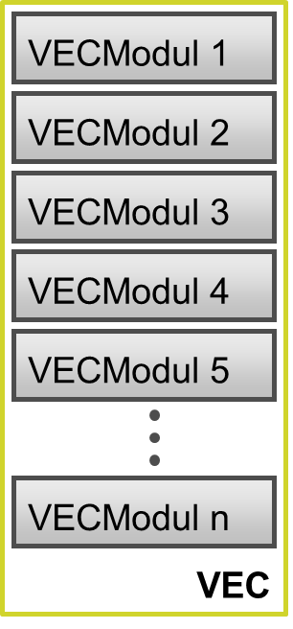
Figure 1: VEC Module concept
A VEC module can be optionally further broken down into sub modules. A VEC Submodule is subset of the classes and associations defined in a VEC module. VEC modules do not have to be disjoint. A class or an association may show up in more than one sub module of a particular VEC module. VEC Submodules may define constraints. Thereby restrictions on cardinalities of attributes and associations can be defined. A VEC Module and its submodules are called a VEC Module Family.
This version of the VEC defines VEC Modules, only. Submodules may be defined in a later version of this specification.
This version of VDA 4968 defines 26 VEC modules:
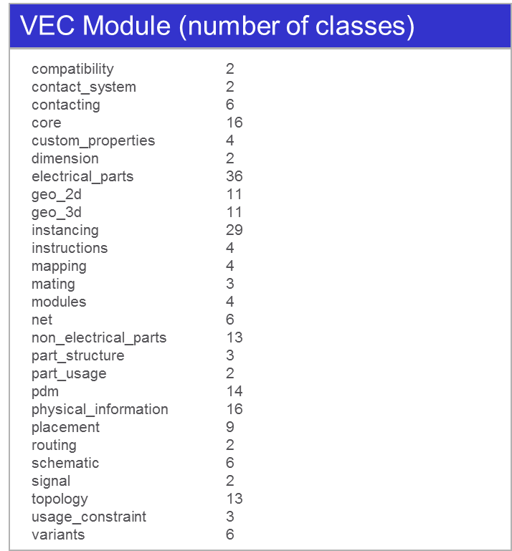

Figure 2: VEC Modules

Conformance Classes
The conformance class concept enables the definition of conformance classes on the basis of a set of dedicated VEC modules or submodules. A conformance class is a set of VEC Modules and VEC Submodules. A conformance class shall contain at most one element of a VEC module family. I.e., a conformance class may either select the VEC module itself or one of its submodules.
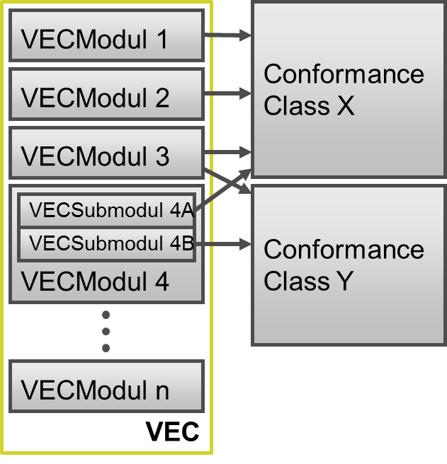
Figure 3: Conformance Class concept
This recommendation does not define concrete conformance classes. Conformance classes may be defined by the users of this recommendation.
There are some interdependencies on the combination of VEC modules. Due to the structure of the data model the existence of a specific class requires the existence of another class. For example, the module contacting needs the modules core, instancing, and electrical_parts. Figure 4 shows the dependencies.

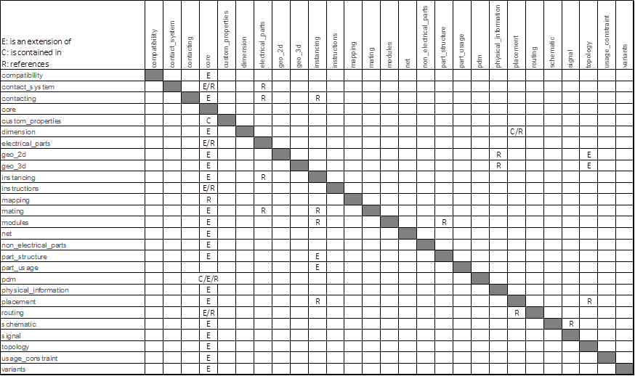
Figure 4: Module dependencies

XML representation of conformance classes and VEC modules
A VEC module or sub module will be represented as a single XML schema. A schema for a dedicated conformance class can be generated by composing VEC module or sub module schemas via the XML <xs:include> directive. A VEC file claiming conformance to a specific conformance class can be validated against the conformance class schema. As such a file also has to conform to the VEC itself, it can be validated against the VEC schema, too.
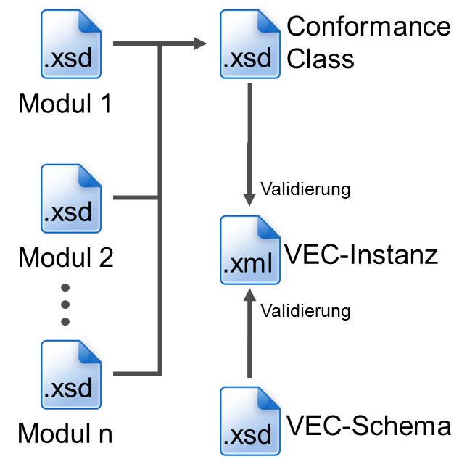
Figure 5: XML representation of conformance classes and VEC modules
The representation of VEC conformance classes and modules with standard XML technology has several advantages:
- Arbitrary XML tools can be used to generate a conformance class schema file
- The approach to compose modules is flexible
- Invalid conformance class schemas are detected by XML tools

Appendix A: Glossary
ECAD electronic computer aided design

ECU electronic control unit

ELOG A data format specification for the description of electrological data in the wiring harness context.

GEO A data format specification for the description of geometrical data in the wiring harness context.

IDC insulation displacement connector

Item In the context of this recommendation an item is either a part or a document.

KBL harness description list (“Kabelbaumliste”). A data format specification for the description of wiring harness data.

KOMP A data format specification for the description of components data in the wiring harness context.

ProSTEP iViP an international association that has committed itself to developing innovative approaches to solving problems and modern standards for product data management and virtual product creation.

XML Extensible Markup Language

XSD XML schema definition

VDA German association of the automotive industry
(“Verband der Automobilindustrie”)

VEC vehicle electric container. A data format specification for the description of harness design data cross process steps and supporting tools.

Appendix B: Data Model Description

