Paige Rosynek

CS 3860

Dr. Magana

10.6.2022

# **Lab 3 – Data Modelling & SQL**

## **Part 1 – Create a Video Database**

##### **Review videodb-readme.txt**

After reviewing the videodb-readme.txt that contains the fields for the other data files: Video_Categories.txt, Video_Actors.txt, and Video_Recordings.txt. While looking at this file, I observed that there are a lot of fields in the Video_Recordings.txt file which could be something we have to fix later in the lab. In addition, I noticed that the Video_Actors file has a recording_id which indicates that there is a relationship between video actors and video recordings.

##### **Create a Video database**

Proof and verification of the created database is shown below.

##### **Create an SQL script to create import tables for importing the data as tab-delimited text files. Note: There are differences between importing csv- and tab-delimited files. Why would you select one format over another?**

One reason you may want to have a .csv file (which can be delimited with a ‘,’) is if you don’t know what type of system a tab-delimited file was made on, then you may have issues loading in the file because different systems have different encodings for how large a tab is. The screenshots below show the results of creating each of the tables: video_actors, video_categories, and video_recordings.

##### **Load the tables from the data files, verify the data has been successfully imported.**

The screenshots below show the ‘Load Data infile’ successful load of each of the data files. In addition, I included the ‘update’ commands that was used to clean up punctuation in the data files.

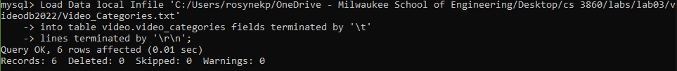

Trimming the columns of the tables and replacing “”.

The screenshots below display the data loaded into each of the tables, verifying the data was loaded in correctly.

## **Part 2 – Design Your Database Schema**

##### **Relational Data Model for Database Schema**

##### Below is the relational data model for my database schema. One thing I changed from the original data is I replaced the term ‘video_recording’ with ‘film’ for better readability. In addition, I created an actor_film table which relates film_ids and actor_ids which are both foreign keys from their corresponding tables, films and actors. The actor table has an actor_id as the primary key and then a name field. The films table has the film_id as the primary key, the category_id and director_id as the foreign keys, and the following fields: title, image_name, rating, year_released, price, stock_count, and duration. The films table is related to the categories table which has the category_id as the primary key and a name field. The films and directors tables are related through the directors table. The directors table has the director_id as the primary key and a name field.

Relational data model for the video database.

##### **Generate SQL Script to Define/Create Tables for Schema**

The text boxes below is the SQL script created by ERDplus from the relational model above.

CREATE TABLE categories

(

category__id INT NOT NULL,

name VARCHAR(100) NOT NULL,

PRIMARY KEY (category__id)

);

CREATE TABLE actors

(

actor_id INT NOT NULL,

name VARCHAR(100) NOT NULL,

PRIMARY KEY (actor_id)

);

CREATE TABLE directors

(

director_id INT NOT NULL,

name VARCHAR(100) NOT NULL,

PRIMARY KEY (director_id)

);

);

CREATE TABLE films

(

film_id INT NOT NULL,

title VARCHAR(200) NOT NULL,

image_name VARCHAR(100) NOT NULL,

rating VARCHAR(10) NOT NULL,

year_released INT NOT NULL,

price FLOAT NOT NULL,

stock_count FLOAT NOT NULL,

duration FLOAT NOT NULL,

category__id INT NOT NULL,

director_id INT NOT NULL,

PRIMARY KEY (film_id),

FOREIGN KEY (category__id) REFERENCES categories(category__id),

FOREIGN KEY (director_id) REFERENCES directors(director_id)

);

CREATE TABLE actor_film

(

film_id INT NOT NULL,

actor_id INT NOT NULL,

FOREIGN KEY (film_id) REFERENCES films(film_id),

FOREIGN KEY (actor_id) REFERENCES actors(actor_id)

);

##### **Load Data from Imported Tables to Final Schema**

The screenshot below shows the successful creation of the tables for the new schema using the generated script above. The created tables are: actor_film, actors, films, directors, and categories.

## **Verify Primary & Foreign Key Constraints. Why would I create the primary key index after the table has been created and the data imported versus defining the primary key in the table definition?**

Defining the primary key after the table has been created makes inserting data into the tables easier because you won’t have to worry about getting any warnings for key constraints when loading data into the table. It can allow you to load in certain columns of data at a time as well as allow you to load tables in any order because there won’t be any key constraint errors. For my schema, I defined the key constraints of each table in the ‘CREATE TABLE’ query, however with this structure I ran into the problems described above which I solved by temporarily turning off foreign key checks which is not best practice. The screenshots below describe the primary and foreign keys of each table. The actors table has the primary key actor_id and the film_actors table has two foreign keys: film_id and actor_id. The films table has the primary key, film_id, and two foreign keys: category_id and director_id. The last two tables, directors and categories, each have a single primary key, named director_id and category_id respectively.

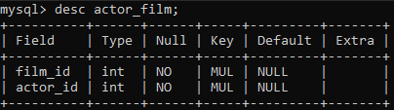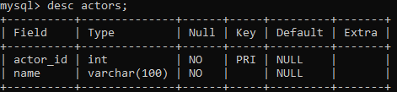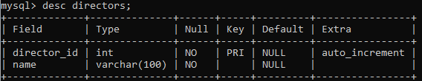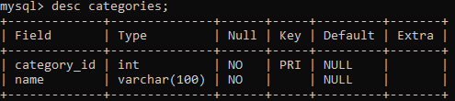

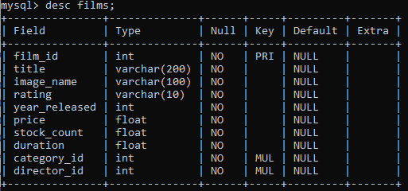

## **Verify Tables Loaded**

In the screenshots below, I included the top results from a ‘select *’ query for each of the tables, as well as the results of a count of how many rows are in each table.

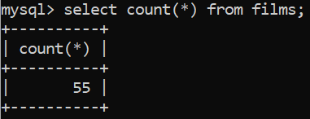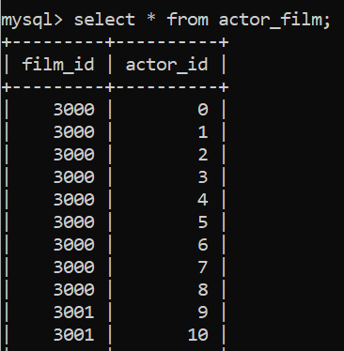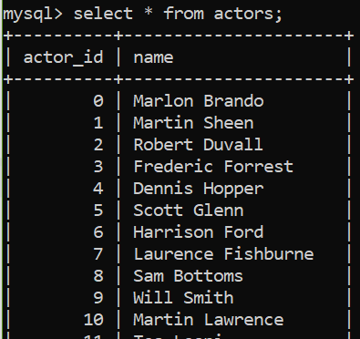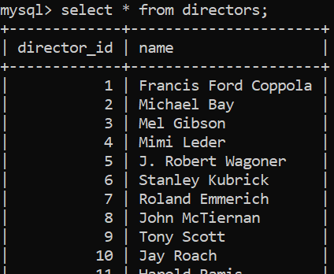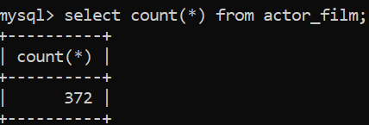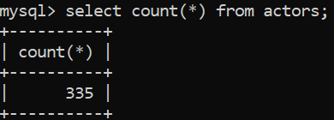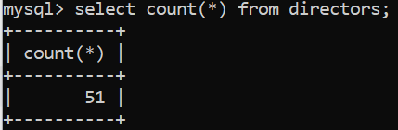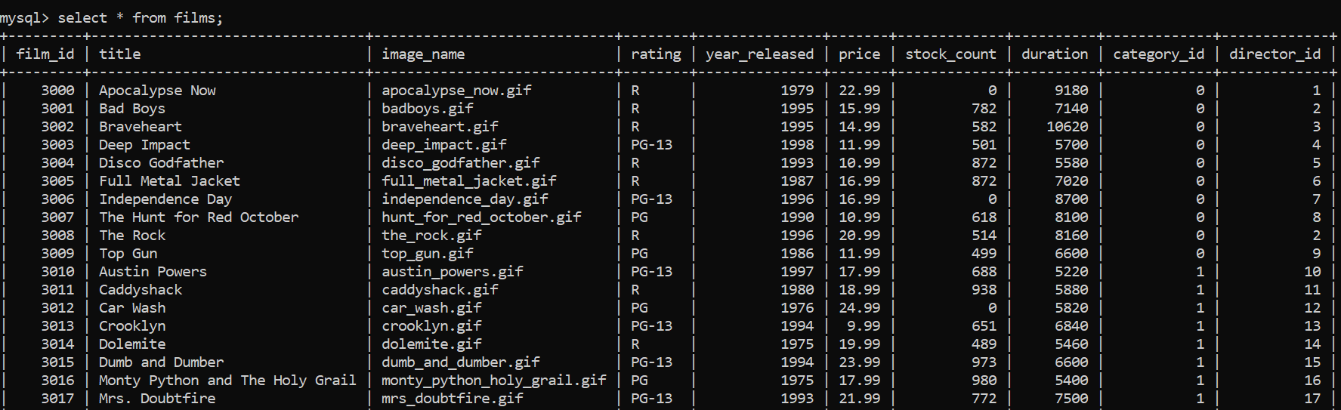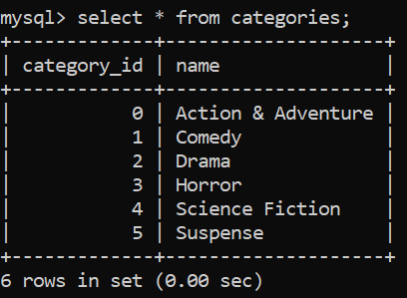

### **Part 3 – SQL**

Use the original tables imported from the files for the first two questions. Include your observations and explanations along with the question, SQL, and your query results.

### **Execute:**

### **SELECT * FROM video_recordings, video_categories;**

### **Note the cross-product effect of joining two tables. Record the number of rows generated. Do all permutations of Video Recordings × Video Categories make sense? Explain**

The first ten results of the above query are shown in the screenshot below; the total amount of rows returned was 330. The video_recordings table has 55 rows and the video_categories table has 6 rows. The above query takes each row of the video_recordings table and joins it with each row of the video_categories table, so each of the 55 rows will be printed 6 times, thus resulting in 55 * 6 = 330 rows total. From inspection, the permutations of video_recordings x video_categories does not make sense. For each of the rows in video_recordings, each row of video_categories is tacked on the end. This does not make sense because a single movie cannot belong to every category as shown in the first 6 rows of the screenshot below.

### **Execute:**

**SELECT \***

**FROM video_recordings vr, video_categories vc**

**WHERE vr.category = vc.name;**

### **Note the cross-product effect of joining two tables when restricted on the appropriate keys. Record the number of rows generated. Explain the purpose of the join.**

The first ten results of the above query are shown in the screenshot below; the total amount of rows returned was 55 which is equal to number of rows in the video_recordings table. The purpose of the above query is to join the two tables where the category column of video_recordings is matches the name column of video_categories.

### **For the remaining questions, use your relational schema.**

### **List the number of videos for each video category.**

Query:

SELECT c.name, f.category_id, COUNT(f.film_id) AS num_videos

FROM films f, categories c

WHERE c.category_id = f.category_id

GROUP BY f.category_id;

Results:

The above query uses the films table by grouping by each category_id and then counting the number of film_ids in each group. The category table is used to get the category name that corresponds with each category_id. The query returned a total of six rows.

### **List the number of videos for each video category where the inventory is non-zero**

Query:

SELECT c.name, f.category_id, COUNT(f.film_id) AS num_videos

FROM films f, categories c

WHERE c.category_id = f.category_id AND f.stock_count != 0

GROUP BY f.category_id;

Results:

The above query is the doing the same thing as the query in #3, however, the above query adds another constraint to the WHERE clause to filter the data such that the stock_count for the film was nonzero. These results make sense because the number of videos for each categories is less than the total film counts in #3. The query returned a total of six rows.

### **For each actor, list the video categories that actor has appeared in.**

Query:

SELECT a.name, GROUP_CONCAT(c.name)

FROM actors a, films f, categories c, actor_film af

WHERE af.actor_id = a.actor_id

AND af.film_id = f.film_id

AND f.category_id = c.category_id

GROUP BY a.name;

Results:

The screenshot above shows the first ten results of the query; the query returned a total of 335 rows which makes sense because that is the number of distinct actors in the database. The above query joins the tables: actors, films, actor_film, and categories, then it filters the data to get the records in with matching actor_ids, film_ids, and category_ids to get the categories of each of the films that each actor has been in. Then it concatenates the different categories each actor has been in.

### **Which actors have appeared in movies in different video categories?**

Query:

SELECT a.name, c.name

FROM actors a, films f, categories c, actor_film af

WHERE af.actor_id = a.actor_id

AND af.film_id = f.film_id

AND f.category_id = c.category_id

GROUP BY a.name

HAVING COUNT(*) > 1;

Results:

I spent a lot of time trying to find a query that would answer the question, but the closest thing I could come up with (it does not return any results. I attempted to filter the data to find all the categories that each actgor has been in and then group those results by each actor and then only choose the actors that had more than one category.

### **Which actors have not appeared in a comedy?**

Query:

SELECT a.name, c.name

FROM actors a, films f, categories c, actor_film af

WHERE a.actor_id = af.actor_id

AND af.film_id = f.film_id

AND f.category_id = c.category_id

HAVING c.name != "Comedy";

Results:

The screenshot above shows the first ten results of the above query; the total number of row returned by the query was 269. The query first gets the corresponding records from the actors, actor_film, films, and categories tables to get the categories that each actor has been in. Then it filters the table further to only get the actors that have corresponding categories that are not ‘Comedy’.

### **Which actors have appeared in both a comedy and an action adventure movie?**

Query:

SELECT a.name

FROM actors a, films f, categories c, actor_film af

WHERE (a.actor_id = af.actor_id

AND af.film_id = f.film_id

AND f.category_id = c.category_id)

AND (c.name = "Comedy" OR c.name = "Action & Adventure")

GROUP BY a.actor_id

HAVING COUNT(*) > 1;

Results:

Unfortunately, I was unable to write a query to answer this question. The query above was as close as I could get but the query itself does not return anything. In theory, this query should filter all of the tables to match actors to the categories they have been in, and also filter for only the actors that have been in a “Comedy” or an “Action & Adventure”. Then it would group the actors by their ids and then only take the actors that had a count of greater than 1 with would mean that the actor was in both a comedy and an action & adventure film.

### **Final ERD:**

### **Note to the professor**

I apologize for how late I turned this lab in. Between studying for the exam and studying for other classes I couldn’t get it done during the week. Also, some of my queries don’t work and I spent as much time as I could trying to get them to work without luck; I planned on having more time to work on it on Saturday but there was a scheduling error with my job and I ended up having to work for much longer than anticipated. I know this doesn’t excuse my work, but I would appreciate it if I could meet about where I went wrong in the lab so I can understand my mistakes.