Instructions:

1. Press the Load Data button to load the data from a folder (videos/pictures)
2. Select one or more data from the folder browser that pops up. (Figure 2)
3. Select the DLM from the drop down menu that is labelled Deep Learning Model
4. (Optional) press import CSV if have previously exported CSV results of data
5. Press Process Data to apply the DLM into the data
6. Press the check box above the video to toggle the detection boxes (if processed)
7. Live Statistics shows the results in the current frame
8. (Optional) press save video for later use of the video
9. (Optional) press export CSV for later use

Extra functionalities:

* Press next video to load up the next video into the media player
* A processed video will have a green image next to it in the file selection widget.
* File Menu allows the user to exit the application
* Edit menu has
* View and Window drop down menus have zoom and window size functionalities and keyboard shortcuts for them
* Help includes the user guide, about the application and external links to documentation and FAQs.

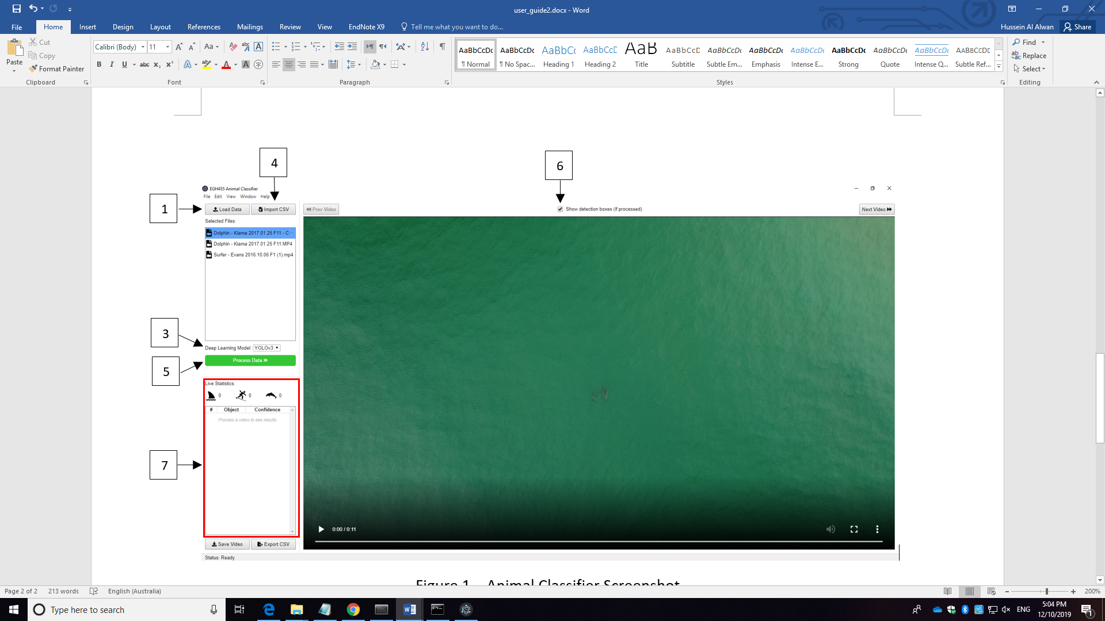

Figure 1 – Animal Classifier Screenshot