Christopher Burger

Cdb0076

COMP 3700: Software Modeling and Design HW 4

1.) A home security system helps monitor the home from break-ins, fires, etc. and helps the people who are living there stay safe as possible. The system has a main access console that the user can access straight from there system in the house, or even via mobile phone application, or even accessing it via web service. The system will be monitoring the interior/exterior of the using monitoring tools such as sensors, cameras, video doorbell and electric locks. There will also be a keypad to arm and disarm the alarm. There will be many sensors such as motion sensors such as glass break sensors, smoke sensors, and carbon monoxide sensors. There will also be outdoor and indoor cameras. The doorbell will be a video doorbell so that you can unlock the door using electric locks via app or console.

The sensors will send signals to the console if anything trips one. The notifications that can be sent are door unlocked, door locked, carbon monoxide warning, smoke warning, glass broke in room x, motion detected in room x. The cameras will record everything so in case of an accident or break-in, etc. there will be recorded evidence of what happened. Our doorbell system will consist of a live video feed when rang. This will allow the user to see who is at his door and also help monitor stolen packages etc. if anything like that should ever happen. The electric locks will be set up so that the user can unlock or lock the doors if they do not want to get up or even if they simply forgot and have to lock up from another location. Our console will be like a mainframe to our security system. At the console you will be able to do everything such as, view doorbell feed, view cameras feed, view monitors status, lock/unlock doors, call for help, and also arm/disarm.

When the system is armed, and the alarm is tripped, you will have 20 seconds to enter the password before the company calls to ask the password and see what is going on. If failed to enter the password, the police will be called. If there are smoke detectors tripped the user will be notified via alert on app/console and if they do not respond with the code the fire department will be called. In these situations the security company will also contact the user via text and phone call to tell them the authorities are being notified and will keep them up to date as soon as they get information.

1)



2.)

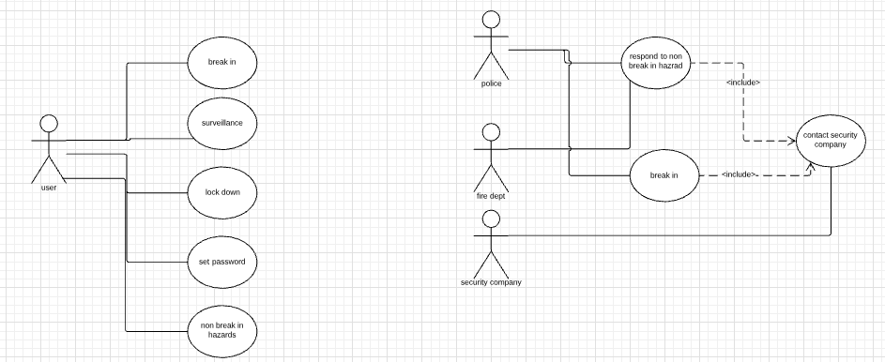

3.) **USE CASE: NON BREAK-IN HAZARD**

ACTOR INTENTION SYSTEM RESPONSIBILITY

1. Sensor tripped which trips alarm

and notifies security company

2. Company notices it is either a carbon

Monoxide or smoke sensor

3. Security company notifies authorities

4. Authorities get call and send out a unit either police or fire

5. user is contacted about the incident

6. Authorities contact security company to update them on the situation

7. Security company contacts user with updates

8. Authorities get situation under control and contact security company

9. Security company contacts user to tell them

everything is ok

4.) **Scenario 1**- Carbon Monoxide is leaking somewhere in the house. The sensor goes off then sets off the security alarm. The console contacts the security company who then contact authorities to send out units to see what is going on. The security contacts the user and tells them what is going on. The authorities arrive and updates the security company. The security company contacts the user and updates them. The authorities get the situation under control and contact the security company. The security ensure the user the situation is handled.

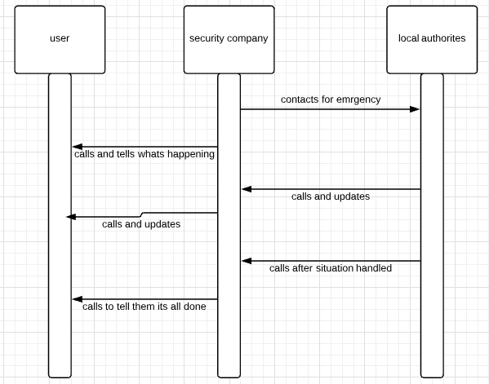

**Scenario 2-** Smoke alarms are going off after the dryer catches on fire. The console contacts the security system. The security people see where the house is on fire via camera. They immediately contact the fire department. Then they contact the user. The fire department arrives to try to put out the fire but cannot. They contact the security company to tell them for no one to come home soon because they cant contain the fire. The security company contacts the user to relay the message. The firemen finally get it put out and call the security company. The security company then tell the user the bad news.

