**Add To Report**

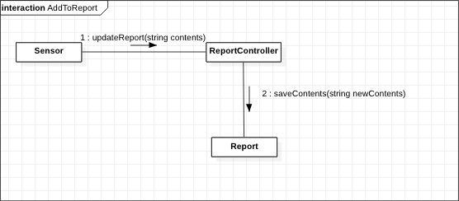

The GRASP guidelines used in this diagram are **Controller**, **Creator**, **Don’t Talk to Strangers**, and **Expert**. The ReportController object is used to create a Report as well as update the contents and save the contents which follows the **Creator** guideline. This diagram also follows the **Expert** and **Don’t Talk to Strangers** guidelines because the ReportController is used to manage and save contents of the report instead of the Homeowner directly accessing the report object.

**Contact Emergency Services**

The EmergencyController object acts as an intermediary between the Homeowner and the EmergencyServices, so the **Don’t Talk to Strangers** guideline is used. Since EmergencyController acts as a controller object, the **Controller** GRASP guideline is also used. This diagram also exhibits the **Low Coupling** GRASP guideline because each object is only focused on one message.

**Set Alarm**

The EmergencyController object acts as a **Controller** that interacts with the ArmingController. Similarly, the ArmingContoller object acts as a **Controller** which changes the status of the Alarm object whenever the EmergencyController contacts it with the setAlarm message. The ArmingController object also acts as an **Expert** between EmergencyController and Alarm, which follows the **Expert** as well as **Don’t Talk to Strangers** guidelines. This model also shows **Low Coupling** and **High Cohesion** because each object is only responsible for one message between two objects.