**Request Feed** 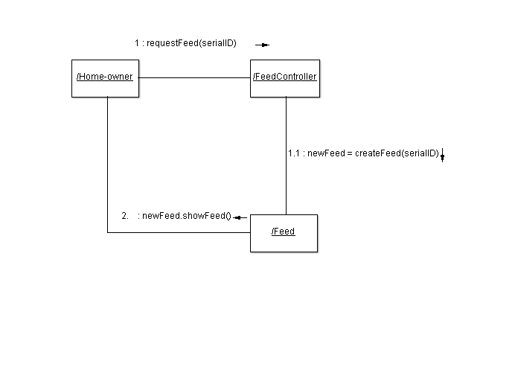

The primary GRASP guideline used in this collaboration diagram is **controller**. The Feed Controller is used to bridge the gap between the home-owner’s interface and the feed itself. The controller is also a **creator** as without it the feed does not actually exist. Once the feed is created, it is an information **expert.** It has sole knowledge of how the feed structure is designed. It gathers the data required to build said feed from the database then displays the structure to the home-owner.

**Lockdown**

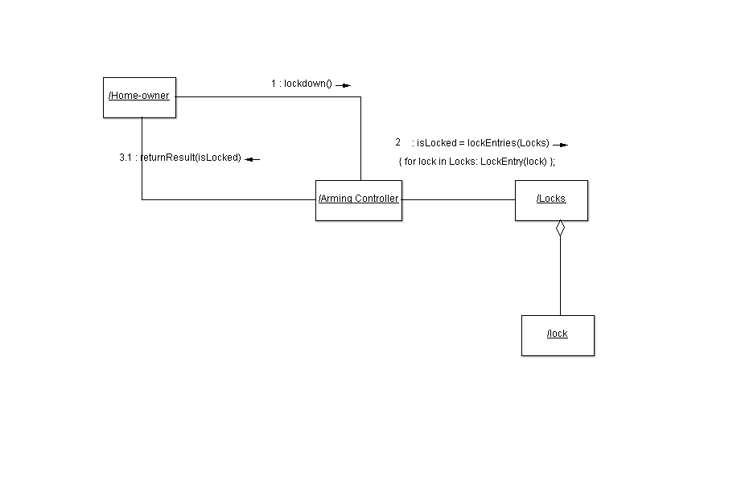

The Arming Controller separates the user’s interface from the actual lockdown procedure. Hence it follows the **controller** guideline. Since the locks are physical locks, they do not carry any information on board. The Locks class follows the **pure fabrication** guideline since it carries the information for the set of locks, but it is not a device itself. Letting the Arming Controller be the information expert would cause cohesion issues since it is in charge of simply arming and disarming devices.

**View Report**

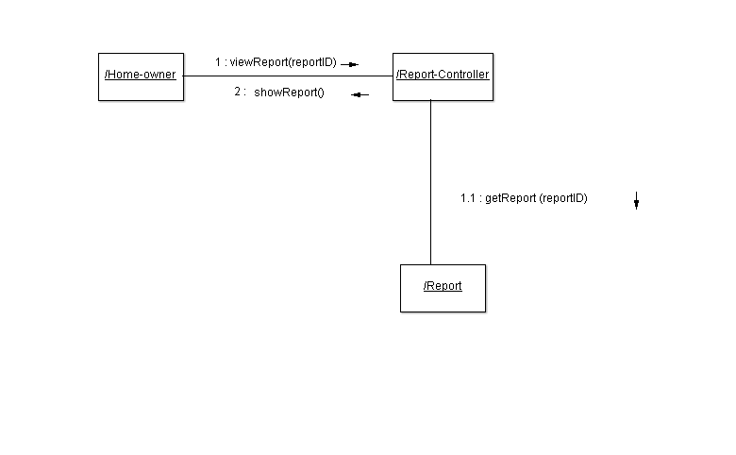

The Report Controller separates the user action from the view report procedure. The Report is an **expert** of its contents, which it passes off to the report controller to handle the transfer of the data to the home-owner. Since the Report Controller handles all of the communication between the Report and the home-owner, it has high cohesion within its own functions.

**Manage Sensor**

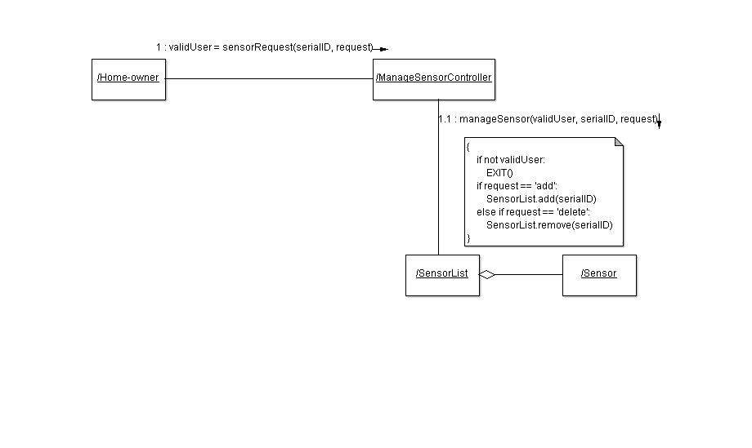

The Manage Sensor Controller is a **controller** between the user’s interface and the list of sensors. It verifies that the user is authorized to make the request. Then the controller manages the sensor list. The sensor list is an information **expert** for all the sensors within the system. This prevents individual sensors from **talking to strangers** by giving a specific line of communication.

Adjust Settings

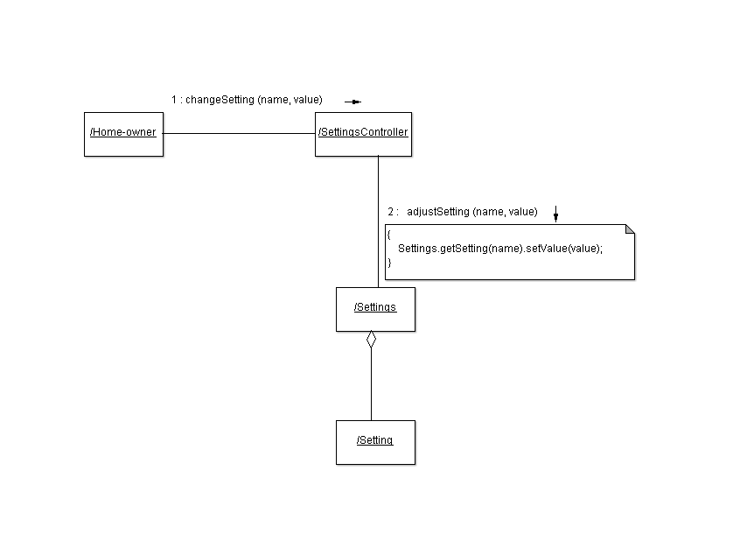

The Settings Controller takes in the information from the interface that the user wants to do with the settings and changes the settings with it. Settings follows the **pure fabrication** guideline as it is a collection of Setting objects used to abstract each setting. This allows each setting to adhere to the **don’t talk to strangers** GRASP guideline.