**Use Case:** Add Sensor

**Essential Use Case:**

**Participants:** Home-owner

**Pre-conditions:** The protecc system is set up and running

**Typical Course of Events:**

**Actor Intention System Responsibility**

1. Access Command Center

2. Show Interface

3. Choose option to add sensor

4. Show which type of sensor you would like to add

5. Choose sensor type

6. Show message enter serial number

7. Enter serial number of the sensor

8. Adds new sensor

9. Show message successfully added

10. Exits to main menu

**Exceptions:**

**-**Step 5. If the user tries to add the wrong type of sensor it will not pair.

-Step 7**.** If the user enters the wrong serial number, the sensor will not pair with the system.

**Post-conditions**: The serial numbers are visible.

**Scenarios:**

Home-owner accesses Command Center.

The Command Center pulls up an interface with options.

Home-owner choses add sensor.

The Command Center asks the user what type of sensor they would like to add.

The Home-owner then choses sensor type.

The Command Center then tell user to enter serial number of the sensor.

The Home-owner enters serial number of the sensor.

The Command center adds the sensor.

The Command Center then displays whether the pairing of the sensor is successful or failed.

The Home-owner then exits to the main menu.

**High Level System Sequence Diagram**

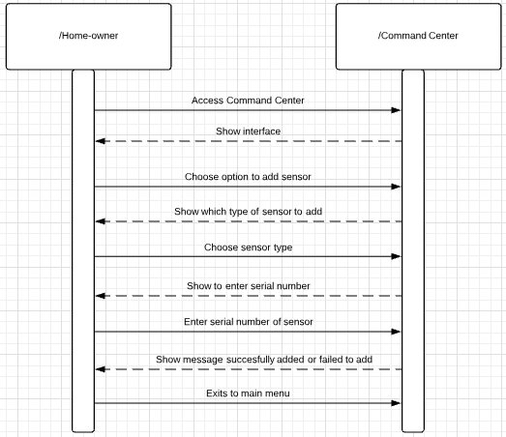

**Concrete Use Case:**

*Use Case Name* Add Sensor

*Entry Conditions* 1. The Home-owner accesses the Command Center and presses the “Add

Sensor” button.

*Flow of Events*  2. The Command Center displays an interface asking what type if sensor you want to add.

3. The Home-owner selects the type of sensor they are adding.

4. The command center displays a message asking them to enter the serial number of the sensor.

5. The Home-owner then enters the serial number of the sensor for pairing.

6. The Command Center then displays a message saying whether the pairing of the sensor was successful or failed.

*Exit conditions* 7. The Home-owner then exits to the main menu of the Command Center

**Detailed System Sequence Diagram:**

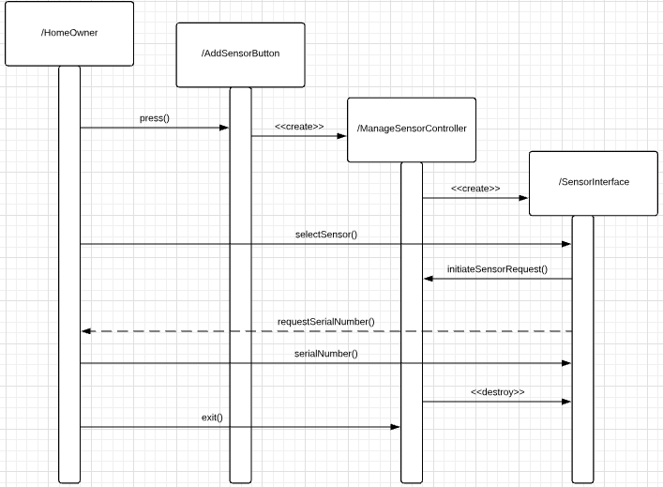

**Use Case:** Remove Sensor

**Essential Use Case**

**Participants:** Home-owner

**Pre-conditions:** The protecc system is set up and running

**Typical Course of Events:**

**Actor Intention System Responsibility**

1. Access Command Center

2. Show interface

3. Choose option to remove sensor

4. Displays message select which sensor you want to remove

5. Select the sensor you want to remove

6. Prompts home-owner to enter password

7. Enters password

8.Removes selected sensor

9. Displays message sensor removed

10. Exits to main menu

**Exceptions:**

-Step 7**.** If the home-owner enters the wrong password the sensor will not be removed.

**Post-conditions**: Removed sensor must be deleted from system.

**Scenarios:**

Home-owner accesses Command Center.

The Command Center pulls up interface with options.

Home-owner choses remove sensor.

The Command Center prompts home-owner to select which sensor they would like to remove

The home-owner then selects which sensor to remove.

The Command Center prompts home-owner for password

The home-owner then enters the password.

The Command Center then removes the selected sensor.

The Command Center displays a message that the sensor was removed.

The home-owner exits to main menu.

**High Level System Sequence Diagram:**

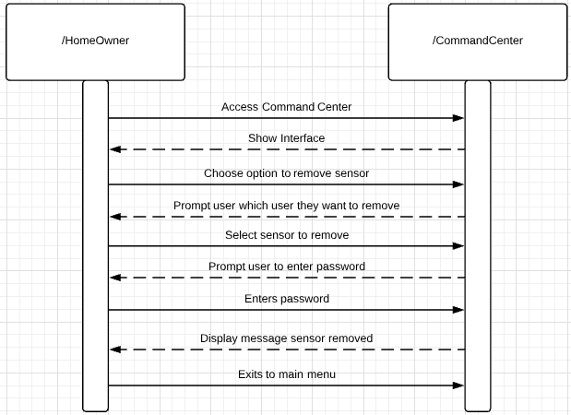

**Concrete Use Case:**

*Use case name* Remove Sensor

*Entry Condition* 1. The Home-owner accesses the Command Center and presses the “Remove Sensor” button.

*Flow of Events* 2. The Command Center prompts what sensor would you like to remove.

3.The Home-owner then selects which sensor he wants to remove.

4. The command center then asks for a password.

5. The home-owner enters the password

6. The command center displays message the sensor was removed.

*Exit conditions* 7. The home-owner exits to the main menu

**Detailed System Sequence Diagram:**

