Setting up Change Management

Install:

Unzip the binary distribution file (changemgmt.zip) into the ‘plugins’ directory in your Protégé installation.

Activate:

To activate the Change Management tab for your given project, ensure you configure your project properly by doing the following in the menu bar:

Project > Configure > Select the ‘ChangesTab’ option.

Using Change Management

Change Viewer:

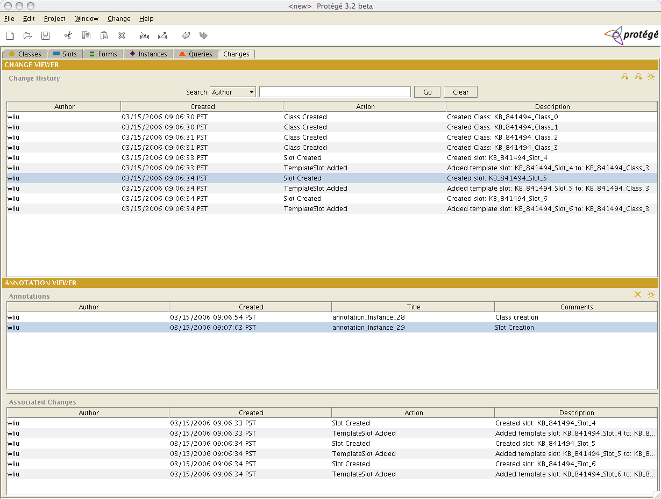
The change viewer shows what changes the user has made to the given project they are working on. Each entry in the table is a particular change. To create an annotation of a change (or a group of changes), simply select the given change(s) and select the ‘Create Annotation’ icon:
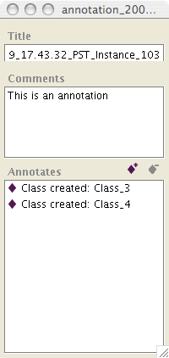
This will bring up a window where you can create the annotation for the given change(s). Simply type the contents of the annotation in the ‘Comments’ text area and close the window.

The two other icons in the ‘Change Viewer’ header are used to filter the changes that are displayed. There is a “Summary View” as well as a “Detailed View”.

The search mechanism works like the other search mechanism built within Protégé. The keyword that is typed is in the form of a regular expression (please also note that the type case does matter).

Annotation Viewer:

The ‘Annotation Viewer’ shows the user generated annotations. The upper table shows the actual annotations. The lower table shows the associated changes for a given annotation. To see the given changes for a given annotation, simply select the desired annotation.

The user can also edit a given annotation. Simply click on the ‘Edit Annotation’ icon:

This will bring up the corresponding annotation window (make the necessary changes within this window):

The user can also remove given annotations. To do this, simply select the annotation in the table and click the ‘Remove Annotation’ icon:

Miscellaneous:

Within Change Management, the user can also make quick changes. If they user is in another tab, once a change has been made, they can use the keystroke command: CTRL+A to bring up the annotation window, or they can go to the menu bar and select the Change item.

Also, the user can get Change or Annotation information about a particular class within the “Classes” tab by selecting the given class, then going to the Change menu (from the menu bar) and selecting: ‘Selected Change Info’.

