V549 Theorem Boundary Update
Selective Fragility and First-Principles Boundary
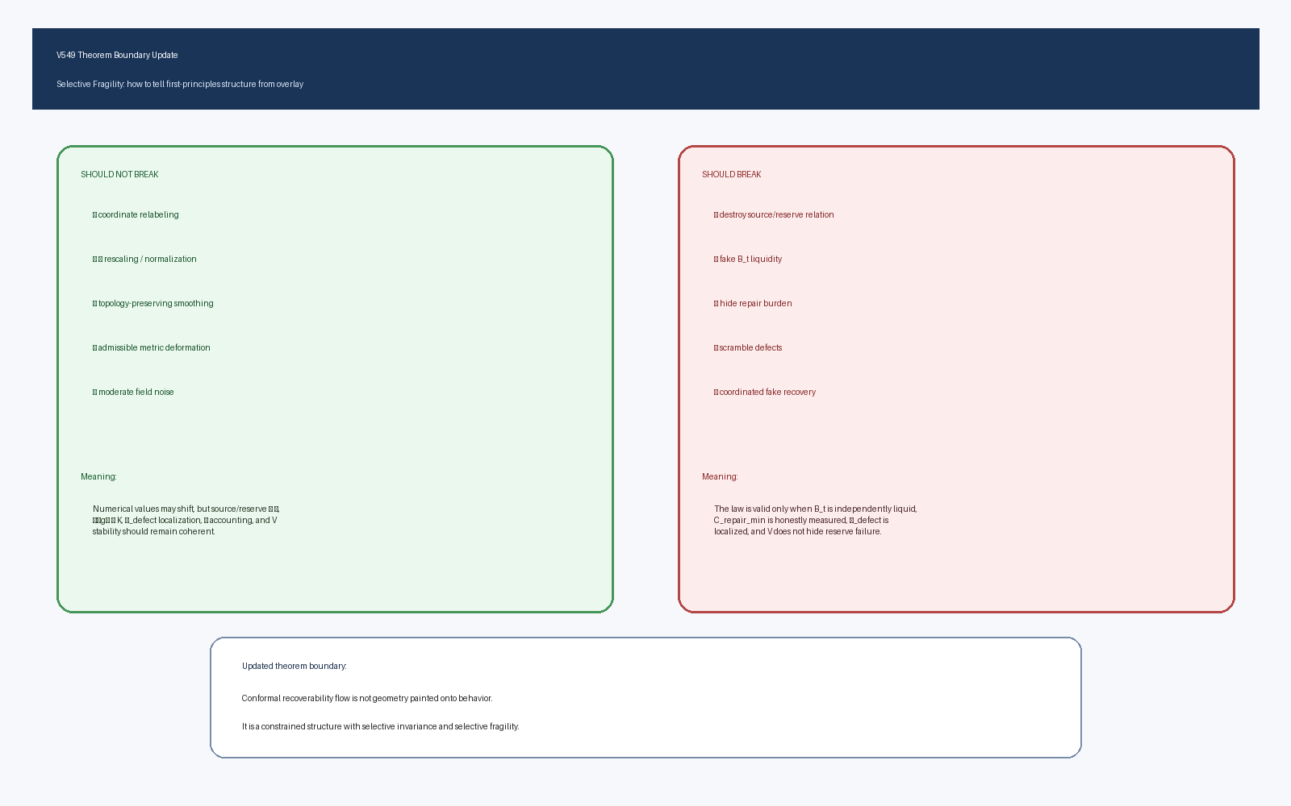

Purpose
V549 updates the retained-geometry theorem after the selective-fragility audits. The key question was whether the geometry is an overlay or a first-principles recoverability structure.

Core Result
The law survives admissible transformations and fails under principle-breaking transformations. This is the selective-fragility signature.

Should Not Break
Coordinate relabeling, Ω rescaling, topology-preserving smoothing, admissible metric deformation, and moderate field noise should not destroy the law.

Should Break
Source/reserve destruction, fake B_t liquidity, hidden repair burden, scrambled defects, and coordinated fake recovery should break the law.

V546 Addition
The theorem now requires independent B_t liquidity and C_repair_min repair-burden audits. Large nominal branch volume does not count as reserve unless it is recoverable and repairable.

Updated Validity Conditions
The flow is valid only when source/reserve is preserved, B_t is independently liquid, repair burden is honestly measured, μ_defect is localized, V does not hide failure, and η_convert is calibrated.

Updated Status
The first-principles boundary is strengthened, but rigorous continuum proof, measure convergence theorem, full Lyapunov proof, and uniqueness of the η channel basis remain open.

