wss<- (nrow(scores[1:199, ]-1)\*sum(apply(scores[1:199, ], 2, var)))

for (i in 2:15) wss[i] <- sum(kmeans(scores[200:397, ], centers = i)$withinss)

plot(1:15, wss, type ="b", xlab = "Number of cluster", ylab = "withinss groups sum of error squares")

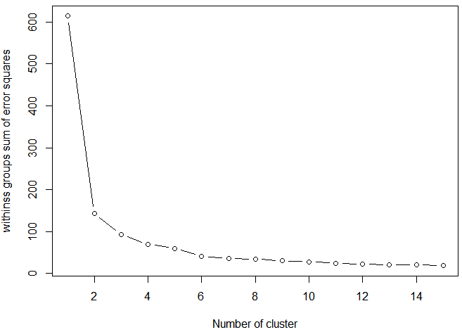

library(vegan)

fit <- cascadeKM(scale(scores[1:199,], center = TRUE, scale = TRUE), 1, 10, iter = 1000)

plot(fit, sortg = TRUE, grpmts.plot = TRUE)

calinski.best <- as.numeric(which.max(fit$results[2,]))

calinski.best

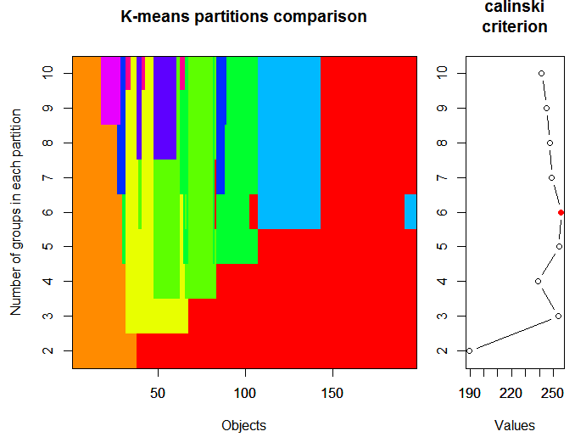

wss<- (nrow(scores[200:397, ]-1)\*sum(apply(scores[200:397, ], 2, var)))

for (i in 2:15) wss[i] <- sum(kmeans(scores[200:397, ], centers = i)$withinss)

plot(1:15, wss, type ="b", xlab = "Number of cluster", ylab = "withinss groups sum of error squares")

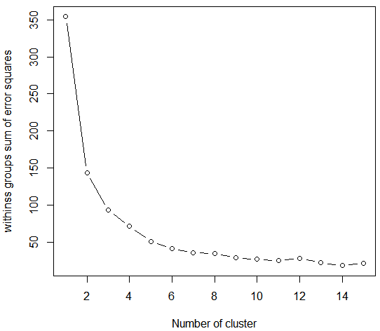

fit <- cascadeKM(scale(scores[200:397,], center = TRUE, scale = TRUE), 1, 10, iter = 1000)

plot(fit, sortg = TRUE, grpmts.plot = TRUE)

calinski.best <- as.numeric(which.max(fit$results[2,]))

calinski.best

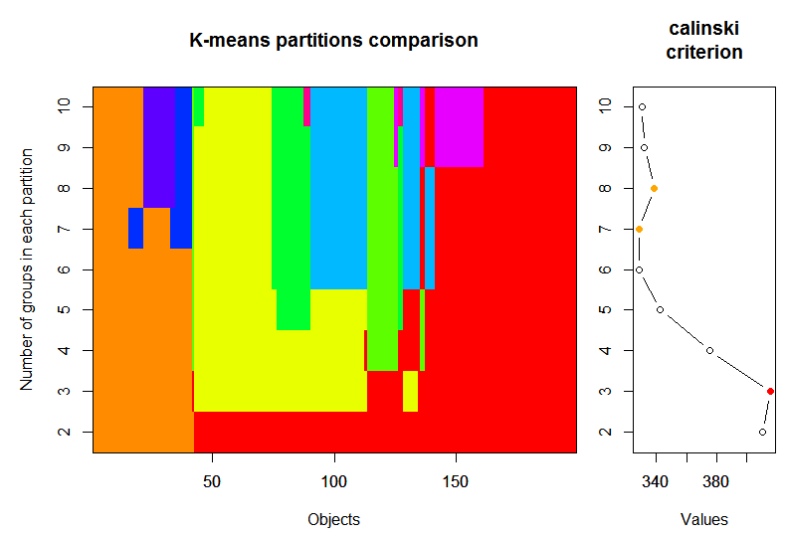

wss<- (nrow(scores[480:885, ]-1)\*sum(apply(scores[480:885, ], 2, var)))

for (i in 2:15) wss[i] <- sum(kmeans(scores[200:397, ], centers = i)$withinss)

plot(1:15, wss, type ="b", xlab = "Number of cluster", ylab = "withinss groups sum of error squares")

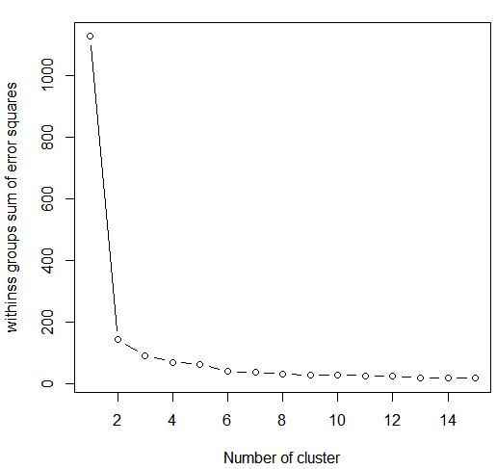

library(vegan)

fit <- cascadeKM(scale(scores[480:885,], center = TRUE, scale = TRUE), 1, 10, iter = 1000)

plot(fit, sortg = TRUE, grpmts.plot = TRUE)

calinski.best <- as.numeric(which.max(fit$results[2,]))

calinski.best

