# WASTE MANAGEMENT

# AT LOCAL SELF-GOVERNING BODY LEVEL

PROJECT REPORT

*Submitted by*

|  |  |
| --- | --- |
| LEO JOY | 20419052 |
| MOHAMMED HISHAM A | 20419054 |
| VAISHAK VINODKUMAR NAIR | 20419060 |
| SAURABH KUMAR | 20419074 |

As part of RDBMS based mini project assigned in Sem 4 of Bachelor of Technology Degree in Information Technology.



**SCHOOL OF ENGINEERING**

## COCHIN UNIVERSITY OF SCIENCE AND TECHNOLOGY KOCHI-22

**JUNE 2021**

**COCHIN UNIVERSITY OF SCIENCE AND TECHNOLOGY**

**SCHOOL OF ENGINEERING**

**COCHIN-22**



**CERTIFICATE**

*It is certified that this report titled “WASTE MANAGEMENT at Local Self-Government Body level” is a bonafide record of the mini project work done by Leo Joy, Mohammed Hisham A, Vaishak Vinodkumar Nair and Saurabh Kumar and is forwarded towards the partial fulfillment of the requirements for the award of the degree of Bachelor of Technology in Information Technology from Cochin University Of Science And Technology during the year 2021.*

Dr. Shelbi Joseph Dr. Binsu Kovoor

PROJECT GUIDE HEAD OF THE DIVISION

**ACKNOWLEDGMENT**

The project on the topic “WASTE MANAGEMENT SYSTEM” was taken as a part of the curriculum for the award of B.Tech degree in Information Technology Engineering.

We also express our gratitude to Dr.BINSU C KOOVOR, Head of department for providing us with adequate facilities, ways and means by which we were able to complete this project.

We express our sincere gratitude to our project guide Shelby Sir. Information technology Division for their constant support and valuable suggestions without which the successful completion of this project would not have been possible.

We express our immense pleasure and thankfulness to all the teachers and staff of the Department of Information Technology, CUSAT for their cooperation and support. We would also like to thank some of our seniors, who helped us in all ways they could, when we were stuck at important conjectures during this effort of ours.

Last but not the least, we thank all others, and especially our classmates and our family members who in one way or another helped us in the successful completion of this work

## ABSTRACT

**Waste Management at local self-governing body level** is an RDBMS based mini-project with a website wherein the database used was MySQL. HTML5, CSS, BOOTSTRAP were used in designing the front-end and PHP was used for the back-end of the website. The aim of the project is to provide technical support to the government and aid managing waste in an efficient way. It manages the data of various residents in municipality or panchayats and provides a means for residents to dispose waste properly and hereby ensure that we reach the global goal of Zero-Waste.

Residents/Users when accessing the website first visit the home page, a user can go to the collection centre page and enter his ward no. and house No. and then schedule a slot.

The admin can login and access all the schedule details at that collection centre.

We intend to use technology as a decisive part in this mission and hence ensure maximum efficiency in the management system.

**CONTENTS**

1. INTRODUCTION
   1. BACKGROUND
   2. OBJECTIVES
   3. PROBLEM STATEMENT
2. LITERATURE SURVEY
   1. EXISTING SYSTEM
   2. PROPOSED SYSTEM
3. SYSTEM REQUIREMENT SPECIFICATIONS
   1. HARDWARE REQUIREMENTS
   2. SOFTWARE REQUIREMENTS
4. DESIGN
5. SYSTEM IMPLEMENTATION
6. RESULT AND DISCUSSION
7. CONCLUSION AND FUTURE SCOPE
8. REFERENCES

# INTRODUCTION

* 1. **Background**

Managing wastes is a necessity for a good environment, a happy population, and consequently, a better economy.

Waste Pollution is a major threat to any developing country. What we need is a proper, efficient way to manage wastes and what lacks is the proper way the people can play a part in this task. The irresponsible disposal of non-biodegradable wastes, improper methods to treat bio-degradable waste products and simply, the disunity of people in the disposal of garbage can threaten a country’s development. So we chose this topic as project so as to address this very problem our society faces.

**1.2 Our Objective-Initiative**

We see the dream of transforming this world into a zero-waste planet.

The smallest step in this big initiative is our pilot project at the Kalamassery Municipality.

Our plan is to establish vermicompost conversion plants at particular centers in the municipality limits wherein the waste collected from the houses of the residents will be brought by the waste collection trucks owned by the municipality.

The residents will be equipped with the necessary technical guidance for the proper segregation and disposal of waste.

Bhoomi Project deals with providing the technical support to this initiative wherein the residents can schedule their waste collection time and hence contribute towards the noble cause of a zero-waste world.

**1.3 Problem Statement:**

“Bhoomi” is a website developed for managing the waste disposal process in the municipality of Kalamassery.

In an ideal situation the waste management would have been environment friendly and lead to zero waste environment.

The scope of the project deals with providing a technical aid so as to go closer towards achieving the above-said ideal scenario.

The current condition of waste management is pathetic and miserably harmful for the environment. Bio waste including food wastes and other items are dumped up in a landfill wherein they tend to pile up with time.

Such a scenario makes the atmosphere filled with stagnant smell of decomposing waste along with many harmful gases. The water resources in the nearby neighbourhood also become contaminated.

The piled-up waste remains there for years together in decomposing state making the land nearby barren and incompetent for agriculture or living purposes.

As in Kalamassery the problem of landfill exists in North part of the town.

Our solution is to handle this waste in bio-friendly methods of vermicompost and biogas conversion.

Whereas for plastic waste it is their proper accumulation and break-down.

**2. LITERATURE SURVEY**

**2.1 Existing System**

The Existing systems for technical support in waste management is the Suchitwa Mission by the Kerala Government.

But the working of the group is limited to road cleaning initiatives and such small scale works. There exists some local-bodies where the method of waste disposal is bio-friendly having method of biogas and vermicompost, but as it is limited only to certain localities, it’s impact is also small.

**2.2 Proposed System**

We as a whole look forward to change the existing system by decentralizing the responsibility on the local self-governing body and the residents of that area. The use of our created website will systematize the waste collection and generic breakdown of the same as to get usable byproducts. The proposed system will help keep our roads and by lanes free from illegal waste dumping. The landfills used as part of waste dumping can be freed from more wastes and the benefit of this can be made available to citizens.

3. SYSTEM REQUIREMENTS

* HARDWARE REQUIREMENTS

he section of hardware configuration is an important task related to the

software development insufficient random-access memory may affect adversely on the speed and efficiency of the entire system. The process should be powerful to handle the entire operations. The hard disk should have sufficient capacity to store the file and application.

Processor : Pentium IV and above

Processor speed : 1.4 GHz Onwards

System memory : 128 Mb minimum 512 Mb recommended

Cache size : 512 KB

RAM : 512 MB(Minimum)

Network card : Any card can provide a 100mbps speed

Network connection : UTP or Coaxial cable connection

Hard disk : 80Gb

Monitor : SVGA Color 15”

* SOFTWARE REQUIREMENTS

Operating system : Window 7

Back End : PHP,SQL

Front end : HTML,CSS,BOOTSTRAP,JS

Database : MYSQL

**4. SYSTEM DESIGN**

**4.1 Input Design**

The system design is divided in to two portions. The Administrator (staff at the collection center) section and the User(residents) section.

**4.1.1 Administrator**

1. The Administrator can access the details of schedules at that collection center.

2. His powers also include the addition of a new resident into the database on basis of a manually submitted request with details to support his claim of residence.

A process of converting user originated inputs to a computer-based format. Input design is an important part of development process since inaccurate input data are the most common cause of errors in data processing. Erroneous entries can be controlled by input design. It consists of developing specifications and procedures for entering data into a system and must be in simple format. The goal of input data design is to make data entry as easy, logical and free from errors as possible. In input data design, we design the source document that capture the data and then select the media used to enter them into the computer.

**4.2 Process Design**

Process design plays an important role in project development. In order to understand the working procedure, process design is necessary. Data Flow Diagram and System Flow chart are the tools used for process design. System Flow Chart is a graphical representation of the system showing the overall flow of control in processing at the job level; specifies what activities must be done to convert from a physical to logical model. Data Flow Diagram is the logical representation of the data flow of the project. The DFD is drawn using various symbols. It has a source and a destination. The process is represented using circles and source and destination are represented using squares. The data flow is represented using arrows. One reader can easily get the idea about the project through Data Flow Diagram.

**4.2.1 Data Flow Diagram**

**4.1 Home Page**

**4.2 Collection center**

**4.3 scheduling desk**

**4.4 Admin login**

**4.5 Retrieval of schedules**

**4.6 Adding a new resident**

**4.7 Addition based on request**

**4.3 Database Design**

The data in the system has to be stored and retrieved from database. Designing the database is part of system design. Data elements and data structures to be stored have been identified at analysis stage. They are structured and put together to design the data storage and retrieval system.

A database is a collection of interrelated data stored with minimum redundancy to serve many users quickly and efficiently. The general objective is to make database access easy, quick, inexpensive and flexible for the user. Relationships are established between the data items and unnecessary data items are removed. Normalization is done to get an internal consistency of data and to have minimum redundancy and maximum stability. This ensures minimizing data storage required, minimizing chances of data inconsistencies and optimizing for updates.

Database Used for this Project is given below:

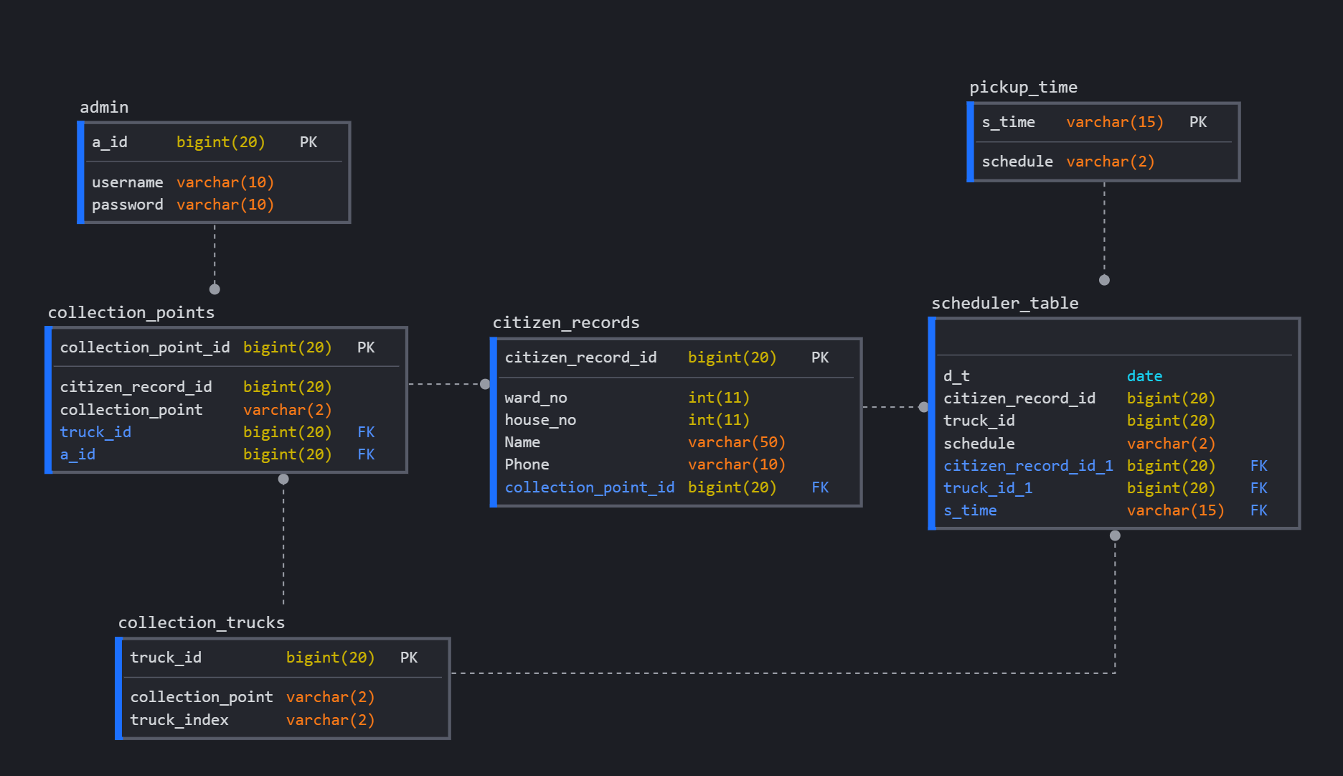

**Some PHP code Used In our project:**

# IMPLEMENTATION

After designing and carefully planning the project comes the next important stage - Implementing the plan. It is the stage in the project where the theoretical design is turned into a working system and is giving confidence on the new system for the users that it will work efficiently and effectively. It involves careful planning, investigation of the current system and its constraints on implementation, design of methods to achieve the changeover, an evaluation of change over methods.

The implementation process begins with preparing a plan for the implementation of the system. According to this plan, the activities are to be carried out, discussions made regarding the equipment and resources and the additional equipment has to be acquired to implement the new system. The system can be implemented only after thorough testing is done and if it is found to be working according to the specification.

In our project, we deal with local body levels like gram panchayats and specifically, the Kalamassery Municipality. Kalamassery is a major industrial region in the city of Kochi in the state of Kerala. It has 42 wards. Our project helps residents to receive our service by entering their ward and house number.

The first step in this implementation starts with partnering x with the officials in the municipality. With their permission, the information of the residents will be collected in our database. The next step is establishing collection centres. In this project, we have in mind two collection centres and one garbage truck each.

The website will be made public, and the residents must be informed of this service.

# RESULT AND DISCUSSION

After careful planning and design, the project **Waste Management at local body level** was implemented. With this project we used Relational Database Management (RDBMS) to store data of different households and create a website for the residents to use.

Several difficulties were faced during the process of designing and programming them. Errors were rectified and many bugs were removed. Finally, the website was hosted successfully. The website has a good user-interface with an easy-to-use functionality.

With this project, we use technology to make the daily life of common people easier. We learned to design database, creating a website, managing a web server and use several tools that is important in the Information Technology.

# CONCLUSION

To conclude the description about the project:

The project developed using PHP and MySQL is based on the requirement specification of the user and the analysis of the existing system, with flexibility for future enhancement. The expanded functionality of today’s software requires an appropriate approach towards software development. This waste management software is designed for people who want to manage waste materials around their locality.

For the past fifty years the removal of wastes from homes and factories have increased rapidly. Thereby cases leading to improper waste disposal have also increased leading to accumulation of waste everywhere be it streets, roads, public places and almost everywhere. And hence there is a lot of harmful effects causing various diseases and hindrance for peddlers. This particular project deals with the problems on managing the household waste and avoids the problems which occur when carried manually. Identification of the drawbacks of the existing system leads to the designing of computerized system that

will be compatible to the existing system with the system which is more user friendly.

The software development although is a very difficult task but it can be carried out successfully with effort of all the team members. After the completion of the project, we learned different things about software and its development. It also helped us to learn to work in a group and realize its importance.

Thus, this project can be a guideline for the beginners and can be an example for the development of a small program.

# FUTURE SCOPE

The future scope of the project can have wide range of a network of communities working to ensure proper waste disposal. We also think of widening the scope to all local-bodies in India and also to include the manure generated from the waste in the pay-wall.

# REFERENCES

* https://www.tutorialspoint.com/·
* https://www.w3schools.com/ ·
* https://www.google.com ·
* <https://getbootstrap.com/>